 |  | CBD
 |  |  |  | Distr.  GENERAL  UNEP/CBD/RW/EBSA/WCAR/1/2  23 February 2012  ORIGINAL: ENGLISH
WIDER CARIBBEAN AND WESTERN MID-ATLANTIC REGIONAL WORKSHOP TO FACILITATE THE DESCRIPTION OF ECOLOGICALLY OR BIOLOGICALLY SIGNIFICANT MARINE AREAS
Recife, Brazil, 28 February –2 March 2012

COMPILATION OF SUBMISSIONS OF SCIENTIFIC INFORMATION TO DESCRIBE EBSAS IN THE WIDER CARIBBEAN AND WESTERN MID-ATLANTIC REGION

Note by the Executive Secretary
- The Executive Secretary is circulating herewith a compilation of submissions of scientific information to describe ecologically or biologically significant marine areas (EBSAs) in the Wider Caribbean and Western Mid-Atlantic region, submitted by Parties and organizations in response to notification 2012-001, dated 3 January 2012, for the information of participants in the Wider Caribbean and Western Mid-Atlantic Regional Workshop to Facilitate the Description of Ecologically or Biologically Significant Marine Areas, being convened by the Convention on Biological Diversity and hosted by the Government of Brazil in Recife, Brazil, from 28 February to 2 March 2012, in collaboration with the Caribbean Environment Programme (CEP), with financial support from the European Union.
- This compilation consists of the following:
(a) A list of submissions made by Parties and organizations. The original submissions are available athttp://www.cbd.int/doc/?meeting=RWEBSA-WCAR-01. The list is divided into two parts: the first table contains submissions of potential areas that meet EBSA criteria, most utilizing the template provided for that purpose in the above notification; the second consists of supporting documentation; and
(b) A background document entitled "Data to inform the Wider Caribbean and Western Mid-Atlantic Regional Workshop to Facilitate the Description of Ecologically or Biologically Significant Marine Areas”, which was prepared by the Marine Geospatial Ecology Lab, Duke University, with financial support from the European Union, in support of the CBD Secretariat in its technical preparation for the above-mentioned regional workshop.
- These submissions are being circulated in the form and language in which they were received by the Secretariat of the Convention on Biological Diversity.

Table 1. Submissions on potential areas meeting EBSA criteria by workshop participations prior to the workshop
(in response to notification 2012-001, 3 January 2012)

Party/organization submitting | Author(s)/Contributor | Contents of EBSA submission | Short description of submission
Brazil |  | Brazil - EBSA Template 1 Amazonian Continental sea mountains  Map | The Amazon River mouth has a complex mosaic of geologic and geomorphological features, comprising shelf-edge reefs, canyons, ravines and seamounts. This area has one of highest values of chlorophyll biomass and primary productivity in the world. The shelf-edge reefs represent one of the few hard substrates in the Amazon continental shelf, being well known that such substratum inside muddy bottoms can increase 50-100 times the number of species. The area harbors the faunal  corridor of South America, which extends beyond the Amazon River mouth, includes the hump of Brazil and serves as a connection between south-western Atlantic with the Caribbean zoogeographical provinces. Even virtually unknown, surveys in the area already revealed a diverse fish and octocoral fauna. The distance from the coast and the great depths ensures a high degree of naturalness, whilst it prevents access to the area for small vessels and prevent fishing with trawl.
Brazil |  | Brazil - EBSA Template 2 Amazonian Inner Continental Shelf  map | The Amazonian inner continental shelf, includes the Amazon River mouth and estuary and the adjacent coastal area influenced by the Amazon River (47º 00´- 51º 30´ W, 000o 30´ - 005º 00´ N), is an unique region which encompasses two geomorphologic world records: the largest mangrove continuous system and the largest river in length, water and sediment discharge. This area contains endemic species and also is important for the life-history stages of fish and crustacean (nursery, feeding and breeding), including threated species and also as migratory route for various species of fish. The high biological productivity is inherent of this area, particular if considered demersal species (fishes and shrimp). Within this region, around 20 species of elasmobranchs and 4 species of mammals are threatened. Massive presence of declining and overexploited species, due to high fishery pressure is also reported.
Brazil |  | Brazil - EBSA Template 3 Manoel Luis  map | „Parcel do Manuel Luiz‟ is the most northern coral communities known in Brazil. In some areas milleporids predominate on the reef walls, followed by the octocoral Phyllogorgia dilatata (endemic to Brazil). There are records of 50% of the Brazilian hard corals species in the area, six of which were not previously reported in the Northeastern adjacent coast. The fire coral Millepora laboreli is endemic to the area and has been recently included as EN in the Brazilian List of Endangered Species. The presence and great abundance of Caribbean reef organisms, which do not occur along the eastern coast of South America, provide additional evidence that these reefs may be one of the main faunal stepping stones between the Caribbean and the Brazilian coast. The region represents an important area of feeding and reproduction of elasmobranchs. Despite its proximity to the Amazon River mouth, the West flowing Equatorial Current provides the region with clear and  saline water. A Marine State Park, covering 354 km2 and including at least three different formations, has protected this area since 1999 and is a RAMSAR site.
Brazil |  | Brazil - EBSA Template 4 Cadeia Norte e Fernando de Noronha  map | The North Brazilian Chain (1 ° S to 4 ° S / 37 ° W to 39 W) and Fernando de Noronha Chain (3 ° to 5 ° S / 32 º to 38 º W) are made up of islands and seamounts of different depths. The North Brazil Current interacts with the submarine topography generating upwellings that promote productivity. Chains are inserted in oligotrophic environment and Fernando de Noronha and Rocas Atoll are seen as a “hotspot" due to the high biodiversity and endemism. The area is a spawning site and / or feeding site for turtles, elasmobranchs, reef fish and pelagic fish. Some elasmobranchs and turtles species are listed in the IUCN red list as threatened occur in the area. Sharks, reef fishes and lobsters are target for fisheries carried out in the region. Fishing exploitation is a traditional activity in the area. Sea turtles are also subject to incidental catch by pelagic longline and ghost nets. The Rocas Atoll has the highest rate of endemism in the region and Fernando de Noronha has the highest species richness when compared to other Brazilian oceanic islands. Fernando de Noronha and Rocas Atoll fauna display great similarity which is attributed to the presence of shallow oceanic banks that function as steps tones in the area. Larvae of coastal species suggest high connectivity with the continental slope area.
Brazil |  | Brazil - EBSA Template 5 Borda de Plataforma NE  map | The northeastern shelf-edge zone extends along the Brazilian outer shelf and upper slope, from depths of 40m to 200m and between parallels 3ºS to 16ºS, from south Bahia up to the Ceará states, where the Brazilian continental shelf is narrow and breaks abruptly at depths between 50 to 80m. The continental shelfedge zone is a marine ecotone where different components of the demersal, benthic and benthopelagic communities of the continental shelf, upper slope and adjacent pelagic biota coexist in a narrow strip along the continental margin. This ecotone, characterized by high population densities and species richness, provides a concentration of diverse fishing resources over a relatively narrow area, easily accessible to local artisanal fleets and sustaining important traditional multispecific reef fisheries. Biogenic reef formations associated to outer shelf channels, ravines and deeper canyons represent important traditional fishing grounds. The northeastern Brazilian shelf-edge zone contains distinct habitats and unusual geomorphological features such as shelf-edge reefs that represent a last refuge for some rare or endemic reef fishes distributed across the continental margin, including threatened (UICN) commercial species of the snapper-grouper complex, currently depleted at the Brazilian EEZ jurisdiction. The shelf-edge harbor critical habitats for the  life cycle of many sea turtles, whales, sharks and reef fish species, including migratory corridors and fish spawning aggregation sites that are extremely vulnerable to human pressures, such as intensive commercial and recreational fishing, shipping and offshore oil and gas exploitation, all activities currently expanding off the Brazilian coast. This region corresponds to a portion of the breeding ground of humpback whales (Megaptera novaeangliae) off the northeastern coast of Brazil. Also corresponds to an important habitat of various relatively low-density cetacean populations.
Brazil |  | Brazil - EBSA Template 6 Oasis Atlantico Oriental  Figures, map  map | The Equatorial Atlantic combines a range of historical, geological and oceanographic features that affect biodiversity patterns of the Atlantic Ocean high seas in both the pelagic and benthic domains. These features include: (a) the Equatorial Fracture Zone, a prominent geological feature that offsets the Mid-Atlantic ridge central axis, affects deep-water circulation patterns and connects deep habitats of the North and South Atlantic, and east-west Atlantic margins; (b) the seasonal East Equatorial Bloom which has an “oases” effect on pelagic biota of the central Atlantic and may be a critical source of energy to the deep habitats of the Equatorial Fracture Zone; (c) the St. Peters and St. Paul’s Archipelago, whose coastal fauna and flora have high levels of endemism and a significant role in the fauna dispersal processes in the Atlantic; (d) “hot spots” for life-history stages of different marine organisms, including an array of endangered species; (e) a recently mapped hydrothermal vent field; (f) benthic habitats poorly disturbed by human activities but a historical pelagic fishing pressure with well documented effects on the abundance of commercially important stocks and large nektonic fauna. This area extends mostly beyond the jurisdiction of Atlantic coastal countries and the recognition of its importance seems crucial for eventual conservation initiatives in the high seas.
Brazil |  | Brazil - EBSA Template 7 Abrolhos e Cadeia Vito¦üria Trindade  map | The Abrolhos Region is an enlargement of the Brazilian continental shelf located in the eastern shore of Brazil, in the southern of Bahia and northern of Espírito Santo States. It is composed by the Abrolhos and Royal Charlotte banks, comprehending an area of 56.000 km2. It harbors the highest marine biodiversity in the South Atlantic, the largest coral reefs in Brazil, and relatively large populations of several endemic and endangered marine species. It presents a mosaic of different habitats, like mangroves, seagrasses meadows, rhodolith beds, submerged and emergent reefs, and a group of small volcanic islands. Abrolhos also has unique biological formations, such as the large mushroom shaped reef formations – “chapeirões”, and unique geological formations, such as the “buracas” – distinctive depressions in the shelf plain (up to 20 metres deep and 70 metres large). The region is an important breeding and/or fishing site for several flagship species such as humpback whales, sea turtles and sea birds. Despite the biological relevance and uniqueness of this region, only 7% of it is within effective protected areas. Several factors put this great diversity in danger, such as large projects related to oil and cellulose.  The Vitória Trindade Chain, located on the central coast of Brazil, is composed of seven seamounts and island complex (Archipelago of Trinidad and Martin Vaz). The substrate of the mountains and ocean islands is composed of living reefs of coralline algae, which is also observed the presence of different species of corals, sponges and algae. The mountains and islands have a fauna of reef fish that still preserved, with a significant biomass and abundance of species, harboring many sharks and spawning aggregation phenomena of important fishery resources. Moreover, the fish fauna of the Vitória e Trindade Chain has at least 11 endemic species on their reefs. Also this area is the only breeding site for three endemic populations of seabirds, the Trindade Petrel Pterodroma arminjoniana, the Atlantic Lesser Frigatebird Fregata minor nicolli, and the Atlantic Greater Frigatebird Fregata ariel trinitiatis.
Brazil |  | Brazil - EBSA Template 8 Southern Brazil Sea  map | The Southern Brazilian Sea EBSA is a region characterized by marked oceanographic complexity and high biological productivity, comprising the continental shelf, the slope and deep waters off southern Brazil, from shoreline up to the 4000 m isobath. This area is strongly influenced by the Brazil and the Malvinas (Falklands) currents, which converge between approximately 32° and 40° S, giving rise to the Subtropical Convergence in the Southwestern Atlantic, and characterizing it as biogeographic transition zone between the large neritic areas of Patagonia and tropical Brazil. Due to this high biological productivity, this same region concentrate highest industrial fishing effort, which had resulted in an overexploitation of several fisheries stocks, some to their collapse, as well as high bycatch, including several endangered species of cetaceans, seabirds, fishes and marine turtles.
Corporation for the Sustainable Development of the Archipelago of San Andres, Old providence and Santa Catalina (CORALINA); | Martha Cecilia Prada Triana, scientific advisor for CORALINA;  Elizabeth Taylor, General Director, CORALINA | Seaflower Marine Protected Area  EBSA Template.pdf | The Seaflower MPA is located in the Southwestern Caribbean eco-region and covers over 6,500,000 ha of Colombia’s most northern boundary. It comprises diverse coastal and marine ecosystems of the Archipelago of San Andres, Old Providence and Santa Catalina. The MPA contains the largest, most productive open-ocean coral reefs in the Caribbean; provides rare, unique and unusual reef environments; contains remote areas demonstrating high integrity and little anthropogenic influence; and displays a continuum of habitats that support significant levels of marine biodiversity.
Dominica |  | 1. Eastern Caribbean Flying Fish Breeding Grounds; 2. Resident Sperm Whale Population of Dominica; 3. The Soufriere /Scotts Head Marine Reserve  Eastern Caribbean Flying Fish Stock EBSA Criteria.pdf | Proposals for EBSAs for: 1. Eastern Caribbean Flying Fish Breeding Grounds; 2. Resident Sperm Whale Population of Dominica; 3. The Soufriere /Scotts Head Marine Reserve, a marine protected area located in the South of Dominica that is home to several species of coral, sponges, a diversity of fish species, hawks bill turtles and often frequented by marine mammals.
French Guiana | Hélène DELVAUX  Chargé de mission Biodiversité marine  Direction de l’Environnement, de l’Aménagement et du Logement Ministère de l'écologie, du développement durable, des transports et du logement  E-mail: helene.delvaux@developpement-durable.gouv.fr | French Guiana EEZ: 3 maps (ecosystem function; Patrimonial species and habitats; and uses and activities)  Map 1 Ecosystem function.pdf;  Map 2 Patrimonial species and habitats.pdf;  Map 3 Uses and activities.pdf;  Submitted Template.pdf
Grenada | Crafton J. Isaac, Assistant Fisheries Biologist, Fisheries Division, Ministry of Agriculture,  Forestry and Fisheries, Grenada.  Email: crafton.isaac@gmail.com | Coastal marine area around the nation of Grenada and the lower Grenadines Archipelago, with maps and supporting document. Appendix to Description of Marine EBSAs.pdf;  Assessment of the area against CBD EBSA Criteria.pdf;  Scientific Information to Describe Ecologically or Biologically Significant Marine Areas.pdf | Grenada, Carriacou and Petite Martinique comprise an archipelagic state. To the east is the Atlantic Ocean and to the west the Caribbean Sea. While Grenada does not claim any deep sea habitat as ecologically or biologically important at this time, the open ocean that surrounds it is of critical importance to the economic welfare and livelihood. Fishery and tourism represent two of the fastest growing sub-sectors and the protection and conservation of the marine environment are priority policy issues. Coastal ecosystems, ranging from littoral mangroves to sea grass meadows and associated coral reefs (including beaches) provides the basis for a significant portion of the national wealth. In this light these ecosystems provides the focus for government’s policy for their protection and conservation through the establishment of Marine Protected Areas (MPAs).
Guatemala | Raquel Sigüenza (Wetlands International  Guatemala)  Manuel Ixquiac and  Edgar Selvin Pérez (National Council on Protected Areas of Guatemala);  Ana Giro (Healthy Reefs Initiative, Guatemala) | Río Sarstún-Punta de Manabique, Guatemala; supporting map.  Annex 1_Marine Portfolio.pdf;  Submitted Template.pdf | The Río Sarsún-Punta de Manabique proposed EBSA comprises 318. 97 km². Conservation targets identified include: mangroves, seagrasses, estuaries and coastal lagoons, sandy beaches and manatee habitat. It is an important natural marine production area, in terms of its relevance as breeding or nursery habitats for fishing and maintenance of livelihoods.
Jamaica |  | Pedro Bank and Cays plus supporting articles and maps (list of relevant articles appears in appendix: Submitted References)  Maps.pdf;  Pedro Bank and Cays-Submitted Template.pdf;  Pedro Bank working bibliography_jan2009.pdf | The Pedro Bank and Cays consist of a group of small coralline islands situated approximately 158 km from Kingston on the south coast of Jamaica. Pedro Bank is a regionally and nationally important biological and historical area. It is one of the country’s last remaining healthy reef systems; represents Jamaica's main commercial and artisanal fishing grounds; and serves as the primary harvesting area for the largest export of Queen Conch from the Caribbean region.
Nicaragua | MINISTERIO DEL AMBIENTE Y LOS RECURSOS ATURALES  (MARENA), GOBIERNO REGIONAL AUTONOMO ATLANTICO (GRAAN), ALCALDIA MUNICIPAL DE PUERTO CABEZAS, GTI TAWIRA, COMITÉ CONSULTIVO FORESTAL Y AMBIENTAL RAAN | Cayos Miskitos, RAAN Nicaragua  Propuesta EBSA Area protegida Cayos Miskitos.pdf | La propuesta de Nicaragua, se orienta a insertar a EBSA, la zona marino costera de Cayos Miskito, el cual se ubica en la zona del Caribe Nicaragüense. Esta reserva natural es considerada como de vital importancia, por cada uno de actores y sectores que inmersos que se establezcan acciones de manejo y control en la búsqueda de su sostenibilidad y conservación de especies de alto valor ecológico y económico, para Nicaragua, las regiones autónomas, los municipios y el territorio indígena dueño de estos recursos.
St. Lucia | Allena Joseph  Fisheries Biologist  Department of Fisheries  Ministry of Agriculture, Food Production, Fisheries and Rural Development.  SAINT LUCIA | - East Coast MMA  - West Coast MMA (includes the already LMPA designated SMMA and CAMMA)  - Laborie MMA  - Cold Upwelling MMA  Submitted Template.pdf | East Coast MMA (believed to encompass all or a part of 12 marine reserves, most of which are of importance for the protection of mangroves and turtle nesting beaches)  West Coast MMA (The MMA is believed to encompass all or a part of 8 marine reserves, all of which are of importance for the protection of natural or artificial reef ecosystems)  Laborie MMA (relatively little information about marine ecosystems along this coast but is believed that there are extensive areas of significant conservation interest)  Cold Upwelling MMA (covers an extensive area to the west of Saint Lucia which is understood to be of significant importance for the fishing industry as an upwelling of mineral rich waters)
Sargasso Sea Alliance | The Sargasso Sea Alliance; edited by Howard S. J. Roe  (Based upon “The Protection and Management of the Sargasso Sea” (in draft) by  Laffoley, D.d’A.,Roe,H.S.J, Angel, M.V., Ardron et al., 2011). | The Sargasso Sea  Figure 1-2-3-4.pdf;  Submission of Scientific Information to Describe Marine EBSAs.pdf;  Table 1-2-3.pdf | The Sargasso Sea is a fundamentally important part of the world’s ocean, located within the North Atlantic sub-tropical gyre with its boundaries defined by the surrounding currents. The features proposed here for international recognition are the pelagic communities dependant upon the holopelagic algae Sargassum spp, the pelagic species that migrate into or through the area and the specialized benthic communities that live on the seamounts. Together these communities and species occupy the Sargasso Sea from the surface to the sea-floor.
NOAA | Dr. Nicolas Alvarado  NOAA Office of Ocean Exploration & Research Oceanographer  Nicolas.Alvarado@noaa.gov  and  Dr. Mark Patterson  Virginia Institute of Marine Science, College of William & Mary  mrp@vims.edu | Bonaire, Netherland Antilles  Submission #1 of NOAA scientific information using the template.pdf | Bonaire, Netherlands Antilles, is arguably the most pristine coral reef environment in the Caribbean.  Percent coral cover is the highest and percent algal cover the lowest compared to other Caribbean reefs. Bonaire, Curacao, Las Aves, and Los Roques have recently been proposed for United Nations World Heritage Status given the pristine marine environments and high degree of endemism.
NOAA | John Tomczuk  OAR Coral Coordinator  NOAA’s Office of Ocean Exploration and Research | “Maritime Maya” (northeast Yucatan Peninsula); template partially completed  Submission #2 of NOAA scientific information using the template.pdf | Describes the Maritime Maya Project, conducted in May 2011, and focused on the ancient Maya port of Vista Alegre, located at the northeast tip of the Yucatan Peninsula – where the Caribbean meets the Gulf.
NOAA | John Tomczuk  OAR Coral Coordinator  NOAA’s Office of Ocean Exploration and Research | Bahamas Deep-Sea Corals (northern Bahamas); template partially completed  Submission #3 of NOAA scientific information using the template.pdf | Describes the findings of a 2009 expedition to the deep slopes of the  Northern Bahamas, in search of deep-sea communities of octocorals (commonly referred to as  soft corals, gorgonians, or sea fans).
NOAA | Catalina Martinez, NOAA OER  Catalina.martinez@noaa.gov | Kick’em Jenny Volcano, (north of Grenada); template partially completed  Submission #4 of NOAA scientific information using the template.pdf | Description of Kick 'em Jenny, a submarine volcano located 8km north of Grenada. The volcano is about 1300m high, and its summit is currently thought to be about 180m below the surface of the sea.
NOAA | Dr. Nicolas Alvarado  NOAA Office of Ocean Exploration & Research  e-mail: Nicolas.Alvarado@noaa.gov | Cayman Island Twilight Zone Expedition 2007/2008. Little Cayman Island.  Submission #5 of NOAA scientific information using the template.pdf | This project used mixed gas technical diving and rebreathers to document the species boundary between shallow- [< 190 fsw] and deep-reef [>190 fsw] communities of the Little Cayman wall system.
NOAA | Kelley Elliott  NOAA, Office of Ocean Exploration and Research  Email: Kelley.Elliott@noaa.gov | Mid-Cayman Rise  Submission #6 of NOAA scientific information using the template.pdf | Describes an expedition conducted in August 2011, at the Mid-Cayman Rise, a rift in the seafloor 70 miles (110 km) long and more than 9 miles (15 km) across—the deepest active spreading ridge on the planet, plunging to nearly 20,000 feet (6,000 m) in places. Hydrothermal vent sites are known in both shallow and deep settings at the Mid-Cayman Rise, including the deepest known hydrothermal vent site on the planet.
NOAA | Catalina Martinez, NOAA OER  RI Regional Manager  Email: Catalina.martinez@noaa.gov | Puerto Rico Trench; template partially completed  Submission #7 of NOAA scientific information using the template.pdf | The Puerto Rico Trench is the deepest part of the Atlantic Ocean, with water depths exceeding 8,400 metres. Its depth is comparable to the deep trenches in the Pacific Ocean.
NOAA | Dr Peter J Etnoyer, NOAA  Marine Biologist  NOAA/NOS/NCCOS Center for Coastal Environmental Health and Biomolecular Research | Deep Coral Reefs of Isla Roatan, Honduras  Submission #9 of NOAA scientific information using the template.pdf | Large and abundant deep-sea coral reefs are present between 50 and 800 meters depth along the West End of Isla Roatan in Honduras in the Caribbean Sea. The reefs were explored and documented using the manned submersible Idabel as part of a series of expeditions called Deep-Coral and Associated Species  Taxonomy and Ecology (DeepCAST) between 2010-2011. The expeditions found significant aggregations of the stony coral Lophelia pertusa, as well as many large (> 1 meter tall) sea fans in families Corallidae, Primnoidae, Ellisellidae, and Plexauridae. Colonies in most of these families are suspected to be several hundreds of years old. Branches of the large sea fans provide habitat for numerous associated species of shrimp, crabs, fish, and brittlestars. Habitat quality is excellent. Most sites are pristine. The deep-sea coral diversity and abundance rivals and likely exceeds well-known sites in the Gulf of Mexico.
NOAA | Jim Hendee, NOAA, Ocean Chemistry Division  Atlantic Oceanographic and Meteorological Laboratory  National Oceanic and Atmospheric Administration  4301 Rickenbacker Causeway  Miami, Florida 33149-1026  Email: jim.hendee@noaa.gov  Carrie Manfrino, Central Caribbean Marine Institute,  PO Box 1461  Princeton, NJ 08540  Tel: 609 933-4559  Email: manfrino@reefresearch.org | Bloody Bay Marine Park (plus map)  Submission #8 of NOAA scientific information using the template.pdf;  Submission #10 of NOAA scientific information using the template.pdf | We identify the coral reef ecosystem of the Bloody Bay Marine Park and the adjacent MPA‘s surrounding Little Cayman Island as ecologically and biologically significant areas (EBSA) with  deep coral reef characteristics that require protection. Satisfying the criteria set forth in Annex I of the CBD/COP9, characteristics include the IUCN red listed – ―endangered‖ Nassau Grouper (Epinephelus striatus) (1), a well-developed (unprotected) mesophotic coral-sponge community, and overall high coral cover (20 – 40%). The west end of the island has a vital Nassau grouper SPAG which after eight years of protection has finally (in 2012) resulted in robust recruitment of juveniles to the island. The coral community includes 7 of the 32 evolutionary distinct (EDGE)  coral species on earth (2), of these, 2 are critically endangered, 3 have ocean acidification identified as a major threat, 1 has recommendations for further research, and 1 is on the IUCN red list of threatened species.

Table2. Other scientific information submitted by workshop participants prior to the workshop
(in response to notification 2012-001, 3 January 2012)
Party/organization submitting | Author(s)/Contributor | Contents of submission | Short description of submission
CRFM Secretariat | Susan Singh-Renton  CRFM Secretariat | List of relevant articles (Appendix: Submitted References), as well as links to additional articles.  List of articles and references.pdf;  Alonso et al. 2007 - Biodiversity representativeness gap analysis in Continental Colombian Caribbean MPAs.pdf;  Baldwin & Mahon 2011 - A Geospatial framework to support ecosystem based management and MSP.pdf;  Caribbean Sea Ecosystem Assessment 2007.pdf;  Global Reef Expedition - Bahamas Final Report 2011.pdf;  Grober-Dunsmore & Wooninck 2008 - State of the Nation's marine managed areas.pdf;  Grober-Dunsmore et al. 2004 - The significance of adjacent habitats on reef fish assemblage structure.pdf;  Kobara & Heyman 2007 - Caribbean-wide geospatial analysis of SPAGs.pdf;  Luckhurst - Evaluation of fisheries management and conservation measures to protect Caribbean groupers SPAGs.pdf;  Luckhurst 2004 - Current status of conservation and management of reef fish SPAGs in the Caribbean.pdf;  Miloslavich et al. 2010 - Marine biodiversity in the Caribbean - Regional estimates and distribution patterns.pdf;  Mohammed 2007 - Quantifying marine biodiversity changes in the southeastern Caribbean.pdf;  Peterson & Lowe 2009 - Alterations to estuarine and marine habitat quality and fish and invertebrate resources.pdf;  Report of the Expert Consultation on the Operationalisation of the Caribbean Sea Commission.pdf;  Report on the Status of the Coral Reefs of Bonaire in 2005.pdf;  Rivera-Monroy et al. 2004 - Framework to develop research and management objectives for the Wider Caribbean.pdf;  Seybert et al. 2007 - Small Island States and global Program of Work on Protected Areas-Grenada.pdf;  Tobago Cays Marine Park Boundary Map.pdf;  A Biological and Socio-Economic Assessment of the Coral Reefs and Associated Fauna of the Tobago Cays Marine Park and Canouan Island
Colombia | David Alonso Carvajal, Carolina Segura-Quintero, Carlos Torres, Daniel M. Rozo-Garzón, José Luis Espriella, Jiner A. Bolaños y Ángela Cecilia López | 1. Chapter 12, “Áreas significativas para la biodiversidad”, in  Biodiversidad del Margen Continental del Caribe Colombiano  Biodiversidad del Margen Continental del Caribe Colombiano.pdf | Outlines process of identification of a portfolio of 43 Biodiversity Significant Areas (ASB) from the Colombian Caribbean deep sea (170 to 3000m), which constitute the base where future efforts of research, management and conservation must concentrate.
Colombia | David A. Alonso, Luisa F. Ramírez, Juan Manuel Diaz, Carolina Segura, Paula Castillo, and Anthony Chatwin | Chapter 4, “Coastal and Marine Conservation Priorities in Colombia”, in Priorities for Coastal  and Marine Conservation in South America  Priorities for Coastal and Marine Conservation in South America - Chapter 4.pdf | Chapter outlines the identification of priority areas for coastal and marine conservation in the Colombian Caribbean; Experts selected 37 targets classified as either ecological subtidal systems, ecological intertidal systems, or  relevant ecological communities (ecosystem level).
Colombia | Alonso, D., Ramirez, L., Segura-Quintero, C. y P.  Castillo-Torres. (Eds). Santa Marta , Colombia. 64 + anexos. | GAP Analysis - MPA Network .pdf | Gap analysis of Colombia’s marine protected area system (in Spanish).
Colombia | David Alonso, Carolina Segura-Quintero, Paula Castillo-Torres and José Gerhantz-Muro | Avances en el Diseño de una Red de Areas Marinas Protegidas: estategia de Conservación para el Norte del Caribe Continental Colombiano. (Marine protected areas network design: Conservation strategy for the Colombian northern continental Caribbean.)  MPA Network in the North.pdf | This paper describes how the first Colombian Northern Caribbean MPA network was designed, using a systematized selection process using MARXAN decision support system (DSS). Fifty-one conservation targets at different biological organization levels (ecosystems, communities and species) as well as archeological, historical, and indigenous cultural important sites were identified based on national expert knowledge. Target and coastal systems (Tayrona, Palomino, and Guajira) quantitative conservation goals were established using four criteria: type, abundance, natural condition, and vulnerability. A portfolio with 63 priority conservation sites, equivalent to an area of 129964 ha, was identified. Based on their high representativeness, habitat heterogeneity, naturalness, and vulnerable life stages 32 sites (71971 ha) were selected above all to be included in the MPA network.
Jose Areces Mallea (Universidad Federal de Pernambuco)  Fig. 1-2-3-4.pdf; | I. A. José Areces, J. Gerhartz, R. Duttit and C. Martínez (with figures) | Assessing Representativeness of the Cuban Subsystem of Marine Protected Areas-SMPA.pdf | An evaluation of the Cuban SMPA was completed through a gap analysis using sites that were nominated, designated, or in the process of implementation. The  analysis was based on information gathered through two main sources: in workshops by Delphic methods, or with a Geographical Information System (GIS) using data provided by nine agencies, scientific organizations, and governmental ministries. A program for the design of Marine Protected Areas (MPA) based on the automatic selection of planning units utilizing the information gathered in GIS, was used to evaluate three different conservation scenarios and to compare them with the SMPA (currently in the implementation stages).
Dominican Republic |  | Information on the Dominican Republic’s marine protected areas.  Marine Protected Areas.pdf | 33 marine protected areas covering 46,669 km ².
FAO | FAO | The International Guidelines for the Management of Deep-Sea Fisheries in the High Seas.pdf | These guidelines are designed to provide guidance on management factors ranging from an appropriate regulatory framework to the components of a good data collection programme, and include the identification of key management considerations and measures necessary to ensure the conservation of target and non-target species, as well as affected habitats. These guidelines are voluntary and constitute an instrument of reference to help States and RFMO/As in formulating and implementing appropriate measures for the management of deep-sea fisheries in the high seas.
FAO | FAO | The Report of the FAO Workshop on the Implementation of the International Guidelines for the Management of Deep-sea Fisheries in the High Seas, Challenges and Ways Forward, Busan, Republic of Korea, 10-12 May 2010.pdf | This workshop analysed the challenges and proposed ways forward for the implementation of the International Guidelines for the Management of Deep-sea Fisheries in the High Seas (adopted in 2008). The meeting was attended by participants from a wide range of disciplines, experience and geographic areas. The report is divided in two parts. Part 1 provides the meeting summary and the main  conclusions and recommendations with respect to general considerations, governance, support to developing countries, management issues, compliance and enforcement, vulnerable marine ecosystems (VMEs) and review and implementation processes. Part 2 contains the background documents on: (i) issues with respect to fisheries management in areas where there are regional fisheries management organizations/ arrangements (RFMO/As); (ii) VMEs in areas where there are RFMO/As; and (iii) both topics in areas where there are no RFMO/As.
Guatemala | Arrivillaga, A. and N. Windevoxhel. 2008.  (The Nature Conservancy, Guatemala) | EVALUACIÓN ECORREGIONAL DEL  ARRECIFE MESOAMERICANO  Plan de Conservación Marina (2008)  Evaluacion ecorregional del arrecife mesoamericano.pdf | This ecoregional assessment identified priority conservation sites that meet specific conservation goals for the selected targets. The assessment also conducted an analysis of the threats to the biodiversity based on the same conservation targets and developed strategies to mitigate threats and implement of the portfolio of priority conservation sites.
Guatemala | 2005 PROARCA/APM, Regional Environmental  Program for Central America / Protected Areas and Environmental Marketing Components, a USAIDCCAD project, The Nature Conservancy (TNC). | Site Conservation Planning Gulf of Honduras: Belize, Guatemala and Honduras.pdf | Site Conservation Planning in the Gulf of Honduras tri-national site (Belize, Guatemala , and Honduras) has identified some of the most important systems that need to be protected to guarantee the conservation of the largest possible sample of biodiversity in this tri-national site. All the selected conservation elements are coastal-marine ecosystems: coral reefs, mangrove forests, marine grasslands, beach systems, estuaries and coastal lagoons, and herbaceous wetlands (which include flood forests). The viability of all these conservation elements is considered good.
Honduras | Secretaria de Recursos Naturales y Ambiente (SERNA), Instituto de Conservación Forestal (ICF), Secretaria de Agricultura y Ganadería (SAG). 2011. Océanos, Costa e Islas. Honduras: TNC. 102 pp. | Análisis de Vacíos y Omisiones de Representatividad Ecológica de la Biodiversidad Marina de Honduras.  Análisis de vacíos y omisiones de representatividad ecologica 2011.pdf | Para las dos áreas de planeación de Honduras, se estableció una diversidad de 23 objetos de conservación de filtro grueso, que incluyen 43 hábitats bénticos diferentes lo cual nos muestra una sorprendente biodiversidad. El portafolio final definido utilizando esta metodología identifico un total de 54 sitios estratégicos, para la conservación de la biodiversidad marina de Honduras.
Netherlands | Mr. Erik H.W. G. Meesters  Marine Ecologist  Institute for marine Resources and Ecosystem Studies  Wageningen University  Netherlands | Maps of Saba Bank  Submitted Template.pdf;  Saba Bank Protected Area Designation.pdf;  Saba Bank (kml file).pdf
CARICOM Secretariat | Judith Gobin  University of the West Indies, Trinidad and Tobago | List of relevant articles (Appendix: Submitted References)  Literature List EBSAs 2012.pdf

Caribbean Marine Protected Area Management (CaMPAM) Network and Forum | Georgina Bustamante, Coordinator | Sullivan Sealey, K. and G. Bustamante. 1999. Setting geographic priorities for marine conservation in Latin America and the Caribbean. The Nature Conservancy, Arlington, Virginia, 125pp.  http://conserveonline.org/workspaces/MarCons_LAC  Sullivan Seally & Bustamante 1999 - Setting geographic priorities for marine conservation in LAC | Analysis of marine ecoregions, prioritization and more for the coasts of South America, Central America, Mexico and the Caribbean. This publication created an ecoregion layer that is currently being used as a reference for global marine ecoregions. A more comprehensive prioritization analysis was done for the provinces, ecoregions and coastal systems in the Caribbean. This site includes a copy of the final publication in digital form (pdf) and the GIS layers that were created (shapefiles).

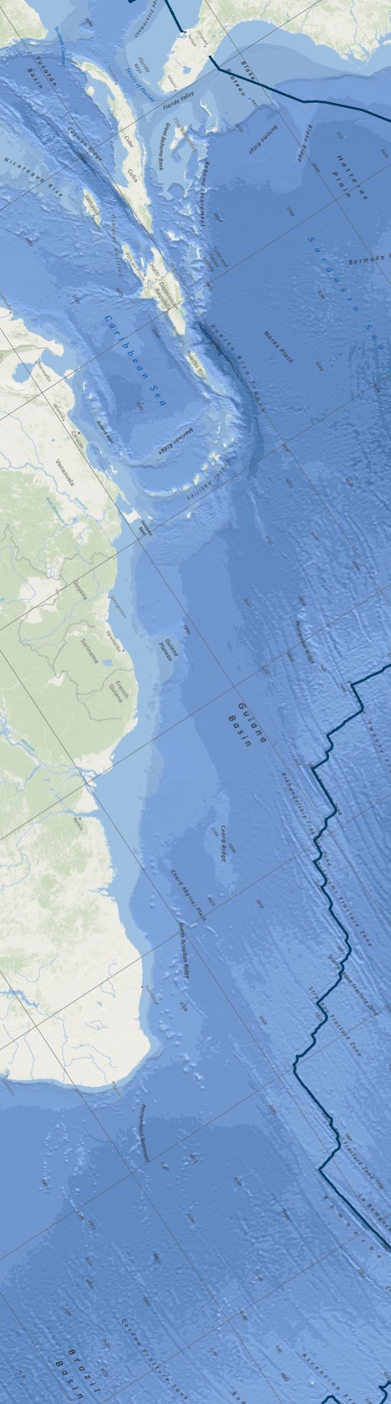

Data to inform the
Wider Caribbean and Western Mid-Atlantic Regional Workshop
to Facilitate the Description of Ecologically or Biologically Significant Marine Areas

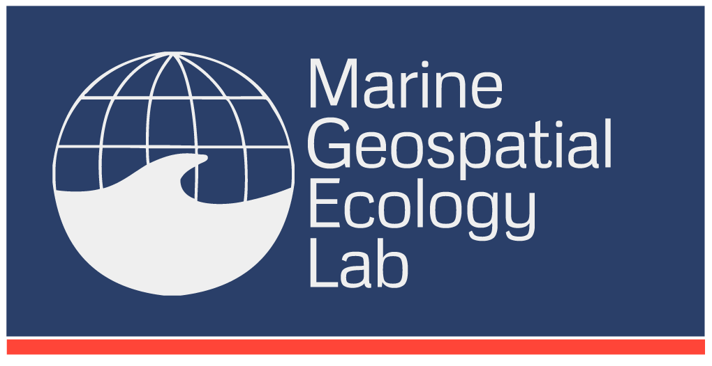
Patrick Halpin, Jesse Cleary, Corrie Curtice, Ben Donnelly
February 20, 2012
Prepared for the Secretariat of the Convention on Biodiversity (SCBD)

Inquiries should be addressed to:

Jesse Cleary
Marine Geospatial Ecology Lab, Duke University
Durham, NC, USA
Telephone : +1 919 613 8021 x6
Email : jesse.cleary@duke.edu
Web : http://mgel.env.duke.edu

Copyright and Disclaimer
© Marine Geospatial Ecology Lab, Duke University, Durham, NC 27708. To the extent permitted by law, all rights are reserved and no part of this publication covered by copyright may be reproduced or copied in any form or by any means except with the written permission of the Marine Geospatial Ecology Lab / Duke University.

Important Notice

Information contained in this publication comprises general statements based on scientific research. The Marine Geospatial Ecology Lab (MGEL) advises the reader to note that such information may be incomplete or unable to be used in any specific situation. No reliance or actions must therefore be made on that information without seeking prior expert professional, scientific and technical advice. To the extent permitted by law, MGEL (including its employees and consultants) excludes all liability to any person for any consequences, including but not limited to all losses, damages, costs, expenses and any other compensation, arising directly or indirectly from using this publication (in part or in whole) and any information or material contained in it. Additionally, some data sets used herein require permission from the data providers for use.

Contents

1 Background 21
2 Biogeography 22
2.1 Global Open Ocean and Deep Seabed (GOODS) biogeographic classification 22
2.2 Marine Ecoregions of the World (MEOW) 24
2.3 Large Marine Ecosystems (LMEs) 25
2.4 Longhurst Marine Provinces 27
3 Biological Data 28
3.1 Distribution of Coral Reefs, Seagrasses and Mangroves 28
3.2 Historical Whale captures 29
3.2.1 Sperm Whales 31
3.2.2 Right Whales 32
3.2.3 Humpback Whales 33
3.3 Catches of Commercial Pelagic Species 33
3.4 Turtle tagging data aggregated by OBIS-SEAMAP 37
3.5 SWOT / WIDECAST nesting beaches 38
3.6 Ocean Biogeographic Information System (OBIS) Data 40
3.6.1 All species 40
3.6.2 Mammals 41
3.6.3 Turtles 42
3.6.4 Shallow Species 43
3.6.5 Deep Species 44
3.6.6 IUCN Red List species 45
3.7 Predictions of Deep Sea Corals 46
3.8 Important Bird Areas 48
4 Physical Data 50
4.1 Seamounts 50
4.2 Vents and Seeps 51
4.3 Bathymetry (GEBCO) 53
4.4 Distribution of Large Submarine Canyons 53
4.5 Total Sediment Thickness of the Worlds Oceans & Marginal Seas 55
4.6 Global Seascapes 56
4.7 Physical Ocean Climatologies 58
4.7.1 Temperature Climatology 59
4.7.2 Salinity Climatology 60
4.7.3 Oxygen Climatology 61
4.7.4 Nitrate Climatology 62
4.7.5 Silicate Climatology 63
4.7.6 Phosphate Climatology 64
4.7.7 Mixed Layer Depth Climatology 65
4.7.8 Sea Surface Height 66
4.7.9 VGPM Global Ocean Productivity 67
4.7.10 SeaWiFS Chlorophyll A concentration 68
4.7.11 Eddy Kinetic Energy 69
4.7.12 Sea Surface Temperature Front Probability 70
4.7.13 Summary of Currents 72
5 Acknowledgments 73
6 Appendix: Submitted References 73
6.1 Document List Compiled By CRFM Secretariat 74
6.1.1 Articles 74
6.1.2 Projects/ studies/ ongoing monitoring activities by organizations/agencies of relevance 75
6.2 Suggested Literature from Judith Gobin (UWI) 77
6.3 Suggested Literature from Loureene Jones Smith 78
6.3.1 Pedro Bank Working Bibliography 78

Background
The Marine Geospatial Ecology Lab at Duke University, in conjunction with international partners, has identified and mapped a large number of data sets and analyses for consideration by the Wider Caribbean and Western Mid-Atlantic Regional Workshop to Facilitate the Description of Ecologically or Biologically Significant Marine Areas (EBSAs). Both biological and physical data sets are included. The data is intended to be used by the expert regional workshop convened by the SCBD and CEP to aid in describing EBSAs through application of scientific criteria in annex I of decision IX/20 as well as other relevant compatible and complementary nationally and inter-governmentally agreed scientific criteria. Each data set may be used to meet one or more of the EBSA criteria. Printed maps will also be available for annotation at the workshop.

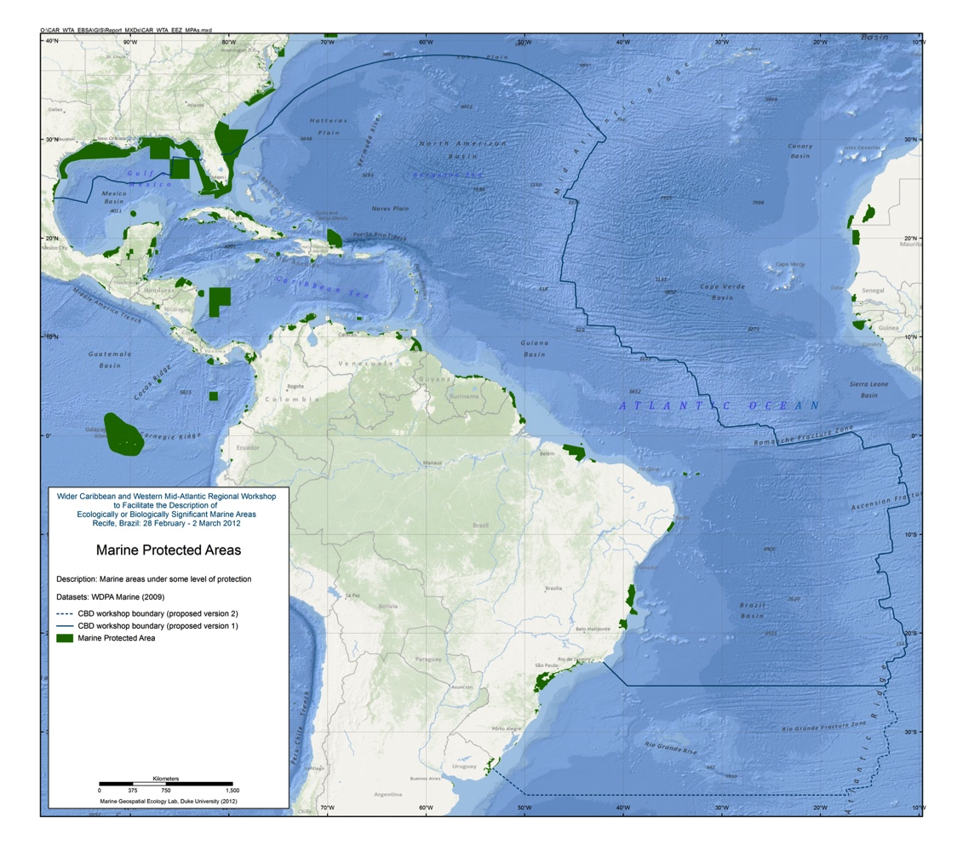
Figure 1.1: Proposed workshop boundary and existing marine protected areas (MPAs)

Biogeography

Global Open Ocean and Deep Seabed (GOODS) biogeographic classification

The classification was produced by an international and multidisciplinary group of experts under the auspices of a number of international and intergovernmental organizations as well as governments, and under the ultimate umbrella of the United Nations Educational, Scientific and Cultural Organization (UNESCO) and its Intergovernmental Oceanographic Commission (IOC).
(source: http://ioc-unesco.org/index.php?option=com_content&task=view&id=146&Itemid=76)

Excerpt from executive summary in full report:

A new biogeographic classification of the world’s oceans has been developed which includes pelagic waters subdivided into 30 provinces as well as benthic areas subdivided into three large depth zones consisting of 38 provinces (14 bathyal, 14 abyssal and 10 hadal). In addition, 10 hydrothermal vent provinces have been delineated. This classification has been produced by a multidisciplinary scientific expert group, who started this task at the workshop in Mexico City in January 2007. It represents the first attempt at comprehensively classifying the open ocean and deep seafloor into distinct biogeographic regions.

The biogeographic classification classifies specific ocean regions using environmental features and – to the extent data are available – their species composition. This represents a combined physiognomic and taxonomic approach. Generalised environmental characteristics of the benthic and pelagic environments (structural features of habitat, ecological function and processes as well as physical features such as water characteristics and seabed topography) are used to select relatively homogeneous regions with respect to habitat and associated biological community characteristics. These are refined with direct knowledge or inferred understanding of the patterns of species and communities, driven by processes of dispersal, isolation and evolution; ensuring that biological uniqueness found in distinct basins and water bodies is also captured in the classification. This work is hypothesis-driven and still preliminary, and will thus require further refinement and peer review in the future. However, in its present format it provides a basis for discussions that can assist policy development and implementation in the context of the Convention on Biological Diversity and other fora. The major open ocean pelagic and deep sea benthic zones presented in this report are considered a reasonable basis for advancing efforts towards the conservation and sustainable use of biodiversity in marine areas beyond the limits of national jurisdiction in line with a precautionary approach. Ongoing work may further refine and improve the classification provided here, however the authors of this report believe that any further refinement to biogeographical provinces need not delay action to be undertaken towards this end, and that such action be supported by the best available scientific information.

Reference:
UNESCO. 2009. Global Open Oceans and Deep Seabed (GOODS) – Biogeographic Classification. Paris, UNESCO-IOC. (IOC Technical Series, 84.)
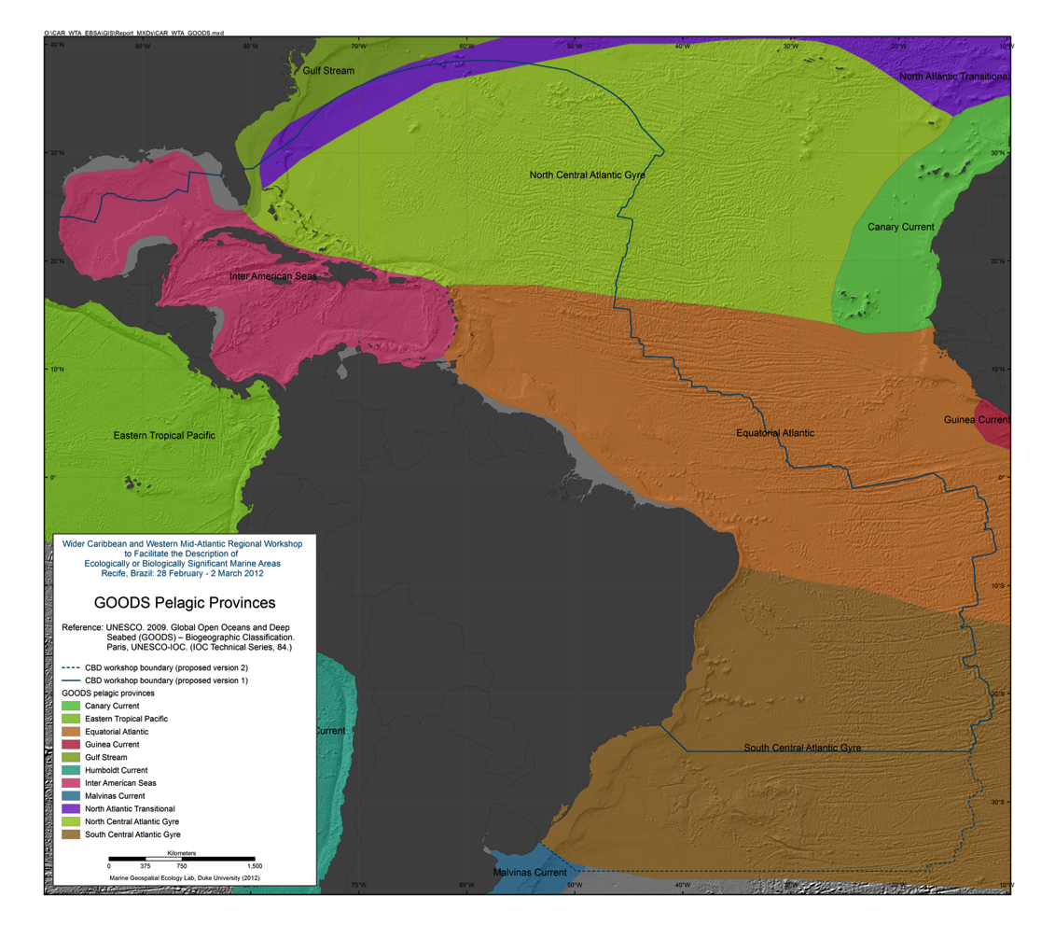
Figure 2.1: GOODS pelagic provinces

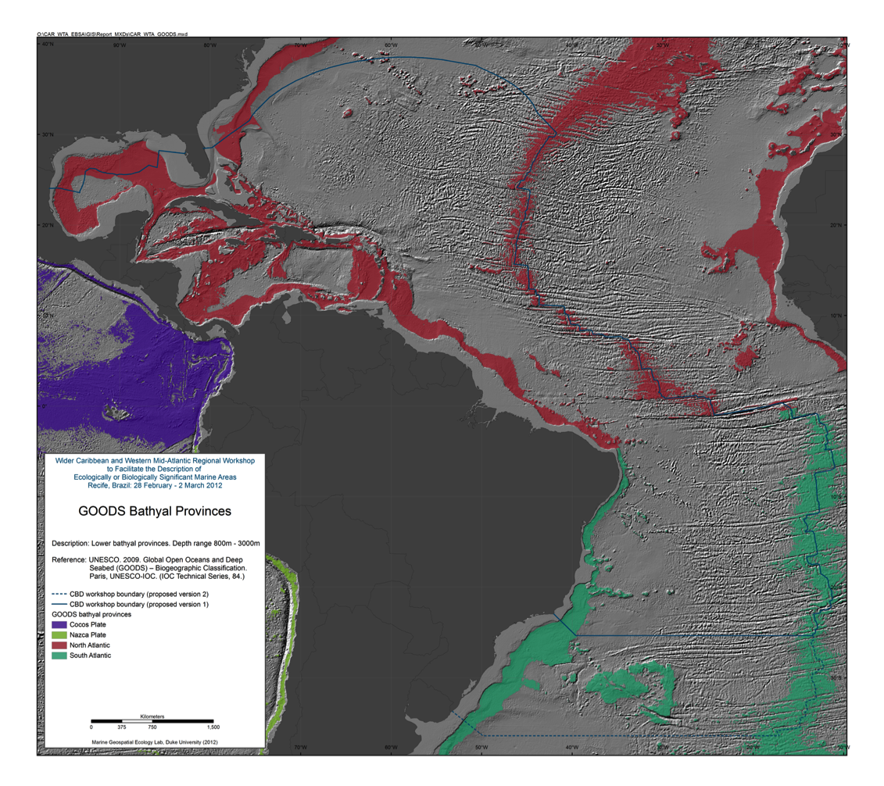
Figure 2.2: Goods bathyl provinces

Marine Ecoregions of the World (MEOW)

MEOW is a biogeographic classification of the world's coasts and shelves. It is the first-ever comprehensive marine classification system with clearly defined boundaries and definitions and was developed to closely link to existing regional systems. The ecoregions nest within the broader biogeographic tiers of Realms and Provinces.
MEOW represents broad-scale patterns of species and communities in the ocean, and was designed as a tool for planning conservation across a range of scales and assessing conservation efforts and gaps worldwide. The current system focuses on coast and shelf areas (as this is where the majority of human activity and conservation action is focused) and does not consider realms in pelagic or deep benthic environment. It is hoped that parallel but distinct systems for pelagic and deep benthic biotas will be devised in the near future.
The project was led by The Nature Conservancy (TNC) and the World Wildlife Fund (WWF), with broad input from a working group representing key NGO, academic and intergovernmental conservation partners.
(source: http://www.worldwildlife.org/science/ecoregions/marine/item1266.html)

Reference:
Spalding, M. D. Fox, H. E. Allen, G. R. Davidson, N. Ferdana, Z. A. Finlayson, M. Halpern, B. S. Jorge, M. A. Lombana, A. Lourie, S. A., (2007). Marine Ecoregions of the World: A Bioregionalization of Coastal and Shelf Areas. Bioscience 2007, VOL 57; numb 7, pages 573-584.

Data available from: http://www.vliz.be/vmdcdata/vlimar/downloads.php#MEOW

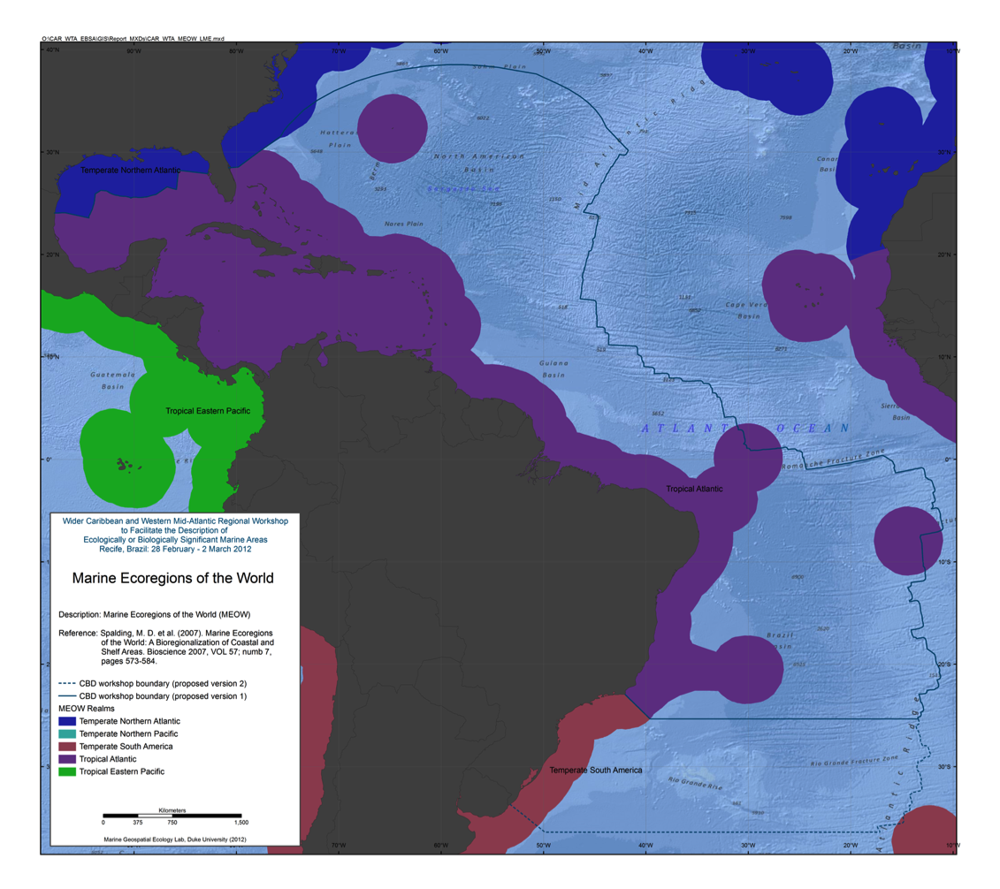
Figure 2.3: MEOW realms

Large Marine Ecosystems (LMEs)

Large Marine Ecosystems (LMEs) are regions of ocean space encompassing coastal areas from river basins and estuaries to the seaward boundary of continental shelves and the seaward margins of coastal current systems. Fifty of them have been identified. They are relatively large regions (200 000 km² or more) characterized by distinct bathymetry, hydrography, productivity and trophically dependent populations.

The LME approach uses five modules:
- productivity module considers the oceanic variability and its effect on the production of phyto and zooplankton
- fish and fishery module concerned with the sustainability of individual species and the maintenance of biodiversity
- pollution and ecosystem health module examines health indices, eutrophication, biotoxins, pathology and emerging diseases
- socio-economic module integrates assessments of human forcing and the long-term sustainability and associated socio-economic benefits of various management measures, and
- governance module involves adaptive management and stakeholder participation.
(source: http://www.fao.org/fishery/topic/3440/en)

Reference:
FAO. © 2005-2012. Fisheries and Aquaculture topics. Large Marine Ecosystems. Topics Fact Sheets. Text by J.J. Maguire and Jorge Csirke. In: FAO Fisheries and Aquaculture Department [online]. Rome. Updated 27 May 2005. [Cited 15 February 2012]. http://www.fao.org/fishery/topic/3440/en

Data available from: http://www.lme.noaa.gov/
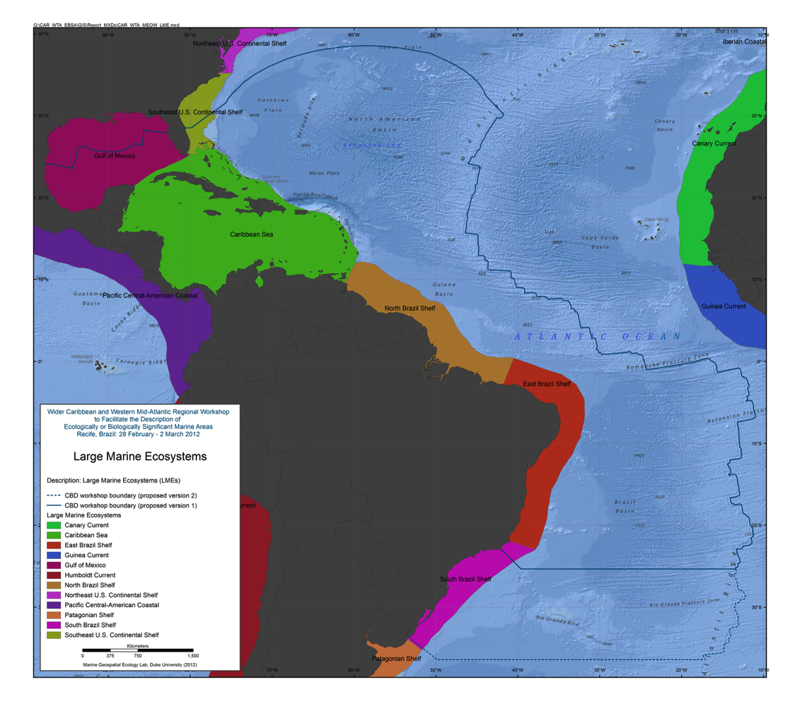
Figure 2.4: Large Marine Ecosystems

Longhurst Marine Provinces

This dataset represents a partition of the world oceans into provinces as defined by Longhurst (1995; 1998; 2006), and are based on the prevailing role of physical forcing as a regulator of phytoplankton distribution. The dataset represents the initial static boundaries developed at the Bedford Institute of Oceanography, Canada. Note that the boundaries of these provinces are not fixed in time and space, but are dynamic and move under seasonal and interannual changes in physical forcing. At the first level of reduction, Longhurst recognised four principal biomes (also referred to as domains in earlier publications): the Polar Biome, the Westerlies Biome, the Trade-Winds Biome, and the Coastal Boundary Zone Biome. These four Biomes are recognisable in every major ocean basin. At the next level of reduction, the ocean basins are partitioned into provinces, roughly ten for each basin. These partitions provide a template for data analysis or for making parameter assignments on a global scale.
(source: VLIZ (2009). Longhurst Biogeographical Provinces. Available online at http://www.vliz.be/vmdcdata/vlimar/downloads.php. Consulted on 2012-02-15.)

References:
Longhurst, A.R. (2006). Ecological Geography of the Sea. 2nd Edition. Academic Press, San Diego, 560p.

Data available from: http://www.vliz.be/vmdcdata/vlimar/downloads.php

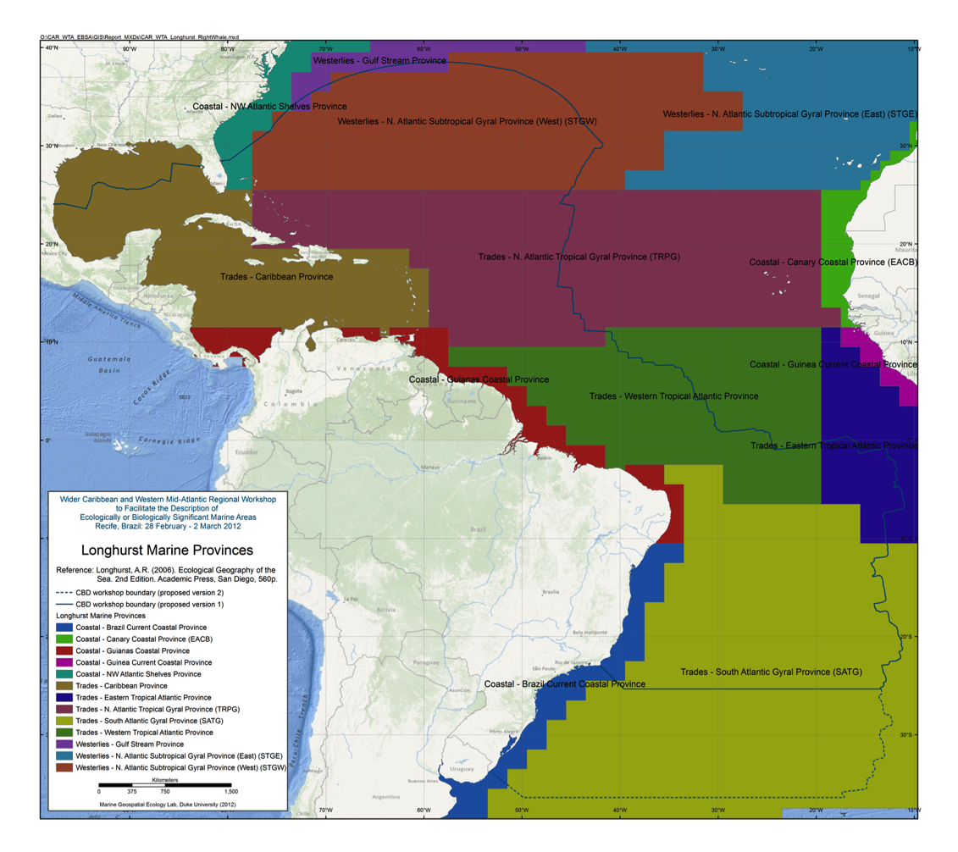
Figure 2.5: Longhurst marine provinces

Biological Data

Distribution of Coral Reefs, Seagrasses and Mangroves

The UNEP World Conservation Monitoring Centre (UNEP-WCMC) is a collaboration between the United Nations Environment Programme, the world's foremost intergovernmental environmental organization, and WCMC(UK), a UK-based charity. UNEP-WCMC is UNEP’s specialist biodiversity assessment arm, and the Centre for UNEP’s collaboration with WCMC 2000.
(source: http://www.unep-wcmc.org/about-us_17.html)

Global Distribution of Coral Reefs (2010) data available from:
http://data.unep-wcmc.org/datasets/13

Global Distribution of Seagrasses (2005) data available from:
http://data.unep-wcmc.org/datasets/10

Global Distribution of Mangroves (1997) data available from:
http://data.unep-wcmc.org/datasets/6

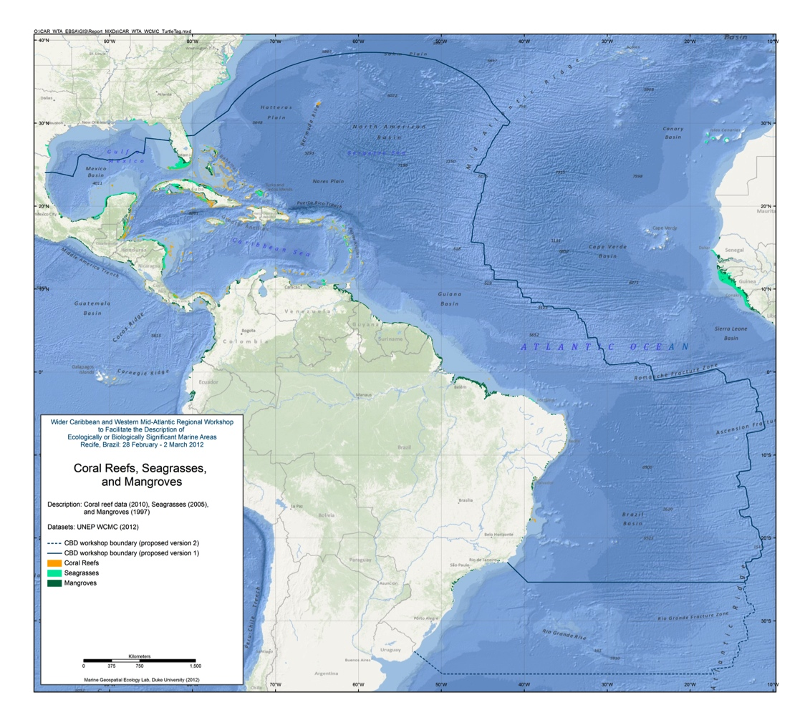
Figure 3.1: Coral reefs, seagrasses, and mangroves

Historical Whale captures
The Wildlife Conservation Society has digitally captured the Townsend Whaling Charts that were published as a series of 4 charts with the article titled ”The distribution of certain whales as shown by logbook records of American whale ships” by Charles Haskins Townsend in the journal Zoologica in 1935.

The 4 charts (of which three are used here) show the locations of over 50,000 captures of 4 whale species; sperm whales (36,908), right whales (8,415), humpback whales (2,883) and bowhead whales(5,114). Capture locations were transcribed from North American (Yankee) pelagic whale vessel log books dating from 1761 to 1920 and plotted onto nautical charts in a Mercator projection by a cartographer. Each point plotted on the charts represents the location of a whaling ship on a day when one or more whales were taken and is symbolized by month of the year using a combination of color and open and closed circles.

Townsend and his cartographer plotted vessel locations as accurately as possible according to log book records. When plotting locations on an earlier sperm whale chart published in 1931the cartographer spaced points where locations were very dense, extending areas slightly for a number of whaling grounds. However for charts in preparation at this time Townsend states that this difficulty is avoided by omitting some of the data, rather than extend the ground beyond actual whaling limits. We assume that this statement refers to the 1935 charts but there is still some question as to whether the cartographer did in fact space locations and thus expand whaling grounds.

Digitizing errors include missed points, particularly from areas of dense chart locations, and incorrect assignment of month of capture because of difficulty distinguishing between chart colors. However to limit these errors multiple checks of digitized and chart locations were made and color enhancements of chart scans were used to ensure correct month assignments. Overall we are confident that at least 95% of catch locations have been digitized and that at least 95% of month attributes are correct.
(source: http://web.archive.org/web/20070926224128/http:/wcs.org/townsend_charts)

Using a used a geographic information system (ArcMap 10.x, ESRI, Redlands, CA), capture point locations for each species were aggregated into 1-degree cells.

References:
Townsend, C.H. 1935. The distribution of certain whales as shown by logbook records of American whaleships. Zoologica 19, No. 1:1-50, 4 charts.
Townsend, C.H. 1931. Where the nineteenth century whaler made his catch. Zoologica 34, No. 6:173-179.
Reeves, R., Smith, T.D. Josephson, E.A., Clapham, P.J. and Woolmer, G. 2004. Historical observations of humpback and blue whales in the North Atlantic Ocean: Clues to migratory routes and possibly additional feeding grounds. Marine Mammal Science. Vol. 20 (4), pg 774-786.

Data available from: http://web.archive.org/web/20070926224128/http://wcs.org/townsend_charts#GIS Data

Sperm Whales

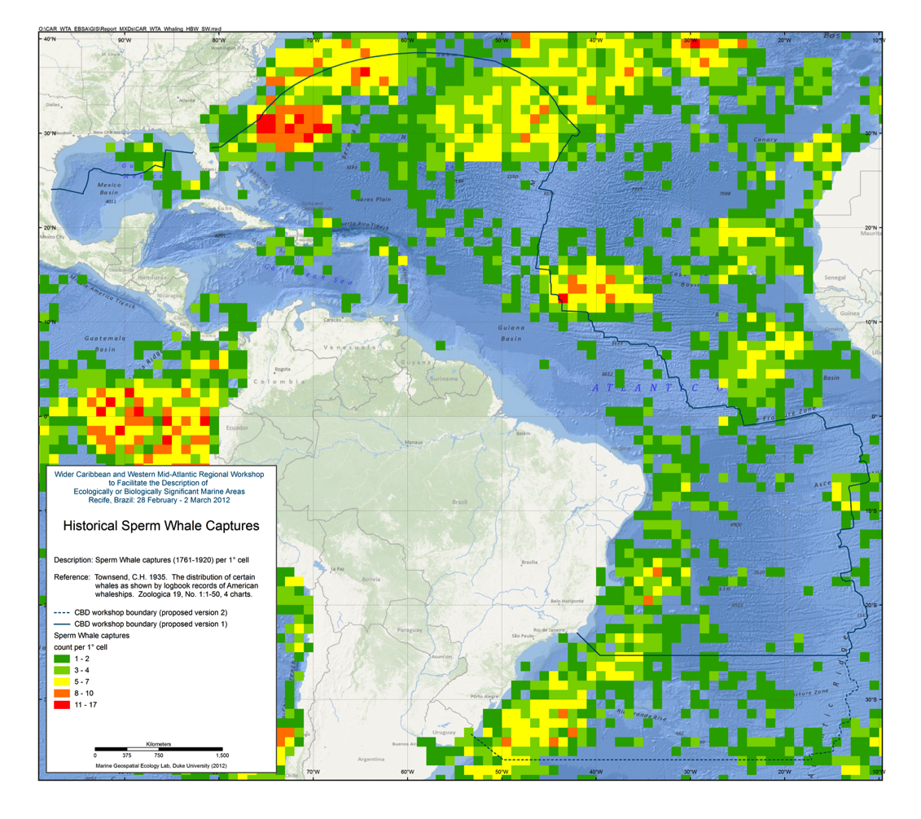
Figure 3.2: Historical sperm whale captures

Right Whales
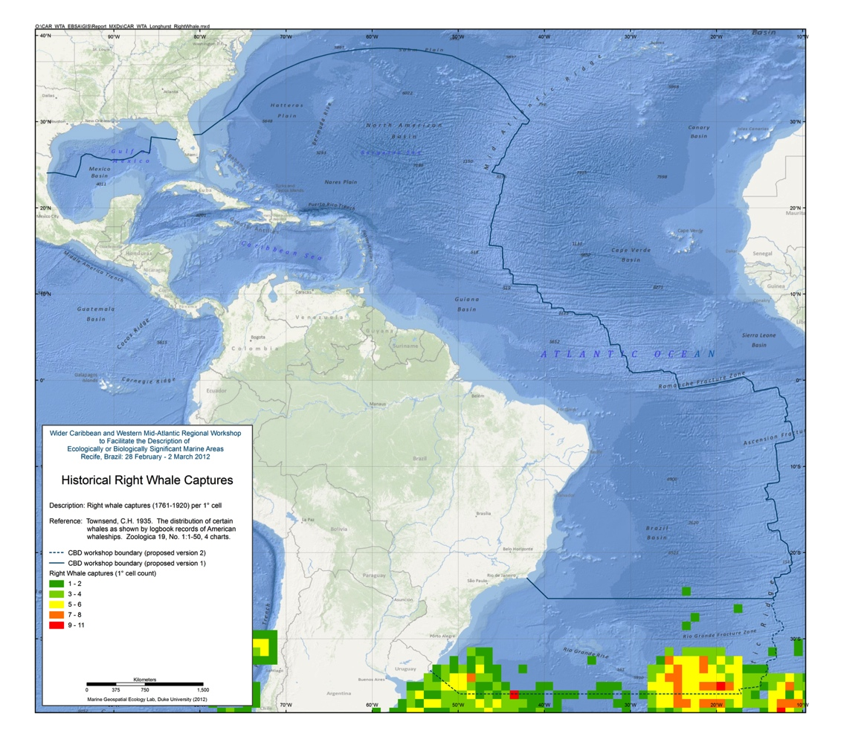
Figure 3.3: Historical right whale captures

Humpback Whales
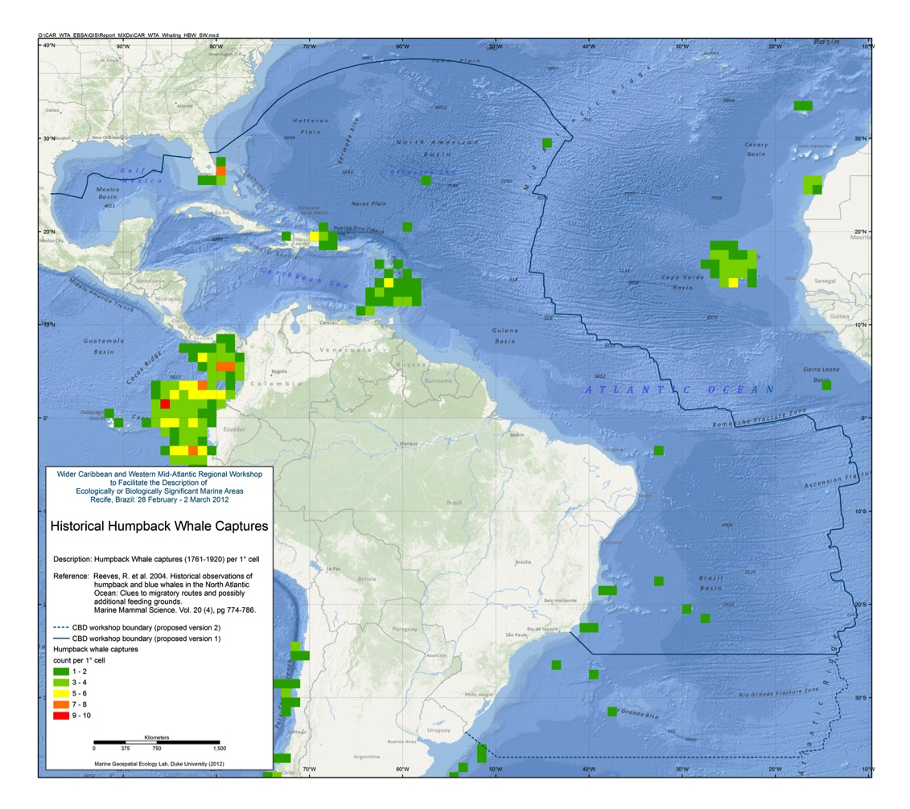
Figure 3.4: Historical humpback whale captures

Catches of Commercial Pelagic Species
Figures of ICCAT catch data were taken from the most recent ICCAT Statistical Bulletin and georeferenced for purposes of figure uniformity in this CBD report. The Bulletin provides the following information about the summary catch data:

“Since 2005, the ICCAT Statistical Bulletin has been published in a new format covering all the time series of the nominal catch data available in the Secretariat database. The statistics in this publication represent the scientific working groups best estimates, according to the decision by the Standing Committee on Research and Statistics (SCRS). Therefore, they may not coincide exactly with the official statistics provided to the Secretariat by the Parties, Entities or Fishing Entities. The data used to develop the fishing maps included in Section IV arefrom estimates made by the Secretariat to redistribute the nominal catches reported by large geographical areas into 5x5 degree squares. They are based on the size sampling, the catch and effort data available, and the rules for substitution adopted by the SCRS over the past years. The vertical or horizontal lines in the maps shown in section 4 delimit north/south or east/west stock species. All the information published in this volume was compiled and processed by the ICCAT Statistics Dept.”

Reference:
Statistical Bulletin Vol. 40 (1960 – 2009) July 2011 INTERNATIONAL COMMISSION FOR THE CONSERVATION OF ATLANTIC TUNAS (ICCAT) http://www.iccat.int

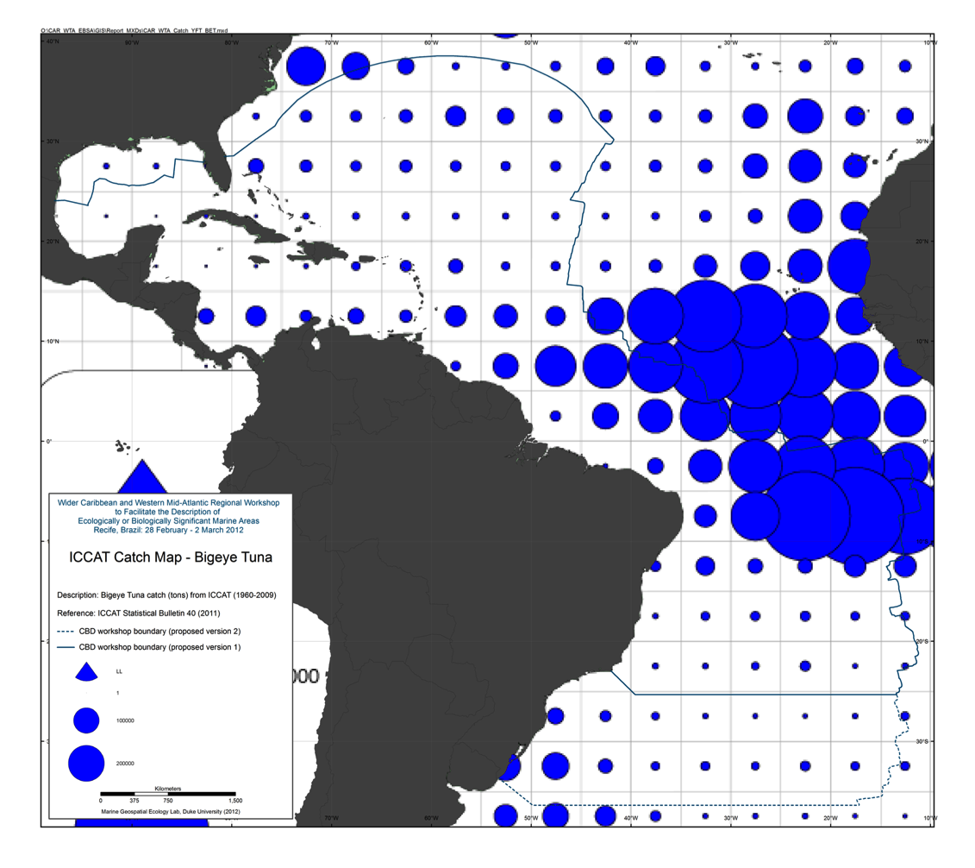
Figure 3.5: ICCAT Bigeye Tuna long line catch statistics

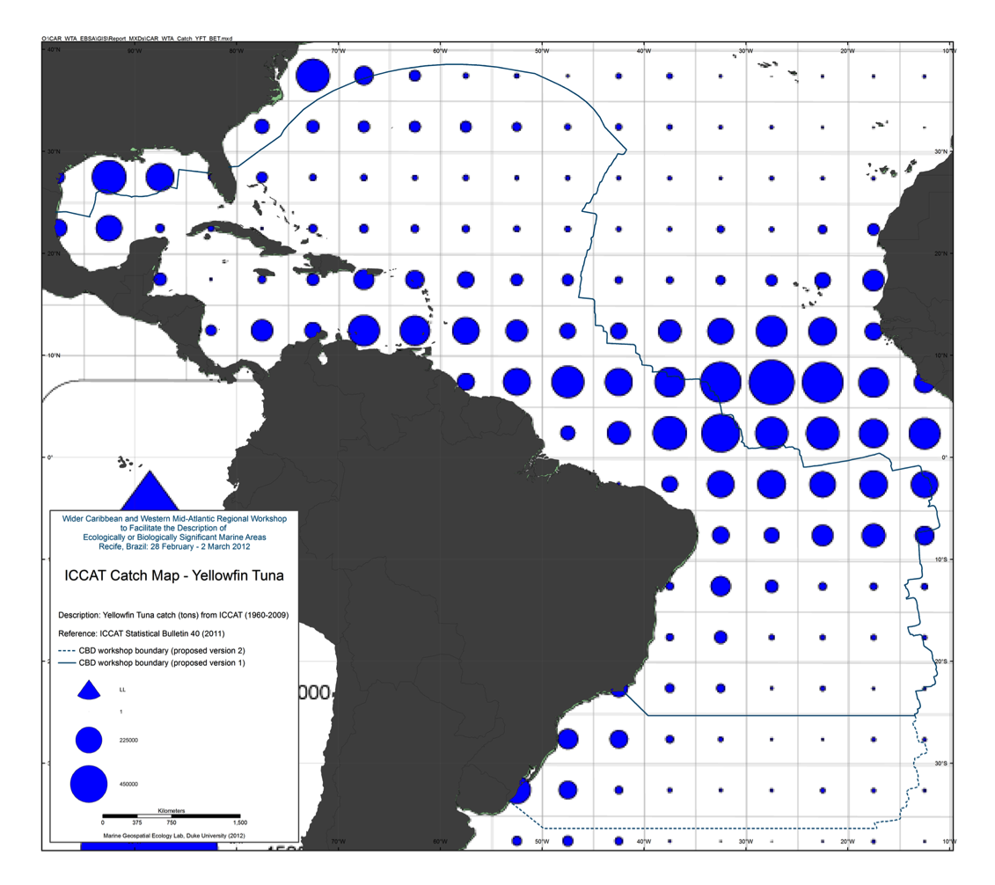
Figure 3.6: ICCAT Yellowfin Tuna long line catch statistics

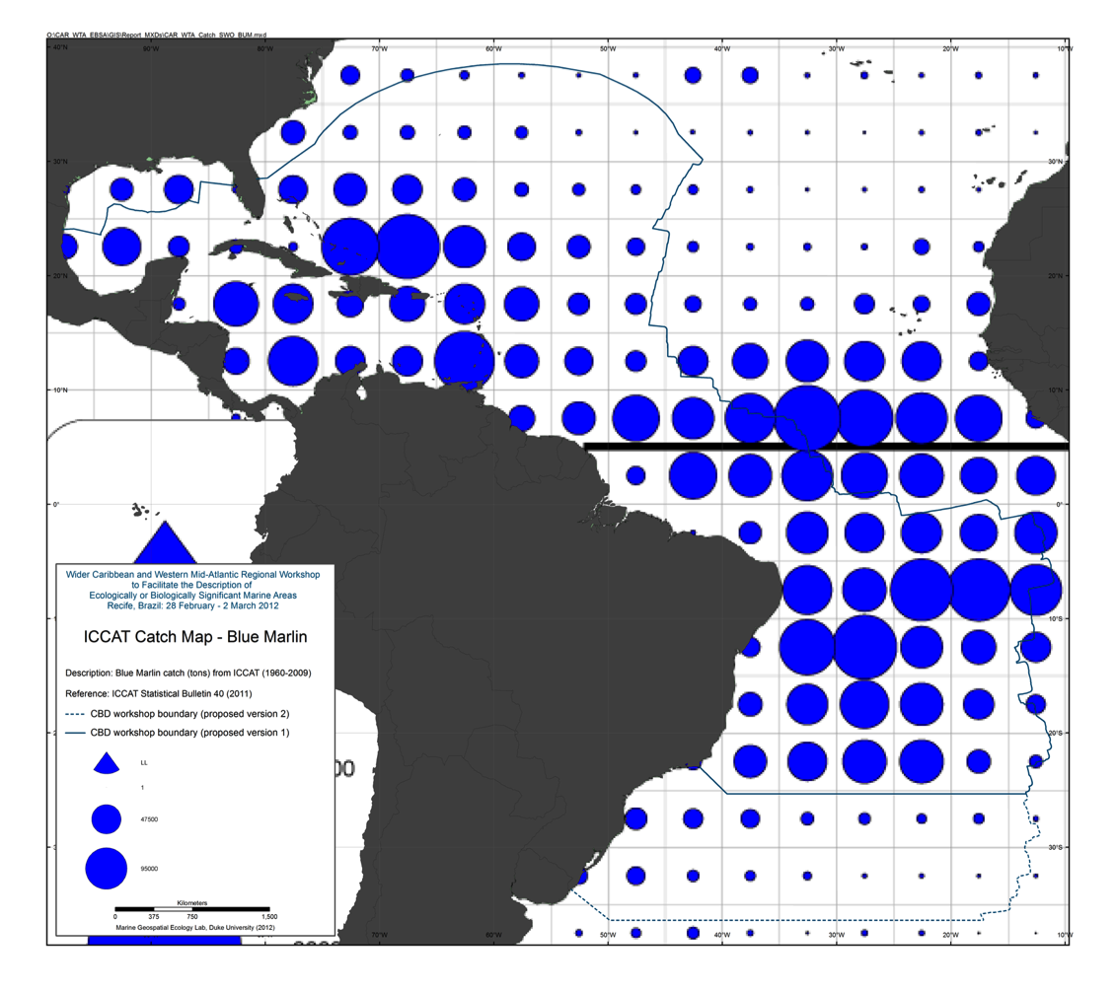
Figure 3.7: ICCAT Blue Marlin long line catch statistics

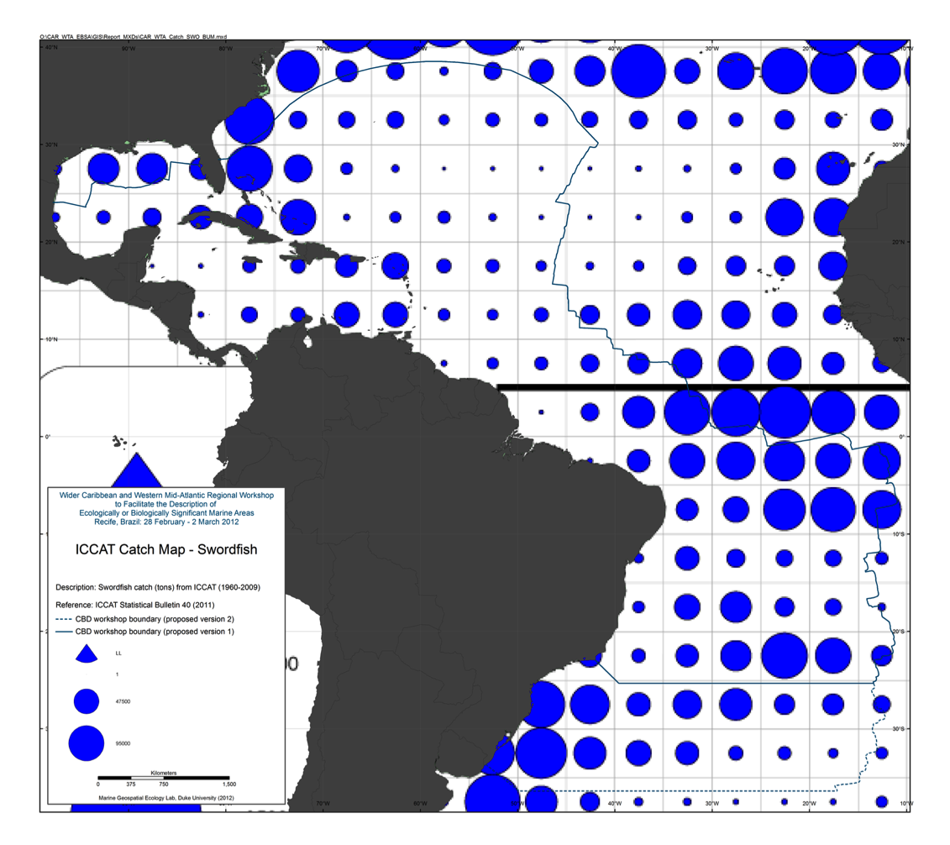
Figure 3.8: ICCAT Swordfish long line catch statistics

Turtle tagging data aggregated by OBIS-SEAMAP

OBIS-SEAMAP, Ocean Biogeographic Information System Spatial Ecological Analysis of Megavertebrate Populations, is a spatially referenced online database, aggregating marine mammal, seabird and sea turtle observation data from across the globe.
(source: http://seamap.env.duke.edu/)

Data from several turtle tracking efforts were extracted from OBIS-SEAMAP data center for the study area and displayed on a per species basis.

Data available from: http://seamap.env.duke.edu/

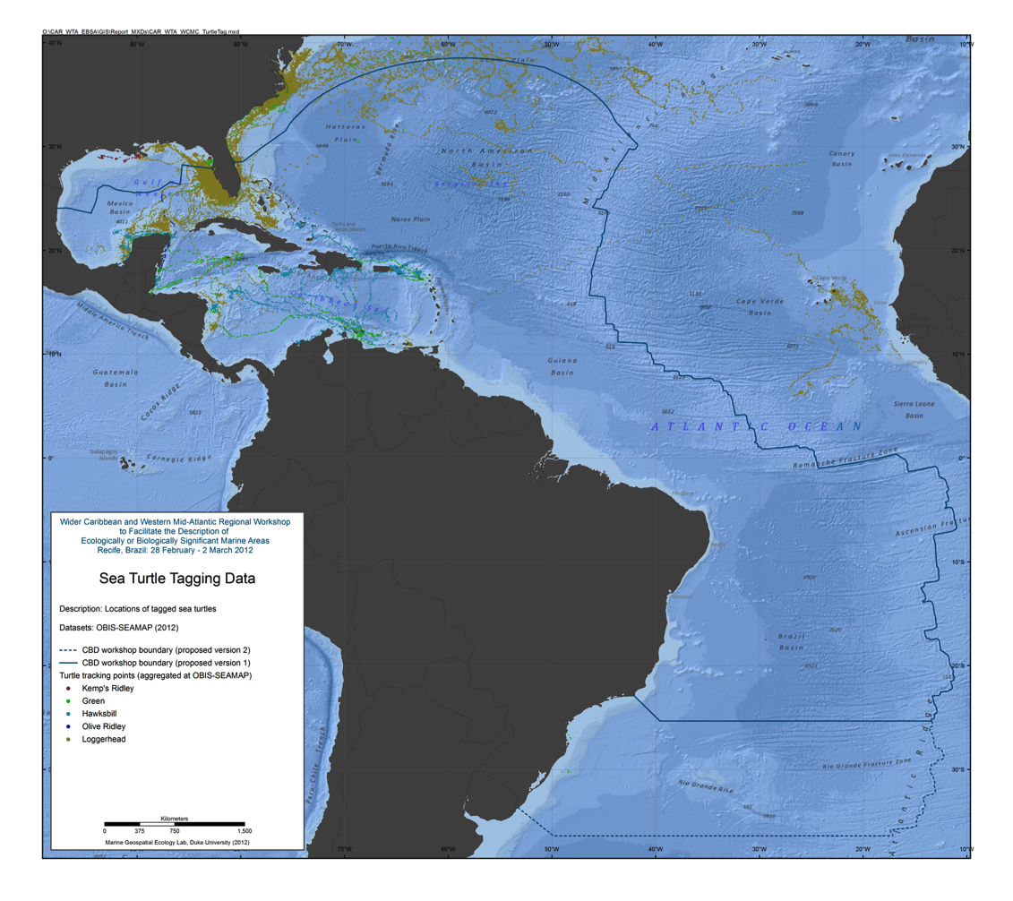
Figure 3.9: Sea turtle tagging data

SWOT / WIDECAST nesting beaches

SWOT — the State of the World's Sea Turtles — is a partnership led by the Sea Turtle Flagship Program at Conservation International (CI), the IUCN Marine Turtle Specialist Group (MTSG), and supported by the Marine Geospatial Ecology Lab (MGEL) at Duke University.
However, the lifeblood of the effort is the network of more than 550 people and projects that contribute data to the SWOT database, the only comprehensive, global database of sea turtle nesting sites. The SWOT team has completed six years of data collection including the global nesting locations of all seven marine turtle species: green, leatherbacks, loggerheads, hawksbills, flatbacks, olive and Kemp's ridleys. SWOT now collects data for all species in its annual data collection.
In addition to collating nesting abundance and distribution information for all species, SWOT now hosts data compiled by the MTSG Burning Issues Working Group that includes Regional Management Units for all seven marine turtle species, including all available georeferenced mtDNA and nDNA stocks. These files can be viewed on the SWOT website and downloaded for analyses once the Terms of Use are agreed to. Furthermore, SWOT also supports recommendations for monitoring effort schemes that will allow for comparison of long-term nesting abundance and trend estimates for regional and global populations of sea turtle species. These advances will solidify SWOT as the premier global monitoring system for sea turtles. Information on Minimum Data Standards are available at http://seaturtlestatus.org/data/standards.
The current SWOT database contains sea turtle nesting records from over 120 countries all over the world. This online tool, hosted by OBIS-SEAMAP, builds on previous work initiated and supported by WIDECAST organization as well as data from several other regional sea turtle organizations. Records coming from projects that are both a part of a regional organization are flagged as such. The WIDECAST Atlas can still be accessed as a stand-alone application. New data from the WIDECAST network is added to the SWOT database annually.
(source: http://mgel.env.duke.edu/projects/swot/)

Reference:
DiMatteo, A., E. Fujioka, B. Wallace, B. Hutchinson, J. Cleary and P. Halpin. 2009. SWOT Database Online. Data provided by the SWOT Team. World Wide Web electronic publication.

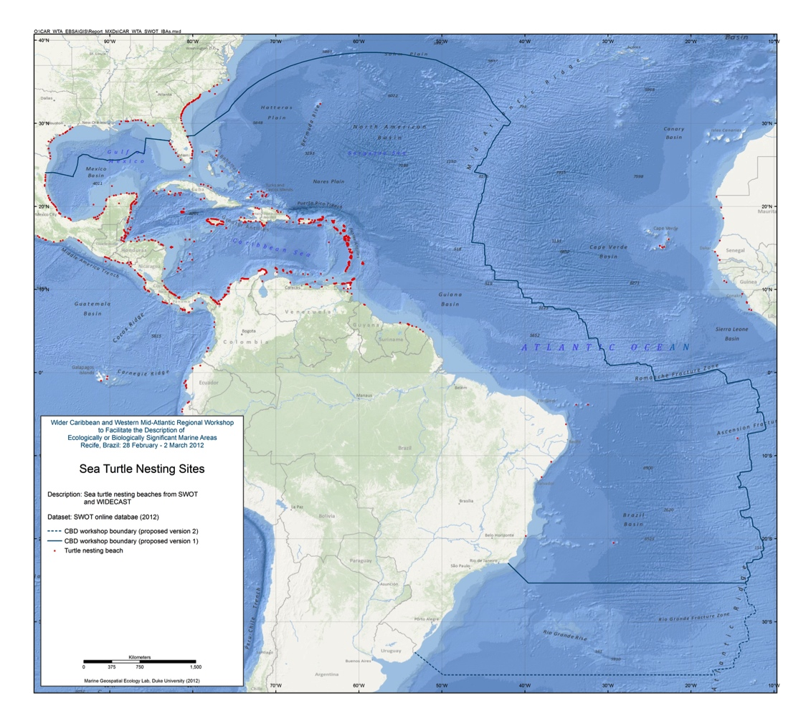
Figure 3.10: Sea turtle nesting sites

Ocean Biogeographic Information System (OBIS) Data

The Ocean Biogeographic information System (OBIS) seeks to absorb, integrate, and assess isolated datasets into a larger, more comprehensive picture of life in our oceans. The system hopes to stimulate research about our oceans to generate new hypotheses concerning evolutionary processes, species distributions, and roles of organisms in marine systems on a global scale. The abstracts that OBIS generates are maps that contribute to the ‘big picture’ of our oceans: a comprehensive, collaborative, worldwide view of our oceans.

OBIS provides a portal or gateway to many datasets containing information on where and when marine species have been recorded. The datasets are integrated so you can search them all seamlessly by species name, higher taxonomic level, geographic area, depth, and time; and then map and find environmental data related to the locations. OBIS aims to be:

- Authoritative, professional, and credible
- Concise, easily read and understood, and use minimal jargon
- User-friendly with a logical consistent design and flow
- Regularly updated.
(source: http://www.iobis.org/about/index)

Reference:
Vanden Berghe, E. (editor)(2007). The Ocean Biogeographic Information System: web pages. Available on http://www.iobis.org. Consulted on 16 February 2012.

The data provided here are summaries of available OBIS data. Species Richness and Hurlbert’s Index (ES[50]) data summaries for 1 degree grids are provided for all species, mammals, turtles, shallow species (<100m depth), deep species(>100m depth), and species on the IUCN Red List. Data gaps do exist in OBIS and thus these summaries are not exhaustive.

Data available from: http://iobis.org/mapper/

All species

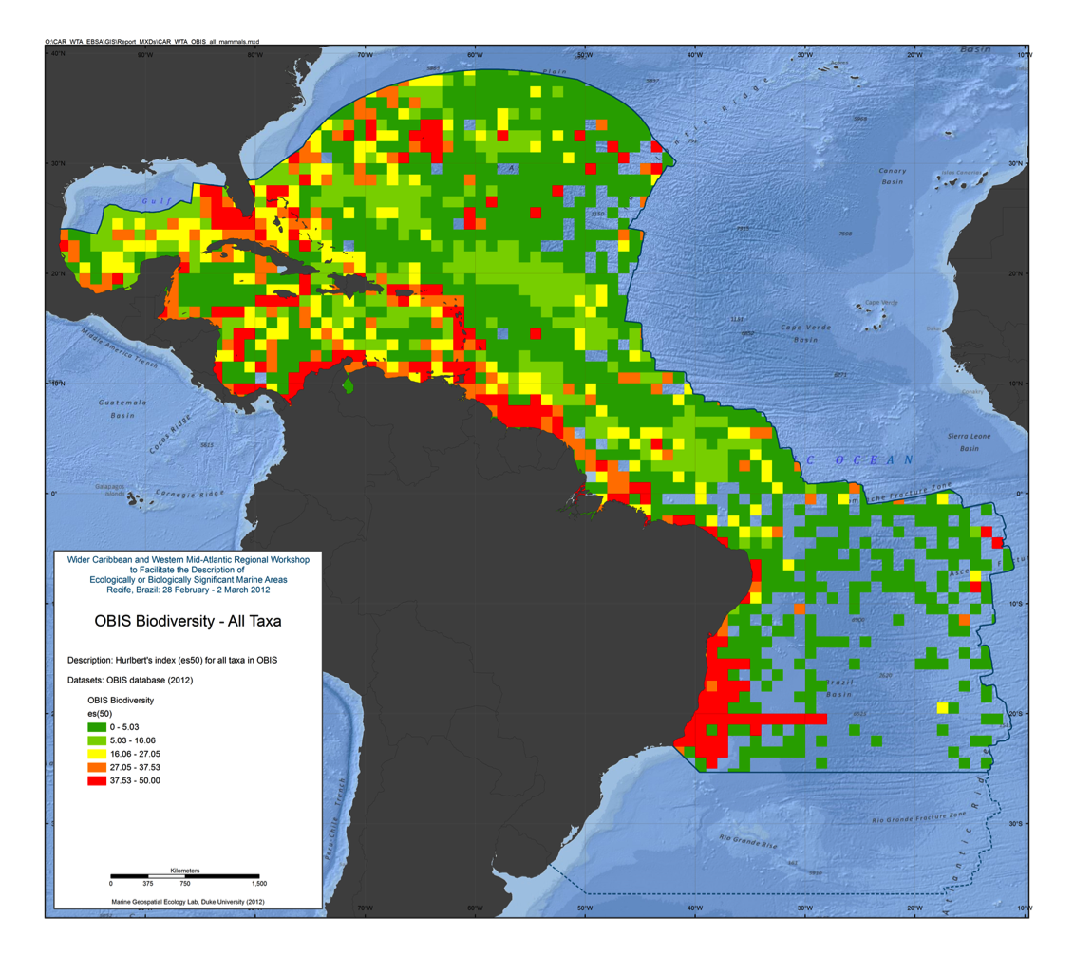
Figure 3.11: ES(50) for all taxa

Mammals

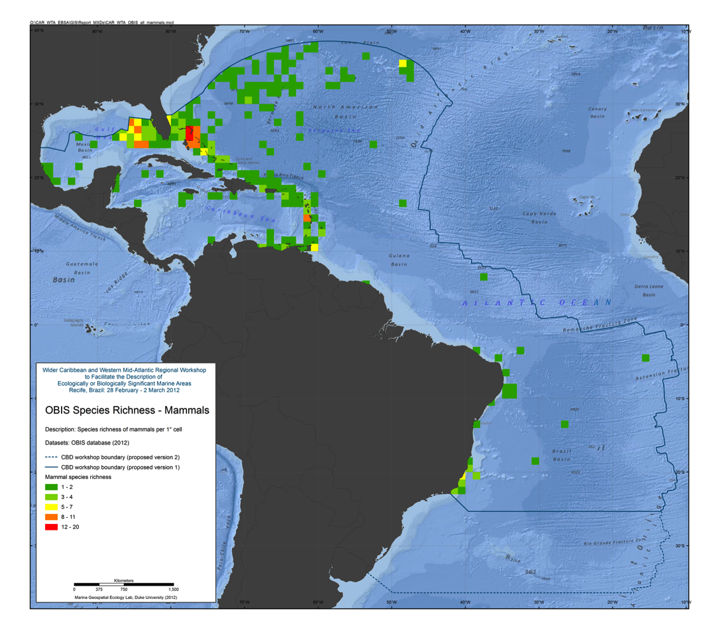
Figure 3.12: Species richness for mammals

Turtles

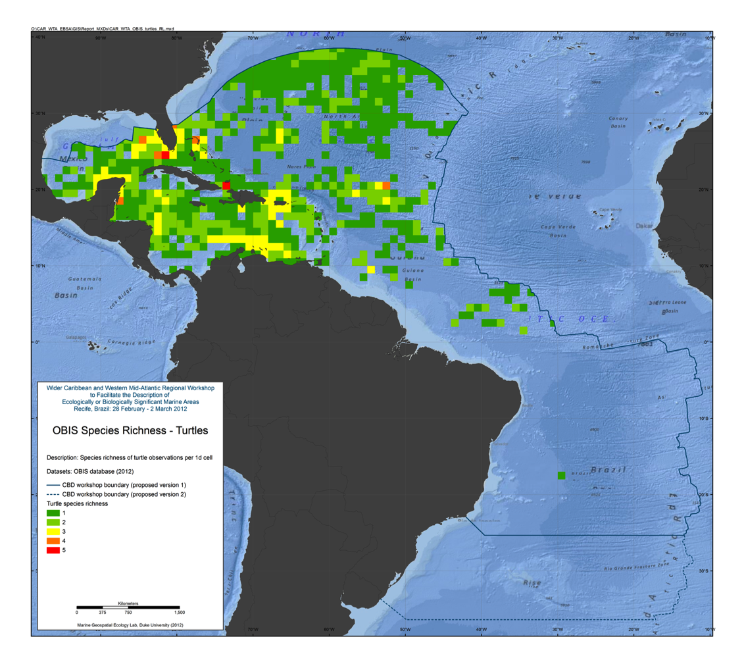
Figure 3.13: Species Richness for turtles

Shallow Species
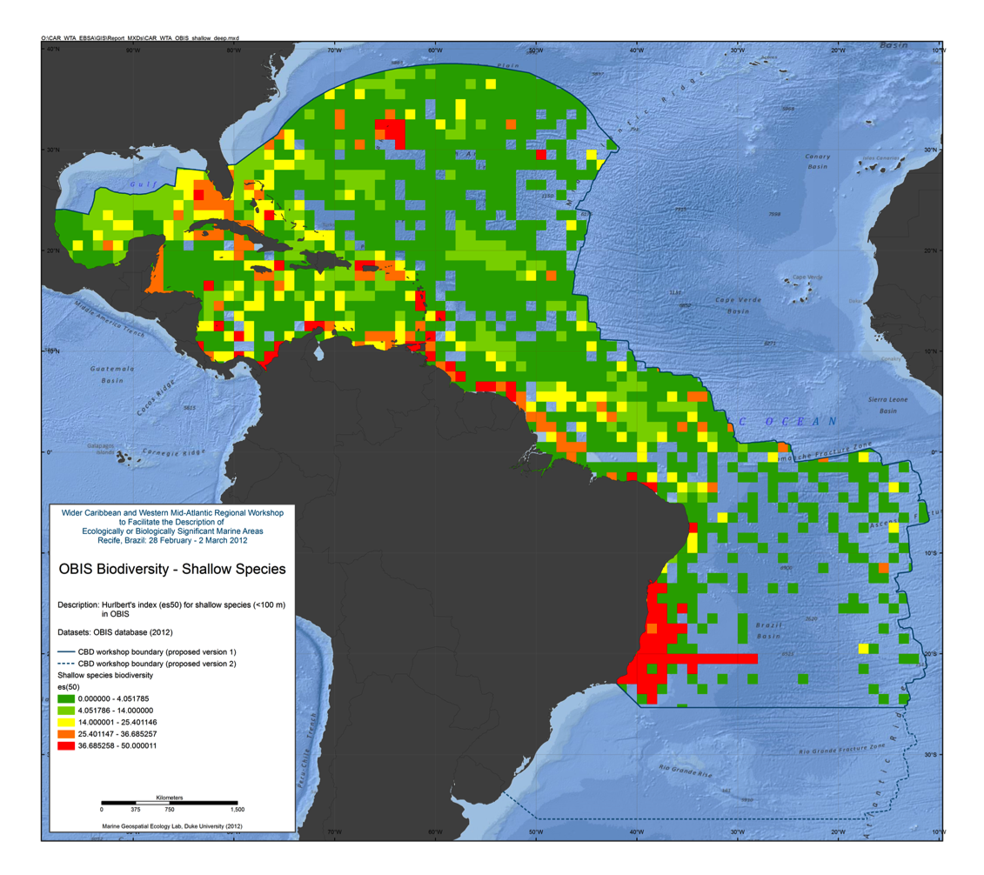
Figure 3.14: ES(50) for shallow species

Deep Species
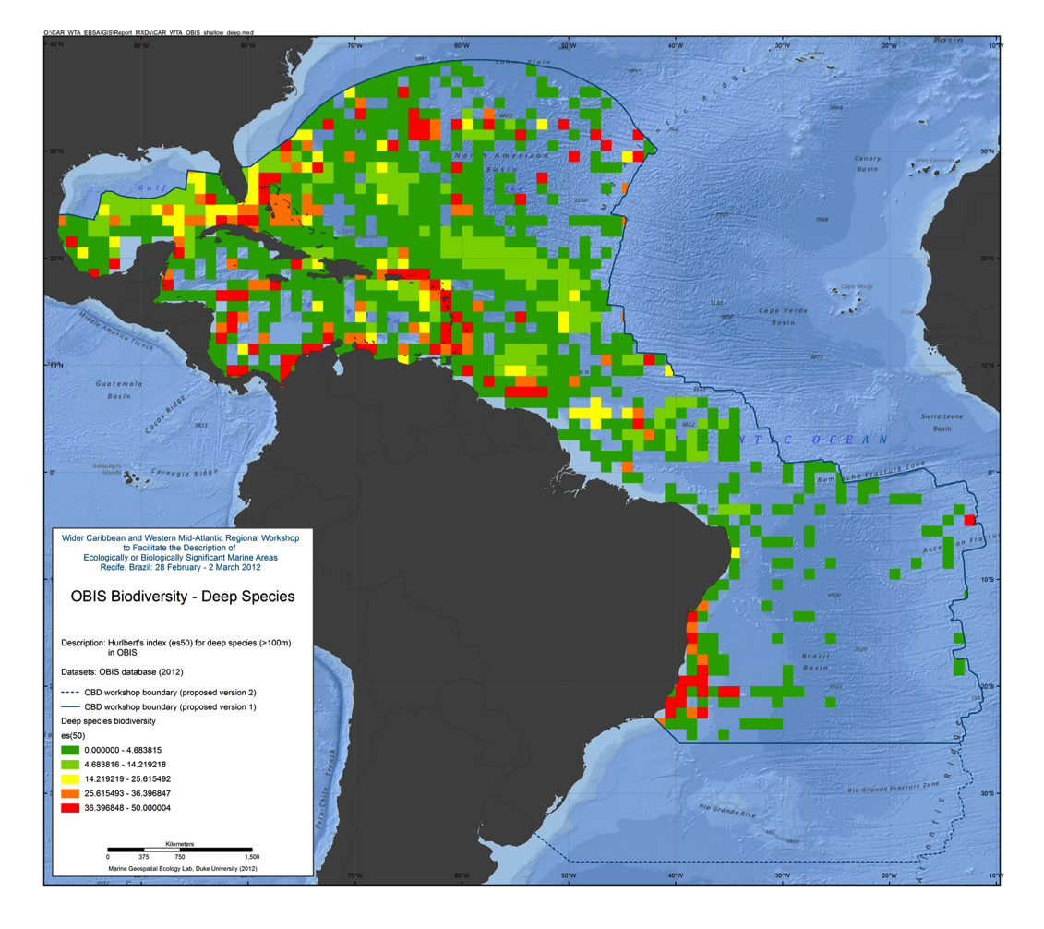
Figure 3.15: ES(50) for deep species

IUCN Red List species
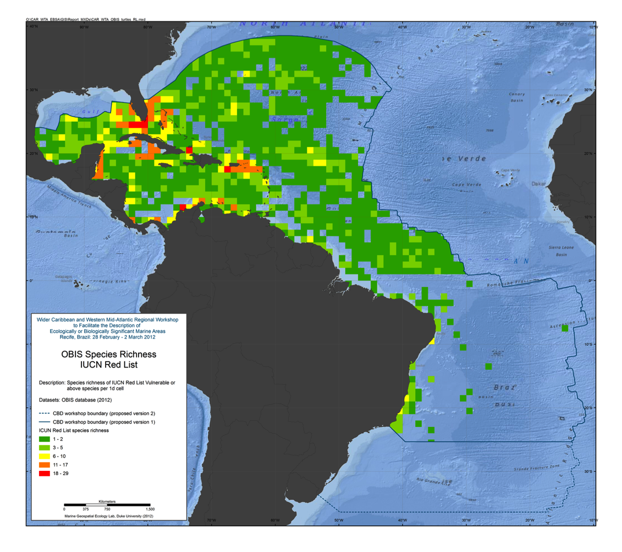
Figure 3.16: Species richness for IUCN Red List species

Predictions of Deep Sea Corals
Abstract:
Predictive habitat models are increasingly being used by conservationists, researchers and governmental bodies to identify vulnerable ecosystems and species’ distributions in areas that have not been sampled. However, in the deep sea, several limitations have restricted the widespread utilisation of this approach. These range from issues with the accuracy of species presences, the lack of reliable absence data and the limited spatial resolution of environmental factors known or thought to control deep-sea species’ distributions. To address these problems, global habitat suitability models have been generated for five species of framework-forming scleractinian corals by taking the best available data and using a novel approach to generate high resolution maps of seafloor conditions. High-resolution global bathymetry was used to resample gridded data from sources such as World Ocean Atlas to produce continuous 30-arc second (,1 km2) global grids for environmental, chemical and physical data of the world’s oceans. The increased area and resolution of the environmental variables resulted in a greater number of coral presence records being incorporated into habitat models and higher accuracy of model predictions. The most important factors in determining cold-water coral habitat suitability were depth, temperature, aragonite saturation state and salinity. Model outputs indicated the majority of suitable coral habitat is likely
to occur on the continental shelves and slopes of the Atlantic, South Pacific and Indian Oceans. The North Pacific has very little suitable scleractinian coral habitat. Numerous small scale features (i.e., seamounts), which have not been sampled or identified as having a high probability of supporting cold-water coral habitat were identified in all ocean basins. Field validation of newly identified areas is needed to determine the accuracy of model results, assess the utility of modeling efforts to identify vulnerable marine ecosystems for inclusion in future marine protected areas and reduce coral bycatch by commercial fisheries.

Reference:
Davies AJ, Guinotte JM (2011) Global Habitat Suitability for Framework-Forming Cold-Water Corals. PLoS ONE 6(4): e18483. doi:10.1371/journal.pone.0018483

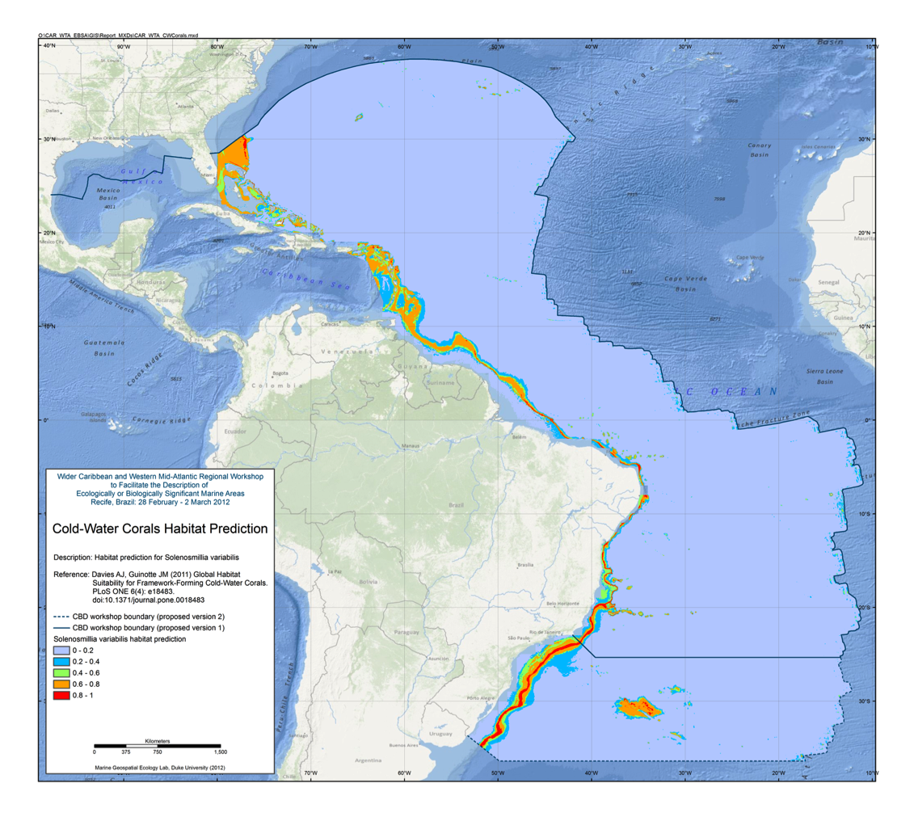
Figure 3.17: Solenosmillia variabilis habitat prediction

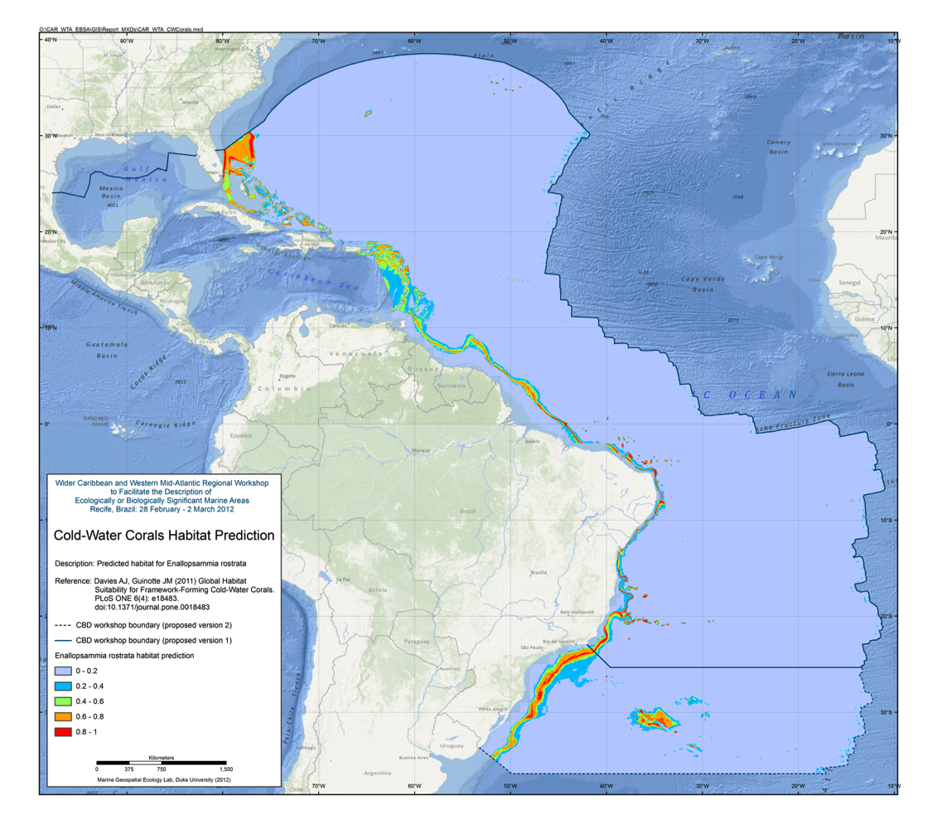
Figure 3.18: Enallopsammia rostrata habitat prediction

Important Bird Areas

BirdLife Important Bird Areas (IBAs) have been used to inform the identification of EBSAs in both the previous EBSA regional workshops for the NE Atlantic and S Pacific. Previously the data provided has been used to either support the designation of an EBSA for a range of taxa and habitats, or to identify EBSAs solely on the basis of bird data.
IBAs have been identified using several data sources:
- Terrestrial seabird breeding sites are shown with point locality and species that qualifies at the IBA
– see http://www.birdlife.org/datazone/site/search
- Marine areas around breeding colonies have been identified based on literature review where possible to guide the distance required by each species. Where literature is sparse or lacking extensions have been applied on a precautionary basis.
– see http://seabird.wikispaces.com/
- Sites identified by satellite tracking data via kernel density analysis, first passage time analysis and bootstrapping approaches.
- www.seabirdtracking.org
Together these IBAs form a network of sites of importance to coastal, pelagic, resident and or migratory species. EBSA criteria of particular relevance are “important for life-history stages”, “threatened species”, “diversity” and “fragility”. For further information Google IBAs vs EBSAs.

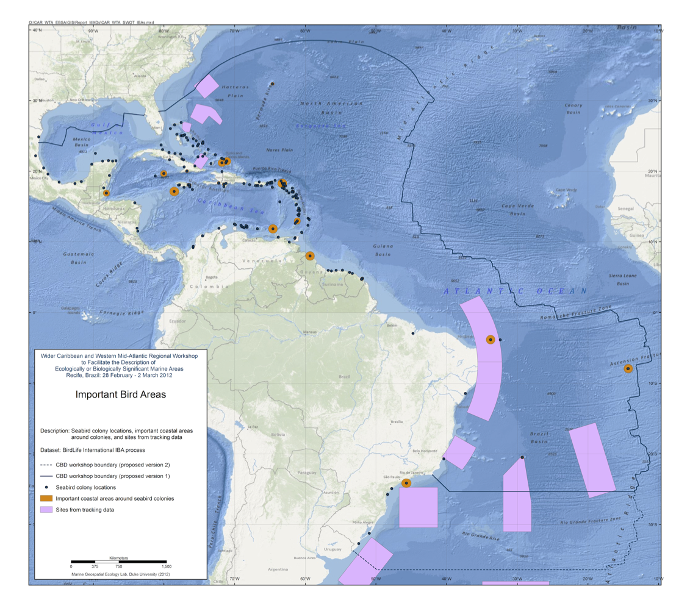
Figure 3.19: Important Bird Areas (IBAs)

Physical Data

Seamounts
Abstract:
Seamounts and knolls are ‘undersea mountains’, the former rising more than 1000 m from the seaﬂoor. These features provide important habitats for aquatic predators, demersal deep-sea ﬁsh and benthic invertebrates. However most seamounts have not been surveyed and their numbers and locations are not well known. Previous efforts to locate and quantify seamounts have used relatively coarse bathymetry grids. Here we use global bathymetric data at 30 arc-sec resolution to identify seamounts and knolls. We identify 33,452 seamounts and 138,412 knolls, representing the largest global set of identiﬁed seamounts and knolls to date. We compare estimated seamount numbers, locations, and depths with validation sets of seamount data from New Zealand and Azores. This comparison indicates the method we apply ﬁnds 94% of seamounts, but may overestimate seamount numbers along ridges and in areas where faulting and seaﬂoor spreading creates highly complex topography. The seamounts and knolls identiﬁed herein are signiﬁcantly geographically biased towards areas surveyed with shipbased soundings. As only 6.5% of the ocean ﬂoor has been surveyed with soundings it is likely that new seamounts will be uncovered as surveying improves. Seamount habitats constitute approximately 4.7% of the ocean ﬂoor, whilst knolls cover 16.3%. Regional distribution of these features is examined, and we ﬁnd a disproportionate number of productive knolls, with a summit depth of o1.5 km, located in the Southern Ocean. Less than 2% of seamounts are within marine protected areas and the majority of these are located within exclusive economic zones with few on the High Seas. The database of seamounts and knolls resulting from this study will be a useful resource for researchers and conservation planners.

Reference:
Yesson, C., et al., The global distribution of seamounts based on 30 arc seconds bathymetry
data. Deep-Sea Research I (2011), doi:10.1016/j.dsr.2011.02.004

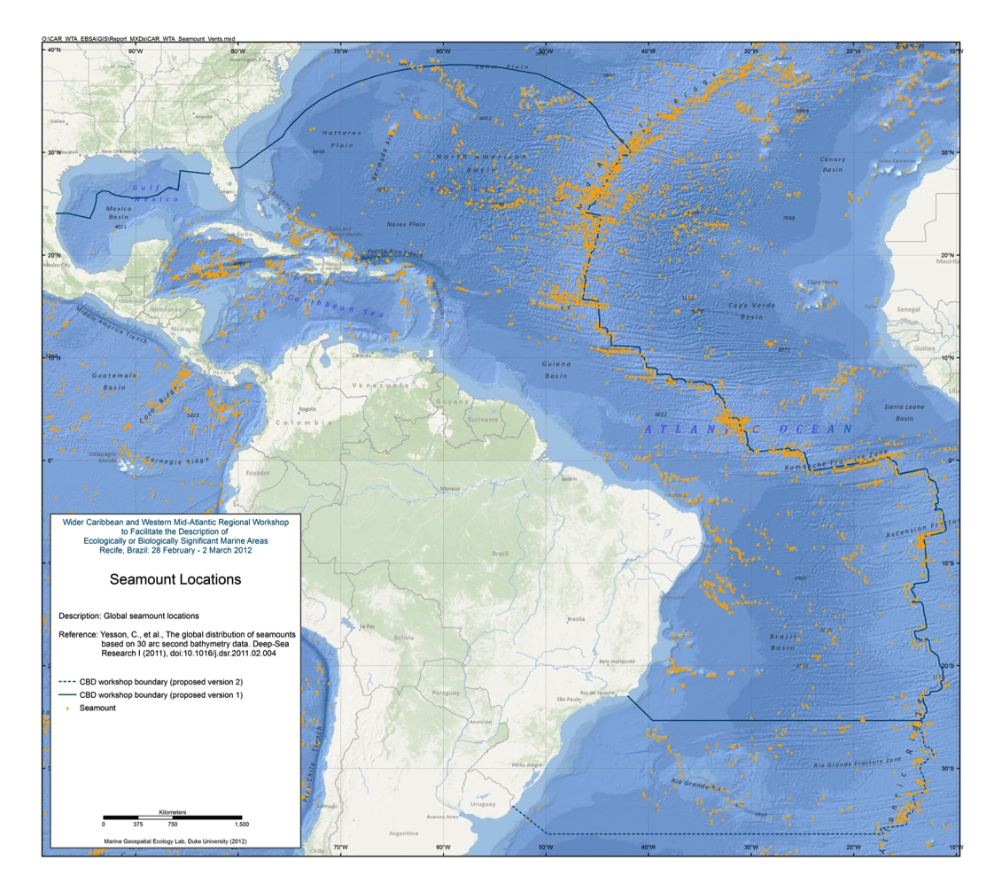
Figure 4.1: Seamount locations

Vents and Seeps

ChEss (Chemosynthetic Ecosystem Science) was a field project of the Census of Marine Life
programme (CoML). The main aim of ChEss was to determine the biogeography of deep-water chemosynthetic ecosystems at a global scale and to understand the processes driving these ecosystems. ChEss addressed the main questions of CoML on diversity, abundance and distribution of marine species, focusing on deep-water reducing environments such as hydrothermal vents, cold seeps, whale falls, sunken wood and areas of low oxygen that intersect with continental margins and seamounts.
(source: http://www.noc.soton.ac.uk/chess/)

ChEssBase is a dynamic relational database available online since December 2004. The aim of ChEssBase is to provide taxonomical, biological, ecological and distributional data of all species described from deep-water chemosynthetic ecosystems, as well as bibliography and information on the habitats. These habitats include hydrothermal vents, cold seeps, whale falls, sunken wood and areas of minimum oxygen that intersect with the continental margin or seamounts.

Since the discovery of hydrothermal vents in 1977 and of cold seep communities in 1984, over 500 species from vents and over 200 species from seeps have been described (Van Dover et al., 2002. Science 295: 1253-1257). The discovery of chemosynthetically fuelled communities on benthic OMZs and large organic falls to the deep-sea such as whales and wood have increased the number of habitats and fauna for investigation. New species are continuously being discovered and described from sampling programmes around the globe and therefore ChEssBase is in active development and new data are being entered periodically. Currently, ChEssBase includes data on 1739 species from 193 chemosynthetic sites around the globe. These data contain information (when available) on the taxonomy, diagnosis, trophic level, reproduction, endemicity and habitat types and distribution. There are now 1879 papers in our reference database.
(source: http://www.noc.soton.ac.uk/chess/database/db_home.php)

Data available from:
ChEssBase: http://www.noc.soton.ac.uk/chess/database/db_home.php

InterRidge: http://www.interridge.org/irvents/maps

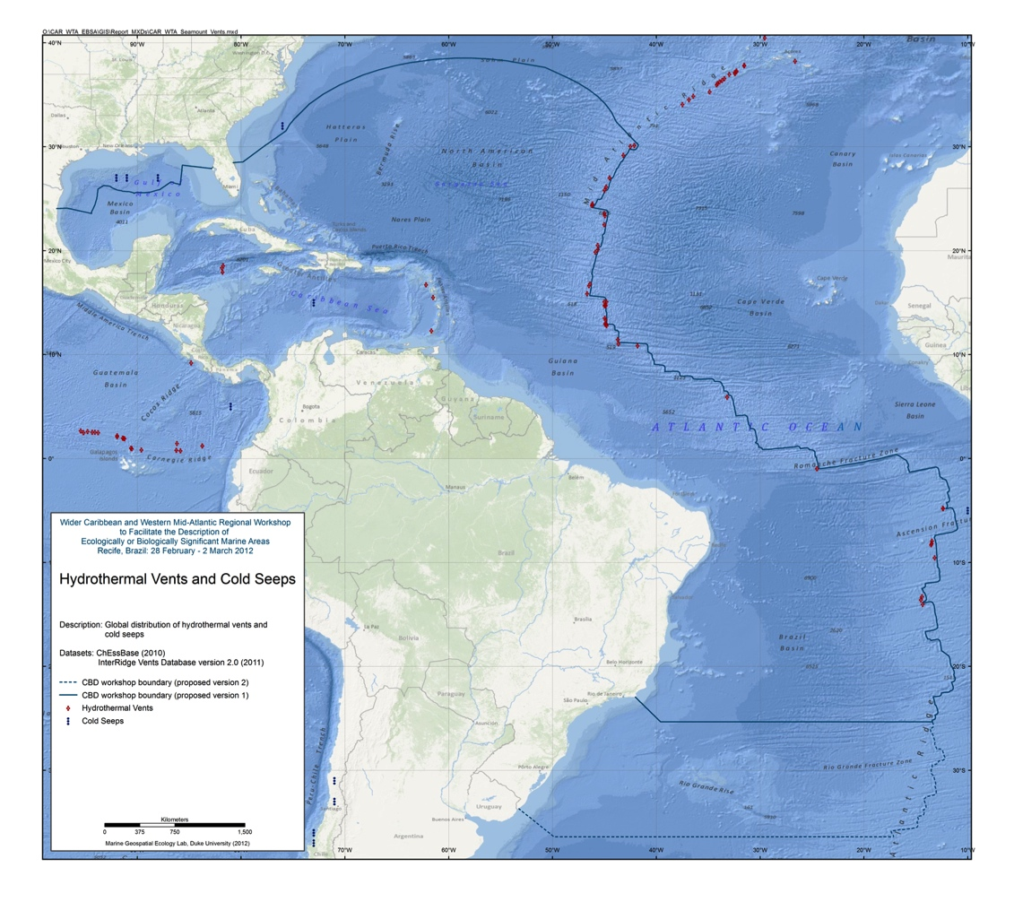
Figure 4.2: Hydrothermal vents and cold seeps

Bathymetry (GEBCO)

The GEBCO_08 Grid is a global 30 arc-second grid largely generated by combining quality controlled ship depth soundings with interpolation between sounding points guided by satellite derived gravity data. However, in areas where they improve on the existing GEBCO 08 grid, data sets generated by other methods have been included. Land data are largely based on the Shuttle Radar Topography Mission (SRTM30) gridded digital elevation model.
(source: http://www.gebco.net/data_and_products/gridded_bathymetry_data/)

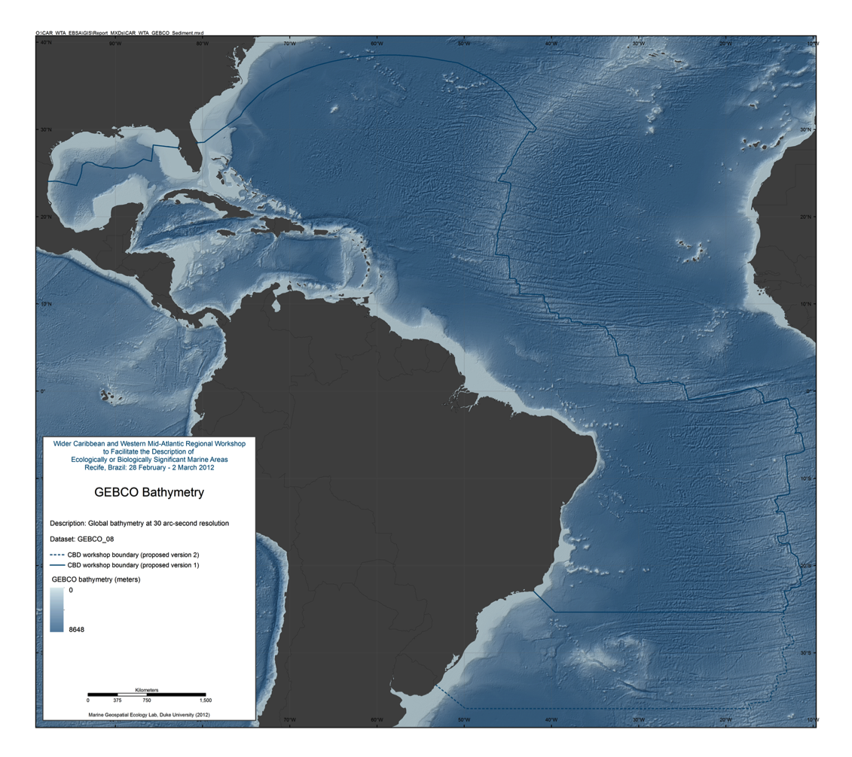
Figure 4.3: GEBCO_08 30 arc-second bathymetry

Distribution of Large Submarine Canyons
Abstract:
The aim of this study is to assess the global occurrence of large submarine canyons to provide context and guidance for discussions regarding canyon occurrence, distribution, geological and oceanographic significance and conservation. Based on an analysis of the ETOPO1 data set, this study has compiled the first inventory of 5849 separate large submarine canyons in the world ocean. Active continental margins contain 15% more canyons (2586, equal to 44.2% of all canyons) than passive margins (2244, equal to 38.4%) and the canyons are steeper, shorter, more dendritic and more closely spaced on active than on passive continental margins. This study confirms observations of earlier workers that a relationship exists between canyon slope and canyon spacing (increased canyon slope correlates with closer canyon spacing). The greatest canyon spacing occurs in the Arctic and the Antarctic whereas canyons are more closely spaced in the Mediterranean than in other areas.

River-associated, shelf-incising canyons are more numerous on active continental margins (n=119) than on passive margins (n=34). They are most common on the western margins of South and North America where they comprise 11.7% and 8.6% of canyons respectively, but are absent from the margins of Australia and Antarctica. Geographic areas having relatively high rates of sediment export to continental margins, from either glacial or fluvial sources operating over geologic timescales, have greater numbers of shelf-incising canyons than geographic areas having relatively low rates of sediment export to continental margins. This observation is consistent with the origins of some canyons being related to erosive turbidity flows derived from fluvial and shelf sediment sources.

Other workers have shown that benthic ecosystems in shelf-incising canyons contain greater diversity and biomass than non-incising canyons, and that ecosystems located above 1500 m water depth are more vulnerable to destructive fishing practices (bottom trawling) and ocean acidification caused by anthropogenic climate change. The present study provides the means to assess the relative significance of canyons located in different geographic regions. On this basis, the importance of conservation for submarine canyon ecosystems is greater for Australia, islands and northeast Asia than for other regions.

Reference:
Harris and Whiteway 2011. Global distribution of large submarine canyons: Geomorphic differences between active and passive continental margins. Marine Geology 285 (2011) 6986. doi:10.1016/j.margeo.2011.05.008

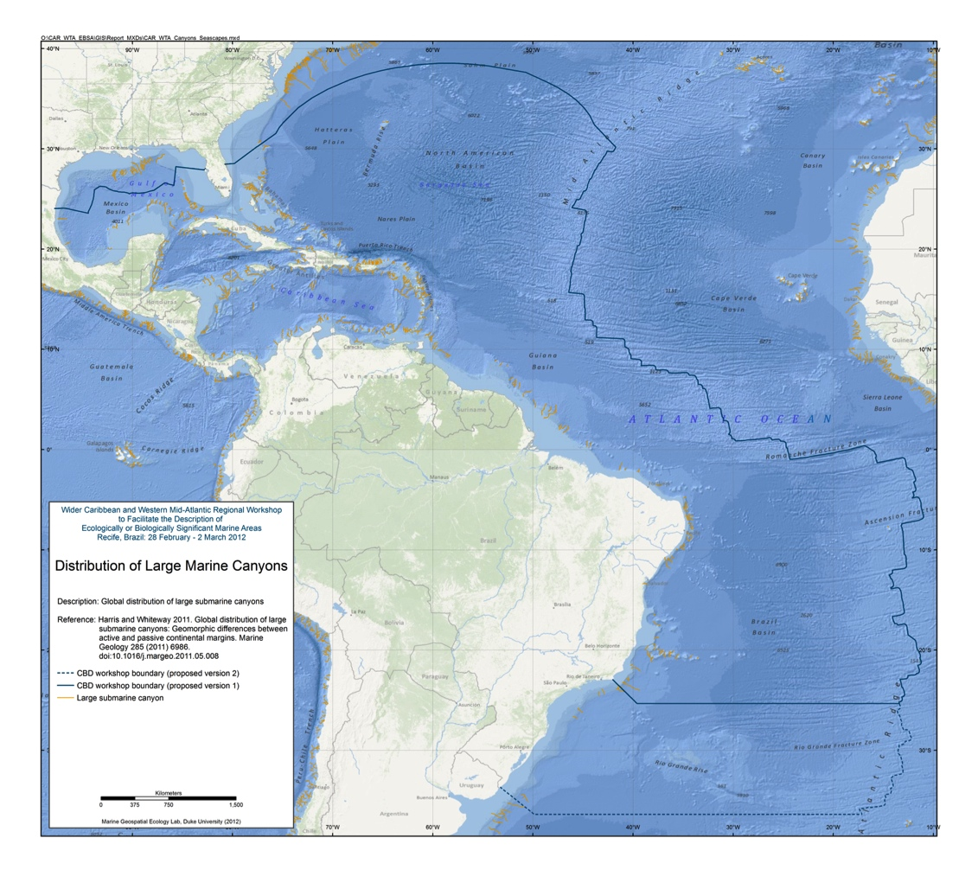
Figure 4.4: Large submarine canyons

Total Sediment Thickness of the Worlds Oceans & Marginal Seas

A digital total-sediment-thickness database for the world's oceans and marginal seas has been compiled by the NOAA National Geophysical Data Center (NGDC). The data were gridded with a grid spacing of 5 arc-minutes by 5 arc-minutes. Sediment-thickness data were compiled from three principle sources: (i) previously published isopach maps including Ludwig and Houtz [1979], Matthias et al. [1988], Divins and Rabinowitz [1990], Hayes and LaBrecque [1991], and Divins [2003]; (ii) ocean drilling results, both from the Ocean Drilling Program (ODP) and the Deep Sea Drilling Project (DSDP); and (iii) seismic reflection profiles archived at NGDC as well as seismic data and isopach maps available as part of the IOC's International Geological-Geophysical Atlas of the Pacific Ocean [Udinstev, 2003].
The distribution of sediments in the oceans is controlled by five primary factors:
- Age of the underlying crust
- Tectonic history of the ocean crust
- Structural trends in basement
- Nature and location of sediment source, and
- Nature of the sedimentary processes delivering sediments to depocenters

The sediment isopach contour maps for the Pacific were digitized by Greg Cole of Los Alamos National Laboratory, for the Indian Ocean by Carol Stein of Northwestern University, and the South Atlantic and Southern Ocean by Dennis Hayes of Lamont-Doherty Earth Observatory. The digitized data were then gridded at NGDC using the algorithm for "Gridding with Continuous Curvature Splines in Tension" of Smith and Wessel [1990].
The data values are in meters and represent the depth to acoustic basement. It should be noted that acoustic basement may not actually represent the base of the sediments. These data are intended to provide a minimum value for the thickness of the sediment in a particular geographic region.
(source: http://www.ngdc.noaa.gov/mgg/sedthick/sedthick.html)

Reference:
Divins, D.L., NGDC Total Sediment Thickness of the World's Oceans & Marginal Seas, Data retrieved 25 January 2012, http://www.ngdc.noaa.gov/mgg/sedthick/sedthick.html

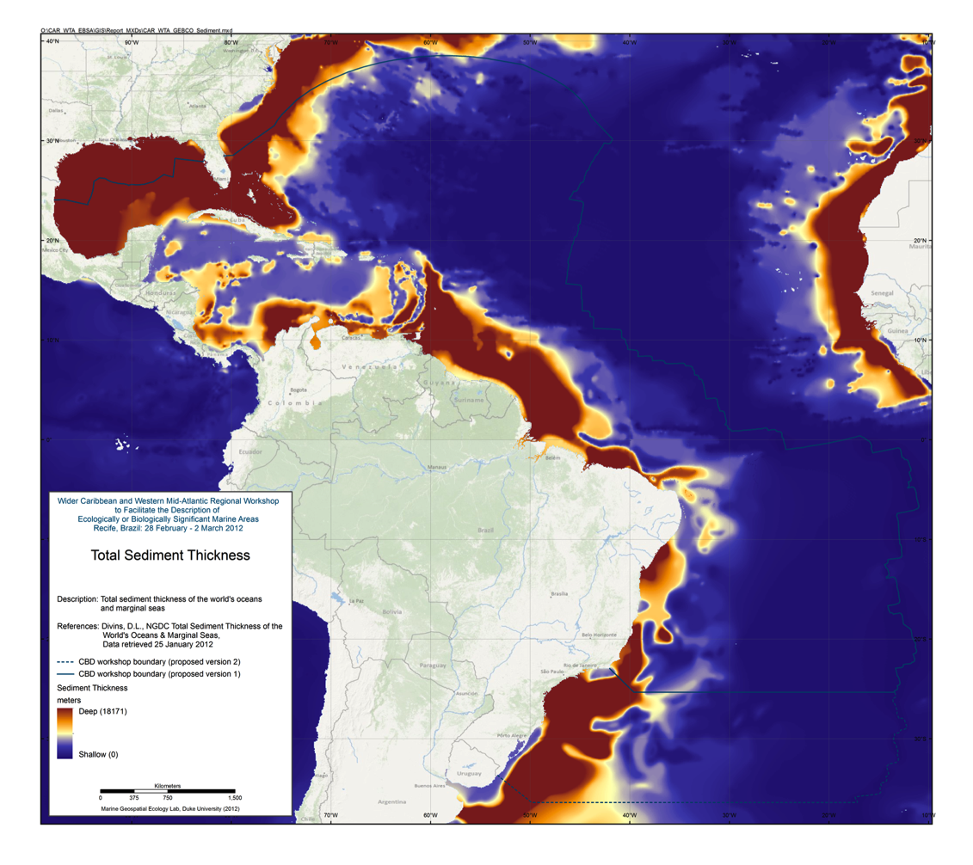
Figure 4.5: Total sediment thickness

Global Seascapes

Abstract:
Designing a representative network of high seas marine protected areas (MPAs) requires an acceptable scheme to classify the benthic (as well as the pelagic) bioregions of the oceans. Given the lack of sufficient biological information to accomplish this task, we used a multivariate statistical method with 6 biophysical variables (depth, seabed slope, sediment thickness, primary production, bottom water dissolved oxygen and bottom temperature) to objectively classify the ocean floor into 53,713 separate polygons comprising 11 different categories, that we have termed seascapes. A cross-check of the seascape classification was carried out by comparing the seascapes with existing maps of seafloor geomorphology and seabed sediment type and by GIS analysis of the number of separate polygons, polygon area and perimeter/area ratio. We conclude that seascapes, derived using a multivariate statistical approach, are biophysically meaningful subdivisions of the ocean floor and can be expected to contain different biological associations, in as much as different geomorphological units do the same. Less than 20% of some seascapes occur in the high seas while other seascapes are largely confined to the high seas, indicating specific types of environment whose protection and conservation will require international cooperation. Our study illustrates how the identification of potential sites for high seas marine protected areas can be accomplished by a simple GIS analysis of seafloor geomorphic and seascape classification maps. Using this approach, maps of seascape and geomorphic heterogeneity were generated in which heterogeneity hotspots identify themselves as MPA candidates. The use of computer aided mapping tools removes subjectivity in the MPA design process and provides greater confidence to stakeholders that an unbiased result has been achieved.

Reference:
Harris and Whiteway 2009. High seas marine protected areas: Benthic environmental conservation priorities from a GIS analysis of global ocean biophysical data. Ocean & Coastal Management 52 2238. doi:10.1016/j.ocecoaman.2008.09.009

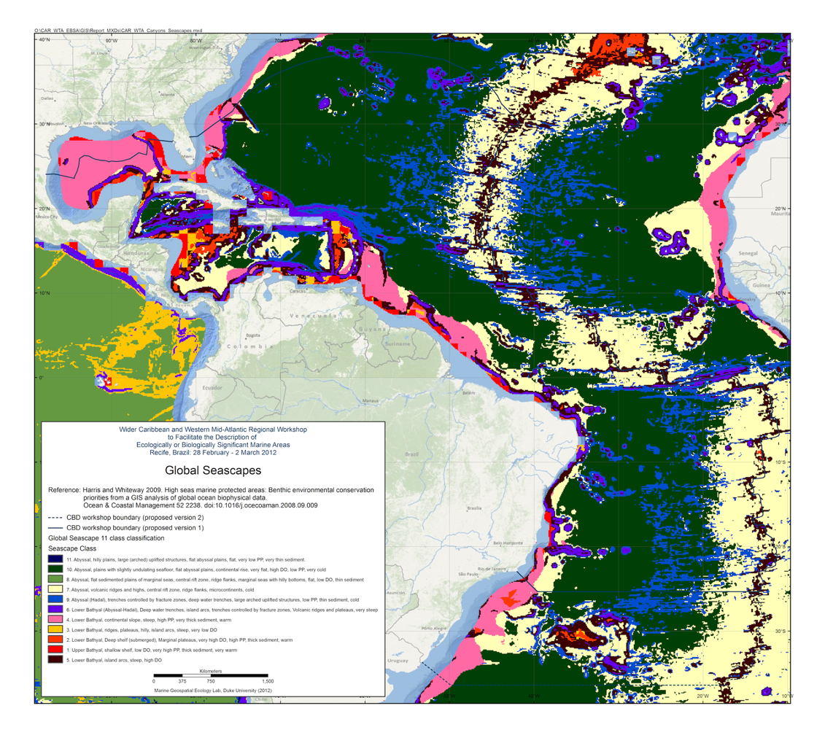
Figure 4.6: Global seascapes

Physical Ocean Climatologies
For items 4.7.1 through 4.7.7, data were downloaded and processed from the CSIRO Atlas of Regional Seas (CARS).

CARS is a digital climatology, or atlas of seasonal ocean water properties. It comprises gridded fields of mean ocean properties over the period of modern ocean measurement, and average seasonal cycles for that period. It is derived from a quality-controlled archive of all available historical subsurface ocean property measurements - primarily research vessel instrument profiles and autonomous profiling buoys. As data availability has enormously increased in recent years, the
CARS mean values are inevitably biased towards the recent ocean state.

A number of global ocean climatologies are presently available, such as NODC's World Ocean Atlas. CARS is different as it employs extra stages of in-house quality control of input data, and uses an adaptive-lengthscale loess mapper to maximise resolution in data-rich regions, and the mapper's "BAR" algorithm takes account of topographic barriers. The result is excellent definition of oceanic structures and accuracy of point values.
(source: http://www.marine.csiro.au/~dunn/cars2009/)

References:
1. Primary CARS citation:
Ridgway K.R., J.R. Dunn, and J.L. Wilkin, Ocean interpolation by four-dimensional least squares -Application to the waters around Australia, J. Atmos. Ocean. Tech., Vol 19, No 9,1357-1375, 2002

2. Algorithm details:
Dunn J.R., and K.R. Ridgway, Mapping ocean properties in regions of complex topography, Deep Sea Research I : Oceanographic Research, 49 (3) (2002) pp. 591-604

3. CARS seasonal fields and MLD:
Scott A. Condie and Jeff R. Dunn (2006) Seasonal characteristics of the surface mixed layer in the Australasian region: implications for primary production regimes and biogeography. Marine and Freshwater Research, 2006, 57, 1-22.

4. Metadata:
CARS2009 metadata record: MarLIN record: 8539, Anzlic identifier: ANZCW0306008539

Temperature Climatology

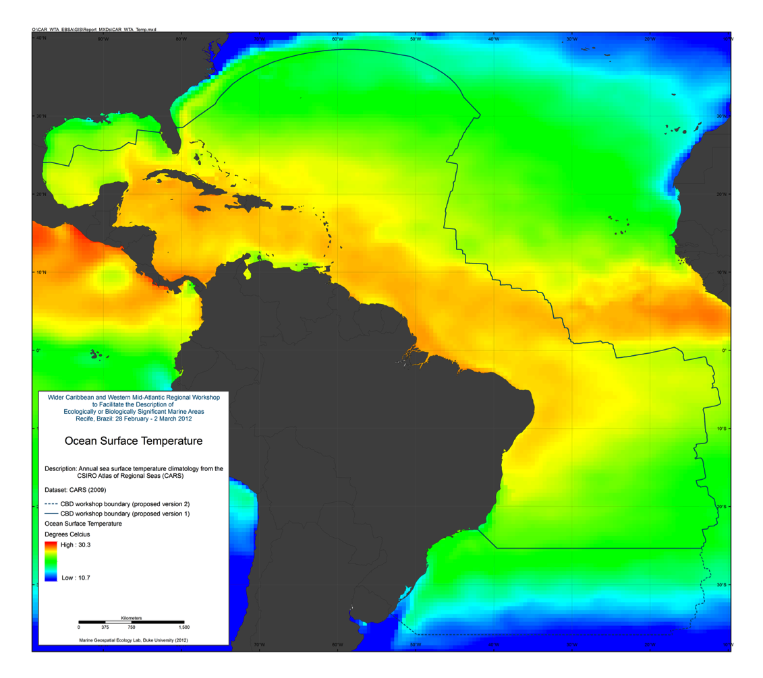
Figure 4.7: Ocean surface temperature

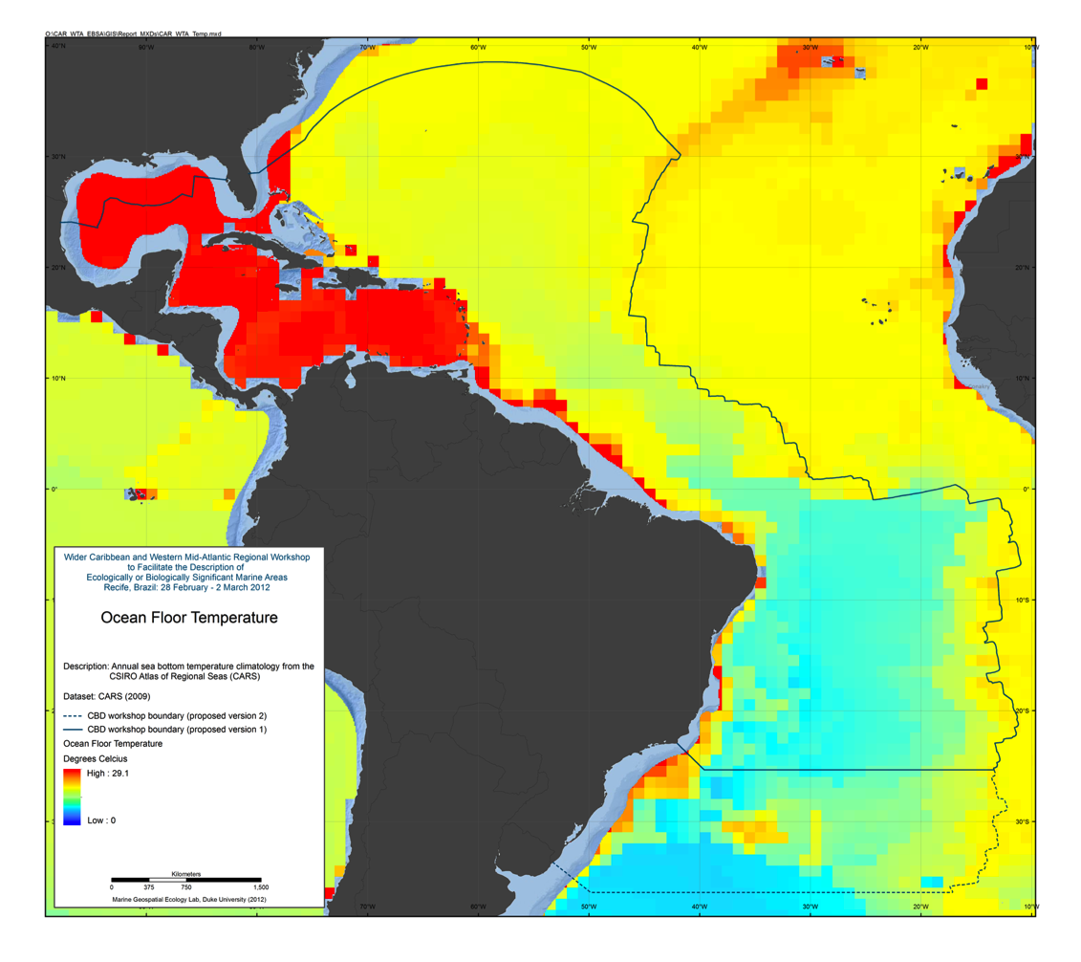
Figure 4.8: Ocean floor temperature

Salinity Climatology
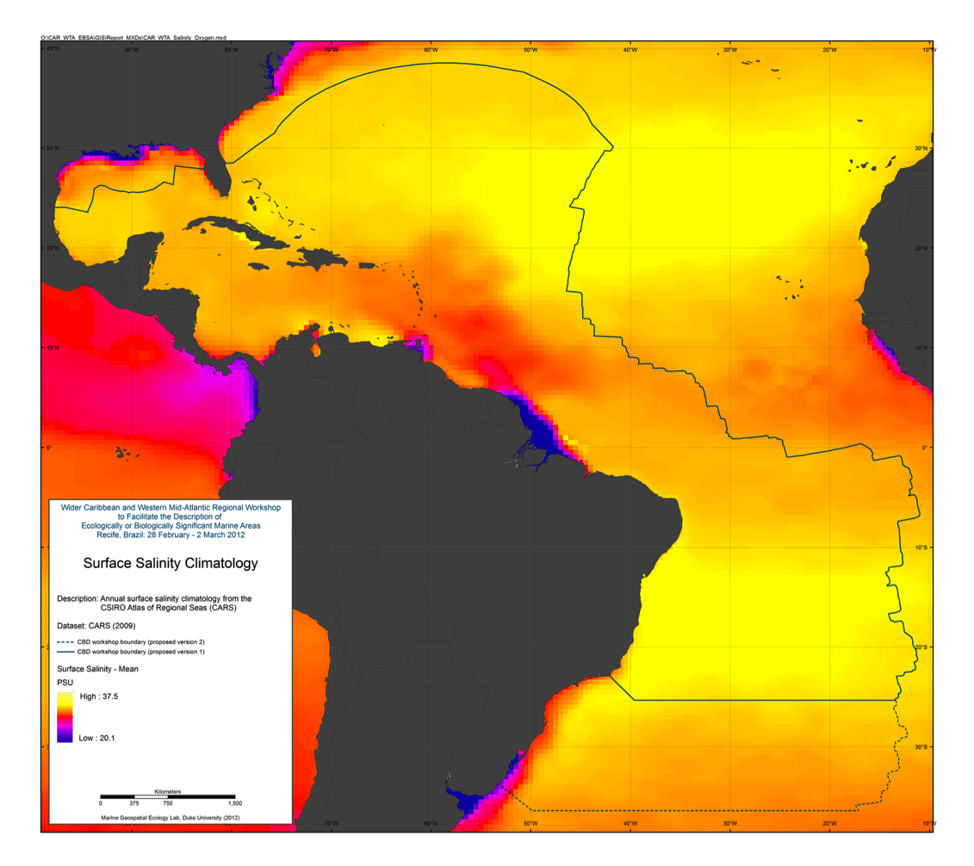
Figure 4.9: Surface salinity climatology

Oxygen Climatology
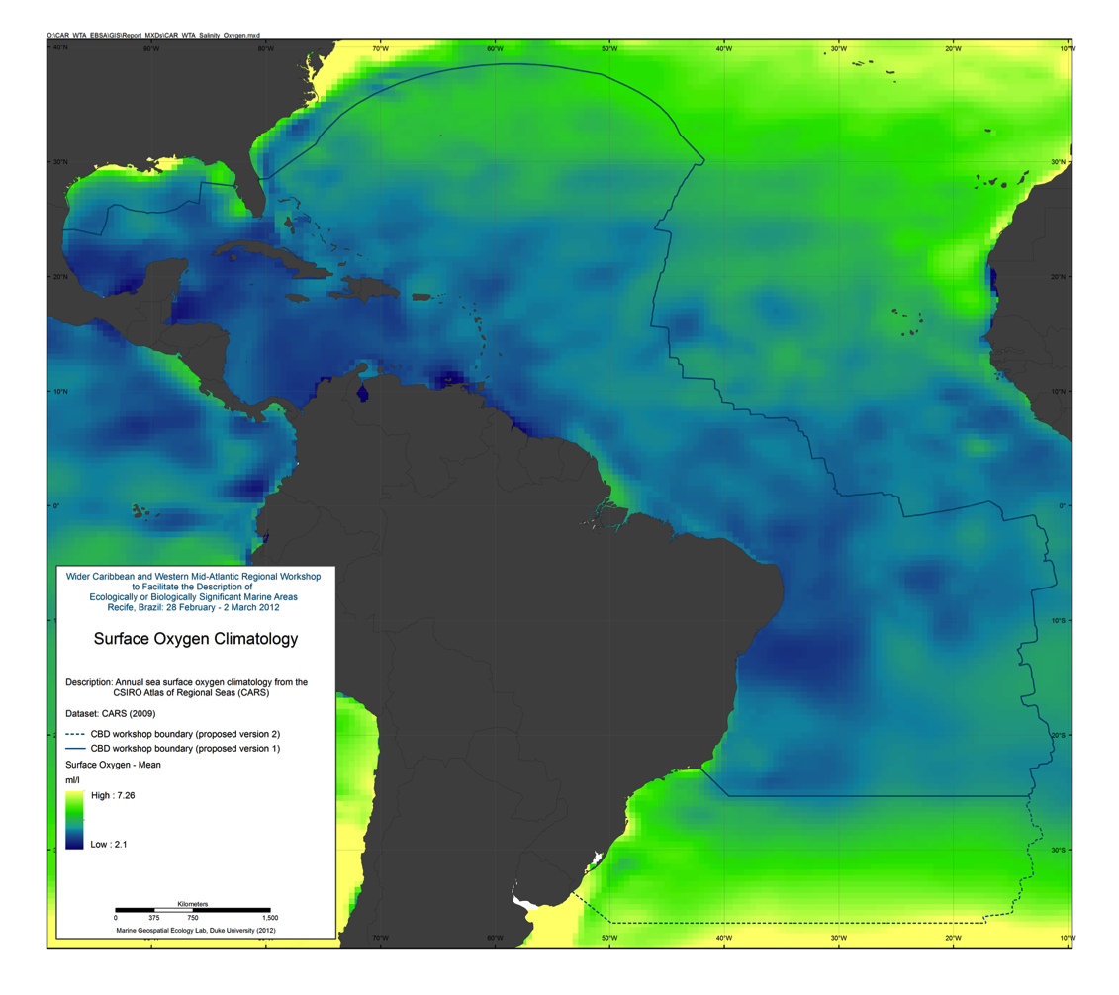
Figure 4.10: Surface oxygen climatology

Nitrate Climatology
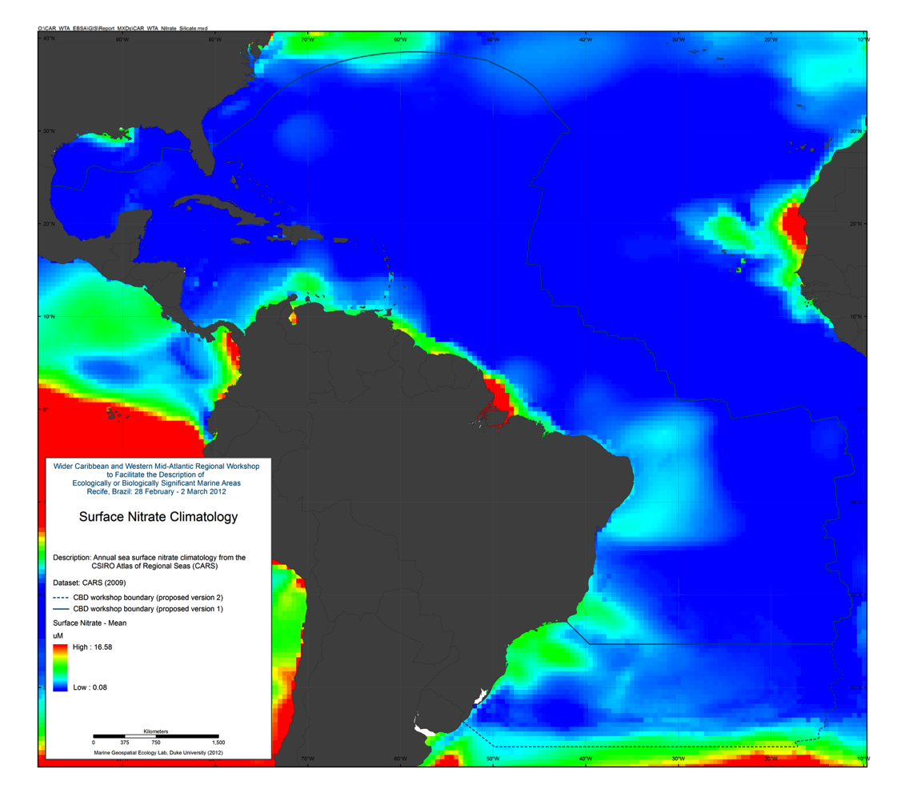
Figure 4.11: Surface nitrate climatology

Silicate Climatology
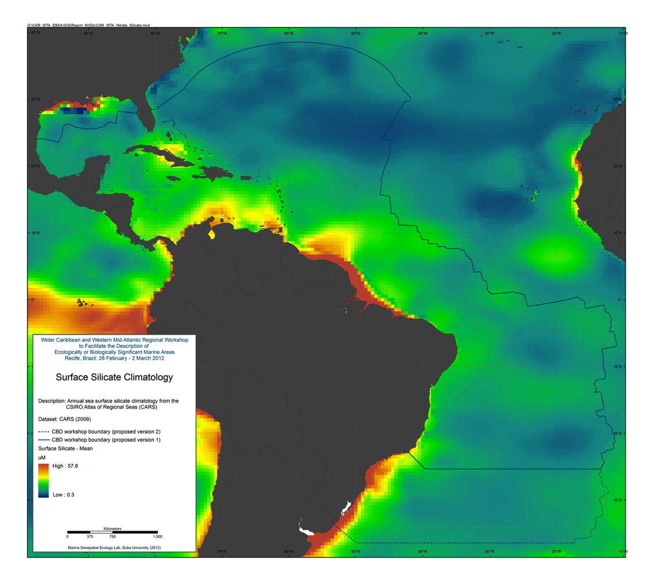
Figure 4.12: Surface silicate climatology

Phosphate Climatology
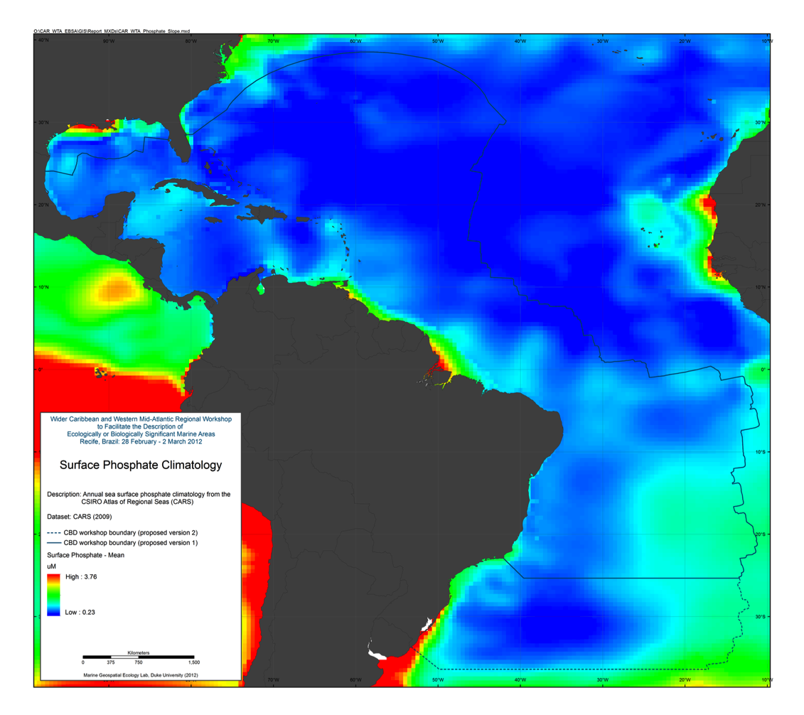
Figure 4.13: Surface phosphate climatology

Mixed Layer Depth Climatology
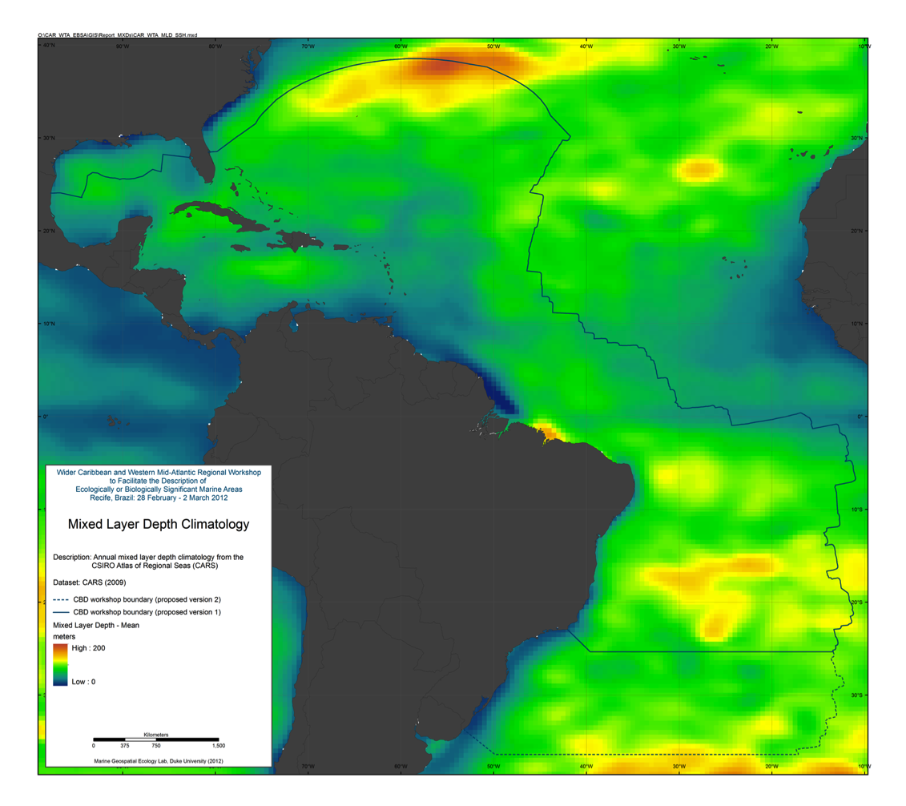
Figure 4.14: Mixed layer depth climatology

Sea Surface Height

The Archiving, Validation and Interpretation of Satellite Oceanographic data (AVISO) group publishes various products derived from satellite altimetry data, including estimates of sea surface height (SSH), geostrophic currents, wind speed modulus, and significant wave height. To maximize accuracy and spatial and temporal resolution and extent, AVISO merges observations from multiple satellites, including Topex/Poseidon, Jason-1, Jason-2, GFO, ERS-1, ERS-2, and EnviSat. Most Aviso products are one of these "merged" datasets, although a few products are based on observations from a single satellite.
(source: http://code.nicholas.duke.edu/projects/mget)

For this effort a cumulative climatology was created from AVISO Global DT-Ref Merged MADT SSH data, from 2001-2010, using the “Create Climatological Rasters for Aviso SSH” tool in the Marine Geospatial Ecology Tools (MGET) for ArcGIS (Roberts et al., 2010)

Reference:
Roberts, J.J., B.D. Best, D.C. Dunn, E.A. Treml, and P.N. Halpin (2010). Marine Geospatial Ecology Tools: An integrated framework for ecological geoprocessing with ArcGIS, Python, R, MATLAB, and C++. Environmental Modelling & Software 25: 1197-1207.

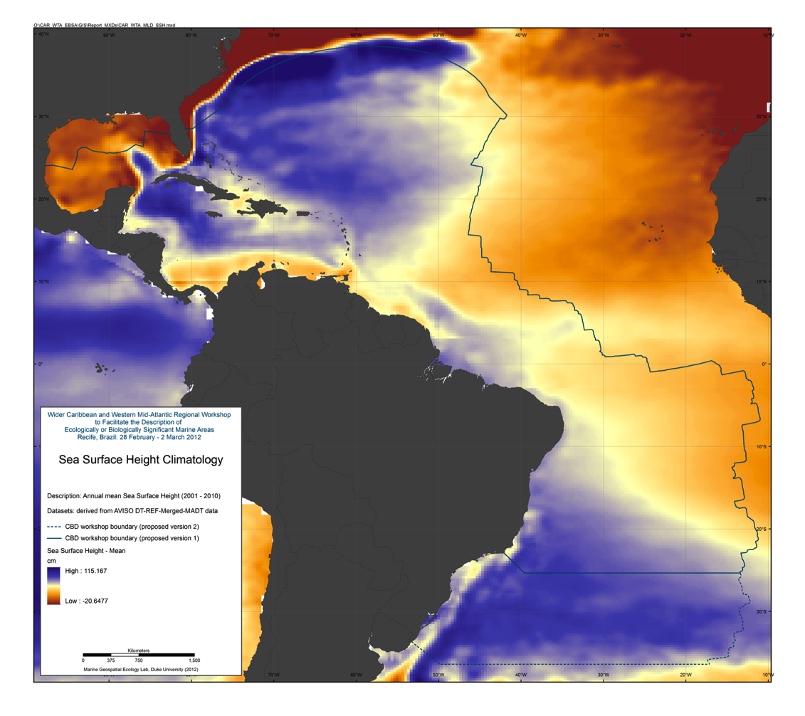
Figure 4.15: Sea surface height climatology

VGPM Global Ocean Productivity

Standard Ocean Productivity Products are based on the original description of the Vertically Generalized Production Model (VGPM) (Behrenfeld & Falkowski 1997), MODIS surface chlorophyll concentrations (Chl_{sat}), MODIS sea surface temperature data (SST), and MODIS cloud-corrected incident daily photosynthetically active radiation (PAR). Euphotic depths are calculated from Chl_{sat} following Morel and Berthon (1989).
(source: http://www.science.oregonstate.edu/ocean.productivity/standard.product.php)

Reference:
Behrenfeld, M. J. & Falkowski, P. G. Photosynthetic rates derived from satellite-based chlorophyll concentration. Limnology And Oceanography 42, 1–20 (1997).

For this effort, a cumulative climatology was created from Standard VGPM data derived from MODIS AQUA data from 2003-2007.

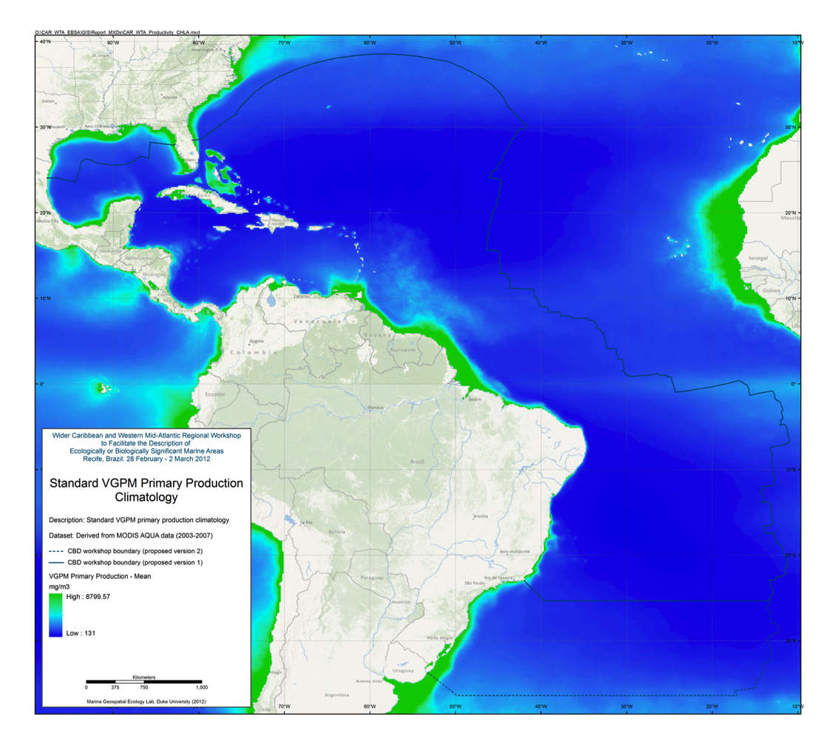
Figure 4.16: Standard VGPM ocean productivity

SeaWiFS Chlorophyll A concentration

The purpose of the Sea-viewing Wide Field-of-view Sensor (SeaWiFS) Project is to provide quantitative data on global ocean bio-optical properties to the Earth science community. Subtle changes in ocean color signify various types and quantities of marine phytoplankton (microscopic marine plants), the knowledge of which has both scientific and practical applications. The SeaWiFS Project will develop and operate a research data system that will process, calibrate, validate, archive and distribute data received from an Earth-orbiting ocean color sensor.
(source: http://oceancolor.gsfc.nasa.gov/SeaWiFS/BACKGROUND/SEAWIFS_BACKGROUND.html)

For this effort, a cumulative climatology (2001-2010) was created using the “Create Climatological Rasters for NASA OceanColor L3 SMI Product” tool in the Marine Geospatial Ecology Tools (MGET) for ArcGIS (Roberts et al., 2010).

Reference:
Roberts, J.J., B.D. Best, D.C. Dunn, E.A. Treml, and P.N. Halpin (2010). Marine Geospatial Ecology Tools: An integrated framework for ecological geoprocessing with ArcGIS, Python, R, MATLAB, and C++. Environmental Modelling & Software 25: 1197-1207.

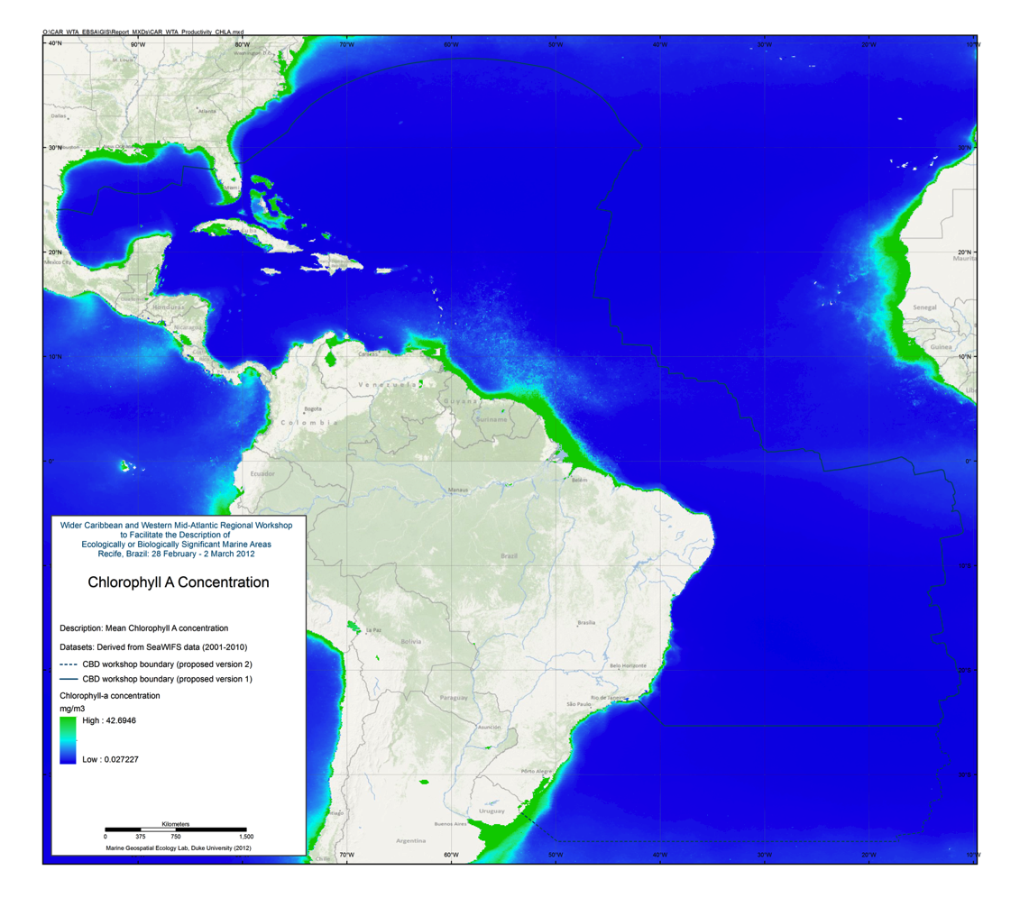
Figure 4.17: Chlorophyll A concentration

Eddy Kinetic Energy
Locations where shear between water masses is high can generate productivity due to mixing. One measure of this mixing is estimated using Eddy Kinetic Energy (EKE). EKE was calculated from the velocity maps based on sea surface height. Using the U and V components from NOAA Ocean Surface Current Analyses - Real Time (OSCAR) currents data, EKE is defined as 0.5*(U² + V²) and was calculated using OSCAR data from 2001-2010, inclusive.

For this effort, a cumulative EKE climatology (2001-2010) was created using the “Create Climatological Rasters for Aviso Geostrophic Currents Product” tool in the Marine Geospatial Ecology Tools (MGET) for ArcGIS (Roberts et al., 2010).

Reference:
Roberts, J.J., B.D. Best, D.C. Dunn, E.A. Treml, and P.N. Halpin (2010). Marine Geospatial Ecology Tools: An integrated framework for ecological geoprocessing with ArcGIS, Python, R, MATLAB, and C++. Environmental Modelling & Software 25: 1197-1207.

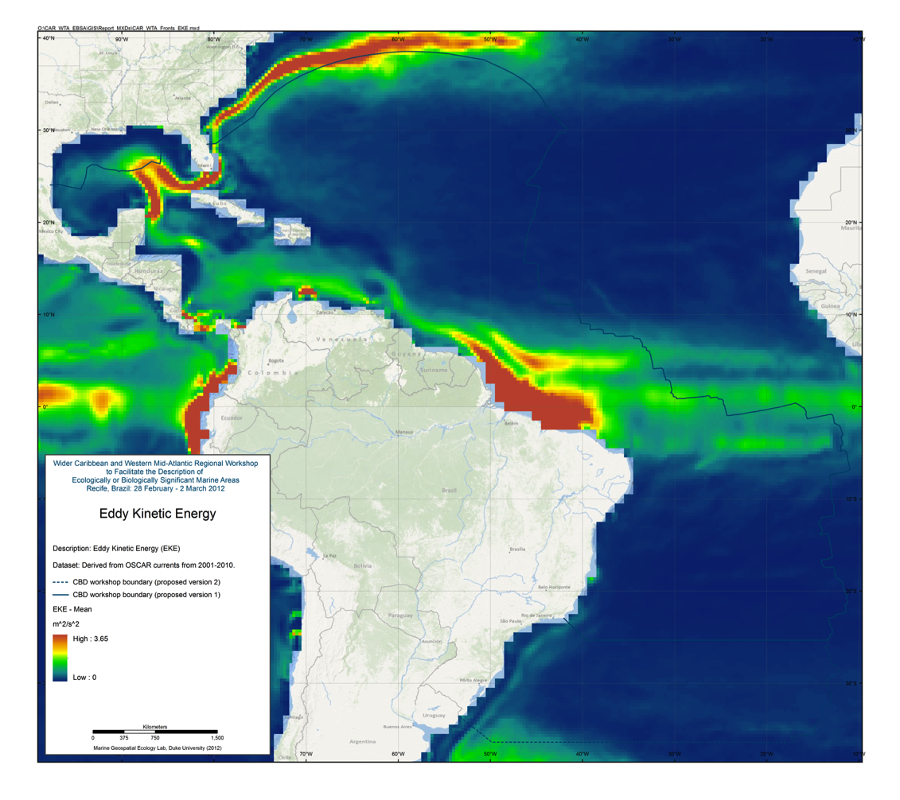
Figure 4.18: Eddy Kinetic Energy

Sea Surface Temperature Front Probability

The SST fronts climatology shows the frequency of SST fronts for the period 2000-2009. We created it by applying the Cayula and Cornillon (1992) edge detection algorithm to daily daytime SST images (3653 total) from the 4km AVHRR Pathfinder SST version 5.0 dataset (Casey et al., 2010). To create the climatology, we first applied the algorithm to one image at a time. For each image, we masked cloudy pixels using a subset of Pathfinder’s pixel quality tests and a cloud filtering algorithm developed at our laboratory. Then we executed the Cayula and Cornillon algorithm to identify pixels that contained fronts. The algorithm output two binary images for each SST image: an image showing the cloud-free ocean pixels that were candidates for containing fronts (0 = cloud or land, 1 = cloud-free water), and an image showing the pixels that were fronts (0 = no front, 1 = front). We then combined the candidate images into a single image by summing up the number of times each pixel was a candidate. We combined the fronts images the same way, then divided the summed fronts image by the summed candidate image to produce the front frequency image. Finally, to address erroneous front detections caused by spurious SST gradients introduced by Pathfinder’s mapping procedures (see Casey, 2009), we masked front frequency pixels at the erroneous latitudes and replaced them with values interpolated by Lapacian interpolation. To calculate monthly climatologies, we performed the procedure on the SST images for that month (e.g. for January, we used January 2000, January 2001, …, January 2009). For the cumulative climatology, we used all of the images. We performed all calculations using the Marine Geospatial Ecology Tools software (Roberts et al., 2010) and ArcGIS.

Casey, K.S., T.B. Brandon, P. Cornillon, and R. Evans (2010). "The Past, Present and Future of the AVHRR Pathfinder SST Program", in Oceanography from Space: Revisited, eds. V. Barale, J.F.R. Gower, and L. Alberotanza, Springer.

Casey, K.S (2009). 4 km Pathfinder Version 5 User Guide. Available online: http://www.nodc.noaa.gov/sog/pathfinder4km/userguide.html.

Cayula, J.-F. and P. Cornillon (1992). Edge detection algorithm for SST images. Journal of Atmospheric and Oceanic Technology 9: 67-80.

Roberts, J.J., B.D. Best, D.C. Dunn, E.A. Treml, and P.N. Halpin (2010). Marine Geospatial Ecology Tools: An integrated framework for ecological geoprocessing with ArcGIS, Python, R, MATLAB, and C++. Environmental Modelling & Software 25: 1197-1207.

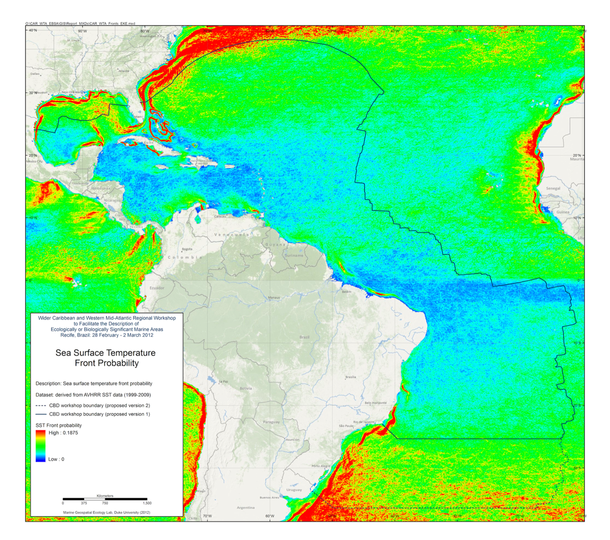
Figure 4.19: Sea surface temperature front probability

Summary of Currents

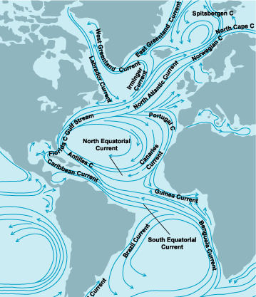

Figure 4.20: Schematic of regional current systems
(from http://www.accessscience.com, accessed on 16 February 2012)

Acknowledgments
This work was supported under a contact from the Secretariat of the Convention on Biological Diversity. The authors gratefully acknowledge the contributions of data and advice from:

Piers Dunstan, Nic Bax (CSIRO)
Ben Lacelles, Phil Taylor, Mark Miller (BirdLife International)
Edward Vanden Berghe (Ocean Biogeographic Information System)
Jeff Ardron, John Guinotte (Marine Conservation Institute)
Eduardo Klein (Universidad Simón Bolívar)
Jason Roberts, Ei Fujioka, Daniel Dunn (Marine Geospatial Ecology Lab, Duke University)
Les Watling (University of Hawaii at Manoa)
Patricio Bernal (Global Ocean Biodiversity Initiative)
Jihyun Lee, Jacquie Grekin (CBD Secretariat)

Appendix: Submitted References

Document List Compiled By CRFM Secretariat

Articles
CARSEA 2007. Caribbean Sea Ecosystem Assessment (CARSEA). A sub-global component of the Millennium Ecosystem Assessment (MA), J. Agard, A. Cropper, K. Garcia,
eds., Caribbean Marine Studies, Journal of the Institute of Marine Affairs. Special Edition, 2007. 85pp.

Miloslavich P, Dı´az JM, Klein E, Alvarado JJ, Dı´az C, et al. 2010. Marine Biodiversity in the Caribbean: Regional Estimates and Distribution Patterns. PLoS ONE 5(8): e11916. doi:10.1371/journal.pone.0011916.

ACS/CERMES-UWI. 2010. Report of the Expert Consultation on the Operationalisation of the Caribbean Sea Commission: building a science-policy interface for ocean governance in the Wider Caribbean. University of the West Indies, Cave Hill Campus, Barbados, July 7th – 9th, 2010. CERMES Technical Report No. 33 (English), 90 pp.

Baldwin, K., and R. Mahon, 2011. A Geospatial Framework to support ecosystem based management and marine spatial planning for the transboundary Grenadine Islands.

Mohammed, E. 2008. Quantifying marine biodiversity changes in the southeastern Caribbean. Proc. GCFI, 59, p 9-20.

Luckhurst, B.E. 2004. Current status of conservation and management of reef fish spawning aggregations in the greater Caribbean. Proc. GCFI, 55, p 530-542.

Kobara S. and W. D. Heyman, 2008. Caribbean-wide Geospatial Analysis of the Location of Transient Reef Fish Spawning Aggregation sites using remote sensing. Proc., GCFI,59, p 397 -399. Also references quoted in this article will be important.

Grober-Dunsmore, R., T.F. Frazer, J. Beets, N. Funicelli, and P. D. Zwick. 2004. The significance of adjacent habitats on reef fish assemblage structure: are relationships detectable and quantifiable at a landscape scale? Proc. GCFI, 55, p 713-734.

Seybert, R., S. Thomas, and R. Weary. 2007. Small Island States and the Global Program of Work on Protected Areas: The Example of Grenada. Proc. GCFI, 58, p 296-300.

Grober-Dunsmore R. and L. Wooninck. 2009. State of the Nation’s Marine Managed Areas:
With Particular Emphasis on the Caribbean, South Atlantic and Gulf of Mexico Regions. Proc. GCFI, 60, p 457-464.

Alonso, D., G. Bustamante, and D. Rozo. 2006. Análisis de Vacíos de Representatividad de la Biodiversidad en las Áreas marinas Protegidas del Caribe Continental Colombiano, Proc. GCFI, 58, p 301-308.

Rivera-Monroy, V.H., R. R. Twilley, D. Bone, D. L.Childers, C. Coronado-Molina, I.C. Feller, J. Herrera-Silveira,R. Jaffe, E. Mancera, E. Rejmankova, J. E. Salisbury, E. Weil. 2004. Conceptual Framework to Develop Long-Term Ecological Research and Management Objectives in the Wider Caribbean Region. BioScience, Vol. 54, No. 9, pp. 843-856.

Wabnitz, C. C. C., Serge Andréfouët, S., D. Torres-Pulliza, F.E. Müller-Karger, & P.A. Kramer, 2008. Regional-scale seagrass habitat mapping in the Wider Caribbean region using Landsat sensors: Applications to conservation and ecology: Remote Sensing of Environment: 3455-3467. http://www.sciencedirect.com/science/article/pii/S0034425708001351

Peterson, M.S. and M.R. Lowe. 2009. Alterations to Estuarine and Marine Habitat Quality and Fish and Invertebrate Resources: What Have We Wrought and Where Do We Go? Proc. GCFI, 61, p 256-262.

B.E. Luckhurst. 2006. Evaluation of Fisheries Management and Conservation Measures Taken to Protect Grouper Spawning Aggregations in the Wider Caribbean: Case Studies of Bermuda, Belize and Cayman Islands. Proc. GCFI, 58, p268-269.

Muller-Karger, F. E., and R. Aparicio. 1994. Mesoscale Processes Affecting Phytoplankton
Abundance in the Southern Caribbean Sea. Continental Shelf Research. Continental Shelf
Research. (14:2/3). 199-221.

Muller-Karger, F. E., C. R. McClain, T. R. Fisher, W. E. Esaias, and R. Varela. 1989. Pigment
distribution in the Caribbean Sea: Observations from Space. Progress in Oceanography. 23. 23-69.

Muller-Karger, F. E., C. R. McClain, and P. L. Richardson. 1988. The dispersal of the Amazon's water. Nature. 333. 56-59.

Projects/ studies/ ongoing monitoring activities by organizations/agencies of relevance

Lesser Antilles Pelagic Ecosystem Project GCP/RLA/140/JPN (Scientific Basis for Ecosystem-based Management in the Lesser Antilles Including Interactions with Marine Mammals and Other Top Predators) – project was conducted during 2002-2007. Data and publications are available at : http://www.fao.org/fishery/eaf-lape/en

MARSIS (Marine Resource and Space Use Information system) study, database, maps. This work was completed as a PhD study, and included habitat mapping and validation of marine space use by stakeholders. For further information visit website at http://www.grenadinesmarsis.com/ and http://www.grenadinesmarsis.com/Files_and_Maps.html

For data on turtle status and abundance trends, see reports of WIDECAST (Wider Caribbean Sea Turtle Conservation Network). For reports, visit resource library at website: http://www.widecast.org/

For reef abundance and health information, see reports of Atlantic and Gulf Rapid Reef Assessment (Agrra) - see website at http://www.agrra.org/reports/field-reports.html

Reef monitoring publications produced by Caribbean Coastal Marine Productivity Program (CARICOMP): Sustaining coastal biodiversity benefits and ecosystem services. Visit website at http://www.unesco.org/csi/publica.htm

For reef assessments, see the relevant Global Reef Expedition (GRE) reports, e.g. http://www.livingoceansfoundation.org/docs/cayman_resilience_first_report_final_102510_sml.pdf
http://www.livingoceansfoundation.org/docs/Bahamas_final_report.pdf
http://www.livingoceansfoundation.org/docs/an_assessment_of_the_health_and_resilience_of_bonaire_sml.pdf

For general information on the Bahamas, see An Ecoregional Plan for the Bahamian archipelago, by K. Sullivan-Sealey et al. – download report, at: http://www.taras.org/PDF/BEP_Final_Report.pdf (Other reports produced by The Nature Conservancy will be of interest).

Fisheries independent surveys have been few, and are dated. See FAO FISHERIES TECHNICAL PAPER 391. The Dr. Fridtjof Nansen Programme 1975–1993 Investigations of fishery resources in developing regions History of the programme and review of results, available online at http://www.fao.org/DOCREP/004/X3950E/x3950e13.htm#ch9

For older information on mangrove health and trends, see FAO report STATUS AND TRENDS IN MANGROVE AREA EXTENT WORLDWIDE by Mette Løyche Wilkie and Serena Fortuna Forest Resources Development Service, 2003. Forest Resources Assessment Working Paper 63 http://www.fao.org/docrep/007/j1533e/J1533E02.htm

For tuna and billfish catch distribution, visit www.iccat.int and access ICCAT tagging database, and catch database, as needed.

ICCAT and FAO catch and effort databases for region could provide indication of species abundance and diversity

ERAEF analyses completed for sharks and seabirds by ICCAT may have some pertinent information. Visit ICCAT website at www.iccat.int

Individual country fisheries databases could provide indication of catch diversity.

Some CRFM countries have conducted queen conch surveys that include some habitat data – these may be accessible through the CRFM or the individual countries, e.g. Jamaica, Belize, Antigua and Barbuda.

For MPA information see:
MPAs in the Wider Caribbean: http://campam.gcfi.org/CaribbeanMPA/CaribbeanMPA.php
Eastern Caribbean MPAs: http://www.thegef.org/gef/node/4727
Belize MPAS: http://ambergriscaye.com/reefbriefs/briefs7.html

Suggested Literature from Judith Gobin (UWI)

Aronson, R.B and Precht, W.F. 2006. Conservation, precaution, and Caribbean reefs. Coral Reefs Springer-Verlag 25:441-450

Burke, L Greenhalgh,S,Prager,D and Cooper,E. 2008. Coastal Capital Economic Valuation of Coral Reefs in Tobago and St Lucia. Final Report WRI 2011.

CARSEA 2007. Caribbean Sea Ecosystem Assessment (CARSEA). A sub-global component of the Millennium Ecosystem Assessment (MA), J. Agard, A. Cropper, K. Garcia,
eds., Caribbean Marine Studies, Journal of the Institute of Marine Affairs. Special Edition, 2007. 85pp

d’Abadie, J. 2011. Marine Protected Areas- Zoning for conservation and rehabilitation of coral reefs in data poor areas. A case study of north-eastern Tobago. MPhil. Thesis.

Essington, T. E, Beaudreau, A.H and Wiedenmann, J. 2006. Fishing through the marine food webs. PNAS

Fanning, L, Mahon, R and McConney, P. 2011. Towards Marine Ecosystem-based management in the Wider Caribbean. Amsterdam University Press.

Guarderas, A.P. 2007/2008. Marine Conservation in Latin America and the Caribbean: An Analysis of Marine Protected Areas (MPAs) Thesis

IUCN. 2011. Ecologically or Biologically Significant Areas in the Pelagic Realm: Examples and Guidelines

Jones, G.P, McCormick, M.I, Srinivasan, M, and Eagle, J.V. 2004. Coral decline threatens fish biodiversity in marine reserves. PNAS.

Linton, D.M and Warner, G.F. 2003.Biological indicators in the Caribbean Coastal Zone and their role in integrated coastal management. Ocean& Coastal Management 46 261-276

Miloslavich P, Dı´az JM, Klein E, Alvarado JJ, Dı´az C, et al. 2010. Marine Biodiversity in the Caribbean: Regional Estimates and Distribution Patterns. PLoS ONE 5(8): e11916. doi:10.1371/journal.pone.0011916.

MPAs in the Wider Caribbean: http://campam.gcfi.org/CaribbeanMPA/CaribbeanMPA.php
Mumby, P. J and Harborne, A. R. 2010. Marine Reserves Enhance the Recovery of Corals on Caribbean Reefs. PLoS One.

Mumby, P. J, Edwards, A.J etal. 2004. Mangroves enhance the biomass or coral reef fish communities in the Caribbean. Nature.

Roberts, C.M, Andelman, S etal. 2003. Ecological Criteria for Evaluting Candidate Sites for Marine Reserves. Ecological Applications 13(1) Supplement 199-214
Schleupner,C. 2008. Evaluation of coastal squeeze and its consequences for the Caribbean island Martinique. Ocean & Coastal Management 51 383-390

Selig, E.R and Bruno, J.F. 2010. A Global Analysis of the Effectiveness of Marine Protected Areas in Preventing Coral Loss. PLoS One

Wielgus, J, Cooper, E, Torres, R, and Burke, L.2010. Coastal Capital: Domminican Republic Case studies on the economic value of the coastal ecosystems in the Dominican Republic. Working Paper.WRI

WRI. 2011. Coastal Capital : Jamaica THE Economic Contribution of Jamaica’s Coral Reefs

WRI.2011. Coastal Capital Literature Review: Economic Valuation of Coastal and Marine Resources in Jamaica.

Suggested Literature from Loureene Jones Smith (Jamaica)

Pedro Bank Working Bibliography
Acropora Working Group Proceedings 1122.
http://www.nmfs.noaa.gov/habitat/ead/Acorpora%20Workshop/AcroporaWrkspBioEco WG.pdf

Adams, C. D. 1969. A Botanical Description of Big Pelican Cay, A little Known Island off the South Coast of Jamaica. Atoll Research Bulletin, No. 130. Issued by The Smithsonian Institution.

Adey, W. H. 1977. Shallow-water Holocene biotherms of the Caribbean Sea and West Indies. Proceedings, Third International Coral Reef Symposium (Miami) 2: xxi-xxiv.

Aiken, K. 1984. A Brief Re-examination of Potential Yields from the Jamaican Demersal Fishery. Fourth Session of the Working Party on Assessment of Marine Fishery Resources. Western Central Atlantic Fishery Commission. FAO Fisheries Report No. 327 – Supplement. Paipa, Department of Boyaca, Columbia, 29 October – 2 November 1984.

Aiken, K. 1984. A Review of Pelagic Fishery Resource Assessments in Jamaican Waters. Fourth Session of the Working Party on Assessment of Marine Fishery Resources. Western Central Atlantic Fishery Commission. FAO Fisheries Report No. 327 – Supplement. Paipa, Department of Boyaca, Columbia, 29 October – 2 November 1984.

Aiken, K. 1993. Marine fishery resources of the Antilles: Jamaica. FAO Fisheries Technical Paper 326 Edition 1.

Aiken, K. 1996. Status of the Fisheries and Regulations Regarding Queen Conch in Jamaica in 1996. International Queen Conch Meeting. Puerto Rico, 29-31 July, 1996

1Aiken, K. 1997. Plan for Managing the Marine Fisheries of Jamaica. Updated/Revised March 1997. CARICOM Fisheries Resources Assessment and Management Programme, Belize

Aiken, K. unpublished. Marine Biotoxin Monitoring Programme for the Pedro Banks 23/03/2000.

Aiken, K. A. and G. A. Kong. 1995. Recent Developments in the Jamaica Conch Fishery (1992-1995). Proceedings of the Gulf and Caribbean Fisheries Institute 48: 541 – 550.

Aiken, K. A. and M. Haughton. 1987. Status of the Jamaica Reef Fishery and Proposals for its Management. Proceedings of the Gulf and Caribbean Fisheries Institute 38: 469- 484.

Aiken, K. A. et al. 2006. Managing Jamaica’s Queen Conch Resources. Ocean & Coastal Management (49) 332-341.

Aiken, K. A., Kong, A. and S. Smikle. 1997. An Overview of the Jamaica Conch Fishery.
Proceedings in: Workshop on the Morant Cays Research Expeditions organized by the Centre for Marine Affairs, Mona Interfaculty Lecture Theatre, UWI. 20 June 1997.

Aiken K. A.; Kong, G.A. and S. Smikle. 1997. Status of the fisheries and regulations regarding queen conch in Jamaica in 1996. Proceedings of the Gulf and Caribbean Fisheries Institute, 49: 485-498.

Aiken, K., Kong, G. A., Smikle, S., Mahon, R. and R. Appledoorn. 1999. The Queen Conch Fishery on Pedro Bank, Jamaica: discovery, development, management. Ocean and Coastal Management 42 (12): 1069 – 1081.

Appledoorn, R. S. 1995. Stock Abundance and Potential Yield of Queen Conch of Pedro Bank. Draft Report Fisheries Division Ministry of Agriculture Kingston, Jamaica. May 31, 1995.
Appropriate Technologies Ltd. 2007. Feasibility Study on Water, Health, Sanitation, Infrastructure & Carrying Capacity of the Pedro Cays, Jamaica. Report for The Nature Conservancy Jamaica Country Programme, Kingston, Jamaica.

Aronson, Richard B. 1990. Onshore- offshore Patterns of human fishing activity. Palaios 5 (1): 88-93. Available at: http://ina.tamu.edu/reprints.htm

Barrett, B. 2006. Pedro Bank Project Management Stakeholder Workshop Report, May 2006. Report for The Nature Conservancy Jamaica Country Programme, Kingston, Jamaica.

Beers, J.R.; Steven, D.M. and J. B. Lewis. 1968. Primary productivity in the Caribbean Sea off Jamaica and the tropical north Atlantic off Barbados. Bull. Mar. Sci. Gulf Carib. 18: 86-104.

Berkes, F., Mahon, R., McConney, P., Pollnac, R. and R. Pomeroy. 2001. Fishery Management process. Chapter 6. Managing small scale fisheries Alternative Directions and Methods. 320 pp. International Development Research.

F. Birkes 1987. The Common Property Resource Problem and the Fisheries of Barbados and Jamaica. Environmental Management (11)(2): 225-235.

Böhm, F., Deyhle, A., Eisenhauer, A. and W. Dullo. 2000. Anthropogenic pH Decline of Caribbean Surface Waters - Reflected in Boron from Sclerosponge Skeletons. AGU 2000 Fall Meeting, San Francisco.

Caribbean Coastal Marine Productivity (Caricomp). 2001. A Cooperative Research and Monitoring Network of Marine Laboratories, Parks, and Reserves. Manual of Methods for Mapping and Monitoring of Physical and Biological Parameters in the Coastal Zone of the Caribbean.

Chapman, V.J. 1939. Cambridge University Expedition to Jamaica. Nature 144- 964. Jour. Linn. Soc. – Botany Volume LII: 407 – 447.

CFRAMP 1998. Contributions to Jamaican Fisheries Science: 1980-1998. Editors, K. A. Aiken, and Y. Williams-Hanson

CFRAMP 2000. Jamaica National Marine Fisheries Atlas. CARICOM Fishery Report No. 4: 53 p.

CITES. 2003. Review of Significant Trade in specimens of Appendix-II species (Resolution Conf. 12.8 and Decision 12.75). Nineteenth meeting of the Animals Committee Geneva (Switzerland), 18-21 August 2003.

Cohen, R. K., Paris, C. B. and A. Srinivasen. 2006. Scaling of Connectivity in Marine Populations. Science 27 - 311 (5760): 522 – 527.

Conch Heritage Network. www.savetheconch.org Dolan, P. 1972. Genesis and distribution of recent sediments on Pedro bank. Ph.D. Thesis. University College London. Dow, W. and K. Eckert. 2006. Sea Turtle Habitat Spatial Database for the Wider Caribbean Region. 2nd INTERIM REPORT. WIDECAST and TNC.

Ecological Applications. February 1998. A Publication of the Ecological Society of America. Ecosystem Management for Sustainable Marine Fisheries. Volume 8 No. 1, Supplement

Ecological Applications. February 2003. A Publication of the Ecological Society of Jamaica of America. The Science of Marine Reserves. Volume 13 No. 1, Supplement

Edwards, P. 2001. A Review of the Environmental and Ecological Conditions of the Pedro Bank, Jamaica. Submitted to Center for Maritime & Underwater Resource Management. July 2001.

Environment News Service. International Daily Newswire. Jamaica Sounds Reopening Note of Queen Conch Fishery. May 11 2001. http://ens-newswire.com/ens/may2001/2001-05-11-01.asp

Espeut, P. 1995. Unsafe Diving Practices of Lobster and Conch Divers in the Caricom Region. Prepared for CARICOM Fisheries Resource Assessment and Management Programme. Presented at the Lobster/Conch Sub-Project Specification and Training Workshop. 9-12 October, 1995 Kingston Jamaica.

Espeut, P. 2004. Towards the Spatial Distribution of Fishing Pressure in Jamaica. The Nature Conservancy.

Espeut, P. 2006. The Wild Frontier: Living and Fishing on the Pedro Cays of Jamaica: a Socio-economic Assessment. Kingston: The Nature Conservancy.

Fisheries Division, Ministry of Agriculture (unpublished). Development of a Policy Framework and Strategic Plan for Sustainable Fisheries in Jamaica: Fisheries Policy Document. (Second draft, 2004).

Gittens, L.G. 2001. An Assessment of Recent (1996-2000) Biological and Socioeconomic Characteristics of the Jamaican Lobster (Panulirus argus) Fishery, With Implications for Future Management. MSc. Thesis, University of the West Indies, Cave Hill Barbados.

Gochfeld, M., Burger, J., Haynes-Sutton, A., Saliva, J. and van Halewyn, R.. 1994. Successful approaches to seabird protection in the West Indies. In D.N. Nettleship, J. Burger and M. Gochfeld (eds). "Seabirds on Islands: Threats, Case Studies and Action Plans." BirdLife Conservation Series No. 1. BirdLife International, Cambridge, U.K.

Goodbody, I and C. Goodbody. Unpublished. Deep Water Fauna of the Pedro (Walton) Channel, Jamaica. University of the West Indies, Mona.

Goreau, T. and K. Burke. 1966. Pleistocene and Holocene geology of the Kingston Harbor, Jamaica. Marine Geology 4 (1966) 207 – 225.

Goreau, T.J., Cervino, J., Goreau, M., Hayes, R., Hayes, M., Richardson, L., Smith, G., DeMeyer, K., Nagelkerken, I., Garzon-Ferreira, J., Gil, D., Garrison, G., Williams, E.H., Bunkley-Williams, L., Quirolo, C., Patterson, K., Porter, J.W., Porter, K., 1998. Rapid spread of diseases in Caribbean coral reefs. Revista de Biologia Tropical 46:157-171.

Gosse, P.H. 1847. The birds of Jamaica. London, Van Voorst. Government of Jamaica 1907. The Morant and Pedro Cays Act. 27th April, 1907.

Amended by Act No. 14 of 1971 and Act No. 19 of 1975. Government of Jamaica 1956. The Beach Control Act. Government of Jamaica 1956. The Wildlife Protection Act. Government of Jamaica 1975. The Fishing Industry Act. Regulations (1976). Government of Jamaica 1991. The Natural Resources Conservation Authority Act. Government of Jamaica 1996. The Maritime Areas Act, 1996 (Act No. 25 of 1996). Grant, S. and A. Blythe.1995. The Pedro Cays. Ministry of Agriculture & Mining.

Grant, S., Brown, M., Edmonson, D. and R. Mahon. Marine Fisheries Census of Jamaica, 1998. CARICOM Fisheries Report No. 8. Belize City: CFRAMP. 2001.

Gustavson, Kent. 2002. Economic production from the artisanal fisheries of Jamaica. Fisheries Research 57: 103-115.

Hallock, P. and J. A. Elrod. 1988. Oceanic chlorophyll around carbonate platforms in the western Caribbean; observations from CZCS data. Proceedings of the sixth international coral reef symposium, Townsville Australia. 8th – 12th August, 1988. Volume 2: Contributed Papers Mini Symposium 1 to 10 - 14 Choat, J. H., Barnes, D., Borowitzka, M. A.; Coll, J. C.; Davies, P.J.; Flood, P.; Hatcher, B.G.; et al. eds. Pp. 449-454.

Hartsuijker, L. and W. Nicholson. 1981. Results of a pot fishing survey on Pedro Bank (Jamaica): The relations between catch rates, catch composition, the size of fish and their recruitment to the fishery. Fisheries Division, Ministry of Agriculture, Jamaica, Technical Report No. 2 of the Project FAO/TCP/JAM 8902.

Hartsuijker, L. 1982. A re-assessment of the stocks of reef fish on Pedro Bank. Ministry of Agriculture, Kingston (Jamaica). Fisheries Division. Trap fishing Survey of Pedro Bank, Phase II, Jamaica. Technical report 4.

Hartsuijker, L. 1982. Pot Fishing Survey of Pedro Bank. Final Report Summary of Findings. Ministry of Agriculture, Kingston (Jamaica) Fisheries Division. 46p.

Hawkins, J. P. and C. M. Roberts. 2004. Effects of Artisanal Fishing on Caribbean Coral Reefs. Conservation Biology 18 (1): 215-226.

Hay, D.B. 2007. Report on the impact of Hurricane Dean on the Pedro Cays, Jamaica. Prepared for The Nature Conservancy. Kingston: The Nature Conservancy.

Hay, D.B. 2006. Biological Survey of the Pedro Cays. Prepared for The Nature Conservancy. Kingston: The Nature Conservancy
.
Haynes, A. 1986. Masked Boobies nesting at Pedro Cays. Gosse Bird Club Broadsheet 47: 2-3. Kingston, Jamaica.

Haynes, A.M. 1987a. Human exploitation of seabirds in Jamaica. Biol. Cons. 41(2):99- 124.
Haynes-Sutton, A.M. 1987b. Seabirds as a socio-economic resource in Jamaica. In Diamond, A.W. and Filion, F. (eds) The Value of Birds. International Council for Bird Preservation Technical Publication No. 6. pp 64-77.

Haynes-Sutton, A.M. 1994. Nest site selection and survival of Sooty Tern eggs and chicks. In Dittami, J., Bock, W. Taborsky, M., van den Elzen, R., and Vogel-Millesi, E. (eds.) 'Research notes on Avian Biology 1994 : Selected contributions from the 21st International Ornithological Congress'. Journal fur Ornithologie, 135 : 196.

Haynes-Sutton, A. 1995. On the nesting ecology of seabirds on the Morant Cays (Jamaica) with special reference to nest site selection, conservation and management. PhD. Thesis. University of the West Indies. Mona. Jamaica.

Haynes-Sutton, A. 1996. Management Plan for Sooty Terns and Brown Noddies in Jamaica. Volume 2 – Main Report. Prepared for Natural Resources Conservation Authority (with funding from the Organization of American States).

Haynes-Sutton, A. 1997. A report on a trip to Pedro Cays – 23 July 1997. Unpublished Manuscript.
Haynes-Sutton, A. unpublished. The History of Regulation of Exploitation of Seabird Eggs at the Morant and Pedro Cays, Jamaica 1847-1971.

Haynes-Sutton, A.M. and Aiken, K. 1992. Off-shore Cays - site report. Plan for a system of protected natural areas for Jamaica. Prepared for the Jamaica Conservation and Development Trust.

HMS Fox and HMS Fawn - UK Vessels 1971/72 Pedro Bank map (bathymetry, coral) UWI Geology/Geography Dept. Prof. Trevor Jackson.

Hodgson G; Maun, L and C, Shuman. 2003. Reef Check Survey Manual for Coral Reefs of the Indo-Pacific, Hawaii, Atlantic/Caribbean, Red Sea and Arabian Gulf. Reef Check, Institute of the Environment, University of California, Los Angeles, CA.

Hoyt, S. D. 1984. The Archaeological Survey of Pedro Banks, Jamaica: 1981-1983, International Journal of Nautical Archaeology.

Hunte, W. and R. Mahon. 1984. A Preliminary Investigation of the Migration of Oceanic Pelagic Fish in the Western Central Atlantic. Fourth Session of the Working Party on Assessment of Marine Fishery Resources. Western Central Atlantic Fishery Commission FAO Fisheries Report No. 327 – Supplement. Paipa, Department of Boyaca, Columbia, 29 October – 2 November 1984.

Jamaica/USSR Cooperative Fisheries Research Project. 1980. Preliminary Report of the 1st Accounting Trawling Survey, July – August, 1979.

King, J. E. 1956. The Monk Seals (Genus Monachus). Bulletin of the British Museum (Natural History) Zoology, London 3: 201-256.

Klomp, K. 2000. Coral Reefs of Jamaica’ s Northern Coast: Assessment of Condition and Key Threats. Final Report of the Atlantic and Gulf of Mexico Rapid Reef Assessment submitted to A.S Agency for International Development. http://www.agrra.org/reports/jamaica.html

Kramer, P.R 2006. Pedro Bank Coral Reefs: Status of coral reef and reef fishes, 2005. Report for the Nature Conservancy, submitted by The Ocean Research and Education Foundation. Miami, FL.

Kong, A. 1994. Proposal for the Allocation of Catch Quotas for the Conch Industry.

Proceedings in: Meeting held between Conch Industry Members and the Ministry of Agriculture and The Ministry of the Public Service and Environment, Kingston (Jamaica). 8th September, 1994.
Kong, A.G. 1994. Conch Management Plan. Ministry of Agriculture, Fisheries Division, Kingston (Jamaica).12pp.

Kong, G.A. 1990. The Jamaican fishing industry: Its structure and major problems. Min. of Agriculture, Fisheries Division, Kingston. 7pp.

Kong, G.A. 1997. The Jamaica queen conch management plan: a review and critical analysis. Unpublished Masters Thesis. Dalhousie University, Halifax, Nova Scotia, Canada: 132pp
Koslow, J.A., F. Hanley, and R. Wicklund. 1988. Effects of fishing on reef fish communities at Pedro Bank and Port Royal Cays, Jamaica. Mar. Ecol. Prog. Ser. 43:201- 212.

Koslow, J.A., Hanley, F. & R. Wicklund. 1989. The impact of fishing on the reef fish off Pedro Bank and Port Royal, Jamaica: a comparison of trap surveys, 1969-73 and 1986. Proc. Gulf Carib. Fish. Instit. 39:340-359.

Koslow, J.A.; Hanley, F and R. Wicklund. 1988. Effects of fishing on reef fish communities at Pedro Bank and Port Royal cays, Jamaica. Marine Ecology progress series. Oldendorf. 43 (3): 201-212.

Kramer, P.R 2006. Pedro Bank Coral Reefs: Status of coral reef and reef fishes. Report for the Nature Conservancy, submitted by The Ocean Research and Education Foundation. Miami, FL.

Lewis, C. Bernard. 1940. Observation on marine turtles of the Pedro and Morant waters with recommendations for conservation. Institute of Jamaica internal report.

Lewis, C. Bernard. 1940. Report on decline in the yield of booby eggs on Pedro and Morant Cays, with recommendations for conservation. Institute of Jamaica internal report. 6pp.

Lewis, C. Bernard. 1947. A Trip to the Morant and Pedro Cays. Natural History Notes. Kingston: Natural History Society of Jamaica, 3 (31): 105-108.

Lewis, C. Bernard. 1947. Inspection of Morant and Pedro Cays. Institute of Jamaica internal report. 7pp.

Lewis, C. Bernard. 1948. The History of the Pedro and Morant Cays. The Jamaica Historical Review. Kingston: The Jamaica Historical Society. pp 302-309.

Lewis, C. Bernard. 1949. Treasure on the Pedro Bank. The Jamaica Historical Review. II: 1 Kingston: The Jamaica Historical Society. pp 26-32.

Mahon, R. and K. Aiken. 1998. Marine Fishery Landings Sites in the area of the south coast sustainable development study. First Draft June 19, 1998.

Mahon, R., Kong, G. A. And K.A. Aiken. 1999. The status of the conch fishery on the shelf and banks off the south coast of Jamaica. Proc. Gulf Carib. Fish. Inst. 45: 955-971.

Malacolog 3.2.4 Western Atlantic Gastropod Database
http://data.acnatsci.org/wasp/wasp.php/DistributionPedJam

Marshall, L.S., Jr. and R.N. Lipcius. 1999. Juvenile queen conch survival in similar seagrass habitats. Proc. Gulf Carib. Fish. Inst. 45: 926-931.

Michael, C. 1997. Framework for an Integrated Management Plan of the Morant Cays, Jamaica. Morant Cays Research Project. University of London and University of the West Indies.

Miller, M. W. and C. L. Gerstner. 2002. Reefs of uninhabited Caribbean island: fishes, benthic habitat, and opportunities to discern reef fishery impact. Biological Conservation 106: 37-44.
Ministry of Agriculture Fisheries Division. 12 November 1993. Maritime Delimitation Treaty between Jamaica and Columbia.

Ministry of Agriculture Library. January 1982. An assessment of the major needs of Jamaican fishermen.

Ministry of Health, Environmental Health Unit. Report on Visit to Pedro Cays, February 2007.

Ministry of Health. Pedro Cays Health Assessment Draft. March 28, 2006. Ministry of Health. Report on the Visit of the KSA PHD to the Pedro Cays. October 8th,1996. Morant Cays Research Project. 1996. An assessment of the marine habitats of the Morant
Cays, Jamaica (brochure).

Munro, J. L. 1969. Science for the Layman: The Sea Fisheries of Jamaica Past, Present and Future. Fisheries Ecology Research Project, University of the West Indies Jamaica Journal Quarterly of the Institute of Jamaica 3 (3).

Munro, J.L. (ed.) 1983. Caribbean coral reef fishery resources. ICLARM Stud. Rev. (7): 276 p. ix, 276 p. (A second edition of ‘The Biology, ecology, exploitation and management of Caribbean reef fishes: scientific report of the ODA/UWI Fisheries Ecology Research Project, 1969-1973’. University of the West Indies, Mona Campus, Jamaica).

Munro, J.L. and Thompson. 1973. Reprint, The Jamaican Fishing Industry.
National Solid Waste Management Authority. 2004. Technical Report on Solid Waste Management on the Pedro Cays. Prepared by Planning and Research Department (NSWMA). March, 8, 2004.

Nicholson, W. and L. Hartsuijker. 1982. The State of the Fisheries Resources of the Pedro Bank and South Jamaica Shelf. FAO

Pears, R.J. 1997. Assessment of the Reef Fishery of the Morant Cays, Jamaica. Morant Cay Research Project, University of the West Indies Mona. 90 pp.

Pikitch, E. K., Santora, C., Babcock, E. A., Bakun, A., Bonfil, R., et al. 2004. Policy Forum. Ecology: Ecosystem-Based Fishery Management. Science 305 (5682): 346 – 347.
Pedersen R.K., 2003, INA's Survey at Pedro Bank, Jamaica URL, http://ina.tamu.edu/pedrobank.pedrobank.htm.

Price, R. 1966. Caribbean Fishing and Fishermen: A Historical Sketch. The American Anthropologist, 68 (6). Pp. 1363-1379.

Roberts C.M. 1995. Effects of Fishing on the Ecosystem Structure of Coral Reefs. Conservation Biology 9 (5): 988-995.

Sahney, A.K. 1982. Sample Survey of the Fishing Industry in Jamaica, 1981. Data Bank and Evaluation Division, MOA. Kingston.

Scott, W.E.D. 1891. Observations on the birds of Jamaica, West Indies II. Auk VIII : 353- 365.

Smith, R.W. 2004. Jamaica’s Maritime Claims and Boundaries. United States Department of State Bureau of Oceans and International Environmental and Scientific Affairs. Limits in the Seas No. 125

Steers, J. A. 1940. The Coral Cays of Jamaica. Geographical Journal 95: 30-42. Steers J. A., Chapman V. J., and J. A. Lofthouse. Sand Cays and Mangroves in Jamaica.
Geographical Journal 96: 305-328. Stoddart, D. and F. Fosberg. 1991. Plants of the Jamaican Cays. Atoll Research Bulletin, 352:1-24.

Stoner, A.W., and J. Lily. 1994. High-density aggregation in queen conch Strombus gigas: formation, patterns, and ecological significance. Marine Ecology Progress Series 106: 73-84.

Sutton, A. H. 1997. Report on a visit to Pedro Cays – 22 July 1997. Sutton, A. H. and K. A. Aiken. 1982. Site Report Offshore Cays. For: Conrad Douglas and Associates, January 1982.

Bureau of Oceans and International Environmental and Scientific Affairs, 2004. Limits in the Seas #125: Jamaica’ s Maritime Claims and Boundaries. United States Dept. of State, Washington DC.

Varnham, K. 2003. Eradication of Black Rats (Rattus rattus) from Sandy Cay British Virgin Islands. Island Resources Foundation. 123 Main Street, Road Town Tortola, British Virgin Islands.

Venema, Siebren C. 2004. Development of a Policy Framework and Strategic Plan for Sustainable Fisheries in Jamaica. Fisheries Policy Document. Shortened version of second draft.

Vierros, M. unknown date. Background information on Jamaica’s reefs. http://www.agrra.org/reports/jamaica2.htm

Webber, D. and M. Webber. 2005. The Planktonic Community Associated with the Conch Industry of the Pedro Banks. Department of Life Sciences, University of the West Indies. Mona. Jamaica.
Wells, S. 1998. Coral Reefs of the World: Atlantic and Eastern Pacific. Chapter on Jamaica pp 175 – 191. IUCN Publisher.

Western Central Atlantic Fishery Commission. 1982. National Reports and Selected Papers Presented at the Third Session of the Working Party on Assessment of Marine Fishery Resources. FAO Fisheries Report No. 278 – Supplement. Kingston, Jamaica, 17- 21 May 1982.

Williams, Y. 1994. Literature Review of Studies Done in Fish Stock Assessment in Jamaican Waters. Natural Resources Conservation Authority.

Wright, P. J. 2004. Pedro Bank Project Ninety Day Report No. 3. Report submitted to Admiralty Corporation.

Zans, V.A. 1958. The Pedro Cays and Pedro Bank. Report on the Surveys of the Cays, 1955-57. Geological Survey Department, Jamaica W.I. 47pp.

Zenny, N. 2005. Internal TNC document. Pedro Bank Atlantic and Gulf Rapid Reef Assessment (AGRRA), April 18-26, 2005. Summary Report. May 2005.
-----

Actual submissions are hyperlinked in column 1 and available for downloading at the meeting webpage: http://www.cbd.int/doc/?meeting=RWEBSA-WCAR-01
Actual submissions are hyperlinked in column 1 and available for downloading at the meeting webpage: http://www.cbd.int/doc/?meeting=RWEBSA-WCAR-01

