 |  | CBD
 |  |  |  | Distr.  GENERAL  25 February 2011  ENGLISH ONLY
REGIONAL WORKSHOP FOR SOUTHERN AFRICA
ON UPDATING NATIONAL BIODIVERSITY STRATEGIES
AND ACTION PLANS: INCORPORATING WORK ON VALUATION
AND INCENTIVE MEASURES
Kasane, Botswana, 14-20 March 2011

Information Note for Participants
QUICK LINKS (Control + click on icons for web page, click on page number to directly access text in document)

Visa Information (page 5)


Meeting Documents (page 5)

Accommodation (page 5)

Weather Information (page 6)

Currency Information (page 6)

INFORMATION HIGHLIGHTS

1. VENUE 3

2. OFFICIAL OPENING 3

3. REGISTRATION 3

4. DOCUMENTS 3

5. ACCOMMODATION 4

6. TRAVEL ARRANGEMENTS AND VISA REQUIREMENTS 4

8. WEATHER AND TIME ZONE
INFORMATION 5

9. IMPORTANT HEALTH NOTICE: MALARIA 5

11. CURRENCY AND RATES OF EXCHANGE 5

13. SECURITY AND SAFETY 6

14. OTHER SERVICES AVAILABLE
TO PARTICIPANTS 6

15. FIELD TRIP 6

16. CONTACTS 7

Regional Workshop for Southern Africa on Updating National Biodiversity Strategies and Action Plans: incorporating work on valuation and incentive measures

PRACTICAL INFORMATION FOR YOUR STAY!!!
14-20 MARCH 2011
KASANE, BOTSWANA
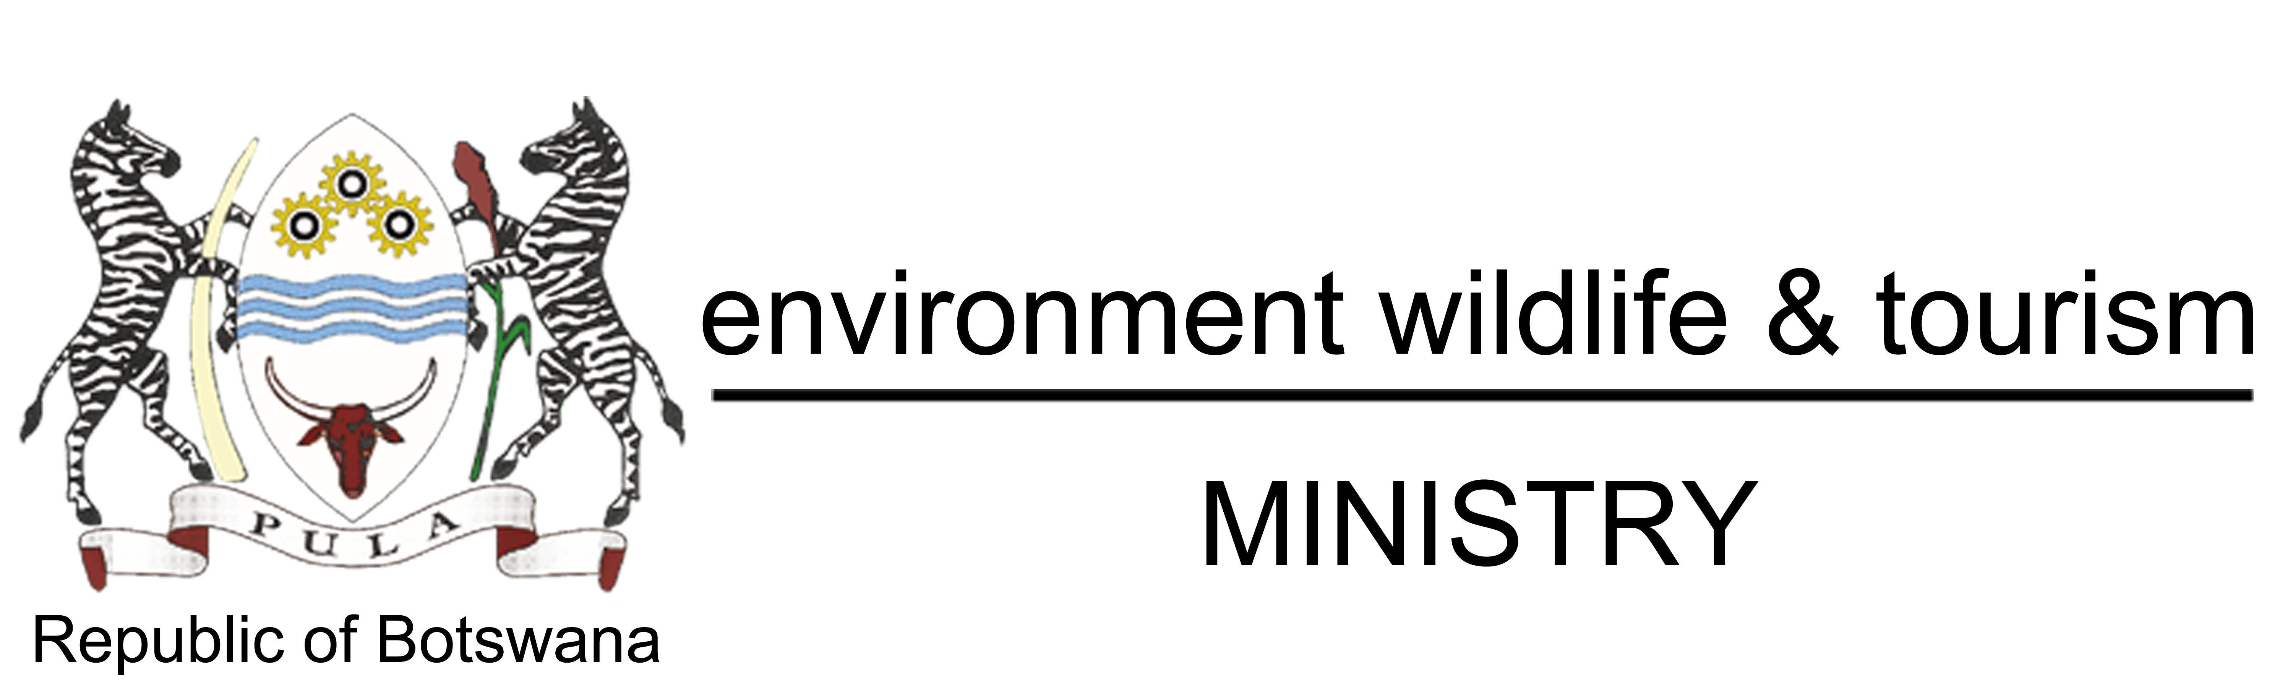

Regional Workshop for Southern Africa on Updating National Biodiversity Strategies and Action Plans: Incorporating work on valuation and incentive measures, 14-20 March 2011 in Kasane, Botswana
Regional Workshop for Southern Africa on Updating National Biodiversity Strategies and Action Plans: incorporating work on valuation and incentive measures
- VENUE

The Regional Workshop for Southern Africa on Updating National Biodiversity Strategies and Action Plans: Incorporating work on valuation and incentive measures will be held in Kasane, Botswana from 14 to 20 March 2011. The workshop will be held at:

Cresta Mowana Safari - Lodge
Plot 2239, Chobe River
P. O. Box 266
Kasane, Botswana
Tel: +267 625 0300
Fax: +267 625 0301
E-mail: resmowana@cresta.co.bw
Web site: http://www.crestahosp.co.za/index.php?option=com_content&task=view&id=32&Itemid=77

- OFFICIAL OPENING

The Regional Workshop for Southern Africa on Updating National Biodiversity Strategies and Action Plans: Incorporating work on valuation and incentive measures will be officially opened on Sunday, 13 March 2011 at 15:30. The workshop sessions will be held daily from 8:30 to 12.30 and from 13:30 to 17:00.

- REGISTRATION

Registration will be on the day of arrival (Sunday, 13 March) at the venue of the workshop. Participants will be presented with the workshop package and name tags. Registration hours:

Sunday, 13 March 2011: 2:30 p.m. until 3:30 p.m.

- DOCUMENTS

Documents for the meeting will be posted on the CBD Secretariat’s web site as they become available at: http://www.cbd.int/doc/?meeting=CBWNBSAP-SAFR-02 All presentations for the workshop will be made available to the participants.

- ACCOMMODATION

Accommodation will be provided in the Cresta Mowana Safari Lodge, which is also the venue for the workshop.

Sponsored Participants:
A prepaid booking has been confirmed for all SCBD sponsored participants to cover their stay according to their flight itineraries

Non-sponsored:
Non-sponsored participants are required to make their own hotel reservations by contacting Ms. Mimi Orekeng at banquetingmowana@cresta.co.bw before 4 March 2011 as rooms will be released after that date. Kindly refer to the KCS block booking to benefit from the special rate of 1023 Pula (Approximately US $150.00) which includes breakfast.

4.1 Meals
Morning Tea, Lunch and Afternoon Tea will be provided during the workshop days, 14-20 March 2011.

Check In: Upon arrival
Check Out: 11:00 a.m.
NB: When checking out of the Hotel, do not forget to settle your personal bills (laundry, mini bar, telephone, safe, etc.).

- TRAVEL ARRANGEMENTS AND VISA REQUIREMENTS

The nearest airport servicing Kasane is the Kasane Airport which is about 5 km away from Mowana Safari Lodge. Transfer from the airport to the hotel will be provided by a shuttle service from the Hotel. This is a free service and a list with the arrival times of sponsored participants has been furnished to the shuttle service. Non-sponsored participants should advise the hotel of their arrival and departure times in order to schedule the shuttle.

5.1 Visa requirements

Citizens from Angola and Democratic Republic of Congo require visas to enter Botswana. Please arrange with the Botswana Embassy or Consulate in your country. Participants that need a visa to enter Botswana will be required a transit visa if passing through South Africa. The transit visa cannot be processed in Botswana kindly ensure that you have it before you leave your home country and it’s processed at the South African Embassy.

To facilitate the issuance of visas, the CBD Secretariat will issue, upon request, an invitation letter to be attached to the visa applications.

- INTERNET ACCESS AND MOBILE PHONES

Wifi internet is available at the hotel and it can only be accessed in the conference room, the lobby and savuti bar. It is free of charge. There is also a business centre in the hotel where relevant charges will be applied to the user.

Some international cellular phones may not be operational in Botswana, it is recommended you check with your provider in advance for roaming options. However the communications tools are available in Kasane with several mobile networks. Three network companies providing such services are Orange, Mascom & beMobile. One can purchase sim-cards from airport, filling stations or super markets at a price cost between 10-20 pula. Call rates differ from each network company. Internet services are also available from these networks.

- WEATHER AND TIME ZONE INFORMATION

The weather in Kasane is sunny and hot nearly all year round, with hot summers and mild winters. Currently (January-March) it is the rainfall season with heavy showers at times. The average temperatures range between a maximum of 28-34°C and a minimum of 20-24°C.

The standard time zone will be UTC /GMT + 2 hours.

- IMPORTANT HEALTH NOTICE: MALARIA

Botswana is currently experiencing heavy rainfalls countrywide and Kasane is one of the few places that often get heavy downpours, which brings great risk of Malaria infection. The Ministry of Health in the country has warned of the likelihood of high levels of malaria transmission this year due to the above normal rainfall experienced. Therefore, since everyone is at the risk of malaria infection, people are advised to take necessary preventive measures and precautions to protect themselves. People are encouraged to use insect repellents and wear clothes that cover arms and legs especially during the evening as well as sleeping under treated mosquito nets where possible. Anyone who develops the following symptoms; fever, severe headache, chills, sweating, abdominal pains, nausea and vomiting must visit the nearest health facility.

For more information, please consult a medical professional with regard to the vaccination requirements for your travel.

- OFFICIAL LANGUAGES

The official languages used in Botswana are Setswana and English which are widely and equally used in hotels and restaurants.

- CURRENCY AND RATES OF EXCHANGE

Botswana's unit of currency is the Pula (P), which is divided into 100 Thebe (t). The word 'Pula' means rain and 'thebe' means shield. The shield appears on the national coat of arms. Bank notes come in denominations of P10, 20, 50 and 100, and coins in denominations of 5t, 10t, 25t, 50t, P1, P2 and P5.

Major credit cards, including Visa, MasterCard, American Express and Diners Club, are accepted widely. Most hotels and lodges accept foreign currency or travellers’ cheques

The current exchange rate as of 28 January 2011 is approximately:
1 Pula = 1.0217 SA rand
1 Pula = 0.1426 US$
A number of exchange bureaux are available in Kasane and you are advised to use those official bureaux for exchange procedures. You can also carry out the transaction at the Lodge but be informed that the exchange rates in hotels are slightly lower than in official bureaux and banks.

Please note: Never change money outside official bureaux.
The Hotel also accepts most major credit cards

- ELECTRICITY

The electrical currents used in Botswana are 220-Volts and 60Hertz. Square and Round sockets are used. (You will need an adaptor for a two pinned cable a e.g. a universal adaptor).

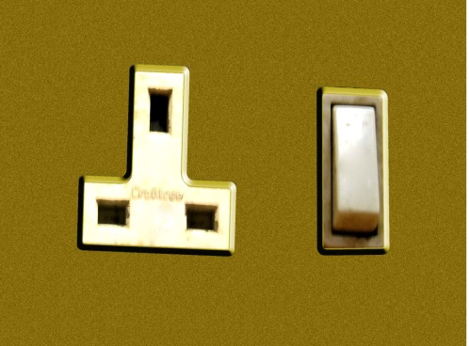
Round plug Square plug

- SECURITY AND SAFETY

Botswana is a relatively peaceful and crime free country, however you advised to take care of your belongings at all times. Always make sure your properties are not left unattended and are in a secure place. Make sure you carry your money safely.

Kasane is largely regarded as having some of the best wilderness and astoundingly rich wildlife areas in Botswana. Most of its land area is devoted to the national park, reserves and it is unfenced to allow animals to roam wild and free. You are therefore advised to be cautious at all times.

- OTHER SERVICES AVAILABLE TO PARTICIPANTS

A variety of services are available in Kasane. These include:

- restaurants and cafeterias
- a medical clinic
- primary hospital
- a post office
- curio shop where one can buy locally produced goods
- golf course
- tourist information service

- FIELD TRIP

The host country has organized a field study visit within and around Kasane with focus on demonstrating the integration of biodiversity in district-level planning. Participants are encouraged to bring comfortable shoes, clothes and a sun hat for this session as it will be conducted outdoors. For more information about Botswana visit: http://www.botswana-tourism.gov.bw

- CONTACTS

For further information contact the following:

Ministry of Environment, Wildlife and Tourism MEWT
Department of Environmental Affairs
Private Bag 0068, Travaglini House 2nd Floor
Tel: (+267) 3902050
Fax: (+267) 3902051/ 3914687

Ms. Dineo D. Gaborekwe
Phone: (+267) 3644635
Mobile: 72719031
E-mail: ddoitsile@gov.bw , dineo.gaborekwe@gmail.com

Mr. Jobe Manga
Phone: (+267) 3902050/ 3644635
Mobile: 71335028
E-mail: jmanga@gov.bw

Ms. Gorata Katlego Maokanyane
Phone: (+267) 3644616
Mobile: 72686459
E-mail: gmaokanyane@gov.bw , M. gorata@yahoo.com

Mr. Baboloki Autlwetse
Kalahari Conservation Society
Phone: (+267) 3974557
Mobile: 71443443
Fax: 3914259
E-mail: baboloki@kcs.org.bw

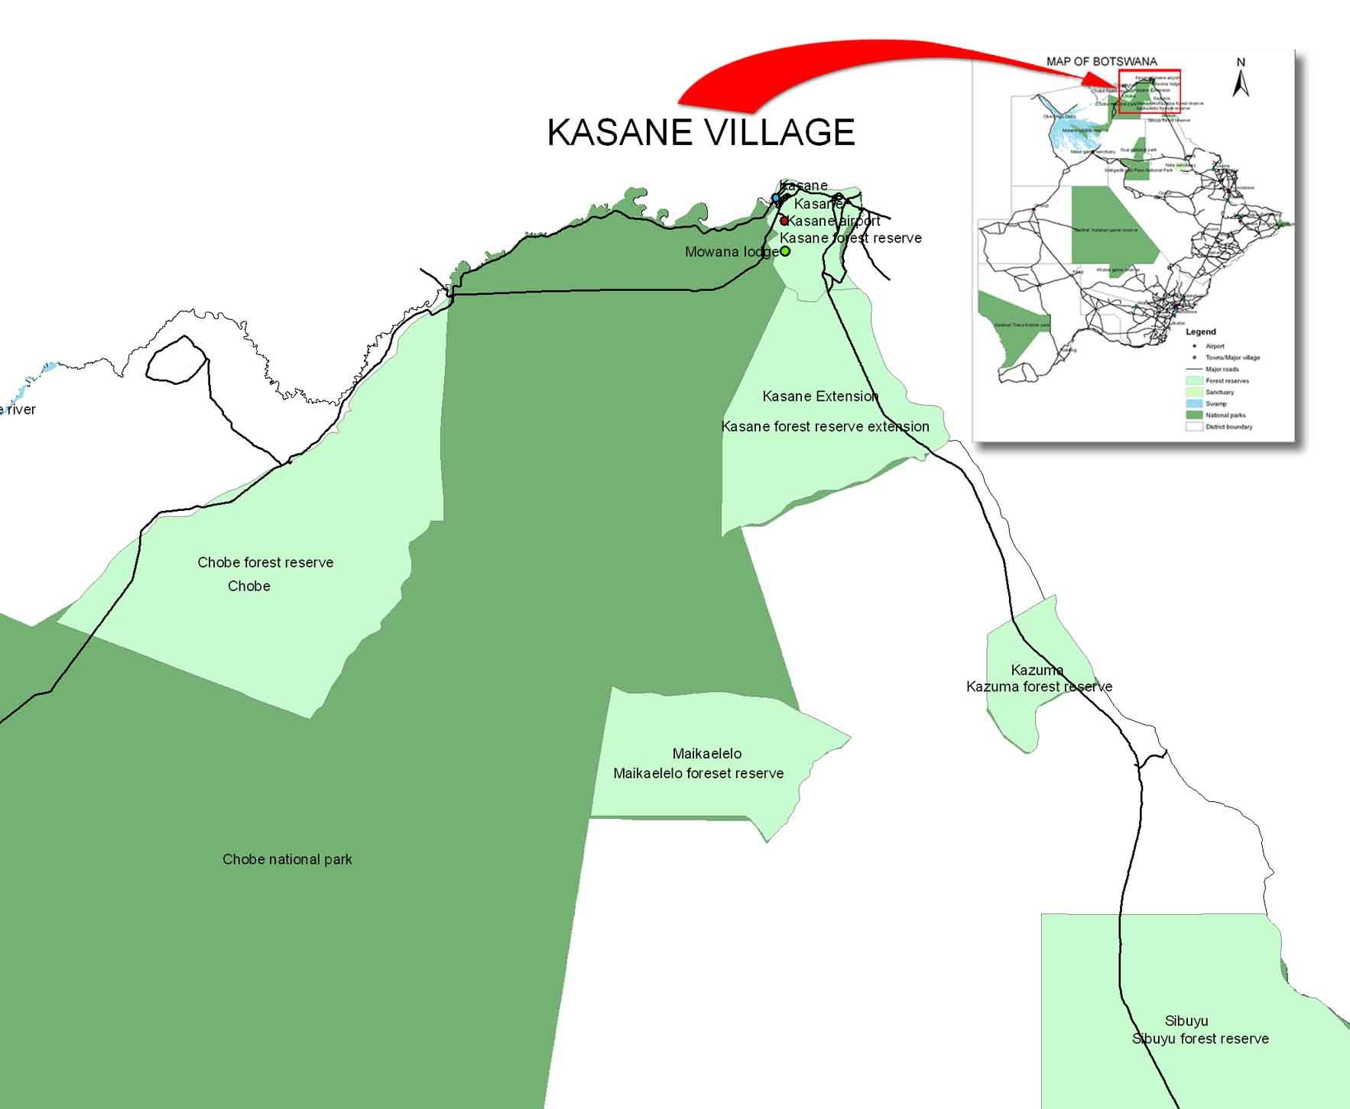

NB:
For security reasons, the display of conference badges is mandatory at all times to gain access to the workshop venue and workshop rooms. Any loss of a conference badge should be reported immediately

- DISCLAIMER

The CBD Secretariat disclaims all responsibilities for medical, accident and travel insurances, for compensation for death or disability compensation, for loss of or damage to personal property and for any other losses that may be incurred during travel time or the period of participation. In this context, it is strongly recommended that participants will secure international medical, accident and travel insurances for the period of participation prior to departure.

-----

