 |  |  | CBD
 |  | CONVENTION ON  BIOLOGICAL DIVERSITY |  |  | Distr.  GENERAL  UNEP/CBD/WS-PA/SWA/1/2  28 February 2007  ORIGINAL: ENGLISH
SOUTH AND WEST ASIA SUBREGIONAL WORKSHOP ON THE REVIEW OF, AND CAPACITY BUILDING FOR, THE IMPLEMENTATION OF THE PROGRAMME OF WORK ON PROTECTED AREAS UNDER THE CONVENTION ON BIOLOGICAL DIVERSITY
Dehradun, India, 2-4 April 2007

programme of work on protected areas of the convention on biological diversity
Note by the Executive Secretary

I. INTRODUCTION
1. Biological diversity—in short, biodiversity—is the variety and variability among living organisms and the ecosystems that support them. Biodiversity is a source of various types of services / (provisioning of goods, regulation of ecosystem functioning, cultural services and supporting services) important for life on Earth and thus the foundation of human well-being, including security, resiliency, social relations, health, and freedom of choice and actions, upon which civilizations have been built. Over the past century, biodiversity loss has been taking place at an unprecedented rate. Setting aside areas for special protection has long been used as a way to counter this loss. However, the established protected areas have not always been representative of all the biomes, species and genetic resources requiring protection, nor managed effectively to respond to their protection objectives.
2. Against this backdrop, the Conference of the Parties to the Convention on Biological Diversity, at its seventh meeting in 2004, taking impetus from the World Summit on Sustainable Development, the Millennium Development Goals, and the Durban Accord and Action Plan arising from the Vth IUCN World Parks Congress, adopted an ambitious programme of work on protected areas to support the establishment and maintenance of “comprehensive, effectively managed and ecologically representative systems of protected areas” that will significantly reduce the rate of loss of global biodiversity. The target date for implementation of the programme of work is 2010 for terrestrial and 2012 for marine areas.

II. PROTECTED-AREA PROVISIONS IN THE CONVENTION
3. The Convention on Biological Diversity (CBD), adopted in 1992 and currently holding the membership of 190 Parties (189 countries and the European Community) is the most important international legal instrument addressing protected areas, and supporting and fostering national and multilateral efforts in a comprehensive manner. Article 2 of the Convention defines a protected area as “a geographically defined area, which is designated or regulated and managed to achieve specific conservation objectives”. Article 8 of the Convention calls for the establishment of a system of protected areas or areas where special measures need to be taken to conserve biological diversity. Accordingly, national protected area systems have been developed and maintained as key elements of national strategies to conserve biological diversity. Articles of the Convention concerning protected areas are reproduced in box 1 below.

Box 1: Articles of the Convention concerning protected areas

The term “protected area” is defined in Article 2 of the Convention as “a geographically defined area, which is designated or regulated and managed to achieve specific conservation objectives”. Subparagraphs (a), (b), (c) (e) and (m) of Article 8 contain specific references to protected areas and provide that Parties should:
(a) Establish a system of protected areas or areas where special measures need to be taken to conserve biological diversity;
(b) Develop, where necessary, guidelines for the selection, establishment and management of protected areas or areas where special measures need to be taken to conserve biological diversity;
(c) Regulate or manage biological resources important for the conservation of biological diversity whether within or outside protected areas, with a view to ensuring their conservation and sustainable use;
(e) Promote environmentally sound and sustainable development in areas adjacent to protected areas with a view to furthering protection of these areas;
(m) Cooperate in providing financial and other support for in situ conservation, particularly to developing countries.
In addition to the provisions on in situ conservation, a number of additional articles are relevant to the establishment and management of protected areas. These include in particular:

-Provisions on sustainable use in Articles 6 and 10, given the fact that protected areas are increasingly places managed for multiple purposes;
-Provisions on ex situ conservation (Article 9) and restoration/rehabilitation (Articles 8(f) and 14, paragraph 2) to complement on site efforts to protect habitats and species;
-Provisions on tools important for protected area management and planning such as biodiversity monitoring (Article 7) and impact assessment (Article 14);
-Other provisions including 8(j) on traditional knowledge, Article 11 on incentive measures,
-Article 12 on research and training and Article 13 on public education and awareness.
The text of the Convention can be accessed at http://www.biodiv.org/convention/articles.asp

III. PREPARATORY PROCESS LEADING UP TO THE ADOPTION OF THE PROGRAMME OF WORK ON PROTECTED AREAS IN 2004
4. To facilitate the implementation of Article 8 and related provisions of the Convention, the fourth meeting of the Conference of the Parties, held in 1998, decided to consider protected areas as one of the three main themes for its seventh meeting (decision IV/16). In preparing for the theme on protected areas, the Conference of the Parties, in decision VI/30, adopted at its sixth meeting, in 2002, encouraged the active collaboration with the Vth World Parks Congress and established an Ad Hoc Technical Expert Group on Protected Areas to review methods and approaches for the planning and management of protected areas, including options for appropriate policies, strategies, and practices consistent with the objectives of the Convention. The preparatory process on protected areas leading up to the adoption of the programme of work by seventh meeting of the Conference of Parties is described in box 2 below.

Box 2: Preparatory process on protected areas leading up to the seventh meeting of the Conference of the Parties
The preparation process leading up to the seventh meeting of the Conference of the Parties consisted of a number of steps with the meetings of the ad hoc technical expert groups on marine and coastal protected areas and on protected areas, and the Vth IUCN World Parks Congress being the major sources of input. Specifically, the following are the main steps in the preparatory process leading up to the seventh meeting of the Conference of the Parties:
- The Ad Hoc Technical Expert Group on Marine and Coastal Protected Areas, mandated by decision IV/5 in 1998, concluded its work in 2002. The results of this work were considered at the eighth meeting of the Subsidiary Body on Scientific, Technical and Technological Advice (SBSTTA) in March 2003 and served as the basis for SBSTTA recommendation VIII/3 B on marine and coastal protected areas. These results provided an interesting and illustrative indication of what is feasible in the wider context of protected areas in general.
- The World Summit on Sustainable Development (September 2002) called, in paragraph 44 (g) of the Plan of Implementation, for supporting initiatives for hotspot areas and other areas essential for biodiversity and promoting the development of national and regional ecological networks and corridors.
- The Open-ended Inter-Sessional Meeting on the Multi-Year Programme of Work of the Conference of the Parties up to 2010, held from 17 to 20 March 2003 in Montreal, requested that the Ad Hoc Technical Expert Group (AHTEG) on Protected Areas, the Subsidiary Body on Scientific, Technical and Technological Advice at its ninth meeting, and the Conference of the Parties at its seventh meeting consider the outcome of the World Summit on Sustainable Development relating to hotspots, ecological networks and corridors and other areas essential for biodiversity in the context of the work on protected areas, taking into account other relevant thematic programmes and cross-cutting issues, in the context of national strategies and action plans, and focusing on biodiversity loss.
- Pursuant to paragraph 4 of decision VI/25, Governments submitted thematic reports on protected areas in May 2003. These thematic reports provide information about national-level protected areas in the context of the implementation of the Convention.
- A strategic roundtable on protected areas, ecological networks and corridors, held in June 2003 in the Hague, provided input to the Expert Group, and to the ninth meeting of SBSTTA, held in November 2003, on the topic of ecological networks and corridors.
- The Ad Hoc Technical Expert Group on Protected Areas met from 10 to 14 June 2003 in Tjärno, Sweden. The objectives of the meeting included review methods and approaches for planning and management of protected areas; identification of ecosystem and bioregional approaches; identification of mechanisms for stakeholder involvement and options for management of transboundary protected areas. The Group reviewed a number of issues relating, inter alia, to the planning, establishment, and management of protected areas; status and trends of, and threats to, protected areas; stakeholders involvement; and ecological networks. The Group also identified elements of a programme of work on protected areas for the Convention on Biological Diversity.
- The IUCN Vth World Parks Congress (WPC) was held in Durban, South Africa, from 8 to 17 September 2003. The main outputs of the Congress are the Durban Accord, Durban Action Plan, the message to the Convention on Biological Diversity and a set of 32 recommendations approved by different workshops organized during the Congress. The Durban Accord calls for a fresh and innovative approach to protected areas and their role in the broader conservation and development agenda, and for specific action inter alia on: expansion and strengthening of worldwide systems of protected areas; mainstreaming protected areas within overall development and poverty-alleviation agenda; interests and aspiration of all stakeholders. The Durban Action Plan provides a framework of the detailed actions needed to achieve the commitments called for in the Durban Accord. The message to the Convention on Biological Diversity calls on the Conference of the Parties to adopt a rigorous programme of work on protected areas including specific targets and time tables, and establish effective means of monitoring and assessing the implementation of the programme of work.
- The Executive Secretary convened a liaison group meeting on the World Parks Congress on 18 September 2003 in Durban, South Africa, to analyse the outcomes of the Congress with a view to identifying elements from the Congress that are not fully reflected in the outputs of the Ad Hoc Technical Expert Group on Protected Areas, and which should be drawn to the attention of SBSTTA for possible integration in its advice to the Conference of the Parties at its seventh meeting.
- In response to paragraph 19(d) of decision VI/22 of the COP, the Executive Secretary convened in Montreal from 6 to 8 November 2003, just prior to the ninth meeting of SBSTTA, an international workshop on protected areas as a measure to conserve and sustainably use forest biological diversity. The workshop enabled participants to exchange current knowledge and experience on opportunities and challenges to establishing and ensuring long-term sustainability of protected forest areas. The workshop recommendations were submitted to SBSTTA for consideration.
- The ninth meeting of SBSTTA, held from 10 to 14 November 2003, considered protected areas as one of the themes for in-depth consideration and adopted recommendation IX/4. A revised proposed programme of work on protected areas was annexed to that recommendation for consideration by the Conference of the Parties at its seventh meeting.

IV. CONSIDERATION OF FACTORS THAT WARRANT A PROGRAMME OF WORK ON PROTECTED AREAS
5. Globally, the number of protected areas has been increasing significantly over the last decade, and there are now more than 100,000 protected sites worldwide covering about 12% of the Earth’s land surface, making them one of the Earth’s most significant land uses. / However, while the number and size of protected areas have been increasing, biological diversity loss continues unabated. Figure 1 presents the trends in surface area under protection by IUCN Protected Area Management Categories. About 12% of the area under protection has not been assigned a Protected Area Management Category. Among all categories, National Parks (category II) and Managed Resource Protected Areas (category VI) show a particularly high increase in recent decades. Moreover, there are substantial differences in coverage between different biomes, ecosystems and habitats. Only 5% of the world’s temperate needle-leaf forests and woodlands, 4.4% of temperate grasslands and 2.2% of lake systems are protected. Furthermore, marine coverage lags far behind terrestrial coverage, with approximately 0.6% of the ocean’s surface area and about 1.4% of the coastal shelf areas protected. A more detailed analysis of the 825 terrestrial ecoregions and 64 large marine ecosystems shows that for a large percentage of these ecosystems, which are characterized by distinct populations of species, the target of 10% protected area coverage is yet to be achieved (figure 2). In figure 3, terrestrial ecoregions are ordered by percentage under protection. While over 5% of ecoregions are completely protected, in three out of five ecoregions, less than 10% of the surface is protected. In 140 ecoregions, equivalent to 17% of all ecoregions, less than 1% of the surface is designated as a protected area.

Figure 1. Trends in terrestrial surface under protected areas
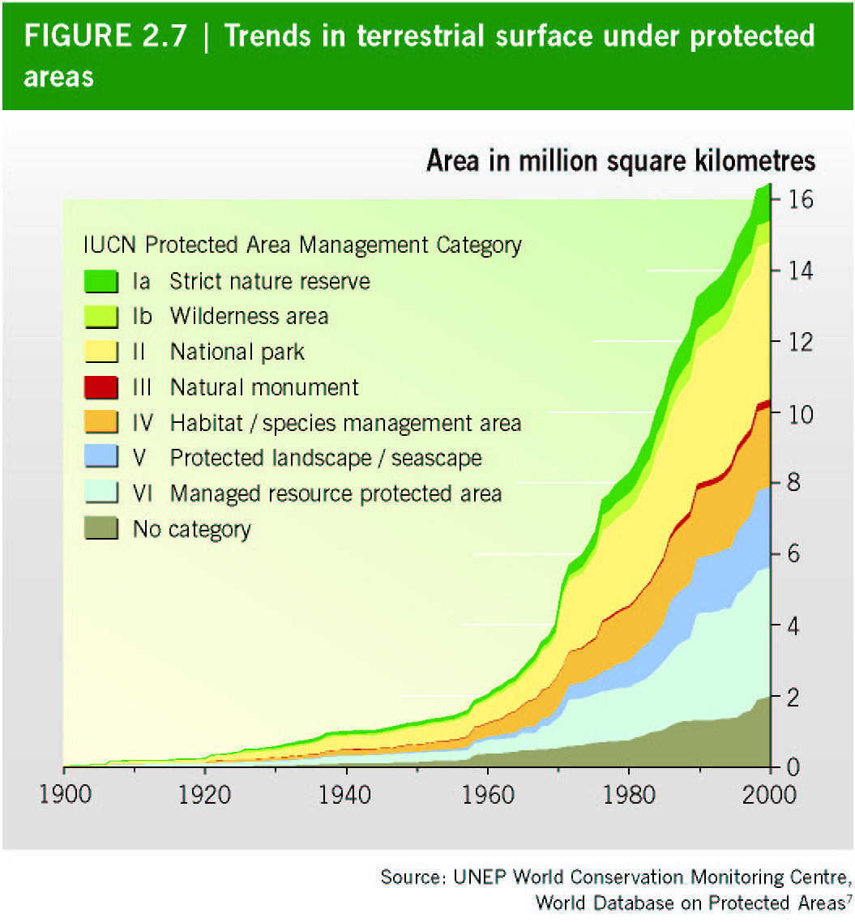
6. Over the last 40 years there has been a paradigm shift in the role of protected areas from “national parks and reserves” to a broader conceptual and practical approach, including sustainable-use areas. Currently, it is recognized that protected areas contribute, besides their conservation function, to human welfare, poverty alleviation and sustainable development. The goods and services that protected areas provide include, inter alia, protection of species and genetic diversity; maintenance of ecosystem services, such as watershed and storm protection; carbon sequestration; products for livelihoods of local people (for example, improvement of fishery and forestry yields); and other socioeconomic benefits, such as in relation to tourism and recreation. /

Figure 2. Degree of protection of terrestrial ecoregions and large marine ecosystems (all IUCN protected area management categories combined).
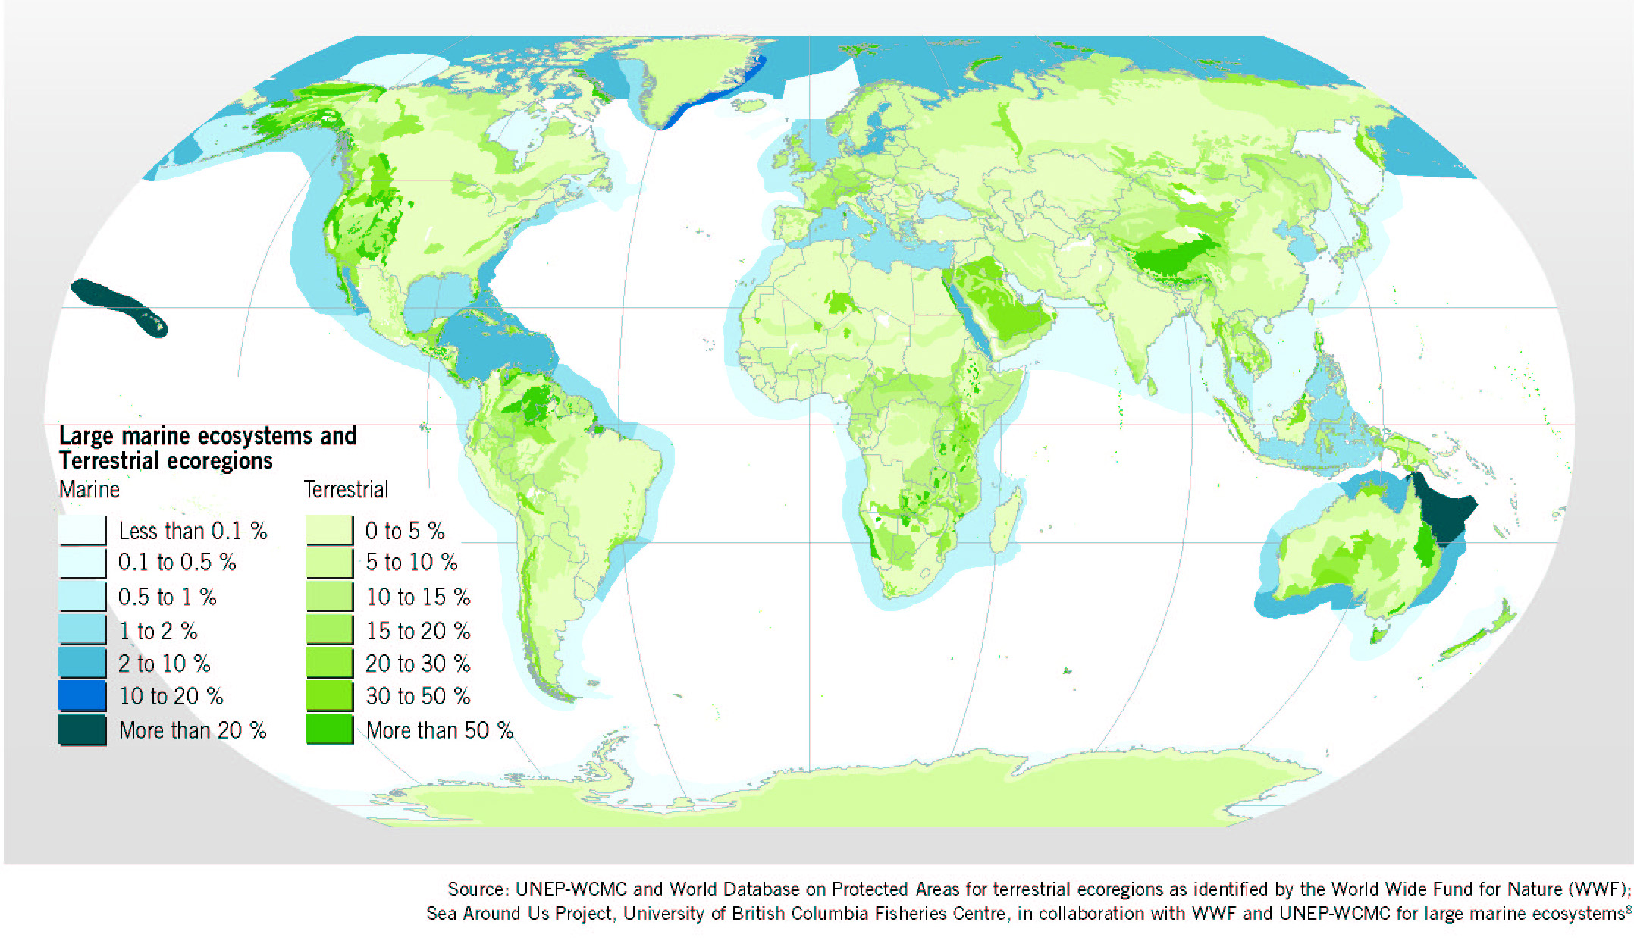
7. However, many protected areas are ineffective for a number of reasons, / including: (i) insufficient financial and technical resources to develop and implement management plans or lack of trained staff; (ii) lack of scientific data and information for management decisions, including information on the impacts of resource use and on the status of biological resources; (iii) lack of public support and unwillingness of users to follow management rules, often because users have not been involved in establishing such rules; (iv) inadequate commitment to enforcing management rules and regulations; (v) unsustainable use of resources occurring within protected areas, including impacts of human settlement, illegal harvesting, unsustainable tourism, and introduced invasive alien species; (vi) contribution to poverty where local people are excluded; (vii) impacts from activities in land and sea areas outside the boundaries of protected areas, including pollution and overexploitation; (viii) poor governance or lack of clear organizational responsibilities for management and absence of coordination between agencies with responsibilities relevant to protected areas; and (ix) conflicting objectives of the protected areas. These issues were discussed at length at the Vth World Parks Congress, held in 2003 in Durban, South Africa and reviewed in CBD Technical Series No 15. /

Figure 3. Frequency distribution of terrestrial ecoregions by percentage surface-area protection

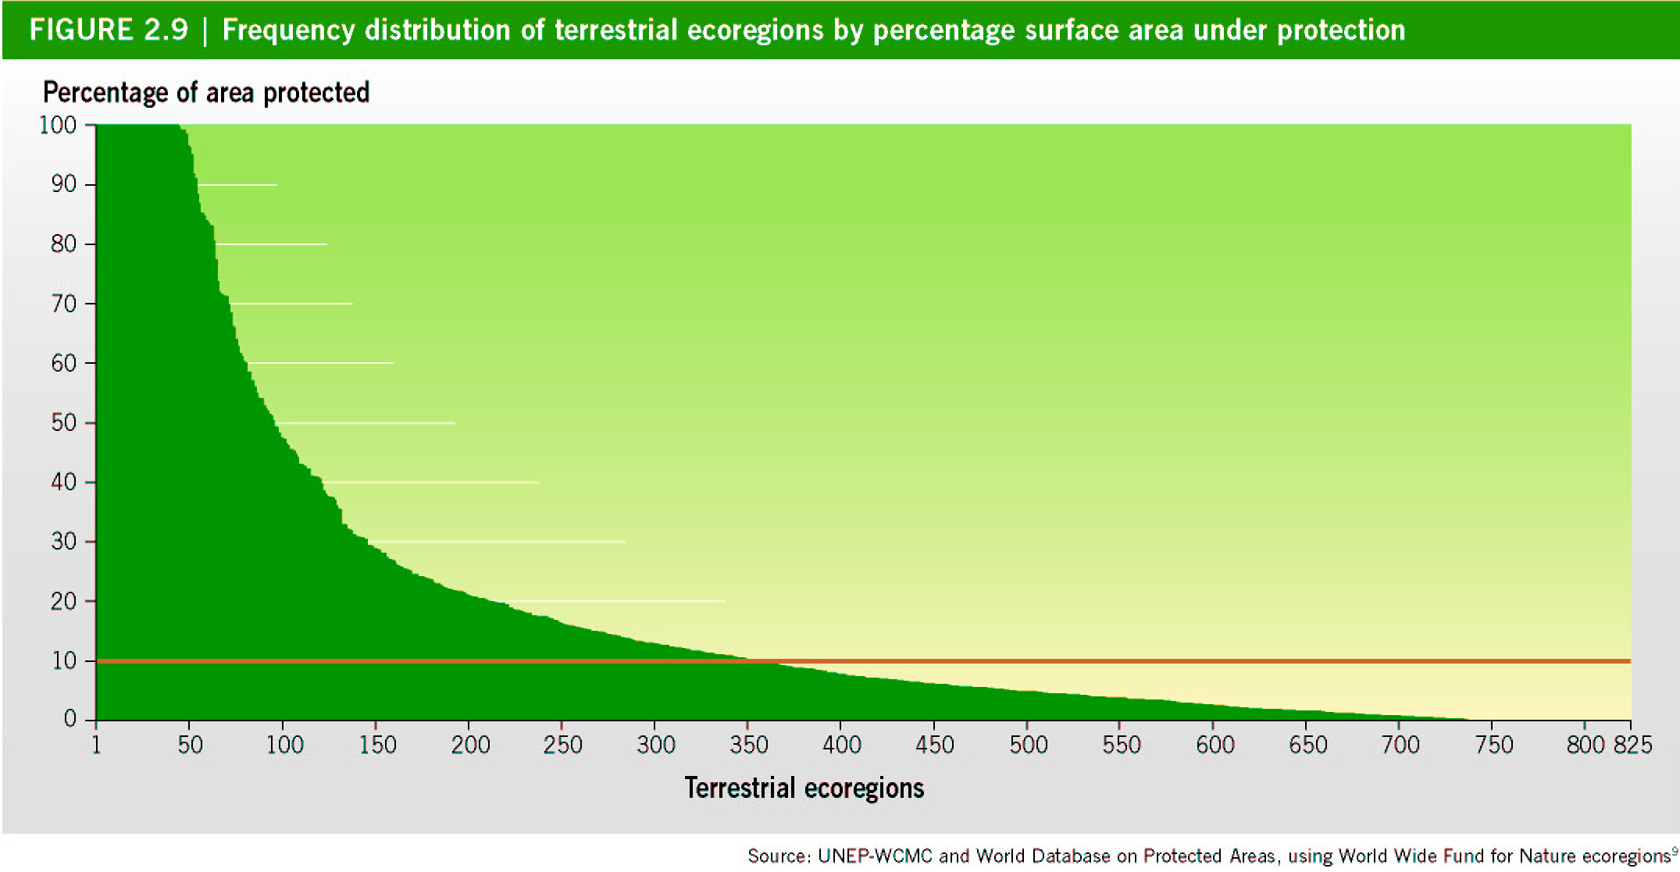

V. OBJECTIVE AND STRUCTURE OF THE PROGRAMME OF WORK ON PROTECTED AREAS OF THE CONVENTION ON BIOLOGICAL DIVERSITY
8. The Conference of the Parties to the Convention on Biological Diversity, at its seventh meeting in 2004, adopted the programme of work on protected areas / with an overall objective of establishing and maintaining, by 2010 for terrestrial areas and by 2012 for marine areas, “comprehensive, effectively managed and ecologically representative systems of protected areas” that, collectively, will significantly reduce the rate of loss of global biodiversity. Implementation of the programme of work on protected areas is expected to contribute to the three objectives of the Convention, its Strategic Plan, the 2010 biodiversity target, / and the poverty alleviation and sustainable development targets of the Millennium Development Goals.

A. Contents of the programme of work
9. The programme of work on protected areas consists of four interlinked elements mutually reinforcing and cross-cutting in their implementation. In essence, programme element 1 deals with what protected area systems need to conserve and where. Programme elements 2 and 3 address the enabling activities that will ensure successful implementation of the other programme elements, including issues such as the policy environment, governance, participation and capacity-building. Programme element 4 covers the steps needed for assessing and monitoring the effectiveness of actions taken under programme elements 1 to 3. Each programme element consists of specific goals, outcome-oriented targets and related activities. The programme of work contains 16 goals with corresponding targets that set specific dates by which respective goals have to be completed. In many cases the programme of work identifies indicators needed for measuring progress towards the goals. A list of activities, 92 in total, follow each paired goal and target.

B. Programme elements
10. Programme element 1 “Direct actions for planning, selecting, establishing, strengthening and managing protected area systems and sites” is in many ways the essence of the programme of work. The goals, targets and activities of this programme element, taken together, define the objectives, nature and extent of the national protected area systems that will ultimately constitute an effective and ecologically representative global network of national and regional protected area systems. Programme element 1 includes establishing and strengthening national and regional systems of protected areas; integration of protected areas into the larger landscape and seascape, and into various sectors of planning; strengthening collaboration between countries for transboundary protected areas conservation; improving site-based planning and management; and preventing the negative impacts of key threats to protected areas. Achieving goal 1.1 is an essential precondition for achieving the overall objective of the programme of work.
11. Programme element 2 is on “governance, participation, equity and benefit-sharing”. Simply stated, achieving the ultimate goal of the programme of work—establishing comprehensive, ecologically representative and effective protected area systems—requires that serious and systematic attention be paid to socioeconomic and institutional matters, not just to biological factors and criteria. This programme element includes promoting equity and benefit-sharing through increasing the benefits of protected areas for indigenous and local communities, and enhancing the involvement of indigenous and local communities and relevant stakeholders. The central importance for protected areas of governance, participation, equity and benefit-sharing is underscored by devoting one of the four elements of the programme of work to this set of enabling activities.
12. Programme element 3 “Enabling activities” is about creating an environment that will ensure successful implementation of the other programme elements. It includes providing policies and institutional mechanisms; building capacity for the planning, designation, establishment and management of protected areas; applying appropriate technologies; ensuring financial sustainability; and strengthening communication, education and public awareness. Programme element 3 provides an umbrella for a number of crucial areas where action is needed to establish the conditions and generate the resources, capacities and public support to plan, establish and effectively manage comprehensive, ecologically representative systems of protected areas. Achieving the goals and targets under this programme activity clearly requires action by policy- and decision-makers in many sectors other than protected areas. Policies, laws and resulting economic incentives in the broader economy are the responsibility of a wide range of government agencies and legislative bodies. In many cases, they can only be changed with strong leadership from senior political leaders.
13. Programme element 4 “Standards, assessment and monitoring” includes developing and adopting minimum standards and best practices; evaluating and improving the effectiveness of protected area management; assessing and monitoring protected area status and trends; and ensuring that scientific knowledge contributes to protected area establishment and effectiveness. Programme element 4 addresses the need for Parties to put in place systems to assess and monitor the effectiveness of their protected area systems. To do so requires a set of standards and criteria against which to measure the effectiveness of management, a system for evaluating the effectiveness of management interventions, and ongoing monitoring of status and trends of both protected areas themselves and the biodiversity that they contain. In addition, it is widely recognized that scientific knowledge of biodiversity needs to be improved and more widely disseminated to those responsible for protected areas management. Implementing the goals under programme element 4 is therefore essential for determining whether the actions taken under programme elements 1 to 3 are having their intended impacts, and for allowing for changes in management strategies and actions where that is not the case.

C. Targets
14. The programme of work on protected areas contains specific time-bound targets primarily organized around national-level actions. The overall target date for implementation of the programme of work is 2010 for terrestrial and 2012 for marine areas. The Conference of the Parties adopted intermediate targets for many activities with time-bound deadlines of either 2008, 2010/2012 or 2015, in recognition of the fact that many of the goals and targets will require a phased, step-by-step approach. The targets are outlined in table 1 in chronological order.
15. The programme of work on protected areas is a framework within which Parties to the Convention may develop national and regional targets and activities, and implement them in the context of their national priorities, capacities and needs.

vi. PROTECTED AREAS IN THE WORK OF THE CONVENTION /
16. Protected areas form a central element of the work in the thematic areas and cross-cutting issues addressed by the Conference of the Parties to the Convention on Biological Diversity.
(a) Marine protected areas. Because oceans and seas cover 71% of the Earth, the under-representation of marine and coastal ecosystems in the current global protected areas system is particularly alarming. At the same time, global and regional assessments indicate that marine biodiversity globally continues to decline rapidly. / For example, coral reefs are highly degraded worldwide, / approximately 35% of mangroves have been lost in the last two decades, / and historic over-fishing has greatly reduced the abundance of large consumer species, including predatory fish. / / In addition, there are increasing and urgent concerns about the effects of over-fishing and destructive fishing practices on biodiversity. Halting, and perhaps ultimately reversing, this trend presents the global community with a formidable challenge. The seventh meeting of the Conference of the Parties to the Convention on Biological Diversity agreed in 2004 that marine and coastal protected areas are one of the essential tools and approaches in the conservation and sustainable use of marine and coastal biodiversity (decision VII/5 on marine and coastal biological diversity /). The Conference of the Parties also agreed that a national framework of marine and coastal protected areas should include a range of levels of protection, encompassing both areas that allow sustainable uses and those that prohibit extractive uses (i.e., so-called “no-take” areas). The Parties further recognized that protected areas alone could not accomplish everything, and that sustainable management practices are needed over the wider marine and coastal environment; /
- In the programme of work on the biological diversity of inland water ecosystems (decision VII/4), goal 1.2 calls for the establishment and maintenance of comprehensive, adequate and representative systems of protected inland water ecosystems within the framework of integrated catchment/watershed/river basin management;
- The use and establishment of additional protected areas and the strengthening of measures in existing protected areas are identified as some of the necessary target actions for the implementation of the work programme on dry and sub-humid lands (V/23, annex I, part B, activity 7(a));
- The expanded programme of work on forest biodiversity, which was adopted in decision VI/22, contains a number of activities related to protected areas. The programme of work also calls for work on the role and effectiveness of protected areas. Controlling deforestation, including through establishment of forest protected areas, is being considered as a means to avoid greenhouse gas emissions and contribute to the objectives of the United Nations Framework Convention on Climate change;
- Goals 1.1 and 2.3 of the programme of work on mountain biodiversity (decision VII/27) contains provisions on how to plan, establish and manage protected areas in mountain ecosystems, including the buffer zones of protected areas, using, as appropriate, planning or management mechanisms, such as ecological/economic/ecoregional planning/bioregional/hazardous-areas zoning, so as to ensure the maintenance of biodiversity, in particular ecosystem integrity. Actions 1.2.5 and 2.3.1, in particular, call for the establishment and strengthening of adequate, effective national, regional and international networks of mountain protected areas, and the promotion of integrated transboundary cooperation, strategies for sustainable activities on mountain ranges and protected areas;
- The programme of work on Article 8(j) on traditional knowledge includes a component on protected areas relating to the management of protected areas by indigenous and local communities (decision VI/10). Specific emphasis is put on the respect of their rights when establishing new protected areas (decisions VII/16);
- The Guidelines on Biodiversity and Tourism Development, adopted in decision VII/14 of the Conference of the Parties, include guidelines on how to incorporate sustainable use and equity strategies within and around protected areas;
- The value of taxonomic data in assisting protected area site selection is recognized in the programme of work for the Global Taxonomy Initiative, contained in decision VI/8. Protected areas are also mentioned in connection with identification, monitoring, indicators and assessments (decision VI/7) and the Addis Ababa principles and guidelines for sustainable use of biodiversity (decision VII/12);
- In the Global Strategy for Plant Conservation (decision VI/9, annex), the Conference of the Parties adopted targets 4 and 5, which specify respectively that by 2010: (i) at least 10% of each of the world's ecological regions should be effectively conserved, implying increasing the representation of different ecological regions in protected areas, and increasing the effectiveness of protected areas; and (ii) protection of 50% of the most important areas for plant diversity should be assured through effective conservation measures, including protected areas;
- In decision VIII/28 the Conference of the Parties endorsed voluntary guidelines on biodiversity-inclusive impact assessment and urged Parties, other Governments and relevant organizations to apply the voluntary guidelines on biodiversity-inclusive environmental impact assessment as appropriate in the context of their implementation of paragraph 1 (a) of Article 14 of the Convention and of target 5.1 of the provisional framework of goals and targets for assessing progress towards 2010. The Conference of the Parties invited multilateral environmental agreements to take note of and, if appropriate, apply the voluntary guidelines on biodiversity-inclusive environmental impact assessment. These guidelines make environmental impact assessment mandatory for activities in protected areas and activities in threatened ecosystems outside protected areas;
- In decision VIII/30, on biodiversity and climate change, the Conference of the Parties encouraged Parties and other Governments to integrate biodiversity considerations into all relevant national policies, programmes and plans in response to climate change, taking into account the maintenance and restoration of the resilience of ecosystems, which are essential for sustaining the delivery of their goods and services. The Conference of the Parties further encouraged Parties, other Governments, relevant organizations and research institutions to develop rapid assessment tools for the design and implementation of biodiversity conservation and sustainable use activities that contribute to adaptation to climate change, particularly in vulnerable countries and regions, including small island developing States. The Conference of the Parties requested the Subsidiary Body on Scientific, Technical and Technological Advice (SBSTTA) to develop draft guidance on how to integrate relevant climate change impacts and response activities into the programmes of work of the Convention, taking into account, inter alia, the contributions that protected areas can make in this context.
17. It is important to note that the planning, establishment, management and monitoring of protected areas need to take into account the ecosystem approach (decision VII/11) biodiversity-inclusive guidelines on environmental impact assessment (decision VIII/28), guidelines for tourism (decision VII/14), provisions of Article 8(j) of the Convention and incentive measures (decision VIII/26).

VII. FOLLOW-UP UNTIL THE EIGHTH MEETING OF THE CONFERENCE OF PARTIES
A. Establishment of a working group for follow-up actions
18. When it adopted the programme of work, the Conference of the Parties decided to make progress, inter alia, in the areas of:
- The establishment of marine protected areas in marine areas beyond the limits of national jurisdiction;
- Mobilization of adequate and timely financial resources for the implementation of the programme of work by developing countries, particularly in the least developed and the small island developing States amongst them, and in countries with economies in transition, with special emphasis on those elements of the programme of work requiring early action;
- Development of “tool kits” for the identification, designation, management, monitoring and evaluation of national and regional systems of protected areas, including ecological networks, ecological corridors, buffer zones, with special regard to indigenous and local communities, stakeholder involvement and benefit-sharing mechanisms.
For this purpose, the Conference of the Parties established an Ad Hoc Open-ended Working Group on Protected Areas to explore the most appropriate ways forward on these issues.
19. The first meeting of the Working Group was held in Montecatini, Italy, from 13 to 17 June 2005. The main outcomes of this meeting included: (i) the initiation of work to compile and synthesize existing ecological criteria for future identification of potential sites for protection in marine areas beyond the limits of national jurisdiction, as well as applicable biogeographical classification systems, and recommendations concerning cooperation and coordination among various forums for establishment of marine protected areas; (ii) agreement on options for mobilizing financial resources for the implementation of the programme of work through a variety of funding mechanisms; (iii) an updated list of tool kits for implementing the programme of work, and (iv) identification of areas where more work is needed. /
B. Financial considerations and donors’ meeting
20. Establishing and managing protected areas cost money. There are significant running costs associated with ensuring that protected areas are effectively protected, that local communities benefit from them and that the value of protected areas are maintained in perpetuity. Three separate studies estimated the total annual cost for effective management of the existing protected areas in developing countries ranges from US $1.1 billion to $2.5 billion per year / and the funding shortfall (total cost minus current funding) between US $1 billion and 1.7 billion per year (figure 4).

Figure 4. Estimates of funding needs and gaps for effective management of existing protected areas in developing countries (Source: Bruner et al., 2004)
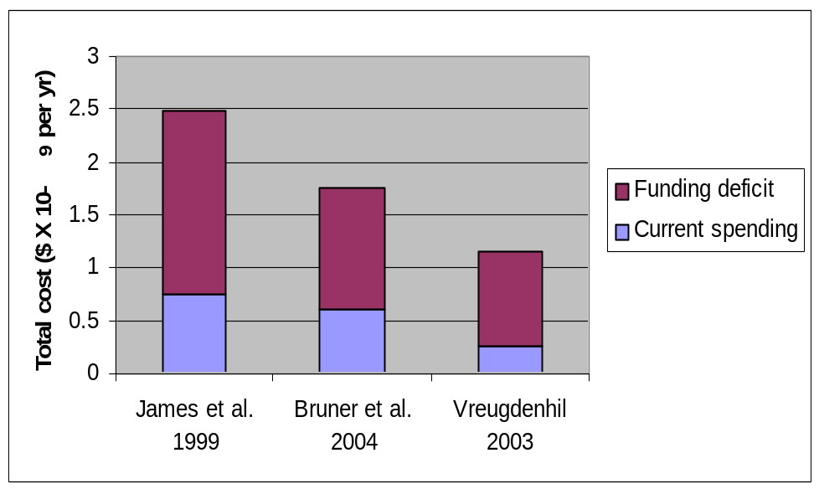
21. Governments are conscious of these estimated shortfalls and, in adopting the programme of work on protected areas, they called for increased financing, including external financial assistance for developing countries and countries with economies in transition. The Conference of the Parties therefore urged Parties, other Governments and funding organizations to “mobilize as a matter of urgency through different mechanisms adequate and timely financial resources for the implementation of the programme of work by developing countries, particularly in the least developed and the small island developing States amongst them, and countries with economies in transition, in accordance with Article 20 of the Convention, with special emphasis on those elements of the programme of work requiring early action” (decision VII/28, para. 9). The Conference of the Parties also called on Parties and development agencies to integrate protected area objectives into their development strategies (decision VII/28, para. 11).
22. Activity 3.4.7 of the programme of work calls for the convening of a meeting of the donor agencies to discuss options for mobilizing funding to developing countries and countries with economies in transition and small island developing States for implementation of the programme of work. In this context, potential donor agencies and other relevant organizations met in Montecatini, Italy on 20 and 21 June 2005, and identified financial considerations for protected areas, including short-term national-, regional- and global- level options for mobilizing additional financial resources for the implementation of the programme of work on protected areas. This meeting also emphasized to undertake country-level protected area values and benefits initiatives to assess protected area contributions to poverty reduction and Millennium Development Goals. /
C. Expert workshop on protected areas
23. In response to the request contained in paragraph 8 (d) of recommendation 1/4 of the first meeting of the Working Group on Protected Areas, an expert workshop on protected areas took place on 17-18 March 2006 in Curtiba, Brazil. Workshop participants concluded that reporting on review of implementation of the programme of work on protected areas should concentrate on outputs to gain an understanding of the overall progress towards targets and highlight the most significant challenges and obstacles. The participants also developed an evaluation matrix for the review of implementation of the programme of work on protected areas to provide for a strategic assessment of progress made, challenges/obstacles, and capacity-building needs. /

VIII. Decision VIII/24 of the eighth meeting of the Conference of the Parties
24. Implementation of the programme of work for the period 2004-2006 was assessed at the eighth meeting of the Conference of the Parties to the Convention on Biological Diversity, held in Curitiba, Brazil, from 20 to 31 March 2006. The outcome of the discussions is reflected in decision VIII/24. / Regarding review of implementation, the Conference of the Parties recognized that limited availability of relevant information, including the insufficient number of reports submitted, was a major shortcoming in the review of the programme of work on protected areas for the period 2004-2006. In addition, the Conference of the Parties, recognizing the need for the systematic collection of relevant information for evaluating progress in the implementation of the programme of work on protected areas, encouraged Parties, other Governments and relevant organizations to provide timely and quality information on the implementation of the programme of work. In paragraph 5 of this decision, the Conference of the Parties agreed that reporting should concentrate mostly on outputs as well as processes, using tools such as the matrix in annex II of recommendation 1/4 of the Ad Hoc Open-ended Working Group on Protected Areas (UNEP/CBD/COP/8/8, annex) and other relevant information, to provide for a strategic assessment of progress made, challenges/obstacles, and capacity-building needs. Further, recognizing lack of implementation and capacity-building constraints for developing countries, especially in the areas of conducting gap analysis, country-level sustainable financing strategies, and protected-area management effectiveness, the Conference of the Parties urged Parties to address these constraints as a priority and encouraged Parties and relevant organizations to support and implement capacity-building activities.
25. The Conference of the Parties decided to convene the second meeting of the Ad Hoc Open-ended Working Group on Protected Areas prior to its ninth meeting, to evaluate progress and elaborate recommendations to the Conference of the Parties for improved implementation of the programme of work on protected areas and invited Parties, other Governments, relevant organizations and other stakeholders to report on progress made towards the targets, challenges/obstacles and capacity-building needs in time for consideration by the second meeting of the Ad Hoc Open-ended Working Group on Protected Areas.
26. Regarding options for mobilizing financial resources for the implementation of the programme of work, the Conference of the Parties, welcoming the Montecatini financial considerations for protected areas, / invited Parties to elaborate financial plans, incorporating a diversity of national, regional and international sources, to meet the costs to effectively and sustainably implement and manage national and regional protected area systems, through consideration of a variety of options. The Conference of the Parties invited the Global Environment Facility to support early action activities of the programme of work as well as national and regional systems of protected areas, taking into account the targets and timetables of the programme of work. The Conference of the Parties also urged donor countries to provide enhanced support to conservation endowment funds and other long-term financing mechanisms that have proven to be particularly successful in supporting recurrent protected area management costs.
27. Regarding options for cooperation for the establishment of marine protected areas in marine areas beyond the limits of national jurisdiction, the Conference of the Parties recognized the central role of the General Assembly of the United Nations in addressing this issue and invited the Assembly to decide, at its sixty-first session, to establish a timely follow-up process for the enhanced conservation and sustainable use of marine biodiversity in areas beyond national jurisdiction. The Conference of the Parties recognized that the Convention on Biological Diversity has a key role in supporting the work of the General Assembly by focussing on provision of scientific and, as appropriate, technical information and advice relating to marine biological diversity, the application of the ecosystem approach and the precautionary approach, and in delivering the 2010 biodiversity target.

IX. Regional workshops
28. In reviewing the implementation of the programme of work for the period 2004-2006, the Conference of the Parties found that the level of implementation was limited in developing countries, essentially due to lack of capacity and requested the Executive Secretary to organize regional workshops to review the implementation of the programme of work and contribute to capacity-building. The first of such regional workshops was held in the Caribbean region, in Miami, Florida, from 20 to 22 June 2006, organized by The Nature Conservancy in collaboration with the Secretariat of the Convention on Biological Diversity, IUCN-World Commission on Protected Areas, USAID, and Parks in Peril. Representatives from 13 countries of the Caribbean region participated and presented case-studies. The workshop focused on practical hands-on-tools and training on the following priority activities, which the Conference of the Parties recognized for capacity-building: (i) ecological gap assessments; (ii) sustainable finance plans; (iii) capacity plans for implementing the programme of work as a whole; and (iv) management effectiveness. Each item was structured into three sessions: (i) critical steps; (ii) tools; and (iii) policy and institutional changes needed for implementation, with lectures, case-studies and interactive sessions for understanding country-specific progress and identification of country-specific challenges, opportunities and ways and means to address these challenges. One important achievement of this workshop, besides capacity-building, was encouraging and inspiring the Caribbean countries to come out with an initiative similar to the Micronesia Challenge.
29. Together with The Nature Conservancy, IUCN-WCPA, USAID and Parks-in-Peril, the Secretariat co-sponsored a workshop on “Strategic Plans for Protected Area Systems” in Quito, Ecuador, South America from 24 to 26 July 2006. The purpose was to provide participants from South and Central American countries with practical hands-on-tools and training for capacity-building in: (i) ecological gap assessments; (ii) sustainable finance plans; and (iii) management effectiveness.

X. Second Meeting of the Working Group on Protected Areas
30. The second meeting of the Ad Hoc Open-ended Working Group on Protected Areas is scheduled for February 2008. Substantive issues before the meeting are: (i) review of implementation of the programme of work; and (ii) options for mobilizing financial resources for the implementation of the programme of work, including innovative financing mechanisms. It is envisaged that regional preparatory processes, such as regional workshops, would provide substantial inputs to the second meeting of the Working Group, assisting it to undertake a meaningful assessment of the implementation of the programme of work and to develop recommendations to the Conference of the Parties.

Table 1: Targets of the programme of work on protected areas
Goal No. | Targets /
Targets for 2008
1.5 | Effective mechanisms for identifying and preventing, and/or mitigating the negative impacts of key threats to protected areas are in place.
2.1 | Mechanisms for the equitable sharing of both costs and benefits arising from the establishment and management of protected areas are established.
2.2 | Participation of indigenous and local communities is full and effective, in full respect of their rights and recognition of their responsibilities, consistent with national law and applicable international obligations, and the participation of relevant stakeholders, in the management of existing, and the establishment and management of new, protected areas.
3.1 | Policies as appropriate, including use of social and economic valuation and incentives, to provide a supportive enabling environment for more effective establishment and management of protected areas and protected areas systems are reviewed and revised as appropriate.
3.4 | Sufficient financial, technical and other resources to meet the costs to effectively implement and manage national and regional systems of protected areas are secured, including both from national and international sources, particularly to support the needs of developing countries and countries with economies in transition and small island developing States.
3.5 | Public awareness, understanding and appreciation of the importance and benefits of protected areas are significantly increased.
4.1 | Standards, criteria, and best practices for planning, selecting, establishing, managing and governance of national and regional systems of protected areas are developed and adopted.
Targets for 2010
1.1 | Terrestrially, a global network of comprehensive, representative and effectively managed national and regional protected area system is established.”
1.3 | Transboundary protected areas, other forms of collaboration between neighboring protected areas across national boundaries and regional networks, to enhance the conservation and sustainable use of biological diversity, implementing the ecosystem approach, and improving international cooperation are established and strengthened.
3.2 | Comprehensive capacity-building programmes and initiatives are implemented to develop knowledge and skills at individual, community and institutional levels, and raise professional standards.
3.3 | The development, validation, and transfer of appropriate technologies and innovative approaches for the effective management of protected areas is substantially improved, taking into account the decisions of the Conference of the Parties on technology transfer and cooperation.
4.2 | Frameworks for monitoring, evaluating and reporting protected areas management effectiveness at sites, national and regional systems, and transboundary protected area levels are adopted and implemented by Parties.
4.3 | National and regional systems are established to enable effective monitoring of protected area coverage, status and trends at national, regional and global scales, and to assist in evaluating progress in meeting global biodiversity targets.
Targets for 2012
1.1 | In the marine area, a global network of comprehensive, representative and effectively managed national and regional protected area system is established.
1.4 | All protected areas have effective management in existence, using participatory and science-based site planning processes that incorporate clear biodiversity objectives, targets, management strategies and monitoring programmes, drawing upon existing methodologies and a long-term management plan with active stakeholder involvement.
Targets to be completed by 2015
1.2 | All protected areas and protected area systems are integrated into the wider land- and seascape, and relevant sectors, by applying the ecosystem approach and taking into account ecological connectivity and the concept, where appropriate, of ecological networks.

-----

/ Millennium Ecosystem Assessment, 2005. Ecosystems and Human Well-being: Biodiversity Synthesis. World Resources Institute, Washington, DC.
/ Mulongoy, K.J and Chape, S. (Eds) 2004. Protected Areas and Biodiversity: an Overview of Key Issues. CBD Secretariat, Montreal, Canada and UNEP-WCMC, Cambridge, UK.
/ Mulongoy, K.J and Chape, S. (Eds) 2004. Protected Areas and Biodiversity: an Overview of Key Issues. CBD Secretariat, Montreal, Canada and UNEP-WCMC, Cambridge, UK.
/ Secretariat of the Convention on Biological Diversity (2003) Status and trends of, and threats to, protected areas. UNEP/CBD/SBSTTA/9/5/Rev.1
/ Secretariat of the Convention on Biological Diversity (2004). Biodiversity Issues for Consideration in the Planning, Establishment, and Management of Protected Area Sites and Networks. CBD Technical Series No.15. CBD Secretariat, Montreal.
/ http://intranet.biodiv.org/decisions/default.aspx? m=COP-07&id=7765&lg=0
/ http://www.biodiv.org/sp/default.asp
/ Goal 1.1 To establish and strengthen national and regional systems of protected areas integrated into a global network as a contribution to globally agreed targets.
/ All the decisions referred to in this paper can be accessed at http://www.biodiv.org/decisions/default.aspx
/ E.g. Pauly D, et al. 2005. Millennium Ecosystem Assessment, Conditions and Trends Assessment. Chapter 25: Marine Systems.
/ Wilkinson, C. (Ed) (2002). Status of Coral Reefs of the World: 2002. Linden, O., Souter, D., Wilhelmsson, D and D. Obura (Eds) (2002). Coral Reef Degradation in the Indian Ocean – Status Report 2002.
/ Valiela I., Bowen J.L. and J.K. York. (2001) Mangrove forests: one of the world's threatened major tropical environments. Bioscience, 1 October, vol. 51, 10: 807-815(9). American Institute of Biological Sciences.
/ Jackson, J.B.C., Kirby, M.X., Berger, W.H., Bjorndal, K.A., Botsford, L.W., Bourque, B.J., Bradbury, R.H., Cooke, R., Erlandson, J., Estes, J.A., Hughes, T.P., Kidwell, S., Lange, C.B., Lenihan, H.S., Pandolfi, J.M., Peterson, C.H., Steneck, R.S., Tegner, M.J. and R.R. Warner (2001) Historical overfishing and the recent collapse of coastal ecosystems. Science, vol 293: 629-638.
/ Myers, R.A. and B. Worm (2003). Rapid worldwide depletion of predatory fish communities. Nature, vol 423: 280-283.
/ http://www.biodiv.org/decisions/default.aspx? m=COP-07&id=7742&lg=0
/ Operational objectives 3.1 to 3.5 under programme element 3 - marine and coastal protected areas in decision VII/5.
/ The report of the meeting was circulated as a document of the Conference of the Parties (UNEP/CBD/COP/8/8) and is accessible atwww.biodiv.org/doc/meetings/cop/cop-08/official/cop-08-08-en.doc
/ James, A., Gaston, K., and Balmford, A. (1999). “Balancing the earth’s accounts”. Nature 401: 323-324; Bruner, A., Gullison, R.E., and Balmford, A. 2004. “Financial costs and shortfalls of managing and expanding protected area systems in developing countries”. Bioscience 54:1119-1126; Vreugdenhil, D. (2003). “Modelling the financial needs of protected area systems: an application of the minimum conservation system design tool”. Paper presented at the Vth World Parks Congress, 8-17 September 2003, Durban, South Africa.
/ The report of the donors’ meeting has been circulated under the symbol UNEP/CBD/PA-DONORS/1/3.
/ The report of the workshop is contained in document UNEP/CBD/COP/8/INF/27 and is accessible at www.biodiv.org/doc/meetings/cop/cop-08/information/cop-08-inf-27-en.doc
/ http://www.biodiv.org/decisions/default.aspx?m=COP-08&id=11038&lg=0
/ Report of the Meeting of Donor Agencies and Other Relevant Organizations to Discuss Options For Mobilizing New and Additional Funding for the Implementation of the Programme of Work (UNEP/CBD/COP/INF/26 at www.biodiv.org/doc/meetings/cop/cop-08/information/cop-08-inf-26-en.doc)
/ These targets are adapted from the programme of work, accessible at www.biodiv.org/decisions/default.aspx?m=COP-07&id=7765&lg=0.

