 |  |  | CBD
 |  | CONVENTION ON  BIOLOGICAL DIVERSITY |  |  | Distr.  GENERAL  UNEP/CBD/LG-GSPC/2/2  16 October 2006  ORIGINAL: ENGLISH
LIAISON GROUP OF THE GLOBAL STRATEGY FOR PLANT CONSERVATION*
Second meeting
Dublin, 23-25 October 2006
Item 3.1 of the provisional agenda**
PRELIMINARY INFORMATION ON THE STATUS OF IMPLEMENTATION OF THE GLOBAL STRATEGY FOR PLANT CONSERVATION

I. Introduction
- In decision VI/9, the Conference of Parties decided to review, at its eighth and tenth meetings, the progress made in reaching the global targets, and to provide additional guidance in light of those reviews, including, as necessary, refinement of the targets.
- However, in line with the Strategic Plan of the Convention and as part of its multi-year programme of work of the Conference of the Parties up to 2010, the seventh meeting of the Conference of Parties decided to undertake an in-depth review of the Global Strategy for Plant Conservation at its ninth meeting to be held in 2008 (decision VII/31).
- The Conference of the Parties, at its sixth meeting, also requested Subsidiary Body on Scientific, Technical and Technological Advice (SBSTTA) to take into consideration the targets in its periodic reviews of the thematic and cross-cutting programmes of work; and develop ways and means, within the Convention’s thematic and cross-cutting programmes of work, for promoting implementation of the Strategy, and for monitoring and assessing progress; and to report to the seventh meeting of the Conference of the Parties.
- At its seventh meeting, the Conference of the Parties decided to integrate the targets of the Strategy into all the thematic and relevant cross-cutting programmes of work of the Convention and decided to integrate the targets of the Strategy into the reporting framework for the third national reports; while reflecting the fact that the targets are a flexible framework within which national and/or regional targets may be developed, in line with decision VI/9.

- Earlier, the expert meeting on the Global Strategy for Plant Conservation (GSPC), held in Dingle, County Kerry, Ireland from 5 to 7 October 2003, had agreed that the outcome-oriented targets of the Strategy provide a commonly agreed framework for actions by a wide range of actors, and that implementation of Strategy requires a number of activities, each of which would contribute to the attainment of multiple targets. The interdependence of the targets, both for implementation and monitoring, was emphasized, as was the need to view the Strategy as a whole (see UNEP/CBD/SBSTTA/9/INF/24). It was noted that current baseline information and indicators, while not perfect, are not a limitation to the implementation or monitoring of most of the targets.
- However, the synthesis of global data, which is necessary to reach a number of targets, would be facilitated by ensuring compatibility of approaches and data standards, whenever possible. Since a coordinated approach to the monitoring of implementation of the targets of the Strategy at global level would allow more efficient use of data, for example by exploiting synergies between species-based and area-based data, the Conference of the Parties, at its seventh meeting, invited UNEP-WCMC to assist in monitoring the implementation of the GSPC (decision VII/10).
- Further, in decision VII/10 the Conference of the Parties welcomed the establishment, by the Executive Secretary, of a flexible coordination mechanism for the Strategy, comprising: liaison groups to be convened as necessary according to established procedures; national focal points, as determined by Parties; the Global Partnership for Plant Conservation; and the Secretariat, including the Programme Officer supported by Botanic Gardens Conservation International.
- Further, in decision VII/10, the Conference of the Parties invited the Commission on Genetic Resources for Food and Agriculture of the Food and Agriculture Organization of the United Nations (FAO) to consider how the Global Plan of Action for the Conservation and Sustainable Use of Plant Genetic Resources for Food and Agriculture contributes to the implementation of the Strategy, in particular target 9 (“70 percent of the genetic diversity of crops and other major socio-economically valuable plant species conserved, and associated indigenous and local knowledge maintained”).
- The Executive Secretary invited the World Conservation Monitoring Centre of the United Nations Environment Programme (UNEP-WCMC) to provide support in monitoring the implementation of the Strategy. He also invited the Commission on Genetic Resources for Food and Agriculture (FAO) to consider how the Global Plan of Action for the Conservation and Sustainable Use of Plant Genetic Resources for Food and Agriculture contributes to the implementation of the strategy, in particular to target 9.
- At its tenth regular session, the Commission on Genetic Resources for Food and Agriculture of FAO decided that it would accept the invitation of the Conference of Parties to the Convention on Biological Diversity to consider how the Global Plan of action can contribute to the Global Strategy for Plant Conservation in particular target 9, and noted the need for, and importance of higher order indicators in this regard. In addition, the Executive Secretary and UNEP-WCMC are developing a joint work plan to facilitate monitoring of the GSPC at the global, regional level as well as provide relevant input and guidance to national level monitoring.

II. review of the progress in implementation

A. National focal points
- The Conference of the Parties, at its seventh meeting, encouraged Parties to nominate national focal points for the Strategy, or designate from among existing focal points, in order to: (a) promote and facilitate implementation and monitoring of the Strategy at national level, including the identification of national targets and their integration in national biodiversity strategies and action plans and sectoral and cross-sectoral plans programmes and activities; (b) promote the participation of national stakeholders in the implementation and monitoring of the Strategy at national level; and (c) facilitate communication between national stakeholders and the Secretariat and Global Partnership for Plant Conservation.
- The Secretariat prepared a notification for the nomination of national focal points for the strategy, which was posted on 30 April 2004. Parties were requested to respond to the notification by 31 July 2004. To date, 39 nominations have been received, namely, from Austria, Australia, Bahamas, Belgium, Belize, Bosnia-Herzegovina, Canada, Colombia, Comoros, Denmark, Estonia, Ethiopia, the European Community, Germany, Ghana, Hungary, India, Ireland, Japan, Latvia, Liberia, Lithuania, Madagascar, Mexico, Morocco, the Netherlands, New Zealand, the Philippines, Saudi Arabia, Singapore, Spain, the former Yugoslav Republic of Macedonia, Togo, Tonga, Trinidad and Tobago, the United Kingdom of Great Britain and Ireland, Venezuela, and Zimbabwe, (see http://www.biodiv/ world/map.aspx and http://www.biodiv.org/doc/lists/nfp-cbd-GSPC.pdf).
- Though responses were initially slow, the Secretariat continued to receive further nominations, following various awareness-raising initiatives by the Secretariat, the Global Partnership for Plant Conservation and other stakeholders.

B. National and regional strategies
- In decision VI/9 and VII/10, the Conference of the Parties also called on Parties to promote and facilitate implementation and monitoring of the Strategy at national level, including the identification of national targets and their integration in national biodiversity strategies and action plans and sectoral and cross-sectoral plans programmes and activities.
- Pursuant to paragraph 7 of decision VII/10, the Secretariat provided support to the Seychelles and China in their efforts to develop national GSPC targets, upon their request.
- The Government of Seychelles held a National Strategy for Plant Conservation Workshop on 16-17 March, 2004) with technical support from Botanic Gardens Conservation International (BGCI) and the Secretariat. Through a SWOT (“Strengths, weaknesses, opportunities and threats”) analysis of the five objectives of the GSPC, the workshop developed sixteen national outcome targets for Seychelles (http://www.geobot.umnw.ethz.ch/staff/Kueffer/PCANewsletter2SEND.pdf.)
- The United Kingdom developed a national response to the GSPC through a national consultative process. A review of the current status in line the global targets was undertaken to provide a baseline for defining national priorities and a gap analysis (http://www.plantlife.org.uk/uk/plantlife-saving-species-global-strategy-PDCC2006.html). The Plant Conservation Strategy of the United Kingdom, “The Plant Diversity Challenge was officially launched by the Minister of Environment of that country at the seventh meeting of the Conference of Parties of the Convention on Biological Diversity at a side-event chaired by the Secretariat.
- Other Parties have developed various national responses and strategies, including Ireland (http://www.botanicgardens.ie/gspc/gspc.htm) and South Africa, and plans are underway in Germany, Honduras, Philippines and Spain.
- The Arabian Specialist Group has held two regional meetings to explore the potential for an Arabian Regional Plant Conservation Strategy (2004 and 2005) and the Latin American Botanical Congress reviewed potential opportunities for a regional and/or national response to the GSPC, with a day workshop dedicated to implementing the GSPC (http://www.botanica-alb.org/).
- The European Plant Conservation Strategy (http://www.plantlife.org.uk/international/plantlife-policies-strategies-epcs.html) was developed in 2001 by Planta and the Council of Europe to provide a framework for wild plant conservation in Europe. Initially 42 targets for plant conservation in Europe, to be achieved by 2007, were developed, but these were harmonized with the targets of the GSPC during its mid-term review in 2004.
- Other initiatives which have developed targets based on the GSPC include the International Agenda for Botanic Gardens (http://www.bgci.org/worldwide/bg_targets/), the African Botanic Gardens Network (http://www.bgci.org/africa/bulletin/), the North American Botanic Gardens Strategy for Plant Conservation (http://www.azh.org/Conservation/NorthAmericanBotanicGardenStrategy2006.pdf), the Canadian Botanical Conservation Network (http://www.rbg.ca/cbcn/en/), Australian Network for Plant Conservation (http://www.anbg.gov.au/anpc/), Philippine Committee for Plant Conservation and the Centre for Plant Conservation (USA) (http://www.centerforplantconservation.org/) amongst others.

C. National reports
- In decision VII/25, the Conference of the Parties endorsed the format of the third national reports which included an elaborate section on the progress in the implementation of the Global Strategy for Plant Conservation. In particular, parties were requested to provide information for each target (http://www.biodiv.org/reports/analyzer.aspx), indicating: whether a national target has been set; whether the global or national target has been incorporated into the relevant plans, programmes and strategies; the current status; measures taken to achieve target indicating activities, legislative measures and other steps taken with a view to achieve the target; progress made towards the target specifying indicators used to monitor progress towards the target; constraints to achieving progress towards the target and any other relevant information.
- One hundred and one reports have been received by the Executive Secretary. Ninety-two of those reports had been submitted in the format adopted by the Conference of the Parties and therefore could be analysed.
- Some summary statistics from the reports are presented below. In general, since very few Parties have set national targets or adopted the global targets, the responses to the questions were not related to the targets but rather to the status of implementation of the main activity implied by the target. For example, from the sample of ninety two countries, the responses on national target setting and mainstreaming for target 1 of the GSPC are presented in the two figures below (a=Yes, b=No).
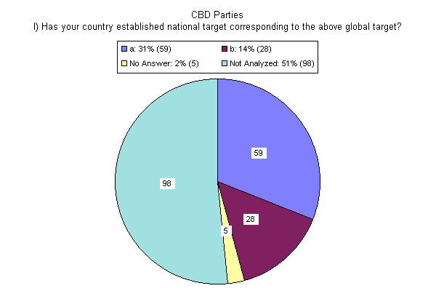

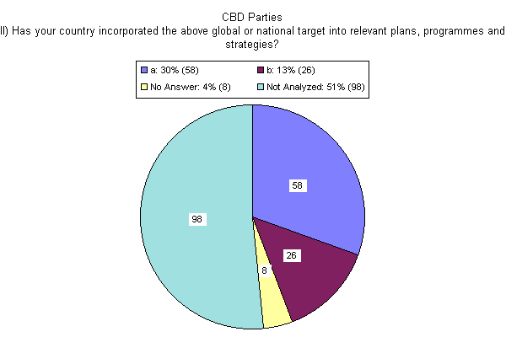

- While there was generally a good sample of responses to target 1, linked to the Global Taxonomy Initiative, not all targets had as many responses. Many of the responses were qualitative and not quantitative hence difficult to analyse and assess progress in implementation. There were very few responses to targets 6, 10, 12 and 13. In general, the range of responses for the questions related to setting national targets and incorporating these targets (mainstreaming) as well as progress in implementation are summarized in the three figures below.
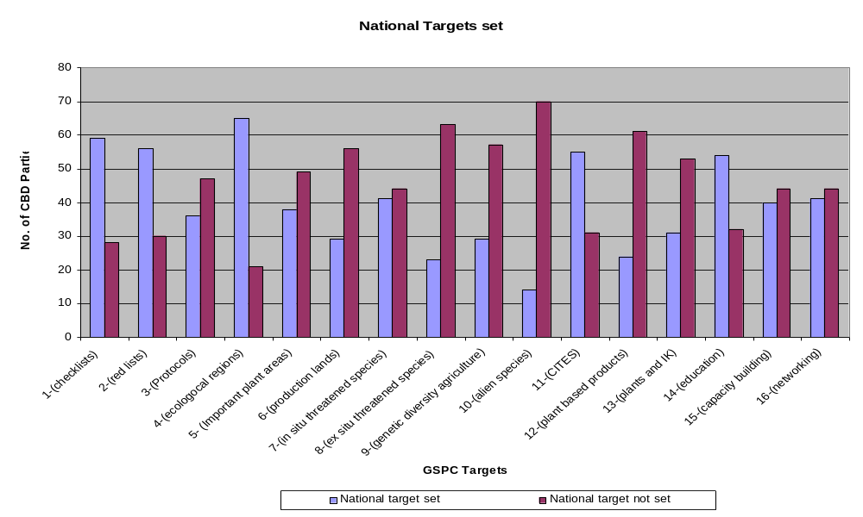
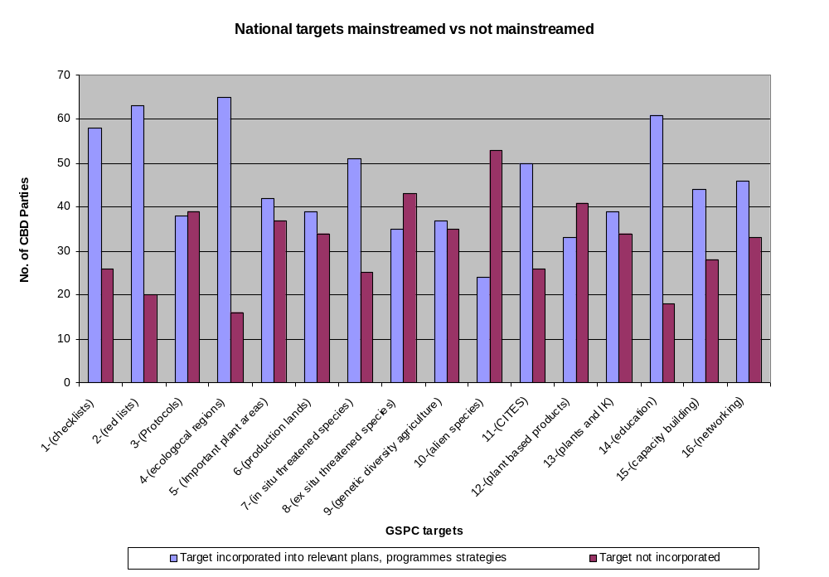
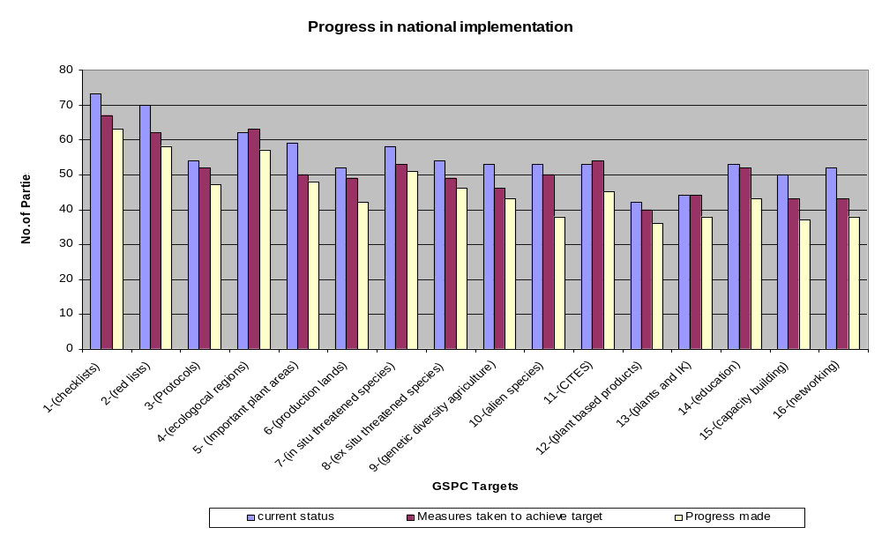

D. Highlights from the responses to the third national report on the progress in implementation of the GSPC
- While some Parties have noted progress in the implementation of the targets of the GSPC and incorporated the respective targets into the national biodiversity strategies and action plans, forestry and agricultural sectoral plans in some instances, in general, target setting at national level is limited.
- Much progress has been achieved by countries where regional programmes and initiatives are in place, such as in Europe in the context of the European Strategy for Plant Conservation and regional initiatives such as Natura 2000 and the EU Habitats Directive. Other examples include the Southern African Countries (Namibia, South Africa, Botswana, Malawi, Swaziland and Zimbabwe) that were part of the GEF funded Southern African Botanical Diversity Network (SABONET) project whose objectives closely matched in part the GSPC targets 1, 2, 3, 5, 7, 8, 13, 14, 15 and 16.
- However, there are national initiatives that led to the significant progress in achieving targets at national and global level such as the completion of the Flora of China (target 1), the revised red list in the United Kingdom, Ethiopia and Southern Africa, etc (target 2); mapping and conservation of the Cape region in South Africa (target 4,5,7 and 8); Important Plant Areas Projects and Natura 2000 Projects in Europe (target 5); Community-based conservation in Nepal and India (target 9), Community-based certification Malaysia, Swaziland and Eastern Europe (target 12), the Plant Resources of South East Asia (PROSEA) and Plants of Tropical Africa (PROTA) Projects supported by Netherlands and National Policies on Traditional and Alternative Medicine (Philippines and China); the proposed conservation for medicinal and herbal plants project (Jordan) and National inventories on traditional practices and use of biodiversity in Morocco (target 13).
- For all targets, the main constraints have been summarized as technical (lack of data, tools and technologies), financial (limited funding available), institutional (poor sectoral coordination and limited institutional capacity and capability) and regulatory (lack of appropriate supporting policies and legal framework). The limited awareness at national level on plant conservation needs has been highlighted a major setback in making progress towards setting national targets, implementing the GSPC and achieving the national, regional and global targets.
- However, various protocols, tools and technologies as well as national experiences have been highlighted in the reports. These include in vitro propagation (Algeria), recovery planning and threat abatement (Austria and Australia), important plant areas designation, (Belgium, Romania and Slovenia), ex situ and in situ conservation (Colombia, Chile, China, India Indonesia and Iran), forest tree breeding (Japan), GIS based conservation models and permanent ecological plots (Malawi), sustainable forest management models (Malaysia), sustainable use models in community forest and pro-poor leasehold forests (Nepal), Translocation of threatened species (Australia), Greening using native seed (Australia) Propagation and harvesting protocols (Chile), implementation of the ecosystem approach (Germany) and species action plans taking into consideration various national and international legislation and conventions (Hungary).
- Others include primordial botanic gardens and grand forest parks (Indonesia), wild relatives projects and integrated management of cedar forests (Lebanon), medicinal and useful plants (Nepal), Conservation of threatened species (Phillipines), Propagation and cultivation of South African threatened species (South Africa), special use forests (Vietnam) and economic valuation of forests (Malaysia).
- Also, while a lot of activities linked to target 2 are ongoing at national level, national target setting has not been indicted as a priority but rather linked to generic national biodiversity assessments. China, Ethiopia, Ghana, India, Malaysia, Philippines, Thailand have initiated preliminary red listing programmes while various countries indicated having a national red list , though various criteria have been used including the IUCN criteria. These are Austria, Australia, Belgium, Denmark, Finland, France, Ireland, Israel, Latvia, Republic of Moldova, Netherlands, Norway, Poland, Singapore, Slovenia, South Africa, Swaziland, Sweden and United Kingdom. Indonesia has focused its red listing initiatives on CITES species while Nepal intends to start the process soon. Some parties have the lists online such as Mexico. The European Union is also supporting a regional initiative in the Mediterranean region, the EURO+MED Initiative.
- With regard to targets 7, 8 and 9, the Government of Armenia is conserving its 387 rare and endangered plants through the Protected Area system; Botswana has identified 43 red list taxa and has regulated harvesting of commercial valuable species while Ethiopia through the Forest Genetic Resources Conservation Project has initiated in situ conservation for five selected species. Latvia has established 61 micro reserves for threatened species; Lesotho has protected 21 populations of the spiral Aloe in situ with community involvement while Lithuania has established 33 botanical reserves.
- Malaysia held its 1st national workshop to assess the plant conservation status of its flora in 2005, while Nepal is focusing on sustainable use as means for ensuring in situ conservation of the threatened species. In South Africa, the threatened and endemic species have been used in determining the priority areas for conservation in the 2005 National Biodiversity Spatial Assessment while in Tajikstan, 126 threatened species are protected by law. While a preliminary red list assessment has been undertaken in Thailand, the United Kingdom is working through various agencies to ensure in situ conservation of threatened plant species.
- While there is increased activity in the botanic gardens community in relation to target 8, very few countries have set national targets or adopted the global target. However, there are examples of regional initiatives such as the European Botanic Gardens Action Plan. China has over 300 botanic gardens with 25 medium-term gene banks and there are various other national botanic gardens associations which are focusing on this target (e.g. South Africa, Romania, Thailand, Chile and the United Kingdom). In general, there was a concern of limited physical, technical and financial resources to achieve this target (e.g. Botswana and Armenia).
- Target 9 has been addressed by many countries through their national response to the FAO Global Plan of Action for the Conservation and Sustainable Use of Plant Genetic Resources for Food and Agriculture. The target has been linked to national agricultural and forestry strategies and sectoral policies such as in Cote d’Ivoire and Cameroon though has not been relevant for some countries, such as Singapore. Various countries are seeking to broaden the mandates of their national plant genetic resource centres to include documentation of indigenous knowledge and practices such as Ethiopia, China, Ireland, Mexico, Nepal and Armenia amongst others.
- Australia has various initiatives on alien invasive species mainly as a result of implementing the Programme of Work on Alien Invasive Species to which target 10 is linked, working closely with the Global Invasive Species Programme and the IUCN species survival commission. They have identified and developed rigorous management strategies for twenty invasive species of national significance and most of the data is available online. Belgium has developed four management plans, Chile put in place control mechanisms for 10 exotic species, while Ireland has management plans for 10 species and Ghana a national programme for two species.
- Many countries indicated ongoing activities on target 11 linked to the national implementation of the CITES Convention and seem to have adopted the global target.
- Many Parties indicated active programmes on education and public awareness mainly linked to the national biodiversity strategies and action plans, national environmental education programmes and policies and the Global Initiative on Communication, Education and Public Awareness under the Convention on Biological Diversity. However, it was apparent that a lot of these activities are mainly undertaken by the conservation, environmental and development non-governmental organizations.
- Most of the capacity-building initiatives are linked to the academic sector and many gaps and challenges were highlighted in relation to this target. Many networks were also highlighted but these were predominantly regional, e.g. the ASEAN Centre for Biodiversity, the Biodiversity Collections Access Service for Europe (BIOCASE), the Southern African Botanical Network (SABONET), Planta Europa,, Plant Resources for Tropical Africa (PROTA), the SADC Biodiversity Support Programme, South East Asian Botanical Collection Information Network (SEABCIN) and others. There were also regional and international networks for botanic gardens, plant genetic resources, protected areas, and plant conservation to which Parties or their stakeholders were affiliated. However, the national networks include the Australian Network for Plant Conservation Network, Irish Network for Plant Conservation, Indonesian National Biodiversity Information Network and Swedish Species Information Centre.

E. Global Partnership for Plant Conservation
- At its seventh meeting, the Conference of the Parties reviewed the progress made in the implementation of decision VI/9 on the Global Strategy for Plant Conservation and welcomed the establishment of a Global Partnership for Plant Conservation and encouraged Botanic Gardens Conservation International (BGCI) to continue its support for the partnership. In response, the Executive Secretary officially invited Dr. Peter Wyse Jackson of Botanic Gardens Conservation International to be the interim chair of the Global Partnership for Plant Conservation (GPPC).
- The Secretariat in collaboration with Botanic Gardens Conservation International hosted a side-event at the seventh meeting of the Conference of the Parties in order to provide an interactive forum for parties and regional initiatives to deliberate on the ways and means for supporting national parties in the implementation of the strategy; and to provide a platform for the relevant regional and international stakeholders to support and promote the implementation of the strategy through the Global Partnership for Plant Conservation, in collaboration with the Secretariat and GSPC Coordination Mechanism.
- The event was chaired by Prof. Oteng Yeboah, Chair of SBSTTA and Director, CSIR, Ghana. Key presentations were made by Prof. Brian Huntley, Director of the National Botanical Institute, South Africa and Project Leader of the GEF-funded Southern Africa Botanical Network (SABONET); Dr. Bian Tan, South East Asia Network for Botanic Gardens, Singapore and Dr. Abu Zinada, Chair, Arabian Plant Specialist Group and Head, National Commission for Wildlife Conservation and Development , Saudi Arabia.
- At this side event, the Global Partnership for Plant Conservation was officially launched as statements of support were made by the Secretariat of the Convention on Biological Diversity, BGCI, UNEP-WCMC, FAO, IUCN-SSC, IPGRI, ICRAF, BioNET International, GBIF, GISP, Plantlife International amongst others.
- An initial meeting of the facilitating organizations for the stakeholder consultations was held with members of the Global Partnership for Plant Conservation, in London, on 6-7 May 2004. The meeting was hosted by the interim chair of the GPPS, and aimed to compile an update on progress and key issues arising out of the stakeholder consultations. It also facilitated the deliberation on ways and means for mobilizing resources to facilitate implementation of the strategy and elaborate the structure, priority actions and the way forward for the GPPC.
- The Partnership organized the Plants 2010 Conference, which focused on strengthening the implementation of the GSPC at the national and regional levels, in Dublin, Ireland, from 22-25 October 2005. The Secretariat provided technical support for this conference. The goal of this conference was to bring together plant conservation scientists, policy makers and practitioners from throughout the world to share methods and results that will advance plant conservation measurably, and to provide and share experiences in plant conservation, in support of the implementation of the Global Strategy for Plant Conservation (GSPC). The conference attracted a wide range of participants to share their experiences and further the development of plant conservation. A special effort was made to support a few GSPC national focal points to attend the meeting. The outputs of the meeting included documented case-studies of GSPC implementation at national and regional levels, consensus on the Working Practices for the Partnership and Identification of gaps and priorities for the Partnership (http://www.plants2010.org).
- The Secretariat, together with the Global Partnership for Plant Conservation organized a symposium to review the progress on the GSPC and the challenges to implementation. The symposium was held at the XVII International Botanical Congress from 17-23 July 2005, in Vienna, Austria. The Secretariat provided comments on a draft resolution, adopted by the Congress, calling on Governments, inter-governmental bodies and others to make the achievement of the targets of the Global Strategy for Plant Conservation an urgent priority.
- Botanic Gardens Conservation International (BGCI) has continued to provide the Secretariat for the Partnership. In order to facilitate communication and public awareness, BGCI has set up and hosts the web page for the Partnership (http://www.plants2010.org).
- Various other workshops and initiatives on the GSPC have been organized by various members of the Partnership, and the limited sample illustrates the range of support to the implementation of the GSPC:
  - A workshop on target 1 was held at the Royal Botanic Gardens Kew from 28-30 June 2004, and in Reading, United Kingdom, on 7-8 January 2005, a conference on implementing the GSPC, organized by Plantnet;
  - Various Regional Important Plant Areas Workshops have been organized by Plantlife International with a focus on targets 2 and 5;
  - An international stakeholder consultation is ongoing to facilitate the revision of the 1993 Guidelines on medicinal plants by WWF, TRAFFIC, IUCN and WHO (target 13);
  - The World Conservation Union (IUCN), PlantLife International and Botanic Gardens Conservation International are developing a GEF Proposal for a project in support of GSPC targets 3, 13, 15 and 16 (“Conservation, sustainable management and public awareness of plants as a component of national sustainable development and poverty alleviation”). IUCN has formed a partnership with Botanic Gardens Conservation International (Kew, UK) and ArtDatabanken (Swedish Species Information Centre, Uppsala, Sweden), to support the implementation of the IUCN-BGCI GEF plant conservation project, which aims to support the implementation of the Global Strategy for Plant Conservation of the Convention on Biological Diversity in six countries (Cameroon, Sri Lanka; Costa Rica; Morocco; Philippines; Madagascar), and their respective regions, across the world. The partnership will develop and implement a fundraising strategy to help secure the co-financing required for implementation of this project. ArtDatabanken will provide key technical support and help raise the match funding needed to implement the GEF plant project, and will demonstrate the value of building similar partnerships to other agencies and foundations;
  - The Global Biodiversity Facility (GBIF) has set up seed funding to support GSPC target 1 activities, and invited the Secretariat to make a presentation on the GSPC and Biodiversity data needs at the GBIF Science Symposium – from 4 to 6 April 2006, in Cape Town, South Africa.

F. Support to the implementation of the GSPC by the Secretariat
- The Secretariat presented progress on the implementation of the Strategy at the CGIAR Annual General Meeting 2003 held in Nairobi, Kenya, from 28 to 31 October and invited CG centres join the Global Partnership and collaborators to participate in activities undertaken within the framework of the Global Strategy for Plant Conservation.
- At the second World Botanic Gardens Congress organized by BGCI in April 2004, the Secretariat presented an overview of the targets of the GSPC. An important outcome of the congress was the development of a series of 20 targets for botanic gardens to be achieved by 2010, to help measure the achievement of the objectives of the International Agenda for Botanic Gardens in Conservation and as a contribution towards the Global Strategy for Plant Conservation (see http://www.bgci.org.uk/events/congress_conclusions).
- The Secretariat also made presentations at the GBIF Science Symposium on 28 & 29 April 2004 in Mexico City and during the Outreach & Capacity Building session on 29 & 30 April, with the aim to promote the GSPC and target 2010 of the Convention on Biological Diversity.
- Further, the Secretariat provided technical input to the Fourth European Conference on the Conservation of Wild Plants: A workshop on the implementation of the Global Strategy for Plant Conservation in Europe from 17-20 September 2004, Valencia, Spain; organized by Planta Europa. The meeting reviewed the progress made in achieving the targets of the European Strategy for Plant Conservation, which is the European platform for the Implementation of the GSPC, and provided an opportunity to harmonize further the European Strategy targets with those of the GSPC. An action Plan for the next three years was agreed for Plant Conservation in Europe in the light of the GSPC (see http://www.nerium.net/plantaeuropa.htm).
- The Secretariat was also represented at the International Ecoagriculture Conference and Practitioners’ Fair convened at the World Agroforestry Centre in Nairobi, from 27 September to 1 October 2004 (www.ecoagriculturepartners.org <http://www.ecoagriculturepartners.org/).

G. Communication and public awareness of the GSPC
- The Secretariat has worked closely with the Global Invasive Species Programme Secretariat to facilitate a stakeholder consultation on target 10. A leaflet and brochure were developed for this target to enhance public awareness and engagement. Other leaflets were produced by Plantlife International on Target 5 and Botanic Gardens Conservation International on target 8 and 14.
- In an effort to make the GSPC more widely available to Parties, the GSPC brochure has now been translated into Arabic, Chinese, French, German, Italian, Japanese, Portuguese, Russian, and Spanish, by volunteers. Further, BGCI produced bookmarks summarizing the sixteen targets of the strategy in the six United Nations languages. These were distributed at the eight meeting of the Conference of Parties to the Convention, in Brazil.
- The GSPC brochures were distributed at the CITES Conference of Parties and the Second World Conservation Congress (IUCN) to raise awareness for GSPC and promote integration of targets.

H. Capacity-building
- In paragraph 6, the Conference of the Parties further emphasized the need for capacity-building, particularly in developing countries, small island developing States, and countries with economies in transition, in order to enable them implement the strategy. Further in paragraph 7, the Conference of the Parties invited Parties, other Governments financial mechanism, and funding organizations to provide adequate and timely support to the implementation of the strategy, especially by developing country Parties, in particular least developed countries and small island developing States among them, and Parties with economies in transition.
- In response to these decisions the Secretariat has involved in the planning and implementation of capacity-building initiatives to support the implementation of the strategy.
- The Secretariat, in collaboration with Royal Botanic Gardens, Kew, United Kingdom and Makerere University, Uganda, secured support to host the African regional expert course in plant conservation strategies. The course was held in Uganda from 10 to 23 November 2004. The course brought together experts from 16 African countries, Benin, Cameroon, Central African Republic , Ethiopia, Ghana, Liberia Madagascar, Morocco, Namibia, Nigeria, Seychelles, Togo, Uganda, United Republic of Tanzania, Zambia and Zimbabwe. Two other participants—from the Democratic Republic of Congo and Senegal—were not able to attend due to logistical constraints. The British American Tobacco Biodiversity Partnership supported full participant costs, while Kenya Airways supported the travel costs in part.
- The course received in-kind support from the members of the Global Partnership for Plant Conservation, thus the Botanic Gardens Conservation International in partnership with HSBC ‘Investing in Nature’, World Agroforestry Centre, International Plant Genetic Resources Institute, Flora and Fauna International , IUCN-The World Conservation Union, Plantlife International and Plant Talk.
- The course provided a basis for cascading capacity at regional level on the sixteen outcome targets of the strategy and how these can be developed into regional/or national strategies. At the end of the Course, a short brainstorming workshop was held on developing a regional strategy and with the support of the IUCN Eastern African Regional Office, a way forward was agreed. An action plan for the awareness raising of the GSPC at national and regional level was agreed.
- The Secretariat has facilitated communication with the various members of the Global Partnership and a draft work plan has been developed. Plans are underway for a partnership meeting in May 2005 and an evaluation of the progress in the implementation of the GSPC at the International Botanic Congress to be held in July 2005 in Vienna.
- The Secretariat has been actively involved in the development of the Eastern Africa network for traditional medicine and medicinal plants, funded by IDRC Canada as a contribution to the regional implementation of target 12 and 13 as well providing technical input to various other regional projects that contribute to the development of the relevant targets. Further technical support was provided to the GEF Botanical and Zoological Network Proposal for Eastern Africa in collaboration with the UNDP Regional Office in Nairobi. The Project will address elements of the GSPC as well as the GTI.
- With support from the Government’s Department for Environment, Food and Rural Affairs (DEFRA) of the United Kingdom through its WSSD IMPLEMENTATION FUND, the Caribbean Regional Workshop was jointly organized by the Joint Nature Conservation Committee (JNCC), Royal Botanic Gardens, Kew, and the Secretariat of the Convention on Biological Diversity/Botanic Gardens Conservation International. The main focus of the workshop was to increase the understanding and implementation of the Global Strategy for Plant Conservation in the Region by sharing local and international experiences especially from the United Kingdom and the Seychelles which had already developed national Strategies.
- The Workshop brought together seventeen delegates from eleven island States (Antigua & Barbuda, Belize, Bermuda, Cayman Islands, Dominica, Jamaica, Montserrat, St. Kitts and Nevis, St. Lucia, and Trinidad and Tobago), and was facilitated by Seychelles, Royal Botanic Gardens, Kew, United Kingdom; Joint Nature Conservation Committee of the United Kingdom and the Secretariat. The outcomes of the workshop include a regional informal network to facilitate the national and regional implementation of the GSPC, as well as project development for priority targets. A similar workshop is planned for China in early November, 2006.

III. Conclusion and recommendations
- The Strategy has provided a useful framework to bring together organizations and initiatives to meet common objectives. Various organizations are already working towards the respective targets, and where possible, they are incorporating actions towards achieving targets into existing work programmes. Botanic Gardens Conservation International and BioNET International, for example, recently reviewed their strategic plans and aligned them as necessary to the targets of the GSPC. Many other members of the Partnership are mainstreaming the relevant targets of the GSPC into their programmes, initiatives and projects.

- However, there are still challenges in strengthening national level implementation and developing regional strategies. The outcomes of the European Plant Conservation Strategy may provide useful lessons and the experiences of Seychelles, South Africa and the United Kingdom may be valuable in addressing national responses to the GSPC.

- In order to further enhance national implementation, further documentation and dissemination of case-studies may provide useful guidance and resources for Parties and facilitate the in depth review process. In addition, workshops on the Strategy for national focal points, which may be organized in conjunction with meetings of the Conference of the Parties, SBSTTA and regional meetings, as well as national workshops to promote the full engagement of all relevant stakeholders at national level, and other capacity-building activities at national level, may be recommended.
- There are various rationales for action at the regional level in support of the Strategy. Regional strategies may provide a useful scale for addressing some of the targets and may be recommended. In addition, regional meetings, held in appropriate languages, could help promote understanding and implementation of the Strategy, as was done with the Latin American Botanical Congress.
-----

* Organized jointly by the Convention on Biological Diversity and Global Partnership for Plant Conservation.
** UNEP/CBD/LG-GSPC/2/1.

