PC13 WG5 Doc. 1
(English only/Únicamente en inglés/Seulement en anglais)
CONVENTION ON INTERNATIONAL TRADE IN ENDANGERED SPECIES
OF WILD FAUNA AND FLORA
____________
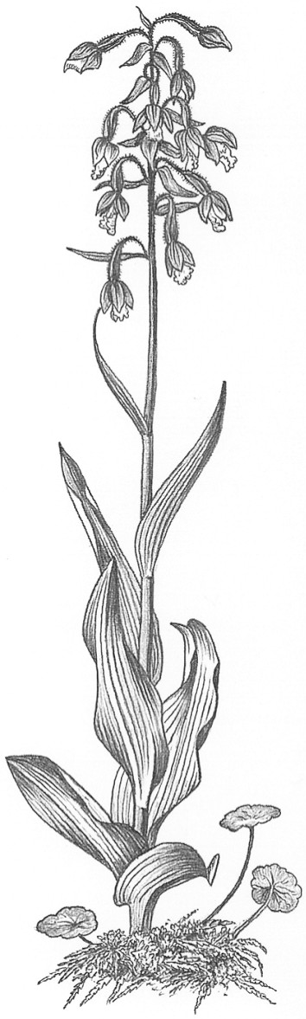
Thirteenth meeting of the Plants Committee
Geneva (Switzerland), 12-15 August 2003
Global Strategy for Plant Conservation (CBD):
Analysis and links with CBD [Decisions 12.12 and 10.86]
1. This document has been prepared by the group working on ways for the Plants Committee to assist in the implementation of the CBD Global Strategy for Plant Conservation (document PC13 Doc. 22).
2. The working group comprised the regional representative of Oceania and the observers from Austria, Mexico, FFI (Chairman), IUCN and UNEP-WCMC.
3. A working group met to discuss the link between CITES and the CBD Global Strategy for Plant Conservation (GSPC) from 18-19:00 on Thursday 14 August, 2003, composed of the parties from Australia, Mexico and Austria, and IUCN, UNEP-WCMC and FFI.
4. The working group examined the following issues:
a) CITES has been identified as the lead agency for target 11 of the CBD GSPC. Therefore the working group began considering the extent to which CITES can contribute to target 11, noting that CITES is actually contributing to many additional targets of the GSPC, at least in part. Therefore each of the 16 targets of the GSPC were examined to see where CITES work contributed and table 1 (annexed below) was drafted. In summary at least 10 plant conservation targets were identified as receiving a contribution from CITES to a greater or lesser extent.
b) It was decided that the work identified in this table should be brought together in a discussion paper for Plants Committee 14, and this would also provide a contribution for CITES to report their activities to the CBD. FFI offered to draft a discussion paper on CITES activities and collaboration based on the Plants Committee work programme, and to circulate it to members of the working group and any other interested parties for comments and additions.
c) It was felt that from this summary paper, indicators or measures of achievement, linking to the CITES Strategic Plan, could be developed to demonstrate the considerable progress CITES is making towards achieving Target 11.
d) It was also suggested that following Plants Committee 14, a document could be sent to the Standing Committee to add their perspective, as not only the work of the Plants Committee contributes to the targets outlined in the Global Strategy for Plant Conservation.
e) The mechanism for liaison with the CBD was discussed, and it was felt that the Chair of the Plants Committee should continue being the main contact, but recognising her workload, it is very important that support should be identified from the Plants Committee (possibly this working group and the Secretariat). CITES achievements should be reported to the ninth meeting of the Subsidiary Body on Scientific, Technical and Technological Advice (SBSTTA-9), as it is important that the CBD recognises the range of work undertaken by CITES.
f) Finally there was a discussion about non-CITES species threatened by trade. It was recognised that there are other mechanisms than CITES for preventing the threat to species from excessive levels of trade. However it was felt that in order to meet Target 11, there will need to be continuing commitment by CITES to examine the range of plant species in trade which are threatened, even if they are not currently CITES-listed species.
5. Other organisations can contribute significantly to the identification of plant species threatened by trade, notably IUCN through its Red List and Wildlife Trade Programme, and can develop solutions to ensure that trade is sustainable, working in partnership with CITES. It was agreed that if CITES is to act effectively as the lead agency for Target 11, additional resources may need to be found. GEF funding should be sought, e.g. for funding regional periodic reviews of species endangered by trade referred to in Dec.12.9 and Dec.12.10, and regional collaboration in order to achieve this target. Any externally funded projects should be developed in collaboration with the PC and approved by them.
Table 1. GSPC targets in which the work of CITES contributes (draft):
(A) Understanding and documenting plant diversity
(1) A widely accessible working list of known plant species, as a step towards a complete world flora. | Yes | Work of the nomenclature Periodic review and significant trade process. Checklists.
(2) A preliminary assessment of the conservation status of all known plant species, at national, regional and international levels. | Yes
(3) Development of models with protocols for plant conservation and sustainable use, based on research and practical experience. | Yes | Article 4 and best practice examples e.g. Guaiacum. Setting quotas and non-detriment findings.
(B) Conserving plant diversity
(4) At least 10 per cent of each of the world’s ecological regions effectively conserved. | No
(5) Protection of 50 per cent of the most important areas for plant diversity assured. | No
(6) At least 30 per cent of production lands managed consistent with the conservation of plant diversity. | No
(7) 60 per cent of the world’s threatened species conserved in situ. | Yes | Identifying App 1 species helps in establishing protected areas. Second, when there is sustainable use in situ studies (e.g. Harpagophytum) it provides an incentive for in situ conservation.
(8) 60 per cent of threatened plant species in accessible ex situ collections, preferably in the country of origin, and 10 per cent of them included in recovery and restoration programmes. | Yes or No? | Does cycad programme have relevance? Listing has created higher motivation for conservation work as opposed to simple collecting. Because they are listed, seeds of cacti in Mexico are cultivated in situ instead of flowing out of country.
(9) 70 per cent of the genetic diversity of crops and other major socio-economically valuable plant species conserved, and associated indigenous and local knowledge maintained. | No
(10) Management plans in place for at least 100 major alien species that threaten plants, plant communities and associated habitats and ecosystems. | No
(C) Using plant diversity sustainably
(11) No species of wild flora endangered by international trade. | Yes | Everything CITES does contributes to this target.
(12) 30 per cent of plant-based products derived from sources that are sustainably managed. | Yes | Annotations bring products into consideration.
(13) The decline of plant resources, and associated indigenous and local knowledge, innovations and practices that support sustainable livelihoods, local food security and health care, halted. | Yes | Non-detriment findings contribute at a minor level.
(D) Promoting education and awareness about plant diversity
(14) The importance of plant diversity and the need for its conservation incorporated into communication, educational and public –awareness programmes. | Yes
(E) Building capacity for the conservation of plant diversity
(15) The number of trained people working with appropriate facilities in plant conservation increased, according to national needs, to achieve the targets of this Strategy. | Yes | Training courses, slide packs, CD-ROM, training officer.
(16) Networks for plant conservation activities established or strengthened at national, regional and international levels. | Yes | CITES is a network. Regional directories are an expression of the network.

