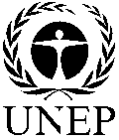 |  | CBD
 |  |  |  | Distr.  GENERAL  UNEP/CBD/SBI/1/INF/29  15 April 2016  ENGLISH ONLY
SUBSIDIARY BODY ON IMPLEMENTATION
First meeting
Montreal, Canada, 2-6 May 2016

Item 8 of the provisional agenda*

report on THE PROGRESS made and results achieved by the secretariat IN promoting and facilitating CAPACITY-BUILDING SUPPORT TO PARTIES FOR the effective IMPLEMENTation of THE CONVENTION AND ITS PROTOCOLS

Note by the Executive Secretary

INTRODUCTION
- In paragraph 8 of its decision XII/2 B (Enhancing support in implementing the objectives of the Convention and its Strategic Plan for Biodiversity 2011-2020), the Conference of the Parties requested the Executive Secretary, subject to availability of resources, to undertake various actions to further facilitate and promote capacity-building support to Parties for the effective implementation of the Convention and its Protocols.
- In accordance sub-paragraph 8(h) of the above decision, the present note provides, for the information of the Subsidiary Body on Implementation, a report on the progress made and results achieved in the implementation of the requests to the Executive Secretary contained in the aforementioned decision. A supplementary information document, progress on capacity development and participation of indigenous peoples and local communities in the work of the Convention is provided as UNEP/CBD/SBI/1/INF/1. A list of capacity-building activities supported and facilitated by the Secretariat since COP-12 is presented in annex I.
- Section II of the note presents a summary of the results of an evaluation of the effectiveness of capacity-building activities that the Secretariat has supported and facilitated, including recommendations on how to further integrate the needs expressed by Parties using participatory approaches. Section III presents a review of related partnership arrangements and opportunities for delivery of capacity-building support to Parties for the effective implementation of the Convention and its Protocols; and section IV presents an analysis of the gaps in capacity-building activities supporting the implementation of the Strategic Plan for Biodiversity 2011-2020.
- The present document complements the information presented in documents UNEP/CBD/SBI/1/6 (capacity-building, technical and scientific cooperation, technology transfer and the clearing-house mechanism) and UNEP/CBD/SBI/1/6/Add.1 (Short-term action plan (2017-2020) to enhance and support capacity-building and technical and scientific cooperation for the implementation of the Strategic Plan for Biodiversity 2011-2020). It may also complement information contained in documents, UNEP/CBD/SBI/1/2 (progress in the implementation of the Convention and the Strategic Plan for Biodiversity 2011-2020 and towards the achievement of the Aichi Biodiversity Targets) and UNEP/CBD/SBI/1/5 (strategic actions to enhance implementation of the Convention and the Strategic Plan for Biodiversity 2011-2020).

II. evaluation of the effectiveness of capacity-building activities supported and facilitated BY the Secretariat for the Implementation of the Strategic Plan for Biodiversity (2011-2020) ANd its Aichi Biodiversity Targets
- In response to the request contained in paragraph 8(d) of decision XII/2 B, the Executive Secretary through notification 2015-147 of 15 December 2015 invited national focal points and participants (including government officials and representatives of indigenous peoples and local communities) who took part in capacity-building activities facilitated and/or supported by the Secretariat during the period 2013-2015 to complete an online survey to evaluate the overall effectiveness of those activities and make recommendations for improvement. The survey was designed to complement the findings of the mid-term review of the Japan Biodiversity Fund (JBF) activities carried out between 2011 and 2012, which was conducted by the Institute for Global Environmental Strategies to, inter alia, assess the relevance and effectiveness of capacity-building activities of the JBF and document the lessons learned.
Methodology
- The survey was conducted online using surveymonkey from 15 December 2015 to 14 January 2016 and was available in English, French and Spanish. Participants were asked to respond to a total of 10 questions, six of which were multiple choice questions with the option of adding further information in a narrative form and four were narrative questions. In analysing the 74 pages of narrative responses received, the Secretariat focussed was on recurring issues and themes raised by various respondents. Some of the points or suggestions made by one or two respondents were also taken into consideration if they were considered crucial or innovative.
- A total of 144 responses to the survey were received from Africa (62), Asia-Pacific (27), Central and Eastern Europe (7), Latin America and the Caribbean (44) and Western Europe and Others Group (4). Of the 144 responses, 27 (17 per cent) were National Focal Points, 87 (54 per cent) were government-nominated participants in capacity-building activities organized or facilitated by the Secretariat and 46 (or 29 per cent) were from representatives of indigenous peoples and local communities.
Level of participation
- In response to Question 3 on the number of capacity-building activities the respondents had participated in during the period 2013-2015, the majority (119 or 83 per cent) indicated that they participated in at least 3 activities, 19 respondents (or 13 per cent) participated in 3 to 5 activities and 3 respondents (2 per cent) participated in more than 5 activities. Three respondents did not participate in any activity.
Subject matter covered
- In response to Question 4, many respondents indicated that the capacity-building activities they participated and/or the capacity-building materials they accessed and used covered Aichi Target 17 on the national biodiversity strategies and action plans (52 respondents), Target 18 on traditional knowledge (52 participants), Target 16 on the Nagoya Protocol (51 respondents), Target 11 on Protected areas (48) and Target 20 on financial resources (46). The least covered subject areas were Target 3 on incentives and Target 8 on pollution. The other subject areas covered are outlined in table 1 below.
Table 1: Subject matter covered by the capacity-building activities
Aichi Target 17: NBSAPs adopted as policy instrument | 52
Aichi Target 18: Traditional knowledge respected | 52
Aichi Target 16: Nagoya Protocol in force and operational | 51
Aichi Target 11: Protected areas increased and improved | 48
Aichi Target 20: Financial resources from all sources increased | 46
Aichi Target 2: Biodiversity values integrated | 39
Aichi Target 1: Awareness increased | 38
Aichi Target 14: Ecosystems and essential services safeguarded | 30
Aichi Target 19: Knowledge improved, shared and applied | 30
Aichi Target 15: Ecosystems restored and resilience enhanced | 28
Aichi Target 5: Habitat loss halved or reduced | 25
Aichi Target 10: Pressures on vulnerable ecosystems reduced | 25
Aichi Target 9: Invasive alien species prevented and controlled | 24
Cartagena Protocol on Biosafety | 18
Aichi Target 12: Extinction prevented | 18
Aichi Target 4: Sustainable production and consumption | 16
Aichi Target 6: Sustainable management of marine living resources | 16
Aichi Target 13: Genetic diversity maintained | 14
Aichi Target 7: Sustainable agriculture, aquaculture and forestry | 13
Aichi Target 3: Incentives reformed | 10
Aichi Target 8: Pollution reduced | 10
Quality of organization and delivery of the activities
- In Question 5, the respondents were invited to indicate on a scale of 1 to 4 their level of agreement with the statement that the capacity-building activities they participated in were well organized and delivered. A large number of respondents (62) strongly agreed, 79 respondents agreed and only 3 respondents disagreed.
- Specifically, a number of respondents commented that the activities provided a conducive environment for learning and allowed for interaction and sharing of experiences and lessons learned. Many also noted that the content was good and comprehensive and was clearly explained. Many also commented that the training materials were very useful, relevant and practical and also that documentation was sent to participants prior to the workshops. A number of respondents also commented that the resource people were very good. A few others made the following statements: the mandatory preparatory work was useful, the exercises were useful and practical, the field trip was well connected to the content and the next steps were clearly defined and understood.
- In terms of improvements needed, some respondents commented that activities they participated in did not allow for adequate time to cover the vast material presented and to engage and share experiences with other participants. A few others noted that the content presented was difficult to apply in their country context. Two respondents commented that it was difficult for IPLCs to be part of the workshop composed of mostly government officials noting that this limited the effective participation.
Usefulness and effectiveness of the capacity-building activities/materials
- In Question 6, the respondents were asked to indicate how the capacity-building activities and materials were useful and effective in facilitating their involvement in and increasing their ability and confidence to contribute to national processes. The results presented in table 2 below shows the 64 respondents (48 per cent) who participated in the capacity-building/training workshops strongly agreed with the statement that those workshops were useful and effective, 64 respondents (46 per cent) agreed and only 8 respondents (6 per cent) disagreed.
Table 2: Capacity-building activities/materials were useful and effective
Type of capacity-building | Strongly Agree | Agree | Disagree | Strongly Disagree | Not Applicable | Total
Capacity-building/training workshops | 67 | 64 | 8 | 0 | 3 | 142
E-learning activities, including webinars | 17 | 62 | 10 | 2 | 33 | 124
Pilot projects/ experiential learning activities | 32 | 60 | 7 | 0 | 25 | 124
Needs assessments/analyses | 24 | 72 | 11 | 1 | 18 | 126
Training/guidance materials | 48 | 70 | 5 | 0 | 8 | 131
Technical support/policy advice | 43 | 63 | 8 | 0 | 14 | 128
Case studies and lessons learned | 32 | 54 | 5 | 0 | 8 | 99
- With regard to e-learning activities, including webinars, a large of number participants (33 respondents or 27 per cent) indicated that this part of the question was not applicable to them, perhaps meaning that they had not participated in e-learning activities. Of the 91 respondents who indicated that they participated in e-learning activities, 17 (or 19 per cent) strongly agreed that they were useful and effective, 62 (or 68 per cent) agreed, 10 (or 11 per cent) disagreed, and 2 (2 per cent) strongly disagreed. These results indicate that this capacity-building modality is still not yet widely used by Parties, other governments and indigenous peoples and local communities. They also indicate that a fairly large number of participants who have used it (12 respondents or 10 per cent) have so far not found it effective. A few respondents commented that the online learning activities are not as successful because participants are not actively engaged and is difficult to interact and share experiences with others. One respondent noted that webinars were difficult to follow due to technical challenges, including limited internet connectivity which resulted in sessions getting disconnected.
- A large number of the respondents (70 or 57 per cent) who utilized the training and guidance materials provided by the Secretariat agreed that they were useful and effective, 48 respondents (39 per cent) strongly agreed while 5 respondents (4 per cent) disagreed. Almost similar responses were made with regard to case studies and lessons learned.
- Quite a large number of the respondents (63 respondents or 55 per cent) who received technical support or policy advice from the Secretariat also agreed that such support and advice was useful and effective, 43 respondents (38 per cent) strongly agreed, while 8 respondents (7 per cent) disagreed.
- Overall, most respondents agreed or strongly agreed that the Secretariat’s capacity-building support was useful and effective in increasing their ability and confidence to contribute to national processes for the implementation of the Convention and its Protocols, particularly the training and guidance materials (96 per cent), the case studies and lessons learned (95 per cent), the capacity-building/training workshops (94 per cent) and the technical support/policy advice provided (93 per cent).
Relevance of the Secretariat's capacity-building activities and materials
- In response to Question 7, a majority of respondents (71 respondents or 49 per cent) strongly agreed that the Secretariat's capacity-building activities and materials were relevant to their work and responded to their country's capacity needs and priorities, 69 respondents (48 per cent) agreed and 4 respondents (3 per cent) disagreed. A number of respondents commented that the workshop material contributed to enhancing their skills to better perform at work and others said they used material provided by the Secretariat for their national capacity-building activities. Others noted that the case of real examples and the practical experiences shared by experts and other participants were relevant and useful for their work. Some suggested that examples of success stories and practical exercises would be useful.
- In response to Question 8, a majority of the respondents (73 respondents or 51 per cent) indicated that they had utilized/applied the knowledge, experience and skills acquired from the Secretariat capacity-building activities to a large extent, while 36 respondents (25 per cent) had done so to a very large extent, 29 respondents (20 per cent) to a limited extent while 6 respondents (4 per cent) to a very limited extend (see Figure 1 below). Specially, a number of respondents mentioned that they used the knowledge and skills in the development and implementation of projects, others applied them in training others and raising awareness at local and national level.
Figure 1: Extent to which the acquired knowledge and skills are utilized/applied
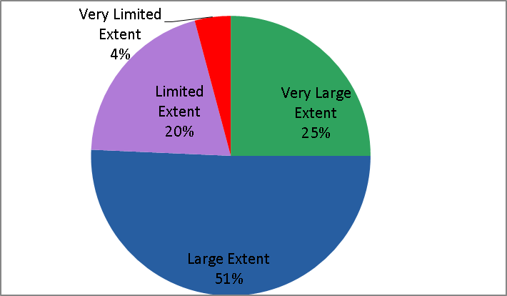

Recommendations for improving the effectiveness of the capacity-building activities
- In Question 9, the participants were invited to make recommendations for improving the effectiveness of the capacity-building activities the supported and/or facilitated by the Secretariat. A number of respondents recommended organization of more “train the trainers” activities, organization of more Webinars and online learning activities, development of more training and guidance materials; assessment of the countries’ specific needs before developing the content and programme of the capacity-building activities, better selection of participants to avoid recycling of participants, provision of follow-up support after workshops and creation of networks for participants to continue sharing experiences. A few others suggested the Secretariat should work towards getting more concrete and clear follow-up actions defined and work plans agreed at the end of the workshops. Other concrete suggestions included: allowing sufficient time for participants to complete the preparatory work; dividing participants according to their level of capacity; incorporating more practical sessions in the training activities; and adding more practical sessions and field work to the workshops.
- A large number of respondents also called for organization of more capacity-building workshops activities, especially on access and benefit-sharing, Article 8(j). Others suggested organizing workshops for sub-national authorities and other stakeholders, organizing more capacity-building activities at local level; inviting more regional organizations and experts in workshop to share their experiences and information about their work; involving more IPLCs in capacity-building activities; increasing the number of participants supported per country especially for big countries; and provision of financial assistance to Parties to organize capacity-building activities at national level.
- The SBI may wish to take note of the above evaluation results and request the Executive Secretary take necessary measures to improve the effectiveness of its capacity-building support activities, taking into account the results of the evaluation and the recommendations made.

III. Partnership arrangements and opportunities for delivery of capacity-building SUPPORT TO PARTIES
- The Secretariat is collaborating with a number of national, regional and international organizations programmes and initiatives in assisting Parties and indigenous peoples and local communities to implement the Convention and its Protocols. Over the last few years, the Executive Secretary has signed more than 200 partnership agreements (including Memoranda of Understanding and Memoranda of Cooperation etc.). More than half of those agreements include elements on collaboration to provide capacity-building support to Parties and stakeholders. A list of some of the organizations with which the Secretariat has signed a formal agreement is contained in Annex 2. In addition, the Secretariat collaborates on an ad hoc basis with a number of intergovernmental, non-governmental, academic and research and business sector organizations, in organizing or facilitating specific capacity-building activities.
- The Secretariat’s Capacity Development Strategy (2015-2020) highlights the importance of working through partners to deliver capacity-building support to Parties. It recognizes that partnering with organizations located in specific countries, regions or subregions and working directly with Parties and stakeholders on a day-to-day basis is more effective and sustainable way of delivering capacity-building.
    - Partnership arrangements
- The Secretariat has entered into various partnership arrangements with international organizations, civil society and the private sector depending on the purposes and conditions of the partnerships, the areas of mutual interest, the nature and profiles of the partners, as well as the operational and strategic opportunities and challenges. The most common partnership arrangements include the following:
  - Memorandum of understanding (MoUs): This is a non-binding partnership agreement that provides a framework for cooperation between the Secretariat and the partners for specific time-bound activities designed to achieve shared goals and objectives. This is the most common partnership arrangement entered into with international organizations. It establishes a common understanding and mutually recognized joint broad activities intended to promote the achievement of the objectives of the Convention and its Protocols.
  - Small Scale Funding Agreements (SSFAs): These are legally binding partnership agreements used when SCBD assigns the implementation of specific activities to a partner within a mutually agreed framework and transfers funds to the partner for this purpose not more than US$ 200,000 cumulatively to the same partner during a given biennial. A detailed activity-based budget and timeframe-based implementation plan that is linked to an approved or mandated activity is attached as an annex to the Agreement. The implementation plan specifies the scope of work and details the activities necessary to achieve the expected accomplishments.
  - Project Cooperation Agreements (PCAs): These are legally binding partnership agreements regarding specific standalone projects. Sometimes, a number of project cooperation agreements can come under one programme-based-agreement. For example, the Secretariat has signed PCAs with the International Union for Conservation of Nature and Natural Resources (IUCN) to deliver a project on “Resilience through investing in ecosystems – knowledge, innovation and transformation of risk management (RELIEF Kit)” and with the International Development Law Organization (IDLO) on a project entitled “Capacity-building Programme to support the implementation of the Nagoya Protocol”.
  - Programme-Based Partnerships (PbP) or Programme-Cooperation Agreements: These usually cover whole sector(s) or programmes and comprise multiple projects. Such agreements detail the projects/activities, the goals to be achieved; the strategy to follow, the parties’ responsibilities, risks and the funding sources. The Secretariat has so far entered into such an agreement with only a few organizations, including IUCN and the Secretariat of the Pacific Regional Environment Programme (SPREP). It hopes to use this arrangement more frequently under its new capacity-building strategy, whereby large partner organizations with the requisite capacity and comparative advantages would be engaged to deliver multiple capacity-building projects relating to different programmes of work.
  - Joint-Initiatives Partnerships (JIP): These are agreements entered with partners to implement joint initiatives such as delivery of training activities (courses, workshops, e-learning modules, etc.), development of university or school curricula or conduct of applied research. These agreements are typical with education and research institutions. The agreements detail funding sources, technical and funding responsibilities, shared risks, and expected outcomes. So far the Secretariat entered into such an agreement with CITES and is exploring opportunities of working with regional and subregional organizations and institutions (including universities) to undertake joint initiatives.
B. Partnership opportunities
- The Secretariat is coordinating or actively involved in a number of partnership initiatives which are directly contributing to capacity-building for the effective implementation of the Strategic Plan for Biodiversity and its Aichi Targets and the programmes of work. Key examples include the following:
  - The PoWPA Friends Consortium: This is an informal collaboration of individuals, non-governmental organizations, UN organizations and governments, united by the common theme of supporting implementation of the Programme of Work on Protected Areas. This consortium has assisted in conducting dozens of regional training workshops and also contributed to the development of e-learning modules on protected areas for self-paced learning;
  - The Sustainable Ocean Initiative (SOI): This initiative aims at building partnerships and enhancing capacity to conserve and sustainably use marine and coastal biodiversity in a holistic manner, building on lessons learned and knowledge gained. It facilitates the sharing and exchange of knowledge, information, experiences and practices; and promotes improved coordination and dialogue to support countries in their efforts to achieve the marine and coastal biodiversity-related Aichi Targets, in particular Targets 6, 10, and 11;
  - Global Taxonomy Initiative: GTI is implemented through a wide range of partners, including governments, non-government organizations, as well as taxonomic institutions. The partner organizations and initiatives identified by the Conference of the Parties as playing key roles in the implementation of the GTI are listed on the CBD website at: http://www.cbd.int/gti/partner.shtml;
  - The Collaborative Partnership on Forests (CPF): The Secretariat works closely with the CPF a voluntary partnership consisting of 14 international organizations, institutions and secretariats working on a range of issues concerning forests and sustainable forest management (SFM). Preparations for the CPF work plan 2017-2020 will identify priorities for collective action by all members to carry out its core functions, which includes joint programming and submission of coordinated proposals to respective governing bodies. CPF will also be identifying ways to activate the CPF Network;
  - Collaborative Partnership on Sustainable Wildlife Management (CPSWM): This is a voluntary partnership of international organizations with substantive mandates and programmes for the sustainable use and conservation of wildlife resources. It aims to, among other things, increase cooperation and coordination on sustainable wildlife management issues by: facilitating communication and sharing of information on policies, programmes and activities among members and other parties and undertaking joint initiatives and collaborative activities. It is currently consists of 13 organizations and is chaired by the CBD Executive Secretary;
  - Global Island Partnership (GLISPA): This partnership assists islands to advance the conservation of island biodiversity by inspiring leadership, catalyzing commitments, and facilitating targeted collaboration and exchanges among islands. It provides a global platform that enables islands to work together to develop solutions to common problems and to take high-level commitments and actions to build resilient and sustainable island communities;
  - The Global Invasive Alien Species Information Partnership (GIASIPartnership): This partnership provides a forum for scientists, environmental managers, policymakers and others share information and discuss issues in order to assist in the implementation of Article 8(h) and Aichi Biodiversity Target 9. It provides access to a range of information services and capacity-building tools. The Secretariat serves on the GIASIPartnership Steering Committee, which provides guidance and support to the Partnership;
  - The Global Partnership on Forest and Landscape Restoration (GPFLR): This is a proactive network uniting Governments, organizations, communities and individuals for the restoration of the world's degraded and deforested lands, contributing towards achieving several Aichi Biodiversity Targets and in particular targets 5, 14 and 15. GPFLR partners are involved in the Secretariat’s capacity-building activities organized under the Forest Ecosystem Restoration Initiative (FERI) through the support of the Korea Forest Service of the Republic of Korea;
  - The Group of Earth Observation Biodiversity Observation Network (GEO BON): This is a global partnership and network of organizations that are collaborating to collect, manage, analyze, and share data on the status and trends of the world’s biodiversity in order to facilitate improved policy and decision-making. GEO BON supports Parties through targeted capacity-building efforts at the national and regional level and provision of tools for data collection, integration and analysis. For example, it has developed a “BON in a Box” toolkit consisting of tools, protocols, software, methods and guidelines that facilitate effective biodiversity monitoring;
  - Consortium of Scientific Partners on Biodiversity: This consortium, which was initiated in March 2006, aims to leverage the expertise and experience of leading scientific institutions in order to implement education and training activities to support developing countries that are building scientific, technical and policy skills in the area of biodiversity;
  - The Aichi Biodiversity Targets Task Force: This task force, which comprises 29 organizations (international non-governmental organizations, intergovernmental organizations and United Nations entities, including the secretariats of biodiversity-related conventions) aims to contribute to the successful and timely implementation of the Strategic Plan for Biodiversity 2011-2020 and, more specifically, to provide a platform to exchange information and coordinate activities among the signatories in support of the efforts of their member countries and stakeholders towards achieving the 2020 Aichi Biodiversity Targets;
  - IPBES Capacity-building Forum: The capacity-building forum of the Intergovernmental Platform on Biodiversity and Ecosystem Services (IPBES) involves institutions that fund and/or themselves undertake capacity-building activities relevant to IPBES’s work. It is intended to facilitate both capacity-building projects and strategic alignments of activities between interested institutions;
  - WAVES partnership: Coordinated by the World Bank, the global partnership on wealth accounting and valuation of ecosystem services that aims to promote sustainable development by ensuring that natural resources are mainstreamed in development planning and national economic accounts. The Secretariat cooperates with WAVES partners, in particular the United Nations Statistics Division and the United Nations Environment Programme, in developing a suite of capacity-building guidance tools and manual for ecosystem accounting;
  - UNDP BIOFIN initiative: The Biodiversity Finance Initiative of the United Nations Development Programme is a global partnership seeking to address the biodiversity finance challenge in a comprehensive manner and to build a sound business case for increased investment in the management of ecosystems and biodiversity, in particular by supporting the development of national resource mobilization strategies in thirty pilot countries. The BIOFIN initiative is committed leverage its technical support to non-BIOFIN core countries and has been a close partner of the Secretariat in rolling out the capacity-building programme on resource mobilization since 2014.
- The above partnership initiatives and networks, and many others, provide important opportunities for facilitating the delivery of capacity-building activities in support of the implementation of the Strategic Plan for Biodiversity 2011-2020 and its Aichi Biodiversity Targets. SBI may wish to invite those partnerships and networks to further develop targeted programmes and share their experiences and lessons through the clearing-house mechanism.

IV. analysis of the gaps in capacity-building activities supporting the implementation of the Strategic Plan for Biodiversity 2011-2020
- At its previous meetings, the Conference of the Parties has adopted a number of decisions requesting Parties, relevant organizations and the Executive Secretary to undertake various capacity-building activities to support and facilitate the effective implementation of the Strategic Plan for Biodiversity and its Aichi Biodiversity Targets.
- Gaps in capacity-building activities can be analysed by Aichi Biodiversity Target, other thematic categories such as biomes, or by cross-cutting capacities needed to accomplish key actions. They can also be analysed at different scales from global, regional, national, subnational to local. For the purposes of this document “gaps” was taken to mean Aichi Biodiversity Targets, or geographic/political regions of the world where there is a lack of, or limited, capacity-building activities supported and/or facilitated by the Secretariat. “Activities” was taken to include workshops, webinars, trainings, pilot projects and/or projects or programmes containing a mixture of different approaches.
- In order to respond to paragraph 8(d)(iii) of decision XII/2B, the Secretariat has compiled (in annexes 1 and 2) information on the coverage of capacity-building activities by region and by Aichi Target, the coverage of the targets by capacity tools and materials, the number of COP decisions relating to capacity-building, and the status of implementation of the Aichi Biodiversity Targets as reported by Parties in their 5 national reports (also presented in document SBI/1/2/add 2).
    - Coverage of capacity-building activities by region and by Aichi Target
- Table 1/Figure 1 shows the gaps in coverage of regions and Aichi Biodiversity Targets of capacity-building activities supported by the Secretariat since COP-10. The information available shows that Targets 4, 7, and 13 have not had any capacity-building activities dedicated specifically to them in any region. The one activity reported covering Target 8 was specifically on marine debris and was a global workshop. The activities reported addressing Target 14, while covering almost all regions have addressed only the biodiversity and health angle and not the target’s broader intention of also the livelihoods and wellbeing of vulnerable groups related to the availability of ecosystem services. Likewise, the activities marked under Target 1 are those specifically addressing living modified organisms and not the broader intention of Aichi Biodiversity Target 1. Table 1/Figure 1 also shows activities supporting the implementation of Targets 1, 3 and 12 having relatively limited regional coverage. On the other hand, the information available indicates that Targets 2, 5, 6, 9, 10, 11, 15, 16, 17, 18, 20 and the Cartagena Protocol have been addressed by capacity-building activities in almost all the regions of the world since COP-10.
- With regard to regional coverage, Table 1 indicates that there has been a good regional balance in capacity-building activities supported by the Secretariat with the slight exception of Central Asia and of Western Europe.
Capacity-building tools available by Aichi Target
- Figure 2 shows the gaps in coverage of Aichi Targets by the capacity-building tools and materials available. Notably there seem to be no capacity-building materials at present to support the achievement of Targets 13 and 19. There are less than 5 tools available to support the implementation of Targets 8, 9, 10, 12, 15, 18, and 20.
COP decisions on capacity-building by Aichi Target
- Figure 3 shows that there is a substantial difference between Aichi Biodiversity Targets in terms of the number of COP decisions on capacity-building to support their achievement. Targets 2, 3, 4, 5, 7, 8, and 20, each have fewer than 5 decisions mandating capacity support for their implementation. However, Targets 12, and 13 are particularly notable as there have been no COP decisions mandating capacity support for their implementation and achievement.
Regions covered and tools available by Aichi Target (Figure 4)
- Figure 4 combines the regions covered by capacity-building activities and the number of tools available for each of the Aichi Targets. It shows that the targets that have been least supported are Targets 3, 4, 7, 8, 12 and 13. Targets 14 and 19 follow closely. These can be considered the gaps in capacity-building activities at the global level. In order to equate these gaps with the need to enhance capacity-building efforts to fill them, it is useful to compare these results with the status of implementation of each of the Aichi Biodiversity Targets.
- Figure 5 shows the status of implementation of the Aichi Targets as reported in Parties’ fifth national reports (included in document SBI/1/2/Add.2 (targets analysis)). It indicates that while most Parties are progressing (albeit at an insufficient rate) on most targets, many Parties are making no progress on almost all targets, and some Parties are moving away from a number of targets. The Targets of most concern seem to be Targets 5, 8, 9, 10, and 12 while targets 2, 3, 4, 6, 7, 9, 13, 14, 15 and 20 also seem to be lagging to varying degrees.
- Comparing the global “gaps” in capacity-building activities supported by the Secretariat with the status of implementation of the different targets shows some evident gaps in capacity-building activities. Targets 8, 12, and 13 coincide in the weakness of their regional coverage by capacity-building activities, the number of tools available to support their implementation, the number of decisions mandating support and their status of implementation. Targets 3, 4 and 7 also coincide in their weakness in the four parameters analysed although all have 5 or more capacity-building tools supporting their implementation.
- Target 5, although being the target most lagging in implementation seems to have a good coverage in terms of capacity-building activities as well as tools. The importance of this target for other targets (including but not only Target 12) may warrant a sustained effort to enhance capacity for its implementation. Targets 9, 10 and 20 are in much the same situation although fewer tools appear to be available to support their implementation.
- This analysis could be complemented with the results of the process undertaken under SBSTTA to identify key scientific and technical needs related to the implementation of the Strategic Plan for Biodiversity 2011-2020 (decision XII/1 annex I, UNEP/CBD/SBSTTA/19/3), and the process undertaken under SBSTTA-19 to identify further opportunities and additional strategic issues/ key actions for productive sectors. It can also be complemented by the results of reviews of implementation to take place under SBI-1 and in the Voluntary Peer Review process currently being tested under the Convention.
- Breaking down the status of implementation by region and comparing these to regional coverage of capacity-building activities may further indicate region-specific gaps. This could also be done at the national level.
- At the national level, capacity-building needs can be derived from Parties’ revised NBSAPs which, according to COP decision IX/8, should contain a national capacity development strategy. The Secretariat notes that, of the post COP-10 NBSAPs received to date, only 5 NBSAPs contain such a strategy, while some 30 others contain some capacity-building provisions (in doc SBI/1/2/Add.1). A preliminary analysis of the capacity needs expressed in the first 13 post COP-10 NBSAPs from developing Parties submitted to the Secretariat revealed that while some information can be gleaned in this way, for the most part, Parties are not systematic and explicit enough in their NBSAPs regarding their capacity needs to allow conclusions to be drawn and capacity-building programmes developed based (solely) on this information.
- Other sources of information on national level capacity needs are the National Capacity Self-Assessments (NSCAs) which were conducted between 2002 and 2010 with support from the Global Environment Facility. A total of 146 countries conducted these assessments to determine their capacity needs for implementing the Rio Conventions. While individual country reports can be examined, GEF’s global summary report indicates the top five capacity development needs expressed by countries: 1) public awareness and environmental education; 2) information management and exchange; 3) development and enforcement of policy and regulatory frameworks; 4) strengthening organizational mandates and structures; and 5) economic instruments and sustainable financing mechanisms.

Annex I
LIST OF CAPACITY-BUILDING ACTIVITIES SUPPORTED OR FACILITATED BY THE SECRETARIAT SINCE COP-12

Date / Country | Title of activity
16 - 20 November 2014  Dubai, United Arab Emirates | West Asia and North Africa Sub-regional Capacity-Building Workshop on Mainstreaming Biosafety into National Biodiversity Strategies and Action Plans and Resource Mobilization
17 - 20 November 2014  Cairo, Egypt | North Africa Regional Workshop of the UN-Water Initiative “Capacity Development to Support National Drought Management Policies”
21 - 22 November 2014  Cairo, Egypt | Joint workshop of the secretariats of the CBD and of UNCCD on synergies for the design, development and implementation of NBSAPs and NAPs
2 - 4 December 2014  Baltimore, United States of America | Expert Workshop to Prepare Practical Guidance on Preventing and Mitigating the Significant Adverse Impacts of Marine Debris on Marine and Coastal Biodiversity
8 - 12 December 2014  Montevideo, Uruguay | Latin America Sub-regional Capacity-Building Workshop on Mainstreaming Biosafety into National Biodiversity Strategies and Action Plans and Resource Mobilization
21, 22 January 2015  Online | Webinar on the ABS-CH
4, 5 February 2015  Online | Webinar on the ABS-CH
9 - 13 February 2015  Ulaanbaatar, Mongolia | Asia Regional Capacity-building Workshop on Mainstreaming Biosafety into National Biodiversity Strategies and Action Plans and Resource Mobilization
16 February 2015  Windhoek, Namibia | Southern African Workshop on CBD Implementation and Financial Reporting
23 - 27 February 2015  Lima, Peru | Sustainable Ocean Initiative (SOI) Capacity-building Workshop for South America
26 February 2015  Online | Webinar on the ABS-CH
2 March 2015  Managua, Nicaragua | Central American Workshop on CBD Implementation and Financial Reporting
9 - 13 March 2015  St. John's, Antigua and Barbuda | Caribbean Sub-regional Capacity-Building Workshop on Mainstreaming Biosafety into National Biodiversity Strategies and Action Plans and Resource Mobilization
16 March 2015  Colombo, Sri Lanka | Asian Workshop on CBD Implementation and Financial Reporting
22 - 27 March 2015  Colombo, Sri Lanka | CBD Regional Workshop to Facilitate the Description of Ecologically or Biologically Significant Marine Areas (EBSAs) in the North-East Indian Ocean region, and Training Session on EBSAs
13 April 2015  Asunción, Paraguay | South American Workshop on CBD Implementation and Financial Reporting
19 - 25 April 2015  Dubai, United Arab Emirates | CBD Regional Workshop to Facilitate the Description of Ecologically or Biologically Significant Marine Areas (EBSAs) in the North-West Indian Ocean and Adjacent Gulf Areas, and Training Session on EBSAs
20 April 2015  Cabo Verde | Western African Workshop on CBD Implementation and Financial Reporting
28 April 2015  Online | Webinar on the ABS-CH
4 - 7 May 2015  Accra, Ghana | West Africa Regional Workshop of the UN-Water Initiative “Capacity Development to Support National Drought Management Policies”
12 May 2015  Online | Webinar on the ABS-CH
18 - 21 May 2015  St. John's, Antigua and Barbuda | Sub-regional Capacity-building Workshop on Resource Mobilization for CARICOM member States
18 May 2015  Libreville, Gabon | Western African Workshop on CBD Implementation and Financial Reporting
27 - 28 May 2015  Guatemala City, Guatemala | Pacific Central American Expert Workshop for Marine Conservation and Sustainability
8 - 10 June 2015  Panajachel, Guatemala | International Training Workshop on Community-based Monitoring, Indicators on Traditional Knowledge and Customary Sustainable Use and Community Protocols, within the Strategic Plan for Biodiversity 2011-2020
9 - 11 June 2015  Ispra, Italy | Workshop of the Network of Laboratories for the Detection and Identification of Living Modified Organisms
11 - 13 June 2015  Panajachel, Guatemala | Dialogue Workshop on Assessment of Collective Action of Indigenous Peoples and Local Communities in Biodiversity Conservation and Resource Mobilization
22 June 2015  Georgia | Eastern European Workshop on CBD Implementation and Financial Reporting
11 - 15 September 2015  Yeosu, Republic of Korea | Sustainable Ocean Initiative (SOI) Training of Trainers Workshop
15 - 18 September 2015  Yanji, Jilin Province, China | Capacity-building Workshop for East Asia and Southeast Asia on achieving Aichi Biodiversity Targets 11 and 12
16 - 18 September 2015  New Delhi, India | Subregional Capacity-Building Workshop on Financial Reporting and Resource Mobilization for South Asia
28 - 30 September 2015  Apia, Samoa | Sustainable Ocean Initiative (SOI) National Capacity Development Workshop for Samoa
28 September - 1 October 2015  Curitiba, Paraná, Brazil | Capacity-building Workshop for Latin America and the Caribbean on achieving Aichi Biodiversity Targets 11 and 12
28 September - 2 October 2015  Sandton, Johannesburg, South Africa | Technical workshop on ecosystem-based approaches to climate change adaptation and disaster risk reduction
5 - 6 October 2015  Avarua, Cook Islands | Sub-regional Capacity-building Workshop on Financial Reporting and Resource Mobilization for the Pacific Region
5 - 9 October 2015  Accra, Ghana | Capacity-building workshop for West Africa on ecosystem restoration to support achievement of the Aichi Biodiversity Targets
13 - 16 October 2015  Swakopmund, Namibia | Sustainable Ocean Initiative (SOI) National Capacity Development Workshop for Namibia
26 - 27 October 2015  San José, Costa Rica | Sub-regional Capacity-building Workshop on Financial Reporting and Resource Mobilization for Spanish-speaking Central American and Caribbean Countries
12 - 13 November 2015  Lima, Peru | Subregional Capacity-building Workshop on Financial Reporting and Resource Mobilization for South America
17 - 19 November 2015  Mexico City, Mexico | International Expert Workshop on Biodiversity Mainstreaming
24 - 25 November 2015  Entebbe, Uganda | Subregional Capacity-building Workshop on Financial Reporting and Resource Mobilization for English Speaking African Countries
30 November - 1 December 2015  Manila, Philippines | Subregional Capacity-building Workshop on Financial Reporting and Resource Mobilization for Southeast Asia
1 - 2 December 2015  Dakar, Senegal | Subregional Capacity-building Workshop on Financial Reporting and Resource Mobilization for French Speaking African Countries
2 December 2015  Online | Webinar on the ABS-CH
7 - 10 December 2015  New Delhi, India | Capacity-building workshop for South, Central and West Asia on achieving Aichi Biodiversity Targets 11 and 12
13 - 18 December 2015  Xiamen, China | CBD Regional Workshop to Facilitate the Description of Ecologically or Biologically Significant Marine Areas (EBSAs) in the Seas of East Asia, and Training Session on EBSAs
14 - 18 December 2015  Saint John's, Antigua and Barbuda | Regional Capacity-Building Workshop for the Caribbean Region on Traditional Knowledge and Customary sustainable use under the Convention on Biological Diversity
18 - 22 January 2016  Nosy Be, Madagascar | Sustainable Ocean Initiative (SOI) Capacity Development Workshop for East Africa
25 - 29 January 2016  Nairobi, Kenya | African Training Workshop on Community Protocols, Indicators on Traditional Knowledge and Customary Sustainable Use under the Convention on Biological Diversity
8 - 11 February 2016  Geneva, Switzerland | Workshop on synergies among the biodiversity-related conventions
9 - 12 February 2016  Addis Ababa, Ethiopia | Africa Regional Capacity-Building Workshop on Mainstreaming Biosafety into National Biodiversity Strategies and Action Plans
25 - 26 February 2016  Tbilisi, Georgia | Subregional Capacity-building Workshop on Financial Reporting and Resource Mobilization for Eastern European and Central and West Asian Countries
7 - 11 March 2016  Ljubljana, Slovenia | Central and Eastern European Workshop on the Detection and Identification of Living Modified Organisms
21 - 24 March 2016  Entebbe, Uganda | Capacity-building workshop for Africa on achieving Aichi Biodiversity Targets 11 and 12
4 - 8 April 2016  Belgrade, Serbia | Regional Workshop for Central and Eastern Europe and Western Asia on the Clearing-House Mechanism
4 - 8 April 2016  Bogotá, Colombia | Capacity-building workshop for Latin America on the restoration of forests and other ecosystems to support the achievement of the related Aichi Biodiversity Targets

Annex II
LIST OF PARTNER ORGANIZATIONS SUPPORTING IMPLEMENTATION OF THE CONVENTION AND ITS PROTOCOLS
United Nations Agencies

- Food and Agriculture Organization of the United Nations (FAO)
- Global Environment Facility (GEF)
- International Civil Aviation Organization (ICAO)
- United Nations Conference on Trade and Development (UNCTAD)
- United Nations Convention to Combat Desertification (UNCCD)
- United Nations Development Programme (UNDP)
- United Nations Development Programme/Drylands Development Centre (UNDP - DDC)
- United Nations Economic Commission for Africa (UNECA)
- United Nations Economic Commission for Europe (UNECE)
- United Nations Economic Commission for Latin America and the Caribbean (UNECLAC)
- United Nations Educational, Scientific and Cultural Organization (UNESCO)
- United Nations Environment Programme (UNEP)
- UNEP Mediterranean Action Plan for the Barcelona Convention (UNEP/MAP)
- United Nations Forum on Forests (UNFF)
- United Nations Framework Convention of Climate Change
- United Nations Human Settlements Programme (UN-HABITAT)
- United Nations Industrial Development Organization (UNIDO) (UNIDO)
- United Nations Institute for Training and Research (UNITAR)
- United Nations University - Institute of Advanced Studies (UNU-IAS)
- United Nations University - International Institute for Global Health (UNU-IIGH)
- United Nations World Tourism Organization (UNWTO)
- World Bank
- World Heritage Centre of UNESCO
- World Health Organization (WHO)
- World Intellectual Property Organization (WIPO)
- World Organisation for Animal Health (OIE)

Intergovernmental organizations

- Asociación Latinoamericana de Integración (ALADI)
- Convention for the Protection and Development of the Marine environment of the Wider Caribbean Region (Cartagena Convention)
- Convention on International Trade in Endangered Species of Wild Fauna and Flora (CITES)
- Convention on the Conservation of European Wildlife and Natural Habitats (Bern Convention), Council of Europe (Bern Convention)
- Convention on the Conservation of Migratory Species of Wild Animals (CMS)
- International Coral Reef Initiative (ICRI)
- International Development Law Organization (IDLO)
- International Fund for Agricultural Development (IFAD)
- International Ocean Institute (IOI)
- International Plant Protection Convention Secretariat (FAO/IPPC)
- Intergovernmental Platform on Biodiversity and Ecosystem Services (IPBES)
- International Treaty on Plant Genetic Resources for Food and Agriculture, FAO (ITPGRFA)
- International Tropical Timber Organization (ITTO)
- International Union of Biological Sciences (IUBS)
- International Centre for Genetic Engineering and Biotechnology (ICGEB)
- International Union for Conservation of Nature (IUCN)
- Organization for Economic Co-operation and Development (OECD)
- Permanent Secretariat of the Amazon Cooperation Treaty Organization (ACTO-OTCA)
- Secretariat of the Pacific Regional Environment Programme (SPREP)

International organizations, initiatives and processes

- AEON Environmental Foundation
- African Centre for Technology Studies (ACTS)
- Alliance for Zero Extinction (AZE)
- Alliance of Small Island States (AOSIS)
- ASEAN Centre for Biodiversity (ACB)
- BioNET-INTERNATIONAL
- Bioversity International
- BirdLife International
- Botanic Gardens Conservation International (BGCI)
- CABI (CAB International)
- Census of Marine Life (CMoL)
- Center for International Forestry Research (CIFOR)
- Centro Internacional de Agricultura Tropical (CIAT)
- Comisión Nacional para el Conocimiento y Uso de la Biodiversidad (CONABIO)
- Comisión Permanente del Pacífico Sur (CPPS)
- Conservation International (CI)
- Consultative Group on International Agricultural Research (CGIAR)
- DIVERSITAS
- Fishbase Information and Research Group (FIN)
- GIZ/ABS Capacity Development Initiative
- Global Biodiversity Information Facility (GBIF)
- Global International Waters Assessment (UNEP/GIWA)
- Global Invasive Species Programme - Secretariat (GISP)
- Global Programme of Action for the Protection of the Marine Environment from Land-Based Activities (UNEP/GPA)
- Indigenous Women's Biodiversity Network
- Institut de l'Énergie et de l'Environnement de la Francophonie
- Institute for Global Environmental Strategies (IGES)
- Instituto Alexander Von Humboldt
- Instituto Nacional de Biodiversidad (INBio)
- Inter-American Biodiversity Information Network (IABIN)
- International Association for Impact Assessment (IAIA)
- International Barcode of Life (iBOL)
- International Federation of Agricultural Producers (IFAP)
- New Partnership for Africa's Development (NEPAD)
- Pan-European Biological and Landscape Diversity Strategy (PEBLDS) Secretariat
- Partnerships in Environmental Management for the Seas of East Asia (PEMSEA)
- Programme régional de Conservation de la zone Côtière et Marine en Afrique de l’Ouest (PRCM)
- Ramsar Convention on Wetlands (Ramsar)
- RARE Conservation
- Sedna Foundation (SEDNA)
- The Nature Conservancy (TNC)
- TRAFFIC International
- Union for Ethical BioTrade (UEBT)
- Western Indian Ocean Marine Science Association (WIOMSA)
- Wetlands International (WI)
- Wildlife Conservation Society (WCS)
- World Agroforestry Centre (ICRAF)
- World Association of Zoos and Aquariums (WAZA)
- World Future Council
- WWF International

Academic and Research Institutions

- Carleton University (Canada)
- Concordia University (Canada)
- Kobe University (Japan)
- McGill University (Canada)
- Museum National d'Histoire Naturelle (France)
- Natural History Museum
- Smithsonian National Museum of Natural History
- Stockholm University (SRC)
- Universidad Livre do Meio Ambiente (Brazil)
- Universita di Roma "La Sapienza"
- Université de Montréal (Canada)
- Université du Québec à Montréal –UQAM (Canada)
- Université Laval (Canada)
- University of Guelph (Canada)
- University of Tokyo (Japan)
- University of Toronto (Canada)

Annex III
Table 1 - Coverage of capacity-building activities organized by the Secretariat since COP-10
 | 1 - 2 activities organized |  |  | 3 - 4 activities organized |  |  | 5 -6 activities organized
  Region | Meso-America | South America | Caribbean |  | Pacific | S, E & SE Asia | MENA | Eastern Africa | Southern Africa | West Africa | Central Africa | Central Asia | CEE | Western Europe
  All Aichi Targets
  Aichi Target 1
  Aichi Target 2
  Aichi Target 3
  Aichi Target 4
  Aichi Target 5
  Aichi Target 6
  Aichi Target 7
  Aichi Target 8
  Aichi Target 9
  Aichi Target 10
  Aichi Target 11
  Aichi Target 12
  Aichi Target 13
  Aichi Target 14
  Aichi Target 15
  Aichi Target 16
  Aichi Target 17
  Aichi Target 18
  Aichi Target 19
  Aichi Target 20
  National Reports
  Biosafety Protocol
   | 1 - 2 activities organized |  |  | 3 - 4 activities organized |  |  | 5 -6 activities organized

Annex III
Figure 1 - Coverage of capacity-building activities organized by the Secretariat since COP-10

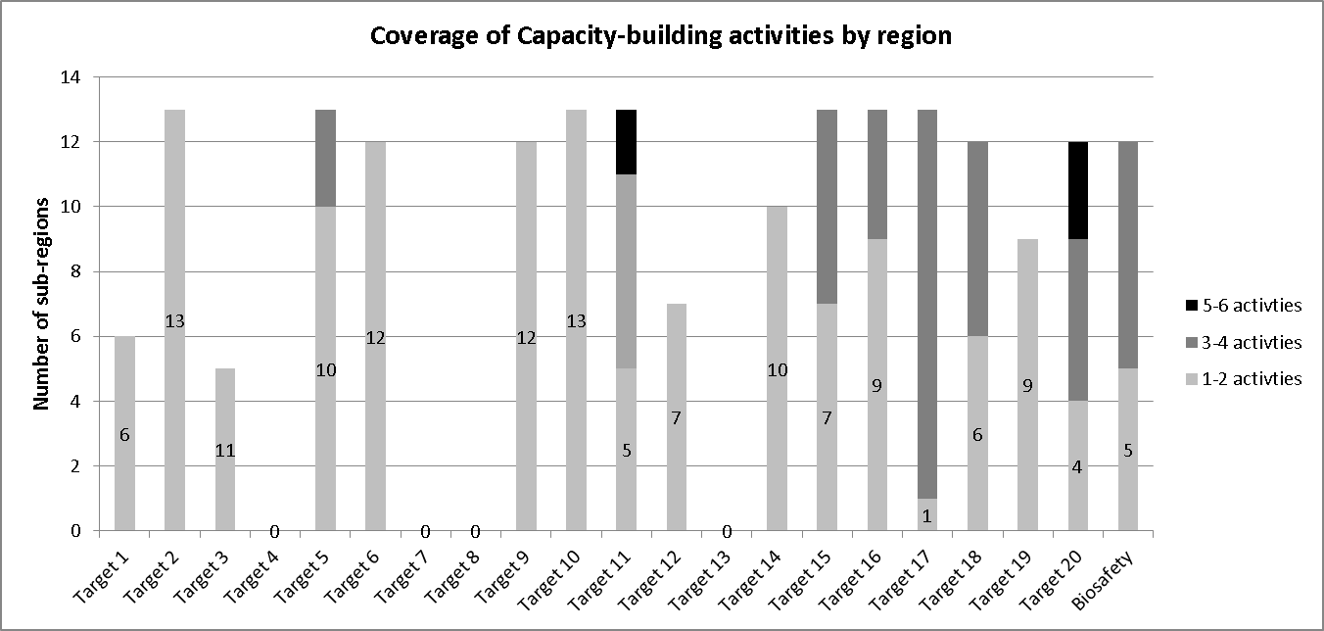

Annex IV
CAPACITY-BUILDING TOOLS AND MATERIALS AND CAPACITY-BUILDING DECISIONS FROM COP

Figure 2

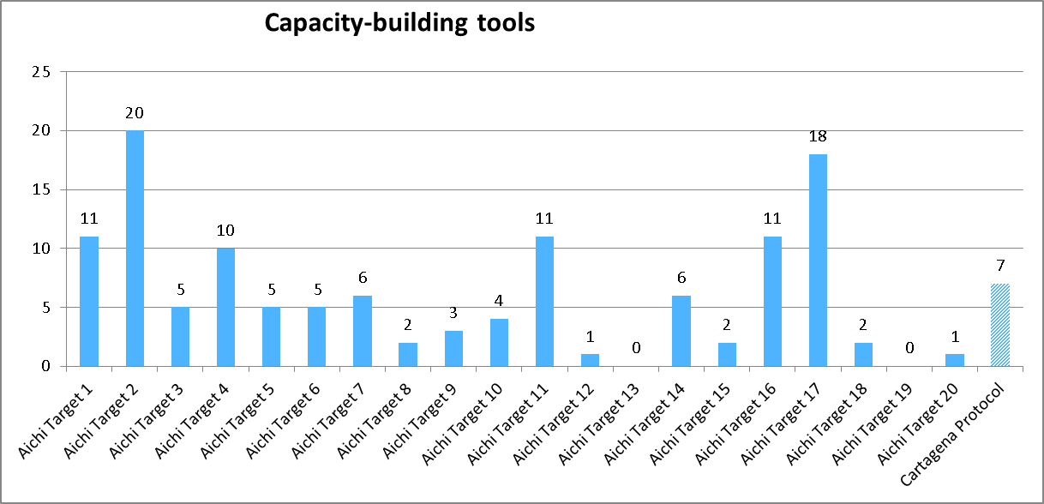

Figure 3
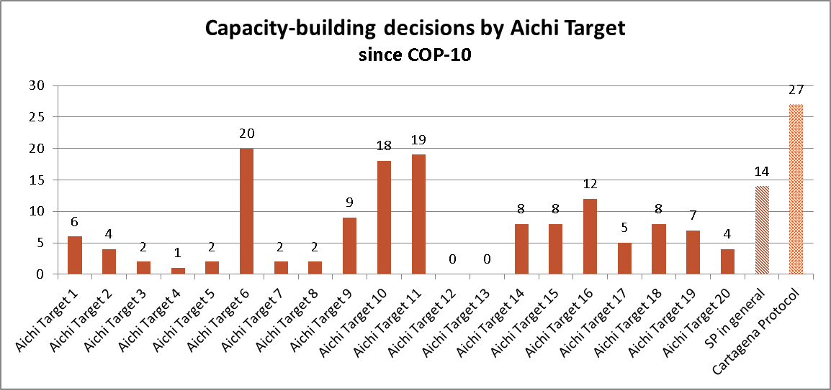

Figure 4
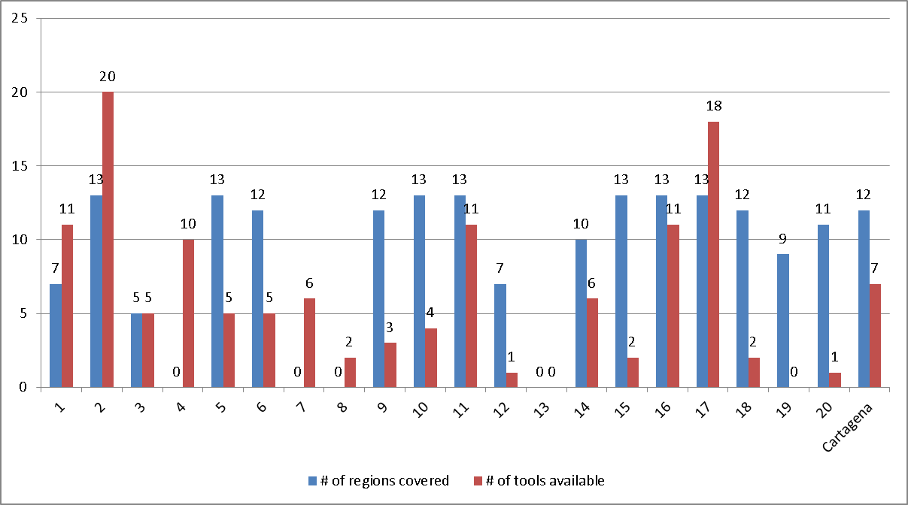

Figure 5 - Assessment of progress towards each of the Aichi Biodiversity Targets based on 10 information in the fifth national reports. The colored bars indicate the proportion of national reports in 11 each category.

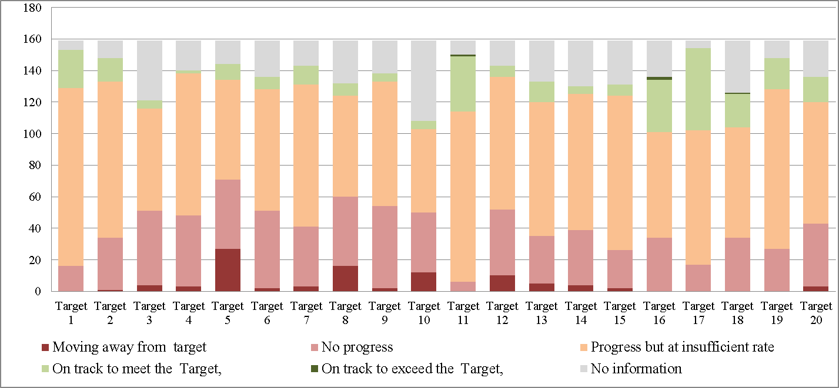

__________

* UNEP/CBD/SBI/1/1/Rev.1.
The list complements reports on the Secretariat’s previous capacity-building support to Parties for implementing the Convention and the Strategic Plan for Biodiversity 2011-2020 contained in documents UNEP/CBD/WGRI/5/3, UNEP/CBD/COP/11/13 and UNEP/CBD/COP/11/INF/13.
The partnership agreements are available on the CBD website at: http://www.cbd.int/agreements/
See details at: http://www.cbd.int/protected/friends
See details at: http://www.cbd.int/soi
CPF is composed of 14 forest institutions, organizations and convention secretariats. See: https://www.cbd.int/forest/partners.shtml
See details at: http://www.fao.org/forestry/wildlife-partnership/en/
See details at: https://www.cbd.int/island/glispa.shtml
See details at: http://giasipartnership.myspecies.info/en
See details at: http://www.forestlandscaperestoration.org/. More information on implementation of the FERI is provided in UNEP/CBD/SBSTTA/20/12.
See details at: http://geobon.org
The Consortium currently comprises at least 24 institutions. See details at: https://www.cbd.int/cooperation/csp/
See: https://www.cbd.int/doc/press/2011/pr-2011-09-20-GlobalPartners-en.pdf
See details at: http://www.ipbes.net/images/documents/WP/1ab/IPBES_capacity-building_forum_Concept-Note.pdf
See details at: www.wavespartnership.org
See details at: http://www.undp.org/content/undp/en/home/ourwork/environmentandenergy/projects_and_initiatives/biodiversity-finance-initiative/
Relevant decisions include: XI/2, XII/2B, XI/2, XII/2B, X/33 para. 8, XII/15 para 3, XI/16, para 5; XII/19, para 5, XI/1D paragraph 1, XII/16 para 9(a-b), XI/18, paras, IX/30, X/15, X/31 para 7, XI/24 para 10 and XII/3 para 30, 31 and 32.
This approach was chosen principally due to the limited information available, and for ease of analysis. However it must be cautioned that, as many of the Aichi Biodiversity Targets are closely interlinked, an activity covering one target may also cover other associated targets. This “indirect” coverage is not captured in the table and graphs. The results of the analysis may be further refined by consideration of these linkages and the coverage it may have afforded the targets that it indicates have been least covered. Likewise, it should be considered that in some regions some Aichi Biodiversity Targets may be less relevant or less in need of support for their implementation.
The tools considered for this analysis are those produced in close collaboration with the Secretariat and reported by the Secretariat Aichi Biodiversity Focal Points to the Capacity-Building Cluster. The Secretariat is aware of many partners producing many tools of different sorts with or without its specific collaboration. These tools and materials should be registered in the recently created database of capacity-building tools resources in order to be considered in future analyses of this type.
This analysis does not consider the quality of these capacity-building materials nor the need (or not) for additional materials. It also does not consider the availability of existing materials in different languages.
This analysis does not consider the contents of these decisions, only their existence/absence. The need (or not) for additional decisions depends a lot on weather previous decisions have been fulfilled and on the content of decisions.
Bellamy, Jean-Joseph and Kevin Hill (2010), “National Capacity Self-Assessments: Results and Lessons Learned for Global Environmental Sustainability”, Global Support Programme, Bureau for Development Policy, United Nations Development Programme, New York, USA.
The listed activities were taken from the CBD Calendar of Meetings from November 2010 to March 2016. Ongoing activities, and those planned for the near future are not in this table but are included in the action plan presented in document UNEP/CBD/SBI/1/6/Add.1)

