 |  | CBD
 |  |  |  | Distr.:  GENERAL  UNEP/CBD/SBI/1/INF/43  20 April 2016  ENGLISH ONLY
Subsidiary Body on IMPLEMENTATION
First meeting
Montreal, Canada, 2-6 May 2016
Item 15 of the provisional agenda*
FURTHER INFORMATION ON THE TRENDS OF THE BUDGETS OF THE CONVENTION AND ITS PROTOCOLS
I. INTRODUCTION
- The present document has been developed to provide Parties with an overview of how the budget of the Secretariat has evolved over time and to identify certain resulting challenges faced by the Secretariat. Through the exercise of the Functional Review of the Secretariat and the resulting move to more integration of the work of the Convention and its two Protocols, it has become evident that a more integrated budget for the Secretariat is also required.
Background
- The budget for the Convention on Biological Diversity is funded through the following four elements in keeping with decision I/6, annex I, and decision III/24 respectively:
- Core budget funded from assessed contributions to the Convention (General Trust Fund of the Convention on Biological Diversity (BY Trust Fund);
- Voluntary budget for additional approved activities of the Convention (Special Voluntary Trust Fund for additional approved activities (BE Trust Fund);
- Voluntary budget for the support of Developing country Parties and Economies in Transition to participate in the activities of the Convention (Special Voluntary Trust Fund for Participation of Parties in the activities of the Convention (BZ Trust Fund);
- Voluntary budget for the support of Indigenous and Local Communities to participate in the activities of the Convention (Special Voluntary Trust Fund for Participation of Indigenous and Local Communities in the activities of the Convention (VB Trust Fund).
- The budget is approved by the Conference of the Parties on a biennial basis. Once the core budget is agreed by Parties, the assessed contributions of each Party is calculated based on the approved budget of the Convention, and the United Nations rate of assessment adjusted for the Convention so that no Party pays more than 22% of the budget, no least developed country Party pays more that 0.01% of the budget, and the European Commission pays 2.5% of the budget.
- The voluntary budgets are indicative, showing the estimated costs for the additional approved activities to be undertaken in the biennium, as well as the estimated costs for developing countries, economies in transition and indigenous and local communities to attend the open-ended meetings of the Convention during the biennium.
- Similar to the Convention, the two Protocols (Cartagena Protocol on Biosafety and the Nagoya Protocol on Access and Benefit Sharing of Genetic Resources) also have core budgets and voluntary budgets, supported by their respective trust funds (decision BS-I/10 and decision NP I/13 respectively) as follows:
- Core budget funded from assessed contributions to the Cartagena Protocol (General Trust Fund of the Cartagena Protocol on Biosafety (BG Trust Fund)
- Voluntary budget for additional approved activities of the Cartagena Protocol (Special Voluntary Trust Fund for additional approved activities (BH Trust Fund)
- Core budget funded from assessed contributions to the Nagoya Protocol (General Trust Fund of the Nagoya Protocol on Access and Benefit Sharing (BB Trust Fund)
- Voluntary budget for additional approved activities of the Nagoya Protocol (Special Voluntary Trust Fund for additional approved activities (BX Trust Fund)
- Donors are encouraged to contribute to the Voluntary Trust Funds of the Convention and its Protocols.
II. CORE BUDGET OF THE CONVENTION AND ITS PROTOCOLS
- The core budget of the Convention funds the following items within the Secretariat, with percentages in accordance with the current budget:
- Staff costs (60%)
- Consultants/subcontracts (1%)
- Meeting costs (11%)
- Official travel (3%)
- General operating expenses (13%)
- Programme support costs and Working Capital Reserve (14%)
A. Staff costs
- For the biennium 2015-2016, the Conference of the Parties approved a budget of US$ 28,626,300 of which US$ 17,146,400 or 60% was for staff costs of 59.5 staff members (33.5 Professional staff members and 26 General Service staff members). Also included under staff costs are funds for temporary assistance, overtime and training costs. The 59.5 staff members approved by the Conference of the Parties includes 7 staff members that are shared on a 85:15 ratio with the Cartagena Protocol and 1 staff member shared on a 50:50 ratio. This cost sharing applies to staff working in the information technology, knowledge management, legal, and capacity-building fields and represents the estimated staff-time allocated to the Convention and Biosafety Protocol.
B. Consultants/subcontracts
- US$ 220,000 was approved for consultancies and subcontracts for the biennium 2015-2016, representing 1% of the approved budget. These funds include funding for the translation of the CHM website, as well and funds of US$ 20,000 per year per Division in the Secretariat for consultancy work.
C. Meeting costs
- For the biennium 2015-2016, the Conference of the Parties approved a budget of US$ 3,049,700 for meeting costs representing 11% of the biennial budget. Meeting costs cover the recruitment of interpreters (salaries and travel costs) report writers and translators for SCBD open-ended meetings as well as the cost of translating pre- and post-session documents into the six official United Nations languages. Other costs covered relate to the rental of conference rooms, security costs, rental of equipment, coffee breaks and other miscellaneous items. Meetings covered include WG Art 8(j); SBSTTA, SBI, COP and COP and SBSTTA Bureau meetings.
D. Official travel
- Official travel for the biennium is 3% of the budget and covers the attendance of SCBD staff at meetings and activities in support of the implementation of the Convention. The budget approved for 2015-2016 is US$ 800,000.
E. General operating expenses
- Costs covered under general operating expenses include the rental and maintenance of the Secretariat premises, communications, furniture and equipment, printing and publications, hospitality and stationery and supplies. It represents 13% of the budget and totals US$ 1,017,100 for the biennium 2015-2016. General operating expenses is shared between the Convention and the Cartagena Protocol on Biosafety on a 85%:15% ratio.
F. Programme support costs
- Programme Support Costs (PSC) represents 13% of expenditures and is paid directly to UNEP for administration of the Convention. These funds are, in turn used to pay for 19 finance and administration staff at the Secretariat (4 Professionals and 15 General Service staff). 67% of the funds are allotted directly to the Secretariat for their use and the remaining 33% is retained by UNEP to support Nairobi-based administrative and financial support. The total approved PSC for 2015-2016 is US$ 3,205,300.
G. Working capital reserve
- The Working Capital Reserve ensures continuity of operations of the Convention’s Secretariat in the event of a temporary shortfall of cash where contributions are coming in late and/or to cover for contingent liabilities in case the organization is dissolved. Any drawdowns from the working capital reserve must be restored from contributions as soon as possible.
- The Working Capital Reserve was first established by the Conference of the Parties for the biennium 2003-2004. The initial amount approved for the working capital reserve was US$ 878,272, (4% of the total 2003-2004 budget of US$ 21,956,800 including programme support costs), which in decision VI/29 the Parties decided on an exceptional basis, without setting a precedent for future biennia would be taken from the saving and surplus of the Convention’s Trust Fund.
- At its Seventh meeting, the Conference of the Parties, in decision VII/6 decided to “…set the working capital reserve at a level of 5 per cent of the core budget (BY Trust Fund) expenditure, including programme support costs.”
- In keeping with United Nations requirements, at its twelfth meeting, the Conference of the Parties, in decision XII/32 decided to “increase the working capital reserve to a level of 7.5 per cent of the core budget (BY Trust Fund) expenditure, including programme support costs and to do so from the existing BY fund balance.”
- The total amount approved to be included in the budget as a working capital reserve for the biennium 2015-2016 was US$ 765,100, representing the amount needed to bring the WCR to a total of 7.5% of 2015-2016 expenditure including PSC.
- Table 1. below illustrates the core budgets approved by the Parties for the Convention and the Cartagena and Nagoya Protocols over past bienniums.
- Table 2 below illustrates the voluntary budgets approved by the Parties for the Convention and the Cartagena and Nagoya Protocols over past bienniums.

H. Voluntary Funds of the Convention and its Protocols
- As can been seen from the preceding, the core budget of the Convention supports only the basic costs of the Convention, mostly staff costs and the basic costs of major meetings. No activities, beyond the major meetings, are funded through the core budget. Most of the activities of the Convention that are requested by the Conference of the Parties, including most studies and capacity building activities etc., as well as the participation of delegates from developing countries in the major meetings, are funded through the voluntary Trust Funds of the Convention (BE, BZ, VB) and through the voluntary Trust funds of the Protocols (BH and BX).
- The Secretariat in preparing its budget proposal takes into account the cost (in terms of funds and time) of delivering the required outputs emanating from the recommendations from the intersessional meetings of the Convention (WGArt8(j); SBSTTA and SBI), and of the Protocols (AHTEG, Compliance Committees and Liaison Groups). These are costed and included in the draft budget recommendations to the Conference and Meetings of the Parties.
- For the biennium 2015-2016, the Conference of the Parties approved a voluntary budget (BE Trust Fund) of USD 31,234,900. Thus the voluntary budget is greater than the core budget approved for the biennium (9% higher).
- The majority of these funds (45%) were approved for the convening of various meetings and regional and international Workshops. 18% of the budget was for staff costs and 12% for consultants and sub-contracts. The remainder of the budget was comprised of travel (8%), publications (6%) and PSC (12%).
- As of the end of 2015, the total voluntary contributions to the BE Trust Fund, received in response to the approved budget, amounted to USD 12,094,100 or 39%. Of these funds, 42% were contributed for meetings and workshops (16% of total funds approved); 33% of the funds received were contributed for consultants (13% of total funds approved); 8% were allocated for travel (3% of total funds approved) and 3% were allocated for staff (1% of total funds approved). See Fig.1 below.
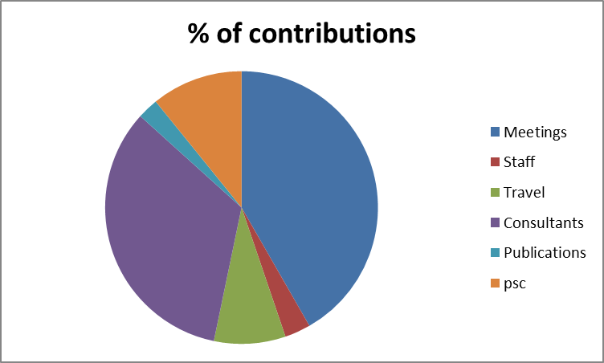
Figure 1. Voluntary contributions to the BE Trust Fund in 2015
- Given that only 1% of the funds received through voluntary contributions was allotted for staff costs, even though the secretariat received 39% of the funds approved by the COP, the ability to utilize these funds were extremely restricted due to lack or insufficiency of staff to cover these activities. This is one of the problems that has been identified over the years by the Secretariat in attempting to implement the activities approved by Parties.
- Nearly all activities implemented by SCBD rely, at least to some extent, on voluntary resources; and yet there are large uncertainties concerning the level and timing of funding. Together with the increased time requirements and decreased flexibility in the light of Umoja, this makes it difficult to deliver on these activities in a predictable, timely and strategic way;
- This issue has arisen in the past, and the Parties attempted to address it during COP-10, when they decided that in reviewing the voluntary budget they would not approve any activity for which they did not have a donor. This would ensure that the budget was fully funded and that the Secretariat could plan in advance without having to wait to see what voluntary funds would be forthcoming.
- The result of that decision was positive as at the end of the biennium 2011-2012 the Secretariat had received contributions to the BE Trust Fund in excess of the amount approved by COP-10. This result however, was also due to the large contribution of USD 50 Million made to the Convention by the Government of Japan through the Japan Biodiversity Fund
- Given the past experience the Secretariat strongly recommends the return to the system that was instituted at COP-10 of receiving firm pledges for the voluntary funds at the time that the budget is being negotiated and of only approving the voluntary budget with those commitments. This would enable the Secretariat to match its resources to the requests of Parties and to focus more efficiently on providing support to Parties in their implementation of the Convention and its Protocols.
- In order to facilitate this process the Secretariat could estimate costs of all recommendations to the COP just after the SBI meeting and then issue a notification with call for pledges in advance to the COP.
I. Participation of developing countries and countries with economies in transition
- The BZ Trust Fund was established in 1997 for voluntary contributions from Parties (donor countries) to enable the participation of developing country Parties – in particular the least developed countries and small island developing States – as well as Parties with economies in transition in the meetings of the Convention.
- Over the years, the contributions to this fund have been complex: from COP 5 to COP 8 the peak funding was in the year prior to the COP, for COP 9 and 10, the peak funding was in the year of the COP (showing the active role of host Governments) and, after COP 10, there has been a continuing decline in funding. The maximum received in any year amounted to US$ 2.35 million in 2010, followed by US$ 1.85 million in 2011 and US$ 1.74 million in 2005. The minimum received in any year was US$ 311,000 in 2015 followed by US$ 316,000 in 2006 and US$ 386,000 in 2004.
- As can be seen from the chart below, the trend for the past five years (2010-2015) has been steadily declining (a fourfold decline).

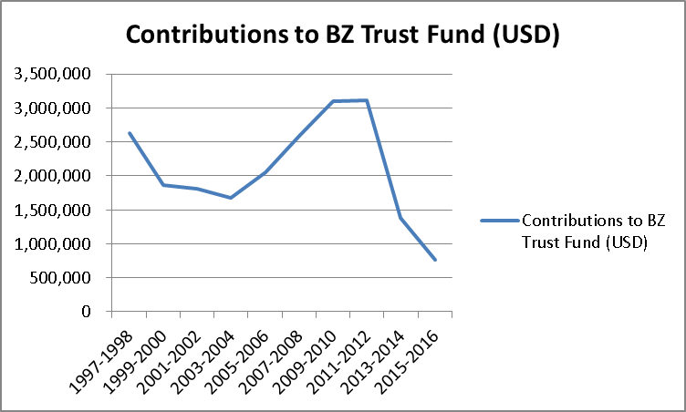
Figure 2. BZ Trust Fund trend in contributions for participants travel 1997-2016

- The funding denoted here covers the costs of participation of developing countries and economies in transition not only to COP and COP-MOP, but also to all other intersessional open-ended meetings of the Convention – SBSTTA, WGRI, WG8(j); ICNP and SBI.
- The decline in funding for participants, as seen in figure 2 above, has meant that, increasingly, the Secretariat has been able to fund the attendance of only least developed country Parties and small island developing State Parties, and, in the majority of cases, only one delegate to attend two meetings that are held back-to-back, or concurrently.
- With the movement towards more integration between the Convention and its two Protocols, including the organization of concurrent COP and COP/MOPs, and given the decision taken at COP-12 (XII/32.24) to merge the BI Trust Fund for the participation of developing country Parties and economies in transition of the Cartagena Protocol with the BZ Trust Fund of the Convention, there is clearly a need for more support for developing country Parties and Parties with economies in transition to be funded to attend the meetings of the Convention and its Protocols – particularly given the new structure, whereby items are considered in proximity, and the Convention and both Protocols are meeting at different times within the same week. (Decisions XII/32.29; BS VII/7; NP I/13.14 and 15)
- In past budget proposals, the Secretariat has included a proposal for funding within the core budget to guarantee funding for at least one least developed country to attend the open-ended meetings of the Convention, which would then hopefully release the funds received from donors to be able to support additional participants. This proposal has, however, been consistently rejected by Parties at budget discussions in recent COPs.
- Other strategies in the past have involved the use of any surpluses accrued under the core budget to pay for limited participation costs of least developed countries and small island developing States. This was done during the earlier years of the Convention (2000-2004) when large surpluses existed. However with time and the full staffing of the Secretariat, such surpluses have diminished, and Parties have preferred to use them to reduce their assessed contributions to the Convention. During the past two bienniums (2013-2014 and 2015-2016), a total of US$ 1.1M has been used from surpluses in this manner.
- Given the move towards fuller integration, the Secretariat strongly recommends that Parties re-look at the mechanisms in place for the funding of participants to the meetings of the Convention and its Protocols. Without the full and meaningful participation of Parties, the work of the Convention and its Protocols loses legitimacy and credibility and cannot proceed. Not only is additional funding required for participation, but that funding needs to be delivered in a timely and predictable manner.
- A number of United Nations organizations and conventions have established financial mechanisms (trust funds) to fund the participation of developing countries and countries with economies in transition in their processes. Such organizations and conventions include the United Nations Framework Convention on Climate Change (UNFCCC), the United Nations Convention to Combat Desertification (UNCCD), the Convention on Migratory Species (CMS), the Ramsar Convention on Wetlands, the Stockholm Convention on Persistent Organic Pollutants (POPs Convention), the Vienna Convention for the Protection of the Ozone Layer and its Montreal Protocol, the Codex Alimentarius Commission, the United Nations Conference on Trade and Development (UNCTAD), and the United Nations Division for Ocean Affairs and the Law of the Sea.
- Since the establishment of the category of least developed countries, the United Nations General Assembly has provided financial support to the representatives of these countries to attend its meetings. However, only three processes have developed clear guidelines and procedures on the allocation of funds to eligible countries. These are the United Nations Framework Convention on Climate Change, the Convention on Migratory Species, and the Ramsar Convention.
- The Ramsar Convention has established the most elaborate procedure for the allocation of funding for participation to eligible countries. At its twenty-sixth meeting, in 2001, the Ramsar Standing Committee decided that the allocation of funds by the Ramsar Convention Secretariat (at the time known as the “Ramsar Bureau”) for sponsored participants shall be as follows (see decision SC26-40):
(a) Funds should be directed first to one delegate from each Ramsar Contracting Party in the United Nations list of least developed countries;
(b) Additional funds should be allocated to one delegate from Contracting Parties that are developing countries and countries with economies in transition;
(c) In case funds are still available, they should be allocated to a second delegate from least developed countries;
(d) In case funds are still available, they should be allocated to a second delegate from developing countries and countries with economies in transition.
- In 2015, the Ramsar Convention added, paragraph 28 of Resolution XII.1: “REQUESTS the Secretariat to utilize the UN Conference on Trade and Development’s list of Small Island Developing States (SIDS) when determining eligibility for sponsorship for delegate travel and to consider SIDS as eligible for support whether or not they are formally classified as such on economic grounds in the OECD Development Assistance Committee (DAC) list;”
- The Parties to the Convention on Migratory Species, on the other hand, have established a threshold for eligibility for funding based on the United Nations scale of assessments for the apportionment of the expenses of the Organization. In its resolution 8.3, the Conference of the Parties to the Convention agreed to set the threshold of eligibility for funding participants to attend the meetings under the Convention at 0.200 per cent on the United Nations scale of assessments in the following order of priority:
(a) Countries lowest on the scale, and others with no unpaid pledges to the Convention, in ascending order up to the 0.200 per cent threshold;
(b) Countries with unpaid pledges to the Convention in ascending order on the scale, up to the 0.200 per cent threshold;
(c) Non-Party developing countries, Range States and countries actively preparing accession that had not previously received a subsidy to attend a meeting of the Conference of the Parties.
- Under the United Nations Framework Convention on Climate Change, funding is provided for the participation of one delegate from each eligible developing country and country with economy in transition. If funds are available, support is provided for a second delegate from small island developing States and least developed countries. Eligibility for funding is extended to all countries eligible for United Nations assistance and is therefore determined according to per capita gross domestic product (GDP). Parties are eligible for funding if their per capita gross domestic product did not exceed US$ 6,500 in 2002 according to the UNCTAD Data Management Service. However, owing to their vulnerability to climate change, this ceiling is raised to US$ 10,000 in the case of small island developing States or if a Party provides an officer to serve as a member of the Bureau (FCCC/SBI/2004/13).
- In the case of the Convention on International Trade in Endangered Species of Wild Fauna and Flora (CITES), no funding is included in the core budget for Parties attending the COP meetings, and the Secretariat therefore mobilizes resources to ensure that all Parties are adequately represented at the COP meeting through the Sponsored Delegates Project (SDP), which was first established for the COP 6 meeting in 1987. The fund-raising target for the 17th meeting of the COP, in September/October 2016, in Johannesburg, South Africa, is US$ 1 million.
- The SDP aims to ensure representation at meetings of the COP of least developed countries, developing countries and countries with economies in transition that do not have sufficient funds to support the participation of two delegates. Full participation in meetings of the COP is essential to ensure that the decisions and recommendations that are voted reflect the agreements reached by the majority of CITES Parties.
- Notifications are sent to Parties asking them to submit requests for financial support for the travel and subsistence of up to two representatives to attend the COP meeting via their national management authorities at least four and a half months prior to the COP meeting, allowing the Secretariat to review and process the requests based on funds raised for this purpose.
- The review process internally is based on requests received on time, available funds, regional representation and priority is given to Parties unable to fund the participation of two delegates and therefore they are also asked to provide information on the expected size of their delegations.
- For members of governing bodies, i.e. Animals, Plants and Standing Committees, funding is included in the core budget for about 6-10 members for the respective meeting, and the Secretariat will process their travel and subsistence.
III. CONCLUSIONS
- The guidelines approved by the Conference of the Parties for the apportionment of funds for the participation of developing country parties and economies in transition in the meetings of the Convention and its Protocols should be revisited with a view to providing additional support to Parties in the light of concurrent meetings, with special attention to least developed countries and small island developing States.
- Approval of the BE Trust Fund should be based on firm pledges for the voluntary funding made at the time that the budget is negotiated.
- In order to secure more predictable funding from voluntary sources, estimates of the costs of all recommendations to the COP should be prepared just after the SBI meeting and a call for pledges based on these estimates made in advance to the COP.
- Additionally, Parties that are able, including developing country Parties, should make concrete pledges in advance, in support of the BE Trust Fund, to enable the Secretariat to plan its activities more efficiently and in a timely manner.
- The way in which the costs of the core budgets of the Secretariat are shared between the Convention, the Cartagena Protocol and the Nagoya Protocol should be reviewed in the light of the increased integration of work and taking into account the number of Parties to the respective instruments.

__________

* UNEP/CBD/SBI/1/1/Rev.1.

