 |  |  | CBD
 |  | CONVENTION ON  BIOLOGICAL DIVERSITY |  | Distr.  GENERAL  UNEP/CBD/SBSTTA/11/INF/16  15 November 2005  ENGLISH ONLY
SUBSIDIARY BODY ON SCIENTIFIC, TECHNICAL AND TECHNOLOGICAL ADVICE
Eleventh meeting
Montreal, 28 November-2 December 2005
Item 5 of the provisional agenda*

Biodiversity Indicators for National Reporting: Experiences from five countries

Information document by the World Conservation Monitoring Centre of the United Nations Environment Programme (UNEP-WCMC), The Netherlands Environmental Assessment Agency (MNP), Kenya Wildlife Service, Bureau of Fisheries and Aquatic Resources (The Philippines), Ukraine Land Resource Management Center, and EcoCiencia (Ecuador)
Note by the Executive Secretary
- In decision VII/30 the Conference of the Parties invited Parties and Governments to use existing national indicators or to establish national indicators using the tools (UNEP/CBD/SBSTTA/9/10) referred to in decision VII/8, on monitoring and indicators, and according to their national needs and priorities, to assess progress towards their national/and or regional targets (para 16). As far as is feasible, the indicators should be identified or developed in such as way that the same indicators may be used at the global, regional, national and local levels as tools for the implementation of the Convention and of national biodiversity strategies and action plans, where so desired by Parties (para 3).
- The attached document summarizes the experiences made in this context in five countries. It was prepared by the World Conservation Monitoring Centre of the United Nations Environment Programme (UNEP-WCMC), The Netherlands Environmental Assessment Agency (MNP), Kenya Wildlife Service, Bureau of Fisheries and Aquatic Resources (The Philippines), Ukraine Land Resource Management Center, and EcoCiencia (Ecuador).
- The document is being circulated, in the language and form in which it was received by the Secretariat of the Convention on Biological Diversity, for the information of participants in the eleventh meeting of the Subsidiary Body on Scientific, Technical and Technological Advice (SBSTTA).

Biodiversity Indicators for National Reporting: Experiences from five countries
Prepared by the World Conservation Monitoring Centre of the United Nations Environment Programme (UNEP-WCMC), The Netherlands Environmental Assessment Agency (MNP), Kenya Wildlife Service, Bureau of Fisheries and Aquatic Resources (The Philippines), Ukraine Land Resource Management Center, and EcoCiencia (Ecuador)
- Introduction
The aim of this INF paper is to provide some insights and recommendations on the benefits of biodiversity indicator reports in supporting the implementation of the CBD at the national level, including measuring progress towards the ‘2010 target’. We present experiences from the GEF project Biodiversity Indicators for National Use (BINU), together with a preliminary study in The Netherlands on the evaluation of progress towards the 2010 target. The BINU project was designed to produce biodiversity indicators to support decision-making at the national-level in Ecuador, Kenya, Philippines and Ukraine, and to make recommendations to the CBD from the results. Each country focused on one ecosystem, as a trial of the process.
This document first presents some conclusions from the experience of the BINU project. These are followed by selected text from the national reports in preparation by the project implementing agencies in each country. These reports are designed firstly for national use and so have differing styles and emphases. A first assessment of progress towards the 2010 biodiversity target in the Netherlands is presented, to contribute to discussions on the use of biodiversity indicators for this purpose.
A more elaborate report entitled “Biodiversity Indicators for National Use – Experience and Guidance” was launched at the CBD SBSTTA 10 meeting, and is available along with other project results from: http://www.unep-wcmc.org/collaborations/BINU/. The BINU project is in its final stages and whilst some conclusions concerning the production and use of indicators can be made, their full implementation and impact will develop further over the next few years.
- National biodiversity indicators are feasible and have multiple roles
The five national reports show that, even from a basic starting point and with limited resources, it is possible to make great strides in the development of national biodiversity indicators in a relatively short space of time. There are significant users of the indicators, and despite many limitations, data already exist to enable at least some useful indicators to be developed.
In the development of biodiversity indicators it is important to be aware of their different roles for different audiences. For policy makers indicators can provide highly relevant information to answer their key questions on biodiversity and can help in the setting of feasible and measurable targets. Indicators also assist in making the public, commercial sectors, and people directly dependent on natural resources, more aware of biodiversity loss and its impact on them. Furthermore, they guide scientists in conducting monitoring and research and provide a vehicle of communication: a common language. Indicators can also help policy makers and environmentalists to complete national reports to multilateral environmental agreements, such as the CBD.
- The 2010 indicators are feasible and useful for national reporting
Many of the indicators selected for national use correspond closely with the framework of indicators adopted or proposed by the CBD for monitoring progress towards the 2010 target (Table 1). This demonstrates that the ‘2010 indicators’ are policy relevant and generally fit well in the national context. For national reporting they can be complemented with other indicators that specifically address national issues, for example specific threats and responses to biodiversity issues.
- Existing national information is useful for regional and global reporting on the 2010 target
The good match between existing national indicators and the ‘2010 indicators’ also demonstrates that existing information used at national scale can also be used to contribute to regional and global reporting of progress towards the 2010 target. However, more work will be needed to harmonise and combine national measures and to develop new indicators where none exist.
- Use of biodiversity indicators by stakeholders requires active communication
Producing reports using biodiversity indicators is not enough to ensure their use. To inform policy makers and the public it is necessary to actively communicate the messages from the indicators as they relate to policy makers’ key questions. This can be done through press releases, workshops, presentations, bilateral contacts with policy makers, etc. The inclusion of biodiversity indicators in national statistical reports is particularly effective in building support for their use and development. In Ukraine an on-line searchable list of indicators greatly assisted their promotion and adoption.

- Indicator development requires time and capacity
The BINU project found that developing indicators in consultation with stakeholders took at least two years. However, some countries may find that this time is reduced as international experience and guidance on indicator development grows.
The expertise and data to produce biodiversity indicators within a country are often scattered among many governmental and non-governmental organisations and research institutes. This is the case in both developing and developed countries. Identifying these sources and building co-operative work among them are indispensable steps in producing representative and sound indicators. Both in The Netherlands and in the BINU project countries it was demonstrated that such partnerships are possible.
- Monitoring systems are required for effective decision making
Existing indicators were selected for the summary reports presented in this paper. In some cases they already track changes over time, in other cases they are only a first snapshot. In order to produce timely and reliable updates of the indicators, standardized monitoring programmes need to be in place to provide the data for tracking changes over time.
- Building support for biodiversity and the CBD
Consultations with national stakeholders often found a lack of common understanding about biodiversity and why it may be important. However, discussions on the selection and utility of the indicators built new support for biodiversity issues amongst diverse groups, including agriculture, fisheries and national statistical agencies. The definition and dissemination of national indicators of the 2010 target can build new collaborations and capacities, including greater understanding of biodiversity with groups who may previously had little understanding of the concept.
- Technical and financial support are indispensable
The BINU project has demonstrated that with some technical and financial support it is possible to bring together a range of stakeholders, build experience and common understanding, and produce national biodiversity indicators. It is unlikely that this would have happened in the absence of external input. Subsequently these countries in their turn can provide technical support to other countries in establishing indicators.
The implementation of the CBD at the national level would be enhanced if more guidance, examples and support were available on producing biodiversity indicators for policy making, monitoring and awareness raising.

Table 1: Indicators proposed by the CBD for monitoring progress towards 2010 target and which are applied in Ecuador, Kenya, Philippines, Ukraine and The Netherlands at the national level.

 | Ecuador | Kenya | Philippines | Ukraine | Netherlands
Change in extent of selected biomes, ecosystems & habitats | √√ | √√ | √ | √ | √
Change in species abundance and distribution |  | √√ | √√ | √√ | √√
Coverage of protected areas | √√ | √ | √ | √ | √√
Change in status of threatened species |  |  | √ | √ | √
Marine trophic index |  |  | √ |  | √
Trends in genetic diversity of domesticated plants & animals |  |  |  | √
Water quality in inland waters |  | √ |  |  | √
Nitrogen deposition; Numbers and costs of alien invasions | * | * | * | * | √*
Connectivity and fragmentation of ecosystems | √ |  |  | √ | √
Health and well-being of people in biodiversity-dependent communities | √ | √
* Other pressure indicators were developed . √ - one or few indicators developed, √√ - several indicators developed.

For further information please contact:
Philip Bubb, Programme Officer, UNEP-WCMC
219 Huntingdon Road, Cambridge CB3 0DL, UK
Tel: 44 1223 277314 philip.bubb@unep-wcmc.org

Tonnie Tekelenburg, Netherlands Environmental Assessment Agency (MNP)
P.O.Box 1, 3720 BA Bilthoven, The Netherlands
Tel: 31 30 2742608 tonnie.tekelenburg@mnp.nl

BINU project website: http://www.unep-wcmc.org/collaborations/BINU/
KENYA WETLAND ECOSYSTEMS STATE AND POLICY
In East Africa wetlands can be classified into five broad types; marine, estuarine, soda and/or saline waters, freshwater and manmade wetlands. Based on this classification Kenya's wetlands occupy approximately 14,000 km², which is about 4% of the land surface, rising to 6% during the rainy season. The majority of these wetlands are highly productive ecosystems offering diverse goods and services and thereby sustaining livelihoods. The quality and functions of Kenya’s wetlands have declined drastically due to reduction of vegetation cover both within the wetlands and in the catchment areas. Between 1970 and 2003 the area under swamps declined by about 40%, the flow rates (discharge) in most rivers was reduced by over 30%, and lakes experienced dramatic fluctuations in water levels, with frequent dry-outs, as has been the case with most of the Rift Valley Lakes.
A cycle of successive and prolonged droughts coupled with catchment change caused adverse effects on diverse assemblages of waterfowl previously seen in the Rift Valley lakes. In Lake Nakuru for instance, species like African Darter have not been recorded in the last ten years and the number of Crowned Crane have significantly declined, and Cormorants are no longer regularly breeding. Flamingos, whose presence is determined by both environmental and water quality parameters prevailing in a particular saline lake, have shown a major degree of fluctuation in all the Rift Valley lakes (See Fig 1 LPI flamingo).

An over-stretched resource
Fisheries are a major socio-economic activity in the wetlands of Kenya, and catches have shown a steady decline (See fig 2 Lake Naivasha case study). The government has responded by introducing closed seasons and regulating the number of fishing licenses.
There is a significant decline in the spatial coverage of wetlands in Kenya due to changing hydrological regimes, over-exploitation of wetland resources, reclamation and conversion among other factors. (See Fig 3 Papyrus cover, case study Lake Naivasha). Increased pollution is evident from data on turbidity, nutrient loading leading to eutrophication, chemical pollution from agricultural ecosystems and industries, municipal wastes and domestic effluents.
The threats to wetlands mainly arise from anthropogenic factors and over utilization of wetland resources. They include deforestation and catchment destruction (See Fig 4 & 5, case study Lake Nakuru), livestock overgrazing, burning of wetland vegetation, upstream water abstraction, human settlement and encroachment, human-wildlife conflict, siltation and sedimentation, over-harvesting of vegetation and trees, and stone and sand mining. Another major threat is the problem of introduced species, some of which have become invasive and seriously encroached on Lake Victoria and its wetlands and on Lake Naivasha.

Changing the legislation
Kenya's economic development is to a large extent based on natural resources and wetlands play a pivot role in this respect. Tourism is the main foreign exchange earner and is centred on our rich biodiversity, which includes wetlands. Lake Nakuru Ramsar site, whose main attraction is flamingos, topped the national list of parks visited by tourists.
The government of Kenya has put in place legislative frameworks to address conservation and wise use of wetland ecosystems, the most significant of which was the National Environment Management and Co-ordination Act (EMCA) in 1999. These frameworks have not yet created the desired impact, including the absence of a national wetland policy. Such a policy would bring co-ordination to sectoral policies and support the national implementation of Multilateral Environmental Agreements. A draft National wetland policy is at an advanced stage of development, and has extensively used results from the BINU project. Its adoption will be a major step forward to the country’s commitment to achieving the CBD’s 2010 target.

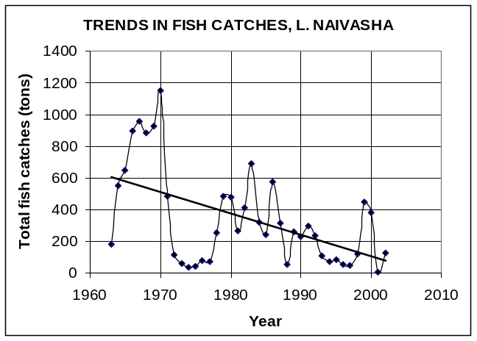
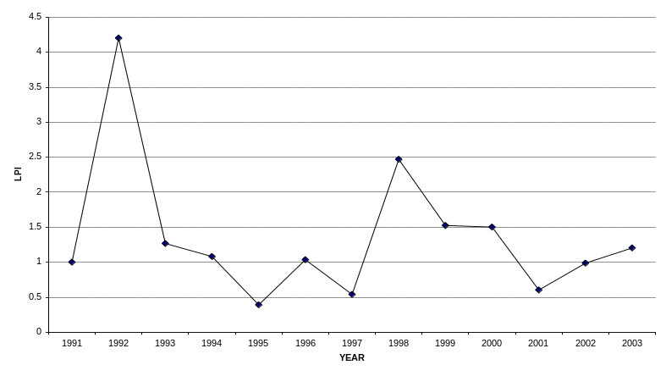
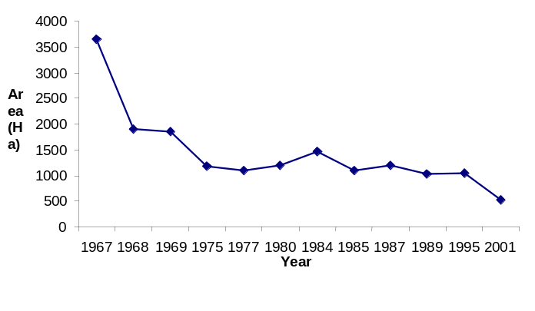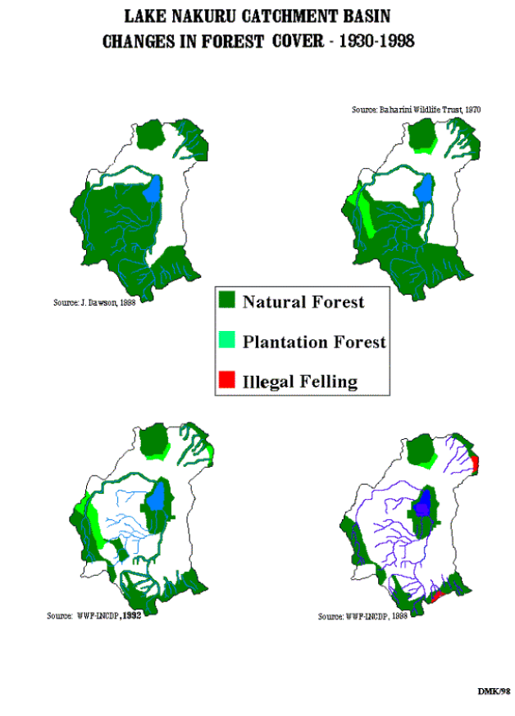
Fig 1: LPI flamingo in the Rift Valley alkaline lakes up to 2003

Fig 2: Trends in fish catches Lake Naivasha
Fig 3:Trends in Papyrus cover Lake Naivasha
Fig 4 Forest cover changes in the Lake Nakuru catchment 1930 to 1998.

.

Fig 5 Land use in the Lake Nakuru catchment 1970 to 2003.

Fig 5: Changes in Catchment Basin Lake Nakuru
PHILIPPINES MARINE AND COASTAL ECOSYSTEMS STATE AND POLICY
The Philippines as a party to the CBD has the moral obligation to adhere to the Convention’s different targets and goals. One of these is to achieve a significant reduction in the rate of biodiversity loss by 2010. The experience gained and knowledge acquired in the implementation of the GEF project on Biodiversity Indicators for National Use (BINU) has better equipped the responsible agencies in addressing the issue of the coastal and marine biodiversity loss in the country. This is the first attempt for the Philippines to address the issue with the proper supporting data sets and figures on indicators for the coastal and marine ecosystems.
Overall, there is a declining trend in the state of most coastal and marine ecosystems in the Philippines. Research on pelagic fishes, demersal fishes, invertebrates, coral reefs, mangroves, marine plants (seagrasses and seaweeds), sharks, marine turtles, and Irrawady dolphins shows that these resources are continuously being depleted as a result of human activities such as over-fishing; illegal fishing; construction of facilities for tourism, industries, transportation (ports, small wharfs and piers), etc.; human settlements near coastal areas; pollution; and the increase in the population density of the country.
High fishing intensity, the use of illegal fishing methods and the rise in human population especially in the coastal areas are the primary factors (pressure indicators) that contribute to the increasing biodiversity loss of most coastal and marine resources.
One example on the loss of biodiversity is seen in the increasing fishing effort or pressure that resulted in an increased catch (Figure 1) but has a negative effect on catch rates (Figure 2). The catch rates will show whether the stocks are healthy or not and if the catch rates are showing a declining trend this indicates that biodiversity is negatively affected.
The sea is the common source of food for many Filipinos. Fishing is the main livelihood of around one million individuals and fish is the main source of protein for approximately 70% of the coastal population of the country. The fisheries contribution to total Gross Domestic Product at current prices is 2.2 % and at constant prices is 4.1%.
While we attempted to develop good indicators for the some marine species, data gaps were recognized and identified in providing understanding of the state of some species, with limited or no time series data. There is also no clear policy objective to protect or conserve some of the marine species like demersal fish and seagrass, for example.
The three most important policy agenda areas among the 10 point policy agenda declared by the government are food security, poverty alleviation and job generation. Food security can only be addressed if habitats that support resources are properly managed and conserved. Indicators or trends are best understood by policy makers from a brief explanation, rather than a long narrative report detailing all the information gathered. Nowadays when Philippine policy makers are beset with so many concerns, indicators are recognized and supported by our leaders and form basis for policy making. In the draft Comprehensive Fisheries Industry Development Plan being formulated by the Bureau of Fisheries and Aquatic Resources, protection and rehabilitation of degraded/critical fishery habitats is the top priority component of the plan, followed by reduction and rationalization of fishing effort. Our experienced in reviewing status of the coastal and marine habitats and the development of the indicators have attracted the attention of the stakeholders including policy makers to give priority to habitat rehabilitation and reverse the condition to support food security for the people. This in turn will restore biodiversity loss.

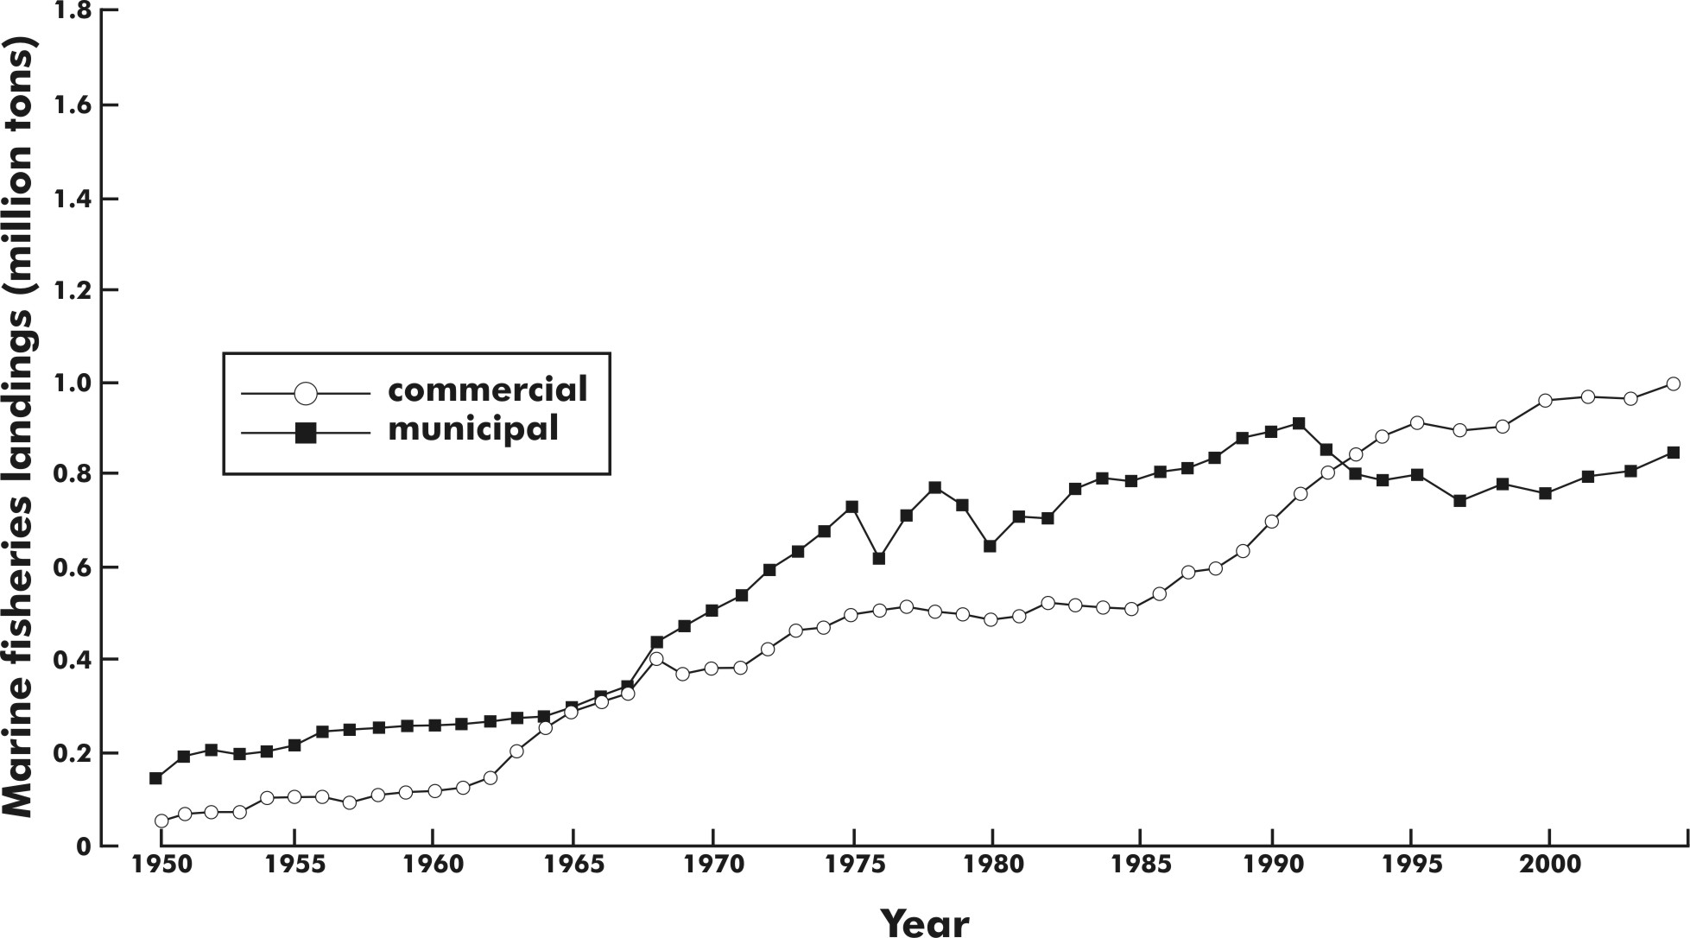

Figure 1. Marine capture fisheries landing from 1950 to present (BFAR Statistics 1950-1986, Bureau of Agricultural Statistics 1987-2003).

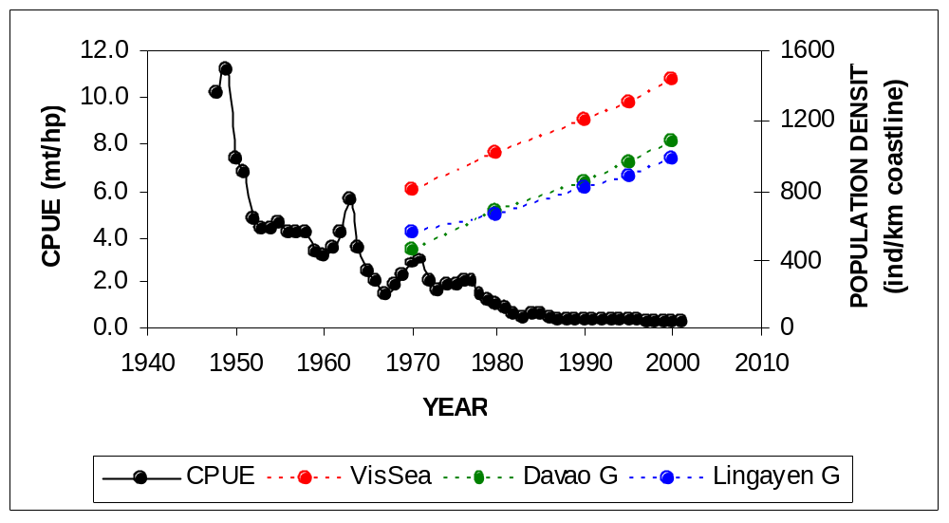

Figure 2. Catch per unit effort (mt/hp/year) of the commercial small pelagic fisheries, 1948 – 2001, with the increase rates of coastal populations in 3 representative fishing grounds superimposed
UKRAINE AGRO-ECOSYSTEMS STATE AND POLICY
(Report based on open-access Internet information of Ukrainian GOs and NGOs and BINU Project materials. The text in italics refers to indicators which have been calculated).

State of agrobiodiversity
According to many indicators in Ukraine a major part of the country’s biodiversity is dependent upon agrolandscapes, with the area of cultivation and agricultural lands forming 72% of the country, and the proportion of agricultural land under cultivation is 56.2%. The index response of Red Data Book species to anthropogenic pressure (or RDB-index) showed that “agricultural activity” as a negative impact factor takes second position after the factor “annihilation of ecological niches”. More than 46% of areas of high diversity with threatened species are located within current agricultural landscapes.
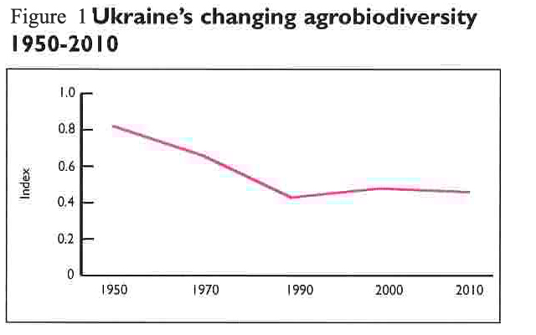
A national Composite agrobiodiversity index (CIA) showed that in comparison to 1995 up to 93% agrobiodiversity is left, and the weakest point was animal husbandry, and, thus, tentative rates of annual losses for the period are 0.95%. As an indicator of the state of Ukrainian agro-ecosystems the Living planet index (LPI) was calculated, using expert assessments of population changes for 128 species of plants, birds, mammals indicative of agro-ecosystems - Figure 1. The LPI showed that the general trend was negative but with features of stabilization for particular groups and natural zones after the 1990’s, when there was economic crisis after collapse of the former USSR. Dominant negative impact factors include changes in land use (37%), as well as poor management (16%) and habitat loss (7%).
Studies of changes in bird habitats in the capital of Ukraine and surrounding areas for 1988 to 2004 using remote sensing data and GIS found that recreational pressures and habitat transformation have effected first of all birds of open landscapes, in particular, larks. It was recorded also that total extension of forest belts and their average length had dropped by 16%, and at the same time, intensive fragmentation of agrolandscapes mosaics occurred – by 40%.
Regarding genetic agrobiodiversity, the number of genotypes that are commonly used (plant sorts suitable for dissemination in Ukraine) is actively growing, and was 2,898 in 2003. The indicator Species diversity used for food, including sorts and breeds was estimated for the first time and comprised 2,968, of which 98% are plants.

Threat factors
The dominant driver of biodiversity change in the agro-ecosystems of Ukraine is land use change, which is the same as the dominant driver of biodiversity change in the world – Figure 2. The second key driver is “improper nature management,” which is also a part of land use and which can and should be a part of agricultural management.
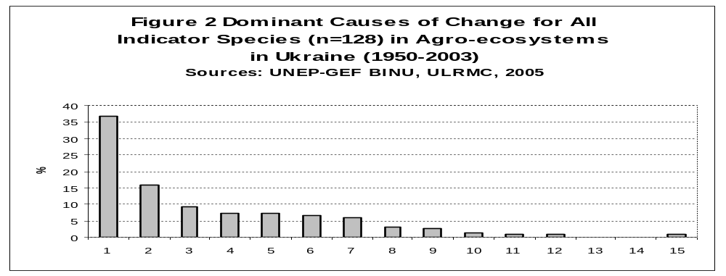
Legend: 1-15: Land use change, Improper nature management, Exploitation, Habitat loss, Toxification, Fragmentation, Disturbance, Factors abroad, Natural succession, Lowering groundwater, Invasive species, Eutrophication, Climate change, Acidification, Unknown.

Analysis of the indicator Poverty: families incomes obtained from private farmland revealed that under dropping salaried incomes the proprtion of incomes from farmlands increased. The indicator Species diversity used for food also showed that farmers’ striving to obtain greater incomes (that is to overcome poverty) can cause two opposite effects: both biodiversity reduction – through introduction of more profitable monocultures, – and biodiversity increase through extension of new plant cultures.

A policy response indicator
The agroecosystems of Ukraine occupy 72% of the country, but only 3% of agricultural territories are inside the protected areas network – Figure 3. Therefore, it is not enough to develop new protected areas in Ukraine for the conservation of agrobiodiversity, but also to manage active agriculture areas for biodiversity. Lands with low agricultural inputs (that is under organic farming) comprised 0.96% of all arable area. In contrast to this, hunting areas inside of agricultural lands comprised 94% in Ukraine.
Based upon these results, even the 10.4% of the total area area of Ukraine which is planned as protected areas by 2015, will not completely solve agrobiodiversity preservation problems, including soil diversity ones. That is why, further consideration of regional agroecosystem status (agrosphere) is fundamental for preserving biodiversity in Ukraine.

Forecasting until 2010
The following is a forecast to 2010 or beyond, if current trends continue. Trends for NCI, LPI, CAI will stay negative, although for particular components the situation will appear to be satisfactory. Total number of species to be entered to the Red Data Book of Ukraine will increase – Figure 4. According to the RDB-index, environmental contamination and agricultural activity will be the dominant negative factors. Farmers will tend to monoculture prodution, which is more profitable for them, and development rates of organic farming will be moderate.

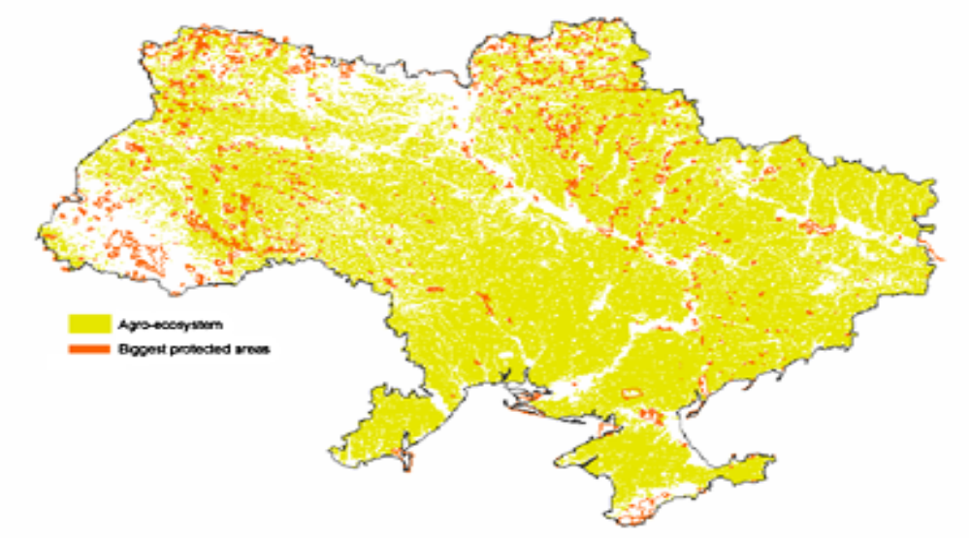
Figure 3 Agro-ecosystems in Ukraine based on Terra MODIS 2002 and biggest protected areas location
Source: UNEP-GEF BINU, ULRMC, 2005

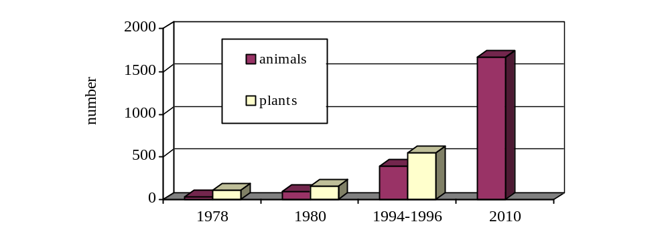
For more details see the Searchable List of Indicators: http://www.ulrmc.org.ua/services/binu/is/index.asp?lang=EN
Figure 4 Change in total number of the Red Data Book species
in Ukraine (1978-1996) and Prognosis (~2010*)
Source of information: see http://www.ulrmc.org.ua/services/binu/is/index.asp?lang=UK

and materials for a 3rd National Report of Ukraine - http://www.ecopravo.kiev.ua/BEY/Variety/comments2_ua.html

ECUADOR TERRESTRIAL ECOSYSTEMS STATE AND POLICY

State and trend. Some research from the Cordillera Real Oriental (CRO) mountain range in Ecuador demonstrates the process of transformation and loss of habitat for many local species and taxonomic groups. Examples are presented for a Podocarpus tree species, the spectacled bear (Tremarctos ornatus), and the orchid Lepanthes auriculata (Figure 1). The original and actual distribution of these species shows the process of habitat fragmentation.

Figure 1: Original and actual distribution for key species in Ecuador.
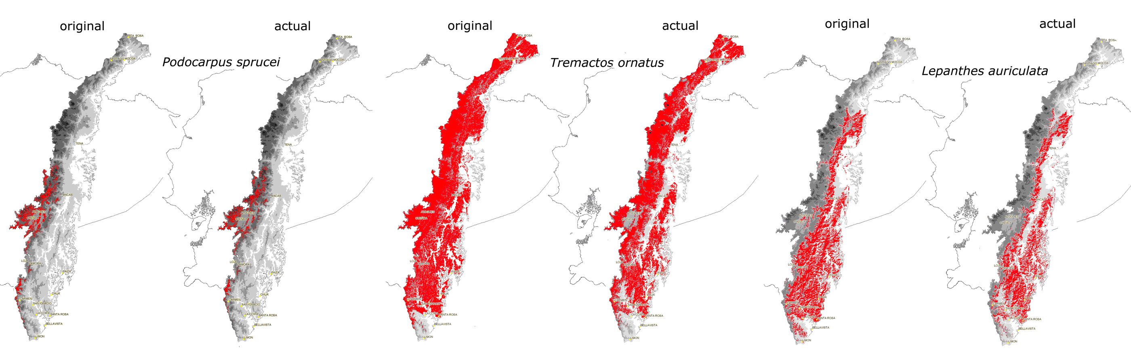

In the same way, for the different groups of species in CRO, we see differences between the original and actual abundance. In all cases, we estimate more than 20% of loss in their abundance (Figure 2). Some endemic key groups like amphibians (e.g. Eleutherodactylus) and birds (e.g. Grallaria), have more than 23% of abundance loss from the original situation.

Figure 2: abundance loss for groups of species in La Cordillera Real Oriental (CRO) in Ecuador.
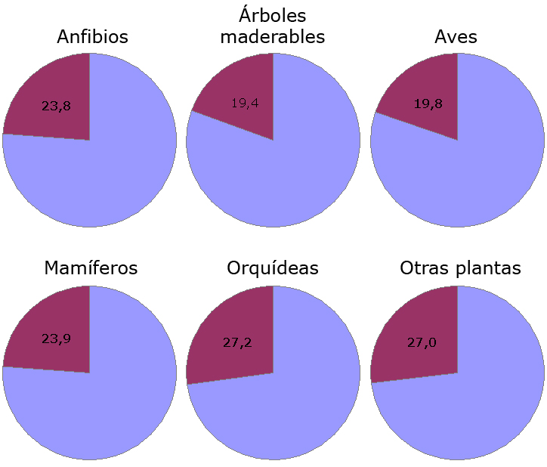

In a multi-temporal study for the central-Andes region in Ecuador, using GIS analysis, we observed the trend in deforestation over the last 25 years, and a projection to 2015 (figure 3): From a total original area of 601 524 ha, this investigation estimated 184 766 ha of forest cover in 1979. In 1991 this area was reduced to 148 670 ha with a loss rate of 2 680 ha/year. In 2004, the total forest area was 120 465 ha (2 060 ha/year). For 2015 the projected forest cover is 88 982 ha.

Figure 3: deforestation trend in central-Andes region in Ecuador (Cotopaxi, 1979 - 2004, and projection 2015).

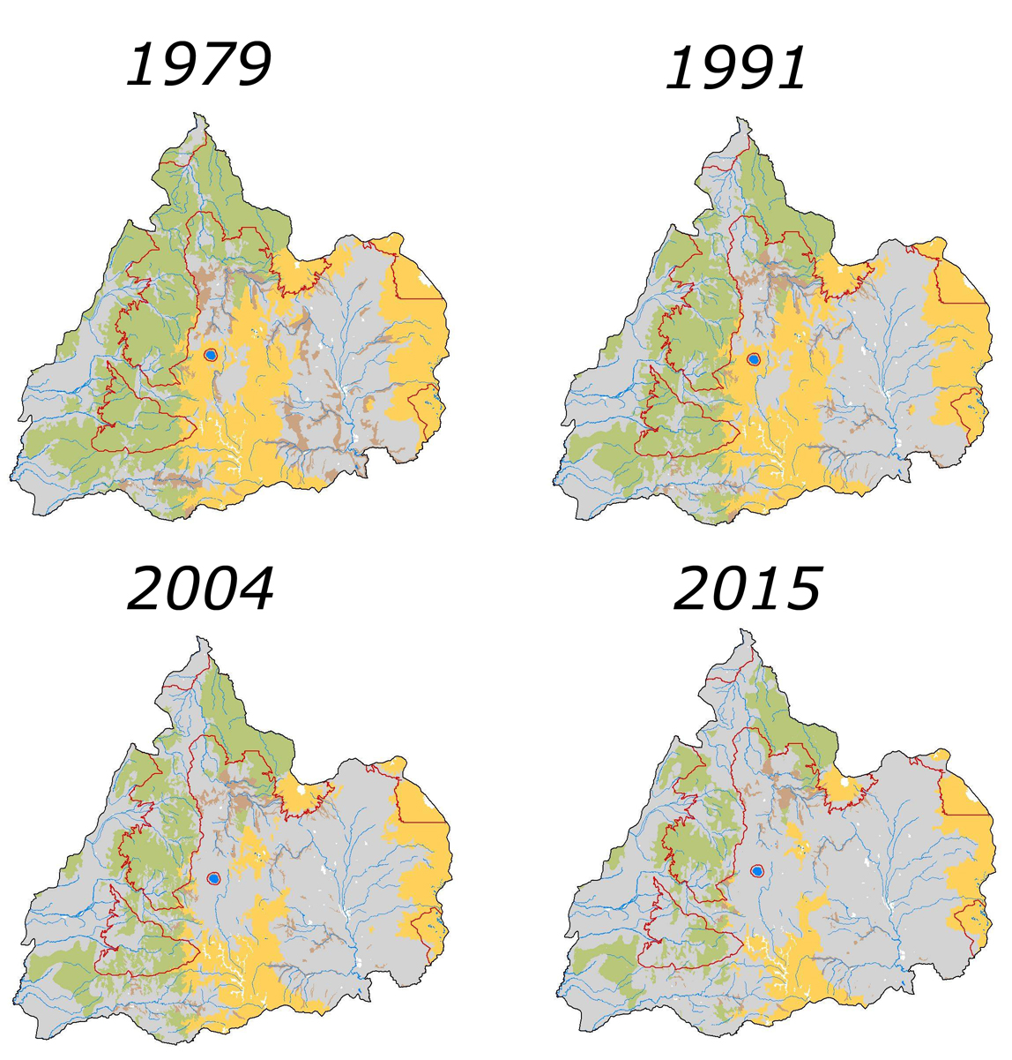

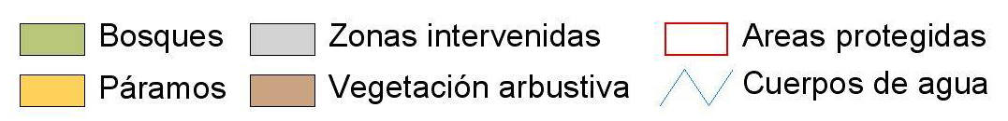

Causes of biodiversity loss. Figure 4 shows the relation between the original extent of each terrestrial ecosystem at national level and current land use. For each ecosystem, the percentage of the natural area (2001) depends on the intensity of the land use: valleys from the Andean region (vhi and vsi) have a high importance for agricultural activities (short-cycle crops), but at the same time this area is exposed to important process of degradation. At national level, pasture is the main use of the land and is present in each ecosystem. For mangroves, shrimps farms represent almost 40% of the total change of area. Degraded areas are 5.3% of total national area, with a high impact in mountain ecosystems like Páramo (ph and ps).

Figure 4: Percentage in land use change for each terrestrial ecosystem (2001).
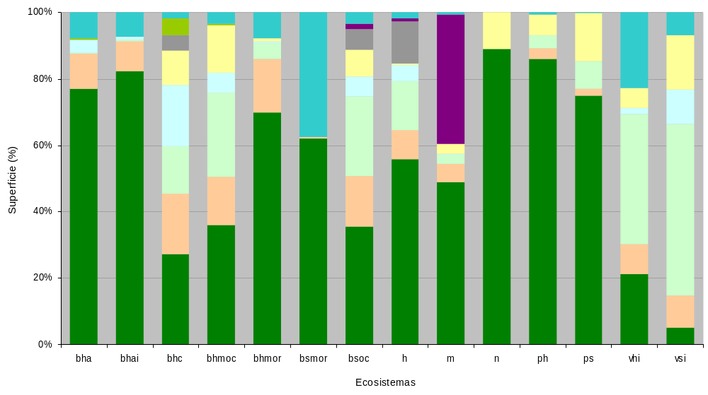

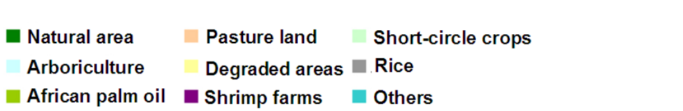
Bosque húmedo amazónico (bha), bosque húmedo de la Costa (bhc), bosque seco occidental (bsoc), bosque húmedo oriental (bhmor), bosque húmedo montano occidental (bhmoc), bosque húmedo amazónico inundable (bhai), páramo húmedo (ph), vegetación húmeda interandina (vhi), vegetación seca interandina (vsi), manglar (m), páramo seco (ps), bosque seco montano oriental (bsmor), humedal (h) y nieve (n).
Impact of national policy responses. What is the impact of more than 40 years of establishment of protected areas in Ecuador? There are many possibilities to measure a national impact and a public response to environmental degradation. Figure 5 illustrates the relationship between land use intensity and biodiversity quality. For protected areas in Ecuador (2001), 87% of total area has a high quality value (0.8 – 1.0) that means a good level of conservation. Only 3% of area is in a low category (0.0 – 0.3), that it means a high agricultural pressure inside protected areas.
Figure 5: land use and quality of biodiversity inside terrestrial protected areas in Ecuador (2003).
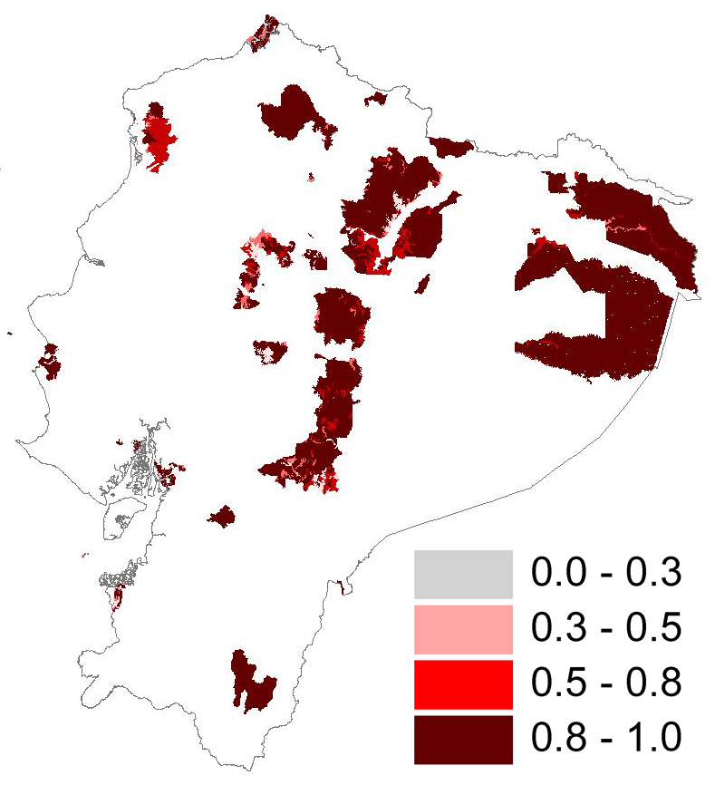
Assessment of the progress towards the 2010 biodiversity target in The Netherlands
The Netherlands as a party to the CBD and a European Union Member State is committed to halt the loss of biodiversity by 2010. This assessment evaluates progress towards this ‘2010 target’ to date, based on existing Dutch indicators selected for their match with the EU 2010 indicators (marked bold in the text). This is a first exercise for the Netherlands and using preliminary figures to explore the feasibility and policy relevance of the individual 2010 indicators and the set as a whole on the national scale.

The loss of biodiversity still continues
At the change of the millenium the extent of natural areas in The Netherlands was ca. 40% of the country (including the territorial zone of the North Sea), whilst the quality of this remaining area, measured by the mean abundance of species relative to the pre-industrial situation was 44% (Figure 1). Since 1990 the extent of natural areas is increasing as agricultural land is reduced (Figure 3). For many species the declines still continue, e.g. for butterflies by more than 50% in the period 1992-2002. Woodland birds and amphibians have been more or less stable in the last decade, whilst reptiles are increasing (Figure 2). Amongst all vertebrates, plants and some major groups of invertebrates 29% of the species are to some extent threatened with extinction (Figure 4).

Conditions for biodiversity are improving, but not yet sufficient
Major causes of the loss of biodiversity in the 20th century in The Netherlands are habitat loss, eutrophication, acidification, lowering groundwater tables and habitat fragmentation. Nitrogen deposition, a major source of acidification and eutrophication, has decreased, but at many places the critical loads for ecosystems are still exceeded (Figure 5). Ca. 4000 km² still suffers from lowering groundwater tables. Within a few decades climate change is expected to become a major factor in biodiversity change too.

What are the goods and services of our ecosystems and do we use them sustainably?
A major use of the marine environment is for fisheries. The pressure of the European fisheries on the stocks is high, indicated by the decline of large fish (proxy for the Marine Trophic Index; Figure 6). Freshwater ecosystems are used for drinking water and swimming water. Since the 1980s the quality of the water for these functions has improved, measured by decreasing nitrogen and phosphate loads (Figure 7) and turbidity. A major use of the terrestrial environment is for agriculture (together with fisheries contributing 2.5% to the GDP), with severe impacts on biodiversity, illustrated by declines in farmland birds of up to 60% since 1990. Besides these impacts within the country, The Netherlands contributes 0.3% to the global loss of biodiversity by using products from abroad (footprint)¹.

Deadlines for national policy response mostly later than 2010
Dutch nature policy aims to increase the extent of (semi-)natural habitats from ca. 450.000 ha in 1990 to 750.000 ha in 2018, by implementing the National Ecological Network (‘EHS’). Due to this policy, the area is currently increasing (Figure 8). Recent studies show that the EHS can be further spatially optimised, taking into account fragmentation, environmental quality and location of biodiversity hotspots². Another issue are recent policy changes for the management of the EHS, giving more weight to management by farmers and private land owners, as opposed to traditional conservation organisations. Ex-ante evaluations of this change in policy indicate negative impacts on conservation goals³.
Large parts of the EHS are also protected areas under the Birds- and Habitats Directives of the EU. Under these Directives also species are protected. 45% of these species do not (yet) have a favourable conservation status. The EU Water Framework Directive requires ground- and surface waters to have a good ‘chemical and ecological status’ by 2015. Recent rural area policies intend to integrate agricultural and biodiversity goals. The Dutch target for environmental quality is to be no impediment for nature objectives by the year 2027.
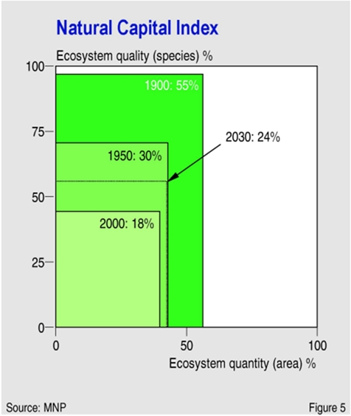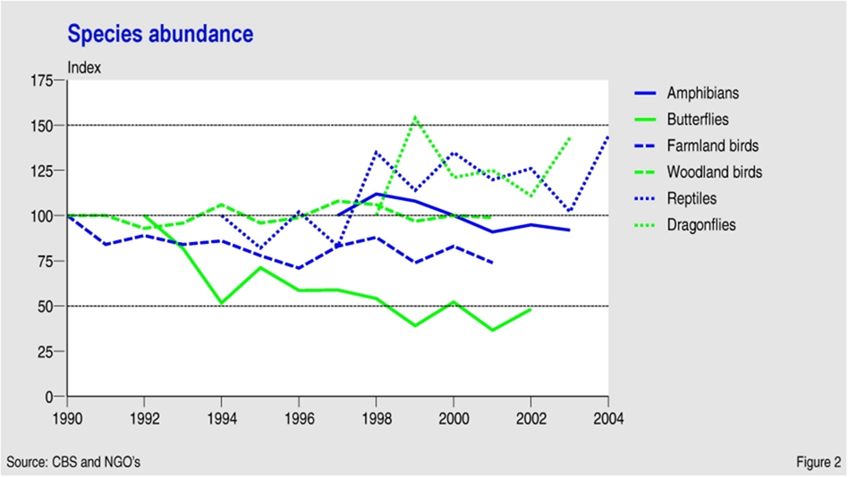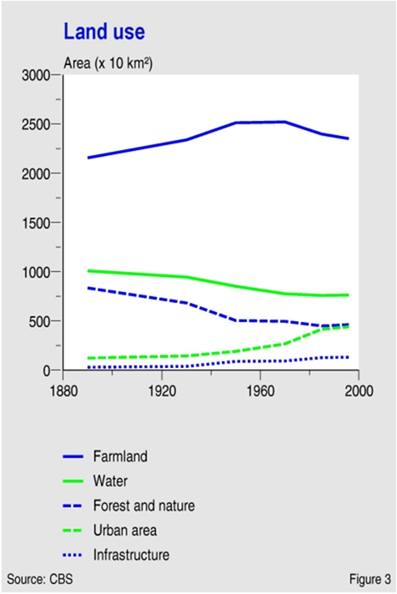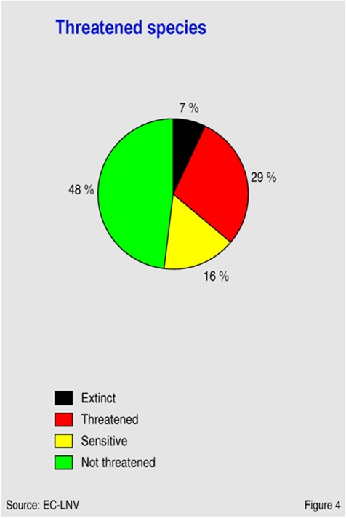
BIODIVERSITY STATUS AND TRENDS IN THE NETHERLANDS

PRESSURES
ECOSYSTEM INTEGRITY AND GOODS & SERVICES
RESPONSE

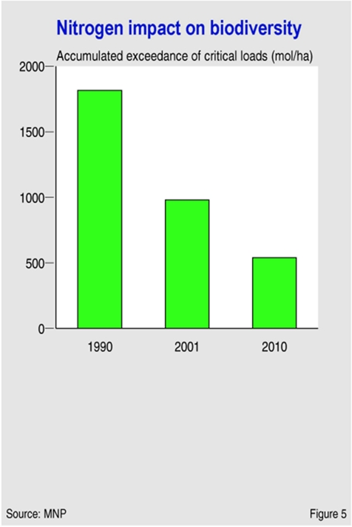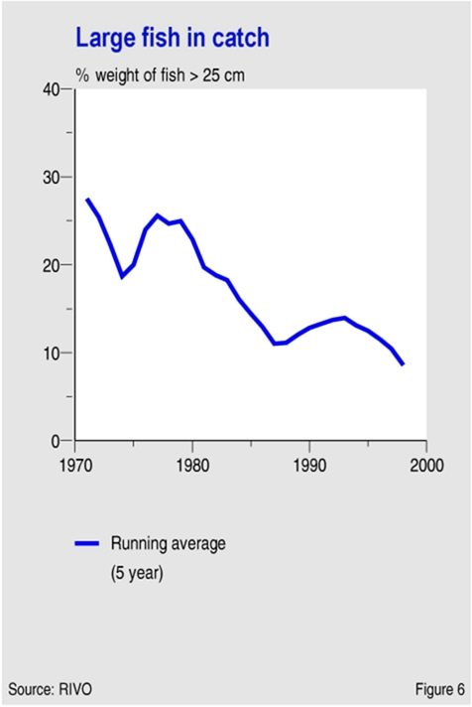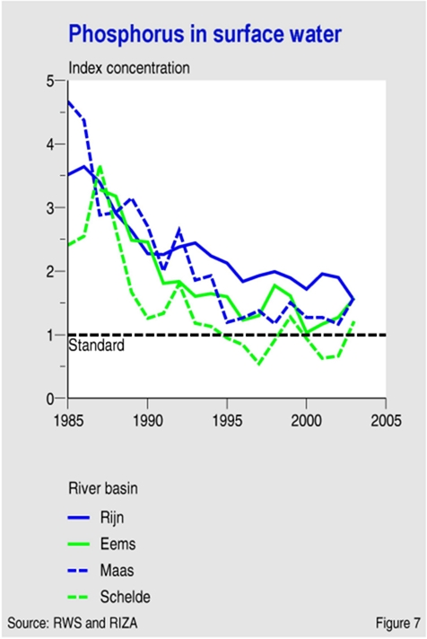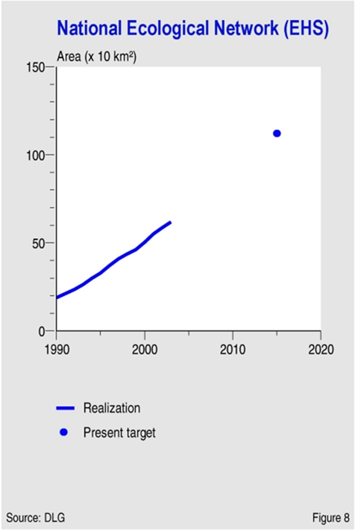

References

¹Rood, G.A, H.C. Wilting, Nagelhout, D., Ten Brink, B.J.E., Leewis, R.J. & Nijdam, D.S. 2004. Spoorzoeken naar de invloed van Nederlanders op de mondiale biodiversiteit. Model voor een ecologische voetafdruk. Rapport 500013005. RIVM, Bilthoven, The Netherlands.

²Lammers, W., Van Hinsberg, A., Loonen, W., Reijnen, R. & Sanders, M. in prep. EHS en bescherming biodiversiteit. Ruimtelijke samenhang en condities. MNP, Bilthoven, The Netherlands,

³Netherlands Environmental Assessment Agency. in prep. Van aankoop naar beheer. Evaluatie omslag natuurbeleid. MNP, Bilthoven, The Netherlands.

-----

* UNEP/CBD/SBSTTA/11/1.

