 |  |  | CBD
 |  | CONVENTION ON  BIOLOGICAL DIVERSITY |  | Distr.  GENERAL  UNEP/CBD/SBSTTA/11/6 5 October 2005  ORIGINAL: ENGLISH
SUBSIDIARY BODY ON SCIENTIFIC, TECHNICAL AND TECHNOLOGICAL ADVICE
Eleventh meeting
Montreal, 28 November – 2 December 2005
Item 5.1 of the provisional agenda*

Second Global Biodiversity Outlook: draft executive summary

Note by the Executive Secretary

The Conference of the Parties, in paragraph 6 (a) of decision VII/30, requested SBSTTA, inter alia, to review a draft of the second Global Biodiversity Outlook and report on the results to the Conference of the Parties at its eight meeting. In paragraph 8 (a) of the same decision, the Conference of the Parties requested the Executive Secretary, with the assistance of the World Conservation Monitoring Centre of the United Nations Environment Programme (UNEP-WCMC) and other relevant international organizations, to prepare the second Global Biodiversity Outlook for publication prior to the eighth meeting of the Conference of the Parties following peer-review and review by SBSTTA at its tenth or eleventh meeting.
Annexed to the present note is the draft executive summary of the second Global Biodiversity Outlook, prepared by the Executive Secretary, with the assistance of UNEP-WCMC and other relevant international organizations in response to these requests, and taking into account the guidance provided through SBSTTA recommendation X/6. The complete document is contained in document UNEP/CBD/SBSTTA/11/INF/14. At the same time as the Executive Summary and the complete document are being made available to SBSTTA, they are also being subjected to expert and government review.
In accordance with decision VII/30, the Subsidiary Body may wish to review the draft Global Biodiversity Outlook and provide any guidance on its finalization, with a view to its publication prior to the eighth meeting of the Conference of the Parties.

SUGGESTED RECOMMENDATION
The Subsidiary Body on Scientific Technical and Technological Advice may wish to:
(a) Welcome the draft second Global Biodiversity Outlook, including its draft executive summary;
(b) Express its gratitude to the Government of the Netherlands and the European Community for their financial support towards the preparation of the second Global Biodiversity Outlook;
(c) Invite the Executive Secretary to take into account the comments provided through the peer-review, as well as those made individually by delegations during the eleventh meeting of the Subsidiary Body on Scientific, Technical and Technological Advice, when finalizing the second Global Biodiversity Outlook, including its executive summary, for publication prior to the eighth meeting of the Conference of the Parties.

Annex
Draft executive summary

This document provides a summary of the second edition of the Global Biodiversity Outlook. It reviews the key importance of biodiversity for human livelihoods and well-being (section 1); provides an assessment of the current status and trends of biodiversity and of some of the key drivers of biodiversity loss (section 2); and reviews the approaches and tools available, and efforts necessary to respond to the challenges provided by the target to achieve by 2010, a significant reduction in the rate of biodiversity loss (section 3).

Introduction

- Biological diversity - or biodiversity - is the term given to the variety of life on Earth. The biodiversity we see today is the result of billions of years of evolution, shaped by natural processes and, increasingly, by the influence of humans. Biodiversity is the web of life, of which we are an integral part and upon which we entirely depend for our well-being and survival.
- Biodiversity is often understood in terms of the number of different species of plants, animals, fungi and micro-organisms in existence. However, biodiversity also includes genetic differences within each species - for example, between varieties of crops and breeds of livestock. Yet another aspect of biodiversity is the variety of ecosystems and habitats covering the planet, such as deserts, forests, wetlands, grasslands, lakes, rivers, and agricultural landscapes. In each ecosystem, living creatures, including humans, form communities, interacting with one another and with the air, water, and soil around them.
- It is the combination of life forms and their interactions with one another and with the physical environment that has made Earth a habitable place for humans. Ecosystems directly or indirectly provide the basic materials necessary for life (e.g., food, water), offer protection from natural disasters and disease (e.g., regulating climate, floods and pests), and underpin important aspects of human culture (e.g., spiritual needs, knowledge systems and traditional use). Ecosystem services also maintain the essential life processes of the planet, such as primary production and nutrient recycling. These supporting services are provided at all levels –local, regional and global –and every one makes crucial contributions to human well-being. Biodiversity is essential for the sustained provision of these ecosystem goods and services.
- The Brundtland Commission established the conceptual link between biodiversity and sustainable development, reflecting a process of thought and international dialogue that led to the United Nations Conference on Environment and Development in Rio de Janeiro in 1992. Recognizing the fundamental role of biodiversity in supporting human life, the Convention on Biological Diversity, a legally binding landmark treaty, was opened for signature at the Rio Earth Summit and entered into force in 1993. Among the existing global biodiversity-related agreements, it was the first to cover all aspects of biodiversity and to acknowledge the role of biodiversity in sustainable development.
- The Convention presently has 188 members, reflecting nearly universal participation. The three main objectives of the Convention–the conservation of biodiversity; the sustainable use of its components; and the fair and equitable sharing of the benefits arising out of the utilization of genetic resources–are reflected in the text of the Convention, which contains both substantive commitments and provisions for the establishment of a framework for implementation. Underpinning the Convention’s three objectives is the recognition that humans—themselves exhibiting a diversity of cultures—are an integral component of ecosystems.

The 2010 Biodiversity Target
- Ten years after the entry into force of the Convention, Parties acknowledged, in 2002, the continued threat to biodiversity from human activities. They reaffirmed that biodiversity is the living foundation for sustainable development, that the rate of loss is still accelerating, that threats must be addressed, and that the Convention remains a key tool for sustainable development.
- For these reasons, the Conference of the Parties adopted a Strategic Plan, in which Parties committed themselves to a more effective and coherent implementation of the three objectives of the Convention in order to achieve by 2010 a significant reduction of the current rate of biodiversity loss at the global, regional and national level, as a contribution to poverty alleviation and for the greater benefit of all life on earth. This target was subsequently endorsed by the World Summit on Sustainable Development.
- Parties recognized that in order to achieve the Strategic Plan, and its 2010 biodiversity target, they required a framework to facilitate an assessment of progress made—a framework within which national and regional targets could be set, and indicators of progress identified. The resulting framework, adopted by Decision VII/30, is structured around seven focal areas, which together represent both responses to the drivers of biodiversity loss, and the means to achieve the three objectives of the Convention. The focal areas are:

- Reducing the rate of loss of the components of biodiversity, including: (i) biomes, habitats and ecosystems; (ii) species and populations; and (iii) genetic diversity;
- Promoting sustainable use of biodiversity;
- Addressing the major threats to biodiversity, including those arising from invasive alien species, climate change, pollution, and habitat change;
- Maintaining ecosystem integrity, and the provision of goods and services provided by biodiversity in ecosystems, in support of human well-being;
- Protecting traditional knowledge, innovations and practices;
- Ensuring the fair and equitable sharing of benefits arising out of the use of genetic resources; and;
- Mobilizing financial and technical resources, especially for developing countries, in particular, least developed countries and small island developing states among them, and countries with economies in transition, for implementing the Convention and the Strategic Plan.

SECTION 1 - Biodiversity loss: Reasons for concern
- People are having a major and growing impact on the biosphere, the long-term consequences of which are feared by many but are in fact not at all well understood. There are currently well over six billion people on the planet, and the human population is expected to reach nine billion by mid-century. Each person has the right to expect adequate food, clean water, safe shelter and energy, the provision of each of which has profound ecological implications. Food must be grown on land or in water, water must be clean to drink, shelter must be constructed from ecosystem-derived materials, and energy must be harnessed from natural processes.
- These minimum needs multiplied by a growing world population translate to increasing demands on the planet’s productive capacity. This minimum demand is massively amplified however, by the wasteful consumption of resources over and above the level needed to meet basic human needs. This growing demand for luxury products among a relatively small segment of the world population is leading to a greater loss of biodiversity, with consequences for all. As biodiversity is lost, the provision of ecosystem goods and services may also be undermined, with a negative effect on human well-being. Recently, the Millennium Ecosystem Assessment concluded that—of the ecosystem services it assessed, and that make a direct contribution to human well-being—15 of 24 were in decline.
- Biodiversity loss can have indirect effects on human well-being as well. By disrupting ecosystem function, biodiversity loss leads to ecosystems that are less resilient, more vulnerable to shocks and disturbances, and less able to supply humans with needed services. The damage to coastal communities from floods and storms, for example, increases dramatically following conversion of wetland habitats, as the natural protection offered by these ecosystems—including regulation of water run-off—is compromized. Recent natural disasters in Asia and North America serve to underline this reality.
- Healthy ecosystems have a critical role to play outside of times of catastrophe as well. Keeping with the example of wetlands, inland wetlands are the principal supply of renewable fresh water for human use, storing water but also purifying it through the removal of excess nutrients and other pollutants. Disruption of wetlands purification processes can have devastating impacts at the source and further downstream; the loss of wetlands in the Mississippi watershed of the United States, for example, combined with high nutrient loads from intensive agriculture in the region, has led to the creation of a low-oxygen ‘dead zone’ extending hundreds of kilometres into the Gulf of Mexico.
- The loss and degradation of natural capital has consequences for national economies, though these are poorly reflected in conventional indicators of economic growth, such as GDP. Existing studies of changes in economic value associated with local changes to biodiversity (such as clear-cutting of forests, or draining of wetlands) have shown the total economic cost of ecosystem conversion (i.e., including both market and non-market values of ecosystems services) to be significant and to sometimes exceed the benefits. Applying the concept of total economic value to national economies would thus reveal—for many countries, and in a number of sectors—that economic gains, as traditionally measured, are illusory.
- The consequences of biodiversity loss and ecosystem disruption are often harshest for the rural poor, who depend most immediately upon local ecosystem services for their livelihoods, and are among the least able to access or afford substitutes. The real costs of biodiversity loss are already recognized to pose a significant barrier to the achievement of the Millennium Development Goals (MDGs). Yet many of the actions that could be implemented most quickly to promote economic growth and reduce hunger and poverty—for example, intensification of agriculture, or conversion of forests—are harmful to biodiversity, and would undermine the long-term sustainability of any development gains. Recognizing the trade-offs and synergies that exist between poverty alleviation and biodiversity conservation will therefore be essential to achieving many of the targets of the MDGs.
- The loss of biodiversity should be of concern regardless of the usefulness of ecosystems, species and genes to human well-being. Every life form is the result of a unique evolutionary pathway, never to be repeated. The loss of any aspect of biodiversity is, in that sense, incalculable and, insofar as it is the result of human action, unconscionable.
SECTION 2 - Assessing progress towards the 2010 biodiversity target: establishing current trends
- To assess progress towards achieving the 2010 biodiversity target, Parties to the Convention established indicators (decision VII/30 and SBSTTA recommendation X/5,) (box 1).
- This set of indicators are applied and tested in this edition of the Global Biodiversity Outlook, providing the basis from which to measure a broad cross-section of issues fundamental to the conservation and sustainable use of biodiversity, and to the equitable sharing of the benefits from the use of genetic resources. Although the indicators cannot cover all aspects of biodiversity, as a set they provide a good overview. It should be noted that it is too soon to determine whether progress is being made towards the 2010 target. This section therefore aims to establish current trends, against which progress can be judged in future editions of the Global Biodiversity Outlook.
- Biodiversity indicators are information tools, summarizing data on complex environmental issues. They can be used to assess national performance and to signal key issues to be addressed through policy interventions and other actions. Indicators, therefore, are important for monitoring the status and trends of biological diversity and, in turn, feeding back information on ways to continually improve the effectiveness of biodiversity management programmes. Small sets of indicators that focus on key issues are referred to as headline indicators, and when used to assess national or global trends, build a bridge between the fields of policy-making and science.

Box 1. Headline indicators for assessing progress towards the 2010 biodiversity target

Focal area: Reducing the rate of loss of the components of biodiversity, including: (i) biomes, habitats and ecosystems; (ii) species and populations; and (iii) genetic diversity

Trends in extent of selected biomes, ecosystems and habitats
Trends in abundance and distribution of selected species
Change in status of threatened species

Trends in genetic diversity of domesticated animals, cultivated plants, and fish species of major socio-economic importance
Coverage of protected areas
Focal area: Maintaining ecosystem integrity, and the provision of goods and services provided by biodiversity in ecosystems, in support of human well-being
Marine Trophic Index
Connectivity/fragmentation of ecosystems
Water quality in aquatic ecosystems
Focal area: Addressing the major threats to biodiversity, including those arising from invasive alien species, climate change, pollution, and habitat change
Nitrogen deposition
Trends in invasive alien species
Focal area: Promoting sustainable use of biodiversity
Area of forest, agricultural and aquaculture ecosystems under sustainable management
Ecological footprint and related concepts

Focal area: Protecting traditional knowledge, innovations and practices
Status and trends of linguistic diversity and numbers of speakers of indigenous languages
Focal area: Ensuring the fair and equitable sharing of benefits arising out of the use of genetic resources

Indicator to be developed

Focal area: Mobilizing financial and technical resources, especially for developing countries, in particular, least developed countries and small island developing states among them, and countries with economies in transition, for implementing the Convention and the Strategic Plan.

Official development assistance provided in support of the Convention

Focal area: Reducing the rate of loss of the components of biodiversity, including: (i) biomes, habitats and ecosystems; (ii) species and populations; and (iii) genetic diversity

- The conservation of biological diversity is the first objective of the Convention. Accordingly, the first of seven focal areas of the 2010 framework is the reduction of the rate of biodiversity loss at ecosystem, species and genetic level, with corresponding indicators established on trends within each of these levels. Indicators under this focal area also include trends in protected area coverage and status of threatened species.
Headline indicator: Trends in extent of selected biomes, ecosystems and habitats
- Ecosystems are naturally occurring, dynamic and complex assemblages of organisms. Both ecosystems and their constituent species interact with each other and with the physical environment. Conversion, degradation, or the unsustainable management of a natural ecosystem has far-reaching consequences: it results in a change of the balance, and frequently the loss, of species populations that constitute the ecosystem, and also to the reduction or loss of ecosystem services. Over the last 50 years, humans have changed ecosystems more rapidly and extensively than in any comparable period of time in human history. Reducing the rate at which ecosystems are being degraded or lost is therefore a key contribution towards the achievement of the 2010 biodiversity target.
- For most of the world’s main habitats and ecosystems, neither the current global extent nor rates of change in that extent are known with any certainty. This is due in part to the difficulties of measuring global habitat extent, differences in definitions and classification systems and the lack of historical data. The exception is forests, which, because of their direct commercial interest, are regularly inventoried and assessed in most countries.
- In the absence of human influence, forests and woodlands would be expected to cover approximately half of the Earth’s land surface. However, over thousands of years human activities have reduced their extent to about a quarter. While forest loss in tropics is accelerating, and about 120,000 square kilometres have been lost annually over the past two decades, forest cover in many temperate regions is increasing, due both to natural reforestation and the increase of plantation forests.

Figure 1: A figure on natural forest area in 1990, 2000 and 2005 will be inserted once the 2005 FAO Forest Resources Assessment is released.

- General patterns of change across other biomes show similar negative trends. Between 10 and 20% of the world’s dryland areas are moderately or severely degraded. Coastal and marine systems have been heavily impacted by human activities, with degradation leading to a reduced coverage of corals, kelp forests and seagrasses. Some 35% of mangroves have been lost in the last two decades in countries for which adequate data are available.

Headline indicator: Trends in abundance and distribution of selected species
- In addition to maintaining their extent, biodiversity conservation efforts seek to maintain the health and integrity of ecosystems. Ecologists judge ecosystem health primarily through the occurrence, population size and structure of particular species or functional groups (guilds) of taxa expected to occur in a particular environment. Thus Trends in abundance and distribution of selected species is an indicator of ecosystem quality that complements the indicator of ecosystem extent. Other indicators, such as Connectivity/fragmentation of ecosystems are also relevant in this regard. Across a range of taxonomic groups, the population size, or geographic range, or both, of the majority of species is declining. Studies of amphibians globally, African mammals, birds in agricultural lands, British butterflies, Caribbean and Indo-pacific corals, and commonly harvested fish species show declines in the majority of species. Exceptions include species that have been protected in reserves, that have had their specific threats reduced, and those that tend to thrive in modified landscapes. Based on published sources, the Living Planet Index aggregates trends of some 3,000 wild populations of species. It shows a consistent decline in average species abundance of about 40% between 1970 and 2000; inland water species declined by 50%, while marine and terrestrial species both declined by around 30% (see figure 2). Similar trends have been observed for abundant and widespread bird species breeding on farmland throughout Europe, and for populations of species threatened by extinction.

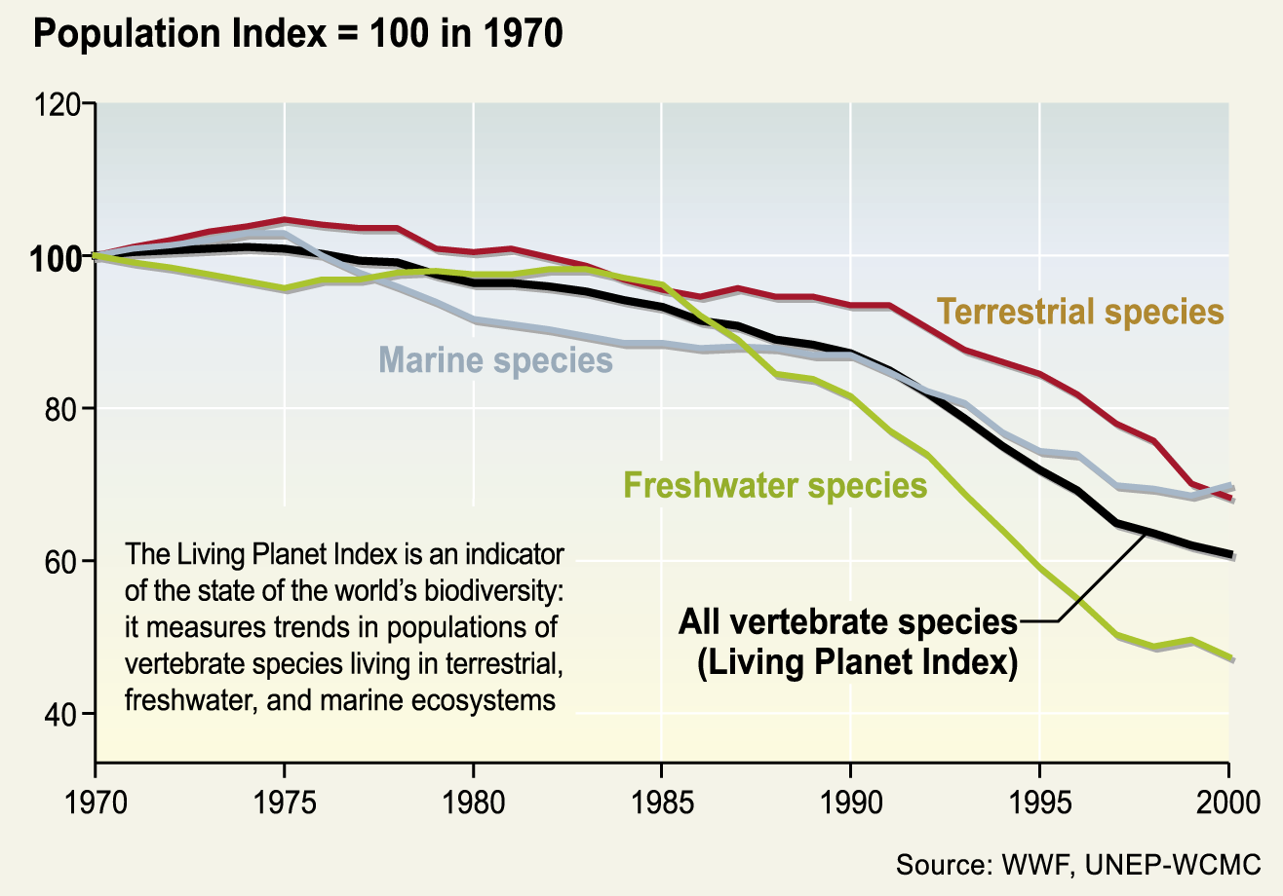
Figure 2: The Living Planet Index shows average trends in populations of terrestrial, freshwater, and marine species worldwide (Source WWF, UNEP-WCMC as presented in the Biodiversity Synthesis of the Millennium Ecosystem Assessment)

Headline indicator: Change in status of threatened species
- Threatened species occur across all taxonomic groups and in all parts of the world. Over the past few hundred years, humans have increased species extinction rates by as much as 1,000 times the background rates typical over Earth’s history. Between 12 and 52% of species within well-studies higher taxa are threatened with extinction, according to the IUCN Red List of Threatened Species. More than half of the 250 species of cycads, an ancient family of slow growing gymnosperms, is globally threatened. On the basis of Red List data, a Red List index can be calculated for different taxonomic groups or geographic regions. The index is based on the number of species in each Red List category, and on the number changing categories between assessments as a result of genuine improvement or deterioration in status. For birds, this index shows a continuing decline in the status of threatened bird species over the last two decades, across all continents (see Figure 3). Preliminary findings for other major groups, such as amphibians and mammals, indicate that the situation for these is if anything worse than for birds.

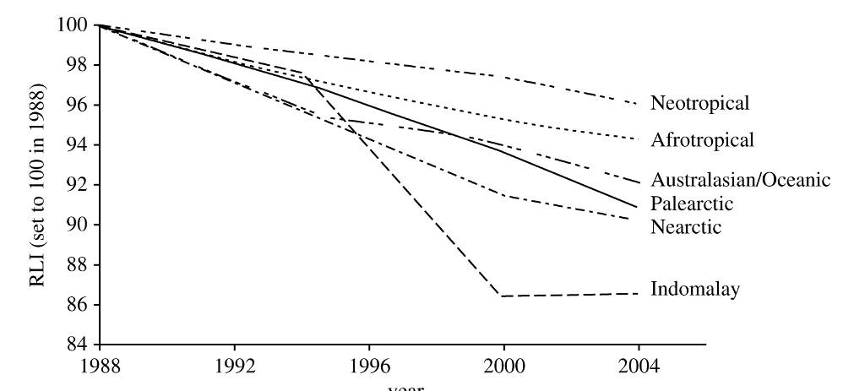
Figure 3: Red List Indices for birds for 1988–2004 in different biogeographic realms. (Source: Butchart et al. 2005)

Headline indicator: Trends in genetic diversity of domesticated animals, cultivated plants, and fish species of major socio-economic importance
- An analysis of trends in the varieties of species that underpin human livelihood, while sketchy, provides an alarming picture. Genetic variation is important for maintaining fitness and the adaptability of species, and of direct importance for people through the maintenance of goods and services provided by cultivated and domestic species: high yields, disease resistance and resilience to changing environmental conditions. At present, human well-being and particularly food security depends on a small group of genetic resources, where failure of one individual crop can have far reaching consequences. Loss of genetic diversity through the disappearance of locally adapted varieties and land-races of crops and livestock breeds is widely reported but difficult to quantify. It has been estimated that one third of the 6,500 recognized domesticated animal breeds are currently threatened with extinction. In addition to cultivated systems, the extinction of wild species and the loss of unique populations that has taken place have resulted in the loss of unique genetic diversity.
Headline indicator: Coverage of protected areas
- A key tool to counter the continuing loss of ecosystems and species is the establishment of protected areas. Protected areas currently cover about 12% of the Earth’s land surface, constituting one of the largest planned changes of land use. However, there are substantial differences in coverage between biomes (see figure 4) and in management effectiveness. Marine coverage lags far behind terrestrial coverage, with less that 0.5% of the ocean’s surface area protected.

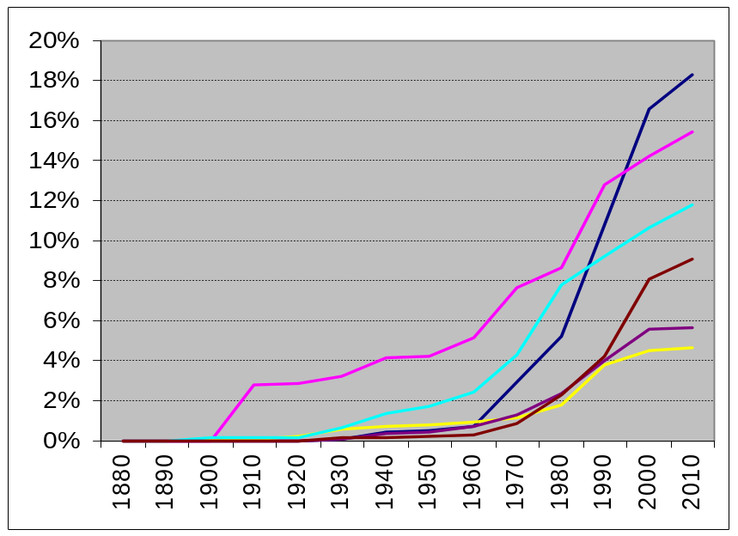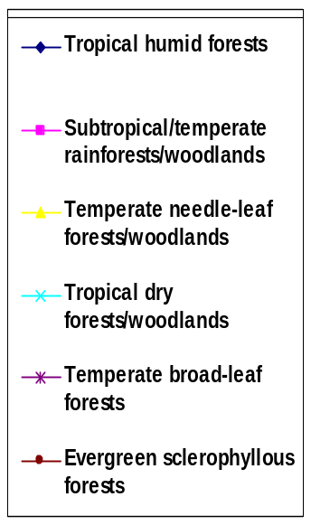
Figure 4: Coverage of major biomes by protected areas over time (Source: UNEP-WCMC)

Focal area: Maintaining ecosystem integrity, and the provision of goods and services provided by biodiversity in ecosystems, in support of human well-being

- Closely related to the assessment of biodiversity components is that of the integrity of ecosystems and their ability to support human livelihoods. The Millennium Ecosystem Assessment has placed particular emphasis on ecosystem goods and services because these provide the basis for human well-being and the ultimate rationale to maintain ecosystem health. While there are several indicators linking the integrity of ecosystems to human well-being, only a few have suitably developed methodologies and comprehensive global data to allow for their present use.
Headline indicator: Marine trophic index
- Oceans cover over 70% of the globe. The primary source of food from the oceans is from capture fisheries. Most preferred fish catches consist of large, high value, predatory fish, such as tuna, cod, and swordfishes. The intensification of fishing to unsustainable levels has led to the decline in these large fish, that are high up in the food chain, so that the relative numbers of small fish and invertebrates lower on the food chain increases. The biomass of top predators in the North Atlantic has decreased by two-thirds in approximately 50 years, and the mean trophic level of fisheries landings, i.e. the mean position of the catch in the food chain, has declined globally at a rate of approximately 0.1 per decade (see Figure 5). The resulting shortened food chains leave marine ecosystems increasingly vulnerable to natural and human induced stresses, and reduce the supply of fish for human consumption. The marine trophic index, which can be calculated from existing fish catch data, is therefore a good indicator of both ecosystem integrity and the sustainable use of living resources.

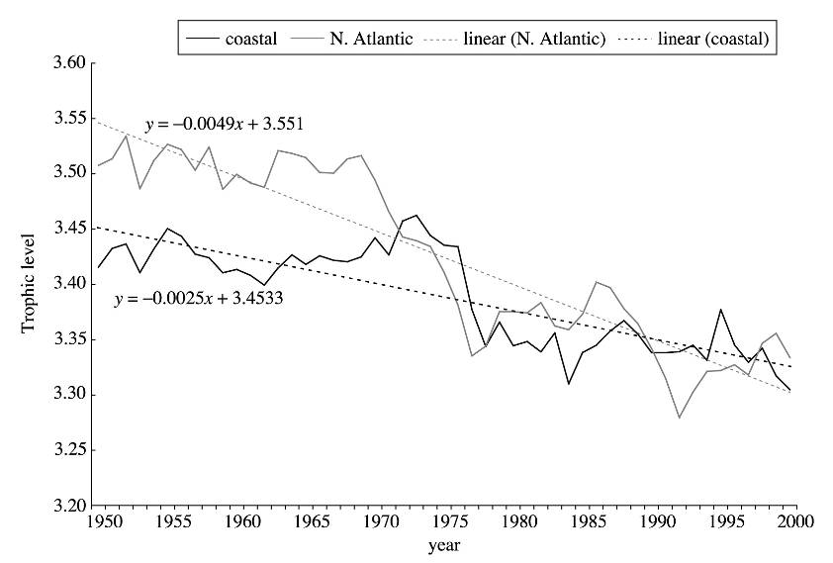
Figure 5: Trends in mean trophic levels of fisheries landings, 1950-2000. based on aggregation of data from over 180,000 half-degree latitude/longitude cells. Data for the North Atlantic is shown in grey and for Coastal waters is shown in black. Observed and fitted data are represented by solid and dashed lines respectively. Note: strong decline, particularly in the North Atlantic.(Source: Pauly & Watson 2005) /

Headline indicator: Connectivity / fragmentation of ecosystems
- In terrestrial and inland water ecosystems, human activities often lead to the fragmentation of habitats, with previously contiguous areas divided into a number of smaller patches. Small patches are much more vulnerable to outside influence than large ones, and also support smaller populations of species, making the latter more vulnerable to extinction. Both forests and riverine systems have been particularly affected by fragmentation (figure 6).
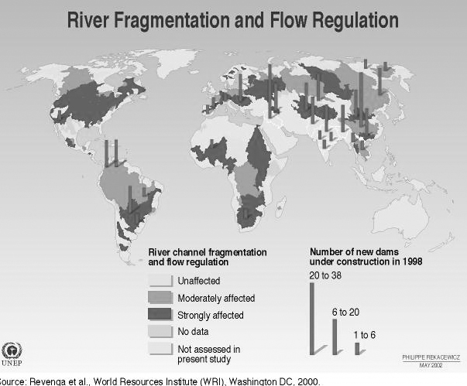

Figure 6: Global map of river fragmentation through channel fragmentation, dams and flow regulation (modified from UNEP-Vital Water Graphics)

Headline indicator: Water quality in aquatic ecosystems
- Besides fragmentation, inland waters are threatened by a series of other factors, in particular the extraction of fresh water for use in agriculture, industry and human consumption, and the drainage of wetlands. Human activities are impacting upon the quality of freshwater available, through pollution, increased sedimentation and climate change. Inorganic pollution of inland waterways has more than doubled since 1960, and increased by ten times in many industrial parts of the world. Biological oxygen demand (BOD), an indicator of the organic pollution of freshwater, has been analysed over the last two decades. Rivers in Europe and Australasia show a small but statistically significant reduction in BOD concentrations, indicating a slight improvement in water quality. There was little change in the assessed results for the other regions, however (Figure 7).
- Monitoring water quality indicates both major direct threats to the sustainability of inland waters and the effects of unsustainable activities outside that ecosystem. In fact, the health and integrity of inland waters is an excellent indicator of the health of terrestrial ecosystems. It can also indicate the impact of responses to environmental problems, for example successful policy interventions leading to improved water quality.

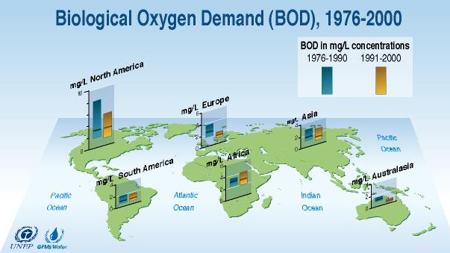
Figure 7: Trends in biological oxygen demand of major rivers in six regions between 1976 and 2000. (Source: UNEP-GEMS/Water Freshwater Quality Programme 2001)

Focal area: Addressing the major threats to biodiversity, including those arising from invasive alien species, climate change, pollution, and habitat change
- Five main threats to biodiversity are commonly recognized in the programmes of work of the Convention: habitat change, invasive alien species, climate change, nutrient loading and pollution, and overexploitation. The indicator Trends in extent of selected biomes, ecosystems and habitats provides information on habitat change (see box 2). Overexploitation is assessed through the ecological footprint and related concepts discussed under the focal area of sustainable use below. Additional indicators for nutrient loading and invasive alien species have been identified under the focal area addressed here.
- While there is no single indicator on the impacts of climate change on biodiversity, a number of indicators, including those on extent of ecosystems (particularly applied to coral reefs, glaciers and certain types of forests and drylands), abundance and distribution of selected species, and incidence of human-induced ecosystem failure, can serve to derive trends. Because small, fragmented ecosystems are more affected by changes in temperature and humidity than large compact ecosystems, Trends in connectivity/fragmentation of ecosystems provide an indicator of the vulnerability of ecosystems to climate change.

Box 2. Conversion of terrestrial biomes

It is not possible to estimate accurately the extent of different biomes prior to signiﬁcant human impact, but it is possible to determine the “potential” area of biomes based on soil and climatic conditions. This Figure shows how much of that potential area is estimated to have been converted by 1950 (medium certainty), how much was converted between 1950 and 1990 (medium certainty), and how much would be converted under the four MA scenarios (low certainty) between 1990 and 2050. Most of the conversion of these biomes is to cultivated systems.

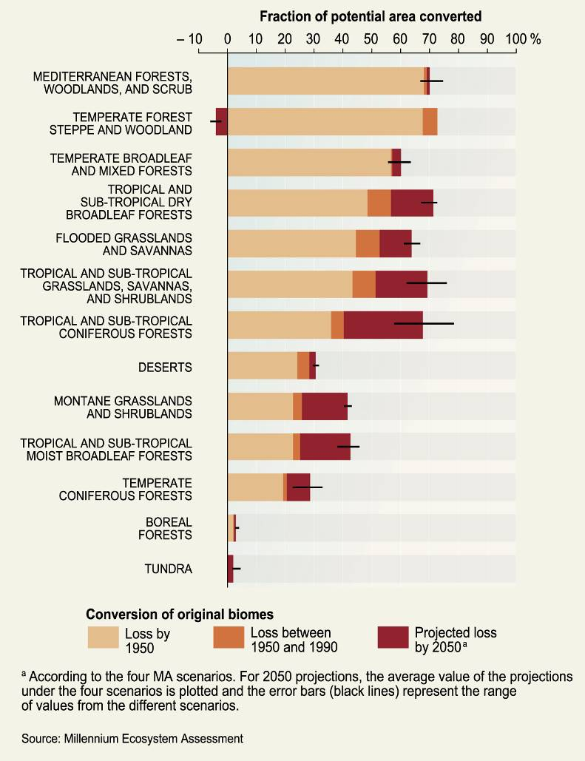

Headline indicator: Nitrogen deposition
- Among the major pollutants, the impacts of nitrogen have long been underestimated. Nitrogen in its fixed (reactive) form occurs naturally in all ecosystems. Most of the nitrogen produced by humans comes from manufacturing synthetic fertilizer to increase agricultural production. This use however, changes ecological balances, both locally and in far-distant ecosystems. Anthropogenic production of reactive nitrogen leads to the release nitrogen compounds into the atmosphere, which are subsequently deposited onto the biosphere. Aerial deposition of nitrogen increases levels in ecosystems such that those slow-growing species that thrive in nitrogen-poor environments cannot compete with faster-growing species that depend on higher nutrient levels. Temperate grasslands are particularly vulnerable in this respect. Moreover, soluble nitrogen leaches from soils into ground water, resulting in increased eutrophication – excess nutrients in inland and coastal waters that stimulate excessive plant growth - algal blooms and the creation of anoxic (oxygen-free) zones in inshore marine areas. Anthropogenic sources of nitrogen - from the manufacturing of synthetic fertilizer fossil fuel combustion and by nitrogen-ﬁxing crops and trees in agro-ecosystems - now exceed natural terrestrial sources, with more than half of all reactive nitrogen in ecosystems globally now from human sources (see figure 8).

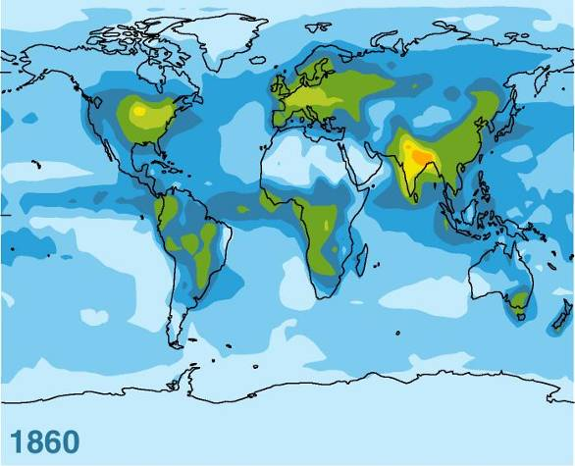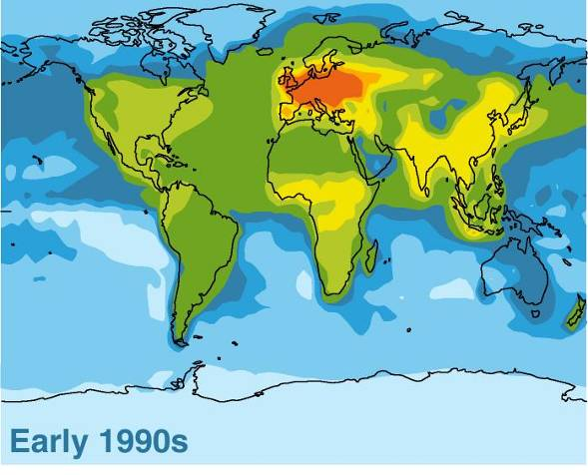
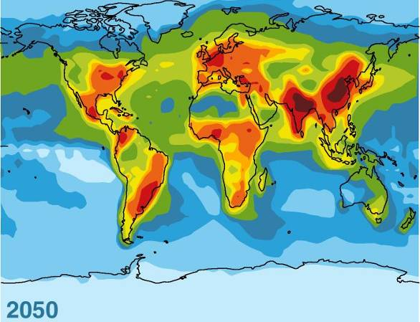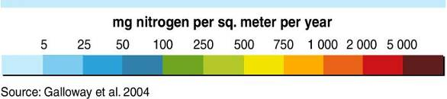
Figure 8: Estimated Total Reactive Nitrogen Deposition from the Atmosphere (Wet and Dry) in 1860, Early 1990s, and Projected for 2050 (milligrams of nitrogen per square meter per year). Atmospheric deposition currently accounts for roughly 12% of the reactive nitrogen entering terrestrial and coastal marine ecosystems globally, although in some regions, atmospheric deposition accounts for a higher percentage (about 33% in the United States). (Source: MA Biodiversity synthesis report).

Headline indicator: Trends in invasive alien species
- Ecosystems that are out of balance - for example as a consequence of fertilization/eutrophication - are particularly vulnerable to the establishment and spreading of non-native species, including pests and pathogens. Such invasive alien species can have devastating impacts on native biota, causing extinctions and impacting on valuable economic species. Invasive species can transform the structure and species composition of ecosystems by repressing or excluding native species. In the recent past, the rate and risk associated with alien species introductions have increased enormously because human population growth and human activities altering the environment have escalated rapidly, combined with the higher likelihood of species being spread as a result of increased travel, trade and tourism. A major source of marine introductions of alien species is hull fouling and the release of ballast water from ships, although other vectors, such aquaculture, and aquarium releases, are also important, and less well regulated than ballast water. The records of established alien species reported along the coast of Europe and in the marine waters of North America have been increasing dramatically over the last century (see figure 9).

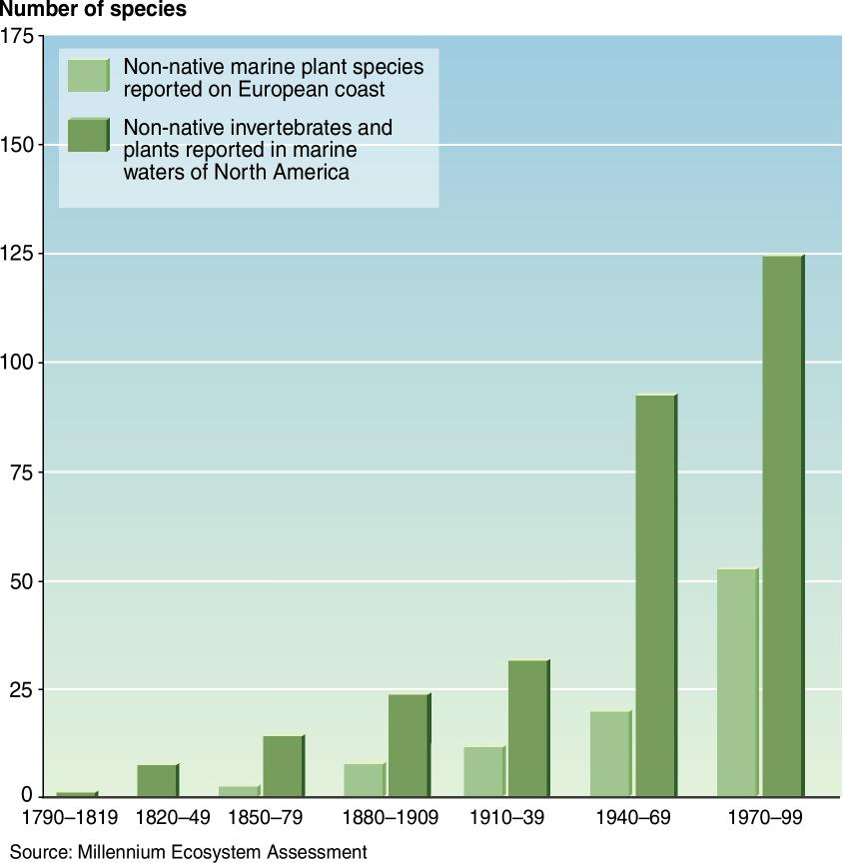

Figure 9. Growth in Number of Marine Species Introductions. Number of new records of established non-native invertebrate and algae species reported in marine waters of North America, shown by date of first record, and number of new records of non-native marine plant species reported on the European coast, by date of first record.

- Figure 10 summarizes the impacts of the main threats on biodiversity according to the main biomes. It is clear that almost all direct drivers of biodiversity loss are constant or are expected to increase in intensity in the future.

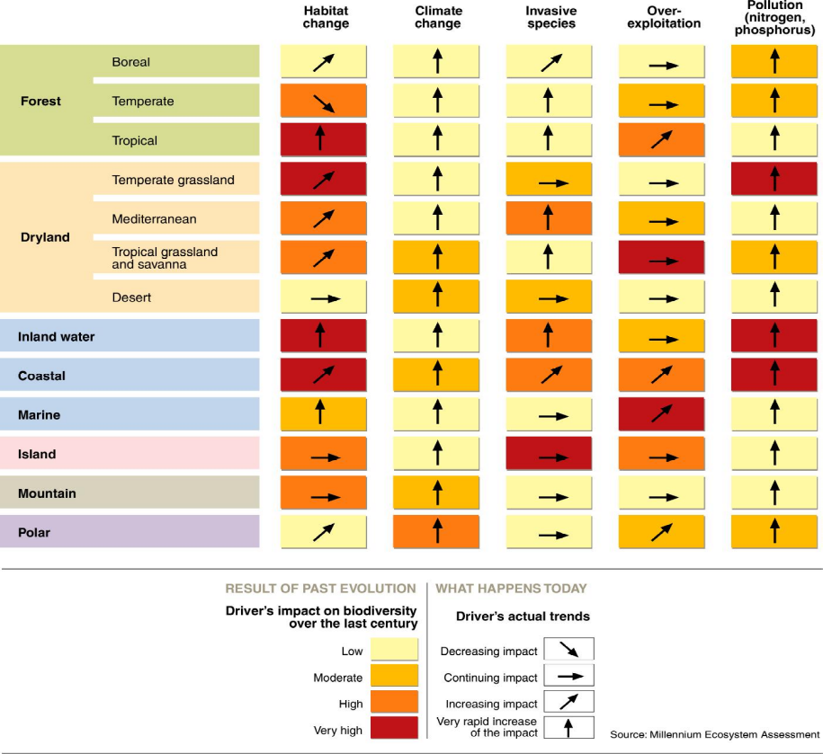

Figure 10. Main direct drivers of biodiversity loss. Source: Millennium Ecosystem Assessment

- In discussing threats to biodiversity it is important to keep in mind that – besides these direct drivers of biodiversity loss - a number of indirect drivers interact in complex ways to cause human-induced changes in biodiversity. They include demographic, economic, socio-political, cultural and religious, and scientific and technological factors, which influence human activities that directly impact on biodiversity through habitat change, overexploitation, the introduction of invasive alien species, nutrient loading and climate change.

Focal area: Promoting sustainable use of biodiversity
- The indicators discussed under the three previous focal areas have primarily focused on assessing biodiversity trends in natural ecosystems, and the factors affecting their integrity. The focal area on sustainable use, the second objective of the Convention, assesses harvesting and consumption pressure in systems where the primary purpose is production, be it for forest resources, agriculture (including horticulture), grazing, or fisheries (including aquaculture and mariculture). Naturally, there is no clear line between conservation and sustainable use, because production and harvesting takes place in almost all ecosystems outside strictly protected areas. Accordingly, some indicators of ecosystem integrity, in particular the marine trophic index, are also good indicators of sustainable use.
Headline indicator: Area of forest, agricultural and aquaculture ecosystems under sustainable management
- The headline indicator recognized for assessing the sustainability of human use of biodiversity focuses on the proportion of area of forest, agricultural and aquaculture ecosystems under sustainable management. One measure corresponds to the proportion of production lands that have been certified as meeting certain criteria for sustainability. Such measures, however, are far from comprehensive. Forest areas certified for their sustainable management, and recognized organic agricultural systems, probably represent only small proportions of the total area under production systems that, intentionally or unintentionally, meet such standards. Certification therefore provides information about market demand and a measure of the degree of awareness about the sustainable production but does not allow comprehensive statements about trends in sustainable use. Therefore, although figures on certified area and products show positive trends, these should not be interpreted as progress on sustainable use in general.
Headline indicator: Ecological footprint and related concepts
- Less complex than attempting to assess sustainable use is to monitor the unsustainable consumption of biological resources. A widely known concept in this respect is that of the ecological footprint: the area of land and water it takes to sustain a defined human population at a set material standard, based on the use of energy, food, water, building material and other consumables. It is a useful accounting tool whose purpose is to quantify the effect of human consumption on the productive capacity of the earth. The ecological footprint has been calculated globally on the basis of United Nations statistics. Figure 11 shows the ratio between the world's demand and the world's productive capacity, or biocapacity, in each year, and how this ratio has changed over time. Humanity has moved from using, in net terms, about half the planet's biocapacity in 1961 to 1.2 times the biocapacity of the Earth in 2001.

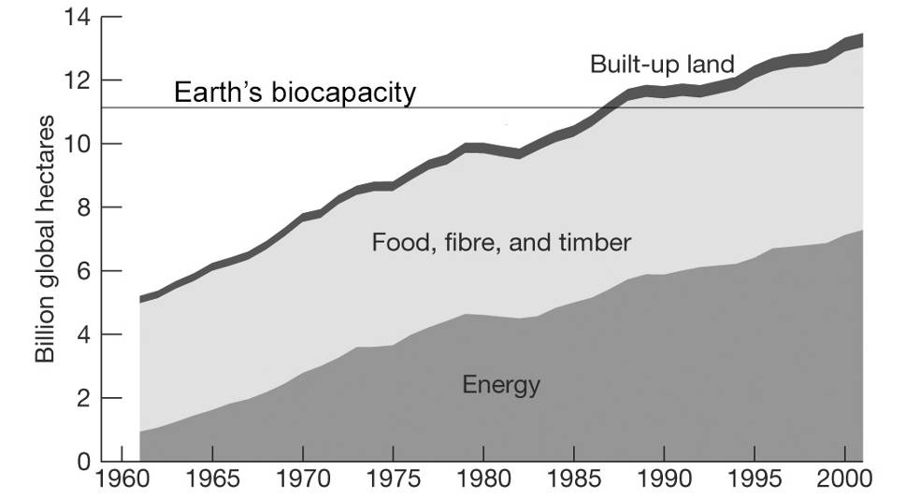
Figure 11. Global ecological footprint (modified from: WWF 2004. Living Planet Report. Figure 16).

Focal area: Protecting traditional knowledge, innovations and practices

Headline indicator: Status and trends of linguistic diversity and numbers of speakers of indigenous languages
- The Convention gives special consideration to the role and needs of indigenous and local communities, and recognizes the value of traditional knowledge and management practices relevant to the conservation and sustainable use of biodiversity. The Convention also recognizes the possible merit of a wider application of such traditional knowledge, innovations and practices pending approval of the holders. Recognizing the link between traditional knowledge and indigenous languages as a vehicle of transmission of such knowledge, a headline indicator on numbers of languages and of speakers of indigenous languages has been adopted. An analysis carried out by the United Nations Educational, Scientific and Cultural Organization reveals that, although a number of indigenous languages are believed to be threatened with extinction, it is difficult to obtain reliable and globally comparable statistics about trends of speakers of these languages. Moreover, in addition to the number of speakers of a language a number of other factors should be taken into account to classify the level of endangerment of a language. The Convention’s Ad Hoc Open-ended Working Group on Article 8(j) and Related Provisions is examining options for additional indicators on the status of traditional knowledge.

Focal area: Ensuring the fair and equitable sharing of benefits arising out of the use of genetic resources
- Perhaps even more difficult than the identification and development of indicators on traditional knowledge is to develop such indicators on the status of access and benefit-sharing, the third objective of the Convention. Few countries have legislation in place on access to genetic resources and the sharing of benefits arising out of their utilization and established procedures to enforce this legislation. As the Ad Hoc Open-ended Working Group on Access and Benefit-Sharing develops options for an International Regime on Access and Benefit-Sharing, it will also consider ways to assess the degree to which this objective is achieved and seek to develop appropriate indicators.

Focal area: Mobilizing financial and technical resources, especially for developing countries, in particular, least developed countries and small island developing states among them, and countries with economies in transition, for implementing the Convention and the Strategic Plan

Headline indicator: Official development assistance provided in support of the Convention
- Implementation of the Convention requires financial and technical resources. Parties to the Convention have agreed that developing countries require particular support to enable them carry out measures required under the Convention. Besides the Financial Mechanism of the Convention, official development assistance –financial flows to developing countries and multilateral institutions provided by official agencies – can be one component of assistance in the implementation of the Convention on Biological Diversity in poorer countries. In 1998, the Creditor Reporting System (CRS) categorized aid activities that target the objectives of the Convention. Initial data suggested that availability of financial resources for the implementation of the Convention was declining (see Figure 12). However, the lag time between the allocation of funds and reporting by donor countries means that longer-term analysis may show a different trend.

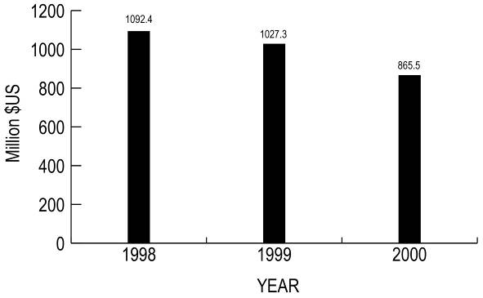

Figure 12: Biodiversity-related aid, commitments 1998-2000 by 19 members of the OECD Development Assistance Committee, Source OECD-DAC.

Conclusions
- The headline indicators discussed earlier vary in the length of underlying time series data, their temporal and spatial resolution, and the confidence with which statements about current trends in biodiversity, the drivers of change, and some response options can be made. Nevertheless, the indicators allow us to establish current trends in biodiversity, particularly when they are analysed and interpreted as a suite of complementary and interdependent variables. As research efforts focus on improving the coverage and quality of underlying data and related indicator methodologies we can expect that – despite certain limitations with some indicators - we will have, for several indicators, sufficient resolution to determine a change in the rate of biodiversity loss by 2010.
- On the basis of the information available to date a common message emerges: that biodiversity is in decline at all levels and geographical scales, but targeted response options – whether through protected areas, or resource management and pollution prevention programmes - can reverse this trend for specific habitats or species (table 1).

Table 1. Status and trends of 2010 indicators
Focal Area | Headline Indicator | Is the indicator showing positive or negative changes for biodiversity? |  | Remarks
Status and trends of the components of biological diversity | Trends in extent of selected biomes, ecosystems, and habitats | ➔ |  | Most habitats in most parts of the world are declining in extent.
Status and trends of the components of biological diversity | Trends in abundance and distribution of selected species | ➔ |  | Most species with limited population size and distribution are being further reduced while some common and invasive species become more common.
Status and trends of the components of biological diversity | Change in status of threatened species | ➔ |  | The risk of extinction increases for many threatened species, although some species recovery programmes have been very successful.
Status and trends of the components of biological diversity | Trends in genetic diversity of domesticated animals, cultivated plants, and fish species of major socio-economic importance | ➔? |  | Although it is likely that the genetic variety of cultivated species is declining, the extent of such a decline and its overall impacts are not well understood.
Status and trends of the components of biological diversity | Coverage of protected areas |  |  | There has been a significant increase in coverage of protected areas over the past decade, although efforts are needed to increase protected area coverage in marine ecosystems and to ensure the effective management of protected areas
Ecosystem integrity and ecosystem goods and services | Marine Trophic Index | ➔ |  | There has been a decline in the trophic level of harvested species, and dramatic increases in the number of fish stocks that are being overexploited.
Ecosystem integrity and ecosystem goods and services | Connectivity – fragmentation of ecosystems | ➔ |  | Most terrestrial and aquatic ecosystems are becoming increasingly fragmented.
Ecosystem integrity and ecosystem goods and services | Water quality of aquatic ecosystems | ➔ |  | Most parts of the world are likely to be suffering from declines in water quality, although quality in some areas has improved..
Threats to biodiversity | Nitrogen deposition | ➔ |  | Human activity has doubled the rate of creation of reactive Nitrogen on the planet’s surface. Major efforts are urgently required to use nitrogen and other nutrients more efficiently to reduce their release into water and atmosphere.
Threats to biodiversity | Trends in invasive alien species | ➔ |  | The number and rate of spread of alien species is increasing in all continents and all ecosystem types.
Sustainable use | Area of forest, agricultural and aquaculture ecosystems under sustainable management | ➢➔ ? |  | There are considerable efforts underway to increase the extent of areas of land under sustainable management. Regional efforts on sustainable forest management are expected to contribute to this. Traditional agricultural practices are being maintained and revitalized as the demand for ethical and healthy products increases. However, these are still relatively small niches and major efforts are required to substantially increase the areas under sustainable management.
Sustainable use | Ecological footprint and related concepts | ➔ |  | The ecological footprint of humanity is continuously increasing. Efforts at increasing energy-efficiency and reducing consumption are more than compensated by demand from a growing human population.
Status of traditional knowledge, innovations and practices | Status and trends of linguistic diversity and numbers of speakers of indigenous languages | ➔ ? |  | A large number of minority languages are believed in danger of disappearing, and linguistic diversity is very likely declining.
Status of access and benefit sharing | Indicator of access and benefit-sharing to be developed | ? |  | The need the need and possible options for additional indicators are being examined the Ad Hoc Open-ended Working Group on Access and Benefit sharing.
Status of resources transfers | Official development assistance provided in support of the Convention | ? |  | Available data show a declining trend, but data is too limited to be conclusive

- The following section discusses the tools and mechanisms established under the Convention to overcome priority challenges and to identify and initiate the efforts that are necessary to achieve the 2010 target in order to continue reducing and eventually halting biodiversity loss in the longer term.

SECTION 3- Responding to the challenges: the Convention on Biological Diversity
- In this section, we summarize current prospects for achieving the 2010 biodiversity target and point out the efforts required. Taking the Strategic Plan as the framework, we outline not only the state of implementation of the Convention and the challenges Parties are facing, but we provide guidance on potential directions for action. This section concludes with a review of key priorities for action, which will enhance the prospects of achieving the 2010 biodiversity target.
Framework for Implementing the Convention
- In the first ten years following entry into force, the Conference of the Parties focused on policy development. It adopted the Ecosystem Approach as a strategy for the integrated management of land, water and living resources that promotes conservation and sustainable use in an equitable way. It also established a series of thematic programmes of work for most of the major biomes on the planet (box 3) and initiated work on a number of cross-cutting issues, all of which have led to the development of biodiversity-related principles, guidelines and tools (box 4). Additional cross-cutting programmes of work such as those on protected areas and transfer of technology were also developed. The Conference of the Parties has also formed issue-specific working groups to advance progress on access and benefit-sharing, traditional knowledge, innovations and practices and on protected areas, and initiated the negotiation of the Cartagena Protocol on Biosafety to address potential risks posed by the transport and handling of living modified organisms.

Box 3: Thematic programmes of work of the Convention: |  | Box 4: Principles, guidelines and other tools developed under the Convention:
Agricultural biological diversity |  | Description, Principles and Operational Guidance for the Ecosystem Approach
Inland waters biological diversity |  | Bonn Guidelines on Access to Genetic Resources and Fair and Equitable Sharing of the Benefits Arising out of their Utilization
Marine and costal biological diversity |  | Addis Ababa Principles and Guidelines for the Sustainable Use of Biodiversity
Forest biological diversity |  | Guiding Principles on Invasive Alien Species
Biological diversity of dry and sub-humid lands |  | Akwé: Kon Voluntary Guidelines for the Conduct of Cultural, Environmental and Social Impact Assessment regarding Developments Proposed to take place on, or which are likely to impact on, Sacred Sites and on Lands and Waters Traditionally Occupied or Used by Indigenous and Local Communities
Mountain biological diversity |  | Guidelines for incorporating biodiversity-related issues into environmental impact assessment legislation and/or process and in strategic environmental assessment
Island biological diversity |  | Proposals on the Design and Implementation of Incentive Measures
 |  | Guidelines on Biodiversity and Tourism Development
- At the national level, most countries have developed national biodiversity strategies and action plans (NBSAPs) based on the principles of the Convention and their elaboration by the Conference of the Parties. As Parties hold primary responsibility for the implementation of the Convention, NBSAPs are central to achieving the objectives of the Convention.

The 2010 biodiversity target – prospects for its achievement
- The indicators adopted by the Convention on Biological Diversity, and discussed in section 2, demonstrate that biodiversity continues to be lost at all levels and reinforces the finding of the Millennium Ecosystem Assessment that unprecedented additional efforts would be needed to achieve the 2010 biodiversity target at national, regional and global levels. The magnitude of the challenge lies in the fact that most of the direct drivers of biodiversity loss - habitat change, overexploitation, the introduction of invasive alien species, nutrient loading and climate change - are projected to either remain constant or to increase in the near future. Moreover, inertia in natural and human institutional systems results in time lags—of years, decades, or even centuries—before the impacts of actions taken become apparent on biodiversity and ecosystems.
- However, the Millennium Ecosystem Assessment has also found that—with appropriate responses at the global, regional, and especially national level—it is possible to achieve, by 2010, a reduction in the rate of biodiversity loss for certain components of biodiversity or for certain indicators, and in certain regions. Several of the goals adopted in decision VII/30 could also be met (see box 5). For example, if areas of particular importance for biodiversity and functioning ecological networks are maintained, and if proactive measures are taken to protect endangered species, the rate of biodiversity loss of the targeted habitats and species could be reduced.

Box 5. Goals and targets of the 2010 biodiversity target and prospects for their achievement

Protect the components of Biodiversity
Goal 1. Promote the conservation of the biological diversity of ecosystems, habitats, and biomes. | Good prospects for most terrestrial regions. Major challenge to achieve for marine regions. Difficult to provide adequate protection of inland water systems.
Goal 2. Promote the conservation of species diversity. | Many species will continue to decline in abundance and distribution, but restoration and maintenance of priority species possible. More species will become threatened, but species-based actions will improve status of some.
Goal 3. Promote the conservation of genetic diversity. | Good prospects for ex situ conservation. Overall, agricultural systems likely to continue to be simplified. Significant losses of fish genetic diversity likely. Genetic resources in situ and traditional knowledge will be protected through some projects, but likely to decline overall.
Promote sustainable use
Goal 4. Promote sustainable use and consumption. | Progress expected for some components of biodiversity. Sustainable use unlikely to be a large share of total products and production areas. Unsustainable consumption likely to increase. Progress in addressing species endangered though international trade is possible, for example through implementation of the Convention on International Trade in Endangered Species of Wild Fauna and Flora.
Address threats to biodiversity
Goal 5. Pressures from habitat loss, land use change and degradation, and unsustainable water use reduced. | Unlikely to reduce overall pressures in the most biodiversity-sensitive regions. However, proactive protection of some of the most important sites is possible.
Goal 6. Control threats from invasive alien species. | Pressure is likely to increase (from greater transport, trade, and tourism). Measures to address major pathways could be put in place and management plans could be developed for major alien species.
Goal 7. Address challenges to biodiversity from climate change and pollution. | Pressures from both climate change and pollution, especially nitrogen deposition, will increase. These increases can be mitigated under UNFCCC for climate change and through agricultural and trade policy, as well as through energy policy for nitrogen pollution. Mitigation measures include carbon sequestration through LULUCF and use of wetlands to sequester or denitrify reactive nitrogen. Proactive measures to reduce impacts on biodiversity are possible, but challenging given other pressures.
Maintain Goods and services from biodiversity to support human well-being
Goal 8. Maintain capacity of ecosystems to deliver goods and services and support livelihoods. | Given expected increases in drivers, can probably be achieved only on a selective basis by 2010. Maintenance of biological resources that support sustainable livelihoods, local food security, and health care, especially of poor people would contribute to the achievement of the MDG 2015 targets, especially targets 1, 2, and 9.
Protect traditional knowledge, innovations and practices
Goal 9. Maintain sociocultural diversity of indigenous and local communities. | It is possible to take measures to protect traditional knowledge and rights, but continued long-term decline in traditional knowledge likely.
Ensure the fair and equitable sharing of benefits arising out of the use of genetic resources
Goal 10. Ensure the fair and equitable sharing of benefits arising out of the use of genetic resources. | Progress is possible in future scenarios based on cooperation.
Ensure provision of adequate resources
Goal 11. Parties have improved, financial, human, scientific, technical, and technological capacity to implement the Convention. | Progress is possible in future scenarios based on cooperation.

- For the most part, efforts to meet the 2010 target will not require the development of new tools. Most of the drivers of biodiversity loss are similar in character, scale, and intensity to those that the international community has experienced over the past 20 years and are already the subject of programmes of work under the Convention, including the framework of goals and targets adopted by decision VII/30. However, in light of the findings of the Millennium Ecosystem Assessment and the indicators, elements of the programmes of work of the Convention on Biological Diversity could be better prioritized and refocused to more squarely address drivers of biodiversity loss, and their impacts (box 6).

Box 6 Issues arising from the Millennium Ecosystem Assessment and CBD indicators to be addressed in the CBD programmes of work
Issue | CBD Response
Land-use change, particularly that due to the expansion of agriculture. | May sometimes fall between more than one programme of work without being adequately addressed by any. (The issue of expansion of agriculture into forests, for example, is not fully integrated into either of the programmes of work on agricultural biodiversity or forest biodiversity).
Over-exploitation of global marine fisheries around the world. | Response measures, such as the establishment of marine protected areas, are already included in the programme of work on marine and coastal biodiversity, but may not be sufficient, given the urgency of the situation.
Degradation in drylands leading to persistent reductions in their capacity to supply ecosystem services, often with significant impacts on livelihood security. | Adequately addressed through the programme of work on the biodiversity of dry and sub-humid lands.
The multiple drivers of change to inland water ecosystems, including modification of water regimes, invasive species, pollution, sedimentation and eutrophication. | Drivers of change are largely external to inland water ecosystems, implying that the programme of work on the biodiversity of inland waters (which does address these drivers) needs to be implemented across many economic sectors.
The problems of increasing reactive nitrogen in ecosystems, to be addressed through both increased efficiency of nitrogen use and by enhancing the capacity of ecosystems, in particular wetlands, to remove reactive nitrogen. | The programme of work on marine and coastal biodiversity covers land-based pollution, and the programme of work on inland waters addresses eutrophication, but there is a need for greater integration of this issue into the programme of work on agricultural biodiversity
An increase in average global temperature of two degrees or more above pre-industrial temperatures giving rise to globally significant impacts on ecosystems. | There is an urgent need for Parties and other Governments to address this threat, inter alia, through their commitments under the UNFCCC and its Kyoto Protocol, in order to lessen dangerous impacts on ecosystems.  The need for adaptation to climate change needs to be borne in mind in the implementation of all thematic programmes of work.
The increasing threat of introduction of invasive alien species, resulting from the increased levels of transportation, tourism and trade associated with globalization. | Not yet comprehensively addressed by the thematic programmes of work, although guiding principles are being elaborated.  This threat will be taken into account when SBSTTA addresses this issue in depth in preparation for the ninth meeting of the Conference of the Parties.

Achieving the Goals of the Strategic Plan: Key actions
- Given the broad scope of the Convention, and the need to be efficient in the use of resources, implementation should be guided by the Strategic Plan. An assessment of progress towards the achievement of the goals of the Strategic Plan—and the goals and sub-targets of the 2010 target—was recently conducted by the Working Group on Review of Implementation of the Convention. While progress is apparent in some areas, implementation of the Convention at the national level, where actions are most needed, is still at an early stage. In the following paragraphs we analyze advances towards the four goals of the Strategic Plan and propose key actions for improving the rate of progress towards these.
Goal 1: The Convention is fulfilling its leadership role in international biodiversity issues
1.1 The Convention is setting the global biodiversity agenda.
1.2 The Convention is promoting cooperation between all relevant international instruments and processes to enhance policy coherence.
1.3 Other international processes are actively supporting implementation of the Convention, in a manner consistent with their respective frameworks.
1.4 The Cartagena Protocol on Biosafety is widely implemented.
1.5 Biodiversity concerns are being integrated into relevant sectoral or cross-sectoral plans, programmes and policies at the regional and global levels.
1.6 Parties are collaborating at the regional and subregional levels to implement the Convention.

- Progress is being made towards goal 1 – and its six sub-objectives. CBD is playing a major role in setting the agenda among biodiversity-related conventions and organizations. The 2010 target has been endorsed by the World Summit on Sustainable Development and adopted or acknowledged by other conventions and NGOs. The framework of seven focal areas for monitoring progress towards the 2010 target has been adapted for use by the European Environment Agency. The scientific community is engaged and working on the framework’s further development.
- Cooperative initiatives responding to decisions of the Conference of the Parties are helping to promote policy coherence among related conventions. The International Plant Protection Convention, for example, has developed phytosanitary standards that cover some of the CBD’s concerns on invasive alien species. The CBD and the Ramsar Convention on Wetlands also have adopted common guidance on impact assessment in their joint work programme.
- In terms of implementation, other international processes are increasingly supporting the work of the Convention. The Global Partnership for Plant Conservation, the UNEP Regional Seas Programmes, the River Basin Initiative, the Global Invasive Species Programme, and other initiatives are pledging to provide or mobilize support for the implementation of the various programmes of work. Much more needs to be done to strengthen support from international and regional organizations for Parties’ efforts to implementing the Convention.
- A major challenge remains in integrating biodiversity concerns into the work of other international organizations and processes concerning trade, development, agriculture fisheries and forestry. For example, successful conclusion to negotiations of the Doha Development Round of the World Trade Organization to eliminate harmful subsidies in fisheries and agriculture and to consider sustainable production methods would mitigate some of the drivers of biodiversity loss.

Goal 2: Parties have improved financial, human, scientific, technical, and technological capacity to implement the Convention
2.1 All Parties have adequate capacity for implementation of priority actions in national biodiversity strategy and action plans.
2.2 Developing country Parties, in particular the least developed and the small island developing States amongst them, and other Parties with economies in transition, have sufficient resources available to implement the three objectives of the Convention.
2.3 Developing country Parties, in particular the least developed and the small island developing States amongst them, and other Parties with economies in transition, have increased resources and technology transfer available to implement the Cartagena Protocol on Biosafety.
2.4 All Parties have adequate capacity to implement the Cartagena Protocol on Biosafety.
2.5 Technical and scientific cooperation is making a significant contribution to building capacity.

- Significant progress towards this goal has yet to be made. This remains a major problem for the Convention, since lack of financial, human, scientific, technical, and technological capacity, particularly at the national level, constitutes an obstacle to implementation.
- Since 1991, the Global Environment Facility (GEF) that also operates the financial mechanism of the Convention has supported the implementation of the Convention on the order of US$150 million per year on average. Over this period, the average annual allocations to biodiversity have only changed marginally. Since 1996, there have been an increased number of projects jointly financed by the GEF and the World Bank resources.
- According to the initial survey of the Organization for Economic Cooperation and Development (OECD), total aid financing in support of the Convention’s objectives is on the order of US $1 billion per year. These external resources have catalysed national commitments and activities in the developing world. Most national biodiversity planning and implementation activities have been initiated and associated with certain external financial resources, in particular those from the Global Environment Facility. Further implementation of the Convention and scaling-up of implementation activities will continue to be dependent, greatly if not entirely, upon availability of international financial resources.
- Securing additional financial resources for biodiversity will likely require adopting new strategies. Development aid is increasingly provided through general budget support to developing countries, and less often earmarked for specific uses. In order that biodiversity conservation and sustainable use activities receive funding, biodiversity concerns will need to be incorporated into relevant national development planning processes, such as Poverty Reduction Strategy Papers (PRSPs). This, in turn, requires greater awareness of the role of biodiversity in ensuring sustainable development and supporting poverty reduction. A better appreciation of the value of biodiversity and of the ecosystem services that it underpins would also encourage the release of domestic resources in support of the Convention’s objectives. In some cases, the creation of markets for biodiversity-related ecosystem services might also generate significant resources.
- Overcoming a lack of human and technological resources is similarly challenging. Many Parties, particularly developing country Parties and those with economies in transition, lack both the trained staff and technological and institutional infrastructure to fully implement the programmes of work of the Convention. Coordinated action and flexible use of the instruments of the Convention, particularly the programme of work on technology transfer and the clearing-house mechanism could help rectify this.

Goal 3: National biodiversity strategies and action plans and the integration of biodiversity concerns into relevant sectors serve as an effective framework for the implementation of the objectives of the Convention.

3.1 Every Party has effective national strategies, plans and programmes in place to provide a national framework for implementing the three objectives of the Convention and to set clear national priorities.
3.2 Every Party to the Cartagena Protocol on Biosafety has a regulatory framework in place and functioning to implement the Protocol.
3.3 Biodiversity concerns are being integrated into relevant national sectoral and cross-sectoral plans, programmes and policies.
3.4 The priorities in national biodiversity strategies and action plans are being actively implemented, as a means to achieve national implementation of the Convention, and as a significant contribution towards the global biodiversity agenda.

- Progress towards Goal 3 is not satisfactory despite the critical importance of national level planning to implementation of the Convention. As of October 2005, just over half of the 188 Parties to the Convention had completed their national biodiversity strategies and action plans. Several other Parties had prepared drafts or had national biodiversity strategies and action plans awaiting government approval. One out of three Parties that have responded to this issue in their third national report describe putting in place comprehensive biodiversity strategies and action plans and integrating the three objectives of the Convention on Biological Diversity into major sectoral plans, programmes and policies.
- Recognizing the difficulty of gauging implementation of NBSAPs, the Working Group on Review of Implementation of the Convention recommended a redesign of the guidelines for the fourth national reports.
- The failure to broadly integrate biodiversity concerns is evident in processes outside of the Convention however. UNDP’s studies on Millennium Development Goal country reports, found that only 65 out of 100 countries reported on environmental indicators beyond those for MDG 7, (on environmental sustainability). Moreover, in the few cases when other MDGs were referenced, neither the causal link between poverty and environment, nor possible response systems were developed.

- To realize significant progress under goal 3 each Party should establish appropriate national targets within the flexible framework set up by the Conference of the Parties, and then focus national efforts on achieving these. Greater efforts must also be taken to mainstream biodiversity concerns into national policies, strategies and programmes for sustainable development and poverty reduction. This includes sectoral integration of biodiversity concerns, with a focus on sectors such as land use planning, agriculture, forestry and fisheries. There are already a number of tools available under the Convention to facilitate cross-sectoral integration and the mainstreaming of biodiversity into decision-making, including the Ecosystem Approach and work on integrated environmental impact assessment.

Goal 4: There is a better understanding of the importance of biodiversity and of the Convention, and this has led to broader engagement across society in implementation.

4.1 All Parties are implementing a communication, education, and public awareness strategy and promoting public participation in support of the Convention.
4.2 Every Party to the Cartagena Protocol on Biosafety is promoting and facilitating public awareness, education and participation in support of the Protocol.
4.3 Indigenous and local communities are effectively involved in implementation and in the processes of the Convention, at national, regional and international levels.
4.4 Key actors and stakeholders, including the private sector, are engaged in partnership to implement the Convention and are integrating biodiversity concerns into their relevant sectoral and cross-sectoral plans, programmes and policies.

- Progress towards this goal is mixed. Current communication, education and public awareness programmes by Parties are not sufficient to address the widespread lack of awareness and understanding of biodiversity and the importance of the Convention. Yet political will to address the biodiversity crisis will only result from an increased public understanding of biodiversity and its relation to human well-being. Such knowledge needs to be included in basic educational programmes and promoted through the general media.
- Indigenous and local community representatives as well as many civil-society organizations are well engaged with the Convention processes. The involvement of indigenous and local communities at the national level is often limited however, and varies greatly from country to country, suggesting the need to develop appropriate participatory mechanisms.
- Engaging key actors and stakeholders to integrate biodiversity concerns into other sectors is advancing, and more tools and instruments are in development, but much more progress is required. Many positive examples of engagement with NGOs exist, and these could be promoted further through the development of a global partnership on biodiversity and similar initiatives. To date, there has been very little engagement of the private sector in the work of the Convention at any level, despite the significant impacts of their activities on biodiversity. Through the “Business and Biodiversity 2010 Challenge” initiative, there is a growing recognition of the business case for biodiversity, leading to increasing and concrete opportunities to promote private sector engagement.

Key challenges for 2010 and beyond
- The key challenges arising from the foregoing analysis of the goals of the Strategic Plan are summarized in box 7. The analysis suggests that achieving the 2010 biodiversity target can be greatly facilitated through the integration and mainstreaming of biodiversity into sectoral policies and plans, and by emphasizing to society at large the economic merits of biodiversity conservation. These actions will contribute to greater progress on goals 2 and 3. At the same time, Parties need to be sensitive to the potential tradeoffs between conservation and development goals.

Box 7. Key Challenges for 2010
Goal 1: Leadership and International Cooperation
- Integrate biodiversity into international policy on trade, agriculture, forestry, fisheries and development.
- Establish effective regional and international mechanisms to support implementation of the Convention
- Complete the elaboration of an international regime on access and benefit sharing
Goal 2: Mobilizing resources for implementation
- Mobilize financial resources by integrating biodiversity into strategies for poverty reduction and sustainable development and creating markets for ecosystem services at all appropriate levels
- Invest in human resources development
- Develop scientific, technical and technological capacity
Goal 3: National Action
- Define national targets for 2010 and integrate them into NBSAPs
- Implement NBSAPs, with a focus on the 2010 targets.
- Integrate biodiversity into national policies, programmes and strategies on trade, agriculture, forestry, fisheries and development
- Apply the Ecosystem approach systematically, and use environmental assessment and integrated ecosystem assessment methodologies
Goal 4: Understanding biodiversity and stakeholder engagement
- Promote wider understanding of biodiversity and its role in ecosystem service provision, resilience to extreme events, and poverty reduction
- Engage the private sector to reduce negative impacts on biodiversity and contribute to the 2010 target
- Promote indigenous and local community participation through capacity-building and funding for participation in CBD meetings and processes taking into account the important role of women and the need to ensure geographic equity;
- Establish a global partnership for biodiversity

- Above all, it is apparent that mainstreaming of biodiversity into the plans, programmes and strategies of the main economic sectors is essential at the national (goal 2) and international (goal 1) levels. Realization of this goal will facilitate others, such as mobilizing resources (goal 2) and enhancing stakeholder engagement (goal 4). Indeed, many of the response actions needed to address the direct and indirect drivers of biodiversity loss, or that seek to establish enabling conditions for biodiversity conservation and sustainable use (see box 8), imply coordinated measures across various economic sectors, including energy, agriculture, forestry and fisheries. Many also have important implications for socio-economic and trade policy.

Box 8: Some additional response measures identified in the Millennium Ecosystem Assessment to address the direct and indirect drivers of biodiversity or establish enabling conditions for biodiversity conservation and sustainable use
- Ecosystem restoration.
- Payments and markets for biodiversity and ecosystem services.
- Incorporating considerations of biodiversity conservation into management practices in sectors such as agriculture, forestry, and fisheries.
- Enhancement of human and institutional capacity for assessing the consequences of ecosystem change for human well-being and acting on such assessments.
- Elimination of subsidies that promote excessive use of ecosystem services (and, where possible, transfer of these subsidies to payments for non-marketed ecosystem services)..
- Sustainable intensification of agriculture.
- Addressing unsustainable consumption patterns.
- Slowing and adapting to climate change.
- Slowing the global growth in nutrient loading.
- Correction of market failures and internalization of environmental externalities that lead to the degradation of ecosystem services.
- Integration of biodiversity conservation and development planning.
- Increased transparency and accountability of Government and private-sector performance in decisions that affect ecosystems, including through greater involvement of concerned stakeholders in decision-making.

- Discussion of these issues by the Conference of the Parties and its subsidiary bodies often has been difficult because of the political sensitivities involved. Nonetheless, these issues need to be discussed and resolved through greater dialogue among different sectors at the national level and within the Convention process, if meaningful progress towards the 2010 target and implementation of the Convention is to be achieved.
- Secondly, as noted by the Millennium Ecosystem Assessment, there is substantial scope for greater protection of biodiversity through actions justified on their economic merits, where economic value includes material or other benefits to human well-being. Realizing this potential requires a greater effort towards understanding and computing the total value of biodiversity, its components, and the provision of ecosystem services, together with the use of the resulting information and understanding in decision making. This includes the establishment of market mechanisms, where appropriate, for non-marketed ecosystem services.
- This observation underscores the more general requirement to pay increased attention in the work of the Convention to socio-economic issues and analysis, including biodiversity valuation, and the promotion of markets for ecosystem services. Care should be taken so that responses do not further marginalize the world’s poor and, wherever feasible, generate synergy with Millennium Development Goal 1 on hunger and poverty reduction. For instance, local capture of the benefits of such markets for ecosystem services can enhance the livelihoods of local communities and stakeholders while generating incentives for conservation and sustainable use of biodiversity. A better understanding of the role of biodiversity in contributing to poverty alleviation will be a key precondition for maximizing such synergy.
- The above points to the important linkages between the objectives and the 2010 biodiversity target of the Convention, and the Millennium Development Goals (MDGs). Because biodiversity underpins the provision of ecosystem services, which in turn affects human well-being, achievement of the MDGs requires that biodiversity loss be urgently reduced and eventually halted. Current trends, as elucidated by the indicators in this report, as well as scenarios developed by the Millennium Ecosystem Assessment and other initiatives, suggest that the degradation of ecosystem services could significantly increase during the ﬁrst-half of this century, representing a barrier to the achievement of the MDGs. At the same time, many of the actions that could be implemented to achieve the Millennium Development Goals, in particular, to promote economic development and reduce hunger and poverty, could harm biodiversity in the short-term.
- Informed decisions on potential tradeoffs and the consideration of synergies between the two sets of goals can be facilitated through coordinated implementation of the CBD and the MDGs. This implies that environmental considerations, including biodiversity, be integrated into the implementation not only of MDG 7 (‘to ensure environmental sustainability’) but of all of the relevant MDGs, including those to eliminate poverty and hunger (MDG 1), and to improve human health (MDGs 4 through 6).
- Such an approach is called for by decision VII/32 of the Conference of the Parties, in which Parties, Governments, international financial institutions, donors, and relevant intergovernmental organizations, are urged to implement development activities in ways that are consistent with, and do not compromise, the achievement of the objectives of the Convention on Biological Diversity and the 2010 target. In situations where there are inevitable tradeoffs between development activities and biodiversity conservation, however, the Conference of the Parties may in future wish to consider implementing mitigating actions to protect biodiversity.

Conclusion

- There should be no illusions. Achieving the 2010 biodiversity target requires not only a redoubling of efforts, but a firm commitment by Parties to act according to the priorities identified through the Strategic Plan. The conservation and sustainable use of biodiversity need to become an integral element of planning, policy and practice for all economic and social sectors of society. We all derive benefits from biodiversity, and will all suffer from its loss.
- We do need to acknowledge however that failure to deal with biodiversity loss will burden the poor disproportionately. Proof of the compassion and care of the global community for the poor can be shown by ensuring that the basis for their livelihoods is conserved, used sustainably and the benefits shared equitably.
- These are heavy commitments. The burden however can be lessened and synergy realized at all levels through cooperation and the contribution of all. Many hands make light work.

-----

* UNEP/CBD/SBSTTA/11/1.
For the purposes of assessing progress towards the target to achieve by 2010 a significant reduction in the current rate of biodiversity loss, biodiversity loss is defined as the long-term or permanent qualitative or quantitative reduction in components of biodiversity and their potential to provide goods and services, to be measured at global, regional and national levels (decision VII/30, paragraph 2). The “current” rate is taken to be the rate in 2002, when the Strategic Plan was adopted.
Focal areas and associated headline indicators are from decision VII/30 with refinement recommended in SBSTTA recommendation X/5. Box 1 lists only those headline indicators discussed in the Executive Summary, and the sequence of focal areas differs from decision VII/30. It should be noted that many headline indicators are relevant to several focal areas: for example the extent of selected biomes is an indicator of land use change, and therefore relevant to the focal area on addressing threats to biodiversity.
Butchart, S.H.M., Stattersfield, A.J., Baillie, J., Bennun, L.A., Stuart, S.N., Akçakaya, H.R., Hilton-Taylor, C., Mace, G.M. 2005. Using Red List Indices to measure progress towards the 2010 target and beyond. Phil. Trans. R. Soc. B 360: 255–268.
Pauly Pauly, D. & Watson, R. 2005. Background and interpretation of the ‘Marine Trophic Index’ as a measure of biodiversity. Philosophical Transactions of the Royal Society (Biological Sciences) 360(1454): 415-423.
http://www.unep.org/vitalwater/23.htm
http://www.unep.org/vitalwater/09.htm.

