 |  | CBD
 |  |  |  | Distr.  GENERAL  UNEP/CBD/SBSTTA/17/INF/11  11 October 2013  ENGLISH ONLY
Subsidiary Body on Scientific, Technical and Technological Advice
Seventeenth meeting

Montreal, 14-18 October 2013
GLOBAL INVASIVE ALIEN SPECIES INFORMATION PARTNERSHIP:
PROGRESS REPORT ON ACTIVITIES
Note by the Executive Secretary

INTRODUCTION
- Aichi Biodiversity Target 9 states: By 2020, invasive alien species and pathways are identified and prioritized, priority species are controlled or eradicated and measures are in place to manage pathways to prevent their introduction and establishment. Parties to the Convention and relevant organizations have been working to achieve the ambitious Target on invasive alien species, globally.
- To achieve Aichi Biodiversity Target 9, Parties need access to scientifically valid information on invasive alien species, including their occurrence with geographic references and their ecological features. “A Joint Work Programme to Strengthen Information Services on Invasive Alien Species as a Contribution towards Aichi Biodiversity Target 9” (UNEP/CBD/SBSTTA/15/INF/14) was developed to improve access to the necessary information through a workshop organized by the Global Biodiversity Information Facility (GBIF), held in Copenhagen, Denmark, on 5-6 September 2011, taking into account the result of an Ad Hoc Technical Expert Group meeting on invasive alien species held in Geneva, Switzerland on 16-18 February 2011(UNEP/CBD/SBSTTA/15/INF/1).
- The Subsidiary Body on Scientific, Technical and Technological Advice (SBSTTA), at its fifteenth meeting, welcomed the Joint Work Programme. To facilitate work prior to the eleventh meeting of the Conference of the Parties (COP 11), the Executive Secretary convened a workshop, “Organizational Workshop for the Global Invasive Alien Species Information Partnership”, at the Natural History Museum in London, United Kingdom, on 9-10 July 2012. The workshop prepared the “Operational Plan for the Global Invasive Alien Species Information Partnership” (UNEP/CBD/COP/11/INF/34).
- On the margins of COP 11 the following organizations signed Memoranda of Cooperation with the Secretariat of the Convention on Biological Diversity to join the Partnership: CABI, International Union for Conservation of Nature (IUCN) and its Invasive Species Specialists Group (IUCN-ISSG), FishBase Information and Research Group, Global Biodiversity Information Facility (GBIF), Museum National d’Histoire Naturelle (France), Natural History Museum (United Kingdom); the Horus Institute for Environmental Conservation and Development (Brazil); and Anatrack Ltd.
- The Conference of the Parties, at its eleventh meeting, welcomed the development of the Global Invasive Alien Species Information Partnership further to the joint work programme. During the first week of COP 11 some of the Partner organizations presented a beta version of its Information Gateway and other information systems and tools that may assist Parties to achieve Target 9.
- Following COP 11, the Partnership set up an interim Steering Committee with membership from CABI, IUCN-ISSG, Natural History Museum, GBIF and the Secretariat of the CBD. The Operational Plan for the Global Invasive Alien Species Information Partnership (GIASI Partnership) (UNEP/CBD/COP/11/INF/34) states that the interim Steering Committee may choose to establish a first full Steering Committee, composed of information providers and users including “representatives of selected partners (organizations which have signed the MoC) and Parties”, at the seventeenth meeting of SBSTTA (SBSTTA 17). The Executive Secretary will convene the first meeting of the Steering Committee on the margins of SBSTTA 17).
- A Coordinator was appointed for the period between January and August 2013. From October 2013, coordination will be provided by GBIF.
- The Partnership set up five Working Groups: Information Gateway, Database Interoperability and Quality Improvement, Information Synthesis and Assessment, Taxonomic Information Services, and Best Practices for Non-Web-Based Communications, with chairs and co-chairs largely drawn from the Partnership.
- The representatives of the partner organizations and technical experts met at an “Information Partnership Technical Workshop” organized by the Natural History Museum in London, United Kingdom, from 14 to 16 May 2013, with generous financial support by the European Union. The workshop made recommendations both for short-term and longer-term activities.
- This note provides a report on the progress made by GIASI Partnership since COP 11. Section II summarizes the progress on various functionalities of the Partnership Gateway and their data contents, while section III presents the outline of a plan for the Partnership during the period between SBSTTA 17 and the twelfth meeting of the Conference of the Parties (COP 12).
- The activities carried out and reported on in this note were made possible by the generous financial support from the European Union as well as very significant in-kind support from partners. Full implementation of the activities of the Partnership will require additional financial resources.
- The activities of the Partnership will be presented to interested Parties at a side event at SBSTTA 17. In addition, the partners will be available throughout SBSTTA 17, at an interactive demonstration kiosk, to present their activities and demonstrate how the Gateway can be used. Parties are encouraged to provide feedback to the partners.
- The Steering Committee will keep under review the Operational Plan, ensure its implementation, and facilitate and support the acquisition of resources to support the work plans. Recognizing that available funds are limited, the Steering Committee will be invited to identify priority activities for the GIASI Partnership.
- To facilitate data mobilization from a wider range of data publishers, particularly those data publishers on occurrence of biological invasion in developing countries, the Steering Committee will be invited to provide guidance for the working groups to further develop the GIASI Partnership Business Plan for 2014-2020. The Business Plan will be presented to potential donors and data publishers that are not yet sharing data through the GIASI Partnership.

II. PROGRESS ON FUNCTIONALITY OF THE PARTNERSHIP GATEWAY AND IMPOVING RESOURCES TO SUPPORT PARTIES IN ADDRESSING TARGET 9

Improving content of the Information Gateway
- The organizational workshop held in London, United Kingdom, on 9-10 July 2012 recommended that a web-based Information Gateway be constructed, and outlined the required functionality. The beta version of the Information Gateway developed from these recommendations was presented to Parties on the margins of COP 11 and Parties experienced its interface and information made accessible on invasive alien species.
- Since COP 11 there has been feedback from users, from the Technical Workshop held in 2013 and from members of the Information Gateway Working Group, and considerable development led by the Natural History Museum and with particular support from IUCN-ISSG. The Information Gateway is now fully active to support the Parties in their efforts to meet Target 9. The Gateway provides access to:
- Web-based resources from many providers, both members of the GIASI Partnership and others;
- Literature resources through bibliographies both on the Gateway and elsewhere;
- Ecological, biological nomenclatural and other information about species known or suspected to be invasive;
- A Forum facility to enable discussion between users and Partners;
- Information about the Partnership;
- A comments facility to allow users to comment on any resource and recommend changes and additions.
- Since COP 11, the web-based information sites referred to from the Information Gateway has increased from fewer than 100 to nearly 700. Each information resource is provided with a hyperlink to the site and a short descriptive text to assist the user in identifying relevant content. The available resources cover a very wide range of topics related to invasive species, including material provided by other conventions and multilateral bodies such as the International Plant Protection Convention (IPPC), the Food and Agriculture Organization of United Nations (FAO), the European and Mediterranean Plant Protection Organization (EPPO) and others.
- To assist the users to locate the desired resources on the Information Gateway a set of key terms to describe web resources content was agreed and implemented. This list includes 359 separate terms, including geographical terms, resource type, sector (agriculture, biofuels, environment etc.), biome and organism. This list is being updated during the evaluation phase in order to improve the search functionalities of the Gateway.
- Currently, web resources are listed under three main headings: “Information Services”, “Tools”, and “Pathway Information”, each of which has a number of sub-menus to refine a search. In addition, a search facility has been designed and built. This operates on key terms and any other term used in the title or descriptive text of the web resource.
- The lists of species known to be invasive across part of their range have been improved with the addition of names from Global Invasive Species Database (GISD), FishBase, SeaLifeBase, Delivering Alien Invasive Species Inventories for Europe (DAISIE) and CABI. These lists provide automatic lookup from each species name of information held in several external resources: IUCN Red List, Encyclopedia of Life, NCBI, Biodiversity Heritage Library and Google Scholar. In addition, many of the names carry links to the relevant species pages on the Internet developed by the Partners. When the interoperable system is developed (see section II D below), the functionality described above will extend to many more resources across the Partnership.
- While anyone can view the contents of the Information Gateway, users can register with the site to provide additional functionality, including the ability to add content to the site.
- The Information Gateway will support additional functionality, and developments will be prioritized with input from the Parties. Parties are encouraged to use the “Comments” fields and the “Contact us” facility to comment on the Gateway and its content and suggest improvements and desired functionality.

Populating the Global Register of Introduced and Invasive Species
- The IUCN-Invasive Species Specialists Group (ISSG) has further developed the Global Register of Introduced and Invasive Species (GRIIS), as an integrated tool within the Global Invasive Species Database. The GRIIS provides annotated country inventories of introduced and invasive species. The annotations include taxonomy, biological status of the species in that country and a Yes/No on evidence of environmental and/or socio-economic impacts. The GRIIS integrated tool is an essential information building block of the GIASI Partnership information infrastructure. The contents of GRIIS will be indexed within the GIASI Partnership central registry and mapped against other information resources (see section II D below). It is foreseen that through interoperability with other information resources, all interconnected information resources will contribute to filling the existing information gaps, supporting data quality improvement and fitness-for-use, and supporting future knowledge acquisition.
- During this first phase of development of GRIIS inventories of introduced and invasive species from over 100 countries have been compiled. These inventories have been derived from a range of information sources as follows:
- Global databases: CABI Invasive Species Compendium, FishBase, SeaLifeBase;
- Regional databases: Pacific Island Ecosystems at Risk (PIER), DAISIE; the European Network on Invasive Alien Species (NOBANIS), European Alien Species Information Network (EASIN);
- National databases: South American countries and some Caribbean countries from the IABIN Invasive Information Network (I3N), Australia, China, Finland, Israel, Japan, Mexico (CONABIO), New Zealand, Norway, Poland, South Africa, and overseas territories of France and the United Kingdom, among others;
- Databases compiled by researchers for countries: Nigeria, Chad, and India; and
- Other information extracted from journal articles and national reports.
- Country editors are being identified to assist with validation of the data sets and keeping the data sets updated with the latest information. It is envisaged that the work continuing in the next phase will allow completing global coverage.
- A preliminary analysis of the collated data for the over 100 countries to date shows that many of the widespread species have not been covered or profiled in the existing global database services. The GRIIS may fill the information gap that needs to be addressed.
- The ISSG has also restructured the Global Invasive Species Database. Presentation of the web pages and functionality of search and download have been optimized. In collaboration with the IUCN Red List of Threatened Species, information on the impacts of invasive species on threatened native biodiversity has been enhanced. This newly populated GISD, through the activities of the GIASI Partnership, enables further coverage of occurrence data on invasive species in the GRIIS.
- The provision of more accurate classification of invasive alien species information will also facilitate the improvement of other information systems, through the tagging of relevant information. For example, GBIF intends to use the GIASI Partnership associated information resources to tag all invasive alien species specimen and observation data within its global index of more than 417 million occurrence data. Such a step will therefore enable the provision of high-quality temporal biodiversity presence data in the native and invasive ranges of selected species. Therefore new collaboration opportunities with information systems not originally designed for invasive alien species assessments are expected to emerge in the short-term.
- The immediate expected outcome of this first phase of development is a better assessment of existing knowledge on invasive alien species as well as an identification of major information gaps between and within the existing information systems. Such assessment will trigger increased data quality improvement within the existing information systems (e.g. correction in species names, identification or observed presence in countries). More importantly, the development will also facilitate a more coherent assessment of gaps in existing knowledge and potential investments in acquisition/capture of new knowledge (e.g. presence of invasive alien species in countries not known today but where presence is neighbouring countries is known).
- It is envisaged that the GRIIS will support Parties to develop or update their national invasive species strategies and action plans as a part of national biodiversity strategies and action plans (NBSAPs), in which Parties may consider appropriate legislation and regulations on invasive alien species using the information accessible at this register. The contents of the GRIIS may also assist Parties in formulation and prioritizing of invasive species management actions.

Populating the Invasive Alien Species Pathway Management Resource
- The identity of the introduction pathways and details of the vectors are the most important data items to assist management of invasive alien species. These are necessary for prevention of introduction of potentially invasive species and also for containment to halt further spread of established invasive species. The Invasive Alien Species Pathway Management Resource (IASPMR) provides the necessary information for Parties.
- To prevent introduction and spread of invasive alien species, knowing the pathways and appropriate measures to control and manage the pathways are critically important, because measures to be taken on the identified pathways are considered to be the most cost effective way of managing invasive alien species. The IUCN/ISSG, in collaboration with several partners from CABI, DAISIE, Centre for Ecology & Hydrology in the United Kingdom, FishBase, and the National Invasive Species Council in the United States of America, has operationalized the prototype developed for the demonstration on the margins of COP 11.
- The current version of the Invasive Alien Species Pathway Management Resource includes mapping of pathways of introduction and spread by using data derived from GISD, CABI, NOBANIS and DASIE; and a list of species and their pathway information for selected pathways. In addition, information on date of first arrival and first report has been documented. Validation of these records and exchanges has been conducted by in-country experts and this collaboration with in-country experts may continue to assist in filling the gaps in the existing data. This data is valuable for measuring trends and identifying critical pathways for management.
- As a result of desktop literature review, relevant legal information on management of pathways, possible measures to manage the pathway and references to the literature are also included in the IASPMR.
- Furthermore, the Invasive Alien Species Pathway Management Resource will allow Parties to understand the principal routes through which alien species enter a country or an ecosystem, and to respond accordingly. This functionality supports policymakers and managers to take the precautionary approach indicated in the Guiding Principles to implement Article 8(h) annexed to decision VI/23.,*

Towards an interoperable system
- An assessment of the existing vocabularies in use within the existing major information systems was envisioned to support the development of appropriate information exchange protocols for the Partnership. At the Technical Workshop in London held in 2013, an assessment was made of the most critical use cases for Parties in addressing core questions set by Aichi Biodiversity Target 9. This exercise has led to the identification of the most critical information components required in the first phase of implementation of the Partnership (Figure 1). The development of complex vocabularies was discouraged at this early stage of development and it was agreed to focus on a more practical approach.
- The core components of vocabularies in the central registry would encompass species, location, measures, pathways, temporal information and sources. For example, participants could submit to the registry a species name that will be centrally verified against existing authoritative resources such as the checklist of Catalogue of Life, the Interim Register of Marine and Non-marine Genera (IRMNG), the International Plant Names Index (IPNI), NCBI Taxonomy, the Integrated Taxonomic Information System (ITIS), the World Register of Marine Species (WoRMS), Index Fungorum, Fauna Europaea, Wikipedia Species, the GRIN Taxonomy for Plants and many others. This service is already implemented in the central registry and offers functionalities to map species names against the GBIF checklist bank, verify the validity of names, and indicate mapping equivalence to known species name in authoritative references. Recent tests with seven publishers have shown that less than 5 per cent of the names were not mapped correctly and these were mostly explained by mapping to a higher taxon (e.g. from subspecies to species). Figure 2 provides a screenshot of the central registry interface for the test list of 311 species from IUCN/ISSG Global Invasive Species Database. Species names are being mapped to names used in authoritative nomenclatures, and other publishers reporting usage of the same names are listed.

Figure 1. Vocabularies in the central registry and flow of information exchange between the registry and participating partner’s database.
- The central registry also offers to data publishers the opportunity to verify the taxonomy mapping against taxonomic references as shown in Figure 2. A list of all taxonomic reference publishers to the GBIF checklist bank is provided, with a list of all known vernacular names in different languages. In addition, this service also offers the visualization of textual information from distributed resources, such as information on where the species is native or invasive, its biology, literature etc. At this stage of development such information is captured in textual form and potentially could be formatted for improved access and discovery.
- With regards to other data elements such as location, a simplified vocabulary is implemented. For example, the intersection between species and location is represented with Boolean values. This applies to presence/absence information whereby the presence of a given species (e.g. Acacia mearnsii) in a country (e.g. South Africa) is represented as “<species> * <country> = true”. Such Boolean values apply also to the attributes of data value pair: native/invasive; or invasive/not invasive.
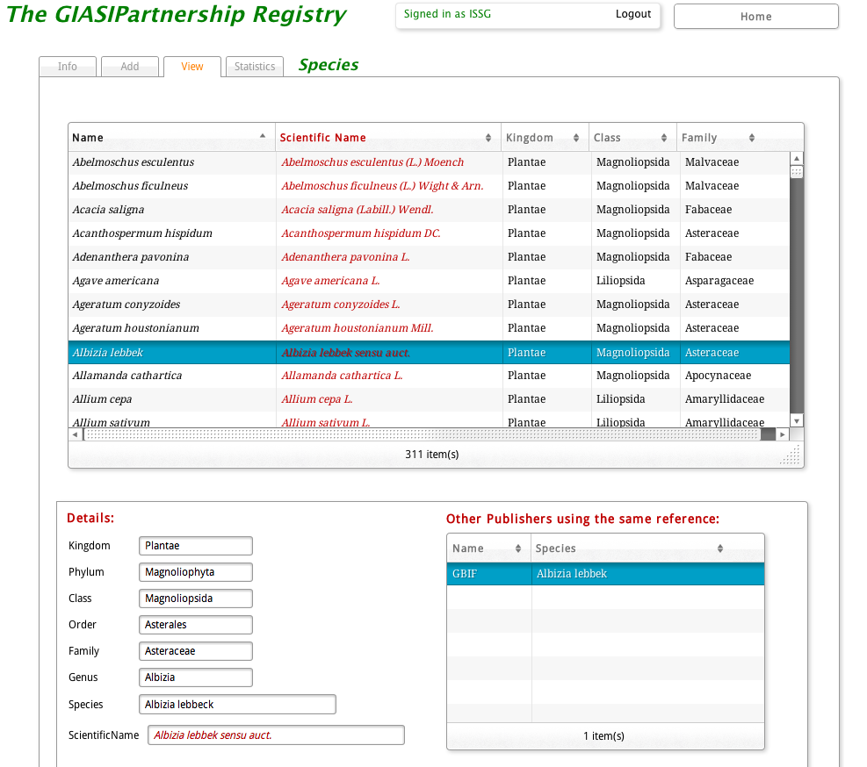

Figure 2. Example of vocabularies in the central registry
- In the first phase of development, the location information will be limited to the country level. While some information systems do hold more precise information (e.g. county, geospatial etc.), it was agreed to initiate the standardization at a higher level: the country level. The standards used will be names of countries, territories and islands based on the ISO 3166-1 standard. The latest assessment of information availability with some data publishers such as GBIF and IUCN-ISSG has shown that this approach is viable.
- During this initial phase of development, it has not been possible to harvest all data publishers’ information. The test of the central registry was undertaken using various information sources and data subsets from GISD, DAISIE, NOBANIS, GBIF, GISP, GISIN and others. When the central registry offers the essential functionalities required, a complete refresh of the data will be undertaken with all data resources in the Partnership. As it stands, the evaluation was undertaken on approximately 2,207 species, of which 39.7 per cent are animals and 59.2 per cent plants. The geographical distribution is still centered on North America, Europe, South Africa, Africa and to a lesser extent Latin America. This can be explained by some selected data resources (e.g. NOBANIS, DAISIE etc.) and their regional focus.
- The central registry also offers a summary view of the indexed information from these multiple data resources. As shown in Figure 3, the registry provides the list of publishers reporting the usage of the same species as well as a consolidated view of the reported presence in different countries (which in this case, for South Africa, includes temporal reports from GBIF) for a given species (here Acacia mearnsii). A preliminary evaluation of some most known invasive alien species has shown great opportunities for contributing information resources based on additional knowledge from other sources (e.g. report of presence of an invasive alien species in a country by multiple other sources). Therefore, this shows already the opportunity of the GIASI Partnership not only to identify gaps in knowledge within information systems but also the opportunity for gap-filling based on collaborative exchange of information.
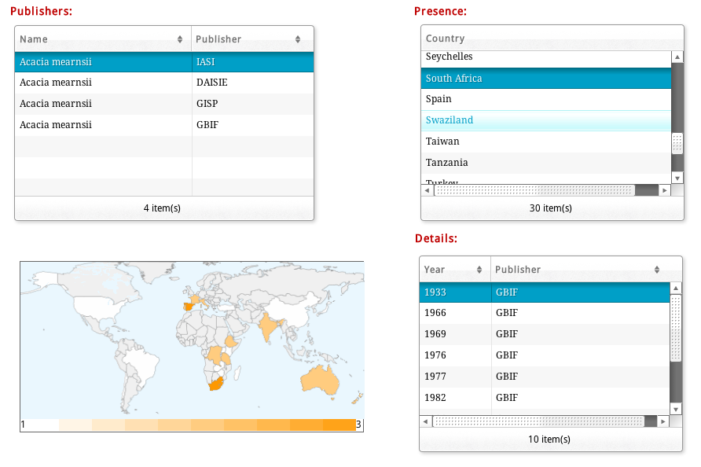

Figure 3. Example of views returned from the central registry of data provided by the partners.
- The central registry web site will be presented at SBSTTA 17 during a side-event. It should be noted that this is a work in progress for the search engine, and uses a selected data exchange protocol for some selected taxa.
- At this stage the data submission to the central registry is made through web forms but should rapidly be complemented with more advanced technologies. For example, GBIF intends to explore the usage of its Integrated Publishing Toolkit (IPT). The IPT is already widely used by hundreds of data publishers such as the GBIF global network. Such a cost-effective solution is in line with the spirit of the GIASI Partnership by building on existing solutions rather that exploring the development of new solutions. Other solutions may be considered such as simplified JavaScript Object Notation (JSON) web services. The connectivity between the Partnership Gateway (based on Drupal) and the central registry will be based on such JSON services.

Development of resources other than those on the Internet
- While a great deal of the activity of the Partnership is related to online resources and increasing their content, relevance and availability, the Working Group on Best Practices for Non-Web-Based Communications is focusing on how to deliver and exchange relevant information without use of the Internet.
- To date most of their attention has been on priorities for development of mobile phone apps, which are increasingly used for identifying, mapping and reporting invasive species.
- Ideally such a tool would draw on information already compiled by the Partners and accessible through the Gateway, so that users could integrate their information with other information on invasive species.
- A project proposal is being produced to support development of a product.

III. PLAN OF ACTION (OCTOBER 2013 – SEPTEMBER 2014)
- The “Information Partnership Technical Workshop” took place in 2013, as noted above in this document. Work Programmes and priorities for each of the Working Groups were outlined. Following this each of the Working Groups developed a full work programme, each of which will be implemented subject to resources being available.
- The workshop produced a plan to improve the Information Gateway for Parties to access needed information in their work flow for achieving Aichi Target 9. Each element of this plan requires additional resources to be made available for implementation.
- A revised Information Gateway structure was suggested, considering the conceptual information flows of users of the Gateway. The proposed revised structure of the Information Gateway is shown in Figure 4.

Figure 4. Revised Gateway structure based on Target 9 workflow concept.
- An interim redesign of the Information Gateway will be implemented for feedback in the last quarter of 2013, and a full redesign, incorporating the interoperability functionality discussed in section II D above and following paragraphs, will be developed and implemented in 2014, subject to appropriate resources being available.
- Additional activities regarding the Gateway will include production of training materials to assist users, establishing means of delivering gateway content in more than one language, developing a monitoring and evaluation strategy, and improving the sustainability of Gateway management.
- The workshop also suggested how the GIASI Partnership could enhance successful discovery of data for national reporting and further planning on management of invasive alien species. A central registry model (Figure 5) was agreed as the most immediate product of the GIASI Partnership in this regard. This central registry model allows queries to distributed partners’ databases to retrieve national and sub-national level occurrences of invasive alien species and possible measures. Preliminary work has taken place to explore functionality and requirements, as detailed in section II D above.

- To enable queries to the distributed partners’ databases, partners are required to agree on the data exchange protocol and implementation of the interface of the proposed interoperable system. Figure 5 shows a generic information architecture of the interoperable system of the GIASI Partnership. In this proposed architecture, the central registry will be searchable by, at least: (i) species name; (ii) location (country name or local geographic area); (iii) management measures; or (iv) pathways; others might be added as a search vocabulary. The query from users on the central registry server will be sent to each corresponding database of the GIASI Partnership, and it will return searched data to the central server via an interface handling the data exchange protocol which is agreed by the GIASI Partnership. The users can retrieve needed information from various distributed databases of the Partner organizations on the screen of the Information Gateway, dynamically.
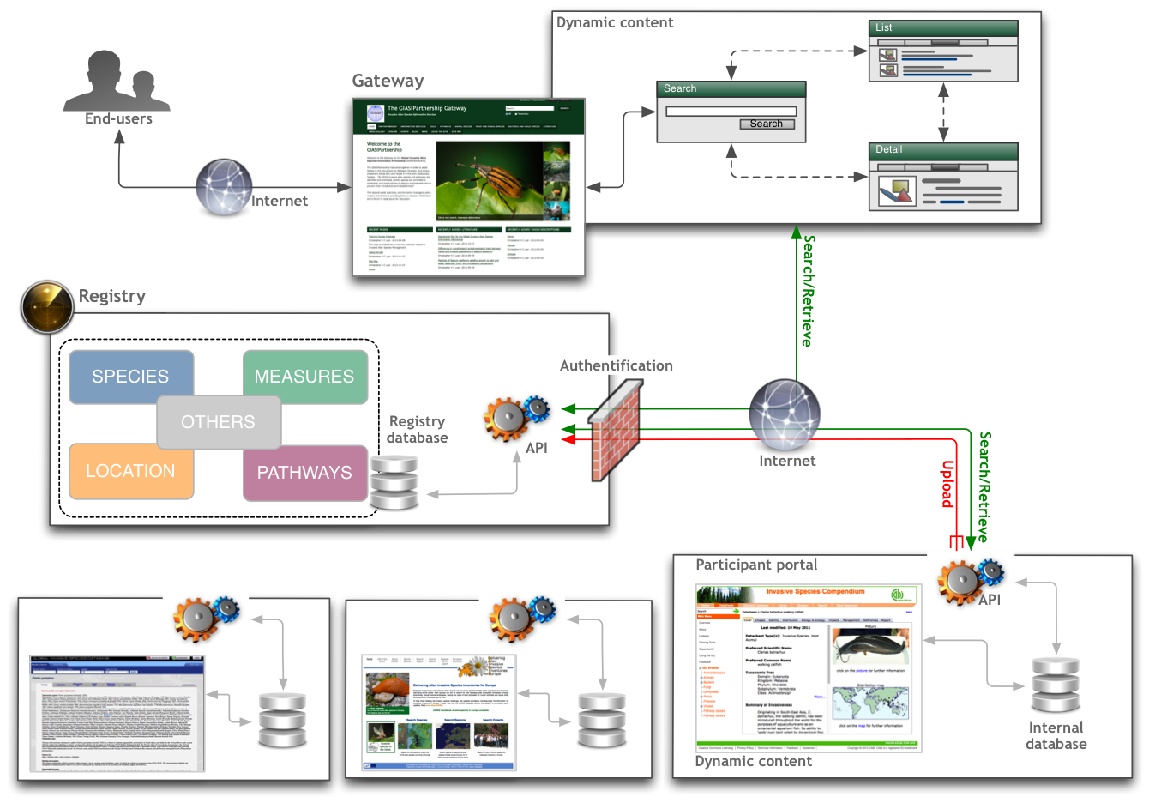

Figure 5. Generic information architecture of the central repository model.
- The provision of data to the central registry by the data publisher will be achieved using web services or file upload / form submission. Various technologies exist for this purpose such as the GBIF Integrated Publishing Toolkit (IPT). During the initial development phase the partners agree to use an authentication system whereby the central registry will not yet be fully accessible to the public.
- The Registry system, including the Gateway redesign, can be developed in 2014 given sufficient resources.
- The Information Synthesis and Assessment Working Group will maintain a focus on the Invasive Alien Species Pathway Management Tool, both developing it further and reviewing its development. It will also further develop the Global Register of Introduced and Invasive Species.
- This Working Group is also considering the practicalities of developing a tool to help protected area managers set priorities for the control and management of invasive alien plants and, funding permitting, develop case studies of best practices with detailed information on management techniques, focusing on biocontrol and protected areas.
- Information important to understanding the status and management of biological invasions is widely spread on the Internet and may not be easily discovered, while further information is not yet available on the Internet. Within the context of the GIASI Partnership mission, mobilizing such data and knowledge from a wider range of data publishers to the Partnership’s information system is important to meet the needs of Parties. Further synthesis of relevant digital information by experts and organizations beyond the Partners would also be important to identify and then fill information gaps.
- Filling information gaps may require additional capacity for the potential data publishers, including citizen scientists in the world. The capacity needed by users may include the skills to analyze data, using them to set priorities, developing management plans, conducting risk analysis/assessments, measuring patterns and trends, developing indicators, and monitoring the progress toward achieving Aichi Biodiversity Target 9.
- The Working Group for Best Practices for Non-Web Communication is considering the requirements for a targeted needs assessment, and is inventorying non-web information and communication products and approaches. It is discussing plans for a good practice toolkit, and focusing on the development of a smartphone app for African invasives, funding permitting.
- The Working Group for Taxonomic Information is planned to be established and operational in 2014, subject to the available funding. The focus of the Working Group, once active, will be in harmonizing taxonomic names across information suppliers and provision of tools to enable rapid identification of alien species.
-----

This note has been prepared in close collaboration with the Interim Steering Committee for the Global Invasive Alien Species Information Partnership.
A detailed workshop report is accessible at http://cbd.int/invasive/GIASIPartnership/.
http://GIASI Partnership.myspecies.info.
http://GIASI Partnership.myspecies.info/resources/14580/all.
http://GIASI Partnership.myspecies.info/resources/14589/all.
⁶ http://GIASI Partnership.myspecies.info/resources/14613/all.
http://GIASI Partnership.myspecies.info/search-resources.
http://www.issg.org/database/welcome/.
http://www.fishbase.org/search.php.
http://www.sealifebase.org/.
http://www.europe-aliens.org/.
http://www.cabi.org/isc/.
http://www.iucnredlist.org/search.
http://eol.org/.
http://www.ncbi.nlm.nih.gov (National Center for Biotechnology Information).
http://www.biodiversitylibrary.org/.
http://scholar.google.com/.
http://www.cabi.org/isc/.
http://www.fishbase.org/search.php.
http://www.sealifebase.org/.
http://www.hear.org/pier/.
http://www.nobanis.org/.
http://easin.jrc.ec.europa.eu/.
http://i3n.iabin.net/.
http://www.iucnredlist.org/search.
http://www.ceh.ac.uk/.
www.invasivespeciesinfo.gov/council/.‎
http://www.cbd.int/decision/cop/default.shtml?id=7197. * One representative entered a formal objection during the process leading to the adoption of this decision and underlined that he did not believe that the Conference of the Parties could legitimately adopt a motion or a text with a formal objection in place. A few representatives expressed reservations regarding the procedure leading to the adoption of this decision (see UNEP/CBD/COP/6/20, paras. 294-324).
www.catalogueoflife.org/‎.
http://www.cmar.csiro.au/datacentre/irmng/.
http://www.ipni.org/.
http://www.ncbi.nlm.nih.gov/Taxonomy/taxonomyhome.html/index.cgi.
www.itis.gov/‎.
www.marinespecies.org/.
www.indexfungorum.org/names/names.asp‎.
www.faunaeur.org/‎.
en.wikipedia.org/wiki/Species.
www.ars-grin.gov/cgi-bin/npgs/html/index.pl‎.
http://www.gbif.org/informatics/infrastructure/publishing/.
http://GIASI Partnership.myspecies.info/sites/GIASI Partnership.myspecies.info/files/GIASI PartnershipTechWorkshopReport_final.pdf .

