 |  | CBD
 |  |  |  | Distr.  GENERAL  UNEP/CBD/SBSTTA/20/INF/43  UNEP/CBD/SBI/1/INF/41  15 March 2016  ORIGINAL: ENGLISH

SUBSIDIARY BODY ON SCIENTIFIC, TECHNICAL AND TECHNOLOGICAL ADVICE  Twentieth meeting  Montreal, Canada, 25-30 April 2016  Item 3 of the provisional agenda* | SUBSIDIARY BODY ON IMPLEMENTATION  First meeting  Montreal, Canada, 2-6 May 2016  Item 4 of the provisional agenda**

Protected areas: facilitating achievement

of Aichi Biodiversity targets 11

Introduction
- At its tenth meeting in Nagoya, Japan, in October 2010, the Conference of the Parties (COP) to the Convention on Biological Diversity adopted a revised and updated Strategic Plan for Biodiversity, for the 2011-2020 period, including 20 Aichi Biodiversity Targets. The Fourth Global Biodiversity Outlook in 2014 reported varying levels of progress for the different elements of Aichi Biodiversity Target 11 on protected areas. This document provides a details update of the status and projections for implementation of this target.
- Decision XI/24 on Protected Areas invited Parties to undertake major efforts, with appropriate support and consistent with national circumstances, to achieve all elements of Aichi Target 11. It invited Parties to: continue to conduct assessments of the governance of protected areas; strengthen recognition of and support for community-based approaches; renew efforts to establish multi-sectoral committees; align protected area projects in action plans for the Programme of Work on Protected Areas (PoWPA) with the fourth, fifth and sixth replenishment periods of the Global Environment Facility (GEF); and to report on the implementation of actions, including incorporation of the results of implementing projects funded by the GEF and other donors, in order to track progress towards achieving Aichi Target 11.
- Given the above, this document first summaries the approach that the Secretariat of the Convention is implementing, in coordination with partners, to facilitate achievement of the target and decision XI/24; then, lays out current information on the status of the target, per element, as well as projections for implementation; summarizes progress made; discusses some lessons learned; and lists some potential directions for increasing achievement of each element as well as next steps. It should be noted that facilitating achievement of Aichi Biodiversity Targets 11 has been possible thus far due to a grant through the Japan Biodiversity Fund.

BAckground
- To facilitate achievement of Aichi Biodiversity Targets 11 figure 1 summaries the approach the Secretariat is taking for this biennium. For the first step, the Secretariat has renewed communications with a number of organizations from the PoWPA Friends Consortium, who have committed to the process including through data sharing and participating in the capacity-building workshops.
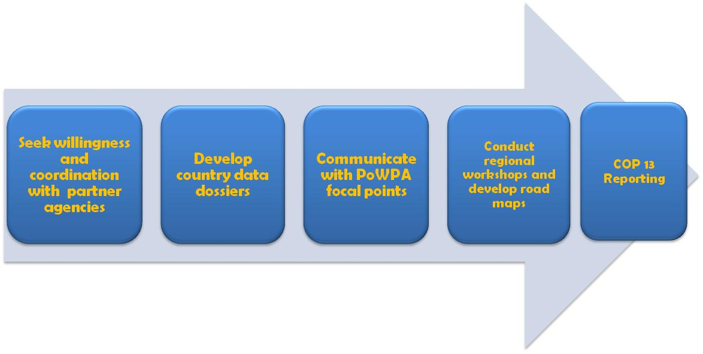
Figure 1. Approach for implementing Aichi Biodiversity Targets 11 in 2015-2016

- For the second step, in order to help Parties collect and share information and data on the status of each target the Secretariat has prepared data dossiers using information from BirdLife International, the Digital Observatory for Protected Areas (DOPA), Global Environment Facility (GEF), and the World Database of Protected Areas (WDPA). Each country data dossiers includes information on: estimated protected area coverage; terrestrial and marine ecoregions; Important Bird and Biodiversity Areas (IBAs); Alliance for Zero Extinction Sites (AZEs); overlaps between unprotected and partially protected IBAs and AZEs and candidate ecological region for further protection; and allocation and utilization of country’s fifth and sixth replenishment of the GEF.
- It should be noted that the country data dossiers are in no way prescriptive; they are intended to help Parties identify specific information and data, including sources, that will increase understanding of some of the elements of the target, such that they can then develop focused actions (road map) to be undertake before 2020. The dossiers are being shared with respective country representatives as part of a series of regional workshops, entitled Capacity-building workshop on achieving Aichi Biodiversity Targets 11 and 12, held from September 2015 to August 2016. Through the workshops countries are validating and updating the information in the dossiers.
- For the third step, the Secretariat has developed a series of e-mail communications to prepare country participants for the workshop. The first communication describes the background and objectives of workshop. The second email recaps the objectives; introduces the country data dossier; and request the participant to go through the information in their PoWPA Action Plan, revised NBSAP, and Fifth National Report to the CBD. The third email presents the country data dossier; summarizes the information contained within it; and asks the participant to go through them with colleagues to validate, update and identify the gaps in information. The third email also presents a questionnaire and requests participants to submit the completed version two weeks prior to the start of the workshop, taking into account information in the dossier as well as other relevant national information, in consultation with CBD focal points and other relevant colleagues.
- The fourth email introduces participants to the workshop’s two exercises. First, participants are requested to report on the status of each element of target 11, including gaps and opportunities in the form of a matrix. Second, participants are also requested to identify and list priority, feasible and focused actions, taking into account gaps, opportunities and commitments in national action plans. Focused actions should be undertake in the next five years to improve the existing status of the target, facilitating achievement at national, regional or global levels. As part of this process, participants are invited to look at ongoing or just approved GEF 5 or GEF 6 and other bilateral projects on protected areas, such as the project grants under the German Government, and requested to map the project components to the relevant element of each target. Furthermore, when needed, country representatives are also engaged in conference calls to clarify the doubts and explain the above process.
- For the fourth step, participants share the information they have collected due to communications prior to the workshop. They submit a table outlining what is the current status, gaps in implementation and the opportunities arising from the gaps for each element of Aichi Target 11. Participants also drafted focused actions (road map) to be undertaken by 2020. Participants are encouraged to share and discuss the updated information with the partner organizations present at the workshop, and to formally submit it through the relevant persons upon return, as a means of updating global databases. Participants also are requested to submit their final road maps after further scrutiny, aligning with GEF 6 and other bilateral projects, formally through their CBD focal point, one to two months following the end date of the workshop.
- Furthermore, as part of the lead up to the thirteenth Conference of the Parties, the Secretariat is exploring the ability to create political build-up for implementation through the issuance of joint letters with the Minister of Environment of Brazil and the Minister of the Environment, Forest and Climate Change of India to their counterparts in all 60 countries in their respective regions, encouraging Parties to develop pledges based on their road maps and to present them at the high-level segment.

Status and projections
- To present the status and projections of Aichi Biodiversity Targets 11 and 12, the targets are broken down into “parts” or elements that can be defined. These elements or sub-sections are:
- Quantitative element
  - Terrestrial protected areas, including inland waters;
  - Coastal and marine protected areas;
- Ecological representation;
- Areas important for biodiversity;
- Areas important for ecosystem services;
- Effectively managed;
- Equitably managed;
- Well connected systems of protected areas;
- Integration of protected areas into wider land- and seascapes; and
- Other effective area-based conservation measures.
- Each sub-section presents information, as per global databases maintained by partner organizations and/or the literature, on the status of the target element as well as country projections and examples, as collected from the three workshops listed in table 1.
Table 1 Status of capacity-building workshops on achieving Aichi Biodiversity Targets 11 and 12 as of December 2015
Workshop | Number of countries invited | Number of countries that attended | Number of countries that submitted the status information | Number of countries that submitted their focused actions | Percent of participants that evaluated the workshop as ‘very good’ and ‘good’
East and Southeast Asia  Yanji City, China  15 - 18 September 2015 | 17 | 12 | 11 | 7 | 99.5%
Latin America and the Caribbean Curitiba, Brazil  28 September - 1 October 2015 | 33 | 24 | 19 | 22 | 97.3%
South, Central and West Asia  New Delhi, India  7 - 10 December 2015 | 29 | 16 | 13 | 13 | 98.3%
- Attendance and submission information for the three regional workshops held thus far, from September to December 2015, is displayed in table 1. Attendance from the two main regions, Asia (61 percent) and Latin American and the Caribbean Group or GRULAC (73 percent), is positive. Furthermore, most countries that have attended have submitted their status matrices (83 percent) and focused actions (81 percent); as such the following sub-sections present a rich variety of examples.

Quantitative element

1. Terrestrial, including inland waters
- As per Protected Planet Report, at the global level 15.4 percent or 20.6 million km² of world’s terrestrial and inland water areas are protected. Chart 1 provides a regional breakdown. Central and South America as well as the Southern Oceans have already reached this element of the target; Africa, Caribbean, North America, Oceania and West Asia are less than 3 percent from reaching the 17 percent target, while Asia and Europe need to protect about five and four percent each.

Chart 1 Global and regional status of terrestrial protected areas in percentages
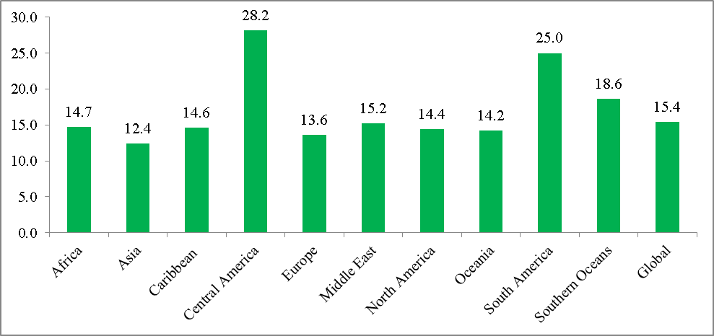
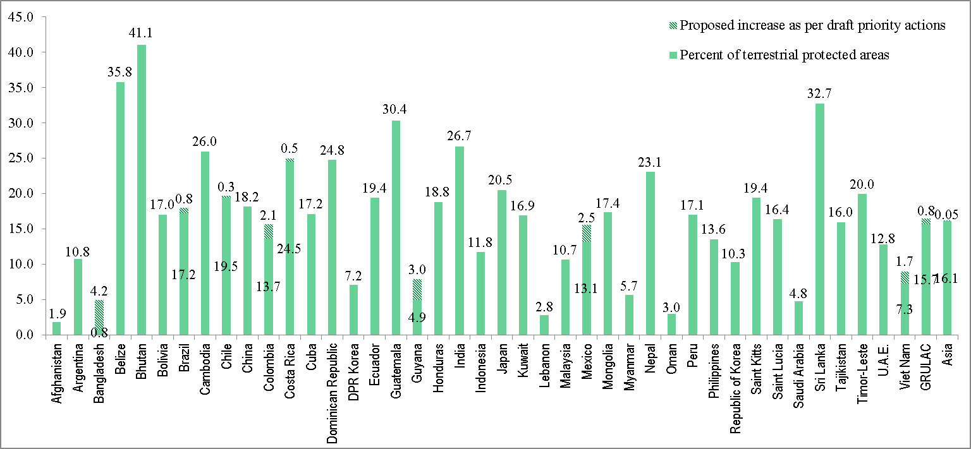
Chart 2 National status of protected areas and proposed increase for terrestrial areas
- Chart 2 presents the national status and proposed increase for terrestrial protected areas, as submitted by country participants in the three workshops. Nationally, from the 41 countries that have submitted numerical information on the status of terrestrial protected areas, 21, or half, have reached or surpassed the 17 percent global target. Three countries are close to reaching the target, with less than one percent of additional protected areas needed, and 6 have less than 5 percent of territorial land areas protected. From the information submitted, only 8 countries have presented their projected increase for terrestrial areas as a percentage.
- Mexico has protected 13.15 percent of its terrestrial territory through several conservation measures and protected areas. As part of Mexico’s priority actions, the country aims to create 7 new terrestrial protected areas, adding 48 318.03 km² of protected areas, resulting in a total of 15.61 percent of Mexico’s total terrestrial territory being protected. To reach 17 percent of its terrestrial territory under protection, the country aims to classify and verify the conservation status of Wildlife Management Units and forest reserves in order to officially include those with the optimal conditions in the National System of Protected Areas.
- Guyana has four National Protected Areas in its National Protected Areas System covering approximately 5.6 percent of the country’s terrestrial area. As part of its priority actions, Guyana aims to include the Konashen Community Owned Conservation Area as an official protected area, adding 3 percent of its terrestrial territory under protection.
- As of May 2015, Vietnam had 166 protected areas covering approximately 7.4 percent of the country’s total terrestrial area. As part of Vietnam’s priority actions, the country aims to reach 9 percent of its terrestrial area under protection by 2020.
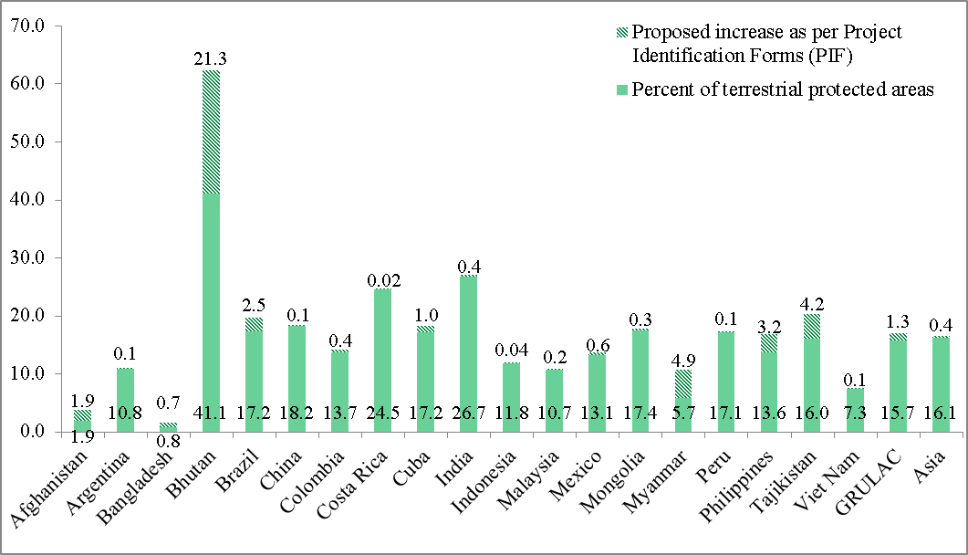
Chart 3 National status of protected areas and proposed increase as identified in country’s project identification forms for GEF funding for terrestrial areas
- Chart 3 presents the national status of protected areas and proposed increase as identified in outcomes of country’s project identification forms (PIF) in GEF 5 projects for terrestrial areas. From the three regional workshops held so far, almost all GEF eligible Parties already have one or two approved protected area projects that address various elements of Aichi Biodiversity Target 11. Out of 41 countries, 19 have GEF 5 projects that will specifically increase the coverage of terrestrial protected areas. From these 19 projected increases, 11 countries have yet to reach the target. One country, Tajikistan, will reach the 17 percent global target when their current GEF 5 project is completed.
- From charts 2 and 3, it can be noted that the projected increase from the expected outcomes of the GEF 5 PIFs differs from the actions submitted in the workshop. Some of the countries, such as Bhutan and Tajikistan, have not included the expected outcomes of their GEF 5 projects in the projected increase of their priority actions, although they were provided such information prior to the workshop. Thus, if countries were to incorporate the objectives of GEF 5 and 6 projects, as well as other bilateral projects, into their actions this would help to increase integration and implementation.

2. Coastal and marine protected areas
- As per Protected Planet Report coverage of protected areas in coastal waters amounts 10.9 percent (0-12 nautical miles) and 8.4 percent in areas within national jurisdiction or the Exclusive Economic Zone (EEZ) (0-200 nautical miles). Chart 4 shows the regional breakdown: Oceania and Southern Oceans and have already reached this element of the target; North America is only 3 percent from reaching the 17 percent target; and all other regions have less than five percent protected. It is important to note that while marine protected areas are expanding in coastal waters and national jurisdiction, development of marine protected areas in the high seas has been limited.
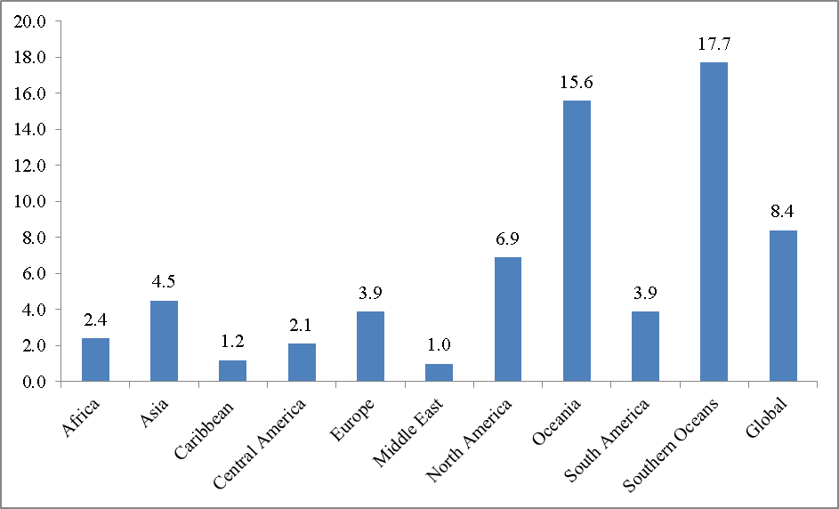
Chart 4 Global and regional status of marine protected areas (EEZ) in percentages

Chart 5 National status of protected areas and proposed increase for marine areas
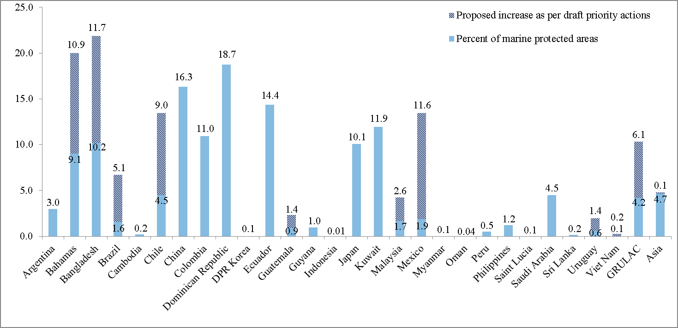
- Chart 5 presents the national status and Party’s proposed increase for marine protected areas, as submitted by country participants from the three workshops held thus far. Nationally, from the 27 countries that have submitted numerical information on the status of marine protected areas, 7, or one third, have reached or surpassed the 10 percent global target. Only one country is close to reaching the target, with less than one percent of additional protected areas needed, and 11 or 40 percent have less than 1 percent of territorial marine areas protected. From the information submitted, 9 countries have presented their projected increase for marine areas as a percentage and of them 3 are projected to reach the target (Bahamas, Chile, and Mexico).
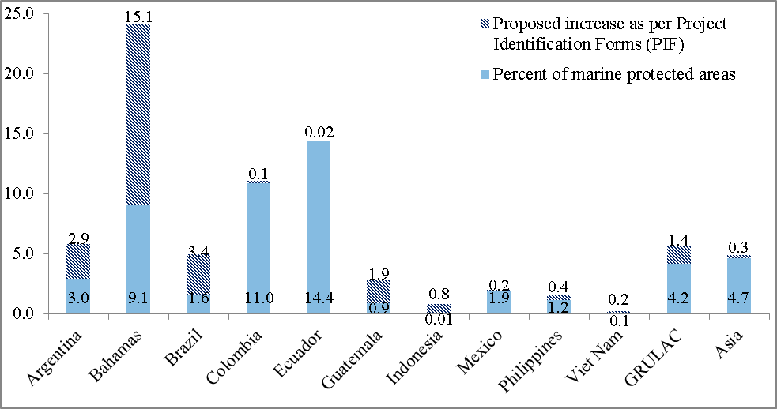
Chart 6 National status of protected areas and proposed increase as identified in country’s project identification forms for GEF funding for marine areas
- Chart 6 presents the national status of marine protected areas and proposed increase as identified in country’s PIF in GEF 5 projects on marine areas. Out of the 27 countries, 10 have GEF 5 projects that will increase the coverage of marine protected areas. From these 10 projected increases, 8 countries have yet to reach the target. One country, the Bahamas, will reach the 10 percent global target when their current GEF 5 project is completed.
2,949,144 Square Kilometres of Large-scale Marine Protected Areas
Chile – 989,144 km²
- The intention to protect Easter Island’s marine biodiversity (approximately 577,000 km² of the surrounding EEZ) was announced and is currently in development with the local board (Mesa del Mar Rapa Nui).
- The Nazca-Desventuradas marine park (300,035 km²) will be soon decreed.
- The Juan Fernández Archipelago MPA (12,109.02 km²) considers a mix of (6) marine parks (1,081.36 km²) with a multiple use MPA around them (11,027.66 km²) and will be soon decreed.
- The MPAs around the southern tip of Patagonia (100,000 km²) is being developed with key strategic partners and the government hopes to announce it in the near future
Palau – 500,000 km²
The small island nation controls a vast EEZ full of incredible marine diversity, including 1,300 species of fish. Historically, Palauans have managed their fisheries by closing important spawning grounds to fishing periodically, a process they call Bul. To protect their heritage and their livelihood, Palauans closed 80% of their EEZ to any fishing or extraction, creating a no-take marine reserve larger than California in the process.
New Zealand – 620,000 km²
The proposed Kermadec Ocean Sanctuary will protect a chain of underwater volcanoes and the world’s second deepest ocean trench. It will ensure that habitats used by whales, dolphins, sea turtles, and over 150 species of fish, many of which are endemic to the region, remain pristine. The Government will be introducing legislation to Parliament to enact the new sanctuary, with the intention to have it in place by 1 October 2016.
United Kingdom – 840,000 km²
After creating the British Indian Ocean Territory Marine Protected Area in 2012, the UK upped the ante in 2015 and announced its intention to designate the largest contiguous no-take marine reserve in the world. The new MPA would encompass the EEZ of Pitcairn, a British Overseas Territory in the South Pacific.
SOURCE: personal communications with the Secretariat.

Ecological representation
- Ecological representation refers to the need for protected areas to represent, or sample, the full variety of biodiversity for the different biological realms, in all ecoregions (freshwater, marine, and terrestrial), and the different biological scales (ecosystems, species and within species variations). This means that protected area systems should contain adequate samples of the full range of existing ecosystems and ecological processes, configured so that populations of all their species persist in the wild over very long periods.
- At global level, ecological representation is usually assessed based on ecoregional representation in protected area networks. It is important to note that coverage of ecological regions are a useful indicator to assess ecological representativeness at global level, but at national level they maybe too coarse to apply requiring proper alignment to the national biogeographic classification systems. In addition, mapping proposed new protected areas, community conserved areas and other effective area based conservation measures vis-a-vis their coverage of ecological regions, at the national level, may improve ecological representativeness.
- Globally, there are eight biogeographic realms, 12 marine realms, 14 terrestrial biomes, 62 marine provinces, and 827 terrestrial and 232 marine ecological regions. As per the Protected Planet Report, out of the eight biogeographic realms, one (Neotropics) has 17 percent protected and two (Indo-Malayan and Oceania) have less than 10 percent protected. As of 2014, 50 percent of the 12 marine realms have at least 10 percent protected, with the Southern Ocean, Temperate South America, Western Indo Pacific and Temperate Southern Africa having less than 10 percent protected. Out of the 14 major terrestrial biomes, three (flooded grasslands and savannas; mangroves; and montane grasslands and shrubs) have over 25 percent protected and two (tropical and sub-tropical dry broadleaf forests and temperate grasslands, savannas and shrublands) are below 10 percent protected. Out of 62 marine provinces, 39 percent (shallower than 200m depth) have 10 percent protected.
Chart 7 The number of terrestrial ecoregions at different levels of protection
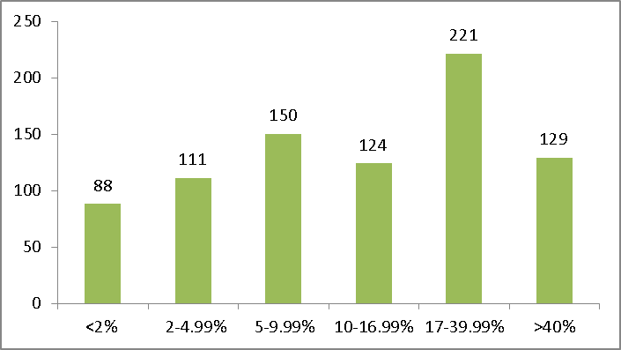
Chart 8. Number of marine ecoregions at different levels of protection
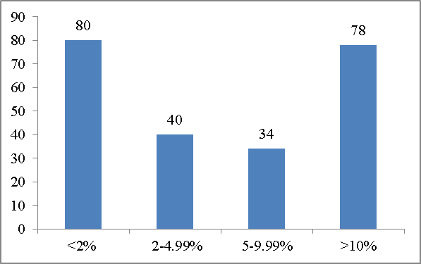
- Charts 7 and 8 show the number of terrestrial and marine ecoregions at different levels of protection. About 20 terrestrial (out of 827) and a dozen marine (out of 232) ecoregions have no protection, such as the Somali montane xeric woodlands, Eritrean coastal desert, the Hindu Kush alpine meadow, the Trindade and Martin Vaz Islands, Southeast Madagascar, and the Kerguelen Islands. About 10 terrestrial areas and a dozen marine ecoregions have full protection. Both the Kermadec Islands off the coast of New Zealand and the Cocos Islands off the shore of Costa Rica have their terrestrial and marine ecoregions fully protected.
- At the national level, each country data dossier explicitly states the total number of ecoregions in each country. From this list, three sets of selected ecoregions are listed as priority candidate sites for action as their worldwide protection is less than the target: ecoregions that occur entirely in the country; ecoregions with at least 75 percent of its coverage in the country; and ecoregions with at least 25 percent of its coverage in the country. For example, in the Mexico country data dossier, out of 47 terrestrial ecoregions that occur in that country, 19 are endemic and 3 have 25 percent or more of their coverage in the country; and out of 9 marine ecoregions, 3 are endemic, one has 75 percent or more of its coverage in the country and one at least 25 of its coverage in Mexico.
- Twenty-five countries in mainland Asia and GRULAC have identified focused actions addressing ecological representation. For example, out of the 10 ecoregions in Bangladesh, 3 have been assessed as high priority for protection by the country. As part of its priority actions, Bangladesh aims to extend the protection of the Sundarbans Mangrove Ecosystem by 4609 km² and the Lower Gangetic Plains Moist Deciduous Forests by 3000 to 4000 km². The country also aims to formally declare a marine park of 1738 km² and a marine reserve of 582 km² as protected areas, extending at the same time the protection of the Northern Bay of Bengal Ecoregion.
- In 2010, Japan identified candidate areas for new establishment or expansion of national or quasi-national parks for the next decade by conducting a gap analysis between important areas in terms of biodiversity and geological/geographical features and pre-existing national or quasi-national parks. So far, three of the 18 sites identified by this gap analysis were fully covered by additional designations (including expansion of existing protected areas), whereas two of the 18 sites were partly covered. The country also aims to conduct additional designations before 2020.
- The current system of protected areas of Cuba covers different types of ecosystems and the range of many endemic species, as assessed in a gap analysis conducted in 2007. As part of its priority actions, the country aims to increase the protection of different landscape and ecosystem types by increasing the protection of: 4 percent of landscape types, 3 percent of natural wetlands, 3 percent of marine ecosystems, 3 percent of natural vegetation, 2 percent of endemic plants, 3 percent of endemic and/or threatened species of terrestrial vertebrates and 3 percent of key areas for marine species.

Areas important for biodiversity
- Areas of particular importance for biodiversity or Key Biodiversity Areas (KBAs) are areas that are locally, nationally and globally important for the manifestation of biodiversity at the genetic, species and/or ecosystem level; they are nationally identified sites using global criteria and thresholds. Different areas important for biodiversity are important bird and biodiversity areas (IBAs), Alliance for Zero Extinction sites (AZEs), Biodiversity Hotspots, high-biodiversity wilderness areas and global 200 priority ecoregions. Table 3 presents information on two types of KBAs as adapted from an IUCN publication, entitled Protected Area Governance and Management, and the country data dossiers.
Table 3 Select areas important for biodiversity
Name | Definition | Scale | Information and source presented in the Country Data Dossier
Important Bird and Biodiversity Areas (IBAs) | Sites hold significant numbers of one or more globally threatened bird species; site is one of a set of sites that together hold a suite of restricted-range bird species or biome-restricted bird species; and/ or has exceptionally large numbers of migratory or congregative bird species | Site | - Number and names of IBAs  - IBAs with no protection  - IBAs with partial protection  - BAs with complete protection  - IBAs in danger  - Overlaps between unprotected and partially protected IBAs and candidates ecoregions for further protection  www.birdlife.org/datazone/country
Alliance for Zero Extinction sites (AZEs) | Site is sole area where an endangered (EN) or critically endangered (CR) species occurs (or contains > 95% of the EN or CR species’ global population for at least one life history segment) | Site | - Number and names of AZEs  - AZEs with no protection  - AZEs with partial protection  - AZEs with complete protection  - AZEs in danger  - Overlaps between unprotected and partially protected AZEs and candidates ecoregions for further protection  http://www.zeroextinction.org/
- As per Birdlife International, accumulatively, out of 10,539 IBAs, 2362 are completely covered by protected areas (greater than 98 percent protection), 4870 are partially covered by protected areas (between two and 98 percent protection) and 3307 are not covered by protected areas (less than two percent protection). Furthermore, accumulatively, out of 531 AZEs, 128 are completely covered by protected areas (greater than 98 percent protection), 193 are partially covered by protected areas (between two and 98 percent protection) and 210 have no protected area coverage (less than two percent protection).
- At the national level for example, the country data dossier for Philippines states that 105 IBAs have been identified; 5 are in danger; 53 have little or protection; 41 are partially protected; and 11 are fully protected. Further, there are 99 overlaps between unprotected and partially protected IBAs and ecoregions (77 terrestrial, 22 marine) proposed as priority sites for further protection. In terms of AZEs, 5 have been indentified; 3 have not protected and 2 are partially protected. Further, there are 7 overlaps between unprotected and partially protected AZEs and ecoregions (77 terrestrial, 22 marine) proposed as priority sites for further protection.
- Twenty-two countries in mainland Asia and GRULAC have identified priority actions to improve the coverage of IBAs and AZEs as submitted through the workshops. For example, the Philippines stated they will increase the number of protected IBAs and improve their management effectiveness. These include the protection of 9 terrestrial IBAs under a UNDP-GEF programme on ICCA/LCA and a Supreme Court order to increase the protection of 5 IBAs in the Manila Bay region.
2,785,350 Square Kilometres of Terrestrial Areas Protected through GEF:
58% are Key Biodiversity Areas

GEF has supported the development of 1,292 terrestrial protected areas (51 percent of them in tropical biomes) in 119 countries, covering a total area of 2,785,350 Km². Of these terrestrial protected areas, 58 percent are considered Key Biodiversity Areas. Thirty-one percent of these terrestrial protected areas have one or more international designations for high biodiversity and/or cultural values, as a WWF priority area, Conservation International Biodiversity Hotspot, Ramsar site, or UNESCO World Heritage site. The remaining 11 percent of protected areas have various local or national designations that indicate a high-level of biodiversity.

Source: GEF. 2015. Impact Evaluation of GEF Support to Protected Areas and Protected Area Systems. Available at https://www.thegef.org/gef/sites/thegef.org/files/documents/EN_GEF.ME_C.49.inf_02_Biodiversity_Impact_Eval_Report_2015.pdf
- Lebanon has identified 15 IBAs, out of which 7 are under legal protection. As part of its priority actions, Lebanon aims to include IBAs that are part of migratory routes of key bird species in its national system of protected areas, as well as to enforce the Hunting Law to reduce illegal hunting by 70 percent by 2020.
- Colombia has reported 124 IBAs and 45 AZEs. Out of these, 60 percent of IBAs and 7 percent of AZEs fall under category of completely covered by protected areas, and 38 percent of AZEs fall under the category of partially covered by protected areas. Colombia’s priority actions aim to increase the level of coverage at least 3 IBAs and 3 AZEs.
Development of New KBA Standard

IUCN, through the World Commission on Protected Areas and the Species Survival Commission, has been convening the development of a new global standard for the identification of Key Biodiversity Areas. This standard builds on the work of existing approaches, most notably BirdLife International’s Important Bird and Biodiversity Areas, but is now inclusive to all taxa and levels of biodiversity. The new standard has undergone two rounds of global consultation and the new criteria and thresholds have been tested against existing data. The next steps in the process are approval of the standard by IUCN council and the formation of a KBA Partnership to implement the standard. The new standard can be used by parties for national identification of areas important for biodiversity under Aichi Target 11 and to halt species under Aichi Target 12. The KBA Partnership will assist parties with national identification and delineations.

Source: Personal communications with IUCN-WCPA Task Force.

Areas important for ecosystem services
- Well-managed protected areas can provide vital ecosystem services, such as water purification and retention leading to water security, erosion control and reduction of both flooding and unnatural wild fires. These services buffer human communities against different environmental risks and hazards and support food and health security by maintaining crop diversity and species with economic and/or subsistence value. They also play an important role in ecosystem-based approaches to climate change adaptation and contribute to mitigation by storing and sequestering carbon as well as to the reduction of vulnerability to natural disasters.
- The status of ecosystem services and how they overlap with protected areas globally has yet to be studied. As such, information reported for this element only pertains to the data obtained through the workshops.
- Out of the 26 countries that responded to the “Questionnaire”, 20 have assessed at least certain elements or areas regarding ecosystem services. Out of the 26 countries that responded to the “Questionnaire”, 20 have specified if such ecosystems have some form of legal or other protection. Out of those, 17 have some level of protection including 6 are protected indirectly through protected areas legislations. Out of the 26 responses, 16 countries have identified priorities, 2 specified they had not identified priorities and 8 didn’t answer that question. The main ecosystem service mentioned by countries is the provision of water: 9 countries mentioned it in some form, including 5 in their priority actions).
- Eleven countries in mainland Asia and GRULAC identified draft priority actions addressing areas important for ecosystem services. For example, Colombia has started to prioritize areas providing important ecosystem services, and areas important for the conservation of water resources have been identified. As part of its priority actions, Colombia aims to include three areas important for water resources and fisheries to the existing system of protected areas within the next five years.
- Nepal has identified rangelands, wetlands, catchment forests, and protected areas as areas important for ecosystem services. Most of these areas are protected under biodiversity related policies and legislations such as the National Wetlands Policy (2012). As part of its priority actions, Nepal aims to promote the development of a Payment for Ecosystem Services mechanisms in selected sub-watersheds. The formulation of a PES bill has also been initiated by the Ministry of Forest and Soil-Conservation.

Effectively managed
- For evaluation of this element, it can be divided into two components: (a) the assessment of management effectiveness, carried out at each protected area or at a systems level; and (b) the enhancement of effectiveness in the management of each protected area.
- With regards to the assessment of management effectiveness there are many tools, including: the protected area management effectiveness (also known as PAME) assessment methodologies; the Rapid Assessment and Prioritization of Protected Area Management (RAPPAM) tool; and the Management Effectiveness Tracking Tool (METT), developed by the World Bank and World Wildlife Fund for Nature. The METT is used to track the progress of management effectiveness of sites over time. Further, Decision X/31 paragraph 19(a) invites Parties to implement management effectiveness evaluations in at least 60 percent of the total area of protected areas in a country by 2015.
- As of January 2015, the Global Database on Protected Areas Management Effectiveness (GD-PAME) has collected 17,739 PAME assessments, representing 9,037 protected areas. Of these, 3,666 sites have multiple assessments. Some 17.5 percent of countries have implemented management effectiveness evaluations in at least 60 percent of their protected areas. Specifically, the GRULAC region has carried out the most terrestrial assessments and Central American and Caribbean sub-regions have carried out the most marine assessments. Further, among biomes and ecoregions, the frequency of PAME assessments is highest in tropical forests, where 45 percent of protected areas have been assessed.
- It can be noted that from the GD-PAME, information on how many of the 9,037 protected areas fall under sound management, that is they have a METT score of at least 0.4 (on a scale on 0-1), is not clear. In an earlier global study, covering 6,800 protected area assessments in 100 countries, 22 percent were categorized under sound management (with average scores above 0.66).
- In a number of GEF projects, 2,440 METTs were analyzed from 1,924 protected areas in 104 countries. Out of these, only 352 protected areas had multiple METTs; 20 percent of the assessments had only half, or less than half, of the 30 questions answered. Some 46 percent of the METTs were from Latin America and the Caribbean, especially Mexico, while Asia was the least represented region, with only 11 percent of METTs.
- In the GEF evaluation study, standardizing only METTs that had more than half of the questions answered, which is only 20 percent of the total assessments, the overall mean METT score is 0.47. Only 275 GEF supported protected areas, out of the total 1,924, has repeated assessments that could be used to analyse for changes in management effectiveness over time. Of these 275 areas, 70 percent recorded improvements in the total score, 27 percent experienced declines and 3 percent no change. Recently approved and ongoing GEF projects continue to evaluate and improve management effectiveness.
Table 4 Summary of management effectiveness component for 9 countries
Country | Status | Priority Actions | GEF Project Outcome
Bangladesh | 45% of protected areas assessed | Conduct M.E. assessment for 30% of PAs every year | METT scores of 70% for 3 new protected areas
Costa Rica | 86 protected areas have management plans | By 2020, 70% of PAs use M.E. tools | ME improves in 20 % of marine protected areas as measured by METT scores
Costa Rica | 84 protected areas assessed M.E. | By 2020, 70% of PAs use M.E. tools | The ME of 7 internationally important wetland protected areas increases by 20%
Honduras | 49% have management plans | Effectively manage the finance and implementation of 15 new management plans | 10% increase in the average ME rating of protected areas measured by METT
India | 125 protected areas assessed M.E. (MEE Score 60.80%) | Evaluate all remaining protected areas (approximately 500) | Improve ME of 7 mountain protected areas (266 km2)
India | 43 Tiger Reserves assessed M.E. (MEE Score 69.00%) | Periodical MEE of all protected areas, by 2020 all PAs should have management plans | Enhanced ME in 3 protected wetlands
Indonesia | 33% of protected areas assessed | Aim to achieve METT scores over 70% for 260 protected areas | Improved ME of existing and new protected areas
Indonesia | 33% of protected areas assessed | Aim to achieve METT scores over 70% for 260 protected areas | Expanded network of effectively managed marine protected areas
Mexico | 2 protected areas assessed | Evaluation of 5 new protected areas | Improved ME of existing and new protected areas, as measured by METT
Mexico | 123 Management plans developed | Evaluation of 5 new protected areas | Increased ME of 18 key protected areas
Mexico | 123 Management plans developed | Evaluation of 5 new protected areas | 10 protected areas (5600 km2) meet or exceed their ME targets (80%)
Peru | 97% of protected areas have management plans | Evaluate 68 protected areas | Increase the ME of islands and peninsulas
Peru | 97% of protected areas have management plans | Evaluate 68 protected areas | Improved ME of underrepresented areas
Peru | 97% of protected areas have management plans | Evaluate 68 protected areas | Improved ME of existing and new protected areas
Peru | 97% of protected areas have management plans | Evaluate 68 protected areas | Improved ME of marine protected areas
Uruguay | 23% protected areas have management plans | 80% of protected areas with management plans | Increased METT scores of 5 protected areas by 20%
Viet Nam | >3% of protected areas assessed | Improve the management system for protected areas | Increased protected area ME, as measured by METT scorecards
- From the regional workshops, 32 countries in mainland Asia and GRULAC identified priority actions addressing both assessment of management effectiveness and improvement of protected area management. Table 4 summarizes the status, priority actions and outcomes of GEF 5 Project Identification Forms (PIFs) for 9 countries.
- For example, the Ministry of Environment and Forestry of Indonesia has conducted management effectiveness studies on 33 percent of all protected areas, of these, in 2014, 32 percent of protected areas had endorsed management plans. As part of their priority actions, the country aim to improve the METT index minimally 0.7 for 260 protected areas. In addition, two approved GEF projects (#4867 and #4892) include the improvement of protected areas management effectiveness.
- In Uruguay, 1 out of 13 protected areas has a management plan and 2 are currently being developed. Uruguay has established national guidelines for management plans. As part its priority actions, the country aims to have management plans for 80 percent of its protected areas, with all protected areas designed according to the Guidelines for Planning of Protected Areas of Uruguay by 2017.
Protected Areas Coordinated Audit in Latin America

With the support of representatives of the Audit Institutions in 12 Latin American countries, 1120 protected areas were evaluated in a standardized manner. Quantitatively, most countries have more than 17 of territory protected. The auditors created a multidimensional assessment with 13 indicators that could be graphically represented in a spider/radar chart. This helped to conceptualize the strong and weak points of protected areas management. Almost 30 percent of protected are on the lowest levels of evaluation, which indicates the existence of structural weaknesses in governance, for example: an absence of management plan in 47 percent of the evaluated areas; an absence of a manager in 13 percent of the territories; and none or little biodiversity monitoring in 44 percent of the evaluated areas.

Source: Protected areas: Latin America: coordinated audit. Organization of Latin American and Caribbean Supreme Audit Institutions (OLACE FS), Special Technical Commission on the Environment (COMTEMA); Coordination Tribunal de Contas da União, Contraloría General de la República de Paraguay. Brasília: Tribunal de Contas da União, 2015.

Equitably managed
- For understanding this element, it can be divided into two components: (a) what is equity and how can it be applied; and (b) recognition of equitable management in the form of diverse governance types for the management of protected areas.
- Equity is a technical term that has three dimensions: recognition, procedure, and distribution. Recognition is the acknowledgement of the legitimate rights, values, interest and priorities of individuals and communities. Procedure refers to how protected areas are being implemented and managed, where communication and public participation is essential. Finally, distribution implies that costs and benefits resulting from the implementation and management of protected areas must be shared amongst relevant actors. In order to facilitate equity, certain enabling conditions are needed, such as a good legal and political environment, awareness of the responsible actors, and an adaptive learning approach. Understanding equity can therefore help improve effectiveness in negotiating with legislators for protected areas governance policies as well as the various protected area stakeholders for the management of individual protected areas.
- In terms of the diversity of governance types for the management of protected areas, IUCN identifies four main types: governance by governments; governance by Indigenous, Peoples and local communities; private governance; and shared governance. A systematic assessment of the diversity of governance types for the management of protected areas has yet to be reported globally. As such, information reported for this element pertains to the data obtained through the workshops.
- The four governance types recognized by IUCN are reflected in the IUCN protected area matrix, which was emailed out to participants for completion. Of the 18 countries that have submitted matrixes: 7 reported governance by governments; 7 reported governance by Indigenous, Peoples and local communities; 8 reported private governance; and 12 reported shared governance.
- Out of 50 countries that provided information on the governance types of protected areas in their countries, 22 reported areas under shared governance, 15 reported areas under community or indigenous conservation and 5 reported using financial initiatives or compensation measures to increase equity in the establishment and management of protected areas. From the country action plans for the Programme of Work on Protected Areas, 65 countries have established multi-stakeholder coordination committees, which often involves natural resources agencies (forestry, wildlife, and/or fisheries), key sectors (tourism, and land-use planning), key donors and funding agencies as well as a variety of other actors, such as conservation organizations, NGOs, and academic institutions.
- Goal 2.1 of the Programme of Work on Protected Areas is to promote equity and benefit-sharing; it includes a provision to establish or strengthen national policies. As such, out of the 26 countries that answered the questionnaire, 22 have identified their national legislation recognizing governance types and 18 have listed the types of governance they recognize. Out of the latter, five countries legally recognize Indigenous or Community Conservation Areas (ICCAs) as an official type of governance for protected areas. Additional, private, co-management, municipal and shared management were also reported by countries in the questionnaire.
- Twenty-two countries in mainland Asia and GRULAC identified draft priority actions addressing equity and governance issues. For example, Bangladesh’s Wildlife Act of 2012 recognizes collaborative and private management, as well as Community Conservation Areas as official governance types for protected areas. This allowed for the implementation of co-management in most protected areas. Furthermore, Bangladesh has established financial mechanisms to increase equity through grants, and has established social forestry programmes in forest reserves. As part of Bangladesh’s priority actions, the country aims to carry out community capacity-building to increase shared management responsibilities as well as to develop new infrastructures in protected areas.
- In Costa Rica, the importance of public participation has been recognized by the Environmental Law 7554 and the Biodiversity Law 7778, which clearly states the obligation to ensure mechanisms for active public participation. Brazil also recognizes the importance of public participation, which is instituted by the National Protected Areas System Law of 2000. Furthermore, Costa Rica has established stakeholder participation bodies and institutional structures to coordinate equity and participation matters. Costa Rica’s priority actions for the next five years include the recognition of different types of governance for protected areas, and the recognition of 13 areas as “other effective area-based conservation measures” to be incorporated in its national system of protected areas.
- The Dominican Republic has 23 protected areas under co-management. These are recognised under the Law on Protected Areas 202-04, which allows for different types of governance. As part of its priority actions, the country aims to implement co-management in 10 protected areas as well as evaluate and monitor co-management initiatives. Furthermore, they will ensure that key stakeholders are part of the creation and implementation of management plans in protected areas.

Well connected systems of protected areas
- Landscape connectivity is the degree to which the landscape facilitates or impedes movement among the patches. In the context of protected areas, movement can be facilitated by a number of mechanisms, including conservation corridors, transboundary corridors, stepping stones, regional connectivity corridors, and ecoregion conservation programmes such as those by WWF and Conservation International. These can be supported by agreements and memorandum of understanding, such as those under the Convention on Migratory Species, involving a range of states for various migratory species.
- Chapter 27 on “Connectivity Conservation Management” of the IUCN’s Protected Area Governance and Management summaries large and continental scale conservation corridors. At the continental level three initiatives have gained momentum: the European Green Belt, the Mesoamerican Biological Corridor, and the North American Wildways Network. Notably, northern Africa, West Asia, Central and Eastern Europe (CEE) and East and Southeast Asia are lagging behind.
- From a 2006 study on Ecological networks a number of countries have national connectivity corridors: 12 countries in CEE, 10 in Western Europe and other regions; 20 countries in mainland Asia; 8 countries in Latin America; and 20 countries in Africa. Some notable national connectivity networks include the Green Network in Estonia; the Ruseconet of Russia; the Ecological Network of Netherlands; the Guadiamar green corridor in Spain; the Bow Valley Wolf Corridor in Canada; corridors in Yunnan province in China; the Terai Arc landscape corridor in Nepal; the Mata Atlantic Forest corridor in Brazil; and the Kibale Forest Game Corridor in Uganda.
UNEP Initiative on Connectivity Conservation

The United Nations Environment Programme (UNEP) has launched a new initiative called “Strengthening biodiversity conservation at a landscape and seascape scale” which aims to tackle the problem of increasing habitat fragmentation through the development of a global connectivity conservation strategy that will support countries and regions to integrate connectivity conservation within their national land use and seascape planning. To achieve this, the initiative seeks to promote an understanding of the priorities for connectivity and the use of connectivity as a conservation tool to strengthen the protection of biodiversity, enhance the provision of ecosystem services, and increase resilience to climate change. This will provide policy and legislative tools and resources to national governments, non-governmental organizations and other stakeholders. UNEP-WCMC, with the collaboration of the International Union for Conservation of Nature World Commission on Protected Areas (IUCN-WCPA) and other partners worldwide, is in the process of producing a global database of connectivity conservation initiatives that includes lessons learned and best practices.

Source: Personal communications with IUCN-WCPA Task Force.

- Twenty-one countries in mainland Asia and GRULAC identified draft priority actions addressing equity and governance issues. Argentina has four biological corridors and has been promoting the sustainable multiple-use of resources in areas important for connectivity. Argentina has identified four priority actions to increase and strengthen connectivity in the next five years. These include analysis of the current status of corridors, analysis of new corridor projects in the Chaqueña region and in other ecoregions, and analysis of the legal and regulatory frameworks to integrate biological corridors in territorial planning. Furthermore, Argentina will continue to promote sustainable multiple-use of resources in connecting areas between protected areas.
- Belize is part of the Mesoamerican Biological Corridor and has established the Central Belize Wildlife Corridor for which an action plan was completed in 2015. As part of its priority actions, the country aims to establish two new biological corridors in the northern and southern parts of the country. Belize has also identified, as a future opportunity, the removal of negative incentives for properties where development does not occur near biological corridors not legally protected.
- Bhutan has established nine biological corridors representing 9 percent of the country’s area. As part of its priority actions, the country has listed a series of measures to increase the protection of existing corridors. These include the complete demarcation and zonation of biological corridors and a review of the functionality of existing corridors for demarcation, operationalization and legal protection.

Integrated into wider land and seascapes
- Protected areas established in isolation (geographical as well as sectoral) may not fully yield their expected benefits, especially for indigenous peoples and local communities. By integrating protected areas into the wider landscape and seascape, and by incorporating protected areas into sectoral plans and strategies, the investments in protected areas will pay ecosystem services and societal dividends well into future. In a time of rapid global economic and social integration the need to integrate protected areas into wider landscape, seascape and sectors is all the more important and imperative, especially in order to address the adverse impacts of climate change and to achieve sustainable development.
- Despite the advancement in connectivity, many Parties have yet to systematically integrate, protected areas into the wider land and seascapes. In 105 Action Plans for Implementation of the CBD PoWPA, in 2012, only 15.6 percent of countries reported significant progress in integrating protected areas into broader landscapes and seascapes and sectors so as to maintain ecological structure and function.
Vilcabamba Amboró Conservation Corridor

The Vilcabamba Amboró Conservation Corridor (VACC) is a trans-boundary conservation corridor that includes portions of the center south Andes Amazon regions of Bolivia and Peru. It was formed in December 2000, after years of groundwork by stakeholders in both countries, and is considered a pioneering approach in landscape-scale conservation in South America. The development and expansion of the corridor has been an ongoing process in which the Bolivian and Peruvian national governments, Conservation International (CI), other NGOs and local communities have been heavily involved. The VACC is a conservation strategy that seeks to articulate multiple categories of protected areas into schemes that integrate management and sustainable land use. The protected areas in the VACC provide critical environmental services to local communities, and are integrated into the local, regional and national economies. The conservation corridor thus proposed a concept that goes beyond the biological connectivity of the protected areas by proposing a land use system that organizes use and management systems that reconcile protection with economic development.

Source: Ervin, J., K. J. Mulongoy, K. Lawrence, E. Game, D. Sheppard, P. Bridgewater, G. Bennett, S.B. Gidda and P. Bos. 2010. Making Protected Areas Relevant: A guide to integrating protected areas into wider landscapes, seascapes and sectoral plans and strategies. CBD Technical Series No. 44. Montreal, Canada: Convention on Biological Diversity, 94pp.
- Eleven countries in mainland Asia and GRULAC identified focused actions in their priority actions addressing integration into the wider land and seascape. For example, Colombia has created biosphere reserves and sectoral plans integrating biodiversity and protection into wider land- and seascapes. As part of Colombia’s priority actions, it aims to create legal and political tools to incorporate social and environmental considerations in mining activities and their impact on 10,000 km² of land. The country also aims to adopt sectoral plans in critical sectors (agriculture, mining, etc.) to reduce their pressure on forests and biodiversity. High conservation value areas in regions of palm oil cultivation would be protected and restored with the participation of the local communities.
- El Salvador has integrated into its protected areas a sustainable tourism strategy as well as local plans for the sustainable use of resources. As part of its priority action, by 2020, the country aims to have created standards for agricultural development and conservation in order to achieve sustainable use of the resource. El Salvador also plans on implementing alternative local development in areas important for biodiversity to minimize the negative impacts caused by anthropogenic activities.
- Timor-Leste has created buffer zones and is carrying out ecosystem conservation research at the Nino Koni Santana Protected Area. The country aims to develop zoning lands together with local communities that live close to PAs, as part of its priority actions.

Other Effective Area Based Conservation Measures
- Due to lack of understanding on what are “Other Effective Area Based Conservation Measures” (OECMs), concern has been raised over the interpretation of this term; therefore, it is important to make a distinction that OECMs are areas that are managed primarily for conservation as oppose to areas managed for other benefits. Given a more detail description of OECMs, they will also need to be tracked, as formally designated protected areas are through the WDPA or the United Nations List of Protected Areas. However, recognition at the national level is limited. This may be because governments only recognize and report on state-owned areas or because the owners of such sites do not wish to be recognized officially. It is important to note that if governments do not legally recognize indigenous peoples and community conserved Areas (ICCAs), they may be considered as OECMs.
- Twenty-one countries in mainland Asia and GRULAC identified priority actions addressing OECMs. For example, Guyana’s Amerindian Act and Protected Areas Act allow for the establishment of Amerindian Protected Areas as Community Conservation Areas (CCAs) as well as their integration in the national protected area system if desired. The Konashen Community Conservation Area represents three percent of the country’s area and is currently the only community conservation area in Guyana. The community has applied to be included in the national system of protected areas and its application is under review. Furthermore, Guyana has established a code of conduct for forest operations requiring all large logging operations to set aside a percentage of their lease for protection, and has listed this initiative as another effective area-based conservation measure. One of Guyana’s priority actions in the next five years is to compile information about forest areas being protected by this initiative.
IUCN-WCPA Task Force on OECMs

Following paragraph 10 of decision XI/24 in which the COP requested the Executive Secretary, in partnership with relevant organizations, making available tools and technical guidance and defining area based conservation measures, IUCN’s World Commission on Protected Areas established a taskforce to develop guidance OECMs. The Taskforce held its first meeting in January 2016 and discussed the elements of parameters of what OECMs are, what not OECMs are and what potential OECMs are. The taskforce will have its second meeting in July and further work on developing the guidance. A preliminary procedural report of the Taskforce is included in the Information document provided by the IUCN

Source: Personal communications with IUCN-WCPA Task Force.
- Lebanon has identified natural parks, natural sites and monuments, Himas (community based natural resources management systems), and sites recognized by international organizations and conventions as other effective area-based conservation measures. Lebanon has already established 11 terrestrial Himas and 3 Himas protecting inland water resources. Within the next five years, Lebanon aims to increase the number of community conserved areas by establishing new Himas as part of its priority actions.
- Honduras has listed Ramsar sites, Important Wildlife Sites and certified private natural reserves as part of its OECM. The certification of private natural reserves is a new initiative and two natural reserves are currently certified. As part of its priority actions, Honduras aims to certify at least 10 new private natural reserves by 2020.
- Bangladesh has listed four different types of OECM: Tea gardens, Forest Reserves, Community Conservation Areas (CCAs), and seasonal fishing bans for rivers. As part of its priority actions, Bangladesh aims to increase the number and the protection level of OECM by identifying and recognizing CCAs and tea gardens contributing to the achievement of Aichi Biodiversity Target 11. Furthermore, Bangladesh aims to identify Forest Reserves with the potential to contribute to the achievement of Aichi Biodiversity Target 11 and integrate them in the protected area network.

Summary of progress
- The previous section has provided a summary of each element of Aichi Biodiversity Target 11, using globally available data and national information submitted by Parties, including case studies. The results from the three subregional workshops held so far have provided a platform for a number of countries to increase their understanding of what are the different aspects of the target, what information is needed for planning their achievement and what actions they can undertake to bring the elements and the target as a whole to fruition.
- In sum, countries in mainland Asia and GRULAC have identified priority actions addressing ecological representation (25 actions), areas important for biodiversity (22), areas important for ecosystem services (11), effectively managed (32), equitable managed (22), well connected systems of protected areas (21), integrated into wider land and seascapes (11), and other effective area based conservation measures (21). ). Further, they have committed to increasing terrestrial protected areas by 0.8 percent and marine protected areas by 6.2 percent, which excludes recent communications from Chile, Palau, New Zealand and United Kingdom for the development of large-scale marine protected areas (2.9 million km²).
- Given the presentation of country road maps from mainland Asia, Latin America and the Caribbean, it is estimated that, for some elements of the target, progress may be better compared to the midterm assessment in the fourth edition of the Global Biodiversity Outlook. Specifically, it is estimated that two elements of Aichi Biodiversity Target 11 can be achieved before 2020, and even exceed the target by 2020 (terrestrial and inland water areas conserved, coastal and marine areas within national jurisdiction conserved); other elements will need particular efforts to be achieved by 2020). This estimation of progress may improve following completion of the series of workshops, covering all United Nations regions, and through analysis and reporting to the Conference of the Parties at its thirteenth meeting.

preliminary Lessons learned
- Out of the 52 Parties that attended the workshops, 82 per cent (43) have provided information on the status of the target and drafted priority actions (road maps). This remarkable response rate shows country’s commitment to achieving Aichi Biodiversity Target 11. If similar commitments are received from other regions, as the series of workshops progresses, the projections for reaching the target by 2020 may further improve.
- The lessons learned thus far from facilitating achievement of Aichi Biodiversity Target 11 are as following.
- The development of a strategy that coherently brought all stakeholders to the same level of understanding was greatly useful in: providing an overarching picture for a collective pathway; demonstrating, internally and externally, the use of funds; and bringing together related activities.
- The development of country data dossiers provided a starting point for country focal points to better understand the information needed to achieve each element of the target, sparking discussion between Parties and partner organizations about the information held in global databases, providing inputs to their updating processes, and increasing coordination between the Secretariat and partner organizations.
- From the three workshops held thus far in the series, the amount of time invested in training country focal points (through emails, conference calls and face-to-face interactions) increased significantly, leading to a better understanding of what are the different aspects of the target, what information is needed for planning their achievement and what actions they can undertake to bring the elements, and the target as a whole, to fruition.
- Due to the information sharing prior to and during the workshops, there have been more communications following its closure, such as announcing the creation of a new protected area.
- In tracking the PIFs of GEF 5 projects, a wealth of implementation information was highlighted. Although country participants were encouraged to take this information into consideration in the development of their road maps, it has been noted that most did not take this additional step.

potential directions for increasing achievement and next steps
- With more concerted effort by all to implement each element, in a coherent manner, there is a chance that the target as a whole may be uplifted to a higher status and may be achieved by 2020. To accelerate achievement of Aichi Biodiversity Target 11 in a coherent manner, potential directions can be divided into 2 parts, countries and partner organizations in cooperation with the Secretariat, and are as following.
- Countries can systematically align NBSAP and protected area actions with outcomes of national, GEF 5 and 6 and bilaterally funded projects and report on the progress of these actions in national reports, as part of their commitments to report on implementation of the Strategic Plan for Biodiversity 2011-2020;
- Countries can undertake mapping of their proposed new protected areas, as well as existing areas, vis-a-vis their coverage of ecological regions, KBAs (including IBAs and AZEs) and other effective area based conservation measures (including community conserved areas, if not legally recognized) with the aim of developing a more systematic assessment of the gaps in connectivity for terrestrial and marine systems and include these as project outcomes;
- Countries can periodically (once per biennium) update their national information in the World Database on Protected Areas, managed by IUCN and UNEP-WCMC, to avoid discrepancies and improve the quality of global information for reporting and monitoring progress;
- Countries can undertake concerted efforts to implement the actions (road maps) identified at the workshops as outlined in point (a) above;
- Partner organizations, such as IUCN, UNEP-WCMC, EU-JRC, ICCA Consortium, UNDP Small Grants Programme, BirdLife International, Alliance for Zero Extinction and others, in cooperation with the Secretariat, can consider undertake systematic compilation and mapping of Indigenous and Community Conserved Areas, KBAs (including IBAs and AZEs) and other effective area based conservation measures vis-a-vis their coverage with ecological regions and existing protected areas systems with the aim of developing a more systematic assessment of the gaps in connectivity for terrestrial and marine systems. Given this, partner organizations can then consider exploring the possibility of developing global and/or regional projects to demark connectivity corridors, including through ICCAs and other OECMs as stepping stones, and the development of management plans. Further, partner organizations can consider providing capacity-building for these issues, including raising awareness on the benefits of connectivity corridors to biodiversity conservation and as a natural solution to global environmental problems, including climate change adaptation;
- Partner organizations, such as IUCN, UNEP-WCMC, EU-JRC, ICCA Consortium, UNDP Small Grants Programme, BirdLife International, Alliance for Zero Extinction and others, in cooperation with the Secretariat, can consider providing additional capacity-building to countries for the identification and designation of sites important for biodiversity and ecosystem services;
- Partner organizations, in cooperation with the Secretariat, can undertake a more systematic assessment of gaps in management effectiveness in each country, and report the results to the Global Database on Protected Areas Management Effectiveness (GD-PAME) maintained by UNEP-WCMC. As such, partner organizations can explore the possibility of developing global or regional projects to complete national assessments of management effectiveness in a coherent manner. Further, partner organizations can consider providing capacity-building to countries to undertake measures to improve the effectiveness of protected areas from the “inadequate management” category to the “sound management” category;
- Partner organizations, in cooperation with the Secretariat, can consider developing more guidance and understanding on equity; the governance-equity nexus; how to measure governance quality, including case studies and best practices; simple user friendly formats for collecting information; and capacity-building to countries on these issues, such as training programmes;
- Partner organizations, in cooperation with the Secretariat, can consider developing more guidance and understanding on what types of integration is needed, guidance on integration and associated capacity-building;
- Given the development of guidance on OECMs through the IUCN-WCPA Task Force, partner organizations, in cooperation with the Secretariat, can disseminate this information to countries through capacity development;
- Countries, partner organizations and the Secretariat can undertake measures to map the elements of Aichi Target 11 as they relate to facilitating achievement of other Aichi Targets, the Sustainable Development Goals and other relevant international commitments and report on the interconnections to a Conference of the Parties and other internal venues.
- To begin facilitating the above points, the Secretariat is in the process of developing next steps in facilitating achievement of Aichi Biodiversity Target 11. The preliminary process in outlined in the Figure 2. The first step is to align NBSAP and protected area actions (road maps identified at the workshops) with GEF and bilateral funding sources, then, to cluster the projects by theme with the aim of developing sub-regional or regional networks for implementation support.
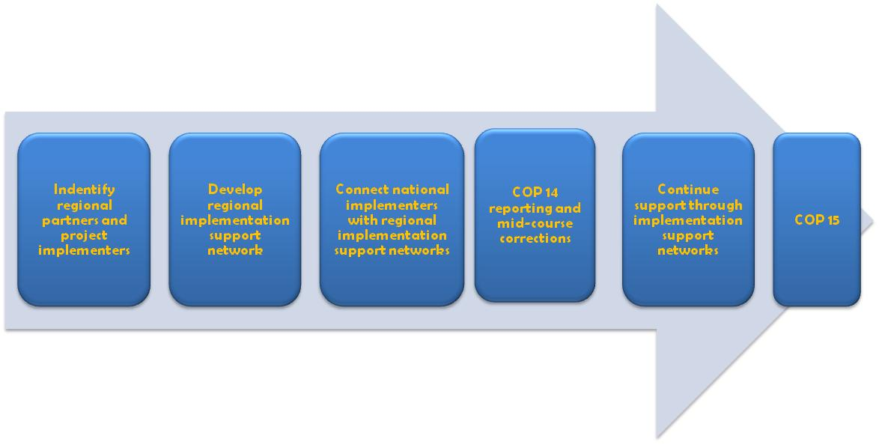
Figure 2. Approach for facilitating achievement of protected areas actions (road maps) identified at workshops from 2017 to 2020
- Therefore, the second step is to explore the possibility of enabling implementation support network in each United Nations region. The aim of these networks is to provide structured technical support through regular communications and capacity development for implementation of country road maps and projects as well as to facilitate monitoring and reporting. The networks will be composed of the project implementers, including implementing agencies, project coordinators, national governments, regional organizations, funders (including GEF implementing agencies and bilateral funding agencies), Friends of PoWPA, the Secretariat and other partners.
- Clustering these projects by theme will enable the implementation support networks to provide structured technical support through regular communications, exchange of best practices, tools and lessons learned, and webinars and training programmes. Further, monitoring and reporting should also be facilitating as a means to help achieve Aichi Biodiversity Target 11. A lead agency should undertake the coordination of the subregional implementation support networks and develop an action plan for facilitating the implementation of country road maps at the national, regional and global levels.
__________

* UNEP/CBD/SBSTTA/20/1/Rev.1.
** UNEP/CBD/SBI/1/1/Rev.1.
Please see notification 2015-027 “Actions towards achieving Aichi Biodiversity Target 11: including areas of particular importance for biodiversity and improving ecological representation” for more details.
The country data dossiers are available at https://www.cbd.int/protected/dossiers/
For information on Aichi Biodiversity Target 12, see UNEP/CBD/SBSTTA/20/INF/44.
The remaining workshops, covering all regions in the United Nations, will take place from June to August 2016, with the next workshop scheduled for the end of March for 54 countries in Africa. The collective information from the whole series will be presented to COP 13.
Juffe-Bignoli, D., et al. (2014). Protected Planet Report 2014. UNEP-WCMC: Cambridge, UK.
Ibid, adapted from figure 2.3
For charts 3 and 5, only projects that are IA approved, council endorsed, CEO endorsed or under implemented were included in the assessment. Figures in PIF of GEF 5 projects were reported in hectares. The percent was, then, calculated using the country’s overall land area; the land area figure was taken from the WDPA (see UNEP-WCMC, 2014).
Juffe-Bignoli, et al. 2014.
Juffe-Bignoli, et al. 2014. Modified from figure 2.5
Jenkins,C. and L.N Joppa. 2009. Expansion of the global protected area systems. Biological Conservation 142:2166-74; Bastian Bertzky, Colleen Corrigan, James Kemsey, Siobhan Kenney, Corinna Ravilious, Charles Besançon and Neil Burgess (2012) Protected Planet Report 2012: Tracking progress towards global targets for protected areas. IUCN, Gland, Switzerland and UNEP-WCMC, Cambridge, UK.; Juffe-Bignoli, et al. 2014.
Olson,D. et al. 2001. Terrestrial ecoregions of the world: a new map of life on Earth. Bioscience 51; 933-8; Spalding, M.D., et al. 2013. Ocean Yearbook 27, 213-48.
Juffe-Bignoli, et al. 2014.
IUCN and UNEP-WCMC (2014), The World Database on Protected Areas (WDPA) August 2014. Cambridge, UK: UNEP-WCMC. Terrestrial Ecoregions, Biomes and Realms (TEOW): GIS data from Olson, D.M. et al. (2001) Terrestrial ecoregions of the world: A new map of life on Earth. BioScience 51: 933-938.
Ibid. Marine Ecoregions, Provinces and Realms (MEOW): GIS data from Spalding, M.D. et al. (2007) Marine ecoregions of the world: A bioregionalization of coastal and shelf areas. BioScience 57: 573-583.
UNEP-WCMC. 2014. “Key Biodiversity Areas (KBA)”. Biodiversity A-Z website. Available at http://www.biodiversitya-z.org/content/key-biodiversity-areas-kba
Modified from G. L. Worboys, M. Lockwood, A. Kothari, S. Feary and I. Pulsford (eds.) 2015. Protected Area Governance and Management, ANU Press, Canberra. Table 3.7 on page 70.
Butchart, S. H.M., et al. (2015), Shortfalls and Solutions for Meeting National and Global Conservation Area Targets. Conservation Letters, 8: 329–337. Note: estimates derived from an overlay of spatial data on Important Bird and Biodiversity Areas and Alliance for Zero Extinction Sites with the January 2013 version of the World Database on Protected Areas.
In 2004, goal 4.1 of the PoWPA suggested Parties implement management effectiveness evaluations in at least 30 percent of each Party's protected areas by 2010. As this target was reached, Decision X/31 paragraph 19(a) invites Parties to continue to expand and institutionalize management effectiveness assessments to work towards assessing 60 per cent of the total area of protected areas by 2015 using various national and regional tools and report the results into the global database on management effectiveness maintained by the World Conservation Monitoring Centre of the United Nations Environment Programme (UNEP WCMC).
Coad, Lauren, et al. 2015. Measuring impact of protected area management interventions: current and future use of the Global Database of Protected Area Management Effectiveness. Phil. Trans. R. Soc. B 370: 20140281
Fiona Leverington, Marc Hockings and Katia Lemos Costa. 2008. Management effectiveness evaluation in protected areas: Report for the project ‘Global study into management effectiveness evaluation of protected areas’, The University of Queensland, Gatton, IUCN-WCPA, TNC, WWF, Australia.
GEF. 2015. Impact Evaluation of GEF Support to Protected Areas and Protected Area Systems. Available at https://www.thegef.org/gef/sites/thegef.org/files/documents/EN_GEF.ME_C.49.inf_02_Biodiversity_Impact_Eval_Report_2015.pdf
GEF. 2015.
Projects that are IA approved, council endorsed, CEO endorsed or under implemented were included in the assessment.
Franks, Phil, and Kate Schreckenberg. February 2016. IIED Briefing: Advancing equity in protected area conservation. Available at http://pubs.iied.org/17344IIED.html
Comment made by a workshop participant.
G. L. Worboys, et al. (eds.) 2015; page 187.
In the context of workshops, 26 countries answered a questionnaire, 43 completed the Status, Gaps and Opportunity matrix, 18 completed the IUCN protected area matrix and 43 specified their Priority Actions for the next 5 years.
Secretariat of the Convention on Biological Diversity. 2012. National Action for Protected Areas: Key messages for achieving Aichi Biodiversity Target 11. CBD, Montreal, 60 pages.
Ian Pulsford, David Lindenmayer, Carina Wyborn, Barbara Lausche, Maja Vasilijević and Graeme L. Worboys. “Chapter 27: Connectivity Conservation Management” in Worboys, G. L., M. Lockwood, A. Kothari, S. Feary and I. Pulsford (eds.) 2015. Protected Area Governance and Management, ANU Press, Canberra.
Graham Bennett and Kalemani Jo Mulongoy. 2006. Review of Experience with Ecological Networks, Corridors and Buffer Zones. Secretariat of the Convention on Biological Diversity, Montreal, Technical Series No. 23, 100 pages.
SCBD. 2012; page 12.
Both the Programme of Work on Protected Areas and successive decisions of CBD COP (IX/16 and X/31) accord recognition to private protected areas and ICCAs.

