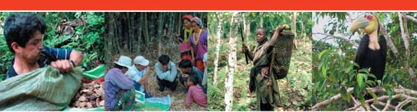
Joint CIFOR - ICRAF Biodiversity Platform November 2006, No. 1

Editorial

Platform highlights
➢ Joint Biodiversity Platform launched in March 2006
➢ Partnerships
➢ Fundraising
Events
➢ Past events
➢ Coming events
Information sharing
➢ Publications
➢ Useful links

Editorial

The idea of this Platform on Biodiversity goes back to 2002, when a consultative process and the ‘Matrix matters report’ suggested that ICRAF and CIFOR complementary strengths would best be applied to advance our understanding of biodiversity in human-dominated landscape mosaics in the tropics. The fact acknowledged by both centers is that poverty alleviation and biodiversity conservation goals must go hand-in-hand in today’s world but they generally need tradeoffs. With the decrease in contiguous forest areas, landscape mosaics are of increasing importance for both livelihoods and biodiversity. Within the Joint Biodiversity Platform, CIFOR and ICRAF aim to better understand biodiversity conservation and sustainable use in mosaic landscapes.

The facilitation team of the Platform currently consists of Jean-Laurent Pfund (CIFOR Bogor), Jean-Marc Boffa (ICRAF Nairobi) and Piia Koponen (CIFOR Bogor). After having much contributed to this Newsletter, Trudy O’Connor (ICRAF Bogor) had to leave the team recently - we wish her all the best in her career. Through the combined efforts of several people at ICRAF and CIFOR, ICRAF’s request to the Ministry of Foreign Affairs in Finland for an Associate Expert to work on the Biodiversity Platform was approved. Thus Ms. Salla Rantala will join Nairobi early December 2006. We look forward to her joining the Biodiversity Platform.

What makes the Platform unique? The core idea is for ICRAF and CIFOR and their partners to join forces and integrate knowledge across institutions, scientists and research sites. In a first stage, the Landscape Mosaics - project should help us to build an analytical framework allowing the comparison of livelihood and biodiversity features across sites. A further guiding element of the Platform is to find the right balance between science and development efforts, using a ‘transdisciplinary’ approach. Simply said, and without any pretention to replace ongoing work, the Platform wants to add value and knowledge to what our institutions are doing by facilitating integrated landscape research involving cross-sectoral thinking.

The editorial team warmly welcomes suggestions to improve this newsletter and invites you to contact us if you have any comments. We wish to thank all colleagues who joined the launch workshop and those involved the preparation of the first project of the Platform, namely “Landscape Mosaics”.

Platform highlights

Joint Biodiversity Platform launched in March

The first workshop of the joint CIFOR-ICRAF Biodiversity Platform was held in March 2006. It gathered 30 scientists from both institutions to define common objectives and discuss the framework and potential operational modes of the Biodiversity Platform. During the meeting, scientists shared their expertise and experiences to give the Platform a strong base from which to work. In addition to an interesting and important set of innovative ideas, research questions and identified gaps, the workshop resulted in an agreed set of goals, objectives and principles. The Biodiversity Platform was officially launched at the workshop and CIFOR and ICRAF have now included the joint initiative in their respective Medium-Term Plans.

What is the framework of the Platform? What should the Platform be? Where should it go? Who is it for?

The CIFOR-ICRAF Biodiversity Platform will focus on biodiversity issues in multifunctional landscape mosaics.

CIFOR
Supervision:
Bogor: Markku Kanninen

ICRAF
Supervision:
Nairobi: Brent Swallow, Mohamed Bakarr
Bogor: Meine
van Noordwijk
Lesson sharing
Synergies
Added value
Joint projects
Other partners
Other partners
Biodiversity Platform
Other partners
Coordinators:
Bogor: Jean-Laurent Pfund (CIFOR)
Nairobi: Jean-Marc Boffa (ICRAF)

Facilitation team:
Bogor: Piia Koponen (CIFOR),
Trudy O’Connor (ICRAF)
Nairobi: Salla Rantala (ICRAF)
Montpellier: Robert Nasi (CIFOR)

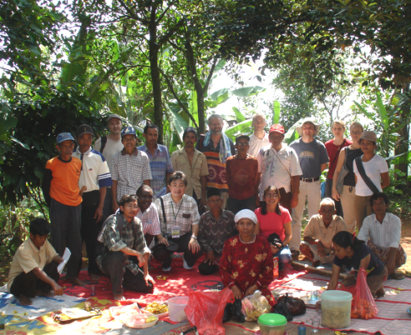

Platform members enjoy a trip to Gunung Halimun, in West Java, as part of the launching workshop.

Both institutions take advantage of their perceived objectivity to address issues related to the combination of conservation and development interests. Emphasis is placed on local people’s perspectives but the guiding principle is to work with multiple stakeholders and at different governance levels. The two centres have sufficient staff capacity to undertake inter- or transdisciplinary research encompassing biophysical, socio-economic and policy issues. The aim is to rigorously address issues of ‘people and biodiversity’, while also focusing on other topics, such as cross-sectoral interactions with land use, that are not addressed in many sector-specific research institutions.

The Platform wants to:
- Promote dialogue and networking to catalyze the development of new thinking, approaches, and practice of biodiversity conservation and sustainable use in multifunctional landscapes.

- Provide opportunities for:
  - Lesson sharing, especially across disciplines, sites and scales.
  - Synergies (e.g. of resources, skills, mandates).
  - Added value (e.g. through syntheses and generalization).

The Biodiversity Platform aims to collaboratively deliver international public goods on the following themes.

    - Relationships between biodiversity and livelihood security in multifunctional landscapes.

For this theme we would like to build on the approaches and findings being developed within the two centres, for example such as by CIFOR’s MLA (Multidisciplinary Landscape Assessment) team and the Poverty and Environment Network (PEN), led by CIFOR. PEN is a group of researchers who are developing a common household derived database of socio-economic data from tropical countries. MLA is a set of methods developed to better understand landscape resources from both biophysical and social perspectives.
(http://www.cifor.org/mla/) (http://www.cifor.cgiar.org/pen/)

    - Ecological processes and spatial dynamics of biodiversity in landscape mosaics.
Experiences from programmes such as ASB (Partnership for the Tropical Forest Margins), hosted by ICRAF provide a useful background for this theme as they bring synthesized information on land uses and trends of forest margins (http://www.asb.cgiar.org/).

    - Opportunities for and constraints to providing incentives for biodiversity conservation, sustainable use and equitable benefit sharing in landscape mosaics.
This theme can build amongst others on the work of ICRAF’s RUPES programme (Rewarding Upland Poor for the Environmental Services they provide), which is studying relationships between local communities and environmental services. The programme is developing workable strategies for people to receive rewards for their environmental stewardship. In particular the RABA tool (Rapid AgroBiodiversity Assessment) explores the potential for creating links between buyers and sellers of biodiversity - related services. (http://www.worldagroforestrycentre.org/sea/networks/rupes/)
    - Potential for harmonization of customary and statutory rules and laws in relation to multifunctionality of landscape mosaics.
We would like to benefit from the involvement of both ICRAF and CIFOR in the Collaborative Partnership on Forests (CPF). This organization brings together a wide range of influential institutions with experience and knowledge related to forests and governance. The knowledge available from the members links to the development of workable models for integrating traditional and State laws regarding land and natural resource use.
(http://www.fao.org/forestry/foris/webview/cpf/)

Information about the workshop and its results is available in the workshop report. (http://www.cifor.cgiar.org/docs/_ref/research/environment/bio_Platform.htm)

Go to TOC

Partnership

There has been an enormous amount of positive interest in the Platform. Coordinators have had discussions about opportunities for future collaboration with many agencies and people:
- Yves Laumonier and Jean-Guy Bertault from Centre de coopération internationale en recherche agronomique pour le développement (CIRAD), South-East Asia showed interest in the Platform and future collaboration is likely. A joint proposal on Biodiversity and multi-functional landscape management for the small to medium size islands of the Moluccas, Eastern Indonesia will be developed.
- Adam Drucker from Charles Darwin University Australia, and Carlo Fadda from the International Plant Genetic Resources Institute (IPGRI), visited Indonesia and ICRAF-CIFOR to work on a Global Environment Facility (GEF) project proposal that could include a common site with the landscape mosaics project.
- Markku Larjavaara from IPGRI, visited CIFOR headquarters and showed interest in collaboration on Influence of fragmentation on genetic diversity and productivity of trees valuable for the rural poor.
- Prof. Jaboury Ghazoul from the Swiss Federal Institute of Technology asked for our support creating a project proposal in dealing with pollination services in India, ‘Linking natural and agricultural habitats in the landscape mosaics through ecosystem services.’ If funded, Douglas Sheil (CIFOR) will conduct part of the research. In addition, Prof. Ghazoul’s team is interested in sharing findings on pollination services that could be communicated to targeted policy-level audiences through the Platform.
- Gil Mendoza from the Department of Natural Resource and Environmental Sciences, University of Illinois, USA, also indicated a strong interest in exploring possibilities to develop a collaborative project proposal for Integrated Natural Resource Management development in the Philippines and Indonesia.
- Dr. Petri Pellikka from the Department of Geography, University of Helsinki expressed interest to collaborate with the Platform in the Taita Hills of Kenya where land cover GIS database development work has been undertaken concurrently with the development of functional landscape connectivity models by partners from the University of Ghent and Antwerp and the East African Wildlife Society. He visited CIFOR to discuss with Jean-Laurent Pfund and Piia Koponen and Jean-Marc Boffa participated in a CEPF-funded workshop on Increasing Connectivity of the Forests of the Taita Hills in Wundanyi, where the results and plans for improved landscape management were discussed with various partners.
- Some PhD candidates have also contacted us regarding involvement in the Platform.

The next very important step to for the Platform will be to develop an interactive internet site by the end of 2006 to facilitate exchanges.

Fundraising

The first project that the Biodiversity Platform is developing is called ‘integrating livelihoods and multiple biodiversity values in landscapes mosaics’. This project is being presented to the Swiss Agency for Development and Cooperation (SDC).

A joint proposal for a biodiversity monitoring and survey training and rapid field inventory project in Jambi, Sumatra has also been developed between CIFOR, ICRAF and the Center for Biodiversity Management in Australia. This has been send to the Australian Regional Natural Heritage Program 2006-7. If accepted the project will start at the end of this year and continue next year.

A group led by Ramni Jamnadass at ICRAF is developing a GEF proposal on ‘Farm Forests of the Future’ focusing on the improved genetic management of priority tree species around World Heritage sites in three African countries.

Roberto Porro and Jonathan Cornelius at ICRAF and Christiane Ehringhaus at CIFOR have submitted a proposal entitled ‘Enhancing Smallholder Livelihoods through Value-Chain Development for Amazonian Palm Products’ in Brazil, Peru and Bolivia to the Bill & Melinda Gates Foundation.
Go to TOC

Events

Past events

Joint Biodiversity Platform core team members joined several meetings after the launch workshop and gave talks about the Platform. We also talked to potential partners about future projects.

Mohamed Bakarr (ICRAF) participated in the First International Stakeholder Meeting of the Platform for Agrobiodiversity Research in Rome, Italy, 29-31 May, 2006. The meeting was organized with support from IPGRI, SGRP (CGIAR System-wide Genetic Resources Programme), CIRAD and the Netherlands. It gathered a wide range of stakeholders from international agencies, research, universities and civil society working on the maintenance and use of agrobiodiversity to discuss the aims, structure and activities of the IPGRI-led Platform. Linkages to this Platform will add critical value to initiatives of the CIFOR-ICRAF Biodiversity Platform.

Biodiversity Conservation in Agriculture, 31 May – 3 June 3 2006, Dominican Republic. A paper intitled ‘Agrobiodiversity and CGIAR tree and forest science’ by M. van Noordwijk, J-L. Pfund, M. Bakarr, L. Jackson, G. Schroth, K. Hairiah and L. Joshi was presented (see: http://www.oired.vt.edu/sanremcrsp/other/biodsymposium.php). The paper focused on research and development activities targeting forests and trees, and used examples from Sumatra, to highlight four current initiatives in partnership with DIVERSITAS, Joint Biodiversity Platform, Conservation international - ICRAF partnership and RUPES.

The CIFOR Inter-Programmatic Meeting on Plantation Landscapes, 8 June 2006, Bogor. Jean-Laurent Pfund and Piia Koponen participated in this meeting, which focused on sharing past engagements, lessons learnt and current activities on plantation research in CIFOR. Gaps and opportunities regarding coming plantation research in CIFOR were identified. To obtain the report please contact Piia Koponen.

Platform team members (Meine van Noordwijk, Trudy O’Connor and Jean-Laurent Pfund) participated in a Diversitas (agrobiodiversity) meeting held in Sumatra in June 2006. As part of the ‘Diversitas’ biodiversity science program, the group who met in Jambi is hoping to use their international experience as part of a project to test hypotheses relating to the effects of high input agriculture on the environment and society as well as the existence and operation of more ‘biodiversity-friendly’ alternatives. In addition to the Jambi case study, we heard presentations from India, Brazil, Mexico, the Netherlands and California. Congratulations to Meine van Noordwijk who has later been nominated as member of the Diversitas Science Committee on Agrobiodiversity.

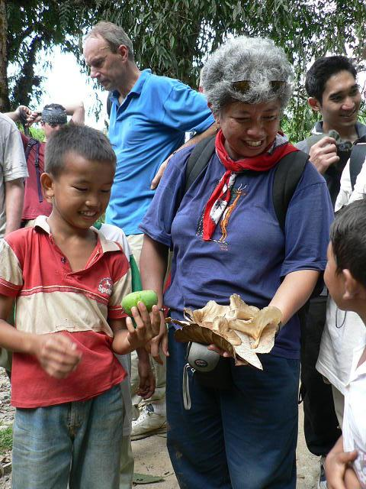
Discussing ‘useful’ (edible) biodiversity at the Diversitas workshop in Jambi, Sumatra.
Conservation International’s Global Symposium 2006. Defying Nature’s End: The African Context was organized by Conservation International, Antananarivo, Madagascar, 20-24 June 2006. Mohamed Bakarr and Brent Swallow were respectively chair and lead speaker in the fourth plenary session on ‘Putting Africa’s biodiversity to work: environmental services valued and evaluated’. Brent Swallow presented the ICRAF Scoping Study on Compensation and Rewards for Ecosystem Services. A final declaration of the symposium is available at http://symposium2006.conservation.org.

The Swiss Center for International Agriculture (ZIL) of ETH (Swiss Federal Institute of Technology) Zurich held its Annual Conference 2006 ’Trees for Poverty Alleviation’ on 9 June 2006, in Zurich. The Biodiversity Platform participated in the conference’s poster exhibition, which gave an overview on the ongoing activities in the fields of natural resource management, forestry and agriculture. The Platform’s poster showed its objectives and research approach. Keynote speakers, Dennis Garrity, Director General of ICRAF and Angela Cropper, Chair of CIFOR’s Board of Trustees, mentioned the joint Biodiversity Platform in their speeches. http://www.cifor.cgiar.org/docs/_ref/research/environment/bio_Platform.htm.

Robert Nasi and Jean-Laurent Pfund participated in the September 2006 meeting in Rome organized by IPGRI of the Future Harvest Alliance Strategy on Forest Genetic Resources, a CGIAR system-wide initiative.

CIFOR and ICRAF have begun a systematic literature review including interviews with people from various projects which incorporate conservation and development in a multidisciplinary way. Brief results of the literature review, ‘Transdisciplinary research to promote biodiversity conservation and management of tropical landscape mosaics’, was presented by Jean-Laurent Pfund this September in the Landscape Ecology IUFRO international conference ‘Patterns and processes in forest landscapes: consequences of human management in Bari, Italy.’ Conference presentations, photos and published papers are available at:
http://www.greenlab.uniba.it/events/iufro2006/ And for the review article see:
http://www.cifor.cgiar.org/Research/ENV/Themes/Bio/biodiversity_platform.htm

IUFRO International congress on cultivated forests: Planted Forests and Sustainable Development with a Scientific Forum on Ecosystem Goods and Services from Planted Forests on 3-7 October 2006 in Bilbao, Spain. Markku Kanninen gave a key note speech on ‘the global importance of plantations’ and Piia Koponen gave a presentation on ‘Are small scale plantations an alternative to forest depletion in Central Vietnam?’ at this meeting for which CIFOR was part of the scientific committee.
http://www.waldbau.uni-freiburg.de/bilbao.html

Go to TOC

Coming events

The VI Brazilian Symposium of Ethnobiology and Ethnoecology will be held from October 31st to November 4th, in Porto Alegre (RS), Brazil. The agenda of discussions includes themes such as the relationship between researchers and traditional communities; research methodologies in ethnobiology; and the contributions of local knowledge to global conservation strategies. Information in Portuguese can be found at http://www.ufrgs.br/desma/visbee/

A training course organized by ICRAF, Ecoagriculture Partners and the University of California, Berkeley on Leadership for Ecoagriculture in East Africa will be held on 12-18 November in Naivasha, Kenya. A number of ICRAF scientists will contribute to the course which will prepare 25 East African leaders to effectively design, lead and manage cross-sectoral, participatory initiatives that jointly achieve agricultural development with biodiversity conservation in landscapes of East Africa.

E-conference: European Support for Biodiversity Research in Developing Countries, and Mechanisms to Enhance International Collaboration and Co-Funding, 27th November – 15th December. This electronic-Conference is sponsored by the BiodivERsA ERA-Net and the European Platform for Biodiversity Research Strategy (EPBRS).
See: http://www.eurobiodiversa.org/News-2006_50.html

2007 Society for Conservation Biology Annual Meeting to be held in Port Elizabeth, South Africa from July 1-5, 2007. The meeting's theme is ‘One World, One Conservation, One Partnership’ - an explicit focus on promoting interdisciplinary approaches to applied conservation. For more information, see: http://compworx.isat.co.za/scb/.

The 7th World Congress of International Association for Landscape Ecology with the theme ‘25 years Landscape Ecology: Scientific Principles in Practice’, will be held from 8-12 July 2007 in Wageningen, The Netherlands. See: http://www.iale2007.com/

Second International Symposium on Multi-Strata Agroforestry Systems with Perennial Crops. To be held at CATIE headquarters in Turrialba, Costa Rica, from 17 to 21 September 2007. One of 4 sessions will be dedicated to landscape-level quantification and valuation of environmental services of perennial crop agroforestry systems.

Information sharing

Publications

The following publications from members or ‘Friends’ of the Platform might be of interest.’

Agroforestry in Landscape Mosaics, or ALAM, is a research partnership between the World Agroforestry Centre, Tropical Resources Institute at Yale University School of Forestry and Environmental Studies, and the University of Georgia Department of Environmental and Ecological Anthropology. ALAM’s mission is to improve the science and practice of conservation though better understanding of agroforestry and communities in landscapes that comprise agricultural lands, trees and protected areas. ALAM has a Series of Working ,papers, which are available at: http://www.yale.edu/tri/wkppragrofor.html

The African Highland Initiative hosted by ICRAF has recently posted a series of program briefs, working papers and journal publications on integrated natural resource management on its Web site http://www.africanhighlands.org.

R. Kindt (ICRAF), ‘Tree diversity analysis. A manual and software for common statistical methods for ecological and biodiversity studies.’ The Biodiversity Analysis Package is at: http://www.worldagroforestrycentre.org/sites/RSU/resources/biodiversity/index.asp

M. Padmanaba & D. Sheil, 2006, ‘Finding and promoting a local conservation consensus in a globally important tropical forest landscape.’ Journal of Biodiversity Conservation. http://www.springerlink.com/content/

K. Evans, S.J. Velarde, R.P. Prieto, S.N. Rao, S.Sertzen, K. Davila, P. Cronkleton and W. de Jong, 2006, ‘Field guide to the future: Four ways for communities to think ahead’. CIFOR-ASB-ICRAF. To receive a copy email Sandra Velarde at s.velarde@cgiar.org.
Evans, K.; de Jong, W.; Cronkleton, P.; Sheil, D.; Lynam, T.; Kusumanto, T.; Colfer, C.J.P.. ‘Guide to participatory tools for forest communities.’ Available for download in CIFOR Web site. http://www.cifor.cgiar.org/

Shanley, P.; Pierce, Alan; Laird, S. 2006. Alem da Madeira: a certificacao de produtos florestais nao-madeireiros. (Beyond timber: the certification of non-timber forest products.) Center for International Forestry Research (CIFOR), Belem, Brazil. 153p. PDF version: http://www.cifor.cgiar.org/Publications/Detail?pid=2085
Hard copies can be ordered from: rsato@cgiar.org

An Ecology and Society special feature with Robert Nasi as guest Editor: “Do we need new management paradigms to ensure sustainability in tropical forests?” is now online at:
http://www.ecologyandsociety.org/viewissue.php?sf=27
Go to TOC

Useful Links for Information sharing

Are you interested in forest landscape restoration? Try these sites:
- www.unep-wcmc.org/forest/restoration/ global partnership/
- www.panda.org/about_wwf/what_we_do/forests/our_solutions/restoration/

The Conservation Commons is a highway to open access to information. Have a look at
www.conservationcommons.org/

Find out about the International Day for Biodiversity in 2007!
http://www.biodiv.org/programmes/outreach/awareness/biodiv-day-2007.shtml

For further information, please visit: http://www.cifor.cgiar.org/Research/ENV/Themes/Bio/biodiversity_platform.htm

Deadline for submitting material for next volume is 31st March 2007.
Contacts:

 | Jean-Laurent Pfund  j.pfund@cgiar.org  CIFOR | 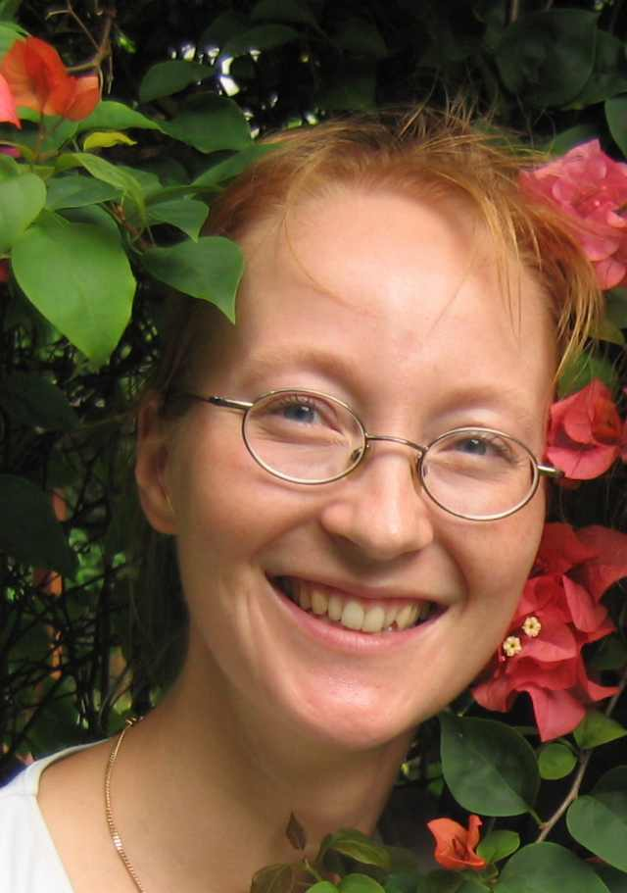 | Piia Koponen  p.koponen@cgiar.org  CIFOR | 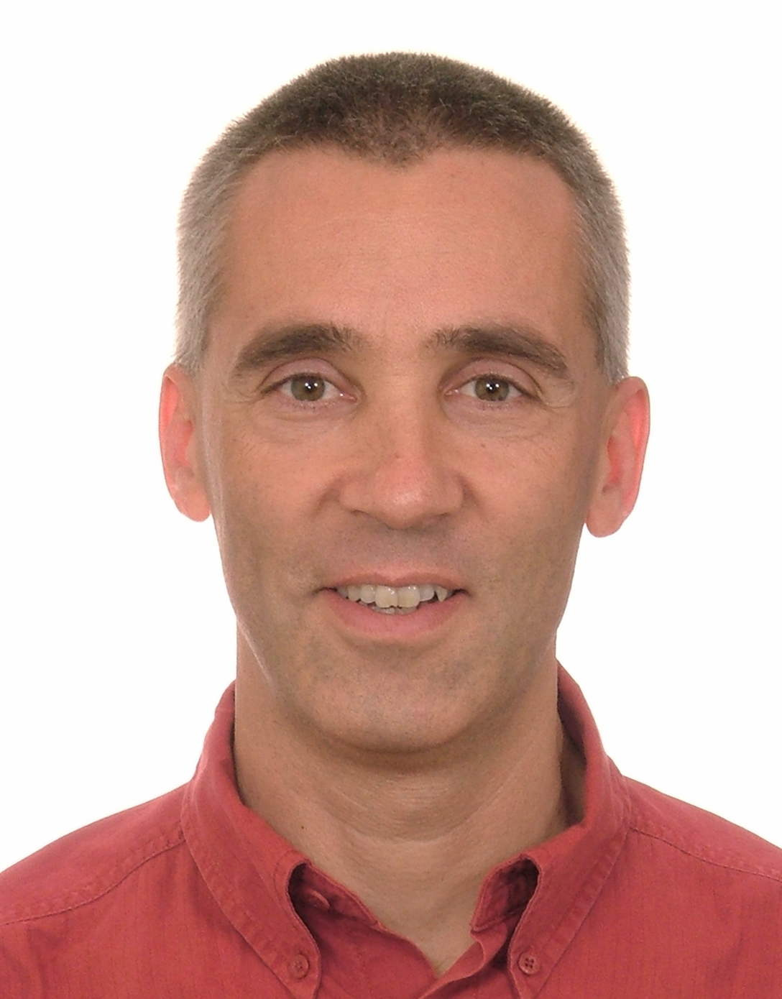 | Jean-Marc Boffa  j.boffa@cgiar.org  ICRAF

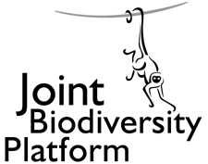
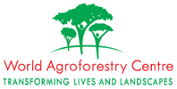
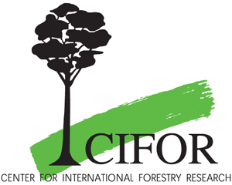

Center for International Forestry Research  Jl. CIFOR, Situ Gede, Sindang Barang, Bogor 16680, Indonesia  Tel: +62-251-622622  Fax: +62-251-622100  www.cifor.cgiar.org |  | World Agroforestry  Centre (ICRAF)  PO Box 30677  Nairobi, Kenya  Tel: +254-20-7224000  Fax: +254-20-7224001  www.worldagroforestrycentre.org

The Center for International Forestry Research (CIFOR) is a leading international forestry research organization established in 1993 in response to global concerns about the social, environmental, and economic consequences of forest loss and degradation. CIFOR is dedicated to developing policies and technologies for sustainable use and management of forests, and for enhancing the well-being of people in developing countries who rely on tropical forests for their livelihoods. CIFOR is one of the 15 Future Harvest centres of the Consultative Group on International Agricultural Research (CGIAR). With headquarters in Bogor, Indonesia, CIFOR has regional offices in Brazil, Burkina Faso, Cameroon and Zimbabwe, and it works in over 30 other countries around the world.

The World Agroforestry Centre (ICRAF) was established in 1978 to promote agroforestry research in developing countries, in response to a visionary study by Canada’s International Development Research Centre (IDRC. An international leader in agroforestry research and development, ICRAF’s vision is to see a massive increase in the use of trees on landscapes by smallholder rural households that help ensure security of food, nutrition, income, health, shelter and energy and a regenerated environment. Our mission is to use science to understand the complex role of trees in livelihoods and the environment, and promote use of this knowledge to improve decisions and practices impacting on the poor. By understanding and integrating the complexities of problems, realities, scale and systems with novel tools, knowledge and germplasm, we seek to improve the decisions, practices and institutional arrangements at farm, market, landscape and policy levels.

Donors
CIFOR and ICRAF receive their major funding from governments, international development organizations, private foundations and regional organizations. In 2006, The Joint CIFOR-ICRAF Biodiversity Platform received support from Centre de coopération internationale en recherche agronomique pour le développement (CIRAD), European Commission, Finland, Indonesia and Switzerland.

