 |  |  | CBD
 |  | CONVENTION ON  BIOLOGICAL DIVERSITY |  |  | Distr.  Limited  10 May 2005  ENGLISH ONLY
CENTRAL AND EASTERN REGIONAL WORKSHOP ON
ECOSYSTEM SERVICES ASSESSMENT AND FINANCIAL COSTS AND BENEFITS ASSOCIATED WITH THE CONSERVATION AND SUSTAINABLE USE OF BIOLOGICAL DIVERSITY
30 May – 2 June 2005, Moscow, Russian Federation

Information for Participants

- Opening and registration
The Regional workshop on Sustainable Use will be held in Moscow, Russian Federation, from Monday, 30 May to Thursday, 2 June 2005.

The workshop will start at 9.30 a.m. on Monday, 30 May, and registration will take place at the venue of the meeting at 9 a.m. the same day.

The meeting will be held at:

Hotel “Ukraina”
2/1, Koutuzovsky prospect
Moscow, Russia
Telephone.: +7 095 933 5656
Fax.: +7 095 243 3276
e-mail: ukrasu@elnet.msk.ru
Web site: www.ukraina-hotel.ru

- Working language of the meeting
The meeting will be held in English and Russian.

- Documents
Participants are kindly reminded to bring their own copies of the pre-session documents for the Workshop, as they will be available at the meeting venue in limited quantities.

- Visas
Attached, as annex I, is a list of diplomatic/consular missions and of countries whose citizens require or do not require an entry visa to Russian Federation.

Information on visa procedure, including a list of relevant Russian Federation diplomatic/consular missions is available at the Web site of the Ministry of Foreign Affairs of Russian Federation: http://www.mid.ru

For more detailed information on visa requirements, please go to the following web sites of the Ministry of Foreign Affairs of Russian Federation:

http://www.ln.mid.ru/dks.nsf/mnsdoc/04.03.10.00 (Russian version)
http://www.rusvisa.ru (English version)

Participants requiring an entry visa to Russian Federation are strongly advised to contact, as early as possible, the diplomatic/consular representations of Russian Federation to allow sufficient time for a visa to be issued as appropriate, prior to departure.

To facilitate and expedite the issuance of visas, the letter of nomination/funding and of invitation should be attached to the visa applications.

For any difficulty or query on visa-related matters, participants should contact directly the designated person whose coordinates are as follows:

Dr. Alexander Shestakov
Address: Nikoloyamskaya str.19, building 3, Moscow
Telephone.: + 7 095 727 0939
Fax: + 7095 727 0938
E-mail: ashestakov@wwf.ru

- Services to participants
Participants wishing to access their e-mail boxes could use the Business Centre located at the meeting venue. Use of the Internet is on a commercial basis. The rate is $2.45 per 10 minutes.

With regard to meals, participants have the option to use the restaurant of the Hotel “Ukraina”. The price for a set menu is approximately. 500 Rubles (US$ 18). There are also cafés and restaurants in the immediate vicinity of the meeting venue.

- Access to Moscow
Moscow is serviced by the Sheremetevo I and II, Vnukovo and Domodedovo airports. Taxis are available at the airport and there is also a shuttle bus and a train service.
Fares are as follows:

- Bus
Sheremetevo I and Shremetevo II:
Bus № 851 (Sheremetyevo – m.st. “Rechnoy Vokzal”) and № 817 (Sheremetyevo- m.st. “Planernaya”) 5.45-0.30.
Bus Stop is located at the right of the Arrival Hall.
A one-way ticket costs 15 Rubbles (approximately US$ 0,5)

- Mini bus
Mini-bus (Sheremetyevo – m.st. “Rechnoy Vokzal”, Sheremetyevo- m.st. “Planernaya”)
Mini bus Stop is located at the left of the Arrival Hall.
A one-way ticket costs 20 Rubles (approx. US$ 0,6). The journey takes about 25-40 minutes).
Mini bus operate 24 hours, and tickets can be bought from the driver.

- Taxis
Fares from airport to downtown are 700-1400 Rubles (approximately US$) 25-50. The journey takes about 20-30 minutes.

- Train service (Aeroexpress)
The train station is located on the left hand side of the airport
A one way ticket costs 100 Rubles (approximately US$ 3,5). The journey takes about 40 minutes to St. Paveletskaya Metro station, downtown. For Metro plan, please refer to Map-1.

Nb. For Aeroexpress, train and bus timetables, please refer to annex II

- Access to the meeting venue
The nearest Metro station to the meeting venue is Kievskaya. For direction, please refer to Map 2.

- Hotel accommodation
Attached, as annex III, is a list of hotels with indicative room rates. Participants in the Workshop are kindly reminded that they are responsible for making their own hotel accommodation arrangements.
For assistance or any queries about hotel accommodation, please directly contact the designted focal person whose coordinates are as follows:

Koritchenko Elena G.
Telephone.: +7 095 368 0114
E-mail: Koritchenko@yandex.ru
- Time zone
Moscow time in May-June will be 3 hours ahead of GMT.

- Weather conditions
During the period of May/June in Moscow, the average temperature is 20°C and can reach a maximum of 28°C. Rains and thunderstorm are frequent. More information on weather is available at the following web site:http://weather.cnn.com/weather/forecast.jsp?locCode=MOSX

- Voltage
220 volts, the plugs are two-pin type.

- Credit Cards
Major credit cards (Visa, MasterCard) are accepted in most hotels and restaurants in Moscow.

- Exchange rate (as of 21.04.2005)
Euro 1 = 36.3 Rubles
US$ 1 = 27.7 Rubles

- Disclaimer
The CBD Secretariat disclaims all responsibility for medical, accident and travel insurance, for compensation for death or disability, for loss of or damage to personal property and for any other loss that may be incurred during travel time or the period of participation. In this context, it is strongly recommended to secure prior to departure international medical insurance for the period of participation.
Annex I

DIPLOMATIC AND CONSULAR MISSIONS AND COUNTRIES AND TERRITORIES WHOSE CITIZENS REQUIRE VISAS IN ORDER TO ENTER THE RUSSIAN FEDERATION AS VISITORS
(Reproduced as provided by the host country)

Country | Address Embassy or consulate | Required (Yes) | Not required (No)
Azerbaijan | (Азербайджанская Республика)-  Consular department of the Embassy of Russian Federation in Baku  370022, г. Баку, ул. Бакиханова, 17  Telephone: + 99 412 98-60-83  Fax: +99412 98-84-56  e-mail: embrus@azdata.net  Web site: http://www.embrus-az.com |  | No
Albania | Consular department of the Embassy of Russian Federation in Tirana  Azim Zeneli str., 5, Tirana, Albania  Telephone: + 355-42 305-44 or 342-18, 322-53  E-mail: rusemb@icc.al.eu.org | Yes
Armenia | 1. Consular department of the Embassy of Russian Federation in Erevan  375015, г. Ереван, ул. Григора Лусаворича, 13A,  Telephone: + 3741 58-98-43  Fax: 3741 58-24-63 or 58-98-43, 50-71-19  E-mail: ruscon@arminco.com  2. Consulate general in Gyumri:  377501, г.Гюмри, ул.Гарегина Нжде, 5  Telephone: + 3744-1 372-61  Fax: + 3744-1 372-61  Web site: http://www.armenia.mid.ru/ |  | No
Belarus | 1. Consulate general in Brest:  224005, Республика Беларусь, г. Брест, ул.Пушкинская, д. 10  Telephone: +375-162 23-78-42, 23-80-69  Fax: +375-162 22-24-73  E-mail: brestcons@brest.by  2. Consular department of the Embassy of Russian Federation in Minsk:  г.Минск, ул. Гвардейская, д. 5а  Telephone: +375-17 222-49-75 or 222-49-85  Fax: +375-17 222-49-80  E-mail: kira1130@yahoo.com  Посольство РФ в Белоруссии: Web site: http://www.belarus.mid.ru/ |  | No
Country | Address Embassy or consulate | Required (Yes) | Not required (No)
Bulgaria | 1. Consulate general in Ruse:  г. Русе, ул. Ниш, 1  Telephone: +359-82 82-2249, or +359-82 82-2250  Emails: gkrf@elits.rousse.bg,  consul@genconru.russe.bg  public@genconru.russe.bg  2. Consular department of the Embassy of Russian Federation in Sofia  г. София, бул. Драган Цанков, 28  Telephone: +359-2 963-4021 or 963-4116  E-mails: consulate@datacom.bg , consulate@mbox.digsys.bg  3. Consulate general in Varna  г. Варна, ул. Македония, 53  Telephone: +359-52 60-2721  Fax: +359-52 60-2722  E-mail: Consul.Rusia@nat.bg  Посольство России в Болгарии:  Web site: ihttp://www.bulgaria.mid.ru | Yes
Bosnia and Herzegovina | Embassy of RF in Bosnia and Herzegovina  ul. Ejuba Ademovica, 9, Sarajevo, Bosnia i Hercegovina  Telephone: +387-33 210-913  E-mail: psrf@bih.net.ba  Web site: http://www.rusembbih.lol.ba | Yes
Croatia | Consular department of the Embassy in Zagreb  41000 Zagreb, Bosanska ulica, 44  Telephone: +38-41 37-55-038  Fax: +38-41 37-55-040  E-mail: veleposlanstvo-ruskefederacije@zg.tel.hr  Embassy of RF in Croatia – Web site: http://www.croatia.mid.ru/ | Yes
Country | Address Embassy or consulate | Required (Yes) | Not required (No)
Czech Republic | 1. Consular department of the Embassy in Prague  nam. Pod Kastany 1, Praha 6 - Bubenec, Ceska Republika  Telephone: +4202) 33-37-4093  Fax: +4202) 33-37-7235  E-mail: rusembassy@cdnet.org  2. Consulate general in Brno  ul.Hlinky 142-b, 60300 Brno, Ceska Republika  Telephone: +4205 43-232-157  Fax: +4205 43-244-429  E-mail: gkbrno@iol.cz  Web site: http://www.brno.mid.ru  3. Consulate general in Karlovy Vary  ul. Petra Velikeho 18, 36000 Karlovy Vary, Ceska Republika  Telephone: +42017 322-1325  Fax: +42017 322-6261  E-mail: gkkv@iol.cz  Web site: Embassy of RF in Czechia http://www.rusembassy.cz  Consulate general in Brno - | Yes
Estonia | 1. Consular department of the Embassy in Tallin  10133 Таллин, ул.Лай, 18, Эстонская Республика  Telephone: +372 646-4166  Fax: +372 646-4130  E-mail: konsotd@hot.ee  2. Consular department of the Embassy of Russian Federation in Tartu  51003 Тарту ул.Юликооли, 1, Эстонская Республика  Telephone: +372-7 403024  Fax: +372-7 403024  E-mail: tarturus@hot.ee  3. Consulate general in Narva  20307, г.Нарва, ул.Кирику, 8, Эстонская Республика  Telephone: +372-35 91-367, 60-652, 60-653  Fax: +372-35 60-654  E-mail: narvacon@hot.ee  Web site: Embassy of RF in Estonia http://www.estonia.mid.ru/ | Yes
Country | Address Embassy or consulate | Required (Yes) | Not required (No)
Georgia | Consular department of the Embassy of Russian Federation in Tbilisi  380062, Тбилиси, пр. И.Чавчавадзе, 53  Telephone: + 99532 91-27-82  Fax: +99532 91-30-85  E-mail: russianconsulate@caucasus.net  Web site: Embassy of RF in Georgia - http://www.georgia.mid.ru/ | Yes
Hungary | 1. Consular department of the Embassy of Russian Federation in Budapest  1062 Budapest, V1 Bajza utca, 35  Telephone: +36-1 331-8985  Fax: +36-1 252-5077  E-mail: ruskons@euroweb.hu  2. Consulate general in Debrezen:  Telephone: + 36-52) 536-928  E-mail: rusgkdeb@axelero.hu  Web site: Embassy of RF in Hungary: http://www.hungary.mid.ru/ | Yes
Kazakhstan | 1. Consular department of the Embassy of Russian Federation in Astana  473000, г. Астана, ул. Кенесары, 107  Telephone: +7-3172 32-75-45  Fax: +7-3172 32-69-65  E-mail: rusposolstvo@at.kz  2. Consulate in Uralsk  417000, г. Уральск, ул. Октябрьская, 78  Telephone: +7-3112 51-16-26  3. Department of the Embassy of Russian Federation in Alma-Ata:  480090, г. Алма-Ата. ул. Джандосова, 4  Telephone: +7-3272 74-71-72  Fax: +7-3272 74-71-68  E-mail: rfe@nursat.kz |  | No
KyrgyzStans | 1. Consular department of the Embassy of Russian Federation in Bishkek  720000, г. Бишкек, ул. Раззакова, 17  Telephone: +996-312 21-77-00 or 21-57-03  Fax: +996-312) 61-01-77  E-mail: ruscons@imfiko.bishkek.su  2. Consulate general in Osha:  genkon@ktnet.kg  Посольство РФ в Киргизии - http://www.kyrgyz.mid.ru/ |  | No
Country | Address Embassy or consulate | Required (Yes) | Not required (No)
Latvia | 1. (Латвийская республика)  Consulate general in Daugavpils  LV – 5403, Латвия, Даугавпилс, ул. Краславас, дом 46  Telephone: +371-54 22-744  Fax: +371-54 29-270  E-mail: Dgcons@mbox.latg.lv  2. Consular department of the Embassy of Russian Federation in Riga  LV – 1010, Латвия, Рига, ул. Антонияс, дом 2  Telephone: +371-7 21-2579 , 21-0123  Fax: +371-7 21-0123  E-mail: ruskons@delfi.lv  3. Consulate general in Liepaya  LV – 3400, Латвия, Лиепая, ул. Лиепу, дом 27  Telephone: +371-34 22-517, 31-393  Fax: +371-34 86-370  E-mail: konsul_liepaja@anet.lv  Посольство РФ в Латвии –  Web site : :http://www.latvia.mid.ru/ | Yes
Lithuania | 1. Consular department of the Embassy of Russian Federation in Vilnus  Latviu g. 53/54, Vilnius, 2600, Lietuva  Telephone: +370-5 272-38-93, 272-33-76  Fax: +370-5 272-33-75  kolatvu@rusemb.lt  2. Consulate general in Klaipeda  K.Donelaiciu g. 21, Klaipeda, 5800, Lietuva  Telephone: +370-46 49-99-51  Fax: +370-46 41-07-60  E-mail: ruskonsul@klaipeda.omnitel.net  Посольство РФ в Литве –  Web site: http://www.lithuania.mid.ru/ | Yes
Macedonia  (The former Yugoslav Republic of) | 1. Consular department of the Embassy in Skopje, Perinska 44, Makedonia, 1000 Skopje  Telephone: +389-2 11-7160  Fax: +389-2 11-7808  E-mail: rusembas@mol.com.mk  Web site: Embassy of RF in Macedonia - http://www.macedonia.mid.ru/ | Yes
Country | Address Embassy or consulate | Required (Yes) | Not required (No)
Moldova  (Republic of) | Consular department of the Embassy in Kishinev  2004, г. Кишинев, пр. Штефан чел Маре, 153  Telephone: +3732-2 23-51-10  Fax: +3732-2 23-51-09  E-mail: domino@mtc.md  Web site http://www.moldova.mid.ru/ |  | No
Poland | 1. Consulate general in Gdansk  ul. Stefana Batorego, 15, 80-251 Gdansk - Wrzeszcz, Rzeczpospolita Polska  Telephpne: +48-58 341-1088, 341-4092  Fax: +48-58 341-6200  E-mail: konsvisagdn@poczta.onet.pl  2. Consular department of the Embassy in Warsaw  ul. Belwederska, 25C, 00-761, Warszawa, Rzeczpospolita Polska  Telephone +48-22 849-5111, or +48-22) 849-2627  Fax: +48-22 849-4085  E-amil: korfwaw@mail.ru  3. Consulate general in Poznan  ul. Bukowska, 53a, 60-809, Poznan, Rzeczpospolita Polska  Telephone: +48-61 841-7523  Fax: +48-61) 847-4997  E-mail: konsulat_gfr_poznan@pro.onet.pl  4. Consulate general in Krakov  ul. Biskupia 7, 31144 Krakow,Rzeczpospolita Polska  Telephone: +48-12 422-2647, 422-9055  Fax: +48-12) 422-9066  Email: konskrk@pro.onet.pl  Web site: Embassy of RF in Poland - http://www.poland.mid.ru/ | Yes
Romania | 1. Consular department of the Embassy in Buharest  Bucuresti, Sos. Kiseleff, 6  Telephone: +402-1 222-1556  Fax: +402-1 222-6405  E-mail: rab@mb.roknet.ro  2. Consulate general in Constanta  Constanta, str. Mihai Viteazu, 5  Telephone: +402-41 61-5168  Fax: +402-41 61-8923  E-mails: consfr@tomis.roknet.ro, consfr@euroweb.ro  Web site: Embassy of RF in Romania - http://www.romania.mid.ru/ | Yes
Country | Address Embassy or consulate | Required (Yes) | Not required (No)
Serbia and Montenegro | 1. Consular department of the Embassy in Belgrad  11000, Beograd, ul. Deligradska, 32  Telephone: +38-111 361-39-64  Fax: +38-111 361-19-00  E-mail: ambarusk@eunet.yu  2. Consulate general in Podgorica  81000, Podgorica,  ul. Vaka Djurovica, 135  Generalni konzulat Ruske Federacije  u Podgorici  Telephone: +381-81 272-460, 272-450  Fax: +381-81) 272-460  E-mail: gencons.ru@cg.yu | Yes
Slovakia | Consular department of the Embassy in Bratislava  Marothyho 5, 811 06, Bratislava, Slovenska Republika  Telephone: +421-2 544-17-929  Fax: +421-2 544-14-664  E-mail: ruskonzulat@chello.sk  Web site: Embassy of RF in Slovakia - http://www.slovakia.mid.ru/ | Yes
Slovenia | Consular department of the Embassy in Ljubljana  ul.Tomsiceva, 9, 1000 Ljubljana, Slovenija  Telephone: +38-661 425-6880 or 425-6875  Fax: +38-661 425-4141  E-mail: ambrus.slo@siol.net  Web site: Embassy of RF in Slovenia - http://www.rus-slo.mid.ru/ | Yes
Tajikistan | 1. Consular department of the Embassy in Dushanbe  734001, г. Душанбе, пр. Рудаки, 105/1, г-ца "Октябрьская"  Telephone: +99-2372 21-1005/85, 15, 21-0477(доп.)  Fax: +99-2372 21-1165  E-mail: RAmbTadjik@rambler.ru  2. Consulate general in Khodzhent  735730, г. Ходжент, Ленинабадская обл., г-ца "Ходжент"  Telephone: +99-23422 5-98-74  Fax: +99-23422) 5-98-74  Посольство РФ в Таджикистане -  Web site: http://www.rusembassy.tajnet.com |  | No
Country | Address Embassy or consulate | Required (Yes) | Not required (No)
Turkmenistan | 1. Consular department of the Embassy in Ashkhabad  744005, г. Ашхабад, пр-т. им. Сапармурата Туркменбаши, 11  Telephone: +99312 35-70-41  Fax: +99312 35-21-77  E-mail: konsul-rf@online.tm  2. Consulate of the Embassy in Turkmenbashi:  Telephone: +993243 214-06  Fax: +993243 234-49  E-mail: kpre@online.tm | Yes
Ukraine | 1. Consulate general in Kharkov  г.Харьков, площадь Свободы, 5, ГОСПРОМ, 7-й подъезд, 8-й этаж  Telephone: 8-0572 40-8838, or 43-1655, 40-8767  Fax: 8-0572 45-4116  E-mail: consul@sky.net.ua  2. Consular department of the Embassy of Russian Federation in Kiev  г. Киев, ул. Кутузова, 8  Telephone: 8-044 294-6701 or 294-6816  Fax: 8-044 294-6816  E-mail: visa@rucons.kiev.ua - для приема визовой информации и  других сообщений касающихся визовых вопросов.  3. Consulate general in Lvov  г. Львов, ул. Патона, 7А  Telephone: 8-0322 69-2039, or 69-2036, 69-2051, 69-2055  Fax: 8-0322 69-2033  E-mail: consrus@lviv.gu.net  4. Consulate general in Odessa  г. Одесса, ул. Канатная, 83  Telephone: 8-0482 22-2232, or 25-2915  Fax: 8-0482 22-0102 or 25-2915  E-mail: gencon.rf.od@farlep.net,  5. Consulate general in Simferopol  Посольство РФ в Украине - http://www.embrus.org.ua  Посольство РФ в Украине (Консульский отдел) –  Web site: http://www.rucons.kiev.ua |  | No
Annex II

Aeroexpress and train and bus timetables from/to airport

Domodedovo airport
A. Aeroexpress
MOSCOW (m.st. “Paveletskaya”) - «DOMODEDOVO» |  | «DOMODEDOVO» – MOSCOW-(m.st. “Paveletskaya”)
7:00 | 7:40 | 8:00 | 8:41
8:00 | 8:48 | 8:30 | 9:15
9:01 | 9:41 | 9:00 | 9:40
9:30 | 10:12 | 9:30 | 10:17
10:00 | 10:41 | 10:00 | 10:46
10:30 | 11:11 | 10:30 | 11:19
11:00 | 11:43 | 11:00 | 11:49
11:30 | 12:12 | 12:00 | 12:45
12:00 | 12:40 | 13:00 | 13:40
13:02 | 13:42 | 14:00 | 14:41
14:00 | 14:41 | 15:00 | 15:40
15:00 | 15:42 | 15:30 | 16:17
16:00 | 16:40 | 16:00 | 16:40
16:30 | 17:12 | 17:00 | 17:47
17:00 | 17:43 | 18:00 | 18:40
18:00 | 18:46 | 19:00 | 19:45
18:30 | 19:10 | 19:30 | 20:15
19:00 | 19:40 | 20:00 | 20:45
19:30 | 20:13 | 20:30 | 21:19
20:00 | 20:44 | 21:00 | 21:49
20:30 | 21:13 | 22:00 | 22:43
21:00 | 21:40 | 23:00 | 23:40
22:00 | 22:40
B. Train (Annex II Cont’d)

departure | arrival | departure | arrival
4:51 | 6:00 | 6:15 | 07:37
6:24 | 7:34 | 6:51 | 8:12
7:14 | 8:32 | 8:10 (*) | 9:27
8:23 | 9:55 | 9:00 | 10:21
10:39 | 11:58 | 10:15 | 11:39
13:39 | 14:48 | 12:15 | 13:36
15:37 (*) | 16:49 | 15:15 | 16:54
16:50 | 17:59 | 17:15 | 18:32
18:04 | 19:19 | 18:15 (**) | 19:30
20:38 | 21:50 | 20:17 | 21:36
21:12 | 22:20 | 23:15 | 00:25
22:50 | 23:59

Saturday, Sunday (*);
Except Saturday, Sunday (**).

C. Bus (Annex II Cont’d)
To airport |  | To m.st. “Domodedovskaya”
Week-days | Holidays | Week-days | Holidays
6:00  6:40 | 6:00  6:40
 |  | 7:00  7:20 | 7:00  7:30
8:20 | 8:20 | 8:15 | 8:40
9:50 | 9:15  9:35 | 9:00  9:20  9:40 | 9:10  9:40
10:00  10:30  10:50 | 10:00  10:30 | 10:00  10:30 | 10:20  10:50
11:20  11:50 | 11:10  11:40 | 11:00  11:20  11:40 | 11:20  11:50
12:10  12:30  12:50 | 12:10  12:40 | 12:00  12:30 | 12:20  12:50
13:20  13:50 | 13:10  13:40 | 13:00  13:20  13:40 | 13:20  13:50
14:20  14:40 | 14:10  14:40 | 14:00  14:30 | 14:20  14:50
15:00  15:30 | 15:10  15:40 | 15:00  15:20  15:40 | 15:20  15:50
16:00  16:20  16:40 | 16:10  16:40 | 16:00  16:30 | 16:20  16:50
17:00  17:30 | 17:10  17:40 | 17:10  17:40 | 17:30  17:50
18:00  18:30 | 18:10  18:40 |  | 18:15  18:30
19:00 | 19:20 | 19:20 | 19:00  19:30
20:10  20:35 | 20:10  20:35 | 20:10 | 20:10
21:00  21:30  21:50 | 21:00  21:30  21:50 | 21:00  21:25  21:50 | 21:00  21:25  21:50
22:00  22:15  22:40 | 22:00  22:15  22:40 | 22:20  22:40 | 22:20  22:40  22:50
23:10 | 23:10  23:40 | 23:05  23:40 | 23:05  23:30

Annex III
List of Hotels with indicative room rates

1. Hotel “Ukraina” ****, m.st. “Kievskaya”
Address | Koutuzovsky av., 2/1
Tel. | +7(095) 9335656
Fax | (095) 243-3276
E-mail | ukrasu@elnet.msk.ru
Web | www.ukraina-hotel.ru
Indicative prices (per night)
Single – 4050 Rubles (app. 145 US $)
Double – 4650 Rubles (app. 167 US $)
Breakfast included

2.“Akademicheskaya” ***, m.st. “Oktyabrskaya”
Address | Donskaya st., 1, b.2
Tel. | +7(095) 959-8157, 237-0514
Fax | +7(095) 238-2539, 959-8157
Web | www.maan.fromru.com
Indicative prices (per night)
Single – 1650-2820 Rubles (app. 60-100 US $)
Double – 1920-3000 Rubles (app. 70-108 US $)

3. “Belgrad” ***, m.st. “Smolenskaya”
Address | Smolenskaya st., 8
Tel | +7(095) 248-3125
Fax | (095) 248-2814, 248-1852
E-mail | reservation@hotel-belgrad.ru
Web | www.hotel-belgrad.ru
Indicative prices (per night)
Single – 2600 Rubles (app. 94 US $)
Double – 2900 Rubles (app. 105 US $)
Breakfast – 384 Rubles (app. 14 US $)

4. “Varshava” ***, m.st. “Oktyabrskaya”
Address | Leninsky av., 2/1
Tel | +7(095) 238-4101, 238-7701, 238-1970
Fax | +7(095) 238-9639
Indicative prices (per night)
Single – 2500 Rubles (app. 90 US $)
Double – 3700 Rubles (app. 134 US $)
Breakfast included

5. “Mosfilm”, m.st. “Kievskaya”
Address | Pyreva ul., 4, build.2
Tel | +7(095) 143-2600, 143-2601
Indicative prices (per night)
Double – 1600 Rubles (app. 60 US $)
Access: from m.st “Kievskaya” troll №14, 34, mini-bus № 17, 34, 521, 119, 205, bus № 119, 205, stop “Ulitsa Pyreva”

6. “Kievskaya”, m.st. “Kievskaya”
Address | Kievskaya ul., 2
Tel | +7(095) 240-1444, 240-5210
Fax | +7(095) 240-5388
Indicative prices (per night)
Single – 800-1700 Rubles (app. 30-65 US $)
Double – 1200 – 2000 Rubles (app. 45-75 US $)
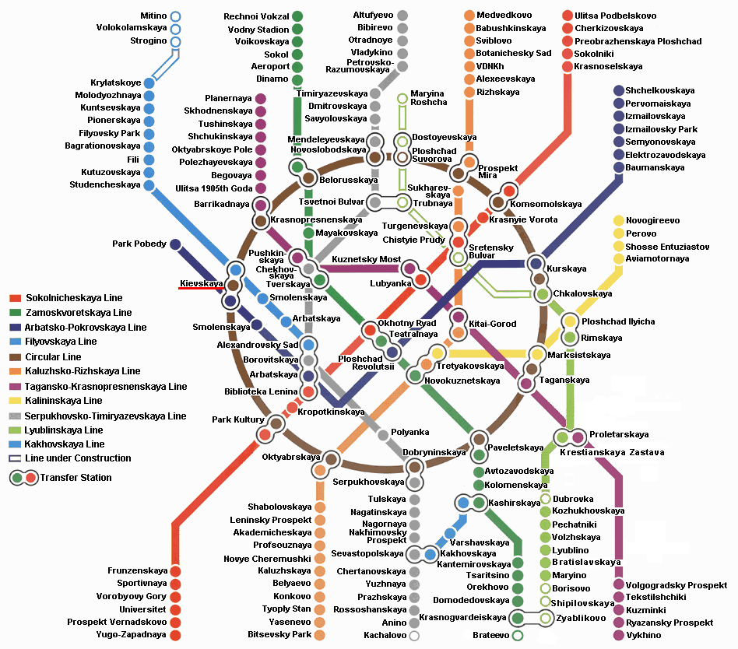

MAP-1 : Moscow Metro
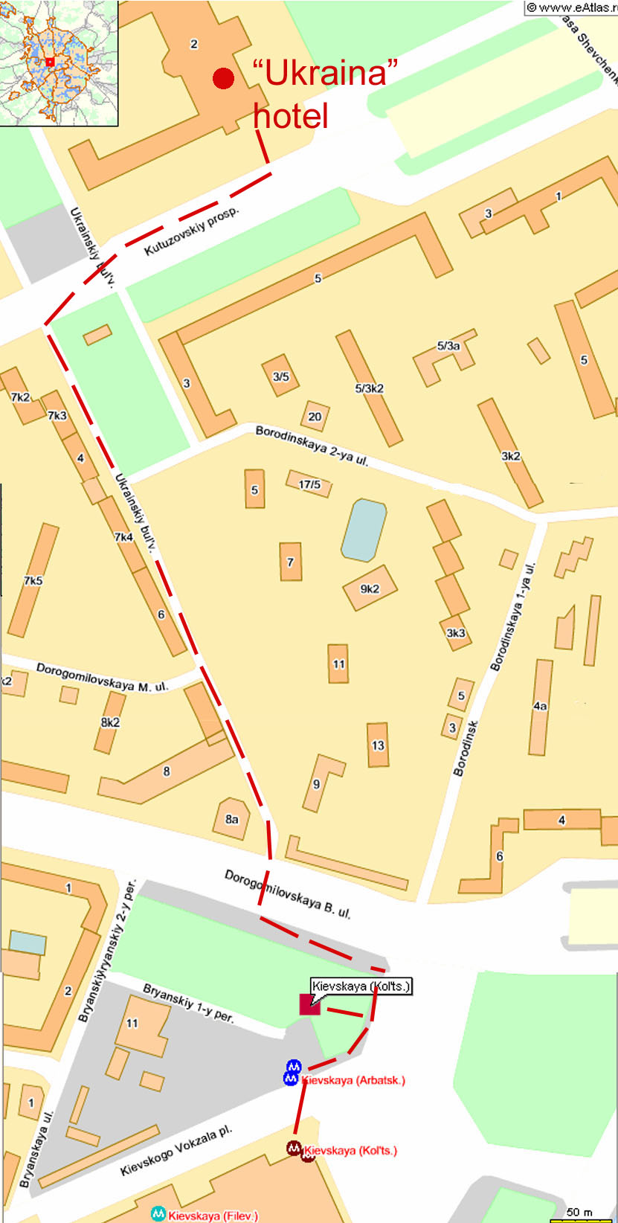

MAP-2 : Meeting venue

