 |  |  | CBD  WORKING DRAFT ONLY
 |  | CONVENTION ON  BIOLOGICAL DIVERSITY |  | Distr.  GENERAL  UNEP/CBD/WG8J/AG/2/INF/1  16 April 2007  ORIGINAL: ENGLISH

ADVISORY GROUP MEETING
ON ARTICLE 8(j) AND RELATED
PROVISIONS OF THE CONVENTION
ON BIOLOGICAL DIVERSITY
Second meeting
Montreal, 30 April – 03 May 2007

COMMENTS FROM GLADMAN CHIBEMEME – REVISION OF THE SECOND PHASE OF THE COMPOSITE REPORT- AFRICA

Note by the Executive Secretary
The Executive Secretary is circulating herewith, for the consideration of participants in the Second meeting of the Advisory Group on Article 8(j) and Related Provisions, the above-mentioned comments, which will be used as input to further develop the second phase of the composite report on the same subject.
The report is being circulated in the form and language in which it was received by the Secretariat.

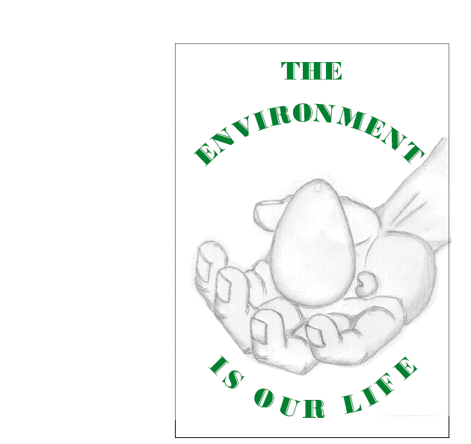
Chibememe Earth Healing Association (CHIEHA)

C/O Takunda (Sangwe) Secondary School

P.Bag 7110
CHIREDZI

ZIMBABWE

E-MAIL: chibememe@hotmail.com or gchibememe@yahoo.co.uk

09 March 2007

CBD Secretariat
CBD Article 8(j) and Related Provision
Convention on Biological Diversity (CBD)
Montreal
Canada

Dear John

Re: Composite Report on the status and trends regarding the knowledge, innovations and practices of indigenous and local communities.

I would like to start by congratulating Mr Sem Shikongo for successfully complying an excellent and comprehensive report on the status regarding the knowledge, innovation and practices of indigenous peoples and local communities. I want to further congratulate the CBD secretariat on Article 8 (j) and related provisions for facilitating this process and the Advisory group for their most valuable technical input or support. However, I have a few issues to highlight . These are:

- A number of international policies (ILO 169, UNCCD, CBD & etc) related to IKS have been highlighted in the report. Page 61 of the report gives a very rough summary on the policies. It would be a good idea to highlight in depth African regional policies that relate to the subject. Among these include the OAU Model. It would be prudent to provide Case studies of countries attempting to set up these policies and legal systems and also those that have already put in place these policies for example Zimbabwe.

- Identification of indigenous communities in Africa. It would be important to identify which countries differentiate indigenous as opposed to local people or communities. It is essential to highlight that some countries in Africa give a thin line between local and indigenous communities. The has resulted in the implementation of Indigenisation of the Economy Policies. Such policies consider local ownership, control and management as indigenisation.
.
- Desensitisation of issues. Page 15 of the report talks about globalisation as a new form of colonialism. It would be good to qualify for example that , ‘most’ or ‘some’ local and indigenous communities consider it a form of colonialism. Alternatively a reference could be cited to reflect that it is an opinion from probably an author. I am saying this because most of the communities from which we come from do not even know that there is a creature like globalisation. Most communities would rather need awareness on the very concept of globalisation and its negative impacts to be able to give their own assessment.

- There is need to check on a few spelling and grammatical mistakes in the report – example- Page 27, Box 7-line 7 ‘…people haves..’, p34- line 17 – ‘…so to does…’., p37-Box 10.

- Page 41 on the food aid section. The first sentence should be rewritten. I think it portrays a very negative image to the African continent. ‘…ravaged by war, poverty and hunger’. From an indigenous and local communities perspective this could be denigrating. Being perceived in this manner denies us our self respect, pride and self-esteem. In situations were there are no catastrophes like natural disasters local and indigenous communities consider themselves self-reliant and not poor. Page 53 –Box 21 capture the spirit and the idea I am driving at, that is that the concept of poverty as defined by the less than a US dollar a day is not convincing for most local and indigenous communities like us.

- It is essential that the report captures in-depth the need for a paradigm shift in development in which the local and indigenous communities are at the centre of the development process. We should be accorded the opportunity to determine our destiny. Indigenous peoples and local communities’ expertise and skills should be formally recognised and integrated in the mainstream development process. In this case there is need to support some Community Knowledge Service (CKS) in which community development and biodiversity champions can help share and disseminate tried and tested IKS based strategies for sustainable use and conservation of biodiversity. Communities offer working and practical solutions to sustainable development.

- On ways to protect and conserve traditional knowledge in Africa , the following should be considered;

a). It is important that Local and indigenous communities be accorded the opportunity to initiate development and conservation task forces at local, regional and international scale which will contribute to the implementation of global sustainable development policies such as the Millennium Development Goals (MDGs). In this case there should be a Community MDGs Task Force which will help guide the relevant stakeholders so that they may development intervention which will not compromise the local and indigenous communities’ knowledge, innovations and practices. Such an MDG Local and Indigenous Community Task Force should have the mandate to closely advise Executive Secretaries of major UN level Multi Environmental Agreements (MEAs) such the UNCBD, UNCCD and others on issues related to Traditional knowledge, innovations and practices.

b). Empower local communities with real rights over their land, places of historical and cultural significance so that they remain the stewards or guidance of their traditions, innovations and practices. Communities should therefore be allowed to co-manage protected areas in and around their areas.

c). Promote the Community Knowledge Service (CKS)- A facility in which communities document, store and share their knowledge for the achievement of the Millennium Development Goals and the global development agenda.

d). Need to promote on-site Access and Benefit Sharing (ABS) projects or models that support the protection and conservation of local and indigenous communities’ knowledge, innovation and practice while deriving benefits from biodiversity. Benefit sharing works as an incentive for communities to continue conserving and protecting their traditional knowledge, innovations and practices. It also dispels the myths that traditional knowledge is not valuable in current a scientific, modern and computer world.

- Acknowledgements should be written in full- Page 82. The names of the Expert group members should be written in full instead of just first names.

I hope these and others comments I will send in due course will be integrated in the report.

Yours Faithfully,

Gladman Chibememe

