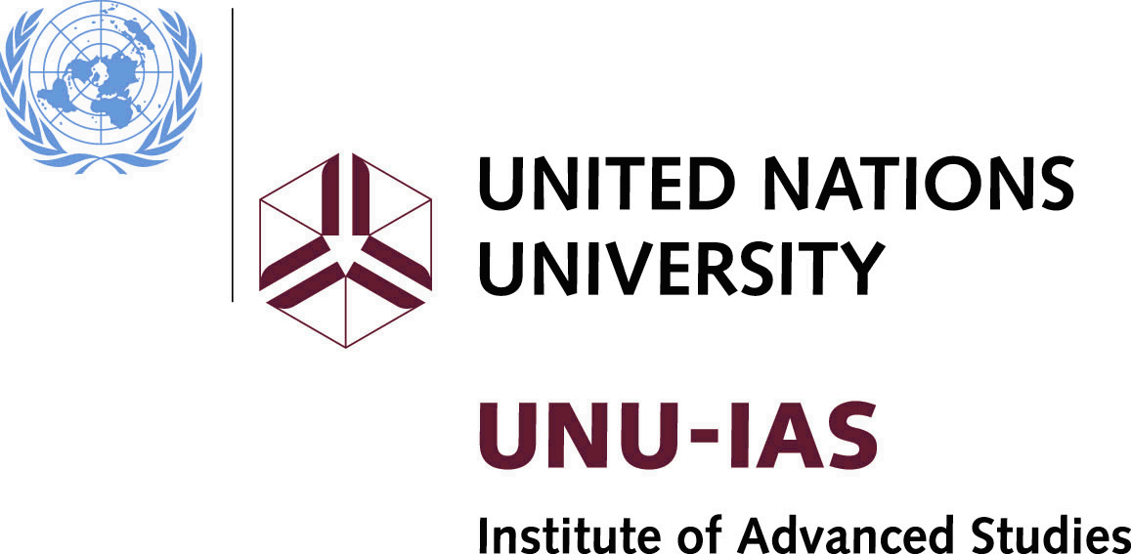 | 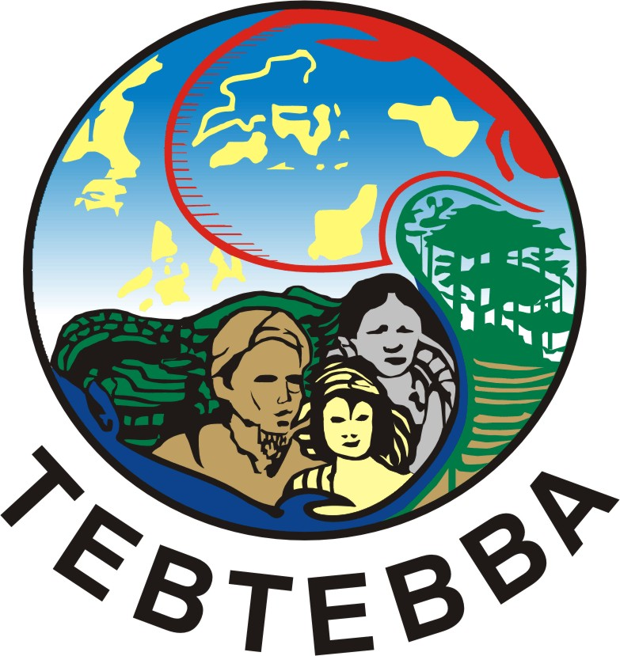 |  | UN-REDD Programme

GLOBAL INDIGENOUS PEOPLES’ CONSULTATION ON “REDUCING EMISSIONS FROM DEFORESTATION AND FOREST DEGRADATION (REDD)”
Baguio City, Philippines
12-14 November 2008
ANNOTATIONS TO THE PROVISIONAL AGENDA
INTRODUCTION
- In the context of the increasing global focus on climate change, attention is being paid to the role of the forestry sector in contributing to and fighting against climate change. In particular, this includes a recent focus on opportunities for reducing greenhouse gas emissions from deforestation and forest degradation in developing countries – known as ‘REDD’. Like most climate mitigation tools, REDD-related activities pose risks and opportunities for Indigenous peoples. A global consultation is therefore being convened with representatives from indigenous and local communities from 12 to 14 November in Baguio City, the Philippines. In order to facilitate this consultation, a strategic partnership has been established between the Secretariat of the Convention on Biological Diversity, the United Nations University – Institute of Advanced Studies, the UN-REDD Programme (UN Collaborative Programme on Reducing Emissions from Deforestation & Forest Degradation in Developing Countries), and Tebtebba – Indigenous Peoples’ International Centre for Policy Research and Education. The organizers also wish to acknowledge the generous donation from the David and Lucile Packard Foundation that has contributed towards convening this meeting.
- In decision IX/5 of the Conference of the Parties to the Convention on Biological Diversity (CBD COP-9) on forest biodiversity, the Executive Secretary of the Convention was requested to facilitate, in close cooperation with existing international, regional and subregional processes, initiatives and organizations, such as the Secretariat of the United Nations Forum on Forests, the Food and Agriculture Organization of the United Nations, the International Tropical Timber Organization, and other members of the Collaborative Partnership on Forests, regional, subregional and/or thematic workshops to support Parties in implementing the programme of work on forest biodiversity. In the same decision, the Executive Secretary was also requested to collaborate with the other members of the Collaborative Partnership on Forests, in particular the Secretariat of the United Nations Framework Convention on Climate Change (UNFCCC) and the World Bank, in order to support Parties efforts to address reducing emissions from deforestation and forest degradation in developing countries in the framework of the UNFCCC.
- Furthermore, decision IX/5 also invited Parties to ensure that possible actions for reducing emissions from deforestation and forest degradation do not run counter to the objectives of the Convention on Biological Diversity and the implementation of the programme of work on forest biodiversity; but support the implementation of the programme of work, and provide benefits for forest biodiversity, and, where possible, to indigenous and local communities, and involve biodiversity experts including holders of traditional forest-related knowledge, and respect the rights of indigenous and local communities in accordance with national laws and applicable international obligations.
- This consultation is part of the Secretariat’s efforts to ensure the effective participation of indigenous and local communities, to build strategic partnerships and to provide Parties with the information they need to ensure that REDD generates benefits for biodiversity and for indigenous and local communities. In particular, two of the participants of this consultation will present the results of the consultation to the first meeting of the Ad Hoc Technical Expert Group on biodiversity and climate change, to be held in London, United Kingdom of Great Britain and Northern Ireland from 17-21 November, to inform the discussions.
- The United Nations Collaborative Programme on Reducing Emissions from Deforestation and Forest Degradation in Developing Countries (UN-REDD Programme) is a collaboration between FAO, UNDP and UNEP. A multi-donor trust fund was established in July 2008 that allows donors to pool resources and provides funding to activities towards this programme.
- The UNFCCC agenda item on “Reducing emissions from deforestation in developing countries and approaches to stimulate action” was first introduced at the Conference of the Parties (UNFCCC COP-11) in December 2005. The challenge was to establish a functioning international REDD finance mechanism that can be included in an agreed post-2012 global climate change framework. Progress has been made and the need to meet the challenge is now reflected in the Bali Action Plan and the COP13 Decision 2/CP.13. A functioning international REDD finance mechanism needs to be able to provide the appropriate revenue streams to the right people at the right time to make it worthwhile for them to change their forest resource use behaviour.
- In response to decision 2/CP.13 of UNFCCC Conference of the Parties COP-13, requests from countries, and encouragement from donors, FAO, UNDP and UNEP have developed a collaborative REDD programme. The UN-REDD Programme is aimed at tipping the economic balance in favour of sustainable management of forests so that their formidable economic, environmental and social goods and services benefit countries, communities and forest users while also contributing to important reductions in greenhouse gas emissions. The aim is to generate the requisite transfer flow of resources to significantly reduce global emissions from deforestation and forest degradation. The immediate goal is to assess whether carefully structured payment structures and capacity support can create the incentives to ensure actual, lasting, achievable, reliable and measurable emission reductions while maintaining and improving the other ecosystem services forests provide.
- The United Nations University – Institute of Advanced Studies (UNU-IAS) undertakes research and postgraduate education on issues at the forefront of knowledge, policy development and learning. The UNU-IAS Traditional Knowledge Initiative seeks to build greater understanding and facilitate awareness of traditional knowledge to inform action by indigenous peoples, local communities and domestic and international policy makers. Key outputs include research activities, policy studies, capacity development and online learning and dissemination.
- Tebtebba (Indigenous Peoples' International Centre for Policy Research and Education) is an indigenous peoples' organization born out of the need for heightened advocacy to have the rights of indigenous peoples recognized, respected and protected worldwide. Tebtebba seeks to promote a better understanding of the world's indigenous peoples, their worldviews, their issues and concerns. In this effort, it strives to bring indigenous peoples together to take the lead in policy advocacy and campaigns on all issues affecting them.
- Other relevant agencies, including the United Nations Environmental Programme (UNEP), the Food and Agricultural Organization (FAO) and the World Bank (FCPF Forest Carbon Partnership Facility) have been invited and have agreed to present their current work and future plans regarding these matters.
- The documents for the meeting are available on the CBD Secretariat’s website at http://www.cbd.int/doc/?meeting=REDD-ILC-01 and the UNU Traditional Knowledge Initiative website at http://www.unutki.org/news.php?news_id=43&doc_id=6. The list of documents is also included in Annex I. A proposed work plan is attached in Annex II.

ITEM 1

A OPENING OF THE MEETING
- The meeting will be opened by Ms. Vicky Tauli-Corpuz,, Kankana-ey, one of the traditional indigenous peoples of the Cordillera region, (also collectively known as Igorot), and also the current Chairperson of the United Nations Permanent Forum on Indigenous Issues (UNPFII). Representatives of the Executive Secretary of the Convention on Biological Diversity, UNU-IAS and the UN-REDD Programme will also address welcoming words to the participants.

B ORGANIZATIONAL MATTERS

1.1. Election of Officers
- Participants will be invited to designate a Chair and a Rapporteur. Participants and presenters will be requested to briefly introduce themselves.

1.2. Adoption of the agenda
- A provisional agenda has been prepared by SCBD, UNU-IAS, UN-REDD Programme and the Tebtebba Foundation. The Participants may wish to adopt the agenda of the meeting on the basis of the provisional agenda.

1.3. Organization of work
- The deliberations of the meeting will be in English. To assist preparations for the consultation, presenters and participants has been provided with guiding questions which appear under item 2. Presenters will be requested to address the questions contained under item 2. Because of the large numbers of participants, indigenous and local community representatives are encouraged to present in regional groups.
- Throughout the consultation, indigenous and local community representatives will be provided with opportunities to consult amongst themselves and to reflect on the information provided (refer to work plan in annex II), with a view to assisting them in formulating informed strategies and positions regarding the issues touched upon in the questions contained under item 3.

ITEM 2. objectives of the consultation
- The Philippines workshop will provide an opportunity for indigenous and local communities to be fully informed about the activities of the international system regarding REDD schemes and climate change, as well as providing them with space to consider information provided and to develop informed positions and timely input into the implementation of such initiatives.
- The objectives of the workshop are:
  - To provide timely information from the international system on the development and implementation of REDD schemes;
  - To provide an opportunity for indigenous and local community representatives to formulate their own informed positions and strategies regarding REDD, including investigating opportunities and challenges;
  - To provide an opportunity for indigenous and local community participants to influence the development and implementation of REDD schemes taking into account biological diversity, their traditional knowledge and their rights;
  - To ascertain the current level of involvement of indigenous and local communities in the global debate on REDD;
  - To allow indigenous and local communities to become familiar with current capacity building tools and opportunities regarding REDD and to ascertain their own capacity building needs regarding REDD and to strategize to ensure their needs are met.
- The presenters are expected to:
- Provide an overview of their organization’s REDD activities, including at pilot country and project level activities;
- Explain how their organization facilitates and supports the involvement of indigenous representatives in REDD;
- Explain how their organization works with national governments regarding involvement of indigenous and local communities, and addresses indigenous rights issues;
- Discuss what capacity building support may be provided now and in the future.
- The indigenous and local community participants are encouraged to consider the following questions and to present on a regional and/or country basis :
- What are the main challenges and opportunities regarding REDD from your perspective?
- How are you currently involved in the national/regional/global debate on REDD?
- How do you cooperate with other indigenous organizations regionally/globally to address this issue?
- What are your capacity building needs, if any?
- What do you expect from this meeting?

Item 3. Presentations from indigneous and local community participants on a regional or country basis
- Under this item, participants will reflect on the afore-mentioned questions, as appropriate and in regional groups discuss country experiences and may appoint a regional rapporteur to report back to plenary.

item 4. Presentations by international organizations
- Presenters will provide information based on the afore-mentioned questions and also answer questions from participants following each presentation.

ITEM 5. review of current level of involvement of indigneous and local communities in the global debate on redd
- Based on the discussions under items 3 and 4, the Chairperson and Rapporteur will provide a brief overview of the topic in plenary, supplemented by the views of the participants.

item 6. Strategies for indigneous coalitions to effectively engage in international redd process
- Participants will discuss possible strategies for indigenous and local communities. If necessary, they may break into regional groups and appoint a regional rapporteur to report back to plenary on possible ways forward.

item 7. capacity building strategy for indigneous peoples

25. Based on the information provided by presenters and outcomes of the discussions, participants will discuss capacity building opportunities and possible needs based on the information received under item 2, in plenary.

item 8. additional tools for influencing the development of REDD schemes

26. Participants will discuss and map potential benefits and negative impacts of REDD schemes on indigenous and local communities, their traditional knowledge and biological diversity. Specifically, it is suggested that they identify the role of traditional knowledge in the development and implementation of REDD schemes. Furthermore they may wish to consider mapping ways to include indigenous views and perspectives on the conservation and sustainable use of biological diversity in the prioritization of REDD investments. If necessary, they may break into regional groups and appoint regional rapporteurs, who will report back to plenary.

item 9. adoption of conclusions and recommendations – mapping the way forward

27. Participants will adopt the conclusions and recommendations of the meeting on the afternoon of Friday 14th November. The report of the meeting, together with the conclusions and recommendations will be made available to the Ad Hoc Technical Expert Group on biodiversity and climate change (AHTEG), to be held in London, United Kingdom of Great Britain and Northern Ireland (to be held 17-21 November 2008) and an information document will be posted on the websites of the CBD Secretariat, UNU, Tebtebba, and UN-REDD. In particular, the outcomes of the meeting will be presented, to the AHTEG by two of the participants of this consultation.

item 10. Closure of the meeting.

28. The expert meeting is expected to end at 5 p.m. on Friday, 14 November 2008.
Annex I

Documents
Agenda
Annotated agenda

Information documents

- Reducing Emissions from Deforestation and Forest Degradation in Developing Countries (REDD): A Guide for Indigenous Peoples, UNU-IAS.
- “Forests, Climate Change, and Human Rights: Managing Risk and Trade-offs“ , CIFOR: http://rightsandclimatechange.files.wordpress.com/2008/10/seymour-forests-cc-hr-0810021.pdf
- “Local Rights and Tenure for Forests: Opportunity or Threat for Conservation?“, IUCN and RRI: http://rightsandresources.org/documents/files/doc_849.pdf
- UN Collaborative Programme on Reducing Emissions from Deforestation & Forest Degradation in Developing Countries (UN-REDD Programme) – Framework Document – 20 June 2008.

Annex II
Proposed organization of work
Day One – 12 November 2008
9.00 – 10.15 | Opening of the meeting/ Organizational matters  Overview of Objectives and programme of the meeting  Introduction of the participants
Morning Tea  10.15 – 11.00 | During the morning break, indigenous participants will meet in regional and/or country groups over tea/coffee, and discuss regional experiences of indigenous and local communities regarding REDD, and appoint a regional Rapporteur, who will report back to Plenary after breakout session
11.00 – 12.30 | Regional Raporteurs will present a summary of regional and country experiences to plenary
12.30-13.30 | Lunch break
13.30-17.00 | Presentations by international organizations:-  a. SCBD  b. UN-REDD Programme  c. The World Bank / Forest Carbon Partnership Facility  d. Other relevant international process and organizations  *Each presentation will be followed by discussion, facilitated by the Chairperson.
Day Two - 13 November 2008
9.00 – 10.00 | Based on the discussions from the previous day, the Chairperson and Rapporteur will present a brief summary on the current level of involvement of indigenous and local communities in the global debate on REDD, followed by a brief discussion in plenary.
10.00 – 12.30  *Morning tea will be available during the discussions | Indigenous participants will break from plenary to discuss strategies for indigenous coalitions to effectively engage in international REDD processes.  International organizations will be available if required as resource persons only.
12.30-13.30 | Lunch break
13.30-14.30 | The Chairperson and Rapporteur will provide a summary to Plenary of the morning’s discussions.
14.30 – 16.00 | Participants will break in to regional groups to discuss current capacity building opportunities, based on information provided by presenters and current and future needs. The regional rapporteurs will summarize the group discussions.
16.00 – 17.00 | The regional rapporteurs will report back to plenary.
Day Three - 14 November 2008
9.00-9.30 | Draft conclusions and recommendations will be circulated to participants.
9.30 – 11.00  *Morning tea will be available during the discussions | Participants will break into regional groups to reflect of the draft provided and provide feedback to plenary through the regional rapporteurs.
11.00 – 12.30 | Regional rapporteurs will report back to plenary.
12.30-14.30 | Lunch break – Rapporteur will make necessary adjustments to ensure the adoption of the report.
14.30-17.00 | Adoption of the report
17.00 | Closure of the meeting
-----

The Cordillera peoples, also collectively known as Igorot, refer to the assemblage of indigenous groups living in the highlands, foothills and river valleys of the Cordillera mountain ranges of Northern Luzon. They are the traditional peoples of the Baguio City and broader region.
Regional rapporteurs will be appointed by regional groups and those groups shall be based on the seven geo-cultural regions used by the UNPFII.

