 |  | CBD
 |  |  |  | Distr.  GENERAL  UNEP/CBD/WG8J/8/INF/12  23 August 2013  ORIGINAL: ENGLISH
AD HOC OPEN-ENDED INTER-SESSIONAL WORKING GROUP ON ARTICLE 8(j) AND RELATED PROVISIONS OF THE CONVENTION ON BIOLOGICAL DIVERSITY

Eighth meeting
Item 4(a) of the provisional agenda*
Montreal, 7-11 October 2013

Report of the International Conference for Indigenous PEOPLES and Local Community LAND AND Sea Managers AND THE RESULTING NETWORK

Note by the Executive Secretary

INTRODUCTION
- As noted by the Conference of the Parties in paragraph 10 of decision XI/14 A, the Executive Secretary is circulating herewith, for the consideration of participants in the eighth meeting of the Ad Hoc Open-ended Inter-Sessional Working Group on Article 8(j) and Related Provisions, the Report of the International Conference for Indigenous Peoples and Local Community Land and Sea Managers and the resulting international network, as possible input into Article 10(c), as well as other issues. The Conference of the Parties noted the potential contribution that the International Indigenous Peoples and Local Communities Land and Sea Managers Network, announced at the United Nations Conference on Sustainable Development (Rio+20), could make to linking indigenous expertise and modern technology and encouraged participation in the associated conference, held from 27 to 31 May 2013 in Darwin, Australia, in order to further develop the Network.
- The report has been reproduced in the form and language in which it was provided to the Secretariat.
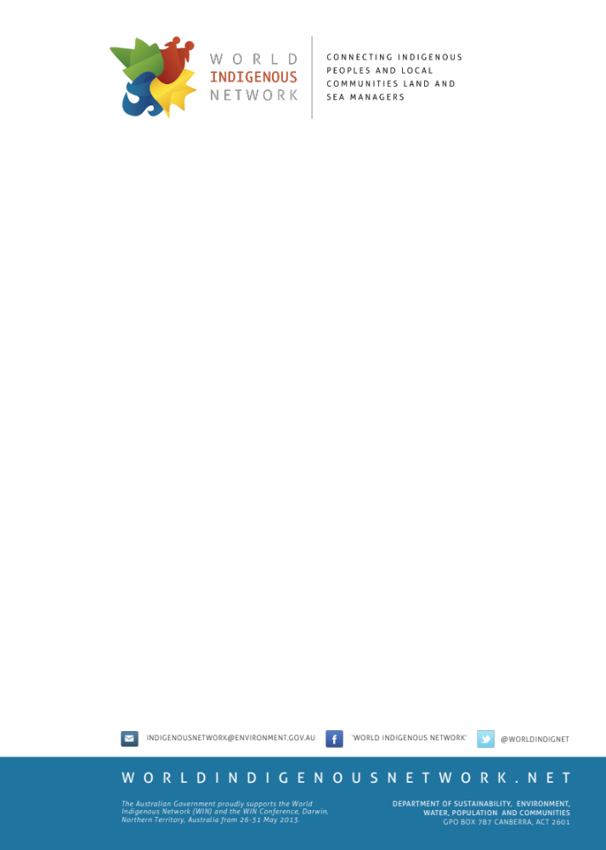

In June 2012 at the United Nations Conference on Sustainable Development (Rio+20) the then Prime Minister of Australia, Julia Gillard, with the support of Brazil, New Zealand and Norway, announced the intention to create a global network for indigenous peoples and local communities land and sea managers - now known as the World Indigenous Network (WIN).

‘Today we acknowledge the immensely important work of local and indigenous communities as custodians with knowledge and expertise linking ancient traditions to modern practices as guardians of the natural environment all over the world.’

- Extract from the then Prime Minister of Australia’s speech at the announcement to create a World Indigenous Network, at Rio+20, Brazil, June 2012

Indigenous peoples and local communities have cared for land and sea for millennia. Their traditional knowledge provides the necessary foundation to ensure our environment is properly cared for today and in the years to come.

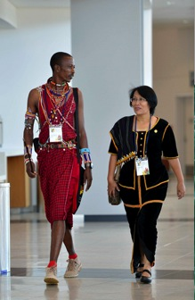
The WIN brings together indigenous peoples and local communities land and sea managers to share stories, cultural experiences and ideas to better manage ecosystems, protect the environment and support sustainable livelihoods. The overall aim of the WIN is:

- better conservation of biological diversity and
sustainable use of natural resources;

- improved social cohesion; and

- increased economic opportunities and the alleviation
of poverty.

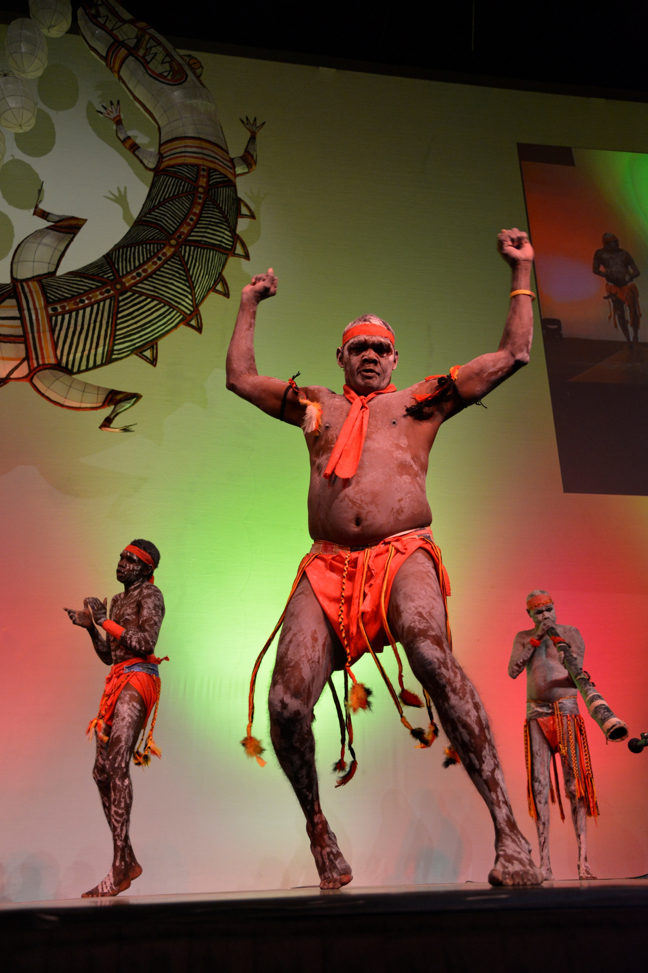
The Conference

‘It was great to meet other rangers and hear what’s going on for them on their country. Some people here have nothing, but they still work with the tools they got. I felt a big connection with everyone, it didn’t matter where they were from.’

- Indigenous ranger, Australia

The inaugural WIN Conference, hosted by the Australian Government and the traditional owners of Darwin, the Larrakia people, took place in Australia from 26 to 29 May 2013. Approximately 1200 delegates from more than 50 countries attended the Conference, participating in the many presentations, workshops and plenary addresses.

The event provided a unique and exciting opportunity for indigenous peoples and local communities land and sea managers to come together and connect.

Topics discussed at the Conference included dugong management knowledge exchanges between the Kimberley region of Australia and Abu Dhabi, enhancing coastal ecosystems for Māori communities, community based environmental education in Mongolia, food security in the Arctic, sustainable livelihoods in the Pacific, protecting cultural landscapes in Brazil, and capturing traditional ecological knowledge in the Torres Strait.

In addition to the WIN Conference, the WIN has been reaching out to indigenous peoples and local communities land and sea managers in the following ways:

Website

A dedicated website www.worldindigenousnetwork.net is providing a virtual meeting space for those making a contribution to the WIN to share knowledge and experiences. Since the launch of the website in mid December 2012, there have been over 90,000 page views from people in more than 170 countries. A great deal of interest was generated at the Conference, with over
19,000 page views from 79 countries.

More than 100 hours of video, covering exchanges and the WIN Conference, is available for viewing. Approximately 30 hours of content was streamed live during the Conference, receiving 1119 page views from people in 26 countries, and is now available on demand.

More than 4000 votes were cast in the WIN photo competition online, via Facebook and at the Conference, and the WIN Facebook page has more than 1530 ‘fans’ globally.
Exchanges

A key goal of the WIN is to foster engagement and share better practices among indigenous peoples and local communities land and sea managers through on-ground exchanges. To facilitate sharing, six international exchanges have so far been delivered in partnership with the Pew Environment Group, The Nature Conservancy, The Thin Green Line, Parks Forum and Ocean Revolution. Participants of these exchanges included indigenous people from Australia, Canada, Mexico, North America, the Solomon Islands, Africa and New Zealand.

The exchanges provided an avenue to share regional approaches and experiences using contemporary and traditional knowledge and local practices to better manage the environment and support sustainable livelihoods.

Building the WIN

A consultation period took place from Monday 6 May to Friday 21 June 2013 for community members to read, consider and comment on a scoping paper of what the WIN could look like. Feedback included formal written submissions, website discussion board comments and group conversations at the WIN Conference. Consultation questions included how stakeholders would like to communicate with others around the globe and share their knowledge. This feedback is now being analysed and will be integrated into the WIN design.

Analysis of the feedback shows a strong desire to continue face-to-face knowledge exchanges to share experiences, best practice, ideas and solutions. Expanding the website to be a hub of information on events, funding, and links to best practice guides and common themes (such as climate change) was also seen as an excellent resource for indigenous peoples and local communities land and sea managers.

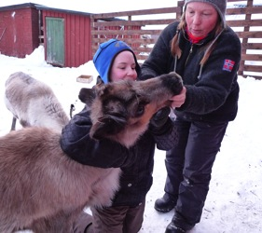

The Future

‘I thank sincerely the Australian Government for this initiative… The Australian Government has planted a seed and now we have to water it.’

- Conference delegate, Republic of Benin

At the WIN Conference opening ceremony, it was announced that the United Nations Development Programme - Equator Initiative would be the interim host of the WIN Secretariat. In making the decision, the Australian Government looked for an established organisation that was already actively supporting the work of indigenous land and sea managers around the world and had significant international partnerships and capacity.

The Equator Initiative brings together the United Nations, governments, civil society, businesses and grassroots organizations to recognise and advance local sustainable development solutions for people, nature and resilient communities. The Equator Initiative recognises outstanding local initiatives through the biannual Equator Prize, has a case study database for sharing knowledge and conducts community to community meetings that have so far involved more than 600 local and indigenous community representatives.

From July 2013, the Equator Initiative assumed responsibility for providing the WIN Secretariat. They will look at integrating stakeholder feedback in the WIN design, the WIN governance structure, securing ongoing funding and how to best connect indigenous peoples and local communities land and sea managers from around the world.

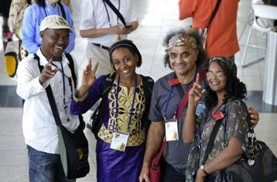
Contact
For further information please contact:

Eileen de Ravin
Manager, World Indigenous Network
United Nations Development Programme – Equator Initiative
304 East 45th St., Room 614
New York, NY 10017
Tel: +1 646 781 4023
eileen.de.ravin@undp.org
www.equatorinitiative.org

* UNEP/CBD/WG8J/8/1.

