 |  | CBD
 |  |  |  | Distr.  GENERAL  UNEP/CBD/WGRI/4/INF/8  15 April 2012  ENGLISH ONLY
AD HOC OPEN-ENDED WORKING GROUP ON REVIEW OF IMPLEMENTATION OF THE CONVENTION
Fourth meeting
Montreal, 7 - 11 May 2012
Item 6 of the provisional agenda*

Assessing the adopted indicators for the implementation of the Strategy on resource mobilization of the Convention on Biological Diversity: A scoping study

Information note by the Executive Secretary
  - The Executive Secretary is pleased to circulate herewith, for the information of participants in the fourth meeting of the Ad Hoc Open-ended Working Group on Review of Implementation of the Convention, an information document entitled “Assessing the adopted indicators for the implementation of the Strategy on resource mobilization of the Convention on Biological Diversity: A scoping study” submitted by the United Nations Environment Programme World Conservation Monitoring Centre (UNEP-WCMC).
  - The document is being circulated in the form and language in which it was provided to the Secretariat.



ASSESSING THE ADOPTED INDICATORS FOR THE IMPLEMENTATION OF THE STRATEGY ON RESOURCE MOBILIZATION OF THE CONVENTION ON BIOLOGICAL DIVERSITY: A SCOPING STUDY

Prepared by Anna Chenery
A Report by UNEP-WCMC for the Finnish Ministry of Foreign Affairs, Finnish Ministry of the Environment and the UK Department of Environmental, Food and Rural Affairs (Defra)
Contents

EXECUTIVE SUMMARY 5
ACRONYMS 12
1. INTRODUCTION 13
2. POLICY BACKGROUND 14
3. METHODS 17
3. RESULTS 23
3.1 Linkages between the Indicators and the Strategy for Resource Mobilization 23
3.2 Indicator Overlap 24
3.3 Level of data collection for global indicator production 28
3.4 Existing data sets 31
3.5 Existing Indicators 38
3.6 Reporting entities 39
3.7 Data Fields for data collection and indicator reporting 41
3.8 National Capacity for Indicator Reporting 58
3.9 Feasibility of the Adopted Indicators 60
3.10 Adopted Indicators and the Aichi Targets 63
4. NATIONAL CASE STUDIES 65
4.1 United Kingdom 65
4.2 Brazil 71
4.3 Croatia 79
5. EXPERIENCES AND LESSONS LEARNT FROM SIMILAR INDICATOR PROCESSES 84
5.1 Performance Review and Assessment of Implementation System (PRAIS) 84
6. CONSTRAINTS IN NATIONAL REPORTING ON THE ADOPTED INDICATORS FOR IMPLEMENTATION OF THE STRATEGY FOR RESOURCE MOBILIZATION 92
7. OPTIONS TO SUPPORT PARTIES IN REPORTING ON THE ADOPTED INDICATORS FOR IMPLEMENTATION OF THE STRATEGY ON RESOURCE MOBILIZATION 95
8. CONCLUSIONS 97
9. RECOMMENDATIONS 103
10. GLOSSARY 108
APPENDICES 112
Appendix 1: Adopted indicators for implementation of the Strategy on resource Mobilization 112
Appendix 2: Survey questions 114
Appendix 3: Indicator Factsheets 124
A3.1 Aggregated financial flows 124
A3.2 Country implementation 137
A3.3 Domestic Financial Support 141
A3.4 GEF Support 142
A3.5 CDB support to financial institutions 145
A3.6 International financial institutions 147
A3.7 Integration in development Plans, etc 149
A3.8 South-South cooperation initiatives 152
A3.9 Technical cooperation & capacity building 155
A3.10 Awareness raising for resource mobilization 158
A3.11 Financial resources for the CBD objectives 160
A3.12 Financial resources for the Strategic Plan 162
A3.13 Removal of harmful incentives 166
A3.14 Innovative Financial Mechanisms 173
A3.15 Access & benefit sharing initiatives 177
Appendix 5: Croatia’s National Resource Mobilization (Additional Information) 180
Appendix 6. Template for the Standard Financial Annex, used in the 2010 Fourth Reporting and Review process of the implementation of the UNCCD 184
Appendix 7. Template for the Project and Programme Sheet, used in the 2010 Fourth Reporting and Review process of the implementation of the UNCCD 186
Appendix 8: Affected Country Parties Reporting Template for UNCCD Performance Indicator CONS-O-3 190

EXECUTIVE SUMMARY

Aims
At CBD COP 10, 15 new indicators were adopted for implementation of the Strategy on Resource Mobilization. As stated in the terms of reference, this report aims to support the Executive Secretary by providing a clear understanding of the feasibility of developing and producing the adopted indicators. The objectives of the report are:
- To review the data availability, reporting requirements, the capacity needed for national reporting, and current feasibility of reporting for each of the adopted indicators
- To identify key constraints, including data availability, and options for establishing mechanisms to support Parties in reporting against the adopted indicators
- To review experiences and lessons learnt from similar processes in regard to developing reporting frameworks for implementation indicators
Methods
Each of the indicators was reviewed to assess:
- Policy relevance/relation to Strategy for Resource Mobilization
- Indicator Understanding (including indicator overlaps)
- Definitions and underlying concepts
- Considerations for data collection and indicator development
- Level of data collection
- Essential data fields and units
- Additional data fields for consideration
- Existing indicators
- National level data availability
- Possible data sources
- Feasibility of indicator production
The evidence base for this report is compiled principally from five sources:
- An online questionnaire distributed internationally to CBD Resource Mobilization Focal Points and CBD National Focal Points
- The existence of related indicators in CBD 4th National reports
- A review of global and regional existing indicators and data collection mechanisms
- National case study reviews conducted with four countries
- A review similar processes for reporting on implementation indicators
Results
Conceptual understanding of the adopted indicators
The adopted indicators cover all eight goals of the Strategy for resource mobilization. A number of adopted indicators overlap, and these overlaps can be separated into two categories:
- Direct overlap: The indicators overlap entirely in their design
- Indirect overlap: Certain measures or elements of the indicators overlap
The indicators which directly overlap in their design could be evaluated to identify the justification for their separation. If the indicators are found to overlap completely then special consideration should be taken to develop data collection templates that do not require reporting entities to report that same data multiple times.
Direct indicator overlaps have implications for target setting and care is needed to ensure that overlapping indicators are not given different or incompatible targets. In the case of both direct and indirect overlaps, specific attention needs to be paid to data collection and the development of a system with well considered data fields that reduce data collection or reporting burdens.
Level of data collection
The level of data collection needed for the production of global indicators varies. The majority of the indicators (9 sub indicators and 7 indicators) respond to resource mobilization activities and financial commitments at a government level and therefore data for these indicators needs to occur at the national level and be aggregated for the production of the indicators at global and regional levels. Two individual indicators and two sub indicators can only be produced at the global level using global data. Two of the indicators will rely on data collected at both the national and global scale.
Existing data sets
Many of the indicators are reliant on specific national level data and existing datasets bringing together this information are few. A number of internationally recognised data sets are available and could be used for the production of two sub indicators and two indicators. However, caveats do exist with the use of these data sets and a supplementary reporting approach for these indicators could be considered.
Reporting entities
A number of reporting entities where identified for the adopted indicators:
- Developed country parties
- Developing country parties
- Private Corporations
- NGOs, foundations and academia
- International Financial Institutions
- UN organizations foundations and programmes, IGOs
- CBD Secretariat (and other MEAs)
Not all indicators are applicable to all entities and as such each entity would be required to report on different combinations of the adopted indicators.
Data fields for indicator reporting
The core data fields were identified for each of the adopted indicators for their production at the simplest level. There are 17 individual data fields for developed and developing country parties respectively. Many of the data fields respond to the total financial value of total number of initiatives/activities related to different aspects of resource mobilization. For the majority of the adopted indicators it would be possible for data collection to occur at the initiative or activity level. A number of advantages exist for this approach:
- Reduces reporting burden: indicator calculation – parties provide activity/initiative level data and there is no requirement for them to undertake calculations for data submission.
- Reduces reporting burden: overlapping indicators – information provided at activity/initiative level could be used for the production of overlapping indicators
- Ensures consistency in indicator calculation – indicators could be calculated using the underlying data from all parties and therefore reducing any discrepancy or inconsistencies in calculation processes.
- Enhances indicator interpretation - enables the collection of supplementary information which can be used to enhance indicator interpretation
- Reduces the risk of double counting – enables institution/organization responsible for producing the indicator to separate out the specific data needed for indicator calculation using the additional fields to identify and correct for double counting.
The use of activity level data fields could be used for all indicators however this could act to increase reporting burden and be costly. Instead activity level reporting could be restricted to indicators that overlap in their design, enabling reporting entities to report data variables once with these variables being used to populate multiple indicators.
National Capacity for indicator reporting
A survey was distributed to CBD Focal points and Resource Mobilization focal points to assess national capacity regarding reporting on the adopted indicators. The results found national level data availability to be low for many of the adopted indicators. Over 40% of respondents answered that no data was available for reporting against five of the indicators and three sub indicators. In addition, for many of the indicators a large percentage of respondents did not know if data was available. None of the respondents stated that data was available for reporting against indicator 12, which measures financial resources from developed to developing Parties for implementation of the Strategic plan.
Current feasibility of the adopted indicators
In order to assess current feasibility each of the adopted indicators was assigned to one of the following categories:
- Ready for immediate use - Existing Data Sources can support the production of the indicator in the first instance (the use of reporting for improved data collection should still be could be considered in the long run)
- Adequate reporting system needed for indicator production – Indicators which will have to rely on reporting for data collection and over 50% of survey respondents answered that data was currently available. Adequate guidelines, technical assistance and capacity building for reporting will be needed.
- Technical support and capacity building needed for the development of monitoring and reporting systems - Indicators will rely on reporting for data collection and survey results show that over 50% of parties answered that no data or they didn’t know what data was currently available for indicator reporting. Substantial investment in technical support and capacity building is needed to assist parties in developing monitoring and reporting systems for these indicators.
- Further development of indicator subject needed – Indicators meet the same criteria as in category 3. However, the indicators are associated with new and emerging subjects within the CBD. Indicator production is dependent on the further development of these areas including the adoption of future CBD decisions.
Only four indicators and two sub indicators are ready for immediate use. Three indicators and six sub indicators would require the establishment of an adequate reporting system, before they can be developed. A high number of indicators, five indicators and five sub indicators would require considerable investment in technical support and capacity building to develop the underlying monitoring systems needed for indicator reporting. Indicator 14 which monitors the number and financial value of new and Innovative Financial Mechanisms (IFMS) fell into category four.
Adopted indicators and the Aichi Targets
Whilst all of the adopted indicators are relevant to Target 20, a number of the indicators also overlap with other Aichi targets. This overlap means that as well as monitoring implementation of the Strategy on resource mobilization and target 20, the adopted indicators can be used to interpret progress towards a number of the Aichi targets.
Experiences and lessons learnt for similar indicator processes
A review of the UNCCD reporting system for a suite of performance indicators, entitled the Performance Review and Assessment of Implementation System (PRAIS), provided a number of relevant experiences and lessons learnt which could be utilized by the CBD for the development of a reporting system for the resource mobilization indicators. These included:
- The provision of separate guidelines for different reporting entities
- The use of sophisticated indicator templates which collect both quantitative and qualitative data
- The use of activity/project level reporting
Constraints for National Reporting
Limited technical and institutional capacity was ranked as the greatest constraint for reporting on the adopted indicators. This constraint may be connected with the limited number of national resource mobilization focal points which have so far been appointed. The lack of suitable data was ranked as the second greatest constraint for indicator reporting. As shown in the review of national capacity, data availability for the adopted indicators was extremely low; with only one indicator and four sub indicators showing a reasonable amount of data availability.
Options to support parties
The online survey for this report found the following five options were given similar levels of importance in response to the question, ‘In addition to increased funding, what are the most important ways international assistance could support reporting on the adopted indicators?’:
- In-country capacity building workshops for the process of indicator reporting
- Regional capacity-building and exchange workshops
- Website/web pages with guidance, reference materials and calculation examples
- Printed guidance on developing data gathering (monitoring) and indicator reporting systems
- Printed guidance on reporting against the adopted indicators

Acknowledgements
This report is for the Finnish Foreign Ministry, Finnish Ministry of Environment and the UK Department for Environment Food and Rural Affairs (Defra) project ‘Assessing the feasibility of adopted indicators for the implementation of the Strategy of Resource Mobilization of the Convention on Biological Diversity: A Scoping Study’.
The author would like to thank the Project Advisory Group for their guidance on the scope and structure of the report, the design of online survey, and their review and comments on the first draft of the report. The members of the Project Advisory Group are:
Ana Delago, Defra
Andrew Stott, Defra
Anne Teller, DG ENV, EC
Laure Ledoux, DG ENV, EC
Maria Schultz, SwedBio
Marina Von Weissenberg, Finnish Ministry of Environment
Matti Nummelin, Finnish Foreign Ministry
Robert Höft, CBD Secretariat
Simone Quatrini, Global Mechanism
Valerie Gaveau, OECD
Yibin Xiang, CDB Secretariat
We are extremely grateful to the following national focal points who provided the information for the national case study examples:
Ana Delago, Defra
Ivna Vukšić and Ana Kobašlić, Croatian Ministry of Culture
Ministry of Environment, Brazil

Kerryn Lang of the Global Subsidies Initiative, Katia Karousakis of OECD and Markus Lehmann from CBD Secretariat provided invaluable information on global data sets and indicators for environmental subsidies.
We are also very grateful to the CBD Secretariat for distribution of the online survey through their networks.
The author would like to express deep gratitude to Philip Bubb, Mat Walpole, Peter Herkenrath and Damon Stanwell-Smith of UNEP-WCMC for their invaluable advice and comments on the production of the report.
Hollie Booth, UNEP-WCMC compiled the results of the online survey and produced the report analysis.
Siobhan Kenney UNEP-WCMC, improved many of the report’s graphics and produced its layout.
We are very grateful to the CBD Focal Points and Resource Mobilization focal points across the globe who participated in the online survey for their contribution of information and experience.
Citation
Chenery, A. (2011). Assessing the adopted indicators for the implementation of the strategy on resource mobilization of the convention on biological diversity: A scoping study. UNEP-WCMC: Cambridge, UK.
Contact:
Anna Chenery, Programme Officer, Ecosystem Assessment Programme
UNEP-WCMC, 219 Huntingdon Road, Cambridge CB3 0DL, UK
Tel: +44 (0)1223 814664
Email: anna.chenery@unep-wcmc.org

ACRONYMS

ABS Access and Benefit Sharing
AHTEG Ad Hoc Technical Expert Group
CBD Convention on Biological Diversity
CEPA Classification of Environmental Protection Activities (for EU Environmental Protection Expenditure)
COP Conference of the Parties
CRIC Committee for the Review and Implementation of the Convention (of the UNCCD)
CSOs Civil Society Organizations
DAC Development Assistance Committee (of the OECD)
EPER Environmental Protection Expenditure and Revenues (for Eurostat; EC Statistics)
GEF Global Environment Facility
GFS IMF Government Statistics
GM Global Mechanism
IFMs Innovative Financial Mechanisms
IFS International Financial Statistics
IMF International Monetary Fund
MEAs Multilateral Environmental Agreements
NAPs National Action Plans (of the UNCCD)
NBSAPS National Biodiversity Strategies and Action Plans
ODA Official Development Assistance
OECD Organization for Economic Cooperation and Development
PPS Project and Programme Sheet (for UNCCD performance indicator reporting)
PRAIS Performance Review and Assessment of the Implementation System (of the UNCCD)
RACs Relevant Activity Codes (for UNCCD performance indicator reporting)
SEBI2010 Streamlining European 2010 Biodiversity Indicators
SFA Standard Financial Annex (for UNCCD performance indicator reporting)
SEBI2010 Streamlining European 2010 Biodiversity Indicators
UNCCD UN Convention to Combat Desertification

1. INTRODUCTION

Aims and objectives of the report
At CBD COP 10, 15 new indicators were adopted for implementation of the Strategy on Resource Mobilization (Decision X/3). This report is a contribution to the CBD process for the development of the adopted indicators for implementation of the Strategy on Resource Mobilization, which is being taken forward by the Executive Secretary of the CBD. This includes the provision of methodological guidelines to Parties during 2011 for the application of the indicators and establishment of a baseline year. This report aims to support the Executive Secretary by providing a clear understanding of the feasibility of resource mobilization indicators development to enable a two-step pathway of implementation:
- The formulation and implementation of indicator guidelines for CBD Parties to assist with national reporting for the resource mobilization indicators
- The development of reporting mechanism which will enable baseline data submitted by parties to be collated for the indicators in 2011.
This report was commissioned by the Finnish Ministry of Foreign Affairs, Finnish Ministry of the Environment and the UK Department of Environmental and Rural Affairs (Defra) in support of the CBD in its request for parties to submit responses on the adopted indicators to the Executive Secretary, so that it can compile and present a synthesis of this information. The objectives of the report are:
1. To review the data availability, reporting requirements, the capacity needed for national reporting, and current feasibility of reporting for each of the adopted indicators
2. To identify key constraints, including data availability, and options for establishing mechanisms to support Parties in reporting against the adopted indicators
3. To review experiences and lessons learnt from similar processes in regard to developing reporting frameworks for implementation indicators.
Use and scope of the report
The report is principally designed to be submitted to the Executive Secretary in support of the request in Decision X/3 for Parties to submit information on the adopted indicators so that synthesis of indicator information can be compiled and presented. The report will also support and feed into CBD consultations regarding the development of methodological guidelines for the indicators.
The scope of this report is principally a review of the data availability and national capacity for the development of the adopted indicators. Whilst the report predominately concerns the feasibility of the adopted indicators it also addresses the use and development of reporting processes that are necessary for their production.

2. POLICY BACKGROUND

CBD Strategy for Resource Mobilization
The major international policy context for this report is the Strategy for Resource Mobilization in support of the achievement of the Convention’s three objectives (Decision X/3) which was adopted at COP 9 in 2008 through decision IX/11. Included in the Decision was the adoption of 15 new indicators (Appendix 1) for monitoring the implementation of the Strategy for Resource Mobilization. The indicators were based on the strategy’s mission and eight goals.
The Decision X/3 invited Parties and other Governments to implement the adopted indicators and associated targets following the collection of information from the Parties and advice of the Executive Secretary to the Conference of the Parties at its eleventh meeting consistent with target 20 of the Strategic Plan for Biodiversity 2011-2020. A process was outlined in the Decision to assist the Executive Secretary to provide advice at COP-11 in 2012:
- Parties, Governments, relevant international organizations and civil-society organizations were invited to submit views and information on the adopted indicators to the Executive Secretary, to enable the compilation and presentation of a synthesis of the information. The agreed deadline for submission of views was the 30 June 2011; however a Notification submitted by the Executive Secretary extended this deadline to 31 July 2011.
- The Executive Secretary was requested to compile information from all sources, including but not limited to the Biodiversity Indicators Partnership, to provided methodological guidance on the adopted indicators. This guidance should be produced in collaboration with the Development Assistance Committee of the Organisation for Economic Cooperation and development (OECD DAC) and be informed by the work of the Ad Hoc Technical Expert Group (AHTEG) on indicators for the Strategic Plan for Biodiversity 2011-2020.
- The Executive Secretary was requested to provide the methodological guidelines to Parties during 2011 to enable implementation of the methodology and application of the indicator to establish a baseline year.
- Parties were further invited to use the baseline year and to apply the methodology during 2011-2012 and use the indicators to monitor progress, potentially increase, in resource mobilization against the established baseline.
- Parties were requested to provide the necessary information to the Secretariat in a timely manner
- The Executive Secretary is requested to then compile and consolidate information from all relevant sources to determine baselines to be presented to CBD COP 11
- The baselines will be used at COP 11 to adopt targets for the adopted indicators on the provision that robust baselines have been identified and endorsed and that an effective reporting framework has been adopted. This will allow progress towards the targets set and target 20 of the Strategic Plan to be assessed at CBD COP 11.

Strategic Plan for Biodiversity 2011-2020 and Target 20
In Decision X/2, CBD COP 10 adopted a revised and updated Strategic Plan for Biodiversity, including the Aichi Biodiversity Targets, for the 2011-2020 period. The new plan will be the overarching framework on biodiversity, implemented not least through partnerships with programmes, funds and specialized agencies of the United Nations system as well as with other conventions, agencies and organizations.
The Aichi Targets are distributed between five Strategic Goals with Goal E focussing on the enhancement of ‘implementation through participatory planning, knowledge management and capacity building’. Target 20 under this goal relates to resource mobilization and makes specific reference to the Strategy on Resource Mobilization:
‘Target 20: By 2020, at the latest, the mobilization of financial resources for effectively implementing the Strategic Plan for Biodiversity 2011-2020 from all sources, and in accordance with the consolidated and agreed process in the Strategy for Resource Mobilization should increase substantially from the current levels. This target will be subject to changes contingent to resource needs assessments to be developed and reported by Parties’.
In Decision X/7, ‘Examination of the outcome-orientated goals and targets (and associated indicators) and consideration of their possible adjustment for the period beyond 2010’, the Conference of the Parties requested the Executive Secretary to convene a meeting of an Ad Hoc Technical Expert Group (AHTEG) on indicators for the Strategic Plan 2011-2020. The terms of reference for the AHTEG included the provision of advice on the further development of indicators. As noted above the Decision on Resource Mobilization also requested the Executive Secretary to compile information from all sources on the indicators, including suggestions made by the AHTEG. As such when the AHTEG met in June 2011 in High Wycombe, UK, experts were asked to consider the adopted resource mobilization indicators for Target 20 and the results of this discussion are presented in Section 3.10.

3. METHODS

Understanding the adopted indicators and identification of core data fields
In order to collate an evidence base for the report the conceptual issues and definitions associated with each indicator were first reviewed. In reviewing the conceptual understanding of the indicators the issues associated with indicator reporting and development were also be highlighted. The end result of the review was the identification of data fields for each of the adopted indicators and the level at which data for these fields can be collected (national, organization, agency, etc). These data fields were utilized to shape collection of the evidence base and indicator analysis.
The adopted text for each indicator was reviewed in order to clarify:
- Indicator definition
- Policy relevance
- Conceptual understanding
- Underlying definitions
- Issues associated with indicator reporting and development.
A variety of sources were utilised for the indicator review, including official CBD documents (decisions and information documents relating to the resource mobilization strategy and adopted indicators; full list provided in Annex 1), draft methodological guidance provided by the CBD Secretariat for expert consultation, and the OECD glossary of statistical terms (http://stats.oecd.org/glossary/).
The evidence base for the report was principally compiled from five sources:
- An online questionnaire distributed to CBD Resource Mobilization Focal Points and CBD National Focal Points
- A review of the existence of related indicators in CBD 4th National reports
- A review of global and regional existing indicators and data collection mechanisms
- National case study reviews conducted with four countries
- A review of similar processes for reporting on implementation indicators in other MEAs
Online Questionnaire
An on-line survey was undertaken to gather information from CBD National Focal Points and Resource Mobilization Focal Points to determine whether they collect or have access to data for the data fields associated with the adopted indicators. The survey was designed in consultation with members of the project advisory body.
Not all the data fields are applicable to all the focal points, for example there are fields such as those concerning south-south cooperation which can only be reported on by developing country parties. The survey used a logic based system to separate participants in developed and developing countries to ensure they only answered questions containing the data fields that are applicable to them. The distinction between developing and developed countries was made using the ‘updated list of developed country parties and other parties that voluntarily assume the obligations of developed country parties to the Convention on Biological Diversity’ (Decision VIII/18, Annex 2).
The survey was made available in English, French and Spanish with the assistance of the Secretariat of the CBD, and a Notification containing an invitation to complete the survey was distributed by the CBD Secretariat to CBD National Focal Points and Resource Mobilization Focal Points. The survey questions are available in Appendix 2 of this report.
Language Choice
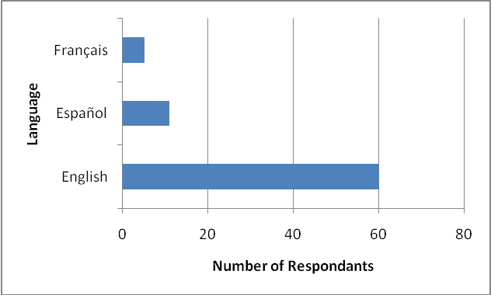
Figure 1: Language choice of the survey respondents
A total of 76 respondents started the survey, with 60 doing so in English, 11 in Spanish and 5 in French (Figure 1).
Respondents CBD Role
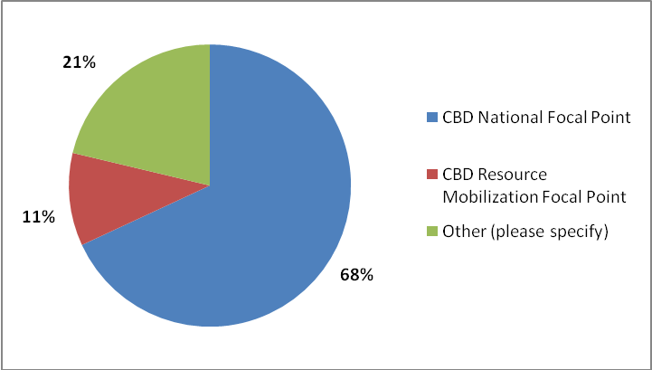
Figure 2: The CBD role(s) of the respondents (n=45)
A total of 45 respondents specified their role(s) in relation to the CBD (Figure 2). Of those who answered the question, 68% are CBD National Focal Points, whilst 11% are Resource Mobilization Focal Points. 22% of the respondents specified alternative roles including ‘observer’ and ‘biodiversity coordinator for CBD National Focal Point’
CBD National Reporting
78% of the 45 survey respondents specified that they were responsible for national reporting to the CBD (Figure 3). 13% were not responsible for reporting and 9% were unsure of their role in this regard.
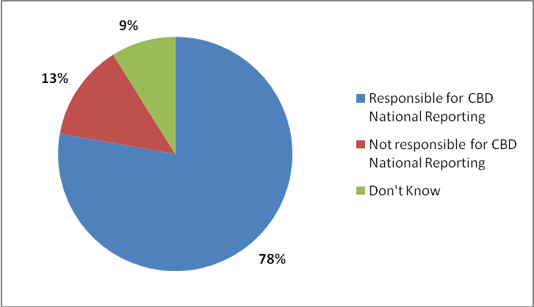
Figure 3: Roles of respondents regarding reporting to the CBD (n=45)
Reporting on the adopted resource mobilization indicators
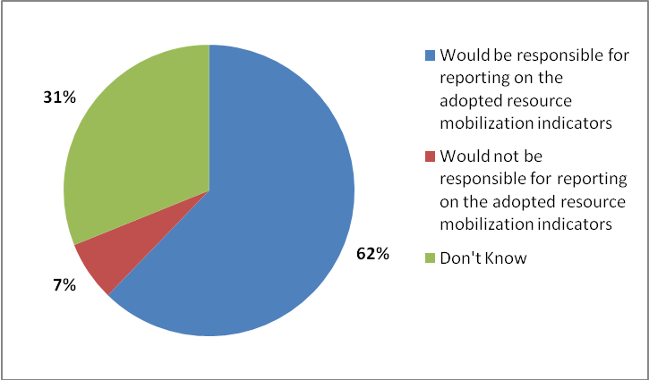
Figure 4: Envisioned roles of respondents in regards to reporting on the adopted
indicators for resource mobilization (n=45)

The respondents were asked what they thought their role would be in regard to future reporting on the adopted indicators (Figure 4). 62% of the survey respondents thought that they would be responsible for reporting on the adopted indicators. Seven percent thought they would not be responsible for indicator reporting and 31% were unsure of their future roles in relation to reporting on the adopted indicators.
Type of Institution
As expected, a significant percentage (91%) of survey respondents were representing government institutions (Figure 5), whilst there was one respondent participating for each of the remaining institution types, NGOs, commercial organizations, academic institutions and other.
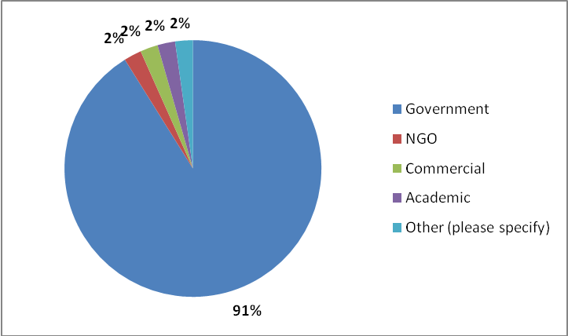
Figure 5: Type of institution represented by respondents (n=45)
Geographic Representation
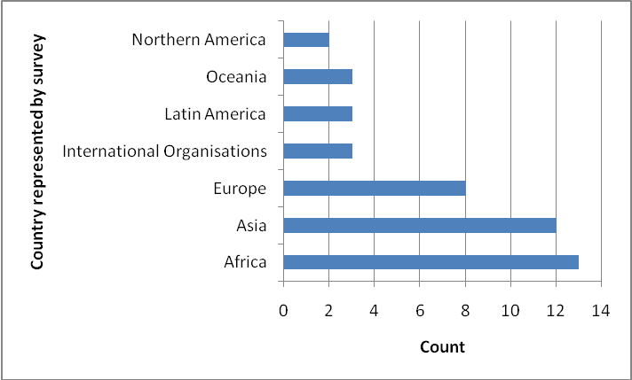
Figure 6: Geographical representation of survey respondents (n=43)

There was good geographic spread of the survey respondents (Figure 6). Asia and Africa both had the greatest representation with 12 and 13 respondents taking part in the survey respectively. Eight of the survey respondents were from Europe. There were three respondents (7%) representing Oceania, Latin America and International Organisations.
Analysis of CBD 4th National reports
An analysis of relevant national indicators in 4th national reports was conducted (http://www,cbd.int/reports)/. By March 2011, reports had been submitted to the Secretariat of the CBD by 159 (83%) of the 193 Parties. Each of the reports was reviewed to identify any indicators or references to indicators that relate to the adopted resource mobilization indicators or associated variables. These indicators were then assigned as far as possible to one of the indicators of the Strategy for Resource Mobilization. Reports in French, Spanish and Arabic were reviewed by speakers of these languages. Four reports in Russian and one in Thai were not able to be reviewed.
Review of existing global and regional indicators and monitoring and reporting systems
Global and regional indicators
Using the identified data fields a review was conducted to identify relevant indicators utilized at regional and global levels. Global indicators for the previous Strategic Plan were investigated to see if any are applicable to the adopted indicators or include underlying data that may be relevant. The same exercise was conducted for regional biodiversity indicators established under regional initiatives including the Streamlining European 2010 Biodiversity Indicators (SEBI2010) and NordBio for Nordic countries.
Monitoring and reporting systems
A review of existing resource mobilization monitoring and reporting systems was also undertaken to establish whether there are any existing processes which could provide data for reporting on the indicators. A desk study was completed to identify if such systems exist and those identified were followed up on through independent consultations with organization/agency focal points.
National case study reviews
National case studies were assembled for the UK, Brazil, Croatia and Tanzania. The countries were chosen to represent different regions and economy types. Consultations with national focal points were conducted remotely firstly through the use of a questionnaire, followed by a telephone interview. Questions centred on national data and monitoring systems which may provide data for the associated data fields, gaps in national data available and national capacities for reporting.
Review of similar processes for implementation indicator reporting
UNEP-WCMC is the executing agency for a Global Environmental facility (GEF) project entitled the Performance Review and Assessment of the Implementation System (PRAIS). The PRAIS project supports the United Nations Convention to Combat Desertification (UNCCD) and its Parties in collecting and collating national, sub-regional and regional data for the production of objective, quantifiable and comparable Performance Indicators, tracking and analysis of Financial Flows and dissemination of Best Practices on Sustainable Land Management. The experience and lessons learnt from the project in regard to developing resource mobilization indicators at global, regional and national levels were reviewed in order to assist with the identification of existing/parallel data sets and the process involved in reporting on the indicators.

3. RESULTS

A review of each of the adopted indicators was conducted and resulting indicator factsheets can be found in Appendix 3 of this report. Each indicator factsheet contains the following sections:
- Policy relevance/relation to the Strategy for Resource Mobilization
- Indicator Understanding (including indicator overlaps)
- Definitions and underlying concepts
- Considerations for data collection and indicator development
- Level of data collection
- Essential data fields and units
- Additional data fields for consideration
- Existing indicators
- National level data availability
- Possible data sources
- Feasibility of indicator production
This section provides an overview of the indicator review encompassed in the factsheets.

3.1 Linkages between the Indicators and the Strategy for Resource Mobilization

The resource mobilization indicators were adopted for monitoring the implementation of the Strategy for Resource Mobilization based on its mission and eight goals. Each of the adopted indicators has been reviewed to assess their relevance to the Strategy and specifically their relation to the eight goals (Table 1).
All eight goals of the strategy are covered by at least one of the adopted indicators. Goals 2, ‘Strengthen national capacity for resource utilization and mobilize domestic financial resources for the Convention’s three objectives’, and 3, ‘Strengthen existing financial institutions and, promote replication and scaling-up of successful financial mechanisms and instruments’ are both covered by three adopted indicators. Three of the adopted indicators (2, 4 and 5) relate to two strategy goals. It can be argued that all indicators which relate to specific goals relate to the mission of the strategy by default. However ,there were two indicators, 11 and 12, which did not directly relate to any of the goals of the resource mobilization strategy and instead linked more generally with the mission of the strategy to ‘substantially enhance international financial flows and domestic funding for biological diversity’.

Table 1: Relationship between the adopted indicators and the mission and goals of the Strategy for Resource Mobilization
ADOPTED INDICATORS
Aggregated financial flows | 1 |  | ✓
Country implementation | 2 |  | ✓ | ✓
Domestic Financial Support | 3 |  |  | ✓
GEF funding | 4 |  | ✓
CDB support to financial institutions | 5 |  |  |  | ✓ | ✓
International financial institutions | 6 |  |  |  | ✓
Integration in development Plans, etc | 7 |  |  |  |  |  | ✓
South-South cooperation initiatives | 8 |  |  |  |  |  |  | ✓
Technical cooperation & capacity building | 9 |  |  |  |  |  |  | ✓
Awareness raising for resource mobilization | 10 |  |  |  |  |  |  |  |  | ✓
Financial resources for the CBD objectives | 11 | ✓
Financial resources for the Strategic Plan | 12 | ✓
Removal of harmful incentives | 13 |  |  |  |  | ✓
Innovative Financial Mechanisms | 14 |  |  |  |  | ✓
Access & benefit sharing initiatives | 15 |  |  |  |  |  |  |  | ✓
 |  |  | 1 | 2 | 3 | 4 | 5 | 6 | 7 | 8 | RM GOAL
 |  | OVERALL MISSION | Improved Information | Strengthened National Capacity | Strengthened Financial Institutions | Innovative Financial Mechanisms | Mainstream biological diversity | South-South cooperation | Access & benefit sharing | Enhance Global Engagement

3.2 Indicator Overlap

A number of the adopted indicators have been found to overlap (). These overlaps can be separated into two categories:
- Direct overlap: The indicators overlap entirely in their design
- Indirect overlap: Certain measures or elements of the indicators overlap
The indicators which directly overlap in their design could be evaluated to identify the justification for their separation. If the indicators are found to overlap completely then special consideration should be taken to develop data collection templates that do not require reporting entities to report that same data multiple times. Careful consideration should also be taken when assigning targets to ensure that targets for overlapping indicators are compatible. In the case of indirect overlap, specific attention needs to be paid to data collection and the development of a system with closely considered data fields that reduce data collection or reporting burdens.
Table 2: Matrix of direct and indirect overlaps between the indicators adopted for implementation of the Strategy for Resource Mobilization. Note, the indicators 1 and 2 comprise sub-indicators and any overlap does not necessary correspond to all sub indicators
Aggregated financial flows | 1
Country implementation | 2 |  |  |  |  |  |  |  |  |  | Direct Overlap
Domestic Financial Support | 3 |  |  |  |  |  |  |  |  |  | Indirect Overlap
GEF funding | 4
CDB support to financial institutions | 5
International financial institutions | 6
Integration in development Plans, etc | 7
South-South cooperation initiatives | 8
Technical cooperation & capacity building | 9
Awareness raising for resource mobilization | 10
Financial resources for the CBD objectives | 11
Financial resources for the Strategic Plan | 12
Removal of harmful incentives | 13
Innovative Financial Mechanisms | 14
Access & benefit sharing initiatives | 15
 |  | 1 | 2 | 3 | 4 | 5 | 6 | 7 | 8 | 9 | 10 | 11 |  | 12 |  | 13 | 14 |  | 15
 |  | A Aggregated financial flows | Country implementation | Domestic Financial Support | GEF funding | CDB support to financial institutions | International Financial Institutions | Integration in development Plans, etc | South-South cooperation initiatives | Technical cooperation & capacity building | Awareness raising for resource mobilization | Financial resources for the CBD objectives |  | Financial resources for the Strategic Plan |  | Removal of harmful incentives | Innovative Financial Mechanisms |  | Access & benefit sharing initiatives
Direct overlaps
Indicators 1b and 3
Indicator 1(b): The amount and where relevant percentage, of biodiversity related funding, per annum, for achieving the Convention’s three objectives for the category: Domestic budgets at all levels
Indicator 3: Amount of domestic financial support, per annum, in respect of those domestic activities which are intended to achieve the objectives of this Convention

Although the wording of these indicators slightly differs, there are no clear differences between the two. Both are concerned with the biodiversity related funding in domestic budgets for achievement of the objectives of the Convention. The text for both indicators also stipulates the same time scale, with data for the indicator being provided on a per annum basis. It is recommended that these indicators are reviewed to see if it is necessary to include both or if there are possible differences between the two that these are made clear for the purpose of data collation.
Indicators 1(a, g, h, i) and 11
Indicator 1(a): The amount and where relevant percentage, of biodiversity related funding, per annum, for achieving the Convention’s three objectives for the category: Official development Assistance (ODA)
Indicator 1(g): The amount and where relevant percentage, of biodiversity related funding, per annum, for achieving the Convention’s three objectives for the category: Non-ODA public funding
Indicator 1(h): The amount and where relevant percentage, of biodiversity related funding, per annum, for achieving the Convention’s three objectives for the category: South-South cooperation initiatives
Indicator 1(i): The amount and where relevant percentage, of biodiversity related funding, per annum, for achieving the Convention’s three objectives for the category: Technical cooperation
Indicator 11: Amount of financial support from all sources from developed countries to developing countries to contribute to achieving the Convention’s objectives

Indicator 11 is a measure of the total amount of financial support from all sources from developed countries to developing countries to contribute to achieving the Convention’s objectives. Indicator 1 through aggregation of its components/sub indicators is a measure of the total financial flows for achieving the Convention’s three objectives. It is therefore difficult to clarify the difference between the aggregation of indicator 1’s components/sub indicators (a, g, h, i) relating to the transfer of financial support from developing to developed countries and indicator 11.
The CBD may wish to review these indicators and see if there is a need for indicator 11, or whether the aggregation of sub indicators 1(a), 1(g), 1(h) and 1(i) serves the same function. One possible reason for existence (separation) of indicator 11 may be the importance of being able to monitor the total funding from developed to developing countries, a perspective which may be lost from the interpretation of indicator 1 with its many sub indicators.
Indicators 11 and 12
Indicator 11: Amount of financial resources from all sources from developed countries to developing countries to contribute to achieving the Convention’s objectives
Indicator 12: Amount of financial resources from all sources from developed countries to developing countries towards implementation of the Strategic Plan for Biodiversity 2011-2020

The distinction between indicators 11 and 12 is not entirely transparent. The Strategic Plan for Biodiversity 2011-2020is considered as the overarching framework for the CBD and therefore any funding towards the implementation of the Strategic Plan for Biodiversity can automatically be argued to contribute to the achievement of the Convention’s objectives. A possible distinction between the two indicators may lie in the fact that the new Strategic Plan for Biodiversity 2011-2020 is to be considered as a framework on biodiversity, implemented not least through partnerships with programmes, funds and specialized agencies of the United Nations system as well as with other conventions, agencies and organizations. The justification for the separation of these indicators may therefore be that indicator 12 will incorporate financial resources for activities undertaken by other UN agencies, MEAs and relevant organizations that respond to one or more of the Aichi targets. If this is the reason for differentiation between the indicators, then there may be considerable implications for data reporting/collection for indicator 12. If country party level reporting is used for this indicator then it is likely that this reporting will fall to national CBD focal points or resource mobilization focal points. These focal points may not have involvement with other MEAs, agencies or organizations and as such reporting on activities towards implementation of the Strategic Plan for Biodiversity under other MEAs may result in technical and capacity challenges
It is recommended that these indicators are reviewed to ascertain the reason for their separation. If this separation is due to the broadening of the Strategic Plan for Biodiversity 2011-2020 to outside of the Convention, then the associated reporting and data collection issues need to be considered. As mentioned above there is also overlap between the aggregation of sub indicators 1(a), 1(g) and 1(i) and indicator 11. If it was found that there is no need for indicator 11, then this may have further implications regarding indicator 12 and whether it will also need to be removed from the indicator list. However, if the justification for indicator 12 is that it incorporates funding towards the Strategic Plan from organisations, etc outside the CBD then indicator 12 could be kept separate aggregating the data from indicators 1(a), 1(g) and 1(i) and combining this with addition data collected for activities undertaken by other UN agencies, MEAs and relevant organizations.
Indirect Overlaps
Indicators 1(h), 1(i), 8 and 9
Indicator 1(h): The amount and where relevant percentage, of biodiversity related funding, per annum, for achieving the Convention’s three objectives for the category: South-south cooperation initiatives
Indicator 1(i): The amount and where relevant percentage, of biodiversity related funding, per annum, for achieving the Convention’s three objectives for the category: Technical cooperation
Indicator 8: Number of South-South cooperation initiatives conducted by developing country Parties and those that may be supported by other Parties and relevant partners, as a complement to necessary North-South cooperation
Indicator 9: Amount and number of South-South and North-South technical cooperation and capacity building initiatives.

There are indirect overlaps between indicators 1(h) and 8. Indicator 1(h) deals with the financial investment in South-South cooperation initiatives whilst indicator 8 is concerned purely with the number of South-South cooperation initiatives. There are also indirect overlaps with indicator 1(i) which deals with the financial investment in technological cooperation and indicator 9 which looks at the number of technical cooperation activities.
There are indirect overlaps between indicators 8 and 9. Indicator 9 is a combined count of the number of South-South and North-South technical cooperation and capacity-building initiatives whilst indicator 8 is a count of the number of South-South cooperation initiatives.
It is likely that all four indicators will collect data through national reporting. Through the use of well structured reporting it may be possible to use one set of data fields for country Parties to populate all four indicators. In order to do so reporting would need to be undertaken at the initiative level (benefits of this approach have also been discussed in Section 3.7. For example the following fields could be used:
Fields for reporting at the initiative level

South-South & North-South Cooperation Initiatives
a) Name of initiative:
b) Date Established:
c) Country providing resources:
d) Country receiving resources:
e) Financial value of investment in cooperation initiative (monetary value):
f) Type of exchange: resources/technology/knowledge/financial
g) Description of initiative: technical cooperation/capacity building/other (please specify)

The sum of all the financial values (field e) for all South –South reported initiatives could be used to populate indicator 1(h). The number of all South-South initiatives reported could be used for indicator 8. The use of field g would enable all technical cooperation and capacity building initiatives to be separated out and counted for the production of indicator 9. Field g would also enable just technical cooperation activities to be separated out and their financial values (field e) to be summed for indicator 1(i).

A number of additional fields have also been included in the suggested example above, which are not specifically necessary for the indicator production. As discussed further in Section 3.7 , the collection of supplementary information can greatly enhance indicator interpretation. For example field’s c and d enable the flow of resources to be monitored, whilst field b could possibly enable the first round of reporting to produce a temporal baseline.

3.3 Level of data collection for global indicator production

It is clear from the review of the indicators that the level of data collection needed for the production of the global indicators varies (Table 3). The majority of indicators relate to resource mobilization activities and financial commitments at a government level and therefore data collection for these indicators needs to occur at the national level and be aggregated for the production of the indicators at global (and regional) levels. Existing global data sets can be used for these indicators providing the underlying data has been collected at the national level. The indicators which rely on national data are scalable and can be aggregated not only to produce the global indicator but to produce regional disaggregations.
Four individual indicators and two of the sub indicators within indicator 1 can only be produced at the global level using global data. There are two reasons for this:
- The resources which this indicator monitors are provided by organizations/institutions/foundations/private sector/etc and therefore cannot be accredited to a specific country (Indicators 1(c), 1(d), 1(e), 1(f) and 4)
- The resource mobilization activity with which the indicator is concerned can only occur at the global level (Indicators 5, 6, 7). For example indicator 5 could be measured as the number of intergovernmental decisions which support financial institutions and this action can therefore only occur at the global level.
ADOPTED INDICATORS |  | National Data forms global indicator | Indicator will combine both national and global data for global indicator | Global Indicator Only
Aggregated financial flows | 1 |  | ✓
Official Development Assistance | (a) | ✓
Domestic Budgets | (b) | ✓
Private Sector | (c) | ✓ |  | ✓
NGOs, foundations and academia | (d) | ✓ |  | ✓
International Financial Institutions | (e) |  |  | ✓
United Nations Organizations, funds, etc | (f) |  |  | ✓
Non-ODA public funding | (g) | ✓
South-South cooperation initiatives | (h) | ✓
Technical cooperation | (i) | ✓
Country implementation | 2 | ✓
Assessed values of biodiversity | (a) | ✓
Identified funding needs, gaps, etc | (b) | ✓
National financial plans | (c) | ✓
Level of funding and capacity building | (d) | ✓
Domestic Financial Support | 3 | ✓
GEF funding | 4 |  |  | ✓
CBD support to financial institutions | 5 |  |  | ✓
International financial institutions | 6 |  |  | ✓
Integration in development Plans, etc | 7 | ✓
South-South cooperation initiatives | 8 | ✓
Technical cooperation & capacity building | 9 | ✓
Awareness raising for resource mobilization | 10 |  |  | ✓
Financial resources for the CBD objectives | 11 | ✓
Financial resources for the Strategic Plan | 12 | ✓
Removal of harmful incentives | 13 | ✓
Innovative Financial Mechanisms | 14 |  | ✓
Access & benefit sharing initiatives | 15 |  | ✓
Two of the indicators (14 and 15) and two sub indicators (1(c) and 1(d)) will rely on data collected at both the national and global scale. This is because a range of entities from national governments to international organizations can invest in the activities which these indicators monitor. Indicator 1 is unique in that it will aggregate sub indicators which vary in the level of data they require for individual production.
Table 3: The level of data needed for production of the global indicators

3.4 Existing data sets

A brief review of existing global and regional data sets was conducted for each of the indicators (see indicator factsheets, Appendix 3). A summary of the available data sets is provided in Table 4.
Many of the adopted indicators are reliant on specific national level data (Table 4) and therefore regional and global data sets do not exist. Where relevant global data sets do exist there are often limitations or caveats associated with them. However, there are a number of internationally recognised data sets which could be used for the production of the following indicators:
- 1(a) Aggregated financial flows: Official Development Assistance (OECD ODA Database)
- 1(b) Aggregated financial flows: Domestic budgets at all levels (IMF Government Statistics)
- 3 Domestic Budgets (IMF Government Statistics)
- 4 GEF Funding (GEF Reports to COP)
Although the identified data sources for these indicators are internationally recognised there are still limitations with their use. For example, the OECD ODA database only contains data on biodiversity related funding for its members (23 donor governments and the European Commission) and this may be considered insufficient for the production of indicator 1(a). As discussed in Section 5.1, the UNCCD collects ODA data for all national Parties through the use of an indicator reporting system. The AidData repository, a partnership between Brigham Yound University, the College of William and Mary and Development Gateway, may also be used for the production of Indicator 1(a), however this database would require further investigation and has not previously been used in CBD reports.
Even though a number of existing datasets may not be sufficient for indicator production and a regular reporting approach is likely to be favoured, reporting entities should be made aware of these data sources in the event that they can provide data and help reduce reporting burden.

Table 4: Summary of existing data sets for the adopted indicators
Indicator |  | Existing data sets that may be used for indicator production
No | Name | Global | Regional
1(a) | Aggregated financial flows: Official Development Assistance | OECD ODA Database  The OECD DAC has collected biodiversity related ODA data (via its Creditor Reporting System) from 1998 using the ‘Rio marker’ for biodiversity. Data is collected from member countries. When assigning the ‘Rio marker’ donors use the scoring system: 0 = Not targeted, 1=Significant objective, 2 = Principal objective. Donors are also required to report qualitative information such as the sector the activity is targeting and this can be used to further analyse the financial flows.  Limitations: Data is only collected for the DAC’s 24 members: 23 donor governments and the European Commission. Activities can target the objectives of the three Rio Conventions at the same time and difficulties exist in trying to accurately extract the proportion/ true financial values spent on biodiversity related activities.  AidData  A repository of development finance activities, including data from OECD’s Creditor Reporting System and other sources including annual reports and project documents and online databases.  Limitations: Data may not be available for all CBD parties or entities providing ODA. | EU Monterrey Survey  An annual questionnaire on Financing for Development which covers all EU commitments related to the international financing for development agenda, and contains some questions on biodiversity financing. It provided the basis for the annual EU accountability reports on Financing for Development.
1(b) | Aggregated financial flows: Domestic budgets at all levels | IMF Government Statistics (GFS)  International Financial Statistics (IFS) is the International Monetary Fund’s principal statistical publication and is the standard source for all aspects of international and domestic finance. Time series data are reported for most countries.  Limitations: Not all countries are incorporated | EU Environmental Protection Expenditure, Eurostat  Eurostat collects environmental statistics for all economic sectors within the EU. Data on environmental expenditure are collected through a joint OECD/Eurostat questionnaire on environmental protection expenditure and revenues (EPER). Data are collected for four economic sectors namely the public sector, industry, private and public specialised producers and households. The data can be disaggregated between nine domains according to the classification of environmental protection activities (CEPA 2000). One domain, the protection of biodiversity and landscape, specifically relates to activities to conserve biodiversity.  EU Life Project  One of its three strands, LIFE-Nature, is designed to contribute to the implementation of community nature protection legislation.  Limitations: LIFE-nature project does not target biodiversity conservation directly, but many projects have benefits for biodiversity
1(c) | Aggregated financial flows: Private sector | AidData  Aims in the future to cover private flows such as those originating from private foundations  Limitations: data not yet available | EU Environmental Protection Expenditure, Eurostat  Eurostat collects environmental statistics for all economic sectors within the EU. Data on environmental expenditure are collected through a joint OECD/Eurostat questionnaire on environmental protection expenditure and revenues (EPER). Data are collected for four economic sectors namely the public sector, industry, private and public specialised producers and households. The data can be disaggregated between nine domains according to the classification of environmental protection activities (CEPA 2000). One domain, the protection of biodiversity and landscape, specifically relates to activities to conserve biodiversity.
1(d) | Aggregated financial flows: Non-governmental organizations, foundations and | AidData  Aims in the future to cover private flows such as those originating from NGOs  Limitations: Data not yet available
1(e) | Aggregated Financial Flows: International Financial Institutions | OECD ODA Database  The OECD DAC has collected biodiversity related ODA data (via its Creditor Reporting System) from 1998 using the ‘Rio marker’ for biodiversity. As well as being collected from member countries biodiversity related ODA is also collected from multilateral agencies such as the World Bank, regional banks and UN agencies  Limitations: IFI’s are just starting to use the markers and at present we are unsure of how many IFIs report on the Rio markers.
1(f) | Aggregated financial flows: UN organizations, funds, etc | OECD ODA Database  The OECD DAC has collected biodiversity related ODA data (via its Creditor Reporting System) from 1998 using the ‘Rio marker’ for biodiversity. As well as being collected from member countries biodiversity related ODA is also collected from multilateral agencies such as the World Bank, regional banks and UN agencies  Limitations: UN organizations, agencies, etc are just starting to use the markers and at present we are unsure of how many report on the Rio markers.
1(i) | Aggregated financial flows: Technical cooperation |  | EULife Project  One of its three strands, LIFE-Third Countries, is designed to contribute the establishment of capacities and administrative structures needed in the environment sectors and in the development of environment policy and action programmes, this includes technical assistance projects. to the implementation of community nature protection legislation.  Limitations: LIFE-nature project does not target biodiversity conservation directly, but many projects have benefits for biodiversity
3 | Domestic budgets | IMF Government Statistics (GFS)  International Financial Statistics (IFS) is the International Monetary Fund’s principal statistical publication and is the standard source for all aspects of international and domestic finance. Time series data are reported for most countries.  Limitations: Not all countries are incorporated | EU Environmental Protection Expenditure, Eurostat  Eurostat collects environmental statistics for all economic sectors within the EU. Data on environmental expenditure are collected through a joint OECD/Eurostat questionnaire on environmental protection expenditure and revenues (EPER). Data are collected for four economic sectors namely the public sector, industry, private and public specialised producers and households. The data can be disaggregated between nine domains according to the classification of environmental protection activities (CEPA 2000). One domain, the protection of biodiversity and landscape, specifically relates to activities to conserve biodiversity.  EU Life Project  One of its three strands, LIFE-Nature, is designed to contribute to the implementation of community nature protection legislation.  Limitations: LIFE-nature project does not target biodiversity conservation directly, but many projects have benefits for biodiversity
4 | GEF Funding | GEF  The GEF provides a report on its activities related to biological diversity at every meeting of the Conference to the Parties.
6 | International financial institutions | OECD ODA Database  The ODA database could be utilized to extract the number of institutions, organizations, funds, programmes and development agencies that report on biodiversity related aid.
13 | Removal of harmful incentives | A range of global and regional data bases exist for different subsidy sectors. However, there are a range of limitations in the use of these databases for this indicator (see factsheet for this indicator)
14 | Innovative financial Mechanism | OECD DAC Database  ODA flows which relate to both Biodiversity and Climate change objectives could be used for this indicator for the IFM, Biodiversity in Climate change finance.  Limitations: There are many caveats surrounding how the proportion relating to both biodiversity financing within climate change projects will be defined.  Six IFMS categories have been adopted by the CBD, this data set could be used for only one category.

3.5 Existing Indicators

A review of existing resource mobilization indicators at the global, regional and national level was undertaken to establish if any relate to the adopted indicators.
Global
Official Development Assistance in support of the CBD
At its meeting in 2004, CBD COP 7 adopted a framework which recommended the use of a range of biodiversity indicators (Decision VII/30). The Biodiversity Indicator Partnership was later established (Decision VIII/15) to develop and promote the indicator framework. The framework of indicators included the headline indicator ‘Official Development Assistance provided in support of the Convention on Biological Diversity’. This was the sole indicator under the Focal Area ‘Status of resource transfers’.
The indicator measures aid contributions via the Development Assistance Committee (DAC) of OECD. The DAC is an international forum of 24 members: 23 donor governments and the European Commission (OECD 2010). The DAC collects aid data from its members, and also from other donors (non-DAC countries and multilateral agencies such as the World Bank, regional development banks, UN agencies). Annual aid reporting takes place using the Creditor Reporting System (CRS), and donors are requested to indicate for each activity whether or not it targets one or more of the three Rio Conventions. This indicator is only concerned with data collected under the ‘Rio marker’ for biodiversity. For an activity to be labelled with this ‘Rio marker’ it must promote one of the three objectives of the CBD: the conservation of biodiversity, sustainable use of its components, or fair and equitable sharing of the benefits of the utilisation of genetic resources. When assigning the ‘Rio markers’ donors use the scoring system: 0 = Not targeted, 1 = Significant objective, 2 = Principal objective. Donors are also asked to report on the sectoral breakdown of activities.
The DAC has collected ‘Rio marker’ data from 1998 onwards: data for years 1998-2006 were obtained on a trial basis, and reporting became mandatory starting with 2007 flows. The data included some gaps, inconsistencies and partial reporting, but the coverage improved regularly. For 2008 data, only Luxembourg, Norway and the United States did not report on the biodiversity marker.
This global indicator specifically relates to adopted indicator 1(a), which in turn indirectly overlaps with indicators 11 and 12.
Further information regarding this indicator can be found on the Biodiversity Indicator Partnership Website: www.bipindicators.net/oda
Regional
The Streamlining European 2010 Biodiversity Indicators (SEBI2010) initiative includes an indicator entitled ‘Financing biodiversity management’. This indicator, developed to answer the policy question ‘How much public funds are being committed to conservation of biodiversity?’, contains information for EU funding of projects using the LIFE financial instrument for the environment (EEA 2009a; 2009b). This indicator deals with the EU contribution (from the LIFE Programme) to the projects, not the total cost of the projects. LIFE tends to cover 50—75% of total costs, depending on the target species and/or habitats. Private or national government spending is not covered by this indicator. This indicator is specifically related to adopted indicators 1(b) and 3.
National
A review of resource mobilization indicators listed in forth national reports to the CBD was conducted to establish if any existing national indicators relate to the adopted indicators. The results of this analysis are presented in Figure 7. The resource mobilization indicators reported by CBD Parties only related to indicators 1(a), 1(b), 3 and 15.
Sixteen CBD Parties reported the use of national Official Development Assistance indicators, which may be related to adopted indicator 1(a) in their 4th national reports to the CBD. Six countries, Australia, Ecuador, Germany, Guatemala, Russian Federation and Samoa, reported ODA related indicators with evidence of their use through the presentation of indicator results. It is important to note that these indicators are not all a measure of ODA provided and in the case of Ecuador and Guatemala these indicators are a measure of the ODA received.
Nine countries reported the use of national biodiversity indicators related to domestic biodiversity and environment allocation in their 4th national reports. These indicators may possibly relate to adopted indicators 1(b) and 3 with monitor domestic budgets at all levels. Five of these countries provided evidence of the indicators use.
Four countries reported the use of evidenced indicators (indicators reported with figures or results) relating to the fair and equitable sharing of benefits arising out of the use of genetic resources in their 4th national reports. These indicators may relate to adopted indicator 15, however it is important to note that indicator 15 monitors the number of access and benefit sharing initiatives whilst a few of the reported indicators deal with implementation issues such as the number of patents granted.
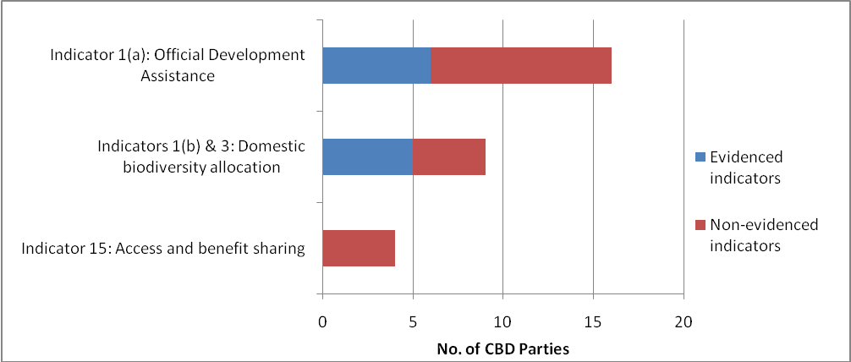
Figure 7: Number of CBD Parties reporting indicators in 4th national reports which relate to the adopted resource mobilization indicators

3.6 Reporting entities

The use of a reporting system may be considered for the collection of data for the adopted indicators. As discussed in Section 3.3, the majority of the indicators focus on government level financial commitments and activities and data therefore needs to be collected at the national level.
 |  | CBD National Parties |  | Other Reporting Entities
ADOPTED INDICATORS |  | Developed Country Parties | Developing Country Parties | Private Corporations | NGOs, foundations & academia | International Financial Institutions | UN organizations, foundations & programmes, IGOs | CBD Secretariat (& other MEAs)
Aggregated financial flows | 1
Official Development Assistance | (a) | ✓ | ✓
Domestic Budgets | (b) | ✓ | ✓
Private Sector | (c) |  |  | ✓
NGOs, foundations and academia | (d) |  |  |  | ✓
International Financial Institutions | (e) |  |  |  |  | ✓
United Nations Organizations, funds, etc | (f) |  |  |  |  |  | ✓
Non-ODA public funding | (g) | ✓ | ✓
South-South cooperation initiatives | (h) | ✓ | ✓
Technical cooperation | (i) | ✓ | ✓
Country implementation | 2
Assessed values of biodiversity | (a) | ✓ | ✓
Identified funding needs, gaps, etc | (b) | ✓ | ✓
National financial plans | (c) | ✓ | ✓
Level of funding and capacity building | (d) | ✓ | ✓
Domestic Financial Support | 3 | ✓ | ✓
GEF funding | 4 |  |  |  |  | ✓ (GEF Only)
CDB support to financial institutions | 5 |  |  |  |  |  |  | ✓ (CBD Only)
International financial institutions | 6 |  |  |  |  |  | ✓ (OECD Only)
Integration in development Plans, etc | 7 | ✓ | ✓
South-South cooperation initiatives | 8 |  | ✓
Technical cooperation & capacity building | 9 | ✓ | ✓
Awareness raising for resource mobilization | 10 |  |  | ✓ | ✓ | ✓ | ✓ | ✓
Financial resources for the CBD objectives | 11 | ✓
Financial resources for the Strategic Plan | 12 | ✓
Removal of harmful incentives | 13 | ✓ | ✓
Innovative Financial Mechanisms | 14 | ✓ | ✓ | ✓ | ✓ | ✓ | ✓ | ✓
Access & benefit sharing initiatives | 15 | ✓ | ✓ | ✓ | ✓ | ✓ | ✓ | ✓
Table 5: Reporting entities for the adopted indicators
A reporting system would enable the collection of this data which is often kept within government databases and not available through other means such as international data sets.
Although global sets do exist for some of the adopted indicators it may be beneficial for the organizations responsible for the management for these data sets to report on the applicable indicators. This would ensure data for the indicators is collected in a standard format and reduce problems associated with combining data collected at different scales.
The different entities that would be responsible for reporting on the adopted indicators is shown in Table 5. Developed and developing country Parties would be required to provide data for 10 and 9 of the adopted indicators respectively. Indicators 11 and 12 are only applicable for developed country Parties as they monitor all financial flows from developed to developing countries. To ask developing Parties as recipients to report on these indicators may lead to double counting. Indicator 8 is only applicable for reporting by developing country Parties as it monitors the number of south-south initiatives. Whilst developed country Parties could report on this indicator if they provide financial resources for these initiatives, this again may lead to double counting. All national Parties would be required to provide data for two of the sub indicators/components under indicator 1 and all sub indicators under indicator 2.
Sub indicators 1(c) - 1(f) refer to specific organizations/agency types and as such these named entities are applicable for reporting against these indicators.
Indicators 4, 5 and 6 are only applicable for reporting on by the GEF, CBD Secretariat and OECD respectively, as these organizations hold the data with which these indicators are concerned.
Indicator 10 is applicable to all reporting parties with the exception of national parties as any of these organization/agency types may undertake activities to raise awareness of the need for resource mobilization. Indicators 14 and 15 are applicable to all reporting entities as they are concerned with the number of Innovative Financial Mechanisms and Access &Benefit Sharing initiatives, respectively. Any of the reporting entities could support the development of these activities.
The lessons learnt and experiences from an indicator reporting system utilised by the UN Convention to Combat Desertification (UNCCD) are provided in Section5.1. The Performance indicators for which the system was established share a number of similarities with the adopted indicators for resource mobilization under the CBD, including the fact that different indicators were applicable for reporting on by different entities.

3.7 Data Fields for data collection and indicator reporting

For each of the indicators the core data fields for indicator reporting at the simplest level were identified (Table and7). There are 17 individual data fields for developed country parties and 16 data fields for developing countries. Five of the data fields applicable for both developed and developing country parties take the form of questions. Data collection for indicators 2 and 7 with which these fields are associated could be undertaken with the use of a questionnaire.
Table 6: The data fields for indicator reporting by CBD national parties and the CBD Secretariat
Indicator |  | Reporting Entity
No | Name | CBD Parties |  | CBD Secretariat (& other MEAs)
No | Name | Developed Country Parties | Developing Country parties | CBD Secretariat (& other MEAs)
1 | Aggregated financial flows, in the amount and where relevant percentage, of biodiversity-related funding, per annum, for achieving the Convention's three objectives, in a manner that avoids double counting, both in total and in inter alia, the following categories:  (a) Official Development Assistance (ODA);  (b) Domestic budgets at all levels;  (c) Private sector;  (d) Non-governmental organizations, foundations, and academia;  (e)International financial institutions;  (f) United Nations organizations, funds and programmes;  (g) Non-ODA public funding;  (h)South-South cooperation initiatives;  (I) Technical cooperation; | - Official Development Assistance in support of the convention (Total monetary value and/or as a percent of total national ODA)  - Biodiversity related allocation in domestic budgets at all levels (Total monetary value and/or as a percent of total domestic budget)  - Non-ODA public biodiversity related funding (Total monetary value & as percentage of total non-ODA public funding)  - Financial contributions to enhancing technical cooperation (Total monetary value)  - Financial contribution to south-south cooperation initiatives (Total monetary value) | - Official Development Assistance in support of the convention (Total monetary value and/or as a percent of total national ODA)  - Biodiversity related allocation in domestic budgets at all levels (Total monetary value and/or as a percent of total domestic budget)  - Non-ODA public biodiversity related funding (Total monetary value & as percentage of total non-ODA public funding)  - Financial contributions to enhancing technical cooperation (Total monetary value)  - Financial contribution to south-south cooperation initiatives (Total monetary value)
2 | Number of countries that have:  (a) Assessed values of biodiversity, in accordance with the Convention  (b) Identified and reported funding needs, gaps and priorities  (c) Developed national financial plans for biodiversity  d) Been provided with the necessary funding and capacity building to undertake the above activities | - Has your country assessed the values of biodiversity in accordance with the Convention? (YES/NO)  - Has your country identified and reported funding needs, gaps and priorities? (YES/NO)  - Has your country developed national financial plans for biodiversity? (YES/NO)  - Has your country been provided with necessary funding and capacity building to undertake the above activities? (YES/NO) | - Has your country assessed the values of biodiversity in accordance with the Convention? (YES/NO)  - Has your country identified and reported funding needs, gaps and priorities? (YES/NO)  - Has your country developed national financial plans for biodiversity? (YES/NO)  - Has your country been provided with necessary funding and capacity building to undertake the above activities? (YES/NO)
3 | Amount of domestic financial support, per annum, in respect of those domestic activities which are intended to achieve the objectives of this Convention | Duplicated field from indicator 1:  - Biodiversity related allocation in national domestic budgets (Total monetary value and/or as a percent of total domestic budget) | Duplicated field from indicator 1:  - Biodiversity related allocation in national domestic budgets (Total monetary value and/or as a percent of total domestic budget)
4 | Amount of funding provided through the Global Environment Facility and allocated to the biodiversity focal area
5 | Level of CBD and Parties' support to other financial institutions that promote replication and scaling-up of relevant successful financial mechanisms and instruments |  |  | - Number of decisions which promote scaling up of relevant financial mechanisms and instruments
6 | Number of international financing institutions, United nations organizations, funds and programmes, and the development agencies that report to the Development Assistance Committee of the Organization of Organization for Economic Co-operation and Development (OECD/DAC), with biodiversity and associated ecosystem services as a cross-cutting policy
7 | Number of Parties that integrate considerations on biological diversity and its associated ecosystem services in development plans, strategies and budgets | - Has your country integrated considerations on biological diversity and its associated ecosystem services in development plans, strategies and budgets? (YES/NO) | - Has your country integrated considerations on biological diversity and its associated ecosystem services in development plans, strategies and budgets? (YES/NO)
8 | Number of South-south cooperation initiatives conducted by developing country Parties and those that may be supported by other Parties and relevant partners, as a necessary complement to necessary North-South cooperation |  | - The number of South-South cooperation initiatives with which your country is involved, including any which may be supported by developed countries as a complement to North-south cooperation (number)
9 | Amount and number of South-South and North-South technical cooperation and capacity building initiatives that support biodiversity | - The number and amount of North-South technical cooperation and capacity building initiatives that support biodiversity with which your country is involved (number) | - The number and amount of South-South technical cooperation and capacity building initiatives that support biodiversity with which your country is involved (number)
10 | Number of global initiatives that heighten awareness on the need for resource mobilization for biodiversity |  |  | - The number of global awareness raising activities undertaken
11 | Amount of financial resources from all sources from developed countries to developing countries to contribute to achieving the Conventions objectives | - Total financial resources transferred to developing countries for achievement of the Conventions’ objectives (monetary value)
12 | Amount of financial resources from all sources from developed countries to developing countries towards implementation of the Strategic Plan for Biodiversity 2011-2020 | - Total financial resources transferred to developing countries for achievement of the Strategic Plan for Biodiversity (monetary value)
13 | Resources mobilized from the removal, reform or phase-out of incentives, including subsidies, harmful to biodiversity, which could be used for the promotion or positive incentives, including but not limited to innovative financial mechanisms, that are consistent and in harmony with the Convention and other international obligations, taking into account national social and economic conditions | - Total amount of resources that are removed from existing government subsidies and used to subsidize biodiversity objectives (monetary value) | - Total amount of resources that are removed from existing government subsidies and used to subsidize biodiversity objectives (monetary value)
14 | Number of initiatives, and respective amounts, supplementary to the financial mechanism established under Article 21, that engage Parties and relevant organizations in new and innovative financial mechanisms, which consider intrinsic values and all other values of biodiversity, in accordance with the objectives of the Convention and the Nagoya Protocol on Access to Genetic Resources and the Fair and Equitable Sharing of benefits Arising out of their Utilization | - The total number of initiatives on new and innovative financial mechanisms (number)  - The amount invested in initiatives on new and innovative financial mechanisms (total monetary value) | - The total number of initiatives on new and innovative financial mechanisms (number)  - The amount invested in initiatives on new and innovative financial mechanisms (total monetary value)
15 | Number of access and benefit sharing initiatives and mechanisms, consistent with the Convention and , when in effect, with the Nagoya Protocol on Access to Genetic Resources and the Fair and Equitable Sharing of the Benefits Arising out of their Utilization, including awareness-raising, that enhances resource mobilization | - The number of access and benefit sharing initiatives and mechanisms which are consistent with the Nagoya Protocol on ABS (number) | - The number of access and benefit sharing initiatives and mechanisms which are consistent with the Nagoya Protocol on ABS (number)

Table 7: The data fields for indicator reporting by private corporations, NGOS, foundations, academia, International Financial Institutions, IGOS, and United Nations organizations
Indicator |  | Reporting Entity
No | Name | Private Corporations | NGOs, foundations and academia | International Financial Institutions | United Nations organizations, foundations and programmes, IGOs
1 | Aggregated financial flows, in the amount and where relevant percentage, of biodiversity-related funding, per annum, for achieving the Convention's three objectives, in a manner that avoids double counting, both in total and in inter alia, the following categories:  (a) Official Development Assistance (ODA);  (b) Domestic budgets at all levels;  (c) Private sector;  (d) Non-governmental organizations, foundations, and academia;  (e)International financial institutions;  (f) United Nations organizations, funds and programmes;  (g) Non-ODA public funding;  (h)South-South cooperation initiatives;  (I) Technical cooperation; | - Total amount of biodiversity-related funding (monetary value) | - Total amount of biodiversity-related funding (monetary value) | - Total amount of biodiversity-related funding (monetary value) | - Total amount of biodiversity-related funding (monetary value)
4 | Amount of funding provided through the Global Environment Facility and allocated to the biodiversity focal area |  |  | For GEF only:  - Biodiversity focal area allocation per funding cycle (monetary value)
6 | Number of international financing institutions, United nations organizations, funds and programmes, and the development agencies that report to the Development Assistance Committee of the Organization of Organization for Economic Co-operation and Development (OECD/DAC), with biodiversity and associated ecosystem services as a cross-cutting policy |  |  |  | For OECD only:  - The total number of defined institutions that report to OECD/DAC with biodiversity and associated ecosystem services as a cross-cutting policy
10 | Number of global initiatives that heighten awareness on the need for resource mobilization for biodiversity | - The number of global awareness raising activities | - The number of global awareness raising activities | - The number of global awareness raising activities | - The number of global awareness raising activities
14 | Number of initiatives, and respective amounts, supplementary to the financial mechanism established under Article 21, that engage Parties and relevant organizations in new and innovative financial mechanisms, which consider intrinsic values and all other values of biodiversity, in accordance with the objectives of the Convention and the Nagoya Protocol on Access to Genetic Resources and the Fair and Equitable Sharing of benefits Arising out of their Utilization | - The total Number of initiatives on new and innovative financial mechanisms (number)  - The amount invested in initiatives on new and innovative financial mechanisms (total monetary value) | - The total Number of initiatives on new and innovative financial mechanisms (number)  - The amount invested in initiatives on new and innovative financial mechanisms (total monetary value) | - The total Number of initiatives on new and innovative financial mechanisms (number)  - The amount invested in initiatives on new and innovative financial mechanisms (total monetary value) | - The total Number of initiatives on new and innovative financial mechanisms (number)  - The amount invested in initiatives on new and innovative financial mechanisms (total monetary value)
15 | Number of access and benefit sharing initiatives and mechanisms, consistent with the Convention and , when in effect, with the Nagoya Protocol on Access to Genetic Resources and the Fair and Equitable Sharing of the Benefits Arising out of their Utilization, including awareness-raising, that enhances resource mobilization | - The number of access and benefit sharing initiatives and mechanisms which are consistent with the Nagoya Protocol on ABS (number) | - The number of access and benefit sharing initiatives and mechanisms which are consistent with the Nagoya Protocol on ABS (number) | - The number of access and benefit sharing initiatives and mechanisms which are consistent with the Nagoya Protocol on ABS (number) | - The number of access and benefit sharing initiatives and mechanisms which are consistent with the Nagoya Protocol on ABS (number)

Due to direct overlap between indicators 1(b) and 3 (see Section 3.2) the same data field can be used for the collection of data for both indicators.
The data fields in Table 6and 7represent the simplest fields for collection of the data necessary for all 15 adopted indicators. However, it is evident from the review of the indicators (see indicator factsheets, Appendix 3) that these data fields can be expanded with the addition of extra fields or response categories for a number of purposes including the improvement of information available for indicator interpretation.
Enabling Greater Interpretation of National Implementation: Additional Response Categories for Question Type Data Fields
Indicator 7 and sub indicators 2(a), 2(b), 2(c) and 2(d) are all concerned with the number of countries implementing different aspects of resource mobilization and as such data fields for the production of these indicators at the simplest level consist of a series of ‘Yes/No’ questions. Whilst being able to provide a indication of the number of parties which have achieved a set objective, such as the development of national financial plans (indicator 2(c)), the usefulness of this approach should be considered in regards to monitoring successful party level implementation over time. It may be much more useful to expand the response categories to include multiple answers which form a scale of achievement (see Example 1). Examples of additional response categories for indicators 2(c) and 7 are provided in Table 8. This would enhance indicator interpretation by enabling progress in implementation to be more adequately monitored over time, with parties being able to move from one category to the next. This approach may also enable the formulation of an index which measures the movement of Parties across the different categories towards the preferred situation.
Table 8: Additional response categories for question type data fields
Indicator |  | Question type data fields for production of the indicator at the simplest level | Additional response categories for question type data fields
2(c) | Number of countries that have: Developed national financial plans for biodiversity | Has your country developed national financial plans for biodiversity? (YES/NO) | Progress in developing national financial plans for biodiversity:  - No financial plan  - Financial plan in development  - Financial plan for biodiversity conducted  - Financial plan incorporated into NBSAP  - Financial plan implemented with evidence
7 | Integration in development Plans, etc | Has your country integrated considerations on biological diversity and its associated ecosystem services in development plans, strategies and budgets? (YES/NO) | Progress in integrating biodiversity and ecosystem services into Development plans, strategies and budgets:  - No integration of biodiversity  - Party has reviewed national development plans, strategies and budgets in order to assess how biodiversity and ecosystem services considerations can be integrated  - Biodiversity and ecosystem services officially/legally adopted in one or more development plans, strategies and budgets  - Biodiversity and ecosystem services officially/legally adopted in all development plans, strategies and budgets

Initiative and Activity Level Data Collection: Alternative Data Fields
Many of the data fields in Table and 7 respond to the total financial value or total number of initiatives/activities related to different aspects of resource mobilization. For the majority of the adopted indicators it would be possible for data collection, whether through reporting or not, to occur at the initiative or activity level. Activity and Initiative data collection would include the use of alternative set of data fields to those presented in Table 6 and 7. Potential alternative data fields are presented in Table 9.
There are a number of advantages to initiative/activity level data collection/reporting:
- Reduces reporting burden: indicator calculation – parties provide activity/initiative level data and there is no requirement for them to undertake calculations for data submission.
- Reduces reporting burden: overlapping indicators – information provided at activity/initiative level could be used for the production of overlapping indicators (see Example 1).
- Ensures consistency in indicator calculation – indicators could be calculated using the underlying data from all parties and therefore reducing any discrepancy or inconsistencies in calculation processes.
- Enhances indicator interpretation - enables the collection of supplementary information which can be used to enhance indicator interpretation (see Example 2).
- Reduces the risk of double counting – enables institution/organization responsible for producing the indicator to separate out the specific data needed for indicator calculation using the additional fields to identify and correct for double counting.
The use of activity level data fields could be used for all indicators however this could act to increase reporting burden and be costly. Instead activity level reporting could be restricted to indicators that overlap in their design, enabling reporting entities to report data variables once with these variables being used to populate multiple indicators.

Example 1: Reporting at Initiative Level to reduce reporting burden
As highlighted in Section 3.2 there are indirect overlaps between indicators 1(h) 1(i), 8 and 9 which deal with different aspects of South-South and North-South cooperation initiatives. It is likely that the data needed for these indicators would be collected through national level reporting. The use of the data fields in Table for these indicators would require national parties to use methodological guidance to perform calculations and extract the correct data needed for each indicator.
Alternatively, it would be possible for countries to report at the initiative level and provide the data needed for each of the four indicators:
Fields for reporting at the initiative level
South-South & North-South Cooperation Initiatives
a) Name of initiative:
b) Date Established:
c) Country providing resources:
d) Country receiving resources:
e) Financial value of investment in cooperation initiative (monetary value):
f) Type of exchange: resources/technology/knowledge/financial
g) Description of initiative: technical cooperation/capacity building/other (please specify)

A responsible institution/organization could manage the initiative level data in a database and use different cuts to populate the four indicators. The sum of all the financial values (field e) for all South –South reported initiatives could be used to populate indicator 1(h). The number of all South-South initiatives reported could be used for indicator 8. The use of field g would enable all technical cooperation and capacity building initiatives to be separated out and counted for the production of indicator 9. Field g would also enable just technical cooperation activities to be separated out and their financial values (field e) to be summed for indicator 1(i).

The use of additional fields responding to recipient countries and dates of establishment would enable greater interpretation of the indicator as shown in example 2.

Table 9: Alternative Data fields for initiative/activity/project data collection
Indicator |  | Data fields for indicator production at simplest level | Alternative Data fields for initiative/activity/project data collection
1 | Aggregated Financial Flows
1(a) | Official Development Assistance (ODA) | Value of Official Development Assistance in support of the convention | - Activity Name:  - Financial resources transferred (Monetary value):  - Donor country:  - Recipient country:  - Applicable Rio Markers (one or a combination of): Biodiversity / Desertification / Climate Change  - Was the commitment: Principal policy objective (CBD’s objectives fundamental in design of the activity) / Significant policy objective (CBD objectives not principal reason for undertaking activity) / Not targeting objectives of the CBD  - Did the funding support South-South cooperation Initiatives: YES/NO  - Did the funding support Technical cooperation: YES/NO
1(b) | Domestic budgets at all levels | Biodiversity related allocation in domestic budgets at all levels | - Activity Name:  - Financial resources transferred (Monetary value):  - Donor country:  - Level of domestic support: National / Regional / Local
1(c) | Private sector | Total amount of private sector biodiversity-related funding | - Activity Name:  - Financial resources transferred (Monetary value):  - Donor:  - Recipient countries:  - Type of funding: ODA / Non ODA  - Did the funding support South-South cooperation Initiatives: YES/NO  - Did the funding support Technical cooperation: YES/NO
1(d) | Non-governmental organizations, foundations and academia | Total amount of biodiversity-related funding from Non-governmental organizations, foundations and academia biodiversity-related funding | - Activity Name:  - Financial resources transferred (Monetary value):  - Donor:  - Recipient countries:  - Type of funding: ODA / Non ODA  - Did the funding support South-South cooperation Initiatives: YES/NO  - Did the funding support Technical cooperation: YES/NO
1(e) | International financial institutions | Total amount of biodiversity-related funding from Non-governmental organizations, foundations and academia | - Activity Name:  - Financial resources transferred (Monetary value):  - Donor:  - Recipient countries:  - Type of funding: ODA / Non ODA  - Did the funding support South-South cooperation Initiatives: YES/NO  - Did the funding support Technical cooperation: YES/NO
1(f) | United Nations organizations, foundations and programmes | Total amount of biodiversity-related funding from United Nations organizations, foundations and programmes | - Activity Name:  - Financial resources transferred (Monetary value):  - Donor:  - Recipient countries:  - Type of funding: ODA / Non ODA  - Did the funding support South-South cooperation Initiatives: YES/NO  - Did the funding support Technical cooperation: YES/NO
1(g) | Non-ODA public funding | Value Non-ODA public funding – assistance to countries not on the DAC list of Aid recipients or not aimed at development | - Activity Name:  - Financial resources transferred (Monetary value):  - Donor country:  - Recipient country:  - Was the commitment: Principal policy objective (CBD’s objectives fundamental in design of the activity) / Significant policy objective (CBD objectives not principal reason for undertaking activity) / Not targeting objectives of the CBD  - Did the funding support South-South cooperation Initiatives: YES / NO  - Did the funding support Technical cooperation: YES / NO
1(h) | South-south cooperation initiatives | Financial contribution to south-south cooperation initiatives | - Name of initiative:  - Date Established:  - Country providing resources:  - Country receiving resources:  - Financial value of investment in cooperation initiative (monetary value):  - Type of exchange: resources / technology / knowledge / financial  - Description of initiative: technical cooperation / capacity building / other (please specify)  NOTE data fields are the same as for Indicators 1(i), 8 and 9, due to indirect overlap between the indicators.
1(i) | Technical cooperation Initiatives (initiatives which include the provision of education or training at home of abroad) | Financial contributions to enhancing technical cooperation | - Name of initiative:  - Date Established:  - Country providing resources:  - Country receiving resources:  - Financial value of investment in cooperation initiative (monetary value):  - Type of exchange: resources / technology / knowledge / financial  - Description of initiative: technical cooperation / capacity building / other (please specify)  NOTE data fields are the same as for Indicators 1(i), 8 and 9, due to indirect overlap between the indicators.
3 | Domestic Financial Support | Biodiversity related allocation in national domestic budgets | - Activity Name:  - Financial resources transferred (Monetary value):  - Donor country:  - Level of domestic support: National / Regional / Local  NOTE data fields are the same as for Indicator 1(b) due to direct overlap between the indicators.
4 | GEF Funding | Financial value of GEF projects in the biodiversity focal area | - Project Name:  - Project type: Full / Medium / Enabling project  - Total Value:  - GEF component (value):  - Value of co-financing:  - GEF cycle:
5 | CDB support to financial institutions | Number of decisions which promote scaling up of relevant financial mechanisms and instruments | - Decision Number:  - Financial Institution supported  - Financial mechanism or instrument replicated or scaled up: Domestic environmental funds / Debt-for nature swaps / Payments for ecosystem services / Biodiversity offset mechanism / Environmental fiscal reforms / Markets for green products / Biodiversity-business partnerships / New forms of charity / Innovative sources of international development finances / Funding schemes for climate change
6 | International financial institutions | Number of international financing institutions, United Nations organizations, funds and programmes, and the development agencies that report on the Rio Marker for biodiversity | No additional data fields which will aid indicator interpretation
8 | South-South cooperation initiatives | Number of south-south cooperation initiatives | - Name of initiative:  - Date Established:  - Country providing resources:  - Country receiving resources:  - Financial value of investment in cooperation initiative (monetary value):  - Type of exchange: resources / technology / knowledge / financial  - Description of initiative: technical cooperation / capacity building / other (please specify)  NOTE data fields are the same as for Indicators 1(h), 1(i) and 9 due to indirect overlap between the indicators.
9 | Technical cooperation & capacity building | Number of South-South and North-South technical cooperation and capacity-building initiatives | - Name of initiative:  - Date Established:  - Country providing resources:  - Country receiving resources:  - Financial value of investment in cooperation initiative (monetary value):  - Type of exchange: resources / technology / knowledge / financial  - Description of initiative: technical cooperation / capacity building / other (please specify)  NOTE data fields are the same as for Indicators 1(h), 1(i) and 8 due to indirect overlap between the indicators.
10 | Awareness raising for resource mobilization | The number of global awareness raising activities undertaken | - Activity Name:  - Date established:  - Activity timeframe:  - Establishing organisation:  - Partner organizations:  - How activity raises awareness: Directly – reason for initiative development / Indirectly – initiative heightens the need of resource mobilization, but this was not the primary objective  - Financial investment in awareness raising activities (Monetary value):
11 | Financial resources for the CBD objectives | Total financial resources transferred to developing countries for achievement of the Convention’s objectives | This indicator could potentially be produced from the aggregation of data from indicators 1(a), 1(g), 1 (h) and 1(i).
12 | Financial resources for the Strategic Plan | Total financial resources transferred to developing countries for achievement of the Strategic Plan for Biodiversity 2011-2020 | - Activity Name:  - Financial Resources transferred (monetary value):  - Country providing financial resources:  - Recipient of financial resources:  - Mechanism for supporting Strategic Plan for Biodiversity: Capacity-building for effective national action / Clearing-house mechanism and technology transfer / Financial resources / Partnerships and initiatives to enhance cooperation / Support mechanisms for research, monitoring and assessment.  - Aichi targets to which the activity relates:  - Convention under which funding activity primarily established: CBD / UNCCD / UNFCCC / Other
13 | Removal of harmful incentives | Total amount of resources that are removed from existing government incentives, including subsidies, harmful to biodiversity | - Incentive Name:  - Incentive type: Subsidy / Policies and laws governing resource uses / Environmental policies)  - Incentive/subsidy name:  - Year ended:  - Mechanism for ending incentive: Removal / Reform /Phase-out  - Monetary value mobilized:  - Incentive sector: Agriculture / Fisheries / Energy / Transport / Water  - Utilization of mobilized resources: Through innovative financial mechanism in harmony with the Convention / Other means in harmony with the Convention / Not used for biodiversity conservation / Decision on redirection of resources not yet decided
14 | Innovative Financial Mechanisms | The total number of and amount invested in initiatives on new and innovative financial mechanisms | - Name of Innovative Financial Mechanism:  - Type of Innovative Financial Mechanism: Payment for Ecosystem Services (PES) / Biodiversity Offsets / Environmental Fiscal Reform / Markets for green products /Biodiversity in development finance / Biodiversity in climate change finance  - Year started:  - Financial Resources Mobilized:
15 | Access & benefit sharing initiatives | The number of access and benefit sharing initiatives and mechanisms | - Initiative/mechanism name:  - Initiative established by:  - Establishment date:  - Financial investment (Monetary value):  - Type of initiative: Awareness raising / Capacity Building / Etc (Categories for initiative types could be taken from a review of the Nagoya protocol)

Example 2: Reporting at Initiative Level to enhance indicator interpretation
Indicator 13 is a measure of the ‘resources mobilized from the removal, reform or phase out of incentives, including subsidies, harmful to biodiversity’. At the simplest level the field for national level reporting/data collection for this indicator could be: Total amount of resources that are removed from existing government incentives, including subsidies, harmful to biodiversity which could be used to subsidize biodiversity objectives.
Whilst there are issues concerning the methodologies that reporting Parties would need to undertake to report against this field, it is also important to consider the limitations for indicator interpretation. For example there is no supplementary information on incentive type, sector, or the means by which the incentive was ended. The collection of data at the incentive level with supplementary fields would enable greater interpretation of the indicator including the option for disaggregating the indicator in a number of ways. For example the following data fields could be used:
Fields for reporting at the Incentive/Subsidy level
- Type of Incentive: Subsidy / Policies and laws governing resource uses / Environmental policies and/or regulations
- Name of incentive/subsidy:
- Year ended:
- Mechanisms of ending incentive: Removal / Reform / Phase-out
- Monetary value mobilized (monetary value):
- Incentive sector: Agriculture / Fisheries / Energy / Transport / Water
- How mobilized resources being used: through innovative financial mechanism in harmony with the Convention/ other means in harmony with the Convention/ not used for biodiversity conservation/ decision on redirection of resources not yet decided
- If applicable, name and type of innovative financial mechanism:

The use of these fields would enable the indicator to be disaggregated to review trends in the types of incentives ended, how the incentives are ended, the sectors in which incentives are ended, and also the mobilized resources are being used.

3.8 National Capacity for Indicator Reporting

A survey was distributed to CBD Focal Points and Resource Mobilization Focal Points to assess national capacity regarding reporting on the adopted indicators. Respondents were asked for each of the indicators whether data was available for reporting against the associated data fields identified (Figure 8). Respondents were only asked to provide answers for data fields applicable to them. As a result the number of respondents providing answers for the indicators, varied from 6 for the fields only applicable to developed countries to 39 for the fields applicable to both developed and developing country parties.
The results of the review of national capacity for reporting on the adopted indicators is presented in Figure 8. Specific indicator results broken down by Party type (developed and developing) is provided in the indicator factsheets (Appendix 3).
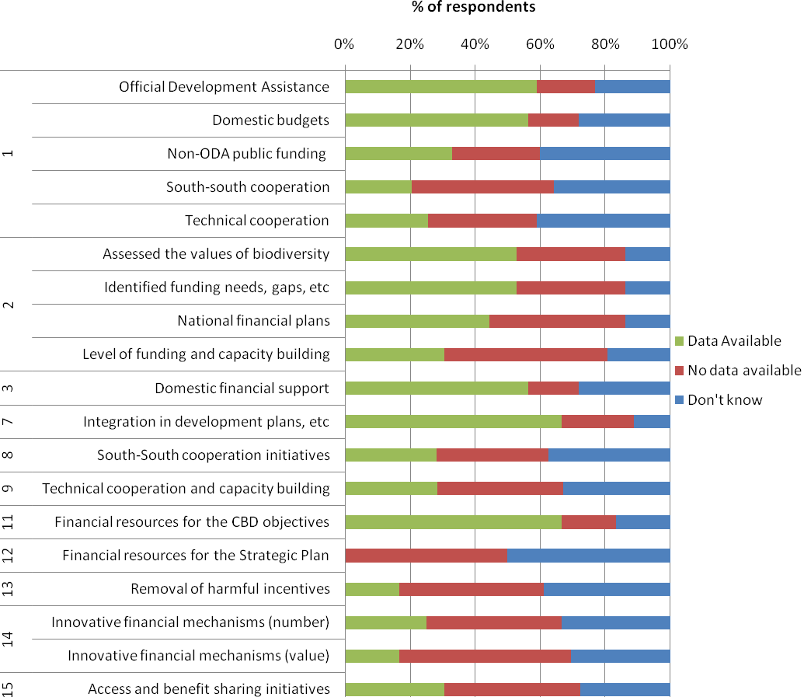
Figure 8: National capacity for reporting on the adopted indicators (n= 6-39)
National capacities for reporting were most promising for indicators 7, the ‘Number of Parties that integrate considerations on biological diversity and its associated ecosystem services in development plans and budgets’ and 11, the ‘Amount of financial resources from all sources from developed countries to developing countries to contribute to achieving the Convention’s objectives’ with over 60% of respondents answering that data was available for reporting against the associated data fields. In addition, over 50% of the respondents answered that data was available for reporting against the following indicators:
- 1(a) Aggregated financial flows: Official Development Assistance
- 1(b) Aggregated financial flows: Domestic budgets at all levels
- 2(a) Number of countries: Accessed values of biodiversity, in accordance with the Convention
- 2(b) Number of countries: Identified and reported funding needs, gaps and priorities
- 3 Amount of domestic financial support, per annum, in respect of those domestic activities which are intended to achieve the objectives of this Convention.
Indicators 2(a), 2(b) and 7 are simple in design consisting of the number of countries achieving a particular objective. As such the associated data fields in their simplest form consist of questions with YES/NO response categories. It is unsurprising that capacities for reporting against these indicators are higher, as they do not rely on existing datasets but instead institutional knowledge. The higher level of capacity for reporting against indicators 1(b) and 3, which directly overlap, may be due the fact that most national governments monitor their domestic budgets and as such it may be relatively easy for Parties to extract the amount targeting biodiversity related activities. There was also promising capacity for reporting against Indicator 1(a) Official Development Assistance, this may be due to a number of Parties participating in the survey being members of OECD DAC and therefore already reporting on biodiversity related aid to OECD.
There was a low level of capacity, with between 40-50% of the respondents stating that data was not available, for reporting against the following indicators:
- 1(d) Aggregated financial flows: South-south cooperation initiatives
- 2(c) Number of countries: Developed national financial plans for biodiversity
- 13 Resources mobilized from the removal, reforms or phase-out of incentives, including subsidies, harmful to biodiversity which could be used for the promotion of positive incentives in line with the Convention
- 14 Number of initiatives, and respective amounts, supplementary to the financial mechanism, that engage parties in and relevant organisations in new and innovative financial mechanisms (Number)
- 15 Number of access and benefit sharing initiatives consisted with the Convention and Nagoya Protocol
Indicator 1(d) relies on very fine scale data and as a result existing data sets may not allow for the extraction of this data. Indicators (2), 13 and 14 deal with relatively new and emerging areas of the CBD and as a result countries may not have the available datasets to report against these indicators. For example indicator 14 is a measure of both the number and financial value of innovative financial mechanisms. The concept of innovative financial mechanisms (IFMs) is very new within the CBD and at present there are continuing discussions around the use of IFM as a supplementary source of resource mobilization for the Convention. It is therefore unlikely that many parties will have the necessary data sets to report against this indicator at present. To deal with the two measurements contained within this indicator, two separate data fields were included in the survey, and it is unsurprising that an even higher percentage of respondents (53%) stated that they had no data available to report on the financial value of IFMs.
National capacity was very poor, with 50% or more of respondents answering that no data was available, for reporting against the following indicators:
- 2(d) Number of countries: Provided with the necessary funding and capacity building to undertake the above activities
- 12 Amount of financial resources from all sources from developed countries to developing countries towards implementation of the Strategic Plan
- 14 Number of initiatives, and respective amounts, supplementary to the financial mechanism, that engage parties in and relevant organisations in new and innovative financial mechanisms (Number)
In addition, no respondents answered that they had any data available for indicator 12. Again the low level of capacity for reporting on indicator 12 may be due to the recent adoption of the Strategic Plan and it may therefore take some time before countries are able to report on this indicator. This indicator would also require fine scale data to enable funded activities specifically targeting the Strategic Plan to be extracted. In addition generation of ODA data specific to this indicator will also take a long time.
The low level of capacity for reporting against indicator 2(d) may be a reflection of the uncertainty surrounding the indicator definition. For instance, thorough definitions and guidance would need to be provided before parties could make a qualitative judgement over whether they have been provided with adequate resources.

3.9 Feasibility of the Adopted Indicators

Following review of the individual indicators, each was assigned a category in relation to the current feasibility of their production (Table 10). The feasibility was judged according to whether existing data sets are available for immediate indicator production and whether existing national capacities would enable indicator reporting.
The categories are as follows:
- Ready for immediate use - Existing Data Sources can support the production of the indicator in the first instance (the use of reporting for improved data collection should still be could be considered in the long run)
- Adequate reporting system needed for indicator production – Indicators which will have to rely on reporting for data collection and over 50% of survey respondents answered that data was currently available. Adequate guidelines, technical assistance and capacity building for reporting will be needed.
- Technical support and capacity building needed for the development of monitoring and reporting systems - Indicators which will rely on reporting for data collection and survey results show that over 50% of Parties answered that no data was available or they didn’t know what data was currently available for indicator reporting. Substantial investment in technical support and capacity building is needed to assist Parties in developing monitoring and reporting systems for these indicators.
- Further development of indicator subject needed – Indicators meet the same criteria as in category 3. However, the indicators are associated with new and emerging subjects within the CBD. Indicator production is dependent on the further development of these areas including the adoption of future CBD decisions.
Table 10: The current feasibility of the adopted indicators for implementation of the Strategy on Resource Mobilization
ADOPTED INDICATORS |  | Ready for immediate use |  |  | Adequate reporting system needed for indicator production | Technical support and capacity building needed for the development of monitoring and reporting systems |  |  | Further development of indicator subject needed
Aggregated financial flows | 1
Official Development Assistance | (a) | ✓
Domestic Budgets | (b) | ✓
Private Sector | (c) |  |  |  | ✓
NGOs, foundations and academia | (d) |  |  |  | ✓
International Financial Institutions | (e) |  |  |  | ✓
United Nations Organizations, funds, etc | (f) |  |  |  | ✓
Non-ODA public funding | (g) |  |  |  |  | ✓
South-South cooperation initiatives | (h) |  |  |  |  | ✓
Technical cooperation | (i) |  |  |  |  | ✓
Country implementation | 2
Assessed values of biodiversity | (a) |  |  |  | ✓
Identified funding needs, gaps, etc | (b) |  |  |  | ✓
National financial plans | (c) |  |  |  |  | ✓
Level of funding and capacity building | (d) |  |  |  |  | ✓
Domestic Financial Support | 3 | ✓
GEF funding | 4 | ✓
CDB CBD? support to financial institutions | 5 | ✓
International financial institutions | 6 | ✓
Integration in development Plans, etc | 7 |  |  |  | ✓
South-South cooperation initiatives | 8 |  |  |  |  | ✓
Technical cooperation & capacity building | 9 |  |  |  |  | ✓
Awareness raising for resource mobilization | 10 |  |  |  | ✓
Financial resources for the CBD objectives | 11 |  |  |  | ✓
Financial resources for the Strategic Plan | 12 |  |  |  |  | ✓
Removal of harmful incentives | 13 |  |  |  |  | ✓
Innovative Financial Mechanisms | 14 |  |  |  |  |  |  |  | ✓
Access & benefit sharing initiatives | 15 |  |  |  |  | ✓

Four indicators and two sub indicators/components are ready for immediate use. Internally recognised data sets already exist which can support the production of indicators 1(a), 1(b) and 4. Although these indicators can be produced immediately, caveats exist with the use of the data sets and national reporting should be considered for future production of the indicators. Indicator 5 is a measure of the financial support to financial institutions through the number of supporting Decisions, although a data set does not exist for this indicator a review of the decisions by the CBD for this indicator should be relatively simple.
Three indicators and six sub indicators/components would require the development of an adequate reporting system before they can be developed. National capacity for reporting on indicators 2(A), 2(b) and 7 is considered adequate providing enough support is provided for indicator reporting. Indicators 1(c), 1(d) , 1(e), 1(f), 10 and 11 are applicable for reporting on by a range of entities excluding national Parties, and the assumption has been made that these relevant organization/agency types will be able to provide the data needed if a reporting system is available.
Five indicators and five sub indicators applicable for reporting by national Parties require a significant investment in technical support and capacity building before indicator reporting can take place. At present there is low availability of data at the national level for these indicators and a significant investment is required to assist Parties in developing the monitoring and reporting systems needed for data production and management.
Indicator 14 monitors the number and financial value of new and innovative financial mechanisms. As discussed above, the use of IFMs as a supplementary source of resource mobilization is highly controversial. At CBD COP 10 a draft decision regarding IFMS was not adopted. In the Strategy for Resource Mobilization (Decision X/3), Parties were invited to submit information and views on IFMs to the Executive Secretary for the compilation and presentation of this synthesis.

3.10 Adopted Indicators and the Aichi Targets

Target 20
As well as adopting the resource mobilization indicators, Decision (X/3) makes multiple references to the use of these indicators for monitoring progress towards Target 20 of the Strategic Plan for Biodiversity 2011-2020. For example the decision states that targets will be adopted at the 11th Conference of the Parties, providing robust baselines have been identified and endorsed and an effective reporting framework has been adopted. These targets ‘will allow progress towards the targets set out in this decision and towards target 20 of the Strategic Plan’ to be reviewed.
Whilst all of the adopted indicators are relevant to Target 20 (Table 11), not all will be likely to be ready for COP 11. As mentioned in Section 3.9 (Table 10) a number of indicators are ready for immediate use and others can be produced providing an adequate reporting system is developed. It is therefore likely that only these indicators will be available at COP 11 for establishing a baseline for Target 20.
Other Aichi Targets
The CBD COP 10 Decision on the Strategy for Resource Mobilization requested the Executive Secretary to compile information from all sources to give methodological guidance on the adopted indicators and that this guidance is ‘informed by the work of the ad hoc technical expert group on indicators for the Strategic Plan for Biodiversity 2011-2020’.
In June 2011, an International Expert Workshop in support of the Ad Hoc Technical Expert Group (AHTEG) on Indicators was run in parallel with the AHTEG meeting. The workshop was attended by over 60 experts including the AHTEG participants, with findings and results of the workshop being submitted to the AHTEG for further review. The main body of the workshop comprised a series of breakout sessions to consider the selection and development of indicators to track the Aichi targets. One breakout group was asked to focus on Strategic Goal E, including Target 20. The group reviewed the adopted indicators under the Strategy for Resource Mobilization and concluded that all indicators if available could be used for monitoring progress towards Target 20. The group also examined the overlap of the adopted indicators with the other Aichi Targets, the results of this review are shown in Table 12. A number of the adopted indicators overlap with the other Aichi Targets, for example Indicator 2 on Country level implementation overlaps with Targets 14, 15, 16 and 17. This overlap means that as well as monitoring implementation of the Strategy on resource Mobilization Indicators and Target 20, the adopted indicators can be used to interpret progress towards a number of the Aichi Targets.
Table 11: Relationship between the adopted indicators and the Aichi Biodiversity Targets
ADOPTED INDICATORS
Aggregated financial flows | 1 |  |  |  |  |  |  |  | ✓
Country implementation | 2 |  |  | ✓ | ✓ | ✓ | ✓ |  | ✓
Domestic Financial Support | 3 |  |  |  |  |  |  |  | ✓
GEF funding | 4 |  |  |  |  |  |  |  | ✓
CDB support to financial institutions | 5 |  |  |  |  |  |  |  | ✓
International financial institutions | 6 |  |  |  |  |  |  |  | ✓
Integration in development Plans, etc | 7 | ✓ |  |  |  |  |  |  | ✓
South-South cooperation initiatives | 8 |  |  |  |  |  |  |  | ✓
Technical cooperation & capacity building | 9 |  |  |  |  |  |  | ✓ | ✓
Awareness raising for resource mobilization | 10 |  |  |  |  |  |  |  | ✓
Financial resources for the CBD objectives | 11 |  |  |  |  |  |  |  | ✓
Financial resources for the Strategic Plan | 12 |  |  |  |  |  |  |  | ✓
Removal of harmful incentives | 13 |  | ✓ |  |  |  |  |  | ✓
Innovative Financial Mechanisms | 14 |  |  |  |  |  |  |  | ✓
Access & benefit sharing initiatives | 15 |  |  |  |  | ✓ |  |  | ✓
 |  | 2 | 3 | 14 | 15 | 16 | 17 | 19 | 20 |  | AICHI TARGETS
 |  | Integration of biodiversity Values | Incentives | Essential ecosystem services | Biodiversity & carbon stocks | ABS implementation | NBSAPs | Biodiversity knowledge | Resource Mobilization

4. NATIONAL CASE STUDIES

National case studies were undertaken with the United Kingdom, Croatia, Brazil and Tanzania to review in more detail existing national capacities with the following objectives:
- To obtain information on what data sets or established monitoring systems currently exist for resource mobilization
- To examine links between existing national data/monitoring systems and the adopted indicators
- Identify where data gaps may exist in relation to the adopted indicators
- Identify national plans for future monitoring of resource mobilization
- Review national constraints for future reporting on the adopted indicators
- Identify national needs for indicator reporting

4.1 United Kingdom

Existing data sets and monitoring systems
The UK Department for International Development prepares project documents (business case) for all spending interventions. Commitments of more than £1m also involve preparation of a logical framework with indicators and monitoring processes. The units of data collected vary from programme to programme, but most commitments require preparation of an annual review. DFID is responsible for collecting, compiling, reporting and disseminating statistics on the deployment of official and private UK financial resources to support developing countries. Statistics on International Development (SID) provides information on the UK’s Gross Public Expenditure on Development (GPEX) which includes both the DFID aid programme and official aid that is provided through other UK government departments. The final figures for UK Official Development Assistance (ODA) are also reported in SID. This approach to approvals, implementation monitoring and reporting is likely to be followed for the foreseeable future. The ability of users to interrogate DFID systems to generate aggregate reports of ODA spend/impact on biodiversity depends upon the nature of the information loaded – in terms of project titles, impact markers, etc.

The UK publication “Biodiversity Indicators in your Pocket” ( http://jncc.defra.gov.uk/page-4229) details some of the data sets the UK uses to monitor changes in biodiversity. The suite of biodiversity indicators is collated and reported on by the UK Department of Environment Food and Rural Affairs (Defra). The indicators were originally developed by the UK Biodiversity Partnership Standing Committee to report on progress towards meeting international goals and targets to stem or slow the rate of biodiversity loss. There have been significant developments in 2010 and 2011 in the international frameworks for biodiversity action and for assessing and reporting biodiversity change. In anticipation of the new Strategic Plan targets, a review of the UK indicators was initiated in 2010 to ensure that they:
- Continue to be based on the most robust and reliable available data; and
- Remain relevant to the new international and European goals and targets.
The suite of biodiversity indicators for the UK was first published in June 2007 and include two which are of relevance to monitoring resource mobilization:
- Public sector expenditure on biodiversity in the UK, with annual estimates from the baseline year 2000-1:http://jncc.defra.gov.uk/page-4251
- UK Government funding for global biodiversity, with annual estimates from the baseline year 2000-1: http://jncc.defra.gov.uk/page-4252

Links between existing data sets /monitoring systems and the adopted indicators
The links between available data sets and monitoring systems and the adopted indicators is summarised in the Table below.
Table 12: Links between exiting data sets and monitoring systems for the United Kingdom and the adopted indicators for implementation of the strategy for resource mobilization.
Adopted Indicator |  | Data fields for data collection/reporting at the simplest level | Does the country have existing data sets or monitoring systems to provide data for the data fields |  | Which data sets or monitoring systems could be used
No | Text |  | YES | NO | Which data sets or monitoring systems could be used
1 | Aggregated financial flows, in the amount and where relevant percentage, of biodiversity-related funding, per annum, for achieving the Convention's three objectives, in a manner that avoids double counting, both in total and in inter alia, the following categories | Official Development Assistance in support of the convention (Total monetary value and/or as a percent of total national ODA) |  | ✓ | Data may be available, however this would rely on interrogating systems to aggregate reports of ODA.
1 |  | Biodiversity related allocation in national domestic budgets (Total monetary value and/or as a percent of total domestic budget) | ✓ |  | Data for this indicator could be derived from the UK Biodiversity Indicators ‘UK biodiversity expenditure’ and ‘Global biodiversity expenditure’
1 |  | Non-ODA public biodiversity related funding (Total monetary value & as percentage of total non-ODA public funding) | ✓ |  | Data for this indicator could be derived from the UK Biodiversity Indicators ‘UK biodiversity expenditure’ and ‘Global biodiversity expenditure’
1 |  | Financial contributions to enhancing technical cooperation (Total monetary value) |  | ✓ | It would be difficult to disaggregate from current data sources as it requires very fine scale data. Data on activity types is not currently collected
1 |  | Financial contribution to south-south cooperation initiatives (Total monetary value) |  | ✓ | It would be difficult to disaggregate from current data sources as it requires very fine scale data. Data on activity types is not currently collected
2 | Number of countries that have:  (a) Assessed values of biodiversity, in accordance with the Convention  (b) Identified and reported funding needs, gaps and priorities  (c) Developed national financial plans for biodiversity  d) Been provided with the necessary funding and capacity building to undertake the above activities | Has your country assessed the values of biodiversity in accordance with the Convention? (YES/NO) | ✓
2 |  | Has your country identified and reported funding needs, gaps and priorities? (YES/NO) |  | ✓
2 |  | Has your country developed national financial plans for biodiversity? (YES/NO) |  | ✓
2 |  | Has your country been provided with necessary funding and capacity building to undertake the above activities? (YES/NO) |  | ✓ | On developing financial plans to support implementation of NBSAPs it would be useful to have more guidance on how to do this and share lessons with other Parties
3 | Amount of domestic financial support, per annum, in respect of those domestic activities which are intended to achieve the objectives of this Convention | Duplicated field from indicator 1:  Biodiversity related allocation in national domestic budgets (Total monetary value and/or as a percent of total domestic budget | ✓ |  | Data for this indicator could be derived from the UK Biodiversity Indicators ‘UK biodiversity expenditure’ and ‘Global biodiversity expenditure’
7 | Number of Parties that integrate considerations on biological diversity and its associated ecosystem services in development plans, strategies and budgets | Has your country integrated considerations on biological diversity and its associated ecosystem services in development plans, strategies and budgets? (YES/NO) | ✓
9 | Amount and number of South-South and North-South technical cooperation and capacity building initiatives that support biodiversity | The number of North-South technical cooperation and capacity building initiatives that support biodiversity with which your country is involved (number) |  | ✓ | It would be difficult to disaggregate from current data sources as it requires very fine scale data. Data on activity types is not currently collected. Difficulties exist in recording this information as a number
11 | Amount of financial resources from all sources from developed countries to developing countries to contribute to achieving the Conventions objectives | Total financial resources transferred to developing countries for achievement of the Conventions’ objectives (monetary value) | ✓ |  | Data for this indicator could be derived from the UK Biodiversity Indicators ‘Global biodiversity expenditure’
12 | Amount of financial resources from all sources from developed countries to developing countries towards implementation of the Strategic Plan for Biodiversity 2011-2020 | Total financial resources transferred to developing countries for achievement of the Strategic Plan for Biodiversity (monetary value) | ✓ |  | Data for this indicator could be derived from the UK Biodiversity Indicators ‘Global biodiversity expenditure’
13 | Resources mobilized from the removal, reform or phase-out of incentives, including subsidies, harmful to biodiversity, which could be used for the promotion or positive incentives, including but not limited to innovative financial mechanisms, that are consistent and in harmony with the Convention and other international obligations, taking into account national social and economic conditions | Total amount of resources that are removed from existing government subsidies and used to subsidize biodiversity objectives (monetary value) |  | ✓ | No data available, with clear definitions production of this indicator may be possible
14 | Number of initiatives, and respective amounts, supplementary to the financial mechanism established under Article 21, that engage Parties and relevant organizations in new and innovative financial mechanisms, which consider intrinsic values and all other values of biodiversity, in accordance with the objectives of the Convention and the Nagoya Protocol on Access to Genetic Resources and the Fair and Equitable Sharing of benefits Arising out of their Utilization | The total number of initiatives on new and innovative financial mechanisms (number) |  | ✓ | No data available, with clear definitions production of this indicator may be possible
14 |  | The amount invested in initiatives on new and innovative financial mechanisms (total monetary value) |  | ✓ | No data available, with clear definitions production of this indicator may be possible
15 | Number of access and benefit sharing initiatives and mechanisms, consistent with the Convention and , when in effect, with the Nagoya Protocol on Access to Genetic Resources and the Fair and Equitable Sharing of the Benefits Arising out of their Utilization, including awareness-raising, that enhances resource mobilization | The number of access and benefit sharing initiatives and mechanisms which are consistent with the Nagoya Protocol on ABS (number) |  | ✓ | No data available, with clear definitions production of this indicator may be possible

Indicator considerations and limitations
The UK identified a number of indicator-specific issues concerning reporting on the adopted indicators:
Indicator 9: Amount and number of South-South and North-South technical cooperation and capacity building initiatives that support biodiversity
Cross party comparisons will be difficult to interpret for this indicator, as year on year changes could be due to changes in the structure of how programmes are organized rather than a real change. There can be different interpretation of what is considered as an ‘initiative’. For example in the UK, the Darwin initiative is a grant awarding programme. When reporting on this indicator the Darwin Initiative could be counted as a single initiative or the number of its underlying projects could be counted which would exceed 50 in number. Therefore there is potential for the levels in this indicator to be artificially inflated.
Indicator 13: Resources mobilized from the removal, reform or phase-out of incentives, including subsidies, harmful to biodiversity, which could be used for the promotion or positive incentives, including but not limited to innovative financial mechanisms, that are consistent and in harmony with the Convention and other international obligations, taking into account national social and economic conditions
The intention of this indicator needs to be carefully considered. For example, a Party which heavily subsidies will have a larger ‘pot’ from which to remove, reform or phase-out subsidies compared to a Party that does not provide subsidies. The indicator therefore may make the assumption that the higher the value mobilized from the removal of subsidies the better the actions of a Party for conserving biodiversity. However, a Party with little or no subsidies will not be able to generate comparable resources from subsidy removal and maybe seen in the case of this indicator to be making less effort to conserve biodiversity.
In addition, the indicator text does not stipulate that the funds mobilized have to be invested in positive incentives and therefore a Party which mobilizes a large amount of funds from subsidy removal may not invest these funds in biodiversity conservation. As a result this Party may seem to have made a large effort on this issue, than a Party which has mobilized a lower value of resources from subsidy removal but then fully invested the mobilized funds in biodiversity conservation.
Further to this identification of harmful subsidies to biodiversity is difficult as long and short term impacts need to be considered, in particular for subsidies that may be combating other environmental issues that may harm biodiversity, such as climate change but may have immediate and negative impacts on biodiversity.
Indicator 15: Number of access and benefit sharing initiatives and mechanisms, consistent with the Convention and, when in effect, with the Nagoya Protocol on Access to Genetic Resources and the Fair and Equitable Sharing of the Benefits Arising out of their Utilization, including awareness-raising, that enhances resource mobilization
This indicator needs careful definition, as it is unclear at present whether the indicator is measuring the following:
- Whether Parties have implemented the Nagoya Protocol through legislation
- The number of in country agreements between private companies, etc
- The number of companies that have ABS policies
Constraints for Indicator Reporting
Reporting on the indicators for which the UK does not have data sets for would require a bottom-up approach rather than a systems approach. As a result it is likely that the data series would rely on knowledge from officials via networks to complete an annual survey acknowledging any new developments, for example, a new and innovative financial mechanism that has been put in place, to develop data series. Therefore, such an approach maybe prone to error as it will rely to a large degree on institutional knowledge. The requirement to develop this approach to monitor these indicators would be a reasonable burden as it would require work to design the questionnaire, officials to complete the questionnaire and analysis to be completed. To set targets on these indicators will be even more complex, as baseline data will be difficult to compile as historical trend data will not be available for most of these indicators. Without historical data it is difficult to judge what a reasonable and achievable target should be. Indicators are looking at intent and not outcomes; without understanding the link between increases in these indicators on the outcomes of biodiversity it is difficult to understand whether we are delivering on positive outcomes. For example, positive biodiversity outcomes may be dramatically increased by a small increase in funding and further funding would see very small returns; the relationship between spend and policy impact is not necessarily linear.

International Assistance Needed
The UK identified that the following assistance would be needed in order to report on the adopted indicators:
- Further definition and clarity on the indicator definition in particular the indicator on ABS.
- An understanding how the information will be used to measure biodiversity outcomes.
- Assistance in knowing how to set appropriate and achievable targets when no historical data trends are available for some of these indicators
- Further advice on how the indicators will be made uniform across the different parties reporting against them i.e. with detailed guidelines, how to deflate for changes in prices, exchange rates and purchasing power, etc.

4.2 Brazil

Existing data sets and monitoring systems
National environmental funds
There are several national federal funds for the provision of financial resources for environmental and biodiversity conservation actions (Table 13). Five of these funds are managed by the Ministry of Environment.
Table 13: Brazil’s national environment funds
Fund Name | Year Established | Objective | Managed by
National Environment Fund (FNMA) | 1989 | Develop projects for the rational and sustainable use of Brazilian natural resources, including the maintenance, enhancement or recuperation of environmental quality to improve life quality of the Brazilian population | Ministry of Environment
National Fund for Forest Development | 2006 | Promote the development of sustainable forest-based activities in the country and to promote the sector’s technological innovation | Ministry of Environment
National Climate Change Fund | 2009 | Secure funds to support projects, studies and ventures to adapt to or mitigate the effects of climate change | Ministry of Environment
Amazon Fund | 2008 | Support the continuity of Brazilian efforts to voluntarily reduce the emission of greenhouse gases resulting from deforestation and forest degradation (REDD) | Ministry of Environment
Atlantic Forest Restoration Fund | 2006 | Finance environmental restoration and scientific research projects within the Atlantic Forest region | Ministry of Environment
Fund for the Defense of Collective Rights (FDD) | 1985 | Funding remedies to damages caused to the environment, to the consumer, to assets and rights of artistic, aesthetic, historical, touristic or scenic value, and to other collective interests | FDD Federal Management Council
MCT Sectoral Funds | 1999 | Mechanism to strengthen and enhance the national science and technology system. Some of the funds support activities that collaborate more directly with CBD objectives | Ministry of Science and Technology (MCT)

State and municipal environmental funds
There are a number of state and municipal environmental funds managed by various councils which fund activities supporting CBD objectives (Table 14).
Table 14: Brazil’s State and municipal environmental funds
Fund Name | Year Established | Managed by
Environmental Fund of the Federal District (FUNAM-DF) | 1989 | Administrative Council of the Environmental Fund of the Federal District (CAF)
Piauí State Environment, Science and Technology, and Urban Development Fund (FEMAM-PI) | 1987 | State Secretariat for the Environment and Water Resources (financial management) and Technical Management Chamber (Technical management)
Ceará State Fund for Environmental Management (FEMA) | 2004 | FEMA Management Council, which is presided by the Environmental Ombudsman Secretary
Santa Catarina Special Fund for Environmental Protection (FEPEMA-SC): | 1980 | State Secretariat for Sustainable Economic Development (SDS)
Rio de Janeiro State Fund for Environmental Conservation and Urban Development  (FECAM/RJ) | 1986
Goiás State Environmental Fund (FEMA/GO) | 1995
Campo Grande Municipal Environmental Fund (FMMA/Campo Grande/MS) | 1999 | Municipal Secretariat for the Environment and Sustainable Development (SEMADES) with the collaboration of the Municipal Environmental Council (CMMA)
Porto Velho Municipal Environmental Fund (FMMA/Porto Velho/RO) | 2001 | Municipal Council for Environmental Defense (COMDEMA)
São Paulo Special Fund for the Environment and Sustainable Development (FEMA/São Paulo): | 2001 | FEMA Council (CONFEMA), composed by representatives of the Municipal Environmental and Sustainable Development Council, and environmental NGOs
Aracaju Municipal Socio-environmental Fund (FMMA/Aracaju/SE) | 2001 | Urban Development and Environment Council (CONDURB)

Government Incentives
Brazil has a number of mechanisms to provide tax incentive to individuals or municipalities in exchange of environmental conservation (Table 15).
Table 15: Brazil’s tax incentives for environmental conservation
Tax Incentive Mechanism | Description | Current status
Green VAT (ICMS Ecológico) | The Green VAT allows municipalities to receive additional financial resources from the Merchandise Circulation and Services Tax (ICMS) in those states that have legally defined environmental criteria for sharing part of the portion owe to the municipality according to constitutional provision. | A total of 13 of the 26 Brazilian states (plus the Federal District) currently have legislation on the Green VAT, listed in Table II-3 below, and 10 other developed Green VAT bills, currently being evaluated.
Private Reserves of the Natural Heritage (RPPN) | Private land owners that voluntarily designate a portion of or the entire property to permanent biodiversity conservation receive a significant reduction in their rural land property tax. | It is estimated that there are currently a total of 973 federal and state RPPNs in Brazil, covering approximately 7,055 km2
Payment for environmental services | The municipality of Extrema, in the state of Minas Gerais, is pioneering since 2007 a system of payment for environmental services through the Water Producer Project, where rural producers receive financial compensation for conserving springs and water catchment areas. The Espírito Santo state initiated a similar system in 2009.

Several other initiatives involving the maintenance or recuperation of native vegetation for compensating carbon emissions, REDD and water conservation are also being developed throughout the country, but as isolated initiatives these do not yet reflected in public policies. Examples of these initiatives are: (i) Oasis – water catchment areas protection project in São Paulo state managed by NGO FBPN; (ii) Carbon sequestration project through avoided deforestation and reforestation in Guaraqueçaba (Paraná state), managed by NGO SPVS; (iii) Adopt-an-Araucaria-Forest program in Paraná state, managed by SPVS; and (iv) São Paulo state discussion to create a fund or other financial mechanisms to support the recuperation of riparian forests and water conservation.
A bill on payment for environmental services, prepared by the Ministry of the Environment, is currently being appreciated by the National Congress. This bill institutes the National Environmental Services Policies, creates the Federal Program of Payment for Environmental Services, and establishes the ways and means for the Program‟s control and financing, among other provisions.
Private Funding
A number of private funds have been established to finance biodiversity conservation and sustainable use projects in Brazil (Table 16).
Table 16: Private funds for biodiversity conservation in Brazil
Fund Name | Description & Donors
FUNBIO - Brazilian Biodiversity Fund | The federal government created FUNBIO, a private fund initially capitalized with a US$20 million donation from the Global Environmental Facility to finance biodiversity conservation and sustainable use projects. Since its creation, FUNBIO has been complementing these initial resources with donations and partnerships with public and private agencies.
FAP – Protected Areas Fund, under the Amazon Protected Areas Project (ARPA) | FUNBIO became the manager of this Fund, created specifically to support the long-term management costs of protected areas in the Amazon. The number and total area of protected areas in the Amazon has increased significantly under the GEF-supported ARPA project, which also receives financial resources from the Brazilian and German governments and WWF.
Atlantic Forest Conservation Fund (AFCoF): | This Fund was created by a two-million Euros donation of the German Ministry of the Environment for the conservation of the Atlantic Forest as a global initiative for climate change mitigation, and is managed by FUNBIO. The donation, originated from Germany’s sale of carbon credits.

Other Government Sponsored Funds
In 2009, the governmental budget allocated R$3,532,621,461 (approximately US$2.08 billion) for federal environmental agencies, only 2% of which from sources other than the national treasury. The Ministry of the Environment and its executing agencies implement this budget through 16 programs in the federal Multi-Year Plan (PPA) and other initiatives not included in the PPA that contribute to the achievement of CBD objectives. Two of these programs are implemented through the Secretariat of Biodiversity and Forests, CBD focal point in Brazil: the Conservation and Sustainable Use of Biodiversity and Genetic Resources Program; and the Conservation, Management and Sustainable Use of Agrobiodiversity Program. In addition to these, several other programs listed in the PPA are implemented by various ministries and contain actions related to: sustainable rural production with agro-forestry systems; local sustainable development with emphasis on family production and sustainable use of natural resources; biofuels research and production; renewable energy; and territorial ordering and regularization
National Budget Allocations
In 2007, the Ministry of the Environment published a first analysis of the financial gap of the National Protected Areas System, which was revised in 2009. This assessment addressed SNUC institutional and legal aspects, as well as the costs of protected areas, necessary investments, and current and potential financial sources.
Links between existing data sets /monitoring systems and the adopted indicators
The links between available data sets and monitoring systems and the adopted indicators is summarised in the Table below.
Table 17: Links between exiting data sets and monitoring systems for the United Kingdom and the adopted indicators for implementation of the strategy for resource mobilization.
Adopted Indicator |  | Data fields for data collection/reporting at the simplest level | Does the country have existing data sets or monitoring systems to provide data for the data fields |  | Which data sets or monitoring systems could be used
No | Text |  | YES | NO | Which data sets or monitoring systems could be used
1 | Aggregated financial flows, in the amount and where relevant percentage, of biodiversity-related funding, per annum, for achieving the Convention's three objectives, in a manner that avoids double counting, both in total and in inter alia, the following categories | Official Development Assistance in support of the convention (Total monetary value and/or as a percent of total national ODA) |  | ✓ | The data for this indicator isn’t managed by the Ministry of the Environment and it is possible that this data is monitored by the Ministry of Planning, Budget and Management.
1 |  | Biodiversity related allocation in national domestic budgets (Total monetary value and/or as a percent of total domestic budget) | ✓ |  | Data could come from national funds, State and municipal environmental funds and national budgets data sets
1 |  | Non-ODA public biodiversity related funding (Total monetary value & as percentage of total non-ODA public funding) |  | ✓ | The data could come from national funds, State and municipal environmental funds and national budgets data sets however this would require fine scale analysis
1 |  | Financial contributions to enhancing technical cooperation (Total monetary value) |  | ✓ | This data would need to be extracted from institutions that have been contributing to the enhancement of technical cooperation, such as UNDP, WorldBank, Etc.
1 |  | Financial contribution to south-south cooperation initiatives (Total monetary value) |  | ✓ | This data would need to be extracted from institutions that have been contributing to the enhancement of south-south cooperation initiatives, such as UNDP, WorldBank, Etc.
2 | Number of countries that have:  (a) Assessed values of biodiversity, in accordance with the Convention  (b) Identified and reported funding needs, gaps and priorities  (c) Developed national financial plans for biodiversity  d) Been provided with the necessary funding and capacity building to undertake the above activities | Has your country assessed the values of biodiversity in accordance with the Convention? (YES/NO) | ✓ |  | Data for this indicator could be extracted from institutional knowledge
2 |  | Has your country identified and reported funding needs, gaps and priorities? (YES/NO) | ✓ |  | Data for this indicator could be extracted from institutional knowledge
2 |  | Has your country developed national financial plans for biodiversity? (YES/NO) | ✓ |  | Data for this indicator could be extracted from institutional knowledge
2 |  | Has your country been provided with necessary funding and capacity building to undertake the above activities? (YES/NO) | ✓ |  | Data for this indicator could be extracted from institutional knowledge
3 | Amount of domestic financial support, per annum, in respect of those domestic activities which are intended to achieve the objectives of this Convention | Duplicated field from indicator 1:  Biodiversity related allocation in national domestic budgets (Total monetary value and/or as a percent of total domestic budget | ✓ |  | Data could come from national funds, State and municipal environmental funds and national budgets data sets
7 | Number of Parties that integrate considerations on biological diversity and its associated ecosystem services in development plans, strategies and budgets | Has your country integrated considerations on biological diversity and its associated ecosystem services in development plans, strategies and budgets? (YES/NO) | ✓ |  | Data for this indicator could be extracted from institutional knowledge
8 | Number of South-South cooperation initiatives conducted by developing country Parties and those that may be supported by other Parties and relevant partners, as a complement to necessary North-South cooperation | The number of South-South cooperation initiatives with which your country is involved (Number) |  | ✓ | No monitor system available.
9 | Amount and number of South-South and North-South technical cooperation and capacity building initiatives that support biodiversity | The number of South-South technical cooperation and capacity building initiatives that support biodiversity with which your country is involved (number) |  | ✓ | No data available
13 | Resources mobilized from the removal, reform or phase-out of incentives, including subsidies, harmful to biodiversity, which could be used for the promotion or positive incentives, including but not limited to innovative financial mechanisms, that are consistent and in harmony with the Convention and other international obligations, taking into account national social and economic conditions | Total amount of resources that are removed from existing government subsidies and used to subsidize biodiversity objectives (monetary value) |  | ✓ | No data available
14 | Number of initiatives, and respective amounts, supplementary to the financial mechanism established under Article 21, that engage Parties and relevant organizations in new and innovative financial mechanisms, which consider intrinsic values and all other values of biodiversity, in accordance with the objectives of the Convention and the Nagoya Protocol on Access to Genetic Resources and the Fair and Equitable Sharing of benefits Arising out of their Utilization | The total number of initiatives on new and innovative financial mechanisms (number) | ✓ |  | Data for this indicator could be extracted from Brazil’s Tax Incentive Mechanisms
14 |  | The amount invested in initiatives on new and innovative financial mechanisms (total monetary value) | ✓ |  | Data for this indicator could be extracted from Brazil’s Tax Incentive Mechanisms
15 | Number of access and benefit sharing initiatives and mechanisms, consistent with the Convention and , when in effect, with the Nagoya Protocol on Access to Genetic Resources and the Fair and Equitable Sharing of the Benefits Arising out of their Utilization, including awareness-raising, that enhances resource mobilization | The number of access and benefit sharing initiatives and mechanisms which are consistent with the Nagoya Protocol on ABS (number) |  | ✓ | No data available

Indicator considerations and limitations
According to the Fourth National Report to the Convention on Biological Diversity, Brazil has made progress toward the achievement of agreed targets. Based on the decisions that took place at COP-10, in Nagoya, Brazil started a process to update its national targets and increase its efforts invested in the implementation of its national and international biodiversity commitments. The main challenges identified throughout the Report still remain on the path of the national implementation efforts. To overcome them, among other factors, it is necessary to further advance international cooperation and increase the means of support to CBD implementation, including the transfer of financial resources and technology, and the exchange of experiences among Parties to the Convention.
Most of the information provided is from the federal level; given the Federative pact in Brazil, there are many initiatives conducted by states that are not available for consultation. Most of the allocated amounts for initiatives for conservation, sustainable use and sharing benefits of Brazilian biodiversity are not clearly defined to these purposes.
Indicator 1: Aggregated financial flows, in the amount and where relevant percentage, of biodiversity-related funding, per annum, for achieving the Convention's three objectives..
Brazil does not have accurate data for biodiversity-related funding, per annum, for achieving the Convention’s three objectives. It is recommended that Brazil should develop the necessary monitoring systems to assure accurate data, since its possession makes it possible to monitor and make better resource allocations.
Indicator 8: Number of South-South cooperation initiatives conducted by developing country Parties and those that may be supported by other Parties and relevant partners, as a complement to necessary North-South cooperation
Indicator 9: Amount and number of South-South and North-South technical cooperation and capacity building initiatives that support biodiversity
The number of cooperation initiatives is difficult to find out due to the various institutions at the different levels of government in Brazil that carry out an infinite number of projects and programs. Most of the cooperation initiatives at the federal level are accompanied by the Brazilian Cooperation Agency, of the Ministry of Foreign Affairs. Moreover, when projects are conducted by the state and municipal levels, it’s extremely challenging to extract the information.
Indicator 10: Resources mobilized from the removal, reform or phase-out of incentives, including subsidies, harmful to biodiversity, which could be used for the promotion or positive incentives, including but not limited to innovative financial mechanisms, that are consistent and in harmony with the Convention and other international obligations, taking into account national social and economic conditions
Concerning indicator 10, the efforts to separate incentives from the perverse ones would require a comprehensive assessment, because there are many productive sectors that are beneficiaries from the same source of incentives.

Constraints for Indicator Reporting
Brazil supports the constraint noted by the UK that “indicators are looking at intent and not outcomes, without understanding the link between increases in these indicators on the outcomes of biodiversity it is difficult to understand whether we are delivering on positive outcomes. For example, positive biodiversity outcomes may be dramatically increased by a small increase in funding and further funding would see very small returns, the relationship between spend and policy impact is not linear.”

International Assistance Needed
It is considered that international assistance would be needed to develop better ways to obtain and manage the information, which is often aggregated, in order to facilitate the evaluation of data. Assistance would also be required for the implementation of an information system where the various levels of government might feed reliable data and make them freely available.
In addition, the following assistance would also be needed:
- Assistance in knowing how to set appropriate and achievable targets when no historical data trends are available for some of these indicators;
- Further advice on how the indicators will be made uniform across the different parties reporting against them i.e. with detailed guidelines.

4.3 Croatia

Since the adopted of Croatia’s first Strategy (NBSPA) in 1999, a significant improvement has been made towards strengthening the financial mechanisms for biodiversity conservation. With regard to the nature protection system as a whole, the state budget continues to be the primary source of financing. The proportion of the state budget assigned to biodiversity has grown steadily over the last few years, but unfortunately, as with many countries the global economic crisis has caused a downturn. In order to ensure that biodiversity objectives are addressed, the institutional system was decentralised from central/state government to regional and local governments. Funding is set aside from country, city and municipal budgets for the management of the National ecological network and protected areas through the activities of state/county/local public institutions. Substantial funds for nature protection activities at the national and/or regional level have been additionally secured in the last decade through various international projects financed by different IFIs, governments/programmes of individual European countries and the EU pre-accession programmes. Given the importance of biodiversity conservation at the EU level, a significant inflow of funds from these sources is expected in the post accession period.
In regard to legislative framework, in addition to the NBSAP the main strategic document for biodiversity protection, the Nature Protection Act envisages a system of financial incentives for environmentally friendly management which takes in to consideration measures for the conservation of biodiversity.
Further information on Croatia’s national resource mobilization can be found in Appendix 5.
Existing data sets and monitoring systems
There has been no addition system established for the management of data sets and monitoring systems for resource mobilization. Existing data sets in use are primarily the function of financial and resource management and can be used for existing reporting and no specific monitoring systems have been established for resource mobilization reporting. The existing data sets for financial reporting have been set in place for institutions that are governed on the state level.
The Nature Protection Directorate (NPD) of Ministry of Culture is the government body responsible for nature protection (including NFP for CBD Convention). The State Institute for Nature Protection (SINP), Central Nature Protection expert institutions and a number of public organizations for management of national and nature parks have been established by the Government. These institutions are funded by the state budget, and are under the jurisdiction of MOC-NPD, but can also utilize different funding mechanisms available. The vast majority of national and all nature parks in Croatia require some financial assistance from MOC through the annual budgeting process (only two out of 19 are self-financed).
On the regional level, County Public Institutions (CPI) have been established to support an efficient decentralised system for nature protection. CPIs are responsible for management of other protected areas as well as the management of ecological network/ NATURA 200 sites with their respective counties. At present there are 20 CPIs (out of 21) at the county level and six at the local level which are primarily funded by the county/municipal budgets, but all can use different funding mechanisms available. The absorption of different funds is proportional to the capacity of each institution. CPIs are not obliged to report to MOC.
Croatia will join the European Union in the near future, The EU Habitats and Birds Directives will require better management of natural resources, new approaches for public and private collaboration, and a sustainable method to finance the expansion of protected areas. In addition to fulfilling the obligations of the Strategic Plan for Biodiversity 2011-2020 and the EU Biodiversity Strategy, Croatia will work on the integration of biodiversity in Common Agriculture Policy (CAP), Common Fishery Policy (CFP) and Cohesion Policy.
Links between existing data sets /monitoring systems and the adopted indicators
The links between available data sets and monitoring systems and the adopted indicators is summarised in the Table below.
Table 18: Links between exiting data sets and monitoring systems for Croatia and the adopted indicators for implementation of the strategy for resource mobilization.
Adopted Indicator |  | Data fields for data collection/reporting at the simplest level | Does the country have existing data sets or monitoring systems to provide data for the data fields |  | Which data sets or monitoring systems could be used
No | Text |  | YES | NO | Which data sets or monitoring systems could be used
1 | Aggregated financial flows, in the amount and where relevant percentage, of biodiversity-related funding, per annum, for achieving the Convention's three objectives, in a manner that avoids double counting, both in total and in inter alia, the following categories | Official Development Assistance in support of the convention (Total monetary value and/or as a percent of total national ODA) | ✓ |  | National accounting system
1 |  | Biodiversity related allocation in national domestic budgets (Total monetary value and/or as a percent of total domestic budget) | ✓ |  | National accounting system
1 |  | Non-ODA public biodiversity related funding (Total monetary value & as percentage of total non-ODA public funding) |  | ✓ | No data available
1 |  | Financial contributions to enhancing technical cooperation (Total monetary value) |  | ✓ | No data available
1 |  | Financial contribution to south-south cooperation initiatives (Total monetary value) |  | ✓ | Not applicable
2 | Number of countries that have:  (a) Assessed values of biodiversity, in accordance with the Convention  (b) Identified and reported funding needs, gaps and priorities  (c) Developed national financial plans for biodiversity  d) Been provided with the necessary funding and capacity building to undertake the above activities | Has your country assessed the values of biodiversity in accordance with the Convention? (YES/NO) | ✓ |  | Data for this indicator could be extracted from institutional knowledge
2 |  | Has your country identified and reported funding needs, gaps and priorities? (YES/NO) | ✓ |  | Data for this indicator could be extracted from institutional knowledge
2 |  | Has your country developed national financial plans for biodiversity? (YES/NO) | ✓ |  | Data for this indicator could be extracted from institutional knowledge
2 |  | Has your country been provided with necessary funding and capacity building to undertake the above activities? (YES/NO) | ✓ |  | Data for this indicator could be extracted from institutional knowledge
3 | Amount of domestic financial support, per annum, in respect of those domestic activities which are intended to achieve the objectives of this Convention | Duplicated field from indicator 1:  Biodiversity related allocation in national domestic budgets (Total monetary value and/or as a percent of total domestic budget | ✓ |  | National accounting system
7 | Number of Parties that integrate considerations on biological diversity and its associated ecosystem services in development plans, strategies and budgets | Has your country integrated considerations on biological diversity and its associated ecosystem services in development plans, strategies and budgets? (YES/NO) | ✓ |  | Data for this indicator could be extracted from institutional knowledge
8 | Number of South-South cooperation initiatives conducted by developing country Parties and those that may be supported by other Parties and relevant partners, as a complement to necessary North-South cooperation | The number of South-South cooperation initiatives with which your country is involved (Number) |  | ✓ | Not applicable
9 | Amount and number of South-South and North-South technical cooperation and capacity building initiatives that support biodiversity | The number of South-South technical cooperation and capacity building initiatives that support biodiversity with which your country is involved (number) |  | ✓ | Not applicable
13 | Resources mobilized from the removal, reform or phase-out of incentives, including subsidies, harmful to biodiversity, which could be used for the promotion or positive incentives, including but not limited to innovative financial mechanisms, that are consistent and in harmony with the Convention and other international obligations, taking into account national social and economic conditions | Total amount of resources that are removed from existing government subsidies and used to subsidize biodiversity objectives (monetary value) |  | ✓ | No data available
14 | Number of initiatives, and respective amounts, supplementary to the financial mechanism established under Article 21, that engage Parties and relevant organizations in new and innovative financial mechanisms, which consider intrinsic values and all other values of biodiversity, in accordance with the objectives of the Convention and the Nagoya Protocol on Access to Genetic Resources and the Fair and Equitable Sharing of benefits Arising out of their Utilization | The total number of initiatives on new and innovative financial mechanisms (number) |  | ✓ | No data available
14 |  | The amount invested in initiatives on new and innovative financial mechanisms (total monetary value) |  | ✓ | No data available
15 | Number of access and benefit sharing initiatives and mechanisms, consistent with the Convention and , when in effect, with the Nagoya Protocol on Access to Genetic Resources and the Fair and Equitable Sharing of the Benefits Arising out of their Utilization, including awareness-raising, that enhances resource mobilization | The number of access and benefit sharing initiatives and mechanisms which are consistent with the Nagoya Protocol on ABS (number) |  | ✓ | No data available

National Plans for future resource mobilization monitoring
In 2008 a revised Strategy and Action Plan for Protection of Biological and Landscape Diversity was adopted by Croatian Parliament giving the NBSAP high political support. There is no legislative basis for an additional resource mobilization strategy as institutional and financial needs were incorporated in the NBSAP with Strategic goals/targets, guidelines and action plans for achievement.
A part of the process of joining the EU, Croatian is preparing the strategic documents/operational programmes needed for planning priorities in regard to absorption of available EU funding. Biodiversity funding has been identified as a priority area and the appropriate documents will be completed in the next programme period; Operational Programme “Environment and Energy” and National Plan for Rural Development (agri-environmental measures and Natura 2000 payments). All government bodies are adopting three year planning programmes as part of the Government Strategy, including the production of indicators to assess progress towards the goals.
Constraints for Indicator Reporting
The systematic control of financial resources set aside from different sources for nature protection activities is difficult, due to the dispersion and heterogeneity of institutions and stakeholders involved in nature protection projects. Not all organizations/institutions are obligated to report on resource mobilization to the Ministry as the central state body and this makes acquisition of suitable data difficult.
International Assistance Needed
Croatia identified that the following assistance would be needed in order to report on the adopted indicators:
- A reporting system which includes best practice examples for countries.
- Training for resource mobilization focal points and other key stakeholders from nature protection institutions and organizations, including training on the development of an adequate IT database.

5. EXPERIENCES AND LESSONS LEARNT FROM SIMILAR INDICATOR PROCESSES

5.1 Performance Review and Assessment of Implementation System (PRAIS)
The information is this section has been taken from personal communication with Luca Perez, UNEP-WCMC project coordinator for PRAIS.
A new monitoring and assessment framework for the UNCCD
The adoption in 2007 of the Ten-Year Strategic Plan and Framework to Enhance the Implementation of the UNCCD (2008–2018) has paved the way for the evolution of a new monitoring and assessment process within the UNCCD. The new monitoring and assessment framework of the Convention, named the Performance Review and Assessment of Implementation System (PRAIS), is based primarily on the derivation of performance indicators to measure progress against the operational objectives (OO) of the Strategy, and impact indicators to measure progress against the strategic objectives (SO) contained in national, sub regional and regional profiles. Special attention is also placed by the framework on measuring investment flows for UNCCD implementation and on the establishment of a knowledge management system, including the dissemination of best practices.
Against this background, the introduction of indicator-based reporting during the first leg of the 4th Reporting and Review process in 2010 represents a paradigm shift for the UNCCD through which its country Parties have started engaging in a long-term learning process aimed at establishing a more solid, credible and science-based understanding of Desertification, Land Degradation and Drought (DLLD) and of the implementation of the Convention. The 2010 exercise, facilitated by the creation of an online reporting platform of the UNCCD (the PRAIS Portal), has entailed an unprecedented effort by UNCCD country Parties to “test” on the ground the agreed set of globally approved performance indicators and other reporting requirements and to establish adequate monitoring and assessment systems at the national level to enable regular and consistent reporting to COPs in the future.
The Performance Indicators
Eighteen performance indicators were identified for monitoring progress in achieving the operational objectives at global and national levels (Table ). The indicators, concerned with implementation efforts are varied and range from the level of capacity building and awareness raising to financial commitments made in achieving the Conventions aims. There are similarities between the adopted indicators for Resource Mobilization and the UNCCD Performance indicators:
- Both sets of indicators are concerned with monitoring implementation.
- The majority of indicators relate to the number of parties achieving an implementation objective or the number of initiative/activities established.
- The reporting entities vary between the indicators.

Table 19: The UNCCD Performance indicators and responsible reporting entities
Operational Objective Outcome* | Indicator number | Indicator Name | Affected | SRAPs &RAPs | Developed | UN & IGOs | GEF | Secretariat | GM
1.1 | CONS-O-1 | Number and size of information events organized on the subject of Desertification, Land Degradation and Drought (DLDD) and/or DLDD synergies with climate change and biodiversity, and audience reached by media addressing DLDD and DLDD synergies.
1.2 | CONS-O-2 | Number of official documents and decisions at international, regional and sub regional levels relating to DLDD issues.
1.3 | CONS-O-3 | Number of Civil Society Organizations (CSOs) and science and technology institutions participating in the Convention processes.
1.3 | CONS-O-4 | Number and type of DLDD-related initiatives of CSOs and science and technology institutions in the field of education.
2.1  2.2  2.3 | CONS-O-5 | Number of affected country Parties, subregional and regional entities to have finalized the formulation/revision of NAPs/SRAPs/RAPs aligned to The Strategy, taking into account biophysical and socio-economic information, national planning and policies, and integration into investment frameworks.
2.4 | CONS-O-6 | Number of partnership agreements established within the framework of the Convention between developed country Parties/United Nations and IGOs and affected country Parties.
2.5 | CONS-O-7 | Number of initiatives for synergistic planning/programming of the three Rio conventions or mechanisms for joint implementation, at all levels.
3.1  3.2 | CONS-O-8 | Number of affected country Parties, subregional and regional entities to have established and supported a national/subregional/ regional monitoring system for DLDD.
3.1  3.2 | CONS-O-9 | Number of affected country Parties, subregional and regional entities reporting to the Convention along revised reporting guidelines on the basis of agreed indicators.
3.3  3.4 | CONS-O-10 | Number of revised NAPs/SRAPs/RAPs reflecting knowledge of DLDD drivers and their interactions, and of the interaction of DLDD with climate change and biodiversity.
3.5 | CONS-O-11 | Type, number and users of DLDD-relevant knowledge-sharing systems at the global, regional, subregional and national levels described on the Convention website.
3.6 | CONS-O-12 | Number of science and technology networks, institutions or scientists engaged in research mandated by the COP.
4.1  4.2 | CONS-O-13 | Number of countries, subregional and regional reporting entities engaged in building capacity to combat DLDD on the basis of National Capacity Self Assessment (NCSA) or other methodologies and instruments.
5.1 | CONS-O-14 | Number of affected country Parties, subregional and regional entities whose investment frameworks, established within the IFS devised by the GM or within other integrated financing strategies, reflect leveraging national, bilateral and multilateral resources for combating desertification and land degradation.
5.2 | CONS-O-15 | Amount of financial resources made available by developed country Parties to combat DLDD
 | CONS-O-16 | Degree of adequacy, timeliness and predictability of financial resources made available by developed country Parties to combat DLDD.
5.3 | CONS-O-17 | Number of DLDD-related project proposals successfully submitted for financing to international financial institutions, facilities and funds, including the GEF.
5.5. | CONS-O-18 | Amount of financial resources and type of incentives which have enabled access to technology by affected country Parties.
Source: UNCCD Decision Document ICCD/COP(9)/Add.1. * Operational and objectives and outcomes also available in the document

The UNEP/GEF project “Enabling a Paradigm Shift on Monitoring and Assessment within the UNCCD”
The short and medium-term capacity development needs, particularly in the field of Monitoring and Evaluation (M&E) and knowledge management, which were raised by the introduction of the new system have been addressed by the UNCCD mainly through the project “Enabling a Paradigm Shift on Monitoring and Assessment within the UNCCD” (hereinafter referred to as the “PRAIS project”).
Funded by the Global Environmental Facility (GEF), the project has been implemented by UNEP and executed by the UNEP World Conservation Monitoring Centre (UNEP-WCMC) under the guidance of and close collaboration with the UNCCD Secretariat and the Global Mechanism, which provides advisory services to the country Parties to the UNCCD, to upscale finance for Sustainable Land Management (SLM).
The main purpose of the UNCCD PRAIS project was to assist UNCCD Parties by building capacities for the 2010 Fourth Reporting and Review process of the implementation of the Convention. Implemented from January 2010 until June 2011, the project focused on (i) development of reporting tools based on the approved set of performance indicators established under the new Monitoring and Assessment Framework of the convention, the so-called Performance Review and Assessment of the Implementation System (PRAIS); (ii) building capacities of affected Parties for the preparation of their fourth national reports; (iii) establishment of an on-line reporting platform to facilitate the reporting process and improve knowledge management within the Convention; and (iv) contribute to the further strengthening of the monitoring framework of the UNCCD through the documentation and dissemination of Lessons learned.
Performance Indicator Reporting
The implementation in 2010 of the first iteration of the PRAIS monitoring and assessment system during the first leg of the 4th Review and Reporting cycle, required the development of a new set of indicator-based reporting tools in accordance with the new approach and reporting requirements defined in Decision 12.COP9 and 13.CO9 which mandated the secretariat to organize the reporting based on the following structure:
  - Table of Content
  - General Information
  - Performance Indicators
  - Standard Financial Annex
  - Programme and Project Sheet
  - Additional information section
  - Best Practices

A new set of reporting guidelines, including templates and instructions for the compilation of the report, was developed not only for affected and developed country Parties, but also for other reporting entities such as Civil Society Organizations, UN Agencies and Intergovernmental Organizations, the Global Mechanism and the GEF Secretariat. The reporting process was also facilitated by the preparation of a glossary to promote common terminology and definitions and a Quick Reference Guide, to provide additional guidance on Rio Markers, Relevant Activity Codes and OECD purpose codes (also known as OECD Common Reporting System, CRS codes).
Standard Financial Annex
As well as reporting on the individual indicators it was recommended at a meeting of the Committee for the Review and Implementation of the Convention (CRIC) that financial reporting was based on a standard financial reporting format to be used by affected country Parties and their development partners. It was also indicated that emphasis in reports should be put on financial matters and also on an analysis of the impact of the activities undertaken (ICCD/CRIC (8)/5).
The purpose of the Standard Financial Annex (SFA; Appendix 6) is to consolidate information on resources mobilized by affected country Parties and their development partners under the framework of relevant strategies and action programmes. It facilitates the aggregation of data on financial commitments, financial flows and resources available by all relevant funding sources for activities related to the implementation of the Convention. It also helps minimize double counting in financial statistics.
The SFA is designed to be used by each country Party and other reporting entities to list all financial commitments they have made during the reporting period in support of institutions, programmes, projects, as well as other relevant initiatives undertaken at national or internal level for the implementation of the Convention. More specifically for each relevant financial commitment or allocation made in the reporting period, the SFA requires a minimum set of data grouped as follows:
- Identification, i.e. data required to identify the reporting entity, the funding source and the activity financed;
- Basic data, i.e. data specifying the amount and type of financial commitment made, as well as the recipient country, region, and/or organization, and the funding period, if applicable;
- Classification, i.e. categorization of the funded activity according to the Rio Markers for desertification, and the UNCCD Relevant Activity Codes (RACs).
The compilation of the SFA is guided by means of a template (Appendix 6), which responds to the recommendations of CRIC 7, and builds on the GM methodological guide for financial reporting presented to CRIC 6 as part of the report of the intergovernmental Ad Hoc Working Group to improve the procedures for communication of information.
Project and Programme Sheet
The Programme and Project Sheets (PPS) are used to provide more detailed information on programmes or projects undertaken or completed in the reporting period. This includes programmes and projects in the pipeline, as well as final proposals submitted for funding to internal or external funding sources. All country Parties and other reporting entities involved in the financing, coordination or implementation of relevant programmes and projects are requested to prepare a PPS for each of them, and to attach them to their official report to the UNCCD.
The compilation of the PPS is guided by means of a template (Appendix 7). These templates are intended to collect a minimum set of qualitative and quantitative data to facilitate the analysis of funding and investment flows, and the production of better financial statistics related to UNCCD implementation², with a view to enabling the CRIC to undertake an objective review of progress in the implementation of the Convention and The Strategy. The PPS also facilitate the computation of certain performance and impact indicators.
A distinctive feature of the PPS is that it allows country Parties and other reporting entities to specify which strategic and operational objectives of The Strategy are targeted by each programme or project. In addition, it allows for individual programme or project components to be categorized using the Rio Markers for desertification and Relevant Activity Codes (RACs).
Furthermore, the PPS can be used to indicate whether the objectives of other Rio Conventions (i.e. the CBD and the UN Framework Convention on Climate Change, UNFCCC) are also addressed by the programme or project. This is done through the use of the biodiversity and climate change Rio Markers, respectively.
The PPS offers an opportunity to increase the visibility of relevant programmes and projects, thereby creating the conditions for a better sharing of experiences and lessons, as well as the transfer of knowledge in general. It also favours collaboration and networking by facilitating the identification of potential synergies. The PPS also allows country Parties and other reporting entities to provide a narrative description of the expected or achieved results. This information will facilitate the qualitative assessment of progress in the implementation of The Strategy, including on returns on investment. The CRIC will use the analysis of financial information originating from the PPS to assess results, performance and impacts.
Reporting Guidelines and Templates
As noted above different guidelines were created for the different reporting entities to allow for the fact that not all indicators are applicable to all entities. As shown in the example template for indicator CONS-O-3 (Appendix 8) the reporting guidelines are quite in depth providing details on indicator understanding, the data needed, data sources and links to the glossary.
The data fields for reporting are also very sophisticated. For example for Indicator CONS-O-3, Number of CSOs and science and technology institutions participating in the Convention processes, instead of just asking for the total number of CSOs and science and technology institutions, the reporting template separates the two institution types and asks for numbers to be reported per year. The reporting template also asks for Parties to report on their level of achievement contribution to the indicator target. In addition, the reporting template contains a qualitative assessment section which aims to generate supplementary information on the reasons for positive or negative responses towards achievement of the target.
The use of the sophisticated data fields in the reporting templates helps to collect additional data for enhanced indicator interpretation. For example when conducting a preliminary analysis of Indicator CONS-O-3 the UNCCD Secretariat was able to disaggregate the indicator to examine trends between the different initiative types and years. The Secretariat was also able to use the information from the qualitative assessment data fields to discuss party level approaches to meeting the targets.
Online Reporting Tool: The PRAIS Portal
The PRAIS portal (http://www.unccd-prais.com/) is an online reporting tool which allows National Focal Points and authorized officers from other reporting entities to communicate information required for the forth performance review and assessment of implementation process leading to CRIC 9.
By registering/logging-in with their user name and password, authorized PRAIS users were directed to relevant reporting templates and guidelines. Users were able to upload information at anytime while filling the template, and submit/authenticate the report once completed.
Experiences and Lessons Learnt
UNEP-WCMC, as implementing agency of the PRAIS project, recently produced a summary of the key lessons learned by partners of the PRAIS project with regards to the implementation of the new indicator-based reporting under the 4th reporting and review cycle of UNCCD. A summary of these key lessons that may be useful to the CBD when developing reporting guidelines is presented here:
General Lessons Learnt
- In general, the new Reporting and Review process of the UNCCD has been well received by the Parties which have largely found the application of the new methodology to be a major step towards improved evidence-based decision-making within the UNCCD and confirmed their strong commitment to the full implementation of PRAIS.

- The experience with the 2010 reporting process also demonstrates that the full benefits of the new system are still to be fully realized and that this will largely depend, on the one hand, on a consistent application of the system and its further improvement over the next cycles and, on the other hand, on the ability of the UNCCD and its stakeholders to make an effective use of the new information generated for policy-making and communication.
Lessons learned regarding the new reporting requirements
- While there was clear support for the new, quantitative approach to reporting, Parties and other stakeholders called for :
a) an improved balance between quantitative and qualitative elements of the reporting template;
b) closer and better alignment of the 2010 reporting requirements with the reporting on the National Action Programmes (NAPs);
c) refinement of some of the performance indicators(particularly CONS-O-1 and CONS-O-4) in order to make them more e-SMART, and of the related guidance note so to ensure clear understanding of terms and requirements;
d) streamlining of the financial sections (i.e. Standard Financial Annex and Programme and Project Sheet;
e) simplification of the Best Practice sections

- The reporting templates and guidelines(and the associated training materials)were regarded as relevant and useful, but the reporting from the Parties would have benefitted from a more comprehensive glossary and the availability of additional guidance and tools that could assist NFPs during the delicate phase of data collection at the national level (editable templates, simple database file).

- The introduction of categories such as Rio Markers, Relevant Activity Codes and OECD purpose codes in the UNCCD reporting raised concerns due to the fact that for the vast majority of projects such classifications were not readily available in existing databases. This implied the need to retro-fit the relevant values for large amount of information with which, in many instances, the NFPs or other reporting officers were not already familiar with. In order to reduce the reporting burden, some developed countries suggested closer alignment between the PPS/SFA formats and the OECD donor reporting system. Exploring ways to ensure coordinated reporting between recipient and donor countries was also recommended by several stakeholders.
Lessons learned regarding the on-line reporting tool
- While posing a new set of challenges to country Parties, the introduction of the online reporting was largely successful, with only a very limited number of countries having to resort to submit their report using an off-line format.

- In order to fully realize its benefits the PRAIS Portal needs to include a fully-fledged public interface, as well as a fully functioning analytical module to enable wide dissemination and effective use of the new knowledge generated during the reporting process
Conclusions
- The UNCCD’s Performance Indicators show some similarities with the adopted indicators for the CBD’s Strategy on Resource Mobilization. If utilizing a reporting system for the collection of indicator data the CBD should review the experiences and lessons learnt from the UNCCD Performance Review and Assessment of Implementation System (PRAIS).
- Clear support was shown from UNCCD Parties for the use of an indicator reporting system. Despite the challenges associated with online reporting, nearly all Parties reported online and met the tight reporting deadlines.
- As well as reporting separately on the Performance indicators, parties to UNCCD were also required to complete a Standard Financial Annex (to collect information on financial flows) and Programme Project Sheets (to collect information on established initiatives). The CBD may wish to consider the use of a similar approach which would provide comprehensive information and remove the need for report countries to undertake calculations. For example the use of a reporting template similar to the Standard Financial Annex would enable Parties to report on all resources mobilized. The data from the template could then be aggregated for the production of a number of the adopted indicators relating to financial flows, meaning that parties would not be required to report separately on these indicators a process which would involve the use of technical calculation procedures. An similar template would also reduce the risk of double counting, which is a serious consideration for the production of indicator one which its many sub indicators. This approach mirrors the conclusions on the review of data fields for the indicators (Section 3.7), where it was found that activity and initiative level reporting could be used to provide the data for multiple indicators reduce reporting burden and ensure that indicator calculation is consistent.
- The reporting templates for the performance indicators are very sophisticated often collecting both quantitative and qualitative information. These carefully designed templates allow for enhanced interpretation of the indictors through disaggregation or the use of supplementary information.
- Although not covered in this section the PRAIS Project included a large capacity building component based on the establishment of a global partnership in support of the reporting process. A ‘training of trainers’ approach was adopted to allow the project to capitalize on existing expertise available within the regions and contribute to further develop capacities at national and regional level. The CBD may wish to review this approach for any capacity building activities undertaken for the adopted indicators.

6. CONSTRAINTS IN NATIONAL REPORTING ON THE ADOPTED INDICATORS FOR IMPLEMENTATION OF THE STRATEGY FOR RESOURCE MOBILIZATION

The questionnaire for this report asked respondents to rank the main constraints for reporting on the applicable adopted indicators for implementation of the Strategy for Resource Mobilization. Thirty two respondents answered the question and the results are presented in Figure 9as the proportion of the total scores for each option weighted by the respondent’s ranking values.
All six of the constraints presented in the questionnaire received a significant ranking but ‘Finance issues’, ‘Technical and institutional capacity’ and ‘Suitable data is absent of inaccessible’ were the most significant and each had about 25% of the ranking values.
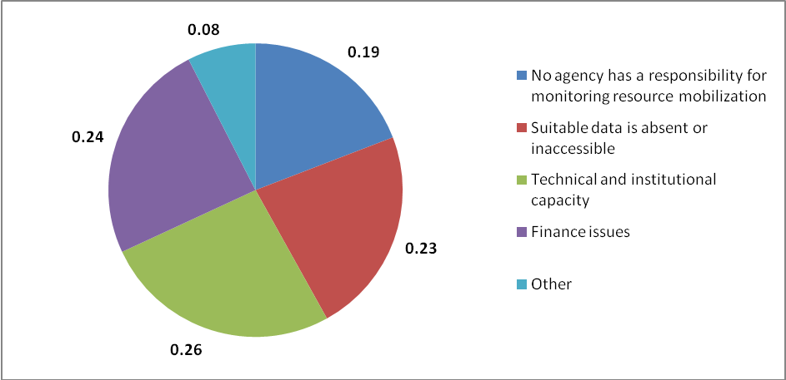
Figure 9: Main constraints to national reporting on the adopted indicators for resource mobilization (n = 32). Six options ranked and weighted by importance.
Lack of technical and institutional capacity
Limited ‘technical and institutional capacity’ was ranked as the greatest constraint for reporting on the adopted indicators. This is consistent with the finding of the national case studies. At CBD COP 9 in Decision IX/11 the text specifies that ‘each party should consider appointing a “resource mobilization focal point” to facilitate national implementation of the strategy for resource mobilization’. This request was further highlighted at CBD COP 10 in Decision X/3 when parties that had not done so where invited ‘appoint a “resource mobilization focal point” to facilitate national implementation of the strategy for resource mobilization’. The primary function of resource mobilization focal points is the organizing the design and dissemination of a country-specific resource mobilization strategy, with the involvement of key stakeholders such as non-governmental organizations, indigenous peoples and local communities, environmental funds, businesses and donors, in the framework of updated national biodiversity strategies and action plans. In addition, resource mobilization focal points should act as liaisons with the Secretariat on behalf of their Parties and in so doing they are responsible for:
- Receiving and disseminating funding information related to the Convention;
- Ensuring that Parties are represented at finance-related capacity building and awareness raising workshops under the Convention;
- Identifying experts to assist with the implementation of the Strategy for Resource Mobilization of the Convention;
- Responding to other requests for input by Parties from the Conference of the Parties and the Secretariat;
- Collaborating with resource mobilization focal points in other countries to facilitate implementation of Articles 20 and 21 and other related provisions of the Convention, particularly at the regional and sub regional level;
- Monitoring, promoting and/or facilitating national implementation of the Strategy for Resource Mobilization of the Convention.

The Resource Mobilization focal points would therefore be responsible for reporting or coordinating reporting on the adopted indicators. In August 2011, 48 parties out of 193, 25% have appointed a resource mobilization focal points. Only five resource mobilization focal participated in the survey, with only three taking part in the constraint question and this may explain why technical and institutional capacity ranked as the highest constraint for indicator reporting.

Even if a country has the institutional capacity of at least one person, such as a resource mobilization focal point, for reporting on the adopted indicators the technical capacity and skills they should have for indicator reporting include:

- A technical understanding of resource mobilization issues and economics,
- understanding of the scientific and statistical strengths of the data required,
- a basic competency in data processing
- good knowledge of the adopted indicators and the reporting system for information collection.

Lack of suitable data for reporting
The lack of suitable data for the indicators was ranked as the second greatest constraint for indicator reporting. As discussed in Section 3.8, survey respondents were asked if data were available for reporting on the indicators applicable to national parties. The results showed that data availability for the adopted indicators was extremely low; with only 4 sub indicators and 1 indicator showing a reasonable amount of data availability (over 50% of respondents answering that data was available). For many of the indicators a large percentage of the respondents answered that no data was available.
Finance issues
The constraint of ‘finance issues’ is a frequent and fundamental problem for indicator development and reporting. Financial assistance for reporting on the adopted indicators could be utilised in the following ways:
- For building technical capacity for the resource mobilization indicators,
- the development of monitoring and reporting systems,
- support the actual reporting processes for the adopted indicators.
Lack of responsibility for resource mobilization monitoring
The fourth ranked constraint of, ‘No agency has responsibility for monitoring resource mobilization’, is also considered a key issue in regards to indicator reporting. Without at least one position or person who has the responsibility for the coordination and reporting of resource mobilization in support of biodiversity, it is very difficult for decision-makers and other stakeholders to be aware of and support resources mobilizations issues and the related information requirements. One questionnaire respondent commented:
“The Ministry of Economic Planning and Finance is the one which monitors the resource mobilization in the country at national level but resources allocated to biodiversity are not monitored at this level”.
More than one department is often responsible for monitoring different aspects of resource mobilization in relation to biodiversity and as such coordination of these departments for reporting on the indicators, and particularly those that rely on institutional knowledge rather than quantifiable data, will be extremely difficult. The UK case study demonstrated the different responsibilities of government departments for resource mobilization. The UK Department for International Development prepares the project documents (business case) for all spending interventions and reports to OECD DAC on ODA. Whilst the UK Department of Environment Food and Rural Affairs (Defra) collates and coordinates a suite of biodiversity indicators including two related to resource mobilization.

7. OPTIONS TO SUPPORT PARTIES IN REPORTING ON THE ADOPTED INDICATORS FOR IMPLEMENTATION OF THE STRATEGY ON RESOURCE MOBILIZATION

The options and issues presented in this section of the report have been identified in response to the results, constraints and lessons learnt sections of this report, including the results of the on-line survey.
Results from the online survey
In the online survey 32 respondents (mostly CBD national focal points) ranked five options in answer to the question, “In addition to increased funding, what are the most important ways international assistance could support reporting on the adopted indicators”. The results raked all five options with a similar importance (Figure 10), and the options can be seen as complementary.
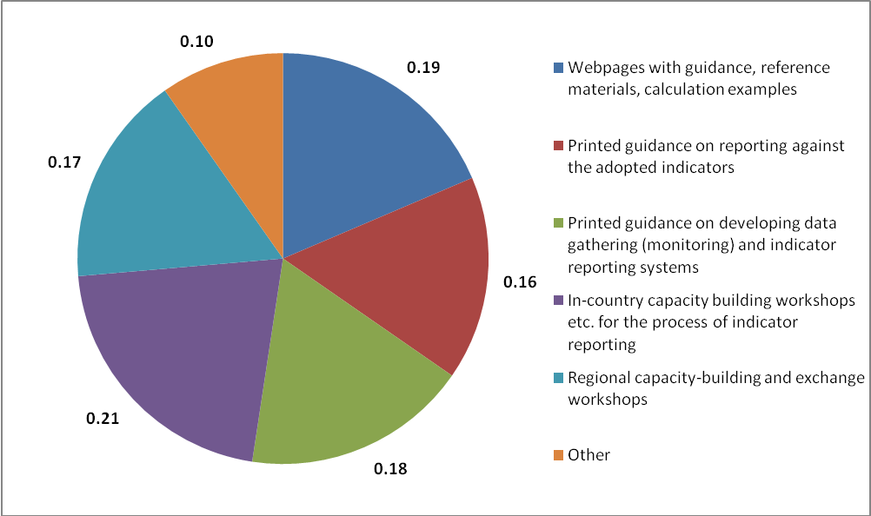
Figure 10: International support needed for reporting against the adopted indicators for resource mobilization (n=32). The proportion of six options ranked and weighted by order of use.
In country capacity building workshops for the process of indicator reporting was ranked as the most favoured option, and regional capacity-building and exchange workshops ranked fourth most important option. The UNCCD PRAIS project for performance indicator reporting included a capacity building component, based on the establishment of a global partnership is support of the reporting process. In addition to the two Convention institutions(UNCCD secretariat and GM) and UNEP-WCMC, the partnership involved a network of fourteen regional and sub-regional organizations, the Reference Centres (RCs), with a recognized expertise and mandate in sustainable land management and implementation of the UNCCD at the regional and sub-regional levels. Using a “training of trainers” approach, the adoption of such a decentralized approach hasallowed the project to capitalize onexisting expertise available within the regions and contribute to further develop capacities at national and regional level, resulting in overall increased sustainability of the project. A review of the results of the PRAIS reporting system (over 120 reports received) and feedback from country Parties, demonstrates that the capacity building strategy of the project was successful. Albeit with different levels of satisfaction, the regional approach was well received. The “Training of Trainers” approach was particularly effective in building a global network of “regional teams” that that, working in close cooperation with the secretariat and the GM, have mobilized resources and strengthened service delivery to country Parties in their respective regions and have been successfully passing knowledge to the national level. A similar approach could be considered by the CBD for reporting on the adopted indicators for resource mobilization to address the international need for regional and in-country capacity building workshops.
A website/web pages with guidance, reference materials and calculation examples was amongst the highest ranked options for international assistance. An example of this type of resource is the website of the Biodiversity Indicators partnership www.bipindicators.net and its linked website to support national indicator developers www.bipnational.net. The UNCCD PRAIS project webpages are also a good example of the information that can be made available for indicator reporting http://www.unccd.int/prais/ and http://www.unccd-prais.com/. The website of the CBD Secretariat and its Clearing House Mechanism for information on the Strategy for Resource Mobilization and its implementation including the definitions and calculation procedures for the indicators.
Printed guidance on developing data gathering (monitoring) and indicator reporting systems was ranked third in the survey ahead of printed guidance on reporting against the adopted indicators, demonstrating the need for national parties to first develop monitoring systems to collect resource mobilization data before they are in a position to report on the adopted indicators. This follows the results from the feasibility review in which technical support and capacity building for the development of monitoring and reporting systems was needed for a large percentage of the indicators before national reporting would be possible. These materials should be available in all UN languages. They should obviously be made through a website, and could be updated in a wiki-style manner.
Other needs and recommendations for international assistance identified by participants in the online survey included:
“International assistance already provides support for developing NBSAPs, drafting National Reports, including national Resource Mobilization Strategies. The CBD Secretariat could cover the provision of guidance.”
“Information campaigns on regional and local/municipal levels and provision of printed information materials, booklets and guidance”.
Funding Needs
Whilst the above needs and activities are all important it should be recognised that they were identified in addition to the need for more funding to indicator reporting. The lack of funds is an issue that developing country Parties to the CBD have consistently highlighted as a major constraint for all aspects of implementing the Convention.

8. CONCLUSIONS

Conceptual understanding of the indicators
The adopted indicators cover all eight goals of the Strategy for resource mobilization. There are a number of direct and indirect overlaps between the adopted indicators. Direct overlaps are where there are no transparent differences between the indicators. This was the case for indicators 1(b) and 3 which both monitor biodiversity related funding in domestic budgets. The difference between indicator 11 and the aggregation of a number of the sub indicators/components under indicator one is also not evident. Indicator 11 monitors the total amount financial resources from developed to developing countries which contribute to achieving the Convention’s objectives. There are also direct overlaps between indicators 11 and 12 which measure total financial resources for the Conventions objectives and implementation of the Strategy for Biodiversity 2011-2020 respectively. Indirect overlaps exist between indicators 1(h), 1(i), 8 and 9 which all relate to technical cooperation and capacity building activities.
Level of data collection for global indicator production
The level of data needed for the production of the indicators varies. Eight of the indicators, plus two of the sub indicators under indicator one, relate to resource mobilization activities and financial commitments at the government level. Data for these indicators needs to be collected at the national level and aggregated for the production of the global indicators. Four of the adopted indicators will rely on global data either because the resources which the indicator monitors are provided at the organizational level or because the activity being monitored only occurs at this level. Two of the indicators will rely on data collected at both the national and global scale. Indicator one is unique in that it will aggregate sub indicators which vary in the level of data they require for individual production.
Existing data and indicators
Many of the indicators are reliant on specific national level data and existing datasets bringing together this information are few. Further to this it is likely that any new system developed to collate such information at a National level would depend on institutional knowledge rather than a systems approach to data collection. Where internally recognized global data sets are available for the indicators, there are sometimes caveats with their use.
The CBD previously adopted a global indicator entitled ‘Official Development Assistance provided in support of the Convention on Biological Diversity’ as part of its indicator framework for monitoring progress towards the 2010 Biodiversity Target. This existing global indicator directly relates to adopted indicator 1(a), which in turn overlaps with indicators 11 and 12.
The Streamlining European 2010 Biodiversity Indicators (SEBI2010) initiative includes an indicator entitled ‘Financing biodiversity management’. This indicator, developed to answer the policy question ‘How much public funds are being committed to conservation of biodiversity?’ contains information for EU funding of projects using the LIFE financial instrument for the environment.
A review of resource mobilization indicators reported in fourth national reports to the CBD found the number of existing national indicators to be low with reported indicators relating to three of the adopted indicators; 1(a), 1(b) and 15.

Indicator reporting
The majority of the adopted indicators focus on government level financial commitments and activities and data therefore would need to be collected at the national level. A reporting system would enable the collection of this data which is often kept within government databases and not available through other means such as international data sets. The reporting could also extend to other entities such as organizations and agencies which may mobilize resources or manage data sets.
The reporting entities vary between the indicators. Developed and developing country parties would be required to provide data for ten and nine of the adopted indicators respectfully. Sub indicators 1(c) -1(f) refer to specific organizations /agency types and as such these named entities will be responsible for reporting against these indicators.
Indicators 4, 5 and 6 are only applicable for reporting by the GEF, CBD Secretariat and OECD respectively, as these organizations hold the data with which these indicators are concerned. Two of the indicators, 14 and 15 are applicable to all reporting entities as there are concerned with the establishment of activities associated with Innovative Financial Mechanisms and Access and benefit Sharing Initiatives.
Data fields for indicator reporting
Core data fields were identified for each of the 15 indicators for their production at the simplest level. However, it was evident from the review of the indicators that these data fields could be expanded with the addition of extra fields or response categories. For example indicators two and seven are concerned with the number of countries implementing certain aspects of the strategy for resource mobilization and as such the collection of data for these indicators at the simplest level could be through the use of YES/NO questions. A more useful approach would be to use a series of response categories which could be ranked according to their closeness towards the final implementation objective. This would enhance interpretation by enabling progress in implementation to be monitored adequately over time, with parties being able to move from one category to the next. This approach may also enable the formation of an index which could provide a measure the movement of parties across the categories towards the preferred category/situation.
For the majority of the indicators which respond to financial values or the number of activities/initiatives it would be possible for reporting to occur at the initiative or activity level. There are a number of advantages to initiative/activity level reporting:
- Reduces reporting burden: indicator calculation – parties provide activity/initiative level data and there is no requirement for them to undertake calculations for data submission.
- Reduces reporting burden: overlapping indicators – information provided at activity/initiative level could be used for the production of overlapping indicators
- Ensures consistency in indicator calculation – indicators could be calculated using the underlying data from all parties and therefore reducing any discrepancy or inconsistencies in calculation processes.
- Enhances indicator interpretation - enables the collection of supplementary information which can be used to enhance indicator interpretation.
- Reduces the risk of double counting – enables institution/organization responsible for producing the indicator to separate out the specific data needed for indicator calculation using the additional fields to identify and correct for double counting.
The use of activity level data fields could be used for all indicators however this could act to increase reporting burden and be costly. Instead activity level reporting could be restricted to indicators that overlap in their design, enabling reporting entities to report data variables once with these variables being used to populate multiple indicators.
National capacity for Indicator reporting
The results of the online survey completed by CBD focal points and resource mobilization points found data availability at the national level to be low for reporting against the majority of the indicators. Over 40% of respondents answered that no data was available for reporting against five of the indicators and three sub indicators. In addition, for many of the indicators a large percentage of respondents did not know if data was available. None of the respondents stated that data was available for reporting against indicator 12, which measures financial resources from developed to developing Parties for implementation of the Strategic plan and this is likely due to the recent adoption of the Strategic Plan.
National capacities for reporting were most promising for indicators 7, the ‘Number of Parties that integrate considerations on biological diversity and its associated ecosystem services in development plans and budgets’ and 11, the ‘Amount of financial resources from all sources from developed countries to developing countries to contribute to achieving the Convention’s objectives’ with over 60% of respondents answering that data was available for reporting against the associated data fields. In addition, over 50% of respondents answered that data was available for reporting against indicator 3 and sub indicators 1(a), 1(b), 2(a) and 2(b).

Current feasibility of the adopted indicators
The current feasibility of the adopted indicators was reviewed with each indicator being assigned to one of the following categories:
- Ready for immediate use - Existing Data Sources can support the production of the indicator in the first instance (the use of reporting for improved data collection should still be could be considered in the long run)
- Adequate reporting system needed for indicator production – Indicators which will have to rely on reporting for data collection and over 50% of survey respondents answered that data was currently available. Adequate guidelines, technical assistance and capacity building for reporting will be needed.
- Technical support and capacity building needed for the development of monitoring and reporting systems - Indicators will rely on reporting for data collection and survey results show that over 50% of parties answered that no data or they didn’t know what data was currently available for indicator reporting. Substantial investment in technical support and capacity building is needed to assist parties in developing monitoring and reporting systems for these indicators.
- Further development of indicator subject needed – Indicators meet the same criteria as in category 3. However, the indicators are associated with new and emerging subjects within the CBD. Indicator production is dependent on the further development of these areas including the adoption of future decisions.
Four indicators and two sub indicators under indicator 1 are ready for immediate use if existing datasets are utilized. Three indicators and six sub indicators would require the establishment of an adequate reporting system before they can be developed.
A high number of indicators, five indicators and five sub indicators would require considerable investment in technical support and capacity building to develop the underlying monitoring systems needed for indicator reporting. Indicator 14 is unique in that it monitors the number and financial value of new and Innovative Financial Mechanisms (IFMS). IFMs as a supplementary source of resource mobilization is still under discussion and production of this indicator should perhaps be halted until future decisions on IFMs have been adopted.
Adopted indicators and the Aichi Targets
Whilst all of the adopted indicators are relevant to Target 20, a number of the indicators also overlap with other Aichi targets. For example, indicator two on country level implementation overlaps with Aichi targets 14, 15, 16 and 17. This overlap means that as well as monitoring implementation of the Strategy on resource mobilization and target 20, the adopted indicators can be used to interpret progress towards a number of the Aichi targets.
Experiences and lessons learnt from similar indicator processes
A review of the UNCCD reporting system for a suite of performance indicators, entitled the Performance Review and Assessment of Implementation System (PRAIS), provided a number of relevant experiences and lessons learnt for the development of indicator reporting systems. In general the PRAIS system was well received by Parties which have largely found the application of the new methodology to be a major step towards improved evidence-based decision-making within the UNCCD and confirmed their strong commitment to the full implementation of PRAIS.
As with the adopted indicators the UNCCD performance indicators are applicable to a range of reporting entities. A new set of reporting guidelines, including templates and instructions for the compilation of the report, was developed not only for affected and developed country Parties, but also for other reporting entities such as Civil Society Organizations, UN Agencies and Intergovernmental Organizations, the Global Mechanism and the GEF Secretariat.
The reporting templates for the performance indicators are very sophisticated often collecting both quantitative and qualitative information. These carefully designed templates allow for enhanced interpretation of the indictors through disaggregation or the use of supplementary information.
As well as reporting on the individual indicators parties where required to complete a Standard Financial Annex (SFA) to consolidate information on financial resource mobilization. The SFA is designed to be used by each country Party and other reporting entities to list all financial commitments they have made during the reporting period in support of institutions, programmes projects, as well as other relevant initiatives undertaken at national or internal level for the implementation of the Convention. The CBD may wish to consider the use of a similar approach which would provide comprehensive information and reduce reporting burden. For example the use of a reporting template similar to the Standard Financial Annex would enable Parties to report on all resources mobilized. The data from the template could then be aggregated for the production of a number of the adopted indicators relating to financial flows, meaning that parties would not be required to report separately on these indicators a process which would involve the use of technical calculation procedures. A similar template would also reduce the risk of double counting, which is a serious consideration for the production of indicator one which it’s many sub indicators.
The PRAIS project utilized an online reporting tool. While posing a new set of challenges to country Parties, the introduction of the online reporting was largely successful, with only a very limited number of countries having to resort to submit their report using an off-line format.
Constraints for National Reporting
Limited technical and institutional capacity was ranked as the greatest constraint for reporting on the adopted indicators. This constraint may be connected with the limited number of national resource mobilization focal points which have so far been appointed. The primary function of the focal points is organizing the design and dissemination of a country-specific resource mobilization strategy in the framework of updated national biodiversity strategies and action plans and as the main focal point for the Secretariat concerning resource mobilization. As such the focal points would likely be responsible for reporting or coordinating reporting on the adopted indicators.
The lack of suitable data was ranked as the second greatest constraint for indicator reporting. As shown in the review of national capacity, data availability for the adopted indicators was extremely low; with only one indicator and four sub indicators showing a reasonable amount of data availability.
The constraint of ‘finance issues’ is a frequent and fundamental problem for indicator development and reporting. The fourth ranked constraint was the lack of institutional responsibility for monitoring resource mobilization. This was also highlighted in the UK case study with different government departments being responsible for the collation and management of different data concerning resource mobilization.
Options to support parties
In addition to increased funding, in country capacity building workshops for the process of indicator reporting and regional capacity-building and exchange workshops were ranked as the favoured and second favoured options for international assistance, respectively. The UNCCD PRAIS project for indicator reporting utilized a “training of trainers” approach for capacity building, enabling the project to capitalize on existing expertise available within regions and contribute to further develop capacities at national and regional level, resulting in overall increased sustainability of the project. A similar approach could be utilized for building capacity for reporting on the adopted indicators for resource mobilization.
A website/web pages with guidance, reference materials and calculation examples was amongst the highest ranked options for international assistance. Printed guidance on developing data gathering (monitoring) and indicator reporting systems was ranked third in the survey ahead of printed guidance on reporting against the adopted indicators, demonstrating the need for national parties to first develop monitoring systems to collect resource mobilization data before they are in a position to report on the adopted indicators.

9. RECOMMENDATIONS

In Decision X/3 the Executive Secretary was requested to compile information from all sources to provide methodological guidelines to Parties during 2011 to enable implementation of the methodology and application of the indicators to establish a baseline year. The decision invited Parties, Governments and relevant international organizations to submit views and information on the adopted indicators to the Executive Secretary to support the production of the methodological guidelines.

The following recommendations or suggestions are to assist the Executive Secretary in the production of the methodological guidelines for the adopted indicators. The recommendations are not listed in an order of priority.

Specific issues and considerations for each of the indicators can be found in the indicator factsheets (Appendix 3).

For the original design and conceptual understanding of the indicators:

Recommendation 1:
The indicators which directly overlap in their design could be evaluated to identify the justification for their separation. If the indicators are found to overlap completely then special consideration should be taken when designing the reporting templates and establishing targets.
Rationale:
A number of the indicators overlap in their design and there is a lack of transparency concerning differences between them and the reason for their separation. These indicators could be investigated to determine if there is justification for the separate indicators or if the same data could be used to generate both indicators and potentially reduce reporting burden. If all indicators are taken forward care should be taken when establishing targets for overlapping indicators to ensure that they are compatible.

Recommendation 2:
The indicators which consist of a count of the number of projects /initiatives should be reviewed to determine if they can provide adequate representation of resource mobilization efforts over time.
Rationale:
Indicators which represent a count of the number of initiatives/projects may not necessarily provide an accurate proxy for trends in resource mobilization. For example, countries could spend the same amount of money but split this across more initiatives and projects. The use of these indicators therefore needs to be considered, especially in regards to whether a greater number of initiatives/projects would necessary equate to greater support for biodiversity protection.

For the development of methodological guidance for the indicators:

Recommendation 3:
The CBD should provide clear guidance for each of the adopted indicators which includes comprehensive glossaries, criterion for data use and illustrated examples of the data which could be used.
Rationale:
Different capacities exist in regards to reporting on the adopted indicators. The indicators may not necessarily align with existing monitoring systems for resource mobilization and clear guidance is needed to help reporting entities extract the appropriate data for each of the indicators.

Recommendation 4:
Indirect overlaps, where indicators share certain measures or elements, should be investigated and reviewed in regards to the development of methodological guidance and data collection processes.
Rationale:
It may be possible in the case of indicators with indirect overlaps for a common set of data fields to be used for reporting which could populate all concerned indicators. This could help reduce the reporting burden for national parties by enabling them to report once at the activity level.

Recommendation 5:
Where indicators relate to the number of initiatives undertaken, clear guidance is needed on the level of initiatives that should be reported.
Rationale:
Indicators which focus on the number of initiatives may present difficulties with cross party comparisons, as year on year changes may reflect changes in the structure of how programmes are organized rather than a real changes. There can also be different interpretations of what is considered as an ‘initiative’. For example clarification is needed on whether parties are required to report at the level of umbrella initiatives or the individual projects that exist under them.

For the development of reporting templates:

Recommendation 6:
Separate reporting templates and guidelines should be provided for each of the different reporting entities. Templates should be extensive providing examples of possible data sources, definitions, etc.
Rationale:
The entities responsible for reporting vary for the different indicators. Specific templates and guidelines should be provided for each entity type to reduce confusion in indicator reporting.

Recommendation 7:
As well as collecting the quantitative data needed for the indicators the template should also be used for the collection of supplementary data, including qualitative data that could be used to enhance indicator interpretation
Rationale:
The collection of supplementary information in addition to the basic data needed for the indicator could help enhance indicator interpretation. Supplementary data or information such as the specific CBD objectives targeted, exchange types, etc would enable the indicator to be disaggregated and trends to be examined in more detail. Suggestions for additional data fields are provided in the indicator factsheets (Appendix 3). The collection of qualitative data for the indicators would enable parties to include information on the underlying reasons for positive or negative responses towards achievement of the targets.

Recommendation 8:
The use of initiative/activity level reporting could be investigated for each of the indicators, especially in regards to overlapping indicators, instead of asking parties to report on total counts or financial investments.
Rationale:
For the majority of the indicators it is possible to report at the initiative or activity level. There are a number of advantages to this approach:
- Reduces reporting burden: indicator calculation – parties provide activity/initiative level data and there is no requirement for them to undertake calculations for data submission.
- Reduces reporting burden: overlapping indicators – information provided at activity/initiative level could be used for the production of overlapping indicators
- Ensures consistency in indicator calculation – indicators could be calculated using the underlying data from all parties and therefore reducing any discrepancy or inconsistencies in calculation processes.
- Enhances indicator interpretation - enables the collection of supplementary information which can be used to enhance indicator interpretation.
- Reduces the risk of double counting – enables institution/organization responsible for producing the indicator to separate out the specific data needed for indicator calculation using the additional fields to identify and correct for double counting.
The use of activity level data fields could be used for all indicators however this could act to increase reporting burden and be costly. Instead activity level reporting could be restricted to indicators that overlap in their design, enabling reporting entities to report data variables once with these variables being used to populate multiple indicators. Activity level reporting could be conducted with the use of well structure reporting templates.
A similar approach was adopted by the UNCCD indicator reporting process, PRAIS, for the collection resource mobilization information. Parties were asked to report on all activities using the Standard Financial Annex and Project and Programme Sheets.
Recommendation 9:
For indicators concerned with the number of countries undertaking certain implementation activities, a scale or ranking system of response categories should be used rather than simple YES/NO categories.
Rationale:
The use of a scale of response categories concerning activity implementation would enhance indictor interpretation by enabling progress to be monitored adequately over time, with parties being able to move from one category to the next. This approach may also enable the formation of an index which could provide a measure of the movement of parties across the categories towards the preferred category/situation.

For the development and management of reporting systems:

Recommendation 10:
A lead organization should be identified for future development and maintenance of the indicator reporting system. Organizational responsibility would include coordination of the indicator reporting system and collation of the data as well as the calculation of the global indicators and communication of the results for COPs and future editions of the Global Biodiversity Outlook, etc.
Rationale:
As with the development of any indicator reporting system organizational responsibility for its coordination is needed. For example, the PRAIS project for reporting on the performance indicators of UNCCD is a GEF funded project executed by UNEP-WCMC in collaboration with the Global Mechanism and UNCCD.

Recommendation 11:
The use of an online reporting system for the adopted indicators should be considered.
Rationale:
The data collected from individual parties would need to be collated for the calculation of the global indicators. An online reporting system could support this by holding the reported data in a database ready for analysis. The UNCCD PRAIS project developed an online system for reporting on performance indicators. Whilst posing a new set of challenges to country parties, the introduction of the online system was largely successful with only a very limited number of countries having to submit their report using an off-line format. The use of an online portal may help generate buy in with indicator reporting as it enable parties to see how the data provided is being used.

For supporting CBD parties with indicator reporting:

Recommendation 12:
Indicator reporting should be supported through regional and national capacity building and exchange workshops if possible in synergy with reporting needs under UNFCCC and UNCCD
Rationale:
National level capacity for reporting against the indicators was found to be low amongst the Parties represented in the online questionnaire. Regional capacity building workshops could provide guidance on the data needed for each of the indicators, the identification of data sources and how to complete the reporting templates. In many cases that underlying monitoring and data collection systems do not exist and workshops could provide guidance on the establishment of necessary systems. Regional workshops are more cost effective than national level workshops and enable focal points from neighbouring countries to share lessons and experiences.

Recommendation 13:
Printed guidance on developing data gathering (monitoring) and indicator reporting systems and reporting on the adopted indicator systems should be provided in addition to methodological guidance. The guidance should also be made available from the internet.
Rationale:
Decision X/3 calls on the Executive Secretary to provide methodological guidance on the indicators. The online survey conducted as part of this study found national capacity for reporting on the indicators to be low and there is the need for guidance concerning other aspects of reporting on the indicators, such as the establishment of data gathering systems and the process of reporting itself.

Recommendation 14:
Each party should consider nominating a government department or individual to coordinate reporting on the adopted indicators. This is in accordance with Decision IX/11 in which parties were invited to consider appointing a “resource mobilization focal point” to facilitate national implementation of the strategy for resource mobilization.
Rationale:
The primary function of resource mobilization focal point is the organization of country specific strategies and to act as liaisons with the Secretariat for a number of purposes. It is likely that the focal points would be responsible for reporting on the adopted indicators. At a national level the data required for reporting on the indicators is likely to be contained within different Government departments. The focal point or they department in which they are positioned could act to bring together the data for the purpose of reporting.
The adopted indicators and the Aichi targets:

Recommendation 15:
The adopted indicators should not only be considered for monitoring progress towards Target 20 but also other applicable Aichi Targets.
Rationale:
A review by participants of the International Expert Workshop in Support of the AHTEG on Indicators the Strategic Plan for Biodiversity 2011-2020, found that a number of the adopted indicators corresponded to targets other than target 20.

10. GLOSSARY

Academia | Academia refers to all institutions aimed at advancing knowledge development, including educational establishments and research institutions
Access and benefit sharing | Access and benefit sharing also referred to as ‘The fair and equitable sharing of the benefits arising out of the utilization of genetic resources’ is one of the three objectives of the Convention on Biological Diversity.
Article 21 | Article 21 is also known as the Financial Mechanism. The Memorandum of Understanding for Article 21 states that “In accordance with Article 21 of the Convention the Conference of the Parties will determine the policy, strategy, programme priorities and eligibility criteria for access to and utilization of financial resources available through the financial mechanism, including monitoring and evaluation on a regular basis of such utilization. GEF, in operating the financial mechanism under the Convention, will finance activities that are in full conformity with the guidance provided to it by the Conference of the Parties’ (MOU, paragraph 2.1).
Awareness Raising | Awareness raising is a common phase advocacy groups use to justify a particular event, brochure or even the entire organization. Raising awareness refers to alerting a specific audience that a certain issue exists and should be approached in the way the group desires.
Budgets | Budgets are contained in the annual budget documentation approved by a national legislative body, for instance, national parliament, national congress or national assembly.
Capacity building activities | Capacity building activities comprise capacity assessment, capacity building and capacity development activities. Capacity assessment is a structured and analytical process whereby the various dimensions of capacity are assessed within the broader context of biodiversity management systems. Capacity building involves the development of human, material and financial resources and provides means by which skills, experience, technical and management capacity are developed, often through the provision of technical assistance, short/long-term training and specialist inputs (e.g., computer systems) (OECD Glossary. EIIP). Capacity development refers to the national process of developing, enhancing and organizing their systems, resources and knowledge in order to perform functions, solve problems and achieve biodiversity objectives.
CBD Objectives | The Convention on Biological Diversity has three main objectives:  - The conservation of biological diversity  - The sustainable use of the components of biological diversity  - The fair and equitable sharing of the benefits arising out of the utilization of genetic resources
Development plans and strategies | Development plans and strategies may take different forms in various countries, such as national poverty reduction strategies, or national sustainability targets. They constitute a master plan for economic growth and development.
Domestic budgets | Domestic budgets include government budgets at national, regional and local levels.
Foundations | Foundations are non-profit organizations that typically either donate funds and support to other organizations, or provide the source of funding for its own charitable purposes.
Incentives harmful to biodiversity | Incentives that are harmful to biodiversity (or as they have also been called under the Convention in the past ‘perverse’ incentives) emanate from policies or practices that induce unsustainable behaviour that destroys biodiversity, often as unanticipated side–effects of policies designed for other objectives. Harmful incentives can include:  - Subsidies  - Policies and laws governing resource uses  - Environmental policies and/or regulations
Innovative financial mechanisms | Innovative financial mechanisms explore supplementary yet more sustainable financial and economic approaches to human interaction with biodiversity and ecosystem services. Based upon the modern financial and economic methods, innovative financial mechanisms seek to develop financial and economic solutions to the current biodiversity crisis and to transform the prevailing financial and economic systems that have been distortionary in sustaining life on earth, thus avoiding unsustainable commodification of the nature. Innovative financial mechanisms are considered as important instruments to mobilize new and additional financial resources for achieving the Convention‘s objectives, and explored in the broad context of innovation for biodiversity while recognizing the close synergies between conserving biodiversity, combating desertification, and mitigating and adapting to climate change.
International financial institutions | International financial institutions, or IFIs, refers to financial institutions that have been established (or chartered) by more than one country, and hence are subjects of international law. Their owners or shareholders are generally national governments, although other international institutions and other organisations occasionally figure as shareholders. The most prominent IFIs are creations of multiple nations, although some bilateral financial institutions (created by two countries) exist and are technically IFIs. Many of these are multilateral development banks. The best-known IFIs are the World Bank, the IMF, and the regional development banks. Some IFIs are considered UN agencies.
Nagoya Protocol on Access to Genetic Resources and the Fair and Equitable Sharing of Benefits Arising from their Utilization to the Convention on Biological Diversity | The Nagoya Protocol on Access to Genetic Resources and the Fair and Equitable Sharing of Benefits Arising from their Utilization to the Convention on Biological Diversity is an international agreement which aims at sharing the benefits arising from the utilization of genetic resources in a fair and equitable way, including by appropriate access to genetic resources and by appropriate transfer of relevant technologies, taking into account all rights over those resources and to technologies, and by appropriate funding, thereby contributing to the conservation of biological diversity and the sustainable use of its components. It was adopted by the Conference of the Parties to the Convention on Biological Diversity at its tenth meeting on 29 October 2010 in Nagoya, Japan. The Nagoya Protocol will be open for signature by Parties to the Convention from 2 February 2011 until 1 February 2012 at the United Nations Headquarters in New York.
National financial plans for biodiversity | National financial plans for biodiversity normally are part of national biodiversity action plans while country-specific resource mobilization strategies for biodiversity are part of national biodiversity strategies.
Non-governmental organization | Non-governmental organization, or NGO, is a legally constituted organization created by natural or legal persons that operates independently from any government. The term originated from the United Nations (UN), and is normally used to refer to organisations that do not form part of the government and are not conventional for-profit business. Operational non-governmental organizations mobilize financial resources, materials and volunteers to develop and implement localized projects and programmes in the field, Campaigning non-governmental organizations typically try to raise awareness by lobbying, press work and activist events.
Non-ODA public funding | Also called “other official flows” (OOFs) refers to transactions by the official sector with countries on the List of Aid Recipients which do not meet the conditions of eligibility as Official Development Assistance or Official Aid, either because they are not primarily aimed at development, or because they have a grant element of less than 25 per cent.
North-South cooperation | North-South cooperation to enhance technical, financial, scientific and technological exchanges and innovations for biodiversity. South-south cooperation may be financially and/or technically supported by developing countries and international development assistance. Such an arrangement is called “triangular cooperation”.
OECD Development Assistance Committee (DAC) | THE OECD Development Assistance Committee (DAC) is a unique international forum where donor governments and multilateral organisations – such as the World Bank and the United Nations System of Organizations (UN) – come together to help partner countries reduce poverty and achieve the Millennium Development Goals (MDGs). The DAC became part of the OECD by Ministerial Resolution on 23 July 1961. The DAC has the mandate to ‘…consult on the methods for making national resources available for assisting countries and areas in the process of economic development and for expanding and improving the flow of long-term funds and other development assistance to them’.
Official Development Assistance (ODA) | The flows of official financing administered with the promotion of the economic development and welfare of developing countries as the main objective, and which are concessional in character with a grant element of at least 25 percent (using a fixed 10 percent rate of discount). By convention, ODA flows comprise contributions of donor government agencies, at all levels, to developing countries (“bilateral ODA”) and to multilateral institutions. ODA receipts comprise disbursements by bilateral donors and multilateral institutions. Lending by export credit agencies – with the pure purpose of export promotion – is excluded.
Other financial institutions | Other financial institutions refer to multilateral and regional development banks, national development banks and financing agencies such as development agencies.
Private sector | The private sector comprises private corporations, households and non-profit institutions serving households (NPISHs).
South-south Cooperation | South-south Cooperation describes the exchange of resources, technology, and knowledge between developing countries. It is essential cross-cutting mechanism designed to deliver capacity building and technology support activities in developing countries and regions of the South, as a complement to North-South cooperation to enhance technical, financial, scientific and technological exchanges and innovations for biodiversity.
Strategic Plan for Biodiversity 2011-2020 | In decision X/2, the tenth meeting of the Conference of the Parties, held in October 2010, in Nagoya, Aichi Prefecture, Japan, adopted a revised and updated Strategic Plan for Biodiversity, including the Aichi Biodiversity Targets, for the 2010-2020 period.  The new plan will be the overarching framework on biodiversity, not only for the biodiversity-related conventions, but for the entire United Nations system.
Subsidies harmful to biodiversity | Some subsidy types have been identified as critical drivers of activities that are harmful to ecosystems and biodiversity. They negatively impact the environment in two ways:  - Under-pricing the use of natural resources  - Increasing production
Technical cooperation initiatives | Technical cooperation initiatives can be defined as initiatives that provide education or training at home and abroad and/or provide consultants, advisers and similar personnel serving in recipient countries. There are two basic types of technical cooperation (IMF 2003):  (1) Free-standing technical cooperation (FTC), which is the provision of resources aimed at the transfer of technical and managerial skills or of technology for the purpose of building up general national capacity without reference to the implementation of any specific investment projects  (2) Investment-related technical cooperation (IRTC), which denotes the provision of technical services, required for the implementation of specific investment projects.
Valuation of biodiversity and ecosystem services | Valuation of biodiversity and ecosystem services comprises assessments at national, local and project levels, which may be undertaken by national or international experts.

APPENDICES

Appendix 1: Adopted indicators for implementation of the Strategy on resource Mobilization

Taken from Decision X/3: Strategy for resource mobilization in support of the achievement of the Convention's three objectives

(1)Aggregated financial flows, in the amount and where relevant percentage, of biodiversity-related funding, per annum, for achieving the Convention’s three objectives, in a manner that avoids double counting, both in total and in, inter alia, the following categories:

(a)Official Development Assistance (ODA);
(b)Domestic budgets at all levels;
(c)Private sector;
(d)Non-governmental organizations, foundations, and academia;
(e)International financial institutions;
(f)United Nations organizations, funds and programmes;
(g)Non-ODA public funding;
(h)South-South cooperation initiatives;
(I)Technical cooperation;

(2)Number of countries that have:

(a)Assessed values of biodiversity, in accordance with the Convention;
(b)Identified and reported funding needs, gaps and priorities;
(c)Developed national financial plans for biodiversity;
(d)Been provided with the necessary funding and capacity-building to undertake the above activities;

(3)Amount of domestic financial support, per annum, in respect of those domestic activities which are intended to achieve the objectives of this Convention;

(4)Amount of funding provided through the Global Environment Facility and allocated to biodiversity focal area;

(5)Level of CBD and Parties’ support to other financial institutions that promote replication and scaling-up of relevant successful financial mechanisms and instruments;

(6)Number of international financing institutions, United Nations organizations, funds and programmes, and the development agencies that report to the Development Assistance Committee of Organisation for Economic Co-operation and Development (OECD/DAC), with biodiversity and associated ecosystem services as a cross-cutting policy;

(7)Number of Parties that integrate considerations on biological diversity and its associated ecosystem services in development plans, strategies and budgets;

(8)Number of South-South cooperation initiatives conducted by developing country Parties and those that may be supported by other Parties and relevant partners, as a complement to necessary North-South cooperation;

(9)Amount and number of South-South and North-South technical cooperation and capacity-building initiatives that support biodiversity;

(10)Number of global initiatives that heighten awareness on the need for resource mobilization for biodiversity;

(11)Amount of financial resources from all sources from developed countries to developing countries to contribute to achieving the Convention’s objectives;

(12)Amount of financial resources from all sources from developed countries to developing countries towards the implementation of the Strategic Plan for Biodiversity 2011-2020;

(13)Resources mobilized from the removal, reform or phase-out of incentives, including subsidies, harmful to biodiversity, which could be used for the promotion of positive incentives, including but not limited to innovative financial mechanisms, that are consistent and in harmony with the Convention and other international obligations, taking into account national social and economic conditions;

(14)Number of initiatives, and respective amounts, supplementary to the financial mechanism established under Article 21, that engage Parties and relevant organizations in new and innovative financial mechanisms, which consider intrinsic values and all other values of biodiversity, in accordance with the objectives of the Convention and the Nagoya Protocol on Access to Genetic Resources and the Fair and Equitable Sharing of the Benefits Arising out of Their Utilization;

(15)Number of access and benefit-sharing initiatives and mechanisms, consistent with the Convention and, when in effect, with the Nagoya Protocol on Access to Genetic Resources and the Fair and Equitable Sharing of the Benefits Arising out of Their Utilization, including awareness-raising, that enhance resource mobilization;

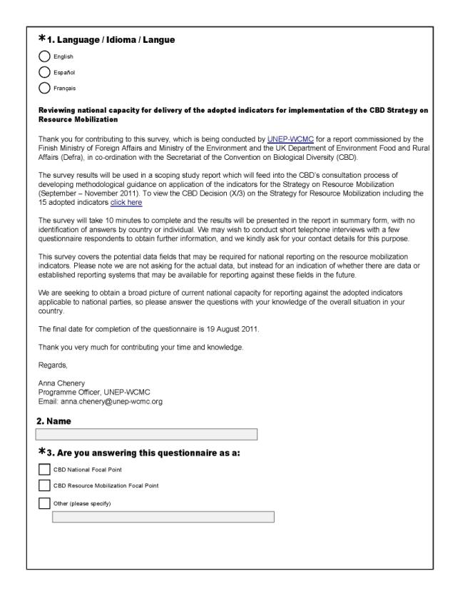
Appendix 2: Survey questions

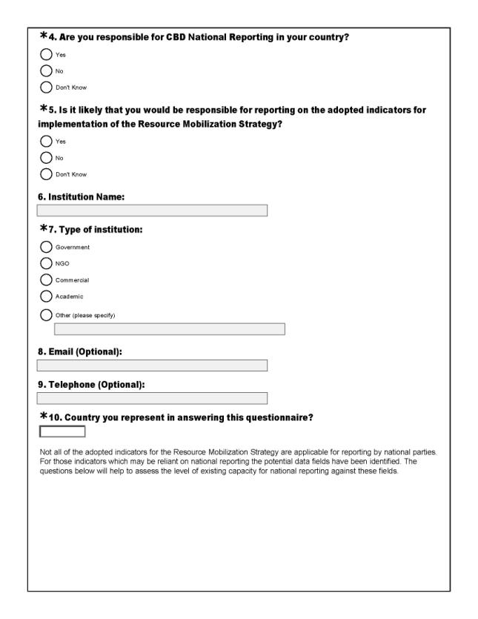

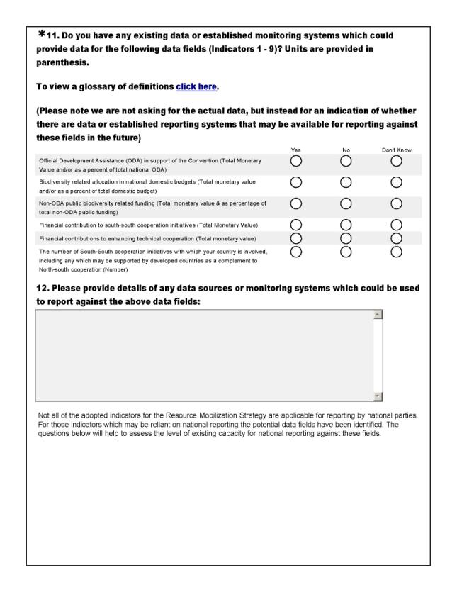

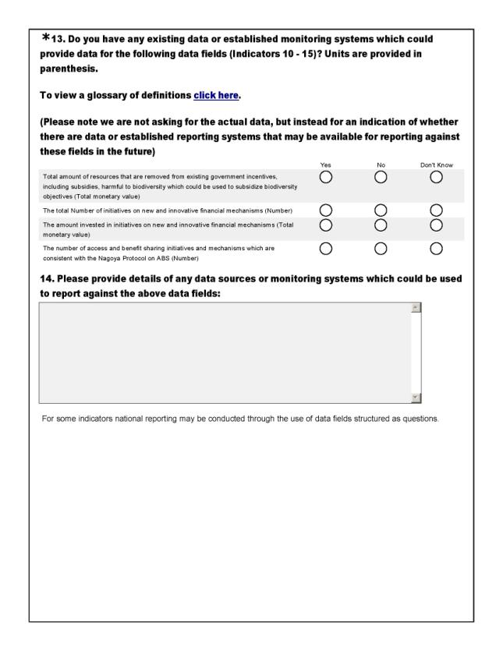

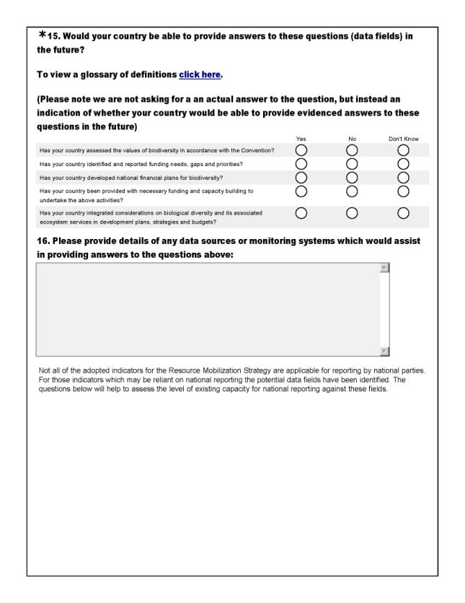

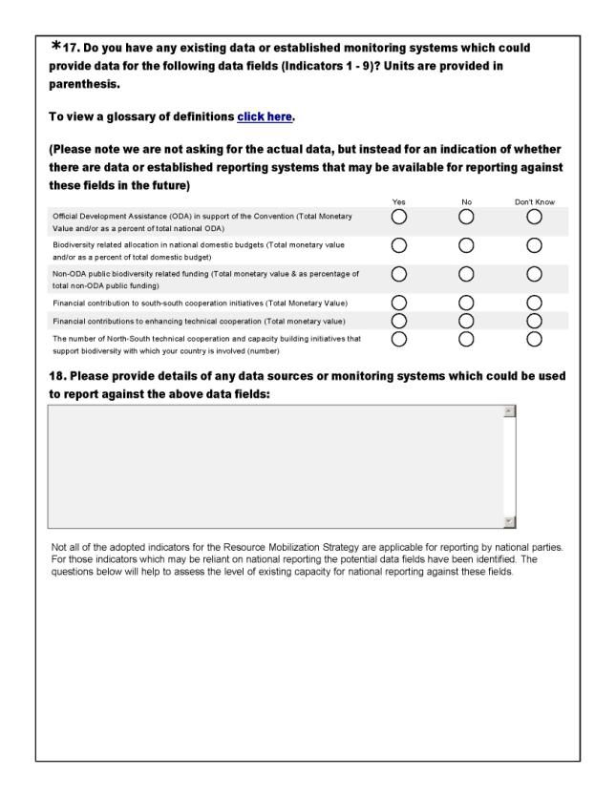

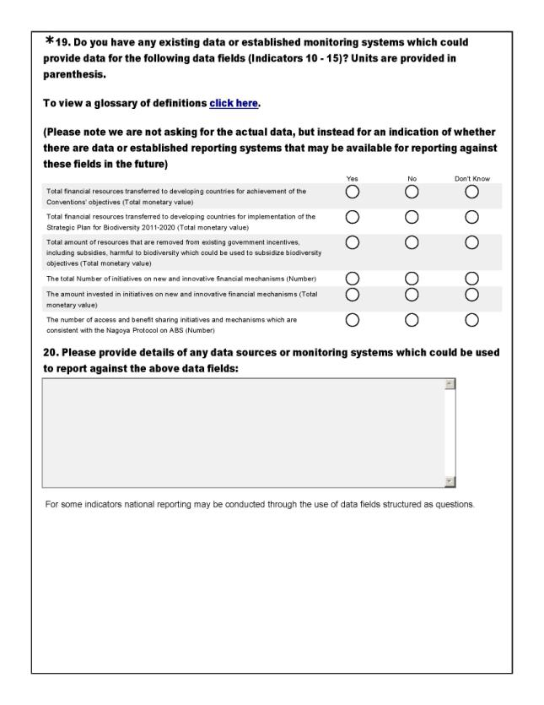

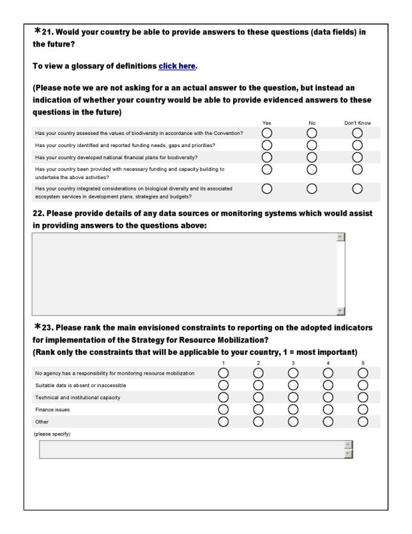

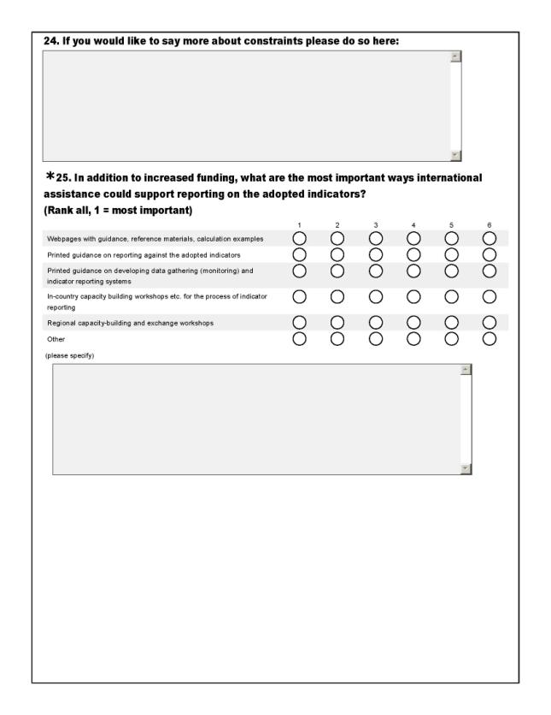

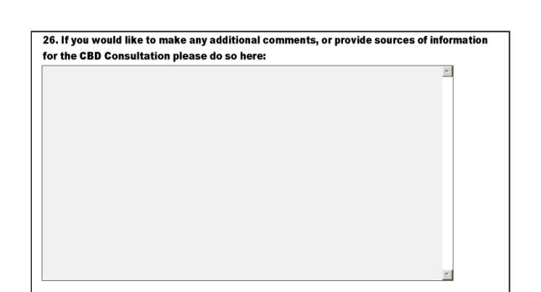

Appendix 3: Indicator Factsheets

A3.1 Aggregated financial flows

Indicator 1
Indicator Text
Aggregated financial flows, in the amount and where relevant percentage, of biodiversity-related funding, per annum, for achieving the Convention’s three objectives, in a manner that avoids double counting both in total and in, inter alia, the following categories:
(a) Official Development Assistance (ODA)
(b) Domestic budgets at all levels
(c) Private sector
(d) Non-governmental organizations, foundations and academia
(e) International financial institutions
(f) United Nations organizations, foundations and programmes
(g) Non-ODA public funding
(h) South-south cooperation initiatives
(i) Technical cooperation

Policy relevance /relation to Strategy for Resource Mobilization
This indicator responds to Goal 1 of the Strategy to ‘improve information base on funding needs, gaps and priorities’. This indicator can also be used to demonstrate efforts in mobilizing all resources, in response to the mission of the Strategy for Resource Mobilization.

Through its sub components this indicator also responds to Goal 2 to ‘Strengthen national capacity for resource utilization and mobilize domestic financial resources for the Convention’s three objectives’ and Goal 6 to ‘Build capacity for resource mobilization and utilization and promote South-South cooperation as a complement to necessary North-South cooperation’.

Indicator Understanding
This indicator will combine biodiversity related funding from all sources to create an aggregated picture of financial flows. Nine categories have been identified within the text as sources of biodiversity related funding.

The indicator as specified will consist of the total sum of financial resources from each of these categories. It is also possible that these categories could be used as sub indicators and presented individually to aid interpretation.

The categories types vary are not not consistent with each other, some categories specifically relate to different elements or measures of biodiversity related funding (a,b,g), whilst other categories actually refer to specific organization/institution/agency types (c, d, e, f) or specific initiative activity types (h, i). This inconsistency means that a funded activity could be included under a number of these sub-components and as specified in the indicator text care should be taken to avoid ‘double counting’.

The text specifies that the indicator will also be presented as percentages were relevant, however it is unlikely that a percentage values are applicable for each category therefore making the presentation of an aggregated indicator in percentages unfeasible. The use of percentage values would therefore be limited to reporting on the individual measures/sub-indicators.

Indicator Overlap

Different sub indicators/components of this indicator overlap with some of the other adopted indicators.

Indicator 1, through aggregation of sub indicator/components a, g, h, and i, directly overlaps with indicator 11 which is a measure of the total amount of financial support from all sources from developed countries to developing countries to contribute to achieving the Convention’s objectives.

Sub indicator 1(b) directly overlaps with indicator 3. Although the wording of these indicators slightly differs, there are no clear differences between the two. Both are concerned with the biodiversity related funding in domestic budgets for achievement of the objectives of the Convention. The text for both indicators also stipulates the same temporality, with data for the indicator being provided on a per annum basis.

There is an indirect overlap between sub indicator 1(h) and indicator 8. deals with the financial investment in South-South cooperation initiatives whilst indicator 8 is concerned purely with the number of South-South cooperation initiatives.

There are also indirect overlaps with indicator 1(i) which deals with the financial investment in technological cooperation and indicator 9 which looks at the number of technical cooperation activities.

Definitions and underlying concepts
Official Development Assistance (ODA) refers to the flows of official financing administered with the promotion of the economic development and welfare of developing countries as the main objective, and which are concessional in character with a grant element of at least 25 percent (using a fixed 10 percent rate of discount). By convention, ODA flows comprise contributions of donor government agencies, at all levels, to developing countries (“bilateral ODA”) and to multilateral institutions. ODA receipts comprise disbursements by bilateral donors and multilateral institutions. Lending by export credit agencies – with the pure purpose of export promotion – is excluded.

Non-ODA public funding, also called “other official flows” (OOFs) refers to transactions by the official sector with countries on the List of Aid Recipients which do not meet the conditions of eligibility as Official Development Assistance or Official Aid, either because they are not primarily aimed at development, or because they have a grant element of less than 25 per cent.

Domestic budgets include government budgets at national, regional and local levels.

The private sector comprises private corporations, households and non-profit institutions serving households (NPISHs).

Non-governmental organization, or NGO, is a legally constituted organization created by natural or legal persons that operates independently from any government. The term originated from the United Nations (UN), and is normally used to refer to organisations that do not form part of the government and are not conventional for-profit business. Operational non-governmental organizations mobilize financial resources, materials and volunteers to develop and implement localized projects and programmes in the field, Campaigning non-governmental organizations typically try to raise awareness by lobbying, press work and activist events.

Foundations are non-profit organizations that typically either donate funds and support to other organizations, or provide the source of funding for its own charitable purposes.

Academia refers to all institutions aimed at advancing knowledge development, including educational establishments and research institutions.

International financial institutions, or IFIs, refers to financial institutions that have been established (or chartered) by more than one country, and hence are subjects of international law. Their owners or shareholders are generally national governments, although other international institutions and other organisations occasionally figure as shareholders. The most prominent IFIs are creations of multiple nations, although some bilateral financial institutions (created by two countries) exist and are technically IFIs. Many of these are multilateral development banks. The best-known IFIs are the World Bank, the IMF, and the regional development banks. Some IFIs are considered UN agencies.

South-south Cooperation describes the exchange of resources, technology, and knowledge between developing countries. It is essential cross-cutting mechanism designed to deliver capacity building and technology support activities in developing countries and regions of the South, as a complement to North-South cooperation to enhance technical, financial, scientific and technological exchanges and innovations for biodiversity.

Technical cooperation initiatives include both the provision of education or training at home or abroad, and the provision of consultants, advisors and similar personnel serving in recipient countries. It is proposed that only free-standing technical cooperation (FTC) initiatives are counted, and investment-related technical cooperation (IRTC) is included in the provision of technical services required for the implementation of specific investment projects.

Considerations for data collection and indicator development
- Not all categories will be applicable to all parties and as such clear distinction is needed to help identify the categories a party will contribute data too. For example International financial institutions are unable to report on domestic budgets.
- Data for a number for categories may be available from country Parties and the CBD will need to consider how this data will be collected e.g. though a national reporting mechanism or by an organization/institutional indicator champion with access to the data. Data for categories (c,d,e,f) will to come from the listed organization types themselves and therefore if a indicator data is collected via a reporting mechanism then non-party members would also be required to report.
- Definitions for each category need to be clearly provided to ensure that double counting is avoided. For example the difference between ODA and Non-ODA public funding would need to be clearly specified. For example Non-ODA public funding would include transactions to countries not listed on the Part 1 of the DAC list of Aid recipients (Official Aid) or where it is not particularly aimed at development (OOF). Mistakes made in the clarification of these different types of flows could result in double counting.
- Biodiversity related ODA is currently reported to OECD by the Development Assistance Committee (DAC) members. The DAC is an international forum of 24 members: 23 donor governments and the European Commission. All donor parties (with the exception of the EC and the United States which hasn’t ratified the CBD) are on the ‘updated list of developedcountry parties and other parties that voluntarily assume the obligations of developed country parties to the Convention on Biological Diversity’ (Decision VIII/18, Annex 2). Therefore it is likely that data collection/reporting for sub indicator 1(a) will only come from developed country parties which are members of the DAC. However, UNCCD reporting on ODA (as one of their performance indicators) requires all parties to report on ODA including developing Parties. The CBD needs to decide if data from this indicator comes from existing data collected by OECD, or whether national level reporting is used, and in the case of national reporting whether this is extended to developing countries.
- Some categories relate to organisation or agency type whilst others specifically relate to financial flow mechanism or activity/initiative types. Care is needed to ensure that this doesn’t cause confusion and as a result double counting. For example International financial institutions (IFS) are listed as a separate category, however IFS such as the World Bank also report on ODA via OECD DAC and care is needed to ensure that double counting does not occur. Funding provided by the organization types in sub indicators 1(c) – 1(f) may also be used for supporting South-South cooperation (1(h)) and Technical cooperation (1(i)) initiatives/activities.
- If national reporting is used for the collection of data for these sub indicators it would be beneficial to ask Parties to report at the activity/initiative level for a number of reasons:
- Helps to avoid double counting – By using activity related fields, overlaps between the sub indicators can be clarified and monitored. Data can then be aggregated depending on whether it is for the communication of the indicator as a whole or a sub indicator in a way that avoids double counting.
- Data can be used to populate overlapping indicators – A number or combination of the sub indicators overlap with the other adopted indicators. The use of activity level reporting may reduce reporting burden by enabling countries to report once on an activity but for that information to feed into a number of applicable indicators
- Enhance indicator interpretation - activity level reporting enables the collection of supplementary information which can be used to enhance indicator interpretation through indicator disaggregation, etc.
Level of data collection
If reporting is used, data for this indicator could be collected from the following Parties:
- CBD Developed Country Parties
- CBD Developing Country Parties
- Private Corporations
- NGOs, foundations and academia
- International Financial Institutions
- United Nations organizations, foundations and programmes, IGOs

Essential Data fields & Units
Different reporting parties would be required to report against different fields:

Developed and developing parties
- Official Development Assistance in support of the convention (Total monetary value & as percentage of total ODA)
- Biodiversity related allocation in national domestic budgets (Total monetary value & as a percentage of total domestic budget)
- Non-ODA public funding – assistance to countries not on the DAC list of Aid recipients or not aimed at development (Total monetary value & as percentage of total non-ODA public funding)
- Financial contributions to enhancing technical cooperation (Total monetary value)
- Financial contribution to south-south cooperation initiatives (Total monetary values)

Private sector, Non-governmental organizations, foundations and academia, , United Nations organizations, foundations and programmes, International financial institutions
- Total amount of biodiversity-related funding (Total monetary value)
Additional data fields for consideration
For all of these sub indicators it may be beneficial to ask Parties to report at the activity level rather than supplying aggregated totals (see reasons above). This approach is already used by OECD DAC for collecting data on biodiversity related aid.

(a) Official Development Assistance

Reporting/data collection fields for Developed (and possibly Developing) Country Parties (primarily based on fields used by OECD DAC):

- Activity Name:
- Financial resources transferred (Monetary value):
- Donor country:
- Recipient country:
- Applicable Rio Markers (one or a combination of): Biodiversity / Desertification / Climate Change
- Was the commitment*: Principal policy objective (CBD’s objectives fundamental in design of the activity) / Significant policy objective (CBD objectives not principal reason for undertaking activity) / Not targeting objectives of the CBD
- Did the funding support South-South cooperation Initiatives: YES/NO
- Did the funding support Technical cooperation: YES/NO

*Note, OECD DAC use a scoring system to obtain this information.

(b) Domestic budgets at all levels

Data fields for this sub-indicator could also be used to populate indicator 3. Example data fields:

- Activity Name:
- Financial resources transferred (Monetary value):
- Donor country:
- Level of domestic support: National / Regional / Local

(c) Private sector, (d) Non-governmental organizations, foundations and academia, (e) International financial institutions, and (f) United Nations organizations, foundations and programmes

These category types respond to specific organization and agency types and it can be interpreted that these organizations are needed to report on their total biodiversity related funding. Several of these organization types may already be reporting to OECD on ODA through the use of Rio Markers and care needs to be taken that double counting is avoided. These organizations/agencies may also be providing funding for activities listed in sub indicators h and i. The use of the following data fields would enable organizations /agencies to report on their funding once to avoid double counting, and enable the activities which may relate to other sub indicators to be extracted and aggregated if needed. Example data fields:

- Activity Name:
- Financial resources transferred (Monetary value):
- Donor:
- Recipient countries:
- Type of funding: ODA / Non ODA
- Did the funding support South-South cooperation Initiatives: YES/NO
- Did the funding support Technical cooperation: YES/NO

(g) Non-ODA public funding

Reporting/data collection fields for Developed and Developing) Country Parties:

- Activity Name:
- Financial resources transferred (Monetary value):
- Donor country:
- Recipient country:
- Was the commitment*: Principal policy objective (CBD’s objectives fundamental in design of the activity) / Significant policy objective (CBD objectives not principal reason for undertaking activity) / Not targeting objectives of the CBD
- Did the funding support South-South cooperation Initiatives: YES/NO
- Did the funding support Technical cooperation: YES/NO

* Note the same scoring system which relates to the purpose and design of the activity which is used for reporting on ODA may also be applicable to reporting/data collection for non-ODA.

(h) South-south cooperation initiatives, and (i) Technical cooperation

These sub indicators overlap with adopted indicators 8 and 9. It may therefore be possible to use the following set of data fields to provide information for all four indicators:

- Name of initiative:
- Date Established:
- Country providing resources:
- Country receiving resources:
- Financial value of investment in cooperation initiative (monetary value):
- Type of exchange: resources/technology/knowledge/financial
- Description of initiative: technical cooperation/capacity building/other (please specify)

Fields c and d could be used to identify which of the initiatives represent South-South cooperation; these initiatives could then be counted for the production of this indicator.

Existing Indicators
National Indicators

(a) Official Development Assistance
16 countries reported the use of national Official Development Assistance indicators in their forth national reports to the CBD. Five countries, Australia, Ecuador, Germany, Guatemala, Russian Federation and Samoa, reported ODA related indicators with evidence of their use through the presentation of indicator results. For example Samoa reported to have incorporated the CBD’s indicator of ODA in their NBSAP through the use of two national indicators, and the results concluded that the Ministry of Natural Resources and Environment had administered US$ 2.1M of ODA funds since 2000. These national indicators are not always a measure of ODA provided and in the case of Ecuador and Guatemala these indicators are a measure of the ODA received (Ministry of Foreign Affairs and Trade 2009).

b) Domestic budgets at all levels

Nine countries reported the use of national biodiversity indicators related to domestic biodiversity and environment allocation in their forth national report. Five of these countries, Azerbaijan, China, Ecuador, Guatemala and Peru, provided evidence of indicator use through the presentation of results. For example Ecuador utilized it’s indicator to report that expenditure allocated to the environment in 2003, represented 0.39% of the State Budget. Between 2005 -2006 the allocation in domestic budgets for the environment almost doubled, and continued increasing up to 2008 before decreasing in 2009 (Ministerio Del Ambiente Del Ecuador 2010).

Regional Indicators

b) Domestic budgets at all levels

The Streamlining European 2010 Biodiversity Indicators (SEBI2010) initiative includes an indicator entitled ‘Financing biodiversity management’. This indicator, developed to answer the policy question ‘How much public funds are being committed to conservation of biodiversity?’, contains information for EU funding of projects using the LIFE financial instrument for the environment (EEA 2009aundefinedb). This indicator deals with the EU contribution (from the LIFE Programme) to the projects, not the total cost of the projects in total. LIFE tends to cover 50—75% of total costs, depending on the target species and/or habitats. Private or national government spending is not covered by this indicator.

Global Indicators

(a) Official Development Assistance
At its meeting in 2004, CBD COP 7 adopted a framework which recommended the use of a range of biodiversity indicators (Decision VII/30). The Biodiversity Indicator Partnership was later established (Decision VIII/15) to develop and promote the indicator framework. The framework of indicators included the headline indicator and indicator ‘Official Development Assistance provided in support of the Convention on Biological Diversity’. This was the only indicator under the Focal Area ‘Status of resource transfers’.

The indicator measures aid contributions via the Development Assistance Committee of OECD. The DAC is an international forum of 24 members: 23 donor governments and the European Commission (OECD 2010). The DAC collects aid data from its members, and also from other donors (non-DAC countries and multilateral agencies such as the World Bank, regional development banks, UN agencies). Annual aid reporting takes place using the Creditor reporting System (CRS), and donors are requested to indicate for each activity whether or not it targets one or more of the three Rio Conventions. This indicator is only concerned with data collected under the ‘Rio marker’ for biodiversity. For an activity to be labelled with this ‘Rio marker’ it must promote one of the three objectives of the CBD: the conservation of biodiversity, sustainable use of its components, or fair and equitable sharing of the benefits of the utilisation of genetic resources. When assigning the ‘Rio markers’ donors use the scoring system: 0 = Not targeted, 1 = Significant objective, 2 = Principal objective. Donors are also asked to report on the sectoral breakdown of activities.

The DAC has collected ‘Rio marker’ data from 1998 onwards: data for years 1998-2006 were obtained on a trial basis, and reporting became mandatory starting with 2007 flows. The data included some gaps, inconsistencies and partial reporting, but the coverage improved regularly. For 2008 data, only Luxembourg, Norway and the United States did not report on the biodiversity marker.

Further information regarding this indicator can be found on the Biodiversity Indicator Partnership Website: www.bipindicators.net/oda

National Level Data Availability
An online survey was distributed to CBD National Focal Points and Resource Mobilization Focal Points to assess national level capacity for reporting the adopted indicators applicable at the national level. Parties were presented with the data fields for the production of this indicator at the simplest level and were asked if they had data available to report against these fields.

(a) Official Development Assistance

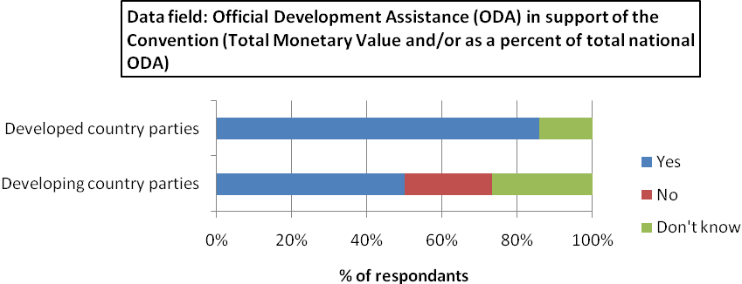

86% of developed country parties who took part in the survey have data available to report against this indicator, compared with only 50% of developing country parties. 23% of developing country parties do not have data available for this indicator. 27% and 14% of developing country parties and developed country parties were unsure of whether data was available for this indicator respectively.

b) Domestic budgets at all levels
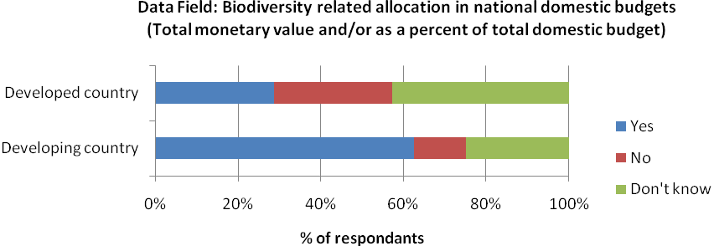
61% of developing countries have existing data or established monitoring systems to provide data for this indicator, while 13% do not. This compares with available data in just 29% of developed countries ,and 29% lacking in data. 26% of developing countries and 43% of developed countries said they did not know.

(g) Non-ODA public funding
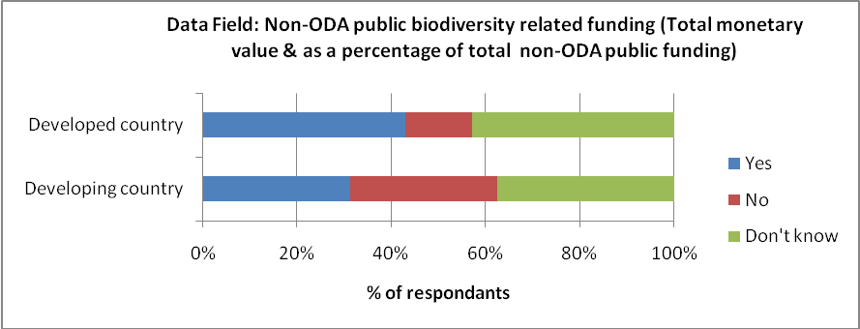
43% of developed countries have data available for this field, while 14% do not and 43% are unsure as to its availability. For developing countries, 32% have existing data, 29% do not and 39% are unsure.

(h) South-south cooperation initiatives
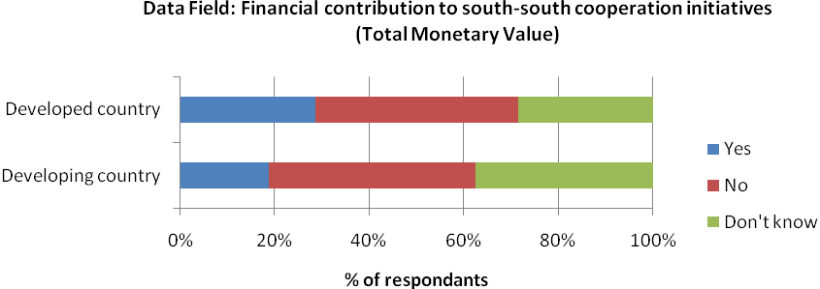
29% of developed countries have data available for this field, while 43% do not and 29% are unsure as to its availability. For developing countries, only 19% have existing data, 45% do not and 35% are unsure.

(i) Technical cooperation
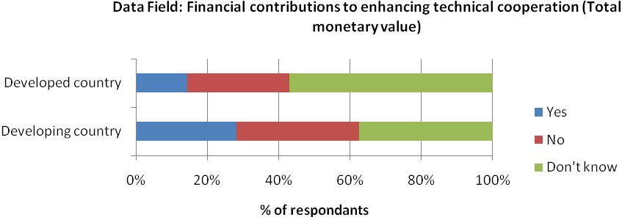
29% of developed countries have data available for this field, compared with only 19% of developing countries. 43% of developed countries lack appropriate data, while 29% don’t know, and 45% of developing countries lack appropriate data, while 35% don’t know.

Possible Data Sources
Regional Level

b) Domestic budgets at all levels

EU LIFE Nature Project
LIFE is the EU’s financial instrument supporting environmental and nature conservation projects through the EU, as well as in some candidate, acceding and neighbouring countries. The LIFE programme was adopted in 1992 to support the implementation of Community policy and legislation in the field of the environment. One of the three strands - LIFE - Nature - is designed to contribute to the implementation of Community nature protection legislation: the “Birds” Directive 79/409/EEC and the “Habitats” Directive 92/43/EEC and in particular the establishment of the Natura 2000 Network. Its main aim is therefore to preserve biodiversity .

It is important to note that LIFE-Nature project does not necessarily target biodiversity conservation directly, but that many of the projects do have benefits for biodiversity. Project information is stored in a database available from the LIFE Programme website: http://ec.europa.eu/environment/life/project/Projects/index.cfm

(b) Domestic budgets at all levels and Private sector

Environmental Protection Expenditure, Eurostat
Eurostat works towards systematically collecting environmental statistics for all economic sectors within the EU. These statistics are used to assess the effectiveness of new legislation and policies and to analyse the links between environmental pressures and the structure of the economy.
For many years, European statistical services have collected data on air pollution, energy, water consumption, wastewater, solid waste, and their management. Data on environmental expenditure are collected through a joint OECD/Eurostat questionnaire on environmental protection expenditure and revenues (EPER). The Member States are free to decide on the data collection methods used, and the main options are: surveys, administrative sources, statistical estimations, the use of already existing sources, or a combination of methods.

Traditionally, data availability has been better for the public sector as many countries have collected data in this area for a number of years. However, problems concerning data comparability across countries exist; these are often related to the structure of expenditure. For industrial activities (mining and quarrying, manufacturing, electricity, gas and water supply) most countries provide data, while the comparability of the information is considered to be good. For private and public specialised producers, while overall data availability is considered to be satisfactory, there are a number of countries that have so far not provided any data.

The data currently published on Eurostat's website (http://epp.eurostat.ec.europa.eu/statistics_explained/index.php/Environmental_protection_expenditure)covers:
- four economic sectors, namely the public sector, industry, private and public specialised producers and households;
- several economic variables concerning current expenditure, investment, fees and purchases, receipts from by-products, subsidies/transfers and revenues;
- nine environmental domains according to the classification of environmental protection activities (CEPA 2000) – protection of ambient air and climate; wastewater management; waste management; protection and remediation of soil, groundwater and surface water; noise and vibration abatement; protection of biodiversity and landscape; protection against radiation; research and development; and other environmental protection activities.

In order to compare expenditure between countries as well as over time, environmental protection expenditure can be expressed in EUR per inhabitant and as a percentage of gross domestic product (GDP), or as a percentage of gross value added when analysing environmental protection expenditure within industrial subsectors.

The use of the CEPA classifications enables expenditure on the protection of biodiversity and landscapes to be disaggregated. There are four further categories within the classification ‘protection of biodiversity and landscapes’:

6 Protection of biodiversity and landscapes
6.1 Protection and rehabilitation of species and habitats
6.2 Protection of natural and semi-natural landscapes
6.3 Measurement, control, laboratories and the like
6.4 Other activities

Definitions for each classification types are available online: http://ec.europa.eu/eurostat/ramon/nomenclatures/index.cfm?TargetUrl=LST_NOM_DTL&StrNom=CEPA_2000&StrLanguageCode=EN&IntPcKey=2999730&StrLayoutCode=HIERARCHIC

(i) Technical cooperation

The third strain of the LIFE Programme, LIFE – Third Countries, was established with the objective to contribute to the establishment of capacities and administrative structures needed in the environment sector and in the development of environmental policy and action programmes in third countries bordering on the Mediterranean and the Baltic Sea other than central and east European accession candidate countries.

Technical assistance projects are eligible for LIFE-Third countries if they:
• are of interest to the Community, notably through their contribution to implementing regional and international guidelines and agreements;
• promote sustainable development at the international, national or regional level;
• provide solutions to major environmental problems in the region and the relevant sector.

Priority is given to projects which will promote cooperation at the transfrontier, transnational or regional level

Again it is important to note that the Life Programme supports environment and nature conservation and that these projects may not necessarily support objectives of the CBD. Data may be able to be used for this indicator if projects overlap with both the LIFE-Nature and Life-Third Countries Streams.

Global Level

(a) Official Development Assistance

OECD Rio Markers

As noted above OECD DAC has collected ODA data using the ‘Rio markers’ from 1998 onwards. Data for years 1998-2006 were obtained on a trial basis, and reporting became mandatory starting with 2007 flows. The data included some gaps, inconsistencies and partial reporting, but the coverage improved regularly. For 2008 data, only Luxembourg, Norway and the United States did not report on the biodiversity marker.

Data is submitted by the DAC’s 24 members: 23 donor governments and the European Commission. Data is also collected from other donors (non-DAC countries and multilateral agencies such as the World Bank, regional development banks, UN agencies).

This indicator will only be concerned with activities reported under the ‘Rio marker’ for biodiversity. It is important to note that an activity can target the objectives of more than one of the Conventions at the same time, so data on biodiversity, climate change and desertification related aid should not be added up as this risks double counting (OECD-DAC 2009).

All information regarding the Rio Markers including the database is available online: http://www.oecd.org/document/48/0,3746,en_2649_34447_42396656_1_1_1_1,00.html

AidData

AidData (www.aiddata.org) is a comprehensive program designed to provide users with access to unprecedented amounts of information on development finance activities, along with tools and analytics to turn these data into real, practical knowledge about aid (Findley et al. 2010). The AidData web portal serves as a repository of development finance activities, many of them taken from the OECD’s Creditor Reporting System. In addition to aggregating information on individual activities from other sources, the program also works to increase the value of the data by providing more descriptive information about development activities, providing data in an accessible format, and strengthening efforts to improve donor and recipient strategic planning and coordination.. AidData’s publicly-accessible interface that will enable researchers, field workers, and policy makers interested in development finance to access detailed project level data in order to increase transparency, accountability, and effectiveness.

AidData is a partnership between Brigham Young University, the College of William and Mary and Development Gateway. The AidData program is run by experts and staff at all three institutions. AidData was formed in 2009 through the merger of two existing programs: Project-Level Aid (PLAID) and Accessible Information on Development Activities (AiDA). PLAID, begun in 2003, was a joint effort between the two universities to expand on the work of the OECD CRS to create an extended database of development finance activities for use in the research community.

The information in the AidData web portal comes from a number of sources. Chief among these is the OECD's Creditor Reporting System, which supplies the AidData program with aid information from its 24 member countries as well as some non-members and many multilateral organizations. Other data sources for AidData include annual reports and project documents published by donors, online databases, and in several cases project documents, spreadsheets and data exports obtained directly from donor agencies.
The AidData programme utilizes a coding scheme developed to overcome reporting problems associated with the Rio Markers and sector codes in the OECD Creditor Reporting System. It ensures categorization of biodiversity projects submitted by donor countries for the OECD CRS database is consistent across donors and across years (Miller, Agrawal, & Timmons Roberts 2010).

b) Domestic budgets at all levels

IMF Government Finance Statistics (GFS)

Published monthly since 1948, International Financial Statistics (IFS) is the International Monetary Fund’s principal statistical publication and is the standard source for all aspects of international and domestic finance. It reports, for most countries, time series data on exchange rates, balance of payments, international liquidity, money and banking, interest rates, prices, production, international transactions, government accounts, national accounts and population.Data are reported in a mixture of indexes, national currencies, US Dollars and SDRs (the basket currency the Fund uses as a unit of account).

The IFS data are drawn from a huge variety of sources including government departments, national accounts, central banks, the UN, Eurostat, the International Labour Organization and private financial institutions.

The Government Finance Statistics database was introduced by the IMF to provide current and internationally comparable data on the finances and fiscal policies of Fund member governments. Topics covered include deficit/surplus or total financing, revenues or grants, expenditures, lending minus repayments, domestic financing, foreign financing, domestic debt or total debt, and foreign debt.

Each time series in the IFS carries a unique identification code consisting of a three-digit country code and a five-digit/character subject code (called a line number). Biodiversity related funding falls under the environmental protection sector and is labelled with sector code 7054: Protection of biodiversity and landscape (International Monetary Fund 2001).

The IMF Government Finance Statistics Manual describes the standards used for the compilation and presentation of fiscal statistics: http://www.imf.org/external/pubs/ft/gfs/manual/index.htm. Data for the Government Finance Statistics are obtained primarily by means of a detailed questionnaire distributed to government finance statistics correspondents, usually located in the ministries of finance or central banks of reporting countries. A total of 140 countries report to the IMF for the GFS. The list of countries is available online: http://www.esds.ac.uk/international/support/user_guides/imf/IMFGFSCTY.pdf
The Government Finance Statistics contains annual time series data. Where the data are available, annual entries generally begin in 1972 and run to the latest available year. A small number of series start in 1970.The IMF's Government Finance Statistics at ESDS International is updated quarterly.
The ESDS International macro-economic datasets are available online through a registration and access management authentication system.

(c) Private sector & (d) Non-governmental organizations, foundations and academia

AidData (www.aiddata.org) aims in the future to cover private flows such as those originating from non-governmental organizations and private foundations (Findley et al. 2010).
References
EEA. (2009a) Progress towards the European 2010 biodiversity target — indicator fact sheets. Compendium to EEA Report No 4/2009. EEA, Copenhagen.
EEA. (2009b) Progress towards the European 2010 biodiversity target. EEA Report 4/2009. EEA, Copenhagen.
Findley, M.G., Hawkins, D., Hicks, R.L., Nielson, D.L., Parks, B.C., Powers, R.M., Tierney, J.T.R.M.J. & Wilson, S. (2010) AidData: Tracking Development Finance. Oxford, U.K., Oxford, U.K. 22-25 March 2010.
International Monetary Fund. (2001) The Government Finance Statistics Manual 2001 (GFSM 2001).
Miller, D.C., Agrawal, A. & Timmons Roberts, J. (2010) Explaining the Allocation of Foreign Aid for Biodiversity Conservation. “Aid Transparency and Development Finance: Lessons and Insights from AidData. pp. 10-27. School of Natural Resources and Environment, University of Michigan, Michigan.
Ministerio Del Ambiente Del Ecuador. (2010) Cuarto informe nacional para el convenio sobre la diversidad biológica.
Ministry of Foreign Affairs and Trade, S. (2009) Somoa’s 4th National Report 2009. Convention on Biological Diversity.
OECD. (2010) Inside the DAC: A Guide to the OECD Development Assistance Committee 2009-2010. Organization for Economic Cooperation and Development, Paris.
OECD-DAC. (2009) Measuring aid targeting the objectives of the Rio Conventions. Organization for Economic Cooperation and Development, Paris.

A3.2 Country implementation

Indicator 2
Indicator Text
Number of countries that have:
(a) Assessed values of biodiversity, in accordance with the Convention
(b) Identified and reported funding needs, gaps and priorities
(c) Developed national financial plans for biodiversity
(d) Been provided with the necessary funding and capacity building to undertake the above activities

Policy relevance /relation to Strategy for Resource Mobilization
This indicator responds to Goal 1 of the Strategy to ‘improve information base on funding needs, gaps and priorities’. It could also be argued that this indicator responds to Goal 2 to ‘Strengthen national capacity for resource utilization and mobilise domestic financial resources for the Convention’s three objectives’.

Indicator Understanding
Like indicator one, this indicator consists of a number of sub-indicators/measures. This indicator is simple in its design and will consist of a count of the number of countries which have achieved the sub indicators/measures. It is likely that the sub indicators will be kept separate and not aggregated as with indicator one, as it is possible for a country to achieve only one of the sub indicators/measures. It may be possible to use a scaling system to give better representation of the progress made under each of the indicators rather than using a simple ‘yes’ or ‘no’ approach.

Definitions and underlying concepts
Valuation of biodiversity and ecosystem services comprises assessments at national, local and project levels, which may be undertaken by national or international experts.

National financial plans for biodiversity normally are part of national biodiversity action plans while country-specific resource mobilization strategies for biodiversity are part of national biodiversity strategies.

Considerations for data collection and indicator development
- All indicator measures refer to the undertaking/achievement of specific activities by the national parties. However, these measures are open to interpretation. In order for accurate assessments to be made for each measure there is the need for clear definitions and criteria. For example as it stands, for a country to be scored as having ‘Assessed the values of biodiversity, in accordance with the Convention’ do they simply to conduct a general review of the value of biodiversity and ecosystem services or do they need to demonstrate this undertaking by including biodiversity and ecosystem services valuations in their national biodiversity strategy and action plans.
- It is possible that this indicator could exist as simply a count of the number of parties achieving each of the sub-indicators. However, the usefulness of this approach would need to be considered in regards to monitoring successful party level implementation over time. It may be possible to consider the use of scores for each of the measures to give a more dynamic picture of implementation progress. For example for sub indicator c (Developed national financial plans for biodiversity) the following scores could be applied:
- No financial plan
- Party has conducted a national financial plan for biodiversity
- Party has incorporated financial plan into its NBSAP
- Party has demonstrated implementation and use of financial plan
- The first three sub indicators all respond to party level implementation whilst sub indicator d relates to the level of external investment in resources enabling the first three sub indicators to be achieved. Difficulties often exist with the determination of whether funding and resource provision is adequate and how this can be measured without relying on unquantifiable judgement. A simple approach could be to score this sub indicator as ‘yes’ if the first three sub indicators are achieved. However, this would not be representative for of parties which have received adequate resources but have not been successful in implementing the first three measures.

Level of data collection
Data for this indicator would need to be collected at the nation level, primarily through the use of national level reporting.

Essential Data fields & Units
Developed and Developing National Parties
The data fields for this indicator would need to be structured a s questions:

- Has your country assessed the values of biodiversity in accordance with the Convention? (YES/NO)
- Has your country identified and reported funding needs, gaps and priorities? (YES/NO)
- Has your country developed national financial plans for biodiversity? (YES/NO)
- Has your country been provided with necessary funding and capacity building to undertake the above activities? (YES/NO)

Additional data fields for consideration
For greater interpretation of party level implementation it may be beneficial to use a scaling system, rather than a simple yes no question for each of the sub indicators. For example the field for sub indicator c could be replaced with:

- Progress in developing national financial plans for biodiversity: No financial plan / Financial plan for biodiversity conducted / Financial plan incorporated into NBSAP / Financial plan implemented with evidence
Existing Indicators
There are no existing indicators which relate to indicator 2.

National Level Data Availability
An online survey was distributed to CBD National Focal Points and Resource Mobilization Focal Points to assess national level capacity for reporting the adopted indicators applicable at the national level. Parties were presented with the data fields for the production of this indicator at the simplest level and were asked if they had data available to report against these fields.

(a) Assessed values of biodiversity

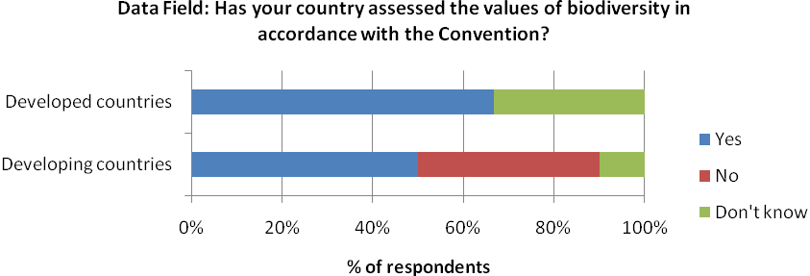

67% of developed countries have data available to report against this indicator, while 33% are unsure as to data availability. In developing countries, 50% have available data, while 39% are lacking data and 11% don’t know.

(a) Identified funding needs, gaps, etc

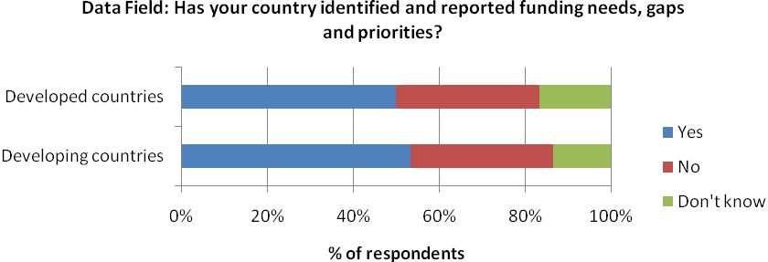

50% of developed countries have data available to report against this indicator, while 33% do not and 17% are unsure as to data availability. In developing countries, 54% have available data, while 36% are lacking data and 11% don’t know.

(c)National financial plans

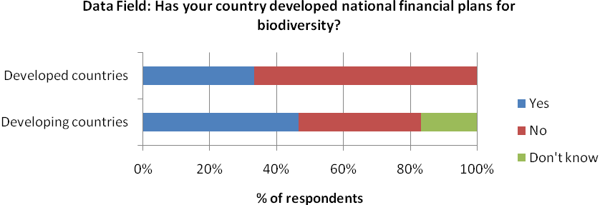

67% of developed countries have no data available to report against this indicator, compared with 39% of developing countries. While 14% of developing countries were unsure as to the data availability, this left 46% of countries with available data, compared to only 33% of developed countries.

(d) Level of funding and capacity building

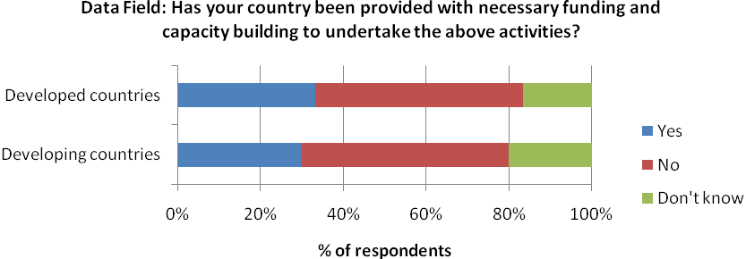

Data to report against this indicator is available from 33% of developed of countries, and 29% of developing countries. There is no data for half of both developed and developing respondents, while 17% of developed respondents and 21% of developing respondents did not know.
Applicable Data
There are no existing data sources to assist with the production of this indicator. This indicator is likely to rely on national level reporting for data collection purposes.

A3.3 Domestic Financial Support

Indicator 3
Indicator Text
Amount of domestic financial support, per annum, in respect of those domestic activities which are intended to achieve the objectives of this Convention
Policy relevance /relation to Strategy for Resource Mobilization
This indicator responds to Goal 2 of the Strategy to ‘Strengthen national capacity for resource utilization and mobilize domestic financial resources for the Convention’s three objectives’.

Indicator Understanding
This indicator is the total domestic support for activities to achieve the objectives of the Convention. The indicator text specifies that data for this indicator is to be reported yearly. It is difficult to distinguish the difference between this indicator and indicator 1(b) which is also a measure of domestic budgets aimed at achieving the objectives of the Convention and will consist of the total financial amount per annum.

Definitions and underlying concepts
Domestic budgets include government budgets at national, regional and local levels.

Considerations for data collection and indicator development
It is important to try and clarify the difference between this indicator and indicator 1(b). If a difference does exist it is important that the CBD provides clear guidance on the data needed.
Level of data collection
Data for this indicator would need to be collected at the national level
Essential Data fields & Units
Developed and Developing National Parties

The use of the same data field as for indicator 1(b):

- Biodiversity related allocation in national domestic budgets (Total monetary value and/or as a percent of total domestic budget)

Additional data fields for consideration
For all of these sub indicators it may be beneficial to ask Parties to report at the activity level rather than supplying aggregated totals as it can help enhance indicator interpretation.

Data fields for this sub-indicator could also be used to populate indicator 1(b). Example data fields:

- Activity Name:
- Financial resources transferred (Monetary value):
- Donor country:
- Level of domestic support: National / Regional / Local
Existing Indicators
This indicator overlaps directly with indicator 1(b). For existing indicators see the factsheet for indicator 1.

National Level Data Availability
This indicator overlaps directly with indicator 1(b). For National Level Data Availability see the factsheet for indicator 1.

Existing Data Sources
This indicator overlaps directly with indicator 1(b). For existing data sources see the factsheet for indicator 1.

A3.4 GEF Support

Indicator 4
Indicator Text
Amount of funding provided through the Global Environment Facility and allocated to biodiversity focal area

Policy relevance /relation to Strategy for Resource Mobilization
This indicator responds to Goal 1 of the Strategy to ‘improve information base on funding needs, gaps and priorities’.
Indicator understanding and conceptual issues
This indicator measures the total amount of fundingprovided by the Global Environment Facility (GEF) to eligible countries through its biodiversity focal area. This indicator is also concerned with the funding allocated to the biodiversity focal area. It is important to clarify the distinction between the financial resources allocated for a replenishment period that are available to eligible countries and the actual financial amounts invested in projects/activities. Allocations are calculated for the beginning of a funding cycle and comprise the total financial amount available to eligible countries. Allocations are a measure of intent and this does not always correspond to the amount invested in activities/projects. Allocations that are not utilised are reverted back to the GEF fund trust fund at the end of each replenishment period. This indicator could therefore be considered to comprise of two measures or sub indicators:

- The amount of funding allocated through the GEF to the biodiversity focal area
- The amount of funding provided/mobilized for projects/activities in the biodiversity focal area

Definitions and underlying concepts
The GEF serves as a financial mechanism to number of Conventions including the CBD. Donor nations fund the GEF and every four years, they commit money through a process called the "GEF Replenishment." The STAR is a short name for the System for Transparent Allocation of Resources. With the STAR, the GEF Secretariat allocates resources in an indicative way to its eligible countries in a replenishment period. It was developed during 2009-2010 to upgrade the Resource Allocation Framework (RAF), which was the former GEF resource allocation system used in the fourth replenishment period of the GEF (GEF-4).

The fifth replenishment period (GEF-5) covers operations and activities from July 1, 2011 to June 30, 2014. GEF-5 STRA covers three focal areas: biodiversity (BD), climate change (CC), and land degradation (LD). The Biodiversity Focal Area includes the following objectives:
- Improve the sustainability of protected area systems
- Mainstream biodiversity conservation and sustainable use into production landscapes/seascapes and sectors
- Build capacity on access to genetic resources and benefit-sharing
- Integrate CBD obligations into national planning processes through enabling processes

Considerations for data collection and indicator development
- As noted above this indicator actually comprises of two separate measures, the funding allocated and the funding transferred. As such two data fields should be utilized for the collection of data.
- In regard to the actual funding transferred to eligible countries, supplementary data could be could be used to enable greater interpretation and storylines to be generated. For example additional data collected could include the number of activities funded, GEF Financing, Co-Financing and Total Financing. For each of these fields the data could be further broken down by project types: Full-sized projects, medium sized projects and enabling activities.
- Biodiversity focal area allocation data is available for the GEF replenishment cycles. However it is important to note the change in the resource allocation system from RAF (up to GEF-4) to STAR (GEF-5 onwards) and whether this affects direct comparison of allocations between cycles.

Level of data collection
Data will be collected at the global level from the Global Environment Facility. Data provided by the GEF however, could be provided at the global and national levels.

Essential Data fields & Units
Data would be provided by the GEF, and could be removed from existing reporting mechanisms:

Global Environment Facility
- Biodiversity focal area allocation (total monetary amount)
- Total financing of projects in the biodiversity focal area (total monetary amount)

Additional data fields for consideration
Instead of reporting/data collection occurring at the global level it may be beneficial if information is provided at the project level. This already occurs in the annex sections of GEF reports to the Conference of the Parties. As a result the following fields can be used:

Fields for project level reporting/data collection:

- Project Name:
- Project Value:
- GEF Component (value):
- Co-financing:
- Project Type: full/medium/enabling projects
- Value of co-financing:
- GEF Cycle:

Existing Indicators
There are no existing indicators which relate to indicator 2.

Applicable Data
Data is available and produced regularly for the production of this indicator.

Funding provided for projects in the biodiversity focal area

The GEF provides to every ordinary meeting if the Conference of the Parties (COP) a report on its activities related to biological diversity. These biannual reports (with exception of the first two which were in subsequent years) provide summary data on the number of funded activities, GEF financing, co-financing and total financing, all broken down by project type. The reports also include a breakdown of all approved projects by country in the supplementary annexes. The first report for COP 2 was produced in 1995

The reports are available from the CBD webpage: http://www.cbd.int/financial/gef.shtml

GEF funding allocated to the biodiversity focal area

The GEF publishes the national allocations available to each of its focal areas at the beginning of each replenishment cycle. The data from these reports can be used for this indicator. The allocations for GEF 4 and 5 are available online: http://www.thegef.org/gef/pubs/STAR

A3.5 CDB support to financial institutions

Indicator 5
Indicator Text
Level of CBD and Parties’ support to other financial institutions that promote replication and scaling-up of relevant successful financial mechanisms and instruments

Policy relevance /relation to Strategy for Resource Mobilization
This indicator responds to Goal 3 of the Strategy to ‘strengthen existing financial institutions and, promote replication and scaling-up of successful financial mechanisms and instruments’. This indicator also responds to Goal 4 to ‘Explore new and innovative financial mechanisms at all levels with a view to increasing funding to support the three objectives of the Convention’.

Indicator understanding and conceptual issues
It is not quite clear what ‘level’ refers to in the context of this indicator. For example it may mean the level of financial support and therefore this indicator could be a measure of the party level financial contributions/grants to financial institutions. However, financial support in this context is already likely to be covered in a number of the other adopted indicators, namely indicator one. As a result this indicator is more likely to mean the level of political support and be a measure of the number of decisions adopted by the Conference of the Parties to promote replication and scaling-up of relevant successful financial mechanisms and instruments. The indicator refers to ‘other’ institutions and as this indicator follows indicator four on funding provided by the GEF, it likely means financial institutions in addition to the GEF.

The indicator text does include criteria of the inclusion of financial institutions by stating that that they must ‘promote replication and scaling up of relevant successful financial mechanisms and instruments’.

Definitions and underlying concepts
Other financial institutions refer to multilateral and regional development banks, national development banks and financing agencies such as development agencies.

A variety of financial mechanisms and instruments exist. The Strategy for Resource Mobilization identifies:

- Domestic environmental funds
- Debt-for nature swaps
- Payments for ecosystem services
- Biodiversity offset mechanism
- Environmental fiscal reforms
- Markets for green products
- Biodiversity-business partnerships
- New forms of charity
- Innovative sources of international development finances
- Funding schemes for climate change

These mechanisms are all classified as innovative financial mechanisms as they mobilize resources in addition to the financial mechanism of the CBD.

Considerations for data collection and indicator development
- A clear definition is needed for this indicator to clarify exactly what is being measured. The units of the indicator need to be clarified, it refers to ‘level’ of support in the indicator and confirmation is needed as to whether this means the financial support or political support.
- The indicator text specifies that the support should only be considered if it promotes replication and scaling-up of ‘successful’ financial mechanisms and instruments. Clarification is needed on how a mechanism or instrument can be deemed successful. In its simplest form ‘successful’ could mean instruments and mechanism which are listed by the CBD in its Strategy for Resource Mobilization.

Level of data collection
If this indicator is a measure of political support, and in turn the number of supporting decisions which promote replication and scaling-up of relevant successful financial mechanisms and instruments then the CBD Secretariat will be needed to provide the data for this indicator.
Essential Data fields & Units
CBD Secretariat:
- Number of decisions which promote scaling up of relevant financial mechanisms and instruments

Possible data fields needed for indicator production
Instead of providing a total count of the number of applicable decisions it may be beneficial for additional data fields to be used at the decision level. For example the following data fields could b used:

Fields for data collection/reporting at the decision level:

- Decision Number:
- Financial Institution supported:
- Financial mechanism or instrument replicated or scaled up: Domestic environmental funds / Debt-for nature swaps / Payments for ecosystem services / Biodiversity offset mechanism / Environmental fiscal reforms / Markets for green products / Biodiversity-business partnerships / New forms of charity / Innovative sources of international development finances / Funding schemes for climate change

Data collection/reporting at this level would enable greater interpretation of the indicator. It would enable trends in the financial institutions supported and the financial mechanisms or instruments replicated or scaled up to be examined.

Existing Indicators
There are no existing indicators which relate to indicator 5.

Applicable Data
The data for this indicator would be provided by the CBD Secretariat. In order to generate a baseline for this data the Secretariat can conduct a review of existing decisions to ascertain the number which promote the scaling up of relevant financial mechanisms and instruments.

A3.6 International financial institutions

Indicator 6
Indicator Text
Number of international financing institutions, United nations organizations, funds and programmes, and the development agencies that report to the Development Assistance Committee of Organisation for Economic Co-operation and Development (OECD/DAC), with biodiversity and associated ecosystem services as a cross-cutting policy

Policy relevance /relation to Strategy for Resource Mobilization
This indicator responds to Goal 3 of the strategy to ‘strengthen existing financial institutions and, promote replication and scaling-up of successful financial mechanisms and instruments’ and specifically objective 3.5 ‘to establish, as appropriate, new and additional funding programmes through voluntary contributions to support the three objectives of the Convention’.
Indicator understanding
The indicator is a direct measure of the number of institutions, organizations, funds, programmes and development agencies that report to OECD DAC with biodiversity and associated ecosystem services as a cross-cutting policy. The indicator states that these groups must report with biodiversity as a cross-cutting policy. Although the indicator does not make reference to Official Development Assistance and the Rio markers, Rio markers are the mechanism whereby the DAC collects data on biodiversity related funding from its members and other donors. For an activity to be labelled with the ‘Rio marker’ for biodiversity it must promote one of the three objectives of the CBD. However, the inclusion of an IFI just because it reports on the Rio markers could be inadequate as it would not provide an indication of whether it has biodiversity and associated ecosystem services as a cross-cutting policy. The different mechanisms with which IFIs report to OECD DAC needs to be indentified to see if any include requirements are collect data which can be used to ascertain if the IFIs have biodiversity and associated ecosystem services as a cross-cutting policy.

Definitions and underlying concepts
THE OECD Development Assistance Committee (DAC) is a unique international forum where donor governments and multilateral organisations – such as the World Bank and the United Nations System of Organizations (UN) – come together to help partner countries reduce poverty and achieve the Millennium Development Goals (MDGs). The DAC became part of the OECD by Ministerial Resolution on 23 July 1961. The DAC has the mandate to ‘…consult on the methods for making national resources available for assisting countries and areas in the process of economic development and for expanding and improving the flow of long-term funds and other development assistance to them’.
The Development Co-operation Directorate (DCD) acts as the Secretariat for the DAC, providing technical expertise and operational capacity. The DAC consists of several subsidiary bodies, including the Network on Environment development and Co-operation (ENVIRONET). ENVIRONET’s work is organised around several work streams including implementation of the Rio Conventions: improving monitoring of aid flows in support of the three Rio Conventions (climate change, biodiversity and desertification) (OECD 2010).
Since 1998, the DAC has monitored aid targeting objectives of the Rio Conventions through its “Creditor Reporting System” (CRS) and the so-called “Rio markers”. Biodiversity-related aid is labelled with the Rio marker for biodiversity. Biodiversity-related aid is defined as activities that promote at least one of the three objectives of the Convention: the conservation of biodiversity, sustainable use of its components (ecosystems, species or genetic resources), or fair and equitable sharing of the utilisation of genetic resources(OECD-DAC 2009).
At present there are 22 member countries of OECD DAC, with various numbers of agencies under each (http://www.oecd.org/dataoecd/14/61/31738599.pdf). The European Commission as well as a number of Multilateral organisations also report to OECD DAC.

Considerations for data collection and indicator development
- From the text the indicator appears to be a combination of the total count of International financing institutions, United Nations organizations, funds and programmes, and the development agencies that report to the Development Assistance Committee. There may be some value in disaggregating the indicator to look at the number reporting within an entity.
- It may be case that entities only partially report their biodiversity related activities to the OECD/DAC and there needs to be clarification of whether entities will only be counted if they report thoroughly on their activities or simply if they report just one or more activities.

Level of data collection
Data for this indicator would be collected at the global level directly from OECD DAC

Essential Data fields & Units
OECD/DAC
Number of international financing institutions, United Nations organizations, funds and programmes, and the development agencies that report to OECD DAC with biodiversity and ecosystem services as a cross cutting policy.

Additional data fields for consideration
Existing Indicators
There are no existing indicators which relate to indicator 6.

Applicable Data
As noted above the DAC collects information on the Rio Marker for Biodiversity through its CRS. This data is available online through the OECD Stat Portal: http://stats.oecd.org/Index.aspx?DatasetCode=CRSNEW. This data may be used if appropriate to extract the number of the number of institutions, organizations, funds, programmes and development agencies that report To the DAC with biodiversity and ecosystem services as a cross-cutting policy.

Other data sets held by OECD DAC should be examined to see if any would be more useful for reporting against this indicator.
References
OECD.Refere (2010) Inside the DAC: A Guide to the OECD Development Assistance Committee 2009-2010. Organization for Economic Cooperation and Development, Paris.
OECD-DAC. (2009) Measuring aid targeting the objectives of the Rio Conventions. Organization for Economic Cooperation and Development, Paris.

A3.7 Integration in development Plans, etc

Indicator 7
Indicator Text
Number of Parties that integrate considerations on biological diversity and its associated ecosystem services in development plans, strategies and budgets

Policy relevance /relation to Strategy for Resource Mobilization
This indicator responds to Goal 5 of the strategy to ‘mainstream biological diversity and its associated services in development cooperation plans and priorities including the linkage between the Convention’s work programmes and the Millennium Development Goals’.

Indicator understanding
The indicator in its simplest form could consist of a count of the number of countries which have integrated considerations on biological diversity and its associated ecosystem services in development plans, strategies and budgets. However, it may be possible to use a scaling system to give a better representation of the progress made.

Definitions and underlying concepts
Development plans and strategies may take different forms in various countries, such as national poverty reduction strategies, or national sustainability targets. They constitute a master plan for economic growth and development.

Budgets are contained in the annual budget documentation approved by a national legislative body, for instance, national parliament, national congress or national assembly.

Considerations for data collection and indicator development
- The indicator is based on national parties’ activities in regards to mainstreaming biodiversity into their development plans, strategies and budgets. Similar to indicator two, the measure of success for this indicator is open to interpretation. In order for parties to report on this indicator in an accurate and consistent way there is the need for clear definitions and criteria concerning achievement. For example for a country to be scored as having integrated biodiversity do they simply need to make national recommendations for mainstreaming biodiversity or do they have to officially have evidence of integration in development plans, strategies and budgets.
- It is possible that this indicator could exist as simply a count of the number of parties which have integrated biodiversity into their development plans, strategies and budgets. However, the usefulness of this approach would need to be considered in regards to monitoring successful party level implementation over time. It may be possible to consider the use of scores to give a more dynamic picture of progress and integration over time. For example the following scores could be applied:
- No integration of biodiversity
- Party has reviewed national development plans, strategies and budgets in order to assess how biodiversity and ecosystem services considerations can be integrated.
- Biodiversity and ecosystem services officially/legally adopted in one or more development plans, strategies and budgets
- Biodiversity and ecosystem services officially/legally adopted in all development plans, strategies and budgets
- As mentioned in its simplest form the indicator would consist of a count of the number of countries which have integrated biodiversity and ecosystem services. However it may be useful to consider incorporating a count of the number of development plans, strategies and budgets per country. This approach would enable more meaningful national representation of the indicator in comparison with the ‘YES/NO’ approach. It would also enable greater interpretation of the global indicator which could be presented in the following ways:
  - Number of Parties that integrate considerations on biological diversity and its associated ecosystem services in development plans, strategies and budgets (same as original text)
  - The total number of development plans, strategies and budgets which have biodiversity integrated within them.
  - The average number of development plans, strategies and budgets per country which have biodiversity and ecosystem services integrated within them.
- It may also be an important to consider separating out development plans, strategies and budgets. For example the mainstreaming of biodiversity into these different policy tools signifies different levels of national integration with integration of biodiversity into budgets seen as the ultimate goal.

Level of data collection
Data for this indicator would need to be collected at the nation level, primarily through the use of national level reporting.

Essential Data fields & Units
Developed and Developing Parties
Has your country integrated considerations on biological diversity and its associated ecosystem services in development plans, strategies and budgets? (YES/NO)

Additional data fields for consideration
For greater interpretation of party level implementation it may be beneficial to use a scaling system, rather than a simple yes no question for each of the sub indicators. For example the field could be replaced with:

- Progress in integrating biodiversity and ecosystem services into Development plans, strategies and budgets:
- No integration of biodiversity
- Party has reviewed national development plans, strategies and budgets in order to assess how biodiversity and ecosystem services considerations can be integrated.
- Biodiversity and ecosystem services officially/legally adopted in one or more development plans, strategies and budgets
- Biodiversity and ecosystem services officially/legally adopted in all development plans, strategies and budgets

Alternatively it may be useful to generate extra supplementary information to aid indicator interpretation (see above) by adding the additional data field:

- The total number of development plans, strategies and budgets which have biodiversity integrated within them

It may be also be useful to replace the original data fields with fields that separate out the the types of policy tools. For example use the following fields:

- Has your country integrated considerations on biological diversity and its associated ecosystem services in development plans? (YES/NO)
- Has your country integrated considerations on biological diversity and its associated ecosystem services in strategies? (YES/NO)
- Has your country integrated considerations on biological diversity and its associated ecosystem services in budgets? (YES/NO)

It may be beneficial to take into account all potential options for replacement and addition fields.

Existing Indicators
There are no existing indicators which relate to indicator 7.

National Level Data Availability
An online survey was distributed to CBD National Focal Points and Resource Mobilization Focal Points to assess national level capacity for reporting the adopted indicator applicable at the national level. Parties were presented with a data field at the simplest level and were asked if they had data available to report against this field

Integration in development plans, etc

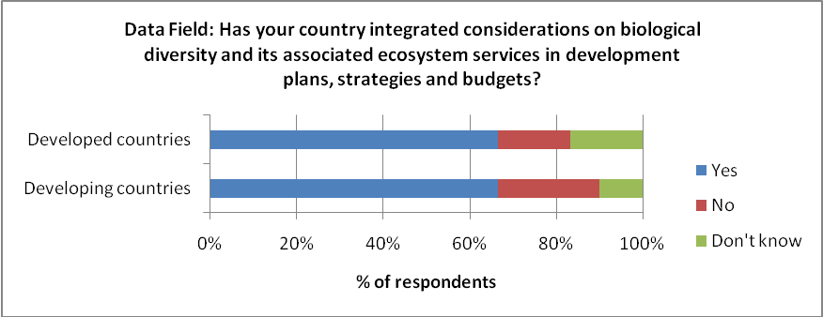.

67% of developed countries and 64% of developing countries reported appropriate data availability for this indicator. There is no data available for 25% of developing respondents, while 11% don’t know, and 17% of developed respondents are lacking data, while 17% don’t know.
Existing Data Sets
There are no existing data sources to assist with the production of this indicator. This indicator is likely to rely on national level reporting for data collection purposes.

A3.8 South-South cooperation initiatives

Indicator 8
Indicator Text
Number of South-South cooperation initiatives conducted by developing country Parties and those that may be supported by other Parties and relevant partners, as a complement to necessary North-South cooperation

Indicator understanding and conceptual issues
This indicator responds to Goal 6 of the Strategy to ‘Build capacity for resource mobilization and utilization and promote South-South cooperation as a complement to necessary North-South cooperation’.

Indicator Understanding
This indicator will consist of a count of the number of cooperation initiatives between developing countries. The count will also include South-South cooperation initiatives which are supported by developed countries and international development assistance.

Indicator Overlaps

There are indirect overlaps with indicator 1(h) and 8. Indicator 1(h) deals with the financial investment in South-South cooperation initiatives whilst indicator 8 is concerned purely with the number of South-South cooperation initiatives.

There are indirect overlaps between indicators 8 and 9. Indicator 9 is a combined count of the number of South-South and North South technical cooperation and capacity-building initiatives whilst indicator 8 is a count of the number of South-South cooperation initiatives.

Definitions and underlying concepts
South-south cooperation describes the exchange of resources, technology, and knowledge between developing countries. It is a cross-cutting mechanism designed to deliver capacity building and technology support activities in developing countries and regions of the South, as a complement to North-South cooperation to enhance technical, financial, scientific and technological exchanges and innovations for biodiversity. South-south cooperation may be financially and/or technically supported by developing countries and international development assistance. Such an arrangement is called “triangular cooperation”.

Considerations for data collection and indicator development
- The indicator is a total count of the number of South-South cooperation initiatives between developing countries including those which are supported by developed countries and international development assistance. Clarification is needed for data collection and development to ascertain whether national parties simply provide a count of the total number of activities or whether they clearly differentiate between activities purely funded by their country from those activities which are additionally supported. Having clear differentiation may be useful and enable comparisons to be made, for example it would provide enable trends in mechanisms for establishing South-South initiatives to be reviewed.
- Clear distinction is needed on which parties report on this indicator. Primarily it will be developing parties that report. However, because South-south activities with support from developing countries are included in the indicator count, consideration is needed over whether developed country parties will be asked to report on the number of south-south cooperation activities they are supporting. If developing countries are also required to report then there are additional considerations regarding double counting.
- The adopted text defines the indicator as the total number of South-South cooperation activities. In its simplest form the indicator could be presented as a trend over time, however the collection of supplementary information would enable greater interpretations and storylines to be generated. For example it may be beneficial to monitor the geographical patterns in terms of the cooperation activities. This could be achieved by asking parties to report on activities for which they provide resources and give details on the countries to which these resources where transferred. Additional fields such as the type of exchange (resources/technology/knowledge) could also be added to the reporting to enable greater interpretation.
- This indicator indirectly overlaps with indicator 1(h) and 9. Indicator 9 also indirectly overlaps with indicator 1(i). It is likely that the data for all four indicators will be collected through national reporting. Through the use of well structured reporting it may be possible to use a set of data fields to provide the data needed for all four indicators.

Level of data collection
Data for this indicator would need to be collected at the national level, primarily through the use of national level reporting.

Essential Data fields & Units
Developing Country Parties
The number of South-South cooperation initiatives with which your country is involved, including any which may be supported by developed countries as a complement to North-south cooperation (number)

Additional data fields for consideration
As noted above this indicator overlaps indirectly with indicators 1(h) and 9. Indicator 9 in turn overlaps with indicator 1(i). Instead of asking developing countries to report on the total number of initiatives, it may be beneficial to ask countries to report at the initiative level. The use of a set of fields at the initiative level could potentially generate the data for all four of the overlapping indicators. For example the following fields could be used for generating information for the four indicators:

Fields for reporting at the initiative level
South-South & North-South Cooperation Initiatives
- Name of initiative:
- Date Established:
- Country providing resources:
- Country receiving resources:
- Financial value of investment in cooperation initiative (monetary value):
- Type of exchange: resources/technology/knowledge/financial
- Description of initiative: technical cooperation/capacity building/other (please specify)

Field c and d could be used to identify which of the initiatives represent South-South cooperation; these initiatives could then be counted for the production of this indicator.

A number of additional fields have also been included in the suggested example above, which are not specifically necessary for the production of the four indicators. The collection of this supplementary information can greater enhance indicator interpretation. For example field f enables trends in the type of exchange to be monitored, whilst field b could possibly enable the first round of reporting to produce a temporal baseline as opposed to a static baseline.

Existing Indicators
There are no existing indicators which relate to indicator 8.

National Level Data Availability
An online survey was distributed to CBD National Focal Points and Resource Mobilization Focal Points to assess national level capacity for reporting the adopted indicator applicable at the national level. Parties were presented with a data field at the simplest level and were asked if they had data available to report against this field. N.B. This field is only applicable to developing nations.

South-South cooperation initiatives

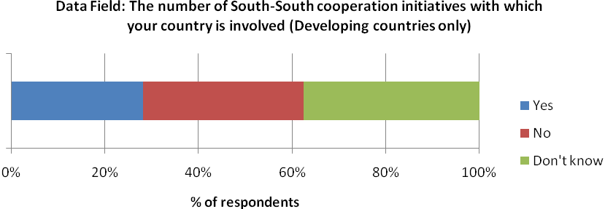

26% of respondents have available data to report against this indicator while 35% are lacking data and 39% are unsure as to the availability

Existing Data Sources
There are no existing data sources to assist with the production of this indicator. This indicator is likely to rely on national level reporting for data collection purposes.

A3.9 Technical cooperation & capacity building

Indicator 9
Indicator Text
Amount and number of South-South and North-South technical cooperation and capacity-building initiatives that support biodiversity

Policy relevance /relation to Strategy for Resource Mobilization
This indicator responds to Goal 6 of the Strategy to ‘Build capacity for resource mobilization and utilization and promote South-South complement to necessary North-South cooperation’.

Indicator Understanding
This indicator could consist of a count of the total number of technical cooperation and capacity building initiatives that support biodiversity. The indicator text also refers to the ‘amount’ of initiatives however it is unclear how this differs to the ‘number’ of initiatives. It is unlikely to correspond to the financial amount invested into the initiatives as the definitions clearly demonstrate that investment in technical cooperation and capacity building isn’t restricted to financial resources.

There is an indirect overlaps with indicator 1(i) which deals with the financial investment in technological cooperation and indicator 9 which looks at the number of technical cooperation activities.

There are also indirect overlaps between indicators 8 and 9. Indicator 9 is a combined count of the number of South-South and North South technical cooperation and capacity-building initiatives whilst indicator 8 is a count of the number of South-South cooperation initiatives.

Definitions and underlying concepts
Technical cooperation initiatives can be defined as initiatives that provide education or training at home and abroad and/or provide consultants, advisers and similar personnel serving in recipient countries. There are two basic types of technical cooperation (IMF 2003):
(1) Free-standing technical cooperation (FTC), which is the provision of resources aimed at the transfer of technical and managerial skills or of technology for the purpose of building up general national capacity without reference to the implementation of any specific investment projects
(2) Investment-related technical cooperation (IRTC), which denotes the provision of technical services, required for the implementation of specific investment projects.

Capacity building activities comprise capacity assessment, capacity building and capacity development activities. Capacity assessment is a structured and analytical process whereby the various dimensions of capacity are assessed within the broader context of biodiversity management systems. Capacity building involves the development of human, material and financial resources and provides means by which skills, experience, technical and management capacity are developed, often through the provision of technical assistance, short/long-term training and specialist inputs (e.g., computer systems) (OECD Glossary. EIIP). Capacity development refers to the national process of developing, enhancing and organizing their systems, resources and knowledge in order to perform functions, solve problems and achieve biodiversity objectives.

Considerations for data collection and indicator development
- This indicator is a combined count of the total number of south-south and North-south initiatives and as such overlaps with indicator 8 which is a count of the number of South-South cooperation activities. This is an important consideration when designing fields for data collection. For example it may be best to ask developing parties to report on the number of South-south technical cooperation and capacity-building initiatives in separate data fields. The data can then be used separately or combined to provide all the necessary information for both indicators.
- If data is collected by national reporting clear guidelines are needed to avoid double counting. For example do all countries engaged in the cooperation and capacity building activities include it in the total count provided or is reporting of an activity limited to the country providing the resources, technology or knowledge. If the former approach is adopted then there is likely to be double counting.
- The adopted text defines the indicator as the total number of technical cooperation and capacity building activities. In its simplest form the indicator could be presented as a trend over time. When designing the mechanism for collecting data it may be beneficial to separate technical cooperation and capacity building initiatives this would enable greater interpretation of the indicator enabling trends in the different activities to be examined separately.
- This indicator indirectly overlaps with indicator 1(i) and 8. Indicator 8 also indirectly overlaps with indicator 1(h). It is likely that the data for all four indicators will be collected through national reporting. Through the use of well structured reporting it may be possible to use a set of data fields to provide the data needed for all four indicators.

Level of data collection
Data for this indicator would need to be collected at the national level, primarily through the use of national level reporting.

Essential Data fields & Units
Developing Parties:
- The number of South-South technical cooperation and capacity building initiatives that support biodiversity with which your country is involved (number)

Developed Parties:
- The number of North-South technical cooperation and capacity building initiatives that support biodiversity with which your country is involved (number)

Additional data fields for consideration
As noted above this indicator overlaps indirectly with indicators 1(i) and 8. Indicator 8 in turn overlaps with indicator 1(h). Instead of asking developing countries to report on the total number of initiatives, it may be beneficial to ask countries to report at the initiative level. The use of a set of fields at the initiative level could potentially generate the data for all four of the overlapping indicators. For example the following fields could be used for generating information for the four indicators:

Fields for reporting at the initiative level
South-South & North-South Cooperation Initiatives
a) Name of initiative:
b) Date Established:
c) Country providing resources:
d) Country receiving resources:
e) Financial value of investment in cooperation initiative (monetary value):
f) Type of exchange: resources/technology/knowledge/financial
g) Description of initiative: technical cooperation/capacity building/other (please specify)

The use of field g would enable all technical cooperation and capacity building initiatives to be separated out and counted for the production of indicator 9.

A number of additional fields have also been included in the suggested example above, which are not specifically necessary for the production of the four indicators. The collection of this supplementary information can greater enhance indicator interpretation. For example field f enables trends in the type of exchange to be monitored, whilst field b could possibly enable the first round of reporting to produce a temporal baseline as opposed to a static baseline.

Existing Indicators
There are no existing indicators which relate to indicator 9.

National Level Data Availability
An online survey was distributed to CBD National Focal Points and Resource Mobilization Focal Points to assess national level capacity for reporting the adopted indicator applicable at the national level. Parties were presented with a data field at the simplest level and were asked if they had data available to report against this field. For this indicator it was required that the data field was adapted for developed and developing countries. The two sets of answers were then combined.

Technical co-operation and capacity building

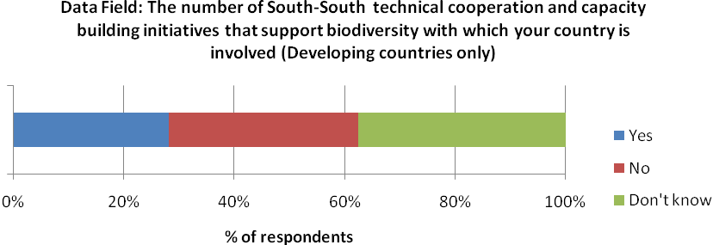

26% of developing respondents reported available data for this indicator, while 35% have no data and 39% don’t know.

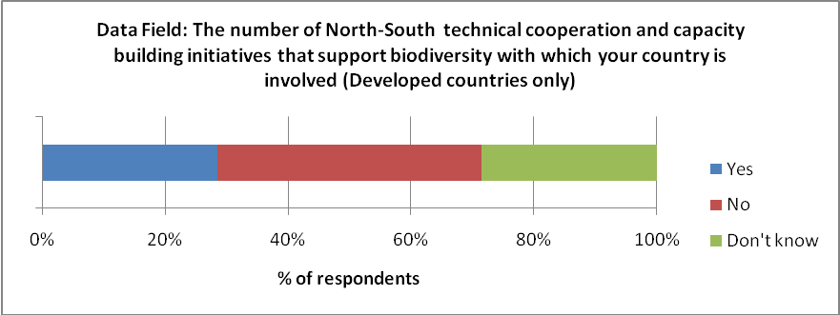

29% of developed respondents reported available data for this indicator, while 43% are lacking data and 29% are unsure as to data availability.
Applicable Data
There are no existing data sources to assist with the production of this indicator. This indicator is likely to rely on national level reporting for data collection purposes.

A3.10 Awareness raising for resource mobilization

Indicator 10
Indicator Text
Number of global initiatives that heighten awareness on the need for resource mobilization for biodiversity

Policy relevance /relation to Strategy for Resource Mobilization
This indicator responds to Goal 8 of the Strategy to ‘enhance the global engagement for resource mobilization in support of the achievement of the Convention’s three objectives’.

Indicator understanding and conceptual issues
This indicator is simple in design, consisting of a count of the number of global initiatives to heighten awareness on the need for resource mobilization. It’s is simplest form the indicator could be restricted to the number of outreach initiatives of the CBD Secretariat. However, a number of additional organizations and agencies may coordinate initiatives to heighten awareness on the need for resource mobilization. Frequency of the indicator could be every two years coinciding with meetings of the Conference of the Parties.

Definitions and underlying concepts
Raising awareness is a common phase advocacy groups use to justify a particular event, brochure or even the entire organization. Raising awareness refers to alerting a specific audience that a certain issue exists and should be approached in the way the group desires.

Considerations for data collection and indicator development
- In its simplest form the indicator could be restricted to the number of outreach initiatives of the CBD Secretariat, however outreach initiatives that heighten awareness on the need for resource mobilization may be conducted by other organizations and agencies. It is therefore important to consider opening this indicator up to include all initiatives and not just those conducted by the CBD Secretariat.
- Clear guidance is needed to decipher which awareness raising initiatives will be counted in the indicator. For example are initiatives only counted if their specific aims and objectives relate to increasing awareness on the need for resource mobilization. It may be argued that awareness raising initiatives on activities of the CBD and importance of biodiversity may indirectly also highlight the need for resource mobilization, even if this was not a primary objective of the initiative. Difficulties however would exist in being able to determine if the latter category of initiatives actually do heighten awareness on the need for resource mobilization.
- The collection of supplementary information regarding the awareness raising initiatives may enable greater interpretation and storylines to be generated. For example data could be collected at the initiative level with the use of additional fields such as the date established, objective, etc.

Level of data collection
If reporting is used data for this indicator could be collected from the following Parties:
- CBD Secretariat
- Private Corporations
- NGOs, foundations and academia
- International Financial Institutions
- United Nations organizations, foundations and programmes, IGOs

Essential Data fields & Units
CBD Secretariat:
- The number of global awareness raising activities undertaken by the Convention Secretariat

Private Corporations, NGOs, foundations and academia, International Financial Institutions, United Nations organizations, foundations and programmes, IGOs:

- The number of global awareness raising activities undertaken

Additional data fields for consideration
Instead of asking parties to report on the total number of initiatives, it may be beneficial to ask parties to report at the initiative level. The use of the following data fields would enable the indicator to be calculated and also provide supplementary information which would help with interpretation.

Fields for reporting at the Initiative level
Name of awareness raising initiative:
Date established:
Period initiative active for:
Established by:
Other participating organizations/institutions:
Initiative heightens need for resource mobilization: Directly – reason for initiative development/ Indirectly – initiative heightens the need of resource mobilization, but this was not the primary objective
Financial resources invested in initiative (total monetary amount):

Existing Indicators
There are no existing indicators which relate to indicator 10.

Applicable Data
There are no existing data sources to assist with the production of this indicator. This indicator is likely to rely on reporting for data collection purposes.

A3.11 Financial resources for the CBD objectives

Indicator 11
Indicator Text
Amount of financial resources from all sources from developed countries to developing countries to contribute to achieving the Convention’s objectives.

Policy relevance /relation to Strategy for Resource Mobilization
This indicator does not seem to directly relate to any of the goals of the resource mobilization strategy and instead seems to link more generally with the mission of the strategy to ‘substantially enhance international financial flows and domestic funding for biological diversity’.

Indicator Understanding
The indicator is quite general in relation to many of the other indicators which have focussed on financial resources for specific categories, activities or initiatives. This indicator is the total monetary amount transferred from developed countries to developing countries to contribute to achieving the Conventions objectives.

Indicator Overlaps

The difference between this indicator and indicator 12, which measures the ‘financial resources from all sources from developed countries to developing countries towards implementation of the Strategic Plan for Biodiversity 2011-2020’ is unclear. All adopted Strategic Plans have been considered as the overarching framework for the CBD and therefore any funding towards the implementation of the Strategic Plan for Biodiversity can automatically be argued to contribute to the achievement of the Convention’s objectives. The only possible distinction between the two indicators may lie in the fact that the new Strategic Plan for Biodiversity 2011-2020 is to be considered an overarching framework on biodiversity, not only for the biodiversity-related conventions, but for the entire United Nations system. The justification for the separation of these indicators may therefore be that indicator 12 will incorporate financial resources for activities undertaken by other MEAs that respond to one or more of the Aichi targets.

Indicator 11 is a measure of the total amount of financial support from all sources from developed countries to developing countries to contribute to achieving the Convention’s objectives. Indicator 1 through aggregation of its components/sub indicators is a measure of the total financial flows for achieving the Convention’s three objectives. It is therefore difficult to clarify the difference between the aggregation of indicator 1’s components/sub indicators (a,g,h,i) relating to the transfer of financial support from developing to developed countries and indicator 11.

Definitions and underlying concepts
The Convention on Biological Diversity has three main objectives:

- The conservation of biological diversity
- The sustainable use of the components of biological diversity
- The fair and equitable sharing of the benefits arising out of the utilization of genetic resources

Considerations for data collection and indicator development
- Due to the overlap between this indicator and indicator 1, the CBD may wish to review these indicators to see if whether the aggregation of sub indicators 1(a), 1(g), 1(h) and 1(i) serves the same function as indicator 11. If this is the case, then care would be needed that data is only aggregated for financial resources transferred from developed to developing country parties. Data for indicators 1(a), 1(g), 1(h) and 1(i) may also include financial flows from developing parties. If the aggregation of these indicators serves the same function, the CBD may wish to consider removing indicator 11. One possible reason for existence (separation) of indicator 11 may be the importance of being able to monitor the total funding from developed to developing countries, a story which may be lost from the interpretation of indicator 1 with its many sub indicators.
- The difference between this indicator and indicator 12 is unclear. These indicators should be reviewed to ascertain the real reason for their separation. If this separation is due to the broadening of the Strategic Plan for Biodiversity 2011-2020 to outside of the Convention, then the associated reporting and data collection issues need to be considered. As mentioned above there is also overlap between the aggregation of sub indicators 1(a), 1(g) , 1(h) and 1(i) and indicator 11. If it was found that there is no need for indicator 11, then this would have further implications regarding indicator 12.

Level of data collection
Data for this indicator is restricted to reporting by developed country parties.

The data for this indicator could potentially be produced from the aggregation of data from indicators 1(a), 1(g), 1 (h) and 1(i). In this case care would be needed to ensure that data is only aggregated for financial resources transferred from developed to developing country parties. Data for indicators 1(a), 1(g), 1(h) and 1(i) may also include financial flows from developing parties.

Essential Data fields & Units
Developed country parties
- Total financial resources transferred to developing countries for achievement of the Convention’s objectives (monetary value)

Additional data fields for consideration
Due to the direct overlap of this indicator with a number of the adopted indicators it is not relevant to make suggestions for alternate or additional data fields.

Existing Indicators
There are no existing indicators which relate to indicator 11.

National Level Data Availability
An online survey was distributed to CBD National Focal Points and Resource Mobilization Focal Points to assess national level capacity for reporting the adopted indicator applicable at the national level. Parties were presented with a data field at the simplest level and were asked if they had data available to report against this field. N.B. This field is only applicable to developing nations.

Financial resources for the CBD objectives

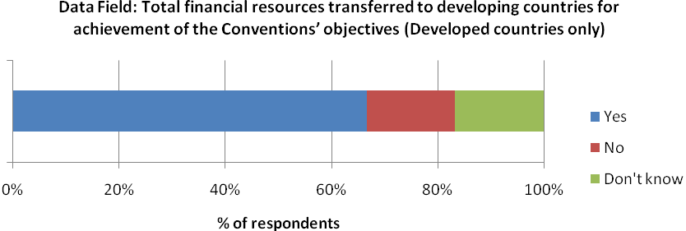

67% of developed country respondents reported available data for this indicator. 17% were lacking data and 17% were unsure of data availability.
Existing data sets
There are no existing data sources to assist with the production of this indicator. This indicator is likely to rely on reporting for data collection purposes.

A3.12 Financial resources for the Strategic Plan

Indicator 12
Indicator Text
Amount of financial resources from all sources from developed countries to developing countries towards the implementation of the Strategic Plan for Biodiversity 2011-2020

Policy relevance /relation to Strategy for Resource Mobilization
This indicator does not seem to directly relate to any of the goals of the resource mobilization strategy and instead seems to link more generally with the mission of the strategy to ‘substantially enhance international financial flows and domestic funding for biological diversity’.
Indicator Understanding
The indicator is quite general in relation to many of the other indicators which have focussed on financial resources for specific categories, activities or initiatives. This indicator is the total monetary amount transferred from developed countries to developing countries towards the implementation of the Strategic Plan for Biodiversity 2011-2020.

Indicator Overlap

The difference between this indicator and indicator 11, which measures the ‘financial resources from all sources from developed countries to developing countries to contribute to achieving the Convention’s objectives’ is unclear. All adopted Strategic Plans have been considered as the overarching framework for the CBD and therefore any funding towards the implementation of the Strategic Plan for Biodiversity can automatically be argued to contribute to the achievement of the Convention’s objectives. The only possible distinction between the two indicators may lie in the fact that the new Strategic Plan for Biodiversity 2011-2020 is to be considered an overarching framework on biodiversity, not only for the biodiversity-related conventions, but for the entire United Nations system. The justification for the separation of these indicators may therefore be that this indicator will incorporate financial resources for activities undertaken by other MEAs that respond to one or more of the Aichi targets.

Indicator 11 also overlaps with indicators 1(a), 1(g), 1(h) and 1(i) and this also creates implications for this indicator.

Definitions and underlying concepts
In decision X/2, the tenth meeting of the Conference of the Parties, held in October 2010, in Nagoya, Aichi Prefecture, Japan, adopted a revised and updated Strategic Plan for Biodiversity, including the Aichi Biodiversity Targets, for the 2010-2020 period.

The new plan will be the overarching framework on biodiversity, not only for the biodiversity-related conventions, but for the entire United Nations system.

The twenty headline Aichi Biodiversity Targets for 2015 or 2020 are organized under the five strategic goals. The goals and targets comprise both aspirations for achievement at the global level, and a flexible framework for the establishment of national or regional targets.

A number of support mechanisms were identified for the Strategic Plan for Biodiversity:
- Capacity-building for effective national action
- Clearing-house mechanism and technology transfer
- Financial resources
- Partnerships and initiatives to enhance cooperation
- Support mechanisms for research, monitoring and assessment.

Considerations for data collection and indicator development
- The difference between this indicator and indicator 11 is unclear. These indicators should be reviewed to ascertain the real reason for their separation. As mentioned above there is also overlap between the aggregation of sub indicators 1(a), 1(g) , 1(h) and 1(i) and indicator 11. If it was found that there is no need for indicator 11, then this would have further implications regarding this indicator.
- If the justification for the separation of this indicator is that it incorporates financial resources for activities undertaken by other MEAs that respond to one or more of the Aichi targets then this may have considerable implications for data reporting/collection for this indicator. If country party level reporting is used for this indicator then it is likely that this reporting will fall to national CBD focal points or resource mobilization focal points. These focal points may not have involvement with other MEAs and as such reporting on activities towards implementation of the Strategic Plan for Biodiversity under other MEAs may result in technical and capacity based challenges.
- If it is assumed that this indicator monitors financial flows for implementation of the Strategic Plan for Biodiversity 2011-2020 by the whole UN system, then this indicator will be able to incorporate data from indicator 11. Indicator 11 could be used to provide information on financial resources for implementation of the Strategic Plan under the CBD. However, it is not clear as to where the data for the other MEAs will be or collected or generated. One possible solution would be the use of Official Development Assistance data as collection by OECD DAC to look at the proportion of funds that support a combination of the UN Conventions: CBD, UNCCD and UNFCCC. However this would not adequately represent financial resources from ‘all sources’.
- It may be beneficial to ask Parties to provide supplementary information or report at the activity level to obtain useful information for greater indicator interpretation. For example activity level reporting could assist with the collection of supplementary information which could enhance indicator interpretation. For example it may be useful to know which of the Aichi targets funded activities are aimed towards achieving.

Level of data collection
Data for this indicator is restricted to reporting by developed country parties.

This indicator could potential build on data from indicator 11, which in turn could be produced from the aggregation of data from indicators 1(a), 1(g), 1 (h) and 1(i). In this case care would be needed to ensure that data is only aggregated for financial resources transferred from developed to developing country parties. Data for indicators 1(g), 1(h) and 1(i) may also include financial flows from developing parties.

Essential Data fields & Units
Developed country parties
- Total financial resources transferred to developing countries for achievement of the Strategic Plan for Biodiversity 2011-2020 (monetary value)

Additional data fields for consideration
It may also be beneficial to ask Parties to report on this indicator at the activity level enable disaggregation and greater interpretation of the indicator. If the difference between this indicator and indicator 11, is that it incorporates activities funded primarily for objectives of other MEAs then a data field could be added to allow for this disaggregation. For example the following fields could be used:

Fields for reporting at activity level
Activity Name:
Financial Resources transferred (monetary value):
Country providing financial resources:
Recipient of financial resources:
Mechanism for supporting Strategic Plan for Biodiversity: Capacity-building for effective national action/Clearing-house mechanism and technology transfer/Financial resources/Partnerships and initiatives to enhance cooperation/Support mechanisms for research, monitoring and assessment.
Aichi targets to which the activity relates:
Convention under which funding activity primarily established: CBD / UNCCD / UNFCCC / Other

Reporting at this level would help monitor the flow of the financial resources and also enable trends in support to the Strategic Plan for Biodiversity to be identified.
Existing Indicators
This indicator overlaps directly with indicator 1. For existing indicators see the factsheet for indicator 1.

National Level Data Availability
An online survey was distributed to CBD National Focal Points and Resource Mobilization Focal Points to assess national level capacity for reporting the adopted indicator applicable at the national level. Parties were presented with a data field at the simplest level and were asked if they had data available to report against this field. N.B. This field is only applicable to developing nations.

Financial resources for the strategic plan

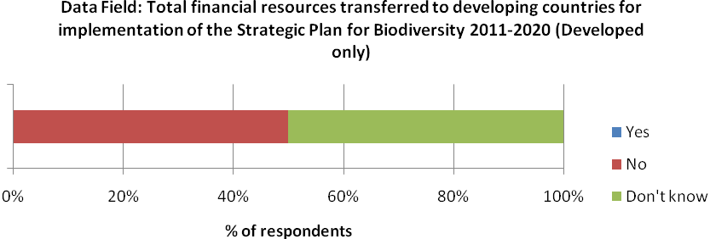

Data availability is poor for this indicator, with 50% of respondents lacking any data and 50% unsure as to the data availability.

Existing Data Sources
This indicator overlaps directly with indicator 1. For existing data sources see the factsheet for indicator 1.

A3.13 Removal of harmful incentives

Indicator 13
Indicator Text
Resources mobilized from the removal, reform or phase-out of incentives, including subsidies, harmful to biodiversity, which could be used for the promotion of positive incentives, including but not limited to innovative financial mechanisms, that are consistent and in harmony with the Convention and other international obligations, taking into account national social and economic conditions;

Policy relevance /relation to Strategy for Resource Mobilization
This indicator responds to Goal 4 of the Strategy to enhance ‘explore new and innovative financial mechanism at all levels with a view to increasing funding to support the three objectives of the Convention’.
Indicator Understanding
This indicator is a measure of the total financial resources mobilized from the removal, reform or phase-out of incentives, including subsidies, harmful to biodiversity. Incentives harmful to biodiversity have previously been referred to under the Convention as ‘perverse’ incentives. Although subsidies are specifically mentioned in the indicator text it is important to remember that this indicator is concerned with the total resources mobilized from harmful incentives. Other incentives types which can sometimes be harmful of biodiversity include policies and laws governing land use and environmental policies and/or regulations. These additional types of harmful incentives should also be included in the indicator.

It is also important to note that whilst the indicator text specifies that the resources mobilized could be used for the promotion of positive incentives including but not limited to innovative financial mechanisms this is not a pre-requisite for the inclusion of data in the indicator. For example, the indicator is the total value mobilized from the removal, reform or phase-out of incentives harmful to biodiversity and there is no condition in the text that mobilized resources cannot be included if they are not channelled in a mechanism in harmony with the Convention. This could be considered as a limitation in the design of the indicator as it is only concerned with the resources mobilized from eliminating harmful incentives and does not track the flow of these resources to see if they are invested in conservation activities.

Definitions and underlying concepts
Incentives that are harmful to biodiversity (or as they have also been called under the Convention in the past ‘perverse’ incentives) emanate from policies or practices that induce unsustainable behaviour that destroys biodiversity, often as unanticipated side–effects of policies designed for other objectives. Harmful incentives can include:

- Subsidies: Some subsidy types have been identified as critical drivers of activities that are harmful to ecosystems and biodiversity. They negatively impact the environment in two ways:
  - Under-pricing the use of natural resources: Subsidies reduce the price paid for natural resources, to below extraction or provisioning cost and as a result can lead to overexploitation.
  - Increasing production: Many policies providing subsidies are implemented to support environmentally sensitive sectors e.g. agriculture, fisheries, energy production. Support measures that reduce costs or enhance revenue for producers provide incentives to produce in larger quantities than in the absence of the subsidy.
- Policies and laws governing resource uses: Many countries had, or have “beneficial use” rules that require land holders to make productive use of resources such as water or forests, which may under certain circumstances generate a perverse incentive to continue using the resource in a non-sustainable manner instead of switching to more adapted use patterns.
- Environmental policies and/or regulations: for example the establishment of protected areas without effective monitoring or enforcement may generate perverse results as adjacent land users or owners have greater incentive to mine the protected source. Similarly, assigning protection status to species whose habitat is on private land can my not act as an incentive to protect the associated habitat and may instead create an incentive to (illegally) remove the species.

It is important to note that there is no single agreed definition for subsidies.
Considerations for data collection and indicator development
- As stated above, although subsidies are specifically mentioned in the text, the indicator is not solely limited to the resources mobilized from removal, reform or phase-out of harmful subsidies. Other types of harmful incentives which should be incorporated in the indicator include policies and laws governing resource uses and environmental policies and/regulations that are harmful to biodiversity. Whilst it is generally accepted that subsidies can be harmful to biodiversity, it is difficult to assess whether these other types of incentives have harmful indirect effects. These national incentive types would therefore need to be assessed on a case by case basis to determine if they are harmful to biodiversity before any mobilised resources can be incorporated in this indicator. Such assessment may require specific expertise and resources.
- Although not a condition of data inclusion, the indicator text makes reference to the fact that the resources mobilized could be used for the promotion of positive incentives, including but not limited to innovative financial mechanisms, that are consistent and in harmony with the Convention. Although not an obligatory criterion for inclusion of data in the indicator, it may be possible to ask countries to report on this indicator at individual incentive level. If so, countries could be asked to indicate where the mobilized resources are being utilized and whether they are being used for the conservation of biodiversity, either through innovative financial mechanisms or not.
- The adopted text defines the indicator as the total resource mobilized from the removal, reform or phase-out of incentives, whilst countries could report on this indicator by providing a total financial value. It may be beneficial to ask Parties to provide supplementary information or report at the incentive level to obtain useful information for greater indicator interpretation. For example it may be useful to know how the resources where mobilized and whether it was the result of removal, reform or phase-out objectives. Trends in the types of harmful incentives eliminated may also be of use. Subsidies are provided in many sectors and it will be important to determine trends in subsidy elimination by sector. Lastly, as mentioned above fields could be added to determine trends in how the mobilized resources are being used.

Level of data collection
Data for this indicator would need to be collected at the nation level, primarily through the use of national level reporting.

Essential Data fields & Units
Developed and developing parties
- Total amount of resources that are removed from existing government incentives, including subsidies, harmful to biodiversity which could be used to subsidize biodiversity objectives (Total monetary value)

Additional data fields for consideration
Instead of asking parties to report on the total amount of resources mobilized from harmful subsidies, it may be beneficial to ask parties to report at the subsidy level. For example the following data fields could be used:

Fields for reporting at the Incentive/Subsidy level
Type of Incentive: Subsidy / Policies and laws governing resource uses / Environmental policies and/or regulations
Name of incentive/subsidy:
Year ended:
Mechanisms of ending incentive: Removal / Reform / Phase-out
Monetary value mobilized (monetary value):
Incentive sector: Agriculture / Fisheries / Energy / Transport / Water
How mobilized resources being used: through innovative financial mechanism in harmony with the Convention/ other means in harmony with the Convention/ not used for biodiversity conservation/ decision on redirection of resources not yet decided
If applicable, name and type of innovative financial mechanism:

Reporting at this level would enable greater interpretation of the indicator. It would provide information on the flow of the mobilized resources, which although referenced in the indicator text is not a condition for the inclusion of data in the indicator (see above).

Existing Indicators
Regional:

The European Environment Agency has an indicator on transport subsidies. The indicator highlights that more then 270-290 billion Euro of annual transport subsidies have been identified in Europe. At present the indicator only appears to include data from 2005 and there is no evidence of whether the indicator will be updated. The indicator has a dedicated webpage where all information can be found: http://www.eea.europa.eu/data-and-maps/figures/overview-of-total-annual-subsidies

Global:
The Producer Support Estimate (PSE) is an indicator of the annual monetary value of gross transfers from consumers and taxpayers to support agricultural producers, measured at farm gate level, arising from policy measures, regardless of their nature, objectives or impacts on farm production or income. OECD collects annual data for the production of this indicator.

Annual data for theseindicatorsare available from 1986 onwards for the 14 OECD economies (Australia, Canada, Chile, European Union, Iceland, Israel, Japan, Korea, Mexico, New Zealand, Norway, Switzerland, Turkey and United States) and in addition 5 non-OECD economies (Brazil, China, Russian Federation, South Africa and Ukraine). All data is available from: http://www.oecd.org/document/59/0,3746,en_2649_37401_39551355_1_1_1_37401,00.html#summary

A caveat with this indicator is that not all measures available in the PSE database are targeted to biodiversity. Some payments can be totally unrelated to ecosystem services.

National Level Data Availability
An online survey was distributed to CBD National Focal Points and Resource Mobilization Focal Points to assess national level capacity for reporting the adopted indicator applicable at the national level. Parties were presented with a data field at the simplest level and were asked if they had data available to report against this field.

Removal of harmful incentives

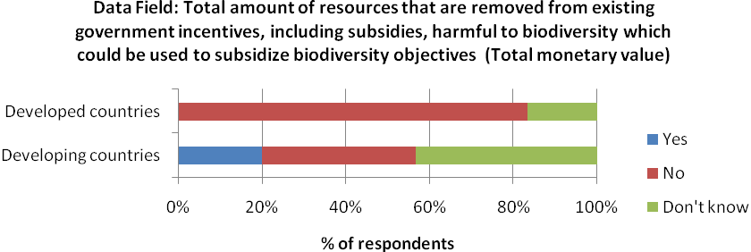

Data availability to report against this indicator is poor in developed nations; 83% of respondents are lacking data, while 17% are unsure as to the availability. Data is also lacking in developing nations, with 21% of respondents reporting available data, 36% reporting no data and 43% who don’t know.
Existing Data
Global and regional:

Although this indicator is likely to be populated through national reporting there are datasets collated and produced by a number or organizations that may provide useful background data and baselines. A number of these datasets are aggregated from national level data which may assist with future national reporting to the CBD. The majority of datasets found relate incentives through levels of subsidies.

Global subsidy estimates were brought together (Table 6) in a review conducted by The Economics of Ecosystems and Biodiversity initiative (TEEB 2009). As shown inTable 6, global subsidies add up to hundreds of billions of dollars every year. Subsidies to agriculture are amongst the largest, estimated at over US$250 billion /year in OECD countries alone. Subsidies to other sectors are also significant and probably under-estimated due to limited data and the specific measurement methodologies used.

Table 6: Aggregate subsidy estimates for selected economic sectors
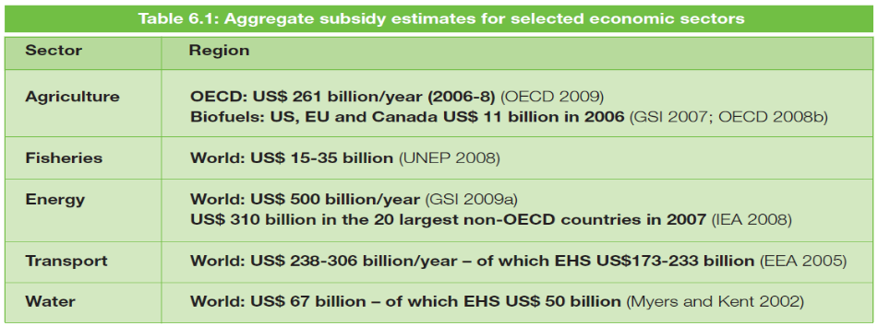
Source: TEEB (2009)

There is no organization which brings together subsidy data for all sectors and instead data for the different sectors is available from different organizations.

Data sources for individual sectors:

Agriculture
OECD has developed a set of indicators, Producer Support Estimates (PSE), designed specifically to monitor and evaluate the level and composition of the support governments provide to agriculture in the form of transfers through a wide variety of policy measures. Annual data for these indicators are available from 1986 onwards for the 14 OECD economies (Australia, Canada, Chile, European Union, Iceland, Israel, Japan, Korea, Mexico, New Zealand, Norway, Switzerland, Turkey and United States) and in addition 5 non-OECD economies (Brazil, China, Russian Federation, South Africa and Ukraine). All data is available from: http://www.oecd.org/document/59/0,3746,en_2649_37401_39551355_1_1_1_37401,00.html#summary

Farmsubsidy.org is an online database of the subsidies paid to farmers and others under the European Union’s Common Agricultural Policy. The initiative is run by the EU transparency, a non-profit organisation in the UK and KaasogMulvad, a research and analysis company in Denmark. The initiative has also established a Transparency Index to compare how well EU member states are doing at providing information on funding under the Common Agricultural Policy.
The online database on farm subsidies in available from http://farmsubsidy.org/EU/.

Biofuels

The Global Subsidies Initiative has collected information on Biofuel Subsidies for a number of case studies. Case study countries include Australia, Canada, China, European Union, Indonesia, Malaysia, Switzerland, and United States. This information is not provided in a database but be accessed online: http://www.globalsubsidies.org/research/biofuel-subsidies.

Fisheries

In a review conducted by the UBC Fisheries Centre (Sumaila and Pauly, 2006) to produce a bottom-up estimation of global fisheries subsidies a database of fisheries subsidies was created. This database consisted of ten subsidy types for 144 coastal countries engaged in fishing activity in the year 2000, spanning 1995 to 2000. Although a static analysis for the year 2000, for countries for which 2000 data was not available, the closest available data within the period 1995 to 2005 was used. Using the data contained within the database the total magnitude of fishery subsidies in marine capture fisheries was estimated at US$25.7 billion for the eleven types of subsidies identified, excluding fuel subsidies. The study grouped the eleven types of subsidies into three categories; ‘Good subsidies’, ‘Bad subsidies’ and ‘Ugly subsidies’. These groupings were made according to impact of subsidies on fishery populations with the ‘Bad subsidies’ and ‘Ugly subsidies’ resulting in over-exploitation of fish stocks.

The data collated for the study is made available in Appendix 2 of the report (http://www.seaaroundus.org/researcher/dpauly/PDF/2006/Books&Chapters/CatchingMoreBait.pdf) and online through the Sea Around Us Website (www.seaaroundus.org). The underlying database is being revised and updated regularly (Personal communication).

Fishsubsidy.org is an online database of the subsidies paid to farmers and others under the European Union’s Common Agricultural Policy. The initiative is run by the EU transparency, a non-profit organisation in the UK and KaasogMulvad, a research and analysis company in Denmark. The online database on fisheries subsidies in available from http://farmsubsidy.org/EU/.

Energy
The International Energy Agency (IEA) within the framework of the World Energy Outlook, has been measuring fossil-fuel subsidies in a systematic and regular fashion for more than a decade. Its analysis is aimed at demonstrating the impact of fossil-fuel subsidy removal for energy markets, climate change and government budgets. The IEA’s latest estimates indicate that fossil-fuel consumption subsidies worldwide amounted to $312 billion in 2009, down from $558 billion in 2008. Declining world prices were the main reason for the sharp drop in the value of subsidies between 2008 and 2009. However, some of the observed drop can also be attributed to deliberate interventions to raise consumer prices (thereby, shrinking the price-gap) in order to reduce the burden on government finances

These estimates are considered to be incomplete; they ignore consumer subsidies in other countries and producer subsidies believed to be provided in almost all countries (GSI 2009). Little is known about producer subsidies with occasional studies having been undertaken by Earthtrack and Greenpeace.

The IEA has also established an online database (http://www.iea.org/subsidy/index.html) to increase the availability and transparency of energy subsidy data as this is seen as an essential step in building momentum for global fossil-fuel subsidy reform.

Transport
The European Environment Agency has an indicator on transport subsidies. The indicator highlights that more then 270-290 billion Euro of annual transport subsidies have been identified in Europe. At present the indicator only appears to include data from 2005 and there is no evidence of whether the indicator will be updated. The indicator has a dedicated webpage where all information can be found: http://www.eea.europa.eu/data-and-maps/figures/overview-of-total-annual-subsidies. A further study by the EEA (2005) reviews data from on transport subsidies from various sources.

Water

The Global Subsidies Initiative has collected information on Biofuel Subsidies for a number of case studies. Case study countries include India, Spain and Mediterranean countries. This information is not provided in a database but be accessed online: http://www.globalsubsidies.org/research/biofuel-subsidies.

Overall Considerations regarding global and regional data sets:

- Although global data sets can provides estimations and important indications of the order of magnitude of global subsidies, they are often riddled with conceptual and data deficiencies (TEEB 2009) The agricultural sector has the most complete data in terms of comprehensiveness and methodology as well as some of the highest subsidy levels. In contrast, other spectral coverage remains rather patchy even though considerable progress has been made in the past few decades to formalise measurement methodologies. Little or no subsidy data is available for large parts of the energy and manufacturing sectors such as mining and forestry.

- Although global datasets and databases exist these are often separated by sector. Due to differences in the methodologies used in calculating subsidy levels for different databases and sectors, comparing subsidies across sectors is often difficult or potentially biased.

- Caution should also be taken with the use of global data sets for this indicator as they provide a measure of the total value of subsidies and do not provide data on the value of subsidies removed, reformed or phased out. A reduction in the value of subsidies may be the result of a range of factors including declining world prices, partial reporting etc, and therefore should not necessarily be taken to represent a reduction in the resources invested in subsidies

- Global data sets and databases (with the exception of the Sea Around Us database) often don’t include information on whether the specific subsidy type is harmful to biodiversity and therefore the use of many datasets could only be undertaken if the assumption was made that all subsidies are harmful to biodiversity.

- The majority of global data sets highlighted here are concerned with subsidies and it is difficult to identify datasets that may provide measures of the other incentive types and may be applicable for this indicator.

References
EEA – European Environment Agency (2005) The Use of Subsidies, Taxes and Charges in the EU Transport Sectors. EEA, Copenhagen, Denmark.

GSI – Global Subsidies Initiative (2009a) Achieving the G-20 call to phase out subsidies to fossil fuels. Policy Brief October 2009. GSI, International Institute for Sustainable Development (IISD).

IEA- International Energy Agency (2008). World Energy Outlook 2008. IEA, Paris.
OECD – Organisation for Economic Co-operation and Development (2009) Agricultural Policies in OECD Countries. Monitoring and Evaluation. OECD, Paris.

Sumaila, U.R. and Pauly, D. (Editors.), 2006. Catching more bait: a bottom-up re-estimation of global fisheries subsidies. Fisheries Centre Research Reports 14(6), 114 p.

TEEB (2009). Reforming Subsidies. TEEB Report for National and International Policy Makers, Chapter 6. The Economics of Ecosystems and Biodiversity (TEEB), United Nations Environment Programme, Bonn.

UNEP – United Nations Environmental Programme (2008) Fisheries Subsidies: A Critical Issue for Trade and Sustainable Development at the WTO: An Introductory Guide. UNEP, Geneva

A3.14 Innovative Financial Mechanisms

Indicator 14
Indicator Text
Number of initiatives, and respective amounts, supplementary to the financial mechanism established under Article 21, that engage Parties and relevant organizations in new and innovative financial mechanisms, which consider intrinsic values and all other values of biodiversity, in accordance with the objectives of the Convention and the Nagoya Protocol on Access to Genetic Resources and the Fair and Equitable Sharing of the Benefits Arising out of Their Utilization;

Policy relevance /relation to Strategy for Resource Mobilization
This indicator responds to Goal 4 of the Strategy to ‘Explore new and innovative financial mechanisms at all levels with a view to increasing funding to support the three objectives of the Convention’.
Indicator Understanding
This indicator consists of two elements the number of initiatives that engage Parties and relevant organizations in new and innovative financial mechanisms and also the monetary value associated with these initiatives. The text specifies that the initiatives should be supplementary to the financial mechanism established under Article 21, however the indicator text also states that the initiatives included should be limited to innovative financial mechanisms which through their definition mobilize additional financial resources for achieving the Conventions aims. Six specific categories of innovative financial mechanisms were identified under Goal 4 of the Strategy for Resource Mobilization and therefore initiatives should only possibly feature in this indicator if they fall under these 6 categories.

It is important to remember that there is continuing discussions around innovative financial mechanisms which provide additional resources for implementing the Convention. At COP 1O the decision on innovative financial mechanism was not adopted and in the Strategy for Resource Mobilization (Decision X/3), parties, relevant organizations and initiatives were invited ‘to submit information concerning innovative financial mechanisms that have potential to generate new and additional financial mechanism that have potential to generate new and additional financial resources as well as possible problems that could undermine achievement on the Convention’s three objectives..... for the Executive Secretary to compile and present a synthesis of this information’.

Definitions and underlying concepts
Article 21 is also known as the Financial Mechanism. The Memorandum of Understanding for Article 21 states that “In accordance with Article 21 of the Convention the Conference of the Parties will determine the policy, strategy, programme priorities and eligibility criteria for access to and utilization of financial resources available through the financial mechanism, including monitoring and evaluation on a regular basis of such utilization. GEF, in operating the financial mechanism under the Convention, will finance activities that are in full conformity with the guidance provided to it by the Conference of the Parties’ (MOU, paragraph 2.1).

Innovative financial mechanisms explore supplementary yet more sustainable financial and economic approaches to human interaction with biodiversity and ecosystem services. Based upon the modern financial and economic methods, innovative financial mechanisms seek to develop financial and economic solutions to the current biodiversity crisis and to transform the prevailing financial and economic systems that have been distortionary in sustaining life on earth, thus avoiding unsustainable commodification of the nature. Innovative financial mechanisms are considered as important instruments to mobilize new and additional financial resources for achieving the Convention‘s objectives, and explored in the broad context of innovation for biodiversity while recognizing the close synergies between conserving biodiversity, combating desertification, and mitigating and adapting to climate change.

Six categories of IFMs are indentified in the Strategy for Resource Mobilisation under Goal 4 (COPIX/9, Annex, Goal). These IFM’s can be summarized as:

- Payment for Ecosystem Services (PES)
- Biodiversity Offsets
- Environmental Fiscal Reforms
- Markets for green products
- Biodiversity in development finance
- Biodiversity in climate change finance

Considerations for data collection and indicator development
- The indicator is made up of two components the actual number of innovative financial mechanism initiatives and the financial amount associated with the initiatives. For the collection of data it may be applicable to ask Parties and organizations to report against two data fields which respond to the separate components. An alternative would be for reporting parties to report separately on each initiative allowing the number and financial amounts to be aggregated, this would also be beneficial in gaining supplementary information (see point below)
- Parties could be asked to report at the level of individual initiatives and if so additional fields could be added to enable greater interpretation. For example the CBD has identified six categories of innovative financial mechanisms and it may be possible to ask reporting parties to indicate which category the initiative they are reporting on falls under. This would enable trends in the type of innovative financial mechanism to be analysed.
- At present there are continuing discussions around the use of innovative financial mechanisms as a supplementary source of resource mobilization for the Convention. The application of this indicator may need to be postponed in order to reflect future recommendations and decisions.

Level of data collection
If reporting is used data for this indicator could be collected from the following Parties:

- CBD Developed Country Parties
- CBD Developing Country Parties
- Private Corporations
- NGOs, foundations and academia
- International Financial Institutions
- United Nations organizations, foundations and programmes, IGOs

Essential Data fields & Units
All reporting Parties
- The total number of initiatives on new and innovative financial mechanisms (number)
- The amount invested in initiatives on new and innovative financial mechanisms (total monetary value)

Possible data fields needed for indicator production
Instead of asking parties to report on the total and respective amounts associated with innovative financial mechanisms, it may be beneficial to ask parties to report at the initiative level. For example the following data fields could be used:

Fields for reporting at the initiative level:

Type of Innovative Financial Mechanism: Payment for Ecosystem Services (PES)/Biodiversity Offsets /Environmental Fiscal Reforms/Markets for green products/Biodiversity in development finance/Biodiversity in climate change finance
Name of innovative financial mechanism:
Year started:
Financial Resources Mobilized (monetary value): (Note, after initial reporting this field should be changed to ask Parties: Additional financial resources mobilized since last reporting cycle)

Reporting at this level would enable greater interpretation of the indicator. It would help with collecting data for the two elements of the indicator. It would also enable trends in the types of innovative financial mechanisms used to be formulated. The use of a field relating to the date of the mechanism enables temporal baseline to be calculated from initial reporting.

Existing Indicators
There are no existing indicators which relate to indicator 14.

National Level Data Availability
An online survey was distributed to CBD National Focal Points and Resource Mobilization Focal Points to assess national level capacity for reporting the adopted indicators applicable at the national level. Parties were presented with the data fields for the production of this indicator at the simplest level and were asked if they had data available to report against these fields.

(a) Innovative financial mechanisms (number)

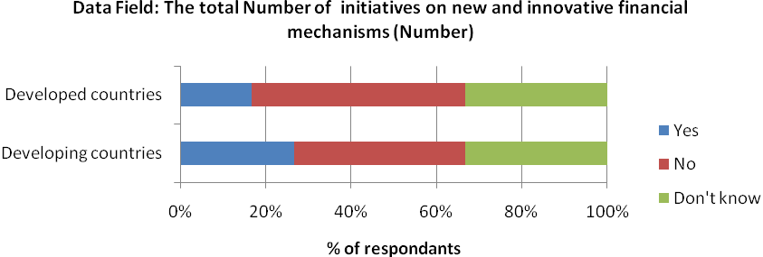

29% of developing respondents have available data to report against this indicator, compared to 17% of developed respondents. 39% of developing respondents reported no data availability, while 32% said they don’t know and 50% of developed respondent reported no data, while 33% don’t know.

(b) Innovative financial mechanisms (value)

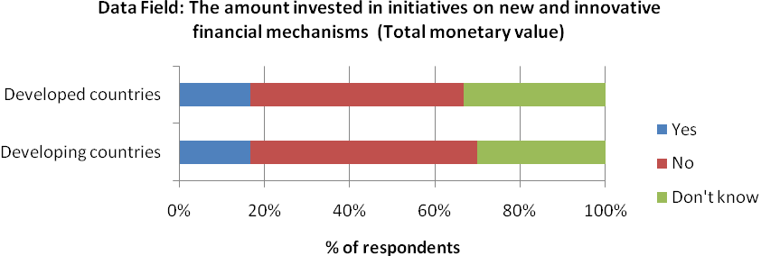

18% of developing respondents, and 17% of developed respondents have available data to report against this indicator. 54% and 50% have no data and 29% and 33% are unsure in developing and developed nations, respectively.

Existing Data Sources
At present there are continuing discussions around the use of IFMs as a supplementary source of resource mobilization for the Convention. Six categories of IFMs have been officially identified by the CBD; however there is a lack of existing data sources for all these categories as IFMs are a new and emerging area.

Biodiversity in climate change finance

The Development Assistance Committee (DAC) of the OECD is an international forum of 24 members: 23 donor governments and the European Commission (OECD 2010). The collects aid data from its members, and also from other donors (non-DAC countries and multilateral agencies such as the World Bank, regional development banks, UN agencies). Annual aid reporting takes place using the Creditor reporting System (CRS), and donors are requested to indicate for each activity whether or not it targets one or more of the three Rio Conventions using the so called ‘Rio markers’. This indicator may utilize ODA marked for both climate change and biodiversity for this IFM category. This approach was adopted in the Global Monitoring Report Produced for CBD COP 10 for reviewing current status and trends in financing for climate change and biodiversity (UNEP/CBD/COP/10/INF/22: http://www.cbd.int/doc/meetings/cop/cop-10/information/cop-10-inf-22-en.pdf)

The DAC has collected ‘Rio marker’ data from 1998 onwards: data for years 1998-2006 were obtained on a trial basis, and reporting became mandatory starting with 2007 flows. The data included some gaps, inconsistencies and partial reporting, but the coverage improved regularly. For 2008 data, only Luxembourg, Norway and the United States did not report on the biodiversity marker.

ODA data for all Rio markers can be accessed online via the OECD Stat Portal: http://stats.oecd.org/Index.aspx?DatasetCode=CRSNEW

A3.15 Access & benefit sharing initiatives

Indicator 15
Indicator Text
Number of access and benefit sharing initiatives and mechanisms, consistent with the Convention and, when in effect, with the Nagoya Protocol on Access to Genetic Resources and the Fair and Equitable Sharing of the Benefits Arising out of Their Utilization, including awareness-raising, that enhance resource mobilization

Policy relevance /relation to Strategy for Resource Mobilization
This indicator responds to Goal 7 of the Strategy to enhance ‘implementation of access and benefit-sharing initiatives and mechanisms in support of resource mobilization’.
Indicator Understanding
This indicator is a measure of the total number of access and benefit sharing initiatives and mechanisms consistent with the Convention. These initiatives will also need to be in harmony with the Nagoya Protocol when implemented. As the Nagoya Protocol has been developed under the CBD is unclear how initiatives could be consistent with only of these, as it could be assumed that initiatives that are consistent with the Protocol would also automatically be consistent with the Convention.

The indicator is simple in its design; however the text includes a specific reference to awareness raising initiatives that enhance resource mobilization. Although the text does not make differentiation of awareness raising initiatives compulsory, additional fields for data collection may enable collection of supplementary information that enables the proportion of awareness-raising initiatives to be analysed.

Definitions and underlying concepts
Access and benefit sharing also referred to as ‘The fair and equitable sharing of the benefits arising out of the utilization of genetic resources’ is one of the three objectives of the Convention on Biological Diversity.

The Nagoya Protocol on Access to Genetic Resources and the Fair and Equitable Sharing of Benefits Arising from their Utilization to the Convention on Biological Diversity is an international agreement which aims at sharing the benefits arising from the utilization of genetic resources in a fair and equitable way, including by appropriate access to genetic resources and by appropriate transfer of relevant technologies, taking into account all rights over those resources and to technologies, and by appropriate funding, thereby contributing to the conservation of biological diversity and the sustainable use of its components. It was adopted by the Conference of the Parties to the Convention on Biological Diversity at its tenth meeting on 29 October 2010 in Nagoya, Japan. The Nagoya Protocol will be open for signature by Parties to the Convention from 2 February 2011 until 1 February 2012 at the United Nations Headquarters in New York.

Considerations for data collection and indicator development
- The indicator is only concerned with access and benefit sharing mechanisms that are consistent with the Convention. Clear guidelines will be needed to help reporting parties differentiate between initiatives which are and are not in line with the Convention.
- Initiatives included in the indicator should also be consistent with the Nagoya Protocol in affect. Again clear guidelines are needed for reporting parties to enable them to assess if initiatives are in harmony with the protocol
- The adopted text defines the indicator as the total number of access and benefit sharing initiatives and mechanisms. In its simplest form the indicator could be presented as a trend over time, however the collection of supplementary information would enable greater interpretations and storylines to be generated. For example the text makes reference to awareness-raising initiatives and therefore it may be beneficial to introduce fields that allow for differentiation between the initiative types, e.g. awareness raising, capacity building, etc.

Level of data collection
If reporting is used data for this indicator could be collected from the following Parties:
- CBD Developed Country Parties
- CBD Developing Country Parties
- Private Corporations
- NGOs, foundations and academia
- International Financial Institutions
- United Nations organizations, foundations and programmes, IGOs

Essential Data fields & Units
The number of access and benefit sharing initiatives and mechanisms which are consistent with the Nagoya Protocol on ABS (number).

Additional data fields for consideration
Reporting take place at the initiative and mechanism level. The following fields could be added to enable greater interpretation of the indicator and enhanced storylines:

Initiative/Mechanism Level Reporting

- Initiative/mechanism name:
- Initiative established by:
- Establishment date:
- Financial investment (Monetary value):
- Type of initiative: Awareness raising/Capacity Building/Etc (Categories for initiative types could be taken from a review of the Nagoya protocol)

Existing Indicators
Four countries (Cameroon, China, Côte d’Ivoire and Tonga) reported the use of indicators relating to the fair and equitable sharing of benefits arising out of the use of genetic resources in their Forth National Reports to the CBD. China improved government legislation by establishing the National Intellectual Property Strategy and the National Program for Conservation and Use of Biological Resources. The indicator could not be used in the 4nr to report a trend for the associated indicator, but data collection over time will allow indicator presentation and interpretation.

The Streaming European 2010 Biodiversity Indicators (SEBI 2010) initiative included an indicator of ‘Biodiversity patent trends for European countries’. However this European indicator does not relate to indicator 15 which is concerned with the number of access and benefit sharing initiatives and mechanisms.

There are no global indicators which relate to this indicator.

National Level Data Availability
An online survey was distributed to CBD National Focal Points and Resource Mobilization Focal Points to assess national level capacity for reporting the adopted indicator applicable at the national level. Parties were presented with a data field at the simplest level and were asked if they had data available to report against this field.

Access and benefit sharing initiatives

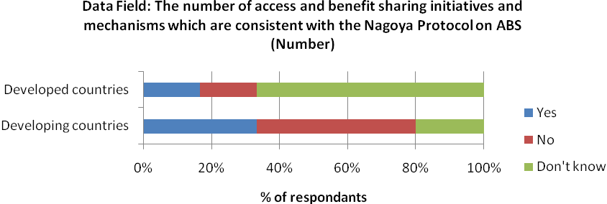

In developed countries, 17% of respondents reported available data for this indicator, while 17% also recorded no data and 67% were unsure as to data availability. From developing respondents, 32% have available data, 50% are lacking data and 18% are unsure.
Existing Data Sets
There are no existing data sources to assist with the production of this indicator. This indicator is likely to rely on national level reporting for data collection purposes.

Appendix 5: Croatia’s National Resource Mobilization (Additional Information)

Since the adoption of the first Strategy (NBSAP) in 1999, it is evident that significant improvement has been made towards strengthening the financial mechanisms for biodiversity conservation. With regard to the nature protection system as a whole, the state budget continues to be the primary source of financing. Croatia have had a stabile biodiversity growth in the national budget in the last few years, but unfortunately, like many countries, due to global economic crisis government budget has shown downturn. In order to ensure that biodiversity objectives are addressed in total, the system of institutions in nature protection was decentralized from central/state government to regional and local governments, including regional/local government resources. Certain percentage of funding is set aside from county, city and municipal budgets for the mainly purpose of management of National ecological network and protected areas through the activities of the state/county/local public institutions. Substantial funds for nature protection activities in the last decade at the national and/or regional level have been additionally secured through various international projects financed by different IFIs, governments/programmes of individual European countries and the EU pre-accession programmes. Given the importance of biodiversity conservation at the EU level, a significant inflow of funds from these sources is expected also in the post accession period.

In regards to the legislative framework, beside the NBSAP - the main strategic document for biodiversity protection, the Nature Protection Act envisages the system of financial incentives for environmental friendly management which takes in consideration measures for the conservation of biodiversity. Such mechanism is necessary for successful management of the ecological network areas, i.e. the future part of the EU NATURA 2000 ecological network, a system of incentives will be established through special regulations in near future (agri-environment programme deriving for CAP, as one of the systems of incentives for successful management of the ecological network areas is expected to contribute the most in this field).

Looking at the protected areas in Croatia, revenues from concession approvals (i.e. non-extractive commercial activities) are the income of the public institution and are designated for nature protection activities. Public institutions may grant concession approvals for a period of three years to legal or natural persons registered for ‘craft trade for the economic use of natural resources or exercising other activities in a protected area’. Revenues from concessions (i.e. for extractive uses such as mining and forestry) go to the Stage Budget or County budget. Concessions can be granted for a period of four to thirty years which provides the ‘right to economic use of natural resources or the right to exercising activities of interest for the Republic of Croatia, as well as the right to constructing and using installations and plants necessary for exercising such activities in protected areas’.

Charges on biodiversity use, include charging fees for issuing authorisation documents such as licenses or permits for nature utilization (e.g. CITES export permits, ecological network impact assessment certificate/permit etc.) These revenues are treated as revenues of State national budget, and thus they are not used solely for purposes of biological diversity, and are only partly returned to biodiversity as annual budget allocation. Also payments for the damage done to nature as a result of non-observance of rates and rules of nature utilization is an instrument used to collect resources , but in most cases, assessments of the overall fines for use of biological resources or products is based on existing market prices, but does not take into account the costs associated with long-term and indirect environmental damage resulting from such activities.

In order to establish long term National environmental funds, Croatian Government in 2004 established Environmental protection and energy efficiency Fund as an extra-budgetary fund which finances projects and activities in environmental protection area, including biodiversity. In last seven years approximately 2,5 million Euros was allocated for nature protection and biodiversity conservation projects. It is expected that the level of funds allocated by the Fund for biodiversity will be gradually increased.

The corporate sector is only beginning to get involved in the protection of biological and landscape diversity. The concept of socially responsible management should, to a large extent, be extended to nature protection through the sponsoring of concrete actions. Those entities that directly use or have a direct impact on natural resources should be obligated to earmark a certain amount of funds for nature protection.

National Data Sets and Monitoring Systems
Regarding the data set/monitoring system for resource mobilization there has not been till now additional system established in Croatia. Existing data sets in use are primarily in the function of financial and resource management (capacity management and financial planning) and can be used for existing reporting (no specific monitoring was set up for existing reporting). The existing data sets for financial reporting have been set in place for institutions that are governed on the state level (by the Ministry of Culture - state body responsible for NP and CBD implementation in Croatia).

To clarify the institutional framework here is a brief descriptionofInstitutional framework for nature protection. On state/national level Nature Protection Directorate (NPD) of Ministry of Culture is the government body responsible for nature protection (including NFP for CBD Convention). Also there are the State Institute for Nature Protection (SINP), central nature protection expert institution, public institutions (PIs) responsible for management of national parks (8) and nature parks (11), established by the Government. All these institutions are funded for primarily state budged, and are under jurisdiction of MOC-NPD, but all have the possibility to use different funding mechanisms available. National and nature parks are funded by a mix of national Government budget, their own self-generated income, and various other sources such as international aid and donations. Self-generated income is predominantly derived from visitor fees, as well as concessions approvals for recreational activities, and at some sites from hotels, restaurants and camping areas owned by the park Public Institutions. 100% of entrance fees for all national and nature parks stay within the park finances. The vast majority of national and all nature parks in Croatia require some financial assistance from the MoC through the annual budgeting process (only 2 out of 19 PIs are self-financed).

On regional (county) level, in order to set up more efficient decentralised system for nature protection, since 2004 County public institutions (CPIs) have been established. CPIs are responsible for management of other protected areas as well as for management of ecological network/NATURA 2000 sites within their respective counties. CPIs are established by regional self-government units and the City of Zagreb that may transfer their founders' rights to the local self-government units (cities, municipalities). For the moment there are 20 CPIs (out of 21) on the county level and 6 at the local level, young institutions that are primarily funded for the county/municipality budget, but all of the but all have the possibility to use different funding mechanisms available. The absorption of different funds is proportional to the capacity of each institution. CPIs do not have the obligation to report to MoC.

Croatia will join the European Union (EU) in the near future. The EU Habitats and Birds Directives require better management of natural resources, new approaches for public and private collaboration, and a sustainable method to finance the expansion of protected areas. Croatia’s Ecological Network (NEN), as a system of interconnected or spatially close ecologically important areas having a balanced biogeographical distribution, thus significantly contributing to the preservation of the natural balance and biodiversity, proclaimed in November 2007, covers 47 percent of Croatian Land Territory and 39 percent of the Territorial Sea. NEN includes international and national ecologically important areas and serves as the preliminary basis for proposal of the future Natura 2000 network in Croatia. Like other EU countries, Croatia will also have to propose sites for the NATURA 2000 Network for over 230 species and 70 habitat types that occur in Croatia and that are considered to be of EU importance.

Additionally to fulfilling the obligations set Strategic Plan and EU Biodiversity Strategy to 2020of the Convention for the period 2011-2020, we will have to work on integration of biodiversity in Common Agriculture policy (CAP), Common Fishery policy (CFP) and Cohesion Policy. Since the EU post accession grants for nature conservation will introduce mainstreaming across several EU instruments and thus access to EU grant funds for nature conservation it will depend on a strong proactive capacity to identify opportunities, and strengthened inter-governmental discourse and coordination to reach agreement on mutually beneficial approaches. In this the transition period, before joining the EU in order to fill the gap in the financing of nature protection sector Croatia with the 20,8 mil. EUR project will (loan from the International Bank for Reconstruction and Development (IBRD)) support Park and County Public Institutions to implement Natura 2000 objectives in investment programs; strengthen capacity for EU-compliant reporting and biodiversity monitoring; and introduce programs that involve a wide group of stakeholders in Natura 2000 network management. So the strengthening the NP Institution for better absorption of all available fund will ensure adequate financial mechanism to fulfil the gaps in the national and county budget.

For Croatia for nature conservation it is proposed to use the European Union Structural Funds (SF), namely the European Regional Development Fund (ERDF), to co-finance implementation of priorities set out in the Operational Programme ‘Environment and Energy’ (hereinafter referred to as OPEE). The OPEE represents a programme document for absorbing the EU funds allocation and the implementation of the cohesion policy of the European Union in the environment sector in Croatia covering a rolling seven-year programing period. Currently it is planned that the OPEE for the next programing period among other aiming at improvement of nature protection and biodiversity preservation through the development of management framework for selected NATURA 2000 sites, improvement of management, development of protocols for defining FCS and setting up the system for long term monitoring of habitats and species. Additional mapping of marine species and habitat types for marine part of NATURA 2000 sites is needed to provide detailed data as the basis for establishment of long term conservation of marine part of the network.

Agricultural land covers more than half of the total Croatian land area. Agriculture is therefore one of the most important sector influencing Croatia’s biodiversity and a large number of potential NATURA 2000 sites (approx. 33% of total Croatian land area) are located in agricultural areas. Because high biodiversity is usually associated with low-input, small-scale farming, most of the farmland in proposed NATURA 2000 sites is in marginal farming areas rather than intensively managed arable areas. Given the fact that one third of proposed area of NATURA 2000 network in Croatia will be managed by farmers, it is necessary to develop conservation measures that can easily be adopted by farmers who live and work in these regions. Once becoming the EU member, Croatia will have on disposal significant budget for rural development programme. According to the EU RD regulation, at least 25% of that budget Croatia will have to allocate to Axis 2 measures, especially to AE programme as the only obligatory measure. At the level of EU-27, 44 percent of the total funding for rural development is spent on Axis 2. Out of this, more than 50 percent is spent on AE programs. To make use of the EAFRD funds for nature conservation, Croatia started working on preparation of extensive AE programmes focusing on nature conservation and build necessary human resources and institutional capacity for accessing EU funds to insure funding mechanisms for of NATURA 2000 areas. The activates planned in next period will be implemented through NIP project and are jointly coordinated by Ministry of Culture and ministry responsible for agriculture in Croatia.

Appendix 6. Template for the Standard Financial Annex, used in the 2010 Fourth Reporting and Review process of the implementation of the UNCCD

- Identification
- Reporting Entity | Enter the name of the country or organization submitting the official report to the UNCCD to which the financial commitment will be attached in the form of a consolidated Standard Financial Annex
- Funding Organization | Enter the full name and acronym (if applicable) of the organization that has made the financial commitment
- Name of activity funded | Enter the name or title of the activity, project, programme, organization or initiative funded with this financial commitment
- Identification code | Enter the Identification Code (ID), number or acronym given to the activity funded (if known)
- Basic Data
- Recipient Country(ies) or (sub)region(s) | Enter the name of the country(ies), subregion(s) or region(s) in which the activity is taking place or is due to take place. Indicate “Global” if the activity is of global scale or has no specific geographical focus
- Recipient Organization(s) | Enter the full name and acronym of the organization(s) to which the funds have been or will be transferred to
- Executing Agency(ies) | Enter the full name an acronym of the Agency(ies) or Organization(s) that is/are in charge of the execution of the activity
- Commitment date (dd/mm/yyyy) | Enter the date at which the financial commitment has been formally approved by the extending organization (e.g. 15/01/2011)
- Currency | Indicate the currency denomination of the financial commitment (e.g. EUR, USD, YEN, etc.)
- Amount committed | Enter the total amount of money committed as a numeric field, showing the entire figure (e.g. enter 1500000 to indicate 1.5 million). Do not use abbreviations, symbols or decimals
- Type of funding | Indicate the type of funding provided through the financial commitment (e.g. grant, concessional loan, basket funding, sectoral support, debt swap, equity, etc.)
- Start date (dd/mm/yyyy) | Enter the date at which the funding has been or is expected to be made available to the recipient organization (e.g. 15/01/2011)
- Completion date (dd/mm/yyyy) | Enter the date at which the funding has been or is expected to be utilized by the recipient organization (e.g. 15/01/2011), if applicable
- Duration (no. of months) | Indicate the period covered by this funding, if applicable, expressed in number of months (numeric field. Do not use abbreviations, symbols or decimals)
- Classification
- Rio Marker for desertification | Assign the appropriate Rio Marker for desertification to the funded activity by ticking only one of the boxes below (refer to the Rio Markers guidance note for more information, examples and instructions)
- Rio Marker for desertification | 0 1 2 3
- Relevant Activity Code(s)  (RACs) | Indicate all the Relevant Activity Codes (RACs) that may apply to the funded activity (refer to the RACs guidance note for more information, examples and instructions). Add as many rows as necessary.
- Relevant Activity Code(s)  (RACs) | i.
- Relevant Activity Code(s)  (RACs) | ii.
- Relevant Activity Code(s)  (RACs) | iii.
- Sources of information | Specify the sources used to extract the information provided above (add as many rows as necessary). If reporting online, you may also upload relevant documents.
i.
ii.
iii.

Appendix 7. Template for the Project and Programme Sheet, used in the 2010 Fourth Reporting and Review process of the implementation of the UNCCD

- Title
Enter the Programme/Project title, and sub-title if applicable
- Organization(s)
Enter the full name and acronym of the reporting organization
- Role of the Organization(s) in the Programme/Project
Indicate the role of the reporting organization in the Programme/Project (e.g. funding agency, implementing agency, etc.)
- Civil Society Organizations (CSOs) and Science & Technology Institutions (STIs)
Enter the name(s) of Civil Society Organizations (CSOs), including Non-Governmental Organizations, research institutions and-or Science & Technology Institutions (STIs) involved in the Programme/Project. Note: This information should be taken into account in the computation of performance indicator no. CONS-O-3.
i.
ii.
iii.
iv.
v.
- Beneficiary Country(ies) or Sub Region(s)
Enter the name of the Country(ies), Subregion(s) and/or Region(s) benefiting from the Programme/Project. Indicate “Global” in the absence of a specific geographical focus
- Target Area size / administrative unit |  | Area Size |  |  |  |  |  |  |  | Administrative Unit
Indicate the total area expressed in number of hectares (numeric field. Do not use abbreviations, symbols or decimals). Also indicate the administrative unit targeted in the project area, if known, by the Programme/Project
- Target Group
Enter the different stakeholders, such as individuals, groups, or organizations, positively affected through their involvement in the implementation of an initiative/project/programme
- Beneficiaries
Enter the total number of people benefitting from the Programme/Project, if known (numeric field. Do not use abbreviations, symbols or decimals)
- Identification code
Enter the Programme/Project identification code (ID) or number, given by the relevant extending agency (if applicable)
- Status |  | Pipeline Ongoing Completed
Indicate the status of the Programme/Project at the time of completing this form.
- Start date (dd/mm/yyyy)
Indicate the date at which the Programme/Project started or is due to start, if known (e.g. 15/01/2011)
- Completion date(dd/mm/yyyy)
Indicate the date at which the Programme/Project was completed or is due to be completed, if known (e.g. 15/01/2011)
- Programme/Project co-financing |  | Source |  |  |  | Currency |  |  |  |  |  |  | Amount
 |  | Provide the full name and acronym of all co-financing organizations |  |  |  | For each co-financing, indicate the currency denomination used (e.g. EUR, USD, YEN, etc.), |  |  |  |  |  |  | Indicate the amount of funding provided by each co-financing organization (numeric field. Do not use abbreviations, symbols or decimals)
 |  | i.
 |  | ii.
 |  | iii.
 |  | iv.
 |  | v.
- UN Conventions’ Rio Markers |  | UNCCD |  |  |  | UNFCCC |  |  |  |  |  |  |  | CBD
 |  |  |  |  |  | adaptation |  |  |  |  | mitigation
Assign the appropriate Rio Marker to the Programme/Project (refer to the Rio Markers guidance note for more information, examples and instructions) |  | 0 1 2 3 |  |  |  | 0 1 2 |  |  |  |  | 0 12 |  |  | 0 1 2
- Strategic objectives |  | 1 |  | 2 |  |  |  |  |  |  | 3 |  |  | 4
Indicate which strategic objective of the UNCCD 10-Year Strategy is addressed by the Programme/Project
- Operational objectives |  | 1 | 2 |  |  |  | 3 |  |  |  |  | 4 |  |  |  | 5
Indicate which operational objective of the UNCCD 10-Year Strategy is addressed by the Programme/Project
- Programme/Project Objectives

Indicate the objectives pursued by the Programme/Project, as specified in the related documentation, choosing from the list of purpose codes provided in the quick reference guide (ICCD/CRIC(9)/INF.11). The OECD list of purpose is also available at the following link: http://www.oecd.org/document/21/0,3343,en_2649_34447_1914325_1_1_1_1,00.html.
i.
ii.
iii.
iv.
v.
- Programme/Project Components | Currency |  |  |  | Amount |  |  | Rio Marker for desertification |  |  |  |  |  |  | Relevant Activity Codes (RACs)
Indicate the specific Programme/Project components, if known, as specified in the related documentation.  Note: This information should be taken into account in the computation of performance indicator no. CONS-O-18. | Indicate the currency denomination (e.g. EUR, USD, YEN, etc.) |  |  |  | Indicate the amount allocated to each Programme/ Project component (numeric field. Do not use abbreviations, symbols or decimals) |  |  | Assign the appropriate Rio Marker for desertification to each Programme /Project component (refer to the Rio Markers guidance note for more information, examples and instructions) |  |  |  |  |  |  | Indicate all the Relevant Activity Codes (RACs) that may apply to the Programme /Project components (refer to the RACs guidance note for more information, examples and instructions)
i.
ii.
iii.
iv.
v.
vi.
- Expected or achieved results

Provide information on the results achieved or expected from the implementation of the Programme/Project (max 100 words).
i.
ii.
iii
iv.
v.
- Sources of information

Specify the sources used to extract the information provided above (add as many rows as necessary). If reporting online, you may also upload relevant documents.
i.
ii.
iii.

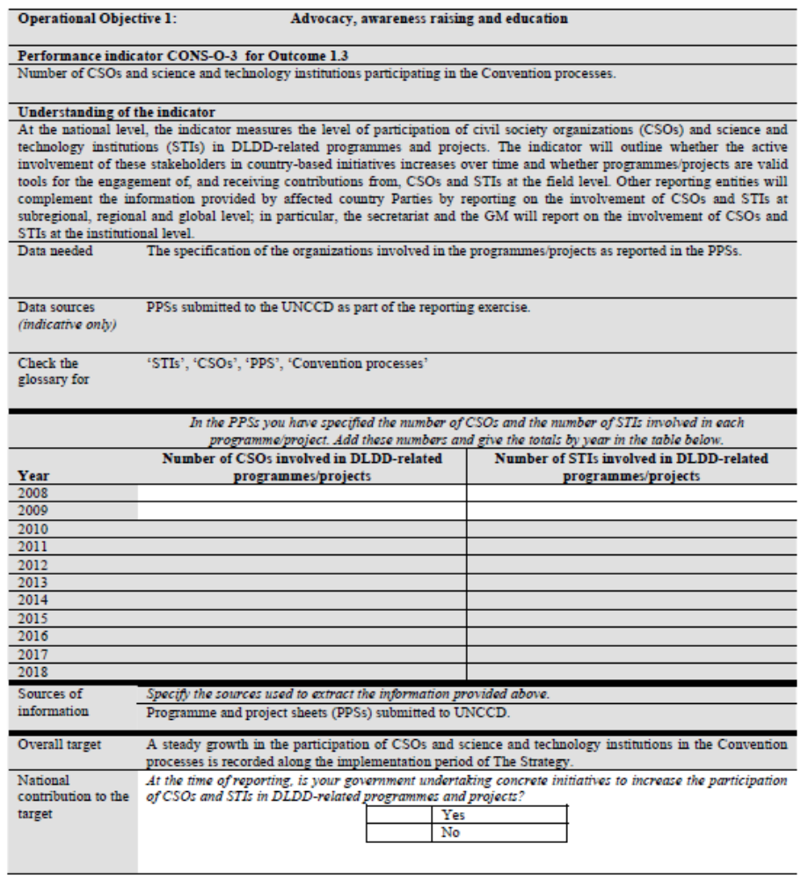
Appendix 8: Affected Country Parties Reporting Template for UNCCD Performance Indicator CONS-O-3

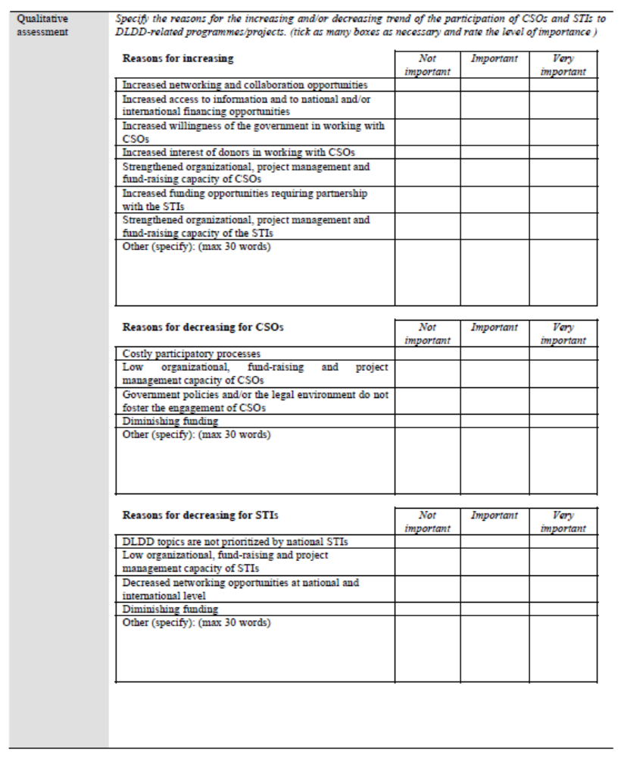

* UNEP/CBD/WG-RI/4/1.
Notification SCBD/ITS/RS/fb/75381: Strategy for resource mobilization in support of the achievement of the Convention’s three objectives (Decision X/3) - http://www.cbd.int/doc/notifications/2011/ntf-2011-061-sp-en.pdf
Decision VIII/18: Guidance to the financial mechanism - http://www.cbd.int/decision/cop/?id=11032
Difficulties may exist in assigning countries with economies in transition to either the developed and developing country reporting entities. This should be taken into consideration by the CBD Secretariat when designing the reporting format.
ICCD/CRIC(9)/13: http://www.unccd.int/php/document2.php?ref=ICCD/CRIC(9)/13
ICCD/CRIC(8)/5/Add.4: http://www.unccd.int/php/document2.php?ref=ICCD/CRIC(8)/5/Add.4
The UNCCD preliminary analysis for all Performance indicators is available online: http://www.unccd.int/cop/officialdocs/cric9/doclist.php
All lessons learnt are provided in the document {citation to be added}
Decision IX/11: Review of implementation of Articles 20 and 21- http://www.cbd.int/decision/cop/?id=11654
Decision X/3:The Strategic Plan for Biodiversity 2011-2020 and the Aichi Biodiversity Targets -http://www.cbd.int/decision/cop/?id=12269

