RESOURCE MANUAL FOR THE FIFTH NATIONAL REPORT (FIRST EDITION)

A. Introduction

This reference manual has been prepared to assist the Parties to the Convention on Biological Diversity (CBD) in preparing their fifth national reports, as per COP Decision X/10 and in accordance with Article 26 of the Convention. This reference manual does not replace the guidelines for the fifth national report. The role of this manual is only complementary and supportive. It is therefore highly recommended that Parties use the guidelines together with this manual in order to gain a clearer idea of what information could be included in the fifth national report and where and how to gather relevant information.

As the guidelines for the fifth national report are organized along a number of general questions with some key guidance notes, this manual is intended to provide detailed annotations of the guidelines, in particular with regard to the scale of reporting (suggested content or information to be included in each part and appendix as well as the executive summary), and some tables, graphics and indicators that countries could use for analyses. Similar to the manual prepared for the fourth national report, it also provides relevant reference materials and web links that Parties could use while preparing each part of the report. This manual also builds on the reference manual for the preparation for the fourth national report and incorporates some content therein.

The manual begins with suggestions for the preparatory process of national reporting. It is hoped that these suggestions will give Parties a chance to think about what process should be followed in order to ensure stakeholder involvement and that the final report comprehensively reflects the national situation. The manual then follows the same structure of the guidelines. The guidelines recommend that Parties prepare the executive summary after they have completed the three main Parts. There are three annexes to this manual. Annex I briefly introduces procedures for eligible countries to obtain funds from the Global Environment Facility for preparing the fifth national report. Annex II contains an indicative set of indicators that may be used for measuring progress towards the 2020 Aichi Targets. Annex III provides web links where countries could find a set of indicators for measuring progress towards relevant targets of the Millennium Development Goals.

It is also important to point out that suggestions in this manual are general in nature and may not be universally applicable, considering different national circumstances. Therefore it is advisable that Parties make use of the suggestions and materials provided in this manual as they deem appropriate. The Secretariat also welcomes feedback from Parties on the usefulness of this manual and any suggestions for its further improvement, which will be considered in the development of other supporting materials and tools and for improving future reporting cycles.
B. Suggestions for the preparatory process

Initiating and designing the process

Countries are encouraged to initiate the process to prepare the report as early as possible to ensure its submission by the deadline set by COP-10
(31 March 2014). The experience of many countries that had submitted their national reports on time shows that the earlier the process is in place the sooner the report will be ready for submission. So it is highly recommended that countries initiate the process immediately after they receive the finalized guidelines for the fifth national report (available on the CBD website at http://www.cbd.int/reports/guidelines/ ).

The guidelines for the fifth national report again stress the importance of the continued involvement of stakeholders in the preparatory process to ensure that the national report comprehensively reflects the national situation. More importantly, involving stakeholders in this process will increase their ownership of the report and mobilize and/or enhance their participation in the implementation of the Convention at various levels. The approach of hiring a consultant to do the whole report is not encouraged, although countries could hire a consultant to compile basic information or data for consultation with relevant stakeholders.

The preparatory process should be well planned before report writing actually begins. The process will vary from country to country, considering that different countries have different institutional arrangements and mechanisms for involving stakeholders. Questions that may need to be considered while designing the process include:

- Does an active multi-stakeholder mechanism to coordinate the implementation of the Convention, including monitoring and reporting, exist? If so, what are its existing structures, operating procedures and calendars of meetings?
- Do forums for dialogue and consultation among the different stakeholders, particularly in regard to NBSAP updating, exist? If so, can these mechanisms continue to be used?
- What are the national cultural traditions and practices regarding meetings, dissemination of information, and promotion of dialogue?
- Is bringing people together for meetings affected by the size of the country and the logistics involved?
- Can business be done effectively by telecommunications infrastructure (email, telephone, video conferencing)? What is the level of telecommunications resources available?
- What is the level of access to relevant information?
- What are the national languages? Is there a need for translation of materials?

These questions are only illustrative of the types of issues Parties may wish to consider as each country will need to assess how best to carry out the reporting process in accordance with its own circumstances and resources. Nevertheless, some general recommendations on how to approach the preparation of the report will be helpful regardless of the specificities of national circumstances.

Establishing coordinating and working bodies or assigning the role to existing bodies

After having received the finalized guidelines from the Secretariat, the National Focal Point should decide who will have overall responsibility for coordinating the preparation of the national report and its submission. In some countries, this may be the National Focal Point her/himself; in other cases s/he may entrust another person or agency to do this. In any case, it is recommended that the National Focal Point monitor or oversee the process to ensure that the report does not solely reflect the work of a few experts or agencies.

In principle, countries could use existing bodies to the extent possible and fill in any gaps with ad hoc arrangements as necessary. If needed, countries could set up a steering or coordinating committee or group involving representatives of other agencies and sectors, preferably with prior knowledge of the Convention and the reporting process. It is important that this steering or coordinating committee not be composed solely of members of a single agency or government department. To the extent possible, the steering committee should include representatives of all relevant sectors. The selection of these sectors will depend on national circumstances, but could include research and academic bodies, relevant private sector bodies, indigenous and local community organizations, ministries, bodies representing the agricultural, forestry, fishery, tourism or other sectors, environmental management bodies, non-governmental organizations, women’s organizations, bodies and agencies addressing sustainable development and poverty eradication, among others. Efforts should also be directed towards involving those sectors whose activities impact directly or indirectly on biodiversity. These can include the planning, finance, transport, energy, construction, health or educational sectors, as well as many others. Again, the list is potentially endless and each country’s list will be different.

Considering that many countries are updating their national biodiversity strategies and action plans in line with the Strategic Plan for Biodiversity (2011-2020), and that usually a steering committee and technical groups need to be established, as well as various stakeholders identified for this process, countries do not need to reinvent the wheel and could continue using the existing mechanisms or bodies, adjusting the process as necessary for preparing the fifth national report.

The first tasks of the steering or coordinating committee, once constituted, are to:

- Identify the relevant organizations who need to be involved in writing each part of the report;
- Consider a preliminary calendar and set of milestones, based on an estimation of the successive stages of preparing the report, the methodology to be adopted (face-to-face meetings, circulation of views by email, telephone or video conferences, etc.), resources available, and planned deadline for completion of the report;
- Invite the organizations identified to participate, providing them with relevant information, including the reporting guidelines, supporting materials (including this manual), after having made any necessary translations, and request them to review the preliminary calendar and set of milestones;
- Convene a first general meeting or consultation.

While establishing a coordinating body, it is important to also establish technical working groups to provide technical advice and support to the preparation of the report and undertake the writing and review of each individual part of the report. Countries could also assign the role to existing bodies that can provide technical advice or support needed. Working groups can be established by relevant themes or issues related to the country or by assigning the writing of individual parts and appendices of the report to certain groups. One or a few members of the steering or coordinating committee should head or coordinate the work of the different working groups to ensure that the working groups complete their respective work by the plan set by the coordinating body, and that there is a high level of communication between the coordinating bodies and working groups. The coordinators of the working groups should be mainly responsible for pooling together all inputs provided by working group members.

Identifying sources of information and data, including use of indicators and the National Clearing-House Mechanism

All the appropriate sources of information should be considered when preparing the fifth national report in order to ensure that it comprehensively reflects the national situation. The steering committee or each working group established or existing bodies assigned such a role could help identify the sources of information needed for the fifth national report. The first sources of information could be country biodiversity studies or assessments, national reviews of implementation of the Convention and the NBSAP for biodiversity planning purposes, in particular reviews or assessments undertaken for updating the NBSAP in line with the Strategic Plan for Biodiversity 2011-2020, as well as evaluations of ecosystem services and biodiversity at various levels and reports submitted to the biodiversity-related Conventions and the Rio Conventions. Such information could comprise printed or electronic information or even information that is only available orally (the latter being particularly relevant to indigenous knowledge). Information could be held by government agencies, national focal points of other conventions, research and scientific institutions, non-governmental organisations or indigenous and local communities. Arrangements need to be made to make this information available for the national reporting process. There might also be an opportunity to discuss how the availability of biodiversity-related information could be improved for this process as well as for future reporting and for any other purposes that might have been identified (for example, reporting under other conventions and agreements). Moreover, some countries have created national biodiversity databases; others have linked information sources through the national Clearing-House Mechanism (which may itself host databases that provide useful information for reporting). The national CHM can be used as a tool for gathering information, data or inputs from various relevant stakeholders or undertaking consultations with various stakeholders during different stages of report preparation.

In addition to the information sources available at the national level, this manual also provides a list of important, relevant resource materials and web links where countries can find further information to assist with the preparation of the report. It should be noted that the materials and web links listed herein are NOT exhaustive and countries are encouraged to access relevant regional and global information systems and databases that can provide useful information for relevant parts of the report.

To help relevant government departments and other stakeholders provide information and data needed for the report, it is advisable that the lead agency or coordinating body develop a template of the report, indicating where information is required for each part and section and to send the template to relevant stakeholders for their responses. Another option is to make such a template available on the national CHM to allow various stakeholders to provide their respective contributions.

It is also important to ensure the quality of the data or information used in the report. While countries are encouraged to use the most up-to-date data and information, countries could use historical data or information relevant to time periods to analyze trends, threats and implementation. In the absence of such data or information, countries could use experts’ opinions and qualitative assessments.

Where possible, countries should seek to use indicators, both global and nationally-developed indicators, for analysis throughout the report. This is particularly recommended for assessing progress towards the 2020 Aichi Biodiversity Targets. For details, please see the section on indicators.

Compiling drafts and finalizing the report through stakeholder consultations

Once drafts of all the parts of the report have been completed, the steering committee should compile them into a first complete draft. This should then be circulated to all participants and a date set for a return of views. Depending on the range of views expressed, the steering committee will need to decide whether to convene a final national meeting to finalize the report or if further rounds of consultation or review are required.

The important task is to ensure that all key stakeholders agree that the final draft is an accurate reflection of the national situation in respect of each aspect of implementation of the Convention. The process is intended to generate a real consensus among national stakeholders. Consultations can be undertaken in various ways depending on national circumstances and mechanisms. For example, a draft report can be made available on the national CHM for wider comments by various stakeholders. A draft report can be discussed and finalized through national workshops attended by various stakeholders or peer reviews.

Submitting the report and use of the report

It is important to remember that the national report to the CBD is an official document being submitted by the government to an inter-governmental body and will need to comply with existing national procedures for such submissions. Nevertheless, there is no compelling reason why a report developed through a multi-stakeholder process should not be compatible with whatever national procedures are in place under the responsibility of the foreign ministry or other authority. At the same time, and in line with the recommendation of COP, the completed report should be made widely available in the country. If it has been developed in the way suggested, a comprehensive, outcome-oriented assessment of implementation of national biodiversity strategies and action plans, as well as biodiversity mainstreaming and progress towards the 2020 targets and relevant targets of the Millennium Development Goals, will generate much interest among stakeholders, researchers, the media and the general public.

The choice of the means for such dissemination is a national decision, but could involve press briefings, briefings in the national parliament, distribution to ‘opinion-formers’, to libraries and educational establishments and to the general public. Parties could also launch national reports on the International Day for Biodiversity (22 May) or in connection with activities promoting the UN Decade for Biodiversity, make the national report available on the national CHM and publish booklets highlighting achievements and obstacles to implementation. After all, the provisions of the Convention cover nearly all aspects of economic activities and public policy issues. Moreover, the conservation and sustainable use of biodiversity is relevant to all sectors and all citizens. Everyone needs to be brought into the discussion on the challenge of meeting the 2020 targets. The report can prove to be a useful tool for alerting those not yet engaged in the issues addressed by the Convention, highlighting that they are not remote issues addressed under an international legal instrument, but rather among the most urgent day-to-day issues faced by a country.

C. Suggestions for preparation of the fifth national report

Part I. An update on biodiversity status, trends, and threats and implications for human well-being

Overall suggestions

Please provide an update of the status, trends, threats and implications. This part of the report should aim to describe/analyze how the status and trends of biodiversity have changed since the last national report was submitted. This analysis should be presented in context with both historical and recent data provided so as to have the whole picture of changes over time, while trying to avoid lengthy repetition of what was already provided in the previous national reports. If countries do not have updates to provide, they should explain the reasons for this (e.g. no adequate data was available during the reporting period, five years is not enough time for changes to become apparent).
- Please do not overburden the report with lengthy assessments. In this section, Parties are requested to provide a brief update or submit a succinct overview of the status and trends of, and threats to, biodiversity in their country. In this respect, the aim should not be to provide a lengthy and exhaustive description of biodiversity in the country but rather assess how the state of biodiversity is changing in the country. Parties may wish to highlight key findings of biodiversity assessments and provide web links to more detailed assessments if available. Parties may also wish to use assessments that exist at different levels, including regional and global levels, so long as these assessments properly reflect their national situation.

- Use indicators where available. If available, national and global indicators could play a substantial role in the analysis of the status, trends, threats and implications. Parties are encouraged to use these indicators, as well as globally and regionally developed indicators that fit their national situation, with adjustments made as necessary.

- Use experts’ opinion for status and trend analysis where little or no adequate data or information is available. The opinions of experts are based on years of observation and research and could be used as reference for this analysis. This is useful for planning where little or no adequate data or information is available.

- Use case studies or success stories to illustrate progress made or outcomes achieved. Where possible, Parties are encouraged to analyse how actions taken (i.e. actions described in Part II) have resulted in changes in biodiversity. The case studies should demonstrate significant reductions in the loss of biodiversity (or a specific component of biodiversity) within a defined scale, and a clear rationale of how this is linked to the actions taken. As much as possible, case studies should substantiate the results achieved with quantitative information.

- Use tools that effectively present or communicate information in the report. Parties could use any tools, such as tables, charts, graphics, figures and pictures that are effective in presenting or summarizing the information contained in this Part. For example, Parties could use figures or charts to present a summary analysis of the status and trends of biodiversity, building on national indicators if available, and/or expert judgment and assessments. See examples below from the fourth national reports.

Suggested information to be included

- Parties could begin this Part with a brief analysis of why biodiversity is important to their country, particularly in terms of contributions of biodiversity and ecosystem services to human well-being and socio-economic development. In doing so, Parties could focus on a few key components of biodiversity. Parties could also address the importance of biodiversity components for human well-being and socio-economic development by analyzing the economic, social, cultural, ecological, scientific, educational, recreational, aesthetic, health and other values of biodiversity. Particular focus could also be given to the functions of biodiversity to provide goods and services for human populations and to maintain the integrity of ecosystems. Where possible, Parties are encouraged to provide estimates of economic values in monetary terms. It should be noted that Parties do not need to cover all the values mentioned above. Instead Parties could present relevant information of particular interest to the country or the region where these biodiversity components are located. The biodiversity-related values and experiences of indigenous and local communities might be of particular interest in this regard. It should also be noted that this analysis should summarize existing assessments made at any level.

- Following this, Parties could highlight changes that have occurred in regard to the status and trends of, and threats to, biodiversity since the fourth or last national report was submitted. Parties could cover all the ecosystems in the country as well as a few key species of national importance however it should be noted that this analysis should be brief and capture key findings from relevant, existing assessments or the results of monitoring programmes. For trend analysis, Parties should describe changes in biodiversity or other trends over time and use quantitative indicators where available. Case studies, particularly actions described in Part II, could be used to illustrate changes in biodiversity, with a clear rationale provided as to how relevant actions have led to such changes. The threat analysis should cover both the main direct and indirect drivers of changes and relate these to the relevant economic sectors.

- In analyzing the implications or impacts of declining biodiversity and provision of ecosystem services, Parties may wish to focus on threats to human health and well-being, particularly local livelihoods, sustainable development, poverty reduction and ecosystems integrity, considering the
multi-dimensional (social, economic, cultural, ecological) implications of declining biodiversity. Consideration could be given to all relevant and significant ecosystem goods and services.
- Parties could conclude this Part with a brief analysis of possible future changes for biodiversity in terms of underlying causes, pressures, impacts on biodiversity and implications for human health and well-being, by comparing what might happen under “business-as-usual” policies with what might happen as a result of greater investment in the conservation and sustainable use of biodiversity and ecosystems. An analysis of such scenarios may take the form of a “What if?” narration, or be based on models (if such models are available) and include any scientific uncertainties described in the model. For this analysis, Parties could select one or two of the most important biodiversity components in the country, particularly where negative changes or trends have been observed over years.

Possible tools for use by Parties including tables, figures and indicators (examples extracted from the fourth national reports)

Figures for Biodiversity Status Analysis

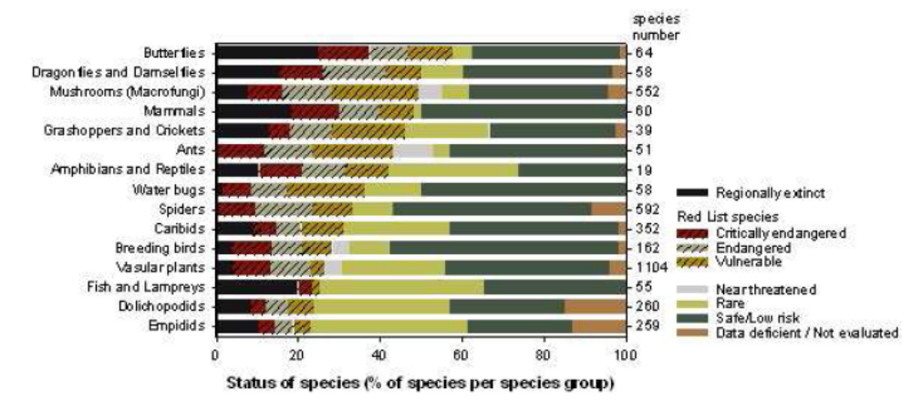
Figure 1. Species status in the Flemish Region in 2008 (Source: Research Institute for Nature and Forest, http://indicatoren.milieuinfo.be/indicatorenportal.cgi?lang=en&detail=657&id_structuur=71).
(NR4 Belgium)

(This figure summarizes a Red List assessment of the status of some taxonomic groups of the Flemish Region of Belgium in 2008. It illustrates the number and percentage of species in different risk categories.)

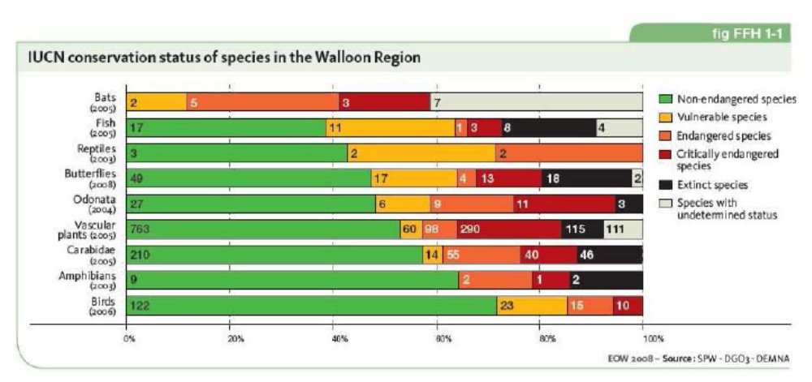

Figure 2. Species status in the Walloon Region in 2008 (Source: Département de l'Etude du Milieu naturel et agricole, http://environnement.wallonie.be/eew/rapportProblematique.aspx?id=p105).
(NR4 Belgium)

(This figure also clearly summarizes the endangerment and conservation status of some species in the Walloon Region of Belgium in 2008.)

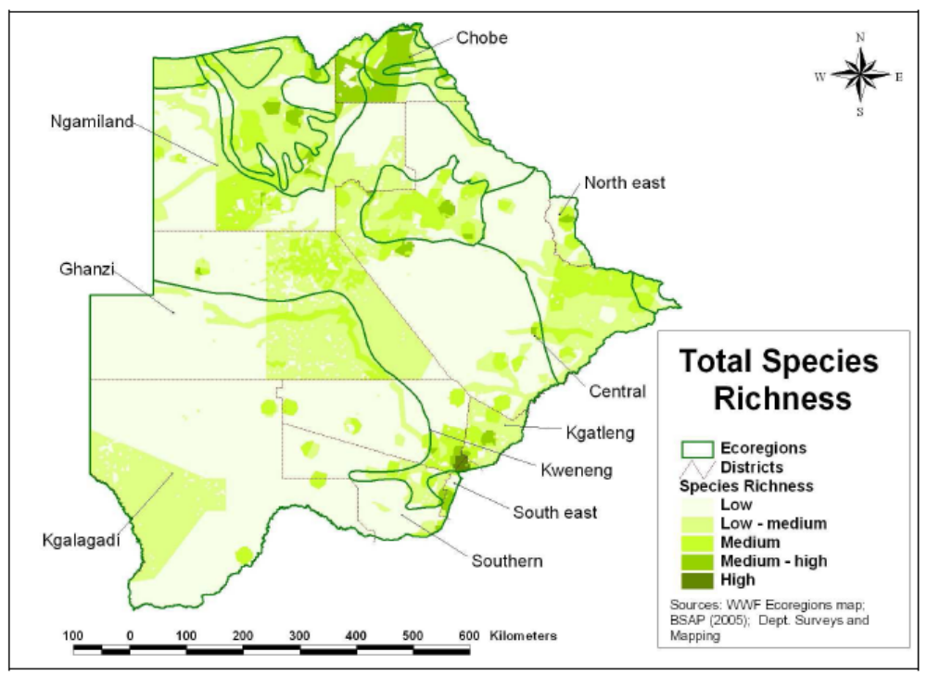
Figure 3. Map showing Species Richness Index in Botswana (BSAP 2005)
(NR4 Botswana)

(This map is a visual representation of Botswana’s Species Richness Index. The darker colors on the map depict areas with higher levels of species richness. Maps such as these can assist with land planning decisions.)
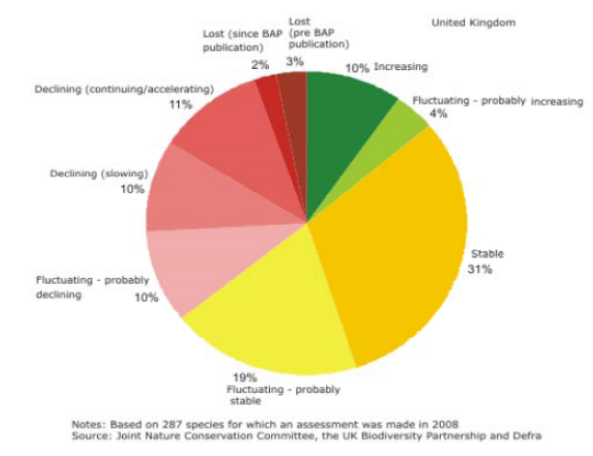
Figure 4. Status of UK Priority Species in 2008: http://jncc.defra.gov.uk/page-4238
(NR4 United Kingdom)

(This figure illustrates the conservation status of priority species in the United Kingdom in 2008 based on an assessment made in 2007. Species are classified according to several categories which show how the species is changing. Graphics such as this can help to prioritize conservation action to those species which are most in need.)
Figures for Biodiversity Trend Analysis
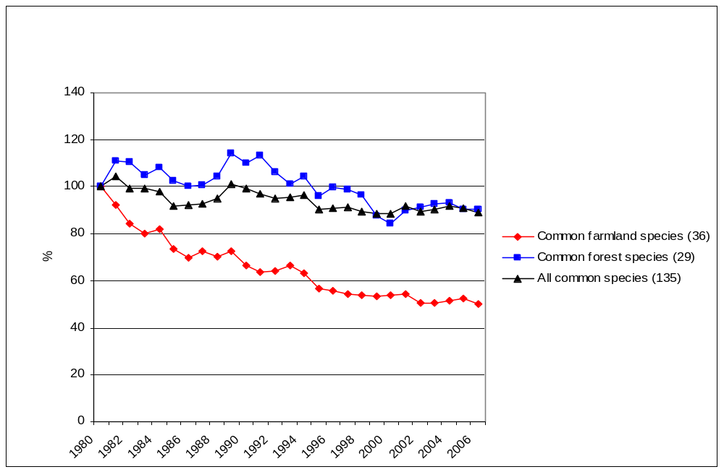
Graph 2: Common birds in Europe, population index (1980 = 100)
(Source: EBCC/RSPB/BirdLife/Statistics Netherlands)
(NR4 European Union)

(This figure illustrates population trends in common bird species in Europe by tracking changes over a 26 year period. Such images help to put changing trends in historical context and the magnitude of the changes being observed.)

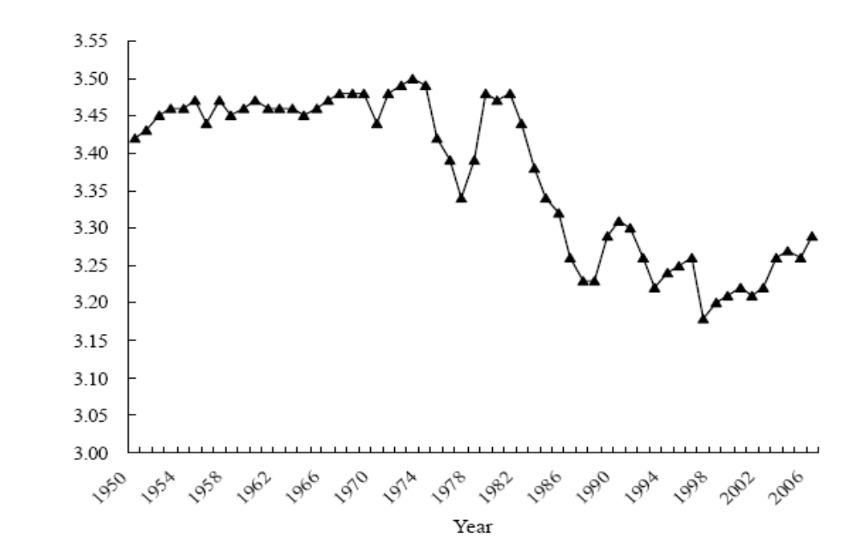
Figure 4-8. Change in China’s Marine Trophic Index over the Years (from Xu et al. 2009)
(NR4 China)

(This figure illustrates the trend in China’s Marine Trophic Index between 1950 and 2005. Graphs such as this one help to place current trends in an historic context as well as explain the changes being observed.)

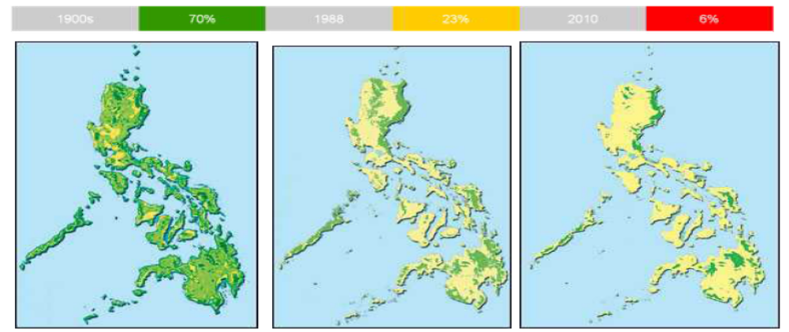
Figure 2. Forest loss in the 20th century. Source: Key Conservation Sites in the Philippines (Haribon and Birdlife International, 2001), citing ESSC booklet, “Decline of the Philippine Forest”.
(NR4 Philippines)

(These three maps help to illustrate changes in forest cover through time for the Philippines. Maps such as these can help make statistics more tangible.)

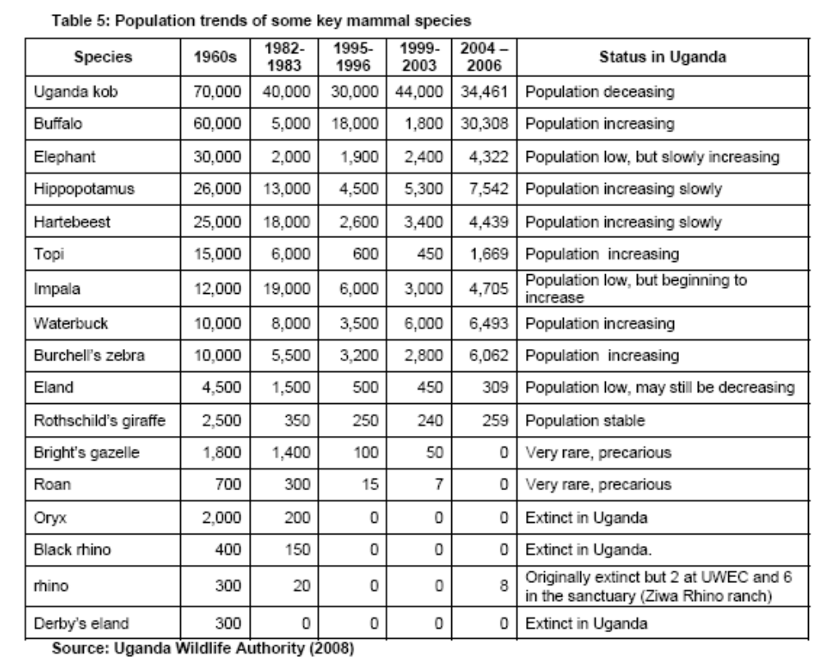
(NR4 Uganda)

(This table illustrates population changes for several Ugandan species. By providing data for multiple time periods, it is possible to compare current population levels with those of the past, as well as to determine if certain species are increasing or decreasing in population.)

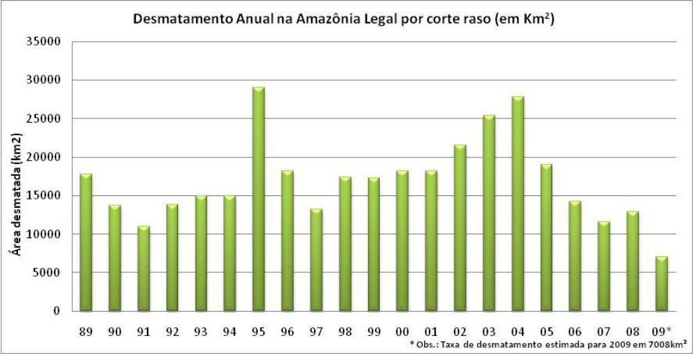
Figure I-10: Annual deforestation rate in Legal Amazon48. Source: MMA, 201049.
(NR4 Brazil)

(This figure illustrates trends in deforestation for the Brazilian Amazon. Graphs such as this can illustrate how the pressures on biodiversity may be changing over time.)
Tables or Figures for Threat Analysis
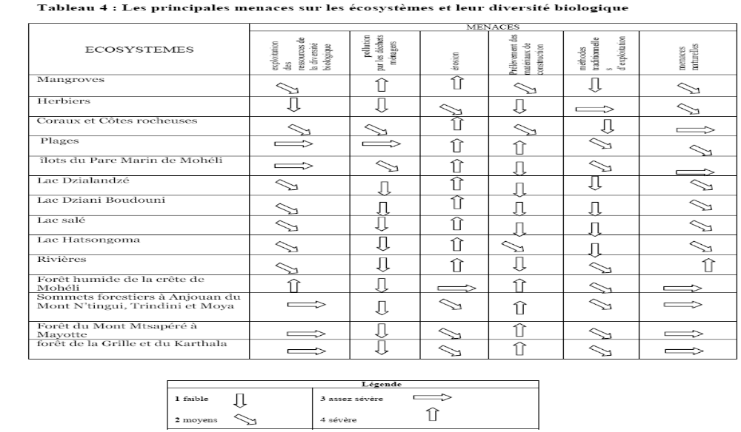
(NR4 Comoros)
(This table represents a threat assessment undertaken by Comoros, using the Millennium Ecosystem Assessment framework, of its different types of ecosystems. It identifies key drivers of biodiversity change as well as their impacts. These types of assessment can be done using experts’ opinion in situations where there is insufficient quantitative data.)

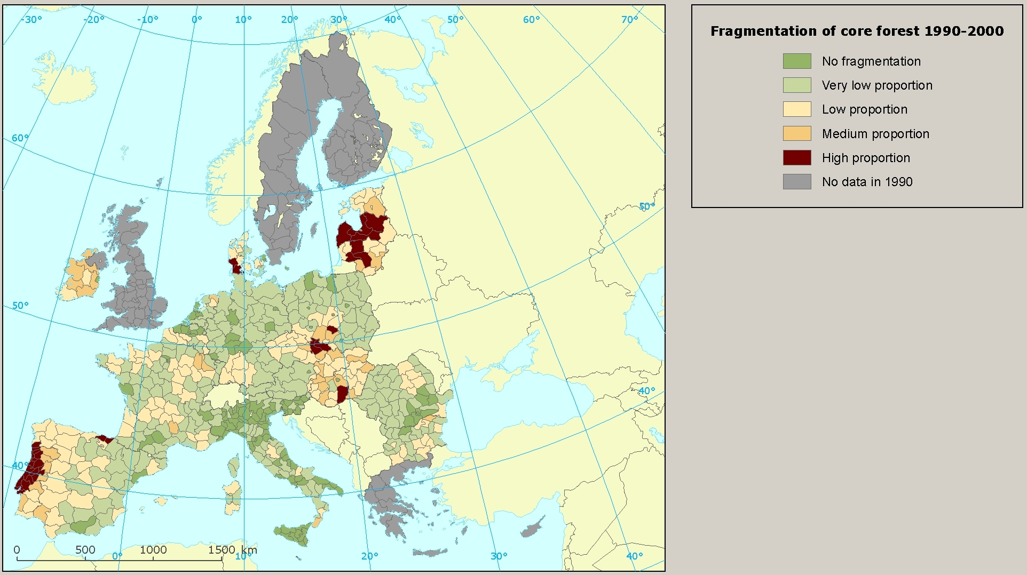
Data source: European forest pattern map based on forest mask of CORINE Land Cover (year 2000 and 1990, 100 m spatial resolution, 25 ha minimum mapping unit; JRC 2008 / Estreguil and Mouton 2008).
(NR4 European Union)

(This map visually represents forest fragmentation across Europe over a 10 year (1990-2000) period. Maps such as this can help to identify areas which are important for conservation.)

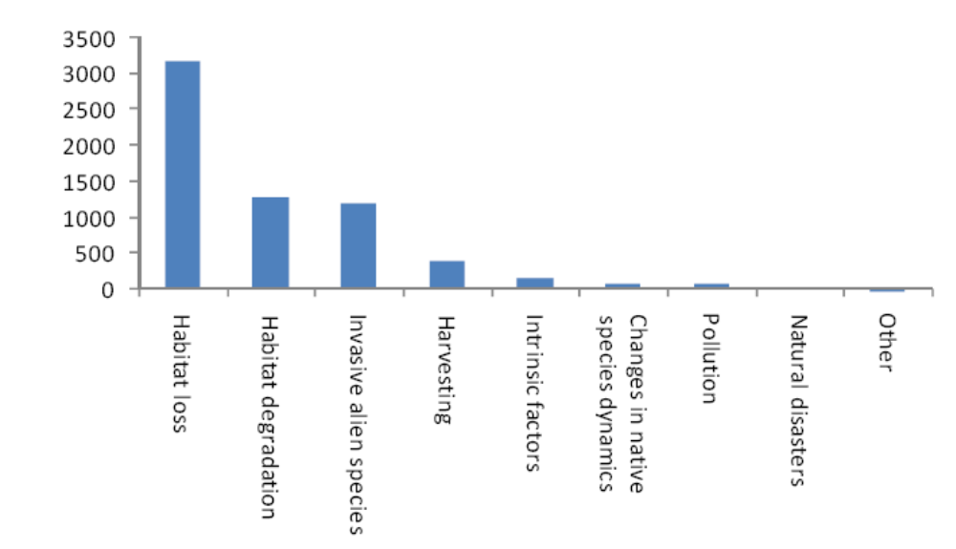
Figure 1‐6: Threats affecting Red Data Listed plant species in South Africa
(NR4 South Africa)
(This figure identifies the number of Red List plant species affected by the major threats to biodiversity in South Africa.
Graphs such as this can help to illustrate the major direct causes of biodiversity loss which can in turn support decision making processes.)
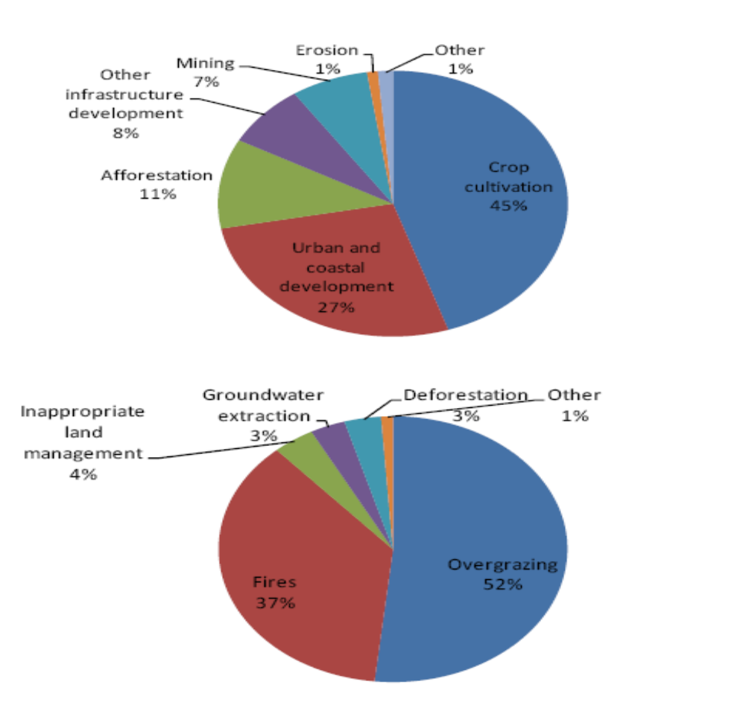
Figure 1‐7: Underlying causes of (a) habitat loss and (b) habitat degradation affecting Red Data
Listed plant species in South Africa
(NR4 South Africa)
(These two pie charts present information on causes of habit loss (above) and habitat degradation
(below) contributing to endangerment of some plant species in South Africa.)

Figures for Scenario Analysis
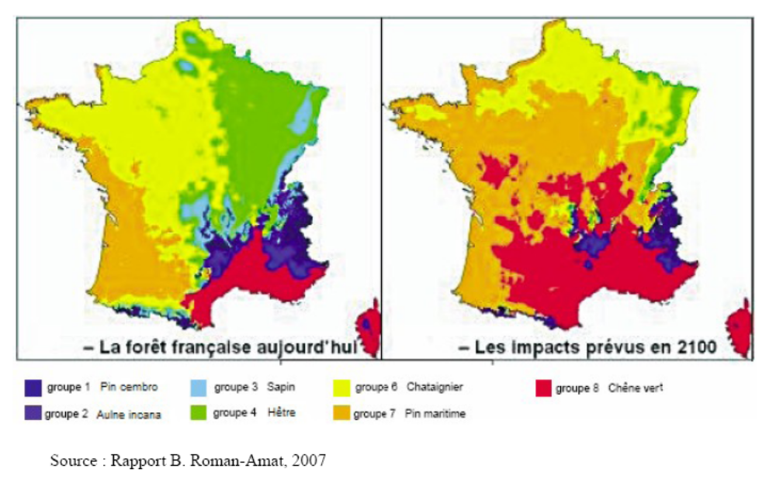
Figure 16: impact du changement climatique sur la forêt française métropolitaine
(NR4 France)

(This figure provides an analysis of the impacts on climate change on forests in France based on a scenario. Such types of maps help to illustrate what the potential effects of a pressure on biodiversity may be like in the future and as such can help to inform policy decisions.)

Figures for Economic Analysis of Benefits Provided by Biodiversity

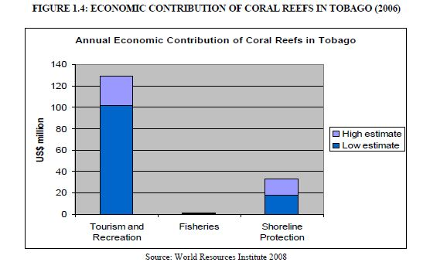

(NR4 Trinidad and Tobago)

(This figure clearly illustrates the annual economic benefits provided by coral reefs to tourism and recreation, shoreline protection and fisheries in Tobago.)
Reference materials and information sources

Assessments and scientific reports

- Biodiversity country study
- National biodiversity strategy and action plan
- National biodiversity assessments
- Database of scientific assessments available at https://www.cbd.int/assessments/
- Millennium Ecosystem Assessment: http://www.millenniumassessment.org/en/index.aspx in particular Millennium Ecosystem Assessment, 2005.Ecosystems and Human Well-being: Biodiversity Synthesis. World Resources Institute, Washington, DC.
- Millennium Ecosystem Assessment – Sub-global Assessments: www.maweb.org/en/Multiscale.aspx
- Global International Waters Assessment (GIWA) (Final Report): http://www.unep.org/dewa/giwa/publications/finalreport/giwa_final_report.pdf
- Freshwater assessments available at http://www.unep.org/dewa/assessments/EcoSystems/water/index.asp
- Global Forest Resources Assessment of FAO (2005): http://www.fao.org/forestry/fra2005/en/ and Forest Resources Assessment 2010 available at http://www.fao.org/docrep/013/i1757e/i1757e.pdf
- State of the World’s Forests (2011) by FAO available at http://www.fao.org/docrep/013/i2000e/i2000e.pdf.
State of the World’s Forest (2003) available at http://www.fao.org/DOCREP/005/Y7581E/Y7581E00.HTM#TopOfPage
State of the World’s Forest Genetic Resources (2009) available at ftp://ftp.fao.org/docrep/fao/meeting/015/k4225e.pdf
- Land Degradation Assessment: http://lada.virtualcentre.org/pagedisplay/display.asp
- Global Marine Assessments: A survey of global and regional assessments and related activities of the marine environment: www.unep-wcmc.org/resources/publications/UNEP_WCMC_bio_series/27/GlobalMarineAssessments-HR.pdf The accompanying database is available at: www.unep-wcmc.org/GRAMED/
- Global Mountain Biodiversity Assessment available at http://www.mountainbiodiversity.org/home.html
- Millennium Development Goal Reports: http://www.un.org/millenniumgoals/reports.shtml
- Global Biodiversity Outlook: http://www.biodiv.org/gbo3/default.shtml
- Global Environment Outlook (GEO): The latest comprehensive GEO report is Global Environment Outlook 5 (2012) available at http://www.unep.org/geo/pdfs/geo5/GEO5_report_full_en.pdf. Global Environment Outlook 4 (2007) also available at http://www.unep.org/geo/geo4/media/ , see also Vital GEO Graphics available at http://www.grida.no/files/publications/vital-geo-graphics.pdf. GEO Yearbook (2011): Emerging Issues in Our Global Environment at http://www.unep.org/yearbook/2011/pdfs/UNEP_YEARBOOK_Fullreport.pdf . GEO Year Book (2012) available at: http://www.unep.org/yearbook/2012/ . For previous versions of GEO, UNEP Yearbooks and other publications from 2002, please see http://www.unep.org/dewa/ProductsandServices/Publications2011/tabid/51370/Default.aspx
- The GEO for Latin America and Caribbean region available at http://www.unep.org/pdf/GEOLAC_3_ENGLISH.pdf
- The Environment Outlook for the Arab Region available at http://www.unep.org/dewa/westasia/eoar/
- Integrated assessments and scientific reports available at the webpage of the UNEP Division of Early Warning and Assessment: http://www.unep.org/dewa/Assessments/tabid/6350/Default.aspx
- First Report of the Census of Marine of Life: http://www.coml.org/pressreleases/census2010/PDF/Highlights-2010-Report-Low-Res.pdf
- “Plant at risk” (a study jointly undertaken by Royal Botanic Garden at Kew and IUCN) available at http://www.kew.org/science-conservation/kew-biodiversity/plants-at-risk/plant-life-under-threat/index.htm
- State of the World’s Birds available at http://www.birdlife.org/datazone/sowb.
- Biodiversity Scenarios-Projections of the 21st century of changes in biodiversity and associated ecosystem services (CBD technical series 50), available at http://www.diversitas-international.org/uploads/File/GBO3_Biodiversity_Futures.pdf
- The Second Report of the State of the World on Plant Genetic Resources: http://www.fao.org/docrep/013/i1500e/i1500e.pdf
- Blue Harvest: Inland Fisheries as Ecosystem Services by UNEP available at http://www.unep.org/pdf/Blue_Harvest.pdf
- State of Biodiversity in Africa 2010 available at http://www.unep.org/roa/docs/pdf/StateBiodiversity.pdf
- Dead Planet, Living Planet by UNEP available at http://www.unep.org/pdf/RRAecosystems_screen.pdf
- “Latin America and the Caribbean: a biodiversity superpower” by UNDP available at: http://www.undp.org/latinamerica/biodiversity-superpower/English_Report.htm
- “Economic values of the wetlands” by WWF International available at http://assets.panda.org/downloads/wetlandsbrochurefinal.pdf
- “Africa Footprint Report” by WWF International available at http://assets.panda.org/downloads/aef_2007_final_4_lr.pdf
- The report on the State of the Ocean by IUCN, available at http://cmsdata.iucn.org/downloads/ipso_workshop_report_june_2011.pdf
- Integrated Global Assessment of Desertification, Land Degradation and Drought available at http://www.unccd.int/knowledge/docs/EDLDD%20zef_dp_150.pdf
- The UK National Ecosystem Assessment and other papers available at http://uknea.unep-wcmc.org/Resources/tabid/82/Default.aspx
- Canadian Biodiversity: ecosystem status and trends 2010 available at http://www.biodivcanada.ca/A519F000-8427-4F8C-9521-8A95AE287753/EN_CanadianBiodiversity_FULL.pdf
- UK Climate Change Risk Assessment Report (including 11 sector reports), available at http://www.defra.gov.uk/environment/climate/government/risk-assessment/#report
- UNEP-WCMC Datasets, Tools & Reports available at http://www.unep-wcmc.org/datasets-tools--reports_15.html
- WWF Living Planet Report: http://wwf.panda.org/about_our_earth/all_publications/living_planet_report/; Living Planet Report (2012) available at http://awsassets.panda.org/downloads/lpr2012_for_desktop_printing.pdf.
- Critically Endangered Birds: A Global Audit by BirdLife International available at http://www.birdlife.org/news/news/2008/09/Complete_Critical%20Birds_superlowres.pdf
- Coral Reefs at Risk: Revisited by World Resource Institute, available at http://pdf.wri.org/reefs_at_risk_revisited_coral_triangle.pdf
- Report on Ecological Footprints of Arab Countries available at http://www.afedonline.org/report2012/PDF/English/FullEng2012.pdf

Useful websites

- UNEP Division of Early Warning and Assessments: http://www.unep.org/dewa/
- 2010 Biodiversity Indicator Partnership: www.twentyten.net
- The Global Biodiversity Information Facility: www.gbif.org
- The Census of Marine Life: www.coml.org
- The Ocean Biogeographic Information System: http://www.iobis.org/
- IUCN Red List of Threatened Species: www.iucnredlist.org
- Group on Earth Observation and Biodiversity Observation Network: http://www.earthobservations.org/geobon_docs.shtml
- The economics of ecosystems and biodiversity: http://www.teebweb.org/
- Encyclopedia of Life: www.eol.org
- A-Z Areas of Biodiversity Importance: http://www.biodiversitya-z.org/
- REFORGEN-FAO database on forest genetic resources available at http://www.fao.org/forestry/fgr/64623/en/
- World Resources Institute: http://www.wri.org/ecosystems
- Worldwatch Institute: http://www.worldwatch.org/environment-society
- UNEP-World Conservation Monitoring Center: http://www.unep-wcmc.org/about-biodiversity_133.html
- Biodiversity International: http://www.bioversityinternational.org/databases.html
- Intergovernmental Science-Policy Platform on Biodiversity and Ecosystem Services: http://www.ipbes.net/
- BISE-the Biodiversity Information System for Europe: http://www.eea.europa.eu/themes/biodiversity/bise-2013-the-biodiversity-information
- The Alliance of Zero Extinction: http://www.zeroextinction.org/
- Map of Life: http://www.mappinglife.org/
- Birdlife International: www.birdlifeinternational.org
- WWF: www.wwf.org

Part II. National Biodiversity Strategies and Action Plans (NBSAPs), their implementation, and the mainstreaming of biodiversity

Overall suggestions

- Parties should report here regardless of the status of their NBSAP. If no NBSAP is in place, countries could report on implementation of other similar strategies and plans. This Part covers both implementation of the NBSAP and mainstreaming, so countries could combine reporting on respective activities to avoid unnecessary repetition. If there is not a lot of information available on the implementation of an updated NBSAP, Parties could include information on the implementation of the previous NBSAP.

- Please provide more analysis than description. Parties should avoid listing all the actions taken to implement their NBSAPs and mainstream biodiversity. Instead Parties should provide an analysis of the effectiveness of the actions that have been taken and provide supporting cases studies or examples where possible.

Suggested information to be included

- Parties could begin this part by providing a description of their updated NBSAPs. In doing so, Parties are encouraged to focus on the key goals, targets, measures and priority actions identified therein, in particular measurable targets developed in line with the Strategic Plan for Biodiversity
2011-2020. Parties also need to elaborate how the revised NBSAP differs from the old one, particularly in terms of (i) how the actions contained therein will achieve the Aichi Biodiversity Targets; (ii) how it will contribute to the achievement of the Strategic Plan for Biodiversity 2011-2020; (iii) how it will address the threats to biodiversity identified in Part I; (iv) how it addresses the guidance provided in COP decision IX/8 (COP Guidance on Developing, Implementing, Monitoring and Reviewing NBSAPs); and (v) particularly how the updated NBSAP will achieve the integration of biodiversity considerations in broader national plans, programmes and policies, economic and social sectors and levels of government.

- Countries could then report on actions taken and outcomes achieved in regard to implementation of the NBSAP since the fourth or last national report was prepared. In cases where the NBSAP has been recently updated and where little has been achieved towards implementation, most of the actions and outcomes reported here may relate to the previous version of the NBSAP. Actions taken could include (however are not limited to) relevant legislation and policies developed, the strengthening of institutional and human capacities, implementation of relevant programmes and projects and various other related investments. Countries could also briefly describe (with details provided in Appendix III through the use of a matrix) how the actions relate to the various programmes of work and cross-cutting issues of the Convention, in particular those included in the post-2010 multi-year programme of work of the Convention. This information will be submitted to COP-12 (and beyond) for in-depth review. In analyzing outcomes or impacts, reference could be made to changes in the status and trends of, and threats to, biodiversity covered in Part I (with rationale provided as to how these actions have led to or are linked to such changes). Use could be made of relevant cases or success stories that have emerged from implementation activities. This information is particularly useful to highlight the positive results and lessons learned that have been generated from NBSAP implementation and where systematic monitoring of implementation is lacking.

- Parties are then requested to fully assess the implementation of the NBSAP, particularly what portion of the planned activities has been implemented and to what extent the related objectives and targets have been met. Parties also need to report on what activities have not been implemented and what objectives or targets have not been achieved. In the latter case, Parties are encouraged to analyze obstacles to implementation.

- While reporting on the mainstreaming of biodiversity, Parties are expected to focus on describing: (i) how biodiversity concerns are considered and addressed in various sectors and integrated into the key sectoral and cross-cutting policy instruments, such as sustainable development strategies, poverty reduction strategies and national health strategies, including an analysis of which sectors integrate biodiversity well and which sectors do not; (ii) how biodiversity is integrated into relevant planning processes or mechanisms; (iii) actions taken and outcomes achieved by each sector to implement biodiversity actions identified in their respective strategies, policies and programmes; (iv) tools used for mainstreaming such as the Ecosystem Approach, environmental impact assessment and strategic environmental assessment, as well as spatial and landscape planning; (v) how synergies are achieved at the national level for implementing relevant conventions such as the UNFCCC, UNCCD, CITES, Ramsar Convention and CMS; and (vi) how biodiversity is considered in various cooperation activities undertaken at various levels, including those related to South-South Cooperation. Countries could use cases or success stories to illustrate outcomes from biodiversity mainstreaming.

Examples of possible tables, figures or matrices that could be used to summarize or analyze implementation of an NBSAP

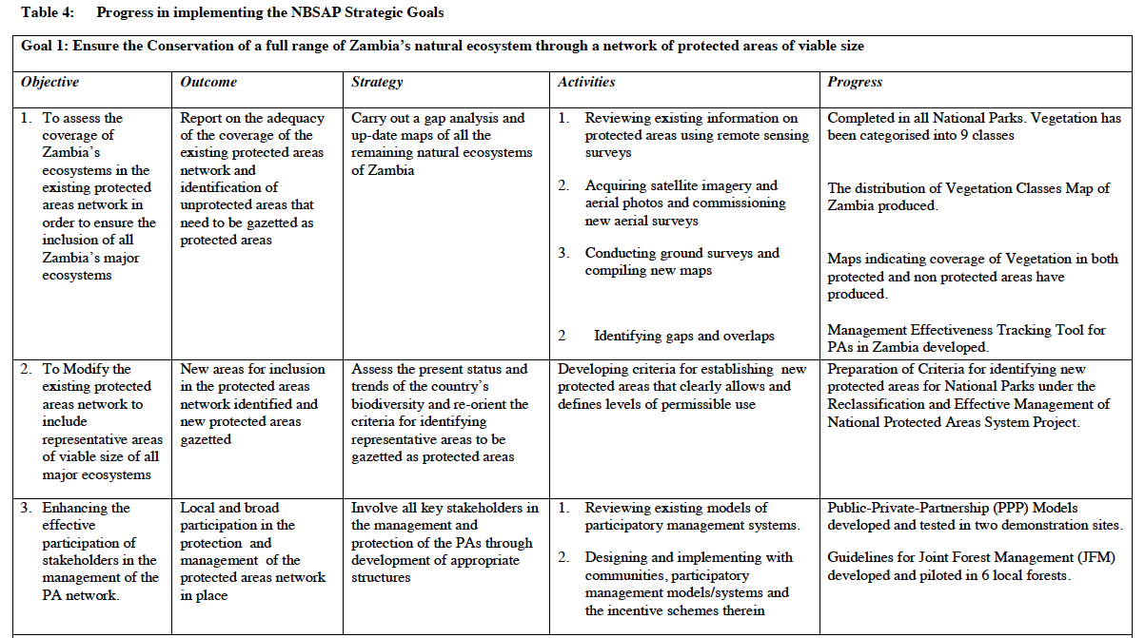
(NR4 Zambia)
(This table provides a summary of NBSAP implementation, with key activities and measurements of progress provided for each objective.)
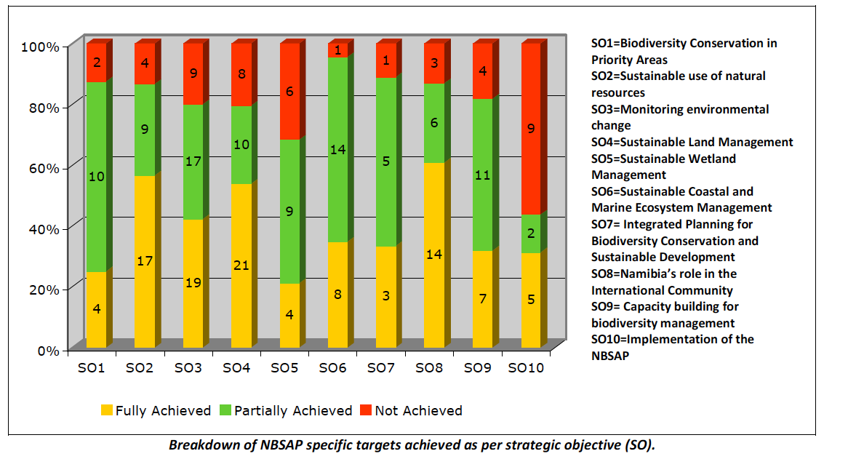

(NR4 Namibia)

(This figure provides a quantitative analysis of NBSAP implementation by classifying the different objectives
of the country’s NBSAP into several categories of implementation.)

Reference materials and web links

Review of NBSAP implementation

- Voluntary Guidelines for the Review of NBSAPs (annex to decision VIII/8): https://www.cbd.int/decisions/?m=COP-08&id=11020&lg=0
- COP Guidance on Developing, Implementing, Monitoring and Reviewing NBSAPs (COP decision IX/8):
https://www.cbd.int/nbsap/guidance.shtml
- UNEP-WCMC Framework for Assessing Implementation of the CBD:
http://www.unep-wcmc.org/cbd/assessment/index.html
- CBD webpage for NBSAPs: http://www.cbd.int/nbsap/
- UK Biodiversity Action Reporting System: http://ukbars.defra.gov.uk/ (Help Guides available at: http://ukbars.defra.gov.uk/help)
- A Biodiversity Outcomes Framework (Environment Canada): http://www.biodivcanada.ca/default.asp?lang=En&n=F14D37B9-1
- Assessing NBSAPs by the Institute of Advanced Studies of the United Nations University: http://www.ias.unu.edu/sub_page.aspx?catID=107&ddlID=807
9. Evaluation of the benefits of ecosystem services delivered by the UK Biodiversity Action Plan by DEFRA, UK, available at: http://archive.defra.gov.uk/temp/sffsd0702-economic-valuation-uk-bap.pdf

Mainstreaming

- The Ecosystem Approach Beginners’ Guide and Advance User Guide: http://www.cbd.int/ecosystem/sourcebook/beginner-guide.shtml & http://www.cbd.int/ecosystem/sourcebook/advanced-guide.shtml
- The Ecosystem Approach Sourcebook: http://www.cbd.int/ecosystem/sourcebook/default.shtml
- The Guidelines for Biodiversity-inclusive EIA and SEA: http://www.cbd.int/impact/guidelines.shtml; also see CBD case studies on impact assessments at http://www.cbd.int/impact/case-studies/
- A Brochure for Biodiversity-inclusive EIA and SEA: http://www.cbd.int/doc/publications/imp-bio-eia-and-sea.pdf
- CBD Proposals for Design and Implementation of Incentive Measures: http://www.cbd.int/incentives/tools.shtml; also see CBD case studies on incentive measures at http://www.cbd.int/incentives/case-studies.shtml
- CBD Options for the Application of Tools for Valuation of Biodiversity and Biodiversity Resources and Functions: http://www.cbd.int/incentives/tools.shtml
- An Exploration of Tools and Methodologies for Valuation of Biodiversity and Biodiversity Resources and Functions, CBD Technical Series No. 28: http://www.cbd.int/doc/publications/cbd-ts-28.pdf
- CBD Training Modules on mainstreaming: http://www.cbd.int/doc/training/nbsap/b3-train-mainstream-revised-en.pdf
- Tools, materials and presentations from regional and subregional capacity-development workshops on implementing national biodiversity strategies and action plans and mainstreaming of biodiversity available at https://www.cbd.int/nbsap/workshops.shtml
- CBD webpage for biodiversity for development: http://www.cbd.int/development/
- Issue-based Modules for Coherent Implementation of Biodiversity-related Conventions: http://www.svs-unepibmdb.net/
- Summary Report of Biodiversity in European Development Cooperation Conference: http://www.iisd.ca/download/pdf/sd/ymbvol126num1e.pdf Mainstreaming Biodiversity into National Development Plans (UNDP): Overview and Selected Tools: http://www.cbd.int/doc/training/nbsap/train-present-2007-intro-mainstream-en.pdf
- Mainstreaming Biodiversity in Production Landscapes (GEF, 2005): http://www.gefweb.org/Outreach/outreach-publications/documents/MainstreamingBiodiversity.pdf
- Mainstreaming Biodiversity into Business (FFI): http://earthmind.net/eibb/docs/workshop-a-ffi-2004-mainisteaming-biodiversity.pdf .
- A Review of Biodiversity Conservation Performance Measures (Earthwatch Institute/Rio Tinto): http://www.businessandbiodiversity.org/pdf/Biodiversity%20report%20(2).pdf
- IUCN/WWF Biodiversity Economics website: www.biodiversityeconomics.org
- Integration of Biodiversity into National Environmental Assessment Procedures: www.unep.org/bpsp/HTML%20files/TS-EIA.html
- WRI Mainstreaming Ecosystem Services Initiative: http://www.wri.org/project/mainstreaming-ecosystem-services
- WRI Ecosystem Services: A guide for decision makers available at http://www.wri.org/publication/ecosystem-services-a-guide-for-decision-makers
- Incorporating biodiversity into integrated assessments of trade policy in the agriculture sector: www.unep.ch/etb/areas/biodivAgriSector.php
- UN Information Portal on Multilateral Environmental Agreements: http://informea.org/
- Development Database on Aid Activities: http://www.oecd.org/dataoecd/50/15/5037782.htm
- Biodiversity for Development (South African Ministry of Environment and Tourism): http://www.environment.gov.za/biodiversity_for_development/biodiversity_development_report.pdf
- The Poverty and Conservation Learning Portal: http://povertyandconservation.info/

Part III. Progress towards the 2020 Aichi Biodiversity Targets and contributions to the relevant 2015 Targets of the Millennium Development Goals

Overall suggestions

- Provide more analysis or assessment than description. The guidelines request Parties to analyze how actions taken at the national level to implement the Convention contribute to progress towards the 2020 targets and relevant 2015 targets of the Millennium Development Goals. Parties do not need to repeat what is already reported in the previous sections of their national report. Instead Parties should draw upon relevant information and findings and undertake additional analyses.

- Highlight national targets, actions taken and outcomes achieved. In assessing progress towards the 2020 targets, Parties should provide information on any national targets adopted, actions taken to achieve these targets and particularly outcomes achieved. Cases or success stories (with detailed criteria for case selection provided below) could be used to illustrate outcomes or progress.

- Cover relevant targets of the Millennium Development Goals. It should be noted that Parties are not requested to report on the implementation of all the goals and targets of the Millennium Developments goals here, but rather to present information on those targets which are relevant to biodiversity. Countries are expected to focus in particular on how the implementation of the Convention and the Strategic Plan 2011-2020 has contributed or is contributing to the achievement of relevant targets of the Millennium Development Goals.

- Use indicators where available and possible. To make analysis or assessment more science-based, countries are encouraged to use quantitative indicators for this analysis or assessment as much as possible. Globally, regionally and nationally developed indicators could be used. Where indicators are not available, countries are encouraged to use qualitative assessments based on experts’ opinion. A set of indicators for assessing progress towards the 2020 Aichi Biodiversity Targets and the Millennium Development Goals are contained in Annex II and Annex III, respectively.

Suggested information to be included

- Parties could begin by highlighting the extent to which the strategic goals and targets have been achieved (which target has been fully achieved, which target has been partially achieved and which target has not been achieved). For those targets that have been fully or partially achieved, countries could provide a few cases or stories to support these statements. It is also important to highlight in this Part how actions taken to achieve the 2020 targets have contributed or are contributing to an improvement in the status and trends of biodiversity or mitigating pressures on biodiversity. A similar process could be followed for reporting on progress towards the relevant 2015 targets of the Millennium Development Goals.

- Countries could then use a table or matrix (see examples below) to summarize progress towards the Aichi Biodiversity Targets, highlighting the national targets adopted, actions taken, outcomes achieved, indicators used and overall progress. One way of demonstrating progress could be to use a simple “traffic light” scheme or a similar visual representation. This type of analysis or assessment is very important as it allows countries to know what has been done and what needs to be done in the next five or six years.

- In conclusion, countries could highlight those areas where actions have been effective and achieved successful outcomes, as well as areas where few or no actions have been taken. It is important to analyze why success has been achieved in some areas and why it has not been possible in others. Obstacles to implementation should be described here. It is also important to identify what needs to be done at various levels to further enhance the implementation of the Convention, particularly what actions or measures need to be taken in the next five or six years to achieve the 2020 targets. This concluding section provides an important basis for writing the Executive Summary of the whole report.

- As suggested above, countries are encouraged to provide cases or examples to illustrate progress achieved. In submitting such cases or examples, it is recommended that Parties consider the following criteria.

Cases needed

The cases should demonstrate the extent of actions or responses taken to achieve the mission of the Strategic Plan for Biodiversity 2011-2020, in addition to one or several of its Aichi Biodiversity Targets, within a defined scale. The case will be most useful if it contains experiences and lessons that are more widely applicable.

Information required

- Full description of impacts or outcomes achieved or expected against the mission of the Strategic Plan and one or several of its Aichi Biodiversity Targets and associated indicators.
- Measures taken to achieve the outcomes or responses to threats or drivers of change to biodiversity.
- Measures in place or planned to ensure that the results achieved will be sustained and further results will be achieved.
- Conclusion and lessons learned, including factors that may have influenced outcomes or are likely to influence outcomes in the future.

Criteria

- Convincing outcomes or impacts observed as a result of measures or responses taken since 2010
- Based on a clear measure of biodiversity and any measure consistent with the indicative set of CBD indicators
- Clear base year
- Clearly defined scale (habitat, biome, country, eco-region)
- Statistically significant (decrease greater than cyclic fluctuations)
- Sustained (more than one data point, or convincing arguments as to why it is to be sustained)

Example of table or matrix to use
Progress Towards the 2010 Target
Key to indicator assessment of change over time:
 |  | = |  | Improving
 |  | = |  | little or no overall change
 |  | = |  | Deteriorating
 |  | = |  | insufficient or no comparable data
PROTECTING THE COMPONENTS OF BIODIVERSITY
Goal 1. Promote the conservation of the biological diversity of ecosystems, habitats and biomes
Global targets |  |  | UK contribution to global target |  | Relevant UK indicator and associated measures |  |  | Assessment of change for each measure |  | Summary of change | Related UK and national targets
 |  |  |  |  |  |  |  | Long term | Since 2000 | Summary of change | Related UK and national targets
1.1: At least 10% of each of the world’s ecological regions effectively conserved. |  |  | Over 2.4 million hectares of land and freshwater have been designated as protected areas under national and international legislation, representing about 10 % of the land area of the UK. A further one million hectares of UK coastal seas have also been designated. These areas have been selected to cover habitats and species of particular importance for the Atlantic biogeographic region. To ensure sites are representative of the entire region site selection is coordinated at a European level under the EU Habitats Directive. The UK is currently in the process of designating marine protected areas. |  | 6. Protected sites  www.jncc.gov.uk/page-4241 | Area of protected sites |  | 1996 |  | The total area of land and sea protected in the UK has increased between 1996 and 2008 from 2.3 million to 3.5 million hectares - an increase of 48%. Since 2000 there has been a 12% increase | No relevant UK targets
 |  |  |  |  | 6. Protected sites  www.jncc.gov.uk/page-4241 | Condition of features on protected sites |  |  |  | Sites are designated with the aim of conserving specific biological or geomorphological features. The condition of these features is assessed on a rolling cycle against agreed standards. The first set of biological feature assessments is used to compile the condition indicator. This shows that the percentage of features or area in favourable condition (or in unfavourable but recovering condition) is generally between 60 and 85 per cent, although it drops to 37 per cent for Special Areas of Conservation. | There are separate targets in each of the countries of the UK to achieve favourable or recovering condition on 95 per cent of designated sites, either by area or by number of features. The date for achieving this target varies between countries.
1.2: Areas of particular importance to biodiversity protected |  |  |  |  | 4. Priority habitats  www.jncc.gov.uk/page-4239 |  |  |  |  | Priority Habitats are semi-natural habitats identified as priorities for conservation in the UK Biodiversity Action Plan.  Based on a comparison of the earliest available and most recent assessment for each habitat, the number either ‘stable’ or ‘increasing’ in area has fallen from 21 to 20 (2.5 per cent of the known habitats).  Despite this position of little or no overall change, 15 priority habitats (44 per cent) are still declining in extent. | In the UK, action plans and conservation targets have been agreed for 65 priority habitats. Targets are included for maintenance and restoration.
 |  |  |  |  | 14. Habitat connectivity  www.jncc.gov.uk/page-4249 |  |  |  |  | Indicator under development. | No relevant UK targets established.
Assessment of progress
Long term declines in habitat extent and quality have been addressed, and in some cases reversed.
Significant effort has been put into establishing an ecologically coherent series of protected areas across the UK providing protection for both nationally and internationally important species and habitats. The effectiveness of these protected areas is measured using a monitoring protocol which enables expert assessments to be made by operational staff of the statutory conservation agencies. The protected areas are part of the UK’s approach to conserving its important habitats and species – and their role is balanced by legislative requirements to take biodiversity into account in decision making, not just in relation to protected areas but also with respect to the wider countryside and seas. Significant further investment is required in order to meet targets beyond 2010 for all priority habitats.
(NR4 United Kingdom)
(This table provides a good summary of national implementation of the 2010 targets as well as measurement of progress using indicators and traffic-light schemes.)

Reference materials and web links

- Quick Guides for the Aichi Targets: https://www.cbd.int/nbsap/training/quick-guides/
- GBO 3: https://www.cbd.int/gbo3/
- 2010 Biodiversity Indicator Partnership (2010BIP): www.twentyten.net; www.bipnational.net
- National indicators: www.cbd.int/indicators/nationalindicators.shtml and Biodiversity Indicators for National Use: www.unep-wcmc.org/resources/publications/BINU/Experience_and_Guidance.pdf
- European Environment Agency Technical Report: Halting of the loss of biodiversity by 2010: proposal for a first set of indicators to monitor progress in Europe: http://reports.eea.europa.eu/technical_report_2007_11/en/Tech_report_11_2007_SEBI.pdf
- Millennium Development Goals: www.unmillenniumproject.org/goals/index.htm; MDG Reports: http://www.un.org/millenniumgoals/reports.shtml; Info concerning Goal 7, Target B available at http://www.un.org/millenniumgoals/environ.shtml. The MDG Monitor: http://www.mdgmonitor.org/
- Ecosystems, Climate Change and MDGs (working paper by WRI) available at: http://pdf.wri.org/working_papers/ecosystems_climate_change_and_millennium_development_goals.pdf.
- The Global Monitoring Report of the World Bank available at: http://web.worldbank.org/WBSITE/EXTERNAL/EXTDEC/EXTGLOBALMONITOR/EXTGLOMONREP2009/0,,menuPK:5924413~pagePK:64168427~piPK:64168435~theSitePK:5924405,00.html.
- UN Development Group MDG Tracking Tools and Databases at: http://www.undg.org/index.cfm?P=97
- Paris 21: http://www.paris21.org/betterworld/home.htm
- Millennium Development Goals Report (2010): http://www.un.org/en/mdg/summit2010/pdf/MDG%20Report%202010%20En%20r15%20-low%20res%2020100615%20-.pdf
Millennium Development Goals Report (2011): http://www.beta.undp.org/content/dam/undp/library/MDG/english/MDG_Report_2011_EN.pdf Millennium Development Goals (2011) Progress Chart:
http://www.un.org/millenniumgoals/pdf/(2011E)_MDReport2011_ProgressChart.pdf
MDG Report Cards: Measuring Progress Across Countries: http://www.odi.org.uk/resources/docs/6172.pdf
Millennium Development Goals Report (2012): http://www.un.org/millenniumgoals/pdf/MDG%20Report%202012.pdf http://www.un.org/en/development/desa/publications/mdg-report-2012.html
- UN MDG website: http://www.un.org/millenniumgoals/
- UNDP webpage for the MDGs : http://www.undp.org/content/undp/en/home/mdgoverview.html
- FAO webpage for the MDGs: http://www.fao.org/mdg/en/
- Handbook for Monitoring the Millennium Development Goals: http://mdgs.un.org/unsd/mdg/Host.aspx?Content=Indicators/Handbook.htm
- Report on Africa’s Progress Towards the MDGs (2010): http://www.undp.org/africa/documents/mdg/full-report.pdf
- Biodiversity and the Millennium Development Goals available at: http://www.undp.org/biodiversity/biodiversity_library.shtml
- “Species and People: Linked Futures” (WWF International) available at: http://assets.panda.org/downloads/wwf_mdgreport_2006.pdf

Appendices
Overall suggestions

- Attach importance to the supplementary information that can be provided in the appendices. In particular, Appendix III provides an opportunity to report on the implementation of the thematic programmes of work and cross-cutting issues of the Convention, particularly those included in the
multi-year programme of work of the Convention for in-depth review at COP-12 and future meetings of the Conference of the Parties. Further sources of information provided in Appendix II are very helpful to learn more about national implementation. A brief account of the process of preparation of the report in Appendix I will provide useful background information.

- Try to avoid overlaps with the three main parts of the report by inserting cross-references where applicable. This is particularly relevant when preparing Appendix III.

- Control the size of the whole report. Countries could provide references and links or append important materials in Appendix II, if necessary.

Suggested information to be included

- In Appendix I, Parties should briefly describe the process of preparing the report, particularly with regards to the involvement of various stakeholder groups. This brief account is important because it helps provide an indication of the extent to which the report is a product of multi-stakeholder consultations. It is also an indication of whether a country has used national reporting as a process to mobilize more public support and participation for the implementation of the Convention.

- In Appendix II, countries could provide further detailed information about the implementation of the Convention and related conventions. Information could include national reports submitted to the biodiversity-related conventions, a list of assessments, reviews and publications on which national reports are based, as well as web links where further information can be retrieved.

- In Appendix III, Parties are invited to report on the implementation of the thematic programmes of work and cross-cutting issues of the Convention, particularly those included in the multi-year programme of work of the Convention for in-depth review at COP-12 and future meetings of the Conference of the Parties. In this appendix, Parties do not need to repeat what is already reported in the main body of the report. Parties could use a table or matrix (see example proposed below) to highlight how national actions taken to implement the NBSAP and the 2020 targets and mainstream biodiversity have contributed or are contributing to goals, targets and activities suggested in the thematic programmes of work and plans or decisions related to cross-cutting issues.
- In reporting on implementation of thematic work programmes and cross-cutting issues (related programmes of work, plans or COP decisions), countries could focus on those goals, targets and activities/tasks recommended for national level or those that are nationally relevant and important. For example, while reporting on the implementation of the programme of work for Article 8(j), 10(c) and related provisions, countries could focus on tasks 1, 2 and 4 identified therein, as well as COP decisions IX 13 B & D and X/40. Countries could also report on the implementation of related guidelines and standards such as the Addis Ababa Principles and Guidelines on Sustainable Use, the Akwé: Kon Guidelines and the Code of Ethical Conduct. Also, in view of the fact that many thematic areas and cross-cutting issues are closely linked to one or several Aichi Targets, countries could also elaborate on how the implementation of the programmes of work and cross-cutting issues have contributed or is contributing to the achievement of relevant targets.
- Finally, Parties could include annexes to provide relevant information related to the report, such as details related to the development and use of indicators.
Proposed Tables or Matrices

Matrix for review of implementation of thematic programmes of work

Thematic programme areas | Global goals, targets and activities | National targets developed, if any | National implementation activities or actions taken | National contributions to achieving global targets and activities | National outcomes | Indicators used for measuring implementation, if any
Agricultural biodiversity
Marine and coastal biodiversity
Biodiversity of inland waters
Forest biodiversity
Biodiversity of dryland and sub-humid lands
Island biodiversity
Mountain biodiversity

Matrix for review of implementation of cross-cutting issues

Cross-cutting issues | Relevant COP decisions, programmes of work, work plans, guidelines and suggested activities | National Implementation and contributions | Outcomes achieved | Future priorities
Access and benefit-sharing
Biodiversity for development
Climate change and biodiversity
Invasive alien species
Global taxonomy initiative
Global Plant Conservation Strategy
Sustainable use/biodiversity and tourism
Communication, education and public awareness
Incentive measures
Impact assessment
Ecosystem Approach
Biodiversity and gender
Traditional knowledge, innovations and practices

Reference materials and web links

Review of thematic programme areas

Agricultural biodiversity

- CBD webpage for agricultural biodiversity: http://www.cbd.int/agro/
- Biodiversity International: http://www.bioversityinternational.org/
- Consultative Group on International Agriculture Research: http://www.cgiar.org/
- FAO Biodiversity: http://www.fao.org/biodiversity/biodiversity-home/jp/

Dryland biodiversity

- CBD webpage for dryland biodiversity: http://www.cbd.int/drylands/
- FAO-Desertification: http://www.fao.org/desertification/default.asp?lang=en. FAO-Land Resources: http://www.fao.org/nr/land/lr-home/en/
- International Center for Agricultural Research in the Dry Areas: http://www.icarda.org/Facelift.htm
- International Crops Research Institute for the Semi-Arid Tropics: http://www.cimmyt.org/
- UNCCD: www.unccd.int

Forest biodiversity

- CBD webpage for forest biodiversity: http://www.cbd.int/forest/
- United Nations Forum on Forests: http://www.un.org/esa/forests/
- Collaborative Partnership on Forests: http://www.un.org/esa/forests/cpf.html
- Centre for International Forest Research: http://www.cifor.cgiar.org/
- FAO Biodiversity: http://www.fao.org/biodiversity/components/forests/jp/

Inland waters biodiversity

- CBD webpage for inland waters biodiversity: http://www.cbd.int/waters/
- National Reporting webpage of the Ramsar Convention: http://www.ramsar.org/cda/en/ramsar-documents-natl-rpts/main/ramsar/1-31-121_4000_0__
- Wetland International: http://www.wetlands.org/
Island biodiversity

- CBD webpage for island biodiversity: http://www.cbd.int/island/
- International Coral Reef Initiative: http://www.icriforum.org/
- Pacific Regional Environment Programme: www.sprep.org
- Small Island Developing States Network: http://www.sidsnet.org/1d.html
- International Coral Reef Action Network: http://www.icran.org/action-csi.html
- CBD Report on Implementation of Resolution 63/214: Towards the Sustainable Development of the Caribbean Sea for Present and Future Generations http://www.cbd.int/islands/doc/report-imp-res-63-214-edited.pdf
- Global Island Database: http://gid.unep-wcmc.org/index.html
- Trends in Sustainable Development, Small Island States, United Nations Department of Economic and Social Affairs, Division for Sustainable Development, 2010: http://www.cbd.int/islands/doc/sids-trends-report-v4-en.pdf
- Summary of outcomes of Helping Islands Adapt: A Workshop on Regional Action to Combat Invasive Species on Islands to Preserve Biodiversity and Adapt to Climate Change: http://www.cbd.int/invasive/doc/workshop-helping-islands-en.pdf
- SCBD Report to UN-DESA on the Five-year Review of Progress Made in Addressing Vulnerabilities of SIDS through Implementation of the Mauritius Strategy for Further Implementation (MSI) of the Barbados Programme of Action: http://www.cbd.int/islands/doc/MSI%20+%205%20report-en.pdf
- National assessment reports prepared by individual SIDS for the five-year review of progress made in addressing vulnerabilities of SIDS through http://www.sidsnet.org/msi_5/nars.shtml
- Global Ocean Protection: present status and future possibilities by IUCN, UNEP, UNEP-WCMC & TNC: http://data.iucn.org/dbtw-wpd/edocs/2010-053.pdf
- Conservation International: http://www.conservation.org/Pages/default.aspx

Marine and coastal biodiversity

- CBD webpage for marine biodiversity: http://www.cbd.int/marine/
- A regular process for global reporting and assessment of the state of the marine environment, including socio-economic aspects (regular process): http://www.un.org/depts/los/global_reporting/global_reporting.htm
- The World Ocean Observatory: http://www.thew2o.net/
- A guide to ecological scoreboard for marine protected areas in North America by CEC: http://www.cec.org/Storage/98/9685_Marine_scorecard_en.pdf
- Global Ocean Protection-Present Status and Future Possibilities by IUCN: http://data.iucn.org/dbtw-wpd/edocs/2010-053.pdf

Mountain biodiversity

- CBD webpage for mountain biodiversity: http://www.cbd.int/mountain/
- Global Mountain Biodiversity Assessment website: http://gmba.unibas.ch/index/index.htm
- GBIF mountain biodiversity portal: http://www.mountainbiodiversity.org/
- International Center for Integrated Mountain Development: http://www.icimod.org/

Review of cross-cutting issues

Access and benefit-sharing

- CBD webpage for the Nagoya Protocol on Access and Benefit-sharing: http://www.cbd.int/abs
- FAO International Treaty on Plant Genetic Resources for Food and Agriculture: http://www.planttreaty.org
- WIPO webpage for genetic resources, traditional knowledge and folklore: http://www.wipo.int/tk/en/genetic/

Biodiversity for development

- CBD webpage for biodiversity and development: http://www.cbd.int/development/
- UNDP Environment and Energy webpage: http://www.beta.undp.org/content/undp/en/home/ourwork/environmentandenergy/overview.html

Communication, education and public awareness

- CBD webpage for CEPA: http://www.cbd.int/cepa/
- IUCN CEC webpage: http://www.iucn.org/about/union/commissions/cec/

Economics, trade and incentive measures

- CBD webpage for economics, trade and incentive measures: http://www.cbd.int/incentives/
- IUCN Economics Unit: http://www.iucn.org/about/work/programmes/economics/
- TEEB: www.teebweb.org

Ecosystem Approach

- CBD webpage for the Ecosystem Approach: http://www.cbd.int/ecosystem/

Biodiversity and Gender

- CBD webpage for biodiversity and gender: http://www.cbd.int/gender/

Global Taxonomy Initiative (GTI)

- CBD webpage for GTI: http://www.cbd.int/gti/

Impact assessments (Biodiversity-inclusive strategic environmental assessments/environmental impact assessments)

- CBD webpage for impact assessments: http://www.cbd.int/impact/

Invasive Alien Species

- CBD webpage for IAS: http://www.cbd.int/invasive/
- Global Invasive Species Program: http://www.gisp.org/

Sustainable use of biodiversity/biodiversity and tourism

- CBD webpage for sustainable use of biodiversity: http://www.cbd.int/sustainable/

Technology transfer and cooperation

- CBD webpage for technology transfer and cooperation: http://www.cbd.int/tech-transfer/

Traditional knowledge, innovation and practices-Article 8(j)

- CBD Information portal on traditional knowledge: https://www.cbd.int/tk/
- United Nations Permanent Forum on Indigenous Issues: http://social.un.org/index/IndigenousPeoples.aspx
- ICLEI: http://www.iclei.org/

Biodiversity and Climate change

- CBD webpage for biodiversity and climate change: http://www.cbd.int/climate/
- Climate Change Vulnerability Assessment and Adaptation Tools: http://ebmtoolsdatabase.org/resource/climate-change-vulnerability-assessment-and-adaptation-tools
- Vulnerability & Adaptation Database: http://projects.wri.org/adaptation-database
- ‘Natural Solutions: Protected areas helping people cope with climate change’. 2010. IUCN-WCPA, TNC, UNDP, WCS, The World Bank and WWF. http://www.cbd.int/climate/doc/natural-solutions-en.pdf
- ‘Convenient Solutions to an Inconvenient Truth: Ecosystem-based Approaches to Climate Change’. 2009. World Bank. http://www.cbd.int/climate/doc/worldbank-convenient-solutions-en.pdf
- The Rio Conventions Pavilion website www.riopavilion.org
- Intergovernmental Panel on Climate Change: www.ipcc.ch

Global Strategy for Plant Conservation (GSPC)

- CBD webpage for GSPC : http://www.cbd.int/gspc/
- Plants2010: http://www.plants2010.org/
- Botanical Garden Conservation International: http://www.bgci.org/
- Mid-term Review of the European Plant Conservation Strategy: http://www.plantlife.org.uk/international/assets/policies/european-plant-conservation-strategy/mid-term-review-EPCS.pdf; Review of the ESPC: Progress and Challenges (2007): http://www.plantaeuropa.org/assets/publications/21465_PL_Review52pp_1.pdf
- Important Plant Areas: www.plantlifeipa.org/reports.asp
- International Pant Protection Convention: http://www.ippc.int/IPP/En/default.htm

Protected Areas

- CBD webpage for protected areas: http://www.cbd.int/protected/
- Delivering on CBD Commitments by WWF International: http://assets.panda.org/downloads/mava_caucasus_1.pdf
- IUCN webpage for Protected Areas: http://www.iucn.org/about/work/programmes/pa/
- IUCN World Commission on Protected Areas website: http://www.iucn.org/about/union/commissions/wcpa/
- Earth Toolbox: A multi-organisational initiative (in conjunction with the CBD) building an open-access database of tools and methodologies to help field programmes, governments and others implement the Ecosystem Approach. It allows users to search for guidelines/ tools/reports for planning, implementation and reporting stages of conservation. http://www.earthtoolbox.net/searchdb.asp
- Protected Areas Learning Network (PAL net): http://www.parksnet.org/
- Protected Planets: www.protectedplanet.net
- UNEP-WCMC Protected Areas Programme Website: http://www.unep-wcmc.org/protected-areas_24.html
- Protected Planet Report (2012):
http://www.unep-wcmc.org/medialibrary/2012/09/14/eb3bb854/PPR2012_en.pdf

Executive Summary

Overall suggestions

- The Executive Summary should be concise and appealing to decision-makers and the general public, capturing key findings from all parts of the report. Instead of repeating details in the report, the Executive Summary should convey key messages from the report to the audience, highlighting key changes in the status and trends of biodiversity (including direct and indirect drivers of changes), achievements in implementation (NBSAP, mainstreaming and progress towards the 2020 targets), as well as identify challenges or failures and what needs to be done to further enhance the implementation and achieve the 2020 targets.

- The Executive Summary should not serve as an outline of, or an introduction to, the report. It should rather crystallize the main findings, conclusions and suggestions from the report into a miniature version.

Proposed outline for the Executive Summary
Countries may wish to prepare roughly one short paragraph per bullet point below:

(Points taken from Part I)

- Importance of biodiversity for the country (highlight contributions to human health, well-being and socio-economic development). Also highlight one or two examples of exceptional biodiversity and ecosystems in the country.
- Key changes in the status and trends of biodiversity that have occurred since the fourth or last national report was prepared.
- Main direct and indirect threats to biodiversity (and ecosystems) specific to the country. Underlying causes of the threats. Link the threats (direct drivers) with the underlying causes (indirect drivers) and relate these to the relevant economic sectors as appropriate.
- Impacts of threats on biodiversity and ecosystems. Possibly use a graphic (or equivalent) from the Millennium Ecosystem Assessment relating threats to impacts (colours) and trends in impacts (arrows) for various ecosystems or components of biodiversity.
- Socio-economic implications of the impacts. Describe the impacts of declining biodiversity and ecosystems on human well-being, livelihoods, poverty reduction, etc. Consider all relevant and significant ecosystem goods and services.
- Plausible future scenarios for biodiversity and their implications for human health and well-being. For example: (i) what might happen under a “business and usual” scenario in terms of future underlying causes, threats, impacts on biodiversity and implications for human well-being?; and (ii) what might happen as a result of investment in the conservation and sustainable use of biodiversity and ecosystems?

(Points taken from Part II)

- Key goals, targets and priority actions in the updated NBSAP, highlighting the national measurable targets for 2020 that have been aligned with the Strategic Plan for Biodiversity 2011-2020 and the key differences between the old and new NBSAPs.
- Progress in implementing the NBSAP since the fourth or last national report was prepared. Provide an overall assessment of implementation. (e.g. proportion of strategic objectives, targets or activities implemented). Give two or three examples of successful actions implemented. Also identify obstacles to implementation.
- Integration of biodiversity into broader national policies. Describe how biodiversity is reflected in Poverty Reduction Strategies and other key cross-cutting policy instruments. Give one or two examples of actions taken and outcomes achieved in this regard.
- Integration of biodiversity into economic and other relevant sectors. Which sectors (and ministries) integrate biodiversity well and which do not? Give one or two examples of actions taken and outcomes achieved by relevant sectors.
- Use of tools or mechanisms for mainstreaming (e.g. Strategic Environmental Assessment).
- Additional efforts needed to mainstream biodiversity.

(Points taken from Part III)

- Progress towards the 2020 targets. Focus on outcomes. You may wish to summarize progress towards the 5 strategic goals and 20 Aichi Targets (e.g. include one bullet point or short paragraph per target). Provide an overall assessment of how progress in your country contributes to the overall implementation of the 2020 biodiversity targets.
- Contributions of the implementation of the CBD and the Strategic Plan for Biodiversity 2011-2020 to the achievement of relevant 2015 targets of MDGs.
- Overall progress in the implementation of the CBD, including areas where progress is lacking.

D. Use of indicators for reporting

Why are indicators important for national reporting?

- While our knowledge of biodiversity is incomplete, there is a tremendous amount of relevant data and information available globally, regionally and nationally. Making better use of these data and information will allow for more informed decision-making and greater efficiencies in biodiversity management. Indicators are a tool which can be used to help make better use of this information.

- Indicators relevant to biodiversity summarize complex data on environmental issues with the aim of indicating the overall status and trends of biodiversity, the pressures being placed on it, or how the benefits we derive from biodiversity are changing. Indicators allow us to better use and understand information by making it easier to identify changing patterns or trends through time. Being able to effectively communicate biodiversity changes can help to build the case for conservation and sustainable use of biodiversity and to justify the expenditure of resources towards these outcomes. Parties are encouraged to use graphic tools to visually summarize patterns and trends derived from the use of indicators. Government policies and programmes, actions taken by the different economic sectors and by the public more broadly, can have direct and indirect consequences for biodiversity. These impacts can be positive, such as greater efficiencies in land use gained from conservation planning, or can be negative, such as unsustainable production or consumption practices resulting from agricultural, transportation or energy policies. Furthermore, the impacts can be in line with the expected outcome of the policy (where biodiversity has been considered as part of the planning process) or be unexpected (often through side effects that were difficult to envisage). Indicators can be used to monitor these impacts and to communicate them to policy makers and the general public. As such, the incorporation of information derived from indicators into national reports can be an effective way of monitoring, reviewing and communicating progress in implementing the Convention at the national level, particularly as it concerns progress towards the achievement of national targets aligned with the Strategic Plan.

- In short, biodiversity indicators used to assess national trends can bridge the fields of policy-making and science. Indicators allow us to monitor changes in biodiversity and to feed this information back into the policy process to improve informed decision-making. Similarly, indicators allow us to monitor the effectiveness of existing policies or actions and to make adjustments as needed.

What should be considered when selecting or developing national indicators?

- Indicators can be either qualitative or quantitative. Quantitative indicators rely on empirical data sets collected over a period of time. They allow for changes to be monitored in numerical terms and for trends to be calculated. However, it may not always be possible to have quantitative indicators, as in some cases the available data may be limited or methodologies may not exist. Similarly, the financial and/or technical resources required to develop indicators may not be available or the timeframe may not allow for robust indicators to be developed. In these types of situations, qualitative indicators based on expert assessments or judgments, can be very useful and provide enough information to determine a general overall trend (i.e. “Are things getting better, worse or remaining the same?”). However, qualitative indicators rarely provide the same level of specificity as quantitative indicators. The use of a combination of quantitative and qualitative indicators can be a useful way of assessing biodiversity conditions.

- When selecting indicators, it is also important to consider what questions you are trying to answer. Generally, indicators should help to determine the magnitude of change to biodiversity without having to measure every aspect of biodiversity. They should also help to identify the source of impacts on biodiversity (e.g. a specific policy or unsustainable practice). In doing so, they serve as a communication and mainstreaming tool that facilitates discussion among societal actors on whether there is a need to change certain policies or influence particular practices so as to minimize unnecessary biodiversity loss.

- The development of a set of indicators for use at the national level should be viewed as a process not as an end point. To begin to derive decision-making benefits from indicators, it is not necessary to have an elaborate set of indicators in place. Countries, especially those with limited resources and not yet using systematically-produced indicators, may wish to initially establish a few simple indicators of high national relevance as a starting point and to gradually expand their use of indicators over time. By starting with a few straightforward indicators, it will be easier to demonstrate the benefits of using indicators and build support for their use in regard to other issues.

- For those countries that do not have systematically-produced indicators, establishing or identifying a facilitator (e.g. individual, committee, agency mechanism) to promote and coordinate the collection and production of national biodiversity information and make it publicly available has been demonstrated by many countries to be an effective way of beginning work on indicators.

When developing indicators for use at the national level, there are several issues which should be kept in mind. Indicators should be:

- Policy relevant and meaningful - Indicators should transmit a clear message and provide information at a level appropriate for policy and management decision-making by assessing changes in the status of biodiversity (or pressures, responses, use or capacity) related to baselines and agreed policy targets, if possible.
- Biodiversity relevant - Indicators should address key properties of biodiversity or related issues (e.g. state, pressures, responses, use, capacity, benefits).
- Scientifically sound - Indicators should be based on clearly defined, verifiable and scientifically acceptable data, which are collected using standard methods with known accuracy and precision, or based on traditional knowledge that has been validated in an appropriate way.
- Broadly accepted - The power of an indicator depends on its broad acceptance. Involvement of the policy makers, and major stakeholders and experts in the development of an indicator is crucial.
- Based on affordable monitoring - Indicators should be measurable in an accurate and affordable way and be part of a sustainable monitoring system, using determinable baselines and targets for the assessment of improvements and declines.
- Based on affordable modeling - Information on cause-effect relationships should be achievable and quantifiable, in order to link pressures, state and response indicators. These relation models enable scenario analyses and are the basis of the Ecosystem Approach.
- Sensitive - Indicators should be sensitive in revealing trends and, where possible, permit distinction between human-induced and natural changes. Indicators should thus be able to detect changes in systems in timeframes, and on the scales, that are relevant to the decisions, but also be robust so that measuring errors do not affect the interpretation. It is important to detect changes before it is too late to correct the problems being detected.

- However, it is important to note that there is no single indicator which will completely fulfill all these criteria at the same time. No indicator will be perfect in all situations and all indicators have limitations. It is therefore important to view these criteria as ideas of the types of issues which could be considered when selecting or identifying indicators for use nationally.

Indicators for the Strategic Plan for Biodiversity 2011-2020

- A number of indicators already exist which can be used to gauge progress towards the Strategic Plan for Biodiversity 2011-2020 and, in particular, the Aichi Biodiversity Targets. When selecting which indicators to use, several considerations should be taken. First, it is important to select indicators which are nationally relevant. There is little point in selecting indicators which do not respond to national priorities or interests. Further there is no need to select a large number of indicators. In most cases, it is better to have a few reliable indicators as opposed to many which only exist on paper.

- The Ad Hoc Technical Expert Group Meeting on Indicators for the Strategic Plan for Biodiversity 2011-2020 proposed a comprehensive indicator framework composed of indicative indicators which can be used for monitoring progress towards the Strategic Plan at global, regional, national and sub-regional levels. The indicator framework, noted by COP-11 in its decision XI/3, includes several indicators available for use at the national level (see Annex II). It was recognized that the “Aichi Biodiversity Targets and proposed indicator framework provide a flexible basis for Parties which can be adapted” and that Parties should “prioritize the application at the national level of those indicators that are ready for use at the global level where feasible and appropriate”.

- For some prioritized biodiversity issues, suitable indicators are available in the indicator framework list while some indicators will need to be further refined and some new indicators will need to be developed. Therefore Parties may wish to develop their own indicators. Recognizing the need for these adjustments, it may be helpful for Parties who have already developed biodiversity indicators to review them in the light of the new framework, in order to assess if their existing indicators need to be adjusted, and/or if new indicators are required. An example of this sort of review, carried out in the UK, is given as a case study below.

46. It is worth noting that there may not be a straight linkage between indicators and assessment of progress towards the targets and goals of the Strategic Plan. The figure below shows how an individual indicator may be relevant to more than one target within a goal, and indeed an indicator may be of relevance to different goals – for example, an indicator on volunteer effort in biodiversity conservation, such as that used by the UK (see http://jncc.defra.gov.uk/page-4253) is relevant to target 1 on awareness, and also to target 20 on resources.

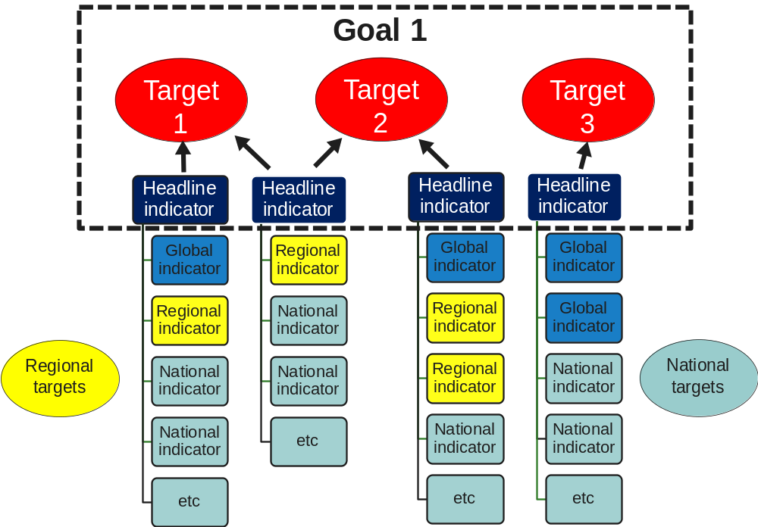

National experiences in using indicators for reporting
Using indicators to measure progress towards the Aichi targets in the United Kingdom
The UK Biodiversity Indicators were developed and published between 2007 and 2010 for reporting on progress with international and European commitments to halt or slow biodiversity loss by 2010. Following the adoption of the Strategic Plan for Biodiversity 2011-2020, the indicators have been reviewed and a programme of work put in place to adapt existing indicators and develop new ones to be used in the 5th and 6th CBD National reports.

Environment is a devolved responsibility in the UK, and the UK’s home countries (England, Scotland, Wales and Northern Ireland) have each developed a biodiversity strategy following consultation with a wide group of stakeholders. Country level indicators, integrated with country NBSAPs, have been developed to address the objectives within those NBSAPs, and are used to evaluate delivery work and report on country level targets.

The UK indicators were selected following an evaluation of the indicators and data available in the countries. The UK indicator set is streamlined with the indicators in each country, and provides a mechanism to evaluate progress across the UK as a whole towards the Aichi Targets. The UK indicators have a specific purpose for international reporting – whereas country-level indicators have a role in implementation and domestic communications. The UK has thereby created a joined up, scaled system of indicators which relate both to country level implementation and international reporting.

A number of selection criteria were adopted to ensure the indicators are ‘fit-for-purpose’:
Each indicator should have the following characteristics; it should be:
- Policy relevant and meaningful
- Biodiversity relevant
- Scientifically sound and methodologically well founded
- Show progress towards the 2010 (now 2020) target(s)
- Easy to understand
- Based on affordable monitoring, available and routinely collected data
- Amenable to modelling of cause-effect relationships
- Good spatial and temporal coverage of data
- Applicable at a national scale
- Aggregation possible at a range of scales
- Sensitive to change

The set as a whole should be:
- Representative
- Limited in number

The individual indicators vary in how well they meet this set of criteria; however having a set of workable indicators is considered as more important than having a set of perfect ones. The indicators published are not just graphs and assessments of change, but include background information on why they were chosen, web-links to related information, and a downloadable spreadsheet of the data values (so others can redraw the graphs if they wish). Being transparent allows an objective evaluation of the indicators, including whether they should be replaced if other options become available. The ability to disaggregate UK indicators to provide information for England, Scotland, Wales or Northern Ireland is seen as important in streamlining between geographic scales.
The indicators are assessed using a ‘traffic light’ system (red, amber, green) which evaluates ‘change over time’. Where possible the assessment is backed up by statistical analysis, but where this is not possible a simple rule of thumb of 3% change is used to identify if we have more than a minor change. This is admittedly crude, but it seems to work! The traffic lights do not show whether the measure has reached any published or implied targets, or indeed whether the status is ‘good’ or ‘bad’, although where targets have been set, these are identified in the indicator text. The advantage of the traffic lights is clarity on whether the status of the indicators has improved or deteriorated, and since many of them can be updated on an annual basis, this provides rapid feedback to policy makers.
Where data are available, two assessment periods have been used:
- Long-term – an assessment of change since the earliest date for which data are available (although if data do not precede 1996 a long-term assessment is not made).
- Short-term – an assessment of change since 2000 (or the closest date for which data are available).
Use of two time periods is used to put the indicators into context – for example, there have been long term declines in many of the species indicators. The UK Biodiversity Indicator Steering Group, which reports to a senior civil servants in the four countries, is considering adopting a ten year rolling period for the short-term change assessment, which will mean that when 2020 is reached, the assessment will be over the period of the Strategic Plan for Biodiversity 2011-2020.
In 2010, a light touch review of the UK indicators was initiated to ensure that they:
- Continue to be based on the most robust and reliable available data; and
- Remain relevant to the new international and European goals and targets.
The quality and relevance of the current indicators and potential changes to the UK Biodiversity Indicator set were reviewed at a Biodiversity Indicator Forum workshop in March 2011. A gap analysis and a data quality assessment were prepared and circulated prior to the meeting. The results from these exercises were presented to the workshop participants and discussed in working groups and in plenary.
The workshop concluded that all of the current indicators were relevant to one or more of the twenty targets in the new Strategic Plan for Biodiversity 2011-2020. A wholesale revision of the indicators set was therefore not required.
A small number of gaps were identified where there were no current indicators for particular targets, or where the existing indicators were only indirectly linked to the Aichi targets. A number of possible refinements to existing indicators were also identified to improve their relevance, make them easier to understand, or to address concerns over data quality or availability.
Work to resolve these gaps and refinements is led by the UK Government and its Agencies and supported by a contract to bring in external capacity and expertise. In the meantime the existing indicators will be reorganized to show their linkages with the targets and goals of the Strategic Plan for Biodiversity 2011-2020, and will continue to be published annually where possible.
It is anticipated that the UK biodiversity indicators will form a major part of the UK’s 5th CBD National Report, especially for section III. However, these indicators are likely to only be part of the information available about changes to the UK’s biodiversity and implementation of the NBSAP. Summarising the progress made for each Aichi target (using the indicators relevant to that target), and summing the progress towards each goal (by aggregating information from the assessment of each target) will provide evidence of progress. An assessment of whether the Aichi targets have been fully achieved is likely to also require other information to be taken into account; for example trends in parts of the UK’s biodiversity that are not part of the indicator set, but that may be reported in section I of the 5th National Report framework. Exactly how to do this is currently being discussed through the UK Biodiversity Indicators Steering Group.

Useful reference materials and web links

- Biodiversity Indicators Partnership. (2011) Guidance for national biodiversity indicator development and use. UNEP World Conservation Monitoring Centre, Cambridge, UK. 40pp.
http://www.bipnational.net/LinkClick.aspx?fileticket=6JNUXXo6xOA%3d&tabid=38&language=en-US
- Biodiversity Indicators Partnership. (2011). Biodiversity Indicators Capacity Strengthening: experiences from Africa. UNEP World Conservation Monitoring Centre, Cambridge, UK. 18 pp. http://www.bipnational.net/LinkClick.aspx?fileticket=hydP3yMsqj0%3d&tabid=38&language=en-US
- UNEP-WCMC 2011. Developing ecosystem service indicators: Experiences and lessons learned from sub-global assessments and other initiatives. Secretariat of the Convention on Biological Diversity, Montréal, Canada. Technical Series No. 58, 118 pp. https://www.cbd.int/doc/publications/cbd-ts-58-en.pdf
- 2010 Biodiversity Indicators Partnership. 2010. Biodiversity indicators and the 2010 Target: Experiences and lessons learnt from the 2010 Biodiversity Indicators Partnership. Secretariat of the Convention on Biological Diversity, Montréal, Canada. Technical Series No. 53, 196 pp. https://www.cbd.int/doc/publications/cbd-ts-53-en.pdf
- Department of the Environment, Food and Rural Affairs of the United Kingdom of Great Britain and Northern Ireland (2011). National Indicators, Monitoring and reporting for the Strategic Plan for Biodiversity 2011-2020. A review of experiences and recommendations in support of the CBD Ad Hoc Technical Expert Group (AHTEG) on indicators for the Strategic Plan 2011-2020. https://www.cbd.int/doc/meetings/ind/ahteg-sp-ind-01/information/ahteg-sp-ind-01-inf-02-en.pdf
- http://www.bipnational.net/LinkClick.aspx?fileticket=hydP3yMsqj0%3d&tabid=38&language=en-US
- Ad Hoc Technical Expert Group Meeting on Indicators for the Strategic Plan for biodiversity 2011-2020 (2011). Ad Hoc Technical Expert Group Meeting on Indicators for the Strategic Plan for biodiversity 2011-2020. Secretariat of the Convention on Biological Diversity. https://www.cbd.int/doc/meetings/ind/ahteg-sp-ind-01/official/ahteg-sp-ind-01-03-en.pdf
- UK Biodiversity Indicators in Your Pocket (2012) available at
http://jncc.defra.gov.uk/page-4229
- Aichi Targets Passport available at http://www.bipindicators.net/LinkClick.aspx?fileticket=d81FvlFQ%2frE%3d&tabid=38.
E. Proposed Outline of the Fifth National Report

This outline is organized by questions as suggested in the guidelines for the fifth national report. However, countries could organize the content of each part of the report as they see appropriate. The bullets under each question, including the suggestions contained in the brackets, are intended to help remind countries of possible content that could be included, however countries should choose their own subtitles.

Executive Summary

Part I: An update on biodiversity status, trends and threats and implications for human well-being

Q1. Why is biodiversity important for the country?

- Importance of biodiversity to human well-being and socio-economic development
- Examples of exceptional biodiversity and ecosystems in the country

Q2: What major changes have taken place in the status and trends of biodiversity in the country?

- Changes in status and trends of biodiversity that have occurred or become known since the last national report was submitted
- Case studies, if any, to illustrate how actions taken to implement the Convention have resulted in changes in biodiversity

Q3: What are the main threats to biodiversity?

- Main direct and indirect drivers of change/pressures/causes of change (for main biomes and/or components of biodiversity)

Q4: What are the impacts of the changes in biodiversity for ecosystem services and the socio-economic and cultural implications of these impacts?

- Impacts of declining biodiversity and ecosystem services on human well-being, livelihoods and poverty reduction (consider all relevant and significant ecosystem goods and services)

Optional Question: what are possible future changes for biodiversity and their impacts?

- Scenarios of “business as usual” (What is likely to happen if the “BAU” approach is taken to address the underlying causes and pressures on biodiversity? What will be the possible impacts on biodiversity? What are the implications for human well-being?)
- Scenarios with greater investment in biodiversity and ecosystems

Part II. NBSAP (its implementation and mainstreaming of biodiversity)

Q5. What are the biodiversity targets set by the country?

- Targets developed in line with the Strategic Plan for Biodiversity (2011-2020) and its Aichi Biodiversity Targets

Q6. How has the NBSAP been updated to incorporate these targets and to serve as an effective instrument to mainstream biodiversity?

- A brief description of the updated NBSAP (how it differs from the old NBSAP, actions to achieve targets listed above, how it contributes to the implementation of the Strategic Plan for Biodiversity 2011-2020, how it addresses threats identified in Part I, how it addresses the guidance provided in decision IX/8)
- How an updated NBSAP could achieve the integration of biodiversity considerations into broader national plans, programmes and policies.

Q7. What actions has the country taken to implement the Convention since the last report and what have been the outcomes of these actions?

- Implementation of the NBSAP (relevant legislation and policies adopted, institutions and mechanisms established, funding and other investments for implementation, programmes and projects implemented, etc.)
- Outcomes achieved in light of positive changes in biodiversity
- Contributions of national actions to the implementation of thematic programmes of work and cross-cutting issues under the Convention (an overview)
- Obstacles to implementation

Q8. How effectively has biodiversity been mainstreamed into relevant sectoral and cross-sectoral strategies, plans and programmes?

- How biodiversity is considered in poverty reduction strategies and other key cross-cutting policy instruments
- How biodiversity is integrated into various sectors
- How biodiversity is integrated into relevant planning processes
- Actions taken by each sector to implement biodiversity actions included in their respective strategies, plans and programmes
- Outcomes achieved by each sector in mainstreaming biodiversity
- Tools used for mainstreaming biodiversity (EIA/SEA, Ecosystem Approach, spatial planning, etc.)
- Synergies in implementation of related Conventions and agreements
- Consideration of biodiversity in other activities such as international development cooperation and transboundary or regional cooperation

Q9. How fully has the NBSAP been implemented?

Assessment of the extent to which the NBSAP has been implemented (analysis of actions fully implemented, partially implemented and not implemented, and why?)

Part III. Progress towards the 2020 Aichi Biodiversity Targets and contributions to the relevant 2015 targets of the Millennium Development Goals

Q10. What progress has been made by the country towards the implementation of the Strategic Plan for Biodiversity 2011-2020 and its Aichi Biodiversity Targets?

- Mid-term assessment of progress towards the 2020 targets (extent to which each target has been achieved)
- Cases to illustrate progress towards the 2020 targets or achievements made
- Suggested Table for summarizing progress towards the 2020 targets
Goals | Targets | National targets | National actions | Outcomes achieved | National or global indicators used | Overall assessment (using “traffic-light” scheme or similar devices)

Q11. What has been the contribution of actions to implement the Convention towards the achievement of the relevant 2015 targets of the Millennium Development Goals in the country?

- Contributions of the implementation of the Convention and its Strategic Plan for Biodiversity (2011-2020), including its Aichi Biodiversity Targets to the achievement of relevant 2015 targets of the Millennium Development Goals

Q12. What lessons have been learned from the implementation of the Convention in the country?

- Areas where achievements have been made
- Areas where progress is lacking and where challenges are encountered
- Gaps and future priorities including suggestions for actions at various levels.

Appendices I and II: Contact information and a brief introduction about the process of preparation of the report as well as further sources of information

Appendix III: Implementation of the thematic programmes of work and cross-cutting issues (focus on those areas and issues of national importance and actions or activities suggested for Parties in relevant thematic programmes of work and COP decisions)

Annexes (if needed)

Annex I

Financial support to eligible countries for the preparation of the fifth national report

- In accordance with correspondence from the CEO of the GEF to implementing agencies and relevant Convention Secretariats in January 2011, eligible countries could access funds for biodiversity enabling activities, particularly in regard to revising and updating national biodiversity strategies and action plans in line with the Strategic Plan for Biodiversity (2011-2020), and preparing the fifth national reports, through the implementing agencies and from the GEF Secretariat directly.

- Requests for financial support should be made as early as possible so that the resources can be made available in a timely manner. Funds are usually limited.

- For more detailed information concerning Direct Access via the GEF Secretariat, please see: http://www.thegef.org/gef/BD_direct_access. To apply via a GEF Implementing Agency, please use the template available at: http://www.thegef.org/gef/node/3891, or contact Ms. Esther Mwangi of UNEP by email <esther.mwangi@unep.org> or Ms. Fabiana Issler of UNDP by email <fabiana.issler@undp.org>.
Annex II
INDICATIVE LIST OF INDICATORS FOR THE STRATEGIC PLAN FOR BIODIVERSITY 2011–2020 (annex to COP decision XI/3)
The Ad Hoc Technical Expert Group on Indicators for the Strategic Plan for Biodiversity 2011-2020 identified three categories of operational indicators. Indicators which are ready for use at the global level are denoted by the letter (A). Indicators which could be used at the global level but which require further development to be ready for use are denoted by the letter (B). Additional indicators for consideration for use at the national or other sub-global level are denoted by the letter (C) and given in italics. The set of (A) and (B) indicators are those which should be used to assess progress at the global level, while the (C) indicators are illustrative of some of the additional indicators available to Parties to use at the national level, according to their national priorities and circumstances.
Aichi Biodiversity Target | Headline indicators (in bold) and most relevant operational indicators
Strategic Goal A: Address the underlying causes of biodiversity loss by mainstreaming biodiversity across government and society
Target 1 - By 2020, at the latest, people are aware of the values of biodiversity and the steps they can take to conserve and use it sustainably. | Trends in awareness, attitudes and public engagement in support of biological diversity and ecosystem services  • Trends in awareness and attitudes to biodiversity (C)  • Trends in public engagement with biodiversity (C)  • Trends in communication programmes and actions promoting social corporate responsibility (C)
Target 2 - By 2020, at the latest, biodiversity values have been integrated into national and local development and poverty reduction strategies and planning processes and are being incorporated into national accounting, as appropriate, and reporting systems. | Trends in integration of biodiversity, ecosystem services and benefits sharing into planning, policy formulation and implementation and incentives  • Trends in number of countries incorporating natural resource, biodiversity, and ecosystem service values into national accounting systems (B)  • Trends in number of countries that have assessed values of biodiversity, in accordance with the Convention (C)  • Trends in guidelines and applications of economic appraisal tools (C)  • Trends in integration of biodiversity and ecosystem service values into sectoral and development policies (C)  • Trends in policies considering biodiversity and ecosystem service in environmental impact assessment and strategic environmental assessment (C)
Target 3 - By 2020, at the latest, incentives, including subsidies, harmful to biodiversity are eliminated, phased out or reformed in order to minimize or avoid negative impacts, and positive incentives for the conservation and sustainable use of biodiversity are developed and applied, consistent and in harmony with the Convention and other relevant international obligations, taking into account national socio economic conditions. | Trends in integration of biodiversity, ecosystem services and benefits sharing into planning, policy formulation and implementation and incentives  • Trends in the number and value of incentives, including subsidies, harmful to biodiversity, removed, reformed or phased out (B)  • Trends in identification, assessment and establishment and strengthening of incentives that reward positive contribution to biodiversity and ecosystem services and penalize adverse impacts (C)
Target 4 - By 2020, at the latest, Governments, business and stakeholders at all levels have taken steps to achieve or have implemented plans for sustainable production and consumption and have kept the impacts of use of natural resources well within safe ecological limits. | Trends in pressures from unsustainable agriculture, forestry, fisheries and aquaculture  • Trends in population and extinction risk of utilized species, including species in trade (A) (also used by CITES)  • Trends in ecological footprint and/or related concepts (C) (decision VIII/15)  • Ecological limits assessed in terms of sustainable production and consumption (C)
Trends in pressures from habitat conversion, pollution, invasive species, climate change, overexploitation and underlying drivers
• Trends in biodiversity of cities (C) (decision X/22)
Trends in integration of biodiversity, ecosystem services and benefits sharing into planning, policy formulation and implementation and incentives
• Trends in extent to which biodiversity and ecosystem service values are incorporated into organizational accounting and reporting (B)
Strategic Goal B: Reduce the direct pressures on biodiversity and promote sustainable use
Target 5 - By 2020, the rate of loss of all natural habitats, including forests, is at least halved and where feasible brought close to zero, and degradation and fragmentation is significantly reduced. | Trends in extent, condition and vulnerability of ecosystems, biomes and habitats  • Extinction risk trends of habitat dependent species in each major habitat type (A)  • Trends in extent of selected biomes, ecosystems and habitats (A) (decision VII/30 and VIII/15)  • Trends in proportion of degraded/threatened habitats (B)  • Trends in fragmentation of natural habitats (B) (decision VII/30 and VIII/15)  • Trends in condition and vulnerability of ecosystems (C)  • Trends in the proportion of natural habitats converted (C)
Trends in pressures from unsustainable agriculture, forestry, fisheries and aquaculture
• Trends in primary productivity (C)
• Trends in proportion of land affected by desertification (C) (also used by UNCCD)
Trends in pressures from habitat conversion, pollution, invasive species, climate change, overexploitation and underlying drivers
• Population trends of habitat dependent species in each major habitat type (A)
Target 6 - By 2020 all fish and invertebrate stocks and aquatic plants are managed and harvested sustainably, legally and applying ecosystem based approaches, so that overfishing is avoided, recovery plans and measures are in place for all depleted species, fisheries have no significant adverse impacts on threatened species and vulnerable ecosystems and the impacts of fisheries on stocks, species and ecosystems are within safe ecological limits. | Trends in pressures from unsustainable agriculture, forestry, fisheries and aquaculture  • Trends in extinction risk of target and bycatch aquatic species (A)  • Trends in population of target and bycatch aquatic species (A)  • Trends in proportion of utilized stocks outside safe biological limits (A) (MDG indicator 7.4)  • Trends in catch per unit effort (C)  • Trends in fishing effort capacity (C)  • Trends in area, frequency, and/or intensity of destructive fishing practices (C)
Trends in integration of biodiversity, ecosystem services and benefits sharing into planning, policy formulation and implementation and incentives
• Trends in proportion of depleted target and bycatch species with recovery plans (B)
Target 7 - By 2020 areas under agriculture, aquaculture and forestry are managed sustainably, ensuring conservation of biodiversity. | Trends in pressures from unsustainable agriculture, forestry, fisheries and aquaculture  • Trends in population of forest and agriculture dependent species in production systems (B)  • Trends in production per input (B)  • Trends in proportion of products derived from sustainable sources (C) (decision VII/30 and VIII/15)
Trends in integration of biodiversity, ecosystem services and benefits sharing into planning, policy formulation and implementation and incentives
• Trends in area of forest, agricultural and aquaculture ecosystems under sustainable management (B) (decision VII/30 and VIII/15)
Target 8 - By 2020, pollution, including from excess nutrients, has been brought to levels that are not detrimental to ecosystem function and biodiversity. | Trends in pressures from habitat conversion, pollution, invasive species, climate change, overexploitation and underlying drivers  • Trends in incidence of hypoxic zones and algal blooms (A)  • Trends in water quality in aquatic ecosystems (A) (decision VII/30 and VIII/15)  • Impact of pollution on extinction risk trends (B)  • Trends in pollution deposition rate (B) (decision VII/30 and VIII/15)  • Trends in sediment transfer rates (B)  • Trend in emission to the environment of pollutants relevant for biodiversity (C)  • Trend in levels of contaminants in wildlife (C)  • Trends in nitrogen footprint of consumption activities (C)  • Trends in ozone levels in natural ecosystems (C)  • Trends in proportion of wastewater discharged after treatment (C)  • Trends in UV-radiation levels (C)
Target 9 - By 2020, invasive alien species and pathways are identified and prioritized, priority species are controlled or eradicated, and measures are in place to manage pathways to prevent their introduction and establishment. | Trends in pressures from habitat conversion, pollution, invasive species, climate change, overexploitation and underlying drivers  • Trends in the impact of invasive alien species on extinction risk trends (A)  • Trends in the economic impacts of selected invasive alien species (B)  • Trends in number of invasive alien species (B) (decision VII/30 and VIII/15)  • Trends in incidence of wildlife diseases caused by invasive alien species (C)
Trends in integration of biodiversity, ecosystem services and benefits sharing into planning, policy formulation and implementation and incentives
• Trends in policy responses, legislation and management plans to control and prevent spread of invasive alien species (B)
• Trends in invasive alien species pathways management (C)
Target 10 - By 2015, the multiple anthropogenic pressures on coral reefs, and other vulnerable ecosystems impacted by climate change or ocean acidification are minimized, so as to maintain their integrity and functioning. | Trends in pressures from habitat conversion, pollution, invasive species, climate change, overexploitation and underlying drivers  • Extinction risk trends of coral and reef fish (A)  • Trends in climate change impacts on extinction risk (B)  • Trends in coral reef condition (B)  • Trends in extent, and rate of shifts of boundaries, of vulnerable ecosystems (B)  • Trends in climatic impacts on community composition (C)  • Trends in climatic impacts on population trends (C)
Strategic Goal C: To improve the status of biodiversity by safeguarding ecosystems, species and genetic diversity
Target 11 - By 2020, at least 17 per cent of terrestrial and inland water, and 10 per cent of coastal and marine areas, especially areas of particular importance for biodiversity and ecosystem services, are conserved through effectively and equitably managed, ecologically representative and well-connected systems of protected areas and other effective area-based conservation measures, and integrated into the wider landscapes and seascapes. | Trends in coverage, condition, representativeness and effectiveness of protected areas and other area-based approaches  • Trends in coverage of protected areas (A) (decision VII/30 and VIII/15)  • Trends in extent of marine protected areas, coverage of key biodiversity areas and management effectiveness (A)  • Trends in protected area condition and/or management effectiveness including more equitable management (A) (decision X/31)  • Trends in representative coverage of protected areas and other area based approaches, including sites of particular importance for biodiversity, and of terrestrial, marine and inland water systems (A)  • Trends in the connectivity of protected areas and other area based approaches integrated into landscapes and seascapes (B) (decision VII/30 and VIII/15)  • Trends in the delivery of ecosystem services and equitable benefits from protected areas (C)
Target 12 - By 2020 the extinction of known threatened species has been prevented and their conservation status, particularly of those most in decline, has been improved and sustained. | Trends in abundance, distribution and extinction risk of species  • Trends in abundance of selected species (A) (decision VII/30 and VIII/15) (UNCCD indicator)  • Trends in extinction risk of species (A) (decision VII/30 and VIII/15) (MDG indicator 7.7) (also used by CMS)  • Trends in distribution of selected species (B) (decision VII/30 and VIII/15) (also used by UNCCD)
Target 13 - By 2020, the genetic diversity of cultivated plants and farmed and domesticated animals and of wild relatives, including other socio-economically as well as culturally valuable species, is maintained, and strategies have been developed and implemented for minimizing genetic erosion and safeguarding their genetic diversity. | Trends in genetic diversity of species  • Trends in genetic diversity of cultivated plants, and farmed and domesticated animals and their wild relatives (B) (decision VII/30 and VIII/15)  •Trends in genetic diversity of selected species (C)
Trends in integration of biodiversity, ecosystem services and benefits sharing into planning, policy formulation and implementation and incentives
• Trends in number of effective policy mechanisms implemented to reduce genetic erosion and safeguard genetic diversity related to plant and animal genetic resources (B)
Strategic Goal D: Enhance the benefits to all from biodiversity and ecosystem services
Target 14 - By 2020, ecosystems that provide essential services, including services related to water, and contribute to health, livelihoods and well-being, are restored and safeguarded, taking into account the needs of women, indigenous and local communities, and the poor and vulnerable. | Trends in distribution, condition and sustainability of ecosystem services for equitable human well-being  • Trends in proportion of total freshwater resources used (A) (MDG indicator 7.5)  • Trends in proportion of the population using improved water services (A) (MDG indicator 7.8 and 7.9)  • Trends in benefits that humans derive from selected ecosystem services (A)  • Population trends and extinction risk trends of species that provide ecosystem services (A)  • Trends in delivery of multiple ecosystem services (B)  • Trends in economic and non-economic values of selected ecosystem services (B)  • Trends in health and wellbeing of communities who depend directly on local ecosystem goods and services (B) (decision VII/30 and VIII/15)  • Trends in human and economic losses due to water or natural resource related disasters (B)  • Trends in nutritional contribution of biodiversity: Food composition (B) (decision VII/30 and VIII/15)  • Trends in incidence of emerging zoonotic diseases (C)  • Trends in inclusive wealth (C)  • Trends in nutritional contribution of biodiversity: Food consumption (C) (decision VII/30 and VIII/15)  • Trends in prevalence of underweight children under-five years of age (C) (MDG indicator 1.8)  • Trends in natural resource conflicts (C)  • Trends in the condition of selected ecosystem services (C)  • Trends in biocapacity (C)
Trends in coverage, condition, representativeness and effectiveness of protected areas and other area-based approaches
• Trends in area of degraded ecosystems restored or being restored (B)
Target 15 - By 2020, ecosystem resilience and the contribution of biodiversity to carbon stocks has been enhanced, through conservation and restoration, including restoration of at least 15 per cent of degraded ecosystems, thereby contributing to climate change mitigation and adaptation and to combating desertification. | Trends in distribution, condition and sustainability of ecosystem services for equitable human well-being  • Status and trends in extent and condition of habitats that provide carbon storage (A)
Trends in coverage, condition, representativeness and effectiveness of protected areas and other area-based approaches
• Population trends of forest-dependent species in forests under restoration (C)
Target 16 - By 2015, the Nagoya Protocol on Access to Genetic Resources and the Fair and Equitable Sharing of Benefits Arising from their Utilization is in force and operational, consistent with national legislation. | Trends in access and equity of benefit-sharing of genetic resources  • ABS indicator to be specified through the ABS process (B)
Strategic Goal E: Enhance implementation through participatory planning, knowledge management and capacity-building
Target 17 - By 2015 each Party has developed, adopted as a policy instrument, and has commenced implementing an effective, participatory and updated national biodiversity strategy and action plan. | Trends in integration of biodiversity, ecosystem services and benefit-sharing into planning, policy formulation and implementation and incentives  • Trends in implementation of national biodiversity strategies and action plans, including development, comprehensiveness, adoption and implementation (B)
Target 18 - By 2020, the traditional knowledge, innovations and practices of indigenous and local communities relevant for the conservation and sustainable use of biodiversity, and their customary use of biological resources, are respected, subject to national legislation and relevant international obligations, and fully integrated and reflected in the implementation of the Convention with the full and effective participation of indigenous and local communities, at all relevant levels. | Trends in integration of biodiversity, ecosystem services and benefit-sharing into planning, policy formulation and implementation and incentives  • Trends in land-use change and land tenure in the traditional territories of indigenous and local communities (B) (decision X/43)  • Trends in the practice of traditional occupations (B) (decision X/43)
Trends in accessibility of scientific/technical/traditional knowledge and its application
• Trends in which traditional knowledge and practices are respected through their full integration, safeguards and the full and effective participation of indigenous and local communities in the national implementation of the Strategic Plan (B)
Trends in accessibility of scientific/technical/traditional knowledge and its application
• Trends of linguistic diversity and numbers of speakers of indigenous languages (B) (decision VII/30 and VIII/15)
Target 19 - By 2020, knowledge, the science base and technologies relating to biodiversity, its values, functioning, status and trends, and the consequences of its loss, are improved, widely shared and transferred, and applied. | Trends in accessibility of scientific/technical/traditional knowledge and its application  • Trends in coverage of comprehensive policy-relevant sub-global assessments including related capacity-building and knowledge transfer, plus trends in uptake into policy (B)  • Number of maintained species inventories being used to implement the Convention (C)
Target 20 - By 2020, at the latest, the mobilization of financial resources for effectively implementing the Strategic Plan for Biodiversity 2011-2020 from all sources, and in accordance with the consolidated and agreed process in the Strategy for Resource Mobilization, should increase substantially from the current levels. This target will be subject to changes contingent to resource needs assessments to be developed and reported by Parties. | Trends in mobilization of financial resources  • Indicators agreed in decision X/3 (B)

Annex III

Indicators for measuring progress towards relevant targets of the Millennium Development Goals

Millennium Development Indicators by UN Statistics Division:
http://unstats.un.org/unsd/mi/mi_worldmillennium_new.asp
http://mdgs.un.org/unsd/mdg/Default.aspx
http://mdgs.un.org/unsd/mdg/Resources/Attach/Indicators/OfficialList2008.pdf

For the classification of drivers of change, the findings of the Millennium Ecosystem Assessment could provide guidance; see the chapter What are the current trends and drivers of biodiversity loss? in the Biodiversity Synthesis of the MA (see reference materials and information sources listed here).
These examples illustrate some of the different types of graphs and figures that countries may wish to consider using in their national reports.
? Countries could provide “possible changes” expected due to some actions or measures taken to achieve the 2020 Aichi Biodiversity Targets, considering that some results may be achieved slowly over years.
The earliest available year is used as the baseline for assessment of long-term change. The base year used for each measure is shown in the table. Where data are unavailable, or do not precede 1996, a long-term assessment is not calculated.
Parties are requested in Decision IX/13 B, to assist indigenous and local communities to develop community action plans for the preservation, maintenance and respect of traditional knowledge; and in decision IX/13 D to consider the development of national action plans for the retention of traditional knowledge relevant to the conservation and sustainable use of biological diversity and in Decision X/40, to consider designating a national focal point for Article 8(j) and related provisions to facilitate communications with indigenous and local community organizations.
If there is a lot of content for one issue, countries could use separate (instead of one) tables to summarize implementation of each of the issues.
The reporting framework on the implementation of the programme of work on protected areas (PoWPA) is contained in the annex to decision X/31 at http://www.cbd.int/decision/cop/?id=12297
A variety of guidance on the selection, development and use of indicators has been developed through the Convention process and by its partners. Some of these resources are indicated at the end of this section. In particular, Parties may wish to consider COP decision XI/3 (annex) which contains an indicator framework for the Strategic Plan for Biodiversity 2011-2020 and the Aichi Biodiversity Targets. This decision is based on the results of an Ad Hoc Technical Expert Group (AHTEG) on Indicators for the Strategic Plan for Biodiversity 2011-2020. The results of the AHTEG are available from https://www.cbd.int/doc/meetings/sbstta/sbstta-15/information/sbstta-15-inf-06-en.pdf. The indicators which were identified during the workshop have also been made available in a database which can be accessed from https://www.cbd.int/sp/indicators/.
http://jncc.defra.gov.uk/page-4229
http://jncc.defra.gov.uk/page-5781
Publication from May 2012 will provide an explicit mapping of each indicator to the Aichi Targets.

