Communiqué
The beauty and variety of life on Earth captured in postage stamps
Montreal, 12 July 2010 – The Syrian Arab Republic recently issued two commemorative stamps celebrating the International Year of Biodiversity (IYB), thus becoming the twelfth country to mark the IYB through the issuance of a stamp.
The 12 countries that have issued and registered their IYB commemorative stamps with the Secretariat represent Europe, Africa, Latin America and the Caribbean, and South-East Asia.
The United Nations offices at Geneva and Vienna have also issued stamps, and the United Nations Postal Administration in New York is planning a commemorative issue.
“I want to pay tribute to the countries that have made the effort to design and issue beautiful stamps as a way of reminding people of the importance and irreplaceable nature of the biodiversity of our world,” said Ahmed Djoghlaf, Executive Secretary to the Convention on Biological Diversity. “Young people and adults alike can enjoy and take pleasure in these stamps, which will become permanent and memorable collector’s items.”
“I call upon all other countries that have not yet done so, to issue their own mementoes of the International Year and its goals.”
To date, the countries that have issued stamps commemorating the 2010 IYB are:

- Belarus
- Hungary
- India
- Indonesia
- Malaysia
- Portugal
- Singapore
- South Africa
- Switzerland
- Syrian Arab Republic
- Trinidad and Tobago
- United Kingdom

-----

1. PORTUGAL | 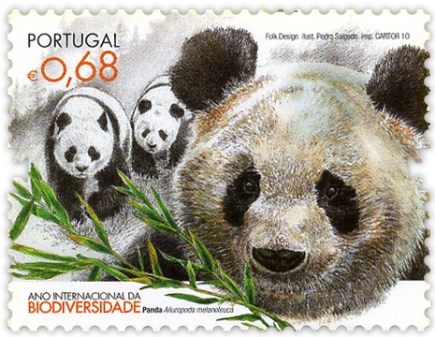  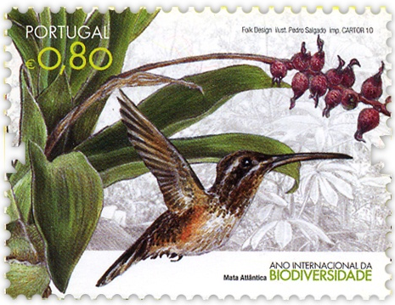  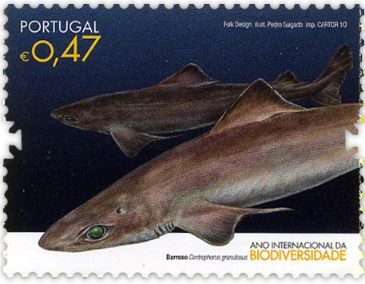  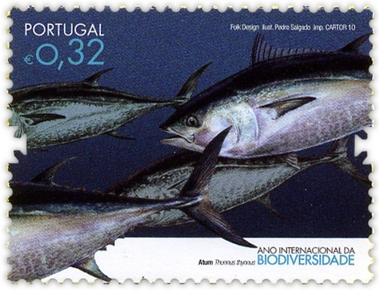
2. SOUTH AFRICA | 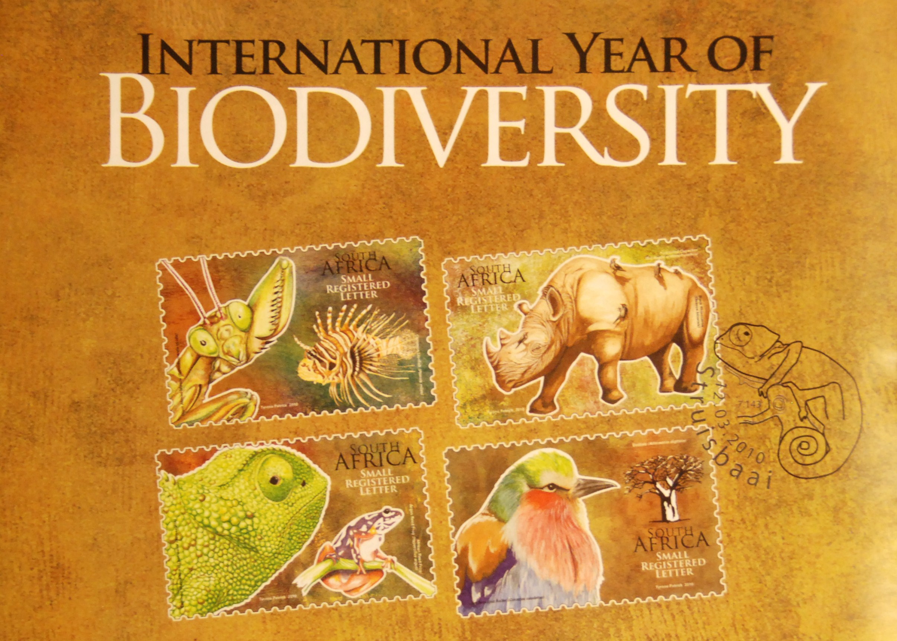
3. UNITED KINGDOM | 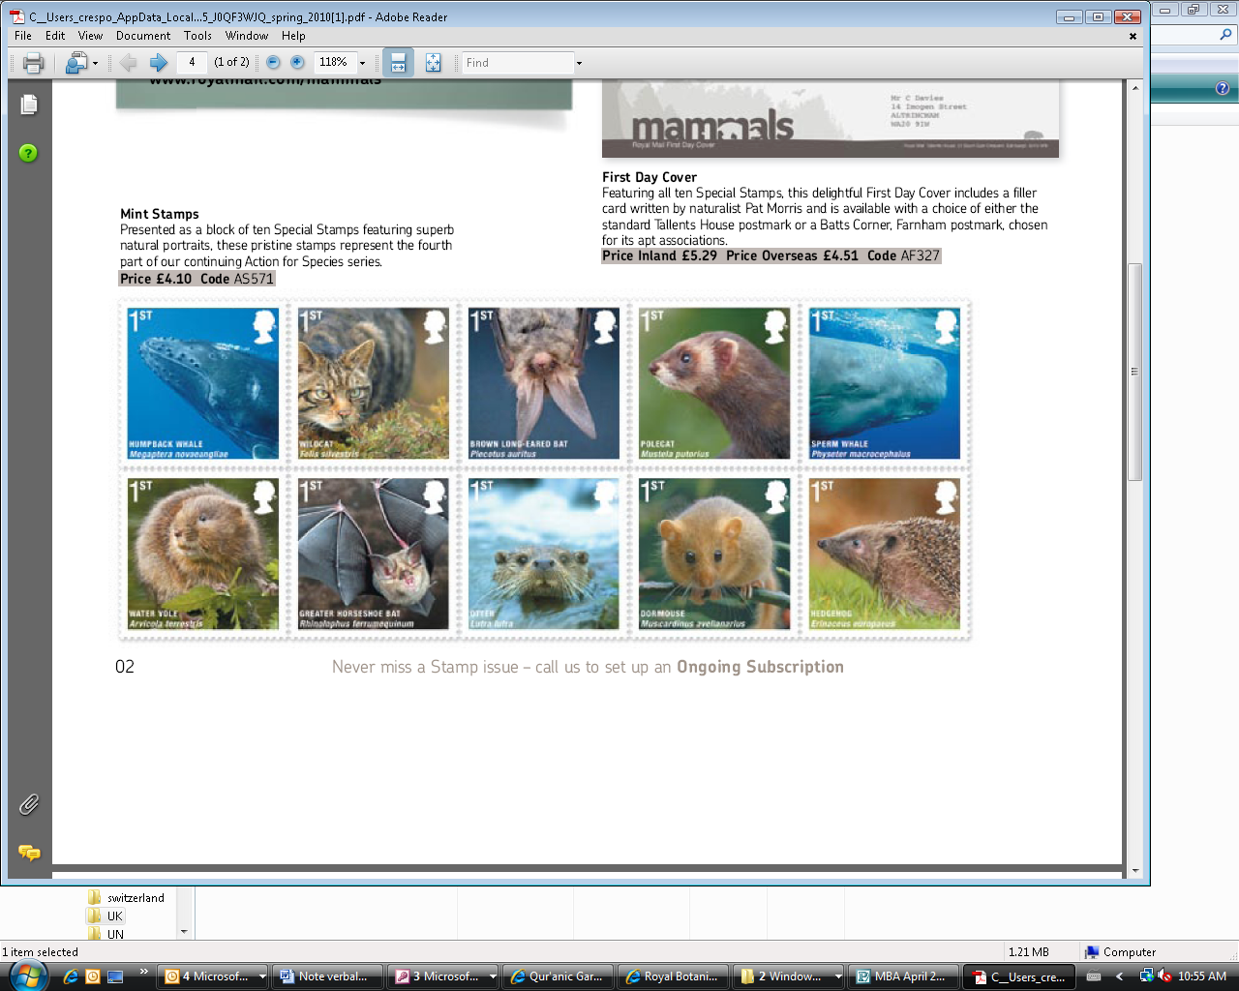
4. SWITZERLAND | 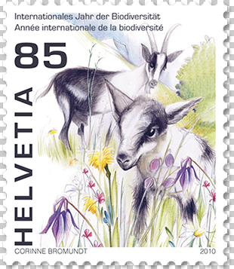
5. TRINIDAD AND TOBAGO | 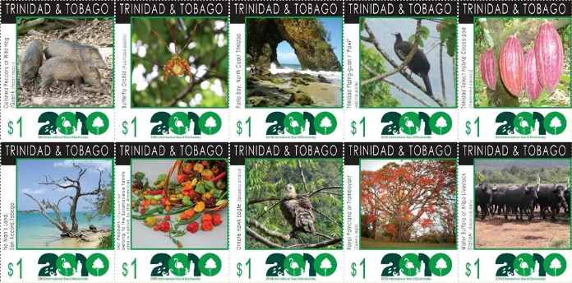  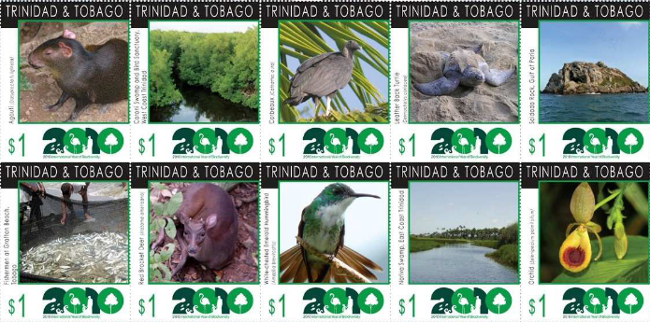
6. BELARUS | 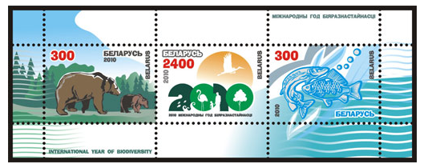
7. UNITED NATIONS (VIENNA) | 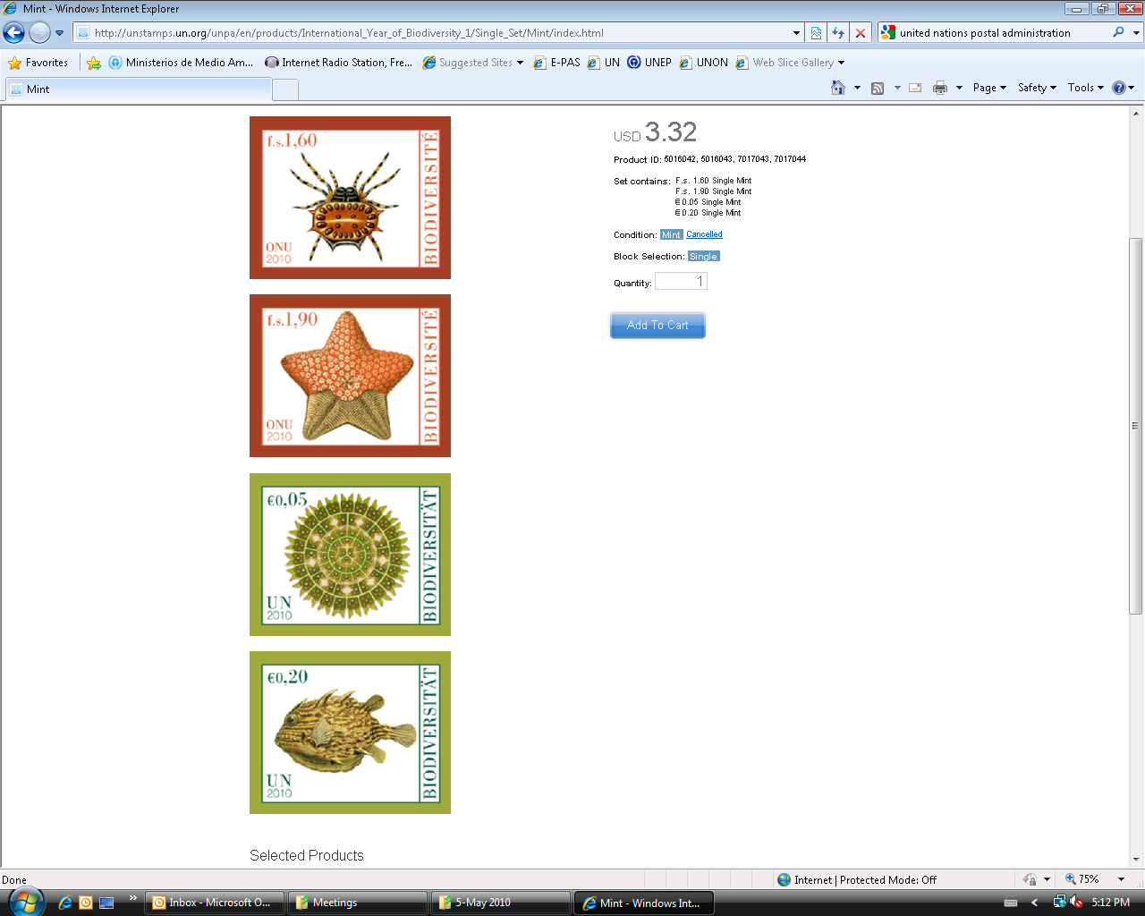
8. UNITED NATIONS (GENEVA)
9. MALAYSIA | 
10. HUNGARY | 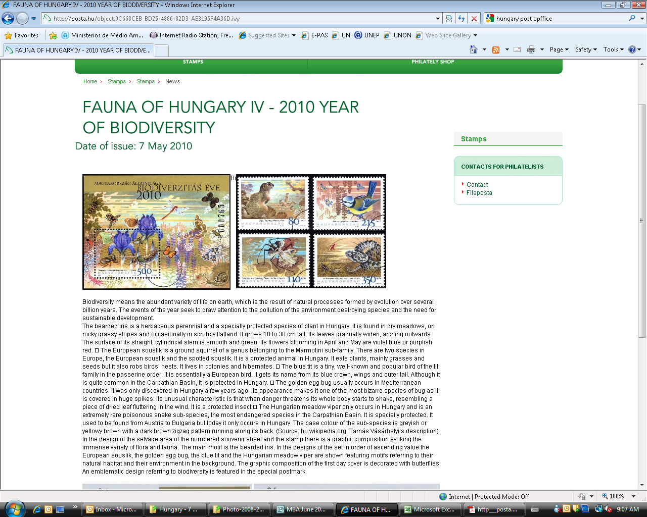
11. SINGAPORE | 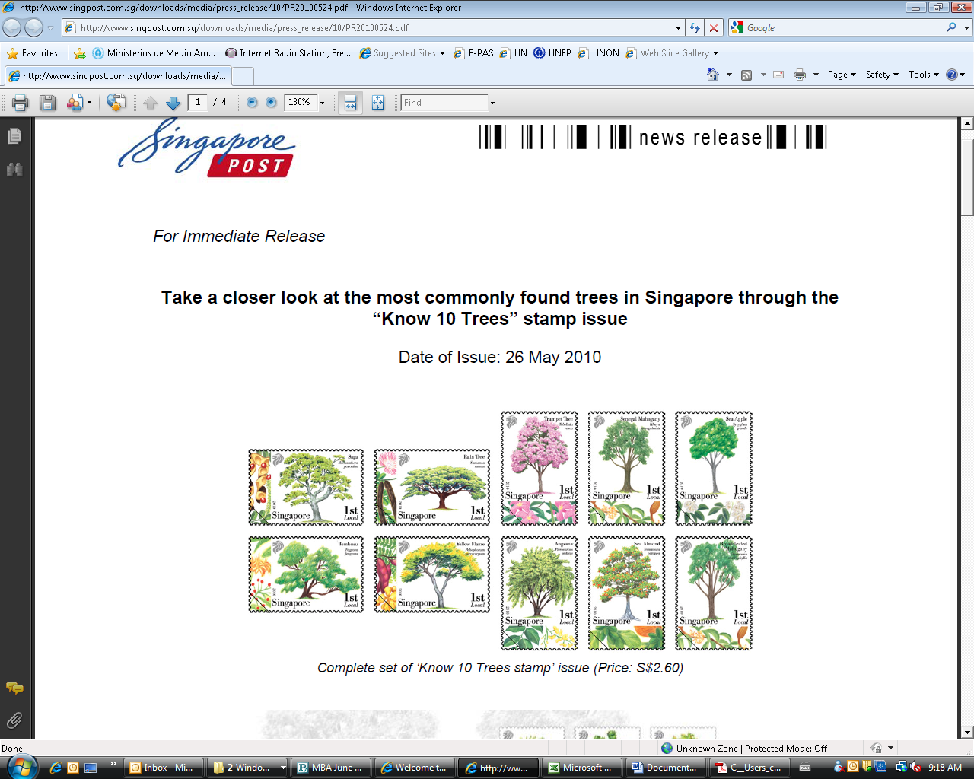
12. INDIA | 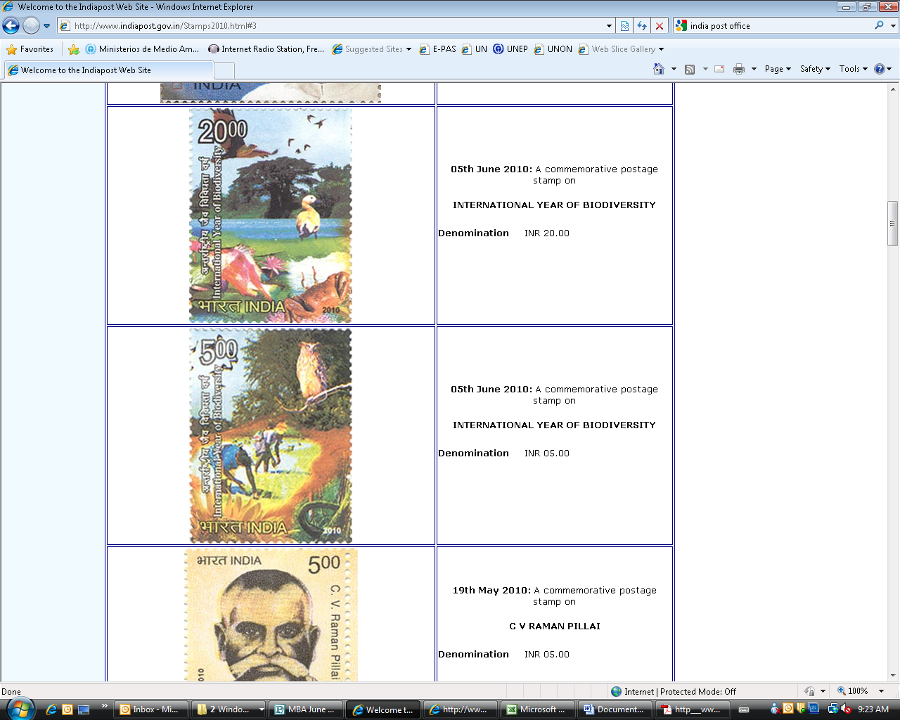
13. SYRIA | 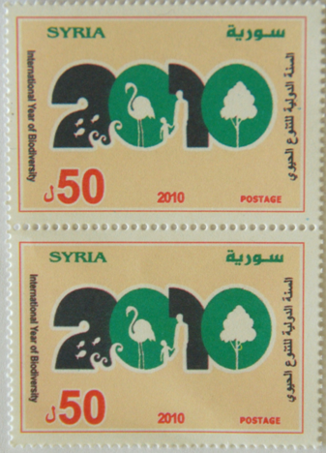
14. HONG KONG | 

