PRESS RELEASE
President Lee of the Republic of Korea receives CBD Award for his contribution to biodiversity conservation and green growth

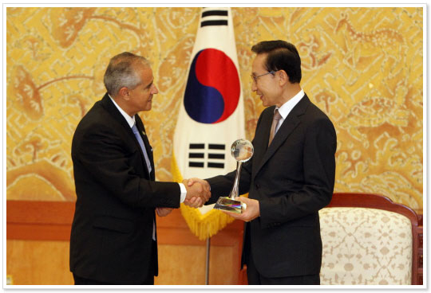
Picture courtesy of www.president.go.kr

Seoul, 24 August 2010 – In recognition of his unique contribution to the preservation of life on Earth, Mr. Lee Myung-bak, the President of the Republic of Korea, was today presented with the CBD Award by Ahmed Djoghlaf, Executive Secretary of the Convention on Biological Diversity (CBD).
The presentation of the CBD Award took place during the visit of the Executive Secretary to the Presidential Office in Seoul on 24 August 2010.
The Award represents the CBD Secretariat’s recognition of President Lee's outstanding contribution and commitment to the conservation and sustainable use of biological diversity as a major instrument for achieving a green economy and sustainable development.
“President Lee is an example to us all – to world leaders and to citizens alike,” said Ahmed Djoghlaf. “At a time when global leadership is needed more than ever, the leadership shown by President Lee has advanced the achievement of the Convention on Biological Diversity at the national level and provides a model for others to follow.”
President Lee, recognized by Time magazine in 2007 as a "Hero of the Environment," demonstrated his strong global leadership toward achieving "low-carbon, green growth,” by securing national commitments on green investment at the level of two per cent of GDP. His green leadership was demonstrated when, as Mayor of Seoul, he initiated a project to restore the once buried major stream, Cheonggyecheon, which helped move the city towards a more environmentally friendly future.
The CBD Award was established in 2006 to recognize individuals who have made significant contributions to advancing the three objectives of the Convention. Previous recipients include the President of Tunisia, for his outstanding contribution to the CBD Museum of Nature and Culture, as well as other Heads of States and Government, including Chancellor Angela Merkel of Germany, Canadian Prime Minister Stephen Harper, and dignitaries that attended the Heads of State segment of the ninth meeting of the Conference of the Parties held in Germany in 2008.
Korea’s emerging role in global efforts for biodiversity conservation and sustainable use has been highlighted in various international forums, such as the third ad hoc intergovernmental and multi-stakeholder meeting on an intergovernmental science-policy platform on biodiversity and ecosystem services in Busan from 7 to 11 June 2010. The report of Busan meeting will be submitted to the Heads of State and Government during the high-level meeting of the United Nations General Assembly, to be held in New York on 22 September, as a contribution to the celebration of the 2010 International Year of Biodiversity. In this regard, the Executive Secretary also discussed with President Lee the ways and means of enhancing the collaboration between the Republic of Korea and the Convention on Biological Diversity in light of the decisions to be adopted in October 2010 in Nagoya, Japan, at the tenth meeting of the Conference of the Parties to the Convention.
The Executive Secretary highly appreciated the commitment expressed by President Lee to contribute to fostering the biodiversity agenda at both global and national levels.
During his visit to Seoul, the Executive Secretary had a bilateral meeting with Mr. Lee Maanee, the Minister of the Environment of the Republic of Korea, on the preparations for the G-77 forum on biodiversity for development and the support of Korean centre of excellence to facilitate the implementation of the plan. To this end, Mr. Djoghlaf visited the National Institute on Biodiversity and Natural Resources and discussed with its President the elements of a memorandum of understanding on training and education, which will be finalized at the tenth meeting of the Conference of the Parties. Mr. Djoghlaf was accompanied by the staff member on South-South cooperation seconded from the Ministry of the Environment to the Convention Secretariat. Mr. Djoghlaf also delivered a keynote statement at the opening of the twenty-third World Congress of the International Union of Forest Research Organizations, which was attended by 3,000 participants representing 110 countries and 700 member institutions.
The Convention on Biological Diversity (CBD)
Opened for signature at the Earth Summit in Rio de Janeiro in 1992, and entering into force in December 1993, the Convention on Biological Diversity is an international treaty for the conservation of biodiversity, the sustainable use of the components of biodiversity and the equitable sharing of the benefits derived from the use of genetic resources. With 193 Parties, the Convention has near universal participation among countries. The Convention seeks to address all threats to biodiversity and ecosystem services, including threats from climate change, through scientific assessments, the development of tools, incentives and processes, the transfer of technologies and good practices and the full and active involvement of relevant stakeholders including indigenous and local communities, youth, NGOs, women and the business community. The Cartagena Protocol on Biosafety, a supplementary treaty to the Convention, seeks to protect biological diversity from the potential risks posed by living modified organisms resulting from modern biotechnology. To date, 159 countries and the European Union have ratified the Protocol. The Secretariat of the Convention and its Cartagena Protocol is located in Montreal.
For more information visit www.cbd.int
2010 International Year of Biodiversity (IYB)
The United Nations declared 2010 the International Year of Biodiversity (IYB) to raise awareness about the crucial importance of biodiversity, to communicate the human costs of biodiversity loss, and to engage people, particularly youth, throughout the world in the fight to protect all life on Earth. Initiatives will be organized throughout the year to disseminate information, promote the protection of biodiversity and encourage countries, organizations, and individuals to take direct action to reduce biodiversity loss. The focal point for the year is the Secretariat of the Convention on Biological Diversity. www.cbd.int/2010/welcome/
For additional information, please contact: David Ainsworth on +1 514 287 7025 or at david.ainsworth@cbd.int; or Johan Hedlund on +1 514 2787 7760 or at johan.hedlund@cbd.int.
-----

