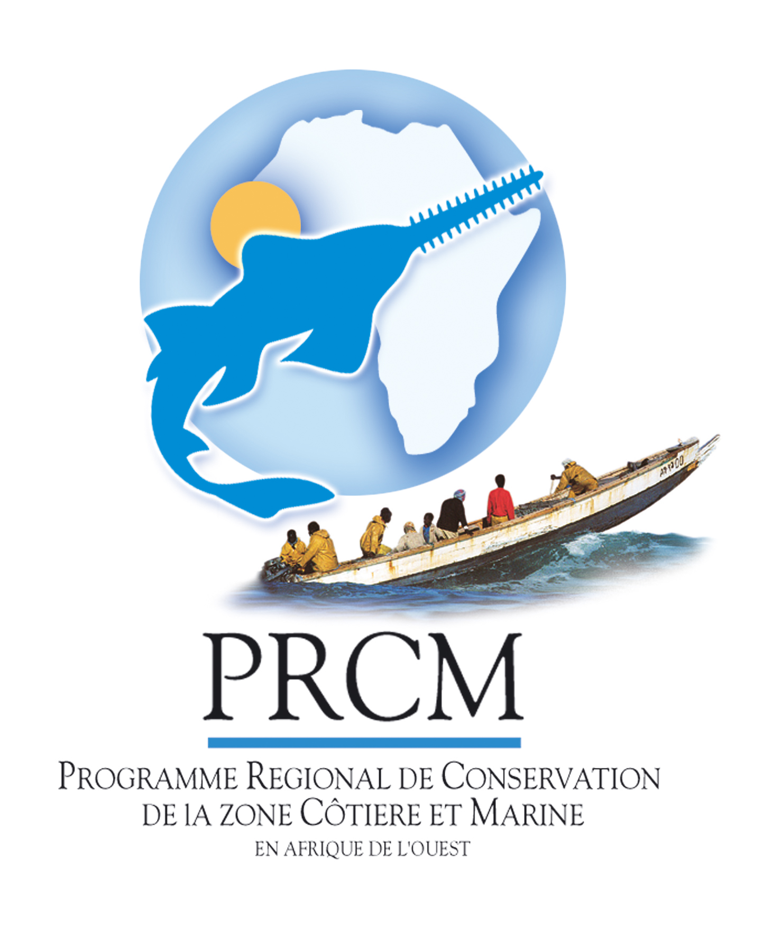
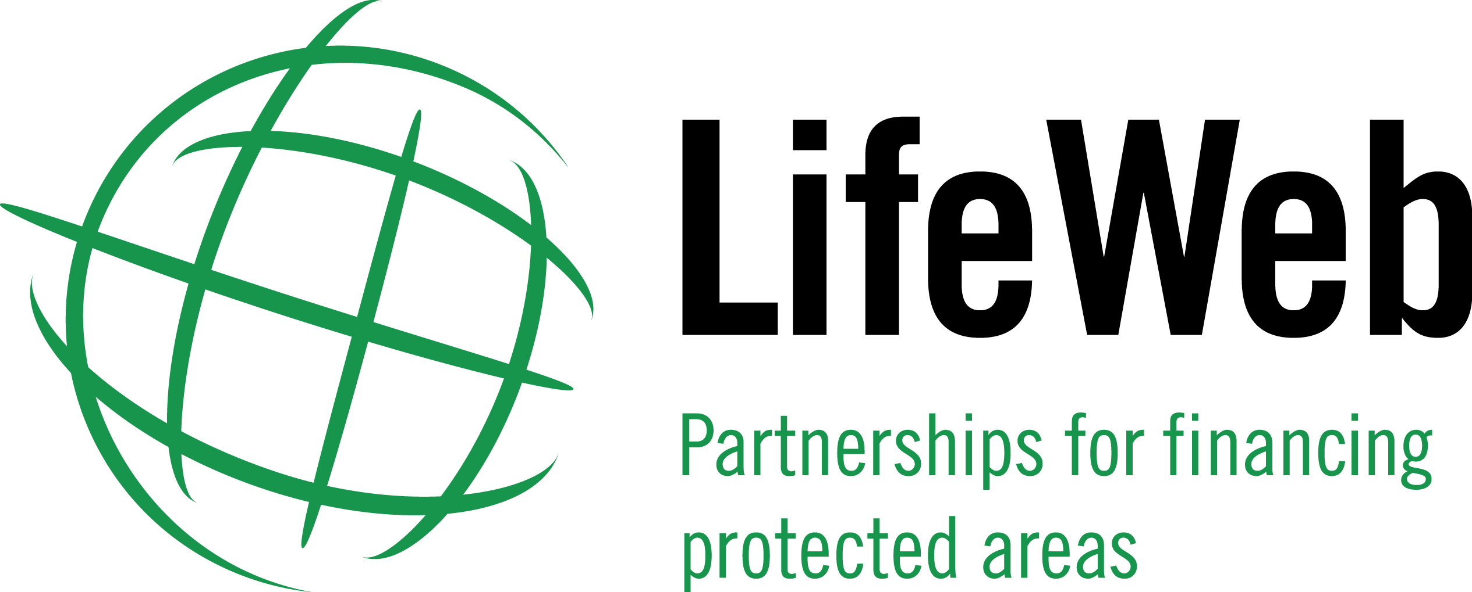

MEDIA ADVISORY – 25 May 2011

International Call for Investments in Protected Areas in West Africa
The first roundtable meeting on Financing Protected Areas in West Africa will be held in Dakar, Senegal, on 27 May 2011. The meeting builds on statements made at the (CBD) tenth meeting of the Conference of the Parties to Convention on Biological Diversity, in October 2010, where ministers and officials from Cape Verde, Guinea, Guinea Bissau, Mauritania, Senegal, Sierra Leone and The Gambia declared that they were joining together to take actions to implement the target on protected areas (Target 11) of the Strategic Plan for Biodiversity 2011-2020.
At Friday’s roundtable meeting, hosted by the Government of Senegal, with the support of the Regional Coastal and Marine Conservation Programme for West Africa (PRCM) and the CBD LifeWeb Initiative, the seven West African countries will call for international donor support to protect terrestrial, coastal and marine habitats and develop sustainable financing of protected areas for the future.
These seven countries have invited partners and international cooperation donors to join them in strengthening funding cooperation to address shared priorities for sustaining biodiversity, addressing climate change and securing livelihoods through the ecologically representative and effectively managed protected areas systems. At a meeting in Dakar in April 2011, the seven countries assessed progress in implementation of the programme of work on protected areas (PoWPA) under the Convention on Biological Diversity in the region, identified gaps, and discussed priorities for action. These results will be fed into the roundtable meeting process to help ensure donor support is coordinated, targets the highest protected area priorities, and builds long-lasting collaboration for the future.
The CBD LifeWeb Initiative provides a user-friendly clearing-house for countries to profile their protected area needs and invite international support; facilitates funding matches; coordinates counterpart financing among donors; and recognizes donor support and innovation for natural solutions.

INVITATION TO JOURNALISTS – PRESS BRIEFING

Financing Roundtables for Strengthening Protected Areas in West Africa
to sustain biodiversity, address climate change and secure livelihoods

- Briefing Details
Press are invited to attend a briefing on the financing roundtable meeting on
Friday, 27 May 2011, at 5 p.m.

The following presenters will attend the briefing:
- Representative of the Governments of Senegal, Guinea , Guinea Bissau
- President of the PRCM steering Committee
- CBD Lifeweb, Programme Officer
- Representative of MAVA foundation
- Representative of the Embassy of the Netherlands

The briefing will cover the following matters, discussed during the Financing Roundtable Meeting:
- Highlight new commitments and ambitions of the West African Governments for the Implementation of the CBD programme of work on protected areas in West Africa
- A presentation of clearly-defined vision of priorities, strategic actions and funding needs in West Africa for the next five years
- Commitment from the donors and partners to jointly support these funding needs
- The next steps

- Venue
The financing roundtable meeting press briefing will be held at:

Terrou-Bi Hotel  Boulevard Martin Luther King  B.P.1179 Dakar, Senegal  Tel.: (221) 33 839 90 39  Fax: (221) 33 839 47 96  Web site: www.terroubi.com/ | 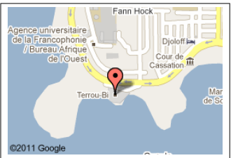

- Working language
The briefing will be held in English and French, with interpretation.

- For Further Information
For any media enquiries, please contact:
- Mame Fatou Touré: MameFatou.TOURE@iucn.org, +2213716538 or +22222157662
- Birima Fall, bfall@wwfsenegal.org, +221775398582

Note: The Regional Coastal and Marine Conservation Programme for West Africa (PRCM) is a joint initiative of IUCN, FIBA, WWF and Wetlands International (WI), in partnership with the Sub-regional Fisheries Commission (CRSP). Today, the PRCM is a coalition of over 100 institutional partners that seek to co-ordinate efforts to conserve the biodiversity of countries in the sub-region, i.e. Cape Verde, the Gambia, Guinea, Guinea-Bissau, Mauritania, Senegal, and Sierra Leone.

