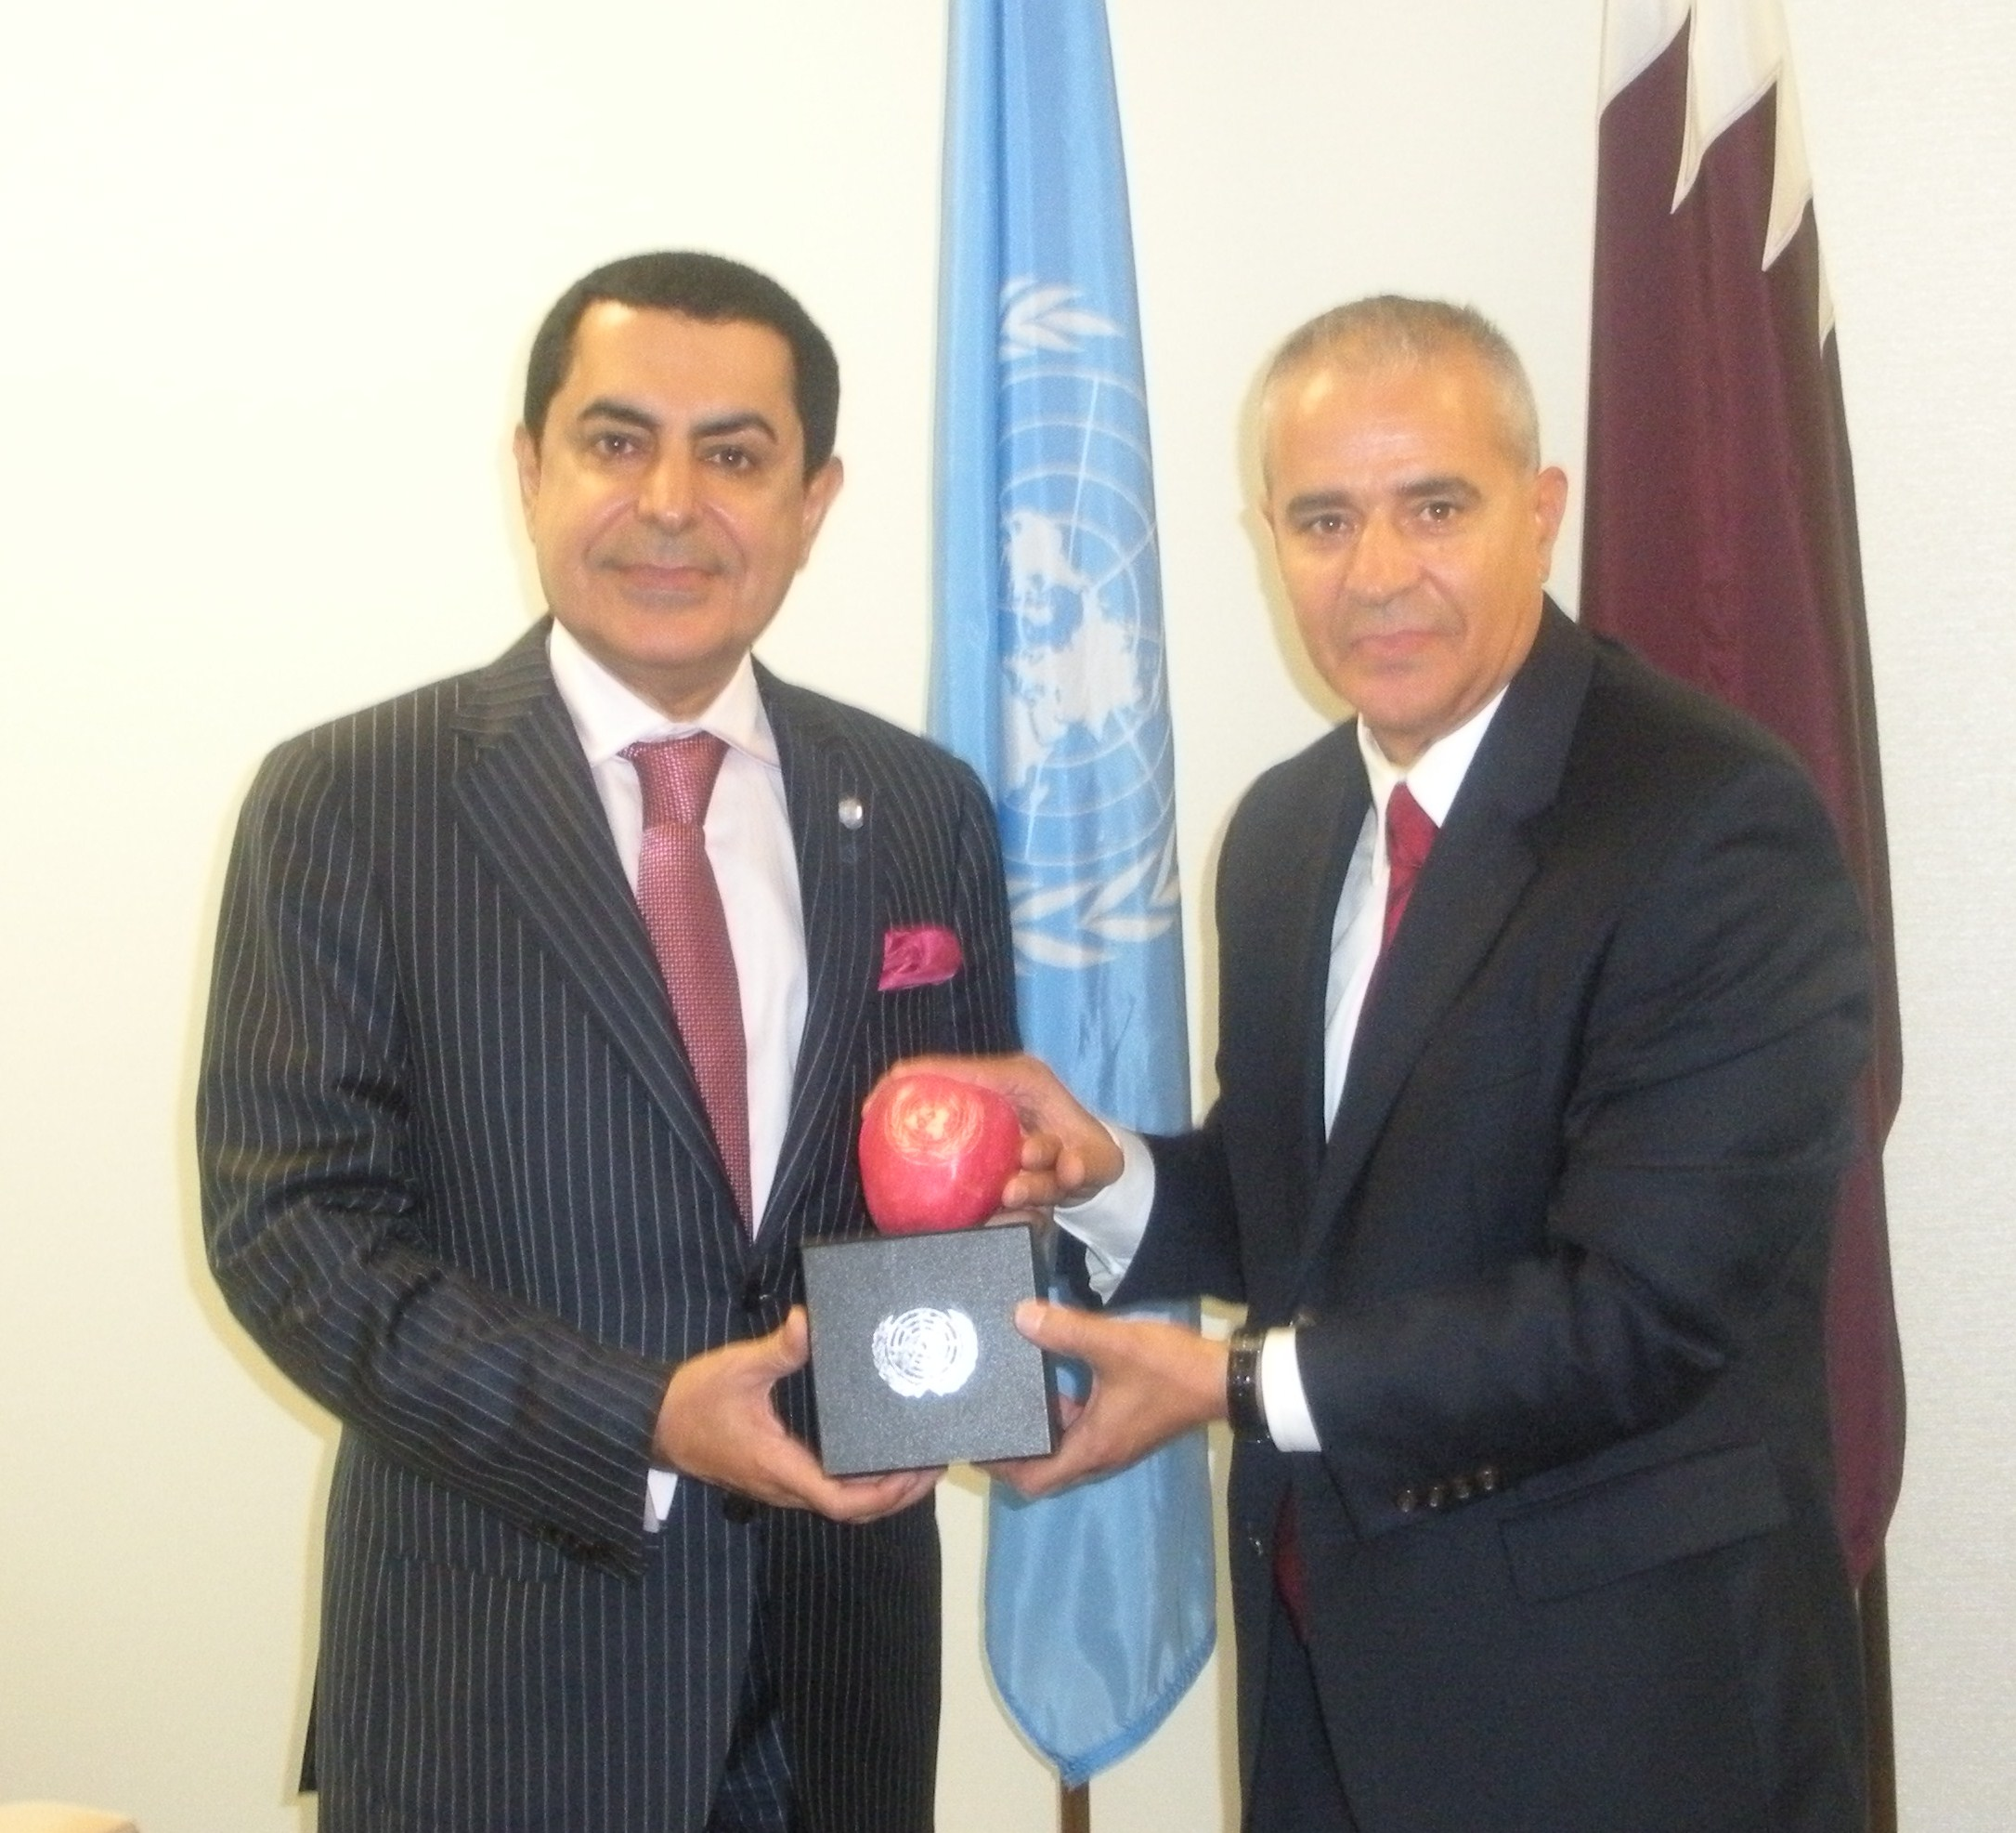
COMMUNIQUÉ
Nature at the service of the noble objectives of the United Nations
Montreal, 27 September 2011 – Through the Convention Secretariat’s partnership with the Conseil Général de Moselle, marked apples have been produced with the logo of the United Nations Decade on Biodiversity and offered to the signatories of the Convention’s Nagoya Protocol on Access to Genetic Resources and the Fair and Equitable Sharing of Benefits Arising from Their Utilization and the Nagoya – Kuala Lumpur Supplementary Protocol on Liability and Redress to the Cartagena Protocol on Biosafety. Marked apples were also given to the three winners of the 2011 World Futures Award on the best forest policy, during a ceremony hosted by the Wildlife Conservation Society, a partner of the Convention Secretariat, which took place at the Central Park Zoo in New York on 21 September. The marked apples were also given to ministers attending the ministerial breakfast on access and benefit-sharing held in New York on 22 September on the margins of the sixty-sixth session of the General Assembly and attended by over 200 participants.
A special marked apple featuring the logo of the United Nations was presented to the President of the sixty-sixth session of the General Assembly, H.E. Mr. Nassir Abdulaziz Al-Nasser, at a meeting on 24 September 2011. During this meeting, the Geneva Call for Urgent Action on the Implementation of the Successful Nagoya Outcomes, adopted on 3 September 2011 by past, present, and future presidents of the Conference of the Parties, was handed over, as was an invitation to attend the special meeting of past, present and future presidents of the three Rio conventions to mark the twentieth anniversary of those treaties, scheduled to be held at Château de Bossey, Switzerland, on 3 September 2012.
In 2010, the Conseil Général de Moselle produced marked apples with the logo of the International Year of Biodiversity. These apples were handed over to the heads of delegation attending the high-level segment of the tenth meeting of the Conference of the Parties, held in Nagoya, Japan, on 27-28 October 2010.
Patrick Weiten, President of the Conseil Général de Moselle, said: “These marked apples are a contribution of the people of Moselle, to raising public awareness and engaging the policy makers of the world in the fight to protect life on Earth.”
The marked or “illustrated” apple is an ancient tradition that reached its peak in France in the nineteenth century. A method scarcely used in the rest of the world, it was reinvented in Japan in 1970. The entirely natural technique is based on controlling the coloration of the fruit. Thanks to the bagging of the apples, their unpacking, and the setting up of a stencil at key times of their growth, the apples become “fully-fledged masterpieces”.
Ahmed Djoghlaf, Executive Secretary of the Convention on Biological Diversity, said: “Human beings have always, and will continue to learn from the wisdom of nature. The marked apples produced by the Conseil Général de Moselle are a reminder of the need to live in harmony with nature and achieve the successful implementation of the 20 Aichi Biodiversity Targets at the latest by 2020.”
For more information, please see photos of the marked apples:
www.cbd.int/photos/?albumpath=Album%3d66th%2bsession%2bof%2bthe%2bUnited%2bNations%2bGeneral%2bAssembly
-----

