 |  | CBD/SB8J/REC/1/6

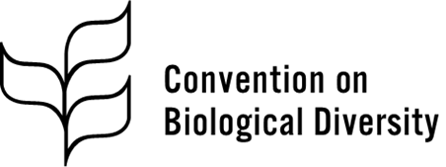 | Distr.: General  30 October 2025  Original: English

Subsidiary Body on Article 8(j) and Other Provisions of the Convention on Biological Diversity Related to Indigenous Peoples and Local Communities
First meeting
Panama City, 27–30 October 2025
Agenda item 7
Recommendations of the Permanent Forum
on Indigenous Issues
Recommendation adopted by the Subsidiary Body on Article 8(j) and Other Provisions of the Convention on Biological Diversity Related to Indigenous Peoples and Local Communities on 30 October 2025
1/6. Recommendations of the Permanent Forum on Indigenous Issues
The Subsidiary Body on Article 8(j) and Other Provisions of the Convention on Biological Diversity Related to Indigenous Peoples and Local Communities
Recommends that, at its seventeenth meeting, the Conference of the Parties adopt a decision along the following line:
[The Conference of the Parties,
Having considered the note by the Secretariat of the Convention on Biological Diversity on the recommendations of the Permanent Forum on Indigenous Issues,
Noting that there are divergent views among Parties with regard to the recommendations of the Permanent Forum on Indigenous Issues,
1. Takes note of the recommendations emanating from the twenty-third and twenty-fourth sessions of the Permanent Forum on Indigenous Issues in the context of the Convention on Biological Diversity;
2. Requests the Executive Secretary to continue to inform the Permanent Forum on Indigenous Issues of developments of mutual interest and to provide information to the Forum about activities undertaken under the Convention that are related to the aforementioned recommendations of the Forum.]
__________

United Nations, Treaty Series, vol. 1760, No. 30619.
CBD/SB8J/1/7.

