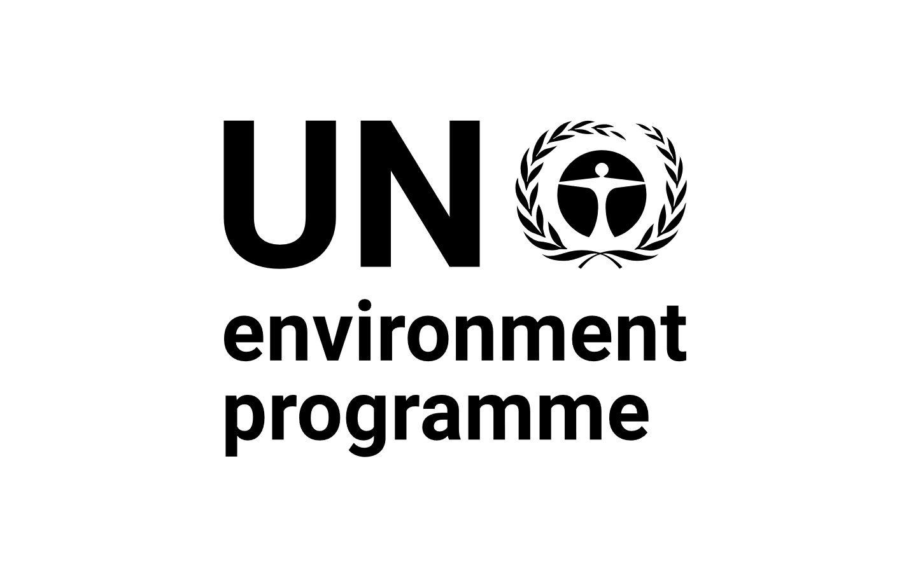 |  | CBD
Distr.
GENERAL

CBD/SBI/REC/3/12
28 March 2022

ORIGINAL: ENGLISH

SUBSIDIARY BODY ON IMPLEMENTATION
Third meeting
Online, 16 May-13 June 2021 and
Geneva, Switzerland, 14-29 March 2022
Agenda item 8

RECOMMENDATION ADOPTED BY THE SUBSIDIARY BODY ON IMPLEMENTATION

3/12. Cooperation with other conventions, international organizations and initiatives
The Subsidiary Body on Implementation,
Recalling the decisions of the Conference of the Parties concerning cooperation with other conventions, international organizations and initiatives, including those adopted at its thirteenth and fourteenth meetings,
Recalling also the decision of the Conference of the Parties at its fourteenth meeting to establish a comprehensive and participatory process for the preparation of the post-2020 global biodiversity framework,
Welcoming the participation and contributions to the preparation of the post-2020 global biodiversity framework by programmes and specialized agencies of the United Nations, other multilateral environmental agreements and processes, and intergovernmental organizations,
Also welcoming the participation and contributions to the preparation of the post-2020 global biodiversity framework by representatives of non-governmental organizations, indigenous peoples and local communities, subnational governments, cities and other local authorities, women’s groups, youth groups, the business and finance community, the scientific community, academia, faith-based organizations, representatives of sectors related to or dependent on biodiversity, among others,
Recognizing the important role of the post-2020 global biodiversity framework to help focus the efforts of all Parties, governments at all levels, partners, relevant stakeholders, organizations and conventions to contribute to the objectives of the Convention, to foster cooperation among them, and the essential contributions they will make to its implementation,
- Takes note of the recommendations of the Ad Hoc Open-ended Working Group on Article 8(j) and Related Provisions of the Convention, at its eleventh meeting, and the Subsidiary Body on Scientific, Technical and Technological Advice, at its twenty-third meeting, concerning options for possible elements of work aimed at an integration of nature and culture in the post-2020 global biodiversity framework and further takes note of the proclamation by the United Nations General Assembly of the period 2022–2032 as the International Decade of Indigenous Languages;
- Invites the Co-Chairs of the Open-ended Working Group on the Post-2020 Global Biodiversity Framework and the Open-ended Working Group to take into consideration in the further development of the post-2020 global biodiversity framework, the report of the Second Consultation Workshop of Biodiversity-related Conventions on the Post-2020 Global Biodiversity Framework contained in CBD/SBI/3/INF/29 and the conclusions of that workshop included in CBD/SBI/3/10, as appropriate, as well as the submissions made by governing bodies of multilateral environmental agreements concerning their views on the post-2020 global biodiversity framework and its monitoring framework, which are appropriate to the mandate of the Convention on Biological Diversity;
- Also invites the Co-Chairs of the Open-ended Working Group on the Post-2020 Global Biodiversity Framework and the Open-ended Working Group in the further development of the post-2020 biodiversity framework to consider possible new areas and approaches for enhancing cooperation, as well as lessons learned, in line with paragraph 1 of decision 14/30;
- Further invites the Co-Chairs of the Open-ended Working Group on the Post-2020 Global Biodiversity Framework and the Open-ended Working Group to take into consideration in the further development of the post-2020 global biodiversity framework, the recommendations of the Ad Hoc Open-ended Working Group on Article 8(j) and Related Provisions of the Convention, at its eleventh meeting, and the Subsidiary Body on Scientific, Technical and Technological Advice, at its twenty-third meeting, concerning options for possible elements of work aimed at an integration of nature and culture in the post-2020 global biodiversity framework;
- Recommends that the Conference of the Parties at its fifteenth meeting adopt a decision along the following lines:
The Conference of the Parties,
Recalling decisions XIII/24 and 14/30,
[Recognizing the critical role of actions for the conservation and sustainable use of biological diversity, including restoration, for addressing multiple global crises, including biodiversity loss, climate change and pollution,]
Acknowledging the independent nature of the mandates of biodiversity-related conventions, other multilateral environmental agreements and international organizations, emphasizing the need to fully observe their respective mandates and reaffirming that synergies in their implementation at the global, regional and national levels should be promoted on a Party-driven basis, in accordance with the priorities set out within each instrument and with national circumstances, capabilities and priorities,
Reaffirming the importance of enhancing cooperation in the implementation of the Convention on Biological Diversity and its Protocols and other multilateral environmental agreements and initiatives, including but not limited to biodiversity-related conventions and agreements, chemicals and waste conventions, and the Rio conventions, at the global, regional, subregional, national and subnational levels, in a manner respectful of their respective mandates,
Emphasizing the importance of cooperation among all relevant conventions, organizations and initiatives to achieve the three objectives of the Convention and to implement and monitor progress in the implementation of the post-2020 global biodiversity framework in an effective and timely manner in order to achieve its targets, goals and its 2030 mission and the 2050 Vision for Biodiversity,
Taking note of the work conducted by the United Nations Environment Management Group and the United Nations System Chief Executives Board for Coordination to facilitate system-wide attention to biodiversity and the post-2020 global biodiversity framework,
Welcoming with appreciation the support provided by the Government of Switzerland for the organization of the consultation workshops of biodiversity-related conventions on the post-2020 global biodiversity framework (Bern I and II) and welcoming the reports of both workshops,
Also welcoming with appreciation the support provided by the United Nations Environment Programme to the implementation of decisions XIII/24 and 14/30 with respect to enhancing synergies among biodiversity-related conventions, including in convening the Bern II workshop,
Further welcoming the contributions of other biodiversity-related conventions, multilateral agreements and international organizations and processes to the preparation of the post-2020 global biodiversity framework, including through their active participation in the “Bern process”,
Recognizing that relevant multilateral environmental agreements have specific contributions to make in implementing elements of the post-2020 global biodiversity framework, in line with their mandates,
Welcoming with appreciation the work conducted by other organizations to fulfil elements of decision 14/30, including the Food and Agriculture Organization of the United Nations, the United Nations Educational, Scientific and Cultural Organization, the International Tropical Timber Organization and the World Health Organization,
Also welcoming with appreciation, the work undertaken by the Global Partnership for Plant Conservation in promoting plant conservation and contributing to the 2050 Vision for Biodiversity as described in the fifth edition of the Global Biodiversity Outlook and the 2020 Plant Conservation report,
Also welcoming the cooperative activities under the Rio conventions,
Recognizing the rolling work programme up to 2030 of the Intergovernmental Science-Policy Platform on Biodiversity and Ecosystem Services,
Welcoming with appreciation the resolution of the United Nations General Assembly proclaiming the United Nations Decade on Ecosystem Restoration 2021-2030 and the contribution that this may provide to objectives of the Convention and the post-2020 global biodiversity framework,
1. Welcomes the contributions of other biodiversity-related conventions, multilateral agreements and international organizations and processes to enhancing synergies in the implementation of the post-2020 global biodiversity framework;
2. Encourages the strengthening of cooperation and synergies among relevant conventions and multilateral agreements by, as appropriate and in line with their respective mandates, legal authority and responsibilities, establishing or renewing cooperation frameworks such as the trilateral Memorandum of Cooperation between the Convention on Biological Diversity, the Alpine Convention and the Carpathian Convention which is being updated in the light of the post-2020 global biodiversity framework;
3. Invites the governing bodies of other biodiversity-related conventions and relevant multilateral environmental agreements, as well as international organizations and other relevant programmes, to [formally endorse] the post-2020 global biodiversity framework through their own governance processes, as appropriate, in order to support its operationalization and contribute to the transparency and monitoring of progress in implementing the post-2020 global biodiversity framework by, among others, using synergetic modular reporting tools such as the Data Reporting Tool for MEAs (DaRT);
4. Also invites the governing bodies of the biodiversity-related conventions and relevant multilateral environmental agreements, as well as international organizations and other relevant programmes, to contribute to the implementation and monitoring of the post-2020 global biodiversity framework, in particular by further strengthening cooperation at the global level within their respective mandates and enhancing synergies among themselves, to encourage mutually supportive decisions, to align their own strategies with the post-2020 global biodiversity framework and to propose key issues for thematic discussions facilitated by the Liaison Group of Biodiversity-related Conventions, taking into account, where appropriate, the conclusions of the Bern II workshop included in document CBD/SBI/3/10 and invites the United nations Environment Programme to continue its work to enhance cooperation among the biodiversity-related related conventions and other relevant multilateral agreements, including their governing bodies;
5. Invites the Liaison Group of Biodiversity-related Conventions, as well as the informal advisory group on synergies, to enhance cooperation, reduce inefficiencies and facilitate synergies, between the heads of the secretariats of biodiversity-related conventions, including through thematic consultations, on key issues for the implementation of the post-2020 global biodiversity framework and to provide common messages or draft recommendations to their respective governing bodies to act upon;
[6. Encourages Parties to work together with all stakeholders to jointly implement the post-2020 global biodiversity framework in a spirit of cooperation and mutual support, at global, regional, subregional, national and subnational levels, across areas and sectors, through bilateral joint work programmes where appropriate, and through existing global, regional, subregional, national and subnational instruments, mechanisms and processes;]
[7. Invites the United Nations Environment Programme, subject to the availability of resources, to support the Parties and secretariats of the biodiversity related conventions and agreements to continue to enhance synergies on key actions and priorities established by their Parties to be implemented at the national and regional levels;]
8. Also invites the United Nations Environment Programme, in consultation with the secretariats of the biodiversity related conventions and relevant partner organizations, to continue to facilitate and implement key actions aimed to enhance synergies at the national and international levels outlined in decisions XIII/24 and 14/30, in particular regarding reporting and the use of supportive tools, such as DaRT, capacity-building and development, and facilitating linkages between relevant multilateral environmental agreements;
9. Invites the Food and Agriculture Organization of the United Nations and the United Nations Environment Programme to continue to liaise closely with the Secretariats of the Rio conventions and relevant partner organizations in the implementation of the United Nations Decade on Ecosystem Restoration and to provide a report on its progress at the sixteenth meeting of the Conference of the Parties;
10. Invites the United Nations Environment Management Group to facilitate United Nations system-wide coordination towards the objectives of the Convention, its Protocols and the post-2020 global biodiversity framework, in a manner fully respectful of the mandates of different multilateral environmental agreements and international organizations;
11. Urges Parties, invites other Governments and invites non-governmental organizations, indigenous peoples and local communities, subnational governments, cities and other local authorities, women’s groups, youth groups, the business and finance community, the scientific community, academia, faith-based organizations, representatives of sectors related to or dependent on biodiversity, among others, to reinforce actions to enhance synergies in the implementation of the post-2020 global biodiversity framework, the Sustainable Development Goals, the biodiversity-related conventions, the Rio conventions and other relevant multilateral agreements and initiatives at the national level, including through their national coordination, planning, review and reporting processes, including through existing common and voluntary reporting platforms such as DaRT, in line with options for action at the national level provided in decision XIII/24, and in accordance with national circumstances and priorities;
12. Encourages Parties to implement the Convention and other biodiversity-related conventions and multilateral agreements to which they are party, in a complementary manner, including in reviewing and updating their national biodiversity strategies and action plans, in order to enable the effective implementation of the post-2020 global biodiversity framework;
13. Invites the Global Partnership on Plant Conservation, with the support of the Secretariat, to prepare a set of complementary actions related to plant conservation to support the implementation of the post-2020 global biodiversity framework aligned with the final version of the framework, other relevant decisions adopted by the Conference of the Parties at its fifteenth meeting, as well as previous experiences with the implementation of the Global Strategy for Plant Conservation as described in the fifth edition of the Global Biodiversity Outlook and the 2020 Plant Conservation report, to be considered by a meeting of the Subsidiary Body on Scientific, Technical and Technological Advice following the fifteenth meeting of the Conference of the Parties;
14. Requests the Executive Secretary, subject to the availability of resources:
(a) To identify, develop and provide [any necessary guidance and] technical support that will help to encourage and assist other biodiversity-related conventions, multilateral environmental agreements, international organizations, and other relevant programmes in contributing to the implementation of the post-2020 global biodiversity framework and, in consultation with their secretariats, identify opportunities to cooperate with biodiversity-related conventions and other relevant multilateral environmental agreements and organizations specifically to help achieve the goals and targets of the post-2020 global biodiversity framework and provide a list of relevant initiatives and action plans for review by the Subsidiary Body on Implementation at its fourth meeting;
(b) In consultation with Parties and the secretariats of the biodiversity-related conventions, other multilateral agreements and international organizations and processes, building wherever possible on existing mechanisms, to continue to implement key actions outlined in decisions 14/30 and XIII/24 to enhance synergies among biodiversity-related conventions and to cooperate with other relevant multilateral agreements at the international level, in a manner consistent with their mandates;
[(c) In consultation with the Liaison Group of Biodiversity-related Conventions and the informal advisory group on synergies, to [explore the usefulness] for a liaison mechanism among Parties to the various biodiversity-related conventions at an intergovernmental level to support cooperation in the implementation of the post-2020 global biodiversity framework, and options for its establishment, including consideration of its mandate, structure and resource requirements, and to submit a proposal, which clearly explains the necessity and, if appropriate, the scope of each option, for consideration by the Subsidiary Body on Implementation at its fourth meeting and by the Conference of the Parties at its sixteenth meeting;]
[(d) To continue working with the Permanent Forum on Indigenous Issues and the Permanent Forum on People of African Descent on topics related to biodiversity and traditional knowledge;]
15. Also requests the Executive Secretary and invites the United Nations Educational, Scientific and Cultural Organization and the International Union for Conservation of Nature, to advance, subject to the availability of resources, the Joint Programme of Work on the Links between Biological and Cultural Diversity, where appropriate in cooperation with relevant initiatives of Parties, other Governments and other organizations, such as the Intergovernmental Science-Policy Platform on Biodiversity and Ecosystem Services, and to report on progress to the Subsidiary Body on Implementation and other mechanisms, as appropriate;
[16. Requests the Executive Secretary to collaborate with the World Health Organization, subject to the availability of resources, with a view to facilitating, as appropriate, consideration of [timely] access to pathogens and the fair and equitable sharing of the benefits arising from the utilization of genetic resources in its ongoing work on pandemic prevention, preparedness and response.]

__________

Decisions XIII/24 and 14/30.
Decision 14/34.
Recommendations WG8J-11/3 and SBSTTA-23/5.
A/RES/74/135
The Conference of the Parties could consider the placement of such encouragement to stakeholders in its decision adopting the post-2020 global biodiversity framework or its decision concerning cooperation, or both, as appropriate
The Conference of the Parties could consider the placement of such encouragement to stakeholders in its decision adopting the post-2020 global biodiversity framework or its decision concerning cooperation, or both, as appropriate
Decision XIII/24, annex I

