 | 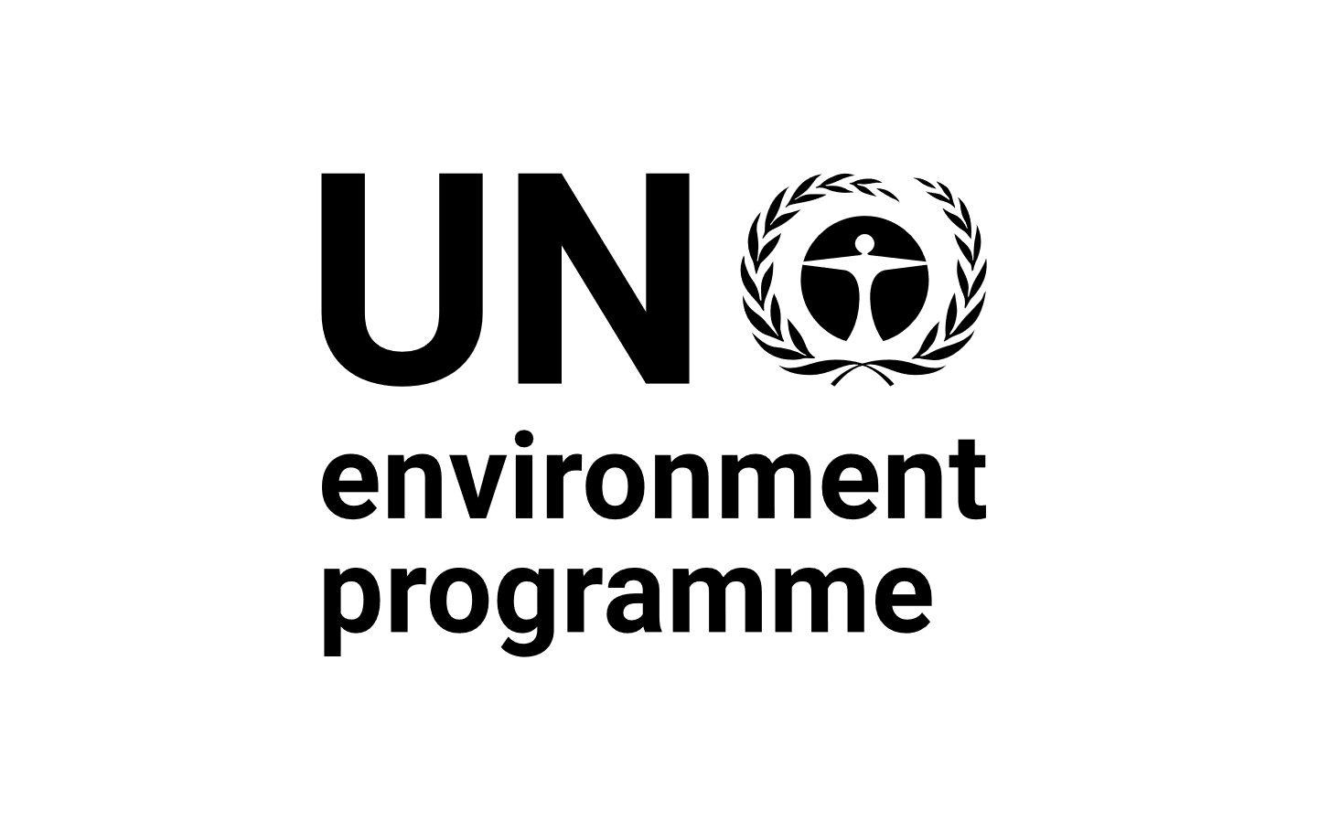 | CBD
Distr.
GENERAL

CBD/SBI/REC/3/16
28 March 2022

ORIGINAL: ENGLISH

SUBSIDIARY BODY ON IMPLEMENTATION
Third meeting
Online, 16 May-13 June 2021 and
Geneva, Switzerland, 14-29 March 2022
Agenda item 12

RECOMMENDATION ADOPTED BY THE SUBSIDIARY BODY ON IMPLEMENTATION

3/16. Specialized international access and benefit-sharing instruments in the context of Article 4, paragraph 4, of the Nagoya Protocol
The Subsidiary Body on Implementation recommends that the Conference of the Parties serving as the meeting of the Parties to the Nagoya Protocol adopt a decision along the following lines:
[The Conference of the Parties serving as the meeting of the Parties to the Nagoya Protocol on Access and Benefit-sharing,
Recalling Article 4 of the Nagoya Protocol and decision NP-3/14,
[1. Takes note of the indicative criteria for specialized international access and benefit-sharing instruments in the context of Article 4[, paragraph 4,] of the Nagoya Protocol, contained in the annex to the present decision, noting that they are intended to contribute to strengthening coordination and mutual supportiveness between the Nagoya Protocol and other international access and benefit-sharing instruments, without creating a hierarchy among them;]
2. Invites Parties, and other Governments to take into account, consistent with Article 4[, paragraph 4,] of the Nagoya Protocol, each of the indicative criteria in developing and/or applying access and benefit-sharing measures and/or in endorsing international instruments that include provisions on access and benefit-sharing;
3. Invites relevant international organizations and intergovernmental processes to take into account the indicative criteria in their efforts to develop or [when agreeing on] [implement]specialized international access and benefit-sharing instruments;
4. Requests Parties to include information in their national reports and, as appropriate, through the Access and Benefit-sharing Clearing House, and invites other Governments and relevant international organizations to share information on any steps that they have taken towards the development and/or implementation of specialized international access and benefit-sharing instruments that are [consistent with] [mutually supportive of] the objectives of the Convention and the Protocol, including information on the specific genetic resource[s and/or specific uses] [including traditional knowledge associated with genetic resources] covered by and for the purpose of the specialized instrument;
[5. Decides that the meeting of the Parties to the Nagoya Protocol shall act as the authority to assess, determine, review or terminate the status of instruments as specialized international access and benefit-sharing instruments in the context of Article 4, paragraph 4, of the Nagoya Protocol based on the criteria provided in the annex to the present draft decision and that the Parties to Nagoya Protocol can approach the meeting of the Parties for determination or termination of the status of instruments;]
[6. Requests the Executive Secretary to receive and submit instruments from Parties to the Nagoya Protocol for such consideration by the meeting of the Parties as mentioned in paragraph 5, four months before the meeting of the Parties, starting from the fifth meeting];
7. Decides to review the present decision in the context of the assessment and review process as provided for in Article 31 of the Protocol, taking into account relevant developments and with a view to taking any steps necessary to promote coherence in the international regime on access and benefit-sharing.

Annex

Indicative criteria for specialized international access and benefit-sharing instruments in the context of Article 4, paragraph 4, of the Nagoya Protocol on Access to Genetic Resources and the Fair and Equitable Sharing of Benefits Arising from Their Utilization
- These indicative criteria are reference points or elements to consider as guidance when developing or implementing specialized international access and benefit-sharing instruments. They are intended to contribute to strengthening coordination and mutual supportiveness between the Nagoya Protocol and other international access and benefit-sharing instruments, without creating a hierarchy among them.
- Intergovernmentally or internationally agreed — The instrument is agreed [or adopted] through an intergovernmental process and/or is [explicitly] endorsed by States [and/or Governments][through a decision of a governing body of an international organization]. [The instrument may be binding or non-binding.]
- Specialized — The instrument:
(a) Applies to a specific set of genetic resources and/or traditional knowledge associated with genetic resources which would otherwise fall under the scope of the Nagoya Protocol;
(b) Applies to specific uses of genetic resources and/or traditional knowledge associated with genetic resources, or to specific purposes, which require a differentiated and hence specialized approach.
- Mutually supportive — The instrument is consistent with and supportive of, and does not run counter to, the objectives of the Convention on Biological Diversity and the Nagoya Protocol, including with respect to:
(a) Consistency with biodiversity conservation and sustainable use objectives;
(b) Fairness and equity in the sharing of benefits;
(c) Legal certainty with respect to access to genetic resources or traditional knowledge associated with genetic resources, including[, as appropriate,] the application of prior informed consent, and to [the fair and equitable sharing of benefits][benefit-sharing];
(d) Full and effective participation of indigenous peoples and local communities concerned;
(e) Contribution to sustainable development, as reflected in internationally agreed goals;
(f) Other general principles of law, including good faith, effectiveness and legitimate expectations.]
__________

