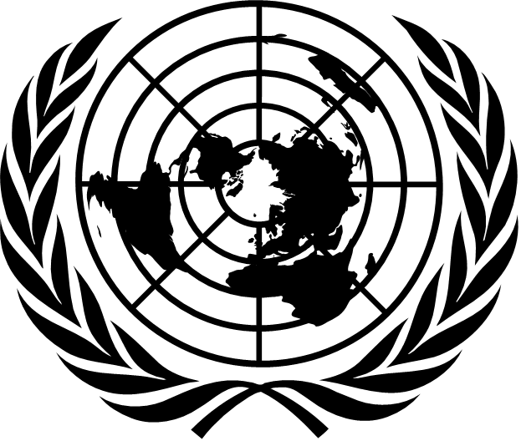 | 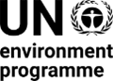 | CBD/SBI/REC/6/6

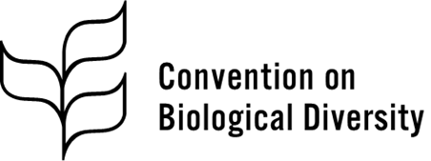 | Distr.: General  19 February 2026  Original: English

Subsidiary Body on Implementation
Sixth meeting
Rome, 16–19 February 2026
Agenda item 7
Cooperation with other conventions and
international organizations
Recommendation adopted by the Subsidiary Body on Implementation on 19 February 2026
6/6. Cooperation with other conventions and international organizations
The Subsidiary Body on Implementation
Recommends that, at its seventeenth meeting, the Conference of the Parties adopt a decision along the following lines:
The Conference of the Parties,
Recalling its decisions XIII/24 of 17 December 2016, 14/30 of 29 November 2018, 15/4 and 15/13 of 19 December 2022 and 16/35 of 27 February 2025,
Taking note of General Assembly resolution 80/140 of 15 December 2025 and previous resolutions relating to the Convention on Biological Diversity,
Recognizing that strengthening cooperation, synergies and complementarity among multilateral environmental agreements and relevant organizations must be promoted in a Party‑driven manner, with adequate means of implementation, including financial resources, capacity‑building and technology transfer, on voluntary and mutually agreed terms, while avoiding the duplication of efforts and additional administrative burdens, through, inter alia, measurable reductions in reporting and transaction costs for countries, in particular developing countries, including the least developed countries and small island developing States among them,
1. Welcomes the work of the United Nations Environment Management Group in reinforcing the Common Approach to Integrating Biodiversity and Nature-based Solutions for Sustainable Development into United Nations Policy and Programme Planning and Delivery and its Issue Management Group on Biodiversity;
2. Also welcomes the continued work of the United Nations Environment Programme in facilitating cooperation among the biodiversity-related conventions and other relevant multilateral environmental agreements, including through the Bern process, for the effective and efficient implementation of the Kunming-Montreal Global Biodiversity Framework;
3. Further welcomes the outcomes of the seventh session of the United Nations Environment Assembly of the United Nations Environment Programme on promoting synergies, cooperation or collaboration for national implementation of multilateral environmental agreements and other relevant environmental instruments;
4. [Welcomes][Notes] the entry into force of the Agreement under the United Nations Convention on the Law of the Sea on the Conservation and Sustainable Use of Marine Biological Diversity of Areas beyond National Jurisdiction[, recognizes the importance of ensuring coherence, complementarity and mutual supportiveness between its implementation and the Convention on Biological Diversity,] [and expresses its readiness to strengthen cooperation and mutual supportiveness between the Secretariat of the Convention and the interim Secretariat of the Agreement];
[5. Welcomes the global analytical study on the implementation of a human rights-based approach into the goals and targets of the Framework prepared by the United Nations High Commissioner for Human Rights for the sixty-first session of the Human Rights Council pursuant to Human Rights Council resolution 57/28 of 11 October 2024, and encourages Parties and other Governments to make use of the study and take up its key messages, both in national implementation and in all cooperative efforts towards the implementation of the Framework;]
6. [Also welcomes][Notes] the ongoing efforts of, and actions taken by, Parties, the governing bodies and secretariats of the other Rio conventions, biodiversity-related conventions, chemical and waste-related conventions and other relevant multilateral environmental agreements, United Nations entities, other relevant organizations and stakeholders, including financial institutions and initiatives relevant to thematic sectors, to enhance cooperation in the context of the Kunming-Montreal Global Biodiversity Framework and other relevant frameworks;
7. [Further welcomes][Notes] the collaborative efforts of the Joint Liaison Group of the Rio Conventions and the Liaison Group of Biodiversity-related Conventions, and invites the secretariats of the conventions to identify best practices for improving the effectiveness of meetings and to share the findings among relevant secretariats for consideration by their respective governing bodies;
8. [Notes][Welcomes] the establishment of the Intergovernmental Science-Policy Panel on Chemicals, Waste and Pollution, and invites collaboration between the Panel and the Intergovernmental Science-Policy Platform on Biodiversity and Ecosystem Services, together with the Intergovernmental Panel on Climate Change and the Science-Policy Interface of the United Nations Convention to Combat Desertification in Those Countries Experiencing Serious Drought and/or Desertification, Particularly in Africa;
9. Also welcomes the resolutions and decisions adopted by the governing bodies of other conventions, organizations and programmes in support of the coherent implementation and monitoring of the Framework, including by mainstreaming biodiversity in different sectors;
10. Invites the governing bodies of all relevant conventions, organizations and programmes to continue to adopt mutually supportive decisions and provisions to enhance cooperation and coherence in the development of international policy and the implementation of the Rio conventions, biodiversity-related conventions and other relevant multilateral environmental agreements and accelerate and facilitate action and tangible outcomes in the implementation of, and monitoring of progress with, the Framework at all levels, within their respective mandates;
11. [Placeholder in relation to the outcomes of paragraph 6 of recommendation 27/3 of the Subsidiary Body on Scientific, Technical and Technological Advice];
12. Invites Parties and other Governments to continue to strengthen national cooperation and coordination among the national focal points of the Convention on Biological Diversity and its Protocols, the national focal points of other conventions and processes relevant to the implementation of the Framework and relevant stakeholders in the development and implementation of their national biodiversity strategies and action plans and the preparation of their national reports, in line with national priorities and circumstances;
[13. Invites Parties to consider opportunities to promote and enhance synergies between the Convention and multilateral agreements in other sectors outside the environment sector[, where appropriate,] [in accordance with the common but differentiated responsibilities principle and recognizing that measures taken to conserve, protect, restore or sustainably use biodiversity, including unilateral ones, should not constitute a means of arbitrary or unjustifiable discrimination or disguised restriction on international trade];]
14. Encourages the secretariats of the other Rio conventions, biodiversity-related conventions and other relevant multilateral environmental agreements and relevant organizations to continue to strengthen collaboration, cooperation and coherence in the implementation of, and monitoring of progress with, the Framework, as appropriate and within their respective mandates;
[15. Invites the United Nations Environment Programme to build on the Bern process and continue to strengthen cooperation among biodiversity-related conventions and other relevant multilateral environmental agreements, contributing to effective and efficient implementation of the Framework, including by addressing the outcomes of the global review of collective progress in the implementation of the Framework, and requests the Executive Secretary to continue to engage in the Bern process;]
16. Requests the Executive Secretary, subject to the availability of resources:
(a) To further engage in continued collaboration and cooperation with the secretariats of the other Rio conventions, biodiversity-related conventions and other relevant multilateral environmental agreements, United Nations entities and other relevant organizations in supporting the complementarity of efforts in the implementation of [the Convention and] the Framework without prejudice to their respective objectives and mandates;
(b) To seek views from Parties, other Governments, the secretariats of the other Rio conventions, biodiversity-related conventions, other multilateral environmental agreements, relevant organizations, indigenous peoples and local communities, women, youth and other stakeholders on how to assess and track more systematically good practices, improvements to and the results of cooperation between the Convention on Biological Diversity and other conventions and organizations;
(c) To undertake, in collaboration with the other members of the Joint Liaison Group of the Rio Conventions, an analysis of overlaps in the frameworks for planning, monitoring, reporting and review of the three conventions and provide options for their enhanced coordination and simplification, as appropriate and within their respective mandates;
[(d) To enhance awareness-raising in alignment with the objectives of the programme of work on communication, education and public awareness on the interconnectedness of the biodiversity loss, climate change, land degradation and pollution challenges, including by addressing their interrelated direct and indirect drivers of biodiversity loss and the benefits of coordinated responses to those challenges;
(e) To continue collaboration with the Office of the United Nations High Commissioner for Human Rights and make available the tools and guidance on a human rights-based approach to the implementation of the Framework developed by that Office further to the invitation in paragraph 20 of decision 16/35;
(f) To collaborate and share relevant information with the Secretariat, including the interim Secretariat, of the Agreement under the United Nations Convention on the Law of the Sea on the Conservation and Sustainable Use of Marine Biological Diversity of Areas beyond National Jurisdiction, noting the potential important synergies between the Convention and the Agreement;
(g) To report to the Subsidiary Body on Implementation and the Subsidiary Body on Article 8(j) and Other Provisions of the Convention on Biological Diversity Related to Indigenous Peoples and Local Communities at meetings held before the eighteenth meeting of the Conference of the Parties on progress made with the activities listed in the present paragraph and on further work undertaken in response to decision 16/35;
(h) To explore, in collaboration with the Global Environment Facility and other relevant financial mechanisms and initiatives, such as the Biodiversity Finance Initiative, options for integrated programming and synergistic funding to allow Parties to submit joint projects on biodiversity loss, climate change, land degradation and pollution;
(i) To continue collaboration with the other members of the Joint Liaison Group of the Rio Conventions on joint capacity-building activities, including on the traditional knowledge of indigenous peoples and local communities, to promote cooperation and synergies among the three conventions, within their respective mandates.]
__________

United Nations, Treaty Series, vol. 1760, No. 30619.
CEB/2021/1/Add.1.
Decision 15/4, annex.
See United Nations Environment Assembly resolution 6/4.
A/CONF.232/2023/4.
A/HRC/61/36.
United Nations, Treaty Series, vol. 1954, No. 33480.
Available at www.ohchr.org/sites/default/files/documents/issues/climatechange/materials/briefing-note-applying-a-human-rights-based-approach-in-line-with-sectionc-kunming-montreal.pdf. The joint publication entitled “Applying a human rights-based approach in line with Section C of the Kunming-Montreal Biodiversity Framework – A briefing note” of the Office of the United Nations High Commissioner for Human Rights and the Secretariat of the Convention on Biological Diversity does not reflect the views of the Parties or the Conference of the Parties to the Convention or those of the States members of the Human Rights Council. It is a first draft, unedited and subject to further revision and inputs received.

