 | 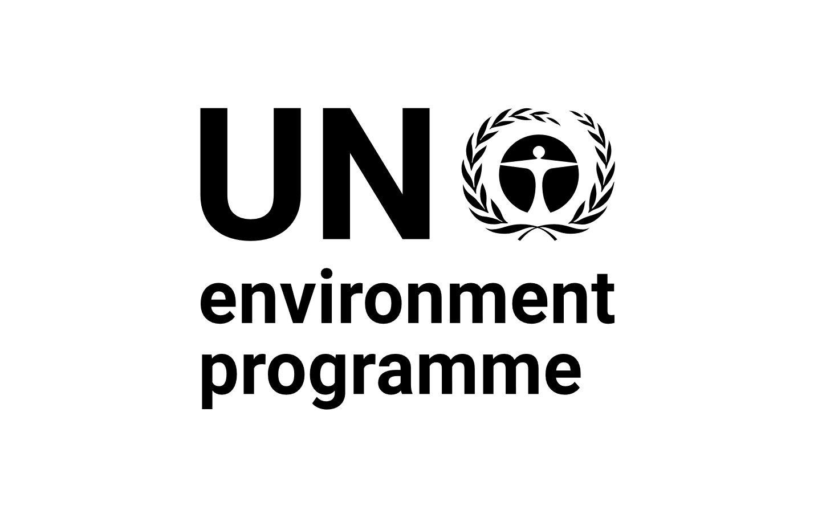 | CBD
Distr.
GENERAL

CBD/SBSTTA/REC/24/1
27 March 2022

ORIGINAL: ENGLISH

SUBSIDIARY BODY ON SCIENTIFIC, TECHNICAL AND TECHNOLOGICAL ADVICE
Twenty-fourth meeting
Online, 3 May – 9 June 2021
Geneva, Switzerland, 14-29 March 2022
Agenda item 3
RECOMMENDATION ADOPTED BY THE SUBSIDIARY BODY ON SCIENTIFIC, TECHNICAL AND TECHNOLOGICAL ADVICE
24/1. Fifth edition of the Global Biodiversity Outlook and its summary for policymakers
The Subsidiary Body on Scientific, Technical and Technological Advice recommends that the Conference of the Parties at its fifteenth meeting adopt a decision along the following lines:
The Conference of the Parties
      - [Welcomes][Takes notes of] the fifth edition of the Global Biodiversity Outlook, including its summary for policymakers, as well as the second edition of the Local Biodiversity Outlooks and the 2020 Plant Conservation Report;
      - Acknowledges with appreciation the financial support provided by the Governments of Canada, Japan and the United Kingdom of Great Britain and Northern Ireland as well as the European Union for the preparation of the fifth edition of the Global Biodiversity Outlook;
      - Takes note of the general conclusions from the fifth edition of the Global Biodiversity Outlook;
      - Also takes note of the lessons learned from the implementation of the Strategic Plan for Biodiversity 2011-2020 identified in the fifth edition of the Global Biodiversity Outlook;
      - Encourages Parties, and invites other Governments and local and subnational governments as well as relevant organizations, as appropriate, to use the reports and to take steps to widely disseminate their findings, including by translating the reports into local languages and producing other appropriate communication products for different stakeholders, and to make use of the reports when implementing the post-2020 global biodiversity framework.
__________

Secretariat of the Convention on Biological Diversity (2020). Global Biodiversity Outlook 5. Montreal.
Forest Peoples Programme (2020). Local Biodiversity Outlooks 2: The contributions of indigenous peoples and local communities to the implementation of the Strategic Plan for Biodiversity 2011–2020 and to renewing nature and cultures. A complement to the fifth edition of the Global Biodiversity Outlook. Moreton-in-Marsh, England (United Kingdom) (see www.localbiodiversityoutlooks.net).
Sharrock, S. (2020). Plant Conservation Report 2020: A review of progress in implementation of the Global Strategy for Plant Conservation 2011-2020. Secretariat of the Convention on Biological Diversity, Montreal, Canada and Botanic Gardens Conservation International, Richmond, United Kingdom. Technical Series No. 95.
Conference of the Parties decision X/2, annex.

