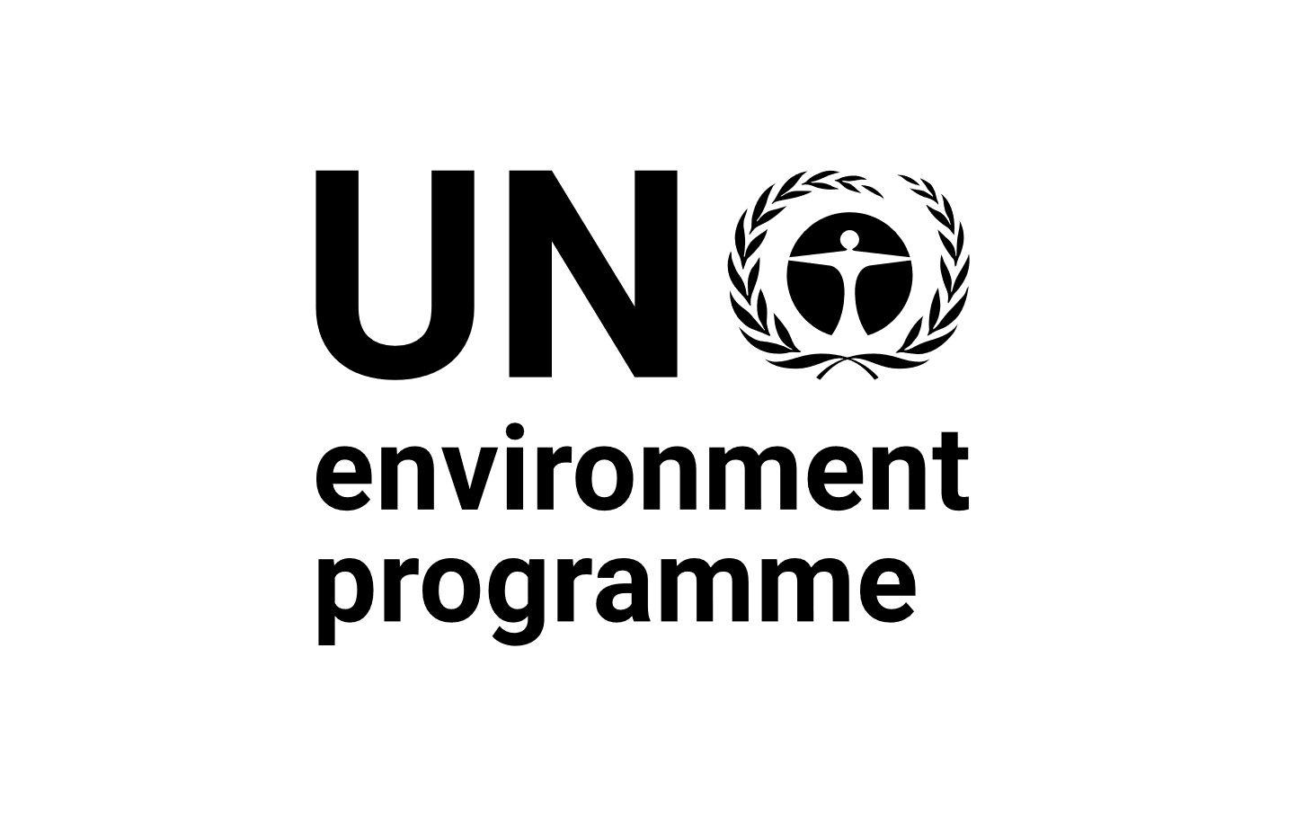 |  | CBD
Distr.
GENERAL

CBD/SBSTTA/REC/24/9
27 March 2022

ORIGINAL: ENGLISH

SUBSIDIARY BODY ON SCIENTIFIC, TECHNICAL AND TECHNOLOGICAL ADVICE
Twenty-fourth meeting
Online, 3 May – 9 June 2021
Geneva, Switzerland, 14-29 March 2022
Agenda item 6

RECOMMENDATION ADOPTED BY THE SUBSIDIARY BODY ON SCIENTIFIC, TECHNICAL AND TECHNOLOGICAL ADVICE
24/9. Conservation and sustainable use of marine and coastal biodiversity
The Subsidiary Body on Scientific, Technical and Technological Advice
1. Takes note of the outcomes of the unresolved discussions during its twenty-fourth meeting under agenda item 6 on the conservation and sustainable use of marine and coastal biodiversity, contained in the annex to the present recommendation, and the proposals submitted by Parties and observers on this issue, which were provided at the invitation of the Chair, contained in document (CBD/SBSTTA/24/INF/42), which are to be taken as the basis for further negotiations on this issue by the Conference of the Parties at its fifteenth meeting;
2. Notes that work reflected in the annex to the present document was not completed due to the extraordinary circumstances resulting from the limitations on in-person meetings caused by the COVID-19 pandemic, the need to urgently negotiate the post-2020 global biodiversity framework and the need to take into account the availability of delegates who participated in the fourth session of the intergovernmental conference on an international legally binding instrument under the United Nations Convention on the Law of the Sea on the conservation and sustainable use of marine biological diversity of areas beyond national jurisdiction;
3. Also notes that the practice described in paragraph 1 will not set a precedent for the future and that sufficient time will be allocated in the future to allow thorough, fair, just and equitable deliberations by the Subsidiary Body on Scientific, Technical and Technological Advice;
4. Requests the Executive Secretary, in advance of the fifteenth meeting of the Conference of the Parties, and subject to the availability of financial resources, to facilitate consultations, both in person and online, among Parties, other Governments and relevant stakeholders, including indigenous peoples and local communities, women and youth, with a view to advancing discussions on the conservation and sustainable use of marine and coastal biodiversity;
5. Recognizes that the outcomes of these consultations will help to form the basis for focused deliberations on this issue at the fifteenth meeting of the Conference of the Parties and requests that dedicated time be given to this issue in the organization of work for the fifteenth meeting of the Conference of the Parties;
6. Transmits the work facilitated by the Secretariat, referred to in paragraph 4 above, to the Conference of the Parties to the Convention on Biological Diversity for consideration at its fifteenth meeting with a view to adopting a decision on this matter.

Annex
OUTCOMES OF THE DELIBERATIONS OF THE SUBSIDIARY BODY ON SCIENTIFIC, TECHNICAL AND TECHNOLOGICAL ADVICE, AT ITS TWENTY-FOURTH MEETING, ON THE CONSERVATION AND SUSTAINABLE USE OF MARINE AND COASTAL BIODIVERSITY UNDER AGENDA ITEM 6
The Subsidiary Body on Scientific, Technical and Technological Advice recommends that the Conference of the Parties adopt a decision along the following lines:
The Conference of the Parties,
Recalling its decisions IX/20, X/29, XI/18, XII/23, XIII/9, XIII/11, XIII/12 and 14/30 with respect to cooperation and collaboration with relevant global and regional organizations and initiatives,
Recognizing the need to strengthen collaboration and cooperation with [other] [the] competent intergovernmental organizations with a mandate [to protect and conserve marine biodiversity at the regional level] in areas beyond national jurisdiction in support of the application of the ecosystem approach and the conservation and sustainable use of marine biodiversity[, within the jurisdictional scope of the Convention and its Protocols],
[Also recognizing the need to strengthen collaboration and cooperation with other competent intergovernmental organizations in support of the conservation and sustainable use of marine biodiversity, including of areas beyond national jurisdiction, applying the ecosystem approach and the precautionary principle and using the best available science,]
[Acknowledging the importance of science for decision-making and welcoming the work under initiatives such as the United Nations Decade of Ocean Science for Sustainable Development and the United Nations Decade for Ecosystem Restoration,]
Recognizing the importance of marine and coastal biodiversity as [a cross-cutting element] [one of the key elements] of the post-2020 global biodiversity framework and critical to achieving the 2050 Vision for Biodiversity,
1. [Takes note of][Welcomes] the report of the Thematic Workshop on Marine and Coastal Biodiversity for the Post-2020 Global Biodiversity Framework, and requests the Executive Secretary to conduct a strategic review and analysis of the programme of work on marine and coastal biodiversity [in the context of][to inform] the implementation of the post-2020 global biodiversity framework, and to prepare a draft update to the programme of work on the basis of this analysis, also considering the outcomes of the above-referenced workshop, as appropriate, for consideration by the Subsidiary Body on Scientific, Technical and Technological Advice [prior to the sixteenth meeting of] the Conference of the Parties;
[1.alt [Takes note of][Welcomes] the report of the Thematic Workshop on Marine and Coastal Biodiversity for the Post-2020 Global Biodiversity Framework, and requests the Executive Secretary to compile submissions from Parties, other Governments and relevant stakeholders to be considered as potential elements of a strategic review and analysis of the programme of work on marine and coastal biodiversity within national jurisdiction in the context of the implementation of the post-2020 global biodiversity framework, and to prepare a compilation of views based on the aforementioned submissions to support the preparation of an draft update to the programme of work by Subsidiary Body on Scientific, Technical and Technological Advice, taking into account, where appropriate, the outcomes of the above-referenced workshop, as appropriate, for consideration by the Conference of the Parties at its sixteenth meeting;]
2. Requests the Executive Secretary to develop a strategic review and analysis of the programme of work on island biodiversity in the context of the implementation of the post-2020 global biodiversity framework, in collaboration with the Global Islands Partnership and building on other relevant efforts to review progress towards global commitments and goals for island biodiversity, and to prepare a draft update to the programme of work on the basis of this analysis for consideration by the Subsidiary Body on Scientific, Technical and Technological Advice and the Conference of the Parties;
[2.alt Requests the Executive Secretary to compile submissions from Parties, other Governments and relevant stakeholders to be considered as potential elements of a strategic review and analysis of the programme of work on island biodiversity in the context of the implementation of the post-2020 global biodiversity framework, in collaboration with the Global Islands Partnership and building on other relevant efforts to review progress towards global commitments and goals for island biodiversity, and to prepare a compilation of views based on the aforementioned submissions to support the preparation of a draft update to the programme of work by the Subsidiary Body on Scientific, Technical and Technological Advice, for consideration of the Conference of the Parties at its sixteenth meeting;]
3. Urges Parties and invites other Governments to take [action to conserve and sustainably use][into account the importance of] marine and coastal biodiversity [in efforts to implement][in the implementation of] the post-2020 global biodiversity framework, including through enhancing the conservation, protection, restoration and sustainable use of marine and coastal ecosystems, [particularly the most vulnerable marine ecosystems in accordance with the need to effectively protect at least 30 per cent of the global oceans,] addressing threats and pressures, such as marine plastic litter and [illegal, unreported and unregulated][unsustainable] fishing, and conserving and sustainably using marine genetic resources as well as supporting appropriate access to marine genetic resources and the fair and equitable sharing of the benefits arising out of their utilization, within the jurisdictional scope of the Convention and its protocols[, and recognizing the role of indigenous peoples and local communities in conserving and sustainably managing marine and coastal biodiversity];
4. Invites relevant global and regional organizations, including the United Nations Framework Convention on Climate Change, the International Maritime Organization, the International Seabed Authority, the Food and Agriculture Organization of the United Nations, regional fishery bodies, and regional seas conventions and action plans, to support the implementation of the post-2020 global biodiversity framework with respect to marine and coastal biodiversity, and to contribute to monitoring and reporting with respect to the implementation of the framework;
5. Welcomes the work of the Executive Secretary on the compilation and synthesis of information on:
(a) Impacts of anthropogenic underwater noise on marine and coastal biodiversity and means to minimize and mitigate these impacts;
(b) Impacts of marine debris on marine and coastal biodiversity and habitats and means to minimize and mitigate these impacts;
(c) Experiences with the application of marine spatial planning;
(d) Efforts to implement the Priority Actions to Achieve Aichi Biodiversity Target 10 for Coral Reefs and Closely Associated Ecosystems;
(e) Efforts to implement the Voluntary Specific Workplan on Biodiversity in Cold-water Areas within the Jurisdictional Scope of the Convention;
6. Encourages Parties and invites other Governments and relevant organizations to use the information referred to in paragraph 5 above in their efforts to conserve and sustainably use marine and coastal biodiversity, according to national priorities and circumstances, and requests the Executive Secretary to facilitate the compilation, synthesis and sharing of information on efforts to implement the post-2020 global biodiversity framework with respect to various thematic issues related to marine and coastal biodiversity, in line with decisions of the Conference of the Parties;
7. Also encourages Parties and invites other Governments to support the development of a global agreement to reduce marine plastic litter under the auspices of the United Nations Environment Assembly;
8. Requests the Executive Secretary to support the implementation of marine spatial planning, including through capacity-building and partnership activities under the Sustainable Ocean Initiative, in collaboration with Parties, other Governments and relevant organizations;
9. Encourages Parties and invites other Governments to minimize and mitigate the impacts of deep-sea mining on marine and coastal biodiversity as well as its impacts on other uses of the marine environment;
10. Welcomes the cooperation between the Food and Agriculture Organization of the United Nations, the International Union for Conservation of Nature and the Executive Secretary to support efforts to mainstream the conservation and sustainable use of biodiversity in fisheries, and requests the Executive Secretary to continue this cooperation in an open and transparent manner and building on the results of the Expert Meeting on Other Effective Area-Based Conservation Measures in the Marine Capture Fishery Sector, including for the development of voluntary guidance on identifying and applying other effective area-based conservation measures in fisheries;
11. Also welcomes the capacity-building and partnership activities being facilitated by the Executive Secretary, including through the Sustainable Ocean Initiative, at the national, regional and global levels in collaboration with Parties, other Governments and relevant organizations, expresses its gratitude to donor countries and many other partners for providing financial and technical support for the implementation of activities under the Sustainable Ocean Initiative, and requests the Executive Secretary to continue to facilitate capacity-building activities under the Sustainable Ocean Initiative in order to facilitate implementation of the post-2020 global biodiversity framework with respect to marine, coastal and island biodiversity;
12. Further welcomes the collaborative efforts among the Secretariat, the United Nations Environment Programme, the Food and Agriculture Organization of the United Nations, the International Maritime Organization, the International Seabed Authority, the regional seas conventions and action plans, regional fishery bodies, large marine ecosystem projects/programmes and other relevant regional initiatives to strengthen cross-sectoral cooperation at the regional scale in order to accelerate progress to achieve the Aichi Biodiversity Targets and the Sustainable Development Goals, including through the Sustainable Ocean Initiative Global Dialogue with Regional Seas Organizations and Regional Fishery Bodies, and requests the Executive Secretary to continue this collaboration in the context of the implementation of the post-2020 global biodiversity framework;
13. Requests the Executive Secretary to enhance cooperation and synergies with other global and regional organizations in support of the implementation of the 2030 Agenda for Sustainable Development and the achievement of the Sustainable Development Goals;
14. Also requests the Executive Secretary to build synergies with other relevant global and regional organizations to support the implementation of an international legally binding instrument under the United Nations Convention on the Law of the Sea on the conservation and sustainable use of marine biodiversity in areas beyond national jurisdiction, upon its adoption;
15. Further requests the Executive Secretary to enhance cooperation and synergies with global and regional organizations, in particular the United Nations Framework Convention on Climate Change, with respect to matters related to marine and coastal biodiversity and climate change.
__________

Held from 7 to 18 March 2022
This annex reflects the outcomes of the deliberations of the Subsidiary Body on Conference Room Paper 2 (“Conservation and Sustainable Use of Marine and Coastal Biodiversity”) on 23 March 2022.
CBD/POST2020/WS/2019/10/2.
CBD/POST2020/WS/2019/10/2.
General Assembly resolution 70/1.
United Nations, Treaty Series, vol. 1833, No. 31363.
Ibid., vol. 1771, No. I-30822.

