 | 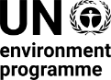 | CBD/WG8J/REC/12/5
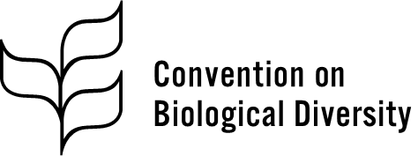 |  | Distr.: General  16 November 2023  Original: English
Ad Hoc Open-ended Intersessional Working Group on Article 8(j) and Related Provisions of the Convention on Biological Diversity
Twelfth meeting
Geneva, 12–16 November 2023
Agenda item 8
Recommendations of the Permanent Forum on Indigenous Issues

Recommendation adopted by the Working Group on 16 November 2023

12/5. Recommendations from the Permanent Forum on Indigenous Issues pertaining to the Convention on Biological Diversity
[The Ad Hoc Open-ended Intersessional Working Group on Article 8(j) and Related Provisions of the Convention on Biological Diversity
Recommends that, at its sixteenth meeting, the Conference of the Parties adopt a decision along the following lines:
The Conference of the Parties,
Recalling that the Kunming-Montreal Global Biodiversity Framework is to be understood, acted upon, implemented, reported and evaluated consistent with the contribution and rights of indigenous peoples and local communities and that the important roles and contributions of indigenous peoples and local communities as custodians of biodiversity and as partners in its conservation, restoration and sustainable use are acknowledged in the Framework,
Recalling also that the Framework is to be implemented in accordance with international instruments, including the United Nations Declaration on the Rights of Indigenous Peoples, and human rights law, and in this regard that nothing in the Framework may be construed as diminishing or extinguishing the rights that indigenous peoples currently have or may acquire in the future,
Having considered the note by the Secretariat on the recommendations from the Permanent Forum on Indigenous Issues pertaining to the Convention on Biological Diversity,
1. Takes note of the observations and recommendations emanating from the twentieth, twenty-first and twenty-second sessions of the Permanent Forum on Indigenous Issues;
2. Requests the Secretariat to continue to inform the Permanent Forum on Indigenous Issues of developments of mutual interest and to provide information to the Forum about activities undertaken under the Convention related to the observations and recommendations of the Forum, in accordance with the system-wide action plan for ensuring a coherent approach to achieving the ends of the United Nations Declaration on the Rights of Indigenous Peoples.]
__________

Decision 15/4, annex.
General Assembly resolution 61/295, annex.
CBD/WG8J/12/7.
United Nations, Treaty Series, vol. 1760, No. 30619.
E/C.19/2016/5 and E/C.19/2016/5/Corr.1.

