MESSAGE FROM DR. AHMED DJOGHLAF, EXECUTIVE SECRETARY
OF THE CONVENTION ON BIOLOGICAL DIVERSITY,
ON THE OCCASION OF THE
WORLD DAY FOR CULTURAL DIVERSITY FOR DIALOGUE AND DEVELOPMENT
21 MAY 2006

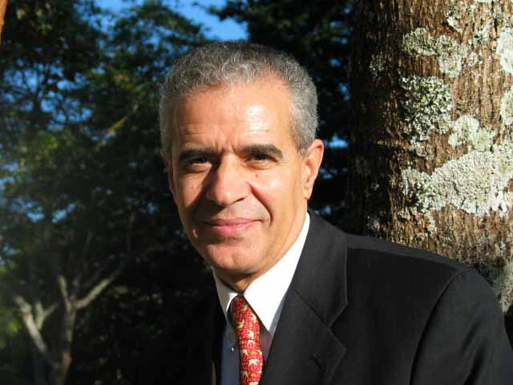

DEVELOPING POSITIVE RELATIONS BETWEEN CULTURES CAN BLOSSOM ONLY IN HEALTHY ENVIRONMENTS
Strong action and commitments are required to protect the world’s biodiversity. A number of important mechanisms have been put in place to do this and promote the conservation of biological diversity, and much can be learned from the successes of evolving international regimes. In this context, I welcome the approval by the UNESCO General Conference on 20 October 2005 of the Convention on the Protection and Promotion of the Diversity of Cultural Expressions. This is the first legal instrument the international community has had to raise cultural diversity to the rank of “common heritage of humankind” in the same way that biological diversity is recognized in the Convention on Biological Diversity as a “common concern of humankind”. I also welcome the first ratification of this Convention by Canada, a country that also happened to be, six months after the 1992 Earth Summit in Rio, the first industrialized country to ratify the Convention on Biological Diversity.
The young Convention follows the adoption of the UNESCO Universal Declaration on Cultural Diversity on 2 November 2001. The Declaration states that: “As a source of exchange, innovation and creativity, cultural diversity is as necessary for humankind as biodiversity is for nature” (Article 1). Heureux hasard? The World Day for Cultural Diversity falls on 21 May, while the International Day for Biological Diversity is on the 22 May.
In addition to the theoretical frameworks underpinning the understanding of the variables that must be in place to foster both cultural and biological diversity, important linkages exist as to the social, economic, educational, cultural, recreational and aesthetic values of biological diversity and its components. Among other important linkages, one is especially in need of fuller consideration: the close and traditional dependence of many indigenous and local communities on biological resources and the role of their traditional knowledge in the conservation and sustainable use of biological diversity. At its recent eight meeting, the Conference of the Parties to the Convention approved the establishment of a Voluntary Trust Fund to Facilitate the Participation of Indigenous and Local Communities in the Work of the Convention on Biological Diversity, which should assist in the further study of this association.
Mention should also be made of the work of the Convention on, inter alia, protected areas and sacred sites, and on indicators of progress towards achieving the 2010 biodiversity target, specifically the indicator relating to the status and trends of linguistic diversity and numbers of speakers of indigenous languages, which often coincide with regions that are rich in biodiversity. This reminds us that languages are unique expressions of our experience of the world, that each time a language dies out we have less knowledge to understand patterns in the maintenance of the Earth’s diverse ecosystems. Specialist environmental knowledge is often associated with a specific vocabulary, for which there is frequently no equivalent in other languages.
Indeed, just like the extinction crisis facing the planet’s species and gene pool, the world’s cultural diversity, mainly the variety and wealth of languages – and associated cultural traits – is in danger of extinction.
Beyond their intrinsic value, plants, animals and ecosystems, in their variety and distinctness, present unique emotional and physical benefits to our lives and play an integral part in culture. Their loss, which equates to the loss of diversity within and among human civilizations, impoverishes us beyond repair.
The promotion and protection of biological and of cultural diversity is a unique opportunity to unite and cooperate.
Ultimately, the conservation and sustainable use of biological diversity and the fair and equitable sharing of benefits deriving from its utilization and the protection and promotion of the diversity of cultural expressions will strengthen friendly relations among States, assist in attaining the Millennium Development Goals, and contribute to peace for humankind. The development of positive relations between cultures can blossom only in healthy environments.
On the occasion of the fourth World Day for Cultural Diversity for Dialogue and Development, I invite you, in my capacity as Executive Secretary of the Convention and its Secretariat, to join forces to win the battle of diversity of life on Earth. The combination of maintaining both the maximum achievable biological and cultural diversity is certainly the most sensible approach toward dealing with the dynamic future facing humanity.

-----

