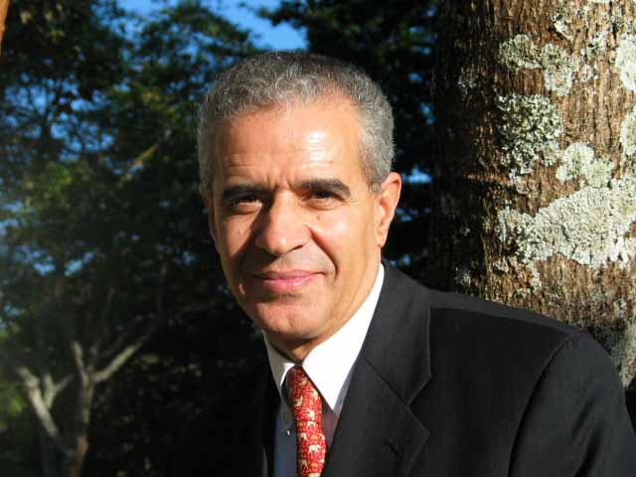
I am very pleased to have an opportunity to commend the initiative of Spain, and the objectives of this event, to contribute to the preservation and promotion of the world’s oasis through the promotion of sustainable tourism. This congress comes towards the end of what the General Assembly of the United Nations declared the International Year of Deserts and Desertification (IYDD).
Throughout the International Year, people from across the world have spoken about the serious threat presented by desertification. At the same time, the Year is an opportunity to expound upon the beauty of the world’s deserts.
Land degradation affects one third of the planet's land surface and around one billion people in over a hundred countries. Such challenges are especially visible in the jewels of the desert that we call oasis. There could not have been a better choice of the setting of this Congress, in the El Palmeral de Elche oasis, a remarkable UNESCO World Heritage site at the crossroads between East and West, which allowed, over thousands of years, the exchange of cultures.
Oases are absolutely critical repositories of biodiversity, as well as invaluable cultural and historical heritage. The importance of biodiversity in oases is not limited to the variety of animals and plants but extends to livelihood and development. Biodiversity in oases maintain the functioning of these unique and critically important habitats. For years, oases have been central to the livelihoods of desert people. Now, as the impacts of climate change are becoming evident, the role of oases in climate-change adaptation is being increasingly recognized.
In order for oases to continue providing critical services to people and biodiversity, the three components of the Convention on Biological Diversity must be applied:
- Life in the desert and drylands must be conserved;
- The sustainable use of the resources of oasis, according to the Addis Ababa Principles and Guidelines on Sustainable Use must be applied;
- Biodiversity resources from oases must be fairly and equitably shared to benefit present and future generations of residents of the oasis.
Sustainable tourism can contributed to the protection and sustainable development of oases—especially if based upon the Guidelines on Biodiversity and Tourism, as adopted by the Conference of the Parties of the Convention on Biological Diversity at its seventh meeting, through decision VII/14. I encourage participants in this Congress to learn more about the Convention’s Tourism Guidelines through visiting our website (http://www.biodiv.org/programmes/socio-eco/tourism/guidelines.asp).
Recently, the United Nations World Tourism Organization (UNWTO) and the Government of Germany have collaborated in the implementation of these Guidelines by setting up a consulting unit based in Bonn that will assist Asian countries affected by the 2004 tsunami to rebuild and renovate tourism facilities according to biodiversity-friendly guidelines. UNWTO is also taking a proactive stance through the activities of the Sustainable Tourism Development Section. The Secretariat of the Convention on Biological Diversity is proud to support such initiatives, and invites participants in the Oasis Congress to learn from this experience.
Another recent valuable contribution to this topic has been the UNEP publication Tourism and Deserts: A Practical Guide to Managing the Social and Environmental Impacts in the Desert Recreation Sector
(see http://www.uneptie.org/pc/tourism/library/Desert%20Guide.htm).
Tourism within desert areas, and particularly to oases, is growing, as changing consumption patterns lead to shorter and cheaper tours further afield, and as innovative technologies make adventure tourism mainstream. However, oases are very sensitive environments, naturally and culturally. Sustainable and biodiversity-friendly tourism is an essential component of any strategy to make sure that oasis continue to host communities, human and otherwise, that can offer an unforgettable experience to visitors.
I wish this Congress much success in advancing these issues, and look forward to continuing to work with you.

