Action Plan for Implementing the Programme of Work on Protected Areas of the Convention on Biological Diversity

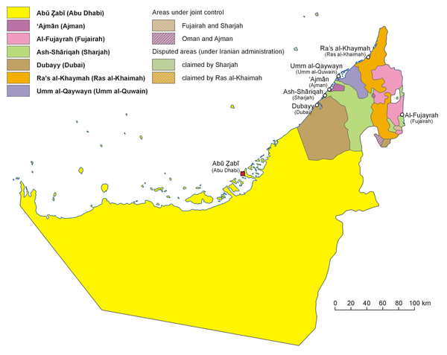
(INSERT PHOTO OF COUNTRY)

UNITED ARAB EMIRATES

Submitted to the Secretariat of the Convention on Biological Diversity [DATE]

Protected area information:

PoWPA Focal Point: (Name, contact details)
Eng. (Mr.) Saif Mohammed Al Shara
Undersecretary, Water Resources and Nature Conservation Affairs
Ministry of Environment and Water
United Arab Emirates, Dubai
P.O. Box 1509
+971 4 214 8331, +971506295050
Fax: +971 4 265 5822
E-Mail: smalshara@moew.gov.ae

Lead implementing agency: (Add name of primary government agency)
Ministry of Environment and Water
Description of protected area system
Coverage
UAE Covered by more than 60 protected areas (marine and terrestrial protected areas), meanwhile only 21 are officially declared as shown bellow:-
Officially declared Marine Protected areas
Protected area | Emirate
Marawah PA | Abu-Dhabi
Al Yasat | Abu-Dhabi
Ras elkhure | Dubai
Jabal Ali | Dubai
Sir bunair | Sharjah
Bird island | Fujairah
Albadia | Fujairah
Alekka | Fujairah
Dedna | Fujairah

Officially declared terrestrial protected areas
Protected area | Emirate
Dubai Desert Conservation Reserve | Dubai
Wadi-Elhelw | Sharjah
Al-gheil | Sharjah
Khur kalba | Sharjah
Al-Berdy | Sharjah
Waset | Sharjah
Al-zolimaa | Sharjah
Al-madina | Sharjah
Jabal Al-Fayah | Sharjah
Al-Zawraa | Ajman
Wadi Al-Naseem | Ajman
Wadi Al-Wereah | Fujairah

Governance types
(Summary matrix of governance types)
- Government Protected Areas, 20 out of 21 officially declared PA are governmental
- Co-managed Protected Areas, one protected area is Co-managed protected area (Wadi Al-Wereah
Key threats
(Description of key threats, and maps, if available)
- Construction of mega projects
- Proliferation of invasive species
- Over-grazing
Barriers for effective implementation
(Description of key barrier s for effective implementation)
- Community participation relative to management is minimal
- Lack of data regarding key biodiversity hotspots and main threats affecting them.
- Weak cooperation between different >>>>>>>>>
- Improper national CEPA programmes and activities.

National Targets and Vision for Protected Areas
(Insert national targets for protected areas/Target 11 of the Aichi Targets. Include rationale from protected area gap assessment, if completed, along with any additional information about the vision for the protected area system, including statements about the value of the protected area system to the country)
- Conduct gap analysis assessment for PAs in UAE.
- 40% management plans for PAs.
- 50% management effectiveness evaluation for PAs.
Progress in and plans for achieving the goals of the Programme of Work on Protected Areas
Progress: 0 = no work, 1 = just started, 2 = partially complete, 3 = nearly complete, 4 = complete
Goals of the Programme of Work on Protected Areas | Progress 0-4
- Progress in establishing and strengthening national and regional systems of protected areas (1.1) | 2
- Progress in integrating protected areas into broader land- and seascapes and sectors so as to maintain ecological structure and function (1.2) | 2
- Progress in establishing and strengthening regional networks, transboundary protected areas (TBPAs) and collaboration between neighbouring protected areas across national boundaries (1.3)
- Progress in substantially improving site-based protected area planning and management (1.4) | 2
- Progress in preventing and mitigating the negative impacts of key threats to protected areas (1.5) | 2
- Progress in promoting equity and benefit-sharing (2.1)  - Progress in assessing and implementing diverse protected area governance types (2.1) | 1
- Progress in enhancing and securing involvement of indigenous and local communities and relevant stakeholders (2.2) | 2
- Progress in providing an enabling policy, institutional and socio-economic environment for protected areas (3.1)  - Progress in assessing the contribution of protected areas to local and national economies (3.1) | 2
- Progress in building capacity for the planning, establishment and management of protected areas (3.2) | 2
- Progress in developing, applying and transferring appropriate technologies for protected areas (3.3) | 2
- Progress in ensuring financial sustainability of protected areas and national and regional systems of protected areas (3.4) | 2
- Progress in strengthening communication, education and public awareness (3.5) | 3
- Progress in developing and adopting minimum standards and best practices for national and regional protected area systems (4.1) | 2
- Progress in evaluating and improving the effectiveness of protected areas management (4.2) | 2
- Progress in assessing and monitoring protected area status and trends (4.3) | 2
- Progress in ensuring that scientific knowledge contributes to the establishment and effectiveness of protected areas and protected area systems (4.4) | 3
- Progress in marine protected areas | 2
- Progress in incorporating climate change aspects into protected areas | 1

Priority activities for fully implementing the Programme of Work on Protected Areas:
Action 1: (Strengthen the communication and cooperation among concerned stakeholders)
Key steps | Timeline | Responsible parties | Indicative budget
Establish a permanent joint committee for protected areas to ensure effective participation of all concerned parties and stakeholders | 2013-2015 | MoEW – competitive authorities

Action 2: (Integration of conservation work and issues)
Key steps | Timeline | Responsible parties | Indicative budget
Specify the priority conservation hotspots | 2012 - 2014 | MoEW – competitive authorities
Define the roles of each stakeholders regarding protection of biodiversity hotspots | 2013 - 2014 | MoEW – competitive authorities
Develop and implement National Communication Plan | 2014 - 2015 | MoEW – competitive authorities

Action 3: (Issue necessary legislation on protected areas designation and governance)
Key steps | Timeline | Responsible parties | Indicative budget
Review and update the existing legislation for PAs | 2013 -2014 | MoEW
Implement and enforce the legislation | 2014 - 2020 | MoEW – competitive authorities

Action 4: (Development, implementation and Review of protected areas management plans)
Key steps | Timeline | Responsible parties | Indicative budget
Develop/establish site-specific management plans for 40% of existing protected areas | 2013 - 2020 | MoEW – competitive authorities
Conduct management effectiveness evaluation for 50% of existing management plans for protected areas | 2013 – 2020 | MoEW – competitive authorities
Capacity building for MoEW and competitive authorities' staff on protected areas management, evaluation effectiveness and monitoring. | 2013 - 2020 | MoEW – competitive authorities

Action 5: (Developing best practices and minimum standards for protected areas)
Key steps | Timeline | Responsible parties | Indicative budget
Development, testing, review and promotion of protected areas standards and best practices on planning and management. | 2016 - 2020 | MoEW – competitive authorities
Develop and implement an efficient, long-term monitoring system | 2014 - 2020 | MoEW – competitive authorities
Use monitoring results to adapt and improve protected area management based on the ecosystem approach. | 2016 – 2020 | MoEW – competitive authorities
Develop appropriate methods and indicators for protected area management. | 2014 - 2016 | MoEW – competitive authorities
Use of new technologies including geographic information system and remote sensing tools for monitoring protected areas. | 2014 - 2020 | MoEW – competitive authorities

Key assessment results
Ecological gap assessment
- Isolation of protected areas
- Habitats fragmentation

Management effectiveness assessment
- Lack of clear management plans for most protected areas
- Deficiency in communication and cooperation between related agencies
Sustainable finance assessment
- Sustainable finance is not yet established in the management plans of some protected areas
- Lack of clear vision for ecotourism in some protected areas
- Allocation of necessary funds for protected areas conservation and management

Capacity needs assessment
- Capacity building for PAs designation, planning and management
- Capacity building for conservation activities
- Capacity building for scientific research and use of modern technology
- Provide incentives for skilled work force in PAs
- Strengthen scientific expertise integration and networking among related agencies
- Establishment of a rangers system for protection and monitoring
Policy environment assessment
- There is a need to develop National Biodiversity Strategy (it will be finalized by the end of 2013) in addition to updating the existing National Protected Areas Strategy (by the end of 2012).
Protected area integration and mainstreaming assessment
- There is a need to develop guidelines for integrated management plan for protected areas (it will be ready by the end of 2012).

Protected area valuation assessment
- There is a need to develop valuation of ecosystems services in UAE.
Climate change resilience and adaptation assessment
- There is a need to know status of protected areas under climate change impacts. UAE is currently preparing a comprehensive plan for different scenarios of climate change resilience and adaptation within PAs.

