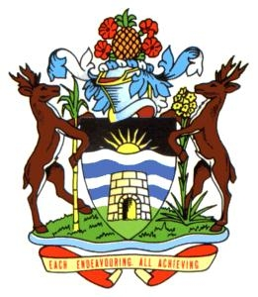

Action Plan for Implementing the Programme of Work on Protected Areas

of the Convention on Biological Diversity

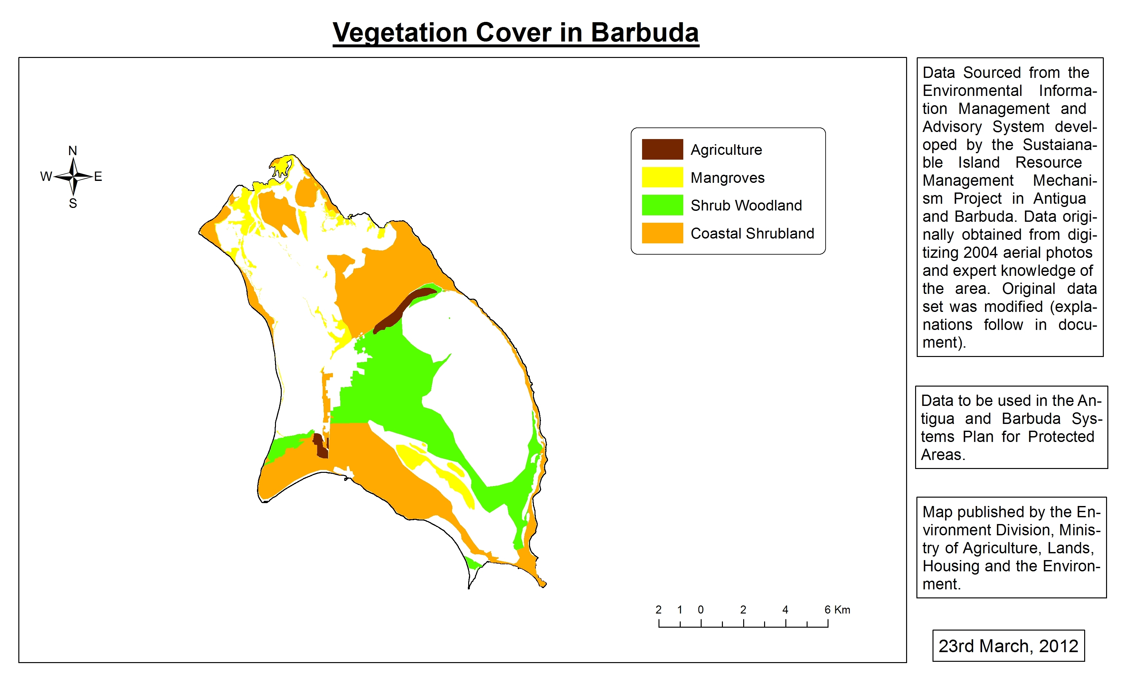
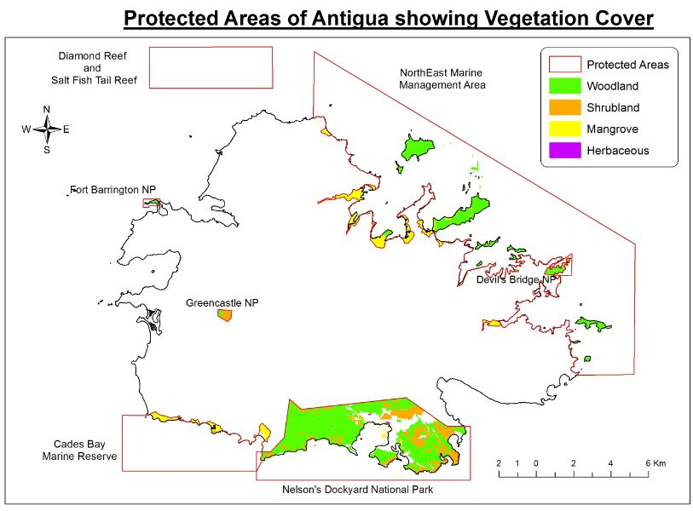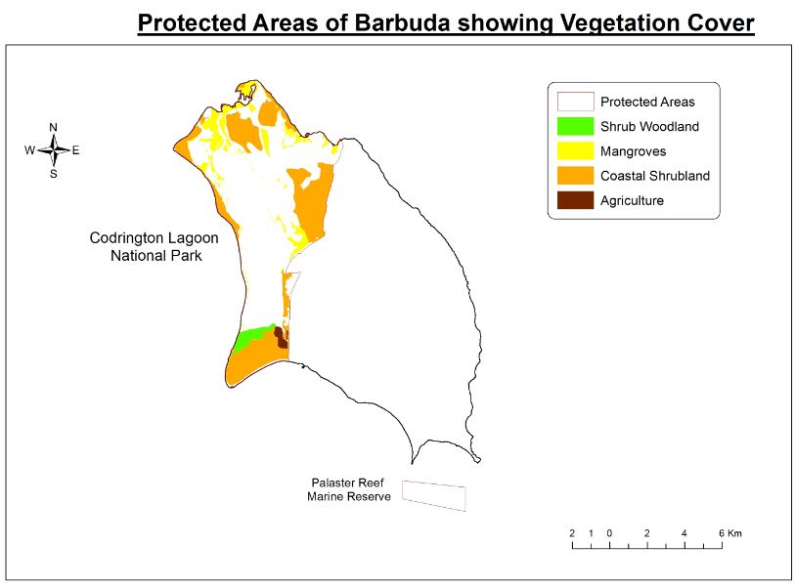

(Antigua and Barbuda)

Submitted to the Secretariat of the Convention on Biological Diversity April 2012

Protected area information:

PoWPA Focal Point: Diann Black-Layne,
Chief Environment Officer,
Environment Division, Ministry of Agriculture, Housing, Lands and the Environment,
#1 Prime Minister Office Drive,
Factory Road,
St. Johns,
Antigua

Lead implementing agency: Environment Division

Multi-stakeholder committee: NCM – The National Coordinating Mechanism is a multi-stakeholder group comprising both government and non-governmental representation from key areas that are critical to the effective management of Protected Areas for Antigua and Barbuda

Description of protected area system
Coverage
Antigua and Barbuda had recognized the importance of protected areas and is determined to work diligently in ensuring that areas of critical importance to the survival of the country’s biodiversity are not only protected but managed effectively. Work completed on protected areas to date includes the development of a plan for a system of protected areas, an analysis of the protected areas situation, the development of an action plan for the management of protected areas as well as the development of maps of the current protected areas systems. Though there is still work to be completed particularly as it relates to the completion of the systems plan and the completion of site specific ecological gap analyses, the work completed to date tells of the country’s overarching commitment to meeting the goals of the convention on biological diversity and more specifically as it relates to the implementation of the CBD’s program of work on protected areas (PoWPA). Maps 1-6 below show the coverage of the country’s protected areas and the coverage should the proposed protected areas be legalized and included as part of the protected areas system.
Map one shows the protected areas for Antigua that have already been declared. Map two shows these protected areas with some of the vegetation categories that are located there in.

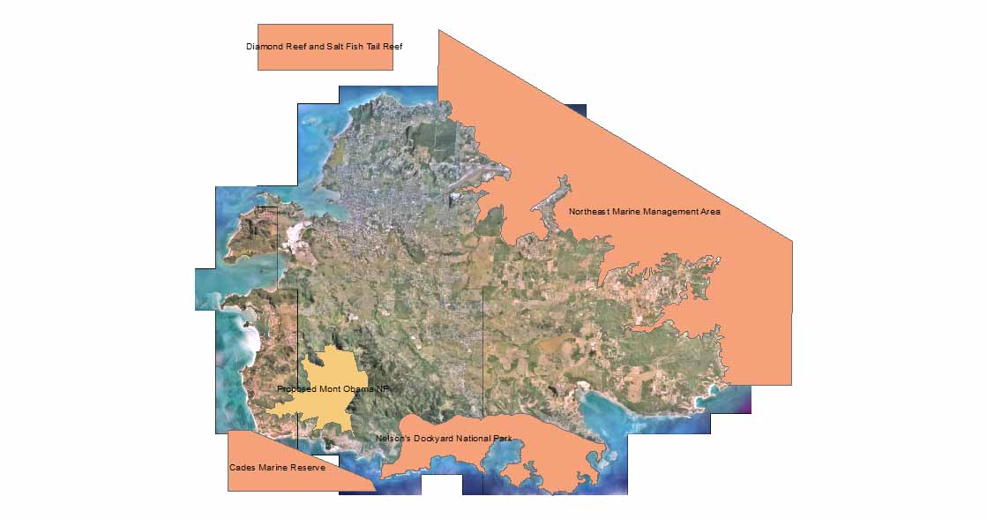
Map 1 Existing protected Areas for Antigua

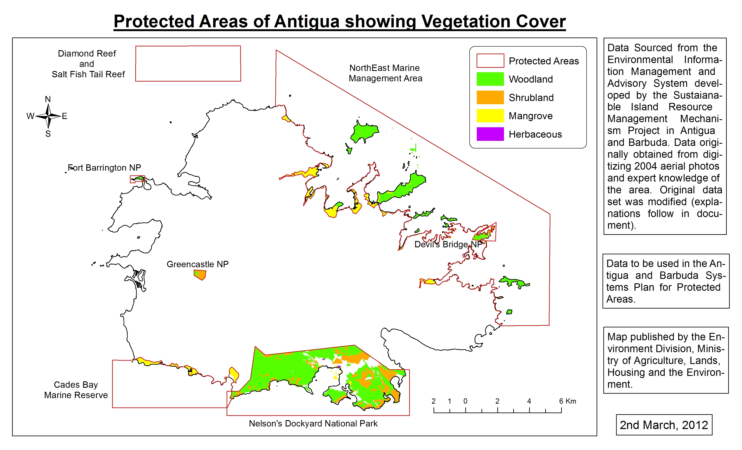
Map 2 Protected Areas Map for Antigua showing vegetation cover

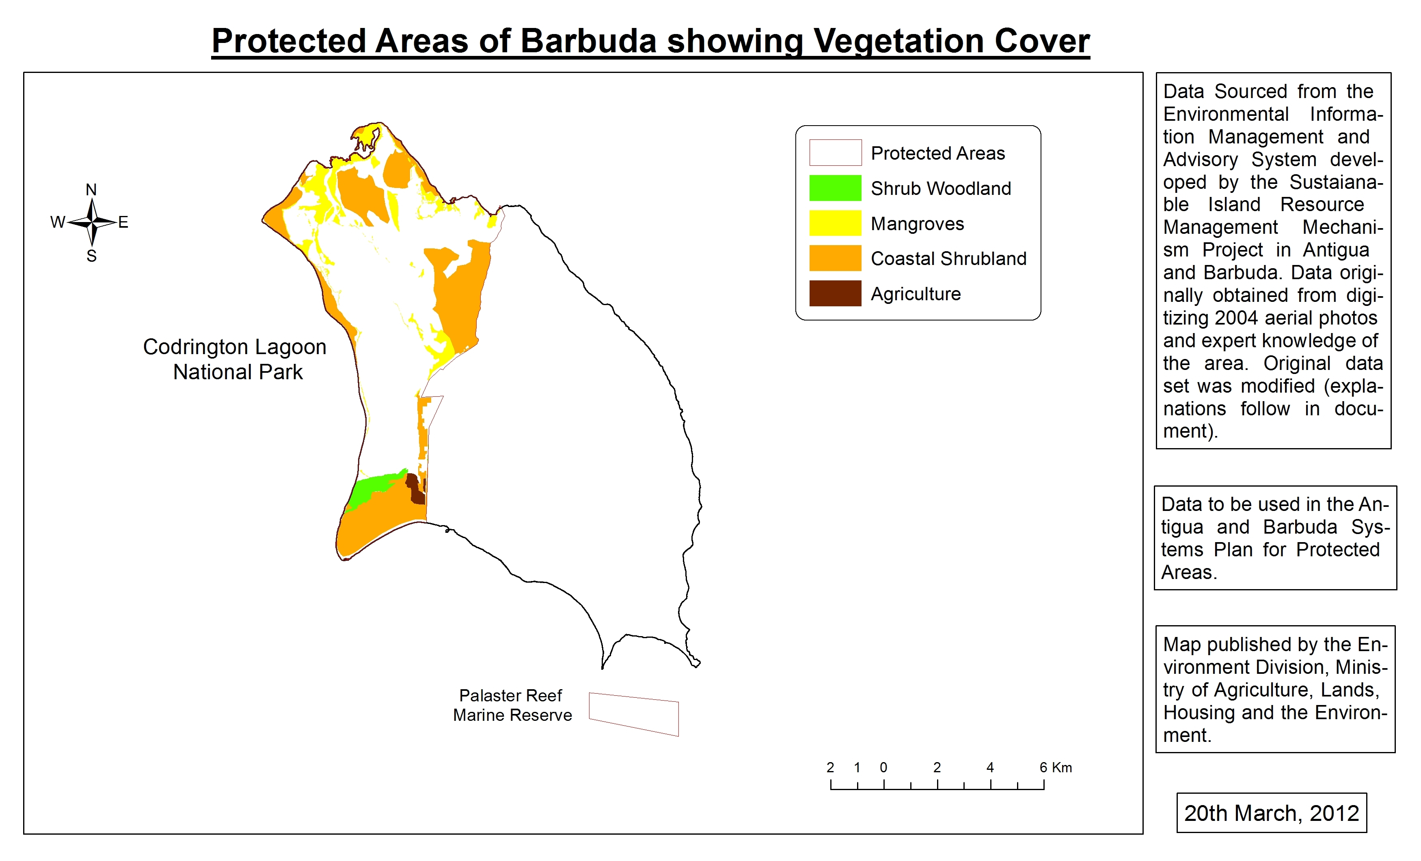
Map 3 Protected Areas Already Declared for Barbuda showing Vegetation Cover

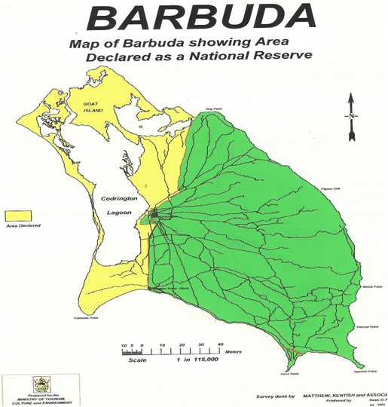

Map 4 Map of Barbuda showing Codrington Lagoon National Park

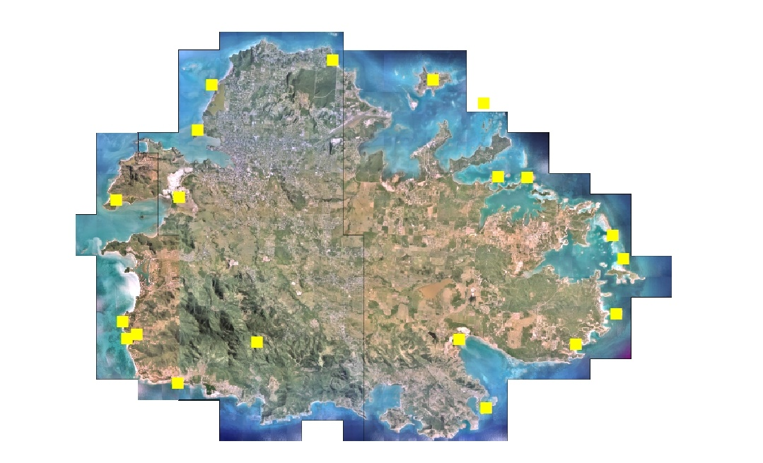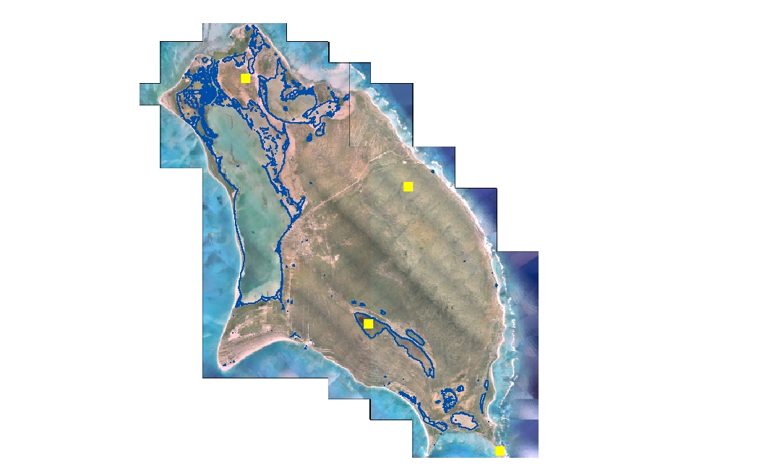
Map 5 Proposed Protected Areas for Antigua Map 6 Proposed Protected Areas for Barbuda
The maps above, 5 and 6 show the areas within Antigua and Barbuda that have been proposed by government and NGO agencies for protection. Including these as legally declared areas will help the country to meet its obligation under the CBD Target 11 for 17% terrestrial and 10% marine protected areas by 2020.
Description and background

Background
Antigua and Barbuda has been seeking to develop a system of protected areas since 2006. Initiated by the OECS, the process began through the OPAAL project and was endorsed by the Cabinet of Antigua and Barbuda on the 21st of November 2006. However, due to various delays, in 2008 additional financial assistance to complete the process was sought through the GEF Program of Work on Protected Areas (PoWPA) Project executed through the convention on biological diversity and the SIRMM Project. Through these two projects as well as the assistance from the OECS, in 2010 a draft systems plan was developed along with a series of documents relating to the monitoring, identification and management of protected areas. Based on subsequent consultations on the submitted draft, it was determined that the information presented was still not representative of the existing protected areas situation and further details needed to be incorporated to ensure that the systems plan created for Antigua and Barbuda’s protected areas was a more comprehensive one. The completion of the National Land Use Plan further necessitated that the system plan be revised. The revised plan which is a compilation of the previous system plan and newly created supporting documentation is slated for completion by August 2012.

Description
The twin island state of Antigua and Barbuda is situated in the eastern arc of the Leeward Islands in the Caribbean and occupies an area of only 440 km² ranking 3rd in area among the islands of the OECS. Antigua occupies an area of 280 sq. km while Barbuda is approximately two thirds this size occupying 160 sq. km. It is classified as a semi-arid country and includes several small near shore islands including the uninhabited island of Redonda (located 40 km south west of Antigua measuring 1.3 sq. km). The islands are the emergent parts of the Barbuda bank, which is one of the largest sub-marine platforms in the Eastern Caribbean (spanning 3,400 sq. km) with water depths ranging from 27 to 33 m.
The country’s rich biodiversity is under threat form a number of immerging issues such as development and natural disasters including climate change. A major threat to habitat destruction for example, comes from the building of hotels and other infrastructure for the tourism Sector. There have been serious losses of wetlands and salt ponds in this way in the last twenty years and the pace is not slowing down. Inland, similar destruction has taken place for other types of building construction – housing, roads, and commercial operations.
Global climate change is in itself a challenge of the 21st Century particularly for small island developing states (SIDS) like Antigua and Barbuda. Its effects are already adding to the urgency and the burden being faced by Caribbean countries to conserve biodiversity, water supply, forests and improve overall human development. The link between biodiversity and climate change has long been established. Biodiversity is affected by climate change, with negative consequences for human well-being, but biodiversity, through the ecosystem services it supports, also makes an important contribution to both climate-change mitigation and adaptation. Consequently, conserving and sustainably managing biodiversity is critical to addressing the climate change issue. Climate change is already forcing biodiversity to adapt either through shifting habitat, changing life cycles, or the development of new physical traits. Conserving natural terrestrial, freshwater and marine ecosystems and restoring degraded ecosystems (including their genetic and species diversity) is essential for the overall goals of both the Convention on Biological Diversity and the United Nations Framework Convention on Climate Change since both are essential for human well-being and the achievement of the Millennium Development Goals.
It is with this in mind that the idea to develop a system of protected areas for the country was birthed. The government of Antigua and Barbuda, having recognized this opted to ensure the inclusion of Climate Change issues into its development of a system of protected areas. A protected areas systems plan can be expected not only to reduce some of the negative impacts from climate change and protect the habitats of critical species but to also promote overall national economic development in Antigua and Barbuda
Antigua and Barbuda is home to over 1150 species of plants belonging to 149 plant families and 180 species of birds. To understand the importance of this, it is worth noting that one subspecies of the Broad winged hawk is found only in Antigua and Barbuda has a warbler which is not found anywhere else in the world. A number of species of native terrestrial mammals and an unknown number of insects may also be found on the islands. In the marine area, Antigua and Barbuda’s many sandy beaches provide good nesting sites for Hawksbill, Leatherback and, occasionally, Green sea turtles, all of which are considered globally threatened. There are a large number of species of freshwater fish as well as reptiles, invertebrates and plants that call Antigua and Barbuda’s territorial waters home. In addition to the flora and fauna, Over 70,000 people also call Antigua and Barbuda their home and they too have a diverse background and heritage.
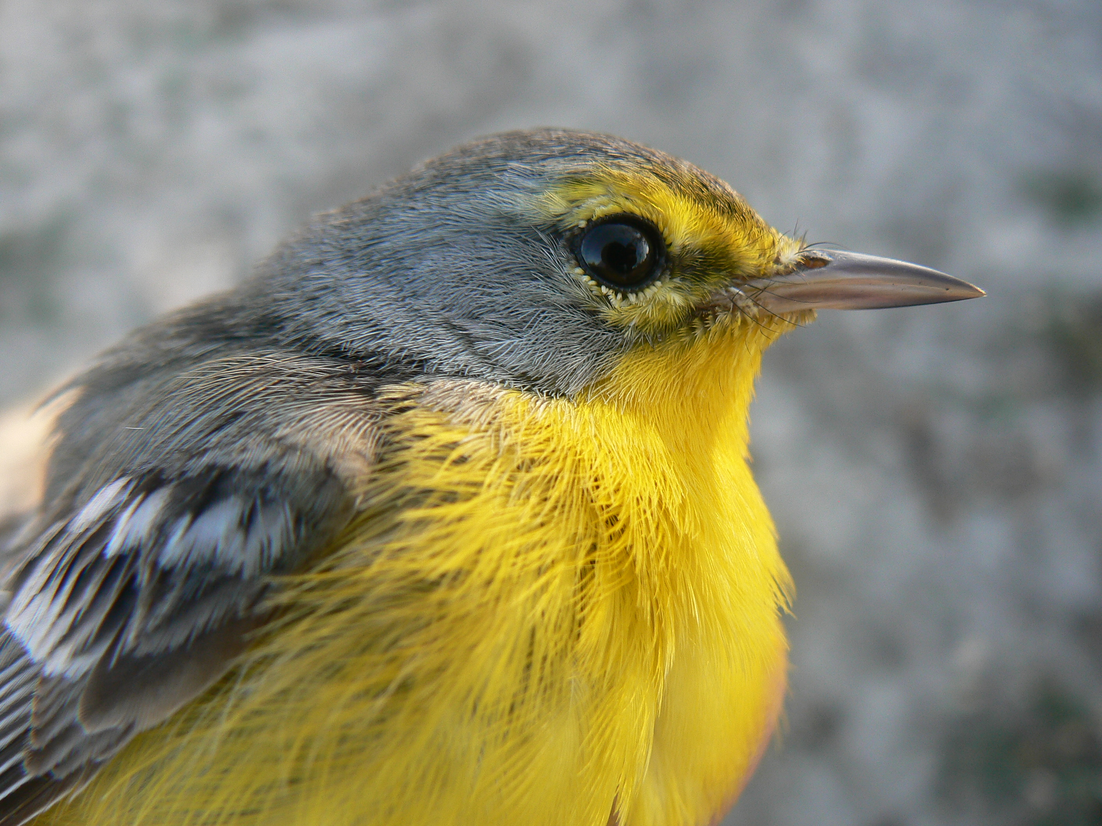
Photo 1 Barbudan Wabler (Dendroicasubita). (Photo by Graham Forbes)
The systems plan for protected areas and the subsequent actions plans will help to:
- Improve management of Protected Areas in Antigua and Barbuda by creating a management framework that allows all agencies involved in biodiversity and cultural conservation to work effectively and efficiently;
- Create mechanisms for improved revenue capture and retention;
- Establish PA categories that reflect local values and are linked to the IUCN PA category system;
- Institutionalize the role of Civil Society especially in the form of NGOs in the creation and management of PAs in Antigua and Barbuda;
- Lay the groundwork for a comprehensive PA system that promotes biodiversity and cultural conservation and sustainable natural resource management;
- Meet the obligations of Antigua and Barbuda as signatories of the pertinent international agreements to which it is a party, in particular, the Convention on Biodiversity (CBD).
The Systems plan which has been developed identifies not only the areas that have been designated as protected but sites that Government should consider for designation as protected. The potential protected areas will be suggested as part of a phased approach to ensure protection by 2020 to commemorate the end of the International decade of Biodiversity
Governance types
The nine protected areas that have been developed have a range of governance types that have been utilized in ensuring their effective management. Though there is some work still to be done on these areas to ensure effective governance, it is a notable achievement that the government has begun the process. Below is a table of the existing governance types based on the IUCN Protected Areas matrix and their application to the protected areas governance system that currently exists for the nine protected areas in Antigua and Barbuda. It should be noted that though most of the categories of protected areas designated by Antigua and Barbuda do not specifically apply to the IUCN PA categories, elements of each has been associated with the best related category. Additionally, it is also worth noting that some areas may be classified under more than one category.

Table 1 Governance Structures in Antigua and Barbuda for Declaring Protected Areas
Agency Name | Legal authority | PAs declared/Identified | Year
Agencies with operational PAs
National Parks Authority (NPA) | National Parks Act (1985) | Nelson’s Dockyard National Park | 11/15/1989
 |  | Ft Barrington National Park | 10/01/2008
 |  | Devils Bridge National Park | 10/01/2008
 |  | Greencastle Hill National Park | 10/01/2008
NPA / Barbuda Council | National Parks Act 1985 /Barbuda Land Act | Codrington Lagoon National Park | 3/24/2005
Fisheries Division, MoALH&E | Marine Areas (Preservation and Enhancement) Act No 5 of 1972 | Diamond Reef/Salt Fish Tail Restricted Area | 6/1/1973
 |  | Palaster Reef Restricted Area | 6/1/1973
 | Fisheries Act (1983) | Cades Bay Marine Reserve | 6/1/1999
 | Fisheries Act (1983) | North East Marine Management Area (Marine Reserve) | 12/29/2005
Agencies with no operational PAs
Forestry Unit | Forestry Act (Cap 178) | None declared | N/A
Development Control Authority | Physical Planning Act No6 2003 | None declared | N/A

Table 2 Protected areas Governance Matrix in Antigua and Barbuda
IUCN Category (Mgmt. Objective) | Government Managed Protected Areas |  |  | Co-Managed Protected Areas |  |  | Private Protected Areas |  |  | Community Conserved Areas
 | National Ministry or Agency in Charge | Local min. or agency in charge | Government delegated mgmt.. (eg. NGO) | Trans-boundary conservation | Collaborative magmt. | Joint mgmt.. | Declared and run by individual land owners | By non-profit organizations | By for-profit organizations | Declared and run by indigenous peoples | Declared and run by local communities
I - Strict Nature reserve/Wilderness Area
II - National park (ecosystem protection of cultural values) | Codrington Lagoon National park.  Nelson’s Dockyard National park
III - Natural Monument | Fort Barrington
IV - Habitat/ species Management
V – Protected Landscape/ seascape | Palaster Reef  Cades Bay Marine Reserve  NEMMA  Diamond Reef
VI – Managed Resources

Key threats
Threat 1. The most immediate threat to PAs in Antigua and Barbuda currently is indiscriminate development for housing and commercial use. With neither an effective system of protected areas nor a detailed land use plans identifying what can be constructed in sensitive areas, there is no legal guide (based on PAs criteria) that would facilitate development with an emphasis on PA management. In light of this, developers cut valuable species of trees indiscriminately, remove valuable sea grass, mangroves and other marine species that are essential to the overall health of marine ecosystems etc. during the construction phase of their projects. As the tourism industry develops this situation becomes an even bigger problem as developers, due to the demand of the market, seek to place their hotels, guest houses and related businesses on the coast, at closer and closer proximities to the beach and sea. This in many cases has led to the removal of large mangrove areas to accommodate development and the creation of artificial beaches.
Such actions have inevitably led to the decline in the availability of some fish species as their habitats face certain destruction. This has even more far reaching implications for other industries such as fishing and Tourism itself.
This is further exacerbated by weak legislative and institutional arrangements for the effective management of protected areas. Zones that should be reserved as marine or terrestrial habitats are facing extinction from economic activities including infrastructural development. This situation cannot be allowed to continue.
It is anticipated that with the recent drafting of a new land use plan and the development of a draft protected areas systems plan, the country will be able to move towards correcting this problem.
Threat 2. The second threat facing PAs is that of agricultural development. Due to the fact that local farmers are located in PA without an effective management plan, farmers remove valuable PA species through the burning of areas for planting of crops and irrigation. In some cases, water resources are diverted and the impact of this on ecosystems not yet protected is unknown.
Threat 3. The illegal removal of various species particularly marine from their habitats is a serious concern for Antigua and Barbuda. This is evident for example in the fact that undersized lobsters and conch are removed from various areas that are not adequately monitored and used by the local market. This affects the development of those species and the industries they service i.e. the fishing and export industries. The introduction of an effective system of protected areas and the introduction of more stringent legislation to support their overall management is therefore absolutely necessary to ensure that such situations are curtailed.
Threat 4 Another serious threat to PAs for the country is that of invasive species/alien species. In a number of areas that are not yet protected, invasive species are causing an increasing decline in the native species that exist in the country. This is primarily evident in the last remaining forest area of Antigua and the only wetland area in Barbuda. The most recent occurrence of the lion fish to the waters surrounding Antigua and Barbuda is just one such example. In Antigua, the lemongrass has overtaken a number of secondary forested areas and since this grass has been known to spontaneously catch fire, it presents a hazard not only for the native species it is aggressively replacing but also is a fire hazard to the surrounding residents and remaining forested areas.
Threat 5 Another threat affecting the areas that have been declared protected and those that should be declared is that of natural disasters. This has become particularly a problem for the coastal areas due to the aggravating effects of legal and illegal sand mining. In Barbuda sand mining has increase the vulnerability of a number of areas within the Lagoon (the PA) and the main town itself. This results from the fact that the mining has led to the removal of necessary sand dunes which has increased the likelihood of flooding of that PA system and the town itself. In other cases the mining has led to the removal of a number of habitats and the destruction of various ecosystems and species. Additionally, it has led to the increased vulnerability of near shore marine ecosystems and many of the surrounding wetlands to hurricanes in particular

Barriers for effective implementation
Barrier 1. Lack of knowledge on the status of vital habitats. During the execution of the Initial PoWPA analysis, it became obvious that the status of some of the areas which have been declared protected was unknown. Though a declaration had been made, neither a systematic monitoring nor a management system was or has been implemented to ensure the protection and sustainability of the ecosystems within these areas. In general, information on the existence of protected areas and statistical information of the habitats and overall biodiversity that they host is unavailable in both islands. Such information is critical if the country is to achieve its responsibilities under the CBD’s PoWPA. To date, through funding provided by the GEF and other agencies, some of these gaps have been filled (as can be seen by the maps produced in this action plan). However, there is still some work to be done in order to ensure the development of a comprehensive system of protected areas. An example of the tasks that still need to be completed includes the collection of more data and analysis and the designation of a responsible, dedicated management authority for protected areas within the country.
Barrier 2. Non-systemic or missing PA legislation. Presently, Antigua and Barbuda has various laws for the designation of protected areas. However, there are immediate problems with how these laws were enacted and their application. The legislations are considered inadequate as they are encased in a wide cross-section of existing laws as small parts on particular issues. Such a situation makes it difficult to utilize these laws to effectively address issues relating to protected areas. The laws are also seen as inadequate as they address individual issues rather than protected area systems. For example, while the Fisheries Act contains guidelines for development within reserves, protection of flora and fauna is confined to marine species. A second example is the Physical Planning Act. Additional policy guidance and more clearly defined rules would need to be outlined in order for this act to be an effective protected areas management tool. Serious legislative gaps also exist for the protection of many terrestrial species, as well as mangrove forests. Secondly, the legislations allow for the declaration of protected areas however there are no established regulations to govern their operation once they have been designated. Without regulations, the acts do not achieve the goals they are intended to achieve. Without the necessary legislation to govern the activities of protected areas in Antigua and Barbuda the expected outcomes will not be achieved
With the assistance of the GEF and other donors, the Environment Division recently presented draft legislation which includes the issue of protected areas to the attorney general’s office for review and approval. It is anticipated that by December 2013 this legislation will be enacted.
Barrier 3. Lack of institutional integrity and cohesion. The lack of order in the institutional arrangements for PA is indirectly connected to lack of proper PA legislation. Since none of the legislative instruments provide for the establishment and management of a system of protected areas a management authority for the implementation of the acts does not exist. This results in several agencies managing several different aspects of protected areas. This becomes very inefficient and ineffective. Presently there is no single institution with full responsibility for the identification and management of protected areas. There are departments within which the mandate to declare protected areas falls however due to the fact that their primary function is not directly related to the protection of natural resources or the environment in general, this mandate is not efficiently carried out. In the case of the Fisheries Division where the issue of protected areas is one of their primary goals, the focus is on marine protected areas only. As a result of this several biodiversity species are being adversely affected and their habitats are being destroyed.
This situation is addressed in the current Draft Environmental Management Bill (2011). It is anticipated that once this legislation is passed, the relevant activities will be undertaken and agencies put into place to solve the problems.
Barrier 4. Financial constraints. The financial capacity of the country to manage its PA system has to be well documented, and clear suggestions for improving the PA financing have to be put in place. There is clearly a financial gap in what is required for a comprehensive system of protected areas and what currently exists. This also correlates closely to the issue of further PA network extension. E.g. a number of new areas have been proposed by Government and NGOs for inclusion in the list of protected areas for Antigua and Barbuda. However, without an effective system for the management of these areas, particularly in terms of creating guidelines for the management of the resources and the establishment of a management authority such areas may not be declared protected and the resources which they encompass may be destroyed.
Once again, assistance from the GEF and other donors has ensured the development of a protected areas management plan which is now available for use in protected areas management. This will be officially utilized in the system that is being established with the review of the systems plan for protected areas.

National Targets and Vision for Protected Areas
Antigua and Barbuda is very committed to ensuring the effective protection and monitoring of its protected areas. This is attested to by the number of activities that have been undertaken to assist in the designation and management of protected areas within the last few years. The current list of protected areas and proposed protected areas presented throughout this report has been presented as the general system of protected area targets for Antigua and Barbuda. In the context of Antigua and Barbuda, protected area targets means the application of the CBD Biodiversity Targets to specific protected areas or portions of protected areas chosen for designation, monitoring and management. Additionally, protected area indicators are taken to be qualitative or quantitative parameters or indices that can be documented or measured, which will give us information on the integrity or sustainability of a system or a species. The overall national target for the country is to ensure that at least 50% of the protected areas that have been proposed are declared as protected areas by 2020. More specific targets are discussed in the tables below.
The goal of the country is to ensure that the country’s protected areas are not only increased but that all ecological systems and services are functioning appropriately and sustainably such that species of special interest (rare/endangered/endemic/invasive) are receiving the preservation and management treatment they require. Though some activities have been completed to this end, there is still a great deal of work that must be finished in order to develop the baseline assessment needed to characterize basic biological and physical conditions of indicators from large to small scale both for the areas that have already been declared and those that are intended for declaration. Though a set of baseline parameters have been assessed and mapped into the EIMAS there is still need for some additionally data layers. Once these are obtained, it will become an easier task to understand current ecological conditions, establish management regimes, evaluate and track changes in the important variables; ecosystems and species populations.
The aim with regards to protected areas for the Government of Antigua and Barbuda therefore is to fully evaluate these proposed areas and species of critical concern in order to plan a protected area system that is both biologically and economically viable, and meets the requirements/mandates of the CBD while helping to bring additional value to the country both in and of themselves as well as the benefit they bring to other agencies.
Action | National Target | Outputs | Outcomes | CBD 2020 Target
Assess the biophysical resources and their condition | By 2014 Ensure the completion of the Final Ecological Gap analysis for PAs and by 2015 update the PA systems plan | Databases/inventories | Basis on which to make management decisions in conjunction with socioeconomic information. | Goal C: Target 11
Assess challenges to effective implementation of management plans and/or systems plans | By 2015 all challenges to the implementation of the management plans resolved. | Tools and strategies exist to address impediments to success proactively. | “Train wrecks” avoided or minimized. | Goal C: Target 11
Identify, engage and sustain stakeholders | By 2013 All stakeholders have adopted the action plan and are committed to working towards the PA goals for 2020 | A synergistic team of collaborators, exists, and clearly documented recommendations are made by the group. | Broad-based support for the vision and resources needed. | Goal C: Target 11
Select and establish a technical advisory group and /or a representative advisory committee | By 2013 a Protected Areas Sub Committee is established and functioning towards achieving the 2020 goals | Such a body exists with a set of by-laws or clearly documented guidelines for engagement. | Stakeholders feel empowered to participate. Governance enhanced. Additional management wisdom is accessed by the manager. | Goal C: Target 11
Identify and formalize partner relationships | By 2014 partners that can be approached to assist with the development and management of protected areas are identified and recruited to meet the PA goals. | A broader-based “management team” exists. Support for management activities is affected beyond the capacity of the management authority. Numerous partner interaction events have taken place. Input from partners, and commitments of support have been made. | Management effectiveness is enhanced. Partners feel empowered and have a real sense of sharing in governance. Broad-based support for the management authority’s goals and objectives is achieved and sustained. | Goal C: Target 11
Determine Areas of Greater Significance based on one or more attributes, and their ability to contribute to the Biodiversity Targets | By 2018 establish boundaries and legally declare at least 50% of the proposed protected areas within this report | An information base on the status of A & B’s biodiversity is established and new protected areas are declared | Stakeholders and decision-makers can make well-informed choices on priorities, based on biodiversity issues versus available human and financial resources. | Target C: Goal 11
Enact the drat Environmental Management Bill | By 2013 the draft Environment Management Bill (2011) is enacted along with relevant regulations | The more efficient and enabling legislative tool that has been produced is utilized. | Measures to protect and enhance biodiversity are available. | Target C: Goal 11
Centralize the protected area management authority | By 2013 confirm and enable a protected areas management authority for Antigua and Barbuda | A central body exists to coordinate management efforts effectively. | Much more efficient use of limited resources is realized, and management effectiveness is enhanced. | Goal C: Target 11
Hire appropriate staff | By 2017 all declared protected areas have management plans and systems in place including adequate staffing | The human resources required to manage effectively are in place. | Management effectiveness is enhanced. | Goal C: Target 11
Develop a public relations and outreach strategic plan | By 2015 revise, approve and implement the public awareness plan developed for protected areas | Tools with which to gather and share information with the community and special interest groups. | Transparency enhanced / Misunderstanding and mistrust minimized. | Goal C: Target 11
Develop individual area or system management plans sequentially | By 2014 complete management plans for all declared protected areas based on the existing templates | A complement of area or system management plans has been developed. | Managers have clearly defined sets of goals and objectives, and clear guidance on how to accomplish them. | Goal C: Target 11
Create and implement a financial sustainability plan | By 2013 develop sustainable financing plans for all declared protected areas and by 2020 establish a sustainable financing system for protected areas. | The management authority has clear guidelines on how to finance its efforts on a sustainable basis. / There is a viable and sustainable income stream to finance the management operations. | Efficient flow of activities from inception to completion, or on an ongoing basis; job security; enhanced employee morale, reduced staff turnover. | Goal C: Target 11
Develop and implement a plan for strategic capacity building / professional development of key staff and advisory committee members and stakeholders | By 2014 utilizing the existing capacity building assessment, develop means of addressing the issue of capacity building for Protected areas management in Antigua and Barbuda | Staff performance has increased measurably. | Efficient flow of activities from inception to completion, or on an ongoing basis; job security; enhanced employee morale. | Goal C. Target 11
Enforce policies, regulations and legislation | By 2020 complete operation of declared protected areas with enforcement of regulations, policies and legislation for PAs and the PA systems | Increased patrolling, public interaction/ relations with enforcement and prosecution is documented in Antigua and Barbuda. | Take, damage and encroachment on protected resources are significantly reduced. | Goal C: Target 11
Establish and implement research protocols | By 2020 develop and implement within management plans and operations research protocols | Original assessment database is augmented with new data and Identified data gaps are filled. | Managers have more robust information to guide adaptive management within the protected area. | Goal C: Target 11
Establish and implement monitoring protocols and schedules, and an evaluation plan | By 2020 develop and implement within management plans and operations monitoring protocols and schedules as well as evaluation plans | The number of studies of species and biophysical dynamics within the protected areas has increased. | Managers have more robust information to guide adaptive management within the protected area | Goal C: Target 11
Course correct/ identify newly emerging areas of greater significance and newly emerging opportunities for sustainable use of resources | By 2020 incorporate into management plans and operations newly emerging issues and how to address them effectively | A new, revised, adapted management plan is produced to serve as a guide for the next 5-year cycle | Adaptive management approaches are implemented. | Goal C: Target 11

Progress in and plans forachieving the goals of the Programme of Work on Protected Areas
Progress: 0 = no work, 1 = just started, 2 = partially complete, 3 = nearly complete, 4 = complete
Goals of the Programme of Work on Protected Areas | Progress 0-4
- Progress in establishing and strengthening national and regional systems of protected areas(1.1) | 2
- Progress in integrating protected areas into broader land- and seascapes and sectors so as to maintain ecological structure and function(1.2) | 2
- Progress in establishing and strengthening regional networks, transboundary protected areas (TBPAs) and collaboration between neighbouring protected areas across national boundaries (1.3) | 1
- Progress in substantially improving site-based protected area planning and management(1.4) | 2
- Progress in preventing and mitigating the negative impacts of key threats to protected areas(1.5) | 1
- Progress in promoting equity and benefit-sharing(2.1)  - Progress in assessing and implementing diverse protected area governance types(2.1) | 1
- Progress in enhancing and securing involvement of indigenous and local communities and relevant stakeholders(2.2) | 2
- Progress in providing an enabling policy, institutional and socio-economic environment for protected areas (3.1)  - Progress in assessing the contribution of protected areas to local and national economies (3.1) | 1
- Progress in building capacity for the planning, establishment and management of protected areas(3.2) | 1
- Progress in developing, applying and transferring appropriate technologies for protected areas(3.3) | 1
- Progress in ensuring financial sustainability of protected areas and national and regional systems of protected areas (3.4) | 1
- Progress in strengthening communication, education and public awareness(3.5) | 2
- Progress in developing and adopting minimum standards and best practices for national and regional protected area systems(4.1) | 2
- Progress in evaluating and improving the effectiveness of protected areas management(4.2) | 1
- Progress in assessing and monitoring protected area status and trends(4.3) | 1
- Progress in ensuring that scientific knowledge contributes to the establishment and effectiveness of protected areas and protected area systems(4.4) | 2
- Progress in marine protected areas | 2
- Progress in incorporating climate change aspects into protected areas | 1

Priority activitiesfor fully implementing the Programme of Work on Protected Areas:
Activities | Timeline
1. Completing the revision of the System Plan | 2012
2. Implementing the Legislation that addresses the issue of Protected Areas | 2013
3. Developing the capacity to manage Protected Areas in Antigua and Barbuda | 2020
4. Developing sustainable financing methods for Protected Areas in Antigua and Barbuda. | 2020
(Insert more as needed)

Action Plans (detailed steps)for completing priority activities for fully implementing the Programme of Work on Protected Areas:

  - Activity 1:
Key steps | Timeline | Responsible agencies | Indicative budget
Completing additional data collection on proposed and existing protected areas | December 2012 | Environment Division | US$320,000.00
Declaration of key proposed protected areas based on national and IUCN categories | November 2012 | Environment Division | US$ 120,000.00
Establishing Biodiversity Corridors | December 2012 | Multiple | US$ 160,000.00
Completing the Systems plan and submitting same for Cabinet approval | December 2012 | Environment Division

  - Activity2:
Key steps | Timeline | Responsible agencies | Indicative budget
Meeting with the minister for Formal presentation of the Environmental Management and Protection Bill (2011) (EPMB) | June 2012 | Environment Division
Presentation of Environment Protection and Management Bill to the Attorney General’s Office for review | July 2012 | Environment Division
Submission of EPMB to parliament for approval | December 2012 | Minister of Environment
Enactment of the EPMB into law | December 2013 | Cabinet of Antigua and Barbuda | 40,000.00 (public awareness)

  - Activity3:
Key steps | Timeline | Responsible agencies | Indicative budget
Establishing a Protected Areas Centralized Agency for Protected Areas Management | December 2013 | Environment Division | US$ 200,000.00
Complete ongoing training programs for the development of technical capacity in protected areas management | 2012-2020 | Multiple | US$ 200,000.00
Hire Staff for existing protected areas (over three years) | 2012-2020 | Multiple | US$1,000,000.00
Acquire necessary equipment etc for effective protected areas management | 2012-2020 | Multiple | US$ 500,000.00
Develop and implement management plans and public awareness plans for all legally declared protected areas in Antigua and Barbuda | December 2015 | Multiple | US$ 600,000.00

Activity 4
Key steps | Timeline | Responsible agencies | Indicative budget
Complete a protected areas valuation study for the system of protected areas developed for Antigua and Barbuda | December 2013 | Environment Division | US$ 200,000.00
Developing and implementing a financing system for protected areas which involves the use of renewable energy production | 2013-2020 | Multiple | US2,500,000.00
Introducing the use of incentives and user fee systems to ensure sustainable financing of protected areas for Antigua and Barbuda | December 2013 | Multiple | US$ 200,000.00
Establish a protected areas trust fund to be used in the sustainable management of protected areas | December 2013 | Environment Division | US$ 300,000.00

Key assessment results
Ecological gap assessment
The results from and recommendations of this biological resource mapping and assessment for Antigua and Barbuda are primarily completed to provide guidance, information and support for the inclusion of special areas into the draft “Protected Areas Systems Plan”. Antigua and Barbuda hasin-tact, healthy and extensive natural resources with significant ecological and economic value. Many are obvious areas, others are hidden or generally unnoticed. These are biological hotspots for the islands and the region and require some form of protection and management if resources are to thrive or even survive. Protected Areas by their definition have been identified for the purposes of this report as places of significant biological, physical, cultural and economic value. These complex ecosystems must be assessed by multiple approaches to understand the depth of their value to ecology, culture and economics. This report is only a first step in that process.
Mapping of natural resources on an island-wide basis is a large task using complex technology and digital software to simplify a complicated three dimensional land and seascape into a two dimensional map of multiple information layers. This GIS enables relatively easy mapping of classified elements. On the other hand, ecological assessment of the health and function of island wide resources on the other hand is a large task with many uncertain interacting parameters often based on changing human perspectives of what is important. Mapping is tedious but straight forward. Assessment is basing judgment on the interpretation of multiple factors whose meaning is uncertain and determining the best analytical approaches given the information available. This mapping and assessment effort was limited by budget in scope to developing useful map products and providing recommendations on proposed protected areas based on their perceived ecology.
This current assessment is also limited to the physical and biological factors that are quantified in the GIS resource mapping process, the resource documents and aerial photographs available and the islands-wide natural resource field assessment completed. This assessment has produced significant information about terrestrial and marine community distribution at large and finer scales employing computer software tools to display and use these EIMAS data. Much has been found in historical research papers, previously collected data on vegetation and marine communities, maps, extensive field work, expert field observations, stakeholder discussions, plans and guidance documents and other studies help guide these data.
This information collected for the EIMAS is relevant to mapping and assessing natural resources and ecosystems at a physiognomic class level. A large data gap was discovered in the research phase of this project. Consequently, an Ecological Gap Analysis cannot be accurately completed for either island and mapping must be done accurately to a scale that is supported by the available information. Greater species and population level detail will be necessary to complete a final Ecological Gap Analysis and management portfolio of sites and to create a comprehensive management plan. Information at finer scales is needed for all sites and species of interest. For future strategic management purposes, it will be necessary to conduct additional detailed mapping to the level of vegetation Alliance and Association, to the level of dominant species communities of linear and patch reefs, to the density and composition of sea grass beds and diversity of economically valuable, threatened and endangered species. These targets, while known, will require a significant assessment to understand how they can be protected in a Systems Plan of Protected Areas.
Further note that the final boundaries of these ecological protected area systems must be established by a greater level of understanding of these target species. IUCN Protected Area Categories can be decided once the assessments and management objectives of each area have been considered. The final Protected Area Systems Plan should be based on a sound ecological framework of the individually and collectively managed areas, all contributing to a more diverse and inclusive end result.

Management effectiveness assessment (Insert summary findings if available)
The assessment of the effectiveness of the management of protected areas in Antigua and Barbuda was completed as part of the completed systems plan report. The following observations were made as regards the existing state of the Protected Area “System”.
- The various protected areas exist more or less in isolation of each other and clearly, from a management perspective, do not establish a comprehensive framework for a Protected Area System.
- Boundaries of the PAs are very poorly marked; in most cases, maps of PAs are difficult to find and few persons are aware of the actual boundaries. The marine PAs have had buoy markers, but these are apparently not well maintained.
- In most of the PA sites there is very little management of the natural resources, although in some cases, historical and cultural aspects are actively managed. The Fisheries Division does monitor fisheries and other resources in its general monitoring programme, but these activities are not directed specifically at the PA system.
- Apart from the Nelson’s Dockyard National Park,
  - No user fees or other kinds of revenue are generated by the PA management for use in the particular PA.
  - Little or no funding has been successfully sought for PA development outside of government support for the respective agencies.
- Apart from the Codrington Lagoon National Park, there are no rangers or wardens with specific roles in making sure that PA regulations regarding use of natural resources are being observed and there is very little enforcement.
- With the exception of data recently generated by the SIRMM project consultancies, there is very little documented data available on the biodiversity to be conserved in any of the PAs. Except where consultants have been contracted to provide them, management plans for most PAs are non-existent or badly out of date.
- In some declared PAs, the legal basis for the PA is restricted in scope and is not adequate to properly support the multiple uses of the PA that need to be included and in other cases, the legal authority is not accompanied by the required technical capacity for managing the PAs.
- So far, despite the adoption of participatory management principles in some of the newer PAs, participation has not been facilitated due to inadequate legal provisions or fears that it will not work effectively, or perhaps will lead to erosion of the agency’s authority.
- There is very little public awareness within the local population about existing PAs and little promotion or educational activity to inform the local population about the country’s Pas.
- Since each PA is managed quite separately from the other PAs, there is little opportunity for any sharing of costs or human resources.
- Few persons have had tertiary level training in areas of PA management or development and this means that with these scarce human resources, some PAs will be left without the required technical expertise.
- There has been no systematic analysis of the nation’s biodiversity.
- Proposals for additional PAs have not been made on a coordinated basis with the result that some sites are being proposed several times, or areas within already existing PAs are proposed for declaration.
- Adequate training is lacking as regards the requirements for site type designation. This can lead to some confusion among tourist visitors whose expectations from the name may not be met by what is on the ground.

Sustainable finance assessment
Under the GEF funded Protected Areas project for Antigua and Barbuda, a sustainable finance assessment was completed. Following is the executive summary of the report presented. It outlines the financial strategy needed in Antigua and Barbuda to facilitate the establishment of an effective sustainable financing mechanism that enables the sustainable development and management of Protected Areas.
The report examined the various costs associated with the establishment and operation of Protected Areas as well as the solutions considered to be the most appropriate financing options for this small twin island nation.
To ensure efficiency in addressing all issues, the costs associated with PAs are divided into three categories. These are:
(a) Costs relating of the initial establishment of PAs: These include expenditure incurred to establish a Protected Area including the cost of Infrastructure, Transportation & Equipment, Human Resource as well as other miscellaneous costs.
(b) Recurring Costs: These include the daily operational costs for the protected areas.
(c) Opportunity costs: These costs, which in most cases are not considered either because by nature it is difficult to quantify them or because they are usually not associated with traditional economic costs, are those revenues that may have been earned if the resources within a protected area had been otherwise invested.
These costs as outlined above vary depending on the type of protected area being considered. The costs associated with terrestrial, Marine, and Land /historic protected areas will be different because the components of these varied ecosystems are different. Each type is examined in the relevant chapters in some detail as it relates to the varying needs of each ecosystem. As part of this assessment, a schedule of cost estimates is provided which differentiates the three main types of PAs.
The second section of the report examines the available national and global financing options for Protected Areas within Antigua and Barbuda. Funding opportunities are assessed in relation to potential contributions from:
(a) External sources: Here, consideration for financial assistance is examined in relation to Public Sector Financing, Private sector financing, Grants and Debt for Nature swaps
(b) Self Generated sources: Here, an analysis is conducted on the potential financing which may be obtained through the collection of user fees, the use of fiscal Instruments and the use of wind Generated & other renewable energy technologies. The need for accounting Controls is also addressed in this section.
In an effort to portray the profitability of the identified financing sources efforts have been made to show examples of these methods that have been demonstrated within the Caribbean region. The potential of each of the mechanisms identified for the island is assessed and review where they have been implemented for protected Areas throughout the region. Though they have met with various successes, it is essential to note that the potential for these mechanisms to foster the growth and development of PAs is enormous. The introduction of these success stories also provide an adequate reference point of best practices as well as establish a contact point from which lessons learnt may be obtained.

The specific Protected Areas reviewed are:
- Wreck of RMS Rhone Marine Park – British Virgin Islands
- Saba Marine Park - Saba
- Pigeon Island National Historic Park – St. Lucia
- Nelson’s Dockyard National Park – English Harbor, Antigua
- Bahamas National Trust – Nassau, Bahamas
- Dominican Republic national Park - Dominican Republic

The effective financing of PAs in Antigua and Barbuda will not be met with success unless there is a concerted effort to ensure the long term sustainability of Protected Areas within the country.

Capacity needs assessment
A capacity needs assessment for the twin island nation with regards to environmental management was completed for 2007-12. Within this report the capacity needs for protected areas was addressed. The following summary was taken from this report.
Antigua and Barbuda, like other Small Island Developing States (SIDS), face a number of problems relating to the protection and effective management of its natural resources. As previously mentioned, all the areas listed in this document have constraints that are similar to those identified specifically for protected areas and in most cases are interlinked to the development and management of protected areas on a whole.
The primary causes of the problems specifically linked to protected areas include a lack of financial, physical and human capacity within responsible government agencies to effectively address the management requirements. A critical issue that impedes the effective management of protected areas in Antigua and Barbuda is the lack of an established management system or agency with responsibility for protected areas.
Presently, there are three main agencies with legislative responsibility to declare protected areas. These agencies are the forestry department, the fisheries department and the Development Control Authority. All three agencies however have no clear guidelines for the management of these areas once they have been declared.
To address this deficiency one suggestion is to strengthen the current Forestry Unit through the development of its resources, capacity and staffing and assign all responsibility for the management of protected areas to this department. However, with the current legal system, it may be necessary to strengthen all three agencies and develop a policy that clearly outlines the management responsibilities of each with regards to the respective areas over which they have jurisdiction.
A second management option that has been proposed is the institution of co-management arrangements with members of the communities in which protected areas are located. It is anticipated that this will ensure long-term conservation through effective management of protected areas.

Policy environment assessment
An assessment of the current policy environment for protected areas management in Antigua and Barbuda was conducted as part of the system plan which was developed for the country. The following paragraph outlines a summary of the existing situation in Antigua and Barbuda.
The country has completed its national environmental management strategy which has been approved by the Cabinet of Antigua and Barbuda. However, there are some gaps that exist in the work plan established for implementation and the activities which have been implemented. Besides being outdated the legislative framework evidences several weaknesses that range from duplication and overlap, limited harmonization or rationalization among statutory instruments and absent regulations. Serious legislative gaps also exist for the protection of many terrestrial species, as well as mangrove forests. None of the legislative instruments provide for the creation and operation of a system of protected areas, a management authority for the implementation of the acts does not exist. There are inadequate legal provisions for the participation of civil society organizations in all stages of protected areas development and management. This results in several agencies managing several different aspects of protected areas. Additionally a comprehensive policy for protected areas management that links protected areas and environmental management is not yet in place.
Within the last year however, the country has been able to draft a single Act which covers all areas of Biodiversity which seeks to integrate and ensure the effective management of biodiversity by all relevant agencies. It is anticipated that this legislation will be presented for its first reading by December 2012.

Protected area integration and mainstreaming assessment
This has not yet been completed

Protected area valuation assessment
This has not yet been completed

Climate change resilience and adaptation assessment
Some aspects of this assessment have been completed in the country’s second national communication report on climate change. This report, presented to the UNFCCC, highlights some of the country’s biodiversity and areas that are most vulnerable to climate change and the adaptation measures that would need to be put in place to ensure sustainability.

