Fifth National Report of Belgium
to the Convention on Biological Diversity

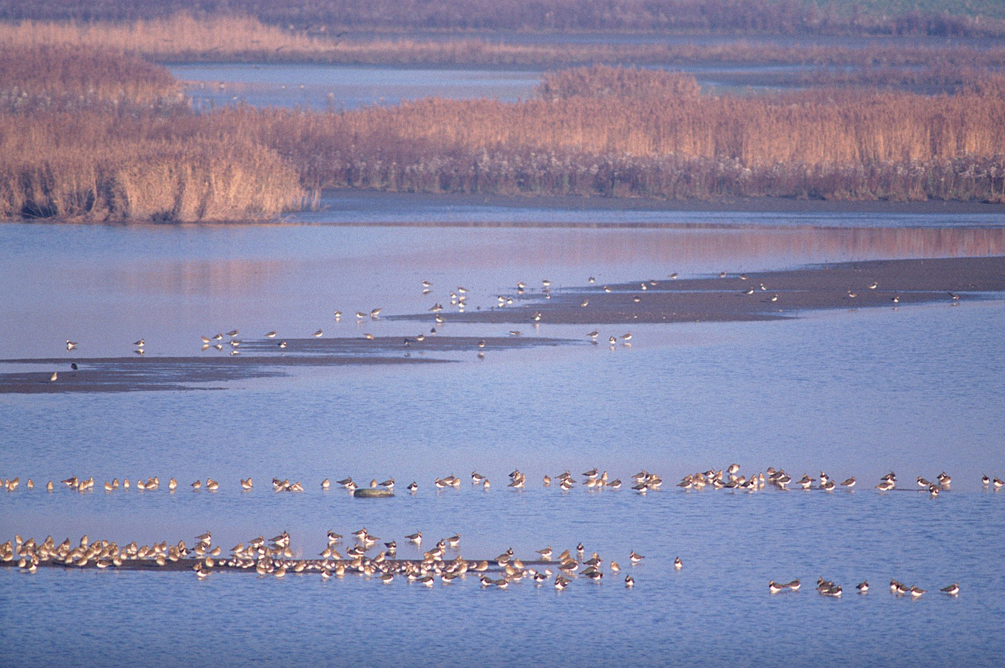
(Th. Hubin, RBINS)

2014

Contents

Executive Summary 4
Preamble 6
Chapter I - Overview of Biodiversity Status, Trends and Threats 7
1. Importance of biodiversity in Belgium 7
2. Status of biodiversity 10
3. Trends in biodiversity 16
4. Main threats to biodiversity 29
Chapter II - Status of national biodiversity strategies and action plans, their implementation, and the mainstreaming of biodiversity 44
1. Introduction 44
2. Biodiversity 2020, Update of Belgium's National Strategy 45
3. Regional and Federal action plans 52
4. Sectoral and cross-sectoral integration or mainstreaming of biodiversity considerations 61
Chapter III - Progress towards the 2020 Aichi Targets and contributions to the relevant 2015 Targets of the Millennium Development Goals 83
1. Progress towards the 2020 Aichi Biodiversity Targets 83
2. Contributions to the 2015 Targets of the Millennium Development Goals 126
Appendix I - Concordance of the Aichi Targets with Biodiversity 2020, Update of Belgium's National Strategy 128
Appendix II - Information concerning reporting Party and preparation of national report 134
1. Reporting Party 134
2. Overview of Belgian Regional and Thematic Focal Points 135
3. Procedure for the preparation of the report 136
4. Contributing experts 137
Appendix III - Further sources of information 139
1. National / Federal level 139
2. Flemish Region 140
3. Walloon Region 140
4. Brussels-Capital Region 141

Executive Summary

The present report is the fifth National Report on the implementation of the Convention on Biological Diversity in and by Belgium. The previous Belgian National Reports were published in 1998, 2001, 2005 and 2009. The report is organised as follows:
Chapter I starts with some information and research results on the importance of biodiversity and ecosystem services in Belgium. It further provides an overview of the status and trends of biodiversity in our country, at the species and habitat levels, and focuses on threats such as fragmentation, pollution, alien species and climate change. Information is provided for the Flemish, Brussels-Capital and Walloon Regions as well as for the Belgian part of the North Sea.
The geography and geology of Belgium, together with long-standing human impact in land use, resulted in an amazing diversity of habitat types for a rather small territory. Not less than 58 of them are listed in the EU Habitats Directive. Around 36,300 species of micro-organisms, plants, fungi and animals have been recorded in Belgium and expert extrapolations suggest that the actual number should range between 52,000 and 55,000 species.
In Flanders, at least 7% of formerly recorded species are extinct, 19% are endangered and 28% are vulnerable to near threatened. In Wallonia, 9% of the animal and plant species have already disappeared and 31% of the animal and plant species are threatened to disappear. In the Brussels-Capital Region, 80 higher plant species, 12 bird species and half of the amphibian species have disappeared. The Belgian marine area suffers from severe declines in fish and crustaceans, notably in commercial species.
The first part of chapter II provides an overview of the country’s strategic documents and action plans. ‘Biodiversity 2020, Update of Belgium’s National Strategy’ is briefly described and its status of implementation is discussed. This strategy complements the strategic documents developed at the regional level.
In the Flemish Region, the Policy Plan for Environment and Nature 2011-2015 includes a chapter on biodiversity and nature, and gives a framework for sectoral integration to improve environmental quality and to give specific attention to ecosystem services. In the Walloon Region, the administration for agriculture, natural resources and the environment has adopted a strategic plan with targets and indicators for the period 2008-2013. It will be renewed in 2014. The Wallonia Nature Network, a progressive catalogue of concrete and realistic actions, is also being created.
In application of a new global nature legislation (ordonnance du 1er mars 2012 relative à la conservation de la nature), the Brussels-Capital Region has adopted in September 2013 a project of regional nature plan. This project establishes the Brussels vision for nature at the horizon 2050 and sets up 7 main objectives for 2020 that are underpinned by a set of 26 measures. A public consultation on this project was held at the beginning of 2014.
At the federal level, the government has identified priority policies for biodiversity in its Federal Plan for Sustainable Development (2009-2012 (FPSD2)). Since 2013, a pre-project of the third plan (FPSD3) is in preparation which will also include specific measures and actions related to biodiversity and ecosystem services. The federal government has also established a master plan for the management of the Belgian part of the North Sea.
The second part of the chapter describes the sectoral and cross-sectoral integration of biodiversity enhanced and supported at the regional and federal level. It focuses on the initiatives in various themes and sectors such as water management, land use planning, construction, agriculture and forestry, and in relation to stakeholders such as business, local authorities, etc.
The final part focuses more in detail on the federal plan for the sectoral integration of biodiversity in four key sectors, which was adopted by the federal government in 2009. It was elaborated by four multi-stakeholder committees representing the major actors in the field of transport, economy, development cooperation and science.
Chapter III reviews the progress made by Belgium towards the 2020 Aichi Biodiversity Targets. It provides a non exhaustive overview of programs and actions in relation to key issues such as biodiversity conservation, sustainable use, threats to biodiversity, ecosystem services, traditional knowledge, benefit sharing and financial resources. It is concluded by a note in relation to the Millennium Development Goals and its 2015 Targets.
After the report, appendices are presented:
- concordance table linking the Aichi targets with the objectives of the updated National Strategy;
- overview of the Belgian Regional and Thematic Focal Points;
- information on the elaboration process of the report;
- list of contributing experts;
- further sources of information.
.

Preamble

Belgium is a federal state, composed of communities and regions. The power to make decisions is not the exclusive prerogative of the federal government and the federal parliament. The leadership of the country is in the hands of various partners, who independently exercise their authority within their domains.

The implementation of the Convention on Biological Diversity is carried out by the federal government, the regions, the communities and the local authorities (provinces and municipalities).

The regions are in charge of territorial matters. They have therefore the greatest amount of responsibilities on biodiversity-related issues: nature conservation, forest management, agriculture, exploitation of natural resources, land use and spatial planning, hunting, fisheries, etc. They are also in charge of tourism, which is a competence that has been delegated to them by the communities.

The federal government is the competent body for the biodiversity management of the Belgian part of the North Sea, for the international dimension of the marine environment policy and coordinates the Belgian external relations with respect to biodiversity (see CCIEP below). It is the federal government that undertakes the follow-up of trade in threatened species and that takes measures relating to the trade of exotic species.

The communities take care of issues linked to culture, research, education and public awareness. The regions and the federal government can also conduct research and raise public awareness in their own fields of competence.

The provinces and the municipalities play an important role at the local level, in accordance with regional policy.

The coherence of international environmental policy at national level is ensured by a coordination mechanism composed of representatives from the federal government, the regions and the communities. It is called the Coordinating Committee for International Environment Policy (CCIEP). This body functions under the high level authority of the Inter-ministerial Conference for the Environment (ICE). Under the CCIEP different committees, convention related or thematic, have been established, such as for Biodiversity, Climate Change, Adaptation to Climate Change, Forests, Nature, etc.

Chapter I - Overview of biodiversity status, trends, threats and implications for human well-being

1. Importance of biodiversity in Belgium

1.1. Context

Biological diversity, or biodiversity, is the term given to the variety of life on Earth. The biodiversity we see today is the fruit of billions of years of evolution, shaped by natural processes and, increasingly, by the influence of humans. It forms the web of life of which we are an integral part and upon which we so fully depend.

This diversity is often understood in terms of the wide variety of plants, animals and microorganisms. So far, about 2 million species have been identified. Scientists reckon that there are actually about 13 million species, though estimates range from three to 100 million.

Biodiversity also includes genetic differences within each species, for example between varieties of crops and breeds of livestock. Chromosomes, genes, and DNA determine the uniqueness of each individual and each species.

Yet another aspect of biodiversity is the variety of ecosystems such as those that occur in deserts, forests, wetlands, mountains, lakes, rivers, and agricultural landscapes. In each ecosystem, living creatures, including humans, form a community, interacting with one another and with the air, water, and soil around them.

It is the combination of life forms and their interactions with each other and with the rest of the environment that has made Earth a uniquely habitable place for humans. Biodiversity supports and plays an important role in the way ecosystems function and in the many services they provide.

These services are often grouped into four categories: provisioning services (e.g. food, medicines, wood), regulating services (e.g. climate regulation, water and air purification, pollination), cultural services (e.g. recreation and tourism, education, inspiration) and supporting services (e.g. water and nutrient cycling, primary production).

1.2. Some studies in Belgium

Research on the importance and value of biodiversity and ecosystem services is a rather recent research topic in Belgium. Yet, several studies and reports have been or are undertaken.

1.2.1. Importance of biodiversity for ecosystem services

The Flemish Research Institute for Nature and Forest published a report focussing on biodiversity as a basis for ecosystem services in Flanders. For each ecosystem service they addressed, the authors gave a definition, underlined the contribution of biodiversity, illustrated the interaction between functional biodiversity and the ecosystem service, gave the actual trend, and proposed measures to strengthen the ecosystem service and the underlying biodiversity. The report (in Dutch) is available at: http://www.inbo.be/files/bibliotheek/90/240790.pdf.

The assessment of the values of green spaces in urban and urbanising areas and the values for areas protected under Natura 2000 highlighted the benefits of ecosystems for society - see under 1.2.2. and 1.2.3.

The website http://www.natuurwaardeverkenner.be, called the "nature value explorer", is a calculation tool to value ecosystem services and can help everyone who wants to map the socio-economic importance of ecosystems. The calculated figures inform policy makers of the gain or loss of welfare resulting from the impact of a project or policy on the delivery of ecosystem services.

The University of Namur elaborated a scientific assessment of the services provided by the ecosystems in the Walloon Region. It contains among others a cartography of the ecosystem services in this part of the country. A case study was developed on the monetary value of the forest ecosystem services in the Walloon Region. Three of them (wood, big game and carbon sequestration) represents together more than 6.5 billion euros. When 14 different ecosystem services were taken into account, a value of 1,455 euro was calculated per hectare and per year. The report (in French) is available at: http://etat.environnement.wallonie.be/download.php?file=uploads/rapportsetudes/Dossier%20scientifique%20SE_RW_VF[1].pdf.

1.2.2. Importance of protected areas

The Flemish Institute for Technological Research and the universities of Antwerp and Ghent investigated the value of the Natura 2000-network in Flanders. They found out that the 166,000 hectares of protected areas in Flanders had among others the following benefits: more than 34 million tons of CO₂ stored each year, 4,000 to 8,000 tons of fine dust eliminated from the air each year, 16 million m³ of water purified each year and a gain of 2100 healthy life years (for about 1.8 million people), between 26 and 43 million visitors yearly. The experts concluded that the Natura 2000-areas in Flanders have a total value of 800 million to 1.2 billion euro for society. And this is still an underestimation given the fact that only 11 of the known 36 ecosystem services were taken into account. The report (in Dutch) is available at: http://www.natuurenbos.be/nl-BE/Natuurbeleid/Natuur%20en%20Natura%202000/Natura_2000/Waarom/Voordelen.aspx. For the summary in English: http://www.natuurenbos.be/~/media/Files/Themas/Natuur/Natura%202000/abstract%20estimate%20benefits%20Natura%202000%20-%20EN.pdf.

1.2.3. Importance of biodiversity in the city

The Flemish Agency for Nature and Forests launched an inventory of the benefits of green in the city. The inventory identified not less than 14 ecological, social and economical benefits: climate mitigation, climate adaptation, air quality, noise mitigation, water management, human fitness and health, city agriculture, social cohesion, recreation and tourism, nature education, biomass, better housing and higher estate values, attractiveness to businesses. The inventory also shows the high costs when there is not enough city green. Full report and summary, both in Dutch, are available at: http://www.natuurenbos.be/nl-BE/Natuurbeleid/Groen/Investeer%20in%20groen.aspx.

1.2.4. Some other valuation and related studies

An example of an economic valuation study of a habitat is the one carried out on the value of the Heverleebos-Meerdaalwoud in 2000. Putting together direct values (economic use: wood, mushrooms, other forest products, hunting permits, drinkable water, recreation, ...), indirect values (ecological use: carbon sequestration, pollution break down, noise absorption, mitigation of erosion, habitat for fauna and flora, ...), optional values (such as tourism) and existential values (intact natural landscapes, rare and threatened species, aesthetics, ...) led to a yearly total value of more than 24 million euro for this forest of 2,000 ha, equalling more than 12,000 euro per hectare and per year. A Dutch summary of this study is available at: http://www.econ.kuleuven.be/ete/downloads/SUMMARY_VLINA1.pdf.

Other examples of related research projects are ECOFRESH (ECOsystem services of FRESHwater systems, http://www.belspo.be/belspo/ssd/science/projects/ecofresh.e.pdf, final report: http://www.belspo.be/belspo/ssd/science/Reports/ECOFRESH_FinRep_2012_AD_2.pdf), ECOPLAN (Planning for Ecosystem Services, a conference was held on 31.05.2013: http://www.ua.ac.be/main.aspx?c=*ECOBE&n=76239), VOTES (Valuation Of Terrestrial Ecosystem Services in a multifunctional peri-urban space, http://www.votes-project.be). The latter project investigates how the values of ecosystem services are likely to change under different scenarios. The issues of trade-offs, transfer, communication and distribution of ecosystem services are examined under economic, social and environmental perspectives with the local community and stakeholders. Development of new and/or adaptations to existing policy instruments is suggested, which implement the developed methodology into decision-making processes.

1.3. Belgian community of practice on ecosystem services

Given the importance assigned to the subject, a Belgian community of practice was launched on ecosystem services (April 2012). The Belgium Ecosystem Services (BEES) Community (http://www.beescommunity.be/en/) is an open and flexible network that interfaces between different societal actors. The BEES community is open to all potentially interested organizations (policy, business, NGO’s, science, consultancy, civil society,…). It was among others set up as a result of the BEES (BElgium Ecosystem Services) cluster of the Belgian Science Policy and the project 'BElgium Ecosystem Services - A new vision for society–nature interactions' (final report available on: http://www.belspo.be/belspo/SSD/science/Reports/FinalReport_BEES%20ML.pdf).

The BEES Community has the following objectives:
- Develop ecosystem services concepts, tools and practices that help to adapt human activity and clarify ecosystem thresholds in order to preserve the actual and potential well-being of present and future generations; and to stop ecosystem and biodiversity degradation, and improve their status.
- Develop mainstreaming & policy tools to promote the integration of ecosystem services concepts in policy and management, business and society.
- Facilitate capacity building, exchange of expertise and experience: including methodologies and transfer of knowledge on Belgian ecosystem services to policy and share the needs from policy makers on this issue, to enable involvement of Belgian actors in national and international initiatives and build the capacity to conduct assessments of ecosystem services.
- Provide overviews of state of the art knowledge and best practices

On 27.04.2012, a conference on The Economics of Ecosystems & Biodiversity in Belgium was organised in Brussels. The programme and presentations are available at http://www.teebelgium.be/page/show/7. The themes and presentations of previous workshops are available at http://www.teebelgium.be/page/show/4.

2. Status of biodiversity

2.1. Species status

The Belgian diversity of life forms comprises around 36,300 recorded species of micro-organisms, plants, fungi and animals. However, expert extrapolations suggest that the actual number should range between 52,000 and 55,000 species. Bacteria and blue-green algae are not included in these numbers. Roughly 6,000 species of bacteria are known worldwide, but this is supposed to be only a fraction of the real number. As many bacteria species are cosmopolitan, we assume that at least a few thousand of them occur in Belgium. In addition, some 300 species of blue-green algae have been found in Belgium, and many more are expected to be discovered. Hence, the total number of species living in Belgium probably amounts to over 55,000 species. This figure exceeds all previous estimates.

Our knowledge of the taxa is unbalanced. The best known are the vascular plants (flowering plants, conifers, ferns, horsetails, quillworts and clubmosses), bryophytes, macro-algae and macro-lichens, vertebrates (fish, amphibians, reptiles, birds and mammals), carabids (ground beetles), butterflies, and dragon- and damselflies. They are often used to underpin and justify conservation measures and many species are well-known bio-indicators. Yet they represent less than 4% of the species living in Belgium. Obviously, expanding our knowledge of the remaining 96% of organisms would improve, refine and optimise Belgian conservation policies and actions.

Table 1. Overview of animal species numbers in Belgium (Biodiversity in Belgium, 2003) as an example of the discrepancy between observed and expected numbers of species.

Animals | Number of observed species in Belgium | Total species number expected in Belgium
sponges, cnidarians, … | 77 | 250
flatworms | 670 | 1 500
nematodes | 545 | 2 500
annelids | 330 | 600
other worm groups | 81 | 240
arachnids and pycnogonids | 1 713 | 2 000
insects | 17 295 | 25 000
myriapods | 97 | 160
crustaceans | 774 | 1 250
molluscs | 311 | 370
other invertebrates | 429 | 1 300
vertebrates | 449 | 460

2.2. Habitats status

The geographical and geological characteristics of Belgium, together with long-standing human impact in land use, resulted in an amazing diversity of habitats for such a small territory, many of which are of European importance (no less than 58 of them are listed in the EU Habitats Directive).

The main vegetation types found in Belgium are deciduous and conifer forests, grasslands, heathlands, peat bogs, wetlands, lakes and rivers, and marine ecosystems in the North Sea. The distribution of these varies from region to region. For example, about 80% of the forested areas are found in the southern part of the country. On the other hand, northern Belgium is noted for its semi-natural grasslands, wetlands, heathlands and coastal dunes.
It is difficult to give precise numbers on the vegetation cover at the national level. More precise data is available for those habitats listed under the European Union’s Habitats Directive. In Belgium, 58 habitats types are protected under the Habitats Directive. The table below presents the 15 most frequent ones, based on the total area and the number of occurrences in the country. The sign * indicates priority habitat types for conservation.

Table 2. Fifteen most frequent habitats in Belgium following the EU Habitats Directive (Biodiversity in Belgium, 2003).

Code | Habitat
1110 | Sandbanks which are slightly covered by sea water all the time
4010 | Northern Atlantic wet heaths with Erica tetralix
4030 | European dry heaths
6410 | Molinia meadows on calcareous, peaty or clayey-silt-laden soils (Molinion caeruleae)
6430 | Hydrophilous tall herb fringe communities of plains and of the montane to alpine levels
6510 | Lowland hay meadows (Alopecurus pratensis, Sanguisorba officinalis)
9110 | Luzulo-Fagetum beech forests
9120 | Atlantic acidophilous beech forests with Ilex and sometimes also Taxus in the shrublayer (Quercion robori-petraeae or Ilici-Fagenion)
9130 | Asperulo-Fagetum beech forests
9150 | Medio-European limestone beech forests of the Cephalanthero-Fagion
9160 | Sub-Atlantic and medio-European oak or oak-hornbeam forests of the Carpinion betuli
9180 | * Tilio-Acerion forests of slopes, screes and ravines
9190 | Old acidophilous oak woods with Quercus robur on sandy plains
91D0 | * Bog woodland
91E0 | * Alluvial forests with Alnus glutinosa and Fraxinus excelsior (Alno-Padion, Alnion incanae, Salicion albae)

2.3. Protected areas: the Natura 2000 network in Belgium

Natura 2000 supports an ecosystem approach for biodiversity conservation, i.e. the integrated management of land, water and living resources that promotes conservation and sustainable use in an equitable way. The Natura 2000 network comprises the ‘Special Protection Areas’ (SPA) designated under the EU Birds Directive and the ‘Sites of Community Importance’ (SCI) under the EU Habitats Directive.

Designating the sites is just the first stage in setting up the Natura 2000 network. Each site will be the subject of a designation order which specifies the following, backed up by maps: (i) the perimeters of the sites, (ii) the intended species or habitats which are present there, (iii) the objectives of the active management system to be put in place, and (iv) the means suggested to reach them.

Table 3. Surface of Natura 2000 in the Brussels-Capital Region, Flemish Region, Walloon Region and the Belgian part of the North Sea (updated in 2013).

 | territory (ha) | Natura 2000
 |  | surface (ha) | % of the territory
Brussels | 16 200 | 2 375 | 14.7%
Flanders | 1 352 200 | 166 322 ⁽¹⁾ | 12.3%
Wallonia | 1 684 400 | 220 945 | 13.1%
Belgian part of the North Sea | 346 200 | 124 929 | 34.2%
Total | 3 399 000 | 514 571 | 15.1%
(1) When including the Flemish Ecological Network, which is covered by a similar to more strict protective legal framework, the total surface comes to 193 268 ha and 14.3% (areas belonging to the Natura 2000 network as well as to the Flemish Ecological Network are only counted once).

2.3.1. Flemish Region

In 2005 a 24th Special Protection Area under the Birds Directive was designated in the port area of Zeebrugge: Baai van Heist, bringing the total surface to 98,243 ha (ca 7.3% of the surface of Flanders), giving focus to 28 breeding bird species and 26 non-breeding bird species of annex I of the Birds Directive. On 15 February 2008 the Flemish Government approved 2 additional zones under the Habitats Directive: the water zone of the estuary of the IJzer and of the estuary of the Schelde. In 2012 there was an expansion of the SCI site 'Uiterwaarden langs de Limburgse Maas en Vijverbroek. Taking into account these additions the 38 SCI sites under the Habitats Directive cover now a surface of 105,022 ha (7.8% of the surface of the Flemish region), giving focus to 47 habitat types and 59 species of the annexes of the Habitats Directive. The total surface of Natura 2000 in Flanders covers 166,322 ha or 12.3% of the surface. 37.7% of the Flemish Ecological Network is situated within the Natura 2000 network.

An Executive Law of 2004 on site-based management stipulates general measures for Natura 2000 sites concerning conservation, management aspects and derogation issues. For each of the sites a Nature Objectives Plan has to be developed highlighting the objectives for the habitats and species concerned and indicating possible measures for restoration and management. The development of the site specific plans is carried out in consultation with land owners and users and relevant local authorities. Draft plans are also put in public consultation before final approval. Based on the experience the procedure is shown to be too complex and is now being revised. A new Executive Law giving the procedures for the formal designation of the sites and the development and adoption of the site specific conservation objectives has been approved in May 2009.

- Establishment of the conservation objectives and designation of the SCI
* legal and policy framework: Executive law of the Flemish Government of 3 april 2009 'on the procedure for the designation of special areas of conservation and the establishment of conservation objectives'
For each habitat and species of European importance the objectives on the regional level of Flanders were determined in the regional conservation objectives (G-IHD). The G-IHD indicate when a specific species or habitat in Flanders reaches a favorable conservation status and what areas are essential for this goal. This is when for a species the area, the population size and the quality of the habitat or for a habitat type, the total area and quality is sufficiently large or good enough to survive in a sustainable way. The G-IHD were approved by the Flemish Government on July 23, 2010.

Based on the G-IHD the site specific objectives (S-IHD) were developed, scientifically screened and brought in consultation with stakeholders and actors. On the basis of the S-IHD, the priority measures for each site were established and integrated in de draft designation acts. End of 2012 the S-IHD and designation acts for all 38 SCI and overlapping SPA passed the 1st principle adoption by the Flemish Government and were submitted to the formal advisory councils.

For the protection and management of species a new Executive law for species protection was adopted 15th May 2009 that includes horizontal measures for the management and protection of species with specific attention to species of European interest. For the development of species protection programmes a format, procedure and prioritization of species was prepared.

* consultation process: an extensive consultation and participation process was set up with all relevant actors, both the socio-economic groups that are active in the open space in the ‘IHD-discussion group’ (agriculture, nature management, hunting, land owners, economic sectors and forest managers) and the relevant authorities in the ‘IHD-project group’. To enable the socio-economic actors to participate in the consultation process in a professional manner, resources were also provided for capacity-building within each participating organization. The framework for the consultation process in the IHD-discussion group was set out in a letter of intent that was signed in 2009 by all organizations involved.
http://www.natura-2000.be/overlegproces
http://www.natuurenbos.be/nl-BE/Natuurbeleid/Natuur/Natura_2000/In_samenwerking.aspx

- Policy and management in relation to Natura 2000:
The implementation of the conservation objectives of Natura 2000 is one of the three strategic projects of the Agency for Nature and Forests ANB. The existing instruments were evaluated by the Mina Council (Advisory Board of target groups) and, where necessary, proposals for changes for a more effective and more efficient implementation are being prepared.

In the various processes of the ANB policy priority attention is given to the conservation objectives and Natura 2000:

* The management of nature and forest areas located in Natura 2000 is further tuned to achieving the conservation objectives. The surface with an approved management plan in Natura 2000 came the end of 2012 to 40.916 ha, about 25% of the total area of Natura 2000. All existing management plans are being screened and where needed the focus on the conservation objectives will be enhanced. Besides a new approach has been developed for multifunctional management with an integrated management plan for larger areas together with several landowners and managers and a division of tasks in realisation of objectives and appropriate stimulating policies.

For the concrete guidance of measures on site a vade-mecum on management measures was in collaboration with the INBO.

* For acquisition of land priority is given to areas with vulnerable nature values and areas located in Natura 2000. In the period 2007-2012 a surface of 5.749 ha was purchased whereby the total area of land owned by ANB came to 37.335 ha of which 63% is located in Natura 2000.

* Protection provisions: For the screening of projects/plans with potential impact on Natura 2000 an overall approach was developed to make ' the appropriate assessment ' more tailored and more accessible. For this purpose, the development of an on-line pre-screening system was initiated.

* Nature development projects are initiated to restore and extend natural values and develop infrastructure for public access. Of the 24 selected projects started during the reporting period about 50% of the total surface of the project areas (ca 9400 ha) is located in Natura 2000.

* Cooperation: for the realisation of Natura 2000 the establishment of cooperation with other Governments and stakeholders is crucial. In the framework of the IHD-process the establishment of engagements with the various actors was initiated. Existing cooperation programmes provide the example of good practices, such as:

-with the Ministry of Defense: with the management of Natura 2000 on military domains the investment of the project Danah is continued on a long term: http://www.DANAH.be

-with the authority of the port of Antwerp and the NGO Natuurpunt a site specific species protection programme for the Antwerp port area was establised in 2011: http://www.portofantwerp.com/nl/natuur.
The objective is to preserve and manage up to 5% of the port area, about 600 ha, as suitable habitat for the species of European importance.

-in collaboration with the public administrations competent for the management of waterways, roads and railways attention is given to solve bottlenecks in connectivity so that measures that contribute to connection between Natura 2000 and other nature and forest areas are integrated in the projects or management programmes of infrastructure.

- Life-Nature projects under theme ‘Nature’ are submitted for the realization the sustainable recovery of habitats and species of European importance and improvement of the landscape and the public access of Natura 2000 sites. In addition, these projects are also important for the development of cooperation with partners in the region and in neighbouring countries (Governments, NGOs, municipalities, provinces, local associations, private owners) and for awareness raising and communication regarding Natura 2000 and biodiversity conservation. Thanks to this co-financing projects specialized equipment could also be purchased and expertise built up in restoring and managing Natura 2000 habitats that are often very vulnerable or that need large-scale overdue management. In the reporting period 10 new LIFE projects for actions in Natura 2000 in Flanders were approved.
http://www.natuurenbos.be/nl-BE/Over-ons/Projecten.aspx
http://www.natuurenbos.be/nl-BE/Natuurbeleid/Natuur/Natura_2000/Geen_verre_toekomstmuziek/Life_en_Interreg.aspx
http://www.natuurpunt.be/nl/natuurbehoud/natura-_273.aspx

* in the scientific research priority attention was given to enhancing knowledge on habitats and species of European interest and the conservation objectives: scientific basis for the determination and evaluation of regional objectives G-IHD and site objectives S-IHD; methodology for a calibration model to optimize the distribution of the objectives over the various Natura 2000 sites and to evaluate effects of the implementation of the objectives on socio-economic processes; development of an on-line system for the pre-screening of the appropriate assessment; scientific basis for the determination of reference values for main effects groups; basis to use population-genetic principles for the analysis of bottlenecks on connectivity between areas and to determine favourable reference values; cost-benefit analysis of Natura 2000; development of plans and methodology for the monitoring of habitats and species .

* Monitoring and reporting: "Nature report 2007: State of nature in Flanders: data for policy" gives a comprehensive reporting of the conservation status and the trends of habitats and species. For the following reporting in 2019 a more focused monitoring is being developed, priorities and inventory networks are determined and methodologies are worked out.

* Communication: For the general communication on Natura 2000 and about the process for establishing the conservation objectives an online newsletter was developed – http://www.natuurenbos.be/nl-BE/Natuurbeleid/Natuur/Natura_2000/Nieuwsbrief.aspx.
The preparation of an umbrella website Natura 2000 was initiated in collaboration with the INBO.

2.3.2. Walloon Region

There are 240 SCI in the Walloon Region, covering 220,944 ha, equivalent to 13% of the Region. The network is based on the hydrological network and is nearly 70% forest (31% of Walloon forests). Grassland, fallow land and orchards on the one hand, and crops on the other, occupy 16% and 2% respectively of the total network, but represent less than 5% of agricultural land. The Walloon Region hosts 44 habitat types, of which 10 priority types, 101 bird species and 31 other animal and plant species listed in the annexes of the directives.

All of the 240 SCI are subject to general measures (AGW dated 24.03.2011). Furthermore, as far as each SCI will be designated to SAC (covered by a designation order), it will be subject to specific measures (AGW dated 19.05.2011) according to the characteristics of the habitats and species. The designation orders have been approved for an initial batch of 8 sites covering just over 3,600 ha. A new adoption process for designation orders has been finalized on January 23rd 2014 for 52 SAC covering 21,852 ha.

http://biodiversite.wallonie.be/fr/natura-2000.html?IDC=829.

http://biodiversite.wallonie.be/fr/accueil.html?IDC=6

http://etat.environnement.wallonie.be/index.php?mact=tbe,m588bb,default,1&m588bbalias=Natura-2000-network_1&m588bbreturnid=46&page=46

2.3.3. Brussels-Capital Region

The EU Commission has approved the list of Natura 2000 sites proposed for the Brussels-Capital Region in December 2004. Brussels is currently working on the official designation of those sites, including the definition of conservation objectives, according to the new regional legislation (ordonnance du 1er mars 2012 relative à la conservation de la nature). Each site (48) will be covered by a management plan that aims to reach the defined objectives.

2.3.4. Belgian part of the North Sea

As mentioned above, the Federal authorities are competent for the environmental policy in the Belgian part of the North Sea.

In 2005 (Royal Decree of 14 October 2005) three Special Protection Areas (SPAs) were designated in the Belgian part of the North Sea: SBZ1 (in front of the coast of Koksijde): 110.1 km², SBZ2 (in front of the coast of Oostende): 144.80 km² and SBZ3 (in front of Zeebrugge): 50.95 km², as well as two Special Areas of Conservation (SACs): Trapegeer Stroombank, 181.20 km² and Vlakte van de Raan, 19.17 km². By Royal Decree of 6 March 2006, a strict marine reserve (Gericht marien reservaat) Baai van Heist, was designated. These marine protected areas (MPAs) were selected on the basis of a scientific study carried out by the MUMM (Royal Belgian Institute of Natural Sciences, RBINS) and the Research Institute for Nature and Forest (INBO). Following a complaint against the designation of the Vlakte van de Raan as SAC, on the ground that the designation of the site was not scientifically underpinned, the Council of State nullified in 2008 the designation of the Vlakte van de Raan as SAC. However, the site is still on the European list of Sites of Community Importance. Policy plans for the marine protected areas have been drawn up by the competent authority and have been approved by the State Secretary in charge of the marine environment.

The EU-Habitats Directive also applies to the Exclusive Economic Zone. Hence the Special Area of Conservation 'Vlaamse Banken' (1,099 km²) was designated (Royal Decree of 16 october 2012). This new site includes the previously designated Trapegeer Stroombank area and covers a part of the territorial waters and the EEZ. Thanks to the designation of the SAC 'Vlaamse Banken', one third of the Belgian part of the North Sea is now integrated in the Natura 2000 network.

3. Trends in biodiversity

3.1. Trends in species

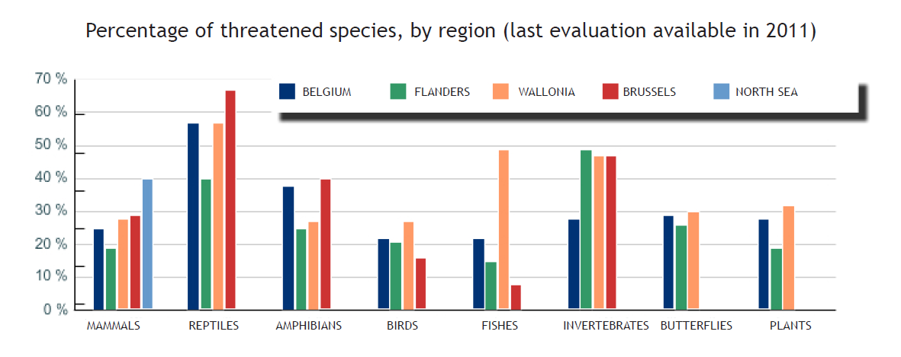
Figure 1. Species status in Belgium, Flanders, Wallonia, Brussels and the Belgian part of the North Sea in 2011 (Source: Statistics Belgium - http://statbel.fgov.be/fr/statistiques/chiffres/environnement/diversite_biologique/).

Detailed monitoring and thorough comparisons of old collection and observation data with more recent ones show that many species are in decline or even have disappeared. It can be estimated roughly that between 20% and 70% of the species are threatened per main group of organism, depending on the group and the region of the country:
- In Flanders, at least 7% of formerly recorded species are extinct. Of the remaining assessed species, 17% are endangered to critically endangered and 29% are vulnerable to near threatened; only 52% are considered safe or at low risk (for 2% of the assessed species, data are insufficient to define a status).
- In Wallonia, 9% of the animal and plant species have already disappeared and 31% of the animal and plant species are threatened to disappear.
- In the Brussels-Capital Region, 80 higher plant species (out of the ca. 580 indigenous ones recorded before 1950), 12 bird species (out of 103) and half of the amphibian species have disappeared.
- The initial assessment of the Belgian marine waters (2012) describes the current state of the marine habitats and species. The area covered by the Belgian part of the North Sea (BPNS) is part of a larger marine area, affected by sea currents, and as such no clear statement should be made on the state of the population size of species in the BPNS. Commercial fish species are assessed on a EU-level. An increase of invasive species has been identified over the years and some of these invasive species are fairly well inventoried (crustaceans, molluscs, ...). The quality of the structure and function of sandbanks and biogenic reefs have been affected by bottom-disturbing activities.

The trends in the species listed in the EU Habitats Directive have been evaluated within the framework of the Article 17 reporting of the Habitats Directive for the period 2008-2013, (see also http://cdr.eionet.europa.eu/be/eu/art17/envucdy2q). The main goal of the Habitats Directive is to maintain a ‘favourable’ conservation status of selected species that are assumed to be endangered or rare and Europe should play an important role in their conservation. The evaluation of the conservation status is based on four criteria set down by Europe. These are the range of the species, its distribution, the size of its population and its future prospects.

The overall results for the species of European interest in Belgium (fig. 2) show that 43% have a bad conservation status, 26% an inadequate status and 19% a favourable status. For 12% of the species there is not enough information. Fig. 3 shows the conservation status trend of these species in our country.

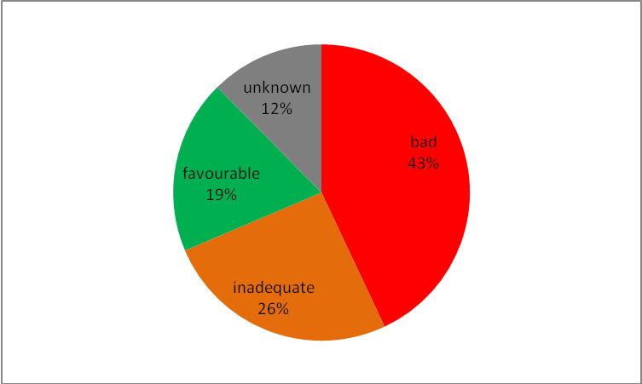

Figure 2. Overall assessment of the conservation status of the 85 species of European interest in Belgium (based on the Article 17 reporting of the Habitats Directive for the period 2008-2013).

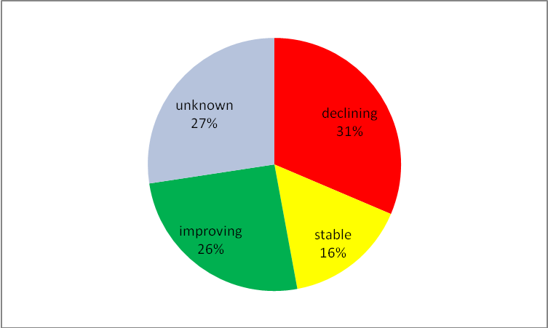

Figure 3. Overall trend in conservation status of the 85 species of European interest in Belgium (based on the Article 17 reporting of the Habitats Directive for the period 2008-2013).

More detailed and more precise information is available for each region of Belgium and the North Sea. For all of them, nature and environment reports are compiled using European headline biodiversity indicators.

3.1.1. Flemish Region

Figure 4 illustrates the species status in the Flemish Region, based on validated Red Lists. The status of 1,909 species (ca. 5% of all species occurring in Flanders) has currently been documented. Knowledge on the status of Flemish biodiversity is strongly biased towards vascular plants, the status of which has been described for 58-70%. The status of invertebrates remains largely undocumented, with the status descriptions only available for 2% of the species. From the species assessed, 7% have recently become regionally extinct and 24% have been listed as threatened (critically endangered, endangered or vulnerable). Butterflies are among the most threatened with 29% categorized as extinct and 27% as critically endangered, endangered or vulnerable. A relatively large number of the fish and lampreys, grasshoppers and crickets, amphibians and reptiles are threatened as well. Among vascular plants, breeding birds, waterbugs and dragonflies, a smaller number of species was listed as extinct or threatened. Red List data of fungi, mammals, ants, spiders, dolichopodids and empidids are excluded from this analysis due to a lack of sufficient actual data.

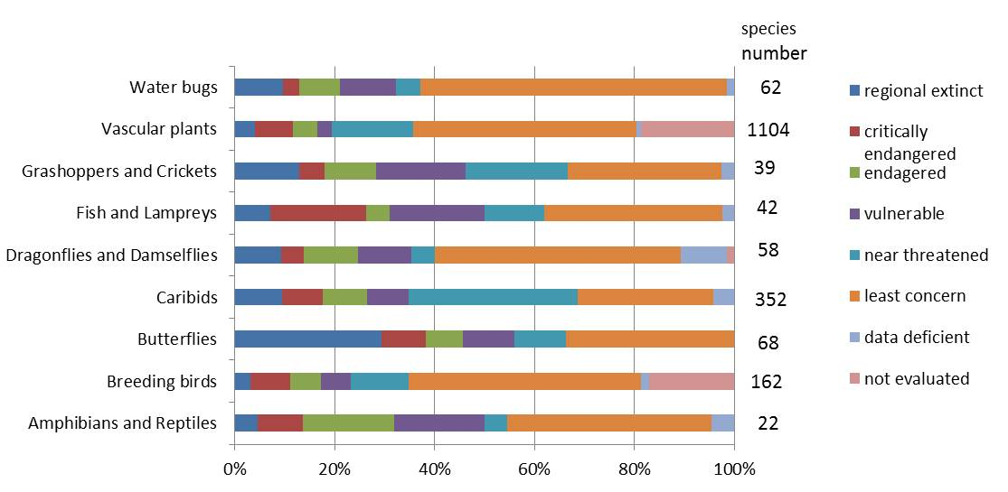

Figure 4. Species status in the Flemish Region in 2013 (Source: Research Institute for Nature and Forest, http://indicatoren.milieuinfo.be/indicatorenportal.cgi?lang=en&detail=657&id_structuur=71).

The ‘Common birds index’ is calculated as the trend abundance of forest, farmland and other common birds in Flanders. The farmland bird indicator dropped sharply between 1990 and 2000-2002. This decline continued in the period 2000-2002 until 2007. Between 2007-2012 the decline was less pronounced. The decline is related to the intensification of agriculture.

On average, the trend of common forest birds shows a continual increase. This is the result of a more natural tree and shrub vegetation and structure in the forest. The other common birds of different habitats, especially a lot of habitat generalists, still increase.
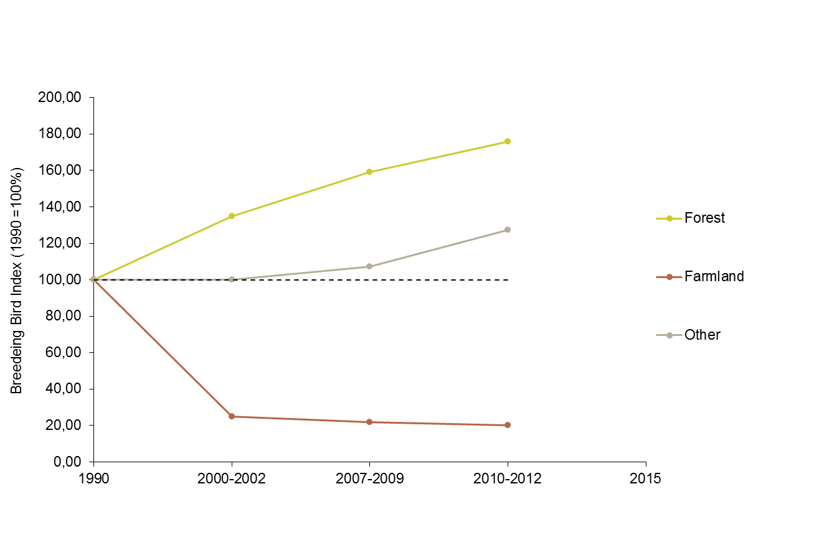

Figure 5. Trend abundance of forest, farmland and other breeding birds in Flanders, http://indicatoren.milieuinfo.be/indicatorenportal.cgi?detail=715&id_structuur=71&id_categorie=-1&lang=en&jump=yes.

The general decline of the birds of agriculture is linked to the intensification and expansion in agriculture. Measures to stop this decline, like measures taken within the scope of CAP, proved to be applied on a far too small scale. However, a recent INBO study showed that some of these measures can possibly be very useful. The general progress of the woodland birds is probably mainly due to the concern of the forestry sector for nature and a more natural tree and shrub species composition and structure, the increased tolerance in regard of standing dead wood and older trees to be. All these measures lead to increased food supply and nesting.

Population targets haven been formulated for 19 wintering waterbird species which occur in internationally important numbers in Flanders. When comparing average numbers during the last five winters to these target values (fig. 6), we can conclude that population goals are met for seven species. Numbers of four species are just below the targets. For 8 species, there is a rather large gap between actual numbers present and population goals. Most of them showed a clear negative trend during the last 10 years. Trends of migrating waterbirds are often determined by a combination of different factors. For many species the Flemish trend reflects the changes in the European population. There are also increasing signs that recently, large scale changes are taking place, mainly under the influence of changing climate. Milder winters mean that many species can shorten their migration route and can overwinter further north (and resulting in lower wintering numbers in Flanders). But local and/or regional factors within Flanders are important for observed population changes too. The trends in Flanders for common teal, pintail and common pochard have been strongly influenced by ecological changes in the Scheldt estuary which has had a big impact in the numbers of waterbirds stopping over in this area. It is believed that nature development and restoration projects could help to reverse negative trends, as has been successfully demonstrated in several areas during the last years.

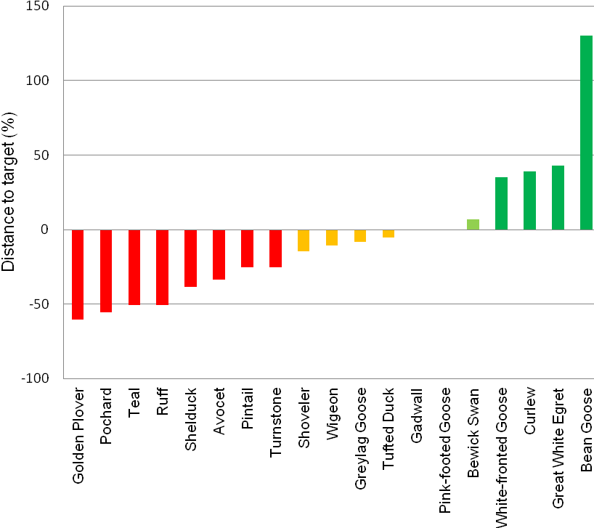

Figure 6. Distance to population goals of wintering waterbird species (Flemish Research Institute for Nature and Forest).

Population targets have been formulated for 28 breeding bird species, 27 of the Annex I of the Birds Directive (27) and one internationally important species, lesser black-backed gull. When comparing for 20 yearly monitored species the numbers of breeding pairs during the period 2007-2012 to the target numbers (fig. 7), we can conclude that population goals are met for three species. For another three the goals were met in one or two years during the six year period. For 14 species however, there is still a large gap between actual numbers and the goals. Five of the remaining seven species have larger populations that are not monitored each year. Their average number of breeding pairs for the period 2007-2012 compared to the target number suggests that the target is met by four of them. Two species which have population goals but are still irregular or very scarce breeders are still between 90 and 100% away of their goals. Some forest breeding species seem to do rather well. It is however clear that for most of the other species, although some of them are slowly increasing in numbers, the population is actually depleted or too low and there is still a long way to go. For most of them, nature development and large nature restoration projects could help to reverse negative trends. In particular species with large homeranges are often in need of a better general quality of their environment. Additionally, increasing the quality of mosaic farmland landscapes should be another important goal for the future.

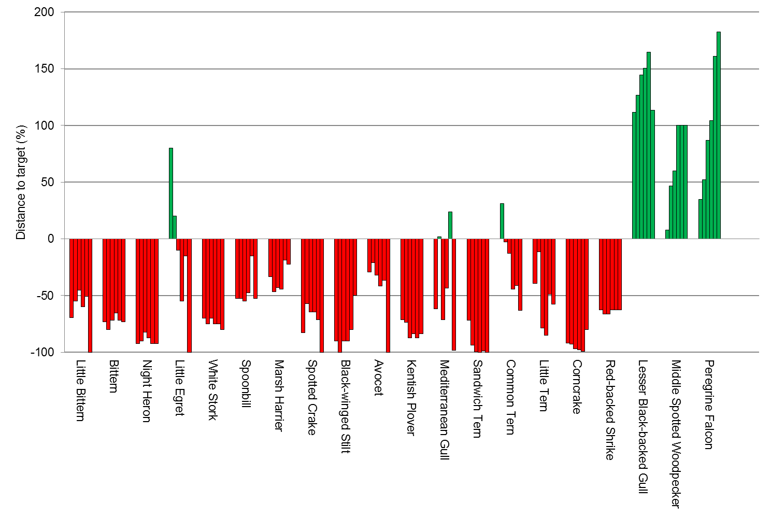

Figure 7. Distance to population goals of breeding bird species (Flemish Research Institute for Nature and Forest).

The conservation status of species of European interest has been evaluated as part of the reporting requirements for the EU Habitats Directive, under the Article 17 Report (2007-2012). The main goal of the Habitats Directive is to maintain a ‘favourable’ conservation status of selected species. These species are assumed to be endangered and Europe should play an important role in their conservation. Generally these are species living in specific habitats. The evaluation of the conservation status is based on four criteria set down by Europe. These are the population of the species, its distribution, the state of its habitat and its future prospects. In Flanders, only nine species (three amphibians, one fish and five bats) have a favourable conservation status. For more than half of the species (32) the conservation status is poor and for nine species (16%) the status is inadequate. For 10 species there was insufficient data to evaluate their status. Compared with 2007, the conservation status of 14 species improved, but at the same time the situation for 17 species deteriorated (fig. 8).
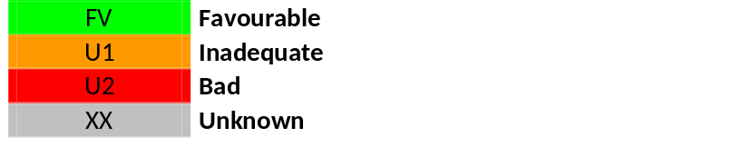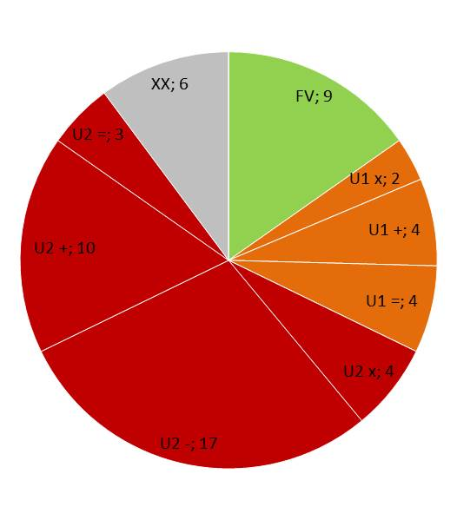

Figure 8. Evaluation of the conservation status of species (partim, no birds) of European interest in Flanders (2013). For each category there is information on the number of species that improves (+), deteriorates (-), remains unchanged (=) or when the trend is not known (x).

Other species-based indicators for Flanders can be consulted on-line (in English) at the following URL:
http://indicatoren.milieuinfo.be/indicatorenportal.cgi?detail=700&id_structuur=23&id_categorie=-1&lang=en&jump=yes.

3.1.2 Walloon Region

In Wallonia, the species conservation status is poor for 2/5 of the species in the monitored groups (mammals, birds, reptiles, amphibians, fishes, dragonflies, butterflies, ladybirds, beetles, vascular plants and non vascular cryptogamous). All groups combined, 31% of the species that were examined run the risk of disappearing in Wallonia and close to 9% have already disappeared. Among bats, fish, reptiles, butterflies, dragonflies and damselflies, more than half of species are in an unfavourable situation. The conservation status of any given species is the result of a combination of factors such as habitats fragmentation, incidence of pollution, disruptions caused by invasive exotic species… The objective
of halting the loss of biodiversity for 2010, as set at European level, has also been written down in the 2009-2014 Regional Policy Declaration. This objective has not been reached yet and supplementary
measures have to be put in place.

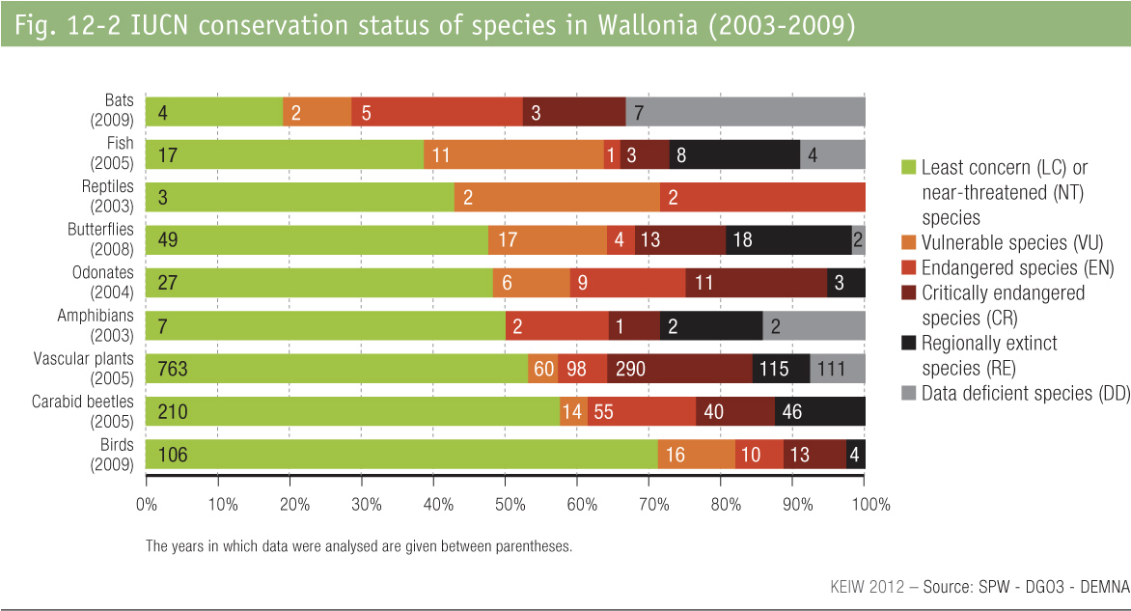

Figure 9. Species status in the Walloon Region (Source: SPW - DGO3 - DEMNA, http://etat.environnement.wallonie.be/index.php?mact=tbe,m588bb,default,1&m588bbalias=Conservation-status-of-species_2&m588bbreturnid=46&page=46).

During the last two centuries, 172 nesting bird species have been observed in the Walloon Region, 149 of which have been subjected to a recent evaluation: 106 species are not threatened, 39 species are threatened and 4 species are extinct. In comparison with the previous evaluation (1997), 23 species have a better status (some due to a more sensitive methodology) while the status of 16 species deteriorated (fig. 9). About 64% of the threatened species are linked to open and aquatic habitats. This situation is partly due to the fact that the surface of heathlands, fens and grasslands is rather restricted in the Walloon Region. Within agricultural zones, only few nesting sites and alimentary resources are available all year long, hence creating unfavourable conditions for farmland birds. For more information: http://biodiversite.wallonie.be/fr/oiseaux.html?IDC=787.

A detailed analysis indicates that 52% of the 101 studied species of butterflies in the Walloon Region are threatened or extinct (fig. 10). The analysis also shows that the expanding species are the more common, ubiquitous or flexible species, while numerous rare species with strict ecological demands are in regression. The disappearance, alteration and fragmentation of habitats, as a consequence of inappropriate urbanisation, agricultural and sylvicultural practices, are the main reasons for this regression.

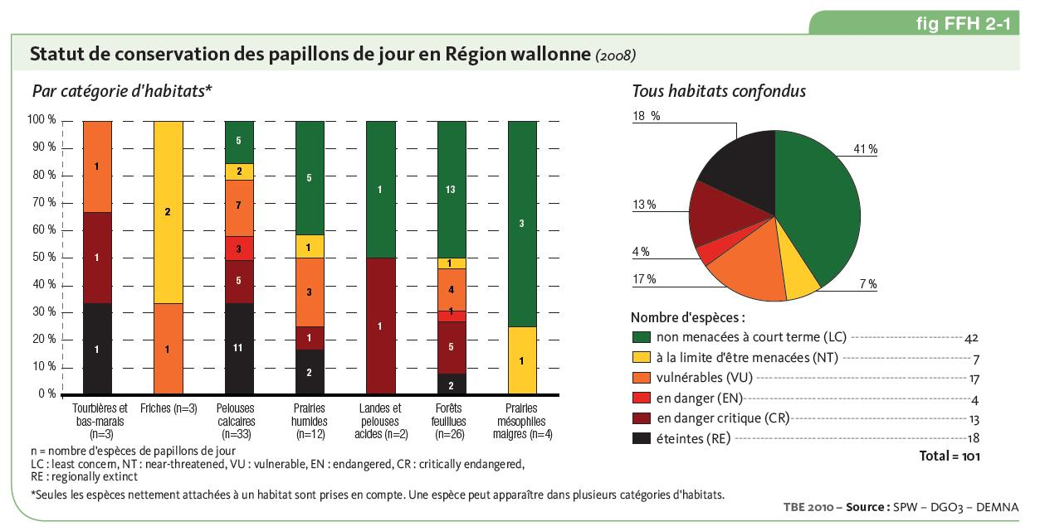

Figure 10. Conservation status of butterfly species in the Walloon Region (Source: Département de l'Etude du Milieu naturel et agricole, http://etat.environnement.wallonie.be/index.php?mact=tbe,m787b7,default,1&m787b7what=fiches&m787b7alias=Statut-de-conservation-des-papillons-de-jour&m787b7returnid=40&page=40).

According to the Article 17 Report for the Habitats Directive, the conservation status of ‘species of European interest’ was deemed to be unfavourable for 73 % of the species in the Continental Region. 67 taxa or groups of taxa were studied. Among them, superior plants and butterflies had the largest number of taxons whose conservation status was unfavourable. As for vertebrates with a very unfavourable status, there were in particular: the great crested newt (Triturus cristatus) and the natterjack toad (Bufo calamita); the sand lizard (Lacerta agilis); 3 species of bats; the European hamster (Cricetus cricetus) and the European otter (Lutra lutra).

Other species-based data for Wallonia can be consulted on-line at the following URL (in French):
http://biodiversite.wallonie.be/fr/especes.html?IDC=3025. Given the difficulty to realise a Nature Plan, the Walloon Region elaborated a project of an evolutionary catalogue of actions aiming among others to specifically preserve rare and threatened habitats.

3.1.3. Brussels-Capital Region

The wealth of Brussels’ natural heritage derives from its diversity of geomorphological and urban structures (valleys, wetlands, old trees, old buildings). However, continuous urbanisation is highly disruptive to plant and animal communities.

While the most drastic declines in species and natural habitats were recorded during the nineteenth and early twentieth centuries, or during the post-war period, at a time of major industrial and economic developments and growing urbanisation, numerous species are still in a precarious situation, mainly due to the increasing scarcity of their habitats and the deterioration of the quality of their environment (fig. 11).

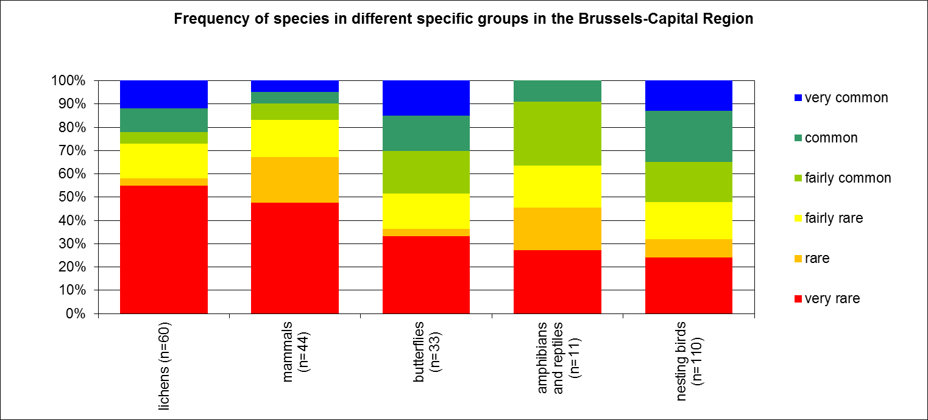

Figure 11. Frequency of species in different specific groups in the Brussels-Capital Region.

More information on species-based data for the Brussels-Capital Region can be found at:
http://documentation.bruxellesenvironnement.be/documents/NARABRU_20120910_FR_150dpi.pdf (French)
http://documentatie.leefmilieubrussel.be/documents/NARABRU_20121004_NL_150dpi.PDF (Dutch).

3.1.4. Belgian part of the North Sea

Several reports describe the international importance of the Belgian part of the North Sea for marine bird species. The trend of the marine bird species occurring in the Belgian part of the North Sea and listed in annex I of the EU Birds Directive is as follows: population counts in 2007 and 2009 show a decline of the populations of little tern (Sterna minor), Sandwich tern (Sterna sandvicensis) and common tern (Sterna hirundo), probably due to modified breeding circumstances (source: http://indicatoren.milieuinfo.be/indicatorenportal.cgi?lang=nl&detail=716&id_structuur=71).

The trend for marine mammals is more positive, although it is certain that most species remain threatened. The article 17 reporting, in application of the Habitats Directive (http://cdr.eionet.europa.eu/Converters/run_conversion?file=be/eu/art17/envucdy2q/BE_species_reports-1371-154426.xml&conv=354&source=remote) mentions a positive trend for the harbour porpoise (Phocoena phocoena), primarily due to a shift of the population in the North Sea, as well as for the common seal (Phoca vitulina). The trend for the grey seal (Halichoerus grypus) is uncertain.

3.2. Trends in habitats

The trends in habitats have been evaluated within the framework of the Article 17 reporting of the EU Habitats Directive (2008-2013, see also http://cdr.eionet.europa.eu/be/eu/art17/envucdy2q). The main goal of the Habitats Directive is to maintain a ‘favourable’ conservation status of selected habitats. These habitats are assumed to be endangered and Europe should play an important role in their conservation. Generally they are very specific habitats. The evaluation of the conservation status is based on four criteria set down by Europe. These are the area of the habitat, its distribution, its quality related to structure and function and its future prospects.

The overall assessment of conservation status is the following: 9% of the Belgian habitats of European interest are in favourable conservation status; 17% are in inadequate, 73% bad and 1% are in unknown status (fig. 12). Fig. 13 shows the conservation status trends of these habitats in our country.

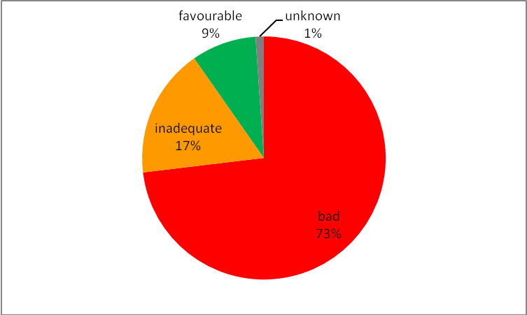

Figure 12. Overall assessment of conservation status of the 59 habitats of European interest present in Belgium (based on the Article 17 reporting of the Habitats Directive for the period 2008-2013).

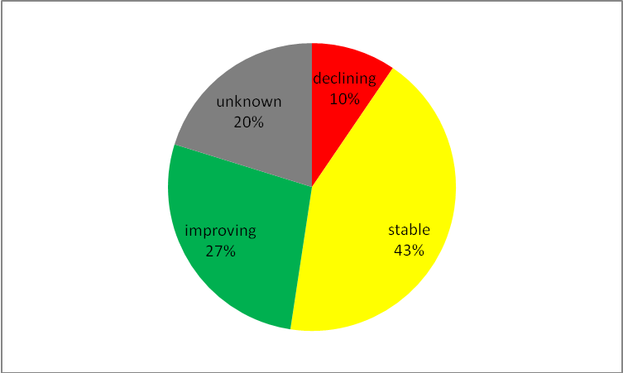

Figure 13. Overall trend in conservation status of the 59 habitats of European interest present in Belgium (based on the Article 17 reporting of the Habitats Directive for the period 2008-2013).

3.2.1. Flemish Region

More than three-quarters of the habitats (38 habitats) are of poor conservation status and 9% have an inadequate conservation status. The latter includes one peat and marsh habitat, one coastal dune habitat, one heathland, one grassland and one aquatic habitat. Consequently, only five habitats have a favourable conservation status, these being one saline habitat (mudflats and sandflats not covered by seawater at low tide), one coastal dune habitat (dunes with sea buckthorn), one aquatic habitat (hard oligo-mesotrophic waters with benthic vegetation of Chara spp.), one grassland habitat (Rupicolous calcareous or basophilic grasslands of the Alysso-Sedion albi) and one cave habitat (caves not open for public). For seven habitats the situation on the field improved slightly compared with 2007.

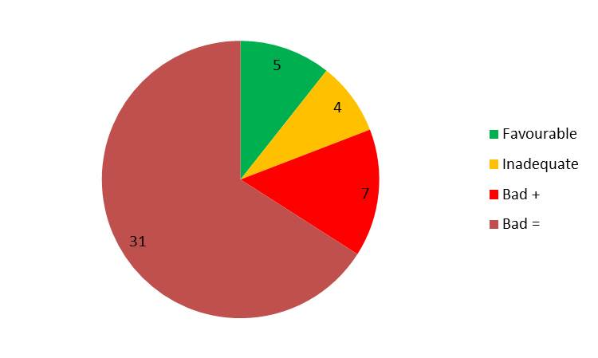
Figure 14. Conservation status of habitats of European interest in Flanders,
http://indicatoren.milieuinfo.be/indicatorenportal.cgi?detail=694&id_structuur=23&id_categorie=-1&lang=en&jump=yes.

3.2.2. Walloon Region

Based on the Article 17 reporting (Habitat Directive) for the period 2008-2013, 4 habitat types of European interest in the Walloon Region are in a favourable conservation status (compared to only one in the previous report), 9 habitat types are in an inadequate conservation status (compared to 4 in the previous report), 27 habitat types are in a bad conservation status (33 in the previous report) and only one habitat type has an unknown conservation status. Habitat types of European interest in favourable conservation status in the Walloon Region: water courses of plain to montane levels with the Ranunculion fluitantis and Callitricho-Batrachion vegetation, petrifying springs with tufa formation (Cratoneurion), caves not open to the public, and stable xerothermophilous formations with Buxus sempervirens on rock slopes (Berberidion p.p.).

As far as forests are concerned, factors lowering the status basically involve the presence of wide diameter-wood and dead wood (insufficient volume and number). No forest habitat in the continental region had a good evaluation as far as the vertical structure was concerned or the presence of natural regeneration. As well as various structural and functioning problems, the poor evaluation of other formations such as dry heaths, grasslands and screes comes from the reduced size of their distribution area in relation to the land area required for the good functioning of the habitat and its long term conservation.

http://etat.environnement.wallonie.be/index.php?mact=tbe,m588bb,default,1&m588bbalias=Conservation-status-of-habitats_1&m588bbreturnid=46&page=46

3.2.3. Brussels-Capital Region

Almost all the forest types present in the Brussels-Capital Region are protected internationally. 83.6% of the forests in Brussels have been put forward as Natura 2000 areas, the largest part of which are acidophile beech forests (habitat type 9120). 112 ha of the Brussels part of the Sonian forest have been designated as forest reserve, 36 ha of which as integral reserve. However, the quality of forests could be better. The high (potential) nature value of the Brussels’ forests is mainly due to the average high age of the plants, the topographic and pedologic diversity and the fact that the majority of the current forest surface used to be forest in the previous centuries as well. The numerous old forest plants, in regional forests as well as in residential gardens, are proof of that.

An evaluation of the conservation status shows that large parts of the forests are in an unfavourable state. Some criteria and indicators are scoring rather well, but according to the stricter European evaluation method, in which the general score is unfavourable when one criterion is (one out, all out), less than 3% of Natura 2000 forests has a favourable conservation status. The alluvial forests (habitat type 91E0) display a more positive picture: a quarter of those forests have a favourable conservation status.

The problem that causes the unfavourable status of the forests in Brussels rarely has to do with quantity. The analysis shows that it is mainly qualitative improvements that can be made. The most striking issues have to do with horizontal and vertical structure, vegetation composition and the amount of dead wood. Distortions because of leisure activities and wastewater discharge create local problems in various Natura 2000 stations. Atypical species in the canopy layer and the presence of invasive introduced species are local issues as well.

Besides the forest habitats, 5.3% of grasslands in the Natura 2000 areas have a favourable conservation status.

Because of their rarity and species richness, some humid habitats are of international importance. In order to protect the Natura 2000 habitat types 6430 (Hydrophilous tall herb fringe communities) and 91E0 (alluvial forests), special protection areas (SPA) were delimited in the Brussels-Capital Region. Eutrophication, ruderalisation and desiccation are the most important issues for realising a favourable conservation status.

The role of city parks, playgrounds, sports grounds and gardens is first and foremost to give inhabitants a place to relax, walk and enjoy, in short, a place for leisure activities. However, especially parks play other roles as well:
• heritage role: the specific design and style of a lot of parks make them real architectural pearls;
• water managing role: because of their location near valleys and the presence of ponds, parks play a water storage role and are important areas for the infiltration of rain water;
• nature role: large city parks have a high nature value, therefore many of these sites have been put forward as Natura 2000 areas.

Large private domains play the same roles, but without public access. Some of these domains with a high nature value have been included in the Natura 2000 network as well.

3.2.4. Belgian part of the North Sea

The Belgian part of the North Sea consists primarily of sandbanks, which are permanently covered by sea water although there are also areas of reef-like biotopes consisting of coarse gravel beds with large pebbles or sea beds dominated by Lanice conchilega, both qualifying under annex I of the EU-Habitats Directive. Although from a geomorphologic point of view these habitats are still largely present, they are significantly affected by bottom-affecting gear. Hence their typical assemblage of species has been altered over time and habitats such as biogenic oyster reefs, which used to occur in those stony areas, have disappeared completely. The conservation status of the habitat types of European interest mostly range from inadequate to bad, only the habitat type 'Mudflats and sandflats not covered by seawater at low tide' is in a favourable conservation status.

4. Main threats to biodiversity

A summary of the main threats to biodiversity in Belgium is followed by a more in depth review of some of these threats, indicators at hand.

4.1. Overview

Proximate causes of biodiversity loss are mostly man-induced. Land conversion -whether for urban and industrial expansion, agriculture, infrastructure or tourism- is undoubtedly the main cause in our country. It results in the loss, degradation or fragmentation of habitats, and currently affects all habitat types.

In Flanders, Brussels and the marine area, changes in environmental quality due to eutrophication also impose a heavy pressure on the fauna and flora. This problem is probably less acute in Wallonia, but pollution (including eutrophication) is nevertheless considered as the second threat to biodiversity in the region.

The urban nature of the Brussels-Capital Region leads to specific problems, such as a very high recreation pressure on green areas. Cities are also important introduction points for alien species.

There is a growing attention to the issue of invasive alien species, especially given the rapid expansion of some introduced plants, fish, amphibians, reptiles, birds, and of invertebrates such as insects, crayfish, mussels, land slugs, etc.

Climate change is a growing concern. It already has a perceptible impact on biodiversity and notably on the geographical range, phenology and behaviour of organisms such as migrating birds and insects. It also exacerbates other threats to biodiversity, such as habitat fragmentation and biological invasions.

4.2. Loss, degradation and fragmentation of habitats

4.2.1. Flemish Region

Fragmentation of the territory

Because of increasing development and construction in Flanders, open space has become fragmented into small areas enclosed by other functions, such as business domains, roads and residential areas. To estimate this fragmentation, the number and size of open space fragments per square kilometer in Flanders is measured.

Less fragmented areas consist of a small number of fragments with a large average surface. Highly fragmented areas are characterized by a large number of fragments with a small average surface. The less fragmented areas in Flanders are located in the regions of the Westhoek, the Meetjesland and the Scheldt Polders. High fragmentation occurs mainly in and around cities, but also in the Flemish Diamond (densely populated and constructed area including the agglomerations around Brussels, Ghent, Antwerp and Leuven) and in the region between Roeselare and Kortrijk.

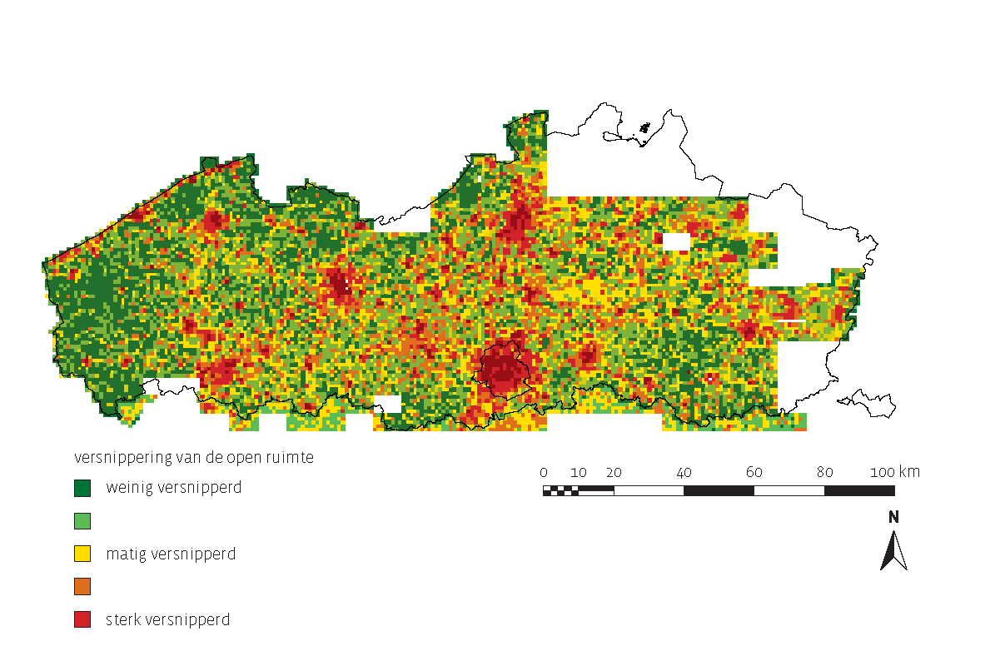

Figure 15. Fragmentation of the Flemish territory (Source: Environment Report based on data provided by the National Geographical Institute), http://www.milieurapport.be/nl/feitencijfers/MIRA-T/milieuthemas/versnippering/versnippering-van-de-open-ruimte/versnippering-van-de-open-ruimte/.

4.2.2. Walloon Region

Fragmentation of the territory

Land fragmentation contributes to the loss of biodiversity with:
- demographic consequences linked to the lack of habitat and/or food and confining species to restricted spaces, thereby limiting their chances of survival;
- genetic consequences linked to the isolation of populations and the subsequent genetic impoverishment that can eventually lead to the disappearance of certain species.

A recent study has provided an estimate of the level of land fragmentation in Wallonia based on an ‘effective mesh size’ (EMS) indicator. When taking all possible ecological obstacles into account, the sandy-loamy and loamy regions appear to be most fragmented, whereas the regions to the south of Condroz are less affected. Only 28% of the loamy region has an EMS greater than 10 ha, compared with more than 90% for Famenne, Belgian Lorraine and the Ardennes. This situation is basically a result of greater urban, economic and agricultural pressure to the north of the Sambre and Meuse river line.

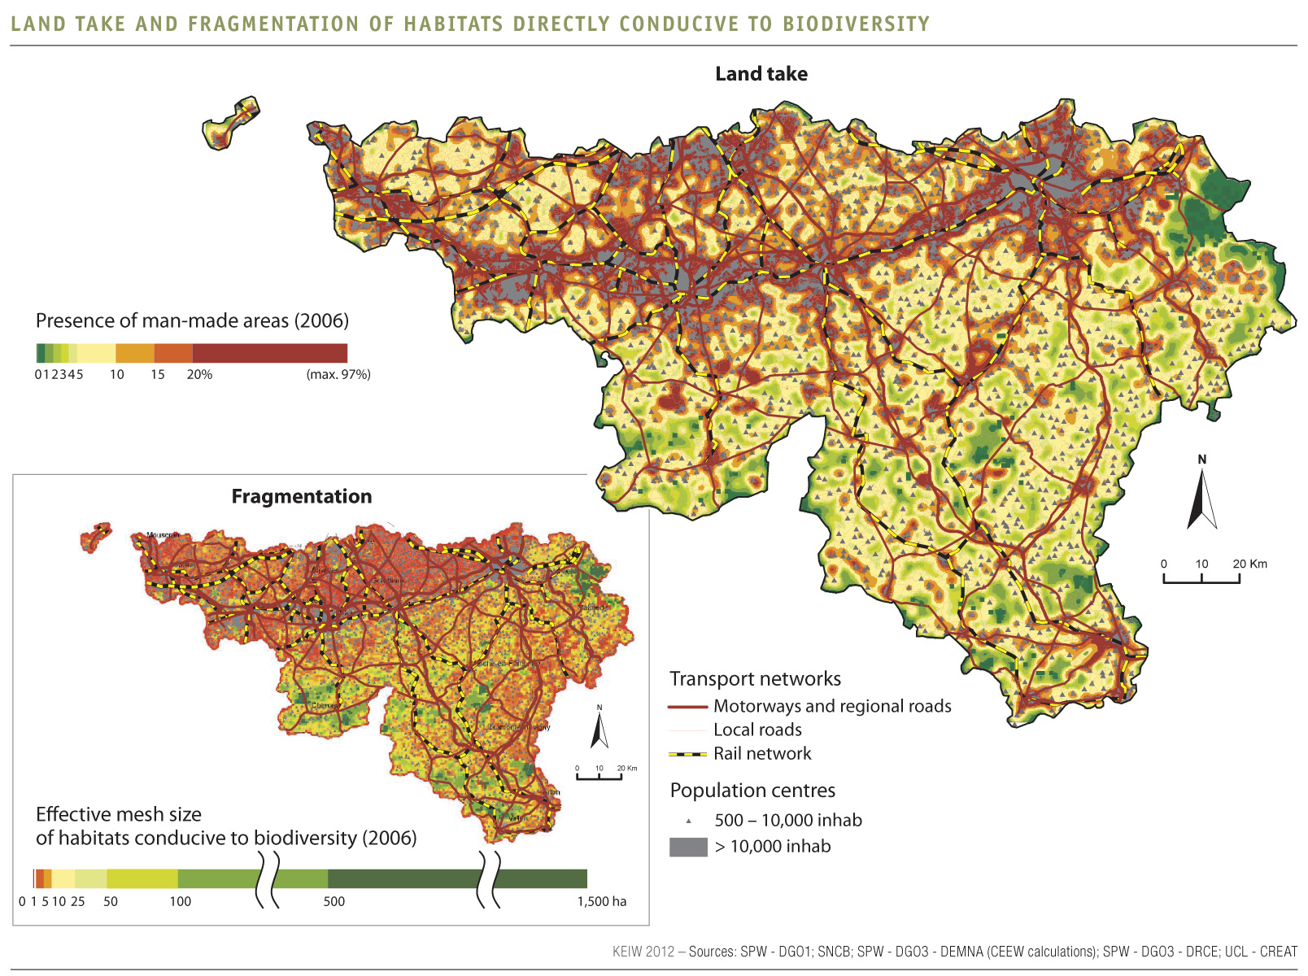

Figure 16. Fragmentation of the Walloon territory (Source: UCL-CREAT, DGO3 - DRCE (COSW 2006), Calculs CEEW), http://etat.environnement.wallonie.be/index.php?mact=tbe,m588bb,default,1&m588bbalias=Land-fragmentation_1&m588bbreturnid=46&page=46.

4.2.3. Brussels-Capital Region

Loss and fragmentation of open spaces

Brussels has a long extension history at the expense of the surrounding green spaces. In a first phase this extension resulted mainly in a shift of the soil affectation, for example the conversion of forests into agricultural zones. Urbanisation followed during a second phase. Towards the exterior, Brussels extended along the Senne and the canal Brussels-Charleroi. Towards the interior, Brussels was characterised by a second densification phase starting from the habitation centers. Both processes resulted in the loss of numerous natural and semi-natural green spaces. Another consequence of the urbanisation is the loss of the continuity and the disappearance of the connections between the enclosed green spaces. Patches of forests, grasslands and bogs are isolated due to the loss of the natural matrix. In an urban context, this fragmentation of habitats submits the fauna and flora to strong pressures. The presence of species in the landscape depends upon the availability of habitats with an adequate size and quality and upon the possibility to move from one zone to another following their needs (search for food, reproduction, migration, etc.).

The description of the green spaces in Brussels shows that the green spots are close to one another in the periphery. About 70% of the woodlands of at least 0.5 ha are situated less than 10 metres from each other. For open environments of the grassland type, this figure is somewhat inferior to 20%, but locally more pronounced such as in Neerpede where it reaches 50% for grasslands and fields. Initiatives to reduce the fragmentation are thus part of a realistic objective. Fig. 17 illustrates the fragmentation of the habitats by the dense network of roads and constructions. The green spaces are not very distant from one another but the road network limits significantly the dispersion of less mobile and of easily disturbed species.

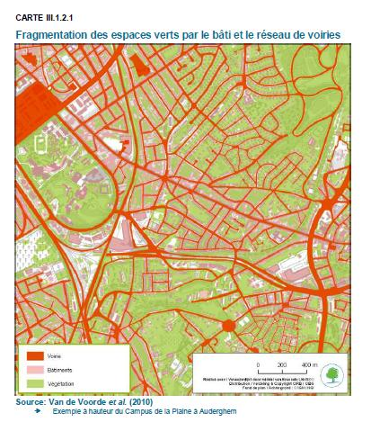
Figure 17. Example of fragmentation in the Brussels-Capital Region (Source: http://documentation.bruxellesenvironnement.be/documents/NARABRU_20120910_FR_150dpi.pdf).

Running and standing water elements in Brussels also suffer from fragmentation. One of the main problems of the aquatic network is the overarching of water courses as well as their connection to the sewage systeme, making the development of aquatic life impossible and creating impassable barriers for numerous species such as the amur bitterling, a Natura 2000-species.

The challenge will be to maintain the existing connections and to apply measures to reduce fragmentation in locations where these measures will be the most efficient.

4.2.4. Belgian part of the North Sea

Fragmentation of and activities in the seascape

The Belgian part of the North Sea welcomes an extraordinary biodiversity thanks to its location along migration routes, the combination of sandbanks, diverse soil types, tides and a varied water composition. The species and habitats of European importance are the best example of this. The sea and its biodiversity also deliver various products and services that form the basis of important economic activities.

Nevertheless, our lively coastal waters are under considerable pressure (fig. 18). Not only is the southern North Sea the busiest navigated region in the world, there are numerous other activities as well, such as fisheries, sand extraction, dredging, wind power generation, military operations and leisure activities, that put the marine environment under pressure: disturbances, pollution, bycatch, alien species, etc. Most of these pressures have a negative impact on the state of marine species and habitats.

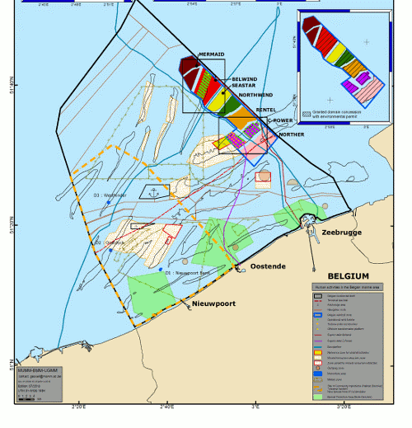
Figure 18. Numerous human activities take place in the Belgian part of the North Sea (Source: http://www.mumm.ac.be/EN/Management/Atlas/map.php?HumanActivities).

4.3. Pollution and eutrophication

4.3.1. Flemish Region

Exceedance of critical load for eutrophication

Eutrophication causes damage to natural vegetation. Nitrofilous plants are favoured and biodiversity is
affected. Nitrate leaching can occur. For each type of vegetation, ‘critical loads’ for eutrophication are
determined as the damage threshold for atmospheric nitrogen deposition. If these deposition limits are
exceeded, it will lead to harmful effects on vegetation in the long term. According to the target in the MINA plan 4 (2011-2015), only 65% of the nature surface in Flanders may still exceed the limits by 2015.

In 2010, on 75% of the Flemish nature area (forest, heathland and species-rich grassland) the critical
load for eutrophication was exceeded. For forest, the figure is 100%. For heathland and species-rich
grassland, it is 99% and 15% respectively. In 2004, 47% of the nature in the EU-25 was exposed to
nitrogen deposition levels higher than the critical load (fig. 19).

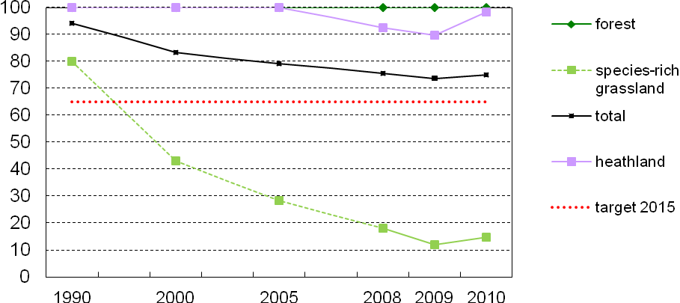

Figure 19. Nature area with exceedance of critical load for eutrophication (Flanders, 1990-2010).

The long-term objective is that there should be no nature area where the critical load is exceeded. The conversion from coniferous forest to broadleaf forest reduces the sensitivity to acidification. Moreover, the long-term effect of the critical load being exceeded leads to an accumulation of nitrogen in the soil, the effects of which are not yet well understood. This implies that eutrophication is a much greater threat to the conservation of biodiversity than acidification. The current deposition values pose a barrier to achieving the conservation objectives for Natura 2000 areas. Further emission reductions under international agreements are necessary. For Flanders this means that both NO_{x} and NH₃ emissions must be further reduced.
http://www.milieurapport.be/nl/feitencijfers/mira-t/milieuthemas/vermesting/gevolgen-van-vermesting/oppervlakte-natuur-met-overschrijding-kritische-last-vermesting/.

Exceedance of critical load for acidification

Acidification causes damage to vegetation. Biodiversity is affected. Forests suffer root damage. For each type of vegetation, ‘critical loads’ for acidification have been determined as the damage threshold for acidifying deposition. If these deposition limits are exceeded, this leads in the long term to harmful effects on the vegetation.

In 2010, the critical load for acidification was exceeded in 28% of the total area of terrestrial ecosystems (forest, heathland and species-rich grassland) in Flanders. This is a rather positive development since in 2008 critical loads were still being exceeded in 38% of the total area. Between 2009 and 2010 however the situation remained more or less constant. Forests remain the most sensitive, with the limits being exceeded in 42% of the area in 2010. Because the critical load is based on threshold values, even minor changes in deposition can, in some cases, lead to larger changes in nature area achieving compliance with the critical load for acidification.

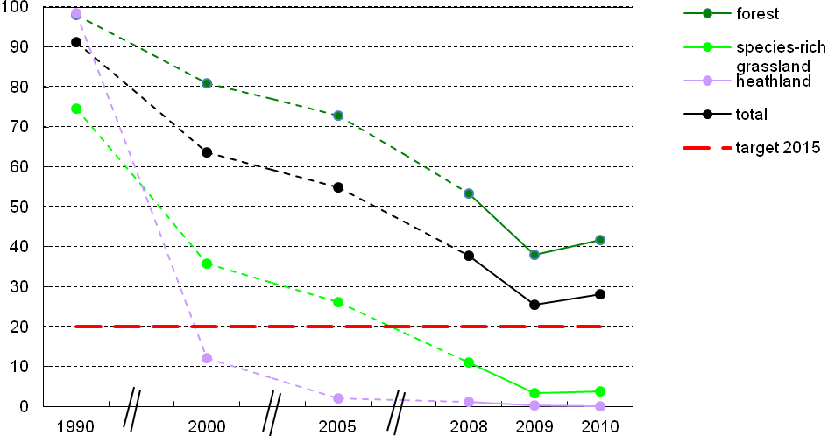
Figure 20. Nature area with exceedance of critical load for acidification (Flanders, 1990-2010).

Efforts are still needed to meet the objective of the MINA plan 4 (2011-2015), notably to reduce the
percentage of nature area where limits are being exceeded to 20% by 2015. By comparison, the critical load was exceeded in the EU-25 in 2004 in 15% of the nature area. The European long-term objective is to ensure that the critical loads for acidification are not exceeded in any ecosystem. Additional efforts continue to be needed to reduce the emissions of acidifying substances into the air. Moreover, the decrease in the pressure on ecosystems in Flanders does not lead directly to a proportional recovery of the soil and biodiversity. This recovery is a very slow process, which depends, among other things, on the duration and the degree of the historic excess.
http://www.milieurapport.be/nl/feitencijfers/mira-t/milieuthemas/verzuring/gevolgen-van-verzuring/oppervlakte-natuur-met-overschrijding-van-de-kritische-last-verzuring/

4.3.2. Walloon Region

Exceedance of critical load for acidification and eutrophication

When present in excessive amounts, depositions of atmospheric acidifying and eutrophying pollutants (sulphur and nitrogen compounds) constitute one of the major causes for ecosystem degradation. They can in particular induce nutritional imbalances as well as the decline/disappearance of certain plant species.

In 2007, some 6% of forested areas and nearly all open habitats (heathland, marshes, bogs, etc.) in Wallonia were affected by nitrogen depositions exceeding the acceptable critical load of eutrophying nitrogen. In forested areas, the situation has greatly improved compared to 1990 as a result of a reduction in atmospheric nitrogen depositions. This is not the case for other (semi-)natural ecosystems (in particular oligotrophic ones) which remain extremely sensitive to this type of disturbance. As regards acidification, the current status is now much less of a problem, in the sense that the percentage of forested areas affected has dropped from 90% in 1990 to under 10% in 2007. This development reflects the positive effect of the measures introduced to reduce emissions of acidifying pollutants by 50-60% (between 1990 and 2010) at both Walloon and European levels.
http://etat.environnement.wallonie.be/index.php?mact=tbe,m588bb,default,1&m588bbalias=Exceedance-of-critical-loads-of-acidifying-and-eutrophying-pollutants&m588bbreturnid=46&page=46

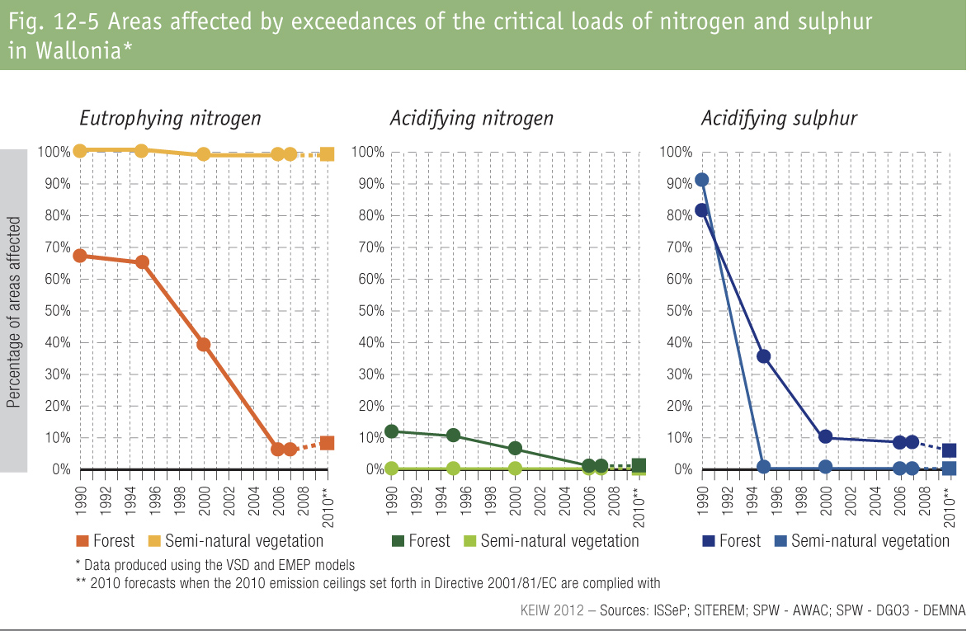

Figure 21. Areas affected by exceedance of critical loads of nitrogen and sulphur in the Walloon Region.

Eutrophication of watercourses

The most eutrophied water courses are found mainly in north Wallonia, in the Scheldt river basin with its large density of urban and industrial areas as well as a lot of agricultural plots. Improvements in water quality are cyclical, due to a combination of factors. While reduced industrial pollution, tertiary treatment
of urban waste water, a ban on phosphates in detergents and the lower use of phosphorous fertilizers (decrease of 70% between 1995 and 2010) are improving the situation, various diffuse inflows, generally higher after significant rainfall (run-off, erosion, etc.), the presence of polluted sediments and lower water flow rates
(in dry years) are increasing the concentration of phosphates. Greater improvement in water quality is expected following the introduction of additional measures proposed in the draft river basin management plans.
http://etat.environnement.wallonie.be/index.php?mact=tbe,m588bb,default,1&m588bbalias=Eutrophication-of-water-courses&m588bbreturnid=46&page=46

4.3.3. Brussels-Capital Region

Acidification and nutrient enrichment of soils through atmospheric depositions still constitute limiting factors for the qualitative development of habitats on nutrient-poor soils. Nutrient-poor grasslands such as grasslands with common Agrostis, recognized as natural habitat of regional interest, are also suffering from these two phenomenons, while eutrophication is compromising the long terme presence of acidophilic oak stands on poor and sandy soils (habitat of European interest).

In the past the chemical quality of the water elements in Brussels was strongly influenced by domestic and industrial wastewater as well as by diffuse pollutions. Until 2000 the wastewater running through the sewage systeme and the collectors were spilled out directly in the Senne, increasing even more the pollution load coming from upstream. The water treatment plants South (active since August 2000) and North (active since October 2006) now treat the organic and suspended matter. Thanks to this important treatment effort, the concentrations of nitrogen and phosphorus as well as the values of the biological oxygen demand and the chemical oxygen demand are decreasing while the concentration of dissolved oxygen in the water is increasing, allowing to respect the actual norms. During heavy rainfall, however, overflows from the sewage network into the surface waters can still be observed and the collection of wastewater is not covered for 100% (some wastewater is still reaching the Verrewinkelbeek, a water course running through and in the proximity of zones with a high biological value, but this will be adressed at the end of 2013 by the finalisation of a new collector). Another factor possibly contributing to the eutrophication of small water elements is the perseverance of the feeding of water birds and pigeons by citizens, despite the fact that this is forbidden. The set up of a sensibilisation campaign adressing this issue is therefore recommanded.
http://documentation.bruxellesenvironnement.be/documents/NARABRU_20120910_FR_150dpi.pdf

4.3.4. Belgian part of the North Sea

Marine biodiversity is particularly threatened in our coastal zone and shelf sea, where direct and indirect disturbances are concentrated. There is also a trend towards more industrial activities at sea (sand and gravel extraction, mariculture, wind turbines, etc.). Marine pollution remains a concern: eutrophication of the marine environment caused by riverine input of nitrates and phosphates, input of hazardous substances from land based activities, pollution caused by accidents at sea. Heavy metal input into the Belgian part of the North Sea decreased substantially during the last 20 years. Organotin compounds (TBT) are still a major concern, particularly in sediment near harbors and shipping lanes, although the total ban of TBT clearly results in a sharp decrease of ambient concentrations. As far as other organic compounds are concerned (PAH, PCBs, etc.), these hazardous substances remain a concern, primarily as a result of historical inputs into the marine environment and the very low degradation rate. Perfluorinated Organic Compounds and Brominated Flame Retardants constitute a more recent problem, emerging contaminants are constantly sought after.

4.4. Invasive alien species

4.4.1. Flemish Region

Number of alien animal species
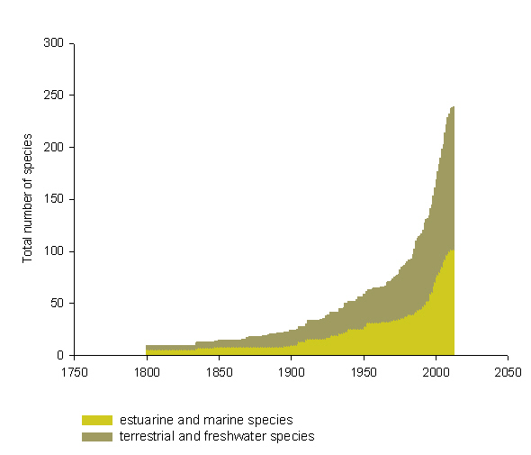

Figure 22. Number of alien animal species in Flanders (Source: Research Institute for Nature and Forest, VLIZ Alien Species Consortium).

This indicator evaluates the cumulative number of species that do not live in Flanders naturally, but were introduced through human activities. Between 1800 and 2012 about 250 alien species were found in Flanders. It is expected that the number of biological invasions will continue to rise if policy remains unchanged.
http://indicatoren.milieuinfo.be/indicatorenportal.cgi?lang=en&detail=654&id_structuur=19

Number of alien plant species

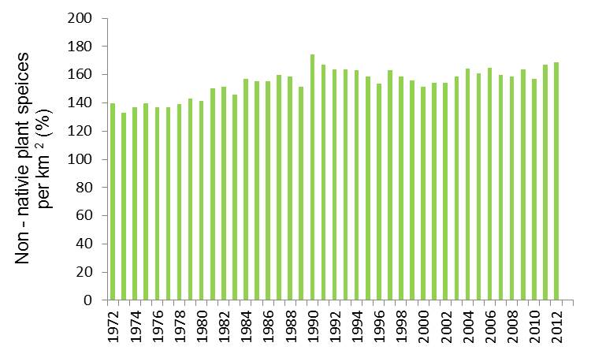

Figure 23. Alien plant species per km² in Flanders (Source: Research Institute for Nature and Forest, FLOWer vzw, National Botanical Garden).

The percentage of non-native species within the plant species assemblages in Flanders is increasing steadily, most probably because of globalisation of trade, transport and tourism. New invasions can be the result of either intentional (e.g. use of ornamental species in horticulture) or unintentional (e.g. contamination by transport of seeds) introductions. Only part of these introductions result in permanent establishment and only some of the naturalised species subsequently spread spontaneously. In light of the steady increase of many non-native plant species and the growing number of new arrivals, we expect a growing percentage of non-natives in the Flemish flora.
http://indicatoren.milieuinfo.be/indicatorenportal.cgi?lang=en&detail=712&id_structuur=19

4.4.2. Walloon Region

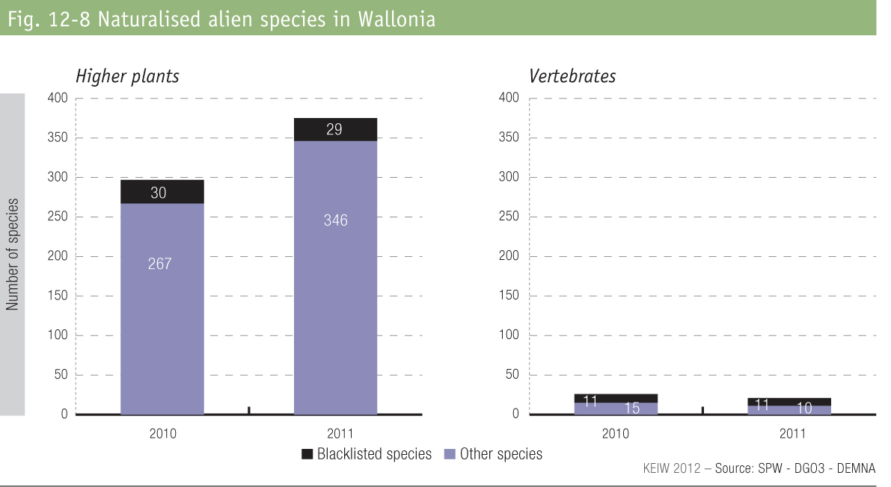

Figure 24. Number of naturalised alien species in the Walloon Region.

In Wallonia, 375 species of ornamental plants and 21 species of vertebrates of alien origin were naturalised in 2011. Among them, 29 plant species and 11 vertebate species are known to cause major environmental damage and are therefore blacklisted. The number of naturalised species is steadily growing, with several species of mammals having gained a footing in Wallonia over the last few years. The changes observed in relation to previous estimates do not necessarily reflect the arrival or disappearance of invasive species on the territory; they can also reflect increased survey work on the ground or progress in scientific knowledge. On the initiative of the Walloon structure responsible for coordinating work on invasive species, different types of preventive tools are currently under development. In addition, a plan for fighting Giant Hogweed has been recently introduced with the collaboration of different River Contracts in Wallonia.
http://etat.environnement.wallonie.be/index.php?mact=tbe,m588bb,default,1&m588bbalias=Invasive-alien-species_1&m588bbreturnid=46&page=46

4.4.3. Brussels-Capital Region

Table 4. Number of species (within various groups) observed in the Brussels-Capital Region. Source : Bruxelles Environnement – IBGE : species database, January 2011.

 | Total number of species in the Brussels-Capital Region | Number of exotic species | Percentage of exotic species in the total number of species
reptiles | 7 | 3 | 42,9
higher plants | 793 | 215 | 27,1
amphibians | 9 | 0 | 0
birds | 103 | 11 | 10,7
mammals | 44 | 3 | 6,8
grasshoppers and crickets | 26 | 1 | 3,8
butterflies | 28 | 1 | 3,6
mushrooms | 913 | 1 | 0,1

The majority of species groups count one or more exotic species. Table 4 shows the percentage of exotic species within different groups. The proportion of exotic species is particularly high within the reptiles, higher plants and birds. Within the reptiles, however, it only concerns subspecies which are not reproducing in nature in our regions (red-eared and yellow-eared slider) and the observations concern rather isolated cases of released or escaped individuals. Among the exotic plants observed in Brussels, several are invasive. Best known are the Japanese knotweed (Fallopia japonica), giant hogweed (Heracleum mantegazzianum) and black cherry (Prunus serotina). These three species are widely distributed in the Brussels-Capital Region.

Among the birds, the best known invasive species are the Egyptian goose, the Canada goose and three species of green parakeets. From 1992 to 2010, the population of the Alexandrine parakeet increased on average by 20% each year (Weiserbs & Derouaux, 2011). The increase of the population of the ring-necked parakeet during the same period was less spectacular (10% per year, in average), but the increasing trend does not seem to bend. In 2011, the number of parakeets counted in the three sleeping sites known in Brussels reached a maximum of 10,500 individuals (Alexandrine and ring-necked parakeets).

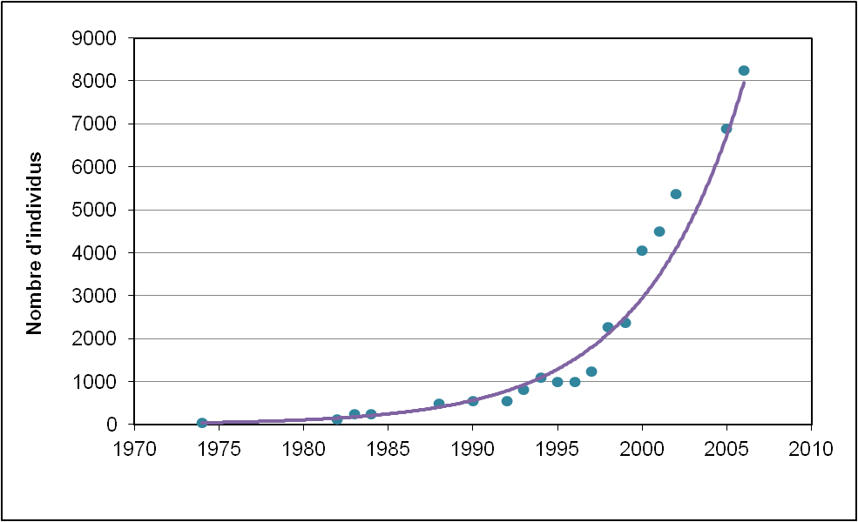

Figure 25. Evolution of the number of Alexandrine and ring-necked parakeets in the Brussels-Capital Region (Source: AVES).

From 2000 on, the lightning progression of the multicolored Asian lady beetle has received much attention. In 2003, only two years after its first observation in nature, this species was already the most common ladybird in our region. Since its larvae are predating the larvae of our indigenous species, with which they also compete for the same food sources, an ecological disaster could be feared. Meanwhile the species, sold as a biological control agent acting against aphids, has been withdrawn from the commerce.
http://documentation.bruxellesenvironnement.be/documents/NARABRU_20120910_FR_150dpi.pdf

4.4.4. Belgian part of the North Sea

A study by Kerckhof et al. (2007) identified 61 alien species in the Belgian marine and brackish waters, eight of which are considered cryptogenic. The majority of these species have established self-sustaining populations, although for some species the establishment is uncertain or in need of verification. Four species, namely the American jack-knife clam Ensis directus (Conrad, 1843), the pacific oyster Crassostrea gigas (Thunberg, 1793), the New Zealand barnacle Elminius modestus Darwin, 1854 and the slipper limpet Crepidula fornicata (Linnaeus, 1758) now constitute a dominant part of the Belgian marine nearshore fauna. These species are invasive, competing with native species, changing the original habitat and significantly altering the overall biodiversity and biomass. Prime introduction vectors are shipping, including small recreational craft. The invasion rate has been increasing during the last two decades.

4.5. Impact of climate change on biodiversity

4.5.1. Flemish Region

Dragonflies

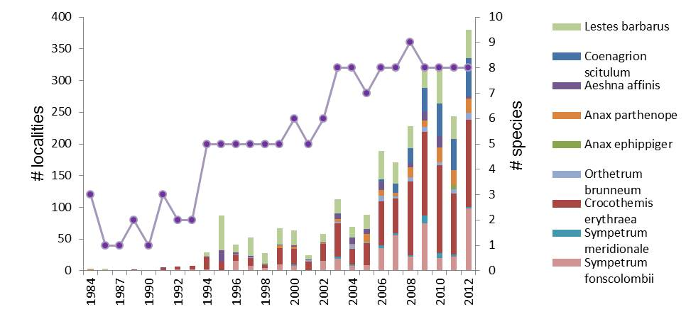

Figure 26. Evolution of the number of localities from Southern European dragonflies and the total number of observed species (Source: Flemish Dragonfly Society an the common database of Natuurpunt Studie vzw and the Flemish Dragonfly Society that were collected by http://www.natuurindicatoren.be).

During the last two decades, many Mediterranean dragonflies (Odonata) expanded their range northwards. Until 1980, populations of these were unknown in north-western Europe. Here we analysed the evolution of the number of localities since 1980 for each of the nine Mediterranean species and the total number of Mediterranean species observed. The figure shows that both the number of localities for each of those nine species as the number of species increased since 1980. A first clear increase can be noticed since 1994, followed by a steep increase since 2006, both for the number of localities as for the number of species seen annually. Even if there are annual fluctuations, mostly due to weather conditions during the time of the flight season, this trend is clear and statistically significant. Never before were these species seen on so many localities in Flanders as in 2012. Species as the Broad Scarlet (Crocothemis erythraea) or the Dainty Bluet damselfly (Coenagrion scitulum) have already several years many flourishing populations in Flanders. http://indicatoren.milieuinfo.be/indicatorenportal.cgi?lang=en&detail=404&id_structuur=25

Migrating birds

The arrival date for 15 species has been monitored during the past 20 years. This arrival date has advanced by on average 7.63 days (or 0.45 days/year). The biggest change was recorded for Common Chiffchaff (total 20 days or 1.16 days/year), the smallest for Marsh Warbler (total 3 days or 0.17 days/year).

Since some species adapt better than others, there is a risk for changes in the food web and/or ecological cohesion of ecosystems. This is illustrated by the Pied Flycatcher. The arrival date of this migratory species advances more slowly than the period of occurrence of the main food for its young, the caterpillars of the Winter Moth. This is a possible cause of the decline of this forest woodland bird.
http://indicatoren.milieuinfo.be/indicatorenportal.cgi?lang=en&detail=406&id_structuur=25.

4.5.2. Walloon Region

Dragonflies

For the past decade, the frequency of southern dragonfly species has increased significantly. Seven species have recently settled down. If various colonisation trends have always been observed, they used to be limited in time (e.g. during warm summers). The new arrivals are more stable in time, and are interpreted as a consequence of climate change. Species with a more northern distribution also suffer from the rise in temperature as they have quite strict habitat requirements.
http://environnement.wallonie.be/eew/rapportchapitre.aspx?id=ch12

Birds

A recent study by BirdLife International predicted a movement in the ranges of European bird species of 550 km to the north east by 2100. This study is based on the “climate envelope” model for a probable rise of 3°C for the global average temperature. Wallonia would be the range limit for 60 species, 44 of which would be on the decline and 16 on the rise. There would be 19 new species, and the same number of species which would disappear.
http://environnement.wallonie.be/eew/rapportProblematique.aspx?id=p105

Butterflies

The climate's warming benefits certain southern species, which have posted the greatest expansions of their ranges. Still, the lack of relay habitats in Wallonia, e.g., "hot" habitats such as chalk grasslands for xerothermophilic species, is thought to limit the northward expansion of a series of other species that have more demanding habitat requirements and/or are less mobile.
http://environnement.wallonie.be/eew/downfile.aspx?dwn=ffh.pdf&dir=tbe2005en

4.5.3. Brussels-Capital Region

The recent changes of the flora of the Brussels-Capital Region show that it is adapting to a warmer mineral and ambient environment, typical for an urban setting. The species showing the most progression in the periods 1991-1994 and 2003-2005 (such as the creeping woodsorrel and proso millet) are typical for dry, undeep and rapidly warming substrates. Among them, numerous species are neophytes originating from warmer regions such as the Mediterranean basin (tomato, box elder, common fig). It is however too early to attribute these evolutions to climate change. Other factors are indeed contributing to these observations such as the progression of the regions’ urbanisation as well as a more intense prospection of urban environments in more recent times.

4.5.4. Belgian part of the North Sea

Regional climate change scenarios predict an increase in air temperature of 2-3.5°C by the 2080s, with high summer temperatures becoming more frequent and very cold winters becoming increasingly rare. Water temperatures will also increase, but not as rapidly as temperature over land. Sea-level is expected to rise by 35-84 cm at 2100 compared to 1990.

Observed correlations strongly suggest that the North Sea ecosystem is vulnerable to variation in climatic conditions in general, and to anomalies in temperature and hydrodynamics in particular. Several processes within the North Sea food web appear to rely on temperature as a trigger, and further increases in temperature may disrupt the connectedness between species potentially leading to changes in community structures and possibly local extinctions. For many marine species, including commercially caught fish, the number of recruits mainly determines the year-to-year variation in the size of the adult stocks. If the annual sea-surface temperature increases further, efforts to maintain previous fishery yields from reduced stocks (due to northward movement and lowered recruitment levels) have the potential to significantly impact fisheries and have strong effects on the local ecosystem.

Because of the strong tidal regime and the effects of storm surges many of the coastal regions of the North Sea, especially in the south, are particularly susceptible to rising sea levels and to an increase in the frequency and severity of storms.
Chapter II - Status of national biodiversity strategies and action plans, their implementation, and the mainstreaming of biodiversity

1. Introduction

Given the structure of the country, as a federal state composed of communities and region, there are several levels of biodiversity policy development in Belgium.

Belgium has adopted its first National Biodiversity Strategy (2006-2016) in October 2006. It has been reviewed and updated in 2013. Both documents are available at:
http://www.biodiv.be/implementation/docs/stratactplan.

The three Belgian Regions - the Flemish Region, the Walloon Region and the Brussels-Capital Region - each have their own strategic documents and action plans in relation to biodiversity:
- The objectives for the conservation of biodiversity in the Flemish Region are included in the Policy Plan for Environment (2011-2015) under a specific chapter on biodiversity: http://www.lne.be/themas/beleid/mina4.
Since 2006 the Agency for Nature and Forests also has its own Strategic Plan and a yearly operational plan giving more detailed information on objectives, actions and indicators related to actions and processes for the conservation and management of nature, forests and green spaces: (in Dutch) http://www.natuurenbos.be/nl-BE/Over-ons/Missie_en_visie.aspx.
- The strategic plan 2008-2013 of the administration in charge of agriculture, natural resources and the environment in the Walloon Region includes biodiversity objectives. In the Walloon Region, the administration for agriculture, natural resources and the environment has adopted a strategic plan with targets and indicators for the period 2008-2013. It will be renewed in 2014. The Wallonia Nature Network, a progressive catalogue of concrete and realistic actions, is also being developed. More information on http://biodiversite.wallonie.be.
- In application of a new global nature legislation (ordonnance du 1er mars 2012 relative à la conservation de la nature), the Brussels-Capital Region has adopted in September 2013 a project of regional nature plan. This project establishes the Brussels vision for nature at the horizon 2050 and sets up 7 main objectives for 2020 that are underpinned with a set of 26 measures. A public consultation on this project plan is planned for the very beginning of year 2014. http://www.bruxellesenvironnement.be/plannature.

At the federal level, the government has identified priority policies for biodiversity in its Federal Plan for Sustainable Development (2009-2012 (FPSD2)). In response to the action 18 of the FPSD2, the federal plan (2009-2013) for the integration of biodiversity in 4 federal sectors has been developed. Since 2013, a pre-project of the third plan (FPSD3) is in preparation which will also include specific measures and actions related to biodiversity and ecosystem services. The federal government has also established a ‘Masterplan’ for the management of the Belgian North Sea.

2. Biodiversity 2020, Update of Belgium’s National Strategy

2.1. Description

Belgium’s first National Biodiversity Strategy (NBS) was adopted on 26 October 2006 by the Interministerial Conference for the Environment, which is composed of the competent ministers of the Federal Government and the three Regions of Belgium (Flanders, Brussels, Wallonia). Its updated version for the period 2013-2020 was adopted on 13/11/2013.

The strategy is the Belgian answer to the formal obligation under the CBD, while also taking into account existing strategies, plans and documents at (pan-)European level. It is also a necessary tool to confirm priority and voluntary themes and goals of and for Belgian policy-makers. It is a most useful framework document for supporting the integration and the fine-tuning of Regional and Federal action plans.

Updating process

In March 2012, the Interministerial Conference for the Environment decided to extend the length of validity of the current strategy with four years, until 2020. The update of the strategy has been carried out in 2013 by the national Steering Committee ‘Biodiversity Convention’, one of the committees established under the Coordination Committee for International Environment Policy (CCIEP). The updated strategy considered the conclusions of the mid-term state of play of the implementation of the NBS (2011) and the recommendations formulated for the updating of the NBS (2012). Adaptations were also made to fully reflect the new international and European commitments made by Belgium until 2013 in the field of biodiversity, as the CBD Aichi targets and the new EU Biodiversity Strategy to 2020. It also takes into account the results of international processes such as The Economics of Ecosystems and Biodiversity (TEEB reports on mainstreaming the Economics of Nature presented at the CBD COP-10) and the newly created Intergovernmental Platform on Biodiversity and Ecosystem Services (IPBES).

The draft updated strategy went through a public consultation in 2013 (May-July) and has been debated during a stakeholders dialog organized in June 2013 with representatives of the civil society, private sector trade unions, NGO's and administrations. The final consolidated version, taking into account the comments and opinions received during the consultation, has been approved by the Interministerial Conference for the Environment on 13/11/2013.
For more information on the updating process, please visit: http://www.biodiv.be/implementation/strategy-be/updating-process-nbs.

The updated strategy

While revising the NBS it appeared important to frame its objectives into a vision for the future and adopt a general objective achievable by 2020, so as the Strategic Plan of the CBD and the EU 2020 Biodiversity Strategy:

Vision to 2050: By 2050, our biodiversity and the ecosystem services it provides - our natural capital - are valued, conserved, appropriately restored and wisely used for their intrinsic value and for their essential contribution to human well-being and economic prosperity, and so that catastrophic changes caused by the loss of biodiversity are avoided

General objective of the Strategy until 2020: The general objective of the Strategy is to contribute nationally and internationally to the achievement of the 2020 target of halting the loss of biodiversity and
the degradation of ecosystem services, and restoring them in so far as feasible, while stepping up our contribution to averting global biodiversity loss.

The updated strategy spells out a range of 15 priority strategic objectives and 85 operational objectives to guide the development of actions by the stakeholders and competent regional and federal authorities. All operational objectives have to be implemented by 2020 at the latest, unless otherwise stated. Several objectives remain unchanged while others are only slightly amended.

The 15 strategic objectives are the following:
- Identify and monitor priority components of biodiversity in Belgium.
- Investigate and monitor the effects of threatening processes and activities and their causes.
- Maintain or restore biodiversity and ecosystem services in Belgium to a favourable conservation status.
- Ensure and promote the sustainable use of components of biodiversity.
- Improve the integration of biodiversity concerns into all relevant sectoral policies.
- Promote and contribute to an equitable access to and sharing of benefits arising from the use of genetic resources-ABS.
- Improve and communicate scientific knowledge on biodiversity and ecosystem services.
- Involve the community through communication, education, public awareness and training.
- Strengthen the biodiversity-related regulatory framework and ensure the implementation of, compliance with and enforcement of biodiversity-related legislations.
- Ensure a coherent implementation of / and between biodiversity-related commitments and agreements.
- Ensure continued and effective international cooperation for the protection of biodiversity.
- Influence the international agenda within biodiversity-related conventions.
- Enhance Belgium’s efforts to integrate biodiversity concerns into relevant international organisations and programs.
- Promote the commitment of cities, provinces and other local authorities in the implementation of the Biodiversity Strategy 2020.
- Ensure the provision of adequate resources for biodiversity.

The 15 strategic objectives cover both biodiversity in Belgium and the impact of our activities in the rest of the world, including through international cooperation and our economic activities. The strategy pays special attention to the need for the integration of the conservation and sustainable use of biological diversity into the different relevant sectors of society including social and economic sectors. Some specific issues (such as GMOs, biofuels, climate change, invasive alien species) are treated horizontally through the different objectives of the Strategy. One additional strategic objective has been added to promote the engagement of the provinces, cities and other local authorities. The former objective 14 on promoting sustainable forest management in other countries has been merged with objectives 11 and 13.

New operational objectives have been added to respond to the commitments at global and European level:
- Tackling emerging risks and the impact of internal trade of live specimens (op. obj. 2.3).
- Protecting and restoring biodiversity and associated ecosystem services through protected areas – green infrastructure – no net loss (op. obj. 3.3 and 3.8).
- Identify pathways of introduction of Invasive Alien Species (IAS) (op. obj. 3.7).
- Phasing out perverse incentives and using guidelines on the integration of the values of biodiversity and ecosystem services, in development strategies, planning processes and reporting systems included (op. obj. 5.5).
- Developing an approach to include these values in national accounting (op. obj. 5.11).
- Implementing the Nagoya Protocol (op. obj. 6.2).
- Mapping ecosystem services in Belgium and assessing their values (op. obj. 7.4).
- Ensuring the implementation and enforcement of biodiversity legislation (op. obj. 9.2).
- Involving provinces, cities and other local authorities (op. obj. 14).
- Boosting the mobilisation of resources (including through innovative mechanisms) and enhancing capacities (op. obj. 15.3 and 15.4).

Four support mechanisms for implementation have been identified in the updated strategy:
SM1. By 2015, adopt, apply and publish indicators to measure progress against the strategic objectives of the NBS.
SM2. By 2015, implement the EU reporting tool for NBSs on the CHM website.
SM3. By 2015, have a functional Clearing-House Mechanism in place for the Convention and its
protocols, including a network of practitioners.
SM4. By 2015, functional Clearing-Houses for implementation and technology transfer are in place
for the CBD and its Protocols (BCH, ABS-CH).

To promote the implementation of the updated Strategy and to inform stakeholders of possible actions at their level, a brochure was drafted in French and Dutch. A study day with a poster session will be organised in the margins of the International Biodiversity Day in May 2014. The invited stakeholders are the federal, regional and local authorities (provinces and municipalities included), agencies for nature conservation, local coordinators Agenda 21 and PCDN, professional associations with activities in the concerned sectors, representants of the civil society, universities, institutions involved in research, environment and/or development cooperation, and NGOs. The public at large will be informed of the NBS through social media and diffusion by all partners of a postcard entitled '2020, a future for Biodiversity in Belgium', printed in French, Dutch, German and English.

2.2. Targets and indicators

No specific actions nor indicators are adopted in the Strategy itself but they will be adopted and developed in a later stage in the implementation process, in consultation with all the actors for biodiversity in Belgium. However, specific targets and actions are already included in the plans of the Regions. Indicators will be developed to enable a better follow-up of the implementation of the strategy.

2.3. Relation with the Convention on Biological Diversity

The text of the NBS clearly identifies, for each objective, the link with articles of the CBD, the relevant Aichi targets, thematic programs of work, guidelines, etc. adopted under the Convention. A Concordance table was created as an appendix to the NBS, which links the Aichi targets with the objectives of the updated NBS (see appendix I).

Major adaptations made to contribute to the achievement of the Strategic Plan for biodiversity 2011-2020:

Objectives 3.1 and 3.2 have been adapted to align with Aichi target 11:
-3.1 At least 17 per cent of terrestrial and inland water areas, especially areas of particular importance for biodiversity and ecosystem services, are conserved through the development of effectively and equitably managed, ecologically representative and well-connected systems of protected areas and other effective area-based conservation measures, and are integrated into the wider landscapes.
-3.2 At least 10 per cent of coastal and marine areas, especially areas of particular importance to biodiversity and
ecosystem services, are conserved through the development of effectively and equitably managed, ecologically
representative and well-connected systems of protected areas and other effective area-based conservation measures,
and are integrated into the wider seascapes.

Objective 3.3 was adapted to align with Aichi targets 14 and 15:
-3.3 Ecosystems, their resilience and their services are maintained and enhanced by establishing, inter alia, a green
infrastructure and restoring at least 15 % of degraded ecosystems.

Objective 3.7 has been developed to align with Aichi target 9:
-3.7 Invasive alien species (IAS) and pathways are identified and prioritized, priority species are controlled or eradicated, and measures are in place to manage pathways to prevent their introduction and establishment.

Objective 5.5 was adapted to align with Aichi target 3:
-5.5 Eliminate, phase out or reform incentives, including subsidies, harmful to biodiversity in order to minimize or
avoid negative impacts on biodiversity and encourage the development and application of incentives favourable to the conservation and sustainable use of biodiversity, including economic, fiscal and financial instruments.

Objective 5.11 was adapted to align with Aichi target 2:
-5.11 Integrate biodiversity values into national (federal and regional) policies, programmes, planning processes and
reporting systems, and develop an approach to support incorporation into national accounting if needed.

Objective 6.1 and 6.2 were adapted to align with Aichi target 16:
-6.1 By 2014, raise awareness about the concept of ABS in the context of the CBD and the Nagoya Protocol, and widely disseminate information on ABS.
-6.2 By 2014, ratify and implement the Nagoya Protocol on Access to Genetic Resources and the Fair and Equitable Sharing of Benefits Arising from their Utilization.

Objectives 15.3 and 15.4 have been developed to align with Aichi target 20 and CDB Decision XI/4:
-15.3 By 2015, contribute towards the doubling of the total biodiversity-related financial resource flows to developing countries and at least maintain this level until 2020, including through a country-driven prioritization of biodiversity within development plans in recipient countries, using as preliminary baseline the average annual biodiversity funding to developing countries for the years 2006–2010.
-15.4 By 2020, support, as appropriate, developing countries to enhance institutional, national, administrative and managerial capacities, in order to increase the effectiveness and sustainability of international and national financial flows for biodiversity.

2.4. Progress in implementation

It is important to underline that since the Regions and the Federal level have developed (and are implementing) their own plans and programmes, specific actions are being taken and several operational objectives of the National Biodiversity Strategy are (at least partly) being implemented. Where necessary, implementation measures are undertaken in a coordinated way by the Regional and Federal Governments and other relevant actors. In 2011, a mid-term state of play of the implementation of the NBS up to 31 December 2011 was conducted to assess its level of implementation (http://www.biodiv.be/implementation/strategy-be/updating-process-nbs).

When implementing the Strategy, specific attention is paid by the federal and regional authorities to stakeholders’ information, involvement and participation. This implies consultation and collaboration between the different stakeholders, which will increase the support for and thus give a boost to the implementation of the Strategy.

In 2013, the EU portable toolkit for the CHM has developed a module for the online integrated reporting on the Aichi targets, the EU Biodiversity Strategy and the national biodiversity strategies. In line with SM2, the Belgian CHM website will integrate this module on its website. This will facilitate the sharing of, and access to, information related to the Aichi Targets, the EU biodiversity strategy and the national strategy. The information in the tool will be updated periodically based on the results of SM1. Belgium will be involved in further developing the tool, through a special working group of the EU, to ensure that the tool will allow adding implementation information between national and EU reporting cyclises.

Examples of achievements until 31/12/2011 are available in the mid-term state of play of the implementation of the Strategy (http://www.biodiv.be/implementation/strategy-be/updating-process-nbs). The information on implementation of the NBS is also published on the website of the Belgian Clearing-House Mechanism (http://www.biodiv.be).

A few non-exhaustive examples of implementation:

- Establishment of an integrated, representative and coherent network of terrestrial and marine protected areas at national and transboundary levels. About 12.77 % of the territory at land and 35.85% at sea are designated as Natura 2000 sites.

- Definition of a common Belgian methodology for the identification and monitoring of biodiversity and application of SEBI 2010 indicators to harmonise data when reporting to European and International organisations. Flanders and Wallonia already use biodiversity indicators closely linked to the SEBI and CBD indicators to evaluate and report on the status of biodiversity in their region upon on a yearly basis (http://www.biodiversityindicators.be; http://etat.environnement.wallonie.be/index.php?page=icew-2012). The City-biodiversity index (CBI indicators) is tested in the Brussels-Capital Region.

- Financing of scientific research contributing to the best knowledge on, and understanding of biodiversity, ecosystems services and functions, their value and their socio-economic benefits. The first phase (2012-2017) of the recurrent framework programme for research, BRAIN-be (Belgian Research Action through Interdisciplinary Networks, see: http://www.belspo.be/BRAIN-be/) has been approved in 2012. It allows, through the funding of research projects based on scientific excellence and European and international anchorage, to meet the needs for scientific knowledge of the federal departments and to support the scientific potential of the Federal Scientific Institutes. One of the 6 thematic areas of this framework programme is “Ecosystems, biodiversity, evolution”; the integration of biodiversity issues is also taking into account in some of the other axes.

- Development of national coordinated CEPA actions on the 2010 Biodiversity Target. Several actions were carried out in this context: yearly celebration of the International Biodiversity Day; promotion of public engagement towards biodiversity conservation, e.g. through the national engagement campaign ‘I give life to my planet’ (http://www.jedonnevieamaplanete.be), creation of an online educative kit for schools (http://jedonnevieamaplanete.enclasse.be), press releases. Numerous Belgian governmental and non-governmental organizations, academic entities, scientific institutions, private companies and other actors celebrated the 2010 International Year of Biodiversity (IYB) through a diverse set of events and activities. The CBD National Focal Point presents an overview of the diverse Belgian IYB activities that took place in Belgium's final report of the International Biodiversity Year (http://www.cbd.int/iyb/doc/celebrations/iyb-Belgium-FinalReport2.pdf).

- Improve the links and communication between research and policy. The science-policy interface has been improved through the establishment of Communities of Practices (CoP) at national level in support of the recently established Intergovernmental Platform on Biodiversity and Ecosystem Services (IPBES), such as the communities of practice BEES (BElgium Ecosystem Services - and its working group BE-MAES for the mapping of ecosystem services), Invasive Alien Species, Biodiversity and Public Health (http://www.biodiversity.be/1787).

- Contribute to an equitable access to and sharing of benefits arising from the use of genetic resources. A study was conducted to contribute to the ratification and the implementation in Belgium of the Nagoya Protocol on ABS, and to identify and evaluate the possible consequences for the Belgian national legislation and regulation, as well as for Belgian stakeholders, resulting from this implementation. Two stakeholders’ dialogues were organised in May 2012 and April 2013 in view of Belgian ratification by summer 2014. Basic information on ABS is also provided through the Belgian Clearing House Mechanism (See: http://www.biodiv.be/convention/nagoya-protocol-access-and-benefit-sharing).

- Investigate national financing possibilities for biodiversity. Belgium is working on the Strategy for Resource Mobilisation; it participates in the reflection on the mobilisation of additional financial resources under the CBD to increase funding for biodiversity related activities, both nationally and globally. Belgium also makes extensive use of the possibilities of co-financing through European projects.

- Promote actors participation. Six stakeholders dialogues/debates between Federal and Regional administrations, political cells on environment and main stakeholders were organised; two on ABS issues (2012, 2013), one on "Recent achievements and steps forwards for biodiversity in Europe and internationally" (2011), one on "Updating the National Biodiversity Strategy until 2020" (2013), one during a study dedicated to the integration of biodiversity in the business sector (June 2012), one at the end of 2 studies on the integration of biodiversity in key market players (business and consumers, but also civil society) (December 2013). A public consultation was organised in 4 languages (EN / FR / NL / DE) on the pre-project of update of the NBS (May-July 2013).

- Influence the international agenda within biodiversity-related conventions. Since the adoption of the NBS, Belgium continued to be involved at the forefront of the biodiversity-related conventions and actively participate in all important meetings. Belgium has also chosen biodiversity and climate as priority themes for the environment during its EU Presidency. The negotiating team of the Belgian Presidency has effectively contributed to the success of the Tenth Conference of Parties to the CBD (October 2010, Nagoya, Japan).

- Avoid the introduction and mitigate the impacts of Invasive Alien Species on biodiversity. Several joint initiatives have been undertaken to tackle the issue of invasive alien species:
  - Development of black/grey lists of invasive alien species based on a standardised impact assessment protocol (ISEIA) (see: http://ias.biodiversity.be),
        - Reviewing/update of existing legislation to prevent introduction of IAS in Belgium (which will lead to an import/export ban of some IAS at federal level, ban of introduction of IAS into the environment in Brussels (art. 77 and 75 Ord. nature), etc.),
  - Consultation of plant and breeding sectors to increase awareness and understanding of the issue and identification of the most appropriate measures (e.g. labelling, substitution, information, etc.),
  - Co-organization of workshop SOS invasions gathering policy makers, scientists and other stakeholders,
  - Research projects relating to IAS: MACROREG (Developing a risk analysis methodology for the registration of biological control agents (macro-organisms)), Alien Alert (see: http://ias.biodiversity.be/alienalert),
        - Awareness raising on invasive alien plants in the horticultural sector at national level (federal + Regions): Life+ project "AlterIAS" (ALTERnatives to Invasive Alien Species, see: http://www.alterias.be/): Development of public awareness tools: update of the brochure "SOS invasions", new brochure on alternative plants to IAS, DVD, development of a code of conduct on invasive alien plants in Belgium …
        - The Federal law on nature conservation of 12 July 2012 (modifying the law of 12 July 1973) foresees a number of provisions on IAS (regulate, suspend or prohibit the import, export and transit of non-indigenous plant and animal species and their remains). In implementation of this law, Pest Risk Assessments have been prepared in 2013 for 21 species.

- Adoption of biodiversity criteria in public procurement policies. For example, Federal and Regional authorities encourage the use of certified wood in public works (http://www.guidedesachatsdurables.be). The idea of "green procurement" is gaining popularity and biodiversity criteria are taken increasingly.

- Make best use of Belgian expertise to support the implementation of biodiversity-related conventions in developing countries, facilitate technology transfer and provide adequate capacity building. Belgium participates as a member institution (RBINS) to the Consortium of Scientific Partners of the CBD. A new framework strategy has been agreed at the end of 2012 between the Directorate General for Development Cooperation (DGD) and RBINS for a ten years period (2014-2023), with the aim to build scientific and technical capacities for a more effective implementation of the CBD in the partner countries. Activities of the former program (2008-2012) included i.e. the improvement of the exchange of information on biodiversity and the training of scientific and technical staff both in developing countries and in Belgium. A framework agreement between the Directorate-General for the Environment and RBINS also includes the capacity-building of federal actors, for a better integration of biodiversity in their activities.

- Involve the community through education and training. Trainings on the theme of biodiversity were organized at different levels. At the federal level, training cycles were provided, in partnership with the CBD National Focal Point team, to: the "underwriters" of the Ducroire / Delcredere (Belgian Export credit agency, 2010-2011); the Federal Directorate General for Development Cooperation (2011), the members of the SNCB Group (B-holding, Infrabel, Tucrail, Eurostation) (2012), the Maritime Transport and the DG for the Environment (2012), the EMAS federal network coordinating the environmental management of the federal institutions (2012), the FPS Economy (2012), the FPS for Public Health, Food Security and Environment (2014), and the secondary school teachers (yearly from 2011 to 2014). The training workshops were especially adapted to the needs of the participants with a special focus on their professional activities.

2.5. Obstacles and challenges

Some of the main obstacles and challenges encountered in the implementation are the following:

- The regulatory framework needs to be reinforced, clear and precise. As many people will not comply with the law unless there are clear consequences for noncompliance, enforcement is essential to ensure compliance with existing legislations aiming at protecting biodiversity (see SNB obj. 9).
- It is difficult to find in Belgium sufficient relevant expertise and without conflict of interest to take part in the work of the Biosafety Advisory Council.
- There is a lack of indicators for the monitoring of the NBS for a rigorous evaluation of the effectiveness of measures taken to implement NBS objectives. This aspect is included in the updated strategy, as a support mechanism for the monitoring of the NBS.
- There is a clear lack of funding to implement the objectives of the strategy, since no specific financial resources have been attributed for its implementation. Although work is going on the Resources Mobilization Strategy, it is not yet operationalized.
- Further progress is needed for a greater involvement of all sectors and stakeholders concerned in the implementation of the NBS, in order to promote a better sectoral integration of biodiversity. There is a lack of a truly participative mechanism involving the stakeholders and the general public for the implementation of the CDB.
- Although the situation has been improving in the past few years, the importance of biodiversity is still not understood at its full value, neither by policy makers nor by other stakeholders.

3. Regional and Federal action plans

3.1. Flemish Region

Environmental Policy Plan 2011-2015 (MINA 4 plan)

The Flemish objectives for the conservation of biodiversity are included in the Environmental Policy Plan 2011-2015 (MINA 4 plan). An environmental policy plan is drawn up every 5 years as based on the General Environmental Policy Provisions Decree of Flemish Government (GEPPD, 1995). The Environmental Policy Plan 2011-2015 succeeds the MINA plan 3(+), which ended in 2010. The most important principle of the successive MINA plans is consistency. The environmental policy plan is not an isolated effort: it is based on such documents as the environmental and nature reports. This plan is followed up and refined in the environmental programmes.

The plan’s primary function is to promote the efficacy and efficiency of the environmental policy and internal coherence at all levels and in all areas. In addition, the environmental policy plan also has an external function, since it was established by the entire Flemish Government and is therefore a commitment that has been made by every minister for his or her purview.

The plan contains eight challenges which guide the environmental and energy policy in the long term, one of these being “Conserving biodiversity and ecosystem integrity”. The objective of the Flemish nature policy is to conserve, restore and strengthen the biodiversity within species, between species and of ecosystems. The focus is on the conservation objectives for the purposes of conserving biodiversity.

The operational objectives of MINA 4 plan are:

- In 2020, sufficient habitat will have been established, re-destined, improved or demarcated to achieve 70% of the conservation objectives of the species and habitats to be protected in Europe.
-In 2015, the condition of endangered and protected groups of species will have improved.
-In 2015, more quality nature under conservation management will have been achieved.
-By 2020, forested area extent and quality have improved.

A package of measures to be taken is provided to support these objectives, as well as the division of tasks and quantitative goals expected by 2015 for biodiversity, through indicators as the “butterfly index”, forest indicators or the total area under conservation management specified in a management plan.

The evaluation of the status of biodiversity in Flanders and the follow-up of the implementation of this policy plan are carried out by means of 21 biodiversity indicators, which are closely linked to SEBI European biodiversity indicators. The indicators are published and regularly updated on the biodiversity indicators website (www.biodiversityindicators.be), on the website of the plan (http://www.milieubeleidsplan.be) and on the environment indicators website (www.milieurapport.be). Pages in English are available.

Some examples of progress:

-Condition of endangered and protected groups of species (See: http://www.lne.be/themas/beleid/mina4/leeswijzer/Opvolging/biodiversiteit). The 2011-2015 policy plan targeted a progress of 10% in 2015 for the “butterfly index”, compared to 2004. It is assessed to have been reached in 2010; but is again decreasing compared to 2004. The target for the “overwintering water bird index” is a 10% progress in 2015, compared to 2005-2006; with an index value of 384 in 2012, 78% of the target of the MINA plan 4 (2011-2015) is reached. The goal was assessed to be reached at 77% in 2011, with a slight negative trend during the last years. The recent decline is a consequence of various factors. In a number of important areas the carrying capacity has been reached and numbers have stabilized or even dropped. Along the River Sea Scheldt, numbers declined considerably due to changes in the food supply as a result of improved water quality. It is likely that climate change is also an important and increasing factor in regionally changes in abundance and distribution.

-The Flemish ecological network (FEN). The ecological network is a network of linked protected and other valuable areas, so that species can migrate over the whole network. The FEN is supported by an `Integral Interweaving and Supportive Network' (IVON) that is composed of so-called interweaving areas (150,000 ha) and of interconnecting areas between the natural areas of VEN and IVON. The 2011-2015 policy plan targeted 125,000 ha of Flemish ecological network (FEN), with nature as its primary function in 2015. This demarcation is outlined in regional planning programmes. In 2012, this goal is assessed to have been reached at 72%.

-Extension of the area with conservation management. The Flemish Environmental Policy Plan (2003-2010) targeted the creation of 50,000 ha of nature area with conservation management by 2007. These include the officially recognised nature and forest reserves managed by non-governmental organisations (NGO), the nature and forest reserves managed by the Flemish governmental Agency and the military sites mainly managed for conservation. At the beginning of 2003, the area with conservation management covered 29,480 ha, or 59% of the target. By the end of 2010 this increased to 43,241 ha (86% of the target). In the Flemish Environmental Policy Plan (2011-2015), this indicator focuses both on public and private grounds with an approved conservation plan. Like this, efforts on conservation management from private owners are taken into account. Grounds without an approved conservation plan are not included. According to this new definition, 46,556 ha or 77.5% of the target (60,000 ha) was achieved by the end of 2010. At the beginning of the planning period (2011) the area with conservation management was 63,329 ha or 90% of the raised target of 70,000ha.

- Sites designated under the EU Habitats and Birds Directives: See 2.3. Protected areas: the Natura 2000 network in Belgium.

Operational Plan of the Agency for Nature and Forests

The objectives and projects implement the vision to realise more and better nature, forests and green spaces and to bring nature to the heart of people in the middle of society (See: http://www.natuurenbos.be/nl-BE/Over-ons/Missie_en_visie.aspx).

- Objective 1: contribute to the ambitions for biodiversity through:
- the development of conservation objectives and measures in consultation with partners and stakeholders
- development of conservation objectives
- development of a monitoring plan for Natura 2000 and for the management of government domains
- the extension of the surface with effective nature oriented management, with the target of an additional 3000 ha every year
- Life projects
- focused acquisition of land
- support NGOs
- the implementation of a contemporary species policy
- prioritise species for development of action plans
  - avoid/mitigate impact by protected species
  - develop strategy for invasive species
  - Life and Interreg projects
- cooperation with partners
- Life projects
- cooperation projects for the rivers Schelde (Sigma plan), Leie, Seine-Schelde, and the port areas Gentse Kanaalzone, Antwerpse haven, haven Zeebrugge

-Objective 2: increase ‘experience and possibilities to enjoy’ nature, forest and green spaces:
- ensure public accessibility in all government domains
- projects ADAGIO to increase accessibility and attractiveness of government domains, Bosland
- support, facilitate and responsibilise partners for public accessibility of their domains
  - Nationaal Park Hoge Kempen
  - project Alden Biesen
- enhance valorisation of nature, forest and green spaces: increase knowledge on economic functions and insight in market systems and impact of management practices;
- project KOBE gathering knowledge on economic functions of forests and biomass production
- make that cost-benefits of nature are taken into account in decision making based on quantification and monetary valuation of ecosystem services
- projects on ES, benefits of Natura 2000, benefits of green structures in cities

-Objective 3: enhance green spaces in and around cities
- align green policy with societal needs
- support and facilitate greening projects, set up competitions

-Objective 4: fulfil conditions that are critical for an efficient and effective nature policy
- active participation in concertation and implementation of international and European policy for nature, forest and green spaces
- harmonise various legislations on nature and forest aspects and simplify procedures
- integration of nature and forest legislation, development of new legislation on management of nature areas and related subsidies
- implement enforcement plan to induce respect for nature
- contribute to the establishment of the new spatial plan of Flanders
- contribute to the implementation of the integrated water policy
- use a communication strategy to raise public and institutional awareness

3.2. Walloon Region

The administration’s Strategic Plan 2008-2013

In Wallonia, the administration in charge of agriculture, natural resources and the environment has adopted its strategic plan for the period 2008-2013. The plan will be renewed in 2014. This plan contains four actions directly related to nature and biodiversity protection. These actions are accompanied by targets and indicators.

- by 2013, a framework decree on nature covering all component of the regional territory will be adopted: jurists are currently working on its elaboration.
- in order to enhance the implementation of the Natura 2000 network, designation bills will be adopted for the 240 Natura 2000 sites (all of the Walloon sites) corresponding to approximately 13% of the Walloon territory.
- a project of an evolutionary catalogue of actions aiming among others to specifically preserve rare and threatened habitats will be elaborated. It should aim at a better integration of nature issues in all relevant sectors and at encouraging exploitation and management methods favourable to wild species. This catalogue should involve public and private stakeholders and define the general objectives for recovery/restoration of nature/biodiversity and to achieve the goal of stopping the loss of biodiversity in Wallonia (see below).
- the sustainability of forests ecosystems and wild habitats will be ensured through the implementation of forests and government nature reserve management plans. This specifies that 6 500 ha of forests must be designated as reserves by 2013. At this stage, about 65% of the forest area is covered by new management plans following the circular Circulaire relative aux aménagements dans les forêts soumises au régime forestier’, which is a normative tool for the management planning in public forests. The remaining area should be covered at an annual rate of 12,500 ha for the public forests and 1,300 ha for nature reserves.

Other actions of this strategic plan will also have an added value for biodiversity such as:
- Management and survey of invasive alien species: there will be measures aiming at reducing the threats due to biological invasions in Wallonia.
- Integrated management plans for water courses.

Wallonia Nature Network - Catalogue of actions

Given the difficulty to realise a Nature Plan, Wallonia decided to create a progressive catalogue of concrete and realistic actions, and whose implementation would bring tangible results. It was presented to the Walloon government in July 2013, and will be re-presented end 2013 for approval, after consultation with the advisory committees and concerned administrations. The catalogue, its annual assessment and proposals for new action sheets will be presented annually to the Walloon Government. A steering committee and an animation cell will be set up. Once implemented, the catalogue would significantly increase the carrying capacity for wildlife in the Walloon region. Particular emphasis is put on the consideration of nature by all actors of the territory. As it is an open approach underpinned by a participatory process, the goal is to gradually expand the partnership while developing the catalogue of measures. Creating a label "Network Wallonia Nature" will bring together and federate the actions already underway and new projects in favour of nature. This Wallonia Nature Network will also offer recognition and visibility to field actors through numerous communication tools.

The actions are divided along 4 axes:
0. A basic axis: Create and maintain the dynamics
The involvement of the concerned actors through education and information;
1. A transverse axis: Integrate biodiversity protection in all areas of human activity
The integration of biodiversity in human activities by adapting methods of management and the consideration of the impacts of all new projects on biodiversity: alternatives, mitigation and / or compensation;
2. A vertical axis: Develop specific actions for threatened species and habitats
Increasing biodiversity through the protection of sites of high biological interest and through the development of biodiversity-friendly habitats;
3. A legislative axis: Modernize legislation
Adapting regulatory and planning instruments (decrees, orders, specifications, etc.) so that they are consistent with the current legislation on nature, hunting, fishing and forestry.

An action sheet is associated to each action, which includes the operational objective for 2018, the actors involved, a description of the action with follow-up indicators (actions and results), etc.

Other Walloon plans and policies related to biodiversity

- The new Forestry code (entered into force end 2008) for the Walloon Region puts emphasis on forestry practices that encourage biodiversity. According to the new Forestry Code, at least 3% of the public broad-leaved forests must be under integral reserve protection status.
- The Sustainable Development Plan of Wallonia, approved in November 2011 by the Strategic Committee, includes seven axes divided into objectives and action plans. Several actions in the Plan take into account, directly or indirectly, issues related to the preservation of biodiversity.
- A sustainable development strategy is being prepared for the Walloon Region. It aims to ensure consistency and strengthen existing plans against the long-term vision of sustainable development for Wallonia. One of the five challenges identified for sustainable development in Wallonia is the restoration and protection of biodiversity. A decree adopted in 2013 imposes to the Walloon government the adoption of a regional Sustainable Development Plan within the first year of the legislature. The Wallonia Nature Network- catalogue of actions foresees to invite the public service Wallonia to transversely integrate in its Sustainable Development Plan the biodiversity dimension.
- Chapter II of the law on the conservation of nature protects a list of animal and plant species. The law on the conservation of nature allows also that municipalities take more stringent measures for the protection of animal and plant species. This could be a good way to protect particular sites such as the migration routes of amphibians. Unfortunately, municipalities rarely use this possibility.
- The Walloon government committed itself in its declaration of regional policy for the period 2009-2014 to create 10,000 hectares of nature reserves. The area of nature reserves created amounted to 5350 hectares end 2013. The Walloon network of protected areas grows slowly but still has a rather limited scale. The main factors involved are the complexity of the procedure for designing sites as Government Nature reserves and declining budgets for the purchase of plots. At the end of 2011, nearly 11,500 ha of natural sites (natural or forest reserves and wetlands of biological interest) had a strong juridical protection status, which corresponds to 0.68% of the Walloon territory. Experts generally believe that it is necessary to provide a strong protection status to 5-10% of the entire territory. Therefore, at least 72,800 ha of ecologically important sites do not yet benefit sufficient protection status in Wallonia. Additional efforts are thus necessary to achieve the recommended minimal surface.

Species action plans

Several action plans for the conservation of endangered species have been initiated since the beginning of the legislature, especially for amphibians, reptiles and insects species, which are groups with a significant proportion of vulnerable species, due to their low dispersal ability and their very specific ecological needs.
- The action plan for the sand lizard (Lacerta agilis) is being implemented. It helped complete the inventory of locations where it was present, identify, for most occupied sites, actions to be taken (completion of sites-sheets) and initiate various conservation actions that have enabled the creation of six state-owned nature reserves and the inclusion of the species in several planning projects.
- The action plan for the common European adder (Vipera berus) is also under implementation: after the completion of the inventory of occupied sites, for each of these sites, actions expected were examined at the level of each cantonment. A livestock facility has been set up for individuals coming from the rescue of endangered sites. Several acquisitions of plots for setting nature reserves have been justified by the presence of the species.
- The implementation of the action plan for the natterjack toad (Bufo calamita) is also partial. Given the larger number of sites (240), half of them have been the subject of a thorough review to determine the measures to be taken by the end of the year 2013; the other half will be reviewed in 2014. Many presence sites of the species are affected by a planning project (slag heaps, brownfields, careers), so actions often involve considering the inclusion of the species in these projects through mitigation and compensation measures.
- Three species of butterflies are also covered by a plan of action under the LIFE program dedicated to the preservation of these 3 species: the marsh fritillary (Euphydryas aurinia) (draft prepared), the violet copper (Lycaena helle) and the large copper (Lycaena dispar) (writing ongoing).
- Concerning the European hamster (Cricetus cricetus), an action plan was drafted in 2005. Raising awareness of farmers of the area to the establishment of favourable crops has been conducted since then. Unfortunately, the few acres of favourable measures installed did not allow the maintenance of the small relict population, which is probably extinct.
- Concerning the black grouse(Tetrao tetrix), although no action plan has been drafted recently, several studies had been assigned to best identify the needs of the species and the main threats in Wallonia, to genetically characterize the population and to define the required conservation measures. The management plan of the State-owned Nature Reserve of the High Fens specifically took into account the presence of this species: all areas of presence of the species are primarily managed in its favour and predator control is applied. The opportunity of a possible introduction of individuals is currently the subject of discussion that will build on the IUCN criteria to identify risks and to assess success probability.

3.3. Brussels-Capital Region

The coordinated regional law about nature

A new coordinated regional law about nature was adopted in March 2012, consisting of 119 articles and 8 annexes, with the general aim of contributing to the conservation and sustainable use of components of biodiversity. Measures taken under this nature law are intended to:
- maintain or restore to a favourable conservation status natural habitats and species of fauna and
flora of community and regional interest;
- contribute to the establishment of an ecological network in Brussels;
- contribute to the integration of biodiversity in an urban context.

This regional law requires the elaboration of a regional plan for nature, which should be adopted at the latest two years after the coming into force of the law (articles 6 and 8 to 11). It also foresees the elaboration of more specific action plans (art. 6 and 12 to 14). These action plans would aim at:
- the improvement of the conservation status of natural species and habitats.
- the struggle against biodiversity threats such as invasive alien species.
- the encouragement of sustainable use of biodiversity components.
http://www.bruxellesenvironnement.be/uploadedFiles/Contenu_du_site/News/Ord_Nature_Natuur_2012.pdf?langtype=2060

Regional Plan for Nature

As required by the coordinated regional law about nature, Brussels is currently working on the elaboration of a regional plan for nature and biodiversity. A first project plan has been adopted in September 2013 by the Government. A public consultation on this project plan is planned for the very beginning of year 2014. The final version of the plan should be adopted in 2014 and would be revised every 5 year.
The project plan outlines the vision of the region for the long-term development of nature on its territory and articulates in the medium term around seven strategic objectives which are the following:
- Improve access to nature for Brussels inhabitants.
- Consolidate the regional green network.
- Integrate nature issues into plans and projects.
- Expand and strengthen the ecological management of green spaces.
- Reconcile wildlife hosting capacity and urban development.
- Raise awareness and mobilize Brussels inhabitants in favour of nature and biodiversity.
- Improve governance as regards nature.

These objectives are accompanied by a program of 26 measures. Some examples of these measures are given below:
- Strengthen the presence of nature in public spaces.
- Develop an operational plan for the implementation of the ecological network.
- Develop an integrated vision for the maintenance and restoration of agricultural areas and relics.
- Set up a “Nature Facilitator”.
- Develop a synthetic indicator to assess the inclusion of nature into projects.
- Adopt a common referential for the ecological management of the green spaces.
- Reduce the fragmentation of biodiversity by finding ways to allow the fauna to move across transport infrastructure (ecoducts and ecotunnels for example).
- Optimizing the management of invasive alien species.
- Develop a comprehensive awareness raising strategy.

The plan also foresees to « Take active protection measures for plant and animal heritage species”. This implies that by 2016, BCR will adopt action plans in order to improve the conservation of:
- Swallows and Swifts, or more broadly, species of regional interest nesting in buildings
- Species of wetlands and aquatic environments (ponds action plan) and more specifically for amphibians and yellow iris.

The Blue Network Programme
This programme aims to have an integrated, durable and ecologically justified management of open waterways in Brussels. The "blue network" is made up of small rivers, ponds and marshes. It is dedicated to the enhancement of natural values and biodiversity while maintaining the access of the public to the areas concerned. The physico-chemical and ecological quality of some rivers and ponds have been monitored for many years. The evaluation - carried out according to strict criteria established at European level - shows that between 2004 and 2010, the overall environmental quality of the Seine, the Canal and la Woluwe has remained relatively stable (poor to good depending on the course water). However progress has been recognized for some bio-indicators at the Woluwe and Senne. Moreover, the last assessment conducted states that ponds located at the Woluwe valley have ecological quality moderate to high (reaching the "good ecological potential"). The improvement in the quality of these ponds can be related with the positive effects of the implementation of the program "Blue Network" (see in particular the "Report on the environmental impacts of the proposed program of accompanying measures management plan for the water of the Brussels-Capital "). A Plan for water management adopted by the BCR in 2012 is in line with this programme (See 4.4 – Water management).

The sustainable Regional Development Plan

Rather than a review of the regional development plan, a new Sustainable Regional Development Plan (see: http://www.prdd.be/) is being elaborated using a participatory process. The area of interest will be extended to the metropolitan area of Brussels. It will include middle term (2020) and long term (2040) objectives. A clear vision will be proposed for all concerned actors. One of the main objectives proposed during the public workshop on the quality of the environment is the protection and increase of biodiversity in the city, under the vision element “green spaces”. Proposed strategic orientations include preserving sites rich in biodiversity and securing the green network, combatting exotic species, increase carrying capacities as green roofs, birdhouses, etc.

3.4. Federal level

Federal Plan for Sustainable Development

The Second Federal Plan for Sustainable Development 2004-2008 (FPSD2) (see: http://www.fedweb.belgium.be/fr/publications/sppdd_plan_developpement_durable_2004_2008.jsp#.UvpYQPsluf9) was adopted by the Federal Council of Ministers on 24 September 2004. Action 18 is devoted to the preservation and maintenance of biodiversity and actions 19 and 20 deal with forests and marine waters. It was extended until the adoption of the next plan. A new Federal Plan for Sustainable Development for 5 years is being prepared, which will include the federal long term vision for sustainable development adopted in 2013 by the government, and will be based on the outcomes of the federal reports on sustainable development.
Some specific measures and actions related to biodiversity and ecosystem services should be included. A pre-project is in preparation and must be further discussed in May 2014.

The FPSD2 determines the measures to be taken at the federal level to promote sustainable development. It is characterized by a normative and indicative planning but is not mandatory. The Plan therefore has no regulatory power, but provides guidelines for the policy that the government intends to implement.

The follow-up of 78 indicators measuring the evolution of Belgium towards sustainable development is available on http://www.indicators.be/en. It includes two indicators related to the biological diversity: population of farmland birds, fish stocks: number inside precautionary values.

The first two federal sustainable development plans (2000-2004; 2004-2008) contain two objectives (intellectual property rights, fight against biopiratery) and six measures devoted to the fair and equitable sharing of benefits arising from the utilization of genetic resources, including four already executed and two in preparation. The executed ones are the responsibility of the federal government and / or applied locally (e.g. Projects of development cooperation). However preventive measures and measures to influence international bodies are in preparation and are also more difficult to execute.

Action 18 of FPSD2 foresees the integration of biodiversity issues into four key sectors: transport, the economy, development cooperation and research. A specific action plan 2009-2013 for the integration of biodiversity in those four federal key sectors has therefore been developed to put Action 18 into practice. It was adopted in November 2009. A mid-term evaluation was conducted in 2011 and the final evaluation will be conducted in 2014 (see 4.5 for information on the results of the mid-term evaluation and possible follow-up).

For each action, the plan identifies the responsible actor for implementation, a calendar of implementation as well as budget necessary for implementation. Examples of actions are the following:
- Economy: a better integration of biodiversity in the actions financed by the Belgian export credit agency, through the provision of training and the organisation of awareness raising activities (directed towards customers, staff, executive committee), development of potential partnership (public-public enterprises), integration of biodiversity concerns in the business sector as well as the inclusion of biodiversity in environmental impact assessment of projects
- Development cooperation: the development of a toolkit that will help better integrate environment (and in particular biodiversity) in projects funded by the Belgian Development Cooperation
- Transport: the provision for the sustainable management of fields and infrastructures of the Belgian railways company (ecological maintenance of embankments and use of less aggressive and less polluting products for clearance of weeds from the tracks)
- Science policy: the setup of research projects for the evaluation of the socio economic value of biodiversity in Belgium.

Bee Health, Our Health: Federal Bee Plan 2012-2014

In 2013, a specific plan dedicated to the preservation of pollinators, in particular, bees, has been carried out. It includes about 30 actions and measures which deal with six main issues: the risk assessment and management for pollinators (including pesticides risk analysis), the integration of pollination in other policies and measures (including economy), the orientation of markets in favour of pollinators (in the broader framework of biodiversity and ecosystem services), the monitoring of honey bees and wild bees, animal health policy and the traceability of hives (for honey bees only). http://www.health.belgium.be/filestore/19084746/plan%20abeille%20fr_internet.pdf

The marine environment

The sustainable management of human activities at sea falls under the umbrella of a ‘Master Plan’ for the North Sea. The ‘MMM’ (Marien Milieu Marin) act of 20 January 1999 on the protection of the marine environment in sea areas under Belgian jurisdiction establishes the legal basis for the protection of the Belgian part of the North Sea against sea-related pollution and for the conservation, restoration and development of nature. Under the Royal Decree of 14 October 2005, five marine protected areas were designated. The policy plan for the management of the marine protected areas was prepared in 2008 and has been approved in 2009.

In Belgium, the Marine Environment Service of the Federal Public Service for Public Health, Food Chain Safety and Environment is responsible for supporting the national implementation of the EU Marine Strategy Framework Directive (MSFD - 2008/56/EC). The Belgian transposition of the Marine Strategy Framework Directive took effect in the Royal Decree of 23/06/2010 concerning the marine strategy for the Belgian sea grounds.

The global implementation schedule as proposed in the framework directive, features a development in two major phases; a preparatory phase up to May 2015, and an executive phase as from 2016. For 2012, the initial assessment of the current environmental status and the environmental impact of human activities is scheduled, as well as the description of a good environmental status. Furthermore, a number of environmental objectives and related indicators have to be established. In 2014, a monitoring programme will be established and implemented. Finally, in the 2015-2016 span of time, the programme of measures takes effect. However, in order to achieve a successful national implementation, the Marine Environment Service needs a detailed step-by-step plan that has been agreed upon in the International Environmental Policy Coordination Committee.

The definition of good ecological status and environmental objectives for the Belgian marine waters have been defined in 2012, in response to the Articles 9 and 10 of the MSFD. For each of the 11 descriptors defined by the directive, among which descriptor 1 on biodiversity and descriptor 2 on exotic species, indicators and objectives are defined to achieve the good ecological status.

4. Sectoral and cross-sectoral integration or mainstreaming of biodiversity considerations

4.1. Introduction

As mentioned in chapter 2, Belgium’s national strategy federates the country’s various biodiversity initiatives into one common framework of action. One of its overarching principles is sectoral integration. It pays special attention to the need for the integration of the conservation and sustainable use of biological diversity into the different relevant sectors of society including social and economic sectors. Objective 4 of the Belgian national strategy deals with sustainable use issues such as sustainable product policies, agriculture, fisheries, forestry, hunting and tourism. Objective 5 specifically focuses on sectoral integration; it is the backbone to achieving sectoral integration of biodiversity concerns and engaging stakeholders in the delivery of the NBS. It targets stakeholder partnerships; the involvement of the private sector; the identification of negative and positive effects in land use planning, transport and energy; encourages the development of financial instruments for biodiversity; foresees the integration of biodiversity concerns into national export credit policy and in import and export decisions, encourages the implementation of CITES, maintains and reinforces the social function of biodiversity, and aims at the integration of biodiversity values into national policies, programs, planning processes and reporting systems (http://www.biodiv.be/implementation/docs/stratactplan/).

The various administrations of the regional and the federal government are the main implementation bodies of the national strategy. They ensure that the objectives provided in the biodiversity strategy are met through adequate initiatives.

Some strategies which integrate biodiversity concerns are carried out at the national level:

National action plan for pesticide reduction

From 2013, the NAPAN (Nationaal Actie Plan d’Action National) has been established as the Belgian national action plan for pesticide reduction as requested by the EU directive 2009/128. It includes the Federal Reduction Plan for Pesticides 2013-2017 (FRPP), and the plans from the three Regions. Each of these plans comprises both specific actions and actions carried out jointly with the other members of the NAPAN Task Force. It aims to reach the objectives of reducing risks linked to pesticides as defined in EU Directive 2009/128/CE establishing a framework for Community action to achieve the sustainable use of pesticides.
The FRPP is coordinated by the federal agencies in charge of the standardization of products, which allows taking many structural changes related to pesticides issues through legislative changes. Examples of the measures foreseen in the federal and regional plans to be implemented at the national level are (i) the harmonization of methods, standards and reports on water contamination by pesticides, (ii) ensuring balanced information for non-professional users of products at the point of sale regarding the right conditions of use, the risks to public health and the environment, including biodiversity and ecosystem services.

Belgian National Climate Change adaptation Strategy

To prevent or limit severe damage to the environment, society and economies, climate adaptation strategies for affected systems must be developed at national, regional and local level. In 2010, Belgium adopted its national climate adaptation strategy. It has 3 objectives:
- to improve the coherence between existing adaptation activities in Belgium (assessing the impacts of climate change, vulnerability to climate change and adaptation measures already implemented);
- to improve communication at national, European and international levels;
- to initiate a process to develop a national action plan.
The Strategy summarizes the expected impacts of climate change in Belgium in several areas including biodiversity and gives an overview of the adaptation measures that have already been made in these areas as well as two cross-cutting areas: research and international cooperation. This strategy has initiated the process of developing a National Adaptation Plan (NAP). The future NAP will:
- provide clear and concise information about the adaptation policies (at regional and federal level) and their implementation in Belgium;
- identify national adaptation measures that will strengthen cooperation and develop synergies between the various governments (federal, regions).
The different levels of government (Federal Government, Wallonia, Flanders and Brussels-Capital) have carried out studies in order to prepare future Federal/Regional adaptation plans that will provide the baseline for the national adaptation plan.
Regional studies have led to the development of regional climate projections and provided information on sectoral vulnerability to future climate conditions.
The Flemish Region has published in 2013 the regional plan for adaptation to and mitigation of climate change (Het Vlaams Klimaatbeleidsplan 2013-2020). Measures for nature development and restoration of ecosystems contributing to adaptation and mitigation are also included. Plan and information documents (in Dutch) are available on: http://www.lne.be/themas/klimaatverandering/klimaattips/klimaattips/wat-doet-de-vlaamse-overheid/vlaams-klimaatbeleidsplan. The Walloon Region adopted in 2007 the Walloon Plan ‘Air-Climate’ available on http://airclimat.wallonie.be/spip/-Plan-Air-Climat-.html. Brussels-Capital Region approved in September 2013 the proposal of pre-project for the regional plan air-climate-energy.
For more information on the Belgian National Climate Adaptation Strategy, see: http://www.lne.be/themas/klimaatverandering/adaptatie/bestandenmap/nationale-adaptatiestrategie.
The federal government has conducted a study to analyse the contribution it can make to climate change adaptation (available on www.climatechange.be). A draft federal Adaptation Plan has been developed on the basis of this study and sectoral consultations. The federal plan will be finalised in 2014.

4.2. Flemish Region

The sectoral integration is enhanced and supported through concrete actions, often based on protocols or cooperation agreements with the relevant sector. Some examples are given below:

Water management

The Government of Flanders is striving to improve water quality and quantity in protected areas by way of an integrated approach of the water policy. The main objective of the Flemish water policy is to obtain a good state of the water systems, an objective which it shares with the European Water Framework Directive. Biodiversity indicators used to monitor progress towards water objectives are the following:

- Defragmentation of rivers (carried out in cooperation with the administration of waterways and local authorities). The fragmentation of watercourses by weirs and sluices, together with the degradation of water and habitat quality, is an important problem for the conservation of aquatic species, in particular fish. In 1996, Benelux countries announced their intention of achieving free fish migration in all water catchments by 2010. This target was incorporated in the Flemish Decree on Integrated Water Policy and the Flemish Environmental Policy Plan (2003-2010). An evaluation of the Benelux situation shows that restoration is in progress, but far too slow to achieve the 2010 target. The target is postponed and synchronised with the European Water Framework Directive. In recent years the restoration was focused on a priority network of rivers of about 3.000 km. By the end of 2009, 171 of the 789 barriers (22%) along this network had been dealt with. Review and additional inventories of the barriers also made a classification: 45 barriers in 1st priority, of which 14 or 31% has been solved; and 682 registered barriers in 2nd priority of which 109 or 16% has been solved. If this trend shown from the data of 2012 continues the removal of fish barriers will not reach the present target. Obstacles to a swifter achievement are lack of budget and work force and social complications. Mean
- while, migratory fish species are recovering slightly, probably as a result of improving water quality.
http://indicatoren.milieuinfo.be/indicatorenportal.cgi?lang=en&detail=567&id_structuur=54

- Trend of ecological status in watercourses: the fish index. According to the Water Framework Directive the objective of good and high ecological quality should be defined for each water type in terms of biotic scores for phytobenthos, macrophytes, invertebrates and fish. At this moment the dataset for Flanders is limited to invertebrates and fish. The score system used for fish is the IBI (Index of Biotic Integrity). This index evaluates different metrics of the type specific fish community. Results are available for two periods: 1995-1999 and 2000-2004. No sampling point reached the minimum standard of good ecological status in 1994-1999, while only one sampling point out of the 250 reached this standard after 2000. In the period 2003-2008 not one measurement point was encountered with an excellent score of the fish index and the proportion of measurement points with a good fishing community is very small (5 %). Following the same trend in the future, the goal of 2015 will not be reached.
http://www.natuurindicatoren.be/indicatorenportal.cgi?lang=en&detail=678&id_structuur=60

- Biological quality: In the assessment of the biological quality of water is an index that is based on the presence or absence of aquatic macroinvertebrates and other biological quality elements are monitored. During the measuring campaign of 2011, the BBI was determined at 361 measuring points. Almost 34 % were assessed as with good or very good biological quality. Both the European and Flemish legislation set to be the good ecological status or good ecological potential achieved basically by 2015. The progress to the target for macro-invertebrates is determined by another (sub)index, namely the MMIF (Multi Metric Macro Invertebrates index Flanders). In the period 2007-2011 only 19 % of water bodies scored good or better, 29 % scored moderate, 33 % inadequate and 18 % bad. For other biological quality elements is the target distance is still large. Only 6 % of water bodies sampled for macrophytes scored good and above. For phytobenthos is 7 %. For phytoplankton meets 38 % of water bodies with the standard for chlorophyll -a. Over the past two decades, the biological quality (BBI) of the Flemish surface improved slowly but steadily. The percentage of measurement locations with extremely or very poor quality decreased significantly and the percentage with moderate or good quality rose sharply. These positive developments are the result of the expansion and improvement of public water treatment and the efforts of businesses and agriculture. Substantial efforts are needed to reach the final goal.
http://www.milieurapport.be/Upload/main/0_ENG_Indicatorrapport%202012/323351_mira2012E_Surface%20water%20quality_accessible.pdf

- Phosphorous concentration in rivers. According to the European Water Framework Directive a "good ecological status" should be achieved in all natural surface waters by 2015. Sufficiently low phosphorus concentrations are an important precondition for obtaining this status. In accordance with the Water Framework Directive, two target values for phosphorus have been set for each Flemish river type: one to obtain very good ecological conditions, and another to obtain good ecological conditions. These targets are a prerequisite for the recovery of aquatic communities. The indicator reports on the share of survey points where these standards are achieved. An increase in water purification capacity and the introduction of low phosphate detergents at the beginning of the 1990s resulted in improvements. Since 1998 the indicator has shown yearly fluctuations, but there is no clear increase of the number of survey points with a good or very good ecological status. In 2008, 27% of the survey points achieved a good or very good ecological status. To achieve the target (100% in 2015) significantly stronger measures on a larger scale will be needed. The phosphorus concentrations in Flemish rivers are among the highest in Europe (EEA 2001, 2008). Plants sensitive to high phosphorous concentrations show a negative trend. Phosphorous concentrations in nutrient-poor brooks and rivers are often too high to attain a favourable conservation status for aquatic habitats and species.

Agriculture

- Agri-environment schemes (in cooperation with the administrations for land use management and agriculture). In the framework of the Flemish programmes for rural development (2000-2006 and 2007-2013), farmers get the opportunity to sign up for agri-environmental schemes, in which they commit themselves to do more for the environment, nature and the landscape than is legally required, such as as: organic agriculture, planting and maintenance of orchards with tall fruit trees, preservation of local breeds, mechanical weed control, confusion technique in fruit cultivation, cultivation of Leguminosae, agroforestry. The Flemish Environmental Policy Plan (2003-2010) aims to put 16.750 ha of agricultural land under agri-environmental schemes by 2010. Schemes for field margin management and for the management of small landscape elements (pools, hedges, wooded banks), aimed at strengthening the ecological infrastructure in farmland areas, have been widely adopted by farmers. In 2011, 1,455 ha of field margins or nearly 6 times the target, have been installed and schemes for 101 ha of wooded banks and 200 km of hedges were in place. The agri-environmental schemes aimed at the development, conservation and restoration of specific farmland species and communities show varying success. The scheme for botanical management (294 ha) is, together with the scheme for nature management, one of the least popular and resulted in only 9% of the targeted 6.000 ha. On the other hand, schemes for farmland birds now occupy 964 ha. Measures for birds of arable land, new since since 2010, are very popular and amount to 130 ha in 2010 and 331 ha in 2011. Schemes for the Common Hamster were stopped. Globally, 64% of the potential 1.500 ha intended for the protection of species was realised. Quantitative data on the results of these schemes are missing. Agri-environmental measures were adopted within the European Rural Development Program 2007- 2013 to stimulate the on farm conservation of 9 local sheepbreeds and 3 local cattlebreeds and fruit tree varieties.

- Area under organic farming (actions supported by the administrations for agriculture and land use management). The area under organic farming remained more or less stable between 2002 and 2010. Between 2002 and 2005 the total area and the number of organic farms decreased slightly. In 2006 this trend was halted and in 2010 the organically farmed area reached 3.822 ha. This area corresponds to about 0.6% of the total farmland area in Flanders. Several socio-economic factors underpin the stagnation. Firstly, biological farmers have experienced difficulties in marketing their products. Secondly, traditional farming organisations erroneously uphold the idea that organic farming is technically and economically less sustainable. The stagnation of organic farming in Flanders is in contrast with the strong increase in organically farmed area in the EU-15, where organic farms comprised 5% of the total farmland area in 2007. Since mid-2008, the Flemish government is seeking to stimulate organic farming with a new action plan aimed at achieving noticeable growth.

- Nitrogen residue in agricultural soils. The 2010 target in the Flemish Environmental Policy Plan (2003-2010) is 70 kg N/ha. The nitrogen residue decreased by 58% between 1990 and 2007 due to reduced livestock numbers, reduced chemical fertiliser use, increased processing of animal manure, increased feeding efficiency and an increased nitrogen uptake and removal associated with yield increases. In 2007 the total N residue in Flanders amounted 80 kg N/ha, excluding ammonia emissions. This is 10 kg N/ha short of the target. If the measures are continued in the next years, the target should be achieved. The nitrogen residues in Flemish agricultural soils, as well as the ammonia emissions from agricultural land use, are among the highest in Europe (EEA, 2005).

- Area of high nature value farmland. About 2% (1,350 ha) of the 68,400 ha habitats of European importance in Flanders is in agricultural use. The majority are grassland habitats (1,125 ha). Besides these habitats there are also 820 ha of habitats of regional importance in agricultural use. Most of these regional important grassland biotopes are half natural permanent grasslands which are little fertilised and only used extensively. In June 2008, 91 ha (7%) of the grassland habitats of European importance and 126 ha (15%) regional important grassland biotopes are under agri-environmental schemes. Within the EU-27, Belgium is among the countries with the least high value nature farmland (20%). For Flanders the high nature value farmland is estimated to be 7 %.

- Farmers’ stimulation and awareness raising. Awareness raising initiatives were carried out such as a code of good agricultural practices nature and biodiversity to stimulate farmers to take into account biodiversity in their operations. Research and projects were conducted to test, demonstrate and stimulate sustainable use of biodiversity in farming context, with local projects as i.a. green farm sites, create pools, prune trees and hedges…. The Department of Agriculture and Fisheries also financed demonstration projects with direct positive effects on the (agro-)biodiversity, such as the projects on sustainable manure use or on genetic diversity in vegetables (http://www.zelfzadentelen.be), where information is gathered and shared to stimulate farmers in growing their own seed of their own local varieties. Many different projects focussing on sustainable food production and consumption were carried out, i.a. direct selling and CSA-farming (Flemish Strategic Plan), organic farming (Flemish Strategic Plan), prevent food waste…

- Other examples of implementation :

- Biodiversity conservation measures e.g. on high nature value pastures prevent degradation of biodiversity rich grasslands.
- Integrated pest management in the fruit sector.
- Reorientate the rural development policy towards the preservation of biodiversity (AGNABIO project: structural consultation between agricultural policy structures and nature policy structures, structural consultations with the agricultural sector, (http://lv.vlaanderen.be/nlapps/docs/default.asp?id=3004).
- The Flemish Decree on integrated water management contains concrete requirements with respect to riparian zones along water bodies with specific requirements on soil cultivation, use of pesticides and manure use.
- The Manure Decree transposes the European Nitrate Directive action program (for the period 2011-2014) into Flemish legislation and contains the required regulations on distance rules for manure use, timing of manure use and other requirements (sleep slopes, snow cover, green cover, residual nitrate in soil (soil and crop specific values), mandatory advise on manure use in horticulture).
- Herdbooks of farm animals are supported; specific attention is paid to activities aimed at controlling the degree of inbreeding within the population.
- The population structure of local breeds of farm animals is systematically monitored.
- A collection of Rhododendron varieties is maintained in vivo and partly by cryopreservation at ILVO (Institute for Agricultural and Fisheries Research, http://www.ilvo.vlaanderen.be).
Forestry

- The Flemish forest policy is based upon multifunctional and sustainable forestry and applied through development of a management vision consisting of:
• specific and concrete guidelines for a close-to-nature forest management,
• a framework to assess the forest functions,
• a method for quality control,
• promotion and granting of FSC-label to forest,
• publication of criteria for sustainable forest management and technical/financial support for the implementation of these criteria by private forest owners (see below).

- Area with management according to the criteria for sustainable forest management (in cooperation with the private forest owners supported financially and technically by the Agency for Nature & Forest). The Flemish Forest Decree allows two types of management plan: limited and extensive. Limited management plans need to comply with only minimum standards, while extensive management plans need to comply with the criteria for sustainable forest management. These approximately follow the guidelines of the Forest Stewardship Council (FSC), whose certificate can then be easily obtained – in 2012 about 20,000 ha were granted the FSC certificate. Forest management plans are by decree compulsory for all forests larger than 5 ha. Private owners are offered the choice between limited and extensive management plans, whereas extensive management plans are compulsory for public forests. They are also compulsory for private forests located within certain nature oriented land use planning areas. The other private owners are encouraged to develop extensive management plans through grants and forest owner groups. Between 1990 and 2008, 48,089 ha of forest management plans were approved (19,101 ha extensive and 28,987 ha limited). Around 32% of the 150,000 ha of Flemish forest area is now covered by approved management plans. Nature conservation management is applied in 15% of the total forest area. The steady increase of the area with extensive forest management plans increases the potential for a better forest quality – 19,286 ha end of 2012. It is expected that this will have a positive effect on biodiversity and ecosystem services. Incentives are provided for the use of criteria for sustainable forest management in the management planning and implementation.

- Controlled hunting for wildlife management
Organised and controlled hunting in Wildlife Management Units (WMU) is promoted so that hunters can act as joint managers of the open space. Principles, criteria and indicators are being developed to evaluate the sustainability of the implementation and hunting plans and to review policies.

Military areas

- Cooperation agreement with the Ministry of Defence for the management of the nature areas on military domains. The agreement includes nature areas on the various military domains covering in total about 15.000 ha in Belgium for which management plans are being developed, implementation of measures for restoration and management, and monitoring is being carried out. Part of the costs is covered by the income of wood sale. A large part of this surface is also designated as Natura 2000 for which an important LIFE-Nature project supports large scale restoration actions, mapping of habitats and species distribution, dialogue for integrated management planning that takes into account nature functions and military use. The Flemish Agency for Nature and Forest manages now about 9,500 ha of military grounds. Specific focus is given to the conservation objectives for Natura 2000 as specified in the management plans.

Business and biodiversity

Several actions related with business sector that have been set up in the framework of the Environment Policy Plan (2003- 2010) are still ongoing.

- Sector-specific platforms have been established under the Department for Environment, Nature and Energy for exchanging information and sharing experience between administrations of the regional environment authority and user groups such as: Environment and Agriculture, Environment and Industries, Environment and Consumers, Biodiversity and Enterprises. The main objectives of these platforms is to look into (1) possible common programmes in which the actors agree to take up their responsibilities and through which the environmental performance can be improved; (2) cooperate for improving jurisdiction and instruments and sector specific objectives.
- NGO Natuurpunt developed guidance sheets for various actions for nature development and conservation on domains of private companies: http://bedrijven.natuurpunt.be/.

The objectives of the Agency for Nature & Forests include other specific actions to enhance the integration of biodiversity concern and measures for conservation with socio-economic objectives:
- Aspects that are being explored include the development of incentive measures such as green taxes, support for land rehabilitation and restoration of nature and landscape values, support for private – public partnerships for biodiversity conservation actions
- New ways are being explored for effective integration of biodiversity into sectoral economic activities, such as improving the biodiversity content of environmental impact assessments, site management and conservation of biodiversity on domains of private companies, sustainable provision of raw materials, sustainable harvests and resource management, certification schemes…
- Consultation groups are set up between the Agency for Nature & Forests and: Drinking Water Companies, Waste Water Management (Aquafin), Waste Handling Companies (Remo), the Departments Waterwegen & Zeekanaal (Waterways and Sea Canal) and De Scheepvaart (Shipping), Port Authorities to discuss environmental impact assessments and other approaches, finding best solutions for limited impacts and for mitigation and/or compensation measures and identify voluntary practices to enhance natural carrying capacity and ecosystem functions. For example, there is a cooperation agreement between the Agency for Nature & Forests and REMO for the implementation of an ‘Action plan for restoration and development of habitats’ on the sites of the waste management company. There is also a strategic planning process for harbour development located in Natura 2000 sites that includes actions for restoration and conservation of habitats and species.
- Consultation group between Agency Nature & Forests, the Department Natural Resources and the Quarry Companies for sand and gravel exploitation to explore relation with biodiversity values and the proposed locations for the quarries, and discuss options for finding best solutions for limited impacts in the framework of EIAs, and for compensations and rehabilitation of natural values after their exploitation. For example with the sand mining company SIBELCO a cooperation agreement was developed to restore the natural values after the sand winning.
- With the private sector in energy production from biomass ways are explored for effective production and retail of biomass from the Agency’s nature and forest areas.
- Consultation and advisory committees have been set up with several sector groups to enhance integration of biodiversity issues into their policies: agriculture, river fisheries, foresters, hunters.

Cooperation with local authorities

Under the Cooperation Framework with local authorities, municipalities receive financial and technical support for projects they submit for nature conservation actions. In the 2010-2012 planning 272 out of 318 municipalities undersigned the cooperation agreement for ‘nature’, and 102 projects for specific actions received financial support. Only about 15% of these projects concerned acquisition and restoration of nature of forest areas, and only 5% for species protection actions. The other projects include installation of green roofs (60%), development and implementation of management plans for parks and for road or river verges (20%).
Information on the programme 2008-2013 and yearly overviews of projects can be consulted on: http://www.lne.be/doelgroepen/lokale-overheden/so_2008-2013.
A review and restructuring of this cooperation system is being carried out in 2012-2013.

Private-public partnerships and stakeholder involvement

In the short term, the Government of Flanders is increasing the number of partnerships with the private sector, organisations and citizens to strengthen the integration of nature conservation, nature restoration and the development of measures in their project management. To achieve the biodiversity ambitions of the Flemish authorities, the Agency for Nature and Forests focusses on the collaboration with partners and the integration into the policy of other entities (project examples: Bosland (http://www.bosland.be/), L&R-over Antwerpen, Nationaal Park Hoge Kempen, Zwin, Sigma plan, ...) . One objective of the Environmental Policy Plan 2011-2015 is encouraging integrated nature management by NGOs, other private owners and local authorities. The Agency for Nature and Forests supports and facilitates partners, as well as makes them aware of their responsibility in relation to the accessibility and the sustainable use of nature, forests and green spaces. Some examples of Private-public partnerships and stakeholder involvement are given below:
- The private-public cooperation project that was established for the protection of natural and cultural heritage of the Herkenrode abbey and its surrounding areas provides a framework for the restoration of the Herkenrode classified monument as well as for the restoration and development of the natural values of the abbey garden, agricultural land and orchards. The project includes partners from the environment administration, tourism department, provincial authority and private sector.
- Private forest owners are organised in forest groups which receive technical and financial support for the development and implementation of forest management plans that take into account forest biodiversity aspects.
- Commissions have been established with the provincial river fisheries representatives and anglers groups for an integrated planning and follow up of management measures of fish populations and river systems.
- Hunters are organised in Wildlife Management Units that receive technical and financial support for the planning and implementation of hunting activities and wildlife management measures.
- With the Youth Organisation a charter was signed in 2005 describing ways and means for the use of nature sites and forest areas for their out-door activities while ensuring protection of natural values.
- The National Park Hoge Kempen integrates objectives for socio-economic activities, recreation networks and measures for biodiversity conservation and awareness raising.
- The NGO Natuurpunt sets up partnerships with private companies for nature development and species protection measures on the areas around their buildings, and developed fact sheets to enhance such practices by others.
- In consultation with the users of the Scheldt region, the Sigma projects sought suitable locations for establishing a flood control area along the Scheldt and its tributaries, and combine it with new opportunities for nature. Safety and nature are the most important functions supporting the Sigma Plan. A new batch of Sigma project starts every five years. The Plan will create no less than 4000 hectares of nature (http://www.sigmaplan.be/en/).

Budget for nature

The Flemish environment authority wants to evaluate and reform potentially environmentally harmful subsidies. For this purpose, it is working on alternative funding and on enabling other Flemish policy areas (e.g. ecology funding) to have a greater influence on the use of resources for environmental objectives. Collaboration with other policy areas and levels of government is an important point of attention in several domains, including the various tracks to evolve towards a green economy. In Flanders, a specific funds (Minafonds) has been established to deal with financial aspects of investments in the field of environment

4.3. Walloon Region

Water management

The Walloon Region has adopted the Water Code (Code de l’Eau) on 27 May 2004 to implement the Water Framework Directive. One of its objectives is to prevent additional degradations and to preserve and improve the state of the aquatic ecosystems as well as of the terrestrial ecosystems and wetlands depending on them. (For more information on water in Wallonia, see: eau.wallonie.be).

Several measures are implemented:
- the decree on fishing activities
- the project 'Saumon 2000'
- restocking projects with local varieties (trout, grayling ...)
- the application of the aquaculture regulation
- awareness actions by the 'Maison de la pêche', fishing courses, ...
- restoration of aquatic environments
- the River contracts: their aim is to gather around the table all the concerned actors (of the valley) in order to define together an action programme for the restoration of the water courses, the adjacent areas and the water resources of the bassin (see: Local authorities and stakeholder involvement below)
- the working groups on water installed within some 'Plans Communaux de Développement de la Nature'
- the river action programs by sectoral approach (PARIS) try to follow an integrated approach by planning the different interventions (for Natura 2000, the Flood Decree, etc.) in the short and the longer term
- the Water Code and some resulting plans and programs:
- the ‘Plans d’Assainissement par Sous-bassin Hydrographiques’ define the decontamination and clean up regime for the relevant areas
- the programme for the sustainable management of nitrogen is the application of the Nitrate Directive (part of the Water Framework Directive)

Some indicators:

- Morphological quality of water courses: out of the 354 bodies of surface water in the Walloon Region, around 70% are qualified as «natural», 25% are «heavily modified» (in other words, penalised by major obstacles to the circulation of fish or with artificial banks), and the remaining 5% are «artificial» surface water bodies (canals). The EU Water Framework Directive stipulates the implementation of a network monitoring the hydromorphological quality of watercourses. The Walloon network will be operational by 2009. A better understanding of the physical status of water courses should help target and adapt measures already included in the Walloon project of river basin district management plan. The main actions aim to prohibit access to the water courses for cattle, to restore the functionality of rivers or to manage water courses and their annexes in an ecological manner.

- Biological quality of water courses: in 2010, 55% of the controlled surveillance sites showed a good to very good biological water quality. The number of sites with a good to very good water quality increased the last ten years mainly thanks to a decrease of diffuse pollution, an increase of the purification of used water and the ecological restoration of certain water courses. Despite the slowness of ecosystem recovery, a progressive improvement is expected for the entire water network following the implementation of additional measures foreseen in the projects of the hydrographical districts management plans. This improvement is connected to increasing awareness on the part of the general public (in particular through River Contracts) and new legislation, the effects of which have been seen in the increase in the level of treatment of waste water and the reduction in pollutant waste water discharges. The implementation of the “Programme de gestion durable de l’azote en agriculture” and the ecological restoration of watercourses also seem to have had positive effects.

Agriculture

- Eco-Efficiency in agriculture: there is a decrease of the used quantities of fertilisers and pesticides per harvested ton and per cultivated hectare. The agricultural sector registers also a decrease of the emissions of atmospheric pollutants (-13% for the greenhouse gases and -11% for the acidifying substances between 1990 and 2010). This eco-efficiency gain is among others related to the implementation of compulsory or voluntary programmes such as the programme of sustainable management of nitrogen, the conditionality of agricultural subsidies or environmental programmes (such as biological agriculture) (see below).

- The agri-environmental measures largely relate to biodiversity, the landscape and protection of surface and underground waters. They foresee incentives for a better consideration of nature in agricultural areas: by the end of 2010, 54% of the Walloon farmers (28% of the agricultural surface) subscribed to one or more agri-environmental measures. The most chosen agri-environmental measures are the planting of hedges, the covering of the soil during winter, the preservation of trees, the natural grasslands and the grassy peat bogs. Between 1980 and 2010, the surfaces dedicated to permanent grasslands registered the biggest decline with an average loss of 1,920 ha per year. In 2010, 5% of the Walloon agricultural surface was dedicated to the preservation of biodiversity (ecological compensation surface). Agri-environmental measures were applied to more than 4,000 ha of grasslands of high biological value. Concerning the surface waters, 2,317 km of the water banks (15% of the total length of water banks bordering meadows or fields) are concerned by an agri-environmental measure. In comparison with the 2000-2006 version, more ambitious objectives have been integrated in the ‘Plan wallon de Développement Rural 2007-2013’(http://agriculture.wallonie.be/n/PDR2007-2013.pdf), aiming to encompass 50% of the farmers and 20% of the agricultural surface in the agri-environmental measures system in 2013. The agri-environmental programmes are reviewed regularly in order to target the most effective measures and priority zones from an environmental perspective. An agri-environmental measure aims to protect threatened local livestock species.

- The number of organic farms and their cultivated areas are on the rise. In 2011, approximately 6.9% of the Walloon agricultural area was covered by organic farming. There is legislation in place concerning the production and labelling processes of biological products as well as concerning grants for organic farming. 'BioForum Wallonie' gathers the representatives of the biological production sector and coordinates their initiatives. It is subsidized by the Walloon Region and promotes biological products towards the public and professionals in the agricultural sector. The Bio Pilot Centre is a technical guidance structure recognized and subsidized by the Walloon authorities and the coordination centre of organic farming and horticulture initiatives. The strategic plan for the development of biological agriculture to 2020 has been approved by the Walloon Government in December 2012. It aims to promote production and consumption of Walloon bio products. The Wallonia Nature Network - Catalogue of actions foresee 1,700 holdings under official bio control by 2018.
http://etat.environnement.wallonie.be/index.php?mact=tbe,mdb1bf,default,1&mdb1bfalias=Agriculture-biologique&mdb1bfreturnid=43&page=43

- The conditionality principle in relation to grants for agriculture entered into force on 01.01.2005. It is linked with several European directives, among others the Bird and Habitat Directives. The conditionality principle contains following points:
- it is forbidden to remove indigenous hedges without an urban permit
- it is forbidden to drain Natura 2000 areas without the prior permission of the DGARNE
- it is forbidden to change the relief of a Natura 2000 area without an urban permit
- it is forbidden to plough Natura 2000 grasslands without prior permission of the Nature and Forest Division
- the destination of the Natura 2000 areas foreseen in the spatial plan has to be respected, mainly in relation to forested zones
- it is forbidden to use herbicides in Natura 2000 grasslands without prior permission of the DGARNE
- it is forbidden to destruct strictly protected species (decree on nature conservation) or hedges on the whole of the Walloon territory
- it is also forbidden to change considerably the landform

- The utilisation of phytopharmaceutical products and of nitrogenous and phosphorus fertilisers is decreasing. Concerning the fertilisers, this tendency results from a more rational use of fertilisers and from the implementation of measures of the programme of sustainable management of nitrogen in agriculture. The Walloon authorities have elaborated a pesticides reduction programme to further decrease their use. Integrated pest management aims to limit as much as possible the use of synthesized fertilisers and phytopharmaceutical products, mainly in the fruit production sector. At the end of 2008, the main label gathered 25% of the Walloon producers, equalling 45% of the production.

- Preservation of genetic diversity: A collection of ancient fruit tree varieties is managed by the Walloon Agricultural Research Centre. Other actions undertaken to preserve or develop genetic resources: the cultivation of spelt and a barley variety, the conservation and valorisation of the genetic patrimony of the mixed type of the Belgian Blue and of the 'poule ardennaise'.

Forestry

Some recent legal measures (new Forest Code, measures to protect the Natura 2000 network) go in the direction of improving the carrying capacity for biodiversity of the Walloon forests. The ambition of these measures remains weak to drive significant positive changes in the conservation status of forest habitats. Many tools are available to improve forest biodiversity and sustainable forest management:

- The ‘Circulaire relative aux aménagements dans les forêts soumises au régime forestier’ is a normative tool for the management planning in public forests (270,000 ha in Wallonia, including regional nature reserves); at this stage, about 65% of the forest area is covered by new management plans following this circular; the remaining area should be covered at an annual rate of 12,500 ha for the public forests and 1,300 ha for nature reserves. The 'Circulaire Biodiversité en Forêts' recommends integrating measures with a more biodiversity-friendly dimension within the objectives of forest management.

- A new Forestry Code entered in force in Wallonia end 2008. The aim of the new code is to safeguard the regeneration and sustainability of forests, as well as an optimum dynamic balance between its economic, ecological and social roles. Certain objectives are imposed on both public and private land owners (choice of species appropriate to local conditions, diversification, measures favouring biodiversity, restricting clear cutting, drainage and input, reasonable opening up to the public, etc.). This code applies to around 540 000 hectares of forests. One of the objectives of the Forestry Code is to combat climate change and to preserve biodiversity. It stipulates that the sustainable development of wood(land)s and forests implies the application of certain principles such as:
- the preservation and improvement of forestry resources and their contribution to the carbon cycle
- the preservation of the health and vitality of forest ecosystems
- the preservation, conservation and improvement of biodiversity in forest ecosystems
- the preservation and improvement of the protective functions of forest among others related to the water and the soil
- the preservation and improvement of other socio-economic benefits and conditions - the use of pesticides as well as the burning of branches is forbidden in all forests.

In the Walloon Region, PEFC certified forests cover nearly about 53% of the Region’s forest areas. The owners engage themselves voluntarily to diversify their forest, to maintain dead wood, to maintain patches where trees can grow old, etc. This means that 17.1% of the Walloon territory is developed sustainably, even though the primary objective is not the conservation of biodiversity. Nearly 90% of certified forest land belongs to public landowners.

- Opened in 2011, the Walloon Observatory for forest health (OWSF) is a powerful tool for the evaluation and Phytosanitary Surveillance of the Walloon forests in the short and long terms. In the particular context of global warming and the preservation of biodiversity, OWSF proposes prompt solutions to health problems, calamities, extension pest or disease or other problems that affect Walloon forests. Health monitoring is the basic principle of the plant forest monitoring because it allows saving a problem when it is observed. Forest health is obviously considered on the whole territory as well for public forest as for private forests.

- About 150,000 ha of forests are included in Natura 2000; management contracts will be concluded between the authorities and the owners, to implement the objectives of each site.

- The application of the 'ecological tree varieties registry' allows to optimise sylvicultural practices as well as to improve ecosystem functioning, the mineral and water cycles, and the biodiversity of the undergrowth.

- Pro Silva: Currently, the Walloon forest area managed through forestry Pro Silva is about 10,000 ha or 2% of the Walloon forest. This mode of forestry meets a lot of enthusiasm and it is hoped that by 2018, 6% of the Walloon forest (at least 80% in government forest) will be managed in this way. This is one of the objectives of the actions of the Wallonia Nature Network – catalogue of actions.

Land use planning

- Wallonia’s 23 ‘plans de secteur’ (land use planning) mainly aim to manage the pressure that urbanisation puts on the area by defining zones which can be built on (270,000 ha) and zones to be used for agriculture, forests, or wildlife (1,400,000 ha). The areas defined in the ‘plans de secteur’ largely correspond to actual use for agricultural land (91% of agricultural land in agricultural zones) and forest land (88% of forests in forest zones). However, 27 % of the wildlife areas defined in the PDSs is built on.

- The principle of compensation: since 2005 in Wallonia, any new zone to be urbanised must be compensated either by a modification going in the other direction, for a similar-sized area not to be urbanised (agricultural, forest, natural, etc.), or by “alternative compensation defined by the Government”. The Wallonia Nature Network – catalogue of actions foresee that by 2018, a Walloon system for planological compensation in favour of biodiversity would be adopted, implemented and followed-up. Furthermore, the implementation of urbanisation projects within the framework of the ZACCs (zones d’aménagement communal concerté) depends on an urban and environmental report which must look at the impact that the projects may have.

- The 'Walloon Code of Land Management, Urban Planning, Heritage and Energy ' (CWATUPE) identifies a natural zone as intended for preservation, for the protection and the regeneration of a natural environment of high biological value or home to species (terrestrial or aquatic) that need to be protected. The only actions and operations allowed in this type of zone are those necessary for the active or passive protection of the environment and the species. A green spaces zone is intended for the preservation, protection and the regeneration of the natural environment. It contributes to the landscape or forms a vegetated transition between zones with incompatible destinations. A forested zone is destined to forestry and the conservation of the ecological equilibrium. It contributes to the preservation or the development of the landscape. The agricultural as well as park zone designations also allow to a certain level to use some of the territory for ecological or landscape purposes. This code also regulates the classification of areas subject to protection measures. Several sites of high biological interest are already listed. It foresees the urbanisation permit for which the Nature and Forest Division is consulted for requests within the Natura 2000 zones as well as within forested zones. It foresees the possibility to impose ecological liaisons to guarantee that animal and vegetal species can migrate from one biotope to another. It stipulates also that sites necessary for the ecological network should be mentioned in the 'Plans communaux d'aménagement'. Discussions are currently ongoing to include new measures related to Nature (in particular Natura 2000) in the CWATUPE and in the ‘Walloon Rural development Program’.

- One of the eight objectives of the regional development scheme (also foreseen by the CWATUPE) aims to valorise heritage and protect resources by: the protection and development of natural heritage (aiming for the sustainable development of the Region), the integration of the landscape dimension in spatial planning and the protection and sustainable management of resources.

- The Wallonia Nature Network – catalogue of actions foresees a systematic consideration of biodiversity in the granting of permits by competent authorities by 2018. It also foresees that by 2018, a technical guide will be published and disseminated for housing companies, architects, entrepreneurs and citizens to ensure the inclusion of wildlife during the construction or renovation of buildings.

Military areas

- Cooperation agreement with the Ministry of Defence for the management of the nature areas on military domains. The agreement includes nature areas on the various military domains covering in total about 15.000 ha in Belgium for which management plans are being developed, implementation of measures for restoration and management, and monitoring is being carried out. Part of the costs is covered by the income of wood sale. A large part of this surface is also designated as Natura 2000 for which an important LIFE-Nature project supports large scale restoration actions, mapping of habitats and species distribution, dialogue for integrated management planning that takes into account nature functions and military use.

Local authorities and stakeholder involvement

Several initiatives on the basis of the participatory approach contribute to biodiversity protection in Wallonia: Municipality plans for Nature development (PCDN), Nature Parks, and River Contracts (Contrats de Rivières). They include actions in favour of biodiversity conservation and protection at local scale. Two other nature development programmes focus on “roadside management” (e.g. through late mowing) and “attics and steeples”. In 2007, 62 % of municipalities were involved in one or two programmes and 18 % in three programmes. Four municipalities are involved in all of the programmes. There were 47 municipalities which were not yet involved in any programmes. The most successful programmes are the «roadside» and «attics and steeples» conventions. More than 13,000 km of roads are under the “roadside” convention in Wallonia (212 municipalities and 1 province). Early 2013, 128 municipalities were involved in the «attics and steeples» convention. The Wallonia Nature Network – catalogue of actions foresees several actions to strengthen all these initiatives.

- River contracts are participative management structures whose aim is to bring together everyone working in the same water catchment basin, whether they come from a political, administrative, financial, associative or scientific background, in order to define a programme for restoring watercourses and their surrounding areas in a consensual way. Early 2013, 18 river contracts were active. The river committees are working on 19 river basins covering more than 95% of Wallonia. Furthermore, 215 Walloon municipalities over 262 have become partners in a river contract. The river contracts currently incorporate more than 5,000 actions, the majority of which (66 %) are intended to practically preserve and improve the qualitative (physical, chemical and biological), quantitative, historical and aesthetic aspects of watercourses.
http://environnement.wallonie.be/contrat_riviere/

- Municipality plans for Nature development (PCDN) is a program of action that serves to maintain, develop and restore biodiversity at local level involving all local actors. Each municipality designs and develops its own plan, according to the characteristics of environments and actors on its territory. The PCDN focus on two objectives: the realization of projects such as ponds in schools, orchards, hedges, agri-environmental measures with farmers, the maintenance and management of nature reserves, operations " attics and steeples" and "roadside", and the continuous awareness of the population to ...). Early 2013, 92 municipalities in the region were engaged in an active PCDN.

- At the local level, municipalities are encouraged to adopt a Local Agenda 21. This corresponds to the writing, in collaboration with the public and local stakeholders, of an action plan with concrete actions to implement short, medium and long term. These plans are presented in Wallonia as Communal Rural Development Plans (PCDD). Themes involved in these plans include environment and land planning such as green spaces management.

Business and biodiversity

Agreements exist with the private sector (quarries, electricity companies, railroad companies ...).
Some examples of public-private partnerships:
- Elia (and formerly Electrabel) have signed conventions with the Nature and Forest administration for the ecological management of areas under high-voltage electrical lines.
- Electrabel (electricity provider) sponsors several projects including the ‘Aquascope de Virelles’, an interpretation centre on wetland areas
- Electrabel, Triodos, Vivara are partners of the nature protection organisation Natagora
- Interbrew (In-Bev, a brewery multinational) sponsors a prize for nature conservation initiatives
- Valvert (mineral water company) finances a Nature Film Festival.
- GlaxoSmithKline has a programme for the rehabilitation of wetlands around one of its site and has a public awareness programme for its staff members.
- Natagora has established partnerships with private companies for the greening of spaces around their buildings and infrastructure (nature-friendly development of sites).
- There are conventions with quarry companies for the preservation of swallow populations.
- There are rehabilitation plans set up with cement quarry companies so that sites that are not exploited anymore can be returned to natural areas.
- ECOSEM is a private company (university spin-off) specialised in the production of indigenous seeds and plants of local provenance.
- The Wallonia Nature Network - catalogue of actions foresees that by 2018, 10 sectorial charters will be established and implemented with interested partners. Sectoral charters aim to develop biodiversity-friendly practices and also to allow the concerned industries to communicate about these actions. For example, the federation of quarry (FEDIEX) signed in April 2012 and began to implement a sectoral charter on biodiversity (See: http://www.fediex.be/uploads/File/FEDIEX%20RA%202012%20BD%20FINAL.pdf, page 20) . The Direction Nature is currently in contact with other sectoral federations: Aquaviva, Infrabel, SPAQuE and Agoria. These four charters could be signed in 2013.

Consultation groups and advice bodies

- The CSWCN (Walloon Council for the Conservation of Nature) mission is to advice, upon request or on its own initiative, on any matter relating to the conservation of nature, including the protection of flora and fauna, the creation and management of nature reserves and Natura 2000.

Budgets for nature development

In the Walloon Region, nature budgets are oriented towards protection measures and the management of sites with a biological interest (acquisition, management, Life Nature projects …). While they only represent a part of the resources mobilised, the budgets dedicated to nature development provide information about the action potential taken by the authorities, as well as about the major focuses for work undertaken in this area. The budgets for nature development have been going up slightly in Wallonia during the period 2005-2008: + 54%. More than 40% of the budgets are allocated to protection and management measures for sites of biological interest (purchase and management of natural reserves, LIFE Nature programmes for the conservation of Natura 2000 habitats etc.). An important part of the budget is also attributed to measures such as the 'combles et clochers' project, delayed mowing projects of road verges, the municipal plans for the development of nature, … They represent around 10 % of the total budget, depending on the year. The Walloon Region has a specific financial instrument for the Natura 2000-sites: the decree of the Walloon Government of 30.04.2009 in relation to compensations and subsidies within Natura 2000-sites.
Financing of biodiversity was quantified for 2010 and around 60 million € were invested for biodiversity that year.

Financing of several measures have a direct effect on biodiversity:
- Measures in relation to agri-environmental subsidies
- Natura 2000 remunerations for the farmers and for the forestry sector
- Conservation and valorisation of the rural patrimony
- Dispensation of property tax and of succession and donation rights within Natura 2000.
- Life programs: since 1992, more than 55millions euros were invested in 21 programs
- Subsidies for biological agriculture.
- Supplementary subsidies for agri-environmental measures in Natura 2000 sites and in the main ecological structure areas (SEP).
- Subsidies for the planting of hedges, tree rows and orchards.
- Subsidies attributed through the 'Plan Communal de Développement de la Nature', for delayed mowing, hedges, for the program 'combles et clochers', within river contracts, for the Maya Plan, for natural parks, for the action 'Semaine de l'Arbre', etc.
- Subsidies for the regeneration of broadleaved and conifer species.
- Subsidies for the management of open spaces
- Subsidies for the acquisition of land that will be designated as nature reserve.
- Forestry Code: dispensation of succession and donation rights to improve the profitability of forestry production. This disposition also stimulates private owners to develop forest stands with a diversified age composition.
- Moreover, the Walloon Region gives subsidies to nature associations for management or for communication and awareness purposes.

During the period 2000-2010, the total budget dedicated to the environmental quality monitoring network more than doubled, to reach 17 million euros in 2010. About 90% of this sum was dedicated to the control of the water and air quality.

Climate

. The Walloon climate changes adaptation strategy will encompass a section on biodiversity. It will take biodiversity into account when designing and applying the numerous adaptation measures.
. Several measures of the Air-Climate Plan take biodiversity into account:
- determine the critical loads of nitrogen, heavy metals, persistent organic substances, etc. and take action when levels are exceeded
- facilitate the migration through an adequate ecological network
- preserve the role of forests and natural spaces
- take measures to prevent erosion, for example by planting hedges

Waste management

The preparation of the Walloon Waste Plan - 2020 is underway. One of the transversal action programs it includes is regarding sustainable production. This action program aims i.e. at defining objective criteria to enable the characterization of sustainable products while integrating sustainable developments aspects such as the biodiversity.

4.4. Brussels-Capital Region

Water management

The Brussels-Capital Region (BCR) adopted in 2012 a first plan for water management and a program of measures to improve water management on its territory. It includes a strategic theme “Quantitatively restore the hydrographic network” in order to achieve the quality objectives required by the EU Directive, including environmental objectives. An operational objective aims at the recovery by surface waters of their role of supporting ecosystems. A register of protected areas was proposed, as foreseen in the “Water Framework Order” (2006) (http://www.ejustice.just.fgov.be/mopdf/2006/11/03_1.pdf) establishing a framework for water policy in BCR. It will be updated for each review of the water plan (2015, then every 6 years). It includes designated zones requiring special protection under specific legislation on the protection of surface water and groundwater and the conservation of habitats and species directly dependent on water areas.

Land use planning

One of the most important threats to biodiversity in Brussels is urbanization. The integration of biodiversity in land use policy is not easy. Nevertheless, the Regional plan of soil allocation (PRAS) indicates the sites where nature conservation has the priority. A distinction is even done between high nature value areas and other nature areas. The plan assigns allocations to areas it defines. Requirements in relation to all areas and each type of assignment are enacted. But these provisions do not confer a protected status on areas of ecological interest: some acts and works are banned but nothing is required in terms of maintaining the biological value of the site or type of management. In addition, the scope of protection varies depending on the assignment in question. However, there are eight assignments likely to confer protected status, small but real, to sites of ecological interest (Green areas, Green areas of high biological value, Park areas, Areas of sports or outdoor recreation, Cemeteries areas, Forest areas, Areas of easements on the edges of woods and forests, Agricultural areas).
This plan was updated in 2013. See: http://www.pras.irisnet.be/PRAS/.

Forestry

Important efforts are done to integrate biodiversity considerations in the forestry policy. The Brussels Sonian Forest covers 1,654 ha, i.e. about 10% of the regional territory (http://www.bruxellesenvironnement.be/Templates/Particuliers/Niveau2.aspx?id=4720). 112 ha are protected as forest reserves, including 36 ha as integral reserves. It belongs to the Natura 2000 network as it contains nine habitat types protected under the Habitats Directive, and benefits of a specific management plan which largely takes nature into account. The goals of the management plan are: enhance forest biodiversity, maintain or restore some of particular ecosystems, partially maintain the cathedral beech grove, secure a diversity of quality landscapes, enhance the historic and cultural patrimony, maintain the forest clean, welcome the public, satisfy public demands for recreation and provide a good cohabitation between multiples activities, limit activities that could damage the soils, inform and heighten public awareness on nature and sustainable management, protect water resources of the site, tend towards natural regeneration of forest stands. The designation of new protected areas is an offshoot of the current management plan for the Sonian Forest. Buffer zones around protected sites, weakened areas or wildlife refuges, they were designated in 2007 to fight against forest degradations. Their status is less restrictive than the reserves. However, it imposes to limit the traffic to the paths and force masters to keep their dog on a leash. 34% of the territory of the Sonian forest, some 564 hectares are affected by this status. In addition, the management of the Sonian forest respects the criteria of the Forest Stewardship Council (FSC) who gave their first attestation (IMO-FM/COC-23023) on 25 November 2003.

Management of public green spaces

Certainly to be mentioned is the Brussels effort to manage green spaces as biodiversity-friendly as possible. It is called “differentiated management”. No pesticides are used, favour is given to native species, dead trees are maintain as long as people security is secure, grass are less often mowed where compatible with the recreational demand. The Nature Plan (in preparation) foresees to extend and strengthen this ecological management of green spaces, by promoting guidelines of ecological management applying to urban green spaces, adopting a common reference framework for the environmental management of green spaces, and developing and implementing management plans for green spaces and spaces associated to transport infrastructures. http://www.bruxellesenvironnement.be/Templates/Particuliers/Informer.aspx?id=1834&langtype=2060.

Eco-construction

Lots of efforts are made towards the architects and the construction sector, among others with the publication of a guide book on eco-construction for professionals. Several chapters concern biodiversity:
- How to maximise ecological productivity (based on the Biotope Area Factor developed by authorities for the city of Berlin, Germany) (fiche TER 05)
- How to build green roofs (fiche TER06)
- How to set up green walls (fiche TER07)
Training workshops are also organised for professionals.
http://www.bruxellesenvironnement.be/Templates/Particuliers/Niveau2.aspx?id=106

4.5. Federal level

A federal plan for the sectoral integration of biodiversity in four key sectors was adopted by the federal government in 2009. This plan is a response to the ‘Second Federal Plan for Sustainable Development 2004-2008’ (FPSD2) adopted by the Federal Council of Ministers on 24 September 2004. This plan is still valid until the adoption of the next plan.

The federal plan for the sectoral integration of biodiversity was elaborated by four multi-stakeholder committees representing respectively the major actors in the field of transport, economy, development cooperation and science, as well as environment. The committees were chaired by the ministerial departments in charge of the sectoral activity concerned, while the secretariat was carried out by the federal ministry of environment. Table 4 highlights the composition of the committees.

Table 5. Committee members involved in the preparation of the federal plan for the sectoral integration of biodiversity. The brackets refer to the category of stakeholder.

Sector | Chair | Members
Transport | Mobility and Transport | Mobility and Transport (administration)  Environment (administration)  National railway company (SNCB-NMBS Group) (agency)
Economy | Economy | Economy (several departments) (administration)  Environment (administration)  Finances (customs) (administration)  Foreign Affairs (administration)  Sustainable development (administration)  Export credit agency (Ducroire-Degueldere) (agency)  Royal Belgian Institute of Natural Sciences (scientific institution)
Development cooperation | Foreign Affairs (Development Cooperation) | Foreign Affairs (administration)  Foreign Affairs / partim Development Cooperation (administration)  Environment (administration)  Sustainable development (administration)  Belgian Technical Cooperation (agency)  Federal Council for Sustainable Development (advisory body)  Royal Belgian Institute of Natural Sciences (scientific institution)  Royal Museum for Central Africa (scientific institution)  National Botanic Garden of Belgium (scientific institution)  Universities (Vrije Universiteit Brussel, Universiteit van Antwerpen, KU Leuven (Katholieke Universiteit Leuven), UCL (Université catholique de Louvain), …)  KWIA/VODO asbl (NGO)
Scientific policy | Science Policy | Science Policy (administration)  Environment (administration)  Royal Belgian Institute of Natural Sciences (scientific institution)  Royal Museum for Central Africa (scientific institution)  National Botanic Garden of Belgium (scientific institution)  Institute of Public Health (scientific institution)  Veterinary and agrochemical research centre (scientific institution)

A steering committee gathering the responsible person of each sectoral committee ensured coherence of the whole process. A public consultation took place between 1 November 2008 and 3 January 2009. The plan entered into force in November 2009.

The plan identifies, for each sector, a number of concrete actions (with identification of the responsible for the implementation, timing, etc.). The plan highlights links between actions and the relevant objectives of the National Biodiversity Strategy.

For each sector, different key areas with several concrete actions each have been identified:
- Transport: maritime transport (limitation of introduction of invasive alien species), construction, use and the dismantling of ships, Belgian Railways Company.
- Economy: the question of bio-energy, economic and financial (federal) instruments, access and benefit sharing, private sector involvement, sustainable use of biodiversity.
- Development cooperation: traditional knowledge; capacity building; communication, education, awareness raising; environmental assessment of development cooperation activities, integration of biodiversity in policies of partner countries; ex situ conservation; climate and biodiversity.
- Science policy: biodiversity integration in all research sectors, tools to improve access to data and information, mobilize scientific competences in support of sustainable development policies.

As far as the Belgian part of the North Sea is concerned, the policy plan for the management of the marine protected areas includes a number of actions, which target specific sectors, in particular the fishery sector and the harbours. The policy plan foresees structural agreements and cooperation with these sectors to prepare appropriate measures to restore the favourable state of conservation for threatened habitat types and species.

One cross cutting action is also identified in the plan (applying to the four sectors):
- Effective integration of biodiversity when making strategic environmental assessments.

Here below are some examples of implementations of the plan:

Transport

- Training: To make students of the naval schools aware of environmental modules of the International Convention on standards of training of seafarers, certification, and vigil. The revision of the STCW Convention (Convention on Standards of Training, Certification and Watchkeeping for Seafarers, 1995) was completed in July 2010, and measures related to the protection of the marine environment have been incorporated into training programs.
- Taking specific measures in fishing areas and reserves in favour of marine fauna and flora was implemented through the policy plan for marine protected areas.
- Species introduction: The risk of species introduction in marine areas was considered during the development of the federal maritime policy, including through appropriate application of appropriate instruments.

Economy

- Biofuels: a study evaluating the biodiversity impact of the development of agro-fuels, including genetically modified plants, in Belgium has been finalised (under funding by the federal environmental administration). This study comprises three main parts: study of the environmental (biodiversity) impacts; analysis of the socio-economic impacts; and policy recommendations.
- Invasive alien species: a legal framework aiming at preventing the introduction of IAS in Belgium is in preparation: The Federal law on nature conservation of 12 July 2012 (modifying the law of 12 July 1973) foresees a number of provisions on IAS. In implementation of this law, Pest Risk Assessments have been prepared in 2013 for 21 species. This legal framework aims to regulate import, transit and detention of non-indigenous invasive species that are assumed to be detrimental to native species in Belgium (based on a simplified environmental impact assessment protocol) and that are not yet established in Belgium (or isolated). It will be in line with the new EU regulation related to invasive alien species. Other examples of implementation include: the education of key sectors to invasive species; awareness raising on invasive alien plants in the horticultural sector at national level (federal and regional) - Life+ project "AlterIAS" : Development of public awareness tools such as the update of the brochure "SOS invasions", a new brochure on alternative plants to IAS, a DVD, the development of a code of conduct on invasive alien plants in Belgium, etc. (see also section 2.4)

- Financial mechanism: a study has been conducted to identify possible federal mechanisms that could be designed for financing federal actions to integrate biodiversity in other sectors (fiscal measures, establishment of a biodiversity funds, etc.). Several discussions took place to better implement the outputs of this study.
- Business and biodiversity: Two studies were carried out in 2012-2013 in order to better integrate biodiversity in key market players (business, consumer, civil society …).
- "Consumers and biodiversity" study: This study shows how the federal government can encourage biodiversity, ecosystems and ecosystem services, adopting measures to alter the demand for goods and services to consumers and citizens. This study is line with the ‘Biodiversity barometer’ of the UEBT.
- "Business and biodiversity" study: This study aims to encourage market participants to provide models of sustainable consumption and production and to consider the potential for sustainable use of biodiversity for economic, social gain, and environmental. This study proposes a list of instruments that can be supported by the federal government.
The output of those studies was presented during a workshop in December 2013 which initiated also some positive debate with the stakeholders.
- Establish an effective network of marine protected areas in the North Sea
- Promote the products from sustainable forest management: development of sectoral agreement (public-private) to promote the use of sustainable wood products

Development cooperation

- Mainstreaming of biodiversity: With regard to the mainstreaming of biodiversity, Belgium supports the development of UNEP-IUCN TEMATEA modules to promote synergies at national and international level to ensure the coherent implementation of biodiversity-related agreements, such as the biodiversity-related conventions (UNCBD, CITES, Convention on Migratory Species, Ramsar and the World Heritage Convention), the other Rio conventions (UNFCCC, UNCCD), regional agreements and others, and organizes national thematic workshops on the use of the modules. Tools have been developed to monitor interactions with other biodiversity-related conventions (TEMATEA)
- Training and capacity building: the Belgian Directorate General for Development Cooperation finances biodiversity capacity building programmes through the Royal Belgian Institute of Natural Sciences and the Royal Museum for Central Africa. These programmes are specifically dedicated to the following CBD cross-cutting issues: the Clearing-House Mechanism, Global Taxonomy Initiative, Communication, Education and Public Awareness and Identification, Monitoring, Reporting and Verification, Indicators and Assessments, Policy Support and the Protocol of Nagoya.
- A toolkit was launched: "environmental sustainability toolkit" for all projects and programs of DGD. Another toolkit to monitor the achievements to the Aichi Targets is being developed in the framework of the EU.
- Forestry: the FLEGT file for DRC was prepared and several projects have been launched around the forestry and forest management, both bilateral and multilateral or under indirect cooperation.
- The other actions/measures of the plan are in progress

Science policy

- Invasive alien species: as a contribution to the set-up of an early warning system, an alert list of invasive alien species in Belgium has been elaborated based on a standardised impact assessment protocol (ISEIA). It was carried out as a collective effort by the Belgian Forum on Invasive Species, which is maintained by the Belgian Biodiversity Platform. It is not exhaustive and will be progressively completed. Species profiles including description, habitat preferences and detrimental impact are currently in development. See: http://ias.biodiversity.be. The Alien Alter project is in progress: this scientific project aims to develop an integrated risk assessment on biodiversity, public health and crop protection protocol.
- Eukaryotic species: a catalogue of eukaryotic species has been developed. a centralized, hierarchically structured and annotated catalogue was developed, which includes all eukaryotic species of Belgium
- Valuation of Belgian ecosystems - Assessing the socio-economic value of biodiversity in Belgium. A BEES (Belgium Ecosystem Services) cluster was carried out with the aim to identify, stimulate, structure and focus research on ecosystem services in Belgium. This cluster materializes through a series of workshops covering different aspects of research including those developed and ECOFRESH VOTES (see also section 1.2). The BEES cluster has evolved into a community of practice open to all actors (now about 60 people) involved in the integration of ecosystem services into policy, business, management and the Belgian society. The BEES community (http://www.beescommunity.be) promotes the development and exchange of experiences, best practices, concepts and methodologies. A "BEES book" containing the contributions of many actors BEEScommunity has been edited. The BEES community is hosted by the Belgian Biodiversity Platform secretariat.

Cross cutting issues

- Environmental strategic assessments: Development of a SEA handbook to guide the managers of plans and programs and/or the persons in charge of the environmental assessments. The handbook includes criteria relating to the biodiversity, based on CBD guidelines. Inclusion of biodiversity components and expert consultation in implementing SEA for various plans and programs.
- Inclusion of biodiversity in the directive 2001/42/CE on the assessment of the effects of certain plans and programmes on the environment, as well as in the law of 13 February 2006 transposing it.

The follow-up of the federal plan for the integration of biodiversity in four sectors relies on annual reporting of data (ideally based on performance indicators) during the implementation of the plan. The four committees ‘economy’, ‘development cooperation’, ‘science’ and ‘transport’ will draft an annual follow-up report identifying measures implemented. Reports will be based on the evaluation of positive and negative effects of integration measures implemented (desired or not). A mid-term review was organised in 2011 in order to identify strengths and weaknesses of the implementation and, if relevant, address potential gaps.

The mid-term assessment highlighted five major trends:
- The results of the mid-term implementation of plan are mixed. Many actions are being implemented. Over the 83 actions contained in the plan, 14 (17%) have been finalized, 7 have not yet been initiated (8%), 4 were abandoned (5%), the other ones are being implemented.
- The taking into account of biodiversity and the services it provides to society as a specific theme of the federal policy agenda is still weak. It is inevitably linked to a lack of resources in terms of both human and financial resources, especially in the case of sectors mobilizing of important resources, such as Science and Development Cooperation.
- Biodiversity is often associated to other societal challenges: climate change, the increasing importance devoted to forests, the economy, the desertification and the importance of soils, the public health, the transition towards sustainable consumption and sustainable production and the key issue of natural resources (access, sustainability, efficiency). This association thereby makes it difficult to identify resources devoted exclusively to biodiversity.
- The federal level has many skills and levers such as taxation, products policy, and animal and plant health. This potential is still poorly explored to preserve and restore biodiversity.
- The lack of quantitative and/or qualitative indicators for the follow-up of the impact of the plan actions often does not allow a rigorous systematic review of the performance assessment of implementation. Ongoing work for the Environment federal reporting on federal indicators to provide are an opportunity to remedy this lack.

The following aspects are identified as requiring special attention:
- Ensure better awareness / knowledge / understanding of the concept of "biodiversity", which includes and goes beyond the conservation of nature, and its socio-economic value to strengthen the commitment of all sectors and actors, both public and private, involved in the implementation of the plan and its ownership.
- Strengthen the sustainable use of biodiversity and its conservation inside and outside protected areas.
- Streamline and better integrate the import, export and transit policy of non-Belgian species with marketing or detention policies in order to modify supply and demand and promote more sustainable alternatives.

A final assessment is planned in 2014 in order to assess the implementation of actions and measures but also to assess the biodiversity sectoral integration process. The output of this assessment will contribute to identify gaps and news actions/measures and the best way to set/push them.

Chapter III - Progress towards the 2020 Aichi Biodiversity Targets and contributions to the relevant 2015 Targets of the Millennium Development Goals

1. Progress towards the 2020 Aichi Biodiversity Targets

Strategic Goal A: Address the underlying causes of biodiversity loss by mainstreaming biodiversity across government and society
Target 1
By 2020, at the latest, people are aware of the values of biodiversity and the steps they can take to conserve and use it sustainably.
Numerous Belgian governmental and non-governmental organizations, academic entities, scientific institutions, private companies and other actors celebrated the 2010 International Year of Biodiversity (IYB) through a diverse set of events and activities. A non-exhaustive overview of Belgian IYB activities can be found in the official Belgian report to the CBD 'Overview of Belgian celebrations in the
framework of the 2010 International Year of Biodiversity': http://www.cbd.int/iyb/doc/celebrations/iyb-Belgium-FinalReport2.pdf. Additional information is available on the following webpage: http://www.cbd.int/2010/country/?country=be.

CEPA activities are undertaken by all 3 regions and by the federal administration, as well as by numerous stakeholders (universities, scientific institutions, NGOs, provincial and local authorities) each in their field of competence.

A national coordination group (the 'CEPA contact group' under the Belgian Steering Committee 'Biodiversity Convention') has been set up for the exchange of information and the coordination of activities relating to public awareness. One of its main tasks is to identify activities for the International Day on Biological Diversity on 22 May (see http://www.biodiv.be/implementation/ibd).

Flemish Region:
The Agency for Nature and Forests uses a varied set of tools to make every inhabitant of Flanders aware of biodiversity, including website, newsletter and brochures as well as information sessions and consultations but also new social media twitter and facebook:
- increases the impact of its public awareness activities through integration and the collaboration with partners and other entities (support of target groups, collaboration projects with the private sector, structural consultations with focus groups, …)
- as a good host, the Agency wants to open up its green spaces as much as possible in a way that they can be experienced by everybody (ADAGIO project)
- supports and facilitates partners, as well as makes them aware of their responsibility in relation to the accessibility and the sustainable use of nature, forests and green spaces, as well as about the extent in which they can be experienced
- executes enforcement actions to obtain respect for nature, forests and green spaces
- applies a communication strategy to strengthen the social and political basis for biodiversity

. Cooperation in the new TV series 'Wild van dieren' for educational and awareness purposes of the general public on specific aspects of species and site conservation issues.
. Specific school programmes MOS (Environment at School) and education projects by the Division for Nature and Environment Education of the Department.
. Activities undertaken by the visitor centres of the Agency for Nature and Forests and provincial authorities.
. Financial support for Nature/Environment NGO's for awareness and educational programmes.
. Organisation/participation in events related to biodiversity: outings, conferences, markets, fairs,…
. Public consultation and brochures on the Environment & Nature Policy Plan, Press conferences such as for the launch of Nature Reports NARA and Environmental and Nature Reports MIRA, newsletters, booklets and leaflets, brochures on the main domains of the Agency, website of the Agency with links to various topics on nature conservation issues (http://www.natuurenbos.be), etc.

Awareness campaigns on the needs to involve all sectors in the conservation of nature values:
- organisation of awareness campaigns such as in relation with port development, transport infrastructure, military domains
- activities of awareness-raising on the use of indigenous material for forestry
- activities of awareness-raising for fishery societies on good fishery practices and standing waters management for fishermen
- trainings for hunters on good hunting practices, big-game licence, ornithology
- information sessions for stakeholders, other administrations and local authorities on Natura 2000 and the process for development of conservation objectives
- training sessions for local authorities for the management of parks and green spaces
- organisation of project calls for afforestation projects, Natura 2000 management actions, competition for the best project idea for greening cities, ...

NGO’s play an important role in awareness raising and educational activities:
- publish their newsletters and brochures on the biodiversity of the reserves and other areas they manage, on species or ecosystems they want to get attention for, on their campaigns, ...
- organise continuous awareness activities and guided tours in nature areas , management activities in reserve areas, youth training sessions on identification of species and nature education, training of volunteer groups for species monitoring and management

Walloon Region:
Several actions to raise awareness on biodiversity are undertaken:
- awareness campaigns by the administration (many brochures, media campaigns, informative sessions, the campaign '52 weeks of biodiversity', etc.)
- the website ‘La biodiversité en Wallonie’: http://biodiversite.wallonie.be/fr/accueil.html?IDC=6
- the network of ‘Centres Régionaux d’Initiation à l’Environnement’ (CRIE) is made of centres for environmental education and awareness; their actions are mainly (but not exclusively) oriented towards school children aged 6-12
- one of the objectives of the natural parks is to inform their visitors and raise awareness on biodiversity
- most LIFE projects include public awareness activities
- naturalists’ associations organise public awareness and education activities oriented towards nature conservation (e.g. excursions, visits of nature reserves, management of nature reserves, publications, etc.) or towards specific thematic areas (e.g. forests, quality of watercourses, etc.)
- through partnerships such as the river contracts, ‘Plans Communaux de Développement de la Nature’, the road verges operation, the 'Semaine de l'Arbre', etc.
- through the 'Plan Maya' on bees and pollinators
- the TV program 'Jardin extraordinaire' of the French Community addresses nature and biodiversity topics from Belgium and worldwide
- other associations such as GAWI (integrated and biological fruit production) and CARI (protection of pollinators) receive support from the Walloon Region to raise awareness on biodiversity
- the right to access environmental information is integrated in the Environment Code ('Code de l'Environnement'); one of the objectives is to make the environmental information readily available through websites and other technological means
- the Walloon Region contributed significantly to a study calculating the total value of Belgian forests
- television information spots on Natura 2000: http://biodiversite.wallonie.be/fr/08-01-2013-capsules-tv-natura-2000.html?IDD=3605&IDC=3429

Different organisms provide educational school programmes in relation to nature conservation. The ‘Institut d'éco-pédagogie’ organises additional training courses for teachers on how to get in touch with nature. The ‘Réseau Idée’ assists schools to integrate activities aiming for the discovery of and sensitisation on nature and the environment. The Walloon Region finances and distributes pedagogic kits on different themes related to the environment and the natural heritage. The ‘Centres de Dépaysement et de Plein Air’ (CDPA), established by the French Community, conduct training and education activities in relation to the environment for schools.

Brussels-Capital Region:
. Regional centres for ecology initiation receive funding to develop training programs for schools.
Communication actions for schools also exist.
. The biodiversity theme is integrated in the general education and public awareness programmes of the Brussels Institute for Environmental Management (brochures, leaflets, presence at fairs and other public events, actions oriented towards families, schools, citizens, etc.). The Institute has a well-developed website with extensive information in French and Dutch (http://www.ibgebim.be).
. Financial and logistic support is given to NGOs for awareness and educational programmes. Among others, there is a programme called “Nature in the garden” which helps city dwellers develop a nature-based approach to their gardening practices (http://www.natureaujardin.be/)
. Public consultation and information campaigns for biodiversity action are organised (e.a. on the extension of protected areas in forests).

The Regional Nature Plan (in development) foresees the following measures:
- promote the participative management of public green spaces
- develop a global communication strategy in relation to nature and biodiversity
- install a ‘nature facilitator’ service aimed towards the developers of plans and projects
- promote good management practices of the green spaces
- improve the support to NGOs that are active in the field of public awareness and education
- install a ‘nature task force’ to strengthen the partnerships and coordination with the field actors
- formalise the ‘nature partnerships’ between the field actors and the Brussels-Capital Region by the signing of targets contracts

Federal level:
In 2011-2012, a ‘business and biodiversity study’ was carried out by the federal administration. The key objective of this study is to move to sustainable consumption and production patterns by encouraging important market players to integrate biodiversity (and ecosystem services) and therefore fully explore the potential of preservation and sustainable use of biodiversity and natural resources for a triple win: an economic, a social and an environmental one. In this study, biodiversity is promoted through a broader environmental approach in the context of sustainable development.

The following sectors/filières were selected (this doesn’t exclude other sectors from being approached by the federal government for negotiating on appropriate measures):
- Food business value chain, i.e. the Food processing sector together with the preceding sector in the supply chain (Agriculture/Fisheries) and the subsequent sector in the supply chain (Retail)
- Chemical business value chain, i.e. the Chemical and Life Sciences sector, together with the preceding sector in the supply chain (i.a. Agriculture/Minerals extraction) and the subsequent sector in the supply chain (Retail)
- The Finance and Insurance sector and the subsequent sector in the supply chain (Retail).

The structured analysis of BES (biodiversity and ecosystem services) impacts and dependencies of the selected sample of business value chains (‘filières’) clearly demonstrates that:
- Each business sector has a range of BES impacts and dependencies, some more significant than others
- BES impacts and dependencies should be identified and assessed along the whole value chain
- Insight in these BES impacts and dependencies and where in the business value chain they are generated is necessary in order to identify instruments that might be most effective.

This study resulted in an open-list of suitable instruments, categorized as regulatory, co-regulatory and voluntary instruments which might be applied or supported by the federal government in the short and mid term. These instruments within the competence of the federal government are complementary to those within the competence of other institutional levels such as the regional or the EU/global -level. The final chapter identifies concrete recommendations to this end.

The outcomes of the study will serve to prepare concrete actions with the relevant stakeholders in order to promote market opportunities favourable to biodiversity (and ecosystem services).

In 2012-2013, a ‘consumers and biodiversity study’ to analyze the consumption patterns of consumers and their knowledge and sensitivity to biodiversity was carried out by the federal administration. The internet survey covered 1.219 Belgian consummers. The main conclusions are:
Regarding the preservation of the environment and biodiversity, it is extremely difficult to identify ‘homogeneous’ consumer groups since one can find very engaged and very disengaged consumers in all categories of the population.

Notoriety and awareness regarding the various issues
The majority (between 97% and 88%) of respondents report having ‘at least’ heard about the different issues related to the environment (sustainable development, pollination, ecosystem, biodiversity, etc.).
- Some issues seem better known than others. For example, 61% of respondents report being able to explain to someone else what sustainable development is and 60% what pollination is
- Others seem slightly less well known. For example, less than half of respondents (48%) say they could explain to someone else what the services provided by nature are, while 11% of interviewees have never heard of them

More specifically, respondents demonstrate a good level of knowledge on biodiversity
For example:
- 86% know that ‘pollinating insects (bees, butterflies, etc.) are essential for our food and for the survival of most plants’
- 78% know that tropical forests are part of biodiversity
- However, some issues related to biodiversity remain unclear in the minds of respondents:
- 44% believe that ‘biodiversity is a synonym for nature’ (versus 33% who think it is not)
- 34% believe that ‘pets and gardens’ are not part of biodiversity (versus 42% who think they are)

Consumption behaviour and habits
In view of the various measures or approaches tested, the level of engagement appears fairly low (47%).
Some measures seem well integrated in the participants’ behaviour...
- Trying to repair an object (or have it repaired) before replacing it (39%)
- Buying seasonal fruit and vegetables (42%)
... While other measures seem much less accepted...
- Buying organic products
- Investing in Green Funds
The ‘behavioural’ sector appears to currently have the highest potential of engagement followed closely by the ‘food’ sector while the ‘non-food (chemical)’ sector is lagging behind. The qualitative phase has revealed, however, that this sector, especially ‘cosmetics,’ could be a potential lever for action if the value for money of eco-friendly products was similar to that of regular products.

Obstacles and drivers of responsible consumption
80% of respondents say they have heard of ‘responsible consumption’ (32% report being able to explain what it means to someone else).
Several factors seem to encourage (drivers) consumers to opt for a more ‘responsible’ consumption:
- The fact that children are made aware of this concept in schools (already identified during the qualitative phase)
- The sense of ‘duty’ towards future generations
The two main obstacles to a more responsible consumption are mainly due to the belief that:
- Responsible consumption is more expensive
- Responsible consumption is restrictive
Several strengths and potential action levers to improve this low level of consumers’ engagement was identified, in particular the importance to clarify and inform consumers about the impact that each step/measure can have on protecting the environment and biodiversity.

Level of trust in brands and labels
The level of attention paid to ‘environmental’ brands and labels seems rather mixed:
- It is slightly higher for brands and labels of ‘food’ products than for products of the ‘non-food (chemical)’ sector
  - 59% of respondents report that they ‘regularly’ or ‘always’ pay attention to ethical and environmental labels when buying food products
  - This percentage drops to 51% for cleaning products and to 45% for cosmetics
- 69% of respondents say that if they knew that a brand was not respecting the environment and biodiversity, they would stop buying it

As in the exploratory phase of the study, the first 2 brands that stand out as being the most committed to the preservation of the environment and biodiversity are Colruyt (Bio-time) and Ecover (11% for each of them), followed closely by Oxfam-World Shop (10%).

Communication, messages and information
Regarding the communication on biodiversity and the environment, the level of satisfaction is also quite mixed:
- 42% are satisfied or very satisfied with the information and messages they receive on biodiversity and the preservation of the environment
- While 45% of them state to be rather or very dissatisfied about it
- The level of satisfaction with communication appears to be slightly lower in upper social and economic categories and among those aged 35 to 54
The greatest cause of dissatisfaction comes from the frequency of information (considered insufficient)
- frequency of messages and information on biodiversity and the preservation of the environment (55%)
- too little (43%) or far too little (42%) messages and information received on this issue
Respondents would primarily favour 2 kinds of information sources: first, education and, second, television.

Measures envisaged and expectations towards public authorities
To promote the preservation of the environment and biodiversity, the key behaviours that participants would be willing to adopt are as follows:
- Reducing waste (18%)
- Reducing consumption (13%)
- Reducing car use (13%)
And their expectations towards public authorities are mainly to:
- Inform and educate the general public on this issue (16%)
- Facilitate access to environmentally friendly products (15%)
- Set a good example (14%)
- Better monitor and sanction behaviour disrespecting the environment (12%)

Some questions were similar to the survey conducted in 2007 by the Royal Belgian Institute of Natural Sciences (see above) and shows some evolution:
- Respondents seem to have a very ‘general’ perception of environmental issues → no distinction between the different aspects: ‘everything is very urgent’ (between 50% and 60% consider all issues as ‘very urgent’). Since 2007, the overexploitation of natural resources seems to be more ‘urgent’.
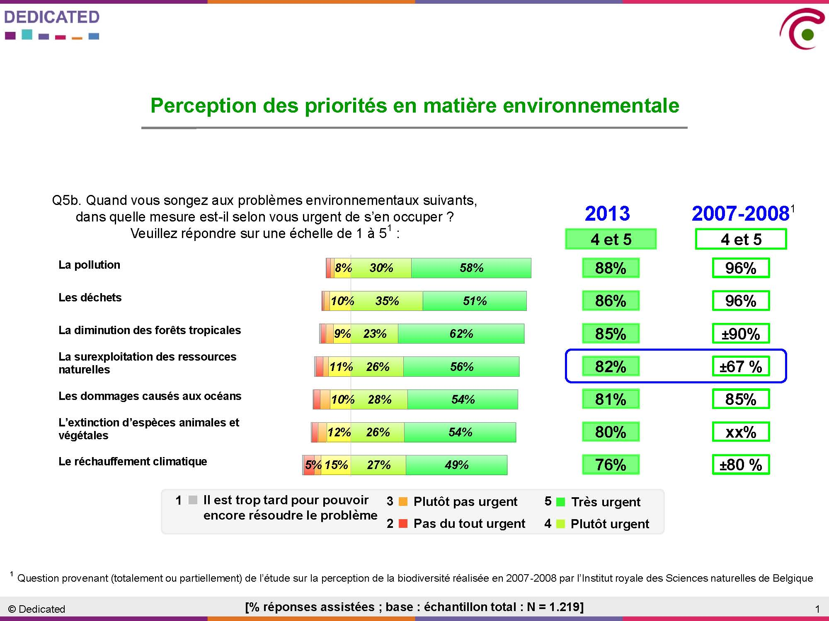

Finally the output of the 2013 study were compared to some results of the 2013 UEBT barometer and have shown that Belgian consumers are pretty aware of biodiversity:

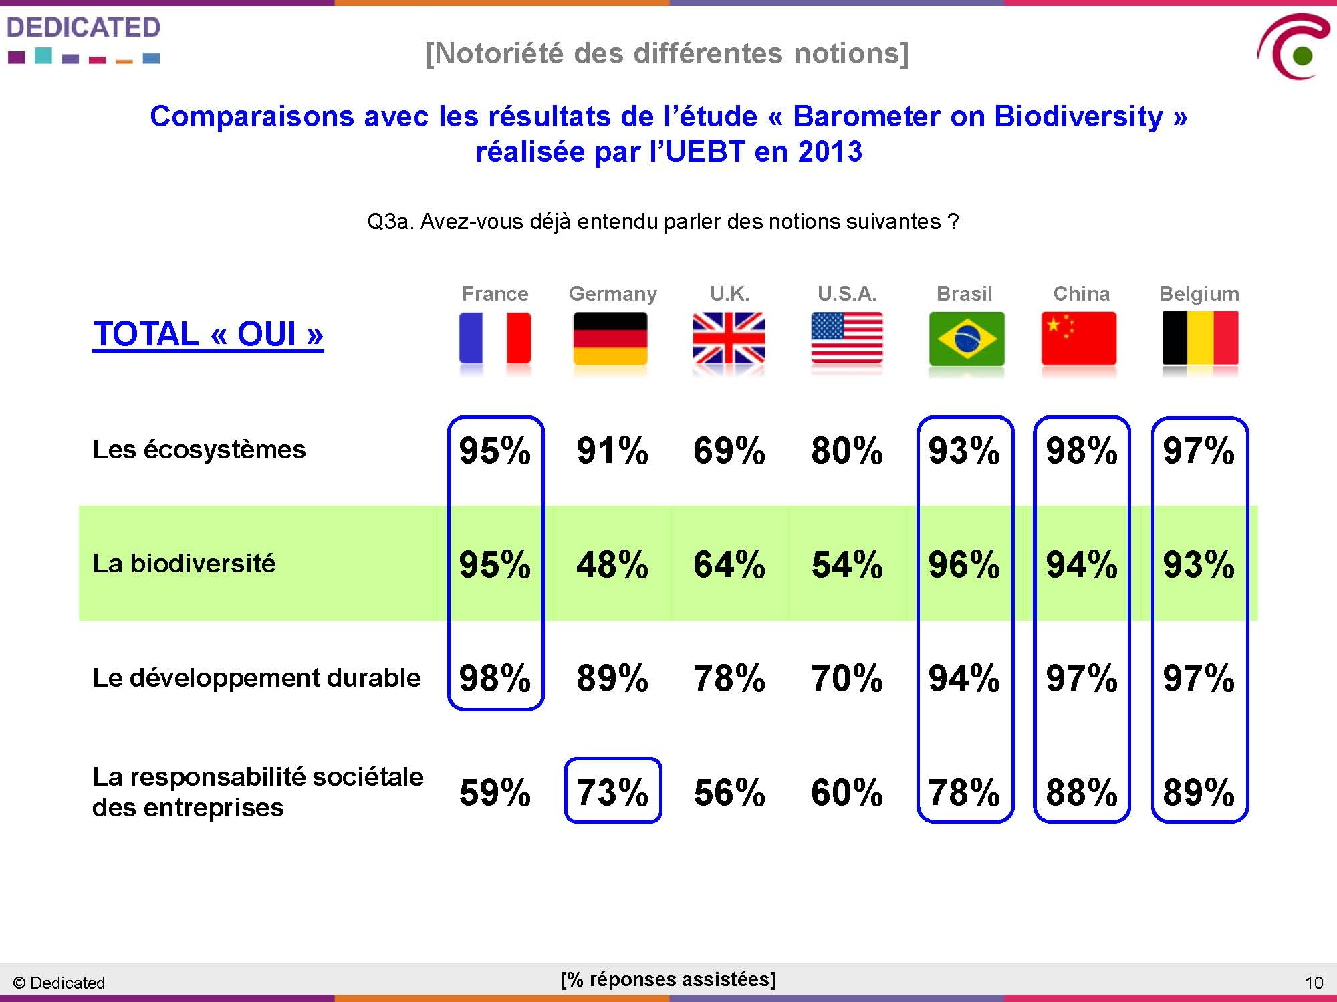

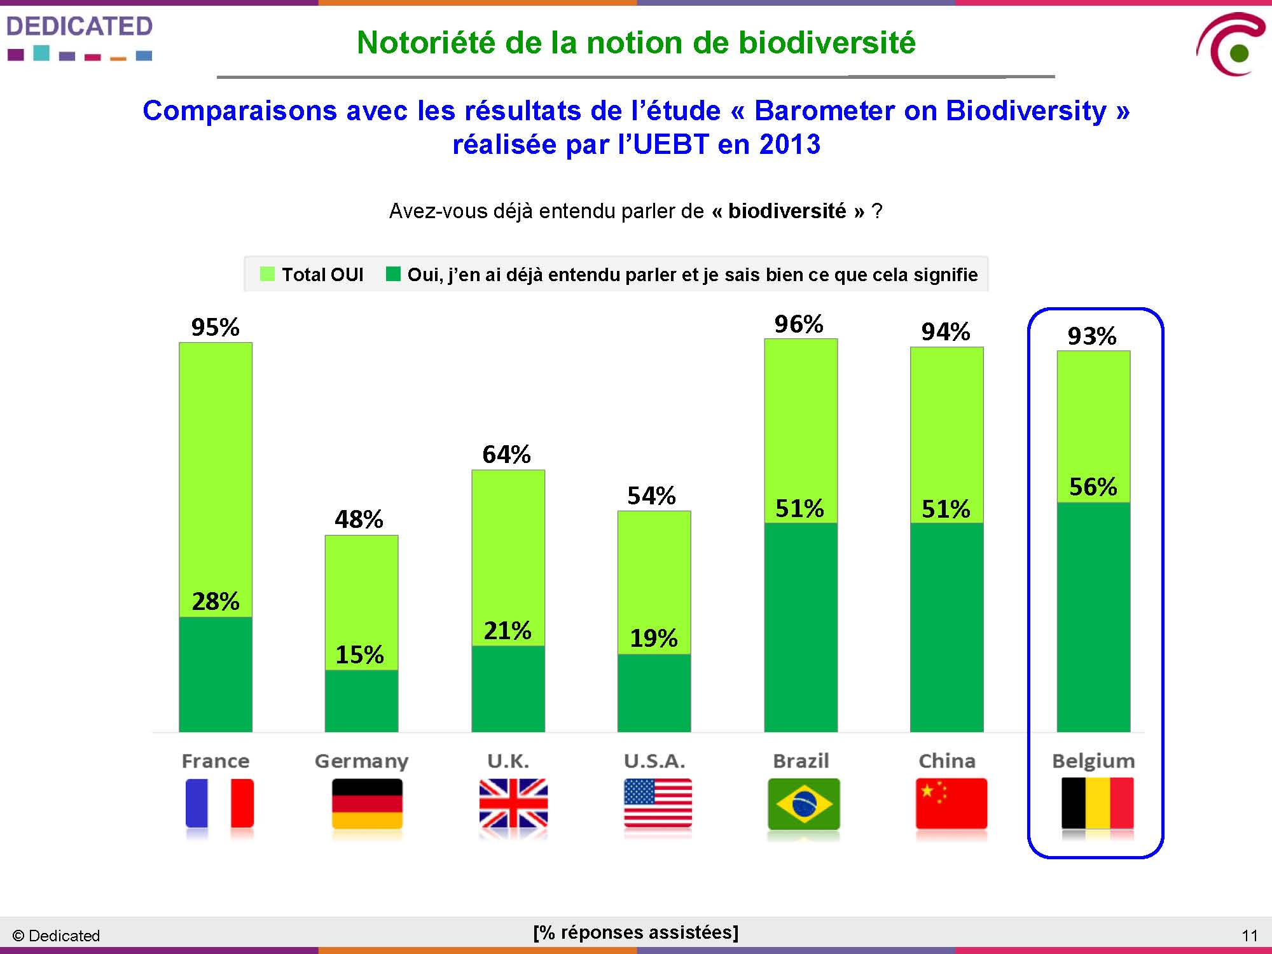

Some examples of recent publications:
. The booklet '366 tips voor de biodiversiteit / 366 gestes pour la biodiversité' was published in the framework of the International Year of Biodiversity and will be reprinted for the third time in 2013. Based on this booklet, the European Commission published the booklet '52 tips for biodiversity' in several languages.
. booklet 'Levend water! Biodiversiteit en Natura 2000 in het Belgische deel van de Noordzee / Une eau vive ! Biodiversité et Natura 2000 dans la partie belge de la mer du Nord' (2012)
. booklet 'Een mariene strategie voor de Noordzee / Une stratégie marine pour la mer du Nord' (2012)

Somewhat less recent publications that have been edited of reprinted several times and are still very much asked for by schools, administrations, press, etc.:
. booklet 'Biodiversiteit in België: een overzicht / La biodiversité en Belgique: un aperçu' (a new edition is scheduled in 2013)
. booklet 'Biodiversiteit in België: van vitaal belang / La biodiversité en Belgique: une question vitale' (a new edition is scheduled in 2013)
. booklet 'Biodiversiteit in België: de opmars van exoten / La biodiversité en Belgique: SOS invasions' (a new edition is scheduled in 2014)
. booklet ‘Bezint eer je met hout begint - FSC en PEFC voor een verantwoord bosbeheer’/ FSC et PEFC : le bois certifié ! Un petit conseil avant d'acheter ?’
. booklet 'Bombybook, biodiversifieer je met Bombylius / Bombybook, biodiversifiez-vous avec Bombylius'
. booklet 'Bombylius helpt de planeet / Bombylius protège notre planète'
. booklet 'Stop de verspreiding van invasieve waterplanten / Halte à la prolifération de plantes aquatiques invasives'
. several folders, brochures, dvd’s and a website were developed during the AlterIAS LIFE project (see section 2.4) in collaboration with the Regions
. several actions were put in place in accordance to the Bees federal plan (see section 3.4)

(see also http://www.jedonnevieamaplanete.be/fr/biodiversite/publications_66.aspx)

Campaigns:
. The engagement campaign ‘I give life to my planet’ is a close collaboration between the Belgian CBD National Focal Point, based at the Royal Belgian Institute of Natural Sciences, the Ministry for Public Health, Food Chain Safety and the Environment and several partners at the regional, provincial, local and NGO-level. The campaign has for objective to engage people in favour of biodiversity, by stimulating individuals to take small and simple steps that will have long-term positive effects. The campaign presents practical tools, relevant information and useful contacts to motivate people who want to take action. People can commit themselves via an engagement form or a website. The campaign, originally launched in 2007, was reactivated in 2010 during the International Year on Biological Diversity and will be up and running at least during the entire Decade for Biodiversity 2011-2020: http://www.ikgeeflevenaanmijnplaneet.be / http://www.jedonnevieamaplanete.be. This unique concept incites people to sign in a special form and online about their personal involvement to preserve and promote biodiversity in their own environment. This concept also allows to keep statistics about the outcome of such a campaign. Up to now, almost 24,000 people have committed themselves to execute more than 87,000 actions for biodiversity.

Training sessions:
. Several trainings were performed to diverse public actors (see section 2.4) to raise the awareness of those actors to biodiversity and ecosystem services with a special focus on their professional activities.

Participation in fairs and other public events:
. The federal Ministry of Environment and the Royal Belgian Institute of Natural Sciences both participate regularly in fairs and public events in order to disseminate information and raise awareness on biodiversity. The RBINS also participates in the ‘sciences congress’ that provides training for science teachers.

Exhibitions:
In 2010, the Royal Belgian Institute of Natural Sciences opened a new permanent exhibition hall on ‘biodiversity in cities’. During the following years, it will dedicate several renovated halls to biodiversity.

A special event (Bee Party) was organised in July 2010 to celebrate the IYB. Theme of the event was the (unsuspected) importance of pollinators in our daily lives. More than 4,100 people visited the event that took place at the Royal Belgian Institute for Natural Sciences. Through 22 info stands, 29 organisations and NGO's presented their work to promote pollinisation and products that depend on it. The event had a special section to showcase public awareness activities on the importance of pollinators that were organised in developing countries with funding by the Ministry of Development cooperation (see below). The same day a special seminar was organised on the taxonomy of African pollinators and the related manual that was published in the ABC-Taxa series. Another scientific conference dedicated to bees took place in June 2013.

In December 2010, in order to close the IYB, the federal administration organised an event to better integrate biodiversity into the business sector. It was the preliminary step of the ‘business & biodiversity’ and ‘consumers & biodiversity’ studies (see above).

Capacity building:
The CHM partnership initiative contains a special Public Awareness component for partner countries. Between 2009-2013, 13 small projects to raise public awareness in partner countries have been implemented in 9 countries thanks to the support of the Belgian Development Cooperation.

In 2009 a special call was launched to enable partner countries to prepare public awareness activities for the International Year on Biodiversity 2010 on the importance of pollinators and their recent decline. 3 projects in Burundi, Benin and Cameroun were selected. The projects consisted of 2 phases: first a research phase in 2009 on the importance of pollinators in the specific country; second, a public awareness phase on the results of the study with a special event during the International Day on Biodiversity in 2010.

In 2011 a special call was launched to assist partner countries to research possible indicators for Aichi Target 1 and do a baseline study on these indicators. Three projects (Benin, Cameroun and Madagascar) were selected and successfully concluded in 2012. For more information on the indicators and the baseline studies: http://www.biodiv.be/cooperation/chm_coop/chm-partnering/public_awareness/results-chm-public-awareness-calls/results-chm-public-awareness-call-2011.

This target is reflected in the updated National Biodiversity Strategy, strategic objective 8.

Target 2
By 2020, at the latest, biodiversity values have been integrated into national and local development and poverty reduction strategies and planning processes and are being incorporated into national accounting, as appropriate, and reporting systems.
Flemish Region:
. Decision-making in spatial planning, land use changes and development projects have to take into account the values of biodiversity; to support the procedures guidances for impact assessment have been developend, for Natura 2000 an on-line screening system of projects is being developed based on new scientific knowledge on impacts by various threat factors and on maps of habitats and distribution of species that form the basis for the management planning of nature areas.
. The Agency for Nature and Forests further enhances the valuation of nature, forests and green spaces: with ecological, economic and monetary valuations additional arguments are developed to ensure appropriate assessments of biodiversity and ecosystem services values in evaluation studies of development projects, and to enhance integration of the costs and benefits of forests, nature and green spaces in the decisional process.
. In the framework of the economic function of nature and forest reserves, the Agency for Nature and Forests tries to better understand the market principles in order to be able to give the sector a better insight in the consequences of the different policy options.
. Some project examples: cost-benefit analyses of the conservation objectives in the framework of Natura 2000, capacity-building and case studies on ecosystem services, eco-hydrological studies, valuation of green structures in cities, ...

Walloon Region:
. The Environment Code ('Code de l'Environnement') integrates dispositions in relation to biodiversity. Following the first principle of the Environment Code, the environment encompasses all natural spaces, landscapes, resources and environments as well as the air, the soil, the water, the diversity and the biological balances. It stipulates that the environmental policy of the Walloon Region relies on preventive action. Its second principle states that the Region and the other public authorities are in charge of the environment and that they have to guarantee its preservation or, if necessary, its restoration. These principles are also to be followed when the other policies of the Region are developed and implemented.
. The Environment Code stipulates which projects are subject to an environmental impact assessment.
. The Nature and Forest Division is consulted for the environmental and related permits.

The 'Code Wallon de l'Aménagement du Territoire, de l'Urbanisme, du Patrimoine et de l'Énergie':
- identifies a natural zone as intended for preservation, for the protection and the regeneration of a natural environment of high biological value or home to species (terrestrial or aquatic) that need to be protected. The only actions and operations allowed in this type of zone are those necessary for the active or passive protection of the environment and the species. A green spaces zone is intended for the preservation, protection and the regeneration of the natural environment. It contributes to the landscape or forms a vegetated transition between zones with incompatible destinations. A forested zone is destined to forestry and the conservation of the ecological equilibrium. It contributes to the preservation or the development of the landscape. The agricultural as well as park zone designations also allow to a certain level to use some of the territory for ecological or landscape purposes.
- regulates the classification of areas subject to protection measures. Several sites of high biological interest are already listed (http://biodiversite.wallonie.be/fr/sgib-sites-de-grand-interet-biologique.html?IDC=824).
- foresees the urbanisation permit for which the Nature and Forest Division is consulted for requests within the Natura 2000 zones as well as within forested zones.
- foresees the possibility to impose ecological connectivity to guarantee that animal and vegetal species can migrate from one biotope to another. It stipulates also that sites necessary for the ecological network should be mentioned in the 'Plans communaux d'aménagement'.

. One of the eight objectives of the regional development scheme (also foreseen by the 'Code Wallon de l'Aménagement du Territoire, de l'Urbanisme, du Patrimoine et de l'Énergie') aims to valorize heritage and preserve resources by the protection and development of natural heritage (aiming for the sustainable development of the Region), the integration of the landscape dimension in spatial planning and the protection and sustainable management of resources.
. One of the objectives of the Water Code ('Code de l'Eau') is to prevent supplementary degradation as well as to preserve and enhance the state of the aquatic ecosystems as well as the wetlands depending on them.
. The river action programs by sectoral approach (PARIS) intend to follow an integrated approach by planning the different interventions (for Natura 2000, the Flood Decree, etc.) in the short and the longer term.
. The Walloon strategy to adapt to climatic changes will encompass a section on biodiversity. It will take biodiversity into account when designing and applying the numerous adaptation measures.
. Several measures of the Air-Climate Plan take biodiversity into account:
- determine the critical loads of nitrogen, heavy metals, persistent organic substances, etc. and take action when levels are exceeded
- facilitate the migration through an adequate ecological network
- preserve the role of forests and natural spaces
- take measures to prevent erosion, for example by planting hedges

. One of the five objectives of the Forestry Code is to combat climate change and preserve biodiversity.
. Biodiversity is one of the issues analysed in the reports on the state of the Walloon environment.
. A Nature Code is foreseen by the 'Direction Générale Agriculture, Ressources naturelles et Environnement'.

Discussions are currently ongoing to include new measures related to Nature (in particular Natura 2000) in the 'Code Wallon de l'Aménagement du Territoire, de l'Urbanisme, du Patrimoine et de l'Énergie’ and in the ‘Walloon Rural development Program’.

Brussels-Capital Region:
. Vision expressed in the Regional Nature Plan (in development): ‘the ambition of the Brussels-Capital Region at the horizon 2050 is that of a region where all the forms of nature have their place, from the most spontaneous to the most managed ones, and where the inhabitants are aware of the value of and show respect for the natural patrimony, while investors and the public authorities considers it as an asset for the attractivity and the sustainable development of the city.’
. Objective 7 of the Regional Nature Plan (in development) states: ‘the Brussels-Capital Region intends to continue its actions in the framework of the stimulation of and the support to the scientific research related to nature in the city, and will focus more particularly:
- on the evaluation of the state of conservation of the natural habitats and the species present on the regional territory;
- on the development of the ecological network within the region;
- on the integration of biodiversity in the urban context and on the evaluation of the ecosystem services’.

Federal level:
. Some measures of the federal plan for the integration of biodiversity in 4 key federal sectors are focussed on this issue, in particular in the economy and science policy sectors (see section 3.4).
. The reflexion is under discussion to see how to better integrate biodiversity values in particular in the preparation of the next federal plan for sustainable development (see section 3.4)

This target is reflected in the updated National Biodiversity Strategy, strategic objective 5.

Target 3
By 2020, at the latest, incentives, including subsidies, harmful to biodiversity are eliminated, phased out or reformed in order to minimize or avoid negative impacts, and positive incentives for the conservation and sustainable use of biodiversity are developed and applied, consistent and in harmony with the Convention and other relevant international obligations, taking into account national socio economic conditions.
Flemish Region:
. CAP direct payments under cross compliance to ensure compliance with i.a. biodiversity legislation and some supplementary rules (for example measures to counter erosion, obligation to maintain amount of permanent grasslands on farm level).
. Code of good agricultural practices nature and biodiversity to stimulate farmers to take into account biodiversity in their operations.
. Research and projects to test, demonstrate and stimulate sustainable use of biodiversity in farming context.
. Local projects to i.a. green farm sites, create pools, prune trees and hedges…

. The Flemish rural development program consists of support for some agro-environmental measures having direct effect on biodiversity:
- organic agriculture,
- planting and maintenance of orchards with tall fruit trees,
- preservation of local breeds,
- mechanical weed control,
- confusion technique in fruit cultivation,
- cultivation of Leguminosae,
- agroforestry.

. The Department of Agriculture and Fisheries also financed some demonstration projects with a direct positive effects on the (agro-)biodiversity, such as the project on genetic diversity in vegetables (http://www.zelfzadentelen.be), where information is gathered and shared to stimulate farmers in growing their own seed of their own local varieties.

. The Agency for Nature and Forests provides subsidies to:
- NGO’s for acquisition of land, management of reserve areas and for infrastructure for public access to the areas
- private forest owners for development and implementation of forest management plans
- local authorities for afforestation projects, development of green infrastructure in urban areas, management of nature areas.

Walloon Region:
. Financing of several measures of the Walloon rural development program has a direct positive effect on biodiversity:
- measures in relation to agri-environmental subsidies
- Natura 2000 remunerations for the farmers
- Natura 2000 remunerations for the forestry sector
- conservation and valorisation of the rural patrimony

. Subsidies for biological agriculture.
. Supplementary subsidies for agri-environmental measures in Natura 2000 sites and in the main ecological structure areas (SEP).
. Subsidies for the planting of hedges, tree rows and orchards.
. Subsidies attributed through the 'Plan Communal de Développement de la Nature', for delayed mowing, for the program 'combles et clochers', within river contracts, for the Maya Plan, for natural parks, for the action 'Semaine de l'Arbre', etc.
. Subsidies for the regeneration of broadleaved and conifer species.
. Subsidies for the acquisition of land that will be designated as nature reserve.
. Dispensation of property tax and of succession and donation rights within Natura 2000.
. Forestry Code: dispensation of succession and donation rights to improve the profitability of forestry production. This disposition also stimulates private owners to develop forest stands with a diversified age composition.
. Natura 2000:
- agricultural compensations are available to farmers; they can be cumulated with agri-environmental measures
- compensations are also available to forest owners
- restoration and acquisition subsidies are available for all Natura 2000 sites and SEP sites, for all owners and farmers
- subsidies for the management of open spaces are also available
. Non financial incentives:
- PEFC label
- BIO label

Brussels-Capital Region:
. The new nature ordinance foresees several cases where positive incentives may be accorded by the Government: public awareness and information (art. 4), scientific research (art. 5), protected areas management and ground purchases (art. 35, 55), management and development of urban biotopes and other key elements of the ecological network (art. 66), actions in favour of protected species (art. 72).
. The Regional Nature Plan (in development) foresees inter alia the following measure: to co-ordonate and to guide nature support mecanisms.

Federal level:
. Following the adoption of the European Maritime and Fishery Fund (EMFF, 2014-2020) the Flemish administration in charge of the Fishery Policy and the federal administration in charge of the protection of the marine environment are currently preparing the Operational Programme so as to facilitate the use of EMFF for the restoration of the marine Natura 2000 areas and to support the implementation of measures of the EU-Marine Strategy Directive.
. The reflexion is under discussion to see how to consider this issue in particular in the preparation of the next FPSD (federal plan for sustainable development) (see section 3.4) and in a future roadmap on resources efficiency at the federal level.

This target is reflected in the updated National Biodiversity Strategy, strategic objective 5.

Target 4
By 2020, at the latest, Governments, business and stakeholders at all levels have taken steps to achieve or have implemented plans for sustainable production and consumption and have kept the impacts of use of natural resources well within safe ecological limits.
Flemish Region:
. Implementation of the Water Framework Directive and the Nitrates directive to protect aquatic environment and to reach good ecological status.
. Many different projects focussing on sustainable food production and consumption, i.a. direct selling and CSA-farming (Flemish Strategic Plan), organic farming (Flemish Strategic Plan), prevent food waste…
. Biodiversity conservation measures e.g. on high nature value pastures prevent degradation of biodiversity rich grasslands (see conditionality principle Wallonian contribution).
. Integrated pest management in the fruit sector (see Wallonian contribution).
. Projects to stimulate a circular economy: reuse and recycling of food and other organic waste, mainly in the agrofood business complex, often combined with renewable energy production.
+ actions of target 3.

. Specifically focussing on the bees, the Flemish government worked on:
- a guide for good beekeeping practices for every beekeeper,
- a guide with plants for pollinators has been distributed to every community service,
- a roundtable conference on the problems of bee and beekeeping was held. Actions are followed up,
- increasing the bee-friendly area by introducing plant for pollinators as eligible green manures,
- projects on beekeeping e.g. artificial insemination to reduce Varroa-contamination.

Code of good practices have been developed and are being applied or are under development:
. for nature with guidelines for the management of protected vegetation types,
. for agricultural uses based upon integration of environmental issues.

The Flemish forest policy is based upon multifunctional and sustainable forestry and applied through development of a management vision consisting of:
. specific and concrete guidelines for a close-to-nature forest management,
. a framework to assess the forest functions,
. a method for quality control,
. promotion and granting of FSC-label to forest,
. publication of criteria for sustainable forest management and technical/financial support for the implementation these criteria by private forest owners (see chapter III, area with management plan according to the criteria for sustainable forestry).

Incentives are provided for the use of criteria for sustainable forest management in the management planning and implementation. Organised and controlled hunting in Wildlife Management Units (WMU) is promoted so that hunters can act as joint managers of the open space. Principles, criteria and indicators are being developed to evaluate the sustainability of the implementation and hunting plans and to review policies.

Walloon Region:
. Many tools are available to improve forest biodiversity and sustainable forest management:
- 53% of the Walloon forest area is PEFC certified
- about 150.000 ha of forests are included in Natura 2000; management contracts will be concluded between the authorities and the owners, to implement the objectives of each site
- the ‘Circulaire relative aux aménagements dans les forêts soumises au régime forestier’ is a normative tool for the management planning in public forests (270,000 ha in Wallonia, including regional nature reserves); at this stage, about 65% of the forest area is covered by new management plans following this circular; the remaining area should be covered at an annual rate of 12,500 ha for the public forests and 1,300 ha for nature reserves
- one of the objectives of the Forestry Code is to combat climate change and preserve biodiversity (see also under Target 7)
- the application of the 'ecological tree varieties registry' allows to optimise sylvicultural practices as well as to improve ecosystem functioning, the mineral and water cycles, and the biodiversity of the undergrowth

. The Walloon Region has adopted the Water Code (Code de l’Eau) on 27 May 2004 to implement the Water Framework Directive. One of its objectives is to prevent additional degradations and to preserve and improve the state of the aquatic ecosystems as well as of the terrestrial ecosystems and wetlands depending on them.
. Agri-environmental methods foresee incentives for a better consideration of nature in agricultural areas.
. Organic farming: this type of agriculture forbids synthesized fertilizers and pesticides, excludes GMOs and has a particular attention for the well-being of cattle and the soil quality. In 2011, approximately 6.9% of the Walloon agricultural area was covered by organic farming. There is legislation in place concerning the production and labelling processes of biological products as well as concerning grants for organic farming. 'BioForum Wallonie' gathers the representatives of the biological production sector and coordinates their initiatives. It is subsidized by the Walloon Region and promotes biological products towards the public and professionals in the agricultural sector. The Bio Pilot Centre is a technical guidance structure recognized and subsidized by the Walloon authorities and the coordination centre of organic farming and horticulture initiatives.
http://etat.environnement.wallonie.be/index.php?mact=tbe,mdb1bf,default,1&mdb1bfalias=Agriculture-biologique&mdb1bfreturnid=43&page=43

. The strategic plan for the development of biological agriculture to 2020 has been approved by the Walloon Gouvernment in december 2012. It aims to promote production and consumption of walloon bio products.

. Integrated pest management aims to limit as much as possible the use of synthesized fertilisers and phytopharmaceutical products, mainly in the fruit production sector. At the end of 2008, the main label gathered 25% of the Walloon producers, equalling 45% of the production.
. The conditionality principle in relation to grants for agriculture entered into force on 01.01.2005. It is linked with several European directives, among others the Bird and Habitat Directives. The conditionality principle contains following points:
- it is forbidden to remove indigenous hedges without an urban permit
- it is forbidden to drain Natura 2000 areas without the permission of the DGARNE
- it is forbidden to change the relief of a Natura 2000 area without an urban permit
- it is forbidden to plough Natura 2000 grasslands without permission of the Nature and Forest Division
- the destination foreseen in the spatial plan has to be respected, mainly in relation to forested zones

. Through the 'Plan Maya' for bees and other pollinators.
. Best practices guide for quarries after their exploitation.
. There are some dispositions in public tenders in relation to the acquisition of paper, invasive alien species, environment-friendly lubricants to be used in hydraulic installations on water courses.
. A sustainable development plan will be developed for the administration of the Walloon Region. It will contain 7 axes (among others: consumption, public tenders, ...) and 16 objectives.
. A sustainable development strategy is being prepared for the Walloon Region.

. The non-profit organisation ECOCONSO promotes environment-friendly and healthy consumption patterns, among others in relation to water, gardening, pesticides, ... The campaign 'Achats verts' is directed towards municipalities and public communities. It aims to implement a more ecological way of consumption within local policies and to improve purchasing practices.

Brussels-Capital Region:
. In the Brussels-Capital Region, much attention is paid to the ecological management of the green spaces,
the use of pesticides is therefore prohibited:
http://www.bruxellesenvironnement.be/Templates/Particuliers/Informer.aspx?id=1834&langtype=2060.
. Forest exploitation in the Brussels Capital Region is in line with the FSC and PEFC certification criteria:
http://www.foret-de-soignes.be/de-la-foret/partenaires/partenaires-economiques/.
. New buildings but also restoration of buildings tends to be more and more nature friendly. One of the more used indicator to measure this is the BAF (biotope area factor):
http://www.sustainablecity.be/themas/sustainable-building,
http://www.bruxellesenvironnement.be/guide_batiment_durable/.
. Much efforts are also made in the field of sustainable food and supply chain:
http://www.sustainablecity.be/themas/sustainable-consumption.

. The Regional Nature Plan (in development) foresees the following measures:
- to develop an integrated vision for the conservation and restoration of agricultural relict zones
- to develop an indicator to evaluate the taking into account of nature into projects
- to strengthen the taking into account of impacts of plans and projects onto the ecological network and the green spaces

Federal level:
. Adoption of a sectoral agreement in the wood sector to stimule the production and sell of sustainable wood products.
. See also results of both ‘Business and biodiversity’ and ‘Consumers and biodiversity’ studies (under Target 1). The future ‘biodiversity’ and ‘resources efficiency’ road maps will make the studies outputs more concrete.
. Development of a federal public procurement policy to promote SFM (circular letter in 2005); a methodological guide supports federal purchasing authorities; promotion and follow-up of forest certification.
. An information campaign was set up to inform the public on SFM and related certification (2006 and 2007).
. Adoption of the 'products plan: towards an integrated product policy'.
. The development of biofuel production pathways/chains is conditioned by the application of a system of sustainability criteria (European directives on Renewable Energy and Fuel Quality 2009/28/CE published in June 2009). Those criteria represent the main measures to allow reasonable use of biofuels while limiting negative impacts on biodiversity. According to the law of 10 June 2006, which promotes biofuels in Belgium, the approval of biofuel production units is based on certain criteria, such as: (1) a short distance between biomass cultivation site and biofuel production unit; (2) the most favourable CO2 balance; (3) the energetic efficiency of the production unit; and (4) reduced use of fertilizers and/or pesticides. Decision rules with respect to the approval of production units also take into account the global CO2 balance, in order to assure that biofuel production leads to a significant reduction of greenhouse gases. However, apart from the use of fertilizers and/or pesticides, no biodiversity-related criteria are included in the attribution criteria.

A workshop entitled 'Vision on the evaluation of socio-economic impact of genetically modified organisms in food: evaluation of the socio-economic impact of GMOs' was organized in Brussels by the Federal Public Service health, Food Chain Safety and Environment on 29.03.2010. Further information and report:
www.health.belgium.be/eportal/Environment/BiodiversityandGMO/GMOs/19069120?backNode=9222.

Belgian delegates and experts were invited to participate in +/- 13 weeks (in 2011 and 2013) international online discussions relative to socio-economic considerations of LMOs in the context of the Cartagena Protocol. One delegate of the Federal Public Service Health, Food Chain Safety and Environment was invited by the Secretariat of the Protocol, on the basis of her participation in the online forum, in an international workshop on the issue in New Dehli (November 2011). The discussions were aimed at reaching a common ground of international understanding of Art. 26.1 of the Protocol (dealing with this issue), before developing some kind of international guidance to implement this article.

Belgian delegates and experts are also presently participating (in the context of the ESEB, European GMO Socio-Economic Bureau) in the development of consensual documents on methodologies for the evaluation of socio-economic implications of the cultivation of LM plants in the EU.

This target is reflected in the updated National Biodiversity Strategy, strategic objective 4.

Strategic Goal B: Reduce the direct pressures on biodiversity and promote sustainable use
Target 5
By 2020, the rate of loss of all natural habitats, including forests, is at least halved and where feasible brought close to zero, and degradation and fragmentation is significantly reduced.
Flemish Region:
. Monitoring and reporting of pressures: 2-yearly reports NARA and MIRA - see chapter I.
. Nature conservation policy measures: extension of surface and numbers of nature and forest reserves, development and implementation of Nature Objectives Plans, site or species specific management plans for nature and forest areas, management agreements with local authorities and land users (+ cross-compliance), introduction of criteria for sustainable forest management; legal framework for protection scheme for FEN and Natura 2000 sites, establishment of Natura 2000 conservation objectives and development of implementation plan in cooperation with stakeholder groups.
. EIA-procedures imposed for development projects, licenses needed for alteration of bottom relief, vegetation and hydrological system; stricter protection regimes in FEN and Natura 2000.
. The use of pesticides and herbicides by local authorities in public domains or parks is forbidden since January 2004.
. Several projects have been carried out for the defragmentation of roads dividing important natural areas by construction of ecoducts, and on river systems by installations resolving fish migration barriers.
. See also Target 11 and the indicators on http://www.milieurapport.be/en/facts-figures/ and http://www.natuurindicatoren.be.

Walloon Region:
The evaluation of the conservation status of natural habitats is performed by biogeographical region. The conservation status of the continental habitats (covering 70% of the Walloon territory) is considered to be bad for 85% of the concerned surface. The conservation status is analysed following 4 criteria: range, area, structure & function and perspectives for the future. The most penalizing criterion for forests is structure & function, mainly due to the insufficient volume and number of large stands and dead wood. For the open habitats the most penalizing criterion is area, resulting from the small area of distribution. Given the difficulty to realise a Nature Plan, the Walloon Region elaborated a project of an evolutionary catalogue of actions aiming among others to specifically preserve rare and threatened habitats.

List of the tools and measures in place to preserve natural habitats (threatened habitats as well as the more common ones):
- the decree on nature conservation
- all measures related to the Natura 2000 network
- the Water Code
- agri-environmental measures
- the Forestry Code
- the 'Circulaire Biodiversité en Forêt'
- PEFC certification of forests
- 'Plans Communaux de Développement de la Nature', delayed mowing, 'combles et clochers', River contracts
- agreements with the private sector (quarries, electricity companies, railroad companies ...)
- the natural zones, green spaces and forests under the ‘Code wallon de l’Aménagement du Territoire, de l’Urbanisme et du Patrimoine’
- species action plans (see also Target 12)
- catalogue of actions of the ‘réseau Wallonie nature’

A recent study estimated the fragmentation level of the Walloon territory based on an effective maze size indicator.
http://etat.environnement.wallonie.be/index.php?mact=tbe,mdb1bf,default,1&mdb1bfalias=Fragmentation-du-territoire_1&mdb1bfreturnid=43&page=43

Brussels-Capital Region:
The Regional Nature Plan (in development) foresees the following measures:
- elaborate a master plan for the Brussels ecological network
- obtain the ownership of strategic sites
- develop an indicator to evaluate the taking into account of nature into projects
- reduce the fragmentation of biodiversity by finding ways to allow the fauna to move across transport infrastructure (ecoducts and ecotunnels for example)
- develop and implement an ecological management plan for the railway verges
- develop and implement an ecological management plan for green spaces related to roadways

Federal level:
. Joint Implementation and Clean Development Mechanism projects.
. Federal Reduction Plan for Pesticides 2013-2017 (FRPP) (see also chapter II, 4.1).
. SEA procedures include biodiversity criteria and refer to relevant national policy documents such as the Belgian Biodiversity Strategy, the CBD and biodiversity-related conventions and agreements.

North Sea
. Sand and gravel extraction, dredging and dumping of dredge spoil are subject to licences. Zero tolerance policy in relation to oil pollution.
. Development of a cleaning policy of the North Sea through the ‘fishing for litter programme’.
. Measures regulating coastal fisheries in protection of marine mammals.
. Ongoing actions in order to reduce import of nutrients and hazardous substances into the North Sea.

This target is reflected in the updated National Biodiversity Strategy, strategic objective 3.

Target 6
By 2020 all fish and invertebrate stocks and aquatic plants are managed and harvested sustainably, legally and applying ecosystem based approaches, so that overfishing is avoided, recovery plans and measures are in place for all depleted species, fisheries have no significant adverse impacts on threatened species and vulnerable ecosystems and the impacts of fisheries on stocks, species and ecosystems are within safe ecological limits.
Walloon Region:
Several measures are implemented:
- the decree on fishing activities
- the project 'Saumon 2000'
- restocking projects with local varieties (trout, grayling, ...)
- the decree on nature conservation, including Natura 2000
- the Water Code
- the application of the aquaculture regulation
- awareness actions by the 'Maison de la pêche', fishing courses, ...
- restoration of aquatic environments
- the River contracts: their aim is to gather around the table all the concerned actors (of the valley) in order to define together an action programme for the restoration of the water courses, the adjacent areas and the water resources of the bassin
- the working groups on water installed within some 'Plans Communaux de Développement de la Nature'

Flemish Region:
. The recently reformed Common Fisheries Policy of the European Union’s most important goal is laying down rules to ensure a sustainable European fishery without damaging the marine environment. An example of one of the decisions taken, is that the fish stocks will have to reach their maximal sustainable yield (MSY) where possible in 2015, but in 2020 at the latest. Now the Flemish government will have to implement or guide this implementation for the Flemish fisheries sector.

. In relation to the marine fishery: continued structural and ad hoc consultations with the Department for Agriculture and Fisheries as well as with the Institute for Agricultural and Fisheries Research on the improvement of the management of fish stocks, and the elimination of the negative effects on fish stocks, species, habitats and ecosystems.

. Codes of good practices have been developed and are being applied or are under review.

Brussels-Capital Region:
The new nature ordinance regulates fishing practices with a sustainable aim (art 79-81). Article 82 regulates the substraction of specimens out of nature.

Federal level:
In 2012, the “Good Environmental Status” and associated objectives for the descriptor “commercial fish species” (MSY by 20120) was defined and agreed (Belgische Staat 2012. Omschrijving van Goede Milieutoestand en vaststelling van Milieudoelen voor de Belgische mariene wateren. Kaderrichtlijn Mariene Strategie – Art 9 & 10. BMM, Federale Overheidsdienst Volksgezondheid, Veiligheid van de Voedselketen en Leefmilieu, Brussel, België, 34 pp.).

This target is reflected in the updated National Biodiversity Strategy, strategic objective 4.

Target 7
By 2020 areas under agriculture, aquaculture and forestry are managed sustainably, ensuring conservation of biodiversity.
Flemish Region:
Actions carried out are initiated to:
- Provide for a better remuneration of collective environmental goods through direct payments and cross compliance in the framework of the EU Common Agricultural Policy on the one hand, and the integration of the preservation of biodiversity through management agreements and (contributions for by the Rural Development Programme and through management agreements on the other hand); see also Flemish contributions on agriculture in relation to targets 3 and 4.
- Reorientate the rural development policy towards the preservation of biodiversity (AGNABIO project: structural consultation between agricultural policy structures and nature policy structures, structural consultations with the agricultural sector, (http://lv.vlaanderen.be/nlapps/docs/default.asp?id=3004).
- ECO² project (http://www.ecokwadraat.be/).
- Enhance contribution to biodiversity of agro-environmental measures under the Rural Development Programme, see also Flemish contributions on target 3).
- Contribute to the preservation of the genetic diversity of the European agriculture (see also Flemish contributions on target 13).
- Sensibilisation initiatives such as a code of good agricultural practices nature and biodiversity to stimulate farmers to take into account biodiversity in their operations.
. Strict spatial planning requirements i.a. to prevent land take and fragmentation of open space and biodiversity rich areas/objects.
- Stimulate forest owners to protect and enhance the biodiversity of the forests (recognition and guidance of forest groups, structural consultations with the forestry sector).
- Integrate biodiversity measures into forest management plans (develop management plans for the Agency's green spaces, support the development of forest management plans by forest groups).

Code of good practices have been developed and are being applied or are under development:
- for nature with guidelines for the management of protected vegetation types,
- for agricultural uses based upon integration of environmental issues.

The Flemish forest policy is based upon multifunctional and sustainable forestry and applied through development of a management vision consisting of:
- specific and concrete guidelines for a close-to-nature forest management,
- a framework to assess the forest functions,
- a method for quality control,
- promotion and granting of FSC-label to forest: about 20 000 ha are granted the FSC label,
- publication of criteria for sustainable forest management and technical/financial support for the implementation these criteria by private forest owners (see chapter III, area with management plan according to the criteria for sustainable forestry),
- incentives are provided for the use of criteria for sustainable forest management in the management planning and implementation.

Organised and controlled hunting in Wildlife Management Units (WMU) is promoted so that hunters can act as joint managers of the open space. Principles, criteria and indicators are being developed to evaluate the sustainability of the implementation and hunting plans and to review policies.

Indicators on practices and impacts by various sectors are reported in the Environment reports: set of indicators available in English: http://www.milieurapport.be/en/facts-figures/sectors/agriculture/.

Ecological footprint of the consumption of renewable natural resources
In order to produce renewable natural resources, biologically productive land is required: e.g. farmland for crops and livestock, forest land for wood, and water bodies for fish. The ecological footprint of renewable natural resources consumption of a certain region is defined as the area of biologically productive land which is required to fulfil these consumption needs. The ecological footprint of renewable natural resources consumption is measured in ‘universal hectares’, which refers to the world average biological productivity of one hectare. On a global scale, there are 1.8 universal hectares of biologically productive land available per person (1999 data). This means that on average, the land required to produce all the renewable natural resources and energy needs for one person should not exceed 1.8 ha.
In 2009, the ecological footprint for renewable natural resources in Flanders (using NFA edition 2010) was on average 4.7 universal hectares per person, but excluding energy consumption. Since on average, only 1.8 universal hectares of biologically productive area is available per person, it is clear that each Flemish inhabitant requires more than the average available area per person on the globe. Under these conditions, halting the loss of biodiversity becomes a difficult task. At the moment, 90% of the area necessary to satisfy Flemish consumption is located abroad. This applies mainly to farmland producing energy-rich feed crops for Flemish livestock. As such, the environmental pressure caused by the Flemish region is partly exported. The ecological footprint did not vary much between 2004 and 2009, methodologies and data are however becoming more accurate in assessing the concept.

Walloon Region:
Forestry
. The 'Circulaire Biodiversité en Forêts' recommends to integrate measures with a more biodiversity-friendly dimension within the objectives of forest management.
. One of the objectives of the Forestry Code is to combat climate change and to preserve biodiversity. It stipulates that the sustainable development of wood(land)s and forests implies the application of certain principles:
- the preservation and improvement of forestry resources and their contribution to the carbon cycle
- the preservation of the health and vitality of forest ecosystems
- the preservation, conservation and improvement of biodiversity in forest ecosystems
- the preservation and improvement of the protective functions of forest among others related to the water and the soil
- the preservation and improvement of other socio-economic benefits and conditions (preservation of an equilibrium between resinous and broad-leaved trees and promotion of a mixed forest type with a diversified age composition, adapted to climate change and able to mitigate some of its effects; restriction of areas where trees are cleared; for public owners: preservation of dead, damaged or biologically interesting trees, preservation of at least 1 tree of special biological interest per 2 ha, the preservation of shrubby hedges, ban on the planting or resinous trees next to water courses; the planning tool for public forests within the Forestry Code takes measures for the promotion of biodiversity into account; the Forestry Code imposes that 3% of the broad-leaved forests with a surface of more than 100 ha are to be delimited as integral reserves)
- the use of pesticides as well as the burning of branches is forbidden in all forests
- all artificial regeneration actions using tree varieties which are not optimal or tolerated following the 'ecological tree varieties registry' are forbidden.

Many tools are available to improve sustainable forest management:
. the ‘Circulaire relative aux aménagements dans les forêts soumises au régime forestier’ is a normative tool for the management planning in public forests (255,000 ha in Wallonia). At this stage, about 65% of the forest area is covered by new management plans following this circulaire. The remaining area should be covered by 2013,
. about 150,000 ha of forests are included in Natura 2000 areas. Management contracts will be concluded between the authorities and the owners, to implement the objectives of each site.

. PEFC certification: owners engage themselves voluntarily to diversify their forest, to maintain dead wood, to maintain patches where trees can grow old, etc.
. Pro Sylva: research about and promotion of a close-to-nature sylviculture based on natural processes.

Agriculture
. Between 1980 and 2010, the surfaces dedicated to permanent grasslands registered the biggest decline with an average loss of 1,920 ha per year.
. The utilisation of phytopharmaceutical products and of nitrogenous and phosphorus fertilisers is decreasing. Concerning the fertilisers, this tendency results from a more rational use of fertilisers and from the implementation of measures of the programme of sustainable management of nitrogen in agriculture. The Walloon authorities have elaborated a pesticides reduction programme to further decrease their use.
. Eco-Efficiency in agriculture: there is a decrease of the used quantities of fertilisers and pesticides per harvested ton and per cultivated hectare. The agricultural sector registers also a decrease of the emissions of atmospheric pollutants (-13% for the greenhouse gases and -11% for the acidifying substances between 1990 and 2010). This eco-efficiency gain is among others related to the implementation of compulsory or voluntary programmes such as the programme of sustainable management of nitrogen, the conditionality of agricultural subsidies or environmental programmes (such as biological agriculture).
. Agri-environmental methods foresee incentives for a better consideration of nature in agricultural areas: by the end of 2010, 54% of the Walloon farmers (28% of the agricultural surface) subscribed to one or more agri-environmental measures. The most chosen agri-environmental measures are the planting of hedges, the covering of the soil during winter, the preservation of trees, the natural grasslands and the grassy peat bogs. In 2010, 5% of the Walloon agricultural surface was dedicated to the preservation of biodiversity (ecological compensation surface). Note that a percentage of 7% is considered as globally very favourable to the preservation of the wild fauna. Concerning the surface waters, 2,317 km of the water banks (15% of the total length of water banks bordering meadows or fields) are concerned by an agri-environmental measure. In comparison with the 2000-2006 version, more ambitious objectifs have been integrated in the ‘Plan wallon de Développement Rural 2007-2013’, aiming to encompass 50% of the farmers and 20% of the agricultural surface in the agri-environmental measures system in 2013.
. An impact assessment is compulsory for all plans or projects susceptible to affect significantly a Natura 2000 site.
. Application of the aquaculture regulation.
. Sustainable management plan for nitrogen.
. The conditionality principle in relation to grants for agriculture entered into force on 01.01.2005. It is linked with several European directives, among others the Bird and Habitat Directives. The conditionality principle contains following points in relation to this target:
- it is forbidden to drain Natura 2000 areas without the prior permission of the DGARNE
- it is forbidden to use herbicides in Natura 2000 grasslands without prior permission of the DGARNE
- it is forbidden to plough Natura 2000 grasslands without prior permission of the DGARNE
- the destination of the Natura 2000 areas foreseen in the spatial plan has to be respected
- it is forbidden to destruct strictly protected species (decree on nature conservation) or hedges on the whole of the Walloon territory
- it is also forbidden to change considerably the landform

Some other measures and tools:
. the Walloon Region has adopted the Water Code (Code de l’Eau) on 27 May 2004 to implement the Water Framework Directive. One of its objectives is to prevent additional degradations and to preserve and improve the state of the aquatic ecosystems as well as of the terrestrial ecosystems and wetlands depending on them.

Assessment of environmental efficiency
http://etat.environnement.wallonie.be/index.php?mact=tbe,mdb1bf,default,1&mdb1bfalias=Indicateurs-structurels-environnementaux_2&mdb1bfreturnid=43&page=43
Within the framework of the Lisbon and Gothenburg strategies, the European Commission has drawn up a list of 20 structural indicators which it can use to monitor and assess the environmental performance of Member States. The table available through the link enables Belgium and the Walloon Region to be compared with the European averages and positioned with respect to other Member States and enables an evaluation of the progress made.

Brussels-Capital Region:
See targets 4 and 6.

Federal level:
. Adoption of a sectoral agreement in the wood sector to stimule the production and sell of sustainable wood products.
. Development of a federal public procurement policy to promote SFM (circular letter in 2005); a methodological guide supports federal purchasing authorities; promotion and follow-up of forest certification.
. An information campaign was set up to inform the public on SFM and related certification (2006 and 2007)
. Adoption of the 'products plan: towards an integrated product policy'.
. The development of biofuel production pathways/chains is conditioned by the application of a system of sustainability criteria (European directives on Renewable Energy and Fuel Quality 2009/28/CE published in June 2009). Those criteria represent the main measures to allow reasonable use of biofuels while limiting negative impacts on biodiversity. According to the law of 10 June 2006, which promotes biofuels in Belgium, the approval of biofuel production units is based on certain criteria, such as: (1) a short distance between biomass cultivation site and biofuel production unit; (2) the most favourable CO2 balance; (3) the energetic efficiency of the production unit; and (4) reduced use of fertilizers and/or pesticides. Decision rules with respect to the approval of production units also take into account the global CO2 balance, in order to assure that biofuel production leads to a significant reduction of greenhouse gases. However, apart from the use of fertilizers and/or pesticides, no biodiversity-related criteria are included in the attribution criteria.

This target is reflected in the updated National Biodiversity Strategy, strategic objective 4.

Target 8
By 2020, pollution, including from excess nutrients, has been brought to levels that are not detrimental to ecosystem function and biodiversity.
Flemish Region:
. The Decree on integrated water management contains concrete requirements with respect to riparian zones along water bodies with specific requirements on soil cultivation, use of pesticides and manure use. Water quality in general terms improved, although the required levels are not yet reached for all chemicals in all water ways: http://www.vmm.be/water/kwaliteit-oppervlaktewater.

. The Manure Decree transposes the European Nitrate Directive action program (for the period 2011-2014) into Flemish legislation and contains the required regulations on distance rules for manure use, timing of manure use and other requirements (sleep slopes, snow cover, green cover, residual nitrate in soil (soil and crop specific values), mandatory advise on manure use in horticulture). Excess fosfates and nitrates in soil pose the main problems for effective revering of habitats and the related ecosystem functions.
http://www.milieurapport.be/nl/feitencijfers/sectoren/landbouw/.

. The Department of Agriculture and Fisheries finances 10 demonstration projects to promote and stimulate farmers in the sustainable manure use, having a positive effect on the biodiversity in the field.
See chapter I, exceeding of critical load for eutrophication, phosphorus in rivers.

The use of pesticides and herbicides by local authorities in public domains or parks is forbidden since January 2004. Pesticide reduction programmes in agricultural practices are promoted through stimulating measures under the Rural Development Programme and codes of good practices.
Impact of use of herbicides and other plant protection chemicals decreased during the last 10 years – due to restricted use of some products, better techniques for applying chemicals in agricultural practices and raising of awareness on the impacts of such products on the environment and in the food chain.
http://www.milieurapport.be/nl/feitencijfers/milieuthemas/verspreiding-van-pesticiden/druk-op-oppervlaktewater-door-pesticiden/druk-op-het-waterleven-door-gewasbescherming-seq-en-seq/

Walloon Region:
In 2007, about 6% of the forest surface and almost the entire surface of open spaces (heathlands, swamps, peat bogs, …) in the Walloon Region was affected by nitrogenous depositions superior to the acceptable level of eutrophying nitrogen. At the forest level, the situation improved substantially thanks to a reduction of atmospheric fallout of nitrogen. This is not the case for the other (semi-)natural ecosystems (in particular oligotrophic environments) which remain extremely vulnerable to such perturbations. Concerning acidification, the situation is now far less problematic given the fact that the affected forest surfaces went from 90% (1990) to 10% (2007). This evolution proves the positive effects of measures implemented to reduce the atmospheric emissions of acidifying pollutants of 50 to 60% (between 1990 and 2010) in the Walloon Region and Europe.

List of Walloon tools and measures in place for this target:
. The Forestry Code forbids the utilisation of pesticides. The only exceptions are defined by the Walloon government to combat certain diseases or invasive alien species that threaten the indigenous fauna and flora.
. The Forestry Code also offers the possibility to impose the utilisation of vegetal oil for chain saws and other forestry exploitation tools.
. The use of herbicides is forbidden in some public areas such as parks, waterways, ponds and lakes, road verges and ditches.
. The Water Code and some resulting plans and programs:
- the ‘Plans d’Assainissement par Sous-bassin Hydrographiques’ define the decontamination and clean up regime for the relevant areas
- the programme for the sustainable management of nitrogen is the application of the Nitrate Directive (part of the Water Framework Directive)

. The Environment Code and certain resulting dispositions:
- the environmental permit and ‘permis unique’
- studies about the impact on the environment

. The evaluation of incidences is imposed for all plans and projects that could affect a Natura 2000 site in a significant way.
. 159 municipalities have signed the ‘Plan Maya’ thereby committing themselves 1) to put in place a plan to reduce the use of pesticides and 2) to manage green spaces more ecologically.
. In the framework of the implementation of the Walloon decree on soil management, an inventory of (potentially) polluted soils is currently in development.

Reduction in the use of inorganic and organic fertilizers and pesticides: the utilisation of phytopharmaceutical products and of nitrogenous and phosphorus fertilisers is decreasing. Concerning the fertilisers, this tendency results from a more rational use of fertilisers and from the implementation of measures of the programme of sustainable management of nitrogen in agriculture. The Walloon authorities have elaborated a pesticides reduction programme to further decrease their use.

Micropollutants in surface waters: evaluations performed during the period 2005-2010 indicated that about 30% of the Walloon surface waters are in a bad chemical situation. To remediate this, additional measures are foreseen in the Walloon programme for the reduction of pesticides and in the projects of the hydrographical districts management plans. They aim, among others, to install buffer zones along surface waters and to re-evaluate and better control environmental permits.

See also ‘Etat de l’environnement wallon’ (http://etat.environnement.wallonie.be).

Brussels-Capital Region:
. A very strict legislation is in place concerning the use of pesticides in public green spaces. In public regional green spaces: no use of pesticides or very restricted.
. Water pollution is gradually removed thanks to the actions taken in the framework of the water plan.
. The Regional Nature Plan (in development) foresees also the following measure:
- to develop an integrated vision for the preservation and restoration of (ancient) agricultural zones and sites.

Federal level:
The Pesticide Reduction Programme was adopted by the Federal Government (PRPB) in 2005 aims to reduce the adverse impact of pesticides. The PRPB has been running until the end of 2012.

From 2013, the NAPAN (Nationaal Actie Plan d’Action National) has been established as the Belgian national action plan for pesticide reduction as requested by the EU directive 2009/128 . It includes the federal plan (FRPP : Federal Reduction Plan for Pesticides) replacing the PRPB, and the plans from the three regions. Each of these plans comprises both specific actions and actions carried out jointly with the other members of the NAPAN Task Force. It aims at reaching the objectives of reducing risks linked to pesticides as defined in the EU Directive 2009/128/CE establishing a framework for Community action to achieve the sustainable use of pesticides.

Throughout the 2005-2012 programme, federal authorities managed to develop and ensure major stakeholders' participation e.g. by establishing a Council and organising direct consultation of specialists who use pesticides. This high level of participation is kept in the 2013-2017 programme and extended to all national competences.

The 2005-2012 programme was an opportunity for federal authorities to deliver reliable and balanced information on the risks relating to the use of pesticides, e. g. through the websites and by publishing thematic booklets. Putting neutral information at disposal in an active way is also a major issue of the 2013-2017 programme, in which it is notably scheduled that such information shall be provided compulsorily in all places where products for amateur use are on sale. Such a balanced information should help raising awareness of non-professional users of pesticides to the consequences of this use on biological diversity and ecosystem services.

Federal authorities delivered key strategic information for public risk management, such as the amounts of pesticide products sold. This aspect, which had not been fully achieved at the end of the 2005-2012 programme, will be amplified in the 2013-2017 programme through the development of a key index scorecard for the issue of pesticide use. Those indexes will tackle the problem according to the DPSIR system (Driven forces, Pressure, State, Impact, Response). Another feature of the 2013-2017 programme is the development of specific follow-up tools for public health purposes, such as health monitoring of professional users of plant protection products.

Programme coordination is provided by the federal services in charge of product standards, making it possible to achieve many structural changes in the issue of pesticide use through legislation modifications. This major asset has resulted in significant progress, such as the 'Phytolicence' (compulsory knowledge certificate for users, sellers and professional advisors of plant protection products), or the splitting of the plant protection product market into a market for professional users and a market for non-professional users.

Finally, throughout the period 2005-2012, the federal programme has contributed to enhance dialogue at several levels (citizens, professional/civilian associations, government, etc.) on numerous issues relating to pesticides. This dialogue capacity will certainly prove useful in the future, notably for tackling delicate issues about pesticides and for which scientific evidence is insufficient, such as for instance the issue of bee population decline, the emergence of certain chronic diseases among farmers, the 'cocktail effect' of pesticide residues in food.

Some of the measures foreseen to be implemented at the national level are the following:
. By 2017, harmonization of methods, standards and reports on water (surface & underground) contamination by pesticides at regional, national and European level.
. Ensure that non-professional users of products receive balanced information at the point of sale regarding the right conditions of use, the risks to public health and the environment.

At the federal and regional levels, measures include:
. Coordinate and enhance the efficiency of activities studying the impact of pesticides on bees.
. Raise awareness of non-professional users to the use of alternative solutions and to the protection of water bodies.
. By 2019, the public space managers (municipalities, administrations) must manage their spaces without the use of plant protection products.
. By 2014, compliance with principles of integrated pest management by all farmers.

North Sea:
. The objective of the OSPAR strategy ‘Hazardous substances’ is to reduce the concentration of hazardous substances to background levels by 2020.
. In 2012, the “Good Environmental Status” and associated objectives for the descriptors “Eutrophication” and “pollution were defined and agreed (Belgische Staat 2012. Omschrijving van Goede Milieutoestand en vaststelling van Milieudoelen voor de Belgische mariene wateren. Kaderrichtlijn Mariene Strategie – Art 9 & 10. BMM, Federale Overheidsdienst Volksgezondheid, Veiligheid van de Voedselketen en Leefmilieu, Brussel, België, 34 pp.).

This target is reflected in the updated National Biodiversity Strategy, strategic objective 2.

Target 9
By 2020, invasive alien species and pathways are identified and prioritized, priority species are controlled or eradicated, and measures are in place to manage pathways to prevent their introduction and establishment.
Flemish Region:
The Agency for Nature and Forests developed a first strategy including a special instrument for invasive alien species; to conduct an invasive species policy focussed on awareness and prevention, as well as combating IAS when necessary, taking also into account control actions and horizontal needs (such as policy framework, communication and knowledge / research). A Dutch version of the vision and action plan is available at: http://www.natuurenbos.be/nl-BE/Natuurbeleid/Soortenbeleid/Overlast_schade/door_uith_soorten/Visie%20ANB.aspx.
Experience and knowledge has been gathered through participation in the INTERREG project INVEXO with the Netherlands (http://www.invexo.be/), the INTERREG-project Rinse (http://www.rinse-europe.eu/) and the LIFE project ALTERIAS (http://www.alterias.be). In cooperation with the Research Institute for Nature and Forests and the NGO Natuurpunt the development of an early warning system is ongoing and collected information over the last 2 years. http://www.natuurenbos.be/nl-BE/Natuurbeleid/Soortenbeleid/Overlast_schade/door_uith_soorten.aspx. Identification tools for the species included are available at http://www.waarnemingen/be/exoten.

It is prohibited to introduce animals and plants without a permit (Forest Decree) in both public forests and forest reserves. The introduction of alien animal species is prohibited, and there is a legal base for measures to control and eradicate alien animal species. Measures can also be taken to control or prohibit the transport of animal species and their carcasses (Decree on nature conservation). A decision describes what species of fish can be used as fish bait (only native fish species are allowed). See also chapter I, number of alien species.

The Decision of the Flemish Government of 21.04.1993 prohibits the introduction into the wild of non-native animal species, unless a special permit is being granted. An integrated and updated executive law for species protection is submitted for approval. This law includes the basis for the prevention and control of invasive species. In the new act on species protection and species management this prohibition has been confirmed: in article 17, Besluit van de Vlaamse Regering van 15 mei 2009 met betrekking tot soortenbescherming en soortenbeheer (BS: 13/08/2009), in short ‘Soortenbesluit’). Some exceptions to this rule apply: specimens of plant species that are cultivated in the frame of Legal forestry, agriculture or horticultural activities or in the frame of garden or park management: specimens of fish reared in closed waters that guarantee that specimens can not move to open waters.
To allow reducing negative impact on native biodiversity of IAS in the wild, to mitigate or to restore, the Flemish minister responsible for the Environment can take measures (articles 28, 29, 30 and 31 of the ‘Soortenbesluit’). The following actions are possible: * actions for increasing awareness including facilitating codes of conduct; * doing, letting do, or enforcing of specific management and control; * making agreements with local governments and/or organisations aiming at local actions; and * limiting or prohibiting transport, trade and possession. Information is published on the website: http://www.natuurenbos.be/Exoten (incl. species fact sheets).

Several research programmes includes monitoring, assessment of impacts and development of control, mitigation and/or eradication programmes:
. assessment of the risks posed by the muskrat (Ondatra zibethicus) and coypu (Myocastor coypus) not only to dikes, crops and vegetation but also to also to local fish, amphibians, breeding bird species,
. monitoring and eradication of exotic plant species in nature and forest areas under management,
. project for removal of floating pennywort (Hydrocotyle ranunculoides) from watercourses,
. monitoring and inventory of fish occurring in inland waters including alien fish species.

There is a program in which rare, colonial and introduced breeding bird species are being monitored in Flanders. Among them, alien breeding bird species as the lesser white-fronted goose (Anser erythropus), the Canada goose (Branta canadensis), the barnacle goose (Branta leucopsis), the Nile (Egyptian) goose (Alopochen aegyptiacus), the mandarin duck (Aix galericulata), the ring-necked parakeet (Psittacula krameri) and the monk parakeet (Myiopsitta monachus) are being monitored. This program is called the ‘Bijzondere Broedvogels Vlaanderen Project’ (Flemish Special Breeding Bird Project). ). Meanwhile, some alien bird species are also monitored within the framework of the common breeding birds monitoring scheme, notably Canada and Egyptian goose.

Walloon Region:
In the Walloon Region, 375 exotic species of ornamental plants and 21 exotic species of vertebrates were considered as naturalised in 2011. Of these, 29 species of plants and 11 species of vertebrates are known to cause considerable environmental damage and are mentioned on the black list. Several exotic species of mammals have established themselves in the Walloon Region in recent years. The number of naturalised species seems to increase over time, although the observed changes (compared with the previous estimations) could also be the reflection of more rigourous field observation efforts or the evolution of scientific knowledge.

Preventive and control actions against invasive alien species are coordinated through a dedicated interdepartmental unit (CiEi) that has been established in 2009 within the strategic plan of the Administration. This unit is in charge of the following tasks:
. Identify priority pathways and develop preventive and regulatory measures accordingly, including guidelines for plantations, soil movement, green waste management, etc.
. Prepare a coherent legislative framework to regulate preventive and control actions against invasive alien species in Wallonia.
. Set up an early warning system in cooperation with the other regions in the country and nature conservation NGOs.
. Identify and disseminate best practices for the management of invasive alien plants and animals;
. Coordinate control action plans against priority species like giant hogweed, Japanese mosquito, Canada goose or muskrat.
. Conduct studies to assess non-native species invasiveness in the field and compile information for risk analyses of priority species.
. Communicate and develop capacity building actions towards field managers and the general public.

Nature Parks, many River Contracts and cities which have either a Municipality Plan for Nature Conservation or a ‘Roadside management plan’ actively manage invasive alien species at a local scale.

The introduction of non-indigenous species or indigenous species of non-indigenous origin in nature is forbidden except for species used for agriculture and forestry.

Brussels-Capital Region:
. The reintroduction and the intentional release in nature of invasive animal and plant species listed in annex IV of the ordinance of the 1st March 2012 in relation to nature conservation is forbidden (art. 77, 1st §). The sale, the transfer for free or against payment, the exchange and the purchase of one of this species are also forbidden (art. 77, 2nd §).
. Article 78 of this ordinance allows the Brussels Government to take measures against these species.
. The intentional release in nature of non-indigenous strains of indigenous animal and plant species and the intentional release in nature of non-indigenous animal and plant species are both subject to permission (art. 75, 2nd §).
. Several research programmes already includes monitoring and assessment of impacts e.g. on parakeets, naturalised water birds and plants. Some management actions are already in use (e.g. Egyptian goose in parks).
. In addition, the Regional Nature Plan (in development) foresees the following measure:
- to optimize the management of invasive alien species
. Priority is given to prevention and sensibilisation of the public and the professionals. In a second phase follows the screening and first intervention actions followed, when needed, by actions to control and reduce the populations.

Federal level:
At the national level, resulting of a collaboration between the federal and regional authorities, a code of conduct in relation to invasive plants has been elaborated in the framework of the AlterIAS-project (http://www.alterias.be, Alternatives for invasive plants).

Action 18 of the second Federal Plan for Sustainable Development is devoted to biodiversity and focuses on sectoral integration of biodiversity in key federal sectors (transport, economy, development cooperation and scientific policy). The action plan ‘Integration of biodiversity in the four federal key sectors’ (in preparation, adoption expected in September 2009) will address IAS.
Actions foreseen in this action plan include (see chapter III for achievements at federal level):
. Economy: the consultation of key sectors in order to increase awareness and understanding of the issue and the identification of the most appropriated measures (such as e.g. labelling, substitution, information, etc.) and the review, actualization and extension of existing legislations at federal level to prohibit the import / export / transit and detention of some IAS in Belgium.
. Science: the establishment of an early warning system on IAS and the development of a system based on molecular barcoding to identify organisms of policy concern (including IAS) for use by Transport.
. Transport: the control and management of ballast water.

The Belgian Law of 20.01.1999 (MMM law) forbids the intentional introduction of non-indigenous species in the marine environment without special license (Art. 11, §1).
A royal decree will be adopted in the second part of 2009 to implement the Council Regulation dealing specifically with alien species in aquaculture (708/2007/CE) with regard to marine species.
The Royal Decree of 9 April 2003 foresees measures related to the commercialisation of species listed in annex A (excepted for specimens bred in captivity, with CITES certificate).

In 2012, the “Good Environmental Status” and associated objectives for the descriptor “invasive species” was defined and agreed (Belgische Staat 2012. Omschrijving van Goede Milieutoestand en vaststelling van Milieudoelen voor de Belgische mariene wateren. Kaderrichtlijn Mariene Strategie – Art 9 & 10. BMM, Federale Overheidsdienst Volksgezondheid, Veiligheid van de Voedselketen en Leefmilieu, Brussel, België, 34 pp.).

This target is reflected in the updated National Biodiversity Strategy, strategic objective 3.

Target 10
By 2015, the multiple anthropogenic pressures on coral reefs, and other vulnerable ecosystems impacted by climate change or ocean acidification are minimized, so as to maintain their integrity and functioning.
Flemish Region:
Stricter control on the use of impact assessments of new developments allow to introduce more general measures in the projects to reduce pressures on environment and nature. Enforcement of exisiting environmental law and imposed restrictions on emissions, land use changes and water use also contribute to reducing pressures.
With the publication of the Policy Plan of Flanders on Climate Change also includes measures related to nature and values of ecosystems. In studies on valuation of ecosystems services contribution of ecosystems and of green spaces in cities on air quality and on absorption capacity of CO2 delivers arguments on the role of healthy ecosystems and more green spaces for adaptation and mitigation to climate change. Such data help to initiate more projects on greening the environment and on restoration of ecosystems.
More research is being carried out on the impact of climate change on changes in migration of species, changes in species compositions of vegetations.
See also chapter II, Natura 2000 and defragmentation of rivers.

Walloon Region:
. The Walloon strategy to adapt to climatic changes will encompass a section on biodiversity.
. Several more general measures are implemented in different frameworks to reduce pressure on the ecosystems:
- the law on nature conservation
- one of the objectives of the Water Code ('Code de l'Eau') is to prevent supplementary degradation as well as to preserve and enhance the state of the aquatic ecosystems as well as the wetlands depending on them
- the 'Circulaire Biodiversité en Forêt'
- the new Forestry Code
- agri-environmental measures
- the agricultural conditionality
- the environmental and urban permits as well as the ‘permis unique’
- protected zones within the ‘Code wallon de l’Aménagement du Territoire, de l’Urbanisme et du Patrimoine’: no changes allowed without an urban permit
. In the Walloon Region, the species and habitats most sensible to climate change have not (yet) been identified.

Brussels-Capital Region:
Large efforts to reduce GES and pollutants that cause acidification are made in the framework of air quality and air plans. In 2002, the Brussels-Capital Region has adopted the 2002-2010 plan to improve structurally the air quality and to combat climate change (Air Climate Plan of the Brussels-Capital Region). This plan groupes the strategy, the priorities and the actions to be implemented by the region to fulfil the European and international obligations concerning air quality. Moreover, the region has recently adopted the Brussels Code for Air, Climate and Energy (Code Bruxellois de l'Air, du Climat et de la maitrise de l'Energie, COBRACE), which integrates all the necessary measures concerning air quality, climate and management of the energy consumption. Throught the COBRACE, the Brussels-Capital Region engages itself to reduce the emissions of atmospheric pollutants such as the precursors of tropospheric ozone, acidifying and eutrophying substances, greenhouse gases, persistant organic pollutants, etc.

Federal level:
. The Royal Belgian Institute of Natural Sciences develops through the Management Unit of the North Sea Mathematical Models and the Scheldt estuary (http://www2.mumm.ac.be/coherens/applications.php ) a mathematical model to better understand fragile ecosystems such as coastal areas and mangroves in Asia and Latin America in order to be better able at developing integrated management plans taking into account the protection of sensitive areas.
. A federal plan to adapt to climate change will be finalised in 2014.

Concerns in relation to climate change are reflected in the updated National Biodiversity Strategy, strategic objective 2.

Strategic Goal C: To improve the status of biodiversity by safeguarding ecosystems, species and genetic diversity
Target 11
By 2020, at least 17 per cent of terrestrial and inland water, and 10 per cent of coastal and marine areas, especially areas of particular importance for biodiversity and ecosystem services, are conserved through effectively and equitably managed, ecologically representative and well connected systems of protected areas and other effective area-based conservation measures, and integrated into the wider landscapes and seascapes.
Following data from 2013 detailed in the following table, 1.3% of the Belgian terrestrial and marine territory is protected by nature, forest and marine reserves. This percentage increases to 15.9% when Natura 2000 zones and alike are taken into consideration.

 | territory (ha) | nature and forest reserves |  | Natura 2000 ⁽¹⁾
 |  | surface (ha) | % of the territory | surface (ha) | % of the territory
Brussels | 16 200 | 240 | 1.5% | 2 375 | 14.7%
Flanders | 1 352 200 | 25 000 | 1.9% | 193 268 ⁽²⁾ | 14.3%
Wallonia | 1 684 400 | 16 719 | 1% | 220 945 | 13.1%
North Sea | 346 200 | 676 | 0.2% | 124 929 | 34.16%
Total | 3 399 000 | 42 635 | 1.3% | 541 517 | 15.9%

(1) nature and forest reserves are often partially or completely situated within Natura 2000 areas.
(2) the Flemish Ecological Network is included (areas belonging to the Natura 2000 network as well as to the Flemish Ecological Network are only counted once).

Flemish Region:
To finalise the realisation of the Natura 2000 network and provide for good management of the Natura 2000 sites:
. the conservation objectives and measures were established in consultation with the concerned actors
. the Agency for Nature and Forests manages its own green spaces with a focus on the realisation of the conservation objectives
. stop the decline of species of European conservation concern and stimulate their recovery to achieve a favourable conservation status through the development of species protection plans and support to species protection measures.

Ensure sufficient funds for the Natura 2000 network:
. to achieve the biodiversity ambitions of the Flemish authorities, the Agency for Nature and Forests focusses on the collaboration with partners and the integration into the policy of other entities (project examples: Bosland, Nationaal Park Hoge Kempen, Zwin, Sigma plan, ...)
http://www.natuurenbos.be/nl-BE/Over-ons/Projecten/
. stimulation of the use of EU-cofinancing: LIFE, INTERREG, Rural Development fund, ...

. the Flemish Region aims to realise high quality nature among others by expanding the surface being effectively managed for nature purposes with 3 000 hectares each year (mapping and enhancing the connectivity of green spaces, nature-oriented management of verges) – the surface with formely approved management plans that focus on concrete conservation objectives and include monitoring of management effectiveness reached about 70.000 ha. Other areas in designated Natura 2000, VEN of green destinations on spatial plans are covered with general measures for protection of environment and nature.
. the Agency for Nature and Forests tries to align its policy in relation to green spaces and elements in the city with the societal needs (GidS project: Groen in de Stad) and supports and realises urban and suburban green projects
. to enhance connectivity in the ecological network systems installation of ecoducts and fish passages as well as agri-environment measures are encouraged and subsidised
. implementation of Natura 2000 through development of Nature Objective Plans, priority setting for acquisition of land, protocols for cooperation (e.g. with ministry of Defence, Port Authorities), agri-environment contracts, financial support of nature development and management projects of local authorities and Regional Landscape Organisations
. together with the Netherlands: transboundary ecological planning processes: Grensoverschrijdend Ecologisch Basisplan (GEB), Zwinproject, Schelde estuary, grensparken (bv. De Zoom Kamthoutse Heide), Grensmaas, Drielandenpark (with Germany)
. together with France: conservation measures for the coastal zone between Duinkerken-Lombardsijde, transboundary integral coast reserve De Westhoek
. coastal zone programme for the conservation of sand dunes, sandy beaches and salt marshes: e.g. acquisition of land, restoration projects, integrated management actions.
(see also chapter II, areas under conservation management, Natura 2000)

Walloon Region:
Core areas with official protection status, or effectively and equitably managed, ecologically representative and well connected systems of protected areas: the Nature department of the Walloon Region continues to strictly protect natural sites through the following status: government nature reserve (Réserves Naturelles domaniales (RND)), chartered nature reserve (Réserves Naturelles agréees (RNA)), forest reserve (Réserves Forestières (RF)), wetlands of biological interest (Zones Humides d’Interêt Biologique (ZHIB)), and underground cavity of scientific interest (Cavités Souterraines d’Interêt Scientifique (CSIS )), in order to protect important sites for species and habitats. The Walloon network of protected areas grows slowly but still has a rather limited scale. At the end of 2011, nearly 11,500 ha of natural sites had a strong juridical protection status, which corresponds to 0.68% of the Walloon territory. Additional efforts are thus necessary to achieve the recommended minimal surface.

The designation of the Natura 2000 sites for the protection of priority species and habitats as meant by the Birds and Habitats Directives covers 220 945 ha for 240 sites in the Walloon Region which corresponds to approximately 13.11% of the territory. The network is based on the hydrological network so there is a good connectivity between the different sites (http://natura2000.wallonie.be/). They form 3/4th of the main ecological structure, also known as the Walloon ecological network. The Walloon Natura 2000 network consists for 70% of forests, equalling 28% of the Walloon forest surface. Meadows, fallows and orchards form 16% of the network, while fields account for 2%, together equalling about 5% of the agricultural surface. In the Walloon Region, 44 habitats of community interest (of which 10 priority habitats), 101 bird species of community interest and 31 other species of community interest are present. Eight sites received, through a designation decree of the Walloon government, a protection regime based on a specific management for the natural habitat types and the species they contain. The other 232 sites all have a primary protection regime.

Furthermore, the Forestry Code imposes that 3% of the broad-leaved forests with a surface of more than 100 ha are to be delimited as integral reserves.

Other effective area-based conservation measures:
- Pro Sylva: 0.89% of the territory outside Natura 2000
- 1.25% of the Walloon territory is covered by agri-environmental measures favourable to biodiversity outside Natura 2000
- delayed mowing: 0.19% of the territory outside Natura 2000

In the Walloon Region, 15.44% of the territory has either an official protection status or is concerned by other effective area-based conservation measures.

In addition, the general concept of the ecological network has been transposed in the ‘Main Ecological Structure’ (Structure écologique principale or SEP) and has been mapped. This structure contains two types of areas which together cover 18% of the territory:
- core areas: mainly dedicated to nature conservation,
- ecological development areas: areas where human activities are less intensive in order to obtain a balance between nature conservation and economic incomes.

. The law on the conservation of nature foresees the creation of so-called stimulating areas around Natura 2000 sites to enhance the ecological coherence of the Natura 2000 network and to allow the management of the intermediate, linear or punctual environments (river banks, arboreal hedges, valleys, small forest patches, ...).
. The 'Code Wallon de l'Aménagement du Territoire, de l'Urbanisme, du Patrimoine et de l'Énergie' foresees the possibility to impose ecological liaisons to guarantee that animal and vegetal species can migrate from one biotope to another. Actions and activities under permit can be forbidden or made subordinate to particular protection conditions.
. One of the objectives of the Walloon natural parks is to assure the protection, management and valorisation of the natural and landscape patrimony.
. 51.8% of the surface of the Walloon forest is PEFC certified. This means that 17.1% of the Walloon territory is developed sustainably, even though the primary objective is not the conservation of biodiversity.
. The Water Code foresees the establishment of a registry of protected zones, inter alia the zones for the protection of economically important aquatic species and the zones for the protection of species and habitats (a.o. the relevant Natura 2000 sites). This registry is a list of protected zones in relation to water, but does not foresee to delimit new zones.

Brussels-Capital Region:
The wealth of Brussels’ natural heritage derives from its diversity of geomorphological and urban structures (valleys, wetlands, old trees, old buildings). However, urbanisation is highly disruptive to plant and animal communities.

The most drastic declines in species and natural habitats were recorded during the nineteenth and early twentieth centuries, or during the post-war period, at a time of major industrial and economic developments and growing urbanisation. The majority of the sites of high biological value today enjoy protected status. The adoption of the new ordinance on nature conservation ensures that almost 14% of the Region’s territory is protected.

All the Region’s protected areas (natural and forest reserves, Natura 2000 zones) need to benefit from management measures relating to conservation goals approved by the Government. For the next few years, priority attention needs to be given to adopting the decrees that designate and define the conservation goals for the reserves and Natura 2000 sites and to finalising and implementing management plans.
For the sites under the Region’s responsibility, the implementation of these management plans should not cause any problems, as certain measures have already been applied there for many years: the diversification of the landscape structure, controlling the enrichment of environments, controlling recolonisation of open environments by shrubs, maintaining the access of sunlight to watercourses and waterbodies, ensuring that embankments have a gentle gradient, using alternatives to pesticides, protecting woodland soils and retaining dead wood, prioritising native plants, managing invasive exotic species, etc. The application of good management practices needs nevertheless to be intensified, in particular at the sites recently acquired by Brussels Environment, on municipal land and on large private estates.

Statut | ha | % territoire
RN seul | 30 | 0,2%
N2K seul ou en combinaison autres statuts | 2321 | 14,4%
Sites protégés nature (protection active) | 2351 | 14,6%
Sites protégés nature effectivement gérés | 2180 | 13,5%
Sites protégés et gérés patrimoine | 590 | 3,7%
Sites non protégés gérés nature | 28 | 0,2%
Sites gérés nature | 2208 | 13,7%
Habitats N2K/BIR dégradés | 1938 | 12,0%
Habitats N2K/BIR à restaurer | 291 | 1,8%

The Regional Nature Plan (in development) foresees the following measures:
- to ensure an adequate protection and management of the sites with a high biological value and to ensure the implementation of the ecological network
- to optimise the articulation between the different systems for the protection of green spaces
- the different policy levels competent for the ecological management of public green spaces should adopt a common language
- to develop and implement plans for the multifunctional management of green spaces
- to develop and implement an ecological management plan for the railway verges
- to develop and implement an ecological management plan for green spaces related to roadways

North Sea:
. The ‘MMM’ (Marien Milieu Marin) act of 20 January 1999 on the protection of the marine environment in sea areas under Belgian jurisdiction establishes the legal basis for the protection of the Belgian part of the North Sea against sea-related pollution and for the conservation, restoration and development of nature.
. The Royal Decree of 14 October 2005 establishes five marine protected areas (Trapegeer Stroombank, Vlakte van de Raan, SBZ1, SBZ2 and SBZ3), all part of the Natura 2000 network. In 2008, the Vlakte van de Raan designation is nullified by the Court of Justice. The Royal Decree of 5 March 2007 establishes a 0.6 km² marine reserve (Baai van Heist); the Royal Decree of 5 November 2012 increases the Natura 2000 to approx. 1000 km² under the new site name “Vlaamse Banken”). In 2009 management plans have been approved for the then designated protected areas. In 2013 zoning restriction are being proposed in the site Vlaamse Banken; this is part of the proposed Marine Spatial Plan.

This target is reflected in the updated National Biodiversity Strategy, strategic objective 3.

Target 12
By 2020 the extinction of known threatened species has been prevented and their conservation status, particularly of those most in decline, has been improved and sustained.
Flemish Region:
See also chapter I, e.g. common bird index.
The species protection plans that are being implemented concern various bat species under the LIFE project BatAction (also including awareness raising, restoration of habitats in forts), hamster (re-introduction programme with 60 specimens and monitoring of the population, cooperation with farmers), some indicator butterfly and plant species of heath habitats, night jar. Species protection plans for fish species have been evaluated and reviewed, and for the eel pilot projects are running and a monitoring scheme has been developed. For endemic tree and scrub species protection plans are being implemented and monitored in the framework of the European Forest Genetic Resources Programme EUGORGEN. For the black popular the restoration programme is carried along the Grens-Maas in cooperation with the Netherlands and France.
For the development of new species conservation plans species have been prioritized based on criteria of red list level, importance on European level, status and trends in Flanders. The aim is to initiate the plan development for 5 species every year.
Development and implementation of species action plans, contracts with land owners for species protection measures (meadow birds, hamster, farmland birds), financial support for birds rehabilitation centres, research for re-introduction projects (e.g. fish species).
For status and trends on main species groups: http://www.biodiversityindicators.be.
(see also target 2.1 and chapter I, conservation status of species of European interest)

Walloon Region:
31% of the studied animal and plant species are threatened to disappear from the Walloon Region and nearly 9% have already disappeared. The conservation status of a species results from a combination of factors such as the fragmentation, alteration and disappearance of habitats, pollution or the presence of invasive alien species. The 2010 objective to stop the decline of biodiversity, agreed at the European level, has been integrated in the regional policy declaration 2009-2014 and has not been reached yet. Concrete field actions are executed in partnership with different actors (quarries, ports, Infrabel, ...) with an aim to integrate the protection of biodiversity in all activity sectors. Moreover, given the difficulty to realise a Nature Plan, the Walloon Region elaborated a project of an evolutionary catalogue of actions aiming among others to raise the welcoming potential for wildlife of the whole territory and to specifically preserve rare and threatened habitats.

Concerning the birds, the most obvious decline is noted for bird species of agricultural environments where few nesting sites and alimentary resources remain available all year long (not even mentioning the possible influence of other practices). However, the index of species linked to agricultural zones is stabilising since 2005, though at a 30% lower level than the average numbers of 1990. This does not seem to be the result of agri-environmental measures but merely the population rise of some, more general, species when other, more specialised, species decline. The numbers of forest bird species fluctuate around the numbers of 1990. The generalist species seem to have regained the average populations size approaching their basic numbers. Following the Walloon red list, nearly one third of the nesting birds are threatened to disappear. Among these, 28% are linked to open environments. This situation is partly due to the very restricted surface of heathlands, bogs and grasslands in the Walloon Region.

. Chapter II of the law on the conservation of nature protects a list of animal and plant species.
. The law on the conservation of nature allows also that municipalities take more stringent measures for the protection of animal and plant species. This could be a good way to protect particular sites such as the migration routes of amphibians. Unfortunately, municipalities rarely use this possibility.
. Several action plans for species are running for the European hamster (Cricetus cricetus), the lesser horseshoe bat (Rhinolohus hipposideros) and the yellow-bellied toad (Bombina variegata).
. Action plans for other species are under development for the sand lizard (Lacerta agilis), the common European adder (Vipera berus), the natterjack toad (Bufo calamita), the marsh fritillary (Euphydryas aurinia) and the European otter (Lutra lutra).
. More localised actions are implemented for the freshwater pearl mussel (Margaritifera margaritifera) and the whinchat (Saxicola rubetra).
. Other projects aim to improve the status of threatened populations of fish species.
. Several LIFE-project and restoration projects are favourable to populations of threatened species (three butterfly species are also targeted: Euphydryas aurinia, Lycaena helle and Lycaena dispar).
. The operation ‘combles et clochers’.
. Study and scientific monitoring in order to restore populations of the Atlantic salmon; inventory of obstacles for fish circulation in the hydrographical network, etc.

Brussels-Capital Region:
. Despite the strict protection of numerous species (ordinance nature, art. 67-72) and the many actions already taken by the Brussels-Capital Region (nesting boxes, restoration and preservation of roosts in buildings, preservation of old trees, creation of extra breeding area, etc), numerous species are still in a precarious situation, mainly due to the increasing scarcity of their habitats and the deterioration of the quality of their environment (see chapter I). The most vulnerable species need to be managed on an adapted and coordinated basis across the entire territory of the Region, if not further afield. It would be useful to formalise the studies that have already been conducted in the form of action plans and to start implementing them on the ground.
. The Regional Nature Plan (in development) foresees the following measure: to develop and implement action plans for the restoration and development of species population with a regional of community interest.

Federal level:
As part of the Marine Strategy Framework Directive, an environmental objective has been defined for the harbour porpoise in the Belgian part of the North Sea. This objective aims to reduce by 2020 the annual bycatch levels of this species to levels below 1.7% of its population size (which is also the OSPAR Ecological Quality Objective EcoQO).

This target is reflected in the updated National Biodiversity Strategy, strategic objective 3.

Target 13
By 2020, the genetic diversity of cultivated plants and farmed and domesticated animals and of wild relatives, including other socio-economically as well as culturally valuable species, is maintained, and strategies have been developed and implemented for minimizing genetic erosion and safeguarding their genetic diversity.
For plant genetic resources, a ‘National Committee on Plant Genetic Resources’ has been created in January 2011. The Committee is a working group that coordinates at the national level all actions and initiatives related to Plant Genetic Resources and cultivated plant biodiversity (policy coordination, management of the Belgian National Inventory of Plant Genetic Resources collections, preparation of participation in international meetings and working groups regards PGR, ad hoc items, …) and works under the supervision of the ‘Permanent Working Group Inter-Ministerial Conference on Agricultural Policy’, the official forum where items on agriculture are structurally discussed and decided between the relevant regional (Flemish, Walloon and Brussels Capital region) and federal authorities, working in the agricultural domain.

In June 2012, Belgium officially notified its public collections to join the Multilateral System of the International Treaty on Plant Genetic Resources for Food and Agriculture (see http://www.planttreaty.org/inclusions) and signed the Memorandum of Understanding for the Establishment of a European Genebank Integrated System (AEGIS, see http://aegis.cgiar.org/about_aegis.html).

In 2005, Belgium prepared its first national report to FAO on animal genetic resources: ‘Les ressources génétiques des animaux d'élevage en Belgique. Rapport national à la FAO. Contribution de la Belgique au Premier Rapport sur l'État des Ressources Zoogénétiques dans le Monde’.
http://agriculture.wallonie.be/apps/spip_wolwin/IMG/pdf/RapportNationalFAO.pdf

Flemish Region:
. Agri-environmental measures were adopted within the European Rural Development Program 2007- 2013 to stimulate the on farm conservation of 9 local sheepbreeds and 3 local cattlebreeds and fruit tree varieties (see also Flemish contribution on target 3).
. Several organisations (non-profit associations) receive a structural subsidy to promote and preserve genetic resources (Steunpunt Levend Erfgoed vzw, Nationale Boomgaardenstichting vzw).
. Herdbooks of farm animals are supported, specific attention is payed to activities aimed at controlling the degree of inbreeding within the population.
. The population structure of local breeds of farm animals is systematically monitored.
. Demonstration project for stimulating farmers and informing them about farm saved vegetable seeds.
. A collection of Rhododendron varieties is maintained in vivo and partly by cryopreservation at ILVO (Institute for Agricultural and Fisheries Research, http://www.ilvo.vlaanderen.be).

Walloon Region:
. An agri-environmental measure aims to protect threatened local livestock species.
. A collection of ancient fruit tree varieties is managed by the Walloon Agricultural Research Centre.
. Other actions undertaken to preserve or develop genetic resources: the cultivation of spelt and a barley variety, the conservation and valorisation of the genetic patrimony of the mixed type of the Belgian Blue and of the 'poule ardennaise'.
. The mission of the 'Comptoir Forestier' is to collect seeds among all the major and secondary tree species and to commercialize these seeds through an annual catalogue. Priority is given to species of great economical value for the Walloon Region and to obtain a high genetic diversity.

Brussels-Capital Region:
In application of the ordinance of the 1st March 2012 related to the conservation of nature, the intention introduction in nature of non-indigenous strains of indigenous animal and plant species is subject to permission (art. 75, §2).

This target is reflected in the updated National Biodiversity Strategy, strategic objective 4.

Strategic Goal D: Enhance the benefits to all from biodiversity and ecosystem services
Target 14
By 2020, ecosystems that provide essential services, including services related to water, and contribute to health, livelihoods and well-being, are restored and safeguarded, taking into account the needs of women, indigenous and local communities, and the poor and vulnerable.
Flemish Region:
See chapter I, ecosystem services and water quality of rivers.
Restoration of natural flood plains and river borders in the estuary of the Schelde and the IJzer, and other main river systems, restoration and nature development of nature and forest zones on military areas, sustainable management of nature and forest areas.

Studies on mapping and valorisation of ecosystem services ongoing. Based on this study, indicators may be developed.

Walloon Region:
. In addition to the measures listed in relation to Aichi Target 10 and the conservation measures listed in relation to Aichi Target 11, following actions and plans can be mentioned:
- one of the objectives of the 'Plan Pluie' is to arrange the beds of rivers and alluvial plains to take into account the meteorological and hydrological features while respecting and promoting the natural habitats
- the river action programs try to follow an integrated approach by planning the different interventions (for Natura 2000, the Inundation Decree, etc.) in the short and the longer term
- the Walloon strategy to adapt to climate change
- one of the objectives of the Forestry Code is to combat climate change and preserve biodiversity (see also under Target 7); this tool takes the economic, environmental and social functions of forests into consideration while allowing a sustainable management
- the restoration of degraded ecosystems occurs mainly within LIFE-projects and habitat restoration projects within protected areas; an example are the LIFE-projects in relation to the peaty plateaus having a positive impact on the water quality, water circle and water reservoirs
. The Water Code and some resulting plans and programs:
- the ‘Plans d’Assainissement par Sous-bassin Hydrographiques’ define the decontamination and clean up regime for the relevant areas
- the programme for the sustainable management of nitrogen is the application of the Nitrate Directive (part of the Water Framework Directive)
- one of the objectives of the Regional Development Scheme is the valuation of the patrimony and the protection of resources: protection and development of the natural patrimony for a sustainable development of the Walloon Region, integration of the landscape dimension in the management practices, sustainable protection and management of the resources

Biological quality of water courses: in 2010, 55% of the controlled surveillance sites showed a good to very good biological water quality. The number of sites with a good to very good water quality increased the last ten years mainly thanks to a decrease of diffuse pollution, an increase of the purification of used water and the ecological restoration of certain water courses. Despite the slowness of ecosystem recovery, a progressive improvement is expected for the entire water network following the implementation of additional measures foreseen in the projects of the hydrographical districts management plans.

Brussels-Capital Region:
. The Regional Nature Plan (in development) foresees the following measures:
- to ensure an adequate protection and management of the sites with a high biological value and to ensure the implementation of the ecological network
- to develop an integrated vision for the preservation and restoration of (ancient) agricultural zones and sites
- to implement the management plans within the protected sites
- the different policy levels competent for the ecological management of public green spaces should adopt a common language
- to develop and implement plans for the multifunctional management of green spaces

. The Blue Network Programme: this programme aims to have an integrated, durable and ecologically justified management of open waterways in Brussels. The "blue network" is made up of small rivers, ponds and marshes. It is dedicated to the enhancement of natural values and biodiversity while maintaining the access of the public to the areas concerned. A Plan for water management adopted by the BCR in 2012 is in line with this programme (See chapter II, item 4.4 on water management).

This target is reflected in the updated National Biodiversity Strategy, strategic objective 3.

Target 15
By 2020, ecosystem resilience and the contribution of biodiversity to carbon stocks has been enhanced, through conservation and restoration, including restoration of at least 15 per cent of degraded ecosystems, thereby contributing to climate change mitigation and adaptation and to combating desertification.
National strategy to adapt to climate change:
http://climate-adapt.eea.europa.eu/viewaceitem?aceitem_id=400.

Flemish Region:
To realise the conservation objectives of Natura 2000 sites and of species of European interest wide spread restoration and re-development projects have been carried out mainly through LIFE projects, and will be further initiated through the implementation plan for Natura 2000 and the Prioritised Action Framework.
Agri)environment measures support to restore the connectivity between sites, to enhance habitat quality of species dependent on agricultural landscapes, to prevent erosion problems. Specific measures for river banks also contribute to connectivity aspects and to improving water quality in general. Through afforestation projects and restorarion of peatlands and wetlands contribution to fixation of carbon is enhanced.

Walloon Region:
. The resilience of ecosystems to climate change is improved by the protection and restoration measures listed in relation to Aichi Targets 10, 11 and 14. The contribution of ecosystems to the capture of carbon is also improved through these measures. The restoration of degraded ecosystems mainly occurs through LIFE-projects and habitat restoration projects within protected areas. Agri-environmental measures play also an important role in this context.
. Walloon working group on restoration gathering representatives from the administration, stakeholders, landowners, ...

Brussels-Capital Region:
. The Regional Nature Plan (in development) foresees the following measures:
- to ensure an adequate protection and management of the sites with a high biological value and to ensure the implementation of the ecological network
- to develop an integrated vision for the preservation and restoration of (ancient) agricultural zones and sites
- to strengthen the presence of nature in public spaces and spaces associated with transport infrastructure
- to strengthen the presence of nature on and around buildings
- to implement the management plans within the protected sites
- the different policy levels competent for the ecological management of public green spaces should adopt a common language
- to develop and implement plans for the multifunctional management of green spaces
- to develop and implement an ecological management plan for the railway verges
- to develop and implement an ecological management plan for green spaces related to roadways

Federal level
. The Belgian science policy office finances the project COBIMFO aiming at: (i) providing a baseline reference data on the C-balance and biodiversity in pristine and intervened dense tropical forests of the Congo Basin and (ii) increasing understanding in the relationship between both variables as a function of forest management and degradation: http://www.belspo.be/belspo/fedra/proj.asp?l=en&COD=SD/AR/01A.

. In 2012, the increase of the ecosystems resilience is one of the underpinning elements of the implementation of the Marine Strategy Directive (Belgische Staat 2012. Omschrijving van Goede Milieutoestand en vaststelling van Milieudoelen voor de Belgische mariene wateren. Kaderrichtlijn Mariene Strategie – Art 9 & 10. BMM, Federale Overheidsdienst Volksgezondheid, Veiligheid van de Voedselketen en Leefmilieu, Brussel, België, 34 pp.).

. A federal plan to adapt to climate change will be finalised in 2014.

This target is reflected in the updated National Biodiversity Strategy, strategic objective 3.

Target 16
By 2015, the Nagoya Protocol on Access to Genetic Resources and the Fair and Equitable Sharing of Benefits Arising from their Utilization is in force and operational, consistent with national legislation.
In order to prepare the ratification and implementation of the Nagoya Protocol (NP) in Belgium, an impact study was issued by the four competent authorities. This study is publicly available and can be found on the Belgian CBD CHM: http://www.biodiv.be/implementation/cross-cutting-issues/abs/20130321-final-report-np-abs-be.pdf. Preliminary results of that study were also presented by Belgium during ICNP2.
Based on the results of the study, a phased approach was adopted by the relevant Belgian regional and federal authorities for the national implementation of the Nagoya Protocol. Its purpose is to maintain the necessary flexibility in order to allow integration of future developments that will result from ongoing European and global discussions, while still allowing a timely ratification to allow Belgium to participate as a Party to the Nagoya Protocol at COP/MOP1. Administrative and political preparation of the ratification files is currently being executed simultaneously.

The phased approach follows a three step process:
Step 1: political agreement to support timely ratification.
Step 2: legal measures implementing the political agreement, based on currently available guidance.

After expressing their clear political commitment to implement the core obligations of the Nagoya Protocol, within the limits of the decisions already taken at the international and European level at the time of the agreement, the competent authorities will proceed with developing legal measures to achieve the following:
. Establishment of PIC and benefit-sharing as general legal principles.
. Designation of four Competent National Authorities (CNAs) as well as one centralized input system for the four CNAs.
. Enforce that Genetic Resources (GR) utilized within Belgian jurisdiction have been accessed by PIC and MAT, as required by provider country legislation, and to address situations of non-compliance.
. Making the PIC documents available in the ABS Clearing-House (ABS C-H) as checkpoint.
. Designation of the Belgian CBD CHM, managed by the Royal Belgian Institute for Natural Sciences (RBINS), as the Belgian contribution to the ABS C-H.

Step 3: further implementation upon availability of new elements.
Once further decisions are taken at European and/or global level regarding the implementation of different provisions of the Nagoya Protocol, these will be gradually integrated into the national policies.
Work under step 1 and 2 is ongoing and progressing as fast as possible, aiming for the June 2014 ratification deadline. It must however be kept in mind that for ratification by Belgium, due to the extent of competences covered to implement the Nagoya Protocol, probably 9 parliaments will need to give their consent.

This target is reflected in the updated National Biodiversity Strategy, strategic objective 6.

Strategic Goal E: Enhance implementation through participatory planning, knowledge management and capacity building
Target 17
By 2015 each Party has developed, adopted as a policy instrument, and has commenced implementing an effective, participatory and updated national biodiversity strategy and action plan.
See text in chapter II of this report.

Target 18
By 2020, the traditional knowledge, innovations and practices of indigenous and local communities relevant for the conservation and sustainable use of biodiversity, and their customary use of biological resources, are respected, subject to national legislation and relevant international obligations, and fully integrated and reflected in the implementation of the Convention with the full and effective participation of indigenous and local communities, at all relevant levels.
This target is reflected in the National Biodiversity Strategy through operational objective 6.4.: By 2020, create operational mechanisms to protect the knowledge, innovations and practices of indigenous and local communities embodying traditional lifestyles relevant to the conservation and sustainable use of biodiversity.

Belgium participates in relevant international discussions and has subscribed to several processes concerning traditional knowledge. Traditional knowledge, innovations and practices should be recognised in access and benefit-sharing arrangements. The participation of representatives of indigenous and local communities in appropriate forums should be supported. Furthermore, the preservation and sharing of traditional knowledge will be integrated into those Belgian development cooperation or scientific cooperation projects that target indigenous and local communities as primary stakeholders.

Flemish Region:
The Flemish Fund for Tropical Forests is particularly emphasising this aspect.

Walloon Region:
Example of a measure applied in the Walloon Region: promote the use of the Ardennais horse for several actions within vulnerable environments.

Federal level:
. The action plan ‘Integration of biodiversity in the four federal key sectors’ (adopted in 2009, see chapter II) addresses traditional knowledge. Actions foreseen in this action plan with regard to traditional knowledge are the following:
- collect ethno-botanic data for central Congo,
- cultivate useful plants in the botanical garden of Kisantu,
- valorisation of useful mushrooms in Eastern Congo,
- valorisation of the ‘Prélude’ database of medicinal plants.
. Belgian Development Cooperation projects that aim to support indigenous communities in partner developing countries.
. Potential actions foreseen in the Global Programme for Biological Diversity and Development Cooperation at the Royal Belgian Institute of Natural Sciences for example include the valorisation of orally transmitted knowledge and the identification, mapping and vulgarisation of the most common local plants, their vernacular names and habitats in DR Congo through the publication of a vulgarization lexicon in order to provide a resource to local rangers and other users for habitat monitoring and protection.
. Within the existing legal framework, conceiving the ‘bundle of rights’ as an innovative mechanism of allotment of tangible and intangible rights on biological resources and related data (see MOSAICS project and ‘bundle of rights’ concept).
. Agreements with users of the marine protected areas have been made in 2005 when the marine protected areas were established.

This target is reflected in the updated National Biodiversity Strategy, strategic objective 6.

Target 19
By 2020, knowledge, the science base and technologies relating to biodiversity, its values, functioning, status and trends, and the consequences of its loss, are improved, widely shared and transferred, and applied.
The Belgian Clearing House Mechanism (CHM) partnership with African countries provides for the building of capacities and for the transfer of technologies for the development of CHM websites, in collaboration with the European Community CHM (EC CHM) and other European countries. The websites are developed using the web content management system ‘EC CHM Portal Toolkit’.

Technical and scientific cooperation: Belgium is involved in many capacity building programmes both at European and international levels, some have already been mentioned in the 3rd National Report. As the situation is not fundamentally different nowadays, please refer to:
http://www.biodiv.be/implementation/docs/reports/nat_reports/nat_report_3/art5
http://www.biodiv.be/implementation/docs/reports/nat_reports/nat_report_3/art16
http://www.biodiv.be/implementation/docs/reports/nat_reports/nat_report_3/art18

Belgian capacity building programme within the Framework Agreement with Belgian Development Cooperation (Royal Museum for Central Africa). Through this programme, the Department of African Biology is providing travel grants to African researchers in several fields. The ABIC (African Biodiversity Information Centre) has provided individual training in diverse taxonomic groups or access to the natural history collections of the RMCA to more than 140 African counterparts since 2005. The RMCA also organizes group training in biodiversity data management, ichthyology, fruit fly pest and wood biology on a regular basis. Several North-South collaborations between the RMCA and African institutions conduct research, including aspects on knowledge transfer, on biodiversity related issues in western, Central and Eastern Africa.

*

Belgium is involved in numerous initiatives at regional level, whether at European (as a member of the European Union) or pan-European level. It is also involved in transboundary projects and in projects within the Benelux framework. It would be too long to list them here. Some examples are already highlighted in chapter II.

A few non-exhaustive examples:
. Forests: participation in the MCPFE process at Pan-European level
. Protected areas: participation in the Natura 2000 network (including the setting up of transboundary projects thanks to financing through the LIFE+ funding initiative)
. Ex-situ conservation: European and international projects through universities and scientific institutions: e.g. KULeuven and the INIBAP project on bananas strains, ENSCONET or the European native seed conservation network through the National Botanic Garden of Belgium (http://www.ensconet.eu); Universiteit Gent and the Belgian Co-Ordinated Collections of Microorganisms (BCCM), a member of the World Federation of Culture Colletions
. Invasive alien species: the Belgian Forum on Invasive Species (moderated by the Belgian Biodiversity Platform) is participating in the Daisie project (Delivering Alien Invasive Species Inventories for Europe (http://www.europe-aliens.org/), and is actively contributing to the development of IAS information systems for national and international use.
. Monitoring, indicators and assessments: contribution to the European Environment Information and Observation Network (Eionet) that collects data on the status and trends of biodiversity in Europe
. Taxonomy (including access to natural history collections): 3 Belgian scientific institutions participate in the EDIT and SYNTHESYS projects financed by the European Union. Belgium was founding member of the Global Biodiversity Information Facility (GBIF) and its federal and federated scientific institutions are involved in several relevant international projects
. Clearing-House Mechanism: the Belgian CHM is an active member of the EC CHM network
. Biodiversity research: Belgian universities and scientific institutions are involved in many European-funded research projects on biodiversity in terrestrial, freshwater and marine ecosystems. See the CORDIS database (http://cordis.europa.eu) as well as in many projects funded by the Belgian science policy office (see biodivERsA database). Belgium is a founding member of the Intergovernmental Panel on Biodiversity and Ecosystem Services, and has organized national stakeholders in this process through Communities of Practice on Ecosystem Services (BEES network: http://www.BEEScommunity.be) and Biodiversity and Public Health
. Science policy and research (policy). The Belgian science policy office is a member of the BiodivERsA project (2009-2014). BiodivERSA is a European network involving 21 major research funding agencies (belonging to 15 European countries) with significant research funding in the field of terrestrial, freshwater and marine biodiversity. Most members are represented on other fora which discuss and recommend requirements for European biodiversity research: including the CBD (SBSTTA), Diversitas, the European Platform for Biodiversity Research Strategy (EPBRS) and the European Science Foundation (ESF). Recommendations from these fora are often made without a formal mechanism to ensure connection with the strategies, priorities and budgets of national research funding agencies. BiodivERsA contributes to setting up such a mechanism, to achieve an efficient trans-national research co-operation in the field of biodiversity research funding. With the aim of contributing to the implementation of the EU Biodiversity Strategy, BiodivERsA allows the funding agencies to collate existing activities, compare future strategies and recommendations of consultative bodies, and systematically explore opportunities for future collaboration. BiodivERsA also contributes to better coherence and increased synergies between the national programmes of cooperation with developing countries in the field of biodiversity research funding. Furthermore, the Belgian Biodiversity Platform participates in the EPBRS network (European Platform for Biodiversity Research and Strategy).
. At the federal level, the recurrent framework programme for research, BRAIN-be (Belgian Research Action through Interdisciplinary Networks) has been approved in 2012. It allows, through the funding of research projects based on scientific excellence and European and international anchorage, to meet the needs for scientific knowledge of the federal departments and to support the scientific potential of the Federal Scientific Institutes. One of the 6 thematic areas of this framework programme is ‘Ecosystems, biodiversity, evolution’; the integration of biodiversity issues is also taken into account in some of the other axes.

Flemish Region:
The yearly implementation plan includes an overview of research projects to gather new information for guiding policy planning or development or review of measures for biodiversity conservation. Research covers the following main thematic aspects: distance to target to conservation objectives, spread-densities-habitat dependencies of species (groups), ecohydrology and relations to flooding and droughts and pollution, impact of climate change, impact of various effect groups on habitats and species of European interest, effect of control measures on main invasive species, species and population modelling and population dynamics of game species and relation to hunting pressures, population genetics, priorities for defragmentation and impacts on migration and population dynamics. An extensive monitoring programma has been developed to monitor habitats and species of European interest and the effects of management measures in nature and forest reserves and government domains. To streamline and support coordination of monitoring of species by volunteer groups of NGOs monitoring blue prints and methodologies and common data bank systems are being developed.

Reports of research studies can be consulted on:
http://informatiecentrum.inbo.be/imis.php?page=start
http://www.vmm.be/pub
http://www.inverde.be/kennis-en-publicaties

Walloon Region:
During the period 2000-2010, the total budget dedicated to the environmental quality monitoring network more than doubled, to reach 17 million euros in 2010. About 90% of this sum was dedicated to the control of the water and air quality.

. Research in relation to biodiversity is integrated in other framework programmes like the one on forestry research as well as other research projects linked to different elements of the environment (forests, hunting and fishing, biodiversity and nature, water, …).
. 'Etat de l'environnement wallon': the elaboration of an annual report on the status of the Walloon environment is an obligation by decree since 12.02.1987. The reports on the status of the Walloon environment lead to the annual publication of the 'Tableau de Bord de l'Environnement' which gives, based on about sixty indicators, an evolving vision on the environmental situation. Each 5 years the 'Tableau de Bord de l'Environnement' is complemented by a more complete and analytical report. Aim of this report is to follow up the evolution of the environmental situation, to analyse it in relation to the pressures and executed actions, and to compare it with the fixed objectives. Biodiversity is one of the elements analysed by these reports (http://etat.environnement.wallonie.be).
. The permanent inventory of the forestry resources.
. Observatory for forest health.
. Portal on biodiversity in the Walloon Region: 700 species, 500 biotopes and 2,000 sites of high biological value. For every habitat and species, a description, the legislation, the ecology and the status are provided for (http://biodiversite.wallonie.be).
. See also the report in relation to article 17 of the Habitats Directive.

Brussels-Capital Region:
. The Regional Nature Plan (in development) foresees the following measures:
- to establish an observatory for the ecological network and the green spaces offer
- to refine a monitoring of the management practices
- to launch studies on the value of nature in the city, its follow-up and its development
- to organise meetings with experts and communication moments on the results of studies on nature in the city for potential users of those results

Federal level:
The Belgian CHM has continued to support the exchange of relevant information for this target through the national CHM website (http://www.biodiv.be). In collaboration with the European CHM a tool is under development to facilitate the reporting obligations on the implementations of national and the EU biodiversity strategies by Parties, as well as to the CBD and related Conventions. It will focus on using indicators for the Aichi Targets.

The Royal Belgian Institute of Natural Sciences and the Belgian Development Cooperation have continued to strengthen technical and scientific capacities for the implementation of the CBD in developing countries.

The CHM partnership activity worked with 25 countries to assist them with the development of their national CHM. Between 2009 and 2013, 305 people were trained through 17 national workshops in partner countries, 4 training workshops in Belgium and 4 regional workshops. 15 people have received training through e-learning. Seven countries have started their national CHM through these activities (Jordan, Iraq, Syria and Yémen through tri-angular/South-South cooperation with Morocco, Bhutan through SACEP, Roumania and Liberia through GEF funding).

The GTI capacity building programme has enabled 66 visits to Belgium to receive taxonomic training or to use the expertise and collections of the Royal Belgian Institute of Natural Sciences. Furthermore, 105 taxonomists and para taxonomists participated in training workshops in developing countries. Ten manuals in the ABC-Taxa series have been produced in the reporting period. More information on these manuals can be found on the ABC-Taxa website: http://www.abctaxa.be.

Seen the importance of monitoring of changes in ecosystems and habitats towards management decisions or external factors a special programme was started in 2009 to monitor changes in habitats and to support reseach towards monitoring. One of the activities is the monitoring of vegetation changes in national parks in DR Congo, Burundi and soon Benin. Part of this programme consists of training park rangers in how to include/integrate habitat changes in their normal monitoring missions. Another activity is the monitoring and modeling of sea currents in Delta's to predict implications of human activities on among other the biodiversity. Through this programme more than 450 people received training.

The Flemish Inter University Council-Cooperation for development, VLIR-UOS, is supporting institutional cooperation in 20 partner countries where environment is an important issue, and specifically with Ecuador and Vietnam with a strong component on research and capacity building in the field of biodiversity (http://www.vliruos.be/en/ongoing-projects/overview-of-ongoing-projects/), as well as several ICP master programmes at Flemish universities for students from developing countries related to environmental issues.

This target is reflected in the updated National Biodiversity Strategy, strategic objective 7.
Target 20
By 2020, at the latest, the mobilization of financial resources for effectively implementing the Strategic Plan for Biodiversity 2011-2020 from all sources, and in accordance with the consolidated and agreed process in the Strategy for Resource Mobilization, should increase substantially from the current levels. This target will be subject to changes contingent to resource needs assessments to be developed and reported by Parties.
The Rio Marker system was not designed to provide accurate information on expenditures. For this reason Belgium will not use this system for reporting on its biodiversity-related expenditures, and is reflecting on possible alternative methodologies to the Rio Markers based on the OECD/DAC CRS. In this respect Belgium recalls the CBD COP X/3 decision which states in paragraph 12: "Invites the Development Assistance Committee of the Organisation for Economic Cooperation and Development (OECD/DAC) to revisit the Rio Markers with a view to providing methodological guidance and coherence in support of paragraph 7, indicator 1(a)". Belgium believes that an alternative methodology needs to be discussed at the international level so that it can be adopted and applied by all.

This target is reflected in the updated National Biodiversity Strategy, strategic objective 15.

2. Contributions to the 2015 Targets of the Millennium Development Goals

Each year, the Belgian Development Cooperation publishes a report on the actions undertaken by Belgium for the realisation of the Millennium Development Goals. The reports can be found on: http://diplomatie.belgium.be/fr/politique/themes_politiques/vers_une_societe_mondiale_et_solidaire/mdg/. For each of the eight objectives, a general state of the art is presented together with an overview of the Belgian efforts and some case studies highlighting specific projects.

For example, for Millennium Development Goal 7 - Ensure environmental sustainability, the following supporting initiatives and measures were mentioned:
- support for the construction of a biodiversity monitoring centre in Kisangani (DR Congo): the 'Centre de Surveillance de la Biodiversité'
- stimulate the partnership between the university of Kisangani and the Flemish universities and colleges (DR Congo)
- support for the maintenance of the herbarium of INERA, the largest centre for agricultural studies within the country (DR Congo)
- support of the activities of the WWF in relation to its efforts in relation to protected areas
- support of the activities of the ngo PROTOS, providing among others clean water and better hygienic conditions to the inhabitants of a number of (remote) villages in Ecuador.

A working group of the Interdepartmental Commission Sustainable Development is preparing the Belgian post-2015 agenda in relation to the Millennium Development Goals process. In parallel with the reports of the Secretary-General (A life in dignity for all: accelerating progress towards the MDGs and advancing the UN development agenda beyond 2015) and the High Level Panel, the following indicative list of possible objectives was compiled by the working group:
1) eradicate poverty in all its forms; 2) combat exclusion and inequality; 3) empowerment of women and girls; 4) qualitative education (lifelong learning); 5) health care; 6) climate change; 7) environmental challenges (management of natural resources, fisheries, forests, freshwater resources, oceans, soil); 8) inclusive and sustainable growth as well as respectful work; 9) hunger and malnutrition; 10) demographic challenges; 11) migration; 12) urbanization; 13) peace and good governance; 14) global partnership. Additional objectives such as sustainable production and consumption, universal access to water and sanitation and sustainable energy were also listed. Discussion will go on based on this list to elaborate and finetune the Belgian input for the MDG process beyond 2015.

The international agency Inter Press Service (IPS) launched a website in Belgium with news on the worldwide implementation of the eight Millennium Development Goals: http://www.deadline2015.be.

Appendix I - Concordance of the Aichi Targets with Biodiversity 2020, Update of Belgium's National Strategy

Aichi Biodiversity Targets 2011 - 2020  - 5 Strategic Goals  - 20 Targets | Biodiversity 2020, Update of Belgium’s National Strategy  - 15 Strategic Objectives  - 85 Operational Objectives
Possible means, milestones and CBD indicators for the Aichi targets of the Strategic Plan 2011-2020 are containted in document UNEP/CBD/COP/27/Add1  (19/12/2010) (p. 11-20) http://www.cbd.int/doc/meetings/cop/cop-10/official/cop-10-27-add1-en.pdf | Documents of the Strategy in EN/ FR/NL/DE  http://www.biodiv.be/implementation/docs/stratactplan  Milestones and strategic indicators yet to be developed (SM1)
Vision  The vision of this Strategic Plan is a world of “Living in harmony with nature” where “By 2050, biodiversity is valued, conserved, restored and wisely used, maintaining ecosystem services, sustaining a healthy planet and delivering benefits essential for all people.” | Vision to 2050  By 2050, our Biodiversity and the ecosystem services it provides - our natural capital- are valued, conserved, appropriately restored and wisely used for their intrinsic value and for their essential contribution to human well-being and economic prosperity, and so that catastrophic changes caused by the loss of biodiversity are avoided
Mission  The mission of the Strategic Plan is to “take effective and urgent action to halt the loss of biodiversity in order to ensure that by 2020 ecosystems are resilient and continue to provide essential services, thereby securing the planet’s variety of life, and contributing to human well-being, and poverty eradication. To ensure this, pressures on biodiversity are reduced, ecosystems are restored, biological resources are sustainably used and benefits arising out of utilization of genetic resources are shared in a fair and equitable manner; adequate financial resources are provided, capacities are enhanced, biodiversity issues and values mainstreamed, appropriate policies are effectively implemented, and decision-making is based on sound science and the precautionary approach.” | General objective of the Strategy until 2020  The general objective of the Strategy is to contribute nationally and internationally to the achievement of the 2020 target of halting the loss of biodiversity and the degradation of ecosystem services, and restoring them in so far as feasible, while stepping up our contribution to averting global biodiversity loss  Guiding principles for interpretation and implementation:  1. Principle of preventive action; 2. Precautionary principle; 3. Polluter Pays principle; 4. Public participation and public access to information and justice in environmental matters; 5. Good governance; 6. Sectoral integration; 7. Ecosystem approach; 8. Ecological networks; 9. Subsidiarity principle; 10. Compensation principle
- Strategic Goal A: Address the underlying causes of biodiversity loss by mainstreaming biodiversity across government and society  - Strategic Goal B: Reduce the direct pressures on biodiversity and promote sustainable use  - Strategic Goal C: To improve the status of biodiversity by safeguarding ecosystems, species and genetic diversity  - Strategic Goal D: Enhance the benefits to all from biodiversity and ecosystem services  - Strategic Goal E: Enhance implementation through participatory planning, knowledge management and capacity building | NBS 15 Strategic Objectives and 85 Operational objectives listed in ascending order of their international dimension; no priority ranking.
Aichi Target 1 - By 2020, at the latest, people are aware of the values of biodiversity and the steps they can take to conserve and use it sustainably. | Op.obj 4c.2 Enhance and encourage the role of farmers as biodiversity actors  Op.obj 4c.4 Promote the integration of biodiversity into rural development  Op.obj 4d.1 Promote the implementation of good fishing practices in the North Sea, favourable to fish protection and their habitats, including the implementation of the Common Fishery Policy  Op.obj 4f.1 Promote the conservation of forest biodiversity through independent credible forest certification systems that provide a guarantee for sustainable forest management  Op.obj 4g.1 Promote integrated management of hunting grounds in cooperation with farmers, foresters and environmental NGO’s and the application of good hunting practices  Op.obj 4g.2 Promote the involvement of hunters as biodiversity actors  Op.obj 5.3 Ensure that this Strategy is taken into account in decision-making and policy discussions and encourage the development and use of guidelines for the integration of biodiversity into all relevant sectoral policies  Obj 8. Involve the community through communication, education, public awareness and training (all operational objectives)  Op.obj 9.3. Ensure full compliance with and enforcement of the environmental liability regime (i.e. Directive 2004/35 CE on environmental liability) towards biodiversity offences
Aichi Target 2 - By 2020, at the latest, biodiversity values have been integrated into national and local development and poverty reduction strategies and planning processes and are being incorporated into national accounting, as appropriate, and reporting systems. | Obj 5. Improve the integration of biodiversity concerns into all relevant sectoral policies.  Op. obj 5.11 Integrate biodiversity values into national (federal and regional) policies, programmes, planning processes and reporting systems, and develop an approach to support incorporation into national accounting if needed.
Aichi Target 3 - By 2020, at the latest, incentives, including subsidies, harmful to biodiversity are eliminated, phased out or reformed in order to minimize or avoid negative impacts, and positive incentives for the conservation and sustainable use of biodiversity are developed and applied, consistent and in harmony with the Convention and other relevant international obligations, taking into account national socio economic conditions. | Obj 4: Ensure and promote the sustainable use of components of biodiversity.  Several operational objectives are relevant, in particular:  Op.obj 4a.1. Identify and promote good practices involving the sustainable use of biodiversity  Op.obj 4b.1 Avoid or minimise the risk to biodiversity posed by production and consumption, products and services  Op.obj 4b.2 Adopt biodiversity criteria in public procurement policies to prevent biodiversity loss  Op.obj 4f.1 Promote the conservation of forest biodiversity through independent credible forest certification systems that provide a guarantee for sustainable forest management  Op.obj 4g.1 Promote integrated management of hunting grounds in cooperation with farmers, foresters and environmental NGO’s and the application of good hunting practices  Op.obj 5.5 Eliminate, phase out or reform incentives, including subsidies, harmful to biodiversity in order to minimize or avoid negative impacts on biodiversity and encourage the development and application of incentives favourable to the conservation and sustainable use of biodiversity, including economic, fiscal and financial instruments
Aichi Target 4 - By 2020, at the latest, Governments, business and stakeholders at all levels have taken steps to achieve or have implemented plans for sustainable production and consumption and have kept the impacts of use of natural resources well within safe ecological limits. | Op.obj 2.3 Investigate the potential impact on biodiversity of the internal trade (legal and illegal) of live animals and plants at a Belgian level and potentially adapt relevant regulations, including market regulation when appropriate  Obj 4: Ensure and promote the sustainable use of components of biodiversity  (including the 23 operational objectives under obj. 4)  Op.obj 5.1 Promote and support stakeholders involvement inter alia through partnerships at all levels of decision-making relating to biodiversity  Op.obj 5.3 Ensure that this Strategy is taken into account in decision-making and policy discussions and encourage the development and use of guidelines for the integration of biodiversity into all relevant sectoral policies
Aichi Target 5 - By 2020, the rate of loss of all natural habitats, including forests, is at least halved and where feasible brought close to zero, and degradation and fragmentation is significantly reduced. | Op.obj 1.2. Identify and monitor priority species, habitats, genetic and functional components of biodiversity  Obj 3: Maintain or restore biodiversity and ecosystem services in Belgium to a favourable conservation status (all operational objectives)
Aichi Target 6 - By 2020 all fish and invertebrate stocks and aquatic plants are managed and harvested sustainably, legally and applying ecosystem based approaches, so that overfishing is avoided, recovery plans and measures are in place for all depleted species, fisheries have no significant adverse impacts on threatened species and vulnerable ecosystems and the impacts of fisheries on stocks, species and ecosystems are within safe ecological limits. | Op.obj 4b.1 Avoid or minimise the risk to biodiversity posed by production and consumption, products and services  Op.obj 4c.1 Promote measures favourable to biodiversity under the implementation of the Common Agricultural Policy  Op.obj 4d Fishery in marine and inland waters  Op.obj 4d.1 Promote the implementation of good fishing practices in the North Sea, favourable to fish protection and their habitats, including the implementation of the Common Fishery Policy  Op.obj 4d.2 Ensure that recreational and sport fishing practices at sea and inland waters respond to ecological management objectives to avoid adverse impacts on biodiversity  Op.obj 4d.3 Prevent GM fish from threatening marine and freshwater biodiversity and populations
Aichi Target 7 - By 2020 areas under agriculture, aquaculture and forestry are managed sustainably, ensuring conservation of biodiversity. | Obj 4: Ensure and promote the sustainable use of components of biodiversity (includes objectives on agriculture, forestry, fishery in marine and inland waters)  Op.obj 5.3 Ensure that this Strategy is taken into account in decision-making and policy discussions and encourage the development and use of guidelines for the integration of biodiversity into all relevant sectoral policies  Op.obj 11.6. Contribute to the creation of an enabling environment for biodiversity in partner countries, based on national priorities, in particular in support of the development of National Protected Area programmes, National Forest Programmes, integrated coastal and marine programmes, or other equivalent instruments, as well as their integration into relevant policy instruments
Aichi Target 8 - By 2020, pollution, including from excess nutrients, has been brought to levels that are not detrimental to ecosystem function and biodiversity. | Op.obj 3.6 Take measures to minimise the impact of the identified processes and activities threatening biodiversity and ecosystem services  Op.obj 4a.1. Identify and promote good practices involving the sustainable use of biodiversity  Op.obj 4c.6 Reduce the impacts of pesticides on biodiversity and ecosystem services  Op.obj 4f.1 Promote the conservation of forest biodiversity through independent credible forest certification systems that provide a guarantee for sustainable forest management  Op.obj 4g.1 Promote integrated management of hunting grounds in cooperation with farmers, foresters and environmental NGO’s and the application of good hunting practices
Aichi Target 9 - By 2020, invasive alien species and pathways are identified and prioritized, priority species are controlled or eradicated, and measures are in place to manage pathways to prevent their introduction and establishment. | Op.obj 2.1 Investigate and monitor the effects and causes of activities and processes, including new and emerging risks, that threaten components of biodiversity in Belgium.  Op.obj 3.7 Invasive alien species (IAS) and pathways are identified and prioritized, priority species are controlled or eradicated, and measures are in place to manage pathways to prevent their introduction and establishment  Op.obj 4c.8 Ensure that the production of plants, inter alia non indigenous plants, for renewable energy does not negatively impact on biodiversity  Op.obj 5.7 Consider the potential impact on biodiversity, and in particular the invasiveness of species, in making import and export decisions
Aichi Target 10 - By 2015, the multiple anthropogenic pressures on coral reefs, and other vulnerable ecosystems impacted by climate change or ocean acidification are minimized, so as to maintain their integrity and functioning. | Op.obj 2.2 Investigate and monitor the effects of climate change on biodiversity and ecosystem services  Obj 3: Maintain or restore biodiversity and ecosystem services in Belgium to a favourable conservation status.
Aichi Target 11 - By 2020, at least 17 per cent of terrestrial and inland water, and 10 per cent of coastal and marine areas, especially areas of particular importance for biodiversity and ecosystem services, are conserved through effectively and equitably managed, ecologically representative and well connected systems of protected areas and other effective area-based conservation measures, and integrated into the wider landscapes and seascapes. | Obj 3: Maintain or restore biodiversity and ecosystem services in Belgium to a favourable conservation status  Op.obj 3.1 At least 17 per cent of terrestrial and inland water areas, especially areas of particular importance for biodiversity and ecosystem services, are conserved through the development of effectively and equitably managed, ecologically representative and well connected systems of protected areas and other effective area-based conservation measures, and are integrated into the wider landscapes  Op.obj 3.2 At least 10 per cent of coastal and marine areas, especially areas of particular importance for biodiversity and ecosystem services, are conserved through effectively and equitably managed, ecologically representative and well connected systems of protected areas and other effective area-based conservation measures, and are integrated into the wider seascapes  Op.obj 4h.1 Apply CBD tools to monitor and control the impact of tourism on biodiversity, in particular in protected areas
Aichi Target 12 - By 2020 the extinction of known threatened species has been prevented and their conservation status, particularly of those most in decline, has been improved and sustained. | Op.obj 3.4 Develop and implement action plans so as to ensure the maintenance or rehabilitation of our most threatened species to a favourable conservation status
Target 13 - By 2020, the genetic diversity of cultivated plants and farmed and domesticated animals and of wild relatives, including other socio-economically as well as culturally valuable species, is maintained, and strategies have been developed and implemented for minimizing genetic erosion and safeguarding their genetic diversity. | Op.obj 4c.5 Promote the sustainable use of genetic resources for food, and agriculture
Aichi Target 14 - By 2020, ecosystems that provide essential services, including services related to water, and contribute to health, livelihoods and well-being, are restored and safeguarded, taking into account the needs of women, indigenous and local communities, and the poor and vulnerable. | Obj 3: Maintain or restore biodiversity and ecosystem services in Belgium to a favourable conservation status.  Op.obj 3.3 Ecosystems, their resilience and their services are maintained and enhanced by establishing, inter alia, a green infrastructure and restoring at least 15% of degraded ecosystems.  Op.obj 5.8 Maximalise the advantages for health arising from biodiversity and expand the collaboration between the interested organisations / public services
Aichi Target 15 - By 2020, ecosystem resilience and the contribution of biodiversity to carbon stocks has been enhanced, through conservation and restoration, including restoration of at least 15 per cent of degraded ecosystems, thereby contributing to climate change mitigation and adaptation and to combating desertification. | Obj 3. Maintain or rehabilitate biodiversity in Belgium to a favourable conservation status.  Op.obj 3.3 Ecosystems, their resilience and their services are maintained and enhanced by establishing, inter alia, a green infrastructure and restoring at least 15% of degraded ecosystems.
Aichi Target 16 - ABS Protocol  By 2015, the Nagoya Protocol on Access to Genetic Resources and the Fair and Equitable Sharing of Benefits Arising from their Utilization is in force and operational, consistent with national legislation. | Obj 6. Promote and contribute to an equitable access to and sharing of benefits arising from the use of genetic resources – ABS  Op.obj 6.1 By 2014, raise awareness about the concept of ABS in the context of the CBD and the Nagoya Protocol, and widely disseminate information on ABS  Op.obj 6.2 By 2014, ratify and implement the Nagoya Protocol on Access to Genetic Resources and the Fair and Equitable Sharing of Benefits Arising from their Utilization  Op.obj 6.3 By 2020, have mechanisms in place to enhance national and global cooperation on ABS issues  Op.obj 6.5 By 2015, have a functional Access and Benefit Sharing Clearing- House in place
Aichi Target 17 - By 2015 each Party has developed, adopted as a policy instrument, and has commenced implementing an effective, participatory and updated national biodiversity strategy and action plan. | Belgium intends to revise its NBS by WGRI-6 in 2014
Aichi Target 18 - By 2020, the traditional knowledge, innovations and practices of indigenous and local communities relevant for the conservation and sustainable use of biodiversity, and their customary use of biological resources, are respected, subject to national legislation and relevant international obligations, and fully integrated and reflected in the implementation of the Convention with the full and effective participation of indigenous and local communities, at all relevant levels. | Op.obj 6.4 By 2020, create operational mechanisms to protect the knowledge, innovations and practices of indigenous and local communities embodying traditional lifestyles relevant to the conservation and sustainable use of biodiversity
Aichi Target 19 -By 2020, knowledge, the science base and technologies relating to biodiversity, its values, functioning, status and trends, and the consequences of its loss, are improved, widely shared and transferred, and applied | Obj 7. Improve and communicate scientific knowledge on biodiversity and ecosystem services (all operational objectives under obj.7)
Aichi Target 20 -By 2020, at the latest, the mobilization of financial resources for effectively implementing the Strategic Plan for Biodiversity 2011-2020 from all sources, and in accordance with the consolidated and agreed process in the Strategy for Resource Mobilization, should increase substantially from the current levels. This target will be subject to changes contingent to resource needs assessments to be developed and reported by Parties. | Obj 15. Ensure the provision of adequate resources for biodiversity  Op.obj 15.1. By 2020 at the latest, the mobilization of financial resources for biodiversity from all sources (including possible innovative financial mechanisms), should increase substantially compared to the average annual biodiversity funding for the years 2006-2010  Op.obj 15.2 Fully use existing EU financing instruments to promote biodiversity  Op.obj 15.3 By 2015, contribute towards the doubling of the total biodiversity-related financial resource flows to developing countries and at least maintain this level until 2020, including through a country-driven prioritization of biodiversity within development plans in recipient countries, using as preliminary baseline the average annual biodiversity funding to developing countries for the years 2006–2010  Op.obj 15.4 By 2020, support, as appropriate, developing countries to enhance institutional, national, administrative and managerial capacities, in order to increase the effectiveness and sustainability of international and national financial flows for biodiversity
Support Mechanisms  - Capacity-building for effective national action  - Clearing-house mechanism and technology transfer  - Financial resources  - Partnerships and initiatives to enhance cooperation  - Support mechanisms for research, monitoring and assessment | Monitoring and support mechanisms  SM1. By 2015, adopt, apply and publish indicators to measure progress against the strategic objectives of the NBS  SM2. By 2015, implement the EU reporting tool for NBS's on the CHM website  SM3. By 2015, have a functional Clearing-House Mechanism in place for the Convention and its Protocols, including a network of practitioners  SM4. By 2015, functional Clearing-Houses for implementation and technology transfer are in place for the CBD and its Protocols (BCH, ABS-CH)

Appendix II - Information concerning reporting Party and preparation of national report

1. Reporting Party

Contracting Party | Belgium
National focal point
Full name of the institution | Royal Belgian Institute of Natural Sciences
Name and title of contact officer | Dr P. Grootaert, Promoter of the CBD NFP
Mailing address | CBD NFP, Vautier Street 29, B-1000 Brussels
Telephone | +32 2 627 43 02
Fax | +32 2 627 41 32
E-mail | patrick.grootaert@naturalsciences.be
Contact officer for national report (if different FROM ABOVE)
Full name of the institution | Royal Belgian Institute of Natural Sciences
Name and title of contact officer | Marc Peeters, Assistant to the CBD NFP
Mailing address | CBD NFP, Vautier Street 29, B-1000 Brussels
Telephone | +32 2 627 45 65
Fax | +32 2 627 41 95
E-mail | marc.peeters@naturalsciences.be
Submission
Signature of officer responsible for submitting national report | Mr Roland Moreau, Director General - Environment, Federal Public Service for Public Health, Food Security and Environment
Date of submission | 25.03.2014

2. Overview of Belgian Regional and Thematic Focal Points

Regional Focal Points

For the Flemish Region:
Dr Els Martens
Nature Division, Ministry of the Flemish Community
Koning Albert II-laan 20, B-1000 Brussels
Tel.: +32 2 553 76 78, Fax: +32 2 553 76 85
E-mail: els.martens@lne.vlaanderen.be

For the Brussels-Capital Region:
Dr Machteld Gryseels
Division Environment Quality & Nature Management
Brussels Institute for Management of the Environment
Gulledelle 100, B-1200 Brussels
Tel.: +32 2 775 75 61, Fax: +32 2 775 76 79
E-mail: mgryseels@leefmilieu.irisnet.be

For the Walloon Region:
Ir Catherine Debruyne
Department for European Policies and International Agreements
Service public de Wallonie
Avenue Prince de Liège 7, B-5100 Jambes
Tel.: +32 81 33 58 06, Fax: +32 81 33 58 22
E-mail: catherine.debruyne@spw.wallonie.be

Thematic Focal Points

Access and Benefit Sharing NFP
DG Environment Federal Public Service of Public Health is acting as ABS NFP until the ratification process has been concluded
Place Victor Horta 40 / 10, B-1060 Brussels
Tel.: +32 2 524 96 23, Fax: +32 2 524 96 00
E-mail: cbd-abs@naturalsciences.be

Mr Han de Koeijer
CHM NFP
Royal Belgian Institute of Natural Sciences
Vautier Street 29, B-1000 Brussels
Tel.: +32 2 627 42 67, Fax: +32 2 627 41 95
E-mail: cbd-chm@naturalsciences.be

Dr Marie-Lucie Susini
GTI NFP
Royal Belgian Institute of Natural Sciences
Vautier Street 29, B-1000 Brussels
Tel.: +32 2 627 45 90, Fax: +32 2 627 41 95
E-mail: cbd-gti@naturalsciences.be
Dr Hendrik Segers
SBSTTA NFP
Royal Belgian Institute of Natural Sciences
Vautier Street 29, B-1000 Brussels
Tel.: +32 2 627 43 10, Fax: +32 2 627 41 13
E-mail: cbd-sbstta@naturalsciences.be

Dr Steven Dessein
GSPC NFP
National Botanic Garden of Belgium
Domein van Bouchout, B-1860 Meise
Tel.: +32 2 260 09 28, Fax: +32 2 260 09 45
E-mail: mailto:steven.dessein@br.fgov.be

Dr Els Martens
Protected Areas NFP
Nature Division, Ministry of the Flemish Community
Koning Albert II-laan 20, B-1000 Brussels
Tel.: +32 2 553 76 78, Fax: +32 2 553 76 85
E-mail: els.martens@lne.vlaanderen.be

Ms Lucette Flandroy
Cartagena Protocol NFP
DG Environment Federal Public Service of Public Health
Place Victor Horta 40 / 10, B-1060 Brussels
Tel.: +32 2 524 96 22, Fax: +32 2 524 96 00
E-mail: lucette.flandroy@environnement.belgique.be

Dr Didier Breyer
BCH NFP
Scientific Institute of Public Health
Juliette Wytsman Street 14, B-1050 Brussels
Tel.: +32 2 642 52 93, Fax: +32 2 642 52 92
E-mail: bbch@wiv-isp.be

3. Procedure for the preparation of the report

- May & June 2013: the National Focal Point started to pre-complete the format of the fifth national report as much as possible with information from various sources, among others data compiled during the actualisation process of the national biodiversity strategy.
- Begin July 2013: the fifth national report was discussed during the joint meeting of the Steering Committee ‘Biodiversity Convention’ and the Steering Committee ‘Nature’.
- July-begin September 2013: the three pre-completed chapters (I, II & III) were sent to the three regional focal points, the federal administration and some other experts and the first feedback was received.
- Begin September 2013: the fifth national report was put on the agenda of the joint meeting of the Steering Committee ‘Biodiversity Convention’ and the Steering Committee ‘Nature’ to stimulate the submission of input.
- The first answers were received in August 2013, but most arrived in the period December 2013-February 2014.
- February 2014: the National Focal Point held a thorough review of the report and the resulting version was submitted to the Steering Committee 'Biodiversity Convention' for final contributions.
- The fifth national report was further completed and submitted to the Steering Committee 'Biodiversity Convention' for approval on 06.03.2014.
- The fifth national report was submitted to the Coordination Committee for International Environment Policy for approval on 11.03.2014.

4. Contributing experts
- Anselin Anny, Flemish Research Institute for Nature and Forest (INBO)
- Boonen Cindy, Flemish Department for Agriculture and Fisheries
- Branquart Etienne, Walloon Public Service
- Buys Jozef, Belgian Development Cooperation
- Collin Claire, Ministry for Public Health, Food Chain Safety and the Environment
- de Koeijer Han, Royal Belgian Institute of Natural Sciences (RBINS)
- Debruyne Catherine, Walloon Public Service
- Demolder Heidi, Flemish Research Institute for Nature and Forest (INBO)
- Devos Koen, Flemish Research Institute for Nature and Forest (INBO)
- Godin Marie-Céline, Brussels Institute for Management of the Environment (IBGE-BIM)
- Hauregard Catherine, Walloon Public Service
- Hollebosch Patrick, Belgian Development Cooperation
- Janssens de Bisthoven Luc, Royal Belgian Institute of Natural Sciences (RBINS)
- Laplasse Marc, Federal Public Service Foreign Affairs
- Martens Els, Agency for Nature & Forests, Flemish Ministry for Environment, Nature and Energy
- Panis Jeroen, Agency for Nature & Forests, Flemish Ministry for Environment, Nature and Energy
- Parmentier Koen, Royal Belgian Institute of Natural Sciences (RBINS)
- Peeters Marc, Royal Belgian Institute of Natural Sciences (RBINS)
- Raeymaekers Geert, Ministry for Public Health, Food Chain Safety and the Environment
- Rochette Anne-Julie, Royal Belgian Institute of Natural Sciences (RBINS)
- Schlesser Marianne, Royal Belgian Institute of Natural Sciences (RBINS)
- Segers Hendrik, Royal Belgian Institute of Natural Sciences (RBINS)
- Van Bol Vincent, Ministry for Public Health, Food Chain Safety and the Environment
- Van de Velde Els, International Environmental Policies, Flemish Ministry for Environment, Nature and Energy
- Van de Walle Cédric, Federal Public Service Sustainable Development
- Van der Biest Katrien, University of Antwerp (UA)
- Van Steertegem Marleen, Flemish Environment Agency (VMM)
- Vander Putten Erika, Flemish Environment Agency (VMM)
- Verleye Ines, Ministry for Public Health, Food Chain Safety and the Environment
- Wallens Sabine, Ministry for Public Health, Food Chain Safety and the Environment
Appendix III - Further sources of information

1. National / Federal level

Biodiversity in Belgium, a country study:
http://www.biodiv.be/implementation/docs/books/bib

Biodiversity 2020, Update of Belgium's National Strategy:
http://www.biodiv.be/implementation/docs/stratactplan

Federal Plans for Sustainable Development:
http://www.poddo.be/nl/inhoud/publicaties-0

Federal plan 2009-2013 for the integration of biodiversity in four key federal sectors:
http://health.belgium.be/eportal/Environment/BiodiversityandGMO/Biodiversity/Conceptandactions/Nationalactions/index.htm

First, Second, Third and Fourth National Report of Belgium to the Convention on Biological Diversity:
http://www.biodiv.be/implementation/docs/reports/nat_reports

Second Regular National Report on the implementation of the Cartagena Protocol on Biosafety:
http://bch.cbd.int/database/record.shtml?documentid=102482

Environmental Performance Reviews: Belgium (2007)
http://www.oecd.org/document/61/0,3343,en_2649_34307_38168061_1_1_1_37465,00.html#Contents

Assessment Report of Belgium (2010) on the implementation of the EU Biodiversity Action Plan:
http://cdr.eionet.europa.eu/be/eu/bap/envtcd44q/CPBE_Final.pdf

Thematic reports of Belgium to the CBD:
http://www.biodiv.be/implementation/docs/reports/them_reports/

Initial assessment of the Belgian marine waters:
http://www.health.fgov.be/internet2Prd/groups/public/@public/@mixednews/documents/ie2divers/19077131_nl.pdf

Bee Health, Our Health; Federal Bee Plan 2012-2014:
http://health.belgium.be/internet2Prd/groups/public/@public/@mixednews/documents/ie2divers/19084746.pdf (French version)
http://health.belgium.be/internet2Prd/groups/public/@public/@mixednews/documents/ie2divers/19084746_nl.pdf (Dutch version)

http://www.biodiv.be
http://www.biodiversity.be
http://www.naturalsciences.be/biodiv
http://www.health.belgium.be
http://www.igivelifetomyplanet.be

2. Flemish Region
Nature Report Policy Evaluation 2012:
http://www.inbo.be/content/page.asp?pid=BEL_NARA_NARA2012download

Nature Reports 1999, 2001, 2003, 2005 and 2007:
http://www.inbo.be/content/page.asp?pid=BEL_NARA_OUD2

State of Nature in Flanders - Nature Indicators 2012:
http://www.inbo.be/files/bibliotheek/54/239554.pdf

Flemish Environment and Nature Outlook 2030:
http://rma.vgt.vito.be/verkenner/index.jsf
Policy Plan for Environment 2011-2015:
http://www.lne.be/themas/beleid/mina4

Environment & Nature Plan 3+ 2008-2010 - Environmental Policy Objectives:
http://www.vlaanderen.be/nl/publicaties/detail/minaplan3-2008-2010-doelstellingen-van-het-milieubeleid
Flanders Environment Reports (MIRA-T, MIRA-BE, MIRA-S) on themes (T), on policy (BE) and on scenarios (S):
http://www.milieurapport.be/nl/MIRA/

http://www.natuurenbos.be
http://www.biodiversityindicators.be
http://www.milieurapport.be/en/facts-figures/
http://www.nara.be
http://www.inbo.be
http://www.lne.be
http://www.natuurwaardeverkenner.be

3. Walloon Region
Le tableau de bord 2010 :
http://etat.environnement.wallonie.be/index.php?page=le-tableau-de-bord-2010
Environmental Outlook 2010 :
http://etat.environnement.wallonie.be/index.php?page=environmental-outlook-2010

Key indicators of the Walloon environment 2012 :
http://etat.environnement.wallonie.be/index.php?page=icew-2012
Plan d’environnement pour le développement durable :
http://environnement.wallonie.be/cgi/dgrne/plateforme_dgrne/visiteur/anims_v2.cfm?pere=261

Walloon Rural development Program 2007-2013 :
http://agriculture.wallonie.be/n/PDR2007-2013.pdf

http://environnement.wallonie.be/
http://biodiversite.wallonie.be/
http://environnement.wallonie.be/cgi/dgrne/plateforme_dgrne/visiteur/v2/frameset.cfm?page=http://environnement.wallonie.be/administration/demna.htm
http://environnement.wallonie.be/contrat_riviere/index.htm
http://biodiversite.wallonie.be/fr/pcdn.html?IDC=3158

4. Brussels-Capital Region

Project Regional Nature Plan:
http://www.bruxellesenvironnement.be/Templates/Particuliers/Informer.aspx?id=12071&langtype=2060
http://www.leefmilieubrussel.be/Templates/Particuliers/Informer.aspx?id=12071&langtype=2067

Sustainable Regional Development Plan:
http://www.prdd.be

Nature Report (2012):
http://documentation.bruxellesenvironnement.be/documents/NARABRU_20120910_FR_150dpi.pdf
http://documentatie.leefmilieubrussel.be/documents/NARABRU_20121004_NL_150dpi.PDF

Report on the state of the environment (2007-2010):
http://www.bruxellesenvironnement.be/Templates/etat/Niveau2.aspx?id=11867&langtype=2060
http://www.leefmilieubrussel.be/Templates/etat/Niveau2.aspx?id=11867&langtype=2067

http://www.bruxellesenvironnement.be
http://www.leefmilieubrussel.be

http://www.bruxellesenvironnement.be/Templates/Particuliers/Niveau2.aspx?id=118&langtype=2060
http://www.leefmilieubrussel.be/Templates/Particuliers/Niveau2.aspx?id=118&langtype=2067

http://www.sustainablecity.be

This aspect is included in the updated strategy, as a support mechanism for the monitoring of the NBS: Support mechanism 1: By 2015, adopt, apply and publish indicators for measuring progress against the strategic objectives of the NBS.
In addition to providing a description of the objectives of the plan, this web page also shows their progress and contain interesting links and background information.

