Action Plan for Implementing the Programme of Work on Protected Areas
of the Convention on Biological Diversity
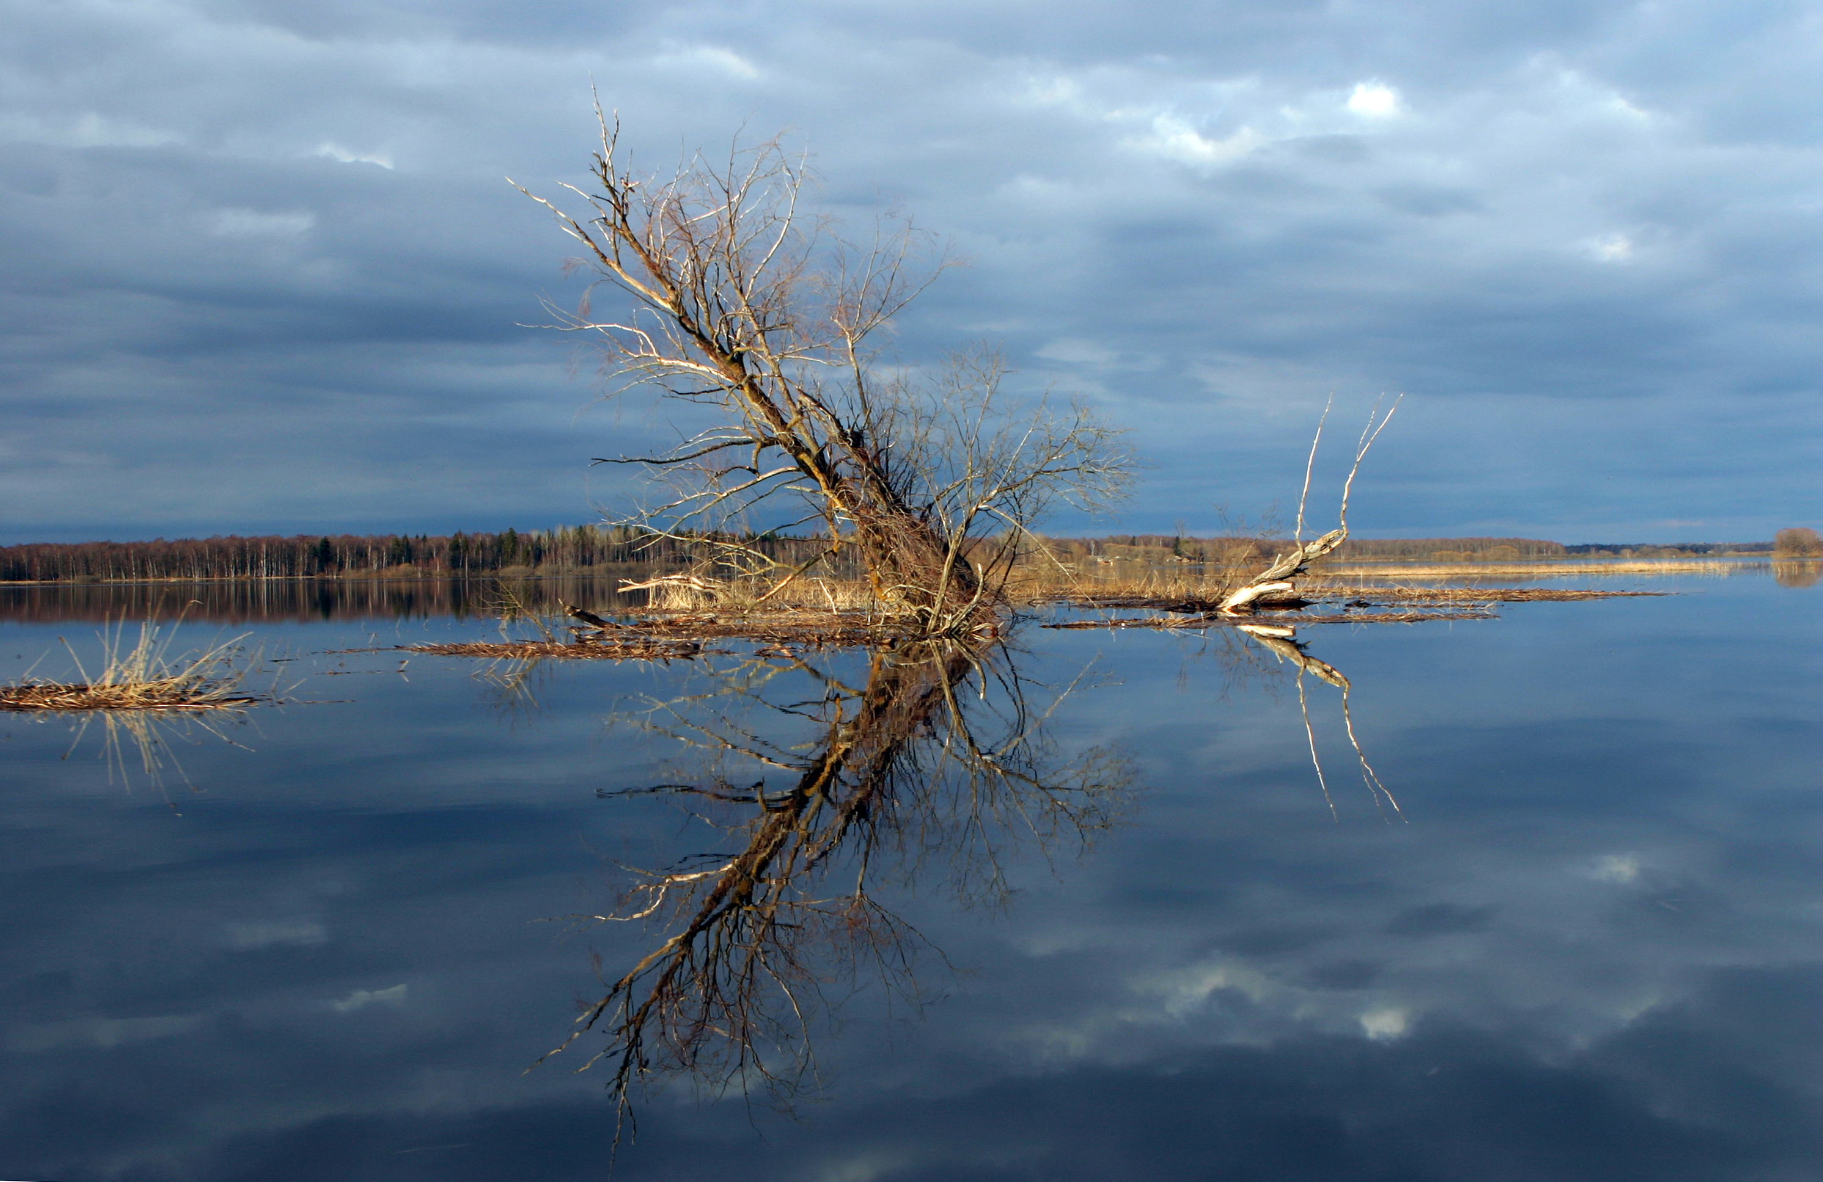

ESTONIA

Submitted to the Secretariat of the Convention on Biological Diversity 31.05.2012

Protected area information:

PoWPA Focal Point: Mrs Leelo Kukk (e-mail: leelo.kukk@keskkonnaamet.ee; + 372 555 966 05)

Lead implementing agency: Ministry of Environment; implementing agency Environmental Board of Estonia

Description of protected area system
Coverage
The protected areas cover 18% of Estonian land area, more than 80% of our coastline and 20% of marine areas.

Description and background
First protected area in Estonia was established in 1910. In 2012 Estonia has 5 National Parks, 131 nature conservation areas, 150 landscape protected areas and 107 protected areas. In addition 539 and arboretums are under state protection.
Total area covered by protected areas is 683 099 ha from which 591 024 ha are terrestial areas.

Governance types
18 objects, mainly single natural monuments (boulders, trees) and some landscape protected areas are protected on local community level. Most of protected areas are protected by the state.
According to Nature Conservation Law (2004) § 4 Protected natural objects are divided:
1) protected areas;
2) limited-conservation area;
3) protected species, fossils and minerals;
4) species' protection sites;
5) individual protected natural objects;
6) natural objects protected at the local government level.
The protected areas are divided:
1) national parks;
2) nature conservation areas;
3) landscape conservation areas.

Key threats
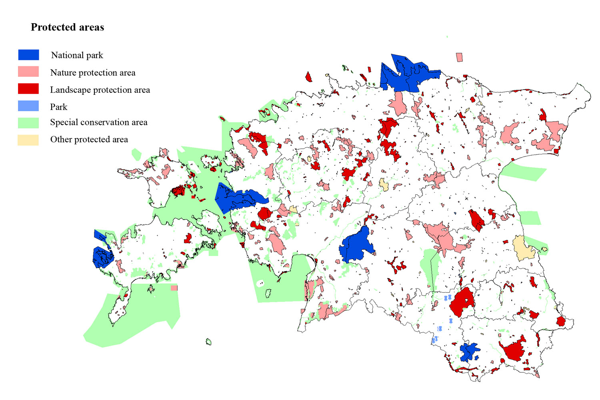
Fragmentation (planning activities, road construction), degradation and loss of habitats (e.g. semi-natural habitats), potential environmental pollution

Barriers for effective implementation
(Description of key barrier s for effective implementation)
Conflicts with economical and nature conservation objectives (incl private landowners), lack of financial and human capacities in conservation management, lack of baseline data (especially in marine environment).

National Targets and Vision for Protected Areas
(Insert national targets for protected areas/Target 11 of the Aichi Targets. Include rationale from protected area gap assessment, if completed, along with any additional information about the vision for the protected area system, including statements about the value of the protected area system to the country)
National targets for protected area system according are set in draft Nature Conservation Development Plan until 2020 (planned adoption 2012). One of the three main objectives of plan is:
- the favorable status of species, habitats and landscape diversity is granted, and habitats function as coherent ecological network (see the priority activities below).
The draft plan has integrated the main goals of Global Strategic Plan for Biodiversity until 2020, and of the EU Biodiversity Strategy to 2020 including the headline target 'Halting the loss of biodiversity and degradation of ecosystem services by 2020, restoring them in so far as feasible, while stepping up the EU contribution to averting global biodiversity loss'.
Quantitative targets are set for achieving favorable conservation status of different habitats, e.g. managing and restoration of semi-natural habitats, granting the protection of typologically representative forest habitats, restoration of threatened mires, restoration of natural river habitats, mapping and conservation of threatened marine habitats, assessing the state of unstudied habitats, assessing the ecological connectivity between the habitats, putting place the proper conservation measures etc.

Value assessments:
No uniform ecosystem service mapping or value assessment, covering the whole Estonia, has taken place. The dealing with the topic is still in discussion level. The following project based activities are undertaken:
* ' The demand for protected forest by working age population of Estonia' (2011) - economical value for the demand for protected forest was assessed based on contingent valuation method – ordered by Estonian Ministry of Environment.
* ' Assessing the economical value of bogs, on the example of Kuresoo bog' (2012) - assessment of economical value of one protected bog - ordered by Estonian Ministry of Environment.
* ' Overview of ecosystem services and their economical value' (2012) - explanatory overview, literature review. Stockholm Environment Institute branch in Tallinn (SEI-Tallinn).
* Ecosystems services assessment topic for marine and inland waters included in the EEA Financial Mechanism 2009-14 programme proposal “Integrated marine and inland water management”. The program waits currently for approval.
* Survey about Estonians attitude toward nature conservation and economy

Progress in and plans for achieving the goals of the Programme of Work on Protected Areas
Progress: 0 = no work, 1 = just started, 2 = partially complete, 3 = nearly complete, 4 = complete
Goals of the Programme of Work on Protected Areas | Progress 0-4
- Progress in establishing and strengthening national and regional systems of protected areas (1.1) | 3
- Progress in integrating protected areas into broader land- and seascapes and sectors so as to maintain ecological structure and function (1.2) | 2
- Progress in establishing and strengthening regional networks, transboundary protected areas (TBPAs) and collaboration between neighbouring protected areas across national boundaries (1.3) | 3
- Progress in substantially improving site-based protected area planning and management (1.4) | 3
- Progress in preventing and mitigating the negative impacts of key threats to protected areas (1.5) | 3
- Progress in promoting equity and benefit-sharing (2.1)  - Progress in assessing and implementing diverse protected area governance types (2.1) | 1
- Progress in enhancing and securing involvement of indigenous and local communities and relevant stakeholders (2.2) | 2
- Progress in providing an enabling policy, institutional and socio-economic environment for protected areas (3.1)  - Progress in assessing the contribution of protected areas to local and national economies (3.1) | 2-3
- Progress in building capacity for the planning, establishment and management of protected areas (3.2) | 3
- Progress in developing, applying and transferring appropriate technologies for protected areas (3.3) | 3
- Progress in ensuring financial sustainability of protected areas and national and regional systems of protected areas (3.4) | 2-3
- Progress in strengthening communication, education and public awareness (3.5) | 3
- Progress in developing and adopting minimum standards and best practices for national and regional protected area systems (4.1) | 2
- Progress in evaluating and improving the effectiveness of protected areas management (4.2) | 2
- Progress in assessing and monitoring protected area status and trends (4.3) | 3
- Progress in ensuring that scientific knowledge contributes to the establishment and effectiveness of protected areas and protected area systems (4.4) | 3
- Progress in marine protected areas | 3
- Progress in incorporating climate change aspects into protected areas | 1

Priority activities for fully implementing the Programme of Work on Protected Areas:
Activities | Timeline
1. compilation of management plans and protection rules for the protected areas | 2016
2. effective implementation of management plans and protection rules for the protected areas | continuous
3. enhancing the coherence and connectivity between habitats within and beyond protected areas
4. public awareness in conservation policy | continuous
5. enhancing other sectors positive contribution (forestry, agriculture, tourism, planning), continuance of agricultural support schemes
6 restoration activities (mires, semi-natural areas, rivers etc).
7 improving impact assessment system (for Natura 2000 areas)
8 knowledge improvement of habitats and species

Action Plans (detailed steps) for completing priority activities for fully implementing the Programme of Work on Protected Areas:

Activity 1:
Key steps | Timeline | Responsible agencies | Indicative budget
Prioritization of protected areas for preparation of management plans | 2013 | Ministry of Environment, Environmental Board
Public tenders to find the partners making the management plans | 2014 | Environmental Board
Preparation of management plans | 2015 | Partners, Stakeholderds, Local Community , Universities
Approvement of management plans | 2016 | Environmental Board

Activity 2:
Key steps | Timeline | Responsible agencies | Indicative budget
Granting of sustainable financing | continuous | EB | 10 MEUR
Granting sufficient and competent human resources | Continuous | EB
Cooperation with stakeholders and local inhabitants | Continuous | EB
Supervision of implementation | continuous | EB
Assessment of management effectiveness

Activity 3:
Key steps | Timeline | Responsible agencies | Indicative budget
Project based assessment of efectiveness | 2015 | Tartu Univesity
Promoting green infrastructure

Key assessment results
Ecological gap assessment In 2012 new project started to assess the connectivity between protected areas for key species

Management effectiveness assessment The study about effectiveness of protected areas management was conducted in 2010. Main outcome was that protected areas which have mangament plans, have higher conservation effectiveness than other and the main problems is lack of sustainable financing . In average protected areas management effectiveness is quite high- 75% of maximum level.
(http://www.keskkonnaamet.ee/public/Valdkonnad/Looduskaitse/Kaitsetohusus_METT_2010_2.pdf)
Sustainable finance assessment In 2005 study for the needs of implementation of Natura 2000 was carried out. In 2011 was started study to find out the needs for restoration and management of semi natural habitats.

Capacity needs assessment

Policy environment assessment Included in draft Nature Conservation Development plan

Protected area integration and mainstreaming assessment
Protected area valuation assessment
* ' The demand for protected forest by working age population of Estonia' (2011) - economical value for the demand for protected forest was assessed based on contingent valuation method – ordered by Estonian Ministry of Environment.
* ' Assessing the economical value of bogs, on the example of Kuresoo bog' (2012) - assessment of economical value of one protected bog - ordered by Estonian Ministry of Environment.
* Survey about Estonians attitude toward nature conservation and economy

Climate change resilience and adaptation assessment

