Action Plan for Implementing the Programme of Work on Protected Areas
of the Convention on Biological Diversity
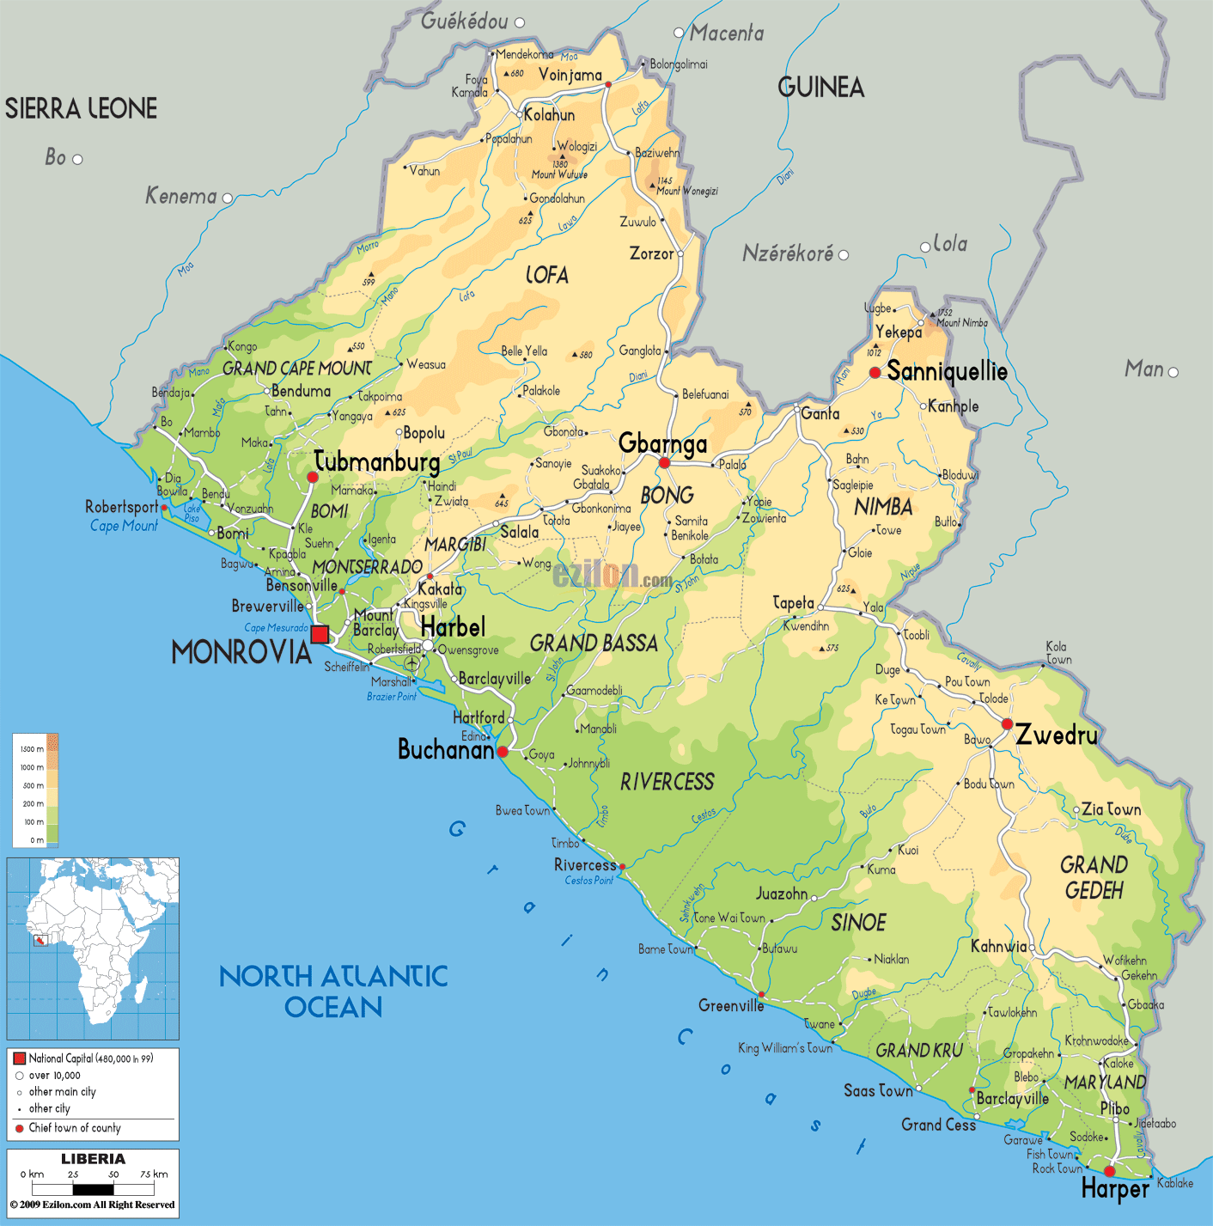

Liberia

Submitted to the Secretariat of the Convention on Biological Diversity June 8, 2012

Protected area information:

PoWPA Focal Point: Nathaniel T. Blama, Sr.
Technical Advisor
Environmental Protection Agency of Liberia
Natpolo2000@yahoo.com
+231886518635

Lead implementing agency: Environmental Protection Agency of Liberia and
Forestry Development Authority of Liberia

Multi-stakeholder committee: NATIONAL STEERING
- Environmental Protection Agency of Liberia
- Forestry Development Authority of Liberia
- Ministry of Internal Affairs
- Ministry of Lands Mines and Energy
- Ministry of Agriculture
- Land Commission
- Ministry of Gender and Development
- Ministry of Planning and Economic Affairs
- Ministry of Health & Social Welfare
- Two members of the Legislature (Committees on the Environment)
- Internal Non Governmental Organizations (conservation INGOs)
- Civil Society
- Two members from Communities
Description of protected area system
Coverage
Liberia presently has about 6% of terrestrial and several proposed which if approved by Law could take it up to 25% we also have 1% of marine protected area and several proposed which if also approved by Law could take it up to 5 %.

Description and background
The country is endowed with natural resources; these include timber, iron ore, diamonds, gold, plentiful waters and rich soil to grow cash crops. With its 579 km² coastline and a forest area covering about 4.3 million hectares (or about 45% of its total land area), Liberia contains the largest remaining vestige of the extensive Upper Guinea Forest. This places the country in a critical position or at the “Heart of the Hotspots” in the sub-region in taking tough decisions to manage its protected areas (IBA, 2004, Blore, 2007, R-PIN, 2008), especially after 14 long years of civil distress and economic plunder.

Although Liberian traditional conservation practices can be associated with land-use where the best uses of land were conducted considering the biophysical, economic and socio-cultural concerns of land resources, modern protected area management was a new concept at the advent of forest management in the 1950s. As the population of forest resource users increased, the rate at of biological resources destruction increased correspondingly resulting to increased threat to these resources. Preliminary report of the Liberia Protected Areas Network (2008) states that in spite of biological endowment of the country, it is necessary to take careful actions or the stock of wild-life will continue to decline or be ‘near extinct outside the country. The impact of the losses of biological resources and habitat destruction in the country is inflicting serious negative impacts on people’s lives and livelihoods, thus resulting into extreme poverty. It is against this backdrop, that the Liberian government, along with its partners-in-development, is fully engaged in series of planning activities as a means of sustaining the country’s biodiversity resources and reducing poverty in the country. However, the implementation of such plans can only be effective if there is a political will and commitment in support of program implementation..

Governance types
Management structures have been established in and around protected areas, with the Forestry Development Authority taking the lead. This system has not been as effective as anticipated; for the mere fact that it advocates the implementation of government’s programmes and policies around the Pas, without consideration for the needs and aspirations of communities around the protected areas.

Key threats
Key threats to Protected Areas include alluvial mining, bush meat hunting, poaching, pit sawing, as well as lack of governance structures around Pas.

Barriers for effective implementation
The major barrier for effectively implementing POWPA activities in Liberia is funding for PA management and related activates; another critical barrier for implementing POWPA activities is low or lack of public awareness and education at all levels, (Individuals, Institutional and Systemic.

National Targets and Vision for Protected Areas
(Insert national targets for protected areas/Target 11 of the Aichi Targets. Include rationale from protected area gap assessment, if completed, along with any additional information about the vision for the protected area system, including statements about the value of the protected area system to the country)
Progress in and plans for achieving the goals of the Programme of Work on Protected Areas
Progress: 0 = no work, 1 = just started, 2 = partially complete, 3 = nearly complete, 4 = complete
Goals of the Programme of Work on Protected Areas | Progress 0-4
- Progress in establishing and strengthening national and regional systems of protected areas (1.1) | 3
- Progress in integrating protected areas into broader land- and seascapes and sectors so as to maintain ecological structure and function (1.2) | 2
- Progress in establishing and strengthening regional networks, transboundary protected areas (TBPAs) and collaboration between neighboring protected areas across national boundaries (1.3) | 3
- Progress in substantially improving site-based protected area planning and management (1.4) | 3
- Progress in preventing and mitigating the negative impacts of key threats to protected areas (1.5) | 3
- Progress in promoting equity and benefit-sharing (2.1)  - Progress in assessing and implementing diverse protected area governance types (2.1) | 2
- Progress in enhancing and securing involvement of indigenous and local communities and relevant stakeholders (2.2) | 2
- Progress in providing an enabling policy, institutional and socio-economic environment for protected areas (3.1)  - Progress in assessing the contribution of protected areas to local and national economies (3.1) | 2
- Progress in building capacity for the planning, establishment and management of protected areas (3.2) | 2
- Progress in developing, applying and transferring appropriate technologies for protected areas (3.3) | 2
- Progress in ensuring financial sustainability of protected areas and national and regional systems of protected areas (3.4) | 2
- Progress in strengthening communication, education and public awareness (3.5) | 3
- Progress in developing and adopting minimum standards and best practices for national and regional protected area systems (4.1) | 2
- Progress in evaluating and improving the effectiveness of protected areas management (4.2) | 2
- Progress in assessing and monitoring protected area status and trends (4.3) | 2
- Progress in ensuring that scientific knowledge contributes to the establishment and effectiveness of protected areas and protected area systems (4.4) | 2
- Progress in marine protected areas | 2
- Progress in incorporating climate change aspects into protected areas | 2

Priority activities for fully implementing the Programme of Work on Protected Areas:
No. | Activities | Timeline
1. | Strengthen the management of the Sapo National Park, Grebo National Forest, Grand Kru-River Gee National Forest, East Nimba Nature Reserve and the Lake Piso Sustainable Multiple Use Reserve
2. | Strengthen the process of the establishment of proposed protected areas and the creation of National Parks in Liberia
3. | Education, Public Awareness and Capacity Building on Biodiversity Conservation
4 | Ensure Land Tenure Reform and the strengthening of local institutions and administration
5 | Reduce the threat to biodiversity in the protected areas through the establishment of sustainable livelihood support projects and income generation
6 | Establish and monitor new or already existing landscape corridors within the

Action Plans (detailed steps) for completing priority activities for fully implementing the Programme of Work on Protected Areas:

Activity 1:
No. | Key steps | Timeline | Responsible agencies | Indicative budget
 | Management teams carry out and improve key management activities such as surveillance, biomonitoring, sensitization and local development around the protected areas to contribute to effective conservation of key species and biodiversity | 2013- 2018 | EPA  FDA  FFI  CI | $1,500,000.00
 | Management teams are well trained and fully equipped to shield the protected areas from intruders and illegal activities. | 2013- 2018 | FDA  EPA | $2,500,000.00

Activity 2:
No. | Key steps | Timeline | Responsible agencies | Indicative budget
 | Comprehensive management plans and their implementation for newly created protected areas and national parks result in increased biodiversity protection | 2013 - 2017 | FDA  WB  FFI  CI | $500,000.00
 | The protected area network of the transboundary is reinforced and become operational National Parks between Cote D’ Ivoire, Guinea, Serra Leone and Liberia | 2013 - 2017 | FDA  WB  FFI  CI | $1,500,000.00
3 | Improved potential of meeting up with CBD quest to conserve 10% of Liberian land space | 2013 - 2017 | FDA  WB  FFI  CI | $500,000.00
Activity 3:

No. | Key steps | Timeline | Responsible agencies | Indicative budget
 | Produce thousands of brochures, and other educational material on the importance of PA , biodiversity and its conservation | 2013 - 2020 | FDA  Civil Society  The Communities | $500,000.00
 | Carry out massive and sustained public awareness using popular media in each of the PAs | 2013 - 2020 | FDA  Civil Society  The Communities | $500,000.00
 | Publish proceedings of public education and awareness | 2013 - 2020 | FDA  EPA  Civil Society  The Communities | $250,000.00
 | Target national school system and universities for awareness activities including curriculum revision to reflect the importance of PAs | 2013 - 2020 | FDA  EPA  Civil Society  The Communities | $500,000.00

Activity 4:

No. | Key steps | Timeline | Responsible agencies | Indicative budget
 | Develop and enact comprehensive laws clarifying ownership, access and use of land around protected areas is set up | 2013 - 2020 | Land Commission  FDA  EPA  The Communities | $250,000.00
 | Strengthen local institutions in resource governance and land administration around protected areas | 2013 - 2020 | Land Commission  FDA  EPA  The Communities | $500,000.00
 | Document and integrate indigenous knowledge and skills about the conservation/protection of PAs | 2013 - 2020 | Land Commission  FDA  EPA  The Communities | $250,000.00

Activity 5:

No. | Key steps | Timeline | Responsible agencies | Indicative budget
 | Diversify and sustainable sources of livelihood and cash income | 2013 - 2020 | FDA  EPA  Civil Society  The Communities
 | Develop schemes for payments of ecosystem services are identified and operational | 2013 - 2020 | FDA  EPA  Civil Society  The Communities
 | Train thousands of community members in sustainable livelihood, agro-forestry schemes and biodiversity conservation | 2013 - 2020 | FDA  EPA  Civil Society  The Communities
 | Increase participation (about 30%) of PA communities in protected areas management and biodiversity-conscious activities | 2013 - 2020 | FDA  EPA  Civil Society  The Communities

Activity 6:

No. | Key steps | Timeline | Responsible agencies | Indicative budget
 | Increase connectivity of protected areas and effective protection of new and already existing corridors allow for genetic exchange of key species and increased forest cover | 2013 - 2020 | EPA  Lands and Mines  Maritime  Fisheries  FDA  Internal Affairs | $1,500.000.00

Key assessment results
Ecological gap assessment (insert summary findings if available)
This assessment still needs to be conducted.

Management effectiveness assessment (Insert summary findings if available)

Sustainable finance assessment
There has been no financial assessment done to date and needs to be conducted

Capacity needs assessment
Capacity needs assessment for the overall conservation and protection of Biological Diversity was done in 2005, more than seven years ago. This assessment identified inadequate capacity for taxonomist and Botanists

Policy environment assessment
Several policy instruments have been developed by the Forestry Development Authority, including the New Forestry Law, the Policy, Ten Year Plan; the Environmental legislations; mining law, tec.

Protected area integration and mainstreaming assessment
Since 2009, significant efforts have been made to mainstream protected areas concerns into the Poverty Reduction Strategy. Reports can be found on the website of the convention.

Protected area valuation assessment (Insert summary findings if available)
Climate change resilience and adaptation assessment (Insert summary findings if available)

(Insert other assessment results if available)

