Action Plan for Implementing the Convention on Biological Diversity’s
Programme of Work on Protected Areas

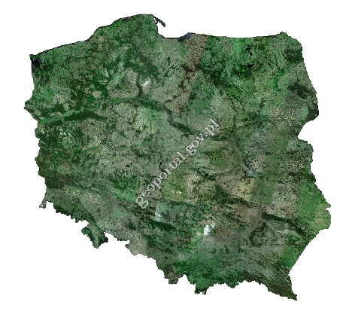

POLAND

Submitted to the Secretariat of the Convention on Biological Diversity -

Protected area information:

PoWPA Focal Point: Marek Kajs, General Directorate of Environmental Protection, Wawelska 52/54, 00-922 Warszawa, marek.kajs@gdos.gov.pl, tel. +48 22 57 92 186

Lead implementing agency: Ministry of the Environment, General Directorate for Environmental Protection

Multi-stakeholder committee: no

Description of protected area system

National Targets and Vision for Protected Areas
According to National Biodiversity Strategy the whole territory of Poland, including marine areas, will be characterized by a good status of the natural environment, enabling the preservation of the richness of biodiversity of Polish nature, as well as the stability and sustainability of natural processes – the areas with the highest natural values will be secured by efficient legal protection and connected by a system of functional ecological corridors.
Coverage
Total area of protected areas in Poland – 120436 km² (38,64 % of Polish terrestrial area and 45,5 % of Polish marine area – internal and territorial waters)
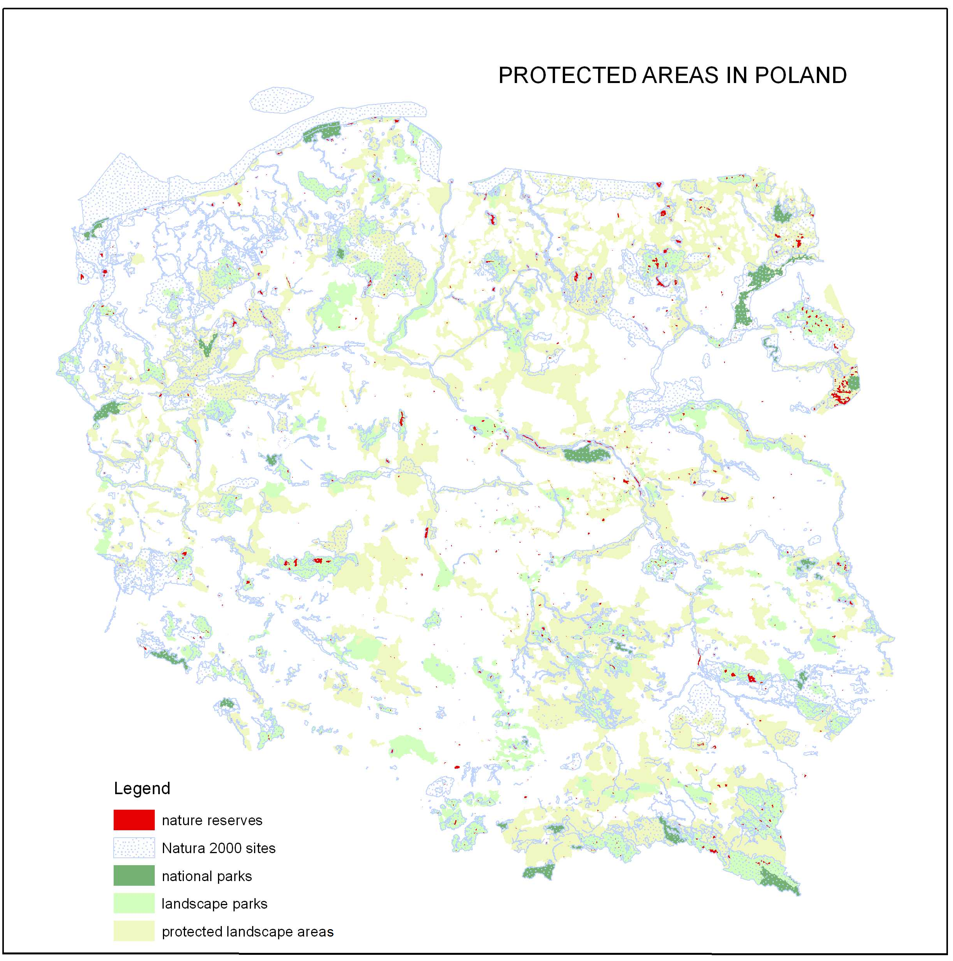

Description and background
The forms of nature protection in Poland according to the Nature Conservation Act of 16 April 2004 include (protected areas in bold):
• national parks;
• nature reserves;
• landscape parks;
• protected landscape area;
• Natura 2000 sites;
• nature monuments;
• documentation sites;
• ecological areas;
• natural and scenic complexes;
• plant, animal and fungi species protection.
National park comprises protected areas with particularly outstanding scientific, natural, social, cultural and educational characteristics, not smaller than 1000 hectares where the environment as a whole, including landscape characteristics, is protected. A national park is established to preserve biodiversity, resources, formations and elements of inanimate nature and landscape values, restoration of a proper state of resources and elements of nature as well as reconstruction of distorted habitats: of plants, animals and fungi species. A national park is established, its area widened or limited by the virtue of a regulation of the Council of Ministers. National parks are supervised by a minister for environmental issues.
Nature reserve is an area in which natural or insignificantly altered ecosystems are maintained, including natural habitats, as well as defined species of flora and fauna and elements of inanimate nature, having significant scientific, natural, cultural or scenic value. An area is recognized as a reserve by the virtue of a regulation of Regional Director for Environmental Protection.
Landscape park is the area protected due to environmental, historical and cultural values. The purpose of establishing a landscape park is preservation, popularization and dissemination of such the values in the conditions of sustainable development. Landscape park is created by way of a resolution of the regional parliament.
A protected landscape area is an area protected due to particularly outstanding landscape features of the area of diversified ecosystems, valuable especially due to the potential for satisfying needs connected with tourism and recreation, or owing to the existing or restored ecological corridors. Protected landscape area is created by way of a resolution of regional parliament.
Natura 2000 Network is a consistent ecological network created in order to preserve natural habitats and important species within the European Community. Natura 2000 Network in Poland comprises of 144 Special Protected Areas (SPA’s) and 823 Sites of Community Importance (SCI’s). Those sites were designated under the Directive 2009/147/EC of the European Parliament and of the Council of 30 November 2009 on the conservation of wild birds and the Council Directive 92/43/EEC of 21 May 1992 on the conservation of natural habitats and of wild fauna and flora, respectively. Both of these directives protect animal and plant species and habitat types, which are of European importance.
Ecological areas comprise the remains of ecosystems which are worthy of protection and having a significance in maintaining unique gene pools and environment types, such as: natural water basins, field and forest ponds, tree and bush clusters, swamps, peat-bogs, dunes, areas of unused flora, old river-beds, rock outcrops, scarps, gravel-banks and localities of rare or protected species of plants and animals, including places of their seasonal stay or breeding. An ecological area is specified by the virtue of a regulation of a commune council.
Natural and scenic complexes are created for the purpose of protecting extremely valuable fragments of the natural and cultural environment and preserving their aesthetic values. A natural and scenic complex is specified by the virtue of a regulation of a commune council.

Governance types
State governance – with regard to the vast majority of protected areas
Shared governance – with regard to some nature reserves
Key threats
- Advancing urbanization and development of the country;
- Fragmentation of ecosystems caused by infrastructure;
- Introduction and spread of invasive alien species;
- Land use changes;
- Intensification of agriculture;
- Tourist and sport pressure on areas with high natural values;
- Synanthropisation of fauna and flora;
- Lack of traditional land use practices.

Barriers for effective implementation
• Lack of management plans;
• Lack of conservation measures;
• Limited financial and human resources;
• General low public awareness and restrained attitude of local communities towards protected areas;
• Incomplete knowledge on natural resources;
• Political reluctance.

Status, priority and timeline for key actions of the Programme of Work on Protected Areas

Status of key actions of the Programme of Work on Protected Areas
Status of key actions of the Programme of Work on Protected Areas | Status
- Progress on assessing gaps in the protected area network (1.1) | 3
- Progress in assessing protected area integration (1.2) | 2
- Progress in establishing transboundary protected areas and regional networks (1.3) | 2
- Progress in developing site-level management plans (1.4) | 2
- Progress in assessing threats and opportunities for restoration (1.5) | 3
- Progress in assessing equitable sharing of benefits (2.1)  - Progress in assessing protected area governance (2.1) | 2
- Progress in assessing the participation of indigenous and local communities in key protected area decisions (2.2) | 3
- Progress in assessing the policy environment for establishing and managing protected areas (3.1)  - Progress in assessing the values of protected areas (3.1) | 3
- Progress in assessing protected area capacity needs (3.2) | 1
- Progress in assessing the appropriate technology needs (3.3) | 2
- Progress in assessing protected area sustainable finance needs (3.4) | 2
- Progress in conducting public awareness campaigns (3.5) | 3
- Progress in developing best practices and minimum standards (4.1) | 2
- Progress in assessing management effectiveness (4.2) | 2
- Progress in establishing an effective PA monitoring system (4.3) | 2
- Progress in developing a research program for protected areas (4.4) | 2
- Progress in assessing opportunities for marine protection | 2
- Progress in incorporating climate change aspects into protected areas | 2
Status: 0 = no work, 1 = just started, 2 = partially complete, 3 = nearly complete, 4 = complete
(Insert notes as appropriate)
1.1. Protected areas network: land and marine national protected areas system was established, including Natura 2000 network. Gap analysis for national parks and Natura 2000 network were conducted. There is a need to conduct gap analysis for smaller forms of protected areas on local level. Natura 2000 is the largest protected areas system in Poland strongly contributing to nature conservation
1.2. Protected areas integration: protected areas are integrated into broader landscapes by incorporating them into land development plans and regional/local decision making process; attempts to improve ecological connectivity by development of ecological corridors.
1.3. Transboundary protected areas: several transboundary protected areas were established, including transboundary biosphere reserves and transboundary Ramsar Site.
1.4. Site level management plans: there is a long tradition in development of management plans for national and landscape parks and nature reserves in Poland. Due to some changes in legislation, old management plans had to be changed and now there is a process of development of new management plans. In the meantime annual protective tasks function as management plans. Management plans for Natura 2000 sites are under development.
1.5. Threats and opportunities for restoration: Such assessment is carried out as a part of the process of elaboration of management plans or protective tasks.
2.1. Equitable sharing of benefits: protected areas are common heritage and all people have equal rights to benefits in accordance with management plans/protective tasks; there are no limits in access to research findings, research cooperation and technology transfer.
2.2. Participation of local communities: representatives of local communities participate in scientific councils of national parks and take part in preparation of management plans and land development plans covering protected areas; according to law regulations key decisions are taken after broad public consultations.
3.1. Policy environment and values of protected areas: all necessary legislation is in place; biodiversity values of protected areas are being assessed, mainly during development of management plans (but without economic valuation of ecosystem services).
3.3. Appropriate technology needs: there is an on-going process of assessing technology needs in national parks.
3.4. Sustainable finance needs: there is an on-going process of assessing financial needs of national parks; those needs are taken into account during drafting budgetary requirements and application for project funds.
3.5. Public awareness campaigns: a great deal of campaigns within protected areas was conducted (education of school children, campaigns focused on local communities and/or tourists); seminars, conferences, workshops, field studies etc. were organized; educational paths were built; booklets and posters were issued. Many of those activities were connected with improving of social acceptance and promotion of Natura 2000 Network.
4.1. Best practices and minimum standards: taking into account multiyear experiences, best practices and standards were developed in several national parks. Best practices were also prepared with regard to habitat types, which are of European importance.
4.2. Management effectiveness: permanent assessment in national parks, required by the act on public financing; assessment as a part of development of new management plans for national parks; self-assessment in national parks; assessment of protection activities by monitoring systems in national parks.
4.3. Effective PA monitoring system: monitoring systems were established in national parks and there are on-going assessments and improvements of those systems in several areas. National database on protected areas was developed and updated. Chief Inspectorate of Environmental Protection conduct
a regular monitoring of status of habitats and species protected under EU nature directives.
4.4. Research program: annual research programs are developed in several national parks; in other national parks priority researches are indicated; there is no multiyear national research program for national parks. A lot of researches, including interdisciplinary researches, are conducted by national parks in cooperation with research institutions and universities. Research programs are conducted also in nature reserves.
Marine protection: marine protected areas system was established, consisting of two national parks and nine Natura 2000 sites. Some changes in legislation are needed in order to enable establishment of marine nature reserves.
Climate change aspects: climate change aspects are taken into account in research, education and protection activities of several national parks. Special attention is paid to long-term changes in structure and functions of ecosystems in changing environment conditions. Meteorological observations are conducted on several sites. Real estates in national parks are gradually thermo-modernized and renewable energy technologies are implemented.

Priority actions for fully implementing the Programme of Work on Protected Areas:
Implementation of the Program of Work on Protected Areas depends mostly on the proper management of protected areas. Lack of site-level management plans makes unworkable the real conservation of nature, participation, monitoring activities etc. Therefore, the priority action for fully implementing the Programme of Work on Protected Areas can be seen as action of site-level management plan development. All other key actions will derive from management plans development.
The level of integration of protected areas into broader land- and seascape is insufficient in Poland. The fragmentation of ecosystems caused by infrastructure and urbanization is becoming stronger. Therefore, the second priority action for fully implementing the Programme is to create a legal basis for the establishment, protection and management of ecological corridors, as well as formal designation of such areas.
One of the most important gaps in Polish Nature Conservation Act is the lack of legal basis for designation of marine nature reserves. This gap is crucial for the conservation of and sustainable use of biodiversity of the marine and the coastal areas. Hence, the next priority action is to create a legal basis for the designation of marine nature reserves, following by formal designation of such protected areas in the field.
Above mentioned priority tasks are identified as priority actions in The National Strategy for the Conservation and Sustainable Use of Biodiversity and partially in the draft of Energetic Safety and Environment Perspective 2020.

Timeline for completion of key actions
Closure of management plan development for protected areas is planned by 2020. To achieve this goal, since 2009 General Directorate for Environmental Protection has led the project POIS.05.03.00-00-186/09 “Preparation of the Natura 2000 management plans in Poland.”. In this project plans for 406 sites should be prepared before the end of 2013. Simultaneously, regional directorates for environmental protection prepare management plans for the remaining Natura 2000 sites. Tens of management plans for national parks and nature reserves are also under preparation
Formation of legal basis concerning ecological corridors and marine nature reserves, as well as formal designation of such areas is planned by 2020.

Action Plans for completing priority actions of the Programme of Work on Protected Areas

Action 1: Site-level management plan development
Key steps | Timeline | Responsible parties | Indicative budget
Completion of project POIS.05.03.00-00-186/09 – management plans for 406 Natura 2000 Sites | 2013 | General Directorate for Environmental Protection | 15 765 933 PLN
Completion of management plans development for all remaining Natura 2000 Sites | 2020 | Regional directorates for environmental protection | No data
Completion of management plans development for nature reserves | 2020 | Regional directorates for environmental protection | No data
Completion of management plans development for national parks and Natura 2000 Sites within national parks borders | 2020 | Ministry of the Environment | No data

Action 2: Establishment, protection and management of ecological corridors
Key steps | Timeline | Responsible parties | Indicative budget
Development of a legal basis for the establishment, protection and management of ecological corridors/Alteration of Nature Conservation Act | 2015 | General Directorate for Environmental Protection | -
Formal designation of ecological corridors | 2020 | General Directorate for Environmental Protection | No data

Action 3: Designation of marine nature reserves.
Key steps | Timeline | Responsible parties | Indicative budget
Development of a legal basis for the designation of marine nature reserves/Alteration of Nature Conservation Act | 2015 | General Directorate for Environmental Protection | -
Designation of marine nature reserves | 2020 | Regional directorates for environmental protection | No data

Key assessment results
Ecological gap assessment (insert summary findings if available)
Management effectiveness assessment (Insert summary findings if available)
Assessments and management controls in national parks shows good management effectiveness. Effective maintenance of protected species, habitats and ecosystems testifies proper management.

Sustainable finance assessment (Insert summary findings if available)

Capacity needs assessment (Insert summary findings if available)

Policy environment assessment (Insert summary findings if available)

Protected area integration and mainstreaming assessment (Insert summary findings if available)

Protected area valuation assessment (Insert summary findings if available)

Climate change resilience and adaptation assessment (Insert summary findings if available)

(Insert other assessment results if available)

