Action Plan for Implementing the Convention on Biological Diversity’s
Programme of Work on Protected Areas
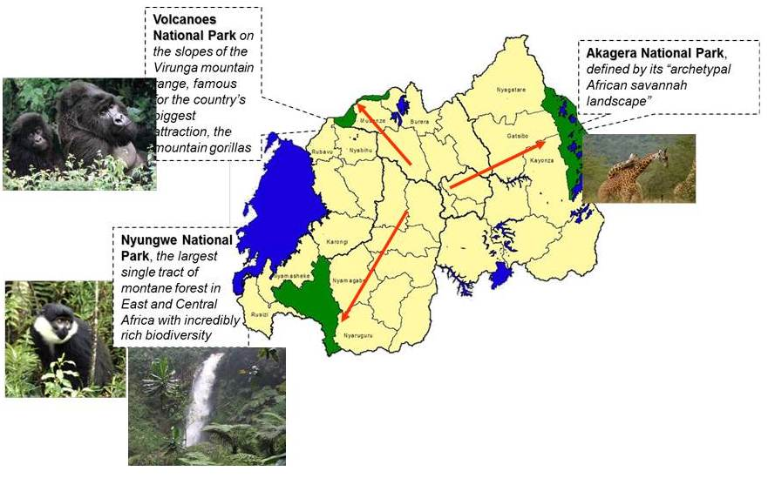

(Rwanda)

Submitted to the Secretariat of the Convention on Biological Diversity [June 2012]

Protected area information:

PoWPA Focal Point: (Francois Bizimungu-Rwanda Development Board)

Lead implementing agency: (Rwanda Development Board/Tourism and Conservation)

Multi-stakeholder committee: (Add description)

Description of protected area system

National Targets and Vision for Protected Areas
(Insert national targets for protected areas/Target 11 of the Aichi Targets. Include rationale from protected area gap assessment, if completed, along with any additional information about the vision for the protected area system, including statements about the value of the protected area system to the country)

Coverage
(9.99%)

Description and background
Biodiversity and genetic resources
Although Rwanda is a small country (26,338 km2), it is rich in biodiversity, which is mainly conserved in protected areas (three national parks, natural forests, wetlands) covering almost 10 per cent of the national territory. The country’s location at the heart of the Albertine Rift eco-region in the western arm of the Africa’s Rift Valley, makes it home to 40 per cent of the continent’s mammal species (402 species). There is a huge diversity of birds (1,061 species), reptiles and amphibians (293) species, and higher plants (5,793 species). Rwanda is also recognized as a biodiversity hotspot, hosting more endemic mammals, birds, butterflies, fish and amphibians than anywhere else in Africa.
Although it is acknowledged that a multitude of benefits accrue to Rwandese from the country’s biodiversity and genetic resources, there is no hard assessment of the value of high value biodiversity and the costs and benefits of protecting it.

Governance types
- National Parks
- Natural Forest reserves
- Protected wetlands
Key threats
- Poaching (illegal PA resource uses)
- Agriculture/encroachment
- Climate change

Barriers for effective implementation
Lack of clear institutional and policy framework (governance types, etc)
Lack of complete valuation assessments

Status, priority and timeline for key actions of the Programme of Work on Protected Areas

Status of key actions of the Programme of Work on Protected Areas
Status of key actions of the Programme of Work on Protected Areas | Status
- Progress on assessing gaps in the protected area network (1.1) | 0
- Progress in assessing protected area integration (1.2) | 0
- Progress in establishing transboundary protected areas and regional networks (1.3) | 2
- Progress in developing site-level management plans (1.4) | 3
- Progress in assessing threats and opportunities for restoration (1.5) | 2
- Progress in assessing equitable sharing of benefits (2.1)  - Progress in assessing protected area governance (2.1) | 2
- Progress in assessing the participation of indigenous and local communities in key protected area decisions (2.2) | 3
- Progress in assessing the policy environment for establishing and managing protected areas (3.1)  - Progress in assessing the values of protected areas (3.1) | 2  2
- Progress in assessing protected area capacity needs (3.2) | 4
- Progress in assessing the appropriate technology needs (3.3) | 2
- Progress in assessing protected area sustainable finance needs (3.4) | 2
- Progress in conducting public awareness campaigns (3.5) | 2
- Progress in developing best practices and minimum standards (4.1) | 3
- Progress in assessing management effectiveness (4.2) | 2
- Progress in establishing an effective PA monitoring system (4.3) | 2
- Progress in developing a research program for protected areas (4.4) | 2
- Progress in assessing opportunities for marine protection | 0
- Progress in incorporating climate change aspects into protected areas | 2
Status: 0 = no work, 1 = just started, 2 = partially complete, 3 = nearly complete, 4 = complete
(Insert notes as appropriate)

Priority actions for fully implementing the Programme of Work on Protected Areas:
Action | Priority | Timeline | Indicative Budget
Protected areas network institutionalized and effectively managed | VH | 2017 | 11,300,000 USD
Diversification of governance types and recognition through acknowledgement in national legislation and other formal means | VH | 2015 | 5,000,000 USD
Development and implementation of sustainable finance plans for protected area systems. | H | 2015 | 800,000 USD
Assessing the values and contribution of protected areas to the national and local economies | VH | 2014 | 1,000,000 USD
Integration of protected areas into wider land use and economic sectors to showcase mainstreaming of biodiversity with other sectors. | H | 2015 | 1,000,000 USD

Priority for completion: VH (very high); H (high); M (medium); L (low); c) Timeline: (e.g., 2012, 2013, 2014)

Action Plans for completing priority actions of the Programme of Work on Protected Areas

Action 1: Protected areas network institutionalized and effectively managed
Key steps | Timeline | Responsible parties | Indicative budget (US $)
Assessing gaps in the protected area network | 2013 | RDB/REMA/RNRA | 100,000 USD
Assessing protected area integration | 2013 | RDB/REMA/RNRA | 100,000 USD
Improving the representativeness of the protected area network | 2015 | RDB/REMA/RNRA | 5,000,000 USD
Restoring degraded protected areas and establishing ecological corridors | 2015 | RDB/REMA/RNRA | 5,000,000 USD
Improving protected area management effectiveness | 2017 | RDB/REMA/RNRA | -
Strengthening protected area capacity | 2014 | RDB/REMA/RNRA | 1,000,000 USD
Improving the equitable distribution of protected area benefits | 2015 | RDB/REMA/RNRA | -
Monitoring and reporting on progress toward management effectiveness | 2015 | RDB/REMA/RNRA | 100,000 USD

Action 2: Diversification of governance types and recognition through acknowledgement in national legislation and other formal means
Key steps | Timeline | Responsible parties | Indicative budget (US $)
Create new protected areas with innovative forms of governance, such as community conserved areas | 2014 | RDB, REMA, RNRB, MINELA | 4,000,000 USD
Improving protected area policies | 2013 | RDB/REMA/RNRA/MINELA | 500,000 USD
improving protected area governance | 2015 | RDB/REMA/RNRA/MINELA | 500,000 USD

Action 3: Development and implementation of sustainable finance plans for protected area systems.
Key steps | Timeline | Responsible parties | Indicative budget (US $)
Assessing protected area sustainable finance needs | 2015 | RDB/REMA/ RNRA/MINELA/MINICOM | 200,000 USD
Developing protected area business plan or plans | 2015 | RDB/REMA/RNRA | 500,000 USD
Developing new protected area funding mechanisms | 2015 | RDB/REMA/RNRA | 100,000 USD

Action 4: Assessing the values and contribution of protected areas to the national and local economies
Key steps | Timeline | Responsible parties | Indicative budget (US $)
Assessing the values of protected areas | 2015 | RDB/REMA/ RNRA/ MINELA/ MINICOM | 200,000 USD
Create finance mechanisms linked to protected area values (e.g., payment for ecosystem services) | 2017 | RDB/REMA/RNRA | 200,000 USD
Develop and apply policies for access and benefit sharing | 2015 | RDB/REMA/RNRA/ MINELA/MINICOM | 200,000 USD
Improve mechanisms for participation of local communities | 2015 | RDB/REMA/RNRA | 200,000 USD
Assess opportunities for local community participation in key protected area management | 2014 | RDB/REMA/RNRA | 200,000 USD

Action 5: Integration of protected areas into wider land use and economic sectors to showcase mainstreaming of biodiversity with other sectors
Key steps | Timeline | Responsible parties | Indicative budget (US $)
Integrate protected areas into poverty reduction strategies | 2014 | RDB/REMA/RNRB/MINELA | 200,000 USD
assess land use planning, zoning and buffers in key connectivity areas | 2015 | RDB/RNRA/RAB/MINELA | 300,000 USD
Harmonize sectorial policies or laws to strengthen protected areas management effectiveness | 2015 | RDB/REMA/RNRA/MINELA | 200,000 USD
Integrate PA values and ecological services into the national economy | 2015 | RDB/REMA/RNRA
Develop incentive mechanisms for private protected areas | 2015 | RDB/REMA/RNRA/PSF | 300,000 USD

Acronyms
RDB: RWANDA DEVELOPMENT BOAD
REMA: RWANDA ENVIRONMENT MANAGEMENT AUTHORITY
RNRA: RWANDA NATURAL RESOURCES AUTHORITY
MINELA: MINISTRY NATURAL RESOURCES
MINICOM: MINISTRY OF COMMERCE
Key assessment results
Ecological gap assessment (insert summary findings if available)

Management effectiveness assessment (Insert summary findings if available)

Sustainable finance assessment (Insert summary findings if available)

Capacity needs assessment (Insert summary findings if available)

Policy environment assessment (Insert summary findings if available)

Protected area integration and mainstreaming assessment (Insert summary findings if available)

Protected area valuation assessment (Insert summary findings if available)

Climate change resilience and adaptation assessment (Insert summary findings if available)

(Insert other assessment results if available)

