Republic of Sudan
Ministry of Environment, Forestry and Physical Development
The Higher Council for Environment and Natural Resources
(HCENR)

SUDAN
FIFTH NATIONAL REPORT
TO THE CONVENTION ON BIOLOGICAL
DIVERSITY

Khartoum, Sudan
2014

Table of Contents
 | Page
Table of Contents | i
List of tables | iv
List of figures | v
List of appendices | vi
Foreword | vii
Preface | viii
Acknowledgements | ix
Abbreviations and Acronyms | x
Executive Summary | xii
Chapter 1
1 Introduction | 1
1.1 Structure of the report | 1
1.2 Sudan: The geography and environment | 1
Part I: An Update on Biodiversity Status, Trends and Threats, and Implications for Human Well-Being | 4
Chapter 2
2.1 Importance of biodiversity | 5
2.2 Biodiversity Status and Trends | 6
2.2.1 Agricultural plants diversity | 7
2.2.1.1 Cereal crops | 7
2.2.1.2 Food grain legumes | 8
2.2.1.3 Oil crops | 8
2.2.1.4 Vegetable crops | 9
2.2.1.5 Fruit producing species | 9
2.2.1.6 Neglectd and/or underutilized plant species | 10
2.2.2 Forest plants diversity | 10
2.2.3 Range and pasture plants diversity | 13
2.2.4 Medicinal and Aromatic Plants Diversity | 14
2.2.5 Farm animal diversity | 14
2.2.5.1 Cattle | 15
2.2.5.2 Sheep | 15
2.2.5.3 Goats | 15
2.2.5.4 Camels | 16
2.2.5.5 Equines | 16
2.2.5.6 Pigs | 16
2.2.5.7 Poultry | 16
2.2.6 Wildlife | 17
2.2.6.1 Mammals | 17
2.2.6.2 Birds | 17
2.2.6.3 Reptiles | 18
2.2.6.4 Others | 18
2.2.7 Inland waters | 18
2.2.8 Coastal and marine ecosystems | 19
2.2.8.1 Mangroves | 19
2.2.8.2 Corals and coral communities | 20
2.2.8.3 Sea-grass | 20
2.2.8.4 Fishes and elasmobranches | 20
2.2.8.5 Turtles | 21
2.2.8.6 Marine mammals | 21
2.2.8.7 Seabirds | 21
2.2.8.8 Marine Plankton | 21
2.2.9 Bees diversity and honey production | 22
2.2.10 Insects diversity | 22
2.2.11 Fungi diversity | 24
2.2.11.1 Pathogenic fungi | 24
2.2.11.2 Arbuscular mycorrhizal fungi (AMF) | 24
2.2.11.3 Yeasts | 24
2.2.11.4 Lichens | 25
Chapter 3
3.1 Threats | 26
3.1.1 Plant crop agro-biodiversity | 27
3.1.2 Forest genetic resources | 27
3.1.3 Rangelands | 28
3.1.4 Livestock | 29
3.1.5 Wildlife and protected areas | 30
3.1.6 In-land waters | 31
3.1.7 Marine ecosystem | 32
3.1.8 Bees diversity | 32
3.1.9 Insect diversity | 33
3.2 Impacts of declining biodiversity for ecosystem services and the socio-economic and cultural implications of these impacts | 33
3.3 Possible future changes for biodiversity and their impacts | 34
Chapter 4
4.1 Agricultural biotechnology | 35
4.1.1 Plant cell and tissue culture | 35
4.1.2 DNA molecular markers | 35
4.1.3 Status of genetically modified crops in Sudan | 36
4.1.4 Status of genetically modified crops detection facilities | 36
4.1.5 Research on genetically modified crops in Sudan | 36
4.2 Microbial industrial biotechnology | 37
4.3 Animal biotechnology | 37
4.4 Molecular studies on bees | 38
4.5 Biosafety arrangements | 38
4.6 Documentation and information management | 38
4.6.1 Plant agro-biodiversity | 38
4.6.2 Forests | 39
4.6.3 Range Plants | 39
4.6.4 Medicinal and aromatic plants | 39
4.6.5 Marine biodiversity | 40
4.6.6 Sudan national computing grid | 40
4.7 Arrangements for access and benefit sharing | 40
Chapter 5
5.1 State of Invasive alien species | 43
5.1.1“Mesquite” | 44
5.1.2 Bromerape (Orobanche) | 45
5.1.3 Scale insects of date palm | 46
5.1.4 Fruit flies | 46
5.1.5 Jatropha | 47
5.1.6 Tomato leaf miner | 47
5.2 IAS management issues | 47
5.2.1 Policy and legislation on management of IAS | 49
Part II. The National Biodiversity Strategy and Action Plan: implementation and Mainstreaming of Biodiversity | 50
Chapter 6
6.1 Biodiversity national targets | 51
6.2 Updated NBSAP as an effective instrument to mainstream biodiversity | 53
6.2.1 Description of NBSAP 2011 – 2020 | 53
6.2.2 Strategic Goals | 53
6.2.3 Vision | 54
6.2.4 Mission | 54
6.2.5 Guiding Principles | 54
6.3 Difference between NBSAP (2011-2020) and NBSAP (2000) | 54
6.4 Actions to achieve the national targets | 55
6.5 Relevant legislation, policies, institutional and cooperative mechanisms, and funding | 56
6.6 Obstacles and challenges to NBSAP implementation | 56
6.7 NBSAP implementation | 57
6.7.1 Plant agro biodiversity | 57
6.7.2 Forestry | 57
6.7.3 Rangelands | 57
6.7.4 Marine ecosystems | 58
6.7.5 Wildlife | 58
Part III. Progress Towards the 2020 Aichi Biodiversity Targets and Contributions to the Relevant 2015 Targets of the MDGs | 59
Chapter 7

7.1 Progress towards the implementation of NBSAP 2011-2020 and its Aichi Biodiversity Targets | 60
7.2 Lessons learned from the implementation of NBSAP 2000 | 60
7.3 Successful actions taken | 61
7.4 Suggested actions to enhance the implementation of NBSAP 2011-2020 | 62
7.4.1 General recommended actions | 62
7.4.2 Specific recommended actions | 63
7.4.2.1 Plant agro-biodiversity | 63
7.4.2.2 Forests biodiversity | 63
7.4.2.3 Livestock and range and pasture plants | 63
7.4.2.4 Wildlife biodiversity | 64
7.4.2.5 Marine and inland water biodiversity | 64
7.4.2.6 Biotechnology | 65

List of Tables

Table | Page
Table 1. Sudan Land Cover Classes in Hectares | 2
Table 2. Identified insect orders, families and species of the Sudan | 22
Table 3. Germplasm material included in the MLS from Sudan | 42

List of Figures
Figure | Page
Fig. 1. Sudan Land Cover | 3
Fig. 2. Agroforestry practices, maize crop grown under (Faidherbia albida) trees | 4
Fig. 3. Irrigated agriculture | 5
Fig.4. Goats browsing | 6
Fig.5. Diversity of food crops seeds | 7
Fig.6. Water melon ( Citrullus lanatus ) | 9
Fig.7. Banana trials | 10
Fig.8. Baobab tree ( Adansonia digitata ) | 11
Fig. 9. Average afforestation area vs. average deforestation area | 12
Fig.10. Targeted vs. executed afforestation area | 12
Fig. 11. Targeted reserve forest area vs. reserved forest area | 13
Fig.12 .Agro- pastoralists of Kordofan state – Sudan | 13
Fig.13. Butana bull | 15
Fig.14. Kenana bull | 15
Fig.15. Wetlands | 18
Fig,16. Beneficial insects-ladybirds | 23
Fig.17. Firewood collection | 27
Fig.18. Wildfire outbreaks | 29
Fig.19. Nile Tilapia fish | 31
Fig.20. Water hyacinth ( Eichhornia crassipes ) | 31
Fig.21. Sudan Red Sea coral reef | 40
Fig.22. Desertification impacts | 52

List of Appendices
Appendix | Page
Appendix 1. Biodiversity stakeholders | 66
Appendix 2: Literature | 67
Appendix 3. National indicators relevant to Aichi Targets | 71
Appendix 4. Thematic implementation plan for plant agrobiodiversity | 76
Appendix 5. Thematic implementation plan for forest biodiversity conservation action plan | 85
Appendix 6. Thematic implementation plan for conservation of the biodiversity of range and livestock. | 89
Appendix 7. Thematic implementation plan for conservation of the biodiversity of wildlife, marine and inland water ecosystems | 94
Appendix 8. Thematic implementation plan for biotechnology and biosafety aspects for biodiversity conservation. | 101
Appendix 9. Thematic implementation plan for management of invasive alien species | 104

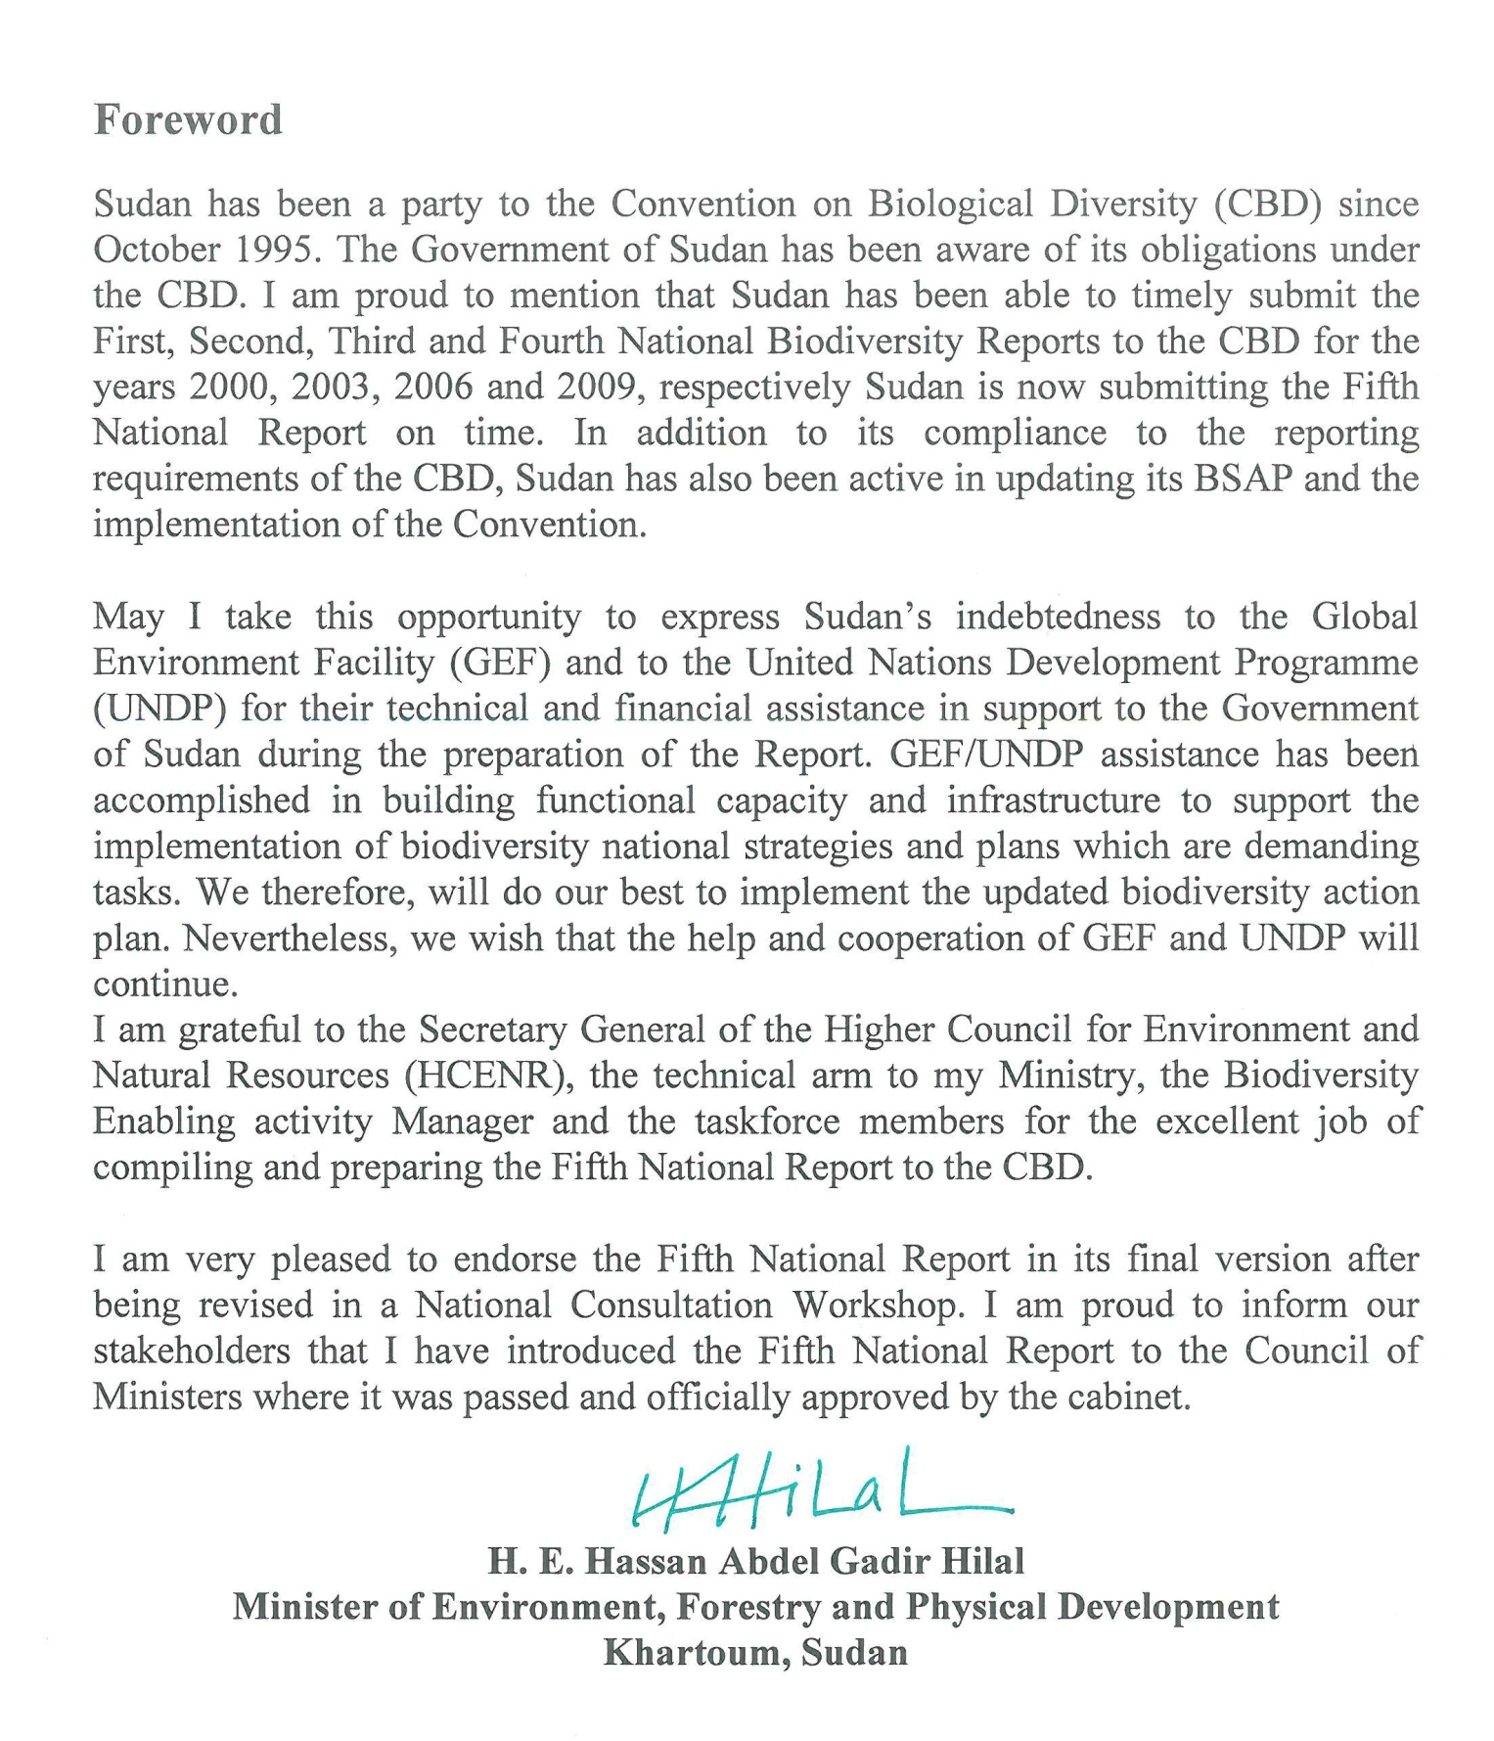

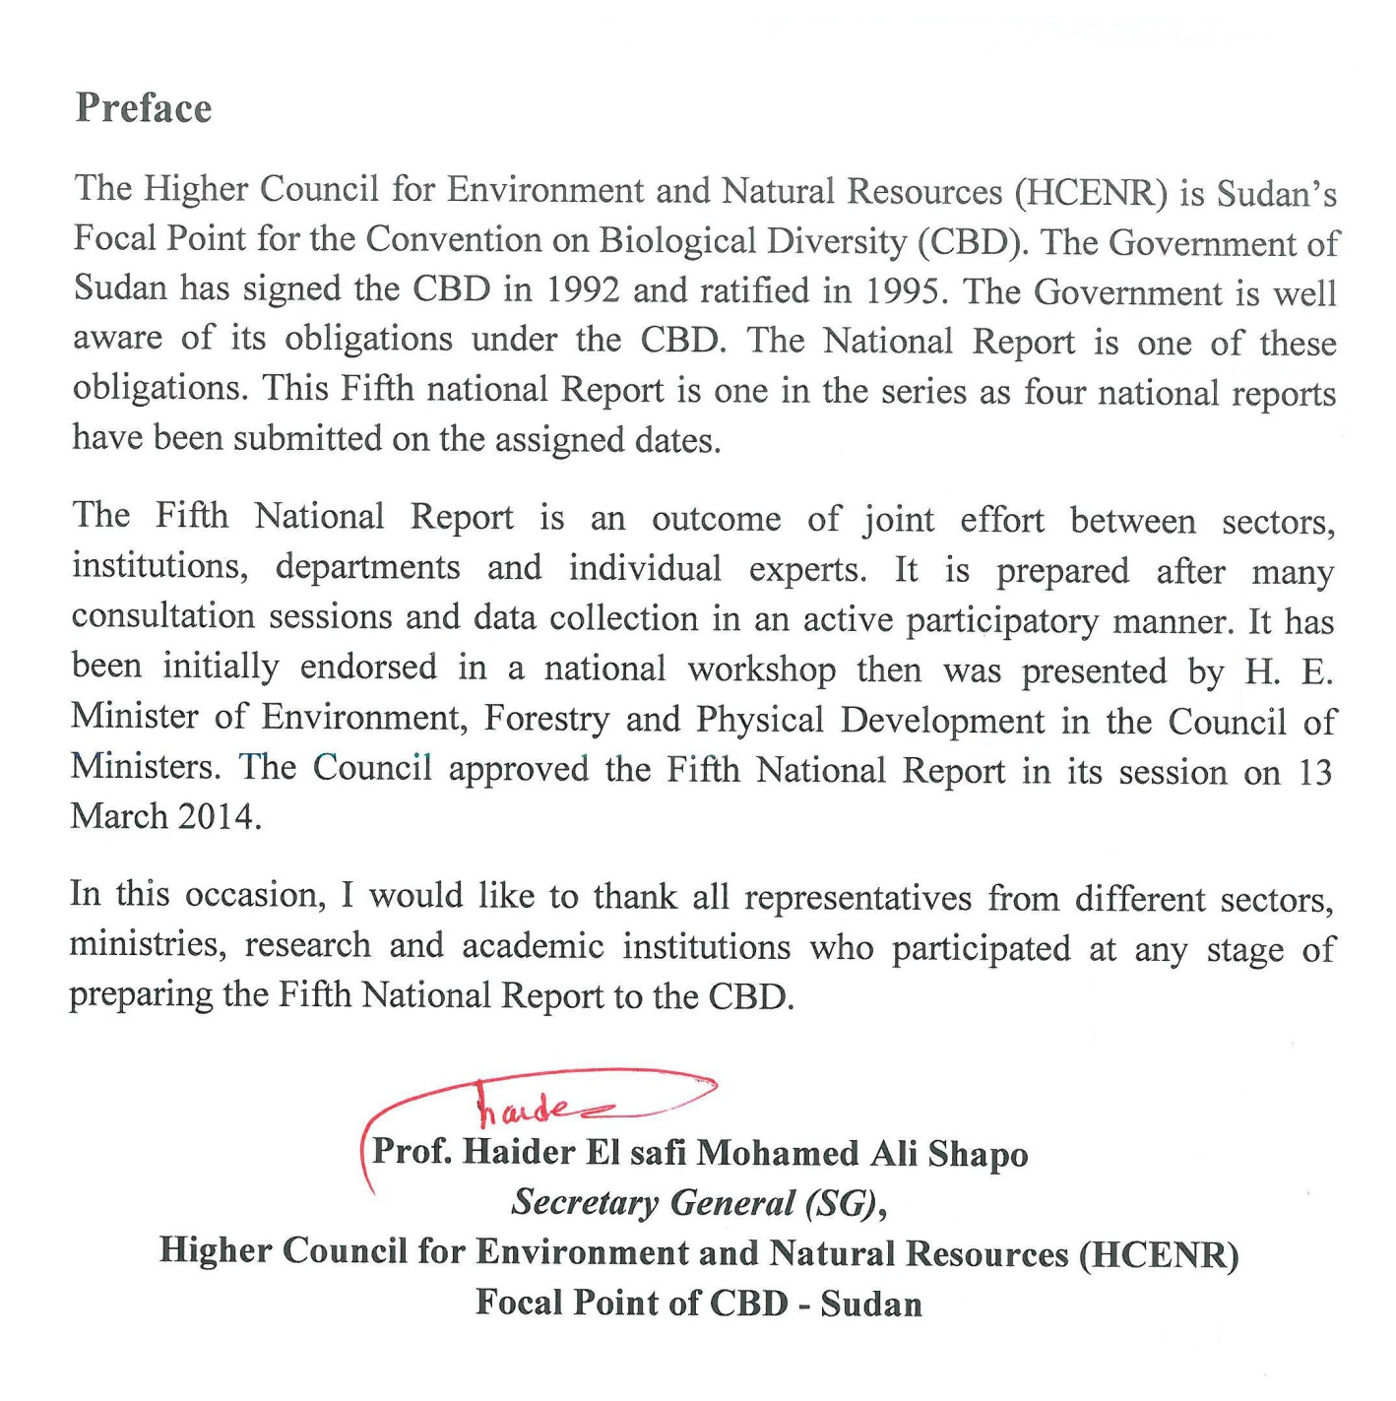

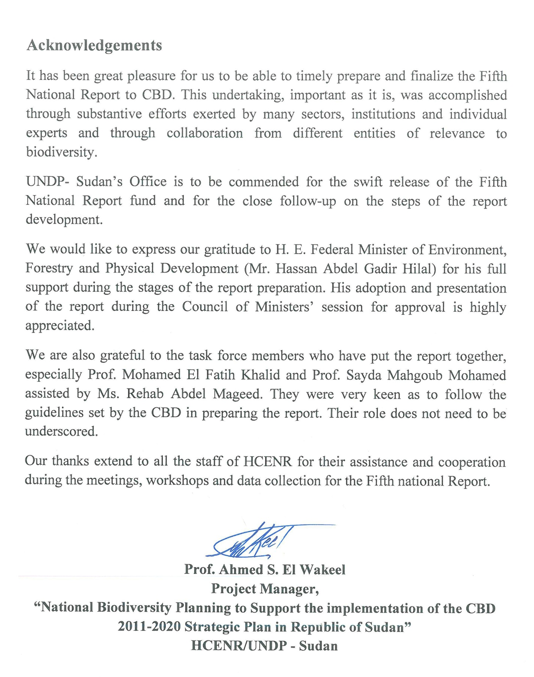

Abbreviations and Acronyms

ARC Agricultural Research Corporation
ARRC Animal Resources Research Corporation
BNF Biological Nitrogen Fixation
CBD Convention on Biological Diversity
CBGE Commission for Biotechnology and Genetic Engineering
CBO Community Based Organization
CBS Central Bank of Sudan
CITES Convention on International Trade in Endangered Species of Wild Flora and Fauna
COP Conference of the Parties
CVRL Central Veterinary Research Laboratory
DNP Dinder National Park
EAPGREN Eastern Africa Plant Genetic Resources Network
ENRRI Environment and Natural Resources Research Institute
EBM Ecosystem-based management
FAO Food and Agriculture Organization of the United Nations
ET Embryo Transfer
FFS Farmers Field Schools
FNC Forests National Corporation
FPTU Farmers and Pastoralists Trade unions and Associations
FRC Forestry Research Center
GDP Gross Domestic Product
GEF Global Environment Facility
GM Genetically Modified
GMO Genetically Modified Organism
HCENR Higher Council for Environment and Natural Resources
HCSP Higher Council for Strategic Planning
IAEA International Atomic Energy Agency
IAS Invasive Alien Species
ICGEB International Center for Genetic Engineering and Biotechnology
ICZM Integrated Coastal Zone Management
IFAD International Fund for Agricultural Development
ITPGRFA International Treaty on Plant Genetic Resources for Food and Agriculture
IUCN International Union for Conservation of Nature
LURSA Land Use unit and Remote Sensing Administration
MAPRI Medicinal and Aromatic Plants Research Institute
MAS Marker Assisted Selection
MDGs Millennium Development Goals
MDTF Multi Donor Trust Fund
MLS Multi Lateral System
MoAI Ministry of Agriculture and Irrigation
MoCI Ministry of Culture and Information
MoEFPD Ministry of Environment, Forestry and Physical development
MoFNE Ministry of Finance and National Economy
MoHRDL Ministry of Human Resources Development and labor
MoJ Ministry of Justice
MoLFR Ministry of Livestock, Fisheries and Rangelands
MoSC Ministry of Science and Communications
MPA Marine Protected Area
NBSAP National Biodiversity Strategy and Action Plan
NCR National Center for Research
NDDCU National Drought and Desertification Control Unit
NENAPGRN Near East and North Africa Plant Genetic Resources Network
NGO Non Governmental Organization
NRA Natural Resources Administration
NTSC National Tree Seed Centre
PERSGA Regional Organization for the Conservation of the Environment of the Red Sea and the Gulf of Aden
PGRU Plant Genetic Resources Unit
PGRFA Plant Genetic Resources for Food and Agriculture
RPGD Range and Pasture General Directorate
SECS Sudanese Environment Conservation Society
SIDA Swedish International Development Agency
SSFS Sudanese Social Forestry Society
SSMO Sudanese Standards and Metrology Organization
TOR Terms of reference
UNCCD United Nations Convention to Combat Desertification
UNDP United Nations Development Programme
UNEP United Nations Environment Programme
UNFCCC United Nations Framework Convention on Climate Change
WCGA Wildlife Conservation General Administration
WCS Wildlife Conservation Society
WRC Wildlife Research Center

Executive Summary
For preparing the Fifth National Report, the working group consulted and reviewed different sources of information related to biodiversity in Sudan. The main sources of information consulted are the Stocktaking and National Biodiversity Targets Setting Report (2013), the Draft of the Sudan’s NBSAP 2013 – 2020, NBSAP 2000 and Sudan’s Fourth National Report to the Convention on Biological Diversity (2009). The review closely followed the guidelines developed for the preparation of the report. According to the guidelines, the main parts of the report include an update on biodiversity status, trends, and threats and implications for human well-being; the NBSAP, its implementation and the mainstreaming of biodiversity; and progress towards the 2015 Targets of the Millennium Development Goals.
Although Sudan is one of the rich countries in biodiversity, no systematic or comprehensive surveys or assessments were conducted. Most of the surveys carried out were fragmentary and site-specific.
Sudan is considered as part of the centers of origin and / or diversity for sorghum, pearl millet, okra, melons, sesame and dry dates. It is also a secondary centre for hot pepper and roselle. Wild relatives of sorghum, pearl millet, rice, okra, watermelon, melon and sesame also do exist in the country.
Sorghum, pearl millet and wheat are the major cereal crops grown in Sudan. The minor cereal crops are maize, rice and barley. At present, variability among traditional farmers' varieties of sorghum and pearl millet is still observable in different regions of the country. The old landraces of wheat in the northern region seems to be completely eroded except for only two accessions that were collected from the River Nile state in 2008.
The summer-adapted grain legumes include cowpea, pigeon pea and hyacinth bean, in addition to bambara groundnut which is grown on a very limited scale. The winter-adapted grain legumes are faba bean, haricot bean, chickpea, lentils, lupin and pea. Cowpea and faba bean are the most important summer and winter-adapted grain legumes in the Sudan, respectively. High variability in seed size and colour is observed among the local cultivars of some of these crops.
The most important oil crops grown are sesame and groundnut. Recently, sunflower is gaining importance in both the rainfed and irrigated areas of Sudan. Sesame germplasm shows high variability in seed colour. Considerable variation in growth habit, seed size and colour is observed among groundnut accessions.
A number of vegetable crops such as okra, onion, tomato, potato, peppers, eggplant, melons, watermelon, pumpkins, squash, sweet potato, radish, jewsmallow, purselane, rocket and chard are grown. Remarkable variability among the local landraces of okra, peppers, melons and watermelon is observed.
The most important fruit producing species are date palm, banana, guava, citrus and mango. The cultivation of date palm, especially dry dates is believed to date back to 3200 BC, while the other fruit producing species were introduced not long time ago. Different date palm local and old cultivars and seedling races are known in the country.
Before separation of South Sudan, 1500 forest trees and shrubs species, subspecies and varieties are recorded in the country. Of these, over 100 species are exotics, some of which are considered as naturalized. Acacias are the most widespread forest species that comprise more that two thirds of the forest flora. A number of indigenous and exotic trees and shrubs are either on the verge of being extinct or are seriously threatened. After separation of South Sudan in 2011, the tree cover declined from 29% to 11.6%. In addition, the rate of afforestaion and reforestation in Sudan is far behind the rate of tree felling, 250,000 vs 1,301,970 feddans (1 feddan = 0.42 ha).
The forestry and rangelands of Sudan support about 101 million heads of cattle, sheep, goats, and camels and a wide range of wildlife species. About 37% of the total livestock feeds requirements in Sudan which is estimated as 92.9 million tons in 2011 are derived from rangelands, which is equivalent to 70% of the available total animal feed. The decrease in the area and production of rangelands and pasture in 2009 and 2011 as compared to the average of the period 1985–1993 amounts to about 33 and 50%, respectively. In addition, many of the valuable or highly palatable range plants species are endangered.
Both wild and cultivated indigenous plants species are known for their importance in the folk medicine in Sudan. The majority of these medicinal and aromatic plants are still wild or cultivated on small scale. The names, taxonomy and distribution of medicinal and aromatic plants are assessed and recorded by MAPRI. Many of the wild medicinal and aromatic plants are endangered.
Sudan possesses a diversified wealth of domesticated livestock species, which include cattle, sheep, goats and camels; with different types of breeds carrying the names of the tribe or locality. Other domesticated local types of animals include horses, donkeys, pigs and poultry. A number of exotic breeds of both livestock and some of the other domesticated animals were introduced into the country leading to the loss in the genetic diversity of local breeds.
The wildlife occur in protected areas and in fragmented habitats outside protected areas in the different ecological zones and marine ecosystems of Sudan. The number of many species has either declined or disappeared from many of their former habitats. Many of the wildlife animals are lost after the severance of South Sudan.
With the severance of South Sudan, the area of inland waters has shrunk significantly. Vast and ecologically valuable areas such as the “Sudd” are no longer within Sudanese borders. Almost all inland waters are confined to the narrow strip of the Nile River system in Sudan, except a few lakes in western Sudan. The inland waters are important habitats for resident and migratory birds. The identification and classification of the aquatic fauna and flora is neither accurate nor complete. Not all inland waters have been surveyed.
The Red Sea coastal lagoons and sheltered bays “marsas” form natural harbours and fish landing places. The Red Sea have attractive and mostly pristine habitats, particulary coral reefs, mangrove stands, sea grass beds and associated marine fisheries and biodiversity including sharks, dugongs, turtles and a variety of sea birds. Sanganeb and Dungonab-Mukawar Island are protected areas with good representation of the Red Sea marine ecosystems.
Two subspecies of honeybees has been reported in Sudan. The first, Apis mellifera sudanensis nov subsp, a small honeybee is distributed all over Sudan between latitudes 3°N and 16° 20´N. The other, Apis mellifera nubica Ruttner, exists along the borders of Ethiopia and Uganda.
Over 5000 insect species belonging to 246 families and 15 orders were collected and identified by the Insect Collection Unit of ARC. The orders Coleoptera (beetles) and Lepidoptera (moths and butterflies) represent the most dominant insect species in Sudan. These insect species include crop insect pests, insects as natural enemies of insects’ crop pests, insects as pollinators of flowering plants, and insects that serve as food for humans, birds and fishes.
In a relatively more comprehensive survey conducted in the early 1950s in some parts of Sudan, 383 fungal species belonging to 175 genera were recorded. In later reports, a large number of fungi had been reported as causal agents of crops diseases. A few entomopathogenic fungi were also recorded. A total of 42 species of arbuscular mycorrhizal fungi were detected from rhizosphere soil samples collected from different sites in the White Nile state. Several yeasts genera and species were reported to be involved in the fermentation of several indigenous Sudanese foods. A total of 25 epiphytic lichen taxa were reported from the mist oasis of Erkwit, Red Sea coastal plain of Sudan.
A number of environmental and human-induced factors are known as causes of loss or threats to the genetic diversity of the different biodiversity components in Sudan. These factors are grouped as direct drivers (pressures) and indirect drivers (underlying causes) of biodiversity loss.
The pressures represented by climatic changes (droughts and floods), biotic factors (pests and diseases) and IAS (broom rape, tomato leaf miner, date palm scale insects, fruit flies), in addition to the underlying causes including modern agriculture, socio-economic factors, developmental construction and farmers practices are the main threats to plant agro-biodiversity.
The pressures including climate change (drought), over-exploitation, IAS (Mesquite and Jatropha) and oil and industrial pollutions, in addition to the underlying causes such as fires, socio-ecomomic factors (increase in population, under estimation of role of forests and civil war) are the major threats to forests genetic diversity.
The pressures including drought, insect pests and diseases, and over-grazing and grazing selectivity, in addition to the underlying causes such as fires, land use changes, investments in sugar, petroleum and mining industries, civil war, seed collection, agricultural practices and poverty are the main threats to rangelands diversity.
The pressures that include habitat change (movement of animals southwards in the dry season), biotic factors (diseases) and unavailability of water, in addition to the underlying causes such as investments in agriculture, and petrol and mining industries and civil war are the mains threats to livestock biodiversity.
The pressures including habitat change (fragmented habitats), overgrazing by livestock, over-exploitation, biotic factors, IAS (Mesquite) and climate change (drought), in addition to poaching and hunting, expansion in mechanized agriculture and mining are the main threats to wildlife diversity.
The pressures including pollution (agricultural, industrial and urban sources), over-exploitation, IAS (water hyacinth) and habitat change, in addition to attitude and perception and legal status (no protection) are the main threats to inland water diversity.

The pressures including over-exploitation (over-fishing, over-grazing of mangrove stands), natural impacts (e.g. coral bleaching, diseases etc..), habitat change (coastal development and tourism) are the main threats to the diversity of the marine ecosystem.
The pressures including pollution (pesticides) and exotic bee species are the main threats to bees’ diversity.
The pressures including climate change (drought), pollution (pesticides) and fires, in addition to modern agriculture (monocropping) and new developmental constructions are the main threats to insects’ diversity.
Ecosystems services and goods provide food and fibre materials, fuel wood, employment and income, in addition to the provision of a vast range of ecological services. These benefits accrue to all living organisms, including animals and plants rather than humans alone. The rural people who constitute 67% of Sudan’s population secure their livelihood by using natural resources. This situation has put intensive pressure on these resources, and this by its turn has led to serious degradation in biodiversity and the rest of ecosystems components such as Agriculture, forests, rangelands, inland and marine water and wildlife. This decline in ecosystems biodiversity has resulted in the provision of poor ecological services and goods and thereby has their negative impacts on the population totally or partially dependent on these resources heightening the poverty conditions among them.
In view of the prevailing poor implementation of the NBSAP and poor or lack of awareness, the decline in ecosystems biodiversity is expected to increase at an alarming rate in the future.
In Sudan, there are several biotechnology laboratories that could help in enhancing the conservation and use of agro-biodiversity. The ARC and the NCR are the leading institutions in biotechnology research. The CBGE, NCR is the focal point in Sudan for the ICGEB in Trieste, Italy. In Sudan, several bio-techniques have been adopted to improve and preserve plants and crops. The most important ones are plant cell and tissue culture and DNA molecular makers.
Bt cotton is the first GM crop introduced in Sudan by the Chinese Center for Agricultural Technology, El Fau, Gedarif State in 2009. In 2012, Chinese 1, which is a GM Chinese Bt cotton genotype (G. hirsutum) carrying Cry1A gene conferring resistance to the African boll worm, was released for commercial production in Sudan. In the same year, it was cultivated on about 20,000 and 50,000 acres in the rainfed and irrigated areas, respectively. There are a few biotechnology and biosafety laboratories for detecting GMOs in Sudan. There are no biosafety guidelines and tolerance limits for GM level. Currently, some research work on the production of GM crops is going on at the Faculty of Science, U. of K.
Several Sudanese yeast strains proved to produce ethanol from molasses, a sugarcane by-product, and sweet sorghum substrate. The Sudanese yeast strains from traditional fermented food and beverages proved to be more efficient in bakery than the introduced ones as they are more tolerant to high temperatures. Some of the identified yeasts strains are under the process for registration as patent of the CBGE and NCR of Sudan.
Identification of microorganisms that can produce enzymes which can substitute the use of chemicals for safe dehairing of leather is an on-going research programme. This work can help in solving serious health and environmental pollution problems caused by the tanneries in Sudan.
Rhizobim inoculum was produced in the Biofertilization Department of ENRRI and it is now commercially used by farmers and agricultural companies throughout the country.
Several promising isolates of microbial degraders of some pesticides, crude oil and heavy metals are obtained. Main Institutions working in this field are ENRRI, CBGE, Central Laboratory, Department of Botany, University of Khartoum, and some others.
Vaccines were produced in Sudan for immunization of livestock against bacterial and viral diseases by the CVRL, Soba. Recombinant DNA vaccines are now being produced against viral and parasitic diseases by the Faculty of Veterinary Medicine, University of Khartoum, Sudan in collaboration with the Department of Medical Helminthology, Pasteur Institute, France.
Recently, very limited studies analyzed the genetic diversity of honey bee in Sudan using mitochondrial DNA analysis and the microsatellites DNA markers.
The Sudanese biosafety National Law was issued in 2010 in order to deal with operations and activities related to handling and trading in GMOs and their products which pose challenges for the application of the law and the whole system of biosafety in Sudan. The law has been preceded by the national framework for biosafety in 2005, a basic document prepared to set out the major policies and principles of biosafety in Sudan.
The PGR Unit of ARC is engaged in systematic documentation of the PGR under conservation using accession-level systems. It has records on the material conserved for different information categories including passport, management and characterization data.
The first national inventory for Sudan forests was conducted during the period 1995 - 1997. A new national inventory of forest resources both in quantity and quality is highly needed after the separation of South Sudan. The herbarium of FRC is the largest in Sudan incorporating over 7000 forest specimens with a computerized appendix.
The RPGD national herbarium, which contains 400 range plant species dating back to the year 1948, needs to be renewed and it is in the process of digitizing its electronic information. There is also an ongoing process for producing an Atlas for important range forage plants including herbaceous grasses and fodder trees and shrubs.
The herbarium of MAPRI currently contains 1000 dried and identified plant specimens. All Sudanese medicinal plants, their local uses and names have been documented by MAPRI in five books. The aromatic and poisonous plants were also documented in two books. In addition, 13 extension pamphlets for the production, harvest practices, medicinal values and uses of some medicinal and aromatic plants were produced.
Collection of baseline data on marine key habitats and species including coral reefs, mangroves, seabirds and turtles, and preparation of up-to-date status reports has taken place.
In Sudan, there is a lack of an overall policy and framework on access to genetic resources and benefit sharing. The only attempt in this regard is in the field of PGRFA in which Sudan is a party to the ITPGRFA. The Ministry of Agriculture, which is the national focal point for the ITPGRFA, has officially notified the Treaty Secretariat on September 2010 of inclusion of 6351 accessions of PGRFA belonging to 12 genera in the MLS.
The existing legal framework in Sudan is not enough to deal with the damage caused by IAS. The prominent IAS that cause damage across the country include “Mesquite”, broom rape, date palm white scale insect and the green pit scale insect, fruitflies and tomato leaf miner. Most of the control efforts for “Mesquite” were very costly and not successful or sustainable. Regulatory measures that prevent the movement of seeds from infested to Oraobanche – free areas have been issued by both federal and state ministries of agriculture. There is no national policy and legislation on the management of IAS in Sudan, although issues of IAS are covered in sectoral policies and legislations.
All of the twenty Aichi Targets were chosen as the national biodiversity targets. Based on the vision, mission and guiding principles, NBSAP 2011-2020 has taken into account the current status of biodiversity in the country, threats to biodiversity and actions needed for ensuring the conservation and sustainable use, in addition to fair and equitable sharing of benefits arising from the use of biodiversity among all stakeholders including local communities.
The vision of NBSAP 2000 was given as "Conservation of diversity and related indigenous knowledge for sustainable national development of Sudan", while that of NBSAP 2011-2020 states: " Biological diversity underpins ecosystem functioning and the provision of ecosystem services essential for human well-being; it provides for food security, human health, the provision of clean air and water; it contributes to local livelihoods, and economic development, and is essential for the achievement of the MDGs, including poverty reduction”.
Several actions to achieve the national targets include raising awareness among different stakeholders, encourage the private sector to invest in biodiversity conservation and sustainable use, encourage rural communities to establish community forests, encourage universities to incorporate biodiversity economic accounting in their curricula, incorporate the plans for sustainable production and consumption into the government 5- year strategy (2012-2016), to have one unified programme for biodiversity conservation and management, to assess endangered or extinct species, restore and conserve, integrate biodiversity values into national and local development and poverty reduction strategies, enact legislative measures at the national level that eliminate incentives including subsidies harmful to biodiversity in compliance with the international obligations, improve technologies used for biodiversity conservation and seek national and international funds for biodiversity conservation and sustainable use.
The adoption of the actions addressing the different national targets will definitely contribute to the mitigation of the different threats facing biodiversity.
The relevant legislation, policies, institutional and cooperative mechanisms, and funding that have been taken in Sudan since the fourth report (2009) include the suggestion of two wildlife protected areas, one in the White Nile state and the other in Kassala state; a 10- year (2014 – 2024) draft strategy funded by ITPGRFA for range management was prepared in 2013 with the objective of building the resilience of pastoral communities to climate change in two ecosystems of Sudan; a national Biosafety Law dealing with the application of modern biotechnology was issued in 2010; a proposed national legislation on PGR has been drafted in 2011 with the objectives of conservation and sustainable use of PGR, equitable and fair sharing of benefits arising from the use of the PGR, Protection of farmers' and community rights related to PGR, Capacity building and protection of traditional knowledge related to PGR.
The inadequate institutional capacities in terms of trained personnel and working facilities and the lack and/ or insufficient government funding for the vital biodiversity sectors are considered as the main obstacles for NBSAP implementation.
Since the NBSAP 2011-2020 has been recently drafted; no effective mainstreaming and implementation have yet been achieved by the different biodiversity sectors. In the previous NBSAP 2000, very limited achievements have been obtained at the sectoral levels due to lack of coordination among the different sectors.
Several challenges hindering the implementation of NBSAP include civil war; lack of coordination among different sectors; poor land use policies; lack of understanding of the role of ecosystem values and services; the escalating poverty conditions; inadequate legislations, policies and poor law enforcement; inadequate and/or lack of regular inventories and monitoring; environmental and human – induced threats; lack of effective mechanisms to regulate, manage and control risks identified for the GMOs.
Several national indicators for measuring progress towards the Aichi Biodiversity Targets such as poor awareness among stakeholders, increasing poverty, harmful incentives and subsidies, IAS, inadequate and/or poor financing etc.. are suggested.
The proposed actions for all selected national targets will contribute in a way or another to the achievement of the relevant 2015 targets of the MDGs. Particularly, the actions proposed for Target 2 and Target 14 are relevant to goal 1 of the MDGs which addresses poverty reduction, and the actions proposed for targets 17 and 18 contribute to the achievement of the targets of Goal 7 of the MDGs which addresses the integration of the principles of sustainable development into country policies and programs.
The poor implementation of NBSAP 2000 is due to the emphasis on conservation aspects, with little attention paid to sustainable use and benefit sharing. In addition to the fact that poverty has not been addressed; lack of association between food security and ecosystems goods and services; lack of synergies between biodiversity, climate change and desertification; and lack of clear vision for mainstreaming the NBSAP into other national strategies and plans.
Examples of successful actions taken by the different biodiversity sectors include the improvement in the capacity of the PGR Unit of ARC; rehabilitation of the degraded Nabag Reserved Forest in South Kordofan and the revitalization of the gum Arabic belt; the declaration of Jebel Al Dair National Park as a wildlife protected area in 2010; and the 10% marine protected area targeted in the Aichi targets for 2020 has already been attained.
Several general and sector – specific actions or measures are suggested to enhance the implementation of NBSAP 2011-2020 based on the different obstacles and constraints that faced the proper implementation of the NBSAP 2000.
Chapter 1

1. Introduction
The National Biodiversity Planning to Support the Implementation of the CBD 2011-2020 Strategic Plan in Sudan is a project supported by the GEF with Partnership of the UNDP, and the MoFNE, Sudan. It is being implemented by the HCENR in Sudan. The project duration is two years (2013-2015). The project objective is to integrate Sudan obligations under the Convention on Biological Diversity (CBD) into national development and sectoral planning framework through a renewed and participative biodiversity planning and strategizing process, in a manner that is in line with the global guidance contained in CBD 2011-2020 Strategic Plan in Republic of Sudan.
This report is prepared by the working group (Annex 1) with the objective of providing information on measures taken for the implementation of the Convention and the effectiveness of these measures. The reporting process has also taken into consideration that the information on the status and trends of biological diversity is relevant to the implementation measures.
The specific tasks of the working group included the following:
- Follow closely the guidelines in preparing the Fifth National Report.
- Compile most recent information and data pertaining to national biodiversity implementation at major sectoral levels including; agriculture, range/livestock, forestry, marine. Information can be on institutional technical, policy and legal frameworks can also be included.
- The national report is to be structured following the guidelines and modules provided with the TOR.
1.1 Structure of the report
In addition to the introduction, the report is structured to contain the following three parts:
Part I: An update on biodiversity status, trends and threats and implication for human well-being.
Part II: the national Biodiversity strategy and action plan, its implementation and the mainstreaming of biodiversity.
Part III: progress towards the 2020 Aichi Biodiversity Targets and contribution to the relevant 2015 Targets of the Millennium Development Goals.
1.2 Sudan: the geography and environment
Sudan is a vast country with an area of 1.8 million km². It lies between latitudes 10º and 22º N and longitudes 22º to 38º E. Its landscape consists primarily of gently sloping plain, with the exception of Jebel Marra Masssif, Red Sea Hills and Nuba Mountains. Mean annual temperatures vary between 26ºC and 32ºC across the country. The northern part is almost desert and semi desert with average annual temperatures around 30ºC and average annual rainfall of about 150 mm. The central part is semi-desert to savannah with average annual temperatures around 27º C, and average annual rainfall of about 200 mm. Rainfall, which supports the majority of the agricultural activity, is erratic and increasing in amount southward. Sudan can be ecologically divided into five vegetation zones according to rainfall patterns from North to South. These are:
- Desert: (0-75 mm of precipitation)
- Semi-desert: (75 - 300 mm)
- Low rainfall savannah on clay and sand: (300 - 500 mm)
- High rainfall savannah: (500 – 900 mm)
- Montane Vegetation: (500 - 900 mm)
Sudan is endowed with a wide range of ecosystems and species diversity. The ecological zones extend over a wide range from the desert in the extreme north to the savannah. According to Land Cover Atlas of Sudan (FAO, 2012), forests and rangelands represent 35.6% of the total country area (Table 1 and Fig. 1).
Sudan is rich in biodiversity within diverse environmental systems making it endowed with flora and fauna which are being threatened by natural factors and human activities.
Table 1. Sudan Land Cover Classes in Hectares
Land Cover Class | Area (ha) | %
Agriculture in terrestrial and aquatic/regularly flooded land | 23,710,025 | 12.6
Trees closed-to-sparse in terrestrial and aquatic/regularly flooded land | 18,733,182 | 10
Shrubs closed-to-sparse in terrestrial and aquatic/regularly flooded land | 22,231,327 | 11.8
Herbaceous closed-to-sparse in terrestrial and aquatic/ regularly flooded land | 25,982,720 | 13.8
Urban areas | 730,331 | 0.4
Bare Rocks and Soil and/or Other Unconsolidated Material(s) | 95,277,727 | 50.7
Seasonal/perennial, natural/ artificial water bodies | 1,290,000 | 0.7
Total Sudan area | 187,955,312 | 100
Source: FAO, 2012: Land Cover Atlas of Sudan

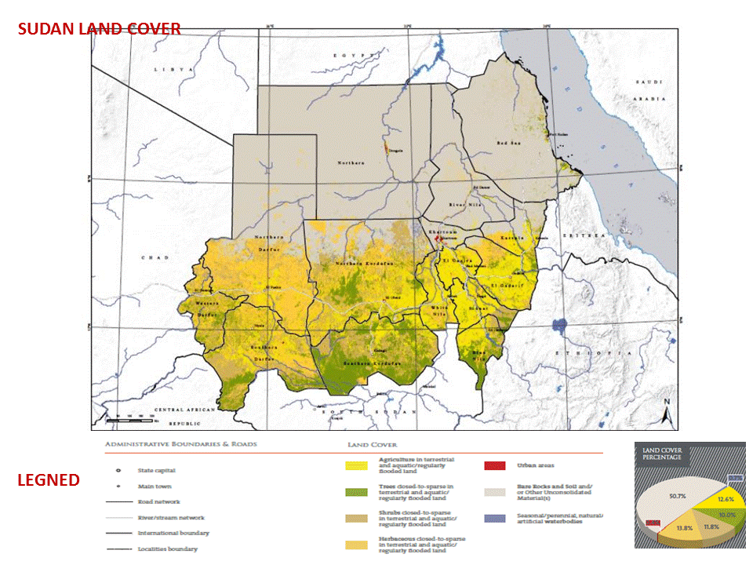

Fig. 1. Sudan Land Cover

Part I

An Update on Biodiversity Status, Trends and Threats, and Implications for Human Well-Being

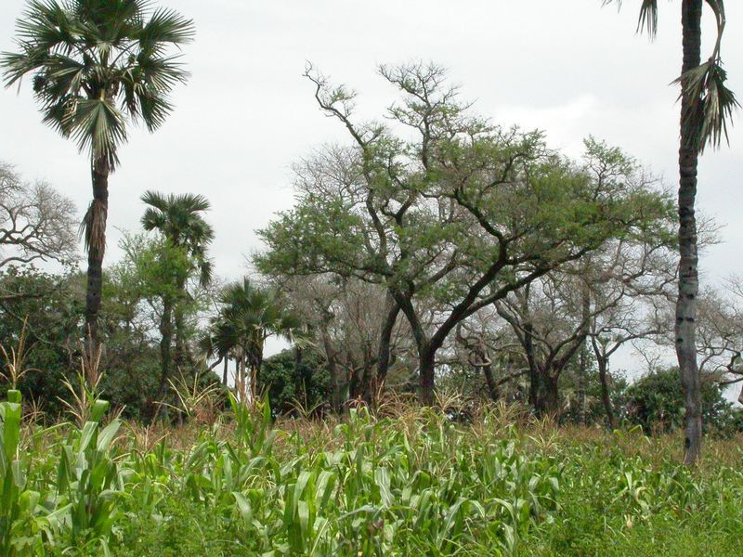

Fig. 2. Agroforestry practices, maize crop grown under (Faidherbia albida) trees

Chapter 2
Biodiversity Status and Trends

2.1 Importance of biodiversity
If we realize that at least 40% of the world’s economy and 80% of the needs of the poor are derived from biological resources, then we can realize how biodiversity is important for human well-being (Convention on biodiversity web site).
Sudan is endowed with diversified biological resources making it one of the richest in biodiversity. The diversity of the Sudan’s climate is responsible for its rich flora and fauna. Agricultural activity, including animal production and forest related activities in Sudan, is based to a great extent on the indigenous heritage of plant and animal species that forms an important component of the country's wealth of biodiversity. Sudan’s principal exports are cotton lint, groundnuts, sesame seed, gum Arabic, sorghum grain, livestock, hides and skins together with cotton seed cake and meat. In recent years, cotton exports are very small because of the significant reduction in areas planted with cotton in the country.
At present, the population of Sudan lives on land resources and their biodiversity. This takes the form of rainfed and irrigated agriculture, wood and non-wood forest products and livestock production. The agricultural sector contribution to GDP is about 40%, which is high compared to other developing countries.
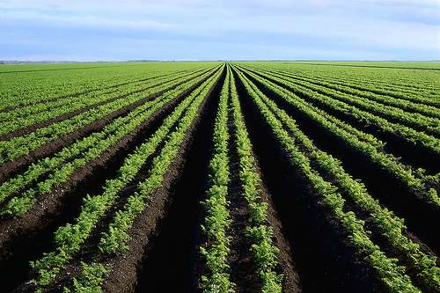
Fig.3. Irrigated agriculture
The forestry sector contributes to the national GDP by about 12%, in addition to its indirect benefits in environmental protection, biodiversity conservation, soil amelioration, work opportunities for rural population and others. Perhaps the most tangible benefit derived by the people of the Sudan from their forests is fuel wood in the form of firewood and charcoal, as well as gum Arabic with an annual export of 20 - 40 thousand tons. Forest products go directly to the household and to small enterprises. The household gets its energy requirements and building materials, while the small enterprises receive energy in the form of wood for brick making and furniture. The non-wood forestry products are numerous and have mainly food and handicraft values. The most important non-wood product is the gum Arabic, which has an export value and fetches a handsome income of foreign currency.
Rangelands contribute substantially to the income and subsistence of a large sector of the population who are either pastoralists (nomads) or agro-pastoralists by providing important forage feed resource. It supplies about 70% of the total feed requirement of national herds, which is estimated as 104.9 million heads (MoLFR, 2012).
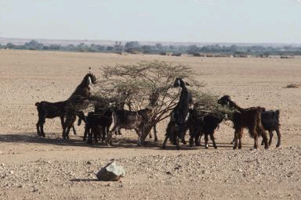
Fig.4. Goats browsing
Sudan possesses an immense and diversified wealth of animal resources, ranging from the domesticated livestock species to the wild and aquatic life which contributes significantly to the food security, as well as forming a considerable base for the economy of the country. Livestock goes beyond its influence on the economy to its role in securing national and strategic food. It allows 100% self-satisfaction in meat. In 2012, the total export of animals is about 3.8 million heads, and the total earnings from the export of 3.4 million heads of sheep amounts to about 451 million US dollars (MoLFR, 2012). The contribution of the sector in the national income is estimated to be 18–25 % and it represents a livelihood activity for about 60% of the population, as well as providing labor for about 40% of the population (Ibid).
From the above description, it is evident that biodiversity is the source of Sudan’s present wealth and the driving force of its economic activity. Although Sudan has started producing and exporting petroleum, it will continue to depend on commodity production for some time to come.
The CBS (2008) classified the population of Sudan into rural (67%) and urban (33%) categories. The pastoral group of the population has been added to the rural category. This implies that a huge number of Sudan’s population secure their livelihood by using natural resources. This situation has put intensive pressure on these resources, and this by its turn has led to serious degradation in biodiversity and the rest of ecosystems components. The end result has been negative impact on the well–being of the rural communities.
This situation means that Sudan has to very carefully conserve the sources of its present wealth in plants and animals. At the same time, and while developing and exporting its oil wealth, Sudan has to avoid and control the pollution hazards associated with the industry both in the hinterland where production takes place and the Red Sea coast where the export terminals are located.
2.2 Biodiversity Status and Trends
In this chapter the state of biodiversity in Sudan is reviewed and updated. Its value and contribution to the national socio-economic development is highlighted. In addition to the known components of biodiversity, this chapter also includes an evaluation of the state of emerging problem of Invasive Alien Species and the modern trends and techniques of biotechnology that are expected to contribute positively or negatively to the state of biodiversity in the country.

2.2.1 Agricultural plants diversity
Sudan is considered as part of the centers of origin and / or diversity for some of the cultivated crops such as sorghum (Sorghum bicolor), pearl millet (Pennisetum glaucum), okra (Abelmoscus esculentus), melons (Cucumis melo), sesame (Sesamum indicum) and dry dates (Pheonix dactylifera). It is also a secondary centre of diversity for others such as hot pepper (Capsicum spp) and Roselle (Hibiscus sabdariffa). Wild relatives of different crops such as sorghum, pearl millet, rice, okra, watermelon (Citrullus lanatus), melon and sesame also do exist in the country. Sudan is part of the East African Region of crop genetic diversity, which is one of the eight global centers of diversity of cultivated crops. A number of crop species of sorghum, pearl millet, sesame, okra and melons might have originated in Sudan, where their wild ancestors and relatives exist. Local cultivars from old introduced germplasm for other crops such as maize, faba bean, cowpea and chickpea, are still existing and being utilized by some farmers.
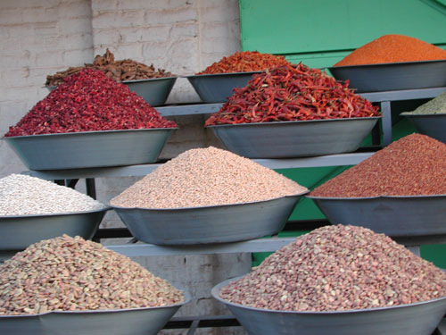
Fig.5. Diversity of food crops seeds
2.2.1.1 Cereal crops. The cereal crops grown in Sudan include sorghum, pearl millet, wheat, maize, rice and barley.
The three wild sorghums (S. aethiopicum, S. verticilliflorum, and S. arundiaceum) are believed to be the progenitors of cultivated sorghum in Sudan. Sudan is also the home of the important forage species, S. sudanense (Sudan grass). At present, variability among traditional farmers' varieties is still observable in different regions of the country.
Western Sudan is believed to be a part of the West African centre of origin for pearl millet. About 18 wild species of Pennisetum are found in the country, in addition to a variety of landraces grown in Darfur and Kordofan regions.
Recent collection missions for maize (Zea mays) showed remarkable variation in cob size, and seed colour.
Old landraces of wheat (Triticum aestivum) in the northern region seems to be completely eroded as not a single wheat accession was collected from the Northern state in 2005 and only two accessions were collected from the River Nile state in 2008.
Rice (Oryza sativa), although grown in a limited scale, it is one of the food crops used in Sudan. The wild red seeded rice (O. punctata) is found in Darfur region where it is still consumed by the people.
2.2.1.2 Food grain legumes. They include both the summer and winter-adapted crops. The main summer-adapted grain legumes include cowpea, pigeon pea and hyacinth bean, whereas the main winter-adapted ones are faba bean, haricot bean, chickpea, lentils, lupin and pea. Some other summer-adapted legumes such as bambara groundnut is grown on a very limited scale.
Cowpea (Vigna unguiculata) comes among the most important summer- adapted food grain legumes in Sudan. It is believed to be introduced into western Sudan from West Africa resulting in a considerable diversity of cowpea types in Kordofan region.
The cultivation of other summer-adapted grain legumes, which include pigeon pea (Cajanus cajan) and hyacinth bean (Lablab purpureus), is dependent on old cultivars that show remarkable variation in seed colour and size especially for the latter one.
Bambara groundnut (Vigna subterranea) is a minor summer-adapted legume crop in western Sudan and Blue Nile state. It is believed to be introduced there by immigrants from West Africa and still grown on limited scale. Cultivars grown are mixtures of several different lines with high variability in seed size and colour.
Faba bean (Vicia faba) is the major winter-adapted food legume crop in Sudan. It is grown in the Northern and Darfur regions. About 90% of the total faba bean production is produced in the Northern region. It is an important food crop in the Sudan, especially in the urban areas. The faba bean varieties grown by farmers are primarily landraces named after the locality of production such as Aliab, Zeidab and Agabat. Faba bean in Darfur is produced mainly on the upper terraces of Jebel Marra and northern parts of the region. Varieties grown there are mainly local cultivars introduced from the Northern region. Variations in seed size and colour among faba bean cultivars were observed.
Chickpea (Cicer arietinum), a winter-adapted grain legume, is mainly produced in the River Nile state. It is also cultivated on the upper terraces of Jebel Marra Mountain and the northern parts in Darfur region, as well as El Hawata area of Gadarif state in eastern Sudan. Recently, a sizeable area of the crop is grown in the Gezira Scheme. Cultivars grown by farmers are local landraces known as Beladi. Although a number of improved cultivars were released, farmers still cultivate their local landraces.
Other winter-adapted legumes include haricot bean (Phaseolus vulgaris) and lupin (Lupinus albus). Old introduced cultivars from haricot bean and lupin are still grown by farmers in Sudan, although a number of haricot bean improved cultivars were released.
2.2.1.3 Oil crops. The most important oil crops grown in Sudan are sesame and groundnut. Recently, sunflower is gaining importance in both the rainfed and irrigated areas of Sudan.
The sesame germplasm collected from areas in eastern, western and central Sudan included both cultivated and wild material with different characters, especially for seed colour.
Groundnut (Arachis hypogea) is another important oil crop grown in central, eastern and western regions of Sudan. It is mainly produced for its seed oil, which is an important cooking oil. Farmers' varieties previously grown were of the runner type locally known as “Abu Hibailat”, a type believed to be available at present only in some remote and isolated areas, with a high risk of disappearance. Fortunately, some few accessions were collected from the traditional runner type from South Kordofan state in 2004. Groundnut accessions collected so far showed a considerable variation in growth habit, seed size and color.
2.2.1.4 Vegetable crops. A number of vegetable crops are grown in Sudan such as okra, onion, tomato, potato, peppers, eggplant, melons, watermelon, pumpkins, squash, sweet potato, radish, jewsmallow, purselane, rocket and chard.
Okra (Abelmoschus esculentus) is the most popular vegetable in Sudan, where both cultivated and wild types are known. Some of the wild types belong to the cultivated species A. esculentus and others belong to other species such as A. ficulneus. Recent studies on okra collections revealed that the species A. caillei (West African okra) is possibly grown in Sudan. Farmers almost depend on the local landraces, which in many cases are designated names relevant to the localities where they are produced. The indigenous okra genetic resources are variable in plant and fruit characters.
Tomato (Lycopersicon esculentum) is among the most important vegetables in Sudan, where it is used for salad and paste. It is an introduced vegetable, and old introduced cultivars have been observed to still exist in some parts of the country, especially in the Northern, Kordofan and Darfur states.
Peppers (Capsicum spp.) that are either hot or sweet are popular in Sudan. They are mainly used as spice or green vegetable in salad. Hot pepper was introduced to Sudan since a long time. Variable local cultivars are well known, especially in western Sudan where unique and distinct local cultivars are very famous. Both species of hot pepper, C. frutescens and C. chinense, are believed to be grown in Sudan.
Among the most important cucurbits grown in Sudan are melon (Cucumis melo) and watermelon (Citrullus lanatus). Melons are believed to have originated in eastern Africa including Sudan. Four cultivated types of melons are grown in Sudan; sweet melon (C. melo cantalupensis), snake melon (C. melo flexuosus), a salad melon known locally as (Tibish(, and a melon type used for its edible seeds known locally as (Seinat). True wild melons known locally as (Humaid) and belongs to the group C. melo agrestis grows in central, northern and western parts of Sudan. Watermelon used for production of seeds is a major crop in western Sudan, where variable landraces are grown. Wild relatives of watermelon such as the wild species C. colocynthis (bitter apple “Handal”) grow extensively in the Northern region. Remarkable variations in fruit shape and size, pulp colour and taste, and seed size and colour has been observed in watermelon genotypes.
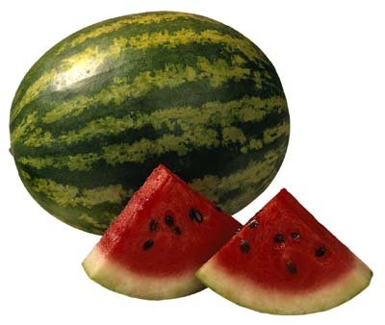
Fig. 6. Watermelon (Citrullus lanatus)
2.2.1.5 Fruit producing species. Several fruit producing species are grown in Sudan. Some of them are ancient in the country, while others were introduced not long time ago. The most important ones are date palm, banana, guava, citrus fruit trees and mango.
Date palm (Phoenix dactlylifera) is believed to be cultivated in northern Sudan and upper Nubia since 3200 BC. Dry date cultivars might have originated in Southern Egypt and Northern Sudan. Different local and old cultivars and seedling races are known in the country.
Mango (Mangifera indica) is believed to be introduced into Sudan from India via Egypt. About 57 cultivars of mango are reported existing in Sudan. Main areas of mango production are along the banks of the Nile in northern Sudan and Blue Nile in central Sudan, in addition to the eastern part of South Kordofan state.
The most important citrus fruit trees are sweet orange (Citrus sinensis), grapefruit (Citrus paradisi) and lime (Citrus aurantifolia) which are currently grown all over Sudan. Cultivars of citrus grown are absolutely introduced old varieties.
An old banana cultivar, Dwarf Cavendish, is to be produced in Sudan since early twentieth century. However, some new improved cultivars have been released for commercial production.
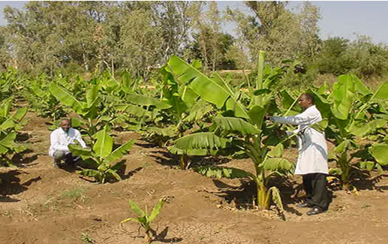
Fig.7. Banana trials
2.2.1.6 Neglectd and/or underutilized plant species. In Sudan, there are some plants species that exist in wild form and used traditionally for their food, fodder, fiber, oil or medicinal properties, but not yet have been adopted in large-scale agriculture. They may have the potential to contribute to food security, nutrition, health, income generation and environmental services. These species have been neglected or underutilized due to a variety of reasons. Some are economical and some are cultural. These plants include species such as Brachiaria obtusiflora, known locally as "Um chirr", Cassia obtusifolia known locally as "kawal”, Echinochloa colona, locally known as "difra", Oryza punctata known as "roz el wadi", and Sonchus spp. known locally as "moleita". Some of these species have the potential for more wide spread use, and hence promotion for food security and agricultural diversification.

In all agricultural crops, there is a general decline in the diversity of crops genetic resources as a result of so many environmental (climatic changes, biotic factors) and human – induced factors (introduction of improved high yielding varieties, monocropping, etc..) resulting in the disappearance or loss of some of the traditional farmers’ varieties or local landraces.
2.2.2 Forest plants diversity:
Trees and shrubs of the Sudan before separation are about 1500 species, subspecies and varieties as recorded by Elamin (1990). Of these, over 100 species are exotics, some of which are considered as naturalized like Azadirachta indica (Neem), Parkinsonia aculaeta (Saisaban) and Moringa olifera. Acacias are the most widespread forest species that comprise more that two thirds of the forest flora. However, ecological revision of Sudan flora was not done since Harrison and Jackson (1959). A number of trees and shrubs, both indigenous and exotic are either on the verge of being extinct or are seriously threatened. Those deemed nearly extinct are those indigenous trees or shrubs whose existence is confined to limited locations. Those considered seriously threatened are 241 tree or shrub species, which showed marked retreat in their distribution and/or regeneration due to climatic conditions and also due to the intensity of their removal for wood, fodder or clearance for cultivation. Also endangered are 43 exotic shrubs or tree species.
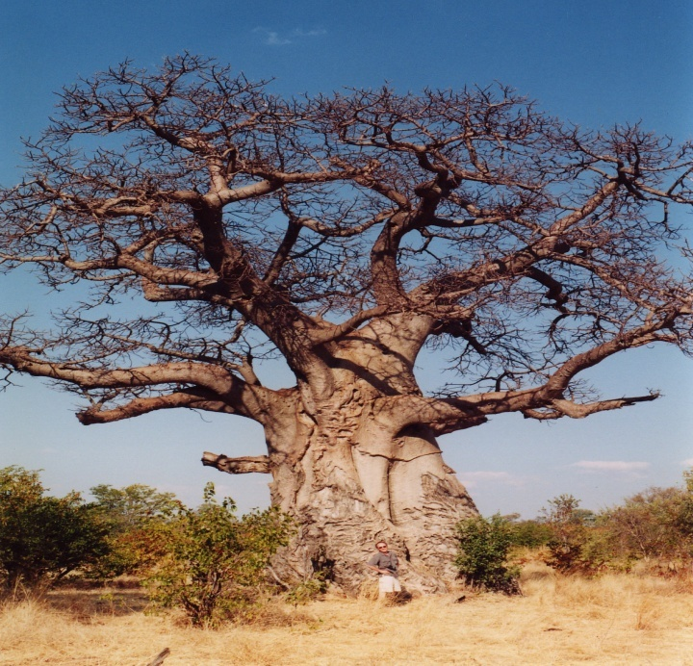
Fig.8. Baobab tree (Adansonia digitata)
The separation of South Sudan in 2011 has major effect on the forest cover and diversity in Sudan as South Sudan is the richest in forest biodiversity. At present, 62% of the Sudan is desert and semi desert and 88.1 % is classified as dry lands. During the last 110 years, the forest cover declined from about 40% to 10% and the tree cover in the humid and sub humid areas also declined from 29.3% to 7.6% during the same period (FNC, 2013). In addition, the rate of afforestaion and reforestation in Sudan is far behind the rate of tree felling, 250,000 vs 1,301,970 feddans (1 feddan = 0.42 ha) as shown in Fig. 2 and Fig. 3 (FNC, 2013). Despite the declining forest cover and loss of biodiversity, some efforts have been taken to conserve forest genetic resources as indicated by the increased reserved forest area from 7.9 million in 1989 to 30 million feddans in 2011 and 2012 (Fig. 4). Also the ex-situ conservation of tree seeds in the cool store and the gene bank of the National Tree Seed Center – FRC is appreciated. Urban plantation is greatly increasing and some species of economic or medicinal value are widely planted nowadays like Moringa and Jatropha. On the other hand, the invasive mesquite tree (Prosopis chilensis ) is still spreading in the agricultural lands in different parts of the country . There are some successful mesquite eradication campaigns here and there.
There is an urgent need to fill the several gaps in knowledge in the field of forest resource assessment at the national level and much work needs to be done.

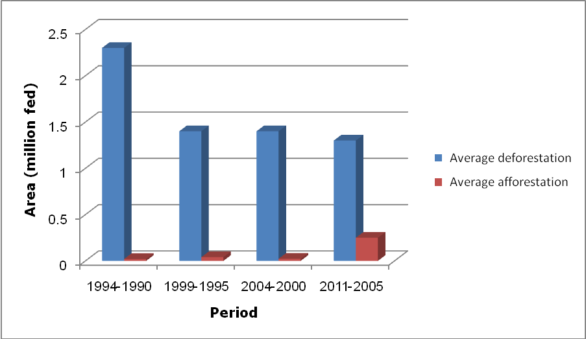

1990 - 1994
1995 -1999
2000 - 2004
2005 - 2011
Fig. 9. Average afforestation area vs. average deforestation area
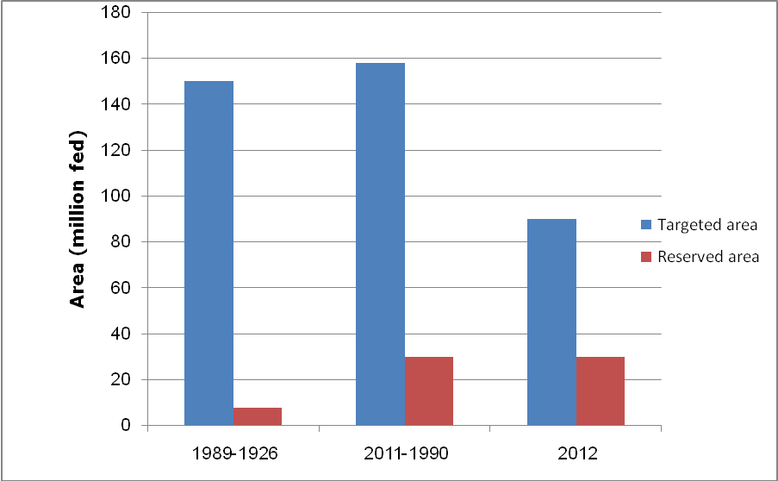
1989 - 1926
1990 - 2011
2012
Fig. 10. Targeted vs. executed afforestation area

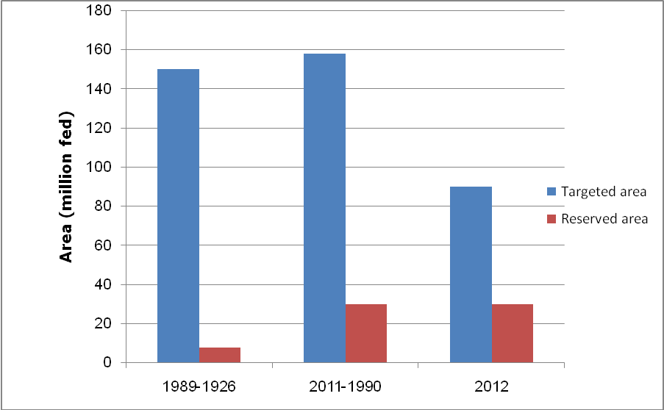
1926 - 1989
1990 - 2011
2012
Fig. 11. Targeted reserve forest area vs. reserved forest area
2.2.3 Range and pasture plants diversity:
The forestry and rangelands of Sudan support about 101 million heads of cattle, sheep, goats, and camels mostly under pastoral and small agro-pastoral systems in the traditional rain-lands, and a wide range of wildlife species.
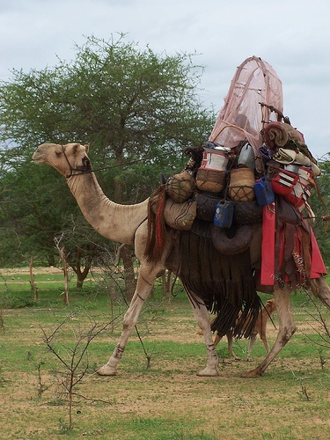
Fig .12. Agro-pastoralists of Kordofan state – Sudan

About 37% of the total animal feeds requirements in Sudan which is estimated as 92.9 million tons in 2011 are derived from rangelands, which is equivalent to 70% of the available total animal feed. While agricultural by-products contribute 28.3 % (14.1million tons), the irrigated forage contributes 1% (0.54 million tons) of the feed and 0.5% (0.2 million tons) from cereals, cakes and concentrates (RPGD, 2012).
Major portion of rangelands encompasses different ecological zones extending from desert and semi-desert in the north to low and high rainfall savannah to the south border. However, nearly 80% of all rangelands are located in the semi-desert and low rainfall savannah ecological zones that are characterized by variable and unpredictable rainfall. The rangelands of importance to traditional livestock raising are confined to the semi–desert, low rainfall savannah and the northern fringes of the high rainfall areas. In the semi- desert, the plant cover is a mixture of grasses and herbaceous plants intermingled with Acacia trees and shrubs representing the main grazing areas for camel and sheep. Two areas of pure grassland form a distinct feature of this rangeland type; namely, the Butana plains (grassland on clay) and Baja area (grassland on sand). The Low rainfall savannah on clay and sand have a plant cover of a mixture of Acacia spp, shrubs and a number of herbaceous plants.
The biomass production of semi-desert vegetation zone is not suitable except for browsing where rangelands area varied according to rainfall. The decrease in the area and production of rangelands and pasture in 2009 and 2011 as compared to the average of the period 1985 – 1993 amounts to about 33 and 50%, respectively (RPGD, 2009 and 2011 Annual Reports; FAO, 2012).
Some natural range plants are of great value to rural people especially during periods of food scarcity and famine such as Dactyloctenium aegyptium, Echinochloa colona (difra), Chrosophora brochidiana, Boscia senegalensis, Curbonia virgate, Brachiaria obtusiflora, (Um chir), Chenopodium album, (asida & balila foods), and Sonchus oleraceus (moleita) used as fresh salad, Cassia obtusiflora (kawal) used as traditional food flavor etc. Some plants have also medicinal importance such as Blepharis linariifolia (Beghail) Cassia senna (sanna meka).
Many of the valuable range plants species are endangered. Herbaceous species which were reported as decreasing in Semi Desert and low rainfall savannah ecological zones include Blepharis linariifolia, Chrosophora brochidiana (Argassy), B. edulis (siha), Aristida palmosa, A. paposa (Byad), A. mutablis, Panicum turgidum, Cenchrus species, Eragrostis temula, Andropogon gyanus (Abu rakhees), Schenfoldia gracilis and Ischaemum ishaemoidis, Dismodium dichotomum. Recently, taxonomists reported that Dactyloctenium aegyptium (Abu Assabi) had shown some changes in its morphological features such as number of fingers (three fingers instead of five).
2.2.4 Medicinal and Aromatic Plants Diversity:
Both wild and cultivated indigenous plants species are known for their importance in the folk medicine in Sudan. The MAPRI had finished the preparation of 5 atlas of medicinal and aromatic plants including information on their names, taxonomy and distribution (Wail et al., 2013). Specimens of these plants are incorporated in the herbarium of the institute, Department of Taxonomy and Phytochemistry. The majority of medicinal and aromatic plants used in Sudan are still wild or cultivated on small scale. In view of the prevailing harsh climatic conditions and accelerated climate change, the domestication of medicinal and aromatic plants on a sustainable basis is an urgent need.
2.2.5 Farm animal diversity
Sudan possesses an immense and diversified wealth of domesticated livestock species, which include cattle, sheep, goats and camels. There are different types and breeds of livestock, the majority of which is raised within tribal groups and often carries the names of the tribe or locality. Other domesticated local types of animals include horses, donkeys, pigs and poultry.

2.2.5.1 Cattle. Cattle of the Sudan are descendants of the Bos indicus (Zebu). These are well adapted to the tropical environment because of their high degree of heat tolerance, partial resistance to tick, many tick-borne diseases and other diseases, as well as their low nutritional requirements, because of their small size, low metabolic rate and possibly more efficient digestion at low feeding levels. Their milk productivity is generally low. They are late maturing both physiologically and sexually.

Cattle in the Sudan are generally classified into the following:
- Zebu that includes two main types, Kenana and Butana of central Sudan and Baggara of western Sudan. The Kenana, Butana and Baggara cattle represent about 15, 9 and 23% of the total cattle population of the country, respectively. Both Kenana and Butana types are considered as dairy breeds because of their high milk production potential, while the Baggara type is used for meat production for local consumption, as well as for export. The milk production of the Baggara type is extremely poor.
The Kenana type is mainly found on the western bank of the Blue Nile area extending from Sennar to Upper Nile and between the Blue Nile and the White Nile. They are steel-grey in color. The Butana type is reddish in color, resembles the Kenana type in size and productivity, and dwells mainly in the Butana plateau in a triangle of River Atbara, Blue Nile and the River Nile.
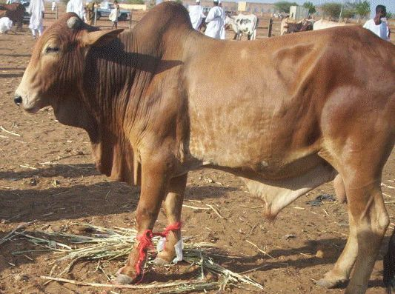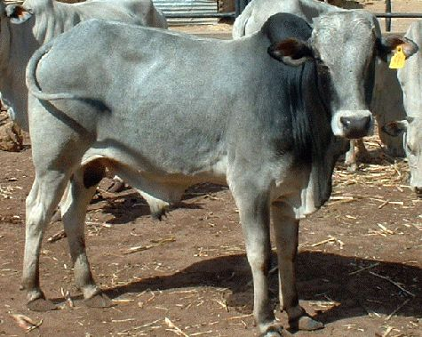

Fig.13. Butana bull Fig.14. Kenana bull

The Baggara cattle are considered small sized animals of various coat colors. They are found mainly in the western region of the country.
- Other types of northern Sudan Zebu cattle include Ayrashai (of eastern Sudan), White Nile cattle, Fuga or Dar El Reeh cattle of North Kordofan, and the Nuba Mountain cattle.
2.2.5.2 Sheep. The sheep of the Sudan belongs to what is called the Sudan Desert Sheep. It is a large animal with excellent meat and carcass characteristics. It is an export animal and live-weights of 65 – 77 kg can be achieved. A number of ecotypes and tribal types exist. The Kababish, Meidob, Hammar, Bija, Dubasi, Ashgar, Wateesh are known in the northern, western and central Sudan.
2.2.5.3 Goats. There are a number of goat breeds in Sudan including;
- The Black Nubian Goat which is the predominant type in the country. It is a milk breed, large and relatively long-legged with pendulous ears. It is commonly found in central Sudan. The Nubian goat represents 50% of the goat population in the country. Weights of up to 40 kg were recorded.
- The Desert goat (17% of the population), which is characterized by long legs and dark brown color, is raised by the nomadic tribes of Baggara and Kababish, in the semi-desert region.
- The Nilotic goat, with black or white or both colors, is found predominantly south of latitude 12° and represents 30% of the goat population of the country.
- The mountain goats “Taggar”, which have short legs, grey or brown in color, and represent 3% of the goat population.
A number of exotic breeds of goats including Toggenburg, Anglo-Nubian, Saaneen (temperate breeds) and Damascus (Middle East) have been imported into the country. The Anglo-Nubian is a British cross-breed from the indigenous Nubian goats. Saaneen proved to be an adequate breed. Crosses with selected indigenous Nubian goats produced milk yield as high as 4.5 kg/day.
2.2.5.4 Camels. Two major types of the one-humped camel (Camelus dromedarius) exist in the Sudan; the slender riding camels, and the heavy-built pack or baggage camel.
The riding camels are slender and include (a) Anafi (Shukri), found in Kassala state, and (b) Bishari, owned by the Bija and Hadandawa, stronger than Anafi and excellent race camel, also found in Gedarif and Red Sea states.
The pack or baggage type is a heavier animal and constitutes 90% of the total camel population, and is widely distributed in the desert and semi-desert regions. This type includes (a) Rashaidi, which is a strong, short-legged animal raised by the Rashaida in the Red Sea and Kassala states, (b) Arab camel makes up the majority of camels raised by Hadandawa, Beni Amir and Amarar, and the large sized is raised by Shukria and Bataheen, (c) the Kababish distributed west of the Nile and raised by the Kababish, Hawawir and Kawahla in Kordofan region, and this is the largest in size of the baggage types in the country, and (d) the Gharbawi (western), which is mainly found in Darfur states.

2.2.5.5 Equines
- Horses. Two groups of horses are recognized in the Sudan:
- Arabian type: found specifically in Northern and Southern Darfur states and in Kordofan states. It has a light brown color, some are white in color
- Dongolawi type: found in north and central Sudan and Northern Darfur state. Its colour varies from brown to dark brown.
Both types are of medium size. Crossing with exotic breeds of horses (mainly English breeds) is practiced in Khartoum, Nyala and El Fashir and excellent hybrids are now recognized as race horses.
- Donkeys. Typical pack donkeys, having local names such as Mackady, Dongolawi and Darawy, are found almost everywhere in the country. The Dongolawi type is a high and fast animal used for riding.
2.2.5.6 Pigs. Indigenous breeds of pigs are raised by the Maban tribes in the Upper Nile State in restricted areas and in limited numbers.
2.2.5.7 Poultry. The local beladi fowl (Gallus gallus) is well adapted in the backyard system everywhere in the country. It is a small bird, supporting families in rural areas with eggs and meet.
2.2.6 Wildlife
The wildlife occur in protected areas and in fragmented habitats outside protected areas in desert, semi-desert, Low rainfall savannah woodland, high rainfall savannah woodland and marine ecosystems. The number of many species has either declined or disappeared from many of their former habitats. The populations of the red-fronted gazelle, Dama gazelle, Barbary sheep, Nubian ibex and lion have declined to critical levels and the number of endangered species is increasing. Sudd, Flooded grassland, Mountain vegetation and the Equatorial Forest have been lost from Sudan’s ecosystem after the Separation of South Sudan together with their flagship species including the Rhino, Okapi, Chimpanzee, Zebra, the White-eared kob, the Nile lechwe, the Mongala Gazelle, Beisa oryx, the Mountain reedbuck, Guenther's Dikdik, Blue duiker, Lesser Kudu, Bongo, Sitatunga, Grant’s Gazelle, the giant forest hog, the Shoebill stork and the Giant Bushbuck.
2.2.6.1 Mammals. Before the separation of South Sudan, there used to be twelve mammalian orders in Sudan in 2011. Therefore, new assessments are needed after the separation of South Sudan. Big mammals like buffalo, lion, roan antelope and elands are hosted in Dinder and Radom National Parks. The population of some species has declined to critical levels. Three hippos could only be seen south of Alrosseries dam in Blue Nile state. Elephants became rainy seasons' migrants. A herd of 4 to 8 individuals visit Dinder National Parks and a big herd visit Radom National Park. Most species belong to carnivore (cats, canes and foxes). Dorcas gazelle, Red fronted gazelle are found in many localities, while Damma gazelle is believed to be found in Wadi Hawar Park. Dorcas, which was considered the most abundant species, is threatened by habitat fragmentation and poaching. Recent surveys indicated that density of Dorcas ranged between 0.007 and 0.1 km² in areas used to have the largest populations.
The Red Sea hills host the Nubian ibex (Capra nubiance) and klipspringer (Oreo tragus). Mountains (jebels) of Northern Darfur such as Medob, and Jebel Hassania of the River Nile state and Jebel Elba of the Red Sea state are hosting the Barbbary sheep (Ammotragus lervia). The greater kudu is still in Jebel Mara and Jebel El Dair and some Nuba mountains. A number of endangered and extinct mammals and reptiles in situ are reported. There is also wildlife ex situ, mainly Dorcas gazelle, in 22 farms.
2.2.6.2 Birds. About 927 bird species are known to be found in Sudan before separation. A new assessment is, therefore, needed for Sudan. Fresh wetlands, coastal habitats, lakes created by dams such as Sennar, Roseries, Khashm el Girba and Marowe, are sites of resident and migratory birds.
Most of the work was done in the central states, particularly Sennar, Blue Nile, Khartoum and the Red Sea states. There is also scattered work in the rest of the states. The work on birds covered most species in Sudan and there is a new record of one species (Capped wheatear) in central Darfur. About 204 Forest birds and 118 Water birds were reported. Among these, the Sao’ Tome (Newton’s) Fiscal of the forest birds and the Sociable Lapwing of the water birds are critically endangered.
About 36 raptors are recorded in ecosystems of Sudan. They were intensively and extensively surveyed in Sennar state and the Eastern states, particularly the Red Sea state. Many raptors are endangered including the Egyptian vulture, white-backed vulture and the hooded vulture.
2.2.6.3 Reptiles. About 90 specis of reptiles were recorded. Snakes and lizards are the most abundant group. The most famous ones are crocodiles, which are hosted at Lake Nubia and few are found in Dinder National Park pools. African Python is widely distributed and African Spur tortoises are found in Kassala and Red Sea areas. No recent records from North Kordofan and Darfur. Two marine turtles have nesting ground in Mukkawar Island in Dungonab National Park. Many species of Dab and lizards are present. The famous are Monitor lizard and Eyed dab lizard (Uromastyx ocellata).
2.2.6.4 Others. Other fauna like amphibians, insects and other invertebrates are important and are hosted in protected areas.
2.2.7 Inland waters
The term “Inland Waters” denotes all aquatic systems that are not part of the marine system i.e. seas and oceans. The term embraces different types of water bodies and is not restricted to freshwater bodies only. Within this context, inland waters could be classified into two categories running waters “Lotic” or Non-running water “Lentic”.
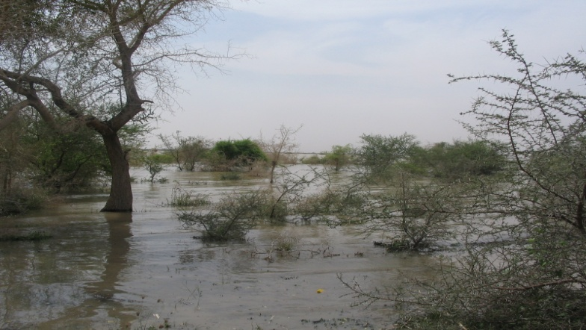
Fig.15. Wetlands
The Nile River System is the main lotic system in Sudan. The system is made of the Blue Nile, White Nile and seasonal rivers such as Atbara, Dinder and Rahad. The Nile System in the Sudan is a mosaic of contrasting combinations: long and short; fast and slow; permanent and seasonal; Azrag and Abyed; silty and clear; infested and weed-free and dammed and free flowing. Other non-Nilotic lotic waters are represented by seasonal water courses (Wadis/Khors) such as Khor Baraka, K. El Gash, K. Abu Habil, Wadi El Mugaddam, W. Kaja, W. Nyla and others.
Lentic systems in the Sudan are encountered in four types:
- Natural Freshwater lakes, which are found in the western region of Sudan. Lake Kundi lies in the southern part of Darfur region about 10 km of the seasonal Bahr el Arab. Lake Keilak lies in South Kordofan region about 200 km north of the junction of Bahar el Arab and Bahr el Ghazal. The drainage systems of the two lakes, their bathymetric features, their physico-chemical properties and their biota have been described. Another natural lake in Kordofan is Turdat el Rahad.
- Saline lakes, which are represented by the two crater lakes, the Dariba crater lakes lie in the massif volcanic caldera of Jebel Marra in Western Sudan while the Malha (salty) lake lies in the Medoub series in Northern Darfur. Saline non-crater lakes also exist in the form of oases such as Nikheila, Natroon and Saleema in the northern region.
- Man-made lakes, which resulted from the construction of dams in the River Nile stretches that create large water impoundments. These are Lake Sennar and Lake Roseiris in the Blue Nile, Lake Jebel Aulia in the White Nile, Lake Khasham el Girba in River Atbra, Lake Merowe and Lake Nubia in the River Nile. Further lakes are anticipated to be formed by the construction of more dams in Seteit and Upper Atbara and on the Nile Rivers.
- Other impoundments, which include many seasonal water bodies that are formed resulting from the standing of rain water in natural depressions, hafirs, and road burrows. The latter have changed into new aquatic ecosystems inhabited by new vegetation and became bird sanctuaries. Extensive wetlands with waters that sometimes remain till the onset of the next rainy season are found in the Dinder pools (Ras Amir, Gireirisa, Fersh El Nieam, Abyad).
The biodiversity in inland waters in Sudan is characterized by the following:
- Limited locations and distribution
With the severance of South Sudan, the area of inland waters has shrunk significantly as Sudan lost most of its large-scale wetlands (e.g. Sudd, Machar). The permanent water bodies have declined from 1.2% to 0.7% of the country's total land surface area. Almost all inland waters are confined to the narrow strip of the Nile River system in Sudan, except a few lakes in western Sudan.
- Aquatic macrophytes
Aquatic macrophytes have always been regarded as nuisance, useless organisms and at the best cases, they have always been neglected. This attitude has been reflected in the fact that the aquatic macrophytes of the Sudan have received little scientific attention, almost no attempt to utilize and of course, no policy to conserve.
- Taxonomy
The taxonomy of the aquatic fauna and flora is neither accurate nor complete. Not all inland waters have been surveyed.
2.2.8 Coastal and marine ecosystems
The Sudanese coastline of the Red Sea is about 750 km long, including bays and inlets. Typical feature of the coast are coastal lagoons and sheltered bays (marsas) that form natural harbours and fish landing places. Several of these lagoons are fringed by mangroves. Sea grass beds are frequently found in the shallow waters of marsas, and in the lagoons, between the coast and the reefs. These features contain a spectacular biological diversity of ecosystems and species that require considerable efforts for conservation.
2.2.8.1 Mangroves. Avicennia marina was the only mangrove species found in the Sudanese coast during a recent survey (PERSGA, 2004). Mangroves are distributed along the Sudanese coast from Mohammed Qol north of Port Sudan to Shabarango-Gafud south of Suakin. Mangrove lagoons and channels are occupied by numerous fish species including many commercially important ones. The leaves and shade zones provide additional habitat.
The mangrove fauna includes true residents that spend their entire life cycle in mangroves (e.g. Aphanius dispar, Gerres oyena and some gobiids), closely associated species that are found there as juveniles (e.g. Acanthopagrus berda, Chanos chanos, Crenidens crenidens, Hypoatherina temminckii, Leiognathus equulus, Terapon jarbua, Pomadasys commersonni and some mugilid species), and loosely associated species that are occasional visitors seeking food or shelter (e.g. Silago sihama, Thryssa baelama) (PERSGA/GEF 2004b). In addition to marine organisms, mangroves are used as a food source by terrestrial vertebrates and as a roosting and nesting site by many species of birds.
2.2.8.2 Corals and coral communities. The Sudanese coast is characterized by the extreme diversity of its reefs compared to the rest of the Red Sea. The primary coral reef habitats are barrier reefs, fringing reefs, isolated patch reefs, and one oceanic atoll (Sanganeb).
The assessment of the condition of Sudan’s coral reefs showed that average live coral cover on reefs in less than 10 m depth ranged from 5–75%. Healthy colonies of framework corals were observed below 10 m. Algal film was the dominant substrate cover in water less than 10 m deep and was attributed to a thermal event. Live coral cover ranged from 5–60%, with dead coral cover higher than 1% noted at only five sites (Nasr and Al-Sheikh, 2000; PERSGA/GEF 2003b).
Assessment of coral reefs in the Dungonab Bay and Mukawwar Island MPA showed major differences in the health of coral communities between parts of the MPA. The coverage of living coral was generally greatest within Dungonab Bay (PERSGA, 2006).
Dungonab Bay is the home for the pearl oyster (Pinctada margaritifera).
2.2.8.3 Sea-grass. Although sea-grass beds are widely distributed in sheltered shallow water and bays, the Sudanese Red Sea coast, only Dungonab Bay and Mukkawar Island MPA was extensively surveyed. The survey showed that it included at least seven species of sea grasses (Thalassia sp., Thalassodendron sp., Halophila stipulacea, H. ovalis, Halodule uninervis, Cymodocea sp. and Enhalus sp.). The total area of sea-grass estimated from Landsat 7ETM image is 11.68 km². The extensive sea-grass beds are a nationally and regionally important feature of the Dungonab Bay – Mukawwar Island area, particularly given the probably substantial population of globally endangered dugong found here (PERSGA/GEF, 2004)
2.2.8.4 Fishes and elasmobranches. The Dungonab Bay and Mukawwar Island MPA is significant for the conservation of fish diversity in Sudan. Major differences exist between the inside and outside of Dungonab Bay in the communities of butterfly fish (family Chaetodontidae) and angelfish (family Pomacanthidae)
Communities inside Dungonab Bay closely resemble communities from the southern Red Sea, while communities outside the Bay are similar to communities from the north-central Red Sea. The basis of this pronounced difference in community structure is likely to be differences in water quality, temperature, and turbidity (PERSGA, 2006).
Additionally, the Dungonab Bay–Mukawwar Island MPA is also well known for its aggregations of whale sharks (Rhyncodon typus) and manta rays (Manta birostris) during summer (PERSGA/GEF 2004).
Groupers were more abundant in Sudan in comparison to other sites in the Red Sea, with more than 20 groupers recorded in over half of 20-minute timed swims (PERSGA/ GEF 2003b). Parrotfish (family Scaridae) are important consumers of algae on coral reefs and contribute to coral dynamics and habitat formation (BELLWOOD et al. 2003). Their conservation is, therefore, important for the maintenance of coral reef ecosystems.
Assessment of fishes in Mukawwar Island and Dungonab Bay MPA prior to the MPA declaration in 2005 (PERSGA/GEF 2004) showed that large groupers (family Serranidae) were rare and Nagil (Plectropomus spp.) over 30 cm in length were rarely observed, suggesting a high fishing pressure on these species.
Regionally important populations of sharks are known to occupy the waters off the coast of Sudan, and are a very important attraction for the marine tourism trade. Hammerhead sharks are known to occur around Sanganeb Atoll and around many of the reefs of Dungonab Park in winter, but very few were observed during the recent survey.
2.2.8.5 Turtles. The eastern shore of Mukawwar Island is a turtle nesting site of regional and possibly international significance. There is no deliberate capture of turtles within the MPA (PERSGA/GEF 2004).
Green turtles nest all year at the following key nesting sites: Seil Ada Kebir Island, Suakin Archipelago and Mukawwar Island. Hawksbill turtles, on the other hand, nest during March- July at the following key nesting sites: Mukawwar Island, Seil Ada Kebir and Suakin Archipelago. Key Foraging Sites for Hawksbill include all fringing and barrier reefs.
All species of marine turtle are globally endangered and are CITES- listed. The eastern shore of Mukkawar Island is one of the two or three most important turtle nesting sites in the entire Red Sea region. This important site merits immediate protection, and the application of a rigorous monitoring programme.
2.2.8.6 Marine mammals. Three species of marine mammals (cetaceans) are present in the Sudanese waters including the Spinner dolphin (Stenella longirostris), the common dolphin (Delphinus delphis) and the Bottlenosed Dolphin (Tursiops truncates). It appears to show that the cetacean population of the Sudan seems to be strong and is not under much pressure at the moment. The Bottle-nosed Dolphins appear to be breeding well and seems to cope being around the many vessels along the coast.
Like the shark species the cetacea are apex predators in the park and as such will be an indicator of the state of the health of the park, so their needs will need to be considered in the long term planning of the park.
Dugong occurs in the Mukawwar Island and Dungonab Bay MPA. The population there may be the most important remaining on the coast of Africa. However, numbers have declined sharply in recent years. The cause is most likely accidental capture in fixed fishing nets. Two species of dolphin occur in the MPA (PERSGA/GEF 2004).
2.2.8.7 Seabirds. The whole area of Dungonab Bay and Mukawwar Island MPA is internationally recognized as an Important Bird Area (IBA). Breeding seabird species include: Sterna bengalensis, Sterna repressa, Sterna anaethetus, Larus hemprichii and Larus leucophthalmus (PERSGA, 2006).
Suakin Archipelago, which is an unprotected area, is also an important bird area including the following breeding seabird species: Sterna bergii, Sterna bengalensis, Sterna repressa, Sterna anaethetus, Anous stolidus, Sula leucoaster and Larus hemprichii (PERSGA, 2006).
2.2.8.8 Marine Plankton. Very few studies have been carried out on plankton in the Sudanese Red Sea although currently some post graduate studies are being carried out. Previous investigations included studies in planktonic populations in Port Sudan coastal area and studies in coastal plankton fauna of the Sudanese Red Sea.

2.2.9 Bees diversity and honey production
Morphological studies on populations of native honey bees in Sudan showed more than one subspecies. El-Sarrag et al. (1992) mentioned two subspecies of honeybees in Sudan. The first, Apis mellifera sudanensis nov subsp, a small honeybee distributed all over Sudan between latitudes 3°N and 16° 20´N. The other Apis mellifera nubica Ruttner, exists along the borders of Ethiopia and Uganda. The morphometric studies carried to differentiate honey bee populations showed more than one subspecies. It has been estimated that there are about 200,000 honey bee hives in Sudan, and 50,000 beekeepers. About 99% of them are traditional beekeepers and 1% using modern beekeeping technology (www.mol-ecol.uni-halle.de/.../sudanese).
The protein structure, physicochemical properties and mineral composition of Apis mellifera honey of different floral origin, commercialized in several states of Sudan were studied. Recent study provided information related to geographical and botanical origin of honey based on honey protein. Honey samples from five floral sources: Ziziphus sp., Helianthus annuus, Acacia nilotica, Acacia seyal, and Azadarichta indica were studied. Ziziphus sp, Helianthus annuus, Acacia seyal and Azadarichta indica honeys were 100% correctly classified, and Acacia nilotica honey was 66.67% correctly classified.
There is an urgent need for more studies and information to assist in developing policies for conservation of the native honeybees in Sudan.
2.2.10 Insects diversity
Welcome Tropical Research Laboratories in Khartoum started insect collection and identification efforts in Sudan in 1902. Since then, intensive surveys were made to cover all geographical regions. Although the National Insect Collection Unit of ARC is concentrating on insect species of agricultural and environmental importance, it is considered as one of the biggest and oldest insect collections in Africa. Over 5000 insect species belonging to 246 families and 15 orders were collected and identified (Table 2).

Table 2. Identified insect orders, families and species of the Sudan
Order | No. of families | No. of species
Orthoptera | 10 | 347
Neuroptera | 3 | 28
Dermaptera | 1 | 6
Ephemeroptera | 1 | 3
Trichoptera | 2 | 6
Odonata | 5 | 48
Hemiptera | 20 | 503
Homoptera | 15 | 115
Lepidoptera | 45 | 876
Diptera | 43 | 577
Hymenoptera | 28 | 392
Coleoptera | 69 | 2089
Isoptera | 1 | 5
Thysanoptera | 2 | 18
Siphonoptera | 1 | 2
15 | 246 | 5015

The orders coleoptera (beetles) and Lepidoptera (moths and butterflies) represent the most dominant insect species in Sudan, while insect species belonging to the ordres Siphonoptera, Isoptera, Ephemeroptera, Dermaptera, Trichoptera and Thysanoptera are the least prevalent.
Based on their economic importance, insects can be grouped as follows:
i. Insect pests. This is the most studied group of insects due to their economic importance as pests of field and horticultural crops.
ii. Insects as natural enemies of insect crop pests. Several insect predators and parasites of crop insect pests have been reported in Sudan. These predators and parasites help in checking the outbreaks of some crops’ insect pests provided that the environment is favourable for their population build-up. The orders Hymenoptera, Diptera, Coleoptera, Dermaptera, Hemiptera and Neuroptera are the orders that include insects as natural enemies.
iii. Insects as pollinators of flowering plants. These are insects that play a role in the pollination of either field crops, vegetable crops or fruit trees. Among these insects, the honeybee (Apis mellifera) of the order Hymenoptera, butterflies (Lepidoptera) and some beetles (Coleoptera) are the most important ones.
iv. Insects as food. Several insects such as desert locust and tree locust (Anacridium melanorhodon melanorhodon), Dura andat (Agonoscelis pubescens) and the queens of termites are eaten by the native people in some parts of the country. Insects also serve as food for birds and fishes.
The extensive irrational use of non selective broad spectrum pesticides for the control of insect pests of field and horticultural crops have resulted in the elimination of the beneficial insects such as predators, parasites and plant pollinators including honey bees.

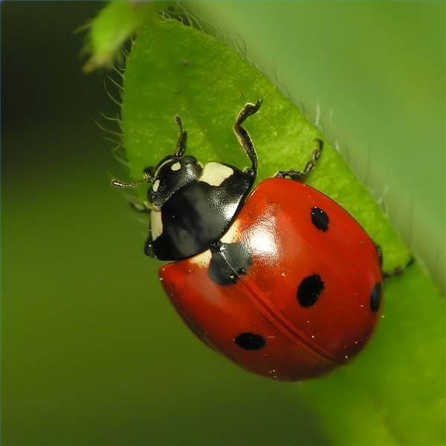

Fig.16. Beneficial insects-ladybird

2.2.11 Fungi diversity

2.2.11.1 Pathogenic fungi. The first systematic collection and identification of plant diseases in the Sudan was carried out during the period 1938 – 45 (Boughey, 1946).
In limited surveys conducted in the early 1950s at relatively few places in the vast area of Sudan, Tarr (1955) recorded 383 fungal species belonging to 175 genera. The recorded fungi belong to four classes; namely Phycomycetes, Ascomycetes, Basidiomycetes and Fungi Imperfecti. The highest and lowest numbers of fungal species belong to the classes Fungi Imperfecti and Phycomycetes, respectively. Most of the fungi so far studied are plant pathogenic fungi causing leaf spots, rusts, smuts, sooty molds, powdery mildews, downy mildews, soil-borne diseases and other diseases. At that time, saprophytic fungi, entomopathogenic fungi, mycorrhizal fungi and lichens have either been hardly investigated or untouched.
A large number of fungal species had been reported as the causal agents of many diseases of field and horticultural crops, and forest trees in the Sudan (Gadoura et al., 1983; Giha, 1987; Ibrahim, 1994).
El-Nagerabi and Elshafie (2000) isolated 69 species and 7 varieties belonging to 24 genera of fungi from lentil seeds. The most prevalent genera were Aspergillus, Rhizobus, Penicillium, Fusarium, Chaetomium and Cladosporium. El-Nagerabi and Abdalla (2004) identified 32 fungal species and four varieties belonging to 19 genera associated with the onion seeds. Of these genera, Aspergillus was the most prevalent, followed by Penicillium, Sclerotium, Fennellia, Rhizopus, Chaetomium, Dreschslera, Alternaria, Fusarium, Emericella and Byssochlamys.
Satti and Gorashi (2013) reported the two entomopathogenic fungi, Paecilomyces sp. and Beuveria bassiana as the first records in Sudan.

2.2.11.2 Arbuscular mycorrhizal fungi (AMF). In a recent study, a total of 42 species of AMF representing 8 families (Acaulosporaceae, Ambisporaceae, Archaeosporaceae, Diversisporaceae, Entrophosporaceae, Glomeraceae, Pacisporaceae and Paraglomeraceae) and 13 genera (Acaulospora, Kuklospora, Ampispora, Archaeospora, Dverispora, Claroideoglomus, Entrophospora, Funneliformis, Glomus, Septoglomus, Semiglomus, Pacispora and Paraglomus) were detected from 52 rhizosphere soil samples collected from different sites in the White Nile state grown with different crops in 2009 (Abdelhalim et al., 2013).

2.2.11.3 Yeasts. Several yeasts genera and species were reported to be involved in the fermentation processes of several indigenous Sudanese foods.
El Nour et al. (1999) identified the yeast Saccharomyces cerevisiae as one of the main microorganisms involved in the fermentation of “Hussuwa”, a traditional Sudanese fermented food from germinated sorghum.
Saeed (1981) identified the yeasts, Saccharomyces globosus, S. exigus and Kluyveromyces bulgaricus as one of the major microbial groups of fermented milk “roub”. El-Mardi (1988) found the yeast Kluyveromyces lactis in “roub”. El-Hadi and Tsenkova (2007) identified the yeasts, Pichia membranefaciens and Candida formata as one of the microorganisms of the fermented milk “roub”.
Samah and Muna (2011) found that the fermentation of millet into “jir” involved a complex microbial succession between Lactobacillus and yeast. The three yeasts involved in the fermentation are Schizosaccharomyces pombe, Saccharomyces sinensis and Trichosporon adeninovorans.

2.2.11.4 Lichens. From the mist oasis of Erkwit (Red Sea coastal plain of Sudan), 25 epiphytic lichen taxa are reported, probably the first lichen floristic report for Sudan (Elshafie and Sipman, 1999).

Chapter 3
Threats to Biodiversity, Impacts and Possible Future changes on Human Well-being
3.1 Threats
A number of environmental and human-induced factors are known as causes of loss or threats to the genetic diversity of the different biodiversity components in Sudan. Drought spells, rain fluctuations, floods and rise in temperatures are specific environmental factors. Expansion in agricultural, industrial and other production activities have had eroding effect on the genetic diversity of indigenous biota. Unrest conditions and civil strives in a number of regions have led groups of populations to move from their local areas and consequently resulted in destruction of natural habitats for different flora and fauna in the country. These factors could be grouped as direct drivers (pressures) and indirect drivers (underlying causes) of biodiversity loss. The direct drivers include climate change, habitat change, overexploitation, invasive species, and pollution, while the indirect drivers include the demographic and economic factors and the development of scientific knowledge and technologies.
3.1.1 Plant crop agro-biodiversity
Direct drivers (pressures):
- Climate change. The drought conditions that have been hitting the country since 1980s have resulted in repeated crop failures in the rainfed sector causing the loss of farmers' sorghum and pearl millet varieties. On the opposite, the heavy rains and floods that have been witnessed in some parts of the country since the 1990s have resulted in complete devastation of crops grown on the banks of the Nile and other rivers. A striking example was the destruction of many banana plantations in Kassala state due to the over-flooding of the seasonal Gash River in 2003.
- Biotic factors. Pests and diseases of crops usually have negative impacts on crops’ genetic variability. They exert selection pressures on such crops leading to the extinction of susceptible genotypes.
- IAS. A number of exotic insect pests such as the two date palm scale insects (Parlatoria blanchardii and Asteroclanium phoenicis), the fruitflies (Bactrocera cucurbitae and B. invadens), tomato leaf miner (Tuta absoluta) and the parasitic weeds (Orobanche crenata and O. ramose) were introduced into Sudan. They are causing serious crop losses and posing serious threats to the genetic diversity of their host crops.
Indirect drivers (underlying causes):
- Modern agriculture: It is characterized by the use of improved high yielding crops cultivars in a mono-cropping system. This is a phenomenon that takes place in Sudan at present. This occurs at the expense of indigenous landraces or old farmers cultivars. Several new varieties have been released by the ARC during the last ten years 2003 – 2013, which will definitely have adverse effect on the local genetic resources of the different crops.
- Socio-economic factors. Changes in types of crops grown can result from such factors. For example, the land tenure system and the consequent land fragmentation have forced farmers in the Northern region to shift to high yielding varieties or to crops with low input cost and high revenues. A good example is the shift to production of date palm in the Northern region in areas that used to be cultivated by annual food crops.
The migration of inhabitants from rural to urban areas due to insecurity and / or economical factors, and the consequent abandoning of farming have negative impacts on agrobiodiversity that used to be utilized and conserved by these people. The civil wars that are still taking place in Dafur region and South Kordofan and Blue Nile states have their negative impacts on the existing farming systems and the diversity they contain.
- New developmental constructions. At present, several developmental activities are taking place in the country such as construction of dams, oil exploration and production activities, and gold mining activities that disturb the life patterns of the local people and hence will definitely result in negative impacts on the existing plant agrobiodiversity.
- Farmers’ practices. Farmers used to select the outstanding strains of crops within their fields for future cultivation based on their knowledge of the environment. Such selection practice results in the dominance of some crops genotypes at the expense of others. Due to drought, farmers of pearl millet in western Sudan tend to select early maturing varieties rather than the medium and late maturing ones providing a good example for the effect of such practice on the genetic diversity of crops.
3.1.2 Forest genetic resources
Direct drivers (pressures):
- Climate change. The repeated drought conditions that hit the country in the1970s, 1980s and 1990s have seriously affected forests genetic diversity resulting in the disappearance of a large number of trees in the country.
- Over-exploitation. The natural forest vegetation has been subjected to heavy over-exploitation for agriculture through the removal of tree cover for crop production, felling trees for fuel wood and building poles and overgrazing to the extent that extensive stretches of forests land lie bare of vegetation (Abdel Magid and Badi, 2008). As a result of overgrazing in the semidesert area, several studies revealed that the tree soil seed bank is zero and no natural tree regeneration is expected in this area unless reseeding or afforestation programs are set (Bashir, 2010; Mutwali, 2007(.
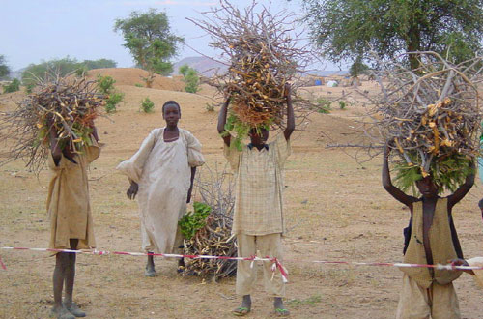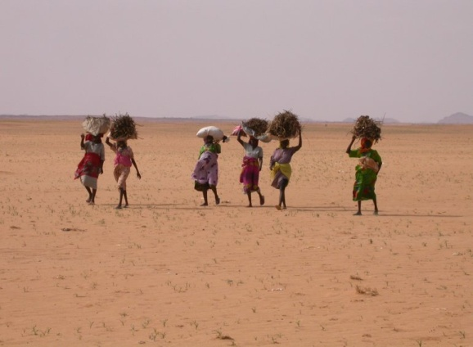
Fig.17. Firewood collection
- IAS. The spreading of the IAS such as mesquite (Prosopis juliflora) and the increase in planting of the toxic shrub Jatropha curcas are expected to have negative impacts on forests genetic diversity.
- Pollution. Pollution from petroleum, mining, cement and other industries are expected to have negative impacts on forests genetic diversity.
Indirect drivers (underlying causes):
- Fires. Forests fires are a serious problem in nearly all forest areas in the Sudan. Only the semi-desert areas, where the grass is normally too sparse to burn, are relatively free from fires. Even in these areas, fires sometimes occur and do considerable damage. Surface fire seriously reduce gum Arabic yield of Acacia senegal and results in the total destruction of the stands if the fire is repeated in the following years.
- Socio-economic factors.
i. The increase in population totally or partially dependent on forests preempts any attempt to sustainably manage the forests and restraints the implementation of national forestry policies. According to FNC estimates, firewood consumption is projected to increase from 22.1 in 2011 to 24.2 million cubic meters by 2015.
ii. Decision-makers and public opinion underestimate the importance of forests for socio-economic development and environmental protection. Accordingly, the investment budgets allocated for forest conservation and development are inadequate.
iii. The displaced people as a result of civil war and refugees from other countries cause serious losses in forest genetic resources.
3.1.3 Rangelands
Direct drivers (pressures):
- Climate change. The repeated drought conditions that hit the country in the 1970s, 1980s and 1990s have their negative impacts on range plants diversity resulting in the disappearance of several range plants species.
- Biotic factors: insects and other pests damage dormant seeds in the soil resulting into declined species diversity.
- Over-grazing and grazing selectivity: As a result of grazing selectivity, some highly palatable forage plant species such as Chrosophora brochidiana, which livestock prefers its flowers and twigs preventing the plant to complete its life cycle, became decreasers. Conversely, unpalatable ones are increasing and becoming dominant. Overgrazing has occurred in many parts of the semi-desert and savannah zones as a result of over stocking of livestock, poor distribution of water sources, amount of available vegetation and blockage of livestock routes during the wet season.
Indirect drivers (underlying causes):
- Seasonal wildfire out-breaks. Increased wildfire hazard is associated with low humidity, high fuel loads and the presence of moving graziers. Repeated fires pose a serious threat to rangelands resulting in the consumption of 10-30% of the standing dry forage in different ecological zones, loss of seeds and erosion of the fire unresisting species. However, fires statistics are lacking except for limited incidents.
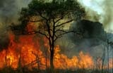
Fig.18. Wildfire outbreaks
- Land use and land use changes. Expansion of both rain-fed and irrigated farming has occurred at the expense of rangelands and woodlands, giving insufficient consideration to the loss of these genetic resources.
- Investments in sugar, petroleum and mining industries. Vast areas of rangelands were shifted to several investment activities such as sugar industry in White Nile State, petroleum explorations in Kordofan states, and mining in Butana area and other states. In addition to reduction of land area, the highly polluted drain waters may affect range plants and cause death to livestock in some cases.
- Civil war. It causes land degradation as a result of fires and removal of plants and thereby affects rangelands plant diversity.
- Seed collection. The traditional collection methods for range seeds from natural rangelands lead to soil erosion, land degradation and seed loss as most collectors harvest the whole plants.
- Agricultural practices. High crops yields are attained through the adoption of good husbandry practices including weed control. As a result of weeding, 29 herbaceous fodder plant species are controlled in central Sudan as weeds.
- Poverty. The rangelands are the most vulnerable to climate change exposing pastoralists to conditions of poverty and food insecurity. This is because the pastoralists are not adopting any practices that conserve their resources.
3.1.4 Livestock
Direct drivers (pressures):
- Habitat change. As a result of the drought conditions of 1984 and 1990 when heavy losses in cattle and sheep in Kordofan region had occurred especially in 1984, the nomads adopted a new management system in order to cope with the adverse effects of drought. Herders simply moved their animals south as far as Bahr El Arab on the Northern border of Bahr El Ghazal of the newly born South Sudan country. This movement brought the danger of exposing the northern cattle (Zebu type) and sheep types to crossing with the southern cattle (Sanja type) and sheep types leading to breed loss, in addition to their exposure to diseases.
- Climate change. Drought condition which results in reduction of available pasture and drinking water is the single most threat to livestock survival, leading to a high rate of mortality particularly among young stock. The drought disaster of 1984 is a case in point. The Foja breed of cattle, which was until 1984 an important animal in north Kordofan, has been eliminated from the area. Remnants of the breed now exist in an enclave in western Kordofan, far away from their traditional home.
- Biotic factors. Diseases of potential economic importance are Rinder pest, Haemorrhagic septicaemia, Contagious Bovine Pleuro-pneumonia, Black quarter, Anthrax, Trypanosomiasis, Foot and Mouth, Tuberculosis, Brucellosis, Helminthiasis, Sheep Pox, Heart Water and internal parasites. The livestock disease problem is complicated by the vast area of the country and the fact that it is bordered by seven countries. Biting insects are common during the wet season in the southern parts of the country, forcing pastoralists to move their herds to drier areas where conditions are not conducive to the multiplication of the biting insects.
- Unavailability of water. Stock water is a limitation during the dry season, particularly in areas underlain by basement complex rocks (non-water bearing rocks) as is the case of Butana, Hamar District, Baja and eastern Darfur which are important grazing lands. Most pastoralists utilize these areas as wet season grazing land and move out before the surface water in natural ponds and dugouts is exhausted. In some places, however, boreholes have been drilled through cracks in the Basement Complex rocks and they furnish a limited source of water.

Indirect drivers (underlying causes):
- Investments in agriculture, petroleum industry and mining in different parts of the country have blocked the traditional and well established grazing routes as well as entailed pressure on grazing lands, hence affecting animal health.
- Civil War has forced some tribes to leave to other parts of the country to find safety. The effect of such distant migration movement is the need to establish another transhumant strategy in the new and alien grazing environment.
3.1.5 Wildlife and protected areas
Direct drivers (pressures):
- Habitat change. Most wildlife habitats are fragmented, thereby reducing chances of wildlife survival and genetic diversity.
- Overgrazing by livestock. The impact of the livestock trespassing into protected areas can be felt in the Dinder National Park. Most traditional grazing land around the park, which is also wet season habitat for the migratory ungulates, has been depleted. The situation inside the park is even worse where Livestock compete with some wildlife species for food.
- Over exploitation. The felling of Balanites aegyptiaca “Heglieg” threatens its existence, which will affect marabou stork that mainly roosts on it; although it could be attractive to some wildlife species like Guinea fowl and larger ungulates.
- Biotic factors. Transmission of diseases like Rinderpest and Anthrax, from livestock to wildlife, took place many times and the reverse is possible particularly the Avian Flu which have negative impacts on wildlife genetic diversity.
- IAS. Mesquite started to increase in the sociable lapwing wintering habitat in Sennar which may have a negative impact on that habitat and ultimately on the bird itself.
- Climate change. Intermittent droughts prevent the bird from attending the wintering sites in Sudan.
Indirect drivers (underlying causes)
- Poaching, hunting, shooting and extractive activities have negative impacts on wildlife diversity. Because of the increasing falconry, most falcons are hunted and smuggled. The practice of falconry itself could be a major threat to the critically endangered Arabian Bustard and other game birds. Populations of larger animals and game birds inside parks and outside them are considerably reduced, sometimes reaching the brink of extinction, due to poaching. The shooting is a major threat to the endangered satellite - tagged migratory vultures.
- Expansion in mechanized agricultural schemes has converted the natural vegetation cover into old field secondary succession, a home for reptiles and small mammals only.
- Fires. Livestock herders together with honey collectors’ burn about 30% of the park area annually affecting wildlife biodiversity.
- Technological developments. Such as electric power lines and dumping sites of waste products kill large numbers of the migratory soaring birds.
- Mining. Traditional miners just look for gold anywhere and thereby disturb ecosystems and the diversity they contain both in the semi desert and woodland savannah. In addition to habitat destruction, intensive and extensive poaching is taking place and pollution of water resources by cyanide which is used by big companies in gold processing will result in the death of many birds, particularly the sand grouse.

3.1.6 In-land waters
Direct drivers (pressures):
- Pollution. Pollution from industrial, agricultural and urban sources is a threat to inland waters and the organisms living within near or associated with. Sewage effluents leading to disturbance of the natural species balance.
- Overexploitation. This threat is particularly befalling the fish communities through excessive uncontrolled fishing and via using illegal fishing methods.
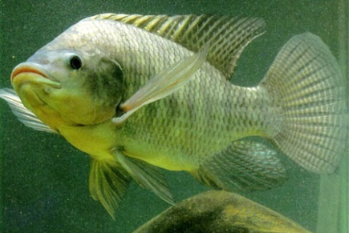
Fig.19. Nile Tilapia fish

- IAS (exotic species). Although the only documented case of invading species is that of the alien water hyacinth (Eichhornia crassipes) which has outnumbered and almost excluded the native Nile cabbage (Pistia stratoites) in the upper stretches of the White Nile.

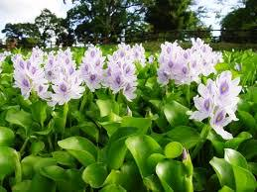
Fig.20. Water hyacinth (Eichhornia crassipes)
- Habitat change. The change in water regime from lotic to lentic waters usually occurs when a dam is built and a reservoir is formed. This could lead to the proliferation of certain species at the expense (dwindling or extinction) of others.

Indirect drivers (underlying causes):
- Attitude and perception. Aquatic macrophytes, for example, have always been regarded as nuisance, useless organisms and at the best cases, they have always been neglected and therefore no attempts for conservation and utilization have been taken.
- Legal status. None of the aquatic flora and fauna has a national protection status.

3.1.7 Marine ecosystem
Direct drivers (pressures):
- Over exploitation:
  - There is severe over-fishing for sea cucumbers in the vicinity of Dungonab Bay where sea cucumbers have been fished out from many shallow areas forcing divers to travel further and exploit deeper waters (PERSGA/GEF 2004f). Similarly, the mollusks Trochus spp., Strombus spp., Lambis spp., and Murex spp. have been severely fished. Most individuals of these species observed in the wild are small and occur at low densities (PERSGA/GEF 2004f).
2. Fishing pressure was intense at spawning and nursery sites for Nagil and
other species especially at the southern end of Mukawwar Island.
Continuation of this form of fishing will undoubtedly lead to the loss of
some of the most important fisheries species.
3. The majority of mangrove stands are affected at various levels by camel
Grazing, felling and limb cutting.
- Natural impacts. A number of ‘natural’ impacts on marine diversity were also observed, including the effects of coral bleaching, diseases, sediments, boring sponges, corallivorous snails (Drupella sp.), and the Crown-of-Thorns starfish (Acanthaster plancii) (African Park Foundation, 2006).
- Habitat change. Increases in coastal development and tourism pressure have negative impacts on marine ecosystem and the flora and fauna it contains.
- Pollution. The expected pollution hazards associated with oil exports in the Red Sea coast on marine biodiversity should be avoided.

3.1.8 Bees diversity
Direct drivers (pressures):
- Pollution. The extensive use of pesticides, particularly the broad – spectrum ones for the control of insect pests of field and vegetable crops and fruit trees will adversely affect the survival of the honey bees.
- Exotic bee species: The previously introduced non-native honeybees in Sudan from Europe (Italian & Carniolan) and Asia (A. florea) and the repeated introduction of non-native species is a threat to the genetic makeup of the native honey bee populations in Sudan. Invasion by non-native species results into introgression through mating in different regions.

3.1.9 Insect diversity
Direct drivers (pressures):
- Climate change. Drought conditions seriously affect the vegetation cover, which indirectly has a negative impact on insect diversity.
- Pollution: The use of broad – spectrum insecticides for the control of insect pests of various crops will result in the elimination of the beneficial insects such as predators, parasites and pollinators.
- Fires. Accidental and planned fires set on pastures or crop remains after harvest kill many diapausing larvae and pupae, and active forms of different insect species and, thereby pose a threat to insect diversity.

Indirect drivers (underlying causes):
- Modern agriculture. The mono-cropping system practiced in the mechanized rainfed and an irrigated sector, where a single crop is grown in large areas, has a negative impact on insect diversity.
- New developmental constructions. Deforestation for expansion in crop production, and recently for oil exploration and mining activities have resulted in elimination of several insect species associated with forest trees and vegetation cover.

3.2 Impacts of declining biodiversity for ecosystem services and the socio-economic and cultural implications of these impacts
An ecosystem is a dynamic complex of plant, animal, microorganism, and the nonliving environment interacting as a functional unit. Ecosystem services are the benefits that people obtain from nature. The ecosystem services are divided into four categories. These include:
- Provisioning services, such as food, water, timber, fuel and fiber, genetic resources.
- Regulating services that affect climate, floods, drought, disease, waste, land degradation, and maintenance of air and water quality.
- Cultural services that provide recreational, aesthetic, and spiritual benefits; and supporting services, such as soil formation, photosynthesis, biodiversity, and nutrient cycling.
- Supporting services – ecosystems provide base or support services that enable provision of the services in the above 3 categories. E.g. soil formation, nutrient recycling, growth, primary production, etc. These generally tend to cover biological (and physico-chemical aspects in case of processes such as weathering, geological changes) processes that support provision of other services.
Ecosystems such as forests, rangelands, wildlife, soil, marine and inland waters and so forth play a very important role in supporting the well being of societies. They provide food and fibre materials, fuel wood, employment and income, in addition to the provision of a vast range of ecological services.
Thus, the constituents of human well-being directly or indirectly affected by ecosystem services are nutrition, health, education and the ability to earn livelihoods.
Ecosystem goods include Food, construction materials, medicinal plants, wild genes for domestic plants and animals and tourism and recreation. The poor generally live off the land on which they grow crops for subsistence and sale, graze their livestock, and obtain wood for cooking, lighting and construction of houses. Since they depend on the land for most of their needs, they tend to use the land intensively, leading to degradation. As the land deteriorates, the poor become poorer. This leads to the well known vicious circle of poverty.
Ecological goods and services are the benefits arising from the ecological functions of healthy ecosystems. Such benefits accrue to all living organisms, including animals and plants, rather than to humans alone. Examples of ecological goods include clean air and abundant fresh water. Examples of ecological services include purification of air and water, maintenance of biodiversity, decomposition of wastes, soil and vegetation generation and renewal, and pollination of crops and natural vegetation.
The CBS (2008) classified the population of Sudan into rural (67%) and urban (33%) categories. This implies that a huge number of Sudan’s population secure their livelihood by using natural resources. This situation has put intensive pressure on these resources, and this by its turn has led to serious degradation in biodiversity and the rest of ecosystems components such as Agriculture, forests, rangelands, inland and marine water and wildlife. This decline in ecosystems biodiversity has resulted in the provision of poor ecological services and goods and thereby has their negative impacts on the population totally or partially dependent on these resources heightening the poverty conditions among them.

3.3 Possible future changes for biodiversity and their impacts
If the current pressures and underlying causes of biodiversity loss, in addition to the lack of awareness among the different stakeholders on biodiversity conservation and sustainable use, the lack or poor implementation of policies, legislations and action plans for conservation and sustainable use of biodiversity exist, the decline in ecosystems biodiversity is expected to increase at an alarming rate in the future.

Chapter 4

Biotechnology Aspects Related to Conservation and Use of Biodiversity

4.1 Agricultural biotechnology
In Sudan, there are several biotechnology laboratories that could help in enhancing the conservation and use of agro-biodiversity. The ARC and the NCR are the leading institutions in biotechnology research. The CBGE, which is one of the institutions of the NCR, is the focal point in Sudan for the ICGEB in Trieste, Italy. The number of laboratories dealing with biotechnology research is increasing; most of them belong to research institutions or universities.
In Sudan, several bio-techniques have been adopted to improve and preserve plants and crops. The most important ones are plant cell and tissue culture and DNA molecular makers.
4.1.1 Plant cell and tissue culture
It is the culture of plant protoplasts, cells, tissues or organs under aseptic conditions that lead to cell multiplication or regeneration of organs or whole plants. Tissue culture proved to be very successful in Sudan. It can also be used for conservation and storage of endangered genetic resources.
The major programs in Sudan on plant tissue culture can be summarized in the following:
  - Improvement of economic crops such as tomato, potatoes, wheat, sorghum, sesame, banana and ginger using callus production and regeneration technology.
  - Production of valuable secondary metabolites through callus or root suspension culture in species such as Vernonia amygdalina, Moringa oleifera, Proboscidea parviflora, Azadirachta indica, Striga hermonthica and Solanum dubium.
  - Micropropagation of important economic and endangered plants such as grape vine, cotton, tomato, sesame pineapple, , strawberry , banana, "mukheit" (Boscia senegalensis), abanous tree (Dalpergia melanoxylon), gum tree "hashab" (Acacia senegal), ginger, rose, date palm , Salvadora persica, bamboos.
  - Production of virus - free sweet orange and grapefruit seedlings using shoot tip grafting for virus elimination.
  - In vitro mutation breeding through which a banana variety named Albeely was officially released in 2004.
  - Production of doubled haploids through which two doubled haploid wheat varieties were released in 2004.
  - Potato Seed production programme is initiated.
4.1.2 DNA molecular markers
They have been used successfully in marker assisted breeding, diagnostics, and in assessment of genetic diversity of several crop species and wild types. On – going research programs are working on selecting crops genotypes tolerant to abiotic and/or biotic stresses. Several DNA marker techniques are used.
MAS has been efficiently used for the selection of desired characters such as tolerance to biotic and abiotic stresses, including the following:
- Release of Striga resistant sorghum lines in 2012.
- On going research for developing sesame lines that are resistant to bacterial wilt.
- On going research for developing white-seeded sesame lines, a character which is highly desired in industry.
- On going research for selecting drought - tolerant sorghum genotypes.
The DNA molecular markers have also been used in assessing the genetic diversity of different crops such as sorghum, sesame, pearl millet, rice, onion, wheat, watermelon and banana. In addition, the genetic diversity of some natural plants of both terrestrial and wetlands that have economic and environmental importance is also investigated. Some of the species studied are classified as neglected, vulnerable or endangered such as Sclercarya birrea, Combretum hartmannianum, Terminalia laxiflora, Salix murielli, Salix subserrata, Acacia senegal and Khaya senegalensis.
4.1.3 Status of genetically modified crops in Sudan
Until recently, genetically modified crops were not grown or produced in Sudan. However, it is speculated that some genetically modified food grains entered the country through food aid in war and conflict affected areas.
Recently, a Chinese Center for Agricultural Technology has been established in Al Faw in Gedarif state to transfer the Chinese agricultural technologies to Sudan including GM crops. In 2009, this centre introduced Bt cotton varieties resistant to African boll worm for testing. In 2012, Chinese 1, which is a genetically modified Chinese Bt cotton genotype (G. hirsutum) carrying Cry1A gene conferring resistance to African boll worm, was released for commercial production in Sudan. In the same year, it was cultivated on about 20,000 and 50,000 acres in rainfed and irrigated areas, respectively. The main objectives of introducing Bt cotton in Sudan were to increase productivity by reducing crop losses due to pest attack and reduce pesticides spraying costs.
4.1.4 Status of genetically modified crops detection facilities
The Biotechnology and Biosafety Center of the ARC, Khartoum is responsible for detection of the GM crops. The SSMO established two GMO detection laboratories one in Khartoum and the other in Port Sudan. Other laboratories that are well equipped with GM detection facilities are in the CBGE, NCR, Khartoum, and the Central Laboratory in Khartoum. However, very few personnel are trained on detection methodologies, qualitative testing, sampling, results interpretation. There are no biosafety guidelines and tolerance limits for GM level.

4.1.5 Research on genetically modified crops in Sudan
The Plant Biotechnology Research Group, at the faculty of Science, University of Khartoum, is the only group working on GM crops. Two years ago, the group developed a transgenic tomato of the adapted Money Maker cultivar expressing defense in anti-fungal gene. Currently, the work by the same group is on the production of transgenic crops, e.g. fungal resistance in tomato, Bt cotton, drought tolerant wheat and drought tolerant sunflower. The transformation is based on Sudanese local farmers’ preferred cultivars. However, all the research is done at the laboratory level and no further testing and field evaluation has been done.
In Sudan, no biosafety research on environmental aspects of biodiversity has been carried out.
4.2 Microbial industrial biotechnology
Sudan is known for its microbial wealth and the research in this field is focusing on the use of microbes from Sudanese sources. Recently, DNA markers are used in the characterization of microbial diversity and identification.
Research on yeast strains isolated from local fermented food and beverages is intended to solve economic and nutritional problems. The production of biofuel using several Sudanese yeast strains proved to produce ethanol from molasses, a sugarcane by-product, and sweet sorghum substrate. The Sudanese yeast strains from traditional fermented food and beverages proved to be more efficient in bakery than the introduced ones as they are more tolerant to high temperatures. Some of the identified yeasts strains are under the process for registration as patent of the CBGE and NCR of Sudan.
There is exploitation of microorganisms as bioreactors for the production of citric acid, xanthan gum, alginate, amylase enzyme, bioactive compounds and others. Production of industrial enzyme, antibacterial and antifungal materials from soil is also carried in some laboratories. Identification of microorganisms that can produce enzymes that are friendly to the environment which can substitute the use of chemicals for safe dehairing of leather is an on-going research programme. This work can help in solving serious health and environmental pollution problems caused by the tanneries in Sudan.
Molecular epidemiology of Salmonella in Sudan, and molecular detection and sequence-based phylogenetic analysis of cucurbit viruses are also ongoing research programs.
Work on Rhizobium biotechnology in Sudan started in 1960 in some universities and research centers by using broth cultures in some pot experiments. The excellent results of those experiments encouraged the research on the local materials to be used as bacterial carriers. Nile silt with the addition of some organic and inorganic substances and other carriers such as charcoal were also examined. A BNF laboratory for bacterial inoculum production was constructed in 1992 in the ENRRI of the NCR with the financial support of UNEP. Via thorough research and experimentation, Rhizobim inoculum production was realized in the Biofertilization Department of ENRRI production unit. Now it is commercially used by farmers and agricultural companies throughout the country.
Biofertilization Department carries research on the use of non-symbiotic nitrogen fixing, phosphate and potassium solubilizing bacteria as well. Many strains showed good potential in improving yield and quality. Many local materials have been tested as bacterial carriers in order to produce good quality inoculants. This work is still at the experimentation level.
Sudan also initiated research on the domain of bioremediation since toxic substances have negative impacts on soil microbes, hence disturbing elements cycles. Several promising isolates of microbial degraders for the degradation of some pesticides, crude oil and heavy metals are obtained. Main Institutions working in this field are ENRRI, CBGE, Central Laboratory, Department of Botany, University of Khartoum, and some others.

4.3 Animal biotechnology
Biotechnology was first applied in vaccine production in 1930. Vaccines were produced in Sudan for immunization of animal populations against contagious and infectious bacterial and viral diseases by the Central Veterinary Research Laboratory, Soba. There is ongoing work to produce additional vaccines against parasitic infections.
Schistosomiasis is an endemic disease in Sudan. Recombinant DNA vaccines are now being produced against viral and parasitic diseases by the Faculty of Veterinary Medicine, University of Khartoum, Sudan in collaboration with the Department of Medical Helminthology, Pasteur Institute, France.
The Ministry of Animal Resources established the National Artificial Insemination Center in 1976. Subsequently, semen collection, evaluation and insemination of synchronized cows were made possible locally through importation of good quality semen. Currently, there is an ongoing research work conducted by a research team in the Faculty of Veterinary Medicine, University of Khartoum for artificial insemination project to improve the genetic makeup and productivity of the Sudanese Nubian goats funded by the IAEA. The ET was started in 1983 in bovine. Successful delivery of a full term calf from ET was reported in 1984, Gezira University Farm.

4.4 Molecular studies on bees
Recently, very limited studies analyzed the genetic diversity of honey bee in Sudan using mitochondrial DNA analysis and the microsatellites DNA markers (Mogbel et al., 2010). Managed and wild honey bee populations in Sudan had been studied using SSR and mt DNA markers.

4.5 Biosafety arrangements
The Sudanese biosafety National Law was issued in 2010 in order to deal with operations and activities related to handling and trading in genetically modified organisms (GMOs) and their products which pose challenges for the application of the law and the whole system of biosafety in Sudan. This law has been preceded by the national framework for biosafety in 2005, which is a basic document prepared to set out the major policies and principles of biosafety in Sudan. The issuance of the national biosafety framework and law preceded the joining of Sudan to the Cartagena Protocol on Biosafety in the year 2005. Thus, these documents are the three main pillars of what could be called a national system of biosafety in Sudan, and must be strictly applied in order to achieve the objectives for which these documents were issued. However, there was a delay in establishing the institutional arrangements as set in the law up till 2012 when the authorized minister was identified by the president of the republic and the national biosafety council was formulated. These actions were taken with a rush and under the pressure to deal with the first case of official introduction and release into the environment of a Bt cotton variety that was already introduced and tested since the year 2009 without official approval of the biosafety competent authority. A lot of public debates among scientists and activists on newspapers and media as well as in public fora has been going on since then with emphasis on issues such as the legality of the activity, and concerns on the risks of such an activity and to what extent the concerned authorities have been dealing strictly with the matters related to the application of biosafety regulations in the country.

4.6 Documentation and information management
4.6.1 Plant agro-biodiversity
The PGR programme in the ARC is engaged in systematic documentation of the PGR under conservation using accession-level systems. The PGR Unit / ARC has records on the material conserved for different information categories including passport, management and characterization data. The data available are sometimes incomplete for some accessions due to gaps created by inappropriate documentation while collecting, or when germplasm material is provided by collectors from outside the PGR program.
At present the PGR programme in the ARC is using a gene bank documentation system operated through a genebank data management tool called SESTO for documenting and accessing both the passport and management data. SESTO is a genebank data management tool, developed by the former Nordic Gene Bank (now the Nordic Genetic Resource Centre). The characterization data are documented using the Microsoft Office Software Excel. The genebank documentation system (SESTO) is installed in a main server that is accessed through a local network of computers within the PGR Unit of the ARC in Wad Medani Town. It is worth mentioning here that the SESTO has been adopted as a tool for PGR documentation and data management by the EAPGREN of which Sudan is a member among eight countries. Training on the system has been provided to PGR national programme staff in the different countries where the system has been installed. In Sudan the SESTO System is being now used for documenting and retrieving the up-to-date passport data of all PGR holdings. Management information on the stored germplasm is being updated at present to support all management operations within the PGR Unit and programme. At present, access to such data as well as characterization data is provided through direct contact of germplasm requesters and utilizers with the PGR Unit. The passport data of the collections held by the PGR Unit can be accessed through the EAPGREN Data Portal at the website link (http://www.eapgren.org/eapgren/) in which data in SESTO-Sudan are uploaded. There is an access to such data through the ARC website at the link http://www.arcsudan.sd/highlight/pgrparc.htm.

4.6.2 Forests
The first national inventory for Sudan forests was launched early 1995 and was completed in 1997. However, some tracts of forests have previously been inventoried e.g. Biomass resources east of the Nile (1991), southern Blue Nile (1984), parts of Kordofan and Darfur (1990-94), parts of northern Blue Nile (1994), besides the regular inventory of forest reserves under management plans. The state of natural forests can only be extrapolated from these ad hoc surveys and from global ones such as that by FAO (1990). A new national inventory of forest resources both in quantity and quality is highly needed after the separation of South Sudan. There is a rich library containing valuable documents on Sudan forests (old and recent) at FNC. The herbarium of FRC is the largest in Sudan incorporating over 7000 forest specimens with a computerized appendix. There is an urgent need for an updated study on trees and shrubs of Sudan after the separation of South Sudan.

4.6.3 Range Plants
With regard to the pastoral sector resources, there are few, sometimes contradicting, data to depend on. However, the RPGD national herbarium which contains 400 range plant species dating back to the year 1948, needs to be renewed and it is in the process of digitizing its electronic information. There is also an ongoing process for producing an Atlas for important range forage plants including herbaceous grasses and fodder trees and shrubs.

4.6.4 Medicinal and aromatic plants
The MAPRI is considering development of Sudanese medicinal plants database. The herbarium of MAPRI currently contains 1000 dried and identified plant specimens. Additionally, there is a small museum of fruits and dried samples.
There is ongoing research project in MAPRI that focuses on the documentation of medicinal, aromatic and poisonous plants in Sudan including development of an Atlas for Sudanese Medicinal and Aromatic plants. So far, twenty one field trips have been accomplished in different regions of Sudan, through which all medicinal plants, their local uses and names have been documented in the following five books:
- Medicinal plants of Erkowit, 1986.
- Medicinal plants of Ingassana area, 2003.
- Medicinal plants of the White Nile provinces, 1994.
- Medicinal plants of Northern Kordofan, 1997.
- The medicinal plants commonly used in Khartoum State (in Arabic)
Two books on Aromatic and poisonous plants were also published:
  - Aromatic plants of the Sudan (2004).
  - Poisonous plants of the Sudan (2008).
The institute produced 13 extension pamphlets for production, harvest practices, medicinal values and uses of sweet fennel, winca, blond psyllium, speermint, caraway, black mustard, cumin, German chamomile, roselle, senna, fenugreek, anise seed, khella, and endangerd plants such as Vernonia species.
4.6.5 Marine biodiversity
Collection of essential baseline data on key habitats and species including coral reefs, mangroves, seabirds and turtles, and preparation of up-to-date status reports has taken place.
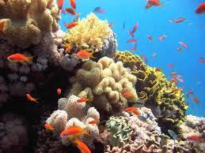
Fig.21. Sudan Red Sea coral reef
4.6.6 Sudan national computing grid
In December 2012, a national network has been launched by Africa City of Technology, Ministry of Science and Communications with partial operation consisting of three computing centers with high performance computers (Supercomputer K1). It constitutes the largest computing system in the region with speed of 40 trillion calculation/second, and storage capacity of 350 million letters, which is used in advanced scientific research such as in life sciences, climate change, chemistry and physics. A national genome database has been launched under this national computing grid. A total of 200 experts had been trained on managing the national database. The priority target for starting is the life sciences, with the goal of storing and gathering genomic data from Sudan such as those related to DNA, protein sequences and publications.

4.7 Arrangements for access and benefit sharing
In Sudan, there is a lack of an overall policy and framework on access to genetic resources and benefit sharing, including legislative, administrative and scientific capacities.
The only attempt to establish and implement a national system for access and benefit sharing is being undertaken in the field of PGRFA. Sudan is a party to the ITPGRFA. The ITPGRFA is regarded as suitable framework that provides the country with a good basis for developing and implementing related policies and plans for providing access to Sudanese PGRFA on the basis of fair and equitable benefit sharing including the MLS established by the Treaty for this purpose.
The Ministry of Agriculture, which is the national focal point for the ITPGRFA, has officially notified the Treaty Secretariat on September 2010 of inclusion of 6351 accessions of PGRFA of 12 genera in the MLS (Table 3). All of these accessions are conserved by the PGR Unit / ARC. An official authorization was made by the Minister of Agriculture for the Head of the PGR Unit, ARC to sign the SMTAs on behalf of Sudan as germplasm material provider.
The germplasm materials included in the MLS have recently been uploaded in 2011 onto the EAPGREN Data Portal and ARC website. A local internal system is adopted by the PGR Unit / ARC for regulating the process of accessing the germplasm others than those included in the MLS. It consists of a germplasm request form to be filled out by the germplasm applicant and a material transfer letter that is submitted to the applicant upon receipt of the germplasm requested. The applicant for germplasm has to mention in his/her request the type of germplasm requested and the purpose for which such material is requested. If the germplasm is provided then it must be accompanied with the letter of material transfer in which the applicant/recipient of the germplasm material is informed on the conditions based on which the material is provided. The acceptance of such conditions is obtained through the signature of the applicant / recipient on the letter. These conditions consist of the following terms:
- The germplasm materials provided or any materials they contain are not permitted to be transferred at any condition to any other party inside or outside Sudan.
- The germplasm materials are provided to be utilized only by the applicant him/herself for the purpose mentioned in the request, and they are not to be used, or any material they contain, for any other purpose without a written consent from the PGR Unit, ARC, Sudan.
- A copy of the results of activity as outlined in the purpose for which the germplasm materials are provided has to be submitted to the PGR Unit / ARC for documentation purposes.

Table 3. Germplasm material included in the MLS from Sudan
Genus | Crop | Total Accessions
Beta | Chard | 12
Cajanus | Pigeon pea | 45
Cicer | Chick pea | 31
Eruca | Rocket | 32
Musa | Banana | 331
Pennisetum | Pearl millet | 947
Phaseolus | Bean | 60
Rapahnus | Radish | 13
Sorghum | Sorghum | 4322
Vicia | Faba bean | 112
Vigna | Cowpea, Bambara. | 276
Zea | Maize | 170
Total |  | 6351

.

Chapter 5

Invasive Alien Species

They are species whose introduction and/or spread outside their natural ecosystems threaten biological diversity. They occur in all taxonomic groups, including animals, plants, fungi and microorganisms, and can affect all types of ecosystems. They are characterized by rapid reproduction and growth, high dispersal ability, phenotypic plasticity, and ability to survive in a wide range of environmental conditions.
The IAS are causing three types of damage; damage to ecosystems, damage to human safety and damage to agriculture, forestry and fisheries.
The significance of the IAS issue was evoked by Article 8 (h) of the CBD stating the problems of alien species. IAS are considered as a global issue that requires international cooperation and actions. There are several conventions, international and regional agreements, guidelines and codes of conduct to deal with IAS. However, existing legal framework in Sudan and several other countries is not enough to comprehensively deal with the damage caused by IAS. A major challenge today is to understand the influence of climate change on the complex interactions and impacts of IAS on natural and human-altered ecosystems.
Although IAS are found in many parts of the Sudan causing enormous problems in the ecosystems and the economy, very limited studies are available on their impact. The prominent IAS that cause damage across the country include, but not limited to, mesquite (Prosopis juliflora), broom rape (Orobanche crenata), the date palm white scale (Parlatoria blanchardii) and the green pit scale (Asterolecanium phoenicis), fruitflies (Ceratitis capitata , C. cosyra, Bactrocera cucurbitae and B. Invadens).

5.1 State of IAS
IAS are regarded as the second largest threat to conservation of biodiversity after direct habitat destruction.
The threat posed by IAS is increasing at a high rate as a result of increased human activity, including international trade, transport, travel and tourism. Ships can carry aquatic organisms in their ballast water. Insects can get into wood, shipping palettes and crates that are shipped around the world. Some ornamental plants can escape into the wild and become invasive. Some invasive species are intentionally or accidentally released pets.
IAS are one of the leading threats to native wildlife. Approximately 42% of the threatened or endangered species are at risk primarily due to invasive species.
Climatic changes associated with fluctuations in rain and temperature patterns caused by global warming will enable some invasive plant species to move into new areas. Insect pests’ infestations will be more severe as pests are able to take advantage of drought-weakened plants.
A range of IAS of plant, insect and animal exist in Sudan, which have been introduced accidentally or deliberately for various purposes. Some of the IAS include the multipurpose trees, which were brought in to provide some benefits such as combating desertification. Unfortunately, their benefits come at the expense of native tree species and ecosystems as they degrade biodiversity by replacing indigenous species and bringing significant habitat transformation and changes in vegetation which in turn increases the cost of biodiversity conservation.
Currently, there is limited published information on IAS in Sudan.
5.1.1“Mesquite” (Prosopis juliflora) is a threat to biodiversity in several regions of Sudan, particularly in eastern Sudan. Its strong tendency for allelopathic-induced monocultural growth and its prolific seed production and efficient spread by browsing animals are the major factors that have enabled this species to take over large areas of the habitats. P. juliflora was introduced into Sudan in 1917 from South Africa and Egypt and planted in Khartoum (Brown and Massey, 1929). The success attained in establishment and its ability to tolerate drought, fix sand dunes and capacity to furnish shade, fuel, timber, fodder and edible pods are main driving forces for its repeated introductions into various agro-ecosystems particularly in dry areas (Babiker, 2006). In the period 1978-1981, the tree was planted as shelterbelts on premises of major cities in eastern Sudan (Elsidig et al., 1998). Moreover, introductions were made into various places in western and central Sudan where it is grown as shelterbelts around farms, irrigated schemes and along the Nile have led to the spread of mesquite into various locations where it has become a national pest (Elhouri, 1986). The plant constitutes a threat to agriculture and may lead to deterioration of natural vegetation and pastures and thus, jeopardize the livelihood of a large population, particularly where livestock keeping and subsistence farming are the main activities for income generation.
The bulk of mesquite infestation (> 90%) is in eastern Sudan where livestock keeping and subsistence cultivation constitute the main source of income. Invading mesquite tends to form dense impenetrable thickets. In pastures, it reduces grass cover and stocking density, and threatens the livelihood of traditional pastoralists. In Sudan as in most of the countries, where mesquite has been introduced, it is underutilized. Its use, beside sand dune fixation is limited to fuel wood and charcoal production (Babiker, 2006). Animal rearing constitutes the main livelihood of landless and resource poor farmers in many of the mesquite endemic areas. Unpalatability of P. juliflora leaves to livestock limits their use as animal feed. Results from trials on feeding mesquite pods to sheep were also disappointing and over 90% of livestock owners in eastern Sudan regard mesquite as a liability (Elsidig et al., 1998).
Mesquite seeds are the main vehicle for long distance transport. Satellite foci are pivotal for establishment of colonies (Babiker, 2006). Mesquite, as is the case with many invasive alien plants, spreads by seed dispersal and repeated establishment of satellite foci from a founder population. Environments with open niches, abandoned land or over-grazed and drought stricken sites are the most vulnerable to invasion. Mesquite, upstream, on rivers, water courses and irrigation canals or in premises of irrigated schemes displays a high tendency to spread. The huge seed bank and basal buds endow mesquite with a high capacity for regeneration after cutting and/or uprooting.
Mesquite suppresses germination, establishment and growth of other plants. The suppressive effects of mesquite were attributed to competition and/or allelopatheic effects. Under heavy natural mesquite stands, other trees and even mesquite seedlings do not survive (Ahmed, 2009).
The dry pericarp of P. juliflora is reported to contain water soluble toxins that inhibited seed germination and substantially retarded seedlings growth (Warrag, 1994).
Plant growth inhibitory alkaloids were isolated from the extracts of P. juiliflora leaves. The alkaloids were identified as 3" "-oxo-juliprosopine, 3-oxo-juliprosine, 3' -oxo-juliprosine and secojuliprosopinal (Nakano et al., 2004). Furthermore, L-tryptophan was shown to be released from mesquite leaves to the environment in sufficient quantities to elicit an allelopathic effect (Nakano et al., 2001). Moreover, two plant growth inhibitors syringin and (-) – lariciresinol, isolated from aqueous leachate of mesquite leaves, were reported to leach and accumulate in soils under mesquite (Nakano et al., 2002).

5.1.2 Bromerape (Orobanche): Faba bean production is threatened by the root parasitic weed, Orobanche crenata. The parasite is recently introduced into Sudan and was first reported in 2000/01 on an area of about 2 ha at Ed Debiba in Merowe governorate in northern Sudan. It was speculated that the parasite seeds were introduced, involuntarily, as contaminants of faba bean seeds from Egypt. Besides faba bean, the parasite attacks several other legumes including lentil and chickpea. A limited survey undertaken in 2001/02 over 158 ha in Ed Debiba revealed that 94 % of the area under faba bean was infested. A second survey in 2002/03 revealed that the parasite had spread into a stretch of about 60 km along the Nile on either side of the original infestation. A third survey conducted in the Northern state in 2003/04 showed that the parasite had spread along about 160 km including El Selaim basin (the most important faba bean production area in Sudan). Isolated infestation foci were reported in the River Nile state. A national survey, undertaken at harvest, in 2004/05 indicated that the infested area in the Northern state was about 9% of the total area (33.6 thousand ha) under faba bean. The infestation was highest in Merowe governorate where the parasite was first reported. In the River Nile state, the parasite was reported from 28 sites infesting 1% of the total area (33.7 thousand ha) under the crop. In both states, infestation varied from light to heavy. A national survey conducted in 2005/06 revealed the presence of the parasite in 99 sites in the River Nile State. Of these sites, 35 were islands. The infested area had risen to 4.4% of the total area under faba bean. In the Northern state, the parasite was reported from 20 sites.
The high seed quality of the introduced faba bean varieties that fetch high price enticed farmers to grow them locally. The parasite, unnoticed, multiplied, naturalized and has become a problem. The wide spread of the parasite is consistent with its invasive nature, lack of natural enemies, lack of awareness about the parasite, its biology, reproduction, methods of spread, the nature of its association with its host, its debilitating effects and a series of malpractices. The different methods for the spread of the parasite from one area to another include the infested faba been seeds that are intended for seeding, irrigation water, animals and agricultural implements. Spread of Orobanche species, as is the case with many invasive alien weeds, occurs through dispersal and repeated establishment of satellite foci from a founder population. Like other root parasitic weeds, no single measure provides effective control and an integrated approach comprising preventive, cultural, biological and chemical methods needs to be adopted. Control of the parasites is further compounded by the existence of wild hosts. Apart from faba bean, chickpea and lentil, the parasite is found growing on Malva parviflora, a common weed in northern Sudan, and on Euphorbia species.
To date, O. crenata occupies a small proportion of the area under faba bean (4 - 9%). However, infestation foci are scattered all over the cultivated area. It is worth mentioning that the bulk of the area under faba bean is restricted to the Nile valley north of Khartoum. If the parasite is not contained and controlled, faba bean production in Sudan will be at stake.
Orobanche ramosa is an alien invasive parasitic weed on tomato distributed in Sudan from Wadi Halfa in the northern state, Dongola, through Khartoum up to Damazin in Blue Nile state, with an expected distribution along river Atbara and White Nile.
With the modernization of agriculture coupled with the rapid movement of global trade during the last decades, new species of insects were accidentally introduced to the country. Unfortunately, most of these insects are potentially harmful species, hence imposing serious threats to agriculture and/or natural resources.
5.1.3 Scale insects of date palm: Two species of scale insects were reported on date palm in Sudan (Satti, 2011), the date palm white scale (Parlatoria blanchardii) and the green pit scale (Asterolecanium phoenicis). The first one seemed to be introduced earlier and distributed in all date palm growing areas particularly in the Northern and Kordofan states (Schmutterer, 1969; Siddig, 1975). According to Schmutterer (1969), P. blanchardii was a major pest of date palm in northern and central Sudan during the second half of the 20th century, but currently its importance seems to be declined. The long history of occurrence of the pest in that region seemed to enhance gradual buildup of certain indigenous natural enemies attacking the pest. It appears from observations that predators dominated by the larvae of lacewing Chrysoperla species, are among the main bioagents combating the white scales.
The second scale insect, the green pit scale (A. phoenicis), though newly introduced, is now surpassing the former species in its population densities and damage inflicted on date palm trees and fruits. This pest is found infesting date palms especially in Asia like Iran and some neighbouring counties, but now is distributed in other regions including certain Arab (e.g., Saudi Arabia) and African (Libya and Sudan) countries. Within a few years following its discovery in Algolid in northen Sudan in 1985, the pest was spreading along large stretches to the south and north of the original point, causing severe infestation and complete drying of the tree leaflets. More than one million trees were said to be infested causing very high yield losses. As a result of infestation, the yield of an individual tree was reduced from 40 kg to 15 kg on average. In an attempt to eradicate the pest during 1990s, quarantine regulations and pruning of infested leaves followed by chemical sprayings were the main control measures adopted. These measures mitigated the damage for a while, but neither succeeded to eradicate the pest nor stopped its progress to new areas. Consequently, the first appearance of the pest in Khartoum State was in 2011. Since A. phoenicis is under natural control in its original places, biological control through importation of suitable natural enemies can be attempted (Abbas and El Nasr, 1992; Elhassan, 2007)

5.1.4 Fruit flies: Ceratitis capitata is one of the old fruit flies in Sudan, detected earlier in mid of the 20th century. This pest was firstly reported from northern Sudan where it is dominant till now. Though C. capitata was said to be originated in sub-Saharan Africa, it was suspected to be introduced to that area of the country largely from the Mediterranean region through Egypt, where it ranks among the economically most destructive fruit pests. The higher occurrence of C. capitata in the northern than in the southern part of Sudan may support what have been pointed by some authors that this species is less serious in the equatorial belt of Africa compared to other Ceratitis spp. (Copeland et al., 2006). In contrast, Ceratitis cosyra was recently introduced, showing its dominant prevalence in central (particularly in Sennar and Blue Nile states) and Kordofan regions as a serious pest of mango fruits (Ahmed, 2001; Ibrahim, 2006).
The genus Bactrocera (ca.500 species) forms a very large group of highly destructive pests, native to Asia and also in Australia and Pacific region. Four invasive species of Bactrocera (viz., Bactrocera cucurbitae, B. invadens, B. latifrons and B. zonata) accidentally invaded Africa at different periods, and now are spreading in a number of countries. Two of these species (B. cucurbitae and B. invadens) were recently introduced into Sudan. They cause extensive damage to cucurbits and fruit trees, respectively. The extent of damage on cucurbits by B. cucurbitae varies between 30 – 100% depending on crop species and the season. On the other hand, B. invadens is spreading very fast and now almost recorded from all parts of the country. In Sudan, B. invadens is largely displacing other fruit fly species like C. capitata and C. cosyra in infestation of some fruits like mangoes. Thus, in Sennar area of central Sudan, the prevailing fruit flies dominated by B. invadens were reported to cause 80% damage on mango fruits. Consequently, in 2007 the problem of fruit flies was aggravated to the extent that these pests were listed among the major national pests receiving considerable attention in control by the Plant Protection Directorate of the Ministry of Agriculture (Ahmed, 2001; Dhillon et al., 2005; Ibrahim, 2006; Gassmallah et al., 2008; Mohamed and Ali, 2008; De Mayer et al., 2009).

5.1.5 Jatropha: The State of Sinnar is planning to use some of the lands within the protected areas of Dinder National Park for growing jatropha (Jatropha curcas) for production of biodiesel. This plant has been reported to be an eminent threat to biodiversity of rangeland, agricultural and forests ecosystems. It can become a noxious weed because of its tolerance to harsh conditions. It can easily colonize large areas, thus displacing and replacing native species.
Transforming natural protected areas into agricultural production system is disastrous to the wildlife biodiversity in the region.
5.1.6 Tomato leaf miner (Tuta absoluta): It is a devastating insect pest with strong preference for tomatoes. It can also attack the aerial parts of potato, eggplant, pepino (Solanum muricatum), tobacco and solanaceous weeds. Its larvae prefer leaves, stems, buds or calyx to tomato fruit. It originates in South America where it is considered a key pest since 1980s. After its detection in Spain in 2006, it spread quickly to other European, North African and Mediterranean countries. It may be a transboundary pest that spreads rapidly by trade pathways or naturally. It is found all the year round in greenhouses and in locations with mild winters. In Sudan, a severe out break of this was reported for the first time on tomato grown in greenhouses at Khartoum state in June 2010 (Mohamed et al., 2012). In surveys conducted in tomato fields at Khartoum and Gezira states during February – May 2011 severe pest infestation were observed. The pest was also reported in the Red Sea and North Kordofan states in tomato grown in both greenhouses and open fields. The severity of infestation in most of the surveyed fields ranged between 80 – 100%. In December 2010, the loss in tomato yield as result of the pest infestation in the greenhouses at Khartoum state was reported to be as high as 76%. The rapid spread of this insect pest and its high level of infestation have raised the alarm to the potential risk to tomato, eggplant and potato production in Sudan.

5.2 IAS management issues:
Several efforts were made in Sudan to eradicate mesquite (Babiker, 2006). Because of high cost and complexity of the problem, most of the control efforts were not successful or sustainable. In 1995, the government approved a bill on mesquite management. The tree is to be eradicated where it constitutes a threat to agriculture or biodiversity and preserved in areas threatened by desertification. Eradication programs using mechanical and manual methods for uprooting mesquite were implemented at very high cost and with variable results (Babiker, 2006). Soil disturbance resulting from uprooting brings mesquite seeds to the soil surface and, thereby aids in regeneration (Ahmed, 2009)
Mesquite, if properly managed, could be a boon to the rural poor. Efforts have to focus on containment and maximum utilization. To curtail mesquite invasion, seed movement should be discouraged or the seeds should be devitalized, satellite foci should be denied establishment, over exploitation of natural vegetation and overgrazing of marginal land should be discouraged. Land tenure in mesquite endemic areas should be reviewed. Satellite foci and mesquite infestations on irrigation canals, water courses and agricultural land should be eradicated. Utilization of the removed mass should be designed to generate income for farmers and pastoralists. Following destruction, mesquite has to be replaced by appropriate trees and/or crops. The treated area has to be vigilantly observed and interventions by chemical and/or mechanical means should be implemented to discourage regeneration.
Mesquite should be conserved in areas prone to desertification and ways and means for its management and utilization should be developed.
Since 2008, a collaborative research programme between Sudan University of Science and Technology and the Japanese Research Institute of Humanity and Nature has been running with the objective of developing sustainable and economically viable management strategies which offer several options for mesquite control.
A programme of uprooting of mesquite was initiated by the federal ministry of agriculture in 1995. A programme for containment of mesquite was planned in New Halfa in 1996, with little success. A Food for Work programme was run by Oxfam to control mesquite in Tokar delta. Under the programme, families of low income were mobilized to the delta. Each family was offered food and two hectares of mesquite infested land. Mesquite pods were swapped for sorghum.
At present, active eradication programs using both mechanical and manual methods for uprooting mesquite are implemented in New Halfa agricultural scheme and Tokar delta at costs of 7.4 and 8.7 million US dollars, respectively. A similar eradication programme was implemented in Zeidab irrigated scheme. Because of the high cost, eradication was incomplete and a significant proportion of the cleared area is re-infested due to poor follow-up. Some herbicides tested by ARC such as triclopyr and clopyralid displayed excellent activity against the weed. Biological control of mesquite has not been thought or adequately researched. However, recent surveys undertaken by Bashir and co-workers showed a number of insect species, including the bruchids, Algarobius prosopis which destroys mesquite seeds. Under natural conditions, the seed damage caused by A. prosopis in Sudan was 7.3 - 24 %.
A regional project on Orobanche management in leguminous crops sponsored by FAO during the period 2004-2005 used FFS and other means for increasing farmers’ and policy makers awareness on crop production practices and Orobanche management.
Detection surveys and regulatory measures that prevent the movement of viable seeds are recommended. To this effect, the federal ministry of agriculture prohibits importation of faba bean seeds without prior consent. The imported seeds are to be examined and their freedom from Orobanche seeds has to be ascertained and certified. Local governments passed internal regulations prohibiting movement of faba bean seeds from infested areas into Orobanche-free areas. Animal grazing, movement of farm equipments (unless thoroughly cleaned) and use of crop residues from infested fields as animal feed are prohibited. Local governments also monitor and document O. crenata spread and distribution annually, locate infested sites, determine intensity of infestations and accordingly advise farmers on how to deal with infestations and on whether to plant faba bean next season or seek an alternative crop.

5.2.1 Policy and legislation on management of IAS:
There is no national policy and legislation on the management of IAS in Sudan, although issues of IAS are covered in sectoral policies and legislations.
The Plant Quarantine Acts prevents the importation, culturing, distribution
And selling of any plant forms without an official permit from the Plant Protection Directorate. The existence of a wider range of IAS in Sudan indicates that enforcement of the Act is weak probably due to weak border control and poor quarantine measures.
Information on IAS is often scattered and incomplete and does not contribute to decision making regarding actions to be taken.
Education and public awareness programs of the risks associated with the introduction of IAS, including mitigation measures, are not in place.
In 1996, the government approved a bill on mesquite management. The tree is to be eradicated where it constitutes a threat to agriculture or biodiversity and preserved in areas threatened by desertification.

Part II

The National Biodiversity Strategy and Action Plan: Implementation and Mainstreaming of Biodiversity

Chapter 6
NBSAP Implementation and Mainstreaming of Biodiversity

6.1 Biodiversity national targets
All the twenty Aichi Targets were chosen as the National Biodiversity Targets. The twenty targets are included under the five strategic goals:
Strategic goal A. Address the underlying causes of biodiversity loss by mainstreaming biodiversity across government and society
Target 1: By 2020, at the latest, people are aware of the values of biodiversity and the steps they can take to conserve and use it sustainably.
Target 2: By 2020, at the latest, biodiversity values have been integrated into national and local development and poverty reduction strategies and planning processes and are being incorporated into national accounting, as appropriate, and reporting systems.
Target 3: By 2020, at the latest, incentives, including subsidies, harmful to biodiversity are eliminated, phased out or reformed in order to minimize or avoid negative impacts, and positive incentives for the conservation and sustainable use of biodiversity are developed and applied, consistent and in harmony with the Convention and other relevant international obligations, taking into account national socio economic conditions.
Target 4: By 2020, at the latest, governments, business and stakeholders at all levels have taken steps to achieve or have implemented plans for sustainable production and consumption and have kept the impacts of use of natural resources well within safe ecological limits.
Strategic goal B. reduces the direct pressures on biodiversity and promotes sustainable use
Target 5: By 2020, the rate of loss of all natural habitats, including forests, is at least halved and where feasible brought close to zero, and degradation and fragmentation is significantly reduced.
Target 6: By 2020, all fish and invertebrate stocks and aquatic plants are managed and harvested sustainably, legally and applying ecosystem based approaches, so that overfishing is avoided, recovery plans and measures are in place for all depleted species, fisheries have no significant adverse impacts on threatened species and vulnerable ecosystems and the impacts of fisheries on stocks, species and ecosystems are within safe ecological limits.
Target 7: By 2020, areas under agriculture, aquaculture and forestry are managed sustainably, ensuring conservation of biodiversity.
Target 8: By 2020, pollution, including from excess nutrients, has been brought to levels that are not detrimental to ecosystem function and biodiversity.
Target 9: By 2020, invasive alien species and pathways are identified and prioritized, priority species are controlled or eradicated, and measures are in place to manage pathways to prevent their introduction and establishment.
Target 10: By 2015, the multiple anthropogenic pressures on coral reefs, and other vulnerable ecosystems impacted by climate change or ocean acidification are minimized, so as to maintain their integrity and functioning.
Strategic goal C. Improve the status of biodiversity by safeguarding ecosystems, species and genetic diversity
Target 11: By 2020, at least 17 per cent of terrestrial and inland water areas, and 10 per cent of coastal and marine areas, especially areas of particular importance for biodiversity and ecosystem services, are conserved through effectively and equitably managed, ecologically representative and well connected systems of protected areas and other effective area-based conservation measures, and integrated into the wider landscapes and seascapes.
Target 12: By 2020 the extinction of known threatened species has been prevented and their conservation status, particularly of those most in decline, has been improved and sustained.
Target 13: By 2020, the genetic diversity of cultivated plants and farmed and domesticated animals and of wild relatives, including other socio-economically as well as culturally valuable species, is maintained, and strategies have been developed and implemented for minimizing genetic erosion and safeguarding their genetic diversity.
Strategic goal D: Enhance the benefits to all from biodiversity and ecosystem services
Target 14: By 2020, ecosystems that provide essential services, including services related to water, and contribute to health, livelihoods and well-being, are restored and safeguarded, taking into account the needs of women, indigenous and local communities, and the poor and vulnerable.
Target 15: By 2020, ecosystem resilience and the contribution of biodiversity to carbon stocks has been enhanced, through conservation and restoration, including restoration of at least 15 per cent of degraded ecosystems, thereby contributing to climate change mitigation and adaptation and to combating desertification.
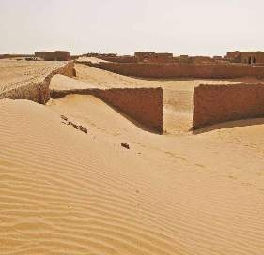
Fig.22. Desertification impacts
Target 16: By 2015, the Nagoya Protocol on Access to Genetic Resources and the Fair and Equitable Sharing of Benefits Arising from their Utilization is in force and operational, consistent with national legislation.

Strategic goal E. Enhance implementation through participatory planning, knowledge management and capacity-building
Target 17: By 2015 each Party has developed, adopted as a policy instrument, and has commenced implementing an effective, participatory and updated national biodiversity strategy and action plan.
Target 18: By 2020, the traditional knowledge, innovations and practices of indigenous and local communities relevant for the conservation and sustainable use of biodiversity, and their customary use of biological resources, are respected, subject to national legislation and relevant international obligations, and fully integrated and reflected in the implementation of the Convention with the full and effective participation of indigenous and local communities, at all relevant levels.
Target 19: By 2020, knowledge, the science base and technologies relating to biodiversity, its values, functioning, status and trends, and the consequences of its loss, are improved, widely shared and transferred, and applied.
Target 20: By 2020, at the latest, the mobilization of financial resources for effectively implementing the Strategic Plan for Biodiversity 2011-2020 from all sources, and in accordance with the consolidated and agreed process in the Strategy for Resource Mobilization should increase substantially from the current levels. This target will be subject to changes contingent to resource needs assessments to be developed and reported by Parties.
In some areas significant steps were taken to achieve the target such as in the marine ecosystem. Target 11 calls for 10 per cent of coastal and marine areas are conserved. Such a percentage has already been reached and clear plans and programs for their management are under way.
Certain targets were portrayed as being almost unachievable such as Target 5 which calls for “By 2020, the rate of loss of all natural habitats, including forests, is at least halved and where feasible brought close to zero, and degradation and fragmentation is significantly reduced”. The “unachieveability” is linked with current status of forest, and the rate of their loss, especially that many forests being now in another country after the severance of Southern Sudan. However, such a gloom situation was perceived by others as in itself a compelling lever to adopt this particular target. As put by one stakeholder,: the more grimmer the situation is , the more is the need for the particular target.

6.2 Updated NBSAP as an effective instrument to mainstream biodiversity
6.2.1 Description of NBSAP 2011 – 2020:
Sudan’s NBSAP will serve as the guide for conserving biological diversity of the country. The strategy has taken into account several factors including, the current status of biodiversity in the country, threats to biodiversity and actions needed for ensuring the conservation and sustainable use. It also contains the actions to achieve each goal. NBSAP has been prepared based on the vision, mission, guiding principles and strategic goals.

6.2.2 Strategic Goals
The global 20 Aichi Biodiversity Targets are selected and used as Sudan national targets. The main components of NBSAP include plant agrobiodiversity, forestry, rangelands, farm animal, wildlife, marine and in-land waters biodiversity and biotechnology and bio-safety. Considering each component circumstances, specific and realistic component targets corresponding to global targets were set. Proposed actions are based upon these component targets.

6.2.3 Vision
Sustainable use of natural resources of Sudan, where biodiversity is valued, conserved, restored and sustainably used to maintain ecosystem services, sustain health and deliver benefits essential for all people of Sudan, and hence contributing to the economic and social development in the country.

6.2.4 Mission
By the year 2020, Sudan will have taken necessary measures to ensure conservation and restoration of all biodiversity components and maintenance of different ecosystems services through effective policy, legislative, financial, administrative and technical actions, to combat threats to biodiversity, integrate the conservation and sustainable use of biodiversity into the country’s policies and programs and deliver fair and equitable sharing of benefits arising from its use.

6.2.5 Guiding Principles
- The people of the Sudan shall have clean, healthy and diverse environment and the State shall not pursue any policy, or take or permit any action, which may adversely affect the existence of any species of animal or vegetable life, their natural or adopted habitat.
- Biological diversity is a heritage of the nation and is a natural capital for the country that has full sovereign rights over it.
- Biodiversity conservation and sustainable use are investments for the present and future generations, and the socio-economic development cannot be achieved without the sustainable management of the biological resources and ecological systems.
- Conservation of biodiversity is a responsibility of the government and society in Sudan and must be based on scientific information, knowledge of local communities and ecological principles.
- Benefits arising from the use of biodiversity must be shared fairly and equitably between all parties including the local communities, whose contributions to conservation and rights of sustainable utilization of biological resources must be fully recognized.

6.3 Difference between NBSAP (2011-2020) and NBSAP (2000)
The vision of the previous NBSAP (2000) was given as “Conservation of diversity and related indigenous knowledge for sustainable national development of Sudan”. The overall objective of it was to conserve and enhance biological diversity for the prosperity and development of the Sudan through actions to achieve the specific objectives of biodiversity conservation, sustainable use, promotion of awareness, creation of enabling environment and complying with and benefiting from regional and international agreements and mechanisms. Actions proposed in the NBSAP (2000) to attain those objectives covered a number of major areas of action that included conservation, use, documentation, training, education and extension, institutional arrangements and legislative arrangements. The plan envisaged future sustainable development plans to take into consideration the conservation of the natural environment and its constituent biological, ethnic and cultural diversity.
The Strategic Plan for Biodiversity 2011-2020, which was adopted by the tenth Conference of Parties to the CBD (COP 10) in 2010 states "Biological diversity underpins ecosystem functioning and the provision of ecosystem services essential for human well-being; it provides for food security, human health, the provision of clean air and water; it contributes to local livelihoods, and economic development, and is essential for the achievement of the Millennium Development Goals, including poverty reduction". This understanding provides basis for keeping reviewing status of progress with regard to implementation of necessary global, regional and national interventions associated with biodiversity including to what extent that biodiversity issues have been mainstreamed in the development policies and plans at global, regional and national levels.
6.4 Actions to achieve the national targets
Several actions contained in the updated NBSAP to achieve the national targets include:
- Raising awareness among different stakeholders and training of civil servants in transforming biodiversity components into monetary value
- Encourage the private sector to invest in biodiversity conservation and sustainable use,
- Encourage rural communities to establish community forests,
- To encourage universities to incorporate biodiversity economic accounting in their curricula
- To incorporate the plans for sustainable production and consumption into the government 5- year strategy (2012-2016)
- To have one unified programme for biodiversity conservation and management to reduce the negative impacts of the existing agricultural practices.
- To assess endangered or extinct species, restore and conserve.
- To integrate biodiversity values into national and local development and poverty reduction strategies.
- To enact legislative measures at the national level that eliminate incentives including subsidies harmful to biodiversity in compliance with the international obligations.
- To improve the technologies used for biodiversity conservation.
- To seek national and international funds for biodiversity conservation and sustainable use.
The adoption and proper implementation of the above-mentioned proposed actions are expected to achieve the national targets and thereby to the achievement of the Strategic Plan for Biodiversity 2011 – 2020.
The adoption of the actions addressing the different national targets will definitely contribute to the mitigation of the different threats facing biodiversity.
The proposed actions of the updated NBSAP address the integration of the various efforts of the different stakeholders at all levels with the objective of achieving the integration of biodiversity into broader national plan, programs and policies, economic and social sectors and levels of government.

6.5 Relevant legislation, policies, institutional and cooperative mechanisms, and funding
- A new wildlife policy sponsored by FAO under the project “Enhancing capacity building in wildlife conservation and sustainable protected area management for the Near East countries” to encourage the establishment of new protected areas. Two protected areas were suggested one in the White Nile state and the other in Kassala state.
- A draft strategy for range management titled “Pastoral Strategic Action Plans for Semi Desert and Low Rainfall Savannah in Sudan 2014 – 2024” was prepared in 2013 with the objective of building the resilience of pastoral communities to climate change in two ecosystems of Sudan. The project is funded by the ITPGRFA.
- A national Biosafety Law dealing with the application of modern biotechnology, in accordance with the national, regional and international commitments was issued in 2010.
- A proposed national legislation on PGR in Sudan has been drafted in 2011 to attain the following objectives:
- Conservation of PGR.
- Sustainable use of PGR for food security and other public goods.
- Facilitated access to PGR for conservation and sustainable use.
- Equitable and fair sharing of benefits arising from the use of the PGR.
- Protection of farmers' and community rights related to PGR.
- Capacity building and transfer of technology related to PGR.
- Protection of traditional knowledge, techniques and practices related to PGR.
- Collection and conservation missions undertaken by the PGR Unit of the ARC from different parts of the country. In situ conservation of banana germplasm at Kassala Research Station. All these activities were conducted through regional or international funds from EAPGREN and SIDA.
The adoption of these actions will improve biodiversity status and trends, and thereby lead to the improvement of human well-being. Rehabilitation of Nabag Forest and revitalization of the Gum Arabic by the local communities under FNC supervision are good examples for the success of the implemented actions.
6.6 Obstacles and challenges to implementation of NBSAP:
- Inadequate institutional capacities in terms of trained personnel and working facilities for the vital biodiversity sectors.
- Inadequate government funding for the vital biodiversity sectors.
- Civil war and armed conflicts in Blue Nile, South Kordofan and Darfur states.
- Lack of coordination between natural resources departments due to the absence of an overall conservation policy and planning.
- Poor land use policies; the extensive mechanized agricultural farms had lead to habitats shrinkage and species loss.
- Lack of understanding of the role of ecosystem values and services leading to inefficient management.
- The escalating poverty conditions among the rural population.
- Inadequate legislations, policies and poor law enforcement for the conservation of the different genetic resources.
- Inadequate and/or lack of regular inventories and monitoring.
- Environmental and human – induced activities including climatic changes, fires, over-exploitation, pollution and others that threaten biodiversity.
- Lack of strong effective mechanisms or strategies to regulate, manage and control risks identified for the GMOs for intentional introduction into the environment or intended for direct use as food or feed, or for processing.

6.7 NBSAP implementation
6.7.1 Plant agro biodiversity. The only national plan of relevance to the plant agro-biodiversity is the NBSAP issued in 2000, in which a separate set of proposed actions are outlined for conservation and sustainable use of plant agro-biodiversity. No detailed strategic action plan has yet been developed. However, actions in this field are usually proposed and undertaken under the guidance provided by the NBSAP together with other institutional frameworks of programs set by relevant institutes such as the Agricultural Research Corporation (ARC). External linkages are established within global and/or regional arrangements such as the membership of the country in the regional PGR networks like EAPGREN and NENAPGRN.
Sudan as a member in EAPGREN has implemented a regional project on capacity building for conservation of PGR in the region during the period 2003-2009, under the common regional vision, mission and objectives. A number of activities for enhancing the national capacities in member countries for conservation and use of PGR have been conducted in Sudan through this project. A second phase follow-on project proposal has been developed and submitted to the SIDA for funding, which has so far provided positive signals of acceptance.
6.7.2 Forestry. In 2006 Sudan defined its National Forest Policy Statement, developed with FAO technical support, as an update of Sudan's Forestry Policy of 1986. The 2006 statement, which has not yet been ratified, incorporates poverty reduction strategy, improvement of people standards, amelioration of physical environment and combating desertification.
The national goals and policy priorities of the proposed National Forest Policy (2006) include the following concerns:
- Governance of the Forestry Sector.
- Population Welfare.
- A greener Sudan.
- Maintaining competitiveness.
- Peoples' participation.
- Land use and tenure conflict resolution.
- Development of jobs and income generation programs.
- Conservation of biodiversity.
6.7.3 Rangelands. The RPGD of the Ministry of Livestock, Fisheries and Rangelands in its capacity as the main institution responsible for conservation and diversity of rangelands, and to direct range use in a sustainable manner is implementing the National Range Seed Collection and Broadcasting Programme. This programme is aiming at ex-situ conservation for endangered valuable range plants species and restocking of disappeared species to their natural habitats through reseeding of native species and natural successions. Currently, RPGD is implementing Pastoral Strategic Action Plan Project titled “Development of Strategy for Building the Resilience of Pastoral Communities to Climate Change in Two Ecosystems of Sudan". This project is part of the portfolio of projects approved for funding by the BSF of the ITPGRFA and submitted under the Call for Proposals in 2010 of the second round of the BSF project cycle.
6.7.4 Marine ecosystems. A regionally applicable manual of standard survey methods for key habitats and key species in the Red Sea and Gulf of Aden was produced by PERSGA (English & Arabic). Regional action plans, following regional surveys, were developed for corals, mangroves, turtles and breeding seabirds and are waiting to be implemented nationally via national action plans.
Two protocols were signed by Sudan in 2005: ‘The Protocol Concerning the Conservation of Biological Diversity and the Establishment of Protected Areas’ and the ‘Protocol Concerning the Protection of the Marine Environment from Land-Based Activities in the Red Sea and Gulf of Aden’. A third protocol was signed by Sudan in 2009: the Regional Protocol concerning Technical Cooperation in Burrowing and transferring experts, technicians and equipment in marine emergency. The three Protocols are additions to the ‘Regional Convention for the Conservation of the Environment of the Red Sea and Gulf of Aden (the Jeddah Convention, 1982).
Site-specific master plans, with management guidelines, have been written for Dungonab Bay and Mukawwar Island MPAs with the involvement and participation of local stakeholders.
Substantial progress has been made in the field of ICZM in Sudan including completion of coastal profiles and preparation of an ICZM plan (awaiting official approval).
With regard to sea-based and land-based sources of pollution, two national plans have been prepared: the National Oil Spill Contingency Plan approved by the Government and the National Programme of Action for the Protection of the Marine Environment from Land-Based Activities.
6.7.5 Wildlife. A new wildlife policy document sponsored by FAO under the project “Enhancing capacity building in wild life conservation and sustainable protected area management for the Near East countries” to encourage the establishment of new protected areas. Two protected areas were suggested one in the White Nile state and the other in Kassala state.
A new wildlife draft legislation is prepared in 2013 to amend the 1986 legislation.

Part III

Progress towards the 2020 Aichi Biodiversity Targets and Contributions to the Relevant 2015 Targets of the Millennium Development Goals

Chapter 7

Progress towards the 2020 Aichi Biodiversity Targets and Contributions to the Relevant 2015 Targets of the MDGs

7.1 Progress towards the implementation of NBSAP 2011-2020 and its Aichi Biodiversity Targets
Several actions were proposed in the draft of the recently updated NBSAP 2011 – 2020 (February 2014) for achieving each of the 20 Aichi targets selected as national targets for Sudan. So far, no implementation was yet effected. It is worth mentioning that some actions are taken by some biodiversity sectors in an attempt to reduce biodiversity losses in spite of the several constraints and challenges that hinder the implementation of these actions as mentioned earlier in this report.
In some areas significant steps were taken to achieve the target such as in the marine ecosystem. Target 11 calls for 10 per cent of coastal and marine areas are conserved. Such a percentage has already been reached and clear plans and programs for their management are under way.
Certain targets were portrayed as being almost unachievable such as Target 5 which calls for “By 2020, the rate of loss of all natural habitats, including forests, is at least halved and where feasible brought close to zero, and degradation and fragmentation is significantly reduced”. The “unachieveability” is linked with current status of forest, and the rate of their loss, especially that many forests being now in another country after the severance of Southern Sudan. However, such a gloom situation was perceived by others as in itself a compelling lever to adopt this particular target. As put by one stakeholder: the more grimmer the situation is, the more is the need for the particular target.
Several national indicators for measuring progress towards the Aichi Biodiversity Targets are suggested (Annex 4)
The proposed actions for all selected national targets will contribute in a way or another to the achievement of the relevant 2015 targets of the MDGs, particularly Goal 1 which addresses poverty reduction and Goal 7 which addresses the integration of the principles of sustainable development into country policies and programs. In particular, the actions proposed for the national targets 2 and 14 specifically contribute to the achievement of the targets of Goal 1 of the MDGs. The specific actions proposed for the national targets 17 and 18 contribute to the achievement of the targets of Goal 7 of the MDGs.

7.2 Lessons learned from the implementation of NBSAP 2000:
1. Most of the emphasis was put solely on conservation aspects, while issues of sustainable use and benefit sharing were given little attention.
2. Poverty has not been addressed in the NBSAP and / or linked to biodiversity even though biodiversity and poverty are intricately connected.
3. The association between food security and other goods and services provided by the ecosystems and biodiversity components was not stressed.
4. There was no clear mention of synergies between biodiversity, climate change and desertification.
5. No clear vision or explanation of how to mainstream the NBSAP into other national strategies and plans.
6. Implementation of action plan (if any) was limited to sectors levels and never in coordination.
7. No monitoring or follow up has been taken.

7.3 Successful actions taken:
In the Plant agro-biodiversity, the following successful actions are taken: The capacity of PGR programme to conserve and enhance the use of plant genetic resources has been improved through funds from EAPGREN and SIDA. This is reflected in:
- Improvement of germplasm storage capacity by 65%.
- Increase in the total PGR holdings by 80%.
- Increase in number of germplasm accessions that have been multiplied and characterized by more than 100%.
- Human capacity of the PGR programme has also been upgraded through training at various levels.
- A PGR documentation system for facilitating data capturing, storage, access and retrieval has been adopted as part of a regional arrangement for PGR information management.
- Passport data of PGR collections in Sudan are made accessible through the internet using the EAPGREN Data Portal.
- Activities to raise awareness and solicit public participation have also been undertaken.
- Establishment of a field genebank within the farm of Kassala and El Gash Agricultural Research Station in Kassala area of eastern Sudan for the conservation of banana genetic resources collected from different parts of the country.
- An in-country regional seed genebank unit was established in El Obeid Agricultural Research Station in western Sudan during 2005 for holding the active collection from the crop genetic resources collected from western Sudan (Kordofan and Darfur regions), as well as an in-country mechanism for safe duplication of germplasm under conservation.
In Forests biodiversity, the successful actions taken are the rehabilitation of the degraded Nabag Reserved Forest in South Kordofan state through adopting a participatory approach system in which the local community in the area is involved. The local community adopted an agroforestry system in which A. senegal (Hashab) is intercropped with other crops. This has led to increase in incomes of local communities, improvement of environment canopy by planting more than 5000 feddans of trees and reforestation of about 1710 feddans of private A. senegal (Hashab) gardens.
The success story of Nabag reserved Forest encouraged decision makers to implement the “Revitalizing the Sudan Gum Arabic Production and Marketing Project (GAPAs)”. The project was funded by MDTF and IFAD, and implemented by FNC. The project covered community activities in different localities of the Blue Nile, Sennar, White Nile, North and South Kordofan states. FNC has been involved in the awareness and training activities for the local communities participating in the project in the production and marketing aspects, in addition to the provision of financial services, water services, transportation, seeds and seedlings for re-farming gum gardens of the households in the target area. More than 50% of the households participated in the production processes of gum Arabic boosting their annual incomes.
The afforestration areas inside forest reserves have increased from 270,207 in 1990 to 511,183 hectares in 2012, and the area planted in community forests has increased from 270,276 to 1,622,675 hectares in 2012.

In range and pasture plants, the seeds of various native species have been collected in several states to meet the requirements of local range re-seeding operations and to provide a surplus which is directed to other states. This opportunistic harvesting of seed from improved pasture or natural grasslands is still practiced, by the local people or within the framework of RPGD.
In wildlife, Jebel Al Dair National Park was declared in 2010 as a protected area.
In marine protected area, the 10% protected area targeted in the Aichi targets for 2020 has already been attained.

7.4 Suggested actions to enhance the implementation of NBSAP 2011-2020
There are general recommended actions for all biodiversity sectors, in addition to
Specific actions suggested for each biodiversity sector.

7.4.1 General recommended actions
- Raising awareness among all stakeholders about the importance of biodiversity conservation and sustainable use.
- Integrating biodiversity issues into the 25 year national strategy (2002-2026) within the remaining period of this strategy.
- Adapting ecosystem approach in conserving and managing biodiversity components whenever feasible.
- Introducing monetary value in dealing with biodiversity as an asset for today and tomorrow.
- Involving local communities in conserving and managing their local biodiversity components.
- Encouraging the private sector to invest in biodiversity components.
- Synergizing and strengthening programs that deal with the implementation of the UNFCCC, CBD and UNCCD.
- Issuance of necessary national legislations for conservation and sustainable use of biodiversity taking into consideration the matters related to access and benefit sharing.
- The establishment of future protected areas should adopt the international categories of protected areas such as IUCN, Ramsar, Biosphere reserve and any other suitable forms.
- The establishment of community, private or institutional protected areas should be encouraged.
- Adoption of technological packages generated by relevant research institutions.
- Synergies and coordination should be made between all national institutions involved in biodiversity conservation.
- Strengthening community participation to improve community compliance and build ownership for resource protection and sustainability.
- Review the available natural biota lists to delineate those within Sudan from those of the South Sudan Republic.
- Linkages should be developed with relevant regional and international organizations and institutions.
- The adoption and enforcement of strict laws and regulations against the introduction of alien species.
- Strict measures to control pollution and pesticides application should be enforced.
- Enhancing the level of implementation of the EPA 2001 and other sectoral acts and laws.
- Participation of local communities with state governments authorities in formulating the management and policies of the protected areas.
- NGOs should seek national and international funds for developing the protected areas and the local communities.
- The introduction of elements of environmental conservation in the syllabi of general education.
- Strengthening research in the ecology and management of wildlife, marine and inland systems.
- The impact of traditional gold mining and processing by gold companies on biodiversity ecosystems should be investigated.
7.4.2 Specific recommended actions
7.4.2.1 Plant agro-biodiversity
- Up-grading the status of the PGR unit of ARC into a national centre responsible for conservation and sustainable use of PGRFA.
- Collecting and conserving samples of plant agro-biodiversity and crops’ wild relatives from Darfur region and some pockets from central and eastern Sudan, in addition to the collection of date palm genetic resources.
- Measures should be taken for safe duplication of germplasm materials inside and / or outside the country.
- Initiation of activities for in-situ on farm conservation of PGRFA in close collaboration with local farmers and communities.
- Strengthening the linkages between germplasm conservation and use for the benefit of the people.
7.4.2.2 Forests biodiversity
- Forest management should change from sustained yield towards sustainable management system considering all economic, social and environmental aspects.
- Taking forestry resources as a means for rural development and strategy for poverty alleviation.
- Revision of forestry education to serve the objectives of policies and strategies at the local, national and regional levels.
- Strengthening research programs towards solving problems at the federal and state levels.
7.4.2.3 Livestock and range and pasture plants
- Supporting disease control programs.
- Carrying out livestock census and identifying lands according to their current type of use.
- Strengthening research programs addressing range and pastures problems.
- Supporting range plant genetic resources conservation.
- Development of range resources legislations for sustainability and livelihood improvement.
- The complexity of the traditional tenure system in pastoral areas necessitates a review of the present status of land tenure and grazing rights with a view to formulating acceptable systems that take into account present day realities and meet the needs of pastoral groups.
7.4.2.4 Wildlife biodiversity
- All established game reserves and sanctuaries should be well conserved.
- Any ecosystem and /or species which are not currently conserved should have a conservational status e.g. the Nubian ibex and Klipspringer should be protected by establishing protected areas in their habitats.
- Extensive surveys should be conducted in all the ecosystems including game reserves and bird sanctuaries for updating biodiversity status and planning for conservation.
- Elbaja, with relatively rich biodiversity should be proclaimed a protected area because it represents the southern limit of the distribution of Dorcas Gazelle and the diverse desert small mammals as well.
- The collaboration among local and international NGOs and the WCGA for the conservation of wildlife endangered species should be appreciated and encouraged.
- Awareness programs for the local community should be conducted to stop shooting satellite-tagged birds.
- The migratory soaring birds should be mainstreamed in existing and future projects of the Electricity Company and the waste management authorities.
7.4.2.5 Marine and inland water biodiversity
- Protected areas should be established in Red Sea salt marches and mangroves. At least one non-Nilotic lake should be designated as a protected ecosystem.
- Introducing ecosystem-based fisheries management to the parks, which represents a significant challenge to the park management that if successfully addressed, will greatly benefit the fishing communities dependent upon the resources of Dungonab Bay MPA by promoting sustainable fisheries, and permanently increasing catch levels in the medium to long term.
- Strengthening coastal communities to use Ecosystem Based Management approaches to improve fisheries management and achieve other marine resource benefits.
- Development of institutional and legal framework for EBM of marine living resources at the community level.
- Building communities capacity to understand resource benefits of the ecosystem approach to fisheries.
- The potential values of aquatic plants as food, fodder and medicine should be considered.
- Systematic revision of the MPA proposed management plans developed by PERSGA in the early-to-mid 2000s.
- Development of linkages among MPA counterparts from PERSGA countries.
- Development of both social and economic monitoring for the distribution of benefits tied to marine resources coming from MPAs (PERSGA, 2011).
- Specific conservation actions are required for dugong in and outside the Mukawwar Island and Dungonab Bay Marine Protected Area..
- Monitoring the impacts of tourism on ecosystems is imperative.
- The neglected habitats and species groups of mangroves, seagrasses, seaweeds, turtles and birds should be monitored.
- The Regional Environmental Monitoring Programme initiated by PERSGA for the water quality should continue to record the physical environmental variables.
- The paucity in taxonomists should be addressed and rectified to bridge the gap in knowledge of aquatic biota.
- Control fishing activities, especially in newly formed reservoirs.
7.4.2.6 Biotechnology
- Improving the status of agricultural biotechnology.
- Building capacities with special emphasis on advanced techniques.
- Use of tissue culture as an appropriate technology for the production of some crops and mass propagation of endangered plant species and neglected crops.
- Use of biotechnology techniques for the production of date palm free from pests and diseases.
- Establishing a microbial genebank to preserve Sudan’s microbes of high value.
- Protecting intellectual property rights.
- Increasing awareness on biosafety related issues.
- Strict enforcement of the biosafety national framework and legislation.
- Setting national regulations for research ethics.

Appendix 1. Biodiversity stakeholders

Ministry of Environment, Forestry and Physical Development
Ministry of Agriculture and Irrigation
Ministry of Livestock, Fisheries and Range
Ministry of Culture and Information
Ministry of Science and Technology
Ministry of High Education and Scientific Research
Ministry of Finance and National Economy
Ministry of Justice
Ministry of Interior
Ministry of Antiquities, Tourism and Wildlife
Ministry of Petroleum
Ministry of Minerals
Higher Council for Strategic Planning
Community Based Organizations
Farmers Trade Union
Pastoralists Trade Union
Non-Governmental Organizations
Sudanese Social Forestry Society
Sudanese Environment Conservation Society

Appendix 2: Literature

Major sources of information:
HCENR. (2000). The Sudan’s National Biodiversity Strategy and Action Plan 2000.
HCENR. (2009). Sudan’s Fourth National Report to the Convention on Biological Diversity.
HCENR. (2013). Stocktaking and National Biodiversity Targets Setting Report (Mohamed, E. I. ed.). National Biodiversity Planning to support the implementation of the CBD 2011-2020 Strategic Plan in Republic of Sudan.
HCENR. (2014). The Sudan’s National Biodiversity Strategy and Action Plan 2013-2020. National Biodiversity Planning to support the
implementation of the CBD 2011-2020 Strategic Plan in Republic of Sudan.
Abbas, A. A. and El Nasr, S. Y. E. (1992). The Sudan: new record of green pit scale insect Asterolecanium phoenicis Rao on date palm in the Sudan. FAO Plant Protection Bulletin 40 (3): 115.
Abdalla, W. E., Mohamed H. A. and Mohamed, Y. S. (2013). A list of medicinal plants of the Sudan. MAPRI, NCR, Sudan.
Abdelhalim, T. S., Finckh, M. R., Babiker, Abdel Gabar and Oehl, F. 2013. Species composition and diversity of arbuscular mycorrhizal fungi in White Nile State, Central Sudan. Archives of Agronomy and Soil Science Vol. 60 (3): 377 – 391.
Ahmed, E. A. (2009). Studies on some aspects of mesquite [Prosopis juliflora (Swartz) DC] biology and management. Ph. D Thesis, Sudan Academy of Sciences (SAS) Khartoum, Sudan. 126 pp.
Ahmed, E. E. (2001). Studies on mango fruitfly (Ceratitis cosyra) in central Sudan. M.Sc. Thesis, Faculty of Agricultural Sciences, University of Gezira, Sudan.
Ali, A. M. (2010). Sudan Status of Biotechnology, Status and Options for Regional GMOs Detection Platform: A Benchmark for the Region.
Babiker, A. G. (2006). Mesquite (Prosopis spp.) in Sudan: history, distribution and control. Pages 11 – 20 In: Labrada R (ed.)
Problems posed by the Introduction of Prosopis spp. in selected
countries. Plant Production and Protection Division, Food and
Agricultural Organization of the United Nations, Rome.
Bashir, N. S. (2010). Spatial heterogeneity and sustainable rangeland management in semi-arid areas of Central Sudan. Ph. D Thesis,
Sudan Academy of Science.
Boughey, A. S. 1946. A preliminary list of plant diseases in the Anglo – Egyptian Sudan. Mycological Paper No. 14, Imperial Mycological Institute, Kew.
Boyden, B. L. (1941). Eradication of the Parlatoria date scale in the United States. United States Department of Agriculture, Miscellaneous Publication 433.
Brown, A. F. and Massey, R. E. (1929). Flora of the Sudan: Thomas Murby and Co. 376 pp.
Copeland, R. S., Wharton, R. A., Luke, Q., De Meyer, M., Lux, S., Zenz, N., Machera, P. and Okumu, M. (2006). Geographic distribution, host fruit and parasitoids of African fruit fly pests Ceratitis anonae, Ceratitis cosyra, Ceratitis fasciventris and Ceratitis rosa (Diptera: Tephritidae)in Kenya. Annals of the Entomological Society of America 99 (2): 261 - 278.
De Mayer, M., Mohamed, S. and White, I. M. (2009). Invasive fruitfly pests in Africa. www. Africamuseum. 33 pp.
Dhillon, M. K., Singh, R., Naresh, J. S. and Sharma, H. C. (2005). The melon fruit fly, Bactrocera cucurbitae: A review of its biology and management. Journal of Incest Science 5: 40, available online: insectscience.org/5.40.
Elamin, H. M. (1990). Trees and shrubs of the Sudan. Itheca, The
Netherlands.
El-Hadi, S. A. and Tsenkova, R. 2007. Manufacture and quality of fermented milk prepared using pure strains of lactic acid bacteria and yeast. Research Journal of Microbiology 2: 684 – 689.
Elhassan, I. M. (2007). Spread of green pit scale (Asterolecanium phoenicis) in Sudan. Arab and Near East Plant Protection Newsletter (NEPPNEL),No.44. p. 29
El Houri, A. A. (1986). Some aspects of dry land afforestation in the Sudan, with special reference to Acacia tortilis (Frosk) Hayne, Acacia seyal Willd. and Prosopis chilensis (Molina) Stunz. Forest Ecology and Management 16: 209 - 221.
El-Mardi, M. M. 1988. A study on fermented milk “roub”. M. Sc. Thesis,
University of Khartoum, Sudan.
El-Nagerabi, S. A. F. and Abdalla, R. M. O. 2004. Survey of seedborne fungi of Sudanese cultivars of onion, with new records. Phytoparasitica 32 (4): 413 – 416.
El-Nagerabi, S. A. F. and Elshafie A. E. 2000. Incidence of seed-borne fungi and aflatoxins in Sudanese lentil seeds. Mycopathologia 149: 151 – 156.
Elnour, M. E. M., Eltigani, S. and Dirar, H. A. 1999. A microbiological study of Hussuwa: a traditional Sudanese fermented food from germinated Sorghum bicolor c.v. feterita. World Journal of Microbiology and Biotechnology Vol. 15(3): 305 – 308.
Elshafie,A. E. and Sipman, H. J. M. 1999. Mediterranean lichens in the tropics: lichens of the moist oasis of Erkwit, Sudan. Tropical Byrology 16: 103 – 108.
Elsidig, N. A., Abdelsalam, A. H., Abdelmagid, T. D. (1998). Socio-Economic, Environmental and Management Aspects of Mesquite in Kassala State (Sudan). Sudanese Social Forestry Society. 96 pp.
FAO (2012). The Land Cover Atlas of Sudan.
FNC (2013). The status of Sudan forests and the changes that have occurred during the period 2000 – 2011. FNC 19th Annual Conference, FNC, Khartoum (In Arabic)
Gadoura, E., Burgstaller, H., Fadl, G. M. (1983). Survey on insect pests, diseases and weeds on vegetable crops in Khartoum Province. The 8th African Symposium on Horticultural Crops, 20 – 24 March 1983, Wad Medani, Sudan.
Gassmallah, A. E., Bashir, N. H. H., Elkashif, M. E. and Assad, Y. O. H. (2008). Current management options for the invasive fruitfly
Bactrocera invadens (Diptera: Tephritidae) in Sudan. The First African Congress in Pesticides and Toxicology Sciences, 8 - 11November 2008, Faculty of Agricultural Sciences, University of Gezira, Sudan.
Giha, O. H. (1987). Plant Pathology. Wiley Eastern Ltd., New Delhi.
Ibrahim, G. (1994). The role of research of plant diseases in Sudanese agriculture. Albuhuth 4b, 154 – 163.
Ibrahim, S. G. (2006). A Report of the Plant Protection Directorate, Ministry of Agriculture, Khartoum, Sudan.
Magzoub, T. (2013). The staus of Environment and forests in the up coming constitution. FNC 19th Annual Conference, FNC, Khartoum (In Arabic).
Mohamed, A. H. and Ali, E. A. (2008). Evaluation of Para pheromones and a three component food bait for mass trapping of fruit flies in fruit trees. The 78th Meeting of the National Pests and Diseases Committee, Agricultural Research Corporation, Sudan.
Mohamed, E. S. I., Mohamed, M. E. and Gamiel, S. A. (2012). First record of the tomato leafminer, Tuta absoluta (Meyrick) (Lepidoptera: Gelechiidae) in Sudan. EPPO Bulletin 42 (2): 325 – 327.
Mohammed, S. A. and Babiker, E. E. (2009). Protein structure, physicochemical properties and mineral composition of Apis mellifera honey samples of different floral origin. Australian Journal of Basic and Applied Science 3: 2477–2483.
Mutwali, N. (2007). Assessment of causes of degradation of the vegetation in the White Nile State (Elgitaina area). M. Sc. Thesis, Sudan Academy of Science.
Nakano, H., Fuji, Y., Suzuki, T., Yamada, Kosemura S. S., Yamamura, S., Suzuki, T. and Hasegawa, K. (2001). A growth-inhibitory substance exuded from freeze-dried mesquite [Prosopis juliflora (Sw.) DC.] leaves. Plant Growth Regulation 33: 165-168.
Nakano, H., Fuji, Y., Yamada, K., Kosemura S., Yamamura, S., Hasegawa, K. and Suzuki, T. (2002). Isolation and identification of plant growth inhibitors as candidates for allelopathic substance(s), from aqueous leachate from mesquite [Prosopis juliflora (Sw.) DC.] leaves. Plant Growth Regulation 37: 113-117.
Nakano, H., Nakajima, E., Hiradat, S., Fuji, Y., Yamada, K., Shigemori, H. and Hasegawa, K. (2004). Growth inhibitory alkaloids from mesquite[Prosopis juliflora (SW.) DC.] leaves. Phytochemistry 65: 587-591.
Nasr, D. and Al-Sheikh, K. (2000). Assessment of coral reefs in the Sudanese Red Sea in the context of coral bleaching. In Proceedings of the International Workshop on the Extent and Impact of Coral Bleaching in the Arabian Region (H. Tatwany, ed.). National Commission for Wildlife Conservation and Development, Riyadh.
Pasiecznik, N. M. (1999) Prosopis ‘pest or providence’ ‘weed or wonder tree’. ETFRN news 28/29 39:12 – 14.
Pasiecznik, N. M., Felker, P., Harris, P. J. C., Harsh, L. N., Cruz, G., Tewari. J. C., Cadorer, K. and Maldonado, L. J. (2001). The Prosopis juliflora – Prosopis pallida complex: A Monograph. HDRA, Coventry, UK. 172 pp.
PERSGA. 2006. Report on the State of Marine Environment in the Red Sea and Gulf of Aden. PERSGA, Jeddah.
PERSGA/GEF. 2003b. Coral reefs in the Red Sea and Gulf of Aden. Surveys 1990 to 2000 summary and recommendations. PERSGA Technical Series No. 7. PERSGA, Jeddah.
PERSGA/GEF. 2004. Survey of the proposed marine protected area at Dungonab Bay and Mukawwar Island, Sudan. Report for PERSGA. PERSGA, Jeddah.
PERSGA/GEF. 2004f. Survey of the proposed marine protected area at Dungonab Bay and Mukawwar Island, Sudan. Report for PERSGA. PERSGA, Jeddah.
Range and Pasture General Directorate (2011). Annual report.
Range and Pasture General Directorate (2012). Annual report.
Range and Pasture General Directorate (2012). Sudan Feed Resource Report.
Saeed Z. K. 1981. Some technological aspects of indigenous Sudanese soups “molahs”. Ph. D Thesis, University of Reading, UK.
Samah, K. H. and Muna, A. A. 2011. “Jir hur” a fermented millet
(Pennisetum typhoides) product of Sudan. Current Research Journal of Biological Sciences 3(4): 400 – 415.
Satti, A. A. (2011). Alien insect species affecting agriculture and natural resources in Sudan. Agriculture and Biology Journal of North America ISSN Print: 2151-7517, ISSN Online: 2151-7525, doi:10.5251/abjna.2011.2.8.1208.1221 , βScienceHu, 2011© ABJNA/org.scihub.www://http
Satti, A. A. and Gorashi, N. E. (2013). Isolation and characterization of new entomopathogenic fungi from the Sudan. IJSID 3(3): 326 – 329.
Schmutterer, H. (1969). Pests of crops in Northeast and Central Africa with particular emphasis to the Sudan. 269 pp.
Siddig A. S. (1975). Field control of the scale insect, Parlatoria blanchardii (Targ), infesting date palm in Sudan. J. Hort. Sc. (1): 13 – 19.
Tarr, S. A. J. 1955. The fungi and plant diseases of the Sudan. The Commonwealth Mycological Institute, Kew, Surrey. 127 pp.
Warrag. M. O. A. (1994). Autotoxicity of mesquite (Prosopis juliflora), pericarps on seed germination and seedling growth. Journal of Arid Environments 27: 79 - 84.
www.mol-ecol.uni-halle.de/.../sudanese.2012. Genetics and ecological
studies on honey bees’s populaion in Sudan.
Zimmerman, H. G. (1991). Biological control of mesquite, Prosopis spp. (Fabaceae) in South Africa. Agriculture Ecosystems and Environment 37: 5 -186.

Appendix 3. National indicators relevant to Aichi Targets
Targets | Indicators
Target 1: By 2020, at the latest, people are aware of the values of biodiversity and the steps they can take to conserve and use it sustainably. | Poor awareness among all stakeholders of the values and conservation of biodiversity on sustainable levels .
Target 2: By 2020, at the latest, biodiversity values have been integrated into national and local development and poverty reduction strategies and planning processes and are being incorporated into national accounting, as appropriate, and reporting systems. | - Lack of integration of biodiversity values into national and local development strategies and plans .  - Increasing poverty among rural communities mostly dependant on genetic resources .
Target 3: By 2020, at the latest, incentives, including subsidies, harmful to biodiversity are eliminated, phased out or reformed in order to minimize or avoid negative impacts, and positive incentives for the conservation and sustainable use of biodiversity are developed and applied, consistent and in harmony with the Convention and other relevant international obligations, taking into account national socio- economic conditions. | Incentives and subsides harmful to biodiversity conservation and sustainable use are still prevailing.
Target 4: By 2020, at the latest, Governments, business and stakeholders at all levels have taken steps to achieve or have implemented plans for sustainable production and consumption and have kept the impacts of use of natural resources well within safe ecological limits. | High rate of consumption as compared to production in all biodiversity components .
Target 5: By 2020, the rate of loss of all natural habitats, including forests, is at least halved and where feasible brought close to zero, and degradation and fragmentation is significantly reduced. | The rate of degradation of forests and rangelands is quite severe that makes the achievement of such proposed levels of restoration difficult to achieve.
Target 6: By 2020, all fish and invertebrate stocks and aquatic plants are managed and harvested sustainably, legally and applying ecosystem based approaches, so that overfishing is avoided, recovery plans and measures are in place for all depleted species, fisheries have no significant adverse impacts on threatened species and vulnerable ecosystems and the impacts of fisheries on stocks, species and ecosystems are within safe ecological limits. | Currently, all fishes, invertebrate stocks and aquatic plants are threatened by severe overfishing and overexploitation.
Target 7: By 2020, areas under agriculture, aquaculture and forestry are managed sustainably, ensuring conservation of biodiversity. | Management plans for agriculture , aquaculture and forestry to conserve and sustain biodiversity are poorly implemented.
Target 8: By 2020, pollution, including from excess nutrients, has been brought to levels that are not detrimental to ecosystem function and biodiversity. | The pollution hazards of the petroleum industry; and the by- products of sugar, cement and mining industries are increasing.
Target 9: By 2020, invasive alien species and pathways are identified and prioritized, priority species are controlled or eradicated, and measures are in place to manage pathways to prevent their introduction and establishment. | Invasive alien species are widely spreading in the country due to:  - Inappropriate control measures.  - Inefficient quarantine measures that control their introduction.
Target 10: By 2015, the multiple anthropogenic pressures on coral reefs, and other vulnerable ecosystems impacted by climate change or ocean acidification are minimized, so as to maintain their integrity and functioning. | The multiple anthropogenic pressures on coral reefs and other vulnerable ecosystems are still prevailing.
Target 11: By 2020, at least 17 per cent of terrestrial and inland water areas, and 10 per cent of coastal and marine areas, especially areas of particular importance for biodiversity and ecosystem services, are conserved through effectively and equitably managed, ecologically representative and well connected systems of protected areas and other effective area-based conservation measures, and integrated into the wider landscapes. | The percentage of terrestrial and inland water areas conserved or protected is far less than the proposed 17 %.
Target 12: By 2020, the extinction of known threatened species has been prevented and their conservation status, particularly of those most in decline, has been improved and sustained. | The disappearance and the increase in the number of threatened species of forests, rangelands, farmers local crops varieties, wildlife, marine and other water species .
Target 13: By 2020, the genetic diversity of cultivated plants and farmed and domesticated animals and of wild relatives, including other socio-economically as well as culturally valuable species is maintained, and strategies have been developed and implemented for minimizing genetic erosion and safeguarding their genetic diversity. | No strategies have been developed and implemented for minimizing genetic erosion and safeguarding the genetic diversity of cultivated plants and farmed and domesticated animals and their wild relatives .
Target 14: By 2020, ecosystems that provide essential services, including services related to water, and contribute to health, livelihoods and well-being, are restored and safeguarded, taking into account the needs of women, indigenous and local communities, and the poor and vulnerable. | The essential services provided by the ecosystems related to water and contribute to health, livelihood and well- being are poor in quantity and /or quality .
Target 15 : :By 2020, ecosystem resilience and the contribution of biodiversity to carbon stocks has been enhanced, through conservation and restoration, including restoration of at least 15 per cent of degraded ecosystems, thereby contributing to climate change mitigation and adaptation and to combating desertification. | The current conservation and restoration efforts so far attained are far below the proposed 15 % of the area of the degraded ecosystems .
Target 16 : By 2015, the Nagoya Protocol on Access to Genetic Resources and the Fair and Equitable Sharing of Benefits Arising from their Utilization is in force and operational, consistent with national legislation. | The Nagoya protocol on access to genetic resources and the fair and equitable sharing of benefits arising from their utilization is not in force and operational as the government has not ratified the Nagoya Protocol yet .
Target 17: By 2015 each Party has developed, adopted as a policy instrument, and has commenced implementing an effective, participatory and updated national biodiversity strategy and action plan. | The updated NBSAP (2014) has not yet been officially adopted as a policy instrument.
Target 18: By 2020, the traditional knowledge, innovations and practices of indigenous and local communities relevant for the conservation and sustainable use of biodiversity, and their customary use of biological resources, are respected, subject to national legislation and relevant international obligations, and fully integrated and reflected in the implementation of the Convention with the full and effective participation of indigenous and local communities, at all relevant levels. | The participation of the indigenous and local communities in the implementation of the convention is very poor at all relevant levels.
Target 19 : By 2020, knowledge, the science base and technologies relating to biodiversity, its values, functioning, status and trends, and the consequences of its loss, are improved, widely shared and transferred, and applied. | - Poor institutional capacities.  - Lack of sufficient trained personnel in the area of biotechnology.
Target 20: By 2020, at the latest, the mobilization of financial resources for effectively implementing the Strategic Plan for Biodiversity 2011-2020 from all sources, and in accordance with the consolidated and agreed process in the Strategy for Resource Mobilization should increase substantially from the current levels. This target will be subject to changes contingent to resource needs assessments to be developed and reported by Parties. | Inadequate and/or poor financial resources are allocated for effective implementation of biodiversity, especially at the national level.

Appendix 4: Thematic implementation plan for plant
Agro- biodiversity

Theme | Action and Aichi Target | Concerned institutions
Awareness and training | - Establishing awareness campaigns and activities through organization of different fora targeting key target audiences (Target 1),  - Media training and awareness activities for putting messages about crop diversity in the public eye (Target 1).  - Production of awareness materials on the values of plant agro-biodiversity and its importance for food security and sustainable agricultural development (Target 1)  - To Train civil servants in transforming biodiversity components into items of monetary value. The training must cover the following stakeholders (Target 2):  - Ministry of Finance and National Economy  - The Central Bank of Sudan  - Ministry of Environment, Forestry and Physical Development,  - Ministry of Agriculture and Irrigation  - To encourage universities to incorporate biodiversity economic accounting in their curricula (Target 2).  - Training and capacity building should be undertaken in several areas of relevance to conservation and sustainable use of PGRFA including plant identification, population biology, ethno-botany, use of GIS and GPS, and molecular tools (Target 13).  - Recruitment and training of staff for the national plant genetic resources center and the regional units. Training includes training at the postgraduate level for researchers, and long and short training courses for researchers and technicians in a number of technical, managerial and policy areas (Target 13);  - Capacity building in the area of plant taxonomy (Target 13). | - MoAI  - MoEFPD  - ARC  - MoFNE  - MoHRDL  - CBS  - Universities
Policy | - Integrating the issues related to agro-biodiversity conservation and sustainable use into the 25 year national strategy (2002-2026) within the remaining period of this strategy (Target 2).  - Development and adoption of a national policy and strategic action plan for the conservation and sustainable use of agro-biodiversity as part of the national policies and strategies for economic and social development (Target 2).  - Development of agricultural policy that is based on the sustainability of resources (Target 7)  - Consideration of how production, economic incentives and other policies, as well as agricultural extension and research services might facilitate and encourage the on-farm management and improvement of PGRFA (Target 7).  - Adoption of adequate policies to support diversified production systems, including the use of multi-line varieties as an option for improvement of agricultural production while maintaining diversity (Target 7)  - Banning expansion in mechanized rain – fed cultivation for ten years (Target 7).  - To reduce the area of the existing mechanized rain–fed cultivation by one third (Target 7).  - Application of crop rotation in traditional rain–fed cultivation on both clay and sand soils (Target 7).  - Extending formal and sustainable agricultural extension programs into the rain–fed sector (Target 7)  - Development of one national programme for biodiversity conservation and management, combating desertification and addressing the issues of climate change (Target 7).  - Development and implementation a national strategic action plan for the conservation of plant genetic resources for food and agriculture in Sudan (Target 13).  - Establishment of a national funding strategy for agro-biodiversity to which different sources of funding can contribute, including a major contribution from the government. Prospects of funding from different other donors have to be tapped through possible national, regional and international agencies including the private sector (Target 20) | - NCSP  - MoAI  - MoEFPD  - ARC  - MoFNE
Conservation | - Initiation of activities for in-situ on farm conservation of plant genetic resources for food and agriculture in close collaboration with local farmers and communities (Target 7).  - Identification of appropriate farmers’ varieties/landraces for multiplication and/or for developing new breeding populations that incorporate specific traits into locally adapted materials (Target 7).  - Conduct and strengthening research on the problems of shifting cultivation and traditional farming systems (Target 7).  - Consider integrating the conservation and management of PGRFA, particularly CWR and wild food plants, in land-use plans in the biodiversity hotspots (Target 7).  - Establishment, strengthening and provision of necessary physical, human and financial capacities and building necessary legal and institutional instruments for conservation and sustainable use of PGRFA (Target 13).  - Up-grading the status of the PGR unit of ARC into a national centre responsible for conservation and sustainable use of plant genetic resources for food and agriculture, with following mandate and objectives (Target 13):  - The objectives of the national center include planning for collection, evaluating and use of the crop genetic resources as a coordinating body with the regional units. It will be responsible for the distribution of germplasm as regulated by legislation;  - The base collection is to be deposited in the national center while the active collections are to be held by the regional units;  - Some central facilities are to be attached to the national center for the conservation and evaluation of the collected germplasm. Examples of these are molecular biology laboratory and in-vitro conservation facility;  - At least four regional plant genetic resources units are to be established in the north, west and east and center where active collections of the materials collected from those regions are maintained;  - Objectives of establishing regional units include collecting inside the regions, and evaluation of such materials collected in these regions;  - Collecting and conserving samples of PGRFA from Darfur region.  - Collecting and conserving samples of PGRFA from some pockets in central and eastern Sudan (Target 13).  - Collecting and conserving samples of range and pasture plant genetic resources (Target 13).  - Collecting and conserving samples of date palm genetic resources (Target 13).  - Collecting and conserving samples of wild relatives of crops (Target 13).  - Measures to be taken for safe duplication of germplasm materials inside and / or outside the country (Target 13).  - Restoration of germplasm of local farmers’ varieties into the original farming systems in disasters and war affected areas, or where requested (Target 13).  - Priorities should be set for collecting plant genetic resources throughout the country to rescue material that may soon disappear in the field or be subjected to catastrophes such as war, epidemics or drought (Target 13).  - Establishment of in-vitro conservation facility and field gene banks for the conservation of vegetatively propagated crops such banana, date palm, and garlic (Target 13).  - Promotion of the effective use of the in-vitro culture methods for conservation and propagation of endangered species (Target 13).  - Taking necessary measures to ensure proper management of current field genebanks of fruit plants that are under the management of the PGR Unit / ARC or others (Target 13).  - Regeneration program is to be executed for the current collections in the PGR Unit/ARC (Target 13).  - Retrieval of Sudanese germplasm conserved abroad; especially from the CG IARCs (Target 13)  - Systematic surveying and inventorying of plant genetic resources under in-situ or ex-situ conditions (Target 13).  - Include, as appropriate, among the purposes and priorities of protected areas, the conservation of PGRFA, in particular appropriate forage species, CWR and species gathered for food or feed in the wild, including in their biodiversity hotspots and genetic reserves (Target 13).  - Enhancing on-farm conservation of farmers’ varieties through improvement of cultural practices for better yields by traditional varieties (Target 13).  - Developing a monitoring and early warning system on the PGRFA using the national PGR information sharing  mechanisms (Target 19). | - ARC  - MoAI  - MoEFPD
Sustainable use | - Development of core collections from big collections under conservation in the PGR Unit / ARC such as those of sorghum and pearl millet (Target 13).  - Establishment of participatory activities between genebank, breeders and farmers for promoting the use of the local germplasm including farmers' varieties (Target 19).  - Conducting genetic diversity studies on conserved germplasm (Target 19).  - Expanding characterization, evaluation and further development of specific subsets of collections to facilitate use through (Target 19):  - Morphological and molecular characterization of collected genetic resources using standardized descriptor lists.  - Evaluation of PGRFA for tolerance against stresses such as climate change induced stresses and pests and diseases.  - Initiating pre-breeding activities using the local genetic resources of cultivated plants.  - Splitting of local diversified PGRFA to produce pure lines for further evaluation and/or commercial use;  - Restoration of traditional varieties in war or disaster-affected areas as in Darfur, South Kordofan and Blue Nile states (Target 13).  - Promotion of under-utilized and neglected crops and varieties (Target 19).  - Promotion of seed production systems both at local and national levels including farmers and local communities' initiatives and mechanisms (Target 19).  - Making available to the concerned bodies and communities the necessary characterization and evaluation information to assist in identifying useful accessions for restoring crop systems, respecting access and benefit-sharing agreements (Target 19).  - Strengthening the present PGR documentation systems adopted by the PGR Unit / ARC to cover different aspects of PGR information and to use it as a nucleus for a national PGR information system (Target 19).  - Documentation of indigenous knowledge, practices and technologies that are associated with the PGRFA (Targets 18 and 19).  - Establishment of national PGR information system for documenting and sharing the information on the PGRFA (Target 19).  - Publication of germplasm catalogues (Target 19).  - Strengthening extension and extension facilities to develop a feedback mechanism (Target 19).
Legislation | - Taking necessary legislative and administrative measures to implement the international instruments related conservation and sustainable use of plant agro-biodiversity such as the CBD and ITPGRFA to which Sudan is a party (Target 13)  - Taking necessary legislative and administrative measures to ensure that conservation of PGRFA is a national concern that has to be conducted by governmental institutions and under public domain (Target 13).  - Issuance of a national legislation on PGR (Target 13).  - Ratification of the Nagoya Protocol (Target 16).  - Enactment of necessary national legislations for conservation and sustainable use of biodiversity taking into consideration the matters related to access and benefit sharing as well as protection of the local communities, farmers and pastoralist rights to biological resources and their indigenous knowledge, practices and technologies; including issuance of a national legislation on PGR (Targets 16 and 18)  - Establishment of institutional bodies for regulating the access to plant agro-biodiversity and relating indigenous traditional knowledge on the basis of fair and equitable benefit sharing with necessary consideration to farmers' and local community rights in consistence with the international instruments of relevance such as the CBD and the ITPGRFA(Targets 16 and 18)  - Development of a national legislation for protection of plant varieties and breeders rights with necessary harmonization with the national and international instruments on the PGR (Targets 16 and 18). | - MoAI  - ARC  - MoJ  - MoEFPD

Appendix 5: Thematic implementation plan for forest biodiversity conservation action plan

Theme | Recommended Actions |  |  | Implementing Agencies
Awareness, Training and Education | - Undertake awareness campaigns and disseminate forestry biodiversity awareness materials:posters, leaflets,fact sheets ,videos etc.(Target 1).  - Promote and integrate forestry biodiversity issues into educational institutions (Target 1).  - Extend formal and sustainable agricultural extension programs in forests protection and biodiversity conservation, particularly, in the rain–fed sector (climate change hotspots) (Target 1).  - Adjustment of professional and technical programs of education in forestry to serve the objectives of policies and strategies at the local, national and regional levels(Target 4)  - Encourage universities to incorporate biodiversity economic accounting in their curricula(Target 2).  - Train relevant civil servants and stakeholders in transforming biodiversity components into items of monetary value (Target2).  - Capacity building for conservation and sustainable use of forest genetic resources (Target 19). |  |  | FNC (forestry extension)  MoAI (Extension Department)  Forestry departments and faculties(Universities)  CBO  FPTU  MoCM  SSFS  NTSC/ FRC/ARC  PGRU/ARC  SSFS  SECS
Policies | - Enhancing the contribution of the forests to the national economy, considering the preservation of the biodiversity (Target 2).  - Taking forestry resources as a means for rural development and strategy for poverty alleviation (Target 2).  - Distribution of free or subsidized seedlings to encourage rural communities to establish community forests (Target 3).  - Provide incentives and benefits to communities involved in sustainable management of forest resources (Target 3).  - Provide subsidies and encourage the development of alternative energy sources to firewood/charcoal such as solar, gas, hydro- and electricity (Target 3).  - Involvement of local communities in forest management, protection and utilization(target4)  - Integration of forest biodiversity conservation agenda into the FNC development plans(target 4).  - Integrating biodiversity issues into the 25 year national strategy (2002-2026) within the remaining period of this strategy(target4).  - Promote collaboration between relevant government institutions and local communities in the use and adoption of these practices (Target 18).  - Encourage the private sector to invest in forest plantations including opportunities for commercial forest production (Target 20).  - Strengthen partnership among government organizations, NGOs and the private sector for establishment of financial mechanism for the conservation of forest biodiversity (Target 20).  - Translation of policies and legislation into simpler forms and involve stakeholders in policy reforms (Target 1). |  |  | NFC  Private sector  MoFNE , CBO  HCSP ,NGOs ,FPTU  HCENR,  National Assembly  SSFS ,SECS
legislations | - To stop illegal activities in forests which influence their degrading through law enforcement (target 4).  - Develop and operate land use plans and laws governing land tenure and land use (target 4).  - Development and strengthening implementation of a policy, and regulations and legislations for the sustainable forest management, conservation and uses (target 4).  - Improve institutional collaboration in the management of forest biodiversity (Target 4).  - Enforcement of existing land legislation and customary rights concerning land ownership and management of forest resources (Target 18)
Conservation | - Rehabilitation and establishment of forest plantations in degraded traditional rain-fed areas (Target 7)  - in situ, on-farm and ex situ conservation and manage of reserved forests in representative ecosystems (Target 7)  - By 2020, 10% of proposed reserved forest registered as reserved forests and established by reforestation and mainly stocked by indigenous species (Target 12)  - Establish a protected area(s) (in-situ) in representative ecosystems for the conservation of forest biodiversity (Target 12).  - Ex-situ conservation as an "insurance policy" against extinction (Target 12).  - Adoption of climate-smart farming systems such as agroforestry and agro-silvo pastoral systems that lead to natural regeneration of native species and rehabilitation of degraded and deforested areas ,especially, in vulnerable areas(traditional dryland farming) (Target 15).  - Save wood by the dissemination of alternative sources of energy and energy saving techniques (Target 15).  - Creation of shelter belts as a measure of boosting agricultural yield and protection purposes such as sand dune fixation(Target 15).  - Rehabilitation and restoration of the natural forests for biodiversity conservation (Target 15).  - Enhance access to forest genetic resources and the associated traditional knowledge (Target 18)  - Research on forest genetic resources assessments and development of resources conservation plans (Target 19).  - Research on the use of tissue culture for forest genetic resources conservation (Target 19).  - Evaluate the role of protected forests in protection of biodiversity (Target 19).  - Development of a program for combating desertification and addressing the issues of climate change (Target 15).
Sustainable use |  | - Expansion in mechanized rain – fed agriculture is minimized and contained and the area of the existing mechanized rain–fed cultivation is reduced at least by one third (Target 5).  - Apply crop rotation/sequence in traditional rain–fed cultivation on both clay and sand soils (Target 5).  - Research on the problems of shifting cultivation to develop agroforestry systems in the climate change sensitive areas (Target 19).  - Support and promote the utilization of traditional practices and indigenous knowledge that are beneficial to the sustainable management and exploitation of forest biodiversity (Target 18).  - Document indigenous knowledge and practices relevant to the conservation and sustainable use of forest biodiversity (Target 18). | NRA , NDDCU  LURSA ,FRC/ ARC  ARC(PGRU) ,NFC  ARC(rain-fed sector research Stations)  CBO , SSFS, SECS

Appendix 6. Thematic implementation plan for conservation of the biodiversity of range and livestock.

Theme | Recommended Actions | Implementing  Agencies
Awareness,  Training and  Education | 1. Enhance awareness among policymakers, legislators, pastoral and farmer communities and other stakeholders regarding the importance of conserving and judiciary using rangelands and livestock for sustainable production and protection of the environment and biodiversity for future generations. Some actions to consider are:  - Promote awareness on range and farm animal biodiversity by organizing campaigns through mass media, workshops, as well as meeting relevant policymakers.(Aichi target 1).  - Introduce range and livestock biodiversity issues in education curricula at all levels (Aichi target 1)  - Enable range and pasture personnel on biodiversity issues and methods to promote among the diverse users of the range (Aichi target 1).  - Enable veterinarians and animal production personnel on biodiversity issues and methods to promote among the users (Aichi target 1).  2. Train relevant civil servants and other stakeholders in transforming biodiversity components into items of monetary value.  - Encourage universities to incorporate biodiversity economic accounting in their curricula (Aichi target 2).  - Determine the real monetary value of rangelands (now neglected) for use to convince policymakers of the contribution of rangelands and their biodiversity to the economy and poverty reduction(Aichi target 2)  3. Integrate biodiversity issues into the 25 year national strategy (2002-2026) (Aichi target 4)  4. Revise professional and technical programs of education range management to serve the objectives of policies and strategies at the local, national and regional levels (Aichi target 4)  - Better understand the scientific basis of ability of range plants to tolerance fire, grazing pressure, water stress and nutritional qualities (Aichi target 19).  - Better understand the scientific basis of desirable characters of farm animals with emphasis on tolerance to disease, high productivity, and tolerance to harsh environments (Aichi target 19).  - Capacity building to enable personnel address above (Aichi target 19)  - Utilize genetic markers to evaluate good characters in plants and animals (Aichi target 19). | - Media, Radio, TV, Newspapers, Relevant ministries and departments of information  - Higher Council for Environment (HCENR),  - Ministry of Animal Resources, Fisheries and Range and Pasture (MARFRP),  - NGOs  - HigherCouncil for Education (HCE),  - Ministry of Education (ME)  - Range and Pasture General Directorate (RPGD);  - Ministry of Finance and National Economy (MFNE);  - Central Bank of Sudan (CBS);  - MARFRP;  - Ministry of Agriculture and Irrigation (MAI)  - HCE  - Agricultural Research Corporation (ARC), Universities  ARC, Animal Resources Research Corporation (ARRC), Universities
Policies | - Provide incentives and benefits to communities involved in sustainable management of community range(Aichi target 3)  - Remove subsidies from vaccines.  - Reduce tax on younger male animals brought to market while increase tax on old animals  - (Aichi target 3)  - Development of a policy framework ,a strategy for the sustainable management of rangelands for conservation and proper use of biodiversity  - (Aichi target 4)  - Assign land title for sustainable management and production from rangelands (Aichi target 18) | MFNE, MARFRP, National and State Legislative councils  MFNE, MARFRP  Federal and State Governments, Legislative councils
Legislation | - Enact laws governing land tenure and land use. (Aichi target 4)  - Development of legislations for the sustainable management of rangelands for conservation and proper use of biodiversity (Aichi target 4)  - Develop a vision for sustainable use of range resources and
Conservation | - Distribute new water sources in a way that reduces overgrazing (Aichi target 3).  - Encourage pastoralists and farmers to collect and broadcast seeds of endangered range species. (Aichi target 3)  - Encourage establishment of small scale individual range properties through giving title to land. (Aichi target 3)  - Rehabilitate rainy grazing season areas (Aichi Target 5)  - Develop and endorse a plan for introduction and propagation of range plant species for specific areas (Aichi target 5).  - Develop and endorse a plan for introduction of farm animal breeds for specific purposes and areas (Aichi target 5).  - Identify endangered indigenous range species especially those most preferred (Aichi target 12).  - Seeds of endangered indigenous range plant species identified, collected, and propagated on the range and in certain sanctuaries to restore endangered species. (Aichi target 12)  - Train communities and encourage their participation in these efforts. (Aichi target 12)  - Ensure appropriate methodology, equipment, trained personnel as well as criteria and indicators to assess mix up of gene pools of indigenous farm animals with exotic are in place. (Aichi target 13)  - Establish areas where pure local animal breeds/types are kept remote from mixing. (Aichi target 13)  - Develop selective breeding programs and establish special farms to improve Kenana and Butana breeds of cattle. (Aichi target 13)  - Rehabilitation of degraded rangelands through reseeding with palatable plant species (Aichi target 15)  - Adoption of good range management practices (Aichi target 15)  - Balance extracting units with available resources (Aichi target 15).  - Assess financial resources needed to implement the biodiversity action plan for range and livestock (Aichi target 20)  - Mobilize funds from government, international donors, NGOs and other stakeholders (Aichi target 20).
Sustainable Use | - Put into action national goals and policy priorities for the management of range resources (Aichi target 4).  - Develop a vision for sustainable use of range resources (Aichi target 4).  - Integrate biodiversity issues into the 25 year national strategy (2002-2026). (Aichi target 4).  - Involve all stakeholders in management, protection and utilization of range resources. (Aichi target 4).  - Revision of professional and technical programs of education in range management to serve the objectives of policies and strategies at the local, national and regional levels (Aichi target 4).  - Improve institutional collaboration in the management of range biodiversity. (Aichi target 4)  - Improve institutional collaboration in the management of range and livestock biodiversity. (Aichi target 4)  - Document indigenous knowledge and practices relevant to the conservation and sustainable use of range and animal resources (Aichi target 18). Marry some modern practices with indigenous ones  - Encourage coordination between various stakeholders in order to sieve and implement indigenous practices (Aichi target 18)  - Conduct animal census to allow a better understanding of the resource capability and the extracting units (Aichi target 19).

Appendix 7. Thematic implementation plan for conservation of the biodiversity of wildlife, marine and inland water ecosystems

Theme | Recommended Actions | Implementing Agencies
Awareness, Training and Education | - Organize workshops and meetings with identified stakeholders to raise awareness about the importance of conservation of biodiversity (Aichi Target 1)  - Design and implement awareness programs on the importance of conservation of the wildlife and marine ecosystems (Aichi Target 1)  - conduct awareness programs for the local communities for sustainable use of natural resources (Aichi Target 1)  - Resolve through educational programs the misconceived conflict between conservation of biodiversity through establishment of wildlife reserves/protected areas and the welfare of the local communities (Aichi Target 1)  - Seek the help of NGOs in spreading awareness among local communities about the long-term value of establishment of new protected areas (Aichi Target 1)  - Increase awareness of ecosystems and economic values of protected areas within the local community (Aichi Target 1)  - Incorporate economic valuation of conservation of wildlife, marine and inland water ecosystems into educational programs (Aichi Target 2)  - Train civil servants in transforming biodiversity components into items of monetary value. The training must cover the following stakeholders:  - Ministry of Finance and National Economy  - The Central Bank of Sudan  - Ministry of Environment, Forestry and Physical Development,  - Ministry of Agriculture and Irrigation (Aichi Target 2)  - To encourage universities to incorporate biodiversity economic accounting in their curricula (Aichi Target 2)  - Strengthen the capacity of the coastal communities to use ecosystem based management for utilization of their resources (Aichi Target 6)  - Provide institutional, legal and technical capacity for coastal communities to adopt an environment base management system (Aichi Target 10)  - Strengthening the institutional technical capacity  - Conduct training programs on community-based management for coastal and protected areas communities. (Aichi Target 12)  - Design and implement programs for capacity building in the planning, establishment, management and financial sustainability of protected areas and national and regional systems of protected areas (Aichi Target 19) | (Aichi Target 1) M of Culture, M of Information, MEAT, M of education, NGOs, SECS,HECNR  (Aichi Target 2) MoHESR, MoFNE, MoEAT ,Mo Agriculture,  (Aichi Target 6) M of Agriculture. MEAT, HECNR,M of Justice  (Aichi Target 10) HECNR, M of Justice, WCGA, M of Agriculture  (Aichi Target 12) WRC, HECNR, WCGA,MEAT,M of Education,  (Aichi Target 19) WRC, HECNR, WCGA,MEAT, Relevant departments in Universities
Policies | - Local plans for poverty reduction should take into account sustainable use of resources (Aichi Target 2)  - Encourage the federal as well as the states authorities to reduce/remove incentives/subsidies or impose penalties for activities that are harmful to terrestrial and marine wildlife biodiversity (Aichi Target 3)  - Integrate the principles of sustainable development into country policies and programs and reverse the loss of environmental resources (Aichi Target 4)  - Enhance the role of the community in enforcing environmental laws Promote more contribution of protected areas to local and national economies  Revise the government existing 5 –  year strategy (2012 – 2016), in  order to incorporate the mentioned  target. (Aichi Target 4)  - Encourage business – men and women and other stakeholders to comply with the mentioned target as well. (Aichi Target 4)  - Encourage the private sector to invest in ecotourism (Aichi Target 4)  - Reduce/remove incentives/subsidies or impose penalties for activities that pollute the natural habitats of terrestrial, inland water and marine flora and fauna (Aichi Target 8)  - Enhance the role of the community in enforcing environmental laws(Aichi Target 8)  - Reduce to environmentally acceptable levels the adverse impacts of traditional as well as organized gold mining on wildlife and inland waters and marine habitats (Aichi Target 8  - Enforce environmental laws for the safe management of the coastal ecosystem(Aichi Target 10)  - Regulate tourism in the coastal ecosystem to ensure sustainable utilization of the resources (Aichi Target 10)  - Mainstreaming of migratory soaring bird species into existing and future conservation projects (Aichi Target 12)  - Mainstreaming wildlife conservation in other sectors and land use plans  - Enforce specific conservation measures for endangered fish and mammals outside the protected areas (Aichi Target 12)  - Encourage active participation of the local communities and authorities in formulating policies and management of the protected areas (Aichi Target 14)  - Provide institutional, legal and technical capacity for coastal communities to adopt an environment base management system (Aichi Target 19)  - Enhance the role of research in wildlife policies and management (Aichi Target 19) | (Aichi Target 2) MoHESR, MoFNE ,MoEAT ,MoAgriculture,  (Aichi Target 3) M of FNE, MEAT, M of Oil and companies, HCENR.WCGA  (Aichi Target 4)M of Justice, WCGA, HCENR, WRC  (Aichi Target 8) M of Agriculture, MEAT, HECNR,M of Justice, NGOs, M of Petroleum  (Aichi Target 10) HECNR, M of Justice, WCGA, M of Agriculture  (Aichi Target 12) WRC, HECNR, WCGA,MEAT,M of Education,  (Aichi Target 14) HECNR, MFNE, M of Animal wealth, M of Agriculture  (Aichi Target 19) WRC, HECNR, WCGA,MEAT, Relevant departments in Universities
Legislation | - Establish regulations that encourage sustainable fishing, avoid over-fishing to reach a point where fishing has no adverse effects on the ecosystem and poses no threats on endangered species (Aichi Target 6)  - Enforce laws for the conservation of biodiversity of the coastal communities around oil-exporting facilities (Aichi Target 8)
Conservation | - Environment impact assessment studies for new development projects should assure the value of conserving biodiversity (Aichi Target 4)  - Resettlement of war and civil strife-displaced communities should be undertaken in consultation with appropriate environmental authorities to avoid marginal and fragile land and areas allocated as protected wildlife and game reserves (Aichi Target 5)  - Areas that constitute a unique habitat for endangered wildlife species should be conserved. (Aichi Target 5)  - Introduce ecosystem-based fisheries management to the protected marine parks (Aichi Target 6)  - Help the local communities and stakeholders to define standards for environmental quality (Aichi Target 6)  - Design and implement a effective ecological monitoring system  - Develop both social and economic monitoring systems to the nature and distribution of benefit tied to marine resources of protected areas (Aichi Target 6)  - Enforce strict control on the introduction of alien species specially to the wildlife and marine ecosystems (Aichi Target 9)  - Eradicate invasive alien species that are already been found adverse effects on biodiversity of wildlife, marine, coastal and inland water ecosystems (Aichi Target 9)  - Establishment of new protected areas, game reserves and sanctuaries to represent all ecological zones and States and adopting international categories of protected areas and with special attention to inclusion of the following ecosystems:  - The semi-desert  - Inland fresh water (khors and wadis),  - Coastal and marine (salt marshes and mangroves) (Aichi Target 11)  - Establishment of protected areas for the following species and habitats:  - Habitats of Nubian Ibex, Klipspringer  - One of the non-Nilotic lakes such as Kundi and Abayd.  - In low rain fall zone: Khor Yabous up to the border with Southern Sudan, South of Talodi (South Kordofan), Upper Jebel Marra, Garsila (Darfur), Shu’ab Rumi,,  - One in the north and one in the south of the Red Sea coast.  - Southern part of Lake Nubia,  - Sudanese stretch of Wadi Alalagi (Aichi Target 11)  - Improve management effectiveness (Implement existing management plans and formulate management plans for areas without) (Aichi Target 11)  - Facilitate more stakeholders involvement in establishment of protected areas (Aichi Target 11)  - Reintroduction of extinct species  - Establish more sanctuaries for sociable lapwing plover and other endangered species (Aichi Target 12)  - Establishment of a zoo park and aquarium (Aichi Target 12)  - Alleviate conflicts between wildlife conservation and human activities (Aichi Target 12)  - Continue monitoring coral reef habitats to include fish, corals, mangroves, seaweeds, turtles and birds (Aichi Target 12)  - Identify if any of the marine inland and wildlife species are threatened and conduct habitat restoration (Aichi Target 12)  - Establishment of wild animal genetic resources unit and gene bank within the Wildlife Research Center for the conservation of local genetic resources of wild animals. (Aichi Target 12)  - Conduct program for the protection of threatened species (Aichi Target 12)  - Update information on the status of wildlife biodiversity after the cessation of South Sudan (Aichi Target 19)  - Conduct exploration and research on non-Nilotic inland water ecosystems (Aichi Target 19)  - Conduct a national census on the status of natural resources (Aichi Target 19)  - Conduct research on the aquatic biota of the Nile Basin in a subsystem perspective (Aichi Target 19)  - Conduct surveys on the biodiversity of the habitats representing the low rainfall wooded grassland ecosystems (Aichi Target 19)  - Conduct research on the status of endangered endemic wildlife species (Aichi Target 19)  - Developing, apply and transfer appropriate technologies for maintenance and conservation of protected areas (Aichi Target 19)  - Conduct research on:  - Protected area valuation assessment  - Climate change resilience and adaptation assessment  - Protected area integration and mainstreaming assessment  - Study, document and assess all terrestrial wildlife, marine and inland biota and conduct a gap assessment study for newly designated protected areas (Aichi Target 19)  - NGOs should help the local communities in availing national and international funding for conservation projects (Aichi Target 20) | (Aichi Target 4) M of Justice, WCGA, HCENR, WRC  (Aichi Target 5) MEAT, HECNR. WCGA, M of Agriculture  (Aichi Target 6) M of Agriculture. MEAT, HECNR,M of Justice  (Aichi Target 9) M of FNE, M of Agriculture, Police and Security Authorities, HECNR,WCGA  (Aichi Target 11) HECNR, WCGA  (Aichi Target 12) WRC, HECNR, WCGA,MEAT,M of Education,  (Aichi Target 19) WRC, HECNR, WCGA,MEAT, Relevant departments in Universities  (Aichi Target 20)HECNR, MEAT,WCGA, NGOs, MFNE
Sustainable Use | - Integrate the principles of sustainable development into country policies and programs and reverse the loss of environmental resources (Aichi Target 4)  - Encourage measures for the sustainable utilization of natural resources that provide potential food, fodder and medicinal value of aquatic plants (Aichi Target 14) | (Aichi Target 4) M of Justice, WCGA, HCENR, WRC  (Aichi Target 14)HECNR, MFNE, M of Animal wealth, M of Agriculture

Appendix 8. Thematic implementation plan for biotechnology and biosafety aspects for biodiversity conservation.

Theme | Recommended Actions | Implementing Agencies
Awareness, Training and Education | - Launching of awareness campaigns to enlighten the public about importance of biotechnology and bio-safety (Aichi target 1).  - Production and dissemination of awareness and educational materials on the concepts of modern biotechnology and bio-safety and their importance in biodiversity and sustainable development of the agricultural sector (Aichi target 1).  - Integration of biosafety principles into education programs (Aichi target 1).  - Capacity building for effective participation of the national biosafety authority in biosafety clearing house of the Cartagena Protocol (Aichi target 5).  - Initiation of a national program to upgrade technical capacity to carry out transgenic research and development and to implement biosafety regulatory systems (Aichi target 6). | (Aichi Target 1) M of Culture, M of Information, M of education, NGOs, SECS,HCENR  MoE, Universities  HCENR  (Aichi Target 2), ARC, Universities, MoSC, HCENR
Policies | - Development of a national action plan and relevant programs for the utilization of modern biotechnology for the acceleration of the development of the agricultural sector and the national economy at large with sustainable utilization of biodiversity (Aichi target 2).  - Integration of biotechnology and biosafety into national development plans (Aichi target 2).  - Establishment of incentive programs for expansion in commercialization of new GM crops of high economic value and low negative impact on the environment (Aichi target 4).  - Establishment of Centers of Excellence in biotechnology (Aichi target 13).  - Empowerment of the national biosafety authority to exercise supervision and control over transfer, handling and use of GMOs and to ensure safety of human and animal health and adequate level of protection of the environment (Aichi target 16).  - Preparation and follow up for ratification of CBP (Aichi target 16).  - Set up biosafety monitoring system (Aichi target 16).  - Establishment of effective mechanism for exchange of biosafety information and data management nationally and internationally (Aichi target 16).  - Promotion of research and development in soil biotechnology (Aichi target 19).  - Establishment of Biosafety information system on gene flow parameter data, effect of GMOs on non-target organisms, allergenicity and toxicology of GM products (Aichi target 19).  - Establishment of funding strategy, rmechanism and programs to finance biotechnology and biosafety. Potential funding bodies include the Sudanese government, international downers and the private sector (Aichi target 20). | (Aichi Target 2) , MoFNE , ,MoAI,  (Aichi Target 3) M of FNE, HCENR.  (Aichi Target 4) MoFNE. MoAI  (Aichi Target 8) M of Agriculture, HECNR,M of Justice,  HCENR, MoAI  (Aichi Target 10) MoSCsit, ARC, Universities  ARC, HCENR, MoH, Universities, MoSC  (Aichi Target 12) MoFNE, MoAI
Legislation | - Strengthen capacity for enforcing biosafety legislations (Aichi target 16). | M of Agriculture. HECNR,M of Justice
Conservation | - Approval, adoption and execution of programs for utilization of modern biotechnology (e,g tissue culture and other techniques) in conservation and multiplication of threatened and endangered species and conservation of genetic diversity (Aichi Target 13). | MoAI, ARC, Universities.  HCENR
Sustainable Use | - Development of a national action plan and relevant programs for the utilization of modern biotechnology for the acceleration of the development of the agricultural sector and the national economy at large with sustainable utilization of biodiversity (Aichi Target 4). | MoAI, MoFNE

Appendix 9. Thematic implementation plan for management of invasive alien species

Theme | Recommended Actions | Implementing Agencies
Awareness, Training and Education | i. Develop and implement a public awareness program about the invasive species and their impact on biodiversity and livelihood of the local communities (Aichi Target 9).  ii. Encourage media organizations and extension workers to participate in dissemination of information about the impact of invasive species (Aichi Target 9)...  iii. Support education institutions to incorporate issues of invasive species, identification, prevention, eradication and management into their curricula (Aichi Target 9).  iv. Develop database of invasive species, identification  guides and make the information accessible to the Stakeholders (Aichi Target 9).  v. Qualify and train taxonomy specialists in plants,  Animals, forestry, wildlife, fishery, birds and insects. | MoCI, MEAT, M of Education, NGOs, SECS,HCENR  MoAI, HCENR, ARC,Universities.
Policies | i. Strengthen quarantine measures and border control to ensure that intentional introductions are subject to appropriate authorization (Aichi Target 9).  ii. Develop risk assessment and management programs and guidelines for newly introduced species (Aichi Target 9).  iii. Develop and implement effective response procedures for the prevention of new potential invasive species (Aichi Target 9).  iv. Encourage and support the involvement of all stakeholder in alien invasive species management programs(Aichi Target 9).  v. Develop invasive species management plans that emphasize prevention of introductions, control and eradication of invasive species (Aichi Target 9).  vi. Develop effective systems and tools for monitoring and evaluation of invasive species (Aichi Target 9).
Legislation | i. Harmonize state and sectoral rules and regulations relevant to invasive species and formulate policy and legislation for the control of introductions, movement and management of alien (Aichi Target 9).  ii. Enforcing the international regulation for maritime activities related to disposal of waste and ballast water.  iii. Penalties for illegal activities within the declared protected areas, game reserves and sanctuaries should be strictly enforced.
Conservation | i. Identify invasive species problems and recommend management actions (Aichi Target 9).  ii. Develop appropriate methods to monitor, prevent and stop spread of invasive species (Aichi Target 9).  iii. Assess the movement of invasive species and develop maps of distribution of the most important invasive species (Aichi Target 9).  iv. Formulate and implement result oriented research on characterization of invasive species; vulnerability of ecosystems, social and economic impact; prevention, control, eradication and management methods (Aichi Target 9).  v. Promote research on the use of traditional knowledge in the development and implementation of measures to manage invasive species (Aichi Target 9).
Sustainable Use | i. Strengthen an existing institution to coordinate research, management and eradication of alien invasive species (Aichi Target 9).  ii. Produce an inventory of invasive species and evaluate their economic, social and environmental impacts (Aichi Target 9) | MoSC, ARC, Universities  HCENR, MoAI.

