Action Plan for Implementing the Programme of Work on Protected Areas
of the Convention on Biological Diversity
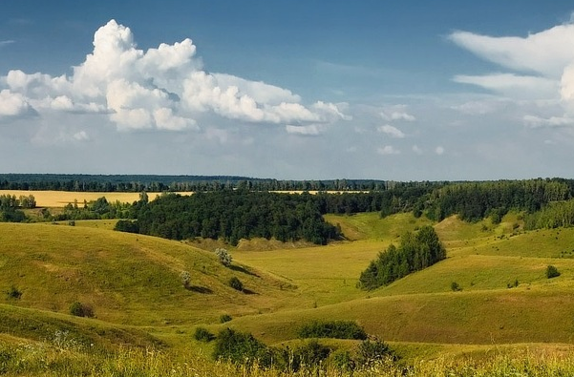

Ukraine

Submitted to the Secretariat of the Convention on Biological Diversity [20 June 2012]

Protected area information:
PoWPA Focal Point: (Name, contact details)
Ihor Ivanenko, Deputy Director of the Department of Protected Areas, Ministry of Ecology and Natural Resources of Ukraine
Lead implementing agency: (Add name of primary government agency)
Ministry of Ecology and Natural Resources of Ukraine

The Ministry provides organization and coordination of protection and use of protected areas in Ukraine.
To achieve main tasks the Ministry makes arrangements for:
creation of new protected areas;
establishment and enforcement of the protected areas regime;
forming of the State Protected Areas Cadastre;
designation and control for Wetlands of International Importance;
special use of natural resources within the protected areas;
coordination of protected, scientific, recreational, ecological, educational, international activities of the protected areas of national importance;
governance of protected areas that are under the jurisdiction of the Ministry of Ecology and Natural Resources of Ukraine.
Minister of Ecology and Natural Resources of Ukraine Mr. Eduard Stavytskyi
Address: 35 Uryts’kogo Str., 03035, c. Kyiv, Ukraine
Tel.: +380 44 31 00; fax: +380 44 206 31 07.
E-mail: secr@menr.gov.ua
Director of the Department – Viktor Kantsurak.
Tel./fax: +380 44 206 31 19.
E-mail: dszs@ukr.net

Multi-stakeholder committee:
The Interagency Commission for Protected Areas Development was created by the Order of the Ministry of Environmental Protection of 10 February, 2010, #73. This commission consists of representatives from interested ministries, state committees, secretariats of the Presidential Administration and Cabinet of Ministers, Ecological Committee of the Parliament, scientific institutes and NGOs.
Main goal of the Commission is preparation of proposals and recommendations for development of protected areas network, conservation of biodiversity and landscapes, ecological education, interagency cooperation, etc.
Description of protected area system
Coverage
According to the State Cadastre of protected areas of Ukraine 570 additional protected areas with total surface of 879 282 ha were established since 2004, including: 32 national parks, 2 nature reserves, 274 reservations, 201 nature monuments, 14 regional landscape park, 18 reserve stows. Percentage of protected areas increased from 4.6 % (in 2004) to 5.9 % (in 2012) of the territory of Ukraine. About 5 % of marine area was protected (Fig. 1).
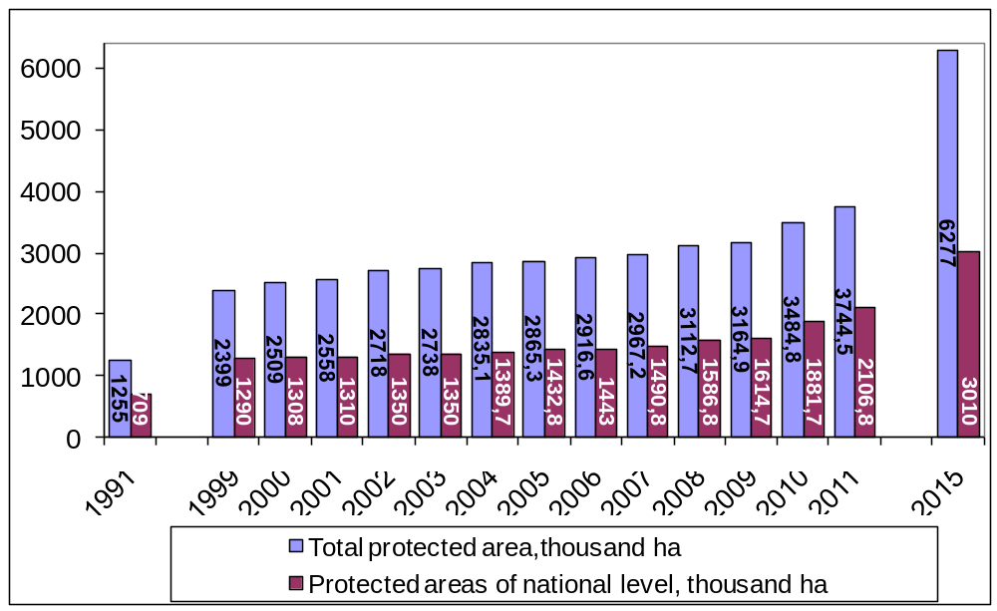Fig. 1: The area of Ukraine's protected areas system (State Cadastre of protected areas of Ukraine 1999-2011)
In 2012 the total protected area is 3 567091.7 ha, and 403 000 ha marine reservation of the Black See area.
The legal procedure of establishing new protected area foresees to collaborate with all stakeholders (users and owners of nature resources in borders of planned protected area). Any institution (state or scientific organizations or nature protection public units or other interested enterprises or organizations) and citizen can prepare petition (proposal) on the creation of a protected area.
After adoption of the proposal by the Ministry of Ecology and Natural Resources of Ukraine (if planned protected area is of national importance) or its regional department (if planned protected area is of local importance) it has to be officially agreed with nature resources users, local authorities and self-government.
Ukraine has also protected forests and a lot of protected coastlines and water-protected zones, etc. Taking this into account the total share of protected areas is more than 10 % of total territory of Ukraine.
In different regions of Ukraine the percentage of PAs ranges from 1.5 to 30.3 %. In 7 oblasts of Ukraine (Vinnytska, Cherkaska, Kirovogradska, Mykolayivska, Dnipropetrovska, Kharkivska, Luganska oblasts) it is only 1-3%. The low percentage of PAs in mentioned oblasts is because they are situated in the forest-steppe and steppe biogeographical zones. These zones are characterized by high populousness and intensive agriculture. Natural sites are preserved by a very small areas here. (Fig. 2).
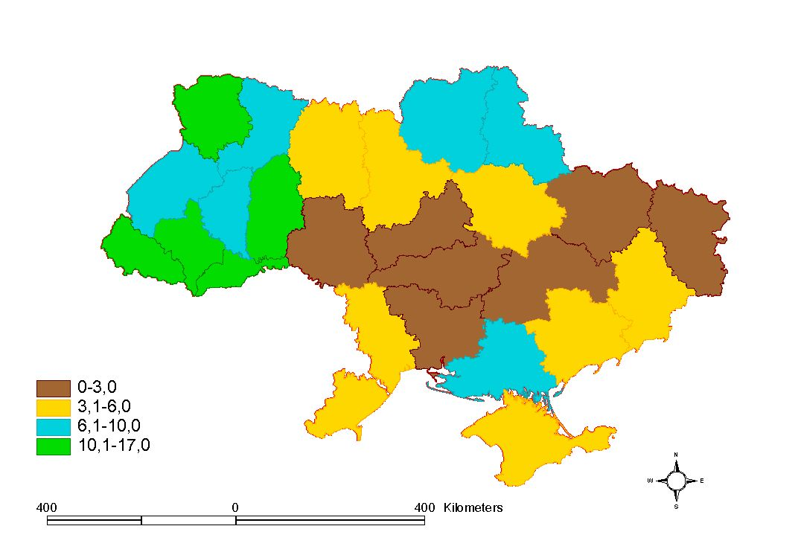
Fig. 2: The representativeness of protected areas in different provinces (oblasts) of Ukraine, % of protected area in total area of the province (State Cadastre of protected areas, 2012)
In the Crimea Autonomous Republic and 12 oblasts (Lvivska, Ternopilska, Rivnenska, Zhytomyrska, Kyivska, Chernihivska, Sumska, Poltavska, Odeska, Khersonska, Zaporizka, Donetska oblasts) it is average – 3.1-10%. Some of these oblasts are located in the forest and mountain biogeographical zones, where people live close to the traditional lifestyle, and there are many marshes. These factors help to survive a sufficient space of natural areas. Other oblasts are located in the steppe coastal zone. This is densely populated area, however there are large flood areas, that are places for migratory birds.
Only in 5 oblasts (Zakarpatska, Ivano-Frankivska, Chernivetska, Volynska and Khmelnitska oblasts) and the city Kiev the percentage is beyond 10.1-17%. Most of these regions are located in the Carpathian Mountains, which are characterized by relatively high level of nature environment. Volynska Oblast is characterized by large number of marshy lands and forests. On the territory of Khmelnitska Oblast there is located Ukraine's largest national park, which occupies an area of ​​261.3 thousand hectares. The Kyiv and the Sevastopol cities have correspondingly 14.4% and 30.3%. These cities have many artificially protected areas (botanical gardens, dendroparks, etc.) Also, in the Kyiv city national park "Holosiivskyi” has been created. (Fig. 3).
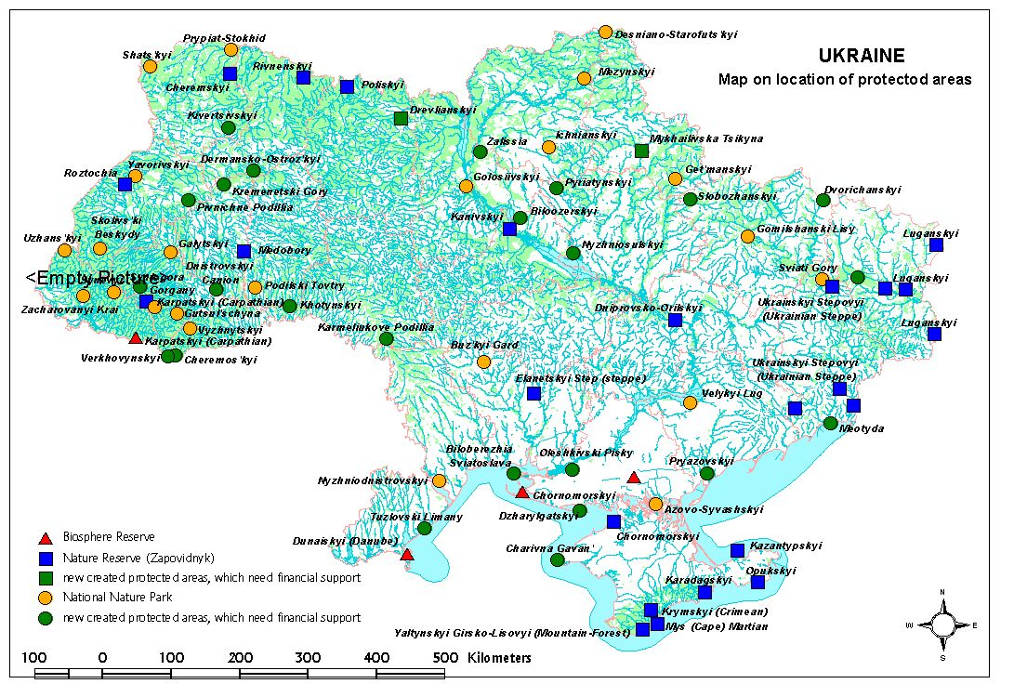
Fig. 3. Map on location of protected areas.
Description and background
(Summary description)
Protected area types
The existing structure of Ukraine's protected areas system includes 11 categories of national and local importance. Among them, 7 categories belong to the natural areas (Nature Reserves, Biosphere Reserves, National Nature Parks, Regional Landscape Parks, Reservations, Nature Monuments, and Reserve Stows) and 4 belong to artificial areas (Botanical Gardens, Zoological Parks, Dendrological Parks and Parks of Landscape Architecture). (Fig. 4)
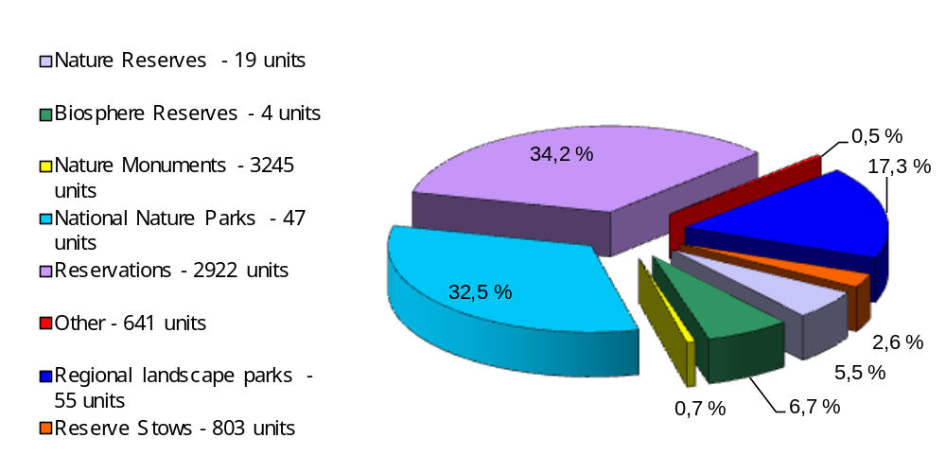

Fig. 4: The structure of Ukraine's protected areas system,2011

By assigning protected areas to certain categories, their regime, activities in their borders, the degree of protection, the use and restoration of their natural systems and resources have been defined by the Law of Ukraine "On Protected Areas of Ukraine".
Below basic information is delivered about the status of Ukrainian protected areas according to their categories which are defined by the law.
Nature Reserves are natural sites of national importance that are created to preserve the natural state of typical or unique landscape with the whole complex of components. They are established for studying natural processes and phenomena that occur in them, and for research that should also provide the foundations for the efficient use of natural resources and environmental safety. In nature reserves area any economic use is not permitted.
Ukrainian category "Nature Reserve" corresponds to category Ia or Ib of IUCN classification (Strict nature reserve or Wilderness area or Wilderness area). However, in real life, the management regime of some Nature Reserves of Ukraine does not correspond with this international category. Some of them could rather be classified as protected areas of category IV.
Biosphere Reserves are protected areas of international significance, created to preserve the natural state of the best examples of all ecosystems of the biosphere. They are established to provide environmental monitoring, for research on the environment and its changes under the influence of anthropogenic factors. They are now considered as model regions for sustainable development where man and nature should interact in harmony. However, this relatively new notion of biosphere reserves is not really understood by all.
In the Biosphere Reserves there are three functional zones with the special regimes: core zone, buffer zone and zone of anthropogenic landscapes (transition area).
A characteristic feature of Biosphere Reserves is that they are usually created on the base of protected areas of other categories. Therefore they could contain different categories (Ia, II, IV, V).
National Nature Parks are nature sites of national importance that are created for the conservation, restoration and effective use of nature complexes that have special natural, recreational, historical, cultural, scientific, educational and aesthetic value. National Nature Parks have four zones: core zone, zones of controlled and stationary recreation, economic zone.
Ukrainian National Nature Parks could meet the requirements of category II "National Park" of IUCN classification. However, most National Natural Parks of Ukraine do not have a strict management regime, and indeed are Protected Landscape/Seascape Area (category V) or Natural Monument (category III).
Regional Landscape Parks are nature sites that are established at the local level with the purpose to preserve the natural state of typical or unique natural area, as well as to provide conditions for recreation use.
The main objectives of Regional Landscape Parks are to preserve valuable natural, historic and cultural area and features, creating conditions for effective tourism, leisure and other recreational activities, promoting environmental education work. In the Regional Landscape Parks zoning could be as in National Natural Parks.
The regional landscape parks of Ukraine correspond to category V "Protected landscape/seascape area" of IUCN classification.
Reservations – natural area that are created for the preservation and restoration of natural systems or individual components. In the Reservations activities are restricted or prohibited which contradict the goals and objectives of the Reservations.
Most of the Reservations could be regarded as PAs of category IV (Habitat/species management area).
Nature Monuments – some unique natural formations that have special environmental, scientific, aesthetic and cognitive value and must be kept in its natural state. In the natural monuments any activity is prohibited that threatens the conservation or leads to degradation or changes their original condition.
Ukrainian category "Natural Monuments" fully corresponds with the third category of IUCN "Natural monument".
Reserve Stows are forest, step, marsh and other structural entire landscapes that have great scientific, conservation and aesthetic values and they are set aside in a natural state. In the Reserve Stows any activity is prohibited that violates the natural processes that occur in natural systems included in their composition.
Formally, the management regime of Reserve Stows, corresponds with the category Ia "Strict nature reserve". The actual treatment of these areas in most cases corresponds to category IV "Habitat/species management area".
Governance types
(Summary matrix of governance types)
According to national legislation there are no restrictions on the governance types of the most categories of protected areas.
Only the area of nature reserves, core zone of biosphere reserves, area that belongs to national parks administrative body have to be type A of IUCN governance Types "governance by government (government-managed Protected Areas).
Regional landscape parks, buffer zone and transition zone of biosphere reserves, area that are not belongs to national parks administrative body, reservations, natural monuments, reserve stows, regional landscape parks can have different types of governance.
According to the National Profile of the implementation of the Programme of Work on Protected Areas the progress has been made in assessing the equitable sharing of costs and benefits of establishing protected areas since 2004 was not significant.
Figures 5 and 6 show that question of equity and benefit-sharing is very actual for Ukraine protected areas system. They’re very weak participatory planning and governance, recalling the principles of the ecosystem approach.

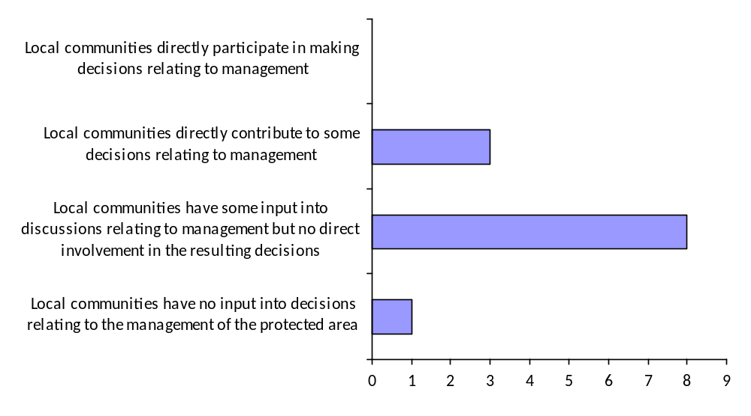
Fig. 5: Result of assessment involving of local communities resident within or with land owned in the protected area input to management decisions (CPAMETT 2011)
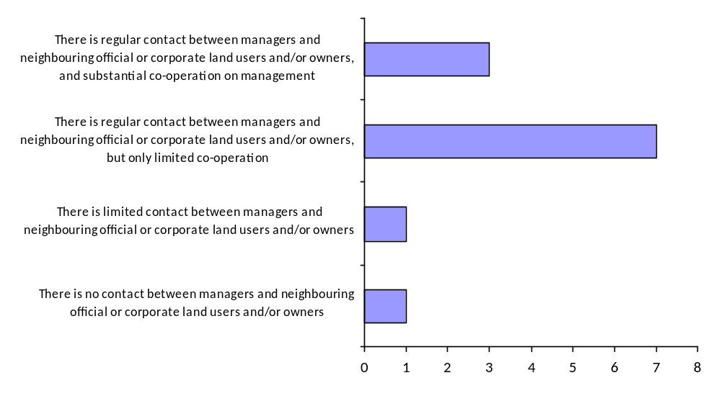
Fig. 6: Result of assessment cooperation of protected areas administration with adjacent land users and/or owners (CPAMETT 2011)

From all protected areas of Ukraine that have its own administrative body only 2 regional landscape parks are managed by private organizations. There are not protected areas with shared governance system, managed and/or owned by NGOs or the church.
Some of protected areas of the local importance are governance by council of community, but it is more official level of managing than real, without local people involvement in the process of governance.
Despite the fact that according to international requirements, conservation areas in their activity to ensure the raising of living standards of local people, local communities receive little direct economic benefits from the creation and existence of the protected area (Fig. 7).

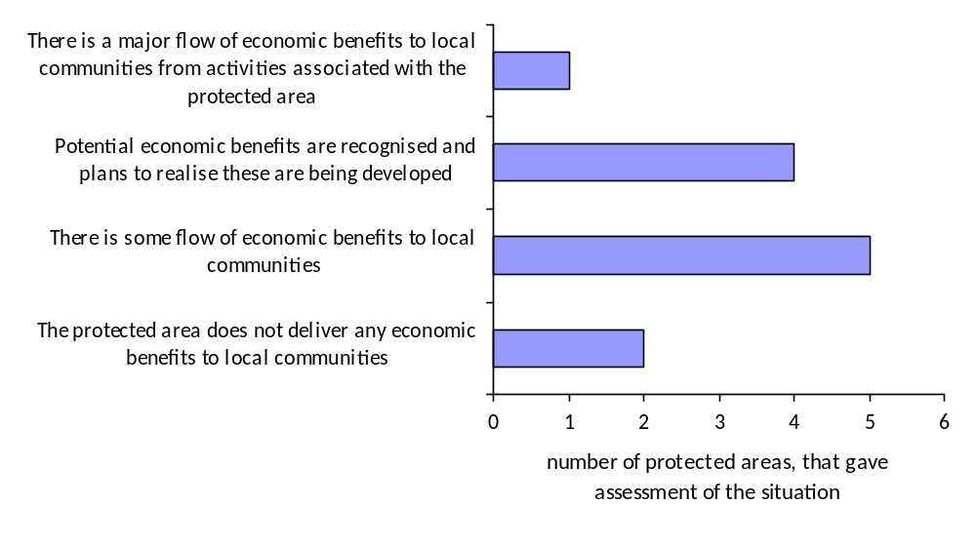
Fig. 7: Result of assessment economic benefits to local communities that provide protected areas in Ukraine (CPAMETT, 2011)

Strengths
  - There are no restrictions on the governance types of the majority of categories of protected areas
  - The question on equitable sharing of costs and benefits starts to be actual during lasts years and is discussed on the stakeholders meetings.

Weaknesses
  - There are not assessed the economic and socio-cultural costs, benefits and impacts arising from the establishment and maintenance of protected areas.
  - There are not established policies and institutional mechanisms with full participation of local communities, to facilitate the legal recognition and effective management of indigenous and local community conserved areas.
  - Lack of existing different types of governance of protected areas.
  - National legislation hasn’t mechanisms on compensation costs and equitably share benefits.
  - Local communities receive little direct economic benefits from the creation and existence of the protected area.

Key threats
(Description of key threats, and maps, if available)
Ukrainian legislation sets out required procedures on Environmental Impact Assessment for different activities which may directly or indirectly affect to protected areas. Also, according this legislation some activities require public hearings and consultations.
Protected Area threats and risks assessments in Ukraine were considered in the frame of Rapid Assessment and Prioritization of Protected Areas Management in 2008. (Fig. 8)

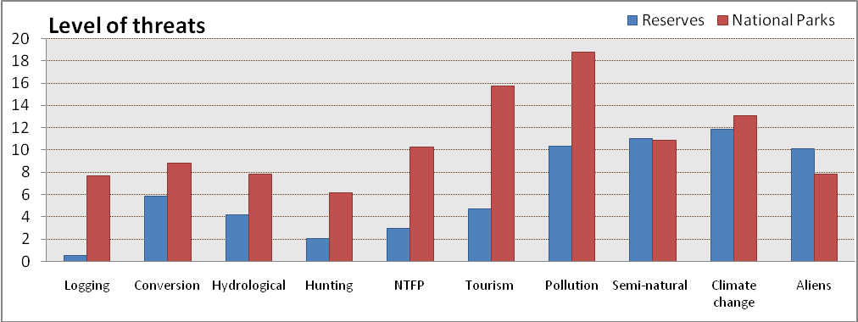
Fig. 8: The level of threats in the reserves and national parks of Ukraine (RAPPAM 2008)
The figure shows that general the largest threats to protected areas in Ukraine are pollution, tourism and climate change.
But, during analyses of threats in the different regions of Ukraine and to different categories of protection it starts to be obviously, that there are big difference in the level of threats and it is necessary to consider every region and category of protected areas separately (Fig. 9 and 10).
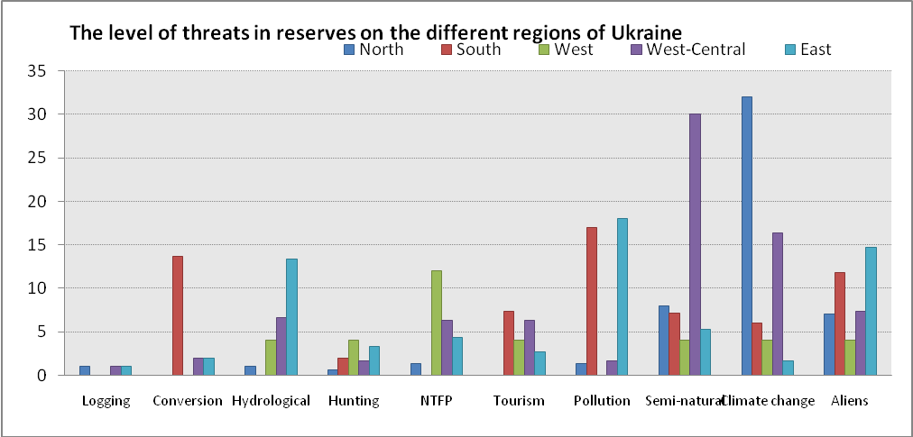
Fig. 9: The level of threats to nature and biosphere reserves in the different regions of Ukraine (RAPPAM 2008)
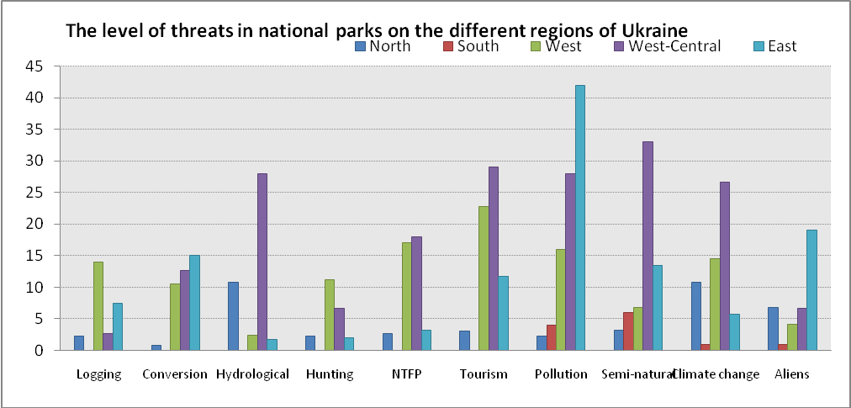
Fig. 10: The level of threats to national nature parks in the different regions of Ukraine (RAPPAM 2008)
Since 2004 for the rehabilitation and restoration of the ecological integrity of protected areas in Ukraine there were changed status and governance type of many protected areas from regional to national significance. For example, 6 regional landscape parks have got status of national nature parks.
Since 2004 most of staff of protected areas was improved skills to prevent and mitigate threats.
One of the main causes of most threats (logging, conversion, hunting, NTFP, tourism) to protected areas is the absence of clearly defined boundaries of protected areas.
For protected areas of national importance are defined border in the area of 609 thousand ha, that is only 32% of the total area of protected areas of national importance. For protected areas of local importance only 238 thousand ha defined, which is equal to 24.5%.
According reports of the Department of Protected Areas today there is a need to set boundaries and make the state acts on the land for 36,5% of the protected areas in Ukraine.

Strengths
  - The procedure on Environmental Impact Assessment required according the national legislation.
  - Protected Area threats and risks assessments impemented.
  - There are activities on rehabilitation and restoration of the ecological integrity of protected areas.
  - Most of staff of protected areas was improved skills to prevent and mitigate threats.

Weaknesses
  - The absence of clearly defined boundaries of many protected areas.
  - The approaches to liability and redress measures, incorporating the polluter pays principle or other appropriate mechanisms in relation to damages to protected areas are not developed.
  - The measures to control risk associated with invasive alien species are not the necessary issues of Management Plan.
  - There are no developed climate resilience and adaptation plans.
  - There is no enough activity in restored degraded areas.

Barriers for effective implementation
(Description of key barrier s for effective implementation)
In Ukraine currently there is a lack of:
- a unified state policy on the development of protected areas,
- sufficient financial support from international, national and local sources.
- public awareness
All this leads to slow development of the protected areas system and its proper management, resulting in threat of losing or loss of important biodiversity areas that have to be conserved.

National Targets and Vision for Protected Areas
(Insert national targets for protected areas/Target 11 of the Aichi Targets. Include rationale from protected area gap assessment, if completed, along with any additional information about the vision for the protected area system, including statements about the value of the protected area system to the country)
Ukraine ratified the Convention on Biological Diversity in 1994. According to national legislation, nature areas of great environmental value and importance and unique and typical natural complexes are the subject of special protection for maintaining favorable environmental conditions, and for prevention and stabilization of negative processes and phenomena in nature.
Protected areas of Ukraine are areas of land and water, natural complexes and sites that have special environmental, scientific, aesthetic, recreational and other values and are dedicated to conserve the natural diversity of landscapes, the genetic fund of flora and fauna, to support an overall ecological balance and to provide background for monitoring of the environment.
Acording National Ecological Stratagy until 2020 (Law of Ukraine # 2818, 21/12/2010) the area of protection have to be increased to 15 percent of the total area of ​​the state until 2020.
The draft National Programme of Work on Protected Areas until 2020 was developed in 2006 due to the fact that according to national legislation all areas of development of the country should be based on the program-based method (through the state programmes).
The purpose of the National Programme is defined as to ensure further development of comprehensive, effectively managed and ecologically representative system of protected areas, that will contribute to achieving reduce the current rate of biodiversity loss and increasing level of living standards, restoration of natural systems and increasing area of protection to 15 percent of the total area of ​​the state.
In order to achieve the purpose of the National Programme of Work on Protected Areas, on the base of analysis that were carried, is proposed to define, taking into account national circumstances and priorities, 8 major goals with determination of specific of the Programme activities:
- Creation on terrestrial and marine objects of a representative system of protected areas, including transboundary protected areas.
- Ensuring effective planning and management of the protected areas system.
- Prevention of negative impacts to protected areas, restoration of their natural systems.
- Involvement of stakeholders, including local communities, to management of protected areas, ensuring equitable distribution of benefits and costs associated with their creation and management.
- Creation of socio-economic environment for the establishment and development of protected areas.
- Environmental education, human resources and public awareness in protected areas.
- Assessment and definition of development trends of the protected areas system.
- The development of scientific knowledge in the field of the protected areas system.
Implementation of the CBD Programme of Work on Protected Areas in Ukraine shows that Ukraine is actively working to preserve biodiversity through the development of a system of protected areas, both at local, national and international levels.
The protected areas system is the best and most actively being developed in the Carpathian and Western regions of Ukraine. This is due to close cooperation of protected areas with neighboring countries, the influence of the European Union in these regions, the presence of international organizations and programmes (WWF, UNDP) with relevant activities in these parts of Ukraine and due to a higher percentage of areas of high conservation value compared to other regions of Ukraine.
It is important to emphasize that of all the activities outlined in the PoWPA the least covered in Ukraine is the work with local communities, equity and benefit sharing, and community involvement in management of protected areas, and the integration of protected areas in different sectors of the state.

Progress in and plans for achieving the goals of the Programme of Work on Protected Areas
Progress: 0 = no work, 1 = just started, 2 = partially complete, 3 = nearly complete, 4 = complete
Goals of the Programme of Work on Protected Areas | Progress 0-4
- Progress in establishing and strengthening national and regional systems of protected areas (1.1) | 3
- Progress in integrating protected areas into broader land- and seascapes and sectors so as to maintain ecological structure and function (1.2) | 2
- Progress in establishing and strengthening regional networks, transboundary protected areas (TBPAs) and collaboration between neighbouring protected areas across national boundaries (1.3) | 2
- Progress in substantially improving site-based protected area planning and management (1.4) | 2
- Progress in preventing and mitigating the negative impacts of key threats to protected areas (1.5) | 2
- Progress in promoting equity and benefit-sharing (2.1)  - Progress in assessing and implementing diverse protected area governance types (2.1) | 1
- Progress in enhancing and securing involvement of indigenous and local communities and relevant stakeholders (2.2) | 1
- Progress in providing an enabling policy, institutional and socio-economic environment for protected areas (3.1)  - Progress in assessing the contribution of protected areas to local and national economies (3.1) | 2  1
- Progress in building capacity for the planning, establishment and management of protected areas (3.2) | 2
- Progress in developing, applying and transferring appropriate technologies for protected areas (3.3) | 2
- Progress in ensuring financial sustainability of protected areas and national and regional systems of protected areas (3.4) | 2
- Progress in strengthening communication, education and public awareness (3.5) | 2
- Progress in developing and adopting minimum standards and best practices for national and regional protected area systems (4.1) | 2
- Progress in evaluating and improving the effectiveness of protected areas management (4.2) | 2
- Progress in assessing and monitoring protected area status and trends (4.3) | 2
- Progress in ensuring that scientific knowledge contributes to the establishment and effectiveness of protected areas and protected area systems (4.4) | 2
- Progress in marine protected areas | 2
- Progress in incorporating climate change aspects into protected areas | 1

Priority activities for fully implementing the Programme of Work on Protected Areas:
Activities | Timeline
Creation on terrestrial and marine areas a representative system of protected areas, including transboundary protected areas | 2020
Ensuring effective planning and management of the protected areas system | 2020
Prevention of negative impacts on protected areas, restore their natural systems | 2020
Involvement of stakeholders, including local communities to management of protected areas, ensuring equitable distribution of benefits and costs associated with their creation and management | 2020
Creation of socio-economic environment for the establishment and development of protected areas | 2020
Environmental education, human resources and public awareness in Protected Areas | 2020
Assessment and definition of trends of the protected areas system | 2020
The development of scientific knowledge in the field of the protected areas system | 2020

Action Plans (detailed steps) for completing priority activities for fully implementing the Programme of Work on Protected Areas:

Proposals to Action Plan on implementation of Programme of Work on Protected Areas in Ukraine until 2020 (Tab. 1)
 | - available funds
 | - partly provided with funds
 | - does not require funds
 | - not provided with funds
X | - funds are needed in this year

Name of goals | Name of Indicators | Score |  |  |  |  |  |  | Name of actions | Performers | Source of funding | Forecasted financial resources to accomplish the tasks million UAH | Years
Name of goals | Name of Indicators | all | Years |  |  |  |  |  |  |  |  |  | 2012 | 2013 | 2014 | 2015 | 2016 | 2017-2020
Name of goals | Name of Indicators | all | 2012 | 2013 | 2014 | 2015 | 2016 | 2017-2020
1. Creation on terrestrial and marine areas a representative system of protected areas, including transboundary protected areas | report | x | x |  |  |  |  |  | 1. Analysis of connectivity and representative system of protected areas with regard to the analysis of the possibilities of creation protected areas and features of economic development | MENR, NAS,  NGOs |  | x | x
 | approved criteria for the identification of sites for protection | x | x |  |  |  |  |  | 2. Identifying areas that are important for biodiversity conservation and for climate-change mitigation and/or adaptation, including carbon sequestration and maintenance of carbon stocks, and where appropriate including them in the protected areas systems | NAS,MENR,  NGOs |  | x | x
 | national standard criteria | x | x | x |  |  |  |  | 3. Development of national standard criteria for the identification of sites for protection with regard to their categories | MENR, NAS,  NGOs |  | x | x | x
 | list of protected areas with precise maps | x | x | x |  |  |  |  | 4. Identifying of the list of protected areas with precise maps that will be created or will be extended their territories (including marine protected areas, and protected areas that promote the preservation and maintenance of traditional knowledge of local communities), involving local people in the process of identifying of the list | MENR, NAS,  SLA,  NGOs |  | x | x | x
 | number of created PAs/ % of PAs in total area of the country | x | x | x | x | x | x | x | 5. Creation of protected areas according to the point 4 | MENR,  SLAs,  NGOs,  POs | Environmental fund | x | x | x | x | x | x | x
 | number of created transboundary PAs, wetlands | x |  |  |  |  |  | x | 6. Development and supporting of a network of transboundary protected areas, wetlands of international importance, World Nature Heritage sites and areas that are awarded the diploma of the Council of Europe | MENR, MfFA,  NGOs,  POs | National and international environmental funds | x | x | x | x | x | x | x
 | number of created transboundary PAs, wetlands | x |  |  |  |  |  | x | 7. Promoting cross-border cooperation between Ukraine and neighbouring countries in that aimed on creation of transboundary protected areas | MENR, MfFA,  NGOs,  POs | National and international environmental funds | x | x | x | x | x | x | x
 | number of created marine PAs/% of marine PAs in total marine area of the country | x |  |  |  |  |  | x | 8. Improving international cooperation and coordination aimed on creation of marine protected areas for the conservation and sustainable use of marine biological diversity beyond areas of national jurisdiction | MENR, MfFA,  NGOs,  POs | National and international environmental funds | x | x | x | x | x | x | x
 | % of PAs that have other types governance than governmental | x | x | x | x | x | x | x | 9. Improve and, where necessary, diversify and strengthen protected area governance types and taking into account local and other community-based organizations | MENR,  MOJ, local communities/ authorities |  | x | x | x | x | x | x | x
2. Ensuring effective planning and management of the protected areas system | Meetings of the Interagency Commission for Protected Areas Development | x | x | x | x | x | x | x | 1. Strengthening of intersectoral coordination and communication to facilitate the integration of protected areas in national and economic development plans and programmes | MENR and other government bodies and NGOs
 | names of improved laws, strategies, action plans | x | x | x | x | x | x | x | 2. Integrate the Action plan of the National Programme into national biodiversity strategies and action plans, and into relevant sectoral plans and budgets | PoU,  CMU,  MENR, other ministries
 | regulations on research-based methods of natural systems managing | x | x | x |  |  |  |  | 3. Developing research-based methods of natural systems managing | MENR, NAS,  NGOs | International environmental funds | x | x | x
 | improved Regulations on developing process and content of Projects of the organization (management plans) of protected areas | x | x |  |  |  |  |  | 4. Improvement of developing process and content of Projects of the organization of protected areas territories (Management Plans) in order to involve stakeholders in the development and implementation of the Projects and ensuring the adaptive method for protected areas management | MENR, NAS,  MOJ |  | x | x
 | % of PAs that have market boundaries | x | x | x | x | x | x | x | 5. Marking of boundaries of protected areas | MENR,  SLAs,  SLA,  SFA,  Landouners and lendusers of PAs | State and local budget | x | x | x | x | x | x | x
 | % of PAs that have Management Plans | x | x | x | x | x | x | x | 6. Development of Projects of the organization of protected areas territories (Management Plans) for nature and biosphere reserves and national nature parks | MENR,  NAS,  SFA,  POs,  AoPAs | National and international environmental funds | x | x | x | x | x | x | x
 | %/number of PAs that have new forms of protected areas governance | x | x | x | x | x | x | x | 7. Supporting of new forms of protected areas governance, including joint, private and public protected areas | MENR, NGOs,  local communities/ authorities,  privet sector
 | number of buildings that were constructed, acquired, repaired and reconstructed /  % of PAs that has good condition of buildings | x | x | x | x | x | x | x | 8. Construction, acquisition, repairing and reconstruction of buildings for protected areas administrations | MENR,  NAS,  SFA,  AoPAs | State and local budget, Environmental fund | x | x | x | x | x | x | x
 | % of ensuring protected areas by equipments and vehicles for administrations | x | x | x | x | x | x | x | 9. Purchasing special equipment and vehicles for protected areas administrations, including material and technical support of protected areas rangers | MENR,  NAS,  SFA,  AoPAs | State and local budget, Environmental fund | x | x | x | x | x | x | x
 | % of funds from additional means and methods of generating and allocating finance in all budgets of PAs | x | x | x | x | x | x | x | 10. Developing and implementation additional means and methods of generating and allocating finance, inter alia, on the basis of a stronger valuation of ecosystem services | MoE,  MoF,MENR |  | x | x | x
 | number of developed sustainable finance plans | x | x | x | x | x | x | x | 11. Developing and implementation of sustainable finance plans based on realistic needs assessments and a diversified portfolio of traditional and innovative financial mechanisms, such as, inter alia, payments for ecosystem services, with expressing project-funding needs | AoPAs |  | x | x | x | x | x | x | x
 | developed new funding opportunities under climate-change adaptation and mitigation strategies | x |  | x | x |  |  |  | 12. Development of funding opportunities under climate-change adaptation and mitigation strategies to contribute to the implementation of the National Programme, while enhancing co-benefits for biodiversity and climate-change adaptation and mitigation | MoE,  MoF,MENR,  NGOs | International environmental funds | x |  | x | x
 | % of PAs where mechanism for financial support is implemented | x | x | x | x | x | x | x | 13. Identifying and implementing an effective mechanism for financial support of protected areas that by the law haven’t administrations | MoE,  MoF,MENR |  | x | x | x | x | x | x | x
 | % of transboundary PAs with cooperative effective governance | x | x | x | x | x | x | x | 14. Promoting regional cooperative frameworks for the effective governance of transboundary protected areas | MENR, MfFA | International environmental funds | x | x | x | x | x | x | x
3. Prevention of negative impacts to protected areas, restoration of their natural conditions | % of PAs where key threats are assessed | x | x | x |  |  |  |  | 1. Assessment of key threats for every protected area and the development and implementation of programs and action plans for their mitigation and prevention | AoPAs  MENR | International environmental funds | x | x | x | x | x | x | x
 | % of PAs with developed relevant programs and action plans | x |  | x | x
 | % of PAs where relevant programs and action plans are implemented | x |  |  | x | x | x | x
 | % of PAs with developed action plans | x | x | x | x |  |  |  | 2. Developing and implementation of action plans for conservation and recovery of species of flora, fauna and their habitats within protected areas | AoPAs |  | x | x | x | x | x | x | x
 | % of PAs where relevant action plans are implemented |  |  | x | x | x | x | x
 | List of improved laws and regulations | x | x | x |  |  |  |  | 3. Improving the system of responsibility and compensation for the damage inflicted on protected areas | PoU,  CMU,  MENR, MoJ |  | x | x | x | x | x | x | x
 | area of restored native natural systems | x | x | x | x | x | x | x | 4. Implementation of activities to restore native natural systems of protected areas | AoPAs  MENR | International environmental funds | x | x | x | x | x | x | x
 | % of mentioned PAs that have nurseries and open air cages | x |  |  | x | x | x |  | 5. Creation in nature and biosphere reserves and national nature parks nurseries and open air cages to restore and dissemination of plant and animal species listed in the Ukraine Red Data Book, the Bern Convention and other international Red lists | AoPAs | National environmental fund | x |  |  | x | x | x | x
 | increasing populations of relevant species in PAs |  |  |  |  |  |  | x
 | % of PAs where are implemented action plans on control of invasive species | x | x | x | x | x | x | x | 6. Control of invasive species of flora and fauna within the protected areas | AoPAs  NAS,  MENR |  | x | x | x | x | x | x | x
 | list of improved regulations on the planning and management of protected areas | x | x | x | x | x | x | x | 7. Including of measures of adaptation to climate change in the planning and management of protected areas, and in the process of developing systems of protected areas | MENR,  NAS, AoPAs
 | improved regulations | x | x | x |  |  |  |  | 8. Improving the regulations of using natural resources of protected areas | MENR, MoJ
 | list of improved laws and regulations | x | x | x |  |  |  |  | 9. Improving of the legal framework on sustainable management of land and marine protected areas. In particular, developing and implementing of regulations for obtaining by protected areas the State acts on land ownership, improving the procedure of including land in the protected area without removing land from users and owners | PoU,  CMU,  MENR,  NAS,  SLA,  MoJ
 | list of harmonized national laws | x | x | x | x |  |  |  | 10. The harmonization of national laws to strengthen the protection of protected areas and opportunities of their development | PoU,  CMU,  MENR, MoJ
4. Involvement of stakeholders, including local communities to management of protected areas, ensuring equitable distribution of benefits and costs associated with their creation and management | report about assessment | x |  | x | x | x |  |  | 1. Assessment of economic and socio-cultural costs, benefits and effects of the creation and management of protected areas | MoE,  NAS, MENR |  | x |  | x | x | x
 | developed and implemented mechanisms for compensation of expenses and equitable sharing of benefits of protected areas | x | x | x |  |  |  |  | 2. Developing and implementation of mechanisms for compensation of expenses and equitable sharing of benefits of protected areas | MoE,  MoF,  MENR |  | x | x | x | x | x | x | x
 | % of PAs where exists mechanisms for involving stakeholders | x | x | x | x | x | x | x | 3. Creation and implementation of mechanisms for involving stakeholders, especially local communities, in the planning process and governance protected areas, including establish transparent and effective mechanisms for stakeholder input and review | MENR,  MoJ, AoPAs | Budget of PAs | x | x | x | x | x | x | x
 | List of improved laws and regulations | x | x | x | x |  |  |  | 4. Improvement of legislation on creating an enabling climate for involvement of private sector on activities in sphere of creation, restoration and conservation of protected areas | PoU,  CMU,  MENR, MoJ
 | % of PAs where exists multi-stakeholder advisory committee | x | x |  |  |  |  |  | 5. Creation of multi-stakeholder advisory committee for every nature reserve, biosphere reserve and national nature park to involve local communities, private business, local authority and other stakeholders in management of protected areas | AoPAs  MENR
 | % of PAs where exists initiatives "Friends of the protected areas" |  |  |  |  |  |  |  | 6. Developing of mechanism of creation and functioning initiatives "Friends of the protected areas" with the participation of NGOs, public figures, politicians, famous people, students and pupils for co-operation with protected areas management | AoPAs
 | % of PAs administrations involved in solving of social problems of local people and improve their well-being | x | x | x | x | x | x | x | 7. Involvement of protected areas in solving of social problems of local people and improve their well-being | AoPAs, local communities/ authorities
 | database of knowledge in the technologies, skills and techniques of traditional nature management |  |  |  |  |  |  |  | 8. Collection and dissemination of knowledge in the technologies, skills and techniques of traditional nature management that have particular importance for the conservation of protected areas | MENR, NAS,  AoPAs |  | x | x | x | x | x | x | x
 | % of PAs that established hobby groups/ training centers | x | x | x | x | x | x | x | 9. Creation on the basis of protected areas hobby groups, training centers for preservation and dissemination of traditional knowledge of nature management and tradition crafts | AoPAs, local communities/ authorities | Budget of PAs | x | x | x | x | x | x | x
 | % of PAs where act public officers | x | x | x | x | x | x | x | 10. Promotion of system of public officers in protected areas | MENR,  MoJ, AoPAs
5. Creation of socio-economic environment for the establishment and development of protected areas | List of improved/developed laws | x | x | x |  |  |  |  | 1. Identifying and implementation of measures to remove legal and institutional barriers in the establishment and effective management of protected areas | PoU,  CMU,  MENR, MoJ
 | created mechanisms to stimulate socio-economic development and conservation of protected areas | x |  |  | x | x | x |  | 2. Creation and implementation of mechanisms to stimulate socio-economic development and conservation of protected areas | MoE, MENR,  MoJ, NAS
 | report about identified economic opportunities | x |  | x | x |  |  |  | 3. Identifying and development of economic opportunities on the national level and markets at local, national and regional levels for goods and services produced by protected areas and/or reliant ecosystem services that protected areas provide, that are consistent with protected area objectives and promote the equitable sharing of the benefits | MoE, local communities,  SLAs, AoPAsMENR
 | % of PAs that provides goods and services local markets |  |  |  |  | x | x | x
 | % of PAs that provides goods and services on national markets |  |  |  |  | x | x | x
 | % of PAs that provides goods and services on regional markets |  |  |  |  | x | x | x
 | list of identified and implemented of positive incentives | x | x | x | x | x | x | x | 4. Identification and implementation of positive incentives that promote conservation of protected areas | MoE,  MoF, SLAs,  AoPas, MENR
 | % of mentioned PAs with ensured functioning |  |  |  |  |  |  |  | 5. Ensuring the functioning of existing nature and biosphere reserves, national nature parks | MoF,  MENR,  SFA,  NAS | State budget | x | x | x | x | x | x | x
 | % of mentioned PAs with ensured functioning |  |  |  |  |  |  |  | 6. Ensuring the functioning of new nature and biosphere reserves, national parks | MoF,  MENR,  SFA,  NAS | State budget | x | x | x | x | x | x | x
 | developed and implemented National action plan | x | x | x |  |  |  |  | 7. Developing and implementing the National action plan for development of tourism and recreational activity in protected areas | MoC, MENR,  SFA |  | x | x | x | x | x | x | x
 | % of PAs where action plans are developed | x | x | x | x |  |  |  | 8. Developing and implementing the Action plan for development of tourism and recreational activity for every biosphere reserve, national nature and regional landscape parks with involving tour operators, private sector and other stakeholders | AoPAs,local communities SLAs other stakeholders, | Local budget, budget of PAs | x | x | x | x | x | x | x
 | % of satisfied tourists that visited PAs |  |  |  | x | x | x | x
 | % of mentioned PAs where are improved tourist and recreational infrastructure | x | x | x | x | x | x | x | 9. Improving in biosphere reserves, national nature and regional landscape parks tourist and recreational infrastructure, including information and tourist centres, laying and construction of hiking trails and resting places, the overhaul and reconstruction of roads with involving tour operators, private sector and other stakeholders | MoC, MENR,  SFA, SRA,, AoPAs | State buget, local budget, budget of PAs | x | x | x | x | x | x | x
 | law about Improved National Strategy of Poverty Reduction | x | x | x |  |  |  |  | 10. Inclusion of issues of protected areas development in the National Strategy of Poverty Reduction and relative National Plans | PoU,  CMU,  MoSA, MENR,  MoJ
 | low about improving the social status of the protected areas staff | x | x | x |  |  |  |  | 11. Improving the social status of the protected areas staff | PoU,  CMU,  MoSA, MENR,  MoJ
 | improved the social status of the protected areas staff according survey |  |  |  | x | x | x | x | 11. Improving the social status of the protected areas staff | PoU,  CMU,  MoSA, MENR,  MoJ
 | % of PAs that has temporary housing for young professionals | x | x | x | x | x | x | x | 12. Creating infrastructure of temporary housing for young professionals in protected areas | MoSA, MoF,  AoPAs
6. Environmental education, human resources and public awareness in Protected Areas | Developed communication plans and awareness raising campaigns | x | x | x | x |  |  |  | 1. Developing and implementation of communication plans and awareness raising campaigns to promote information sharing on, and the understanding of, the importance of protected areas, the benefits of protected areas to national and subnational economies, securing ecosystem services, public health, maintenance of cultural values, sustainable development and climate-change adaptation and mitigation so as to increase support for them among decision-makers and stakeholders of key sectors at all levels of government, community and non-governmental organizations | MENR, MoC,  SCfTBAoPAs
 | % of people that understand the importance of protected areas, the benefits of protected areas according survey | x | x | x | x | x | x | x
 | % of mentioned PAs that have environmental education centers | x | x | x | x | x | x | x | 2. Organization of environmental education centers in every nature and biosphere reserve, national nature park to promote environmental knowledge | MoEd, MENR,  SFA,  NAS, AoPAs local communities,  SLAs | Environmental fund, local budgets | x | x | x | x | x | x | x
 | % of PAs administrations that use interactive teaching methods | x | x | x | x | x | x | x | 3. Ensuring the use of interactive teaching methods in educational activity of protected areas | AoPA,  MENR |  | x | x | x | x | x | x | x
 | list of periodic publications | x | x | x | x | x | x | x | 4. Establishing and publishing on a regular basis, periodic publications of protected areas with and without the status of scientific publication (print and electronic for the Internet) | MENR, NAS,  SFA,  AoPA | State budget | x | x | x | x | x | x | x
 | number of periodic publications that distributed during the year
 | developed programmes and subject | x | x | x |  |  |  |  | 5. Development and implementation of programmes and subject about system of protected areas as an integral component of the school curricula | MoE,  MENR,  SLAs |  | x | x | x | x | x | x | x
 | % of schools where relevant programmes and subject are implemented |  |  | x | x | x | x | x
 | number of visitors of website during the year | x | x | x | x | x | x | x | 6. Ensuring the functioning of the website for dissemination information and exchange of experience on development of system of protected areas in Ukraine and abroad | MENR,  AoPAs NGOs | State budget | x | x | x | x | x | x | x
 | % of PAs that has permanent websites | x | x | x | x | x | x | x | 7. Establishing and maintaining websites of each natural and biosphere reserve, national nature park. Initiating the use of Internet tools such as communication systems (Facebook, Contact, and so on) | AoPAs NGOs,  MENR | Budget of PAs | x | x | x | x | x | x | x
 | number of NT and television shows that were translated during the year | x | x | x | x | x | x | x | 8. Create TV films and television shows for various population groups to promote values and benefits of protected areas | SCfTBMoC, MENR, NAS, NGOs | State budget, Internationl funds | x | x | x | x | x | x | x
 | number of volunteers that worked in PAs during the year | x | x | x | x | x | x | x | 9. Development of methods of implementation and promotion, establishment and support volunteerism among various population groups to promote activities of protected areas | MoEd,MENR, AoPAs,NGOs |  | x | x | x | x | x | x | x
 | % of PAs staff that are trained during the year | x | x | x | x | x | x | x | 10. Organization on a regular basis of continuing education, training and exchange of experiences in the field of management of protected areas for protected area institutions and relevant stakeholders (including using of Internet resources) | MENR,  MoEd,  NAS, NGOs | State budget, Internationl funds | x | x | x | x | x | x | x
 | number of representatives of relevant stakeholders that are trained during the year | x | x | x | x | x | x | x
 | number of conferences/ number of people that took part in the conferences | x | x | x | x | x | x | x | 11. Organization on a regular basis of conferences on issues of protected areas activity with participation of local people, NGOs, private sector and other stakeholders | MENR, NAS, NGOs, AoPas  SLAs | State and local budgets, Internationl funds,
 | developed professional standards of protected areas staff | x | x | x | x |  |  |  | 12. Raising professional standards of protected areas staff | MENR,  NAS,  SFA,  NGOs
 | % of PAs staff that took part in the international programmes, trainings | x | x | x | x | x | x | x | 13. Promoting the training of staff of protected areas in the international programmes, trainings | MENR,  AoPAs | Internationl funds, Budget of PAs | x | x | x | x | x | x | x
 | continuously updated database about international experience | x | x | x | x | x | x | x | 14. Distribution and adaptation of international experience of the protected areas management to the national conditions | MENR, NAS,  AoPAs  NGOs
7. Assessment and definition of development trends of the protected areas system | information on governance and social impacts and benefits of PAs is included into the management effectiveness evaluation process | x | x | x | x | x | x | x | 1. Including information on governance and social impacts and benefits of protected areas into the management effectiveness evaluation process | MENR, NAS,  SFA, AoPAs  NGOs
 | management effectiveness assessments of protected areas at national level is existed | x | x | x | x | x | x | x | 2. Adaptation and implementation of management effectiveness assessments of protected areas at national level on ongoing basis | MENR, NAS,  SFA,  AoPAs  NGOs
 | climate-change adaptation and mitigation in management-effectiveness assessments are existed | x |  | x | x | x | x | x | 3. Considering climate-change adaptation and mitigation in management-effectiveness assessments | MENR, NAS,  SFA,  AoPAs  NGOs
 | relevant information about Ukrainian PAs system regularly updated/ Ukrainian protected areas are included in the United Nations List of Protected Areas | x | x | x | x | x | x | x | 4. Updating relevant information about Ukrainian protected areas system in the World Database on Protected Areas, which includes the United Nations List of Protected Areas | MENR, NAS,  SFA,  AoPAs
 | annual reports about the state of the protected areas system in Ukraine | x | x | x | x | x | x | x | 5. Reporting about the state of the protected areas system in Ukraine into the global database on management effectiveness maintained by the World Conservation Monitoring Centre of the United Nations Environment Programme (UNEP-WCMC) | MENR, NAS
 | annual review of implementation of national policy on system of PAs is published | x | x | x | x | x | x | x | 6. Preparation and publication of annual review of implementation of national policy on system of protected areas, the contribution of protected areas in the country's economy and culture | MENR, NAS,  MoE,  MoC
 | annual review of PAs are published | x | x | x | x | x | x | x | 7. Preparation and publication of nature and biosphere reserves, national nature parks annual review of implementation of tasks set before them | AoPAs
 | the mechanism exists and is used | x |  | x | x | x | x | x | 8. Establishing and using mechanism of evaluation the impact of communication, education and public awareness programmes on public awareness, changing behavior, and on biodiversity conservation in general | MENR, NAS,  SCfTB
 | regular filled and replenished State inventory of protected areas | x | x | x | x | x | x | x | 9. Regular filling and replenishing State inventory of protected areas | MER | Environmental fund | x | x | x | x | x | x | x
 |  |  |  |  |  |  |  |  | 10. Logistical support maintenance of the State inventory of protected areas | MER | Environmental fund | x | x | x | x | x | x | x
 | regular filled and replenished database in the web | x | x | x | x | x | x | x | 11. Setting up a publicly accessible database in the web on PAs ith maps, including all marine PAs | MER |  | x | x | x | x | x | x | x
8. The development of scientific knowledge in the field of the protected areas system | list of acting research and monitoring programmes | x | x | x | x | x | x | x | 1. Developing and implementing research and monitoring programmes for conservation and, in accordance with their management objectives, sustainable use within protected areas at any relevant scale as well as assess the efficiency and effectiveness of various kinds and categories of protected areas complying with the three objectives of the Convention | NAS, MENR,  SFA,  NGOs | State budget | x | x | x | x | x | x | x
 | number of implemented research and monitoring programmes | x | x | x | x | x | x | x
 | % of PAs that have research laboratories | x | x | x | x | x | x | x | 2. Establishment and equipment of research laboratories for nature and biosphere reserves, national nature parks | NAS, MENR,  SFA, AoPAs | Environmental fund | x | x | x | x | x | x | x
 | % of PAs where are existed monitoring centers / monitoring points | x | x | x | x | x | x | x | 3. Creation of monitoring centers and monitoring points in the nature and biosphere reserves, national nature parks | MENR, NAS, AoPAs | Environmental fund, budget of PAs | x | x | x | x | x | x | x
 | % of PA administrations that use electronic database of Chronicle of Nature |  |  |  |  |  |  |  | 4. Approbation and maintenance of electronic database of Chronicle of Nature | MENR,  NAS,  SFA, AoPAs
 | scientific basis is developed/list of especially valuable natural habitats/various species of flora and fauna for witch scientific basis for protection are developed | x | x | x | x | x | x | x | 5. Development of scientific basis for protection and reproduction within protected areas of especially valuable natural habitats, as well as various species of flora and fauna | MENR, NAS,  SFA, AoPAs
 | reports | x | x | x | x | x | x | x | 6. Performance of the environmental forecasting of natural processes | NAS, MENR,  AoPAs
 | reports | x | x | x | x |  |  |  | 7. Interdisciplinary researches that can help improve understanding of the ecological social and economic aspects of protected areas, including methods and techniques for valuation of goods and services of protected area | NAS, MENR,  AoPAs
 | the scientific base is developed | x |  |  | x |  |  |  | 8. Promoting and supporting the development of a scientific base implementation in Ukraine habitats concept approach in biodiversity conservation within protected areas | MENR, NAS,  AoPAs
 | list/number of students' research about protected areas issues | x | x | x | x | x | x | x | 9. Improving cooperation of protected areas with universities and research institutes of Ukraine to attract students' research to protected areas | MENR, NAS,  MoEd, AoPAs | State budget | x | x | x | x | x | x | x
 | the mechanisms are developed |  |  |  |  |  |  |  | 10. Developing effective mechanisms to document existing knowledge and experiences on protected area management | MENR, NAS,  MoEd,  AoPAs

Acronyms and Abbreviations:

 | - available funds | MoE | - Ministry of Economy of Ukraine
 | - partly provided with funds | MoEd | - Ministry of Education, Science, Youth and Sport of Ukraine
 | - does not require funds | MoF | - Ministry of Finance of Ukraine
 | - not provided with funds | MoJ | - Ministry of Justice of Ukraine
AoPAs | - Administrations of protected areas | MoSA | - Ministry of Social Affairs of Ukraine
CMU | - Cabinet of Ministers of Ukraine | POs | - Project organizations
NAS | - National Academy of Sciences of Ukraine | PoU | - Parliament of Ukraine
NGOs | - Non-governmental organizations | SCfTB | - State Committee of Television and Radio Broadcasting of Ukraine
MENR | - Ministry of Ecology and Natural Resources of Ukraine | SFA | - State Forestry Agency of Ukraine
MfFA | - Ministry for Foreign Affairs Of Ukraine | SLA | - State Land Agency of Ukraine
MoA | - Ministry of Agriculture of Ukraine | SLAs | - State local administrations
MoC | - Ministry of Culture and Tourism of Ukraine | SRA | - State Road Administration of Ukraine

(Insert more as needed)

Key assessment results
Ecological gap assessment (insert summary findings if available)
One study about identifying gaps in the representativeness of the protected areas system in Ukraine was provided by Prof. Popovich in 2006 but the current situation was not analysed. (Analyse the representativeness of protected areas)
In Ukraine scientists identified about 220 types of landscapes that were divided according to native zones as follows: zone of mixed forests - 31 types; zone broadleaf forests - 16 types, forest-steppe zone - 48 types, steppe zone - 68 types; Ukrainian Carpathians - 21 types; Crimean Mountains - 11 types.
According to Prof. Popovich’s study, the presence of natural landscapes in the protected areas system largely depends on the areas of ​​the territories. Most comprehensive landscapes are represented in reserves and national parks. In other categories they are represented only as fragments. In the Ukrainian Polissia only eight types of landscapes are under protection; in the forest-steppe zone seven types are protected.
Typical landscapes of central and left-bank (of Dnieper River) forest-steppe zone are only partially protected. In the steppe zone 16 types of landscapes are protected: the north right-bank steppe and central steppe landscapes, partly southern part of the right-bank steppe, and Crimea steppe.
In the Carpathians, about 10 types of landscapes are protected, and in Mountainous Crimea – 6 types. Totally in Ukraine about 40% of the total landscape types are protected. (Popovich, 2006).
The most threatened habitats in Ukraine are the steppe ecosystems due to the habitat fragmentation, agricultural pressure, and infrastructure development, conflict of interests between nature conservation, agriculture and forestry. Wetland and coastal ecosystems are threatened because of urban and industrial development, recreational pressure, and contamination
The tillable land comprises about 56 % of the whole territory of Ukraine. The steppe belt presents the main grounds for agriculture. Therefore the plough lands amount up to 90 % of the some steppe administrative regions. If we add to this index the area covered by buildings, industrial enterprises, windbreaks, roads and other communications, we can see that the area of steppe fragments is meager. The typical steppe areas have remained near ravines, in hollows (small flat-bottom valleys) and slopes along rivers. Relatively large fragments of steppe are situated in the few natural reserves of the South-Eastern of Ukraine (http://pryroda.in.ua/step/nasha-step-vchera-segodnya-zavtra/).
Existing nature reserves of the Crimean peninsula (Opukskyi and Kazantypskyi) and national parks, located on the coastal area (Pryazvoskyi, Nyjnodnistrovskyi) cannot get the Acts of land ownership and define the boundaries for reasons of private interests in the development of recreational facilities and extraction of marine resources. Creating of each coastal protected area often takes tens years (national nature parks "Biloberezhzhya Svyatoslava", “Charivna Gavan’”, etc.).
A comprehensive gap analyses of representativeness has not been implemented in Ukraine that takes into account target biodiversity components, threats, viability, requirements of migratory species, integrity and ecological processes.
Thus, the existing system of Ukraine protected areas cannot be considered as representative and effective at the regional, national and local level.
It is obvious that for the future development of the protected areas system in Ukraine national and regional gap analysis have to be implemented.
Management effectiveness assessment (Insert summary findings if available)

Current status and achievements
According to Ukrainian legislation, all nature reserves, biosphere reserves and national nature parks have to develop the Project of organization of the territory of protected area that is similar to Management Plan.
The functions of each protected area of Ukraine, the purpose of creating and tasks clearly regulated by national legislation and the Project of creation.
Guidelines for developing Management Plans for National Nature Parks, Biosphere Reserves and Regional Landscape Parks are developed and officially approved in 2006.
Management Plan developed only for 40 % of nature and biosphere reserves, national parks (Tab. 2).
Categories of protected areas | Total number | Management Plan is developed | Management Plan isn’t developed | Comments
Nature Reserves | 19 | 13 | 6 | The term of majority Management Plans will be finished in the next 2 years
Biosphere Reserves | 4 | 4 |  | The term of 2 Management Plans will be finished in the next 2 years
National Nature Parks | 47 | 18 | 29 | Most of protected areas that haven’t Management Plan where established in last 3 years
Tab. 2: Information about provision of Management Plans for protected areas in Ukraine (2011)
Other categories of protected areas are not provided with management plans. Developing of management plans for these categories is not required by the law.
Management Plan is implemented only by the administration of protected area. This leads to failure in achieving goals and targets of protected area and ,as a rule, the administration can manage only its own territory, without plots of other land users and landowners.
Integrate climate change adaption measures not available in the protected areas planning and management.
Lack of skilled professionals, who can develop management plans in accordance with European and international standards, leads to ineffective planning.
Is there a planning for active management of PA values according to the objectives?
Answer | Number of PAs with this answer in Ukraine

Requirements for active management of critical ecosystems, species and cultural values have not been assessed. | 1
Requirements for active management of critical ecosystems, species and cultural values are known but are not being addressed. | 2
Requirements for active management of critical ecosystems, species and cultural values are only being partially addressed. | 5
Requirements for active management of critical ecosystems, species and cultural values are being substantially or fully addressed. | 4
Tab. 1: Result of assessment of planning for active management of protected areas values (CPAMETT 2011)

Strengths
  - Legal process of establishing new protected area is partly provides participatory and science-based site planning process that incorporates clear biodiversity objectives.
  - The national legislation requires presence of Management Plan for all nature reserves, biosphere reserves and national nature parks.
  - The functions of each protected area of Ukraine, the purpose of creating and tasks are clearly regulated by national legislation and the Project of creation.
  - Guidelines for developing Management Plans for National Nature Parks, Biosphere Reserves and Regional Landscape Parks are developed and officially approved.

Weaknesses
  - Not all categories of protected areas are provided with management plans. Developing of management plans for some categories is not required by the law.
  - The process of developed Management Plan does not include participatory approach.
  - Management Plan is implemented only by the administration of protected area.
  - State of implementation of Management Plan is not regularly checked.
  - In the protected areas planning and management there are not integrate climate change adaptation measures.
  - Lack of skilled professionals who can develop management plans in accordance with European and international standards.
  - In many cases, planning and management of protected areas is not aimed at achieving specific environmental or social benefits.

Sustainable finance assessment (Insert summary findings if available)

Current status and achievements
System of financing
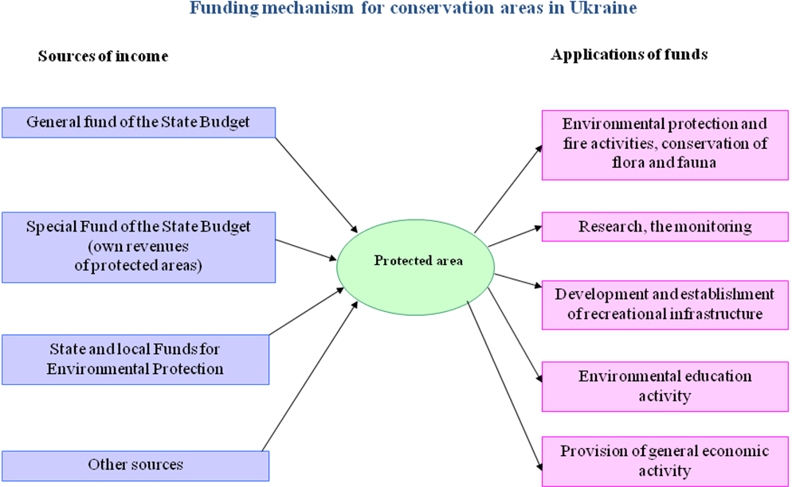
Fig. 1: Funding mechanism for nature and biosphere reserves, national nature parks in Ukraine

According to the Law of Ukraine "On Protected Areas of Ukraine" all nature reserves, biosphere reserves and national nature parks have annual financing from the State Budget.
Planning of the funds from the state budget for the current needs of each protected area carried out according to its size and staff, presence of buildings, transport, and equipment.
There is little difference in average costs from state budget on nature reserves in comparison with other categories (national nature parks and biosphere reserves). For nature reserves it is planned larger amount of expenses, since in their territories is forbidden any activities and most of them hasn’t own revenue.
Regional landscape parks have to be financed from local budgets.
The costs connected with providing protection regime of preserves, nature monuments, reserve stows are carried ​​by enterprises, institutions, organizations, other landowners and land users on whose territory they are located.
All of them may also be co-finance from the budget of the Autonomous Republic of Crimea, local budgets and charitable foundations, funds of enterprises, institutions, organizations and citizens.
All protected areas can also provide paid services according to a specified list:
I. Services that may be provided by protected areas according to their functional competence (services related to the provision of recreational activities, organizing and providing educational activities; services related to research activities).
II. Services that can be provided protected areas in the field of economic activity (photo services, services for the citizens and organizations on video, film and television filming, use of car parks, wharves; advertising and publishing; veterinary preventive and curative health services; selling of the animals and their products, collection and sale of medicinal plants, herbs, berries, mushrooms; growing and selling plants and seeds; realization of the farms production, realization of a timber and its products (gift items, handycrafts); fabrication and sale of decorative and applied arts; services on providing vehicles, equipment, property, tools.
State of financing
Percentage of ensuring requirements for protected areas over the past 5 years ranged from 21.7 to 61.6%. (Tab. 5 and Fig.12)
Is the current budget sufficient?
Answer | Number of PAs with this answer in Ukraine

There is no budget for the protected area | 0
The available budget is covering staff salaries and office costs, but represents less than 50%, of the optimal budget and presents a serious constraint for the implementation of the management plan | 10
The available budget is covering staff salaries and office costs and represents 50-90%, of the optimal budget | 2
The available budget is sufficient and meets the full management needs of the protected area | 0
Tab. 5: Result of assessment of provision of financial need of protected areas (CPAMETT, 2011)
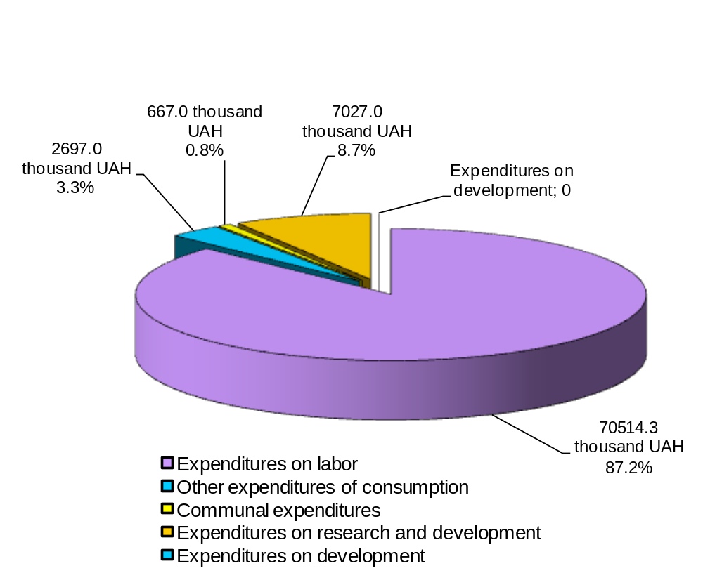
Fig. 2: Financing from State Budget of 39 Protected Areas of Environmental Ministry
in 2010, thousand UAH

The average expenditure for one protected area from the State Budget has tendency to decrease (Fig. 13).
Protected areas of local level, the landowners and users of which are local governments, businesses, organizations, etc. funded on the leftover principle, and in most cases are not funded at all. Many such objects do not have own administrations.
For example, from 55 regional landscape parks of Ukraine, only 27 have special administrations and are funded.
The percent of funding from budget for the maintenance of protected areas is 0.06 – 0.07% of the total State budget expenditure and over the last few years is not changed (Tab. 6).
Indicators | 2005 | 2006 | 2007 | 2008 | 2009
Total government expenditure, mln.UAH | 94145.6 | 109491.6 | 142768.2 | 200106.1 | 193358.1
Expenditures for maintaining protected areas, mll. UAH | 59.10 | 67.62 | 88.89 | 120.91 | 148.87
The percentage of costs for protected areas in total expenditures, % | 0.063 | 0.062 | 0.062 | 0.060 | 0.077
Tab. 6: Comparison of state budget (State Budget 2005 - 2009)

There is no enough activity in recreation and education services. The main share of income of own funds of protected areas are income from the sale of timber and timber products from it (Fig. 14).
Due to the lack of common standards for the financing of protected areas, protected areas are financed in different amounts, depending on whom they are subordinated.
For the development of other protected areas' activity (recreation, research and education services) it is necessary to develop special programs and ensure their implementation.
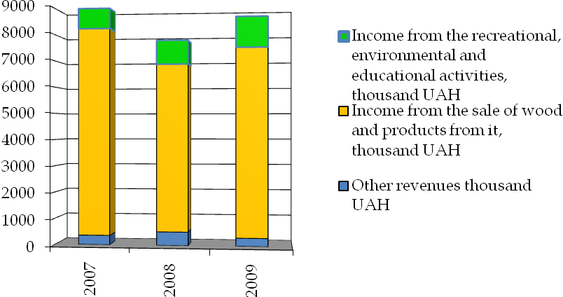
Fig. 3: Structure of revenues of Protected Areas Ministry of Environment Protection

State budget is the mainly source of financing protected areas. There is no good mixture of national and international resources. Funding instruments, such as public funding, debt for nature swaps, elimination of perverse incentives and subsidies, private funding, taxes and fees for ecological services are not identified and used.
There is no developed sustainable finance plan that incorporates a diversified portfolio of financial mechanisms.

Mostly protected areas managers are deciding and responsible for the use of financial resources (Tab. 7)
Who is taking the decisions on the use of financial resources?
Answer | Number of PAs with this answer in Ukraine

Decisions on the use of financial resources are not taken by the protected area management team. | 1
Decisions on the use of financial resources are not taken by the protected area management team, but they can influence them. | 2
The protected area team is mostly deciding and is responsible for the use of all financial resources, but they still have to consider outside opinions. | 3
The protected area team is deciding and is responsible for the use of all financial resources. | 6
Tab. 7: Result of assessment of responsibility of decisions on the budget (CPAMETT, 2011)
New forms of financing

Strengths

  - All nature reserves, biosphere reserves and national nature parks have annual financing from the State Budget.
  - Protected areas can provide paid services according to a specified list.
  - The draft National Strategy for Financing Sustainability of Protected Areas was developed.
  - There are some examples of innovative financial mechanisms such as LifeWeb Initiative, carbon offset project.

Weaknesses
  - Low percentage of ensuring requirements for protected areas.
  - There are no enough funds for improving infrastructure and management.
  - Protected areas of local importance, the land owners and users of which are local governments, businesses, organizations, etc. funded on the leftover principle, and in most cases are not funded at all.
  - There are no enough activities in recreation and education services.
  - The source of financing protected areas is mainly state budget. There is no good mixture of national and international resources. Funding instruments, such as public funding, debt for nature swaps, elimination of perverse incentives and subsidies, private funding, taxes and fees for ecological services are not identified and used.

Capacity needs assessment (Insert summary findings if available)

Current status and achievements
According to the Law of Ukraine "On Protected Areas of Ukraine" all nature reserves, biosphere reserves, national nature parks and regional landscape parks must have own administrative bodies. Real situation in this field is that all first three categories of protected areas of national importance have administrative bodies, but only some regional landscape parks have staff.
Total number of employees that are directly involved in protected areas daily work is rather large - about 7000 people.
Are there enough people employed to manage the protected areas?
Answer | Number of PAs with this answer in Ukraine

There are no staff. | 0
Staff numbers are inadequate for critical management needs and activities. | 0
Staff numbers are sufficient to fulfil only critical management needs and activities. | 6
Staff numbers are adequate for fulfilling all management needs and activities. | 6

Tab.8: Result of assessment of staff number of protected areas (CPAMETT, 2011)

On average, each protected area's administration has staff from 19 to 250 employees. To define the number of employees in Ukraine there is developed and approved Standard. Under these regulations there are several factors that affect to the number of employees, in particular area of ​​the protection, area of core and recreational zones, and the type of landscape, number of visitors of the territory, settlements, educational organizations and so on.
Does the management team have the same people on board?
Answer | Number of PAs with this answer in Ukraine

More than 70% of the total permanent staff changed. | 0
Between 35-70% of the total permanent staff changed. | 1
Between 10-35% of the total permanent staff changed. | 3
No changes or less than 10% changes registered. | 8
Tab. 9: Result of assessment of changes/ fluctuation in the permanent staff during the last year (CPAMETT, 2011)
Personnel staff is stable; turnover of staff is very slow that leads to the coherence of the team, transferring knowledge from generation to generation, the possibility of training for various areas of activity of protected area (Tab. 9).
Are staff qualifications appropriate for the position presently held?
Answer | Number of PAs with this answer in Ukraine

Less than 35 % of the staff has adequate qualifications. | 0
Between 35 and 70 % of the staff have adequate qualifications. | 4
Between 70 and 90 % of the staff have adequate qualifications. | 3
More than 90 % of the staff has adequate qualifications. | 5

Tab.10: Result of assessment of staff qualifications (CPAMETT, 2011)

The professional qualification characteristics of employees in protected areas were developed and approved.
In last two years 7 professional development programmes in different fields for protected area practitioners were created; in some universities protected area curricula were developed.
From 2004 the number of protected area staff was increased more than twice.
With support of WWF-DCP and UNDP/GEF projects a lot of trainings and meetings for protected areas staff, local authority, settlements, and other stockholders have been held in Carpathian and Polissia regions.
How often is staff participating in training seminars?
Answer | Number of PAs with this answer in Ukraine

Less than 35% of the staff participated on a training seminar during the last year. | 5
Between 35 and 70% of the staff has participated on a training seminar during the last year. | 2
Between 70 and 90% of the staff has participated on a training seminar during the last year. | 3
More than 90% of the staff has participated on a training seminar during the last year. | 0
Tab. 11: Result of assessment of staff training (CPAMETT, 2011)
There is no system of regular training for protected areas (Tab. 11).
No comprehensive capacity needs assessment has been carried out and consequently no capacity building programme that builds on identified needs has been developed.
Education implemented mainly for staff of protected areas without community involvement, employees of other sectors related to the protected areas activity.
Most of the employees protected areas do not speak English, which makes impossible to exchange lessons learnt, information and capacity-building experiences from other countries and relevant international organizations.

Strengths
  - All nature reserves, biosphere reserves, national nature parks and regional landscape parks must have own administrative bodies.
  - The staff of every protected area is large enough.
  - The quality of staff is good enough.
  - The professional qualification characteristics of employees in protected areas were developed and approved.
  - The professional development programmes were created.

Weaknesses
  - Very low level of the average salaries and social status of protected areas staff.
  - No comprehensive capacity needs assessment has been carried.
  - There is no system of regular training for protected areas.
  - Number of community and employees of sectors related to the protected areas activity are not educated in protected areas issues.
  - There aren’t effective mechanisms to document existing knowledge and experiences on protected area management.

Policy environment assessment (Insert summary findings if available)

Current status and achievements
Ukraine has national legal frameworks for system of protected areas (first of all the Law of Ukraine "On Protected Areas of Ukraine") that regulate protected areas planning, governance and management, defining the relevant responsible institutions and parties.
Since 2004 with the aim of improving an enabling policy, institutional and socio economic environment for protected areas were developed/ approved:
Conception of State Programme on Protected Areas Development until 2020 was approved.
The draft of State Programme on Protected Areas Development until 2020 was developed.
Multi-stakeholder advisory commission was formed.
4 Decrees of President of Ukraine aimed on protected areas development were adopted.
2 decisions of Parliament’s Committee aimed on protected areas development were adopted.
Law of Ukraine "On Protected Areas of Ukraine" was adopted.
The law "On Econet of Ukraine" was adopted.
The National Strategy of Ecological Policy was adopted.
The draft National Strategy for Financing Sustainability of Protected Areas was developed.

Strengths
  - The national legal frameworks for system of protected areas are exist.
  - There is some improving of enabling policy, institutional and socio economic environment for protected areas.
  - The socio-economic importance of protected areas in Ukraine has high level.

Weaknesses
  - There is no identifies the economic benefits provided by protected areas and who appropriate these benefits.
  - Some gaps exist in harmonization of sectoral policies and laws to ensure that they support the conservation and effective management of the protected areas system.
  - There are no enough activities and positive incentives that support the integrity and maintenance of protected areas and the involvement of indigenous and local communities and stakeholders in conservation.
  - There is no enough activity on cooperation with neighbouring countries to establish an enabling environment for transboundary protected areas and for neighbouring protected areas across national boundaries.

Protected area integration and mainstreaming assessment (Insert summary findings if available)
In 2000 Ukraine adopted the National Programme on Econet of Ukraine until 2015. According to the Programme the national econet has to be a part of the Pan-European Ecological Network.
In the framework of the Pan-European Biological and Landscape Diversity Strategy, the Pan-European Ecological Network aims to ensure that a full range of ecosystems, habitats, species and landscapes of European importance is conserved; habitats are large enough to place species in a favorable conservation status; there are sufficient opportunities for the dispersal and migration of species; damaged parts of the key environmental systems are restored; the key environmental systems are buffered from potential threats (http://www.coe.int).
According to the National Programme on Econet of Ukraine until 2015 protected areas are the core elements of econet.
At the moment 9 large corridors of national importance are designated. For 5 of them draft schemes are developed. Also districts of Ukraine have developed 21 regional schemes of econet creation, 4 of them are approved.
Forming a National Ecological Network as part of a Pan-European ecological network and maintenance of life-support functions of environment is one of the main directions of the spatial planning in Ukraine.
According to the Law of Ukraine "On General Chart of Territory Planning of Ukraine" the General Chart of planning of territory of Ukraine has foreseen the expansion of area of territories of National Ecological Network and forming of the unique territorial system, which unites the elements of national ecological network and establishes special regimes of its protection and use.
In 2009 a Joint Programme with the European Union has been launched, for a period of three years, in order to substantially develop the Emerald Network in the seven following countries: Armenia, Azerbaijan, Belarus, Georgia, Moldova, Ukraine and the European part of the Russian Federation. One of the objectives of this Joint Programme is to identify 80 % of potential sites of Ukraine's Emerald Network (Council of Europe) untill the end of 2011.
Integration of protected areas into other sectors and planning
To show the integration of protected areas into broader land and sectors Yavorivskyi National Nature Park was chosen. The park was created as a response to the national and European econet plans. In 2011 Yavorivskiy NNP became a part of the Roztochchya Biosphere Reserve which is a perspective part of future Ukrainian-Polish transboundary biosphere reserve in the natural region of Roztochchya.
Interactions between Yavorivskyi National Nature Park and regional planning
Authority of Lviv Region (Lvivska Oblast) of Ukraine where Yavorivskyi NNP is located has adopted a Strategy of Development of the Region till 2015. One of primary objectives of the Strategy is: conservation of clean and favorable environment by perfecting the system of natural environment protection and supporting the most valuable ecological territories and ecosystem and by creation of a biosphere reserve.
Main purpose of the Chart of Spatial Planning of the Lviv region is: to provide planned foundation for the rational use of territory, determination of priorities of economic and engineering-transport infrastructure development, protection of environment, conservation of cultural heritage.
One of the features of the Chart of Spatial Planning of the Lviv region is expansion of protected territories and including them to the ecological network of Lviv region.
The Chart of Spatial Planning of the Lviv region includes the framework of protection of natural environment, where are defined main existing elements of regional ecosystem (including Yavorivskyi NNP) and protected areas that have to be created. Also in the Chart there are marked the areas of possible conflicts between interests of region development and nature protection.
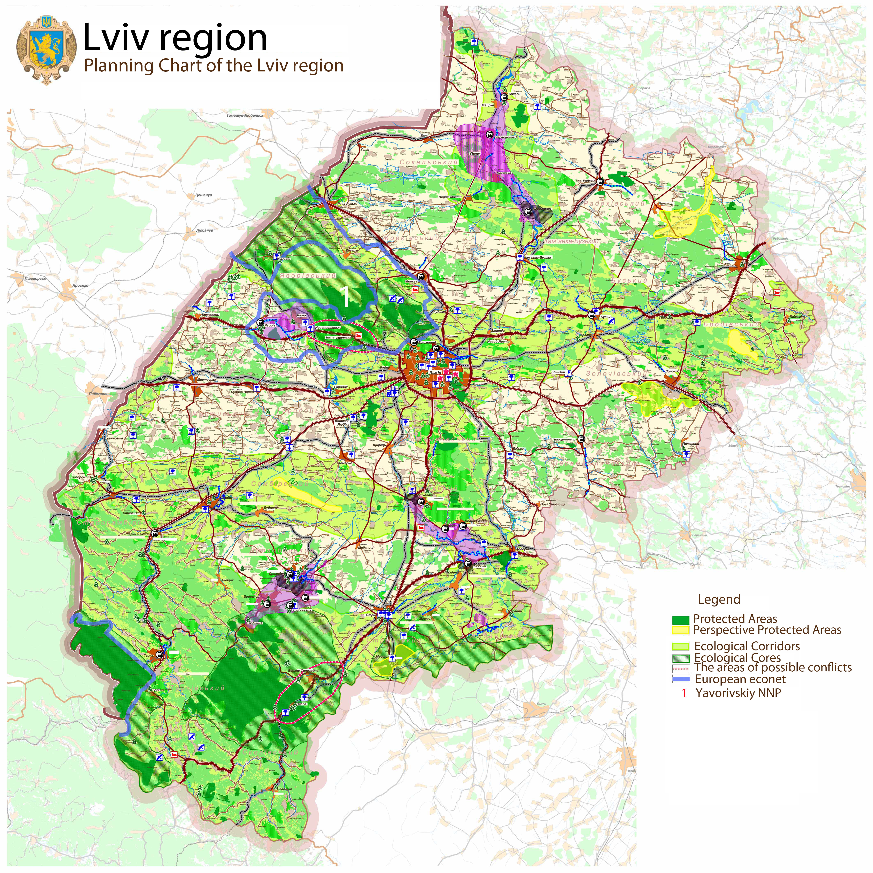
Fig. 15: Planning Chart of the Lviv region

According to the Chart in Lviv region regional parts of two ecological corridors of national importance will be created: Galytsko-Slobojanskiy (latitudinal) and Dnistrovskyi (longitudinal). They will intersect territory of Roztochchya too. Main core and the basic structural elements of the designed framework will be Nature Reserve "Roztochchya" and Yavorivskyi National Natural Park (both are parts of biosphere reserve "Roztochchya"). It is planned that National Ecological Network will be united with European Econet. In the process of this association, transboundary structure of Roztochchya will play the key role, so it has good prospects of nature conservation and social and economic development.
Some main tasks of the Chart of Spatial Planning of the Lviv region concern nature conservation and protected areas development:
- reservation of land for future protected areas conservation and covering by new protected territories with rich biodiversity, especially with old forests, riversides, mountain forests, virgin lands, typical and unique ecosystems and landscapes, habitats of rare and endangered species of animals and plants, rare geological locations, standard types of soils and so on;
- improvement of the state of floodplains ecosystem of large rivers, including Dniester and Western Bug, which begin within territory of the Lviv region;
- recovery of steppes, meadow landscapes and, especially, wetlands (where it is possible).
The Chart plans expansion of protected area to 104 000 hectares, which rises the percentage of protected areas in the region from 6.1 % to 11 % of its territory.
Since development of the Chart in the Lviv region (2009), the Regional Landscape Park was created, proposal for a transboundary Biosphere Reserve is prepared, negotiations to expand territory of Yavorivskyi National Nature Park are considered. Percentage of protected areas is 6.7% of the region area at the beginning of 2011.
Also, with the purpose of protection of biotic and landscape diversity, the Regional Programme of Forming the Ecological Network on 2007-2015 of the Lviv region is developed and ratified. The programme is planned to promote balanced and sustainable use of biological resources.
Researchers of Yavorivskyi National Nature Park participated in elaboration of the Programme.
In order to improve the ecological situation on the territory of the Lviv region, there are planned and fulfilled Annual regional programmes of socio-economic and ecological development.
During the last 7 years Yavorivskyi NNP in the framework of the programmes created 3 recreational zones, developed its infrastructure, held scientific researches and so on.
At the local level Yavorivskyi NNP also has had a good collaboration with authorities of Yavorivskyi district, rural chairmen, public organizations other stakeholders.
Here there is a list of proof for such collaboration:
- district administration together with Yavorivskyi NNP created the Plan of Tourism and Recreation Development of Yavorivskyi district;
- Yavorivskyi NNP together with public organization "Saint Nicholas Fund" developed Program of Ecological-Spiritual Events;
- managers of Yavorivskyi NNP take part in meetings and events of district administration and settlements; managers of NNP are advisers of authorities of district and settlements;
- Yavorivskyi NNP together with the district administration take part in general projects in order to receive grants and other investments from International funds with the purpose of the ecologically balanced development of district and rural settlements;
- Yavorivskyi NNP together with the district administration prepares development projects of scientific and ecological-educational activity in the district;
- prepare offer to expand territory of NNP, and creation of new protected areas in the district;
Last year authorities of Yavorivskyi district settlements together with authorities of transborder territories settlements (Polish Republic) and with representatives of Yavorivskyi National Nature Park and Roztochanskiy National Park (Polish Republic), within the framework of Program of Transborder Collaboration are preparing a project "Folk House".
In addition, managers of the NNP together with authorities of the district and settlements take part in meetings on promotion of establishing new protected areas in other regions of Ukraine.

Strengths
  - General Chart of planning of territory of Ukraine has foreseen the expansion of area of territories of National Ecological Network.
  - National Programme on Econet considers connectivity issues and it is given important guidance to providing connectivity approach.
  - Some corridors of national importance are already in place.
  - Some potential sites of Ukraine's Emerald Network are identified.
  - Landuse planning promotes idea of connectivity of protected areas.

Weaknesses
  - The Econet in Ukraine is developing very slowly and still not finished.
  - The legal framework for effective functioning of Econet is not enough developed.
  - Issues concerning protected areas are not addressed in the National Strategy of Poverty Reduction and related National Plans.
  - The above mentioned positive example of Yavorivskyi NNP for the integration of protected area in various sectors of the economy and cooperation at different levels based on the personal efforts staff and national park managers, not through organized system of interconnections between different sectors of economy. The system of protected areas at national level is poorly incorporated into the various sectors of economy.
  - There is not enough activity to rehabilitate and restore habitats and degraded ecosystems (officially approved action plans, programmes etc both on national and local levels) only some small grant projects implemented by NGOs.

Protected area valuation assessment (Insert summary findings if available)
The natural and socio-economic value of protected areas was defined during RAPPAM assessment (2008).
Analysis of the assessment results indicated that all the assessed protected areas are characterized by high natural and socio-economic value. They are important for the functioning and development of local communities, play an important aesthetic and educational part.
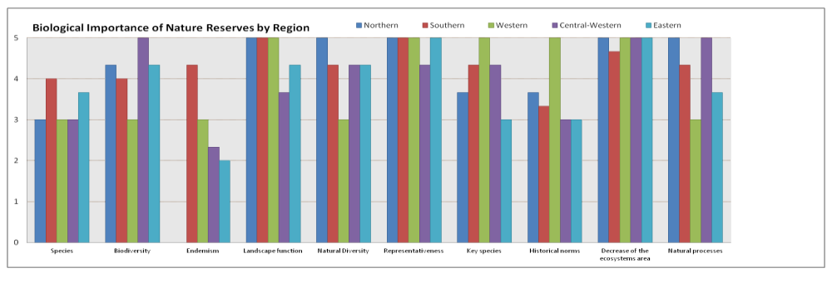
Fig. 4: Result of assessment biological importance of reserves in the different regions of Ukraine (RAPPAM 2008)

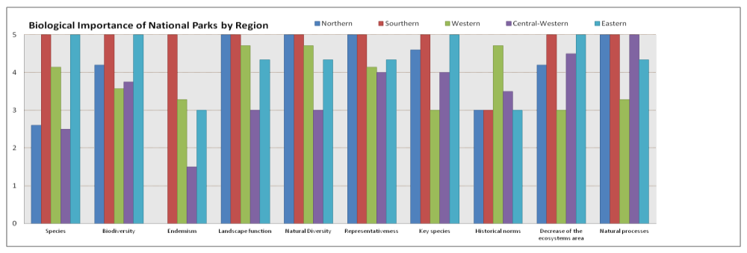
Fig. 57: Result of assessment biological importance of national natural parks in the different regions of Ukraine (RAPPAM 2008)


Fig. 68: Result of assessment socio-economic importance of reserves in the different regions of Ukraine (RAPPAM 2008)

Fig. 79: Result of assessment socio-economic importance of National Parks in the different regions of Ukraine (RAPPAM 2008)

Climate change resilience and adaptation assessment (Insert summary findings if available)
2 projects on mitigation of climate change are implemented in the Polesian Region (forested lowland in the north of Ukraine). They include measures on restoration of mires and floodplains.
The issues of climate change resilience and adaptation are included in Proposals to Action Plan on implementation of Programme of Work on Protected Areas in Ukraine until 2020.

(Insert other assessment results if available)

