Eastern Europe: National Biodiversity Strategies and action Plans

Country | Version of NBSAP | Date of development | Note
Albania | NBSAP | 1999
Armenia | NBSAP | July 1999
Azerbaijan | NBSAP | March 2006
Belarus | NBSAP | November 2010 | no
Bosnia and Herzegovina | NBSAP BiH 2008-2015 | January 2008
Georgia | NBSAP 2014-2020 | 2014
Montenegro | National Biodiversity Strategy with the Action Plan for the period 2010 – 2015 | July 2010 | Se compilation
Republic of Moldova | Strategy on Biological Diversity of the Republic of Moldova for 2015-2020 and the Action Plan for enforcing it | May 2015 | See compilation
Russian Federation | National Strategy of Biodiversity Conservation in Russia | 2001
Serbia | BS 2011-2018 | 2011
TFYR Macedonia | NBSAP | 2003
Ukraine | NBSAP | 1997

Albania
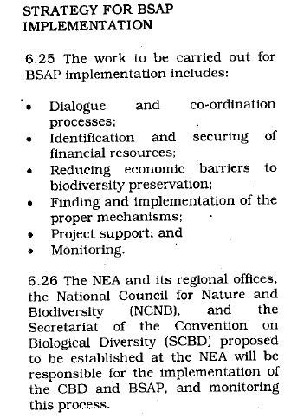
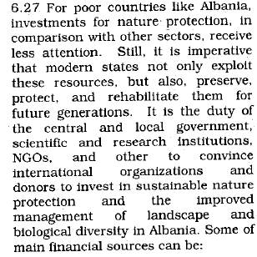
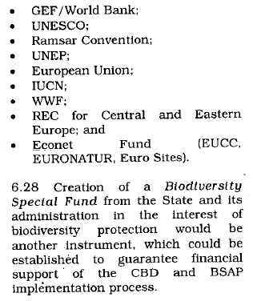
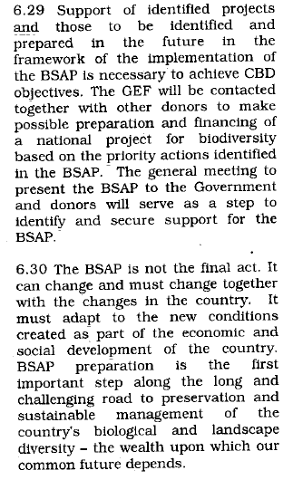

Armenia
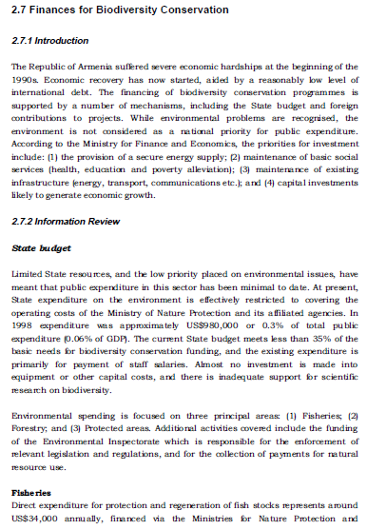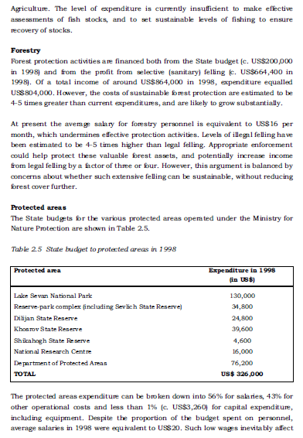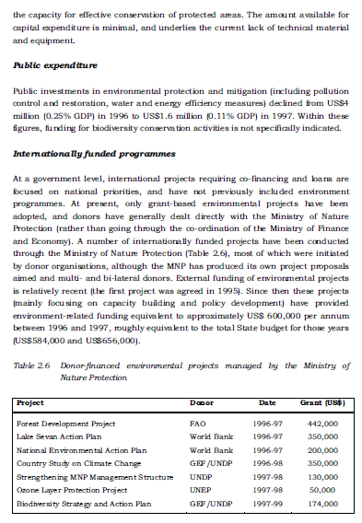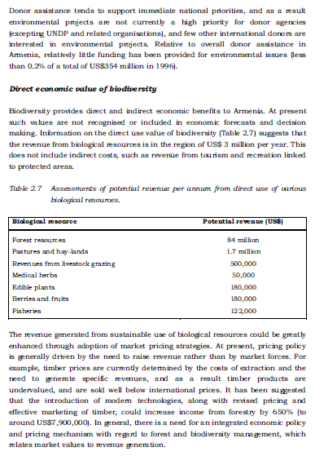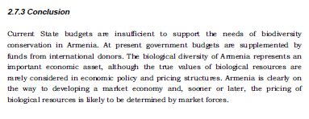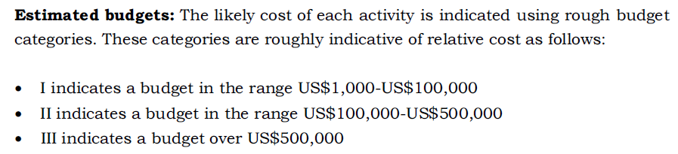
 | I | II | III
A. in situ conservation | 14 | 15 | 5
B. ex-situ conservation | 4 | 6 | 1
C. Sustainable use | 44 | 6 | 2
D. Institutional strengthening and capacity building | 13
E. Environmental education and public awareness | 19
F. Identification and monitoring | 11 | 4
G. research | 7 | 4
H. Information accessibility and exchange | 8 | 2
I. cooperation | 11 | 1
J. Impact assessment | 8 | 2
K. incentive measures | 11
L. Legislation | 10 | 2
M. Financial resources | 13
N. BSAP implementation | 18 | 1

Azerbaijan
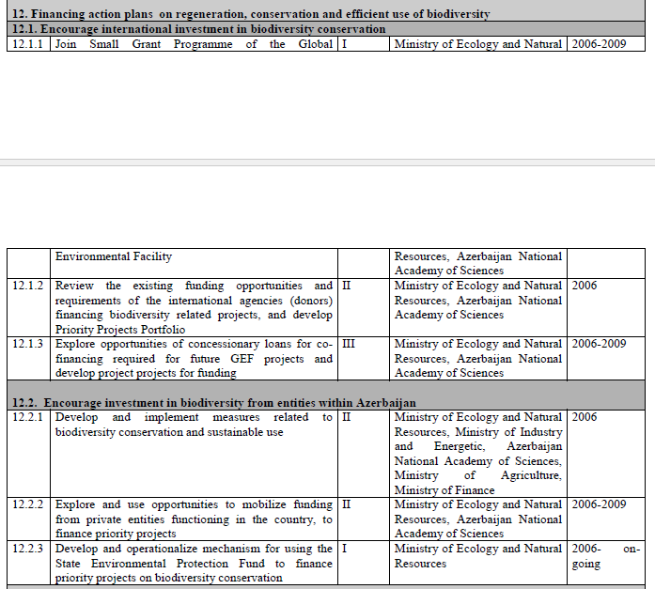

Belarus

Bosnia and Herzegovina
DIRECTION: SETTING UP OF SYSTEM FOR CONSERVATION AND SUSTAINABLE USE OF BIODIOVERSITY IN B&H
SETTING UP OF FINANCIAL CURRENT AS A SUPPORT TO THE SYSYTEM FOR CONSERVATION OF BIODIVERSITY IN B&H
Having respect on one hand for the richness and biodiversity potentials in terms of sustainable development of Bosnia and Herzegovina, and rising political willingness for recognition of biodiversity’s importance as a property and resource on the other, in the contemporary moment of our society emerges a need for steady financial current to be established in order to enable continuous activities regarding nature protection.

Present economic situation, including all associated social effects, shows that Bosnia and Herzegovina is not able to ensure full and steady financial support by its own means for the biodiversity protection on its territory. Moreover, there must not be omitted the fact that financial mechanisms, though poorly inter-connected, have already been in place.

The analysis of B&H’s biodiversity state, as well as the identification of clear conservation targets and system which enables it, made obvious that means invested until now haven’t been enough.

At the same time, it became clear following: a critical items are to ensure stable internal financial basis which shall supply means for the system, to set up and maintain functions of the system and to ensure its sustainability.

In wider sense of words, set up of biodiversity conservation system requires mechanisms for nature management to be developed. This includes, among others, economic functions and connections between adjacent sectors, and extremely important economic potentials for the development of natural management sector as a new economy branch of sustainable development in Bosnia and Herzegovina.

Among working mechanisms in natural management sector there is a creation of space for private entrepreneurs and foreign investments which hasn’t been entirely used until now, when it comes to activities of nature protection in B&H.

It is necessary to adjust current economic patterns through the introduction of incentive measures in programmes of natural management. Public enterprises, for instance, as a way to manage rare protected areas, with taxation burden and poorly developed strategy of fund raising, don’t represent a sustainable way of natural management.

Due to possibility of fast fund raising through the exploitation of hydro-potentials, forest and other natural resources, there is a lack of interest for the establishment of new protected areas. Hence, creation of mechanisms for benefit gain in natural management sector becomes priority in terms of biodiversity preservation.

It is not a question at all if this process requires much stronger political willingness and social efforts in general, but it is also a sole method for maintenance of natural resources of Bosnia and Herzegovina, as a base for the subsistence of entire society.

It is necessary to stress following: concept of environmental foundations in terms of leading idea for their purpose is not satisfactory base for the development of process for natural management. After given concept, there is a number of environmental segments which shall use this foundation and leave no enough space to initiate strong process of natural management.

The Strategy affirms following programme of activities:
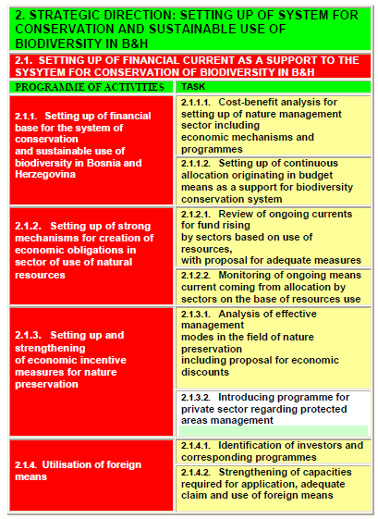

Georgia
13 IMPLEMENTATION AND RESOURCE MOBILIZATION
In comparison to the NBSAP-1, this National Biodiversity Strategy and Action Plan more effectively utilizes a holistic, cross-cutting and ecosystem-based approach. The authors envisage the involvement of a wider spectrum of ministries, local authorities, economic sectors and other stakeholders in its implementation.
The Ministry of Environment and Natural Resources Protection (MoENRP) will establish a Committee for Supervising and Monitoring of NBSAP Implementation that will include all relevant ministries and other stakeholders. This Committee will ensure the integration of biodiversity into various sectors and oversee and monitor the implementation of NBSAP-2on the basis of the indicators outlined for each national target.
The large number of actions in NBSAP-2 will not be carried out simultaneously, but gradually over time, and the Committee will be responsible for developing an Implementation Plan to prioritise and sequence the implementation of the actions.
Allocation of financial and human resources will be crucial for the implementation of NBSAP-2. A national Resource Mobilization Strategy (RMS) will be developed. As a basis for the RMS, the current allocation of resources for biodiversity in Georgia will be monitored based on the monitoring framework and guidelines developed by the CBD. (UNEP/CBD/COP/11/14/Add. 1).
The RMS will consider resources from all sources, including government allocations, contributions from external donors and “innovative” financing, i.e. through partnerships with the private sector.
It should be borne in mind that the NBSAP will lead not only to expenditures, but also to potential savings and revenues, and that what appears to be costs in the short term could well be investments in the longer term through the protection of ecosystem services. The savings and revenues can come from various sources, such as visitor entry fees to national parks, license fees for using natural resources and shifting from unsustainable to sustainable practices (e.g. in forestry and fishery). Through these savings and revenues, viable long-term businesses will be not undermined but secured.

Montenegro
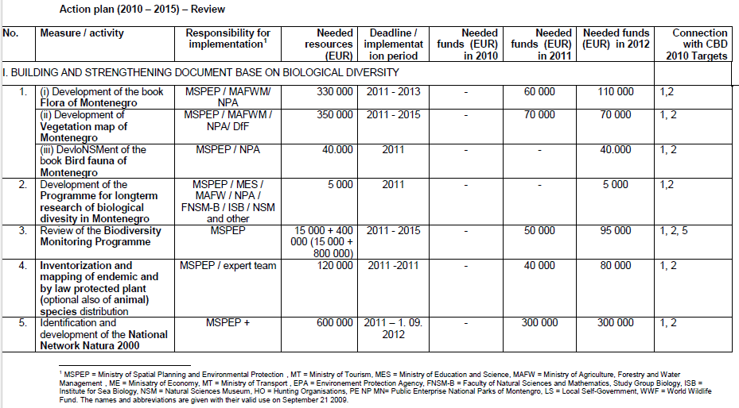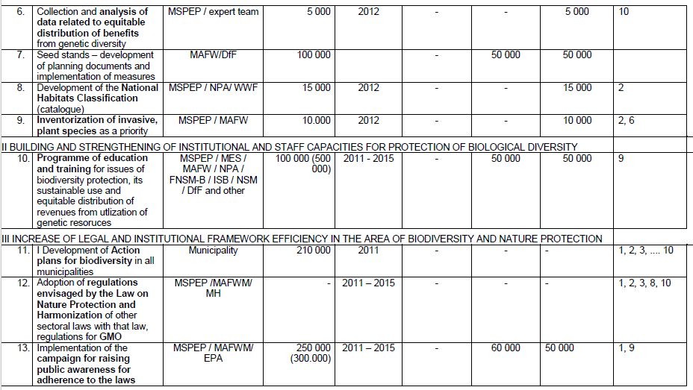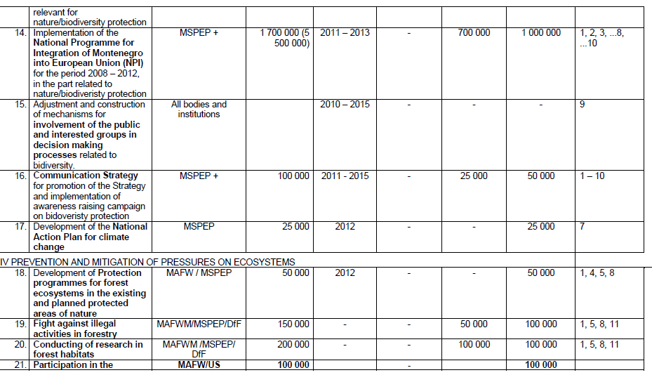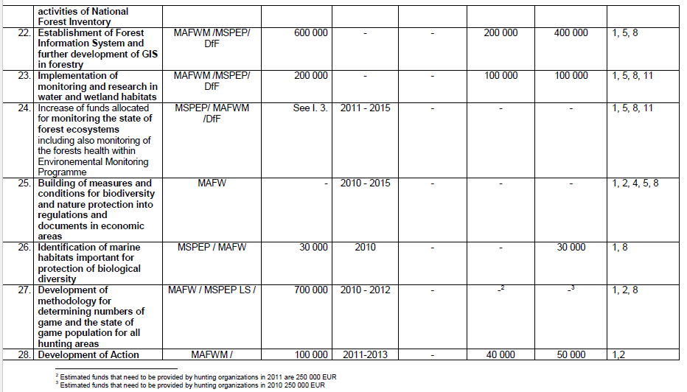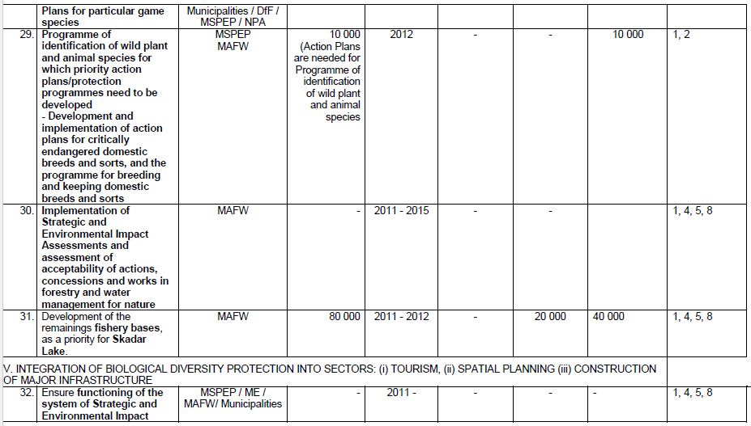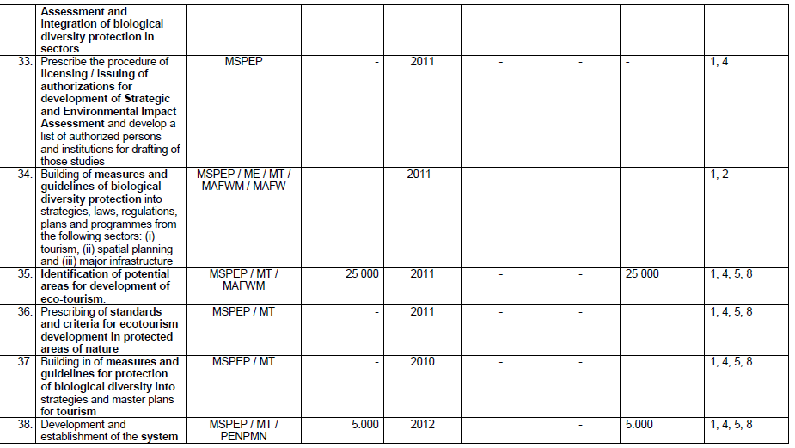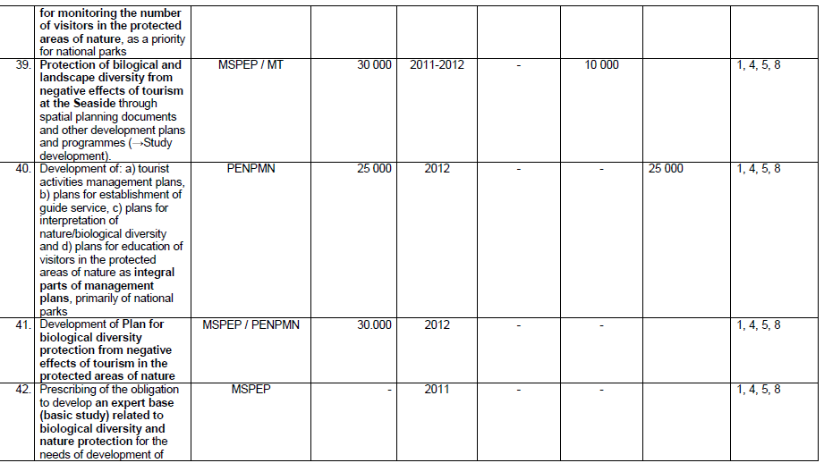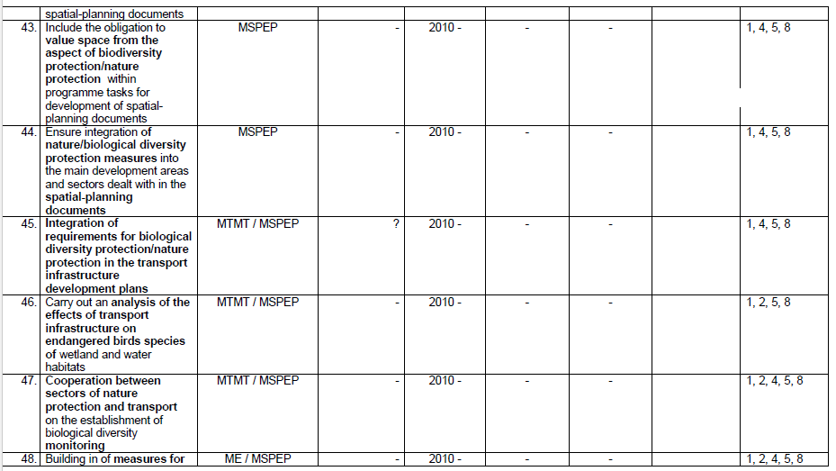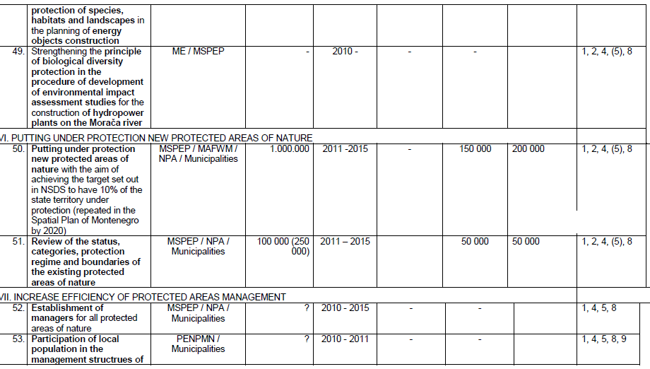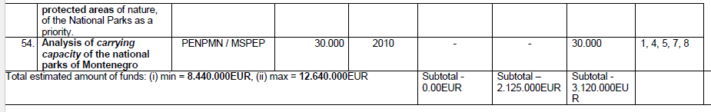

Republic of Moldova
35. The Costs of Implementing the Strategy
The total cost of implementing the Strategy during 2014-2020 will be 38.6 million lei, which represents an average of 5.6 million lei annually (approximately 0.006% of GDP (2012). These costs were estimated in accordance with international practices with reference to economic and cost-benefit analyses taking into account the following components:
- direct and indirect consumables and expenditures, the main components are consumables for labor remuneration (including wages), mandatory social contributions (23% of wages) and the health insurance premiums (3.5% of wages);
- cost of investments, represent costs of actions (without labor remuneration) which, according to relevant legislative acts are considered investments (shelterbelts, forest plantations on degraded lands etc.);
- cost of technical assistance, which includes expenditures for local and international consultants, which were determined using the indicators from the Medium-Term Budget Framework (the thresholds from the state budget per central public authority), especially, special means and funds, projects financed from external sources;
- the cost of time of government employees, which represents 15.5% of the total cost of implementing this Strategy. This means that when Republic of Moldova requires external financial assistance, the Government of Republic of Moldova must be able to prove its ability to co-finance the measures for which this assistance is required.
The distribution of costs related to implementing the Strategy and Action Plan for 2015-2020 is presented in Table 2.
The sources of financing and costs related to implementing the Strategy and Action Plan for 2015-2017 are presented in table 3, and for 2018-2020 – in table 4.
When estimating costs, the information obtained from public authorities, statistical data on the nominal average monthly salary of an employee per economy and in research-development, internal expenditures related to research and development, national accounts for 2011, Medium-Term Budget Framework for 2012-2015 as well as information on projects financed from the National Ecological Fund in 2013 were used.

36. Funding Sources and Proposed Funding Mechanisms
Funding of costs related to the implementation of this Strategy are covered from into internal (national public budget, other legal sources) and external sources.
Funding Mechanisms
Economic mechanisms and tools aim at influencing economic activity for the purpose of establishing conditions that would foster the rational use of natural resources and, especially, conservation of biodiversity. The main elements of the economic mechanism of financing activities in the area of biodiversity conservation are:
- creating conditions for the non-governmental sector (eligibility, reporting, co-financing, pre-financing of activities etc.) to access available funds, including by providing financial support or some facilities;
- developing and implementing a payment system (according to the methodology approved by the Government) as a compensation for land plots planted with forests included in the state protected natural areas;
- implementing a mechanism for mandatory ecologic insurance for environmentally dangerous technologies;
- developing and implementing a system for issuing permits and setting fees for entering state protected natural areas;
- developing and implementing a payment system for ecosystem services.

The costs of implementing the Strategy for the Conservation of Biological Diversity for 2014-2020
(thousand lei)
Specific Objectives | 2015 | 2016 | 2017 | 2018 | 2019 | 2020 | Total
A1. Develop the normative framework on biodiversity conservation | 0.00 | 0.00 | 60.73 | 87.19 | 0.00 | 0.00 | 147.92
A2. Ensure an efficient institutional framework for the sustainable management of biodiversity | 0.00 | 0.00 | 0.00 | 825.65 | 0.00 | 0.00 | 859.91
A3. Ensure the integration of international treaty requirements into national policies on biodiversity | 0.00 | 63.51 | 176.47 | 176.00 | 0.00 | 699.97 | 1,115.95
B1. Ensure the extension of state protected natural areas and the establishment of a national environmental network | 0.00 | 3,056.50 | 0.00 | 95.27 | 250.48 | 1,396.49 | 4,798.74
B2. Ensure the conservation of rare, vulnerable and endangered species | 0.00 | 1,323.52 | 317.56 | 416.52 | 0.00 | 523.53 | 2,686.12
B3. Implement biological safety measures | 0.00 | 636.93 | 0.00 | 0.00 | 0.00 | 206.48 | 843.41
C1. Implement measures to stop soil degradation and diminish the effects of climate change | 23.82 | 76.47 | 71.45 | 76.42 | 0.00 | 5,238.47 | 5,486.68
C2. Implement measures to minimize degradation of water resources and aquatic biodiversity as well as identification of protection measures for them | 220.62 | 569.11 | 631.54 | 0.00 | 0.00 | 4,741.34 | 6,162.61
C3. Implement measures to diminish the negative impact of invasive species | 0.00 | 530.68 | 0.00 | 44.71 | 199.26 | 125.58 | 900.23
C4. Implement measures to minimize the anthropogenic pressing on vulnerable natural ecosystems | 0.00 | 58.06 | 30.48 | 274.74 | 0.00 | 267.13 | 630.47
D1. Promote access to genetic resources and equitable sharing of benefits from using these resources | 0.00 | 484.32 | 276.61 | 774.61 | 0.00 | 859.97 | 2,395.51
D2. Ensure the sustainable development of natural ecosystems which provide services | 0.00 | 644.49 | 458.82 | 604.59 | 0.00 | 0.00 | 1,707.90
E1. Promote scientific research on biodiversity conservation | 0.00 | 431.27 | 0.00 | 0.00 | 0.00 | 923.63 | 1,354.90
E2. Ensure the educational framework and training of staff on biodiversity conservation and biological security | 303.73 | 621.29 | 303.73 | 467.80 | 303.73 | 589.53 | 2,589.80
E3. Raise awareness and inform the general public on biodiversity conservation and biological safety | 1,125.19 | 1,376.32 | 1,125.19 | 1,125.19 | 1,125.19 | 1,125.19 | 7,002.28
Total per year: | 1,557.74 | 10,093.09 | 3,452.58 | 4,968.4 | 1,878.7 | 16,697.3 | 38,647.6

Table 3
Sources of funding and costs related to the implementation of the Strategy and the Action Plan for 2015-2017
(thousand lei)
Specific objectives | Budget | Extra-budgetary means | Special funds/means | External sources | Total
A1. Develop the normative framework on biodiversity conservation | 25.9 | 27.0 | 0.0 | 7.8 | 60.7
A2. Ensure an efficient institutional framework for the sustainable management of biodiversity | 0 | 0 | 0 | 0 | 0
A3. Ensure the integration of international treaty requirements into national policies on biodiversity | 121.9 | 57.8 | 35.4 | 24.9 | 240.0
B1. Ensure the extension of state protected natural areas and the establishment of a national environmental network | 888.6 | 804.1 | 969.7 | 317.7 | 2,980.0
B2. Ensure the conservation of rare, vulnerable and endangered species | 185.7 | 699.5 | 690.4 | 170.6 | 1,746.1
B3. Implement biological safety measures | 272.0 | 65.6 | 230.6 | 68.7 | 636.9
C1. Implement measures to stop soil degradation and diminish the effects of climate change | 59.5 | 83.3 | 79.6 | 25.8 | 248.2
C2. Implement measures to minimize degradation of water resources and aquatic biodiversity as well as identification of protection measures for them | 127.5 | 403.9 | 573.8 | 316.0 | 1421.3
C3. Implement measures to diminish the negative impact of invasive species | 39.2 | 168.7 | 174.7 | 148.2 | 530.7
C4. Implement measures to minimize the anthropogenic pressing on vulnerable natural ecosystems | 38.8 | 5.0 | 35.5 | 9.2 | 88.5
D1. Promote access to genetic resources and equitable sharing of benefits from using these resources | 199.0 | 49.7 | 219.6 | 292.5 | 760.9
D2. Ensure the sustainable development of natural ecosystems which provide services | 157.3 | 335.0 | 454.1 | 156.9 | 1,103.3
E1. Promote scientific research on biodiversity conservation | 30.6 | 183.0 | 172.8 | 44.8 | 431.3
E2. Ensure the educational framework and training of staff on biodiversity conservation and biological security | 500.7 | 166.9 | 433.4 | 127.7 | 1,228.7
E3. Raise awareness and inform the general public on biodiversity conservation and biological safety | 970.6 | 230.8 | 1,009.7 | 1,415.7 | 3,626.7
Total: | 3,617.3 | 3,280.4 | 5,079.2 | 3,126.5 | 15,103.4

Table 4
Sources of funding and costs related to the implementation of the Strategy and the Action Plan for 2018-2020

Specific objectives | Budget | Extra-budgetary means | Special funds/means | External sources | Total
A1. Develop the normative framework on biodiversity conservation | 79.4 | 0.0 | 0.0 | 7.8 | 87.2
A2. Ensure an efficient institutional framework for the sustainable management of biodiversity | 112.2 | 336.5 | 291.2 | 85.8 | 825.7
A3. Ensure the integration of international treaty requirements into national policies on biodiversity | 476.0 | 216.6 | 92.4 | 91.0 | 876.0
B1. Ensure the extension of state protected natural areas and the establishment of a national environmental network | 616.9 | 326.2 | 694.6 | 181.1 | 1818.7
B2. Ensure the conservation of rare, vulnerable and endangered species | 217.7 | 401.9 | 222.8 | 97.7 | 940.0
B3. Implement biological safety measures | 112.2 | 0.0 | 72.0 | 22.3 | 206.4
C1. Implement measures to stop soil degradation and diminish the effects of climate change | 166.0 | 2,271.2 | 2,244.0 | 557.3 | 5,238.4
C2. Implement measures to minimize degradation of water resources and aquatic biodiversity as well as identification of protection measures for them | 1081.9 | 2,730.1 | 348.0 | 581.3 | 4,741.3
C3. Implement measures to mitigate the negative impact of invasive species | 47.0 | 77.9 | 105.0 | 139.6 | 369.5
C4. Implement measures to minimize the anthropogenic pressures on vulnerable natural ecosystems | 215.7 | 63.9 | 205.7 | 56.3 | 541.5
D1. Promote access to genetic resources and equitable sharing of benefits from using these resources | 212.8 | 482.5 | 373.7 | 565.5 | 1,634.6
D2. Ensure the sustainable development of natural ecosystems which provide services | 26.2 | 157.3 | 187.0 | 234.0 | 604.6
E1. Promote scientific research on biodiversity conservation | 65.6 | 225.8 | 296.9 | 335.4 | 923.6
E2. Ensure the educational framework and training of staff on biodiversity conservation and biological security | 552.5 | 187.0 | 480.1 | 141.5 | 1,361.1
E3. Raise awareness and inform the general public on biodiversity conservation and biological safety | 923.1 | 230.8 | 969.8 | 1,251.9 | 3,375.6
Total: | 4,905.0 | 7,707.6 | 6,583.2 | 4,348.5 | 23,544.2

Action Plan
For the enforcement of the Strategy on Biological Diversity of the Republic of Moldova for the 2015-2020
No. | Actions | Deadline | Responsible institutions | Estimated costs (thousand lei) | Sources of funding | Monitoring indicators

1 | 2 | 3 |  | 4 |  | 5 | 6 | 7
Specific objective A. Ensure the sustainable management and efficient institutional framework for biodiversity conservation
Scope of Action 1. Developing the normative framework on biodiversity conservation
1. | Develop and promote new language for the Law on state protected natural areas adjusted to the provisions of international treaties | 2016 |  | Ministry of Environment, Academy of Sciences of Moldova, “Moldsilva” Agency |  | Within the limits approved annually in the state budget law | State budget | Draft approved
2. | Develop and promote the draft Law on habitats (by harmonizing it with the Council Directive 92/43/CEE of 21 May 1992 on the conservation of natural habitats and of wild fauna and flora) | 2018 |  | Ministry of Environment, Ministry of Culture,  Ministry of Constructions and Regional Development, Academy of Sciences of Moldova, “Moldsilva” Agency |  | Within the limits approved annually in the state budget law | State budget | Draft approved
3. | Develop and promote normative acts on deliberate release of genetically modified organisms into the environment and the market in compliance with the Directive 2001/18/EC of the European Parliament and of the Council of 12 March 2001 on the deliberate release into the environment of genetically modified organisms, Directive 90/219/EC of the European Parliament and Council of 6 May 2009 on the contained use of genetically modified organisms, and international treaties | 2016 |  | Ministry of Environment, Academy of Sciences of Moldova, Ministry of Economy, Ministry of Finance (Customs Service), Ministry of Agriculture and Food Industry, Ministry of Health |  | Within the limits approved annually in the state budget law | State budget, external sources | Drafts approved
4. | Develop and approve new wording for the Forestry Code | 2016 |  | “Moldsilva” Agency, Ministry of Environment,  Academy of Sciences of Moldova |  | Within the limits approved in the state budget law | State budget, external sources | Draft approved
5. | Develop and promote the draft Law on game stock and protecting game through harmonization with Directive 2009/147/CE of the European Parliament and of the Council of 30 November 2009 on conservation of wild birds and alignment to the requirements of international treaties | 2016 |  | Ministry of Environment,  “Moldsilva” Agency,  Academy of Sciences of Moldova |  | Within the limits approved annually in the state budget law | State budget | Draft law approved
6. | Improve and modify legislative acts (Law on animal kingdom no. 439-XIII of 27 April 1995, Law on vegetal kingdom no. 239-XVI of 8 November 2007, Law no. 94-XVI of 5 April 2007 on the ecological network) by adjusting them to the requirements of the EU (Directive 2009/147/EC of the European Parliament and of the Council of 30 November 2009 on conservation of wild birds, Directive 92/43/EEC of the Council of 21 May 1992 on the conservation of natural habitats and wild fauna and flora), and international treaties on biodiversity | 2016 |  | Ministry of Environment, Academy of Sciences of Moldova, “Moldsilva” Agency |  | Within the limits approved annually in the state budget law | State budget | 3 drafts approved
7. | Develop modifications and amendments to the Contravention Code and the Criminal Code related to increasing fines and sanctions for violations of environment protection legislation | 2020 |  | Ministry of Environment, “Moldsilva” Agency |  | Within the limits approved annually in the state budget law | State budget | Drafts approved
8. | Develop and promote the draft law on shelterbelts for agricultural lands | 2018 |  | Ministry of Agriculture and Food Industry, Land Relations and Cadaster Agency, Ministry of Environment, “Moldsilva” Agency |  | Within the limits approved annually in the state budget law | State budget | Draft law approved
9. | Integrating the provisions on conservation of the biological diversity in the most important sector policy documents by 2020 | 2020 |  | Ministry of Agriculture and Food Industry,  Ministry of Economy, Ministry of Education, Ministry of Health, Ministry of Culture,  Ministry of Construction and Regional Development,  Ministry of Environment,  Land Relations and Cadaster Agency, “Moldsilva” Agency, “Apele Moldovei” Agency, Tourism Agency |  | Within the limits approved annually in the state budget law | State budget, external sources | Provisions on biodiversity conservation integrated into sector policy documents (forestry, agriculture, fish farming, trade, landscaping, culture and education)
10. | Develop a new national Action Plan for the implementation of the Strategy for the Sustainable Development of the Forestry Sector of Republic of Moldova | 2016 |  | “Moldsilva” Agency, Ministry of Environment, Ministry of Finance, Ministry of Economy, Academy of Sciences of Moldova |  | Within the limits approved annually in the state budget law | State budget, external sources | Draft approved
11. | Develop the Strategy on the adaptation of the forestry fund to climate changes | 2017 |  | “Moldsilva” Agency, Ministry of Environment, Academy of Sciences of Moldova |  | Within the limits approved annually in the state budget law | State budget | Draft approved
12. | Create efficient financial tools and mechanisms for biological diversity and natural ecosystems’ conservation activities (ecosystem services) | 2019 |  | Ministry of Environment, Ministry of Finance, Ministry of Economy, Academy of Sciences of Moldova |  | Within the limits approved annually in the state budget law | State budget | Draft approved, economic tools used
13. | Creating financial tools and mechanisms for equitable sharing of benefits arising from using genetic resources | 2018 |  | Ministry of Environment, Academy of Sciences of Moldova, Ministry of Agriculture and Food Industry |  | 87.19 | State budget, external sources | Methodological mechanism and tools approved
14. | Promote fiscal stimuli and payments for biodiversity conservation | 2017 |  | Ministry of Environment, Ministry of Finance, Ministry of Economy, Academy of Sciences of Moldova |  | 60.73 | State budget, external sources | Draft approved, fiscal tools used
Scope of action 2. Ensuring an efficient institutional framework for the sustainable management of biodiversity
15. | Establish administrative units for some categories of state protected natural areas | 2018 |  | Ministry of Environment, Academy of Sciences of Moldova, “Moldsilva” Agency |  | Within the limits approved in the state budget law | State budget, external sources | Drafts approved; administrative units established
16. | Establish a Biodiversity, Biosafety and Protected Areas Department as part of the central environmental protection authority | 2015 |  | Ministry of Environment |  | Within the limits approved in the state budget law | State budget | Draft approved; Department established
17. | Establish the National Advisory Office for Forestry | 2016 |  | “Moldsilva” Agency |  | Within the limits approved in the state budget law | State budget, external sources | Draft approved; Office established
18. | Establish scientific and teaching centers in the field of biodiversity conservation | 2018 |  | Academy of Sciences of Moldova, Ministry of Environment, “Moldsilva” Agency |  | 825.65 | State budget, external sources | 4 scientific and teaching centers established
Scope of Action 3. Ensuring the integration of international treaty requirements into national policies on biodiversity
19. | Implement the provisions of international treaties on biodiversity to which Republic of Moldova is a party | 2020 |  | Ministry of Environment, Academy of Sciences of Moldova, “Moldsilva” Agency |  | 523.97 | State budget, external sources | Annual reports developed and submitted
20. | Submit to the Government the package of documents necessary for the ratification of the Nagoya Protocol on Access to Genetic Resources and Fair and Equitable Sharing of Benefits Arising from their Utilization | 2016 |  | Ministry of Environment, Ministry of External Affairs and European Integration |  | Within the limits approved annually in the state budget law | State budget, external sources | Package of documents developed;  draft approved
21. | Submit to the Government the package of documents necessary for the ratification of the Nagoya-Kuala Supplementary Protocol on Liability and Redress to the Cartagena Protocol on Biosafety | 2017 |  | Ministry of Environment, “Apele Moldovei” Agency |  | Within the limits approved annually in the state budget law | State budget, external sources | Package of documents developed;  draft approved
22. | Implement the provisions of the inter-governmental politico-scientific platform on biodiversity and ecosystem services | 2017 |  | Ministry of Environment, Academy of Sciences of Moldova, “Moldsilva” Agency, Ministry of Agriculture and Food Industry, “Apele Moldovei” Agency |  | 176.47 | State budget, external sources | Actions implemented
23. | Implement the Agreement between the Government of Republic of Moldova and the Government of Romania on Cooperation for the Protection and Sustainable Use of Prut and Danube Waters | 2018 |  | Ministry of Environment,  “Apele Moldovei” Agency |  | 176 | State budget, external sources | Actions implemented
24. | Implement the Agreement between the Government of Republic of Moldova and the Cabinet of Ministers of Ukraine on Cooperation for the Protection and Sustainable Development of the Nistru River Basin | 2020 |  | Ministry of Environment |  | 176 | State budget, external sources | Activities implemented as part of the Agreement
25. | Implement the requirements of the International Treaty on Plant Genetic Resources for Food and Agriculture of the Commission of Genetic Resources for Food and Agriculture under FAO | 2016 |  | Ministry of Agriculture and Food Industry, Ministry of Environment, Academy of Sciences of Moldova |  | 63.51 | State budget, external sources | normative documents developed and approved
Specific objective B. Reduce the pressure on biodiversity to ensure sustainable development
Scope of Action 1. Ensure the extension of state protected natural areas and the establishment of a national environmental network
26. | Strengthen management capacities of the National Park “Orhei” | 2016 |  | “Moldsilva” Agency, Ministry of Environment, Academy of Sciences of Moldova, Ministry of Culture |  | 2,889.79 | State budget, external sources | Management of Park established, management plan developed
27. | Establish a wetland area of international importance (Ramsar) “Domneasca” in the Middle Prut area | 2016 |  | Ministry of Environment, Academy of Sciences of Moldova, “Moldsilva” Agency |  | 47.63 | State budget, external sources | Wetland area established
28. | Establish the tri-party Biosphere Reservation “Danube Delta – Lower Prut” (Romania-Republic of Moldova-Ukraine) | 2016 |  | “Moldsilva” Agency, Ministry of Environment, Academy of Sciences of Moldova |  | 119.08 | State budget, external sources | Reservation established
29. | Establish the National Park “Lower Nistru” | 2018 |  | Ministry of Environment, Academy of Sciences of Moldova, “Moldsilva” Agency |  | 95.27 | State budget, external sources | National park established
30. | Create the “Emerald” network as a component part of the Pan-European Ecological Network | 2019 |  | Ministry of Environment, Academy of Sciences of Moldova, “Moldsilva” Agency, Land Relations and Cadaster Agency |  | 176.95 | State budget, external sources | Network established
31. | Develop the cadaster of state protected natural areas | 2019 |  | Academy of Sciences of Moldova, Ministry of Environment, Land Relations and Cadaster Agency, “Moldsilva” Agency |  | 73.53 | State budget, external sources | Cadaster developed and published
32. | Develop and promote the program of extending the system of protected areas | 2020 |  | Ministry of Environment, Academy of Sciences of Moldova, “Moldsilva” Agency |  | 348.54 | State budget, external sources | Program developed, system of state protected natural areas extended
33. | Develop management plans for protected areas | 2020 |  | Ministry of Environment, Academy of Sciences of Moldova, “Moldsilva” Agency |  | 1,047.95 | State budget, external sources | 44 plans developed and approved
Scope of Action 2. Ensure the conservation of rare, vulnerable and endangered species
34. | Develop and publish the third edition of the Red Book of Republic of Moldova | 2015 |  | Ministry of Environment, Academy of Sciences of Moldova |  | 105.00 | State budget | Red Book developed and published
35. | Restore the collection of rare plants from the Botanical Garden of the Academy of Sciences of Moldova | 2016 |  | Academy of Sciences of Moldova, Ministry of Environment |  | 1,323.52 | State budget, external sources | Rare plant collection consisting of 50 species established
36. | Develop plans for the conservation of certain species included in the Red Book of Republic of Moldova and international conventions | 2017 |  | Ministry of Environment, Academy of Sciences of Moldova, Ministry of Education, “Moldsilva” Agency |  | 317.56 | State budget, external sources | 10 plans for the conservation of species approved; measures implemented
37. | GIS mapping of rare species and develop measures for restoring degraded species | 2018 |  | Academy of Sciences of Moldova, Ministry of Environment |  | 308.05 | State budget, external sources | GIS maps developed;  measures implemented
38. | Develop management plans for ecosystems and plant and animal species of community interest | 2018 |  | Ministry of Environment, Academy of Sciences of Moldova, Ministry of Constructions and Regional Development, Ministry of Agriculture and Food Industry, “Moldsilva” Agency |  | 64.35 | State budget, external sources | Plans approved;  measures implemented
39. | Restore natural habitats of endangered species populations | 2020 |  | Academy of Sciences of Moldova, Ministry of Environment, Ministry of Education, Ministry of Agriculture and Food Industry, “Moldsilva” Agency |  | 376.47 | State budget, external sources | 5 endangered plant species and 5 endangered animal species restored
40. | Develop a socioeconomic study on conserving rare species in the National Park “Orhei” | 2018 |  | Academy of Sciences of Moldova, “Moldsilva” Agency, Ministry of Environment, Ministry of Economy |  | 44.12 | State budget, external sources | Study conducted;  Report approved
41. | Develop a cadaster of vegetal kingdom and a cadaster of animal kingdom | 2020 |  | Academy of Sciences of Moldova, Ministry of Environment |  | 147.06 | State budget, external sources | 2 cadasters developed and published
Scope of Action 3. Implement biological safety measures
42. | Implement the National Framework on Biological Safety in accordance with the provisions of the Cartagena Protocol |  | 2020 | Ministry of Environment, Ministry of Health, Ministry of Agriculture and Food Industry, Academy of Sciences of Moldova |  | 206.48 | State budget, external sources | National Framework on Biological Safety implemented
43. | Establish a training and advisory center for biosafety |  | 2016 | Ministry of Environment, Ministry of Health, Ministry of Agriculture and Food Industry, Academy of Sciences of Moldova |  | 412.83 | State budget, external sources | 1 center established
44. | Develop procedures and strengthen capacities to assess risks/risk management as part of the genetically modified organisms authorization process |  | 2016 | Academy of Sciences of Moldova, Ministry of Environment, Ministry of Health, Ministry of Agriculture and Food Industry |  | 176.47 | State budget, external sources | 2 risk assessment procedures developed,  3 trainings conducted
45. | Develop the liability and redress mechanism for biosafety |  | 2016 | Ministry of Environment, Ministry of Health, Ministry of Agriculture and Food Industry |  | 47.63 | State budget, external sources | Normative act developed and approved
Specific objective C. Implement measures to stop threats to biodiversity
Scope of Action 1. Implement measures to stop soil degradation and diminish the effects of climate change
46. | Develop eco-soil indicators for marking land plots used for organic farming | 2015 |  | Ministry of Agriculture and Food Industry, Academy of Sciences of Moldova |  | 23.82 | State budget, external sources | Indicators developed and approved
47. | Adjust crop rotation, fertilization and anti-erosion protection systems to organic farming standards | 2017 |  | Ministry of Agriculture and Food Industry, Academy of Sciences of Moldova, Ministry of Environment |  | 71.45 | State budget, external sources | Standards adjusted and approved
48. | Restore shelterbelts of agricultural fields | 2020 |  | Ministry of Agriculture and Food Industry, “Moldsilva” Agency, Ministry of Environment, Academy of Sciences of Moldova |  | 376.20 | State budget, external sources | Shelterbelts with a surface area of 3000 ha restored
49. | Evaluate the contribution of biodiversity to stopping degradation and maintaining the fertility of the soil | 2018 |  | Academy of Sciences of Moldova, Ministry of Environment |  | 76.42 | State budget, external sources | Studies developed and reports approved
50. | Promote organic farming elements and environment friendly practices (lynchets, wicker fences, anti-erosion embankments/belts etc.) | 2020 |  | Ministry of Agriculture and Food Industry, Land Relations and Cadaster Agency, Academy of Sciences of Moldova |  | 1,039.72 | State budget, external sources | Actions implemented in 3 pilot farms
51. | Utilize domestic genotypes to improve forest ecosystems | 2020 |  | “Moldsilva” Agency, Academy of Sciences of Moldova |  | 339.62 | State budget, external sources | 4 local species (oak, beech) promoted, reproductive material created
52. | Develop technologies ensuring the adaptability of forest ecosystems to climate change | 2020 |  | “Moldsilva” Agency, Academy of Sciences of Moldova, Ministry of Environment |  | 102.93 | State budget, external sources | Methodologies/technologies developed and implemented
53. | Establish forest plantations on degraded lands and promote domestic species | 2020 |  | “Moldsilva” Agency, Academy of Sciences of Moldova, Land Relations and Cadaster Agency, Ministry of Environment, Ministry of Agriculture and Food Industry |  | 3,380.00 | State budget, external sources | 500 ha of new plantations established (in the northern and central part of the country)
54. | Develop a study on the relationship between ecosystems, biodiversity and climate change in Republic of Moldova | 2016 |  | Academy of Sciences of Moldova, Ministry of Environment, Ministry of Education |  | 76.47 | State budget, external sources | Study conducted;  Report approved
Scope of Action 2. Implement measures to minimize degradation of water resources and aquatic biodiversity as well as identify protection measures for them
55. | Develop plans for the management of Nistru and Danube-Prut hydrographic basins and the Black Sea | 2016 |  | Ministry of Environment |  | 22,062 | State budget, external sources | Management plans approved
56. | Identify and demarcate water bodies | 2020 |  | Ministry of Environment, “Apele Moldovei” Agency, Academy of Sciences of Moldova |  | 949.34 | State budget, external sources | Water bodies identified and demarcated
57. | Set the borders and map fish run areas and wintering places in natural water bodies and issue them passports | 2016 |  | Ministry of Environment, Academy of Sciences of Moldova |  | 569.11 | State budget, external sources | 12 passports developed
58. | Restore riparian protection belts for rivers and water basins | 2020 |  | “Apele Moldovei”, Ministry of Agriculture and Food Industry |  | 3,792.00 | State budget, external sources | Belts restored on a surface area of 3 thousand ha
59. | Develop a study on the anthropogenic impact on biodiversity caused by the change of hydrological regime of water courses of catchment areas | 2017 |  | Academy of Sciences of Moldova, Ministry of Environment, “Apele Moldovei”, “Moldsilva” Agency |  | 67.52 | State budget, external sources | Study conducted and approved
60. | Establish and restore centers for the artificial reproduction of valuable fish species in the vicinity of Criuleni town, in Proscureni village (Rascani district) and Cuconesti village (Edinet district) | 2017 |  | Ministry of Environment |  | 564.02 | State budget, external sources | 1 center established and  2 centers restored
Scope of Action 3. Implement measures to diminish the negative impact of invasive species
61. | Develop and implement an Action Plan on invasive species in accordance with the requirements of Bern Convention | 2016 |  |  | Ministry of Environment, Academy of Sciences of Moldova | 100.00 | State budget, external sources | Plan developed and implemented
62. | Conduct impact studies for exogenous invasive species | 2016 |  |  | Ministry of Agriculture and Food Industry, Academy of Sciences of Moldova | 430.68 | State budget, external sources | Studies developed and implemented
63. | Develop an Action Plan for fighting against American maple (Acer negundo) | 2018 |  |  | Academy of Sciences of Moldova, “Moldsilva” Agency, Ministry of Environment | 44.71 | State budget, external sources | Program developed and implemented
64. | Develop guidelines on efficient practices to fight invasive species | 2019 |  |  | Academy of Sciences of Moldova, Ministry of Agriculture and Food Industry, Ministry of Environment, “Moldsilva” Agency | 199.26 | State budget, special sources | Guidelines developed and implemented
65. | Train (private, public) land owners on the impact of invasive species and how to fight them | 2020 |  |  | Academy of Sciences of Moldova, Ministry of Environment, Ministry of Agriculture and Food Industry, “Moldsilva” Agency | 125.58 | State budget, external sources | 5 training workshops conducted, 150 people trained, promotion materials developed
Scope of Action 4. Implement measures to minimize the anthropogenic pressing on vulnerable natural ecosystems
66. | Develop a guideline for organizing cultural, sporting, touristic and entertainment events entailing activities for the prevention of actions that might affect the condition of ecosystems and biodiversity | 2017 |  |  | Academy of Sciences of Moldova, Ministry of Environment, “Moldsilva” Agency, Tourism Agency | 30.48 | State budget, external sources | Guideline developed and implemented
67. | Develop efficient and harmless environment friendly/green technologies to produce and process agricultural raw materials | 2018 |  |  | Academy of Sciences of Moldova, Ministry of Agriculture and Food Industry | 274.74 | State budget, external sources | Green technologies developed and implemented
68. | Promote good agricultural practices in order to stop the degradation of steppe areas and grasslands when practicing intensive grazing and grass cutting | 2016 |  |  | Ministry of Agriculture and Food Industry, Academy of Sciences of Moldova | 58.06 | State budget, external sources | 2 guidelines with good practices developed and implemented
69. | Conduct forest development works on lands covered with forest vegetation with the purpose of preventing illegal tree felling and enhancing benefits of forests | 2020 |  |  | “Moldsilva” Agency | 84.54 | State budget, external sources | 5,000 ha of community and privately owned land developed
70. | Promote modern low pollutant emitting technologies (sulphates, nitrogen, heavy metals) | 2020 |  |  | Ministry of Environment, Ministry of Agriculture and Food Industry | 127.02 | State budget, external sources | Modern technologies/equipment promoted
71. | Improve control over waste pollution in vulnerable natural ecosystems | 2020 |  |  | Ministry of Environment | 55.57 | State budget, external sources | Number of inspections, areas cleaned
Specific objective D. Implement measures to increase the benefits of using natural resources and ecosystem services
Scope of Action 1. Promote access to genetic resources and equitable sharing of benefits from using these resources
72. | Conduct a study on access to genetic resources and equitable sharing of benefits from their use (according to the recommendations of Nagoya Protocol) | 2018 |  | Academy of Sciences of Moldova, Ministry of Environment, Ministry of Economy, “Moldsilva” Agency |  | 774,61 | State budget, external sources | Study developed and implemented
73. | Encourage activities for the maintenance of domestic genetic breeding stock | 2017 |  | Ministry of Agriculture and Food Industry |  | 276.61 | State budget, external sources | Actions implemented
74. | Implement the requirements of the International Treaty on Plant Genetic Resources for Food and Agriculture of the Commission of Genetic Resources for Food and Agriculture under FAO | 2016 |  | Ministry of Agriculture and Food Industry, Ministry of Environment, Academy of Sciences of Moldova |  | 330.10 | State budget, external sources | Normative documents developed and approved
75. | Promote valuable plant genotypes for the purpose of establishing industrial plantations | 2020 |  | Academy of Sciences of Moldova, Ministry of Agriculture and Food Industry, “Moldsilva” Agency, Ministry of Environment |  | 859.97 | State budget, external sources | 5 genotypes selected and promoted
76. | Develop a project for local communities based on sustainable management of plant resources (energy, medicinal, feed, essential and oleaginous oils etc.) | 2016 |  | Academy of Sciences of Moldova, Ministry of Agriculture and Food Industry, “Moldsilva” Agency, Ministry of Environment |  | 102.81 | State budget, external sources | 2 projects developed
77. | Develop a program for the genetic improvement of honey-bees | 2016 |  | Ministry of Agriculture and Food Industry, Academy of Sciences of Moldova |  | 51.41 | State budget, external sources | Program approved
Scope of Action 2. Ensure the sustainable development of natural ecosystems which provide services
78. | Identify ecosystems which provide significant services for increasing the welfare of population and the environment | 2016 |  | Academy of Sciences of Moldova, Ministry of Environment, Ministry of Economy, “Moldsilva” Agency |  | 460.35 | State budget, external sources | Ecosystems identified; report developed
79. | Refine the methodology of assessing payments for ecosystem services provided to the national economy sectors | 2016 |  | Academy of Sciences of Moldova, Ministry of Environment |  | 184.14 | State budget, external sources | Methodology developed and approved
80. | Evaluate the impact on biodiversity in various economic sectors (agriculture, forestry, hunting, fish farming, tourism, transportation ) and determine actions to decrease it | 2017 |  | Academy of Sciences of Moldova, Ministry of Environment, Ministry of Agriculture and Food Industry, Tourism Agency |  | 458.82 | State budget, external sources | Study developed and implemented
81. | Develop and test national/local mechanism for PES through pilot projects | 2018 |  | Ministry of Environment, Academy of Sciences of Moldova, Ministry of Agriculture and Food Industry, “Moldsilva” Agency |  | 604.59 | State budget, external sources | 2 pilot projects promoted; national mechanisms tested
Specific objective E. Provide scientific support for biodiversity conservation, access to information and promote education for sustainable development
Scope of Action 1. Promote scientific research on biodiversity conservation
82. | Research and map biogeographic regions of Republic of Moldova (scale 1:400 000) | 2016 |  | Academy of Sciences of Moldova, Ministry of Environment, “Moldsilva” Agency |  | 431.27 | State budget, external sources | Biogeographic regions identified; maps developed
83. | Create botanical gardens in Balti and Cahul municipalities | 2020 |  | Academy of Sciences of Moldova, Ministry of Environment |  | 160.61 | State budget, external sources | 2 botanical gardens created
84. | Promote inter-disciplinary scientific research on biodiversity conservation | 2020 |  | Academy of Sciences of Moldova, “Moldsilva” Agency, Ministry of Agriculture and Food Industry |  | 352.16 | State budget, external sources | Scientific studies and articles published
85. | Promote bio-technologies for the reproduction of rare, vulnerable and economically valuable species | 2020 |  | Academy of Sciences of Moldova, Ministry of Environment, Ministry of Agriculture and Food Industry |  | 234.78 | State budget, external sources | Technologies promoted; species reproduced
86. | Apply the technological transfer mechanism for the promotion of innovations with a positive impact on biodiversity | 2020 |  | Academy of Sciences of Moldova, Ministry of Agriculture and Food Industry, Ministry of Environment, Ministry of Economy |  | 176.08 | State budget, external sources | Study and report developed; conservation activities proposed
Scope of Action 2. Ensure the educational framework and training of staff on biodiversity conservation
87. | Coordinate special courses and modules on the subject of environment protection and biodiversity in the curriculum of relevant higher education institutions | 2016 |  | Ministry of Education |  | 317.56 | State budget, external sources | Courses developed
88. | Develop guidelines for farmers on good practices of biodiversity conservation and sustainable use | 2018 |  | Ministry of Agriculture and Food Industry |  | 95.27 | State budget, external sources | 3 guidelines published
89. | Update the curricula of general primary and secondary education institutions to incorporate biodiversity in the educational programs on natural sciences | 2018 |  | Ministry of Education |  | 68.80 | State budget, external sources | Curriculum reviewed every 6 years
90. | Hold ecologic classes and ecologic competitions on biodiversity | Annually |  | Ministry of Environment, Ministry of Education |  | 1,822.37 | State budget, external sources | 6 ecological classes and 6 ecological contests organized
91. | Develop programs and continuous professional development courses in the public and private sectors on matters related to biodiversity conservation and sustainable management of state protected natural areas | 2020 |  | Ministry of Education |  | 285.80 | State budget, external sources | Programs developed;  Number of courses/trainings
Scope of Action 3. Raising awareness and informing the general public on biodiversity conservation
92. | Update the National System “Clearing House Mechanism” in biodiversity and create a national mechanism for sharing information on biodiversity and biosafety | 2016 |  | Ministry of Environment, Academy of Sciences of Moldova |  | 251.13 | State budget, external sources | Information exchange mechanism developed
93. | Organize special biodiversity conservation events and dedicate them to the International Day of Biodiversity, Wetlands Day, Danube Day, International Day of Forests and International Birds Day, Researcher’s Night etc. and posting information on web-sites | Annually |  | Ministry of Environment, Academy of Sciences of Moldova, “Moldsilva” Agency |  | 2,649.99 | State budget, external sources | Annual events organized
94. | Promote the campaign for biodiversity conservation for a decade (2011-2020) launched as part of the Convention on Biological Diversity | Annually |  | Ministry of Environment, Academy of Sciences of Moldova, “Moldsilva” Agency |  | 378.57 | State budget, external sources | 5 contents, 10 seminars, 8 round tables organized;  annual campaign “Biodiversity Caravan” conducted
95. | Inform the general public and involve citizens in national environment protection actions: the Clean Water Week “Water – Source of Life”; actions “Clean Rivers in Every Village”; “A tree for our perpetuity” | Annually |  | Ministry of Environment |  | 1,514.28 | State budget, external sources | Annual planting, cleaning and information activities conducted
96. | Promote biodiversity conservation actions in local environment protection plans | Permanent |  | Ministry of Environment,  Ministry of Constructions and Regional Development, Academy of Sciences of Moldova |  | 2,208.32 | State budget, external sources | 20 plans developed/updated
TOTAL GENERAL |  |  |  |  |  | 38,647.6

Russian Federation
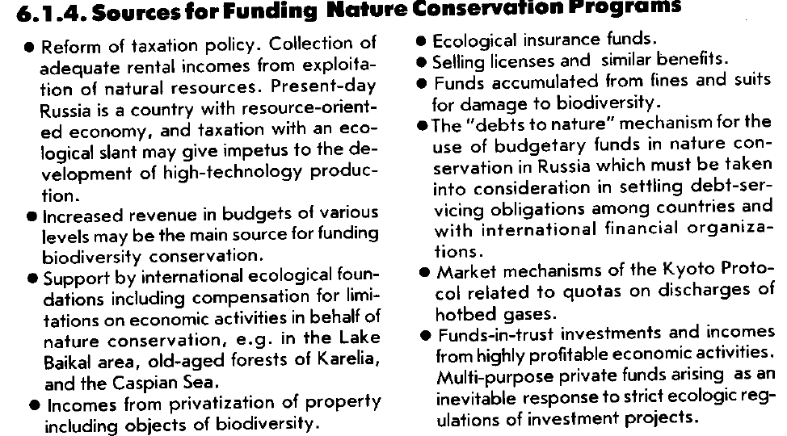

Serbia

4.2.2 Protected Area System
Financing
Objective 2.2: Ensure the availability of sufficient financial resources for maintenance and expansion of the PA system of the Republic of Serbia, while enhancing the long-term financial sustainability of the system.
Activities:
1) Conduct national level PA financial analysis;
2) Develop a sustainable PA system financing plan;
3) Prepare guidelines for the development of individual PA financial plans;
4) Prepare or update individual PA financial plans;
5) Provide and maintain sufficient resources, including trained staff, to implement management plans;

4.4.4 Financial frame work
Objective 4.4: Strengthen and expand financing for biodiversity conservation and provide incentives for biodiversity conservation within all sectors.
Activities:
1) Research and develop financial and other incentives for biodiversity conservation in all relevant sectors (e.g., tax deductions for conservation easing, biodiversityfriendly or organic farming in areas surrounding Pas, combined with promotion of organic products as a value-added approach to increasing income from such strategies; value-added activities in areas surrounding PAs ,such as sustainably harvested non-timber forest products);
2) Diversify funding for biodiversity conservation at all levels and in all sectors by seeking funding from a range of public and private sources, bilateral and multilateral donors;
3) Incorporate expenditure and revenue projections resulting from biodiversity conservation (economic valuation) into the budgets of relevant institutions;
4) Strengthen the capacities of MESP, PSEPSD, INC, PINC, local authorities and PA managers to find funding for biodiversity conservation activities (e.g., training in the preparation of proposals and implementation of projects financed by bilateral and multilateral donors);
5) Increase contributions from the National Environmental Protection Fund for biodiversity conservation projects;
6) Promote the financing of biodiversity conservation programmes and activities within the private sector.

4.11.1 Financing g the Strategy
Objective 11.1: Ensure a diverse portfolio of sources and strategies for the long-term funding of the Strategy. Ensure that the costs of biological diversity conservation are shared equitably among institutions and stakeholders so that they reflect contributions to degradation and benefits from protection or use.
Activities:
1) Develop a strategic financial plan to fund the implementation of the Strategy that identifies a diverse range of funding sources (in-country and international, private and public) and strategies for ensuring longterm implementation, monitoring and refinements of the Strategy and coordination with other relevant strategies and policies. The financial plan should provide a multi-year budget that includes:
•.Anticipated costs of priority activities of the Biodiversity Strategy of the Republic of Serbia;
•.Amount of funding that can be expected for implementation from the national government’s budget;
•.Identification of additional fundraising opportunities associated with sustainable activities depending on biodiversity (tourism, sustainable sport fishing and hunting, scientific tourism etc.);
•.Mechanisms for collecting revenue from these activities (e.g. annual rent, permit fees, visitor entrance fees, levies for utilities etc.);
•.Mechanisms to ensure that revenue collected will be channelled to the correct agency and used to implement the Strategy and its relevant activities.
2) Incorporate expenditure and revenue projections resulting from the implementation of the Strategy into the budgets of relevant institutions.

TFYR Macedonia
The Action Plan encompasses specific activities which should be realized in order to achieve the Overall Aim and the Guiding Objectives enumerated within the Biodiversity Strategy for Macedonia. During the next five years, the Republic of Macedonia should implement the provisions for conservation and sustainable use of biodiversity in accordance with the Strategic Principles outlined in the Biodiversity Strategy (Section 6.1.3.). On the basis of the Strategic Principles, Strategic Approaches have been developed. Each Strategic Approach consists of a series of actions and more specific activities. The actions may be considered as generic items to be accomplished, without specifying how they should be done. In contrast, the activities explain how an action will be achieved, including details. Within the Biodiversity Action Plan for Macedonia, the following Strategic Approaches have been developed:

A. In-situ conservation
B. Ex-situ conservation
C. Sustainable use of biodiversity
D. Institutional improvement
E. Investigation and monitoring
F. Public awareness and education
G. Impact assessment
H. Incentive measures
I. Legislation
J. Financial resources for implementation of the BSAP
K. Co-ordination and implementation of the BSAP
EachofthelistedactivitiesiscorrelatedwithothercloselyassociatedactivitieselsewhereintheActionPlanandGuiding
Objectives.Duration,estimatedbudget,outputs,andpriorityarealsoprovided.Allofthesedataarepresentedin separate
columnsinthetabularActionPlanandareexplainedbelow:
NumberoftheActivity:
NameoftheActionorActivity:
RelatedActivities:
RelatedGuidingObjectives:
Duration:
Estimated Budget:
Inthefirstcolumn,auniquecodeforeachactivityisgiven.
Abriefheadingordescriptionofeachactionoractivityisshown.
Inthiscolumn,othercloselyassociatedactivities elsewhereintheActionPlanareindicated.This
informationallowscross-referencingwithotherrelatedactivitieswhichcouldhaveajointimplementationorjointbudget.
Thiscolumnindicatestowardwhichoftheguidingobjectiveseachactivityisexpectedto
contributeinordertoachievetheoverallaimoftheStrategy.Thenumbersinthiscolumncorrespondwithtothenumbe ring
oftheGuidingObjectivesinsection6.1.2.
Thiscolumnindicateswheneachactivityshouldtakeplaceduringthefiveyearimplementationperiod(2004-
2008)oftheActionPlan.When"2004->"ispresentinthiscolumn,itindicatesthattheactivitywilllastlongerthan the
durationoftheActionPlan.
The estimated budgetary categoryforeachparticular activity is indicated in this column. These
categoriesareapproximatelyasfollows:
• Category I (indicates a budget of up to US$100,000)
• Category II (indicates a budget in the range of US$100,000-US$500,000)
• Category III (indicates a budget over US$500,000)
 | Estimated budgets I | II | III
StrategicApproachA  IN-SITUCONSERVATION | 14I | 31II | 8III
StrategicApproachB  EX-SITUCONSERVATION | 2I | 10II | 5III
StrategicApproachC  SUSTAINABLE USEOFBIODIVERSITY | 4I | 8II | 3III
StrategicApproachD  INSTITUTIONALIMPROVMENT | 7I | 10II | 16III
StrategicApproachF  PUBLICAWARENESSANDEDUCATION | 8I | 4II
StrategicApproachG  IMPACTASSESSMENT | 2I | 2II
StrategicApproachH  INCENTIVEMEASURES | 4I | 3II
StrategicApproachI  LEGISLATION | 28I | 10II
StrategicApproachJ  FINANCIALRESOURCESFORIMPLEMENTATIONOFTHEBIODIVERSITYSTRATEGYANDACTIONPLAN(BSAP)* | 8I
StrategicApproachK  CO-ORDINATIONANDIMPLEMENTATIONOFTHEBSAP | 16I

Ukraine


