Eastern Europe: National Reports

Country | National Reports | Date of submission | Note
Albania | 5th | May 2014 | no
Armenia | 5th | September 2014
Azerbaijan | 5th | April 2014
Belarus | In Russian
Bosnia and Herzegovina | 5th | May 2014
Georgia | 5th | October 2015
Montenegro | 5th | March 2014 | no
Republic of Moldova | 5th | 2013
Russian Federation | 5th (mainly in russian)
Serbia | 5th | August 2014
TFYR Macedonia | 5th | 2014
Ukraine | 5th | April 2015

Albania

Armenia
Target 20: By 2020,at the latest, the mobilization of financial resources for effectively implementing the Strategic Plan for Biodiversity 2011-2020 from all sources, and in accordance with the consolidated and agreed process in the Strategy for Resource Mobilization, should increase substantially from the current levels. This target will be subject to changes contingent to resource needs assessments to be developed and reported by Parties

In Armenia in order to reduce the negative impact on environment and ensure efficient use of natural resources, in addition to financial resources allocated from the state budget annually, a system of economic mechanisms is functioning on the basis of the RA Law on Environmental and Nature Use Fees. It has significantly increased the incomes to the state budget of the country from environmental and nature use fees as well as in some cases the scales of impact on environment have been reduced. Thus, in 2013 the incomes to the state budget from environmental and nature use fees increased about 2,7 times in comparison with 2009.

The incomes to the state budget from environmental and nature use fees establish favorable conditions for mobilization of financial resources for implementation of programs and measures to tackle environmental problems in the country as well as for increased financing.

In recent years, the problems of target use of environmental and nature use fees have been tackled in Armenia through the following:

1. Respective amendment of the RA Law on the RA Budget System (which entered into force in 2011) has stated that “The expenses envisaged by the annual state budget for environmental programs for each year cannot be less than the sum of actual incomes from environmental and nature use fees of the budget two years ago”.
2. Expansion of the limits of enforcement of the RA Law on Target Use of Environmental Fees Paid by Companies. In the frames of the law enforcement the environmental fees paid by large mining companies are allocated to affected communities to finance environmental and public health measures. In the frames of implementation of the RA state budget during 2004-2012, the amount of subventions allocated for implementation of environmental programs in 2004 was 131.4 thousand AMD and in 2012 it reached 277.1 thousand AMD. At the same time since 2012 twenty six communities have been using the right to get respective subventions for implementation of environmental programs.
3. Establishment of environmental funds, in particular:
• In 2004 by the decision #891-N of the RA Government (10.08.2004) the Forest Rehabilitation and Development Fund was established with the main aim to support rehabilitation of forests in Armenia and create favorable conditions for development of forests in Armenia.
• Since 2005 the Fund on Environmental Protection has been functioning with accumulation of respective guaranteed amounts for implementation of works on reclamation, leveling, landscaping, planting and construction works in the areas damaged due to mining activities. As of 01.04.2013 more than 422.5 mln AMD has been already accumulated in the fund.
• Since 2005 the Target Environmental Fund has been functioning, which is an extra-budgetary account. In the period of 2005-2012 thanks to voluntary contributions, donations and fund-raising by legal and physical persons of the Republic of Armenia more than 300 mln AMD has been transferred to the fund, which has been used for implementation of a number of important environmental programs and measures.
• In 2011 by the decision #517-N of the RA Government (28.04.2011) the Foundation on Lake Sevan Restoration, Protection and Development was established with the aim to support mobilization of necessary resources for restoration, reproduction, protection, natural development and use of Lake Sevan as the strategic reserve of freshwaters in the Republic of Armenia as well as for securing water cleanness.

The mentioned activities at national level allow mobilization of necessary financial resources for tackling environmental problems, including biodiversity conservation. At the same time, different structures in Armenia (RA ministries, institutions of higher education, international organizations) implement numerous projects (see section 2.3), which either are fully aimed at biodiversity and ecosystem conservation and improvement of management or have such a component. During 2010-2013 the Caucasus Nature Fund has allocated about 400 mln AMD of extrabudgetary additional funds to specially protected nature areas, including 53.6 mln AMD in 2010, 92.8 mln AMD in 2011, 91.4 mln AMD in 2012 and 182.7 mln AMD in 2013. The projects implemented in SPNAs of Armenia with respective financing are presented in the table below.

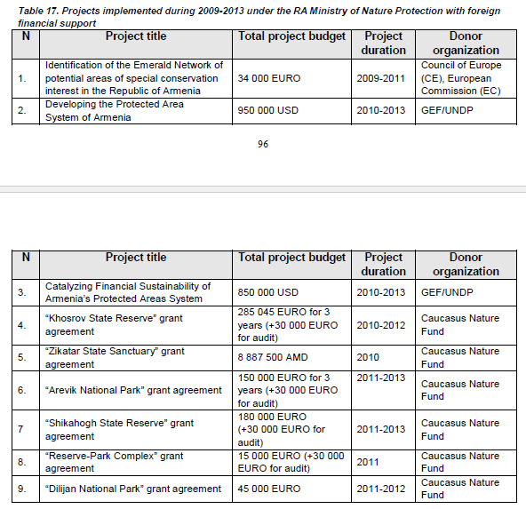
In conclusion it can be stated that the Aichi Biodiversity Targets have been implemented in Armenia at state level with active participation of civil society and the outcomes of their implementation during 2009-2013 in general have had a positive impact in terms of solving biodiversity problems.

Azerbaijan

Belarus

Bosnia and Herzegovina
22. By 2020, a strategy for mobilization of financial resources at all relevant levels has been developed and implemented. | ▪ ODA funds aimed at conservation and sustainable use of biological diversity.
3.3.2 Financial Mechanisms for the Implementation of the Convention

In accordance with Articles 20 and 21 of the UNCBD, which are related to the sources of financing and the funding mechanisms for the implementation of the Convention, it is necessary to establish a financial resources mobilisation system, in order that national objectives could be accomplished and biodiversity-related activities implemented.

At present, there are entity-level environment protection funds in BiH: the Environmental Protection and Energy Efficiency Fund of the Republika Srpska, and the Environmental Protection Fund of the Federation of BiH regulated by the Law on the Fund and the Financing of Environment (Official Gazette of RS, No. 117/11), that is, the Law on the Environmental Protection Fund (Official Gazette of FBiH, No. 33/03), as well as by other bylaws. However, these legal documents are not sufficient for financing the activity of the respective Funds. Their activities include: collecting and allocation of financial resources for environment protection in the territory of the respective entities; and support and financing of the preparation, development and implementation of programmes, projects and similar activities in the field of conservation, sustainable use, protection, and improvement of the state of environment.

Activities of Bosnia and Herzegovina in the field of sustainable natural resources management have been supported to date mostly through financial resources of the above-mentioned Funds and relevant ministries, through implementation of important projects and through international donors’ funds. International donors have been financing the implementation of projects in the environment protection, agriculture, and forestry sectors, which have positive effects on conservation of biological diversity. Donors active in the environment protection sector regularly take part in the Donor Coordination Forum (DCF) meetings organized by the Ministry of Finances and Treasury / Sector for Coordination of International Economic Assistance. When it comes to the forestry sector, there is no formal coordination mechanism at the level of BiH. The DFC members, active in the environment protection sector in 2011 and 2012 include: the EU/EC, UNDP, World Bank, Germany, Italy/IC, Check Republic, Norway, and the Netherlands. Active donors in the agriculture and forestry sector in the same period are: USA/USAID, World Bank, Sweden/SIDA, EU/ECOSYSTEMS, Italy/IC, Check republic, Japan/JICA, and Norway.

Although there are certain local and international financial resources set aside for sectors assisting in conservation of biological diversity, it is still necessary to establish an adequate financial mechanism for the implementation of the Biodiversity Strategy and Action Plan.

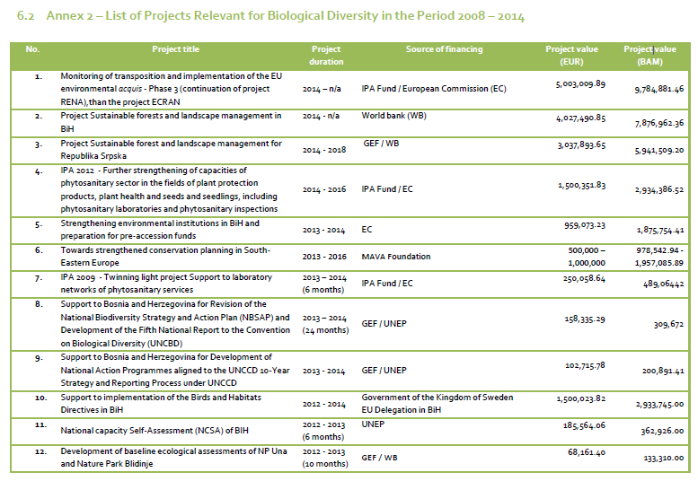
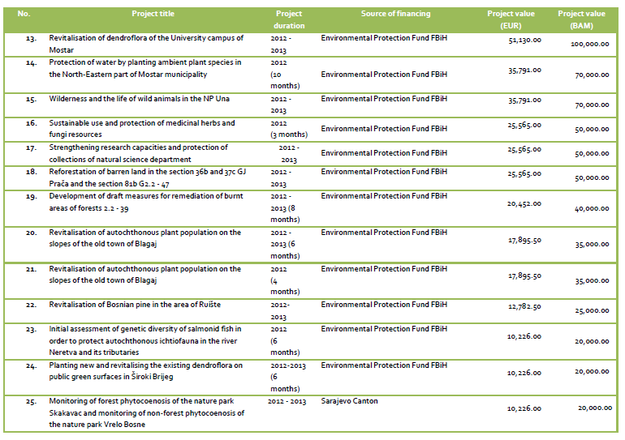
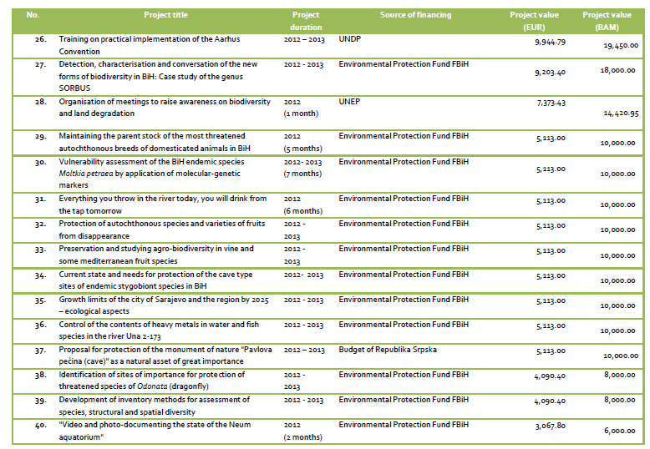
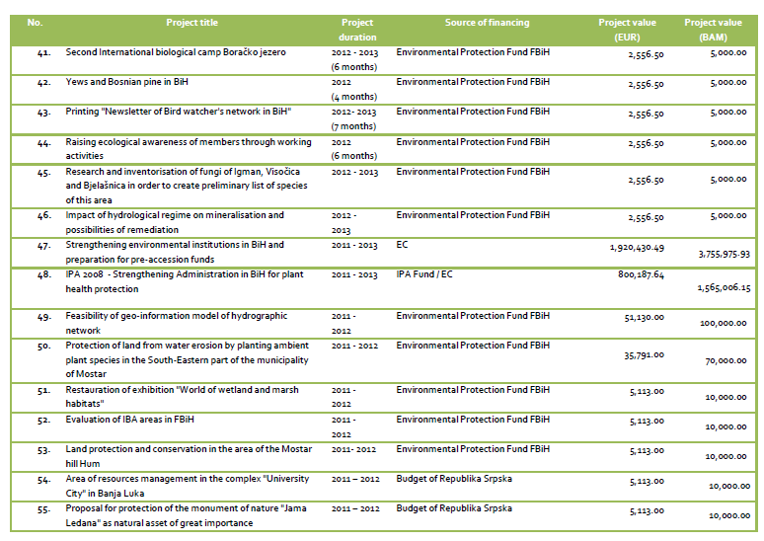
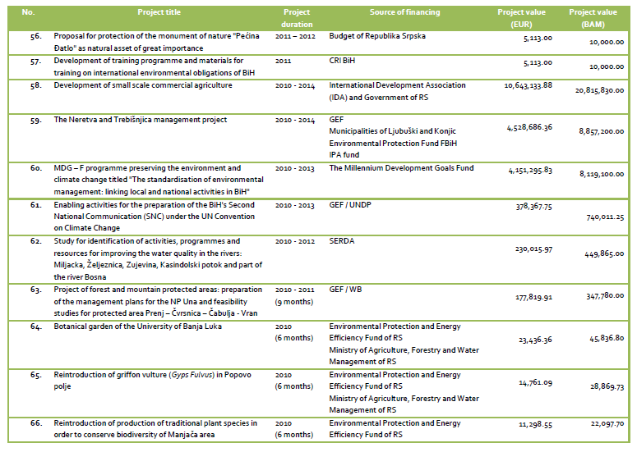
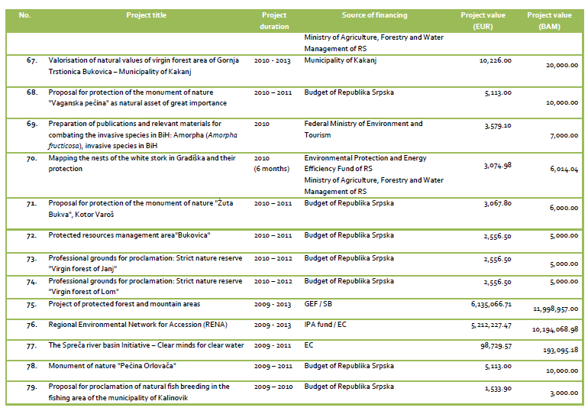
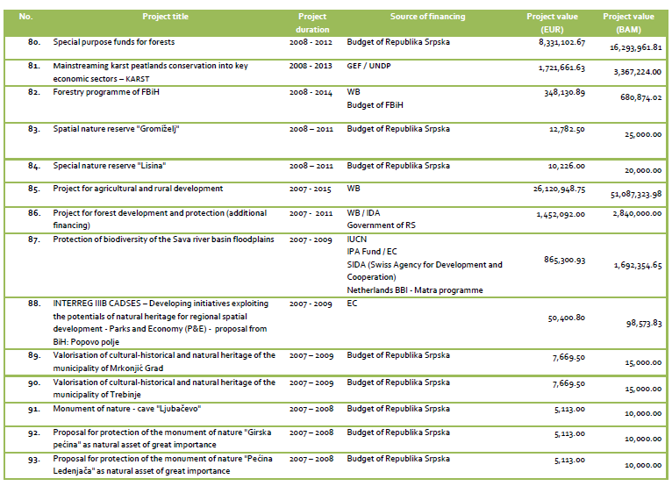
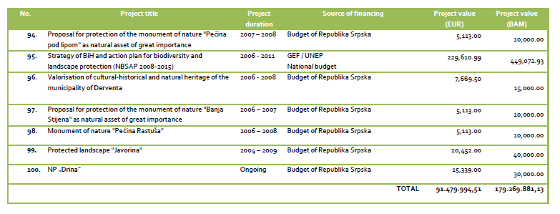

Georgia
Target 20
Development of resource mobilization strategy is planned for NBSAP implementation.
Within the period of 2011-2013, allocations for nature conservation from the state budget have increased by GEL 9640,3 thousand, though they have decreased as against the assignments of the year 2010.
During 2006-2013, financial resources allocated for nature conservation purposes barely exceeded 0,2% of the state budget.
Assistance of donor countries and organizations plays significant part in biodiversity conservation, and constitutes approximately 20% of such expenditures.
(Source: Biotrends, Reuslts of the NBSM, Indicator R7- financial resources for nature conservation;
http://biomonitoring.moe.gov.ge/)

Montenegro

Republic of Moldova

Russian Federation
The financial base for biodiversity conservation measures is flow of funds for their implementation from budgets of different levels. The sources of these funds are payments (taxes, commissions) for natural resource use and environment pollution. Total expenditures on environmental protection in the Russian Federation from all funding sources (federal, regional, local budgets, funds from enterprises, etc.) include investments in fixed capital and on-going expenditures on environmental protection, expenditures on major repair of fixed assets, expenditures on state nature reserves and national parks maintenance, protection and restoration of wild animals, costs of wild fire extinguishing and other expenditures (Tab. 23).

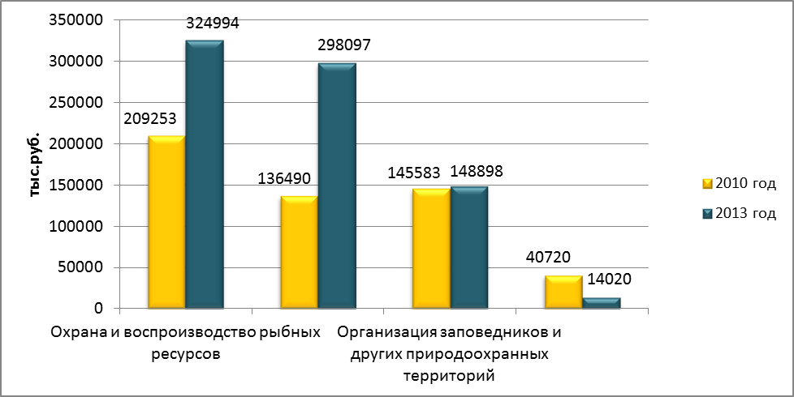 Рис. 23.Инвестиции в основной капитал, направленные на сохранение биоразнообразия (по данным формы государственной статистической отчетности Российской Федерации)

Serbia
NR4
3.2.1. Funding systems in Environment Protection
System of financing environmental protection in the Republic of Serbia is decentralised and counts on dedicated funds, own resources, and budget resources.
Other sources of financing include municipal budgets, industrial financial resources, public enterprises financial resources, and foreign financial aid. General characteristics of the system of financing environmental protection are the insufficiency of dedicated funds and decentralisation of financing sources, particularly from the private sector, as well as the lack of application of financial instruments such as long-term loans, securities, partnership between public and private sector, or investment in stocks.
Proportional investment of dedicated funds for environmental protection related to the realised gross domestic product in 2001 and 2008 was 0.3%. Other countries in transition assign around 2% of GDP for environmental protection.
Funds for environmental protection at the republic level come form taxes for commercial collecting and trading of wild flora and fauna, taxes for environmental pollution equalling 60%, taxes for environmental pollution in areas of particular national interest equalling 80%, taxes for water protection, and funds approved by the Law on Budget of the Republic of Serbia.
The Fund for Environmental Protection was established in 2005, in keeping with the Law on Environmental Protection, for the purpose of securing financial resources for stimulation of environmental protection and improvement in the Republic of Serbia.
The budget funds of the autonomous province and local governments are imposed.
The most active donors and international financial institutions that provide financing of environmental protection include: the EU, the World Bank, the European Bank for Reconstruction and Development, and bilateral donors.

NR5
OBJECTIVE 2.2. Provide availability of financial funds for the maintenance and expansion of the protected areas system in the Republic of Serbia, together with the strengthening of longterm financial sustainability of the system
- Within the UNDP/GEF project “Ensuring financial sustainability of the protected area system of Serbia”, a financial analysis of individual protected areas has been performed in cooperation with the managers of the protected areas, as a basis for the elaboration of the Plan for sustainable financing of protected areas system in Serbia;
- A financial analysis of protected areas on the territory of AP Vojvodina is implemented at the beginning of the calendar year in order to identify the amounts required for co-financing of project activities;
- Financial plans are enacted in conformity with medium-term plans and annual management programmes

OBJECTIVE 4.4. Strengthen and expand the financing of the conservation of biodiversity and provide incentives for the conservation of biodiversity within all sectors
- During preparation of the Action plan for the realization of priorities for the Development programme of AP Vojvodina 2014-2020, the activities and sources of financing for the projects in the area of environmental protection have been stated;
- In conformity with the Law on Incitements in Agriculture and Rural Development (“The Official Gazette of the Republic of Serbia”, No. 10/2013), the Rules on Incentives for the Conservation of Animal Genetic Resources (“The Official Gazette of the Republic of Serbia”, No. 83/2013) and the Rules on Incentives for the Conservation of Plant Genetic Resources (“The Official Gazette of the Republic of Serbia”, No. 85/2013) have been enacted;

TFYR Macedonia
2.3.1.4. Fundin g
According to the Law on Nature Protection, the funds for nature protection are provided from the Budget of the Republic of Macedonia and from other sources (Article 161 of the Law on Nature Protection): budgets of the units of local self-government on the territory of which the protected area is situated, compensations for entrance, visit, parking, collection of wild species of plants, fungi and animals and parts thereof, sustainable use of natural resources, compensation for stay, navigation, ecosystem services, performance of activities in protected areas and other sources (donations, grants, credits, etc.). The funds from these sources are used for achievement of the goals of nature protection.

For the purpose of efficient implementation of the Law on Nature Protection in the segment of financial resources provision from the collection of compensations in the National Parks, Public Institutions National Parks of “Pelister”, “Galichica” and “Mavrovo”, in 2013, took decisions determining the level of compensations in the national parks, but their application has not become operational yet.

The National Strategy for Environmental Investments (2009-2013) was developed in 2009 by the Ministry of Environment and Physical Planning in cooperation with Regional Environmental Center (REC) Country Office in Macedonia, with the financial support from the Austrian Development Agency. In its chapter on nature protection, investments (implementation of projects) are envisaged towards implementation of the EU legislation in the area of nature protection (Bird and Habitat Directives, Regulation on endangered species and Directive concerning wild animals keeping in captivity), as well as implementation of international conventions (Convention on Biological Diversity, Bern Convention, Bonn Convention on biodiversity and CITES. The value envisaged for allocation is 7.67 million EUR from different sources: central budget, EU pre-accesion funds (IPA funds), and other donors. The identified 185 projects (incorporated in the existing strategies in the Republic of Macedonia) and high number of local initiatives (grouped into 9 clusters) has been ranked on the basis of 15 criteria.

Three major projects have been identified for funding, namely: establishment of National Park“Jablanica”, establishment of National Park “Jakupica”, and project for nature conservation and sustainable development of Osogovo.

Starting in 2007, the Government of the Republic of Macedonia (on the basis of Article 172 of the Law on Environment) adopts Programme for Environmental Investments every year (except in 2009 and 2012), under which funds are awarded to fund programmes, projects and other activities in the area of environment. The funds for the implementation of this Programme are provided from compensations paid by legal and natural persons causing pollution of the environment, using natural resources, producing or importing products and goods that are harmful for environment and nature, etc., or from the Budget of the Republic of Macedonia, international cooperation, national and foreign legal and natural persons, foundations, etc. (specified in Article 162 of the Law on Environment). Allocation of funds is carried out on the basis of public competition published by the Ministry of Environment and Physical Planning.

Beneficiaries of these funds are: municipalities or associations of municipalities, legal and natural persons, non-for-profit and non-governmental organizations (including universities and other scientific institutions), non-governmental organizations established for the purposes of environment protection that implement programmes, projects and other activities for environment and nature protection and improvement. In the past period, total of 36.000.000.00 MKD was allocated under the item for implementation of projects aimed at biological diversity and nature protection (see Table 11). The Investment Programme includes, inter alia, items for financial support for scientific research work and public awareness increase and education, through which projects in the area of nature and biological diversity protection are supported, too. The most important projects for nature and biological diversity protection implemented under this Programme are presented in AnnexII.

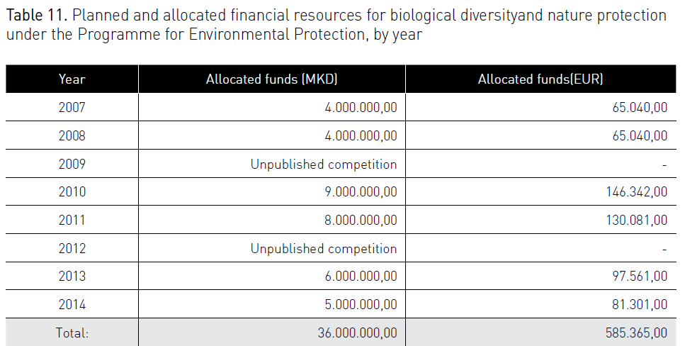

Activities for nature protection in the Republic of Macedonia are to the greatest extent financed by foreign funds, such as: Global Environmental Facility, EU Funds, and donations/grants from other countries, among which Switzerland, Germany, Netherlands, Austria, Italy and other countries have provided the most significant support. Annex II gives a list of significant implemented or ongoing projects for biological diversity protection in the past period.

As part of the cross-border cooperation programme between Macedonia and neighbouring countries Albania, Bulgaria and Greece, financed by the EU Instument for preaccesion (IPA) in the period 2007-2013 different projects regarding conservation of nature and biological diversity were financed.

Ukraine
Target 20: By 2020, at the latest, the mobilization of financial resources for effectively implementing the Strategic Plan for Biodiversity 2011-2020 from all sources, and in accordance with the consolidated and agreed process in the Strategy for Resource Mobilization, should increase substantially from the current levels. This target will be subject to changes contingent to resource needs assessments to be developed and reported by Parties.

Awareness of biodiversity value is continuously being reflected in financial systems; a number of international technical assistance projects focused on conservation and efficient use of biodiversity increases. However, inclusion of biodiversity issues into financial flows is progressing too slowly against the pace of its loss.

