Latin America and the Caribbean: national biodiversity strategies and action plans

Country | Version of NBSAP | Date of development | Note
Antigua and Barbuda | NBSAP draft | April 2001
Argentina | 0
Bahamas | NBSAP | June 1999
Barbados | NBSAP | July 2002
Belize | NBSAP | September 1998 | Detailed costs, very long, not reproduced
Bolivia | NBSAP | 2001
Brazil | First version |  | Not available electronically
Chile | NBSAP | December 2003
Colombia | National Policy for the Integral Management of Biodiversity and its Ecosystem Services | 2010
Costa Rica | National biodiversity Strategy | 2000
Cuba | Plan De Acción Nacional 2006/2010  Sobre La Diversidad Biológica | 2006
Dominica | NBSAP 2014-2020 | December 2013
Dominican Republic | Plan De Acción 2011-2020 | 2011
Ecuador | Política y Estrategia Nacional de Biodiversidad del Ecuador  2001 - 2010 | 2001
El Salvador | National biodiversity strategy | 2013
Grenada | NBSAP | July 2000
Guatemala | Estrategia Nacional De Diversidad Biológica Y Su Plan De Acción 2012-2022 | 2013
Guyana | NBSAP 2012-2020 | May 2015
Haiti
Honduras | NBSAP | 2000
Jamaica | NBSAP | July 2003
Mexico | Estrategia Nacional sobre biodiversidad de México 2000 | NA | NA
Nicaragua | NBSAP | old
Panama | NBSAP | 2000
Paraguay | NBSAP 2004-2009
Peru | ESTRATEGIA NACIONAL DE DIVERSIDAD BIOLÓGICA AL 2021  Plan de Acción 2014 - 2018 | November 2014
Saint Kitts and Nevis | NBSAP | 2004
Saint Lucia | NBSAP | 2000
Saint Vincent and the Grenadines | NBSAP | 2000
Suriname | NBAP  2012-2016 | February 2013
Trinidad and Tobago | NBSAP | 2001
Uruguay | NBSAP | 1999
Venezuela | NBSAP 2011-2020 | May 2012

Antigua and Barbuda

Argentina

Bahamas
4.7 Financial Resources and Mechanisms
Bahamian society, its economy and standard of living depend on the environment and its resources, but there are few mechanisms to ensure that the necessary financial resources to maintain the environment are assured.
Therefore, it is recommended that:
4.7.1 A National Conservation Fund be established for biodiversity conservation.
4.7.2 A user-pays policy be defined, legislated and introduced.
4.7.3 Appropriate national resources for the implementation of this Strategy and Action Plan be determined and committed as appropriate.
4.7.4 External multi-lateral, bi-lateral and private sector sources of financial and other support for the implementation of this Strategy and Action Plan be identified and secured.
4.7.5 National decision-making procedures that incorporate environmental accounting and cost-benefit analysis be developed and adopted.

Action One: Establishment of the Bahamas Environment, Science and Technology Commission as a legal entity | $798,400
Action Two: Establishment of the National Biodiversity Task Force and Preparation for National Consultative Process | $217,250
Action Three: The National Consultative Process | $639,100
Action Four: Implementation of the Recommendations of the Biodiversity Data Management Project | $639, 100
Action Five: Preparation of Bioregional Guidelines, Position Papers and Policy Statements | $363,000
Action Six: Planning for a System of National Parks and Protected Areas
Action Seven: Development of Monitoring and Evaluation Methodologies
Action Eight: Protection or Rehabilitation of Threatened or Degraded Ecosystems and of Threatened Species
Action Nine: Improvement of the Botanic Gardens to Enhance its Capacity for Ex Situ Conservation

Barbados
Objective 1: To mobilize adequate financial resources for the management and conservation of Barbados’ biodiversity
Strategy: Develop mechanisms for funding the conservation and management of biodiversity, ensuring that the costs of protection are equitably shared.
Actions
1. Define and implement a specific mandate for negotiating with financial and technical assistance agencies in the regional and international arenas to fund NBSAP project priorities. This initiative will entail creating and filling the positions of Fund Raising Specialist and Assistant in the Ministry responsible for the environment. The responsibilities would include the submission of suitable projects to the Global Environment Facility. [H]
2. Allocate additional Government funds for biodiversity conservation and management.
3. Establish appropriate user fees for biodiversity resource users (for example, hoteliers, fisherfolk, SCUBA operators, tour operators).
Implementing Institutions and Agencies
Ministry of Physical Development and Environment

Belize

Bolivia
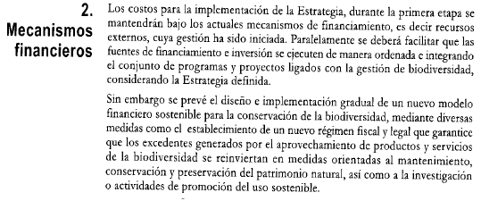

Brazil

Chile
8. To consolidate the FUNDING mechanisms required for adequate conservation of the biodiversity.
a) Define the requirements needed to create a biodiversity conservation fund.
b) Establish tax benefits and other incentives for donations towards biodiversity conservation.
c) Create the necessary conditions for incorporating into official protected areas those tracts of land resulting from the compensation mechanism of the present Environmental Impact Assessment System, as a way of increasing the National System of Protected Wilderness Areas.
d) Study and promote the adoption of new mechanisms for funding conservation, such as payment for environmental services and biodiversity and the implementation of tradable permit schemes.
e) Encourage the creation of public-private agreements and international cooperation pacts for funding biodiversity conservation.
f) Extend tax benefits to include donations for the purpose of biodiversity conservation and for contributions and donations to the Environmental Protection Fund.

1. Asegurar la CONSERVACIÓN Y RESTAURACIÓN DE LOS ECOSISTEMAS de manera de reducir de forma importante el ritmo actual de pérdida de la diversidad biológica antes del 2010. | 4.932.563.594
2. Asegurar la preservación de ESPECIES Y DEL PATRIMONIO GENÉTICO | 306.392.672
3. Promover las PRÁCTICAS PRODUCTIVAS SUSTENTABLES que aseguren el mantenimiento de la biodiversidad | 7.240.298.549
4. Fortalecer la COORDINACIÓN INTERINSTITUCIONAL E INTERSECTORIAL para la gestión integral de la biodiversidad | 873.385.400
5. Establecer los MECANISMOS FORMALES Y NO FORMALES requeridos para asegurar una óptima gestión de la biodiversidad | 264.491.000
6. Fortalecer la EDUCACIÓN AMBIENTAL, LA CONCIENCIA PÚBLICA Y EL ACCESO A LA INFORMACIÓN en el ámbito de la biodiversidad. | 997.222.422
7. Fortalecer y coordinar la INVESTIGACIÓN que permita mejorar el conocimiento sobre conservación y uso sustentable de la biodiversidad | 108.056.000
8. Consolidar los mecanismos para el FINANCIAMIENTO requerido para la conservación de la biodiversidad | 557.000
Monto Involucrado ($) | 14.722.966.637

Colombia
AVAILABILITY OF AND CRITERIA FOR THE ALLOCATION OF FINANCIAL RESOURCES (DCARF)
The analysis of the factors showed that the State does not destine sufficient economic resources for the management of the public institutions directly responsible for environmental policy and the management of biodiversity. The financial resources allocated by the State are mainly concentrated on strengthening and developing economic and sectorial policies which promote activities like mining, energy development, agriculture and infrastructure, among others, enabling these sectors to be strengthened, often to the detriment of the ecological basis of the territories. Nevertheless, the insufficiency of financial resources for the conservation of biodiversity and its ecosystemic services may be worsened by the deficient assigning of priorities for and channeling of resources into investment, which strengthens the feeling, among the actors associated with environmental management, that the resources are too meager to produce an important positive effect on the Result Factors (Figure 12). Additionally, this financial allocation does not take into account the valuation that society might make of biodiversity, with the aim of establishing priorities, an aspect which encourages a situation where the sectors which make use of biodiversity still do not measure its strategic value, nor integrate this value into their processes for planning, production, management and allocation of resources.

In numerical terms, the main contribution to the financing of environmental management has been that of the different national sources --the national government, the regional and municipal environmental authorities and the territorial entities – which represents a little more than 90% of the country´s spending in this field of policy in the past decade. Spending on the functioning of and investment in State environmental agencies between 2002 and 2008p, seen in terms of government spending on environmental protection (GPA), rose from 3.394 billion pesos in 2000 to 6.436 billion pesos in 2007, which means that it rose from 0.33% of the GDP in 2000 to 0.42% in 2007 (DANE 2010). In addition, total public spending (current and investment) on environmental protection in Colombia rose from 695.237 billion pesos in 2000 to 1, 791.183 billion in 2007 (DANE 2010). However, Colombian public spending on the environment continues to fall below international standards; for example, environmental spending represents 1% of the GDP in Mexico and Brazil. Nevertheless, with the new allocation of resources from the National Royalties Fund (10%) to finance projects of science, technology and innovation, the country´s investment in these areas may rise and come very close to 1% of the national GDP.
In Colombia environmental investment between 2006-2010 represented 12% of the resources allocated by the Nation´s General Budget (PGN) to the sector of Environment, Housing and Territorial Development, now the sector of Environment and Sustainable Development (MAVDT 2010c). Total environmental investments for the period were 579.786 billion pesos, having risen from an investment of 76.512 billion in 2006 to 146.244 billion in 2010. In this sense, the effort to protect the environment is ever more strong, insofar as regional and local bodies work at it too, which implies diverse imbalances in their capacities of response, in a context of decentralization and autonomy but with strong budget restrictions on all levels of government and complex dynamics in the reconstitution of territoriality and regional development in the country (Galán and Canal 2002).

The budget allocated by the Nation to research institutes affiliated and linked with the MADS were 112.387 billion pesos between 2006 and 2010 (rising from 14.945 billion in 2006 to 29.248 billion in 2010), which means that total investments in the management of these Institutes in the quadrennial period were 246.453 billion pesos (MAVDT 2010c). In the case of the National Parks Unit (UAESPNN), the total budget for the quadrennium represented a 50% increase, rising from 20.015 billion to 46.821 billion, while the investment budget tripled during the same period, rising from 9.425 billion to 30.278 billion pesos (MAVDT). 3.9 trillion pesos were administered by the Autonomous Regional Corporations between 2007 and 2010. 78% of these resources ($3.1 trillion) were destined for investment programs, with an emphasis on the prevention and control of environmental degradation, strengthening of the SINA in the areas of environmental governability and environmental planning for territorial management (MAVDT 2010c).

Other sources of environmental financing are the National Royalties Fund (FNR) and the Environmental Compensation Fund (FCA). In the first case, the resources allocated to the environmental sector have considerably risen since 2006, going from 246 million pesos to $103.513 billion pesos in 2010. However, most of the resources are focused on coastal protection (6 projects, valued at 47.639 billion pesos, corresponding to 46% of the resources of the FNR) and reforestation projects (52 projects, valued at 33.297 billion pesos, corresponding to 32.2%). Areas like strategic ecosystems, territorial ordering and desertification only received 9.9%, 5.8% and 0.8%, respectively of these resources (MAVDT). The FCA, as a system of redistribution which has allowed for the financial strengthening of the 15 Corporations with small resources, had a budget allocation of $139.712 billion pesos between 2006 and 2010, which were assigned to expenses of functioning (31.264 billion pesos – 24%) and financing 383 projects in 18 Corporations at a cost of 108.737 billions (228 of them Sustainable Development projects and 155 Autonomous Regional ones) (MAVDT 2010c).

In the case of the municipalities, the main resources which they administer that are destined for environmental spending come from the 3% surcharge on the gross earnings of hydroelectricity plants and 1.5% of the gross earnings of thermoelectricity plants. 1% of the municipalities´ current income goes on the purchase and improvement of properties to protect micro-river basins which supply municipal aqueducts (Art. 111, Law 99/93, modified by Art. 210 of Law 1450 of 2011).

With regard to the latter, Rudas (2010) reports that the investment by 447 municipalities and 7 departments, for which information is available on the implementation of the norm since it was established 15 years ago, has had an approximate value of 159 billion pesos (at their current value), whereas if these territorial entities had fully complied with their legal obligation in this matter, the investments should have been 1,27 trillion pesos. That is, these territorial entities only invested 0.12% of their total incomes, according to the available information, as opposed to the 1% laid down by the law (Rudas 2010). With regard to transferences from the electricity sector, they rose to 382.433,4 billion between 2005 and 2009, while the earnings from charging the retributive tax and the tax on water use was 245.567,1 billion pesos and 60.851,8 billion, respectively.

In Colombia one of the most important sources of resources to support the management of biodiversity conservation is international cooperation. In that regard, the Netherlands, Germany, the European Union (through NGOs), the United States (NGOs) and Finland (through the CAN) appear as the country´s most important collaborators in this field in recent years. As of April 2011, the country had 26 such environmental projects in operation, located in 24 departments, with a value of 54,647,526 U.S. dollars, corresponding to 7.36% of total cooperation (Acción Social 2011). Among the most outstanding expressions of this cooperation in recent years we find the Program for Sectorial Focus of the Embassy of the Netherlands, aimed at strengthening the SINA ( at a value of $43.2 billion pesos between 2007 and 2010) in such important areas as environmental planning for territorial management; the integrated management of water resources; knowledge, conservation and use of biodiversity; the promotion of competitive and sustainable processes, and the prevention and control of environmental degradation.

In addition, the Global Environment Fund (FMAM –GEF), which was created to grant donations to developing countries for the realization of projects which benefit the global environment, promote the establishment of sustainable means of life in local communities and support the implementation of the CBD, UNCCD, UNFCCC conventions and the Stockholm Convention on Persistent Organic Pollutants (POPs) has, since 2002, co-financed a total of 29 projects in Colombia, with a total contribution of 100, 245, 929 US dollars. The focal area most represented has been biodiversity, with 19 projects, which received a total contribution from the Fund of $77,339,029 dollars, with national counterpart funds on the order of $123,872,642 dollars.

Table 14. Actions and targets which are a priority in the short term (2014) for the realization of the integral management of biodiversity and its ecosystemic services. These targets are consistent with the proposals for the National Development Plan: 2010-21014
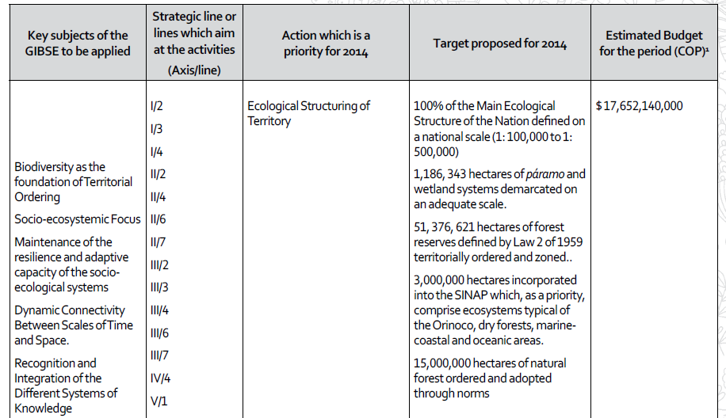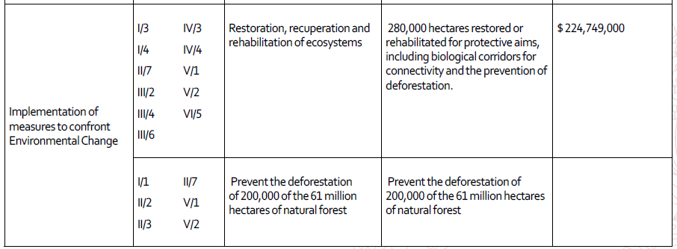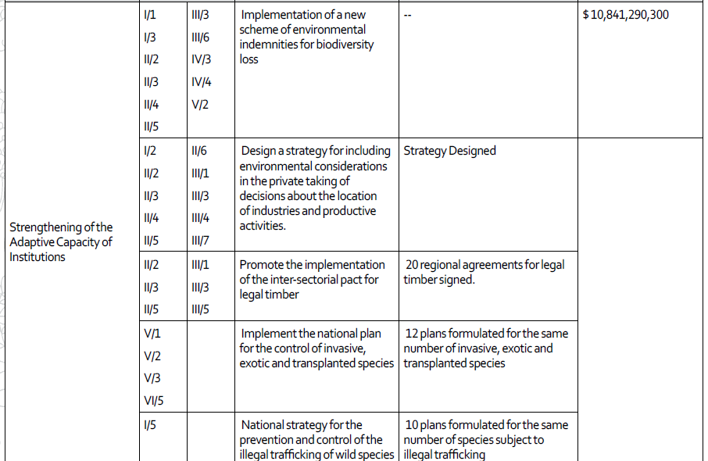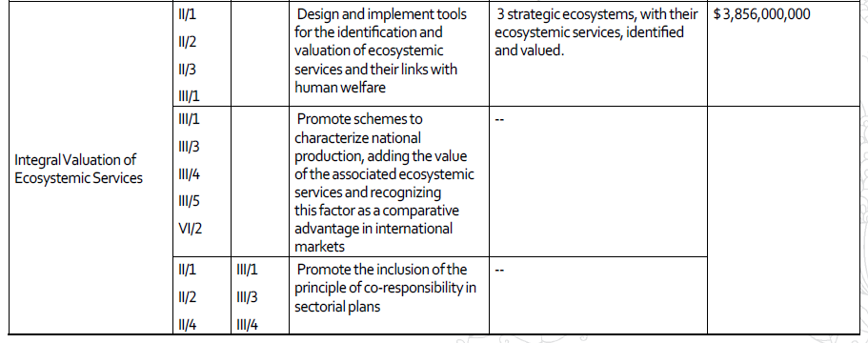

Costa Rica

Cuba

Dominica
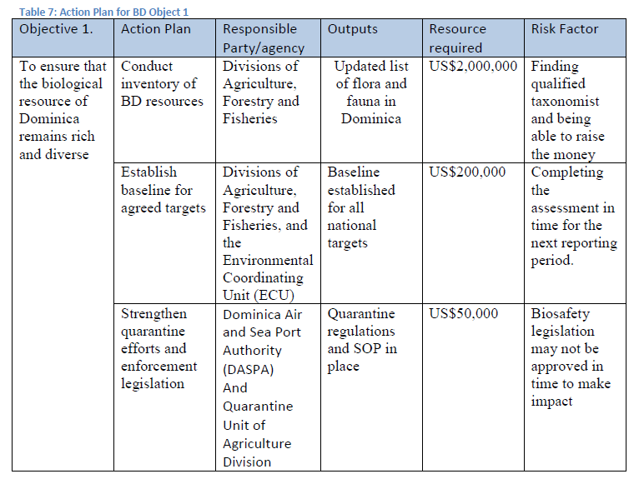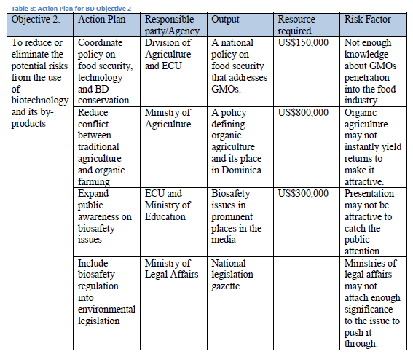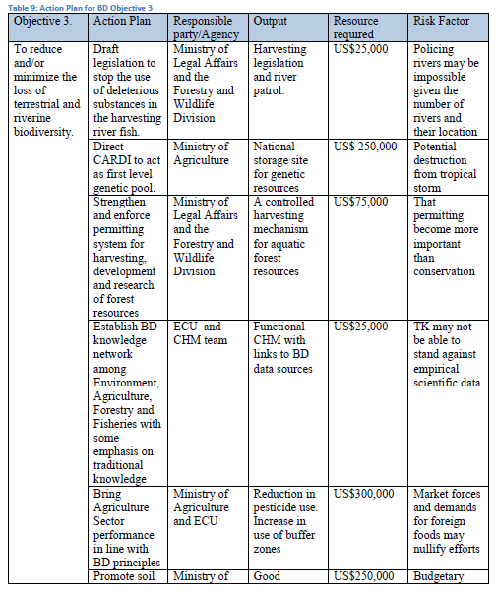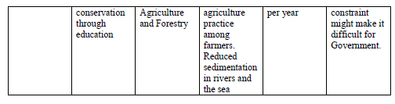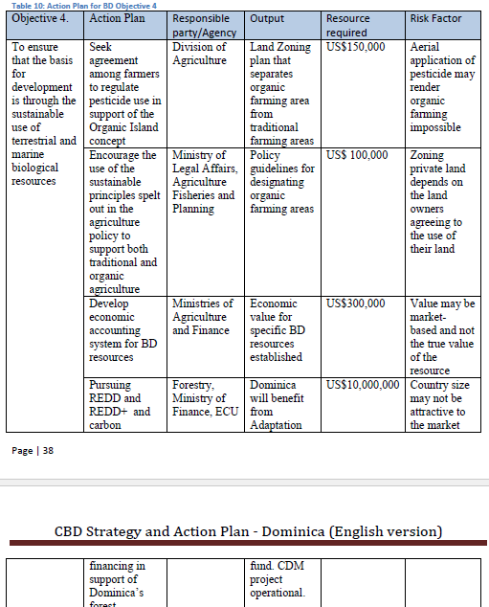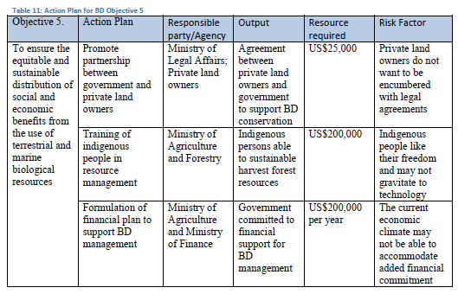

Dominican Republic
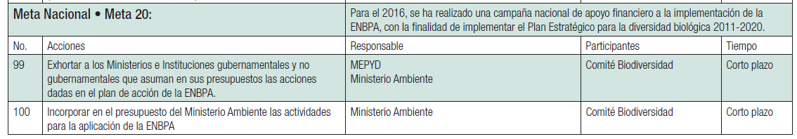
3.10. Presupuesto de gastos e inversiones.
El presupuesto total, incluyendo las instituciones adscritas, es de $4,640.1 millones. El 65% al 70% corresponde al Instituto Nacional de Recursos Hidráulicos (INDRHI), dedicados a fi nanciar obras de infraestructura de riego. El Programa 11 relativo a la conservación de las áreas protegidas y la biodiversidad tiene un presupuesto de RD$159.1 millones (US$4.2 millones). El Programa 12, Subprograma 01, manejo de recursos forestales tiene un presupuesto de RD$325.1 millones y el Subprograma 03 recursos costeros marinos tiene RD$37.2 millones (US$1 millón). El presupuesto del Jardín Botánico es de RD$48.2 millones (US$1.3 millones), el del ZOODOM es de RD$39.8 (US$1.1 millones); el Museo Nacional de Historia Natural es de RD$23.5 millones (US$0.6 millones); y el Acuario Nacional de RD$34.0 millones (US$0.9 millones). La segregación más precisa de los montos exactos del presupuesto nacional y cooperación internacional dedicados a la biodiversidad se difi culta debido a que, prácticamente, en todos los programas del Ministerio se hacen inversiones a favor de la biodiversidad, aún no estén formalmente considerados como tales.

El BID (Garret, 2009) analizó la inversión nacional en medio ambiente encontrando que el presupuesto nacional para el 2008 fue de US$8,289 millones, de los cuales un poco menos del 1% fue dedicado a la protección del medio ambiente. El promedio de la inversión en medio ambiente entre los años 2005 al 2008 fue de US$82.1 millones de los cuales el 90% fueron fondos del Ministerio Ambiente, y el restante 10% de otros Ministerios y la Presidencia de la República. El Plan Nacional Plurianual del Sector Público (PNPSP) indica que la inversión pública programada para el cuatrienio 2010-2013 para el manejo sostenible del medio ambiente sólo es 0.6% del total nacional (Ministerio de Economía, Planifi cación y Desarrollo, 2010).

Bovarnick et al (2010) hacen un análisis de la inversión en áreas protegidas en 19 países de Latino América y El Caribe. En éste los fondos invertidos por la República Dominicana ascienden a US$10.4 millones por año, ocupando el octavo lugar de la región (esto incluye el total de fondos del gobierno central, fondos extra presupuestarios (donantes, fondos especiales, de ONGs, etc.) y fondos generados por el SINAP y reinvertidos en el mismo.

En resumen podemos decir que dados los sistemas fi nancieros y administrativos empleados es difícil conocer con precisión la información sobre la inversión en biodiversidad en el país. Las fuentes principales actuales se basan en la información ofi cial del Ministerio Ambiente, análisis recientes del BID (Garret, 2009), consultoría sobre sostenibilidad fi nanciera del SINAP y el reciente trabajo sobre sostenibilidad fi nanciera de las áreas protegidas de América Latina y El Caribe (Bovarnick et al 2010). De esto se deriva que del presupuesto anual de la nación cerca de un 1% es dedicado a la protección del ambiente, lo que corresponde entre un 0.08 a 0.11% del PIB, y es bajo comparado con otros países de la región. De la inversión total anual para el medio ambiente (US$82 /84 millones) sólo el 4.6% se invierte en conservación de las áreas protegidas y biodiversidad. La inversión anual total en las áreas protegidas de la República Dominicana es de US$10.4 millones, situando al país en el octavo lugar de la región y la inversión anual por hectárea por año es de US$8.43, ocupando el quinto lugar de la región.

Sobre los datos presentados pudiera haber discrepancia, ya que se reporta que para el año 2007 el presupuesto fue de US$10.38 millones, pero sólo se ejecutaron US$6.93, quedando un défi cit de 69%. El Ministerio Ambiente en seguimiento a la Ley General sobre Medio Ambiente ha creado el Fondo Nacional de Medio ambiente y Recursos Naturales (Fondo MARENA), y con la implementación del proyecto FMAM/PNUD/Ministerio Ambiente y fi nanciamiento de TNC y otros socios se espera fortalecer considerablemente la sostenibilidad fi nanciera para la gestión adecuada de la biodiversidad.

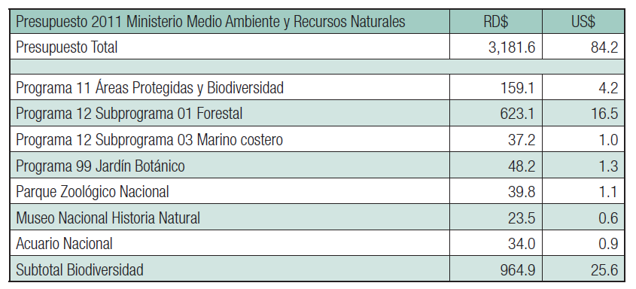

Ecuador
Financiamiento
La implementación de la Estrategia Nacional de Biodiversidad implica una serie de costos monetarios y no monetarios. En función del financiamiento se identifican dos niveles: los costos directos y los costos indirectos.
Los costos directos incluyen el gasto que corresponde al gobierno, al sector privado y las ONGs, en personal, investigación, infraestructura y otros recursos necesarios para implementar los componentes de la ENB.
Los costos indirectos o costos de oportunidad, en términos de actividades disminuidas o eliminadas e inversiones a realizar para la conservación de la biodiversidad. Estos costos indirectos los asumirán principalmente los productores y consumidores. Por ejemplo, el costo de oportunidad de cierta producción agrícola que debe ser suspendida en áreas que necesariamente deben ser protegidas, o los costos asociados a la inversión en tecnologías y métodos de producción que sean sustentables.
Con relación a los costos directos para el financiamiento de los planes y proyectos derivados de la Estrategia Nacional de Biodiversidad, se procurará el establecimiento de fuentes y mecanismos tales como:
1. El financiamiento gubernamental y contribuciones y préstamos de la cooperación internacional, como las principales fuentes de financiamiento de la conservación de la biodiversidad del Ecuador.
2. El fortalecimiento de la operación de los centros de investigación y grupos de trabajo especializados, a través de un mecanismo financiero transparente mediante el cual, las empresas interesadas en utilizar organismos vivos modificados, o en el acceso a recursos genéticos contribuyan a sustentar la operación de los centros de investigación.
3. La valoración económica de los bienes y servicios generados por las áreas protegidas, y la transparencia en el costo de las tarifas de acceso y uso de los mismos (por ejemplo, licencias, tarifas de ingreso de visitantes, derechos de uso de diseños e imágenes, patentes de operación).
Se debe diversificar la base de ingresos del Sistema Nacional Áreas Protegidas a partir de potenciar el uso sustentable de los recursos de las áreas (por ejemplo, turismo de naturaleza), la prestación de servicios ambientales y auspicios comerciales.
Es importante asegurar que los ingresos generados por las áreas protegidas se inviertan en la conservación de los sitios y en el desarrollo de las comunidades interiores y aledañas a las áreas protegidas.
4. El análisis del potencial real de la implementación de estrategias alternativas de financiamiento como el canje de deuda por naturaleza, pago por servicios ambientales globales, captación de donaciones, inversión doméstica e internacional del sector privado, entre otros.

El Salvador
Financiamiento
Las transformaciones tan profundas que demanda la Estrategia Nacional de Biodiversidad 2013 no serán posibles si no se moviliza el financiamiento necesario a la escala adecuada con las metas que se tracen en el Plan deAcción de la Estrategia Nacional del MedioAmbiente.
En forma prioritaria en materia de financiamiento y movilización de recursos, se debe apostar estratégicamente a una agenda integrada y articulada entre Biodiversidad y Cambio Climático, impulsando iniciativas sinérgicas de adaptación y mitigación basada en ecosistemas, que permitir el acceso a mecanismos financieros y fuentes internacionales tanto en el marco del Convenio sobre la Diversidad Biológica, como bajo los mecanismos que se están estableciendo en la Convención Marco de las Naciones Unidas sobre el Cambio Climático.

Grenada
Project concept | budget
Building Awareness on Biological Diversity in Grenada | US$80,000
Drafting a National Land Use Policy for Grenada | US$40,000
Strengthening Management of Key Ecosystems | US$250,000
Promoting Sustainable Use of Biological Resources | US$120,000
Capacity Building for Germplasm Conservation | US$300,000
Strengthening Biological Pest Control | US$80,000
Incorporating Ecosystem Valuation into National Accounting | US$100,000
Strengthening Existing Legislation for Biodiversity Protection | US$80,000

Guatemala
VII. FINANCIAMIENTO Y PRESUPUESTO DE LA ESTRATEGIA Y SU PLAN DE ACCIÓN
A continuación, esta sección presenta una versión preliminar sobre el fi nanciamiento y el presupuesto necesario para implementar la Estrategia Nacional de Diversidad Biológica y su Plan de Acción para la década 2012-2022. Sin embargo, es necesario enfatizar que será imprescindible el desarrollo de una Estrategia de Movilización de Recursos, con el fi n de asistir a todos los actores involucrados en la implementación de la Estrategia Nacional de Diversidad Biológica a movilizar los recursos fi nancieros requeridos de forma adecuada y predecible. La Estrategia de Movilización de Recursos debe considerar un rango amplio de posibles fuentes de fi nanciamiento nacionales, regionales e internacionales, tanto del ámbito público, como del privado.

7.1 FINANCIAMIENTO CON FONDOS PÚBLICOS
La ejecución de políticas ambientales y de diversidad biológica, a través de los tres niveles de jerarquía del gobierno, requieren de aportes en recursos fi nancieros. El nivel de mayor jerarquía es el gobierno central, conformado por el Presidente de la República, el vicepresidente y el gabinete de ministros. El segundo nivel de gobierno está representado en el ámbito departamental, presidido por el gobernador. Aquí también se ubican los Consejos Departamentales de Desarrollo (CODEDE), que reciben financiamiento del Gobierno central para la ejecución de obra pública, la cual debe ser identifi cada y concertada con los actores departamentales (Monterroso& Sales, 2010). El tercer nivel de jerarquía, está representado por los municipios, los cuales cuentan con recursos propios o provenientes de transferencias del gobierno central (URL-IARNA, 2009).

Castañeda y Gálvez (2011) reportaron que para el 2006, el gasto público ambiental total de los tres niveles de gobierno, fue equivalente a 14,000 millones de quetzales (cuadro 1). Los gobiernos departamentales y municipales fueron responsables del 64% del monto total, mientras que el gobierno central participó solamente con el 36% al gasto ambiental total. Dicho gasto público ambiental total representó un 0.6% del PIB y US $ 12 por persona, lo cual es bajo comparado con el gasto de US$ 47 de México ó US$ 34 de Costa Rica (Castañeda y Gálvez, 2011).

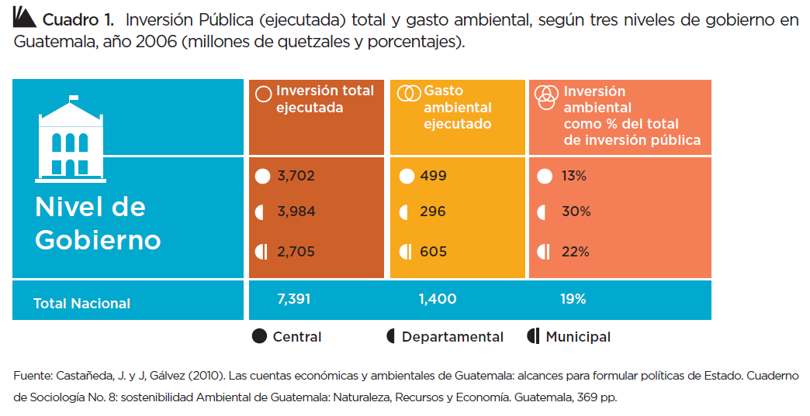
Del total de gasto ambiental reportado para el 2006, el 68.4% se invirtió principalmente en protección de biodiversidad y paisaje, así como la gestión forestal. El resto se invirtió en actividades de extracción, otras actividades de protección, investigación y desarrollo, manejo de residuos y aguas residuales. A nivel de gobierno departamental, la mayor parte del gasto se destinó a infraestructura de aguas residuales y actividades de extracción, principalmente agua. A nivel municipal, el gasto se destinó a la extracción de agua (67%), los servicios de drenaje (27%), manejo de desechos (6%) y protección de la biodiversidad (2%), entre los más destacados (Castañeda y Gálvez, 2011). A nivel general, en el 2001 el gasto en protección ambiental pasó de representar el 43% al 52% para el año 2006, lo cual evidencia un aumento signifi cativo a los gastos de gestión de recursos naturales. Así mismo, el gasto público ambiental se divide principalmente en cuatro rubros:
i) obras de alcantarillado (saneamiento), equivalentes al 20% del gasto ambiental público
ii) obras para proveer de agua a la población (40%)
iii) protección de la biodiversidad (13%), y
iv) gestión de recursos forestales (10%)

Las inversiones en agua y saneamiento son realizadas por los CODEDES y los gobiernos municipales, mientras que la protección de la biodiversidad y los aspectos forestales se promueven por medio del Gobierno central (URLIARNA, 2009).Contrastando con el gasto, se encuentra los ingresos (transacciones) vinculadas al ambiente. Castañeda y Gálvez (2011) reportan que, durante el 2006, éstos suman un total de 3,144 millones de quetzales, los cuales incluyen ingresos del gobierno central (94%) y municipal (6%). Lo anterior evidencia ingresos vinculados al ambiente que representan un 8.33% del presupuesto general de la nación aprobado para el 2006; sin embargo, únicamente el 3.71% fue re invertido como gasto ambiental nacional.

La coordinación de la Política a nivel de nación, ha sido asignada al Consejo Nacional de Áreas Protegidas y el Ministerio de Ambiente y Recursos Naturales. Estas instituciones, durante los últimos 5 años, han manejado en conjunto entre el 0.22 y 0.39% del Presupuesto General de la Nación (Cuadro 2). Ambos presupuestos tuvieron un incremento en su asignación durante 2009 que osciló entre el 20 y 139%.

El reto para la ejecución de la Estrategia Nacional de Diversidad Biológica por el Gobierno en sus tres niveles, será el de gestionar un incremento, de hasta un 100%, en la asignación presupuestaria. Lo anterior se basa en que el margen entre los ingresos y el gasto lo permite. Dicho incremento permitirá incrementar las actividades locales y departamentales encaminadas a la conservación y uso sostenible de la diversidad biológica.

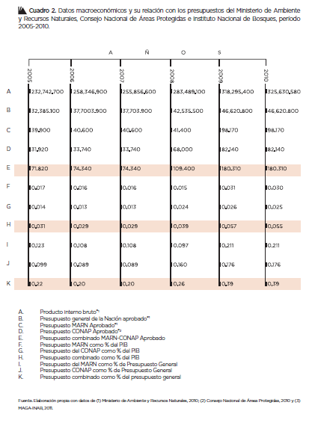

7.2 FINANCIAMIENTO CON FONDOS EXTERNOS
Según la Secretaría de Planifi cación y Programación de la Presidencia (2011), en Guatemala las fuentes cooperantes pueden agruparse en torno a las relaciones que establecen entre sí, o por el tip de cooperación que desarrollan. Por un lado, están dos grupos, uno el autodenominado grupo G-13, conformado por 15 fuentes cooperantes y el otro, por países que operan fundamentalmente en el esquema de cooperación Sur-Sur. Un tercer grupo lo conforma el Sistema de Naciones Unidas (SNU) compuesto por 11 agencias especializadas. En otro grupo, pueden encontrarse una serie de fuentes bilaterales y multilaterales que operan dentro de una lógica menos organizada y más bilateral con nuestro país.

Durante el período 2002-2006, se estima que el monto que la cooperación internacional invirtió en Guatemala asciende a US$ 2.6 billones (incluyendo la cooperación reembolsable y no-reembolsable) (Comisión Europea, 2007). Según los resultados arrojados en la Encuesta OCDE 2008-2010, Guatemala recibió en el 2008 un monto en Ayuda Ofi cial al Desarrollo (AOD) de US $352.99 millones. En 2009, la AOD disminuyó a US $271.57 millones, aumentando al 2010 en US $348.26 millones de dólares, aunque no alcanzó el nivel observado en 2008. En este sentido, conforme al presupuesto vigente para el año 2008, la AOD representó el 6.08%, luego bajó al 4.44% (2009) y fi nalmente ascendió al 5.18% en 2010. En el caso del producto interno bruto, los porcentajes no alcanzan el 1% en ninguno de los tres años (SEGEPLAN, 2011)

7.2.1. ESTADOS MIEMBROS DE LA UNIÓN EUROPEA
La Unión Europea ha aportado US$456 millones (US$281.5 millones de los Estados miembros y US$174.5 millones de la Comisión Europea) (Comisión Europea, 2007). En este sentido, Guatemala recibe cooperación de diez Estados Miembros de la Unión Europea, incluyendo Austria, Alemania, España, Suecia, Holanda, Dinamarca, Italia, Francia, Finlandia y el Reino Unido. Su aporte (US$ 281.5 millones durante el periodo 2002-2006) se enfoca en los sectores de educación, salud, agua, servicios sanitarios, medio ambiente, gobernabilidad, derechos humanos, sociedad civil y género (Comisión Europea, 2007).

7.2.2. OTROS DONANTES E INSTITUCIONES FINANCIERAS INTERNACIONALES
Desde 1997, los Estados Unidos ha aportado casi US$ 400 millones para la implementación de los Acuerdos de Paz y la Agencia de los Estados Unidos para el Desarrollo Internacional (USAID) aporta unos US$ 50-55 millones anuales en ayuda para el desarrollo. El Banco Interamericano de Desarrollo (BID), aporta unos US$ 1,013 millones y el Banco Mundial (BM) unos US$ 558 millones en varios programas de ayuda a Guatemala, con un énfasis en el desarrollo macroeconómico y sectorial. La Organización de las Naciones Unidas (ONU) aporta unos US$ 29 millones y tiene un papel activo en el diálogo sectorial y en la coordinación de la cooperación internacional.

En junio de 2003, el Fondo Monetario Internacional (FMI) aprobó un programa de crédito de SDR 84 millones (US$ 120 millones) como parte de un Acuerdo Temporal para apoyar el programa económico de Guatemala. De acuerdo con el FMI, la implementación de los Acuerdos de Paz será un factor crucial para lograr los objetivos del programa económico (Comisión Europea, 2007).

Para el caso específi co del medio ambiente, la movilización de recursos en el período 1999-2001, provenientes de fuentes externas alcanzó un total de US $64.0 millones (Cuadro 3). Dichos recursos provienen de agencias bilaterales (43.6%) y multilaterales (31.0%), en menor proporción de instituciones fi nancieras internacionales (23.8%) (FOGUAMA, 2002). Los recursos asignados por la cooperación internacional durante el período 1999-2001, fueron designados principalmente para el manejo sostenible (80%), seguido por la reducción de impactos (9%) y conservación (7%).

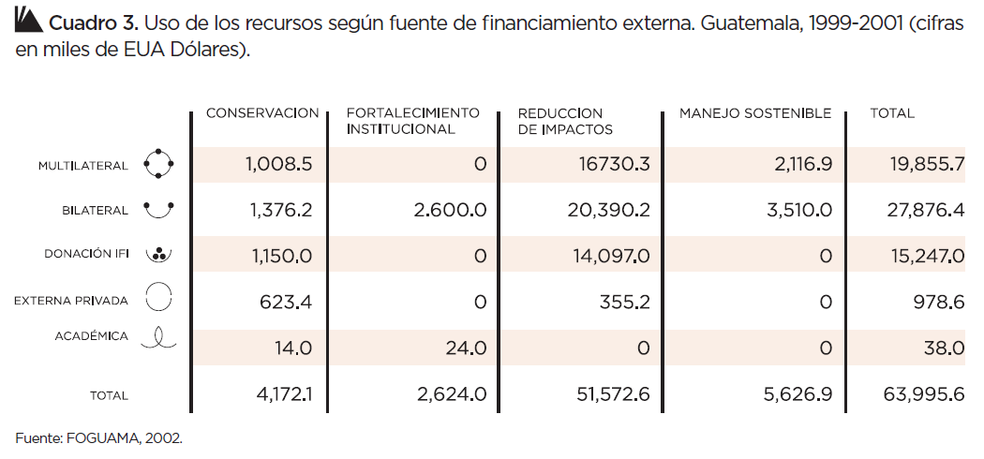
7.3 PROYECCIONES A FUTURO
El Equipo de País de las Naciones Unidas (UNCT por sus siglas en inglés) en Guatemala, conformado por FAO, OACNUDH, ONUSIDA, OPS/OMS, PMA, PNUD, UNESCO, UNFPA, UNICEF, UNIFEM, y VNU, con participación de las agencias no residentes, CEPAL, PNUMA, ONUDI y OIT, ha desarrollado de común acuerdo con las autoridades nacionales, representadas por la Vicepresidencia de la República, el Ministerio de Relaciones Exteriores (MINEX), el Ministerio de Finanzas Públicas (MINFIN) y la Secretaria de Planifi cación y Programación de la Presidencia (SEGEPLAN) el Marco de Asistencia de las Naciones Unidas para el Desarrollo (UNDAF por sus siglas en Inglés) para el periodo 2010-2014 (UNDAF, 2010).

Las cinco áreas de cooperación defi nidas en el UNDAF, corresponden a las prioridades nacionales identifi cadas en conjunto con el Gobierno de Guatemala en el ejercicio de la Evaluación Común de País (CCA por sus siglas en inglés):
1. Ambiente, Reducción del Riesgo a Desastres, Energía y Agua y Saneamiento
2. Desarrollo Social: salud, Educación y Oportunidades Económicas
3. Gobernabilidad Democrática y Participación Ciudadana
4. Seguridad Alimentaria y Nutricional
5. Estado de Derecho, Justicia y Seguridad

Los recursos programados por el Sistema de las Naciones Unidas en el país en las áreas de cooperación identifi cadas, han sido estimados en US $341,728,198 para el período 2010-2014 (el detalle de los fondos a asignar se muestra en el Cuadro 4) (UNDAF, 2010).

Para el caso específi co del Área de Ambiente, reducción de riesgo a desastres, energía, agua y saneamiento, la UNDAF trabajará en estrecha interrelación y armonía con las políticas, programas y estrategias nacionales. Se abordarán el manejo sostenible de tierras; la conservación y uso sostenible de la diversidad biológica; el saneamiento ambiental y manejo sostenible de los recursos hídricos; la mitigación y adaptación al cambio climático, y el manejo ambientalmente seguro de productos químicos. Todo ello a través de la dimensión transversal del fortalecimiento de capacidades, la sensibilización y educación ambiental y un enfoque de género y multicultural que ayuden a consolidar un comportamiento ciudadano cada vez más comprometido con el uso sostenible de los recursos naturales y del patrimonio cultural del país (UNDAF, 2010).

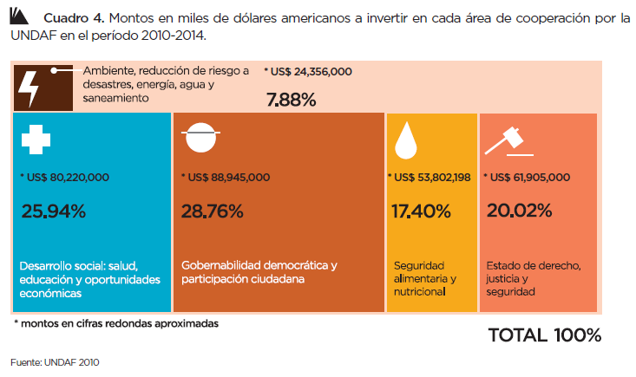
Así mismo, se acompañará al Estado en procesos que contribuyan al cumplimiento de los compromisos nacionales adquiridos en el Marco de Acción de Hyogo para la formulación de la política de gestión de riesgo y su marco estratégico, procesos de adecuación de estructuras y procesos institucionales en el ámbito nacional, departamental y municipal. Este acompañamiento también incluye la sistematización de procesos y herramientas para la recuperación temprana y la recuperación post desastre, el mejoramiento de la gestión de conocimientos, la formación en gestión de riesgo y la apertura de espacios de participación ciudadana (UNDAF, 2010).

7.4 ESTIMACIÓN DEL PRESUPUESTO DE LA ESTRATEGIA NACIONAL DE DIVERSIDAD BIOLÓGICA Y SU PLAN DE ACCIÓN
El presupuesto general, por estrategia y objetivo estratégico para el período 2012-2022 asciende a Q. 2,327,080,500. Del total presupuestado, el 34% será invertido en la institucionalidad territorial y articulación de actores, el 17% en conciencia y valoración, el 39% en paisajes productivos sostenibles y planifi cación territorial para la conservación, el 5% en la atención a amenazas y el 5% en la restauración de la diversidad biológica y sus servicios ecosistémicos.

Durante el primer año, la inversión será mínima (Q 2,894,000.00), puesto que los fondos se invertirán para el desarrollo de condiciones previas dentro del CONAP para lograr la transición de ser una institución centrada en el Sistema Guatemalteco de Áreas Protegidas, a una institución rectora y coordinadora de la Política Nacional de Diversidad Biológica (el desglose completo por estrategia y objetivo estratégico se muestra a continuación).
ESTRATEGIA / OBJETIVO ESTRATEGICO | COSTO (Q)
Objetivo Estratégico 1. Fortalecer la institucionalidad territorial y la articulación de actores que permitan la gobernanza local y regional para la gestión efectiva de la diversidad biológica y sus servicios ecosistémicos. | 226,930,000
Objetivo Estratégico 2. Fortalecer la gestión de recursos fi nancieros para la implementación de la Política Nacional de Diversidad Biológica, su Estrategia y Plan de Acción. | 544,210,000
Objetivo Estratégico 3. Desarrollar mecanismos y herramientas pertinentes que garanticen la conservación y uso sostenible de la diversidad biológica y sus servicios ecosistémicos. | 13,604,000
Objetivo Estratégico 4. Desarrollar un Sistema Nacional de Conocimiento y Valoración de la diversidad biológica y sus servicios Ecosistémicos. | 46,170,000
Objetivo Estratégico 5. Desarrollar mecanismos para generar la conciencia pública y capacidades para fortalecer la apreciación, conservación y uso sostenible de la diversidad biológica y sus servicios Ecosistémicos. | 355,187,000
Objetivo Estratégico 6. Desarrollar procesos de planifi cación territorial que garanticen la funcionalidad de los ecosistemas naturales (terrestres, marino-costeros y de agua dulce), sistemas productivos y su armonización con el desarrollo sostenible. | 87,065,000
Objetivo Estratégico 7. Establecer el Sistema Nacional para la Conservación y Uso Sostenible de la Diversidad Biológica para garantizar la sostenibilidad del desarrollo. | 704,090,000
Objetivo Estratégico 8. Fomentar la generación integrada de los conocimientos científi cos y tradicionales colectivos como elementos de planifi cación territorial para potenciar el desarrollo. | 116,083,300
Objetivo Estratégico 9. Institucionalizar las herramientas que garanticen el uso sostenible de los componentes de la diversidad biológica y sus servicios ecosistémicos. | 400,590,000
Objetivo Estratégico 10. Implementar mecanismos de gestión del riesgo para disminuir las amenazas a la diversidad biológica y sus servicios Ecosistémicos. | 117,196,200
Objetivo Estratégico 11. Desarrollar acciones dirigidas a restaurar la diversidad biológica y sus servicios ecosistémicos para disminuir la vulnerabilidad socio ambiental y mejorar la adaptación al cambio climático. | 116,545,000
TOTAL | 2,727,670,500

Guyana
10.3 Resource Mobilization
This is the most critical area to ensure the management of biodiversity and the effective implementation of the NBSAP. Resources will need to be sourced to implement the various programme areas. Please see Appendix III.
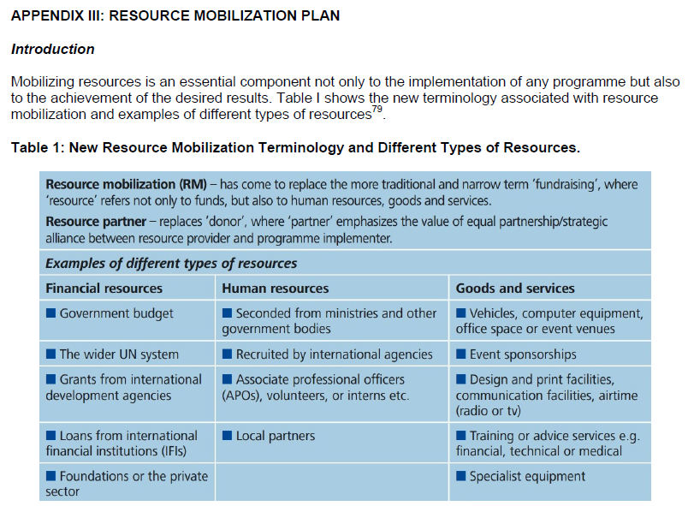
This Resource Mobilization Plan supports the implementation of the NBSAP (2012‐2020). The principal objective of the Plan is to ensure there is a diverse portfolio of resources for the successful implementation of the Strategy and to (1) ensure a better update and distribution of existing funds for biodiversity; (2) rationalize available resources and maximize co-benefits of various sources; and (3) to identify and explore the possibilities of forming strategic partnerships with providers of different types of resources.

Aggregating Contributions and Budgets
There has been no aggregation of funds specifically directed to biodiversity actions and as such there is no financial data to determine trends in contributions and inflows. However, annual budget support is received by several agencies/institutions to implement annual workplans which may include biodiversityrelated work. It is, therefore, difficult to determine an indicative budget for achieving specifically the NBSAP (2012‐2020) Strategic Objectives and implementing the Priority Actions. It would be strategic therefore to identify current resources used for biodiversity-related work, identify resource gaps and needs, assess the potential for resource mobilization in country, from international donors, from innovative financing mechanisms, and assess potential partners and new approaches to building partnerships for resource mobilization.

Mobilizing Resources
A number of approaches will be required to raise the level of contributions to support biodiversity actions. Existing sources of financial, technical and other support would need to be examined and these include Official Development Assistance (ODA); national budget allocations; non-governmental organizations, foundations, and academia; international financial institutions; United Nations organizations, funds and programmes; Non-ODA public funding; South-South cooperation initiatives; and Technical cooperation. In addition, securing support from the private sector and exploring in-kind support would also be critical.

There is a number of resource mobilizing actions Guyana should take as follows:
Direct
▪ Advocate for increased allocations from the national budget to support the BM Division of the EPA.
▪ Securing financing for biodiversity-related initiatives and projects through the Guyana REDD+ Investment Fund (GRIF), which is a multi-contributor trust fund for the financing of activities identified under the LCDS.
▪ Maximizing access to funds allocated through the Global Environment Facility (GEF) and United Nations organizations, funds and programmes.
▪ Build on and expand opportunities for ODA, e.g. the KfW financed National Protected Areas Systems Project.
▪ Expand programme of support for biodiversity activities from NGOs, foundations and academic institutions. Conservation International, World Wildlife Fund, Smithsonian Institute, Iwokrama and others have supported and also executed projects which have contributed to meeting biodiversity conservation objectives.
▪ Expand community-based biodiversity and livelihood projects and activities through developing partnerships GEF Small Grants Programme and other small-scale funding windows of other bilateral partners to support on-the-ground community actions.
▪ Establish and or enhance partnerships and linkages with regional organizations and programmes.

Indirect
▪ Undertake joint and synergistic programming across these 3 GEF focal areas (e.g., joint programme on biodiversity and climate change; joint programme on biodiversity and land degradation).
▪ Enhanced cooperation and coordination of initiatives that would lend to achieving the NBSAP Strategic Objectives and Priority Actions. These could include initiatives being undertaken by other sector Agencies, e.g. the rehabilitation of mined out areas and re-vegetation; and, regional initiatives such as the Guiana Shield Facility.
▪ Explore market-based instruments (such as economic incentives, fiscal instruments, environmental certification schemes, labeling/branding and green public procurement) that have the potential to support the conservation and sustainable use of biodiversity, as well as improve the sustainability of supply chains.
▪ Promote the development and use of innovative financing mechanisms, including market-based instruments. Payments for Ecosystem Services schemes could reward public and private goods from agricultural, forest and marine ecosystems.

Coordination and Disbursement of Resources
In keeping with the mechanism for coordination of implementation of the NBSAP (2012‐2020), the MNRE, through the EPA, will be expected to coordinate the mobilization of financial support by reaching out to the range of potential resource providers to present the NBSAP and Priority Actions and to ascertain levels of interest and financing availability to support the action. In instances where the Priority Actions may be implemented by other State or Non State Entities, the MNRE, through the EPA, would be expected to lend support in accessing financing.

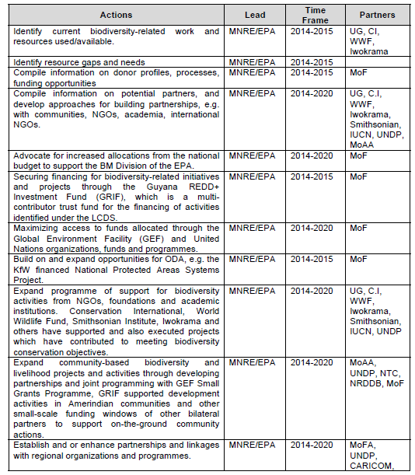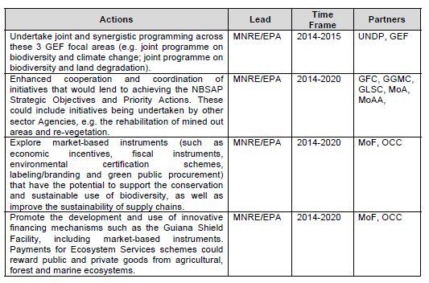

Haiti

Honduras

Jamaica
5.4 Funding and Promotion
Financial resources will need to be secured to implement the project concepts outlined in Section 5.8. It is envisaged that the body responsible for co-ordinating and implementing the National Biodiversity Strategy and Action Plan, the proposed National Biodiversity Secretariat (see the first project on page 51), will have financial sustainability as one of its fundamental goals. In support of this, the staff list for the proposed Secretariat includes two persons trained in financial resource identification and negotiation, who will be responsible for identifying and securing funding for implementation of projects in the Action Plan. Potential funding sources include the Global Environment Facility; United States Agency for International Development; European Union Inter- American Development Bank; Caribbean Development Bank; World Bank, Swedish International Development Agency; Canadian International Development Agency; United Nations Development Bank; Department for International Development (U.K.); United Nations Environment Programme; United Nations Food and Agricultural Organisation; philanthropic groups; national donor agencies (e.g. Environmental Foundation of Jamaica); private sector companies; and the Government of Jamaica. In addition to financial and technical assistance, in-kind contributions will also be solicited (e.g. personnel sharing, office allocations).
Some projects already are under negotiation for funding and these are indicated within the project description.
The projects do not have cost estimates.

Mexico

Nicaragua

Panama
In-situ conservation | B/200,000.00
Exsitu | B/. 500,000.00
USO SOSTENIBLE DE LA DIVERSIDAD AGRiCOLA | B/. 500,000.00  B/. 20,000.00
USO SOSTENIBLE DE LA DIVERSlDAD BIOLOGICA FORESTAL | B/. 3.5 millones de balboas  B/. 18 millones de balboas
USO SOSTENIBLE DE LA FAUNA TERRESTRE | BI. 300,000.00; a raz6n de BI. 60,000.00 por afio  BI. 181,232.00
FORTALEClMIENTO INSTITUClONAL | B/. 300,000.00  B/. 200,000.00

Paraguay

Peru

Saint Kitts and Nevis
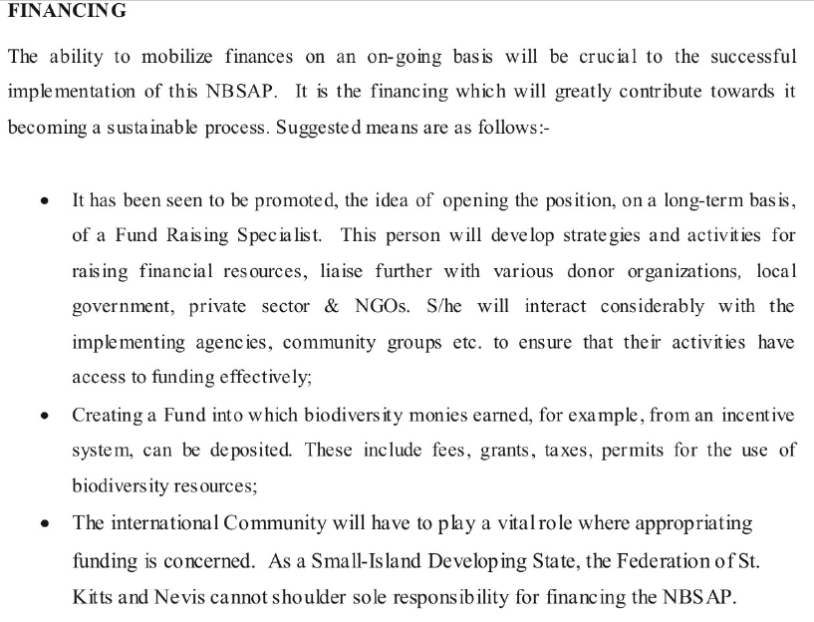

Saint Lucia
Financing
In accordance with the provisions of Articles 11, 20(1), 20(6) and 21(4) of the CBD, a number of principles will guide the financing of biodiversity conservation and management programmes:
- · financing must be seen in the broader context of the economic policies and instruments that will be used to promote biodiversity conservation and sustainable use;
- · user fees will constitute an important source of revenue, but will also be designed as incentives for conservation and sustainable use;
- · all sectors and stakeholders have a role to play in contributing to the cost of biological diversity conservation and management;
- · because of the status of these resources, the financing of biological diversity conservation and management however remains a very special responsibility of the state;
- the international community has a key role to play in supporting St. Lucia's effort to manage its biological resources.

A number of instruments will therefore be put in place and utilised, including fees, grants, licenses, permits and taxes. While the "polluter pays" principle may also be applied, with the imposition of fines, measures will be taken to prevent it from being used by offenders as a license to impact negatively on biological resources.

Agencies responsible for the implementation of the National Biodiversity Strategy and Action Plan will also explore the desirability and feasibility of establishing a funding mechanism, which could be devoted solely to biodiversity or could encompass a broader environmental mandate, which could assist greatly in the generation and management of resources for the implementation of the strategy and action plan.

The possibility of establishing a funding mechanism for community initiatives in biodiversity conservation will also be explored, with particular attention to the option of capitalising such a fund through a partnership between government, the private sector and donor agencies.

project | Total estimated costs ([15US--2.6882 Eastern Caribbean (EC) Dollars])
Project 1: Policy, institutional and legislative review | ECS 85,000/US$ 31,620.
Project 2: Identification and selection of methods, tools, baseline variables, indicators and parameters needed for effective monitoring | ECS 900,000/US$ 334,797.
Project 3: Comprehensive inventory of terrestrial biological resources | ECS 1.5 million/USS 557,994.
Project 4: Inventory of marine and coastal biodiversity | ECS 850,000/US$ 316,197
Project 5: Assessment of the stocks of the Queen Conch, Strombus eieas | ECS 50,000 per year/USS 18,600 per year.
Project 6: Assessment and management of wetlands | ECS 80,000/US$ 29,760.
Project 7: Assessment of freshwater biological resources | ECS 80,000/US$ 29,760 per year over three years.
Project 8: Inventory of biological resources of importance to agriculture | ECS 1.4 million/USS 520,795.
Project 9: Study and determination of the carrying capacity of critical areas used for tourism and recreation
Project 10: Design of standards and guidelines of behaviour in nature tourism sites and attractions
Project 11: Review of the national plan for a System of Protected Areas | ECS 75,000/US$ 27,900
Project 12. The economics of biodiversity loss and conservation | ECS 85,000/US$ 31,620
Project 13: Training | ECS 45,000/US$16,740 for the formulation of the trainingstrategy;  other costs to be determined on the basis of the contents of the strategy and specific needs  identified.
Project 14: Establishment of management programmes for the protection of the endemic and rare species of birds | ECS 850,000/US$ 316,197.
Project 15: Establishment of a turtle monitoring programme | ECS 150,000/US$ 55,799
Project 16: Establishment of a photographic and videographic data base on biodiversity
Project 17: Education, public awareness and participation | ECS 200,000/US$ 74,399.
Project 18: Upgrading of national herbarium, and creation of sub-collections | ECS 850,000/US$ 316,197.
Project 19: Development of artificial habitats for coastal and marine resources | ECS 150,000/US$ 55,799.
Project 20: Evaluation of the medicinal and culinary properties of herbs | ECS 76,000/US$ 28,272
Project 21: Promotion of organic farming
Project 22: Increasing and managing plant diversity for sustainable rural livelihoods

Saint Vincent and the Grenadines
Table 6.1 Proposed Projects for the Implementation of Biodiversity Conservation Initiatives
PROJECT No.1. Public Relations/Education | US$110,000
PROJECT NO. 2 Development of a Wildlife Unit | 80,000
PROJECT NO: 3 In-depth Plant Inventory and Herbarium Establishment | 50,000
PROJECT NO: 4 E n v i r o n m e n t a l Monitoring of Coral Reefs | 60,000
PROJECT NO: 5 Cataloguing of Fisheries Documents | 65,000
PROJECT NO: 6 Turtle Nesting Beach Surveys | In kind
PROJECT NO: 7 Formulation of a Comprehensive Land Use Development Plan | 200,000

Suriname
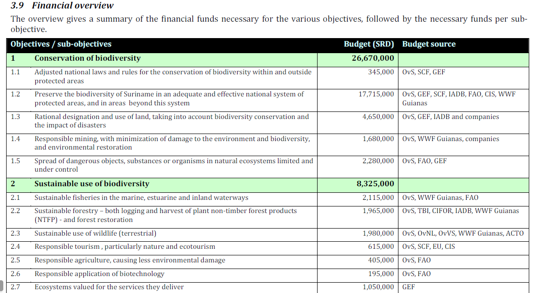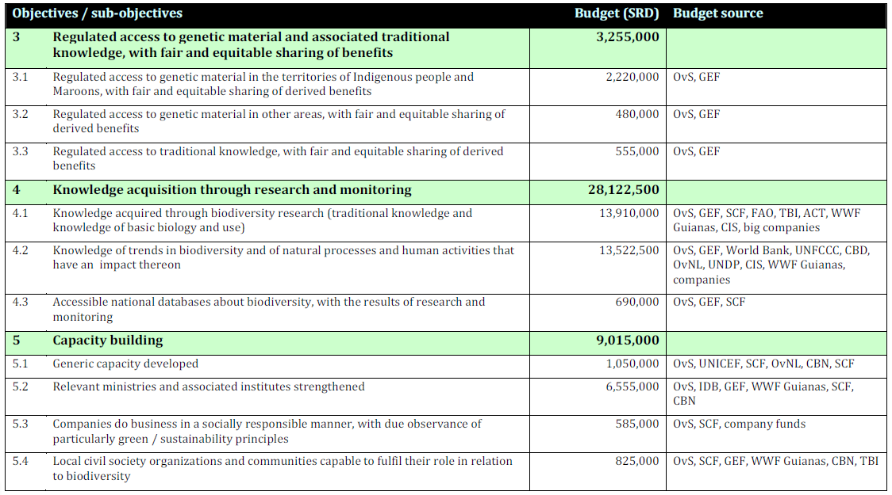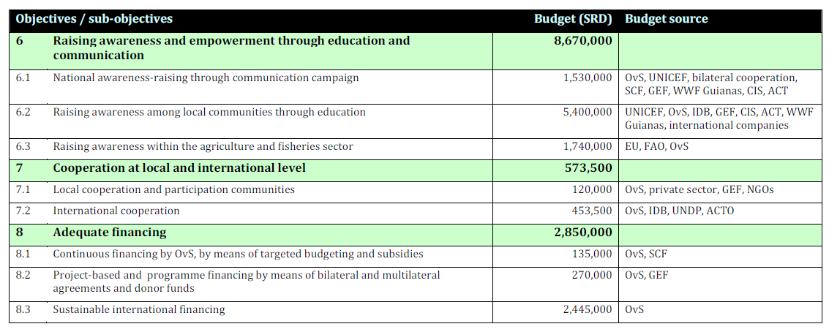

Trinidad and Tobago
It is estimated that the sum of US$ 6,560,000.00 million is needed to execute the priority strategies and actions over the next three years.
The priority Strategies and Actions of the NBSAP for three year period :

strategy | Estimated budget US$
Education And Awareness | 1,990,000
Legislation & Enforcement | 470,000
capacity | 225,000
Information and research | 3,500,000
Policy and commitment | 375,000

FINANCIAL INSTRUMENTS
Introduction:
The use of financial instruments as management tools is an area in dire need of attention, to achieve the aims and objectives of the CBD, and, nationally, for the conservation and sustainable use of biodiversity. Financial instruments can play a significant role in facilitating conservation efforts through demonstrating the monetary value of ecosystems and their components.
As the basis of life and the fundamental core of all economic activity, biodiversity is the essence of all human value systems: economic, spiritual, social, cultural, educational and environmental. It is, therefore, vital to quantify the contribution biodiversity makes to the national economy, if its management and sustainable use is to become a national priority. Our inability to value biodiversity at a macro-economic level, makes it a low priority when it comes to the sharing of national resources for its management and sustainable use, and the understanding of its loss and destruction. Unfortunately, the present information, research and data collection systems, do not allow us to measure its contribution with any degree of accuracy.
Article 11 of the CBD, on Incentive Measures, suggests that Parties should “adopt economically and socially sound measures that act as incentives for the conservation and sustainable use of biological diversity”. The underpinnings of systems and strategies recommended in this NBSAP, for the management and conservation of biodiversity, must be on a sound financial foundation.
Financial instruments have not been more widely utilised for a number of reasons, and these have contributed to attitudes and values about these resources that have encouraged wasteful practices and over-exploitation.
Policy Statement
• Design a comprehensive financial plan for the management and sustainable use of the country’s biodiversity resources through the use of varied financial instruments.

The strategies employed by these instruments must be designed to:
Strategy 34
• Change attitudes, behaviour, wasteful practices and technologies, to favour sustainable use of biodiversity. •
Strategy 35
• Value biodiversity and incorporate its values in monetary terms, in national accounting systems and developmental objectives.
Strategy 36
• Raise awareness in all sectors of their individual and collective effects on the destruction of biodiversity, through internalising costs by methods such as “polluter pays principles”.
Strategy 37
• Finance biodiversity management, research, development and sustainable use.
Strategy 38
• Adapt economic systems to include the social, cultural, ethical and environmental values of biodiversity.
Strategy 39
• Quantify the contribution of biodiversity to the national economy (legal and illegal trade) through the use of indicators of direct employment levels, economic benefit and social wellbeing.
Strategy 40
• Develop an understanding of the driving forces of biodiversity loss, and to use this understanding to target specific economic actions for the sustainable use of biodiversity. (e.g. perverse incentives, insecure property rights, population growth and migration patterns inequitable access and distribution, unregulated externalities, the nature of the demand for natural resources, resource policies, trade imbalances, subsidies, etc.)
Strategy 41
• Design sustainable harvesting and non-consumptive use guidelines, e.g. for tourism.
There are serious “hidden costs” that are passed onto the society through the over-exploitation and destruction of biodiversity, due in part to the under-valuing of these resources. Flooding, due to the destruction of forests and watersheds, and the extreme pollution of rivers by industry, from which the population accesses potable water, are two obvious examples. These have serious and expensive repercussions on other agencies that manage and maintain infrastructure and public utilities.
CONTACT GROUP INPUT: “Our biodiversity resources are seriously undervalued” was the generally held view of all sectors.
• Financial instruments have not been employed to benefit the conservation of biodiversity. In many cases, they have contributed to the over-exploitation of these resources.
• There is a lack of financial instruments that could encourage industry to be sensitive to biodiversity conservation.
• Outdated technology in the industrial sector has given rise to negative impacts on biodiversity. Incentives for the use of cleaner technologies should be employed to encourage industry to clean up their act.
• Incentives have led to over-capitalisation. Reduction must address social and cultural issues in the society. Examples here were Caroni Ltd. and the social impacts of trying to decrease persons involved in the fisheries sector.
• Incentive programme in fisheries is not consistent with directions for fisheries policy.
• Inadequate funding for fisheries administration and management in the public sector.
• There is a lack of appreciation for the value of biodiversity and its importance to the sustainable development of Trinidad and Tobago.
• There is a need to include the valuation of biodiversity in environmental accounting done in the country. Its role can be used as an argument for the protection of biodiversity.
• The economic value of certain species was well recognized by persons who exploit these resources, e.g.
a) Game species
b) Cage birds and pets
c) Poaching of Protected Species.
• The actual price paid for access to these resources through licenses, permits, royalties etc., is highly subsidised and bear little relation to the commercial value of the resource, nor to its management or replacement costs.
The above concerns expressed by the sector specialists, stakeholders and communities, illustrate that there is little or no obvious economic incentive to conserve biodiversity and to use it sustainably in T&T, and that this omission has had a number of repercussions on the use of the resources and their management. Financial instruments that do exist, (subsidies etc.) need to be evaluated in terms of their effect on the sustainable use of biodiversity, in the long term.

Uruguay

Venezuela

