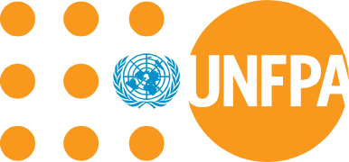
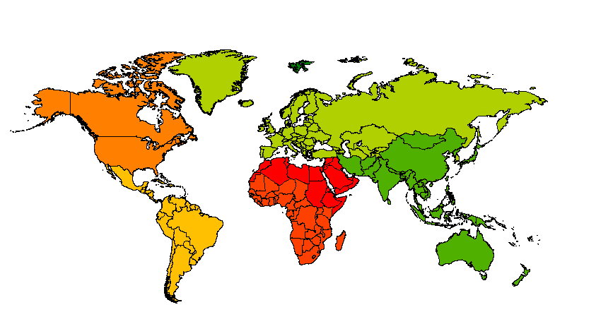
FINANCIAL RESOURCE FLOWS FOR POPULATION ACTIVITIES IN 2011

Foreword
obilization of

W ith preparations for the twentieth anniversary of the International Conference on Population and Development and the post-2015 development agenda both well under way, this twenty-fifth edition of UNFPA’s financial resource flows report is timely indeed. It provides the international community with an opportunity for stock-taking and a renewal of financial commitment to the agreements made in Cairo.

The ICPD’s ambitious twenty-year blueprint for action marked the beginning of a new era of commitment on the part of the international community to integrate population concerns into economic and social planning and policy making. This blueprint came with a price tag – one that has grown considerably over the years because of increasing needs and rising costs. However, the price of inaction is considerably higher. It is not measured in dollars and cents, but in higher morbidity and mortality, especially among women and girls.

According to the revised cost estimates presented to the United Nations Commission on Population and Development in 2009, a total of US $67.8 billion was needed by 2011 to fully fund developing country needs in the area of reproductive health, including family planning and HIV/AIDS services, as well as censuses, surveys, civil registration and population research and training.

As a whole, the international community has risen to the occasion and there has been continued, albeit sometimes slow, progress in the mobilization of resources for population activities that has made possible the countless programmes addressing family planning, reproductive health and AIDS needs around the world. This has also assisted in data collection initiatives necessary for evidence-based policy formulation and programme planning.

Population assistance stood at US $11.4 billion in 2011. We estimate that developing countries mobilized $54.7 billion in domestic resources for population activities which brings the total funding to US $66.1 billion, the largest amount ever raised. However, before the international community becomes complacent about narrowing the gap between resources needed and funds mobilized, it should be pointed out that the increase in domestic funding is the result of a large reported expenditure for family planning and new data for HIV/AIDS and out-of-pocket expenditures. The gap may widen if the family planning projects do not continue. Population assistance is increasing slowly and a number of donors have actually decreased their funding levels.

It is especially important to maintain a sufficient flow of financial resources for population programmes in developing countries in light of the large youth population and particularly now that the world population has surpassed 7 billion. The need for funding is greater than ever if the international community is to meet the challenges and take advantage of the opportunities that a world of 7 billion presents.

We commend the donor and developing countries that have made every effort to continue to mobilize financial resources despite difficult economic times. Your efforts have helped to make a difference in the lives of countless men, women and young people around the world. This is very much appreciated.

We invite all governments to renew their commitments and to continue to raise the necessary funds for population to ensure implementation of the goals of the ICPD Programme of Action.

UNFPA would like to thank the Governments and relevant agencies and organizations of developing countries, as well as donor Governments, NGOs, foundations, multilateral organizations and agencies in developed countries, for providing the information contained in this report. We especially thank our main partner, the Netherlands Interdisciplinary Demographic Institute (NIDI), for the excellent collaboration. We also wish to thank the Joint United Nations Programme on HIV/AIDS (UNAIDS) for their cooperation and our partners, the Indian Institute for Health Management Research (IIHMR) and the African Population and Health Research Center (APHRC) for the productive collaboration in the data collection.

Babatunde Osotimehin
Executive Director
Table of Contents

- Foreword iii

- List of Abbreviations ix

- Glossary of Terms x

- Chapter 1 Introduction 1

- Chapter 2 Highlights of the Report 3

- Chapter 3 Methodology 5

How the Study was Conducted 5
The Costed Population Package 5
The International Population Assistance Network 7

- Chapter 4 International Financial Resource Flows for
Population Activities 9

Overview of International Population Assistance 9

Primary Funds 9
Trends in Population Assistance in Current and Constant Dollars 10
Final Donor Expenditures 12

Trends in Bilateral Resource Flows 12

Overall Primary Funds 12
Population Assistance as a Percentage of Official Development Assistance 14
Population Assistance in Relation to Gross National Product 15

Trends in Multilateral Resource Flows for Population Activities 16

The United Nations System 16
Development Banks 17

Trends in Resource Flows for Population Activities from Foundations and
Non-Governmental Organizations 17

Major Foundations 17
Non-Governmental Organizations 18

Final Donor Expenditures for Population Activities 19

Final Donor Expenditures for Population Activities by Region 19
Final Donor Expenditures for Population Activities by Channel of Distribution 19
Final Donor Expenditures for Population Activities by Category of Activity 28

- Chapter 5 Domestic Financial Resources for Population Activities 31

Global Estimate of Domestic Resource Flows 31

- Chapter 6 Conclusion 34

Progress in Resource Mobilization 34
Future Resource Requirements 35
Resources for Other Population-Related Activities 35
Population and the Millennium Development Goals 35
New Modalities for Resource Mobilization 36
The Way Forward 36

Figures

- Major flows of funds for population assistance to developing countries 8

- Primary funds for population assistance, in current and constant dollars, with percentage
change, 2001-2011 12

- Primary funds for population assistance, by type of source, in percentages, 2011 13

- Primary funds of donor countries for population assistance, in percentages, 2011 13

- Primary funds for population assistance as a percentage of official development assistance,
by donor country, 2011 14

- Primary funds for population assistance per million $US of gross national product, by
donor country, 2011 15

- Primary funds of foundations for population assistance, in percentages, 2011 18

- Primary funds of international NGOs for population assistance, in percentages, 2011 18

- Final donor expenditures for population assistance by region, in percentages, 2011 19

- Final donor expenditures for population assistance in Africa (sub-Saharan), by channel
of distribution, 2001-2011 22

- Final donor expenditures for population assistance in Asia and the Pacific, by channel of
distribution, 2001-2011 23

- Final donor expenditures for population assistance in Latin America and the Caribbean,
by channel of distribution, 2001-2011 24

- Final donor expenditures for population assistance in Western Asia and North Africa, by
channel of distribution, 2001-2011 25

- Final donor expenditures for population assistance in Eastern and Southern Europe, by
channel of distribution, 2001-2011 26

- Final donor expenditures for population assistance to global/interregional activities, by
channel of distribution, 2001-2011 27

- Expenditures for population activities as a percentage of total population assistance,
2001-2011 30

Tables

- Primary funds and final donor expenditures for population assistance, 2001-2011 9

- Primary funds for population assistance, by major donor category, 2001-2011 11

- Final donor expenditures for population assistance, by channel of distribution, 2001-2011 20

- Final donor expenditures for population assistance, by category of population activity,
2001-2011 29

- Estimate of global domestic expenditures for population activities, 2011 32

Appendix Tables

- Primary funds of donor countries for population assistance, by channel of distribution,
2001-2011 38

- Primary funds of donor countries for population assistance as a percentage of official
development assistance, 2001-2011 42

- Primary funds of donor countries for population assistance per million $US of gross
national product, 2001-2011 43

- Final donor expenditures for population assistance, by region and channel of distribution,
2001-2011 44

- Final donor expenditures for population assistance in countries of Africa (sub-Saharan),
by channel of distribution, 2001-2011 45

- Final donor expenditures for population assistance in countries and territories of Asia and
the Pacific, by channel of distribution, 2001-2011 52

- Final donor expenditures for population assistance in countries of Latin America and
the Caribbean, by channel of distribution, 2001-2011 59

- Final donor expenditures for population assistance in countries and territories of
Western Asia and North Africa, by channel of distribution, 2001-2011 65

- Final donor expenditures for population assistance in countries of Eastern and Southern
Europe, by channel of distribution, 2001-2011 69

- Revised ICPD cost estimates by region, 2009-2015 73
Map

- Map 1. Final Donor Expenditures for Population Assistance, by Region and Channel of
Distribution, 2011 28

Special Theme Boxes

- Special Theme Box 1. Resources for Population Come From A Few Key Players 2

- Special Theme Box 2. Major Population News Event in 2011 4

- Special Theme Box 3. The ICPD Costed Population Package 6

- Special Theme Box 4. UNFPA Assistance to Population Activities 16

- Special Theme Box 5. Estimates of Donor Assistance: 2012 and 2013 30

- Special Theme Box 6. Measuring Out-of-Pocket Expenditures for Sexual and Reproductive Health 33

- Special Theme Box 7. Revised ICPD Cost Estimates, 2009-2015 35
Financial Resource Flows for Population Activities in 2011

- Data Collection, Data Entry and Preparation of Tables, Figures and Maps Erik Beekink and Marianne Eelens (NIDI), Anoop Khanna, Manu Gupta and Ajay Sharma (IIHMR) and Beatrice Maina and Estelle Sidze (APHRC)

- Preparation of Projections Erik Beekink (NIDI)

- Data Analysis and Report Preparation Ann Pawliczko (UNFPA)

- Administrative Support Jeannette van der Aar (NIDI)

List of Abbreviations

- DAC Development Assistance Committee
- DESA Department for Economic and Social Affairs
- ECA United Nations Economic Commission for Africa
- ECE United Nations Economic Commission for Europe
- ECLAC United Nations Economic Commission for Latin America and the Caribbean
- ESCAP United Nations Economic and Social Commission for Asia and the Pacific
- ESCWA United Nations Economic and Social Commission for Western Asia
- FAO Food and Agriculture Organization
- GNP Gross national product
- HIV/AIDS Human immunodeficiency virus/acquired immunodeficiency syndrome
- IBRD International Bank for Reconstruction and Development
- ICPD International Conference on Population and Development
- IDA International Development Association
- IIHMR Indian Institute of Health Management Research
- ILO International Labour Organization
- IMF International Monetary Fund
- IPPF International Planned Parenthood Federation
- MDG Millennium Development Goal
- NGO Non-governmental organization
- NAA National AIDS Account
- NHA National Health Account
- NIDI Netherlands Interdisciplinary Demographic Institute
- ODA Official development assistance
- OECD Organisation for Economic Co-operation and Development
- STD Sexually transmitted disease
- SWAps Sector-wide approaches
- UN United Nations
- UNAIDS Joint United Nations Programme on HIV/AIDS
- UNDP United Nations Development Programme
- UNESCO United Nations Educational, Scientific and Cultural Organization
- UNFPA United Nations Population Fund
- UNICEF United Nations Children's Fund
- UNIFEM United Nations Development Fund for Women
- WHO World Health Organization
Glossary of Terms

- BILATERAL CHANNEL. The bilateral channel includes funds that flow directly from donor Governments to recipient country Governments.

- CONSTANT DOLLARS. Constant dollars are current dollars that have been adjusted to measure a value over a series of years at the prices prevailing during a particular year. In this report, 1993 - the year in which the ICPD cost estimates were made - was selected as the base year.

- CURRENT DOLLARS. Current dollars are dollar figures prevailing at the time of measurement. In this report, current dollars were taken as reported by the organizations surveyed. Non-dollar currencies were converted to US dollars using the International Monetary Fund (IMF) period-average exchange rates for the year the funds were expended for population assistance.

- DONOR COUNTRIES. In this report, donor countries refer to the 23 developed donor countries and the European Union, all of which are members of the Development Assistance Committee of the Organisation for Economic Co-operation and Development (OECD/DAC). The 23 donors are Australia, Austria, Belgium, Canada, Denmark, Finland, France, Germany, Greece, Ireland, Italy, Japan, Luxembourg, the Netherlands, New Zealand, Norway, Portugal, Republic of Korea, Spain, Sweden, Switzerland, the United Kingdom of Great Britain and Northern Ireland, and the United States of America.

- DEVELOPMENT BANKS. Development banks include the World Bank and the regional development banks including the African Development Bank, Asian Development Bank, and the Inter-American Development Bank.

- FINAL EXPENDITURES. Final expenditures refer to funds that have been received by developing countries directly from donor Governments or through intermediate donors. The final recipients may be developing-country Governments, national NGOs, or donors' field offices in developing countries. The programmes in which expenditures are made do not necessarily have to be located in developing countries and may include activities, such as research, that benefit more than one developing country or region.

- INTERMEDIATE DONORS. Intermediate donors include multilateral organizations and agencies incorporated into the United Nations system, the development banks, and international NGOs that channel funds for population assistance from the primary donors to the recipients.

- MULTILATERAL CHANNEL. The multilateral channel includes general funds that are not earmarked for specific population activities which multilateral organizations receive from developed countries, funds from developing countries, and interest earned on income.

- MULTI-BILATERAL CHANNEL. The multi-bilateral (multi-bi) channel includes bilateral funds earmarked for specific population activities that are channelled through multilateral organizations.

- MULTILATERAL ORGANIZATIONS AND AGENCIES. In this report, multilateral organizations and agencies refer to the United Nations organizations and agencies, including the Department for Economic and Social Affairs (DESA), Food and Agriculture Organization (FAO), International Labour Organization (ILO), United Nations Children's Fund (UNICEF), United Nations Development Programme (UNDP), United Nations Educational, Scientific and Cultural Organization (UNESCO), United Nations Population Fund (UNFPA), and World Health Organization (WHO), the World Bank, and the regional commissions, namely, United Nations Economic Commission for Africa (ECA), United Nations Economic Commission for Europe (ECE), United Nations Economic Commission for Latin America and the Caribbean (ECLAC), United Nations Economic and Social Commission for Asia and the Pacific (ESCAP), and United Nations Economic and Social Commission for Western Asia (ESCWA).

- NGO CHANNEL. The NGO channel comprises funds from foundations and general contributions to NGOs active in the field of population and bilateral expenditures for specific population activities that are executed by NGOs.

- NON-GOVERNMENTAL ORGANIZATIONS (NGOs). Non-governmental organizations are private not-for-profit organizations that operate exclusively in one country (national NGOs) or in more than one country (international NGOs).

- OFFICIAL DEVELOPMENT ASSISTANCE (ODA). Official development assistance "consists of net disbursements of loans and grants made on concessional financial terms by official agencies of the members of the OECD/DAC and members of the Organization of Petroleum Exporting Countries (OPEC) to promote economic development and welfare" (World Bank, World Development Report 1995, Oxford University Press, p. 238).

- PRIMARY DONORS. In this report, primary donors include 23 developed donor countries and the European Union that are members of OECD/DAC, and foundations.

- PRIMARY FUNDS. Primary funds refer to the financial resources contributed by a primary donor for population activities. Primary funds may be provided by a donor either directly to the developing country or to an intermediate donor such as a multilateral organization or international NGO. Primary funds also include self-generated income of intermediate donors as well as contributions which they receive from donor countries that are not members of OECD/DAC.

1 Introduction

F
inancial Resource Flows for Population Activities in 2011 is the twenty-fifth edition of a report published by the United Nations Population Fund (UNFPA) until 1997 under the title of Global Population Assistance Report. UNFPA has regularly collected data and reported on flows of international financial assistance to population activities. The Fund's annual reports focused on the flow of funds from donors through bilateral, multilateral and non-governmental channels for population assistance to developing countries and countries with economies in transition. Also included were grants and loans from development banks for population activities in developing countries.

In light of the 1994 International Conference on Population and Development (ICPD) and, at the request of the Commission on Population and Development, UNFPA updated its reporting system and began collecting data on domestic resource expenditures in developing countries in addition to data on international population assistance. This report contains information on international assistance from 2001 to 2011 and domestic resource flows to population activities in 2011.

Since 1997, the Netherlands Interdisciplinary Demographic Institute (NIDI), under contract with and in collaboration with UNFPA, has carried out the data collection. To build regional capacity to monitor resource flows, UNFPA and NIDI also work with the Indian Institute of Health Management Research (IIHMR). In 2010, the African Population and Health Research Center (APHRC) joined the collaboration, focusing on data collection in sub-Saharan Africa.

Working with UNFPA, NIDI created a resource-flows database of both donor and domestic resources that is updated regularly. NIDI also carries out evaluation and analysis of the data in collaboration with UNFPA. Real-time estimates are produced to complement existing trend analysis. Thematic reports are produced periodically on such topics as out-of-pocket expenditures, reproductive health sub-accounts, new donor countries, and country reports focusing on financial resource flows for reproductive health.

A resource flows web site, updated in 2012, contains information about the project, annual reports including the Financial Resource Flows for Population Activities, Financing the ICPD Programme of Action advocacy brochure and five regional advocacy brochures, the Reports of the Secretary-General on the Flow of Financial Resources for Implementing the ICPD Programme of Action, as well as survey questionnaires and manuals, and thematic reports. A public database was created in 2012 to enable researchers and interested parties to have access to more detailed information on the flow of funds for population activities.

UNFPA and NIDI work closely with the Joint United Nations Programme on HIV/AIDS (UNAIDS) concerning resource tracking for HIV/AIDS activities to avoid duplication of efforts and maximize cost-effectiveness. The UNFPA/NIDI Resource Flows web site also includes, inter alia, a preview of the latest available data on international population assistance, a Resource Flows Newsletter that provides unpublished data and reports of thematic studies, and regional brochures on financial resource flows and resource requirements to finance the ICPD Programme of Action.

Financial Resource Flows for Population Activities in 2011 is intended to be a tool for donor and developing country Governments, multilateral organizations and agencies, private foundations and non-governmental organizations (NGOs) to monitor progress in achieving the financial resource targets agreed to at the ICPD. Development cooperation officers and policy makers in developing countries can use the report to identify the domestically generated resources and complementary resources from donors needed to finance population and reproductive health programmes.

SPECIAL THEME BOX 1. RESOURCES FOR POPULATION COME FROM A FEW KEY PLAYERS

A major challenge in implementing the ICPD objectives continues to be lack of adequate financial resources to fund population programmes in developing countries.

Population assistance originates with a few major donors and the majority of domestic resources are mobilized in a few large developing countries. Most donor countries do not provide substantial funding for population activities and most developing countries are not in a position to mobilize sufficient resources to fund much- needed population and AIDS programmes. Poor countries are faced with many competing development priorities and many of them cannot afford to make the necessary investments in population.

In addition, the continuing global financial crisis has affected the amount of resources that some donor countries allocated to population activities. The rate of increase in population assistance has slowed down because a number of donors that have been particularly affected by the crisis have decreased funding levels.

Consumer spending exceeds government and NGO expenditures for population. In fact, consumers pay a lion’s share of the expenses. Although not easy to track, consumer spending for family planning, reproductive health and STD/HIV/AIDS services is much larger than usually assumed. Although variations exist between regions and countries, if spending in these areas is in line with spending on health in general, then it can be assumed that consumers in developing countries pay more than half of the burden of such expenditures. Out-of-pocket spending by consumers, especially the poor, has important implications for policy initiatives aimed at reducing poverty and income inequality in developing countries.

It is essential that all donors and developing countries, not just the major players, mobilize adequate resources to help fund population programmes in the developing world.

2 Highlights of the Report

- In 2011, primary funds for international population assistance totaled almost $US 11.1 billion. If development banks' loans are added, the primary funds totaled $11.4 billion.

- Total primary funds, including those of development banks, increased considerably since the ICPD. But even the increases in funding do not meet current needs and costs, both of which have grown considerably since the targets were agreed upon in 1994. The levels of funding are below the revised targets which were presented to the Commission on Population and Development in 2009 and which more accurately reflect today’s needs.

- In 2011, primary funds from the 23 developed countries and the European Union (members of OECD/DAC) totaled $10.4 billion. The top five donors were: the United States of America, the United Kingdom, the Netherlands, Germany and France accounting for 80 per cent of the primary funds in 2011.

- Population assistance from donor countries represented 7.57 per cent of official development assistance (ODA) in 2011, down from 7.69 per cent in 2010.

- According to the UNFPA/NIDI resource flows survey, a total of 157 countries and territories benefited from international assistance for population activities in 2011. Of the population assistance going to the five geographic regions, sub-Saharan Africa received the largest share of assistance (66.4 per cent), followed by Asia and the Pacific, which received 21.6 per cent; Latin America and the Caribbean (6.6 per cent); Western Asia and North Africa (3.6 per cent); and Eastern and Southern Europe (1.8 per cent).

- The majority of final donor expenditures for population activities went to STD/HIV/AIDS activities (66 per cent); followed by basic reproductive health services (22 per cent); family planning services (8 per cent), and basic research, data and population and development policy analysis (4 per cent). Funding for HIV/AIDS, which had decreased in actual dollar amount for the first time in 2009, increased in 2010 and again in 2011, when it reached its highest level. Funding for family planning continued to increase, but is still below the amount required to meet current needs.

- Developing countries are making efforts to mobilize domestic resources for population activities. However, current funding levels are still not adequate to cover the cost of population activities. Most developing countries continue to rely heavily on external assistance to finance programmes.

SPECIAL THEME BOX 2. MAJOR POPULATION NEWS EVENT IN 2011
In 2011, world population reached 7 billion. UNFPA’s flagship publication for that year, State of World Population 2011, focused on making the world better and transforming communities into forces for sustainability. Instead of asking questions such as “Are we too many?” the report pointed out that we should be asking “What can I do to make our world better?” “What can we do to transform our growing cities into forces for sustainability?”

We should also be asking what each of us can do to empower older persons so that they can play a more active role in their communities; what we can do to unleash the creativity and potential of the largest youth cohort in history, and what we can do to remove barriers to equality between men and women so that everyone has the full power to make their own decisions and realize their full potential.

The report clearly states: “We are 7 billion people with 7 billion possibilities”.

With planning and the right investments in people, a world of 7 billion can have thriving, sustainable communities, productive labour forces fueling economic growth, youth that contribute to economies and societies, and older persons who are actively engaged in their communities.

A population of 7 billion can be viewed in many ways as a success story – people are living longer, healthier lives.
But not everyone has benefited equally. Disparities exist between and within countries. Disparities also exist between men and women, girls and boys when it comes to rights and opportunities.

As the world passes the 7 billion mark, the agenda of the Programme of Action of the International Conference on Population and Development is as relevant as ever. We need to make investments to ensure that the ICPD objectives are met.

As we celebrate the achievements of a world of 7 billion, we must plan for the future and work towards development that leaves no one behind.

The report proposed seven opportunities for a world of 7 billion:

- Reducing poverty and inequality can slow population growth
- Unleashing the power of women and girls can accelerate progress on all fronts
- Energetic and open to new technologies, young people can transform global politics and culture
- Ensuring that every child is wanted and every childbirth safe can lead to smaller and stronger families
- Each of us depends on a healthy planet, so we must all help protect the environment
- Promoting the health and productivity of the world’s older people can mitigate the challenges faced by ageing societies
- The next 2 billion people will live in cities, so we must plan for them now

Source: United Nations Population Fund (2011). State of World Population 2011. People and Possibilities in a World of 7 Billion.

3 Methodology

How the Study Was Conducted
D
ata on donor assistance for population activities presented in this report were gathered with the use of a detailed questionnaire mailed to 121 actors in the field of population and AIDS which account for most population assistance. These include donor countries that are part of the OECD/DAC and the European Union, multilateral organizations and agencies, major private foundations and other international NGOs that provide substantial population assistance. A total of 68 organizations responded to the survey, including 24 OECD/DAC donor countries and the European Union; 7 multilateral organizations; 12 major foundations, 23 international NGOs, 1 research institute and 1 development bank. Telephone interviews were conducted, as necessary, for additional information and verification. Increasingly, information for donor countries is obtained from the OECD/DAC database.

For the international population assistance component, the data collection procedure was structured in such a way as to eliminate double counting in cases where primary funds passed through multiple channels of assistance before reaching the final recipient. All respondents, except primary donors, were asked to provide a breakdown of income by source. This procedure yielded an unduplicated count of total primary funds for population assistance and had the additional benefit of permitting a check for consistency of responses between two respondents, when one indicated the provision of funds to the other. Any discrepancies that were found were the result of differences in timing, definitions or exchange rates. All respondents, including donor countries, were asked to provide a breakdown of expenditures by recipient - whether developing country, multilateral organization or agency, or NGO.

The funds provided by a primary donor to a recipient country in year A are included under "primary funds" and "final expenditures" in year A. The funds provided by a primary donor to an intermediate donor in year A, but spent by that intermediate donor in a recipient country in year B, would be included under "primary funds" in year A and "final expenditures" in year B.

Information on domestic resource flows is based on estimates of global domestic expenditures for population activities using a methodology that incorporated reporting on actual and intended expenditures, secondary sources on national spending and, in the absence of such information, estimates were based on national income as measured by the level of gross domestic product which proved the most influential variable explaining the growth of spending by governments.

In keeping with UNFPA's mandate to monitor progress towards the implementation of the ICPD resource targets required for financing population programmes in developing countries and countries with economies in transition, this report does not include funds for population activities that benefit only developed countries or funds contributed by developing countries to be expended in other developing countries.

The Costed Population Package

Earlier editions of the Global Population Assistance Report recorded population assistance that supported several categories of activities, including family planning programmes, demographic research, policy formulation, population education, and activities focused on women, whenever such activities were relevant to population. In the post-ICPD years, modifications were made to reflect the ICPD costed population package.

The donor and domestic financial resource flows analysed in this report are part of the costed population package as specified in paragraph 13.14 of the ICPD Programme of Action: family planning services; basic reproductive health services; sexually transmitted diseases (STDs)/human immunodeficiency virus (HIV)/acquired immunodeficiency syndrome (AIDS) prevention activities; and basic research, data and population and development policy analysis.

To further simplify reporting procedures, all activities relating to STD/HIV/AIDS, including diagnosis and treatment of STDs and referrals, education and counselling services for STDs, including HIV/AIDS are reported under the STD/HIV/AIDS prevention programme component described in the ICPD Programme of Action. Beginning with the 1999 round of questionnaires, the project began to include data on HIV/AIDS treatment and care to address the growing reporting needs of UNAIDS and because it was becoming increasingly impossible for respondents to provide information on HIV/AIDS prevention activities only. To avoid duplication of efforts and to ensure consistency in reporting, data on HIV/AIDS expenditures are obtained directly from UNAIDS.

The growing trend towards integration of services and the increasing use of sector-wide approaches (SWAps), particularly in health and education, make it more difficult to track the level of funding going to the costed population package described in paragraph 13.14 of the ICPD Programme of Action. The realities of data-recording systems are such that many respondents, both donor and developing, have difficulty reporting financial resource flows by the four categories described in the ICPD Programme of Action. Indeed, experience has shown that there are difficulties in disaggregating and differentiating the components of the costed package from the relevant population-related activities that are not included in paragraph 13.14 of the ICPD Programme of Action, especially in integrated development projects. The trend towards integration of services, consistent with the ICPD call for the integration of reproductive health with basic health services, also makes it increasingly difficult to distinguish among the four categories of population activities.

SPECIAL THEME BOX 3. THE ICPD COSTED POPULATION PACKAGE

- FAMILY PLANNING SERVICES - contraceptive commodities and service delivery; capacity-building for information, education and communication regarding family planning and population and development issues; national capacity-building through support for training; infrastructure development and upgrading of facilities; policy development and programme evaluation; management information systems; basic service statistics; and focused efforts to ensure good quality care.

- BASIC REPRODUCTIVE HEALTH SERVICES - information and routine services for prenatal, normal and safe delivery and post-natal care; abortion (as specified in paragraph 8.25 of the ICPD Programme of Action); information, education and communication about reproductive health, including sexually transmitted diseases, human sexuality and responsible parenthood, and against harmful practices; adequate counselling; diagnosis and treatment of sexually transmitted diseases (STDs) and other reproductive tract infections, as feasible; prevention of infertility and appropriate treatment, where feasible; and referrals, education and counselling services for sexually transmitted diseases, including HIV/AIDS, and for pregnancy and delivery complications.

- SEXUALLY TRANSMITTED DISEASES/HIV/AIDS PREVENTION PROGRAMME - mass media and in-school education programmes, promotion of voluntary abstinence and responsible sexual behaviour and expanded distribution of condoms.

- BASIC RESEARCH, DATA AND POPULATION AND DEVELOPMENT POLICY ANALYSIS - national capacity-building through support for demographic as well as programme-related data collection and analysis, research, policy development and training.

Source: Programme of Action of the International Conference on Population and Development, para. 13.14.

More funds are channelled to population activities than are reported here because many integrated projects include population activities but the funds are not disaggregated by component. Countries often express concern that large sums of money for population assistance may go unreported because they are part of integrated health, education or other social-sector projects. Respondents are asked to estimate the population component in integrated projects.

Moreover, in monitoring the flow of financial resources for assisting in the implementation of the ICPD Programme of Action, UNFPA has adhered to the classification of population activities of the costed population package described in paragraph 13.14 of the ICPD Programme of Action. The ICPD+5, +10 and the +15 review processes have shown that there has been progress in advancing the Cairo goals. Indeed, much more has been accomplished than is reported here. Countries indicate that a significant amount of resource flows goes to other population-related activities that address the broader population and development objectives of the Cairo agenda, but have not been costed out and are not part of the agreed ICPD target.

Finally, the information contained in this report is based on responses obtained from the Governments and institutions surveyed, supplemented with secondary sources and estimates. The figures should be treated as best available estimates.

In addition to data collection, NIDI had the primary responsibility for the evaluation and editing of the data as well as the construction of tables, graphs and maps. NIDI examined the questionnaires for completeness, consistency of internal data and consistency of response between donor and recipient respondents. International Monetary Fund (IMF) period average exchange rates were used to convert non-United States currencies into United States currency.

The International Population Assistance Network

Assistance for population programmes flows through a complex network, from donors to recipients through several channels (Figure 1). The channels include: (1) bilateral assistance directly from the donor-country Government to the recipient-country Government; (2) multilateral assistance, through United Nations organizations and agencies and (3) foundations and international NGOs. The international population assistance network includes two groups of donors: (1) primary donors, which are developed countries and private foundations and (2) intermediate donors, which are multilateral organizations and agencies, the development banks and international NGOs that channel most of the primary donors' funds for population assistance.

At the other end of the population assistance network are two groups of final recipients: (1) developing countries and countries with economies in transition that are the final beneficiaries of the programmes being funded and (2) national NGOs that receive funds for programmes that they themselves execute. Tables A.5 through A.9 provide the final donor expenditures for population assistance in the recipient countries. A total of 157 countries and territories received population assistance in 2011.

FIGURE 1. MAJOR FLOWS OF FUNDS FOR POPULATION ASSISTANCE TO DEVELOPING COUNTRIES

Developing Countries

DONORS

RECIPIENTS

Bilateral

Donor
Countries

Multilateral Organizations and Agencies

Multilateral

National
NGOs

International NGOs

NGO

Foundations

NGO

Primary Donor

Intermediate Donor

Recipient
Direct flow from donor to recipient
Flow from donor to donor

It should be pointed out that a small amount of bilateral resource flows originates in developing countries whose Governments assist other developing countries in the area of population and development. This report focuses only on flows from developed donor countries.

4 International Financial Resource Flows for Population Activities

Overview of International Population Assistance

Primary Funds
T
able 1 provides an overview of primary funds and final donor expenditures for population assistance from 2001 to 2011. Figures for primary funds reflect the money originating from primary donors in a given year, compared with figures for final expenditures, which reflect the funds provided to a final recipient (developing country Government or NGO) in a given year.

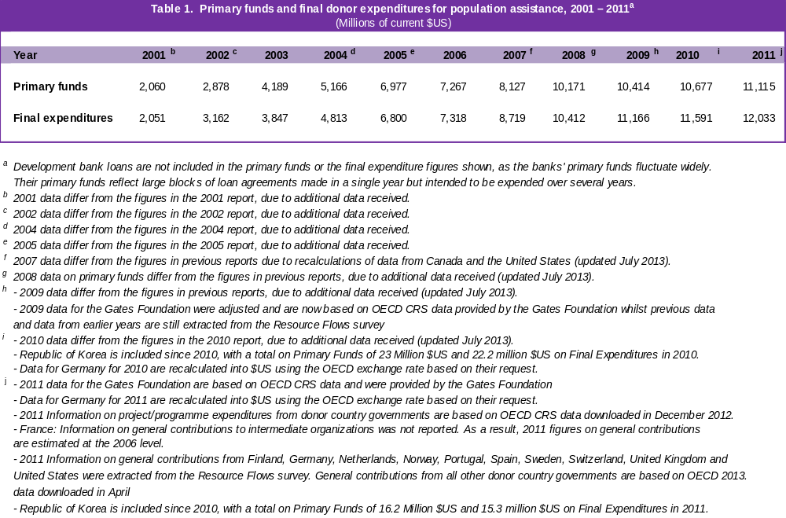

International financial resource flows for population activities - primary funds for international population assistance - totaled $11.4 billion in 2011, the highest amount to date (Table 2). If development bank loans are excluded, primary funds increased from $10.8 billion in 2010 to $11.1 billion in 2011.

Developed countries and the European Union are the largest source of primary funds, accounting for 91 per cent of international financial resource flows for population activities, including loans from development banks. Foundations and NGOs contributed 5.3 per cent of the total, and the United Nations system accounted for 0.6 per cent. A total of 0.4 per cent of international population assistance came from development bank grants.

Trends in Population Assistance in Current and Constant Dollars

In current dollars, total population assistance, excluding development bank loans, has grown from almost $2.1 billion in 2001 to $11.1 billion in 2011, at an average rate of 18 per cent annually (Figure 2). In constant dollars adjusted for inflation using 1993 prices - the year in which the ICPD cost estimates were made - international population assistance grew less rapidly than in current dollars, from $1.7 billion in 2001 to $7.1 billion in 2011, at 15 per cent annually (Table 2 and Figure 2).

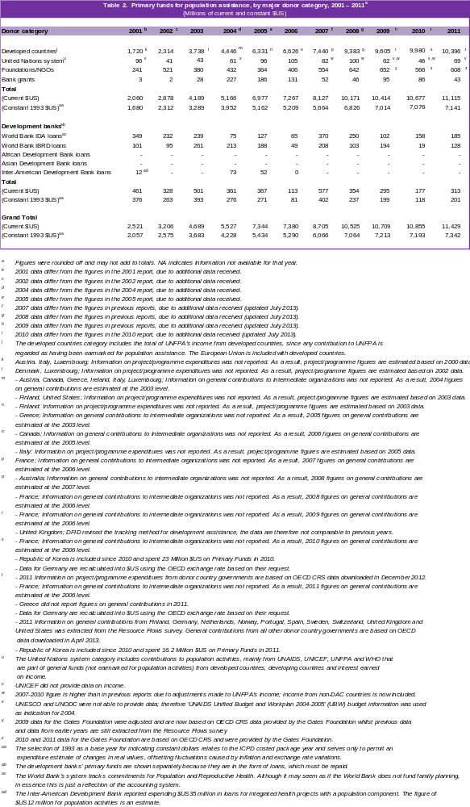

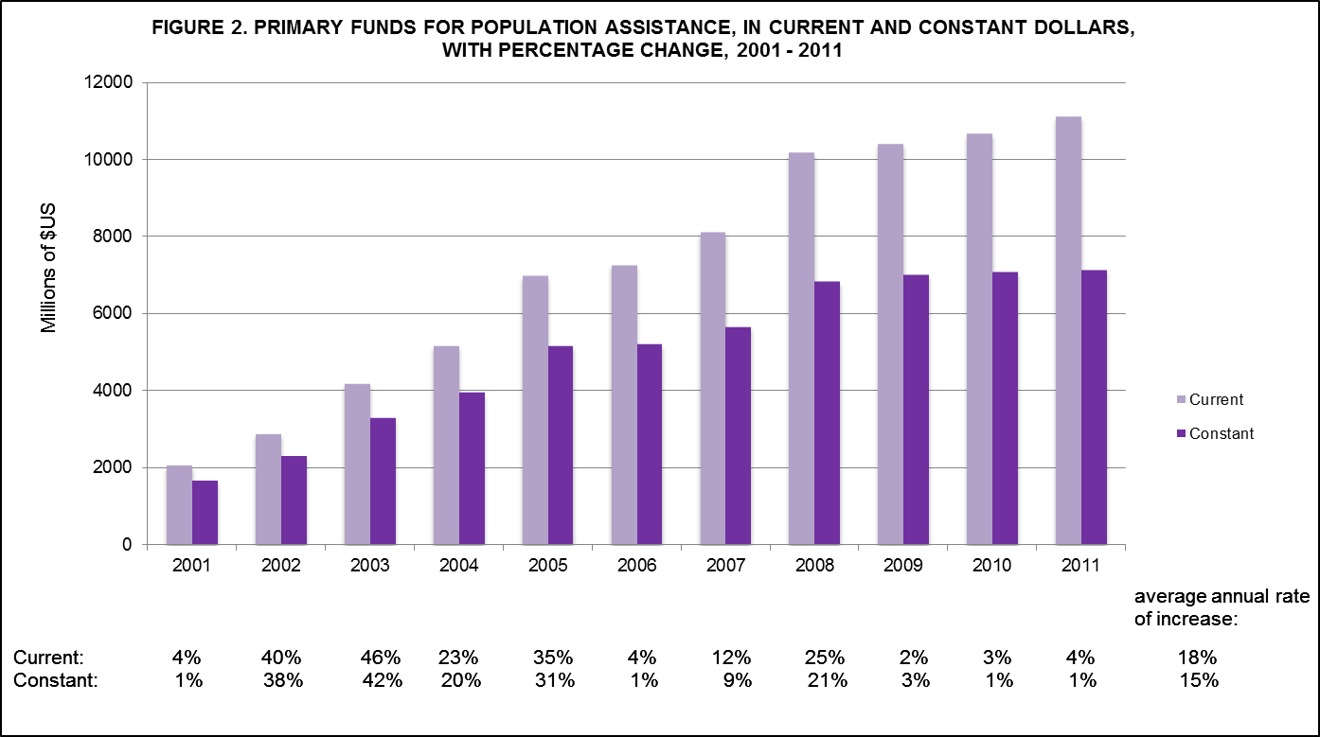

Final Donor Expenditures

Final expenditures on population projects and programmes in recipient countries in 2011, excluding development bank loans, increased to almost $12 billion (Table 1).

Trends in Bilateral Resource Flows

Overall Primary Funds

UNFPA monitors international population assistance from OECD/DAC donor countries and the European Union. Resource flows from the donor countries and the European Union totaled $10.4 billion in 2011 and constituted 91 per cent of total resource flows, including development bank loans, or 93.5 per cent of resource flows excluding loans made available by development banks. Development bank loans accounted for 2.7 per cent of total population assistance in 2011 (Figure 3).

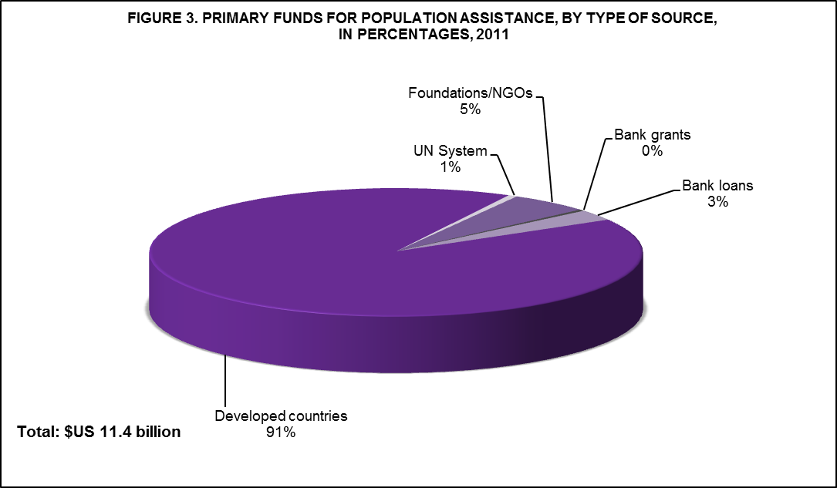

Resource flows from the 23 developed countries and the European Union increased from $10.1 billion in 2010 to $10.4 billion in 2011 (Table 2). Nine countries and the European Union accounted for 93 per cent of population assistance in 2011 (Figure 4).

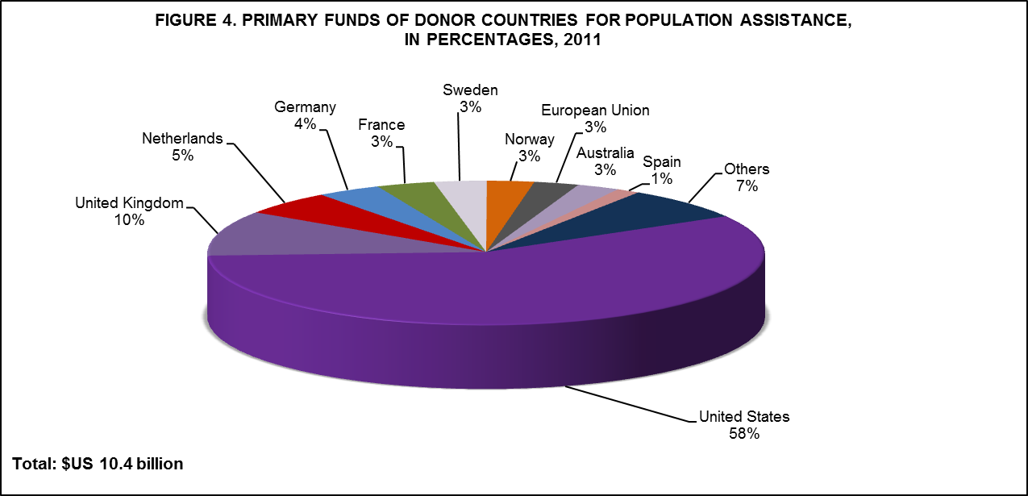

The top donors in 2011 were (in descending order): the United States, the United Kingdom, the Netherlands, Germany, France, Sweden, Norway, the European Union, Australia and Spain.

Population Assistance as a Percentage of Official Development Assistance

Total official development assistance (ODA) increased to $133.7 billion in 2011, the highest level recorded. However, donor countries contributed 7.57 per cent of their total ODA to population assistance in 2011 down from 7.69 per cent in 2010 (Figure 5 and Table A2). This means that donor countries contributed a smaller share of an increased ODA in 2011.

Donor countries vary greatly in the proportion of ODA contributed for population assistance: percentages ranged from 0.05 per cent to 19.43 per cent. Eleven countries contributed more than 4 per cent of their total ODA for population assistance in 2011: Australia, Denmark, Finland, Ireland, Luxembourg, the Netherlands, New Zealand, Norway, Sweden, the United Kingdom and the United States. Seven countries increased their percentage of ODA for population assistance; and sixteen countries contributed a smaller percentage of ODA for population assistance than they had in 2010.

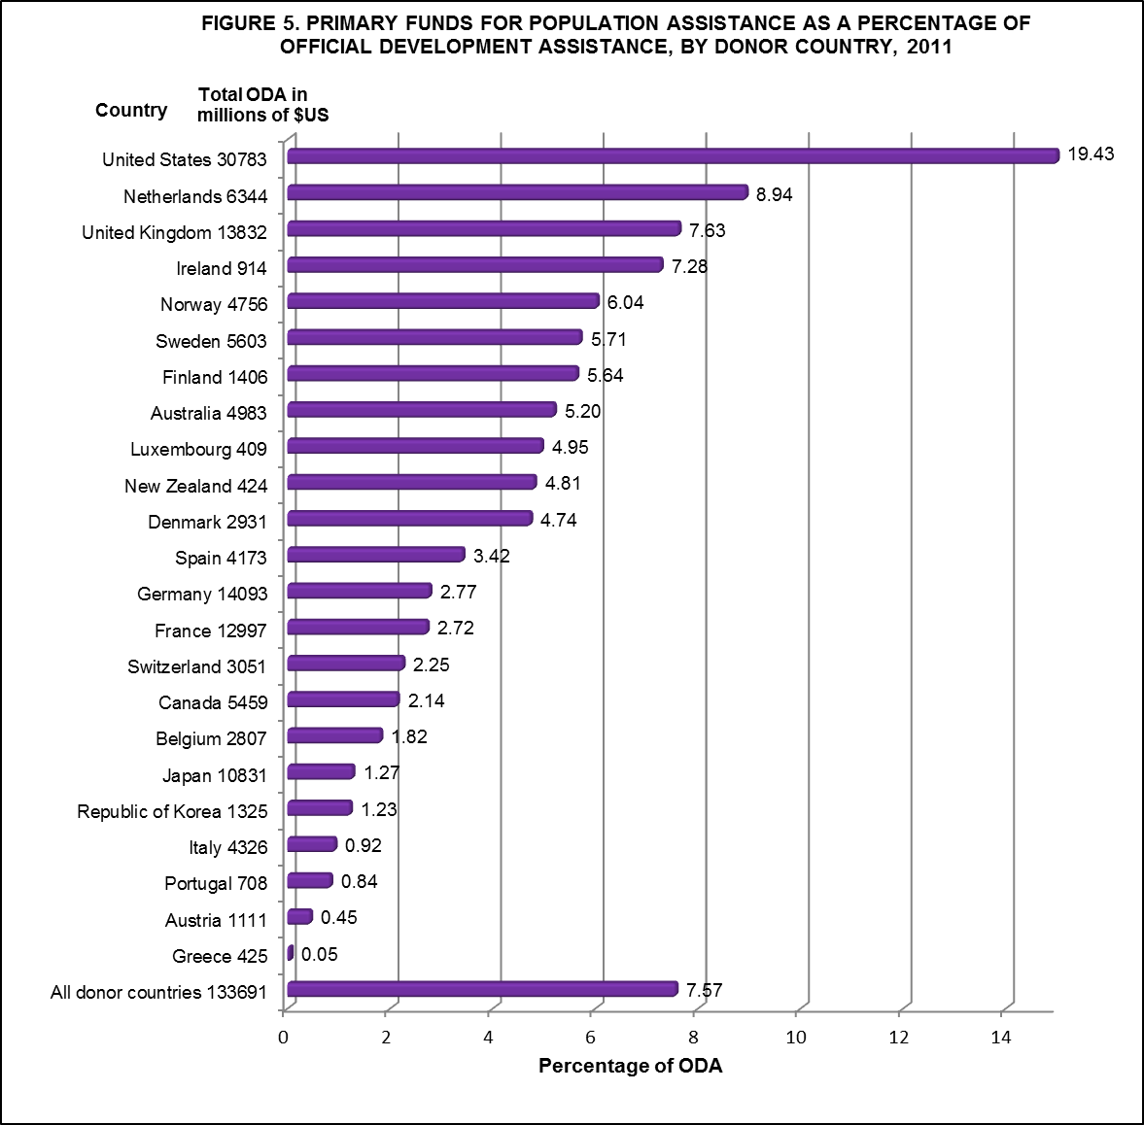

Population Assistance in Relation to Gross National Product

A country's dedication to population assistance can also be measured by the amount of resources it contributes to population in relation to its gross national product (GNP). In 2011, donor countries contributed, on average, $262 per million dollars of GNP for population assistance, almost the same as in 2010. (Figure 6 and Table A.3).

The average dollar amount conceals the large variation between countries, from $1 to $943 per million dollars of GNP. Fifteen countries spent over $100 per million dollars of GNP in 2011, and five countries spent less than $25 per million dollars of GNP. In 2011, Norway led all donor countries in the total dollar contributions per million dollars of GNP to population assistance, earmarking $943 for each million dollars of GNP for population activities. Denmark, Finland, Luxembourg, the Netherlands, Norway and Sweden contributed well over $100 per million dollars of GNP to population assistance each year in the past decade.

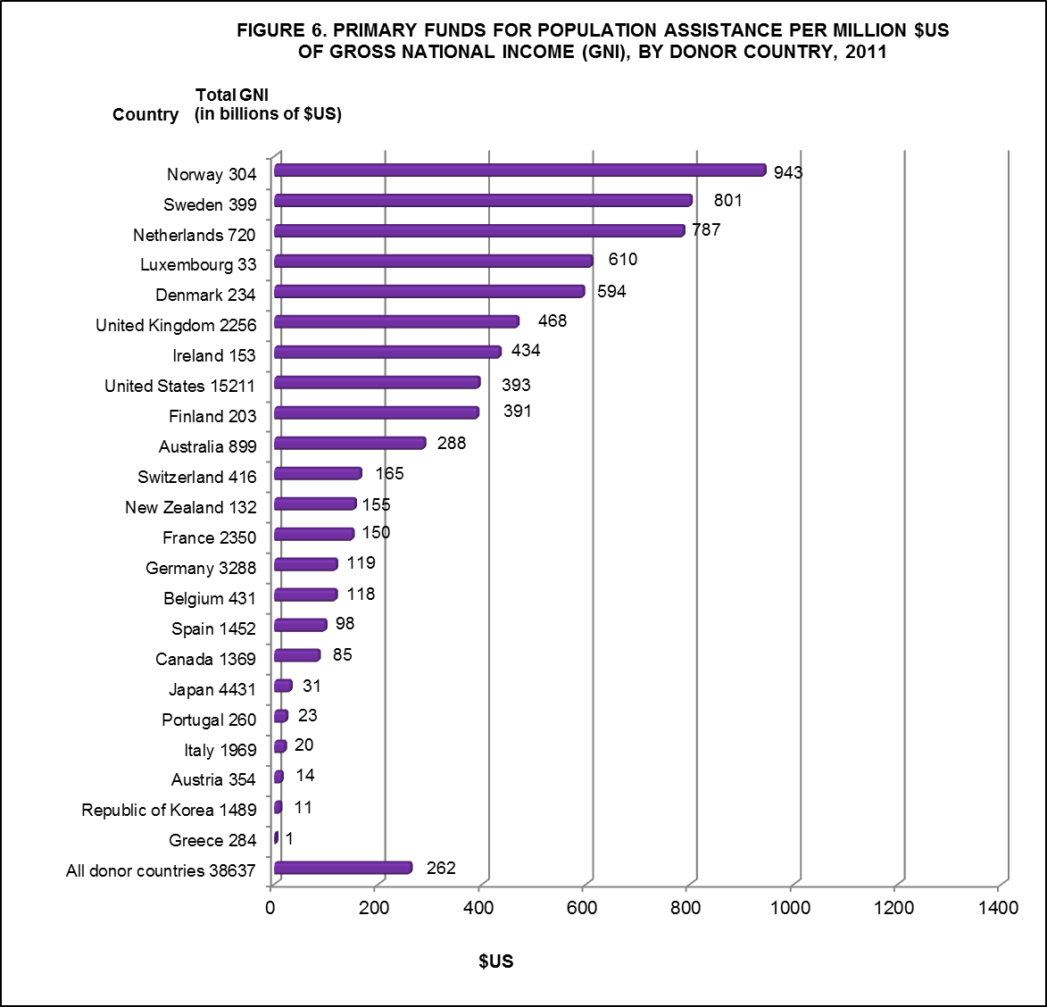

Trends in Multilateral Resource Flows for Population Activities

Multilateral assistance to population activities consists of contributions provided by the organizations and agencies of the United Nations system and loans and grants provided by development banks.

The United Nations System

In 2011, multilateral sources originating in the United Nations system are mainly funds from UNAIDS, UNFPA and the World Health Organization (WHO). Whatever the United Nations agencies receive from DAC member countries for population assistance is considered to be funding from donor countries. Agencies' general funds, interest earned on funds, and money from income-generating activities that are spent on population activities are considered as multilateral assistance for population. Funds received from developing countries which agencies spend on population activities are a small portion of an agency's regular budget and are also included as multilateral assistance. Primary funds from the United Nations system totaled $69 million in 2011, increasing from $20 million in 2010 (Table 2).

The significance of population assistance from multilateral organizations and agencies can best be measured by identifying the amount of funds flowing through these organizations for further distribution. In 2011, $1.23 billion flowed through multilateral organizations and agencies. Because they originate with donor countries, these funds are not included under the multilateral category in Table 2 to avoid double counting.

As the leading provider of United Nations assistance in the population field, UNFPA continues to help countries achieve the goals and objectives of the ICPD Programme of Action. In 2011, UNFPA reported a total income of $934 million as compared to $870 million in 2010. This includes an income of $450.7 million in voluntary donor contributions to UNFPA’s un-earmarked funding and $38.7 million in other revenue which supports UNFPA programmes in developing countries and is also used for administration and management, and $444.7 million in funds earmarked for trust funds and special initiatives administered by UNFPA.

SPECIAL THEME BOX 4. UNFPA ASSISTANCE TO POPULATION ACTIVITIES

UNFPA has been the leading provider of United Nations assistance in the population field since it became operational in 1969. The world’s largest international source of population assistance, UNFPA provides assistance to developing countries, countries with economies in transition and other countries at their request to help them address reproductive health and population issues, and raises awareness of these issues in all countries.

The Fund’s main areas of work are: to help ensure universal access to reproductive health, including family planning and sexual health, to all couples and individuals; to support population and development strategies that enable capacity-building in population programming; to promote awareness of population and development issues; and to advocate for the mobilization of the resources and political will needed to accomplish its work. UNFPA is guided by, and promotes, the principles of the ICPD Programme of Action. The ICPD goals, especially those pertaining to reproductive health and reproductive rights, gender equality, women’s empowerment and girls’ education, are an integral part of efforts to improve quality of life and achieve sustainable social and economic development.

In 2011, UNFPA provided support to 123 developing countries, areas and territories: 46 in sub-Saharan Africa, 23 in Asia and the Pacific, 21 in Latin America and the Caribbean, 19 in Eastern Europe and Central Asia, and 14 in the Arab States. The largest percentage of UNFPA assistance went to sub-Saharan Africa ($136.8 million), followed by Asia and the Pacific ($94.3 million), Latin America and the Caribbean ($33.2 million), the Arab States ($26.4 million), and Eastern Europe and Central Asia ($16.2 million). Global and other programmes totaled $51.7 million. UNFPA provided $158.5 million in assistance for reproductive health, $76.0 million for population and development, $41.8 million for gender equality and women’s empowerment and $82.3 million for programme coordination.

As the lead United Nations organization for the follow-up and implementation of the ICPD Programme of Action, UNFPA is fully committed to working in partnership with Governments, the United Nations system, development banks, bilateral aid agencies, NGOs and civil society to ensure that the ICPD goals and objectives are met.

See UNFPA Annual Report 2011.

Development Banks

Development banks, which provide loans to developing countries, are an important source of multilateral population assistance. Their contributions are treated separately because their assistance is in the form of loans, which must be repaid, rather than grants. The banks' projects reflect multi-year commitments, recorded in the year in which they are approved, but disbursed over several years. Most loans for population assistance come from the World Bank, which supports such activities as reproductive health and family planning service delivery, population policy development, HIV/AIDS prevention, and fertility survey and census work.

The World Bank's lending for population and reproductive health activities increased to $313 million in 2011 from $177 million in 2010 (Table 2). Of this amount, 59 per cent, or $185 million, comprised International Development Association (IDA) loans, made at highly concessional rates, and 41 per cent, or $128 million, comprised International Bank for Reconstruction and Development (IBRD) loans, made at rates closer to those prevailing in the market.

It is extremely difficult to disaggregate the population component in integrated projects and to isolate the costed population package from those activities that are not referred to in paragraph 13.14 of the ICPD Programme of Action. Many bank loans are used to finance basic social service programmes such as nutrition, integrated health and girls' education projects. Often, ICPD components such as family planning, reproductive health and HIV/AIDS-prevention services are embedded in these projects. However, record-keeping systems do not disaggregate funds allocated by the four main population categories defined in the Programme of Action. As a result, loans that are used to finance basic social service programmes and which include family planning, reproductive health and HIV/AIDS services go unrecorded because it is not possible to disaggregate funds allocated by the four ICPD categories.

In addition, the World Bank reported an expenditure of $43 million to intermediate donors for special grants programmes in population in 2011.

Trends in Resource Flows for Population Activities from Foundations and Non-Governmental Organizations

Foundations and international NGOs are important players in the field of population assistance. Each year, UNFPA/NIDI seeks to obtain information on the amount of funds originating with the major foundations and international NGOs that are active in the population field. Together, these organizations contributed $608 million for population assistance in 2011, down from $632 million in 2010 (Table 2).

Major Foundations

Major foundations provided $504 million in grants for population activities in 2011. The Bill and Melinda Gates Foundation accounted for 82 per cent of the funding that foundations made available for population activities in 2010. Other foundations that provided funds include, in descending order, the William and Flora Hewlett Foundation, the David and Lucile Packard Foundation, the United Nations Foundation and the John D. and Catherine T. MacArthur Foundation. These 5 foundations accounted for 99 per cent of the total population assistance from foundations in 2011 (Figure 7).

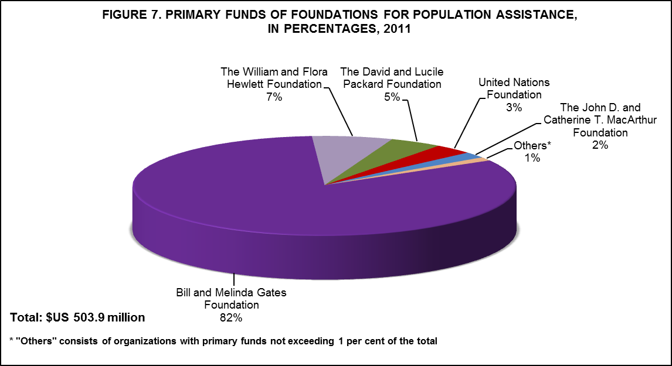

Non-Governmental Organizations

Although most NGOs serve as intermediate donors that channel funds from primary donors such as Governments and foundations to developing countries, a number of NGOs provide funding for population activities out of their own resources directly to developing-country recipients. In 2011, $104 million was earmarked for population activities in this way, of which 95 per cent came from DKT International and almost 4 per cent from the International Planned Parenthood Federation. (Figure 8).

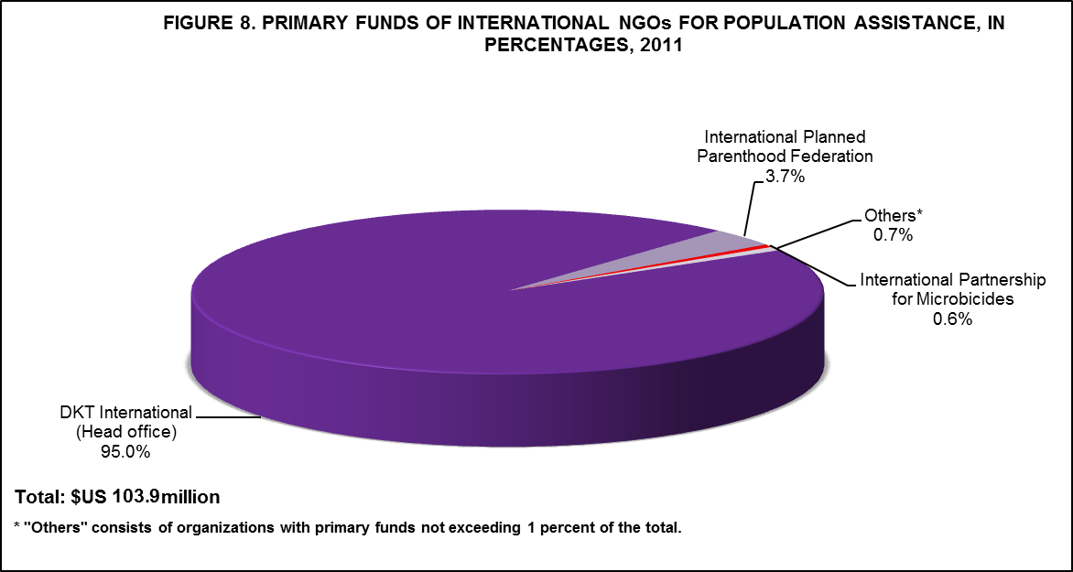

Final Donor Expenditures for Population Activities

According to the UNFPA/NIDI survey, a total of 157 countries and territories benefited from the almost $12 billion in final donor expenditures for population activities in 2011 (Tables A.5-A.9).

Final Donor Expenditures for Population Activities by Region

Of the five geographical regions, sub-Saharan Africa was the largest recipient of population assistance in 2011, followed by Asia and the Pacific. The distribution of population assistance among the regions was as follows: sub-Saharan Africa, 66.4 per cent; Asia and the Pacific, 21.6 per cent; Latin America and the Caribbean, 6.6 per cent; Western Asia and North Africa, 3.6 per cent; and Eastern and Southern Europe, 1.8 per cent.

The share of total assistance to global and interregional population activities remained virtually unchanged at 27.8 per cent in 2011. (Table A.4). Compared with 2010 figures, the 2011 final expenditures by region were as follows:

- Sub-Saharan Africa - $5.8 billion in 2011, up from the 2010 level of $5.6 billion;

- Asia and the Pacific - $1.9 billion in 2011, up from the 2010 level of $1.6 billion;

- Latin America and the Caribbean - $570 million in 2011, down from the 2010 level of $617 million;

- Western Asia and North Africa - $317 million in 2011, down from the 2010 level of $363 million;

- Eastern and Southern Europe - $155 million in 2011, down from the 2010 level of $171 million; and

- Global and Interregional - $3.34 billion in 2011, slightly higher than the 2010 level of $3.26 billion.

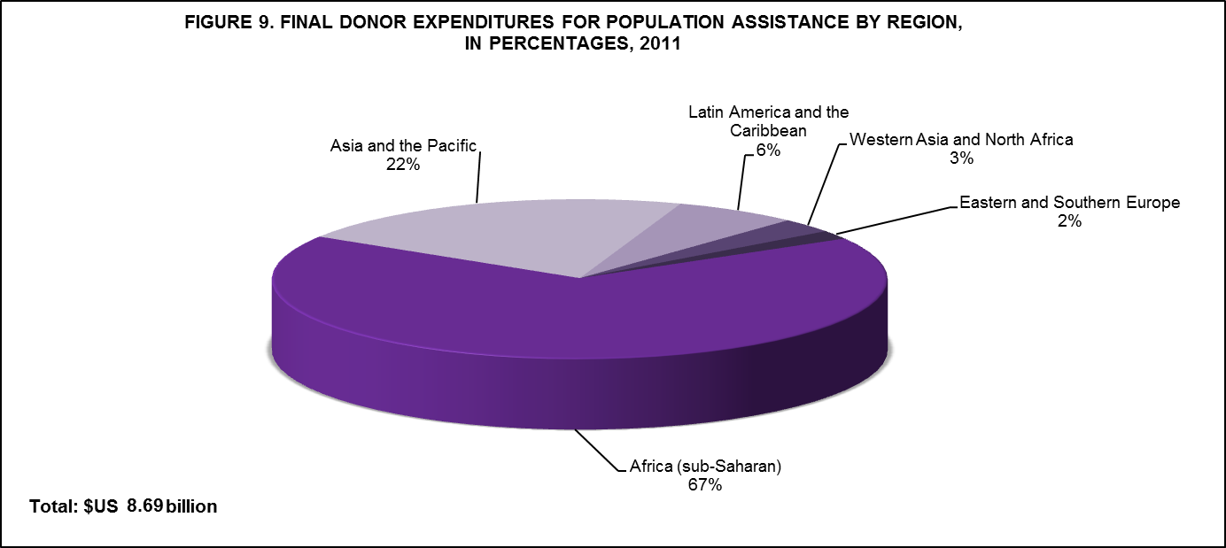

Final Donor Expenditures for Population Activities by Channel of Distribution

Assistance for population activities flows from the donor to the recipient country through one of the following channels: (1) bilateral (2) multilateral or (3) non-governmental. Of the total amount spent for population assistance in 2011, 33 per cent was channelled through bilateral programmes, while 26 per cent was channelled through multilateral organizations and 41 per cent was spent by international NGOs (Table 3).

- Final expenditures of bilateral organizations totaled $3.9 billion in 2011, up from $3.8 billion in 2010;

- Final expenditures of multilateral organizations and agencies totaled $3.1 billion in 2011, down from $3.2 billion in 2010; and

- Final expenditures of NGOs totaled $5.0 billion in 2011, up from $4.7 billion in 2010.

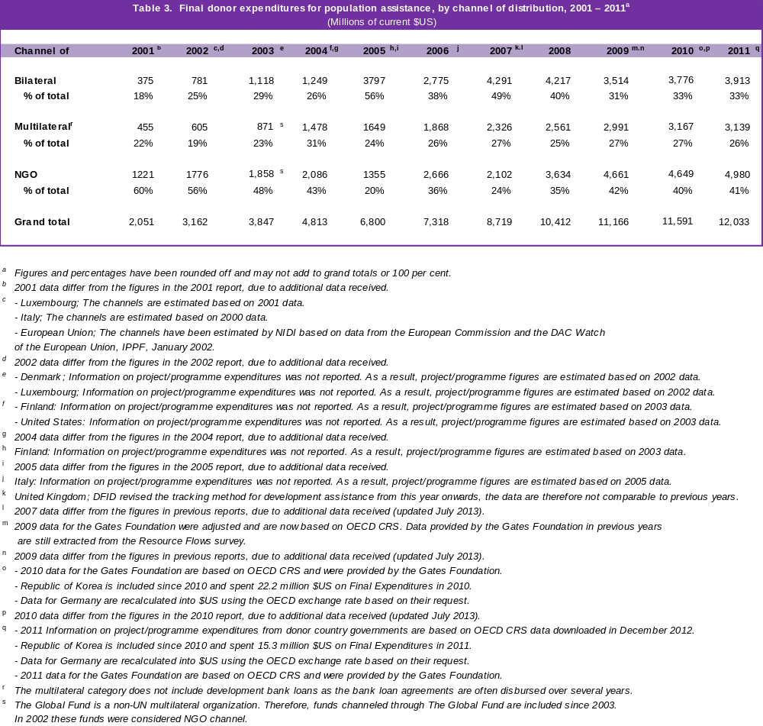

Figures 10 to 15 indicate the trends in final donor expenditures for population activities by channel of distribution and region. In 2011, 33 per cent of all population assistance went through the bilateral channel. Twenty-six per cent of population assistance was channelled by multilateral sources and 41 per cent flowed through the NGO channel.

- In sub-Saharan Africa, the NGO channel predominated every year except 2005, when the bilateral channel provided the most population assistance. The NGO channel peaked at 63 per cent in 2001. The most assistance provided by the multilateral channel was in 2004. In 2011, 36 per cent of population assistance flowed through the bilateral channel, 24 per cent through the multilateral channel and 40 per cent through the NGO channel.

- In Asia and the Pacific, the NGO channel provided the most population assistance every year except in 2002 when the bilateral channel predominated, 2005 when the multilateral channel predominated and in 2011 when both the multilateral and NGO channels provided the same proportion of assistance. The most assistance provided by the multilateral channel was in 2006. In 2011, 25 per cent of population assistance flowed through the bilateral channel, 37 per cent through the multilateral channel and 37 per cent through the NGO channel.

- In Latin America and the Caribbean, the NGO channel predominated in the past decade except in 2005 and 2006, when the multilateral channel provided the most population assistance and again in 2007 when the bilateral channel predominated. The multilateral channel fluctuated between a low of 15 per cent in 2000 and a high of 40 per cent of final expenditures for population in 2005. In 2011, 25 per cent of population assistance flowed through the bilateral channel, 36 per cent through the multilateral channel and 39 per cent through the NGO channel.

- In Western Asia and North Africa, the NGO channel fluctuated between a low of 30 per cent in 2006 and a high of 65 per cent in 2004. The bilateral channel provided most of the population assistance in 2002 and again in 2006 and 2007. The multilateral channel fluctuated between a low of 14 per cent in 2002 and a high of 39 per cent in 2009. In 2011, 21 per cent of population assistance flowed through the bilateral channel, 36 per cent through the multilateral channel and 43 per cent through the NGO channel.

- In Eastern and Southern Europe, the NGO channel was strongest in 2001, accounting for 59 per cent of population assistance. The bilateral channel was strongest in 2000, when it accounted for 35 per cent of assistance. The multilateral channel fluctuated over the years with a low of 20 per cent in the years 2000, 2002 and 2004 and a high of 75 per cent in 2010. In 2011, 19 per cent of population assistance flowed through the bilateral channel, 60 per cent through the multilateral channel and 21 per cent through the NGO channel.

- Assistance to global and interregional population activities flowed chiefly through NGO channels from 2000 to 2003, peaking at 74 per cent in 2002. The bilateral channel accounted for a small percentage of expenditures, until 2004 when it accounted for one third of expenditures and began increasing thereafter, only to decrease considerably in 2009. The multilateral channel ranged in importance from a low of 19 per cent in 2002 to a high of 35 per cent in 2004. In 2011, 34 per cent of population assistance flowed through the bilateral channel, 20 per cent through the multilateral channel and 47 per cent through the NGO channel.

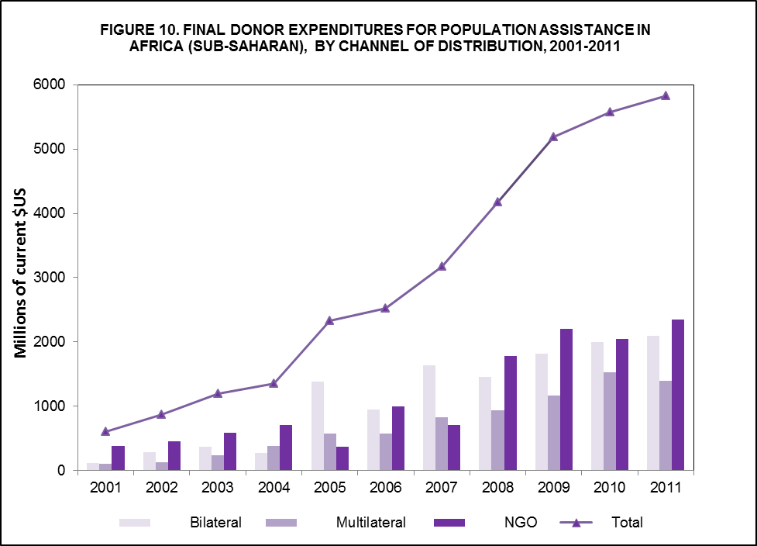

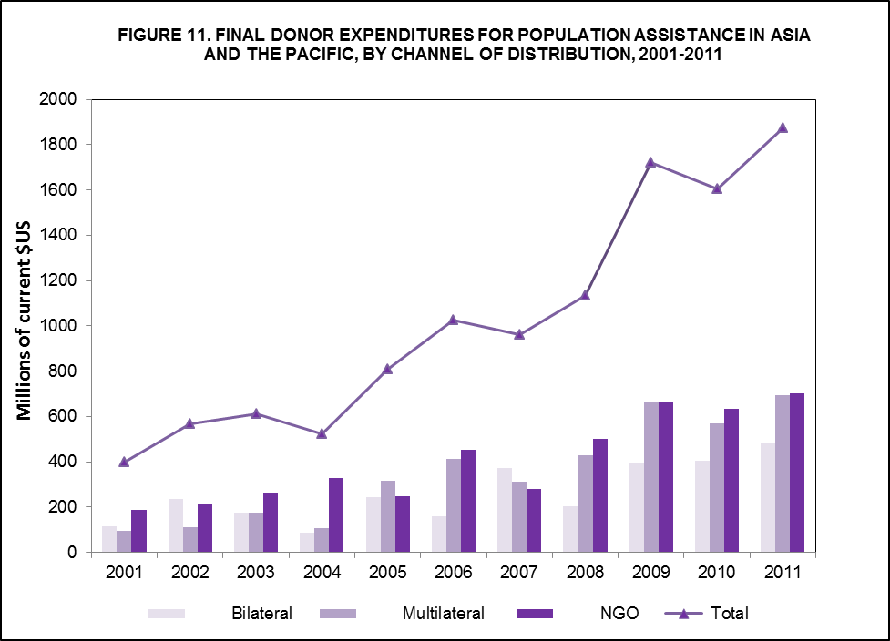

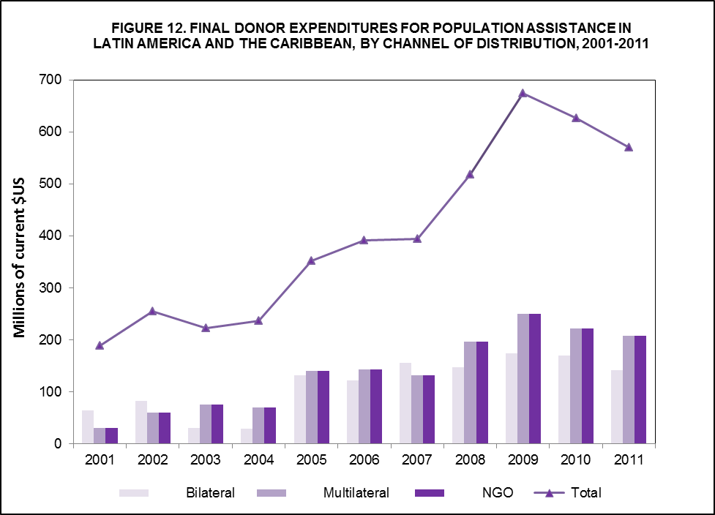

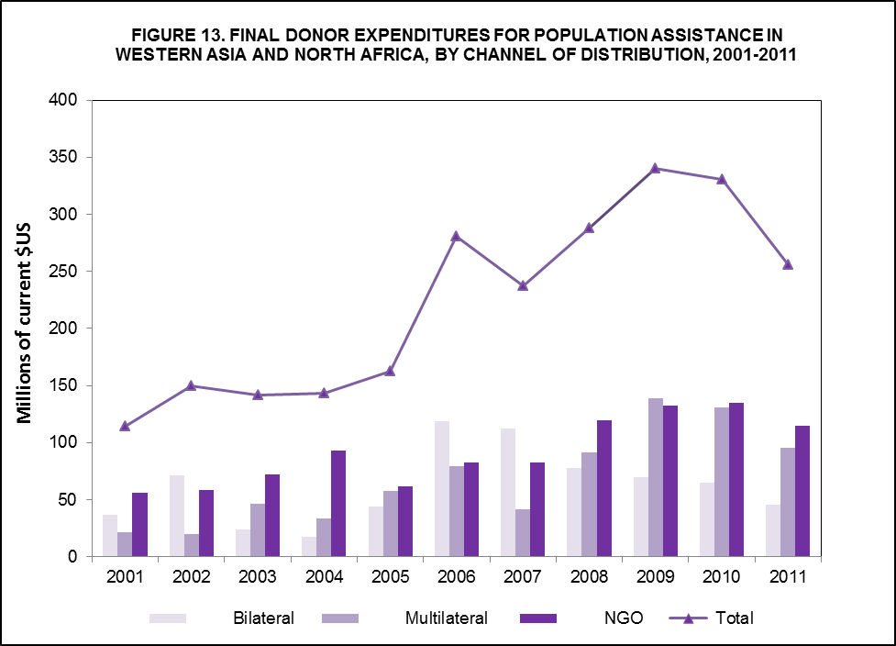

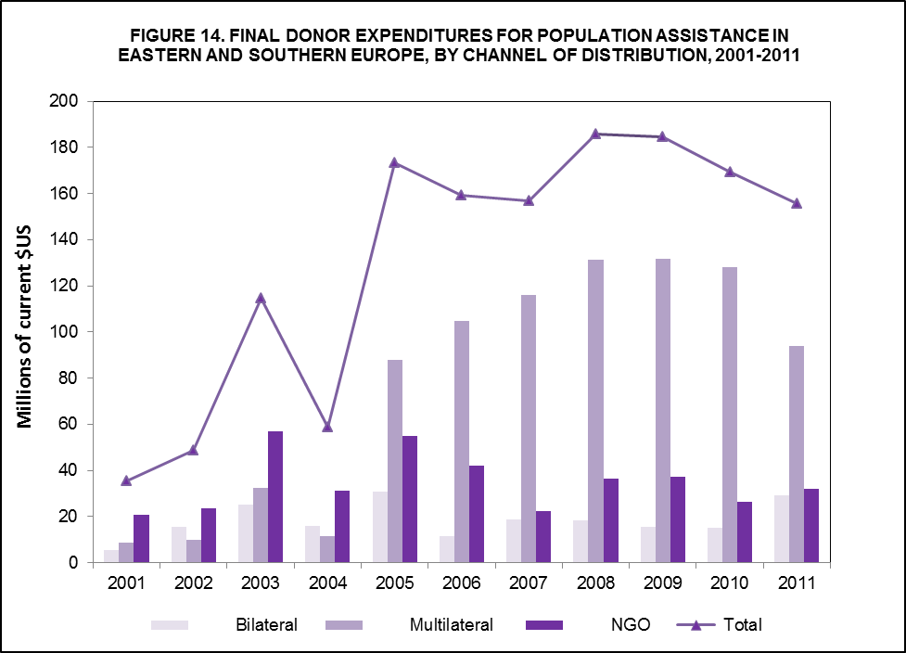

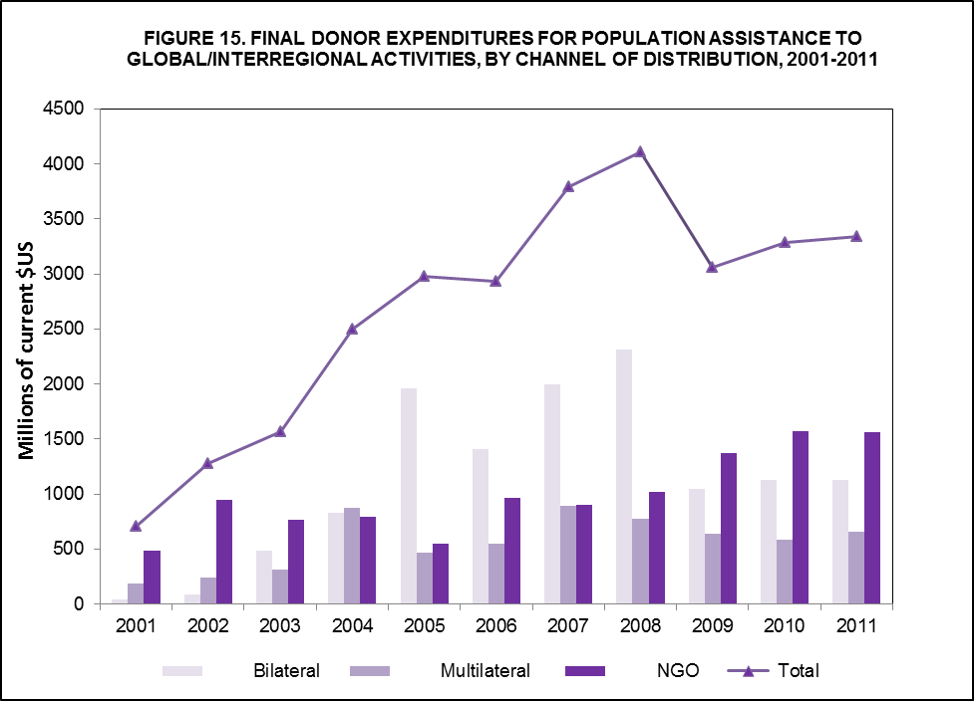

Map 1. Final Donor Expenditures for Population Assistance, by Region and Channel of Distribution, 2011 (percentages)

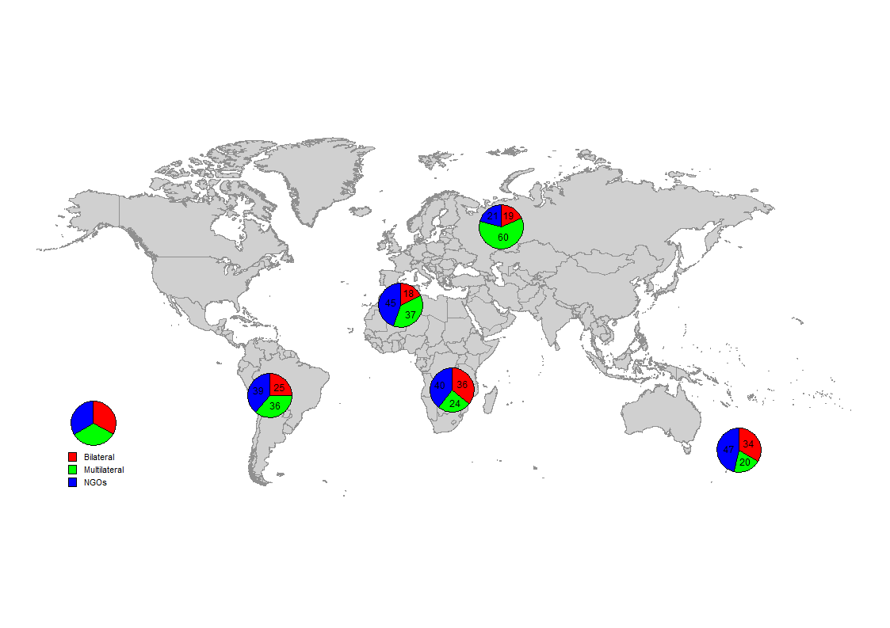

Final Donor Expenditures for Population Activities by Category of Activity

Sixty-six per cent of all population assistance in 2011 was expended for STD/HIV/AIDS activities. A total of 8 per cent of population assistance was expended for family planning services, 22 per cent for basic reproductive health services and 4 per cent was spent on basic research, data and population and development policy analysis. Over the years, the percentage of funding for STD/HIV/AIDS increased from 9 per cent of total population assistance in 1995, the immediate post-Cairo period, to a high of 75 per cent in 2007. During the same period, the percentage of funding as a per cent of total population assistance decreased for all three remaining ICPD components: it decreased from 55 per cent to 5 per cent for family planning services, from 18 per cent to 17 per cent for basic reproductive health services, and from 18 per cent to 3 per cent for basic research, data and population and development policy analysis. The percentage that went to STD/HIV/AIDS activities decreased for the first time in 2006, increased in 2007 and then decreased again. The actual dollar amount continued to increase until 2008, decreased in 2009 and went up again in 2010 and 2011 when it reached almost $8 billion.

In actual dollar amounts, funding for family planning services, which had plummeted to $393.5 million in 2006, had begun to increase, reaching a new high of $992.5 million in 2011 and accounting for 8 per cent of total final expenditures that year. Funding for basic reproductive health services decreased in 2011 in both actual dollar amount and percentage of total expenditures while funding for basic research, data and population and development policy analysis increased (Table 4 and Figure 16). Even though funding for family planning increased, it has not kept pace with current needs as can be seen from the revised cost estimates which show that the needs have increased in all four ICPD areas.

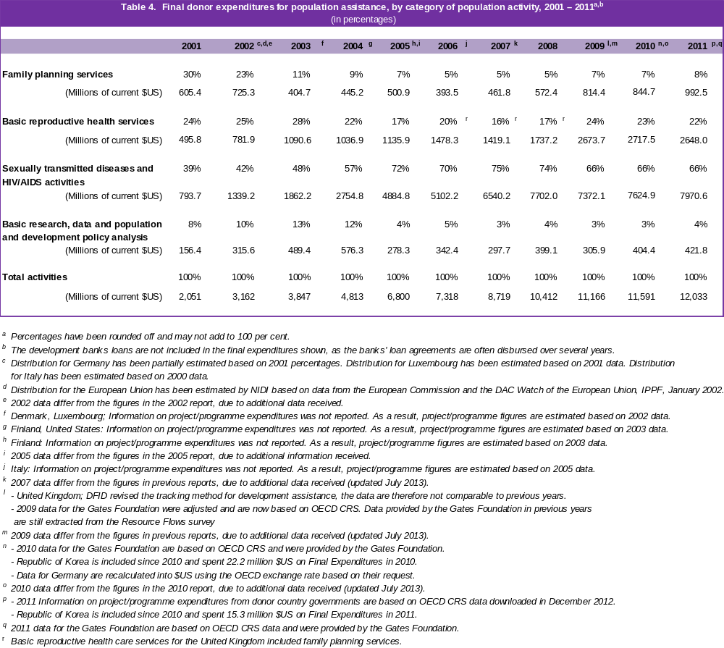

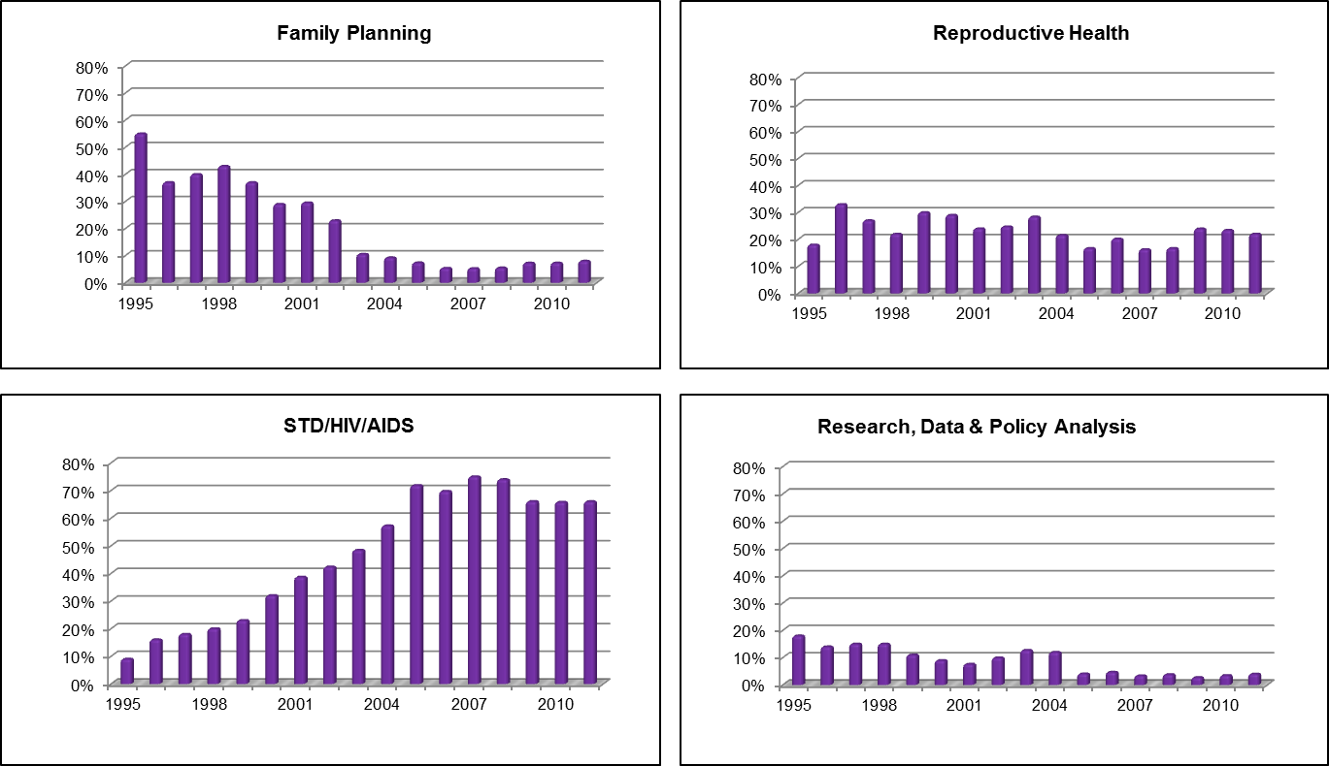
Figure 16. Expenditures for Population Activities as a Percentage of Total Population Assistance, 1995-2011

SPECIAL THEME BOX 5. ESTIMATES OF DONOR ASSISTANCE: 2012 AND 2013

To address the increasing demands for timely data on population expenditures, the UNFPA//NIDI Resource Flows Project produces current estimates to complement existing trend analysis. Real-time estimates have been developed for 2012 and 2013 based on future expected expenditures as reported in the Resource Flows survey and estimation driven projections.

Results of the estimation exercise show that population assistance, not counting development bank loans, was $11.6 billion in 2012 and $12.0 billion in 2013. If development bank loans are included - estimated at the 2011 level, the latest year for which data are currently available - then the estimated total international population assistance would be $11.9 billion in 2012 and $12.3 billion in 2013.

In addition to supplying the information needed by UNFPA and UNAIDS for tracking and reporting purposes, the data for 2012 and 2013 are used to advocate for the mobilization of required resources from the donor community and renewal of national commitments to ICPD goals in order to finance population programmes in developing countries as well as to plan for an effective response to the AIDS pandemic.

See Erik Beekink, “Projections of Funds for Population and AIDS Activities, 2011-2013”, The Hague, 2013.

Domestic Financial Resources for Population Activities
5

Global Estimate of Domestic Resource Flows

The ICPD pointed out that domestic resources of developing countries provide the largest portion of funds for attaining population and development objectives. The mobilization of adequate domestic financial resources is essential to facilitate full implementation of the Cairo agenda. UNFPA has been monitoring domestic expenditures for population activities since 1997 through the use of a survey questionnaire sent to UNFPA Country Offices throughout the world for further distribution to Government ministries and large national NGOs. In many countries, local consultants were recruited to work with government authorities and non-governmental organizations in completing the questionnaires. Respondents were requested to focus on the ICPD costed population package and to report only domestic financial resources, not to include international donor assistance.

Surveys of domestic expenditures were initially conducted on an annual basis but, subsequently, to reduce the burden on financial and human resources, countries were surveyed on a two-yearly basis. Country case studies were conducted as part of the Resource Flows Project to supplement the mail inquiry. Despite intensive follow-up, it was becoming increasingly difficult to track progress of developing countries towards achieving the ICPD financial targets. Many Governments, including several of the most populous countries, were unable to supply the requested data because of funding, staffing and time constraints. In addition, countries that did not have well-developed systems for monitoring resource flows were unable to provide the requested information, especially when funding was pooled in integrated social and health projects and sector-wide approaches. Furthermore, countries with decentralized accounting systems could only supply data on national expenditures and were unable to provide information on expenditures for population at sub-national (lower administrative) levels. The survey is currently conducted annually and focuses on a core group of countries selected on the basis of population size, amount of population and AIDS expenditures, HIV/AIDS prevalence and regional representation. Beginning with fiscal year 2008, data on AIDS expenditures are obtained directly from UNAIDS.

Total global domestic expenditures for population activities for fiscal year 2011 were estimated using a methodology that incorporated the responses received from the survey, together with prior reporting on actual and intended expenditures, secondary sources on national spending and, in the absence of such information, estimates were based on national income as measured by the level of gross domestic product which proved the most influential variable explaining the growth of spending by Governments. This estimate, which should be treated with caution, yielded a crude global figure of $54.7 billion (Table 5).

Table 5. Estimate of Global Domestic Expenditures for Population Activities, 2011
(thousands of $US)
Source of Funds
Region | Government | NGO | Consumers * | Total |  | Percentage spent on STD/HIV/AIDS
Africa (sub-Saharan) | 3,244,374 | 119,916 | 3,567,490 | 6,931,780 |  | 95%
Asia and the Pacific | 11,249,700 | 157,910 | 27,944,254 | 39,351,864 |  | 10%
Latin America and the Caribbean | 2,190,262 | 80,799 | 1,133,654 | 3,404,715 |  | 85%
Western Asia and North Africa | 542,511 | 60,014 | 349,920 | 952,445 |  | 36%
Eastern and Southern Europe | 2,669,365 | 16,025 | 1,374,723 | 4,060,113 |  | 96%
Total | 19,896,212 | 434,664 | 34,370,040 | 54,700,916 |  | 32%

* Consumer spending on population activities covers only out-of-pocket expenditures and is based on the average amount per region measured by the WHO for health care spending in general. For each region, the ratio of private out-of-pocket versus per capita government expenditures was used to derive consumer expenditures in the case of population activities.
See also: Erik Beekink, Projections of Funds for Population and AIDS Activities, 2011-2013, The Hague, 2013.

Although the global figure of domestic resource flows is a rough estimate based on data that are sometimes incomplete and not entirely comparable, the information is useful in that it provides some idea of the progress made by developing countries, as a group, in achieving the financial resource targets of the ICPD Programme of Action. While the global total shows real commitment on the part of developing countries and countries with economies in transition, most domestic resource flows originate in a few large countries. Many countries, especially those in sub-Saharan Africa and the least developed countries, are simply unable to generate the necessary resources to finance their own national population programmes. Most developing countries are dependent on the international donor community to finance population activities.

SPECIAL THEME BOX 6. MEASURING OUT-OF-POCKET EXPENDITURES FOR

SEXUAL AND REPRODUCTIVE HEALTH

In December 2011, the Resource Flows Project convened a meeting to discuss the tracking of out-of-pocket expenditures for sexual and reproductive health. Measuring out-of-pocket expenditures is extremely important because there is increasing evidence that such expenditures act as a financial barrier to essential health care and are a source of impoverishment and ill health, forcing households to reduce spending on other essential items such as food and to rely on risky coping strategies. This is especially true when a household is faced with catastrophic expenditures that represent a significant proportion of its budget.

Information on out-of-pocket expenditures for sexual and reproductive health is scarce and measuring such expenditures is difficult. There are both conceptual and measurement problems. The objectives of the Resource Flows Project meeting were to discuss what is known about out-of-pocket expenditures, to review experiences in collecting data on such expenditures and to determine optimal strategies.

Data sources for out-of-pocket expenditures include surveys, health surveillance systems, financial diaries and costing studies. Specialized out-of-pocket expenditure surveys are expensive to conduct. A UNFPA/NIDI Resource Flows project module to collect such information in connection with service utilization via existing household and individual women’s questionnaires was not implemented due to financial constraints.

There have been a number of initiatives aimed at estimating out-of-pocket expenditures, among them estimates produced by the World Health Organization which are used by the Resource Flows Project to derive data on consumer spending on population activities. Estimating out-of-pocket expenditures for sexual and reproductive health is an on-going process which will be especially important in the context of Family Planning 2020.

Previous Resource Flows Project experience in India, Nepal and Ethiopia recommend that the first step in collecting data on out-of-pocket expenditures is to conduct a detailed mapping of the health system including financing sources, public and private providers, range and type of health services available and health insurance schemes. This will result in a better understanding of the local health system, its actors, functions and types of data available. In addition to identifying the relevant actors in the health system, the mapping exercise can also be used to identify useful data sources and databases. Once a detailed mapping is done, the next step is to determine functional boundaries – what is considered sexual and reproductive health treatment and care within the given country context. This would include official guidelines from the Ministry of Health, international classifications as well as services and treatment outside the formal health care system such as the use of traditional healers. In order to make international comparisons possible, boundaries should be clearly defined and categories should be clearly distinguished.

Tracking out-of-pocket expenditures for sexual and reproductive health is critical to understanding the burden on consumers and addressing financial barriers to accessing essential health care. It is essential to improving progress towards the Millennium Development Goals of reducing child mortality, reducing maternal mortality, and achieving universal access to reproductive health.

Source: Tracking of Out-of-Pocket Expenditures for Sexual and Reproductive Health, Papers prepared for the UNFPA/NIDI Resource Flows Project Expert Meeting. NIDI, The Hague, December 2011.

Conclusion

Financial Resource Flows for Population Activities in 2011 provides information on the flow of international and domestic funding for population programmes in developing countries. The report represents a major effort to capture funding for activities that are part of the costed population package identified in the ICPD Programme of Action: family planning services; basic reproductive health services; STD/HIV/AIDS activities; and basic research, data and population and development policy analysis. It records bilateral, multilateral and NGO assistance to developing countries, including development bank loans, and provides information on resources mobilized by developing countries themselves.

The data presented in this report are based on responses obtained from the Governments and institutions surveyed and estimates of expected expenditures. While information on international population assistance is reliable, that for developing countries is incomplete due to the difficulties that many countries encounter in providing the requested data. Data on domestic resource flows, especially the global total, should be treated as approximations. They are meant to provide some idea of the progress that developing countries, as a group, are making towards achieving the ICPD financial targets.

Both donor and developing countries have indicated that they are finding it increasingly difficult to provide the information requested on resource flows for population activities disaggregated by the four categories costed out in the ICPD Programme of Action because their expenditures on those activities are often part of integrated health and social sector projects and SWAps and do not appear as separate budget items in their accounting systems. Other factors that make it difficult to respond to the resource flows survey include respondent fatigue and financial, staff and time constraints. More external and domestic resources are provided for population activities than are reported here because respondents cannot supply the information requested.

Progress in Resource Mobilization

The ICPD called upon the international community to achieve an adequate level of resource mobilization and allocation, at the community, national and international levels, for population programmes and for other related programmes, all of which seek to promote and accelerate social and economic development, improve the quality of life for all, foster equity and full respect for individual rights and, by so doing, contribute to sustainable development (ICPD Programme of Action, para. 13.21).

The Programme of Action specified the financial resources, both domestic and donor funds, necessary to implement the population and reproductive health package over the next twenty years. It pointed out that “these estimates should be reviewed and updated on the basis of the comprehensive approach reflected in paragraph 13.14 of the present Programme of Action, particularly with respect to the costs of implementing reproductive health service delivery” (para 13.15). In 2009, UNFPA produced revised cost estimates to more accurately reflect current needs and costs (Special Theme Box 7). According to the new estimates, almost $68 billion would be required to meet the needs and costs in 2011.

In 2011, population assistance stood at $11.4 billion. Domestic spending increased to an estimated $54.7 billion. At $66.1 billion, this is a most welcome development. However, before the international community becomes complacent about narrowing the gap between resources needed and funds mobilized, it should be pointed out that the considerable increase in domestic resources is the result of the large expenditure reported for 2011 for family planning in China, as well as new data for HIV/AIDS and out-of-pocket expenditures. The gap may well widen in 2013 if the 2011 family planning projects do not continue. It should also be pointed out that population assistance is not increasing at the same rate as in the past, and shows definite stagnation.

While a number of developing countries have shown commitment to implementing the ICPD financial targets by allocating resources for population activities, the majority of countries have limited financial resources to utilize for population and reproductive health programmes and cannot generate the required funds to implement these programmes. The global estimate of domestic resource flows conceals the great variation that exists among countries in their ability to mobilize resources for population activities. Most domestic resource flows originate in a few large countries.

Most developing countries cannot be expected to generate the required funds to implement their population programmes. In the least developed countries and other low-income countries, a relatively larger part of the total required resources will have to come from external sources. The lack of adequate funding continues to remain one of the chief constraints to the full implementation of the ICPD Programme of Action.

Future Resource Requirements

In response to the ICPD Programme of Action call that the “estimates should be reviewed and updated” (para 13.15), and to harmonize the ICPD financial targets with MDG costing, UNFPA undertook the task of reviewing estimates for the four components of the ICPD costed population package and produced revised estimates to meet current costs and needs. The global revised cost estimates are shown in Special Theme Box 7 below. Annex A. 10 contains the revised cost estimates by region.

SPECIAL THEME BOX 7. REVISED ICPD COST ESTIMATES, 2009-2015 (Millions of $US)
 | 2009 | 2010 | 2011 | 2012 | 2013 | 2014 | 2015
Sexual/Reproductive Health/Family Planning | 23,454 | 27,437 | 30,712 | 32,006 | 32,714 | 33,284 | 33,030
Family Planning Direct Costs | 2,342 | 2,615 | 2,906 | 3,209 | 3,529 | 3,866 | 4,097
Maternal Health Direct Costs | 6,114 | 7,868 | 9,488 | 11,376 | 13,462 | 15,746 | 18,002
Programmes and Systems Related Costs | 14,999 | 16,954 | 18,319 | 17,422 | 15,723 | 13,672 | 10,931
HIV/AIDS | 23,975 | 32,450 | 33,107 | 33,951 | 34,734 | 35,444 | 36,189
Basic Research/ Data/Policy Analysis | 1,551 | 4,837 | 3,943 | 2,239 | 1,181 | 864 | 591
TOTAL | 48,980 | 64,724 | 67,762 | 68,196 | 68,629 | 69,593 | 69,810

Source: United Nations (2009), Report of the Secretary-General on The Flow of Financial Resources for the implementation of the Programme of Action of the International Conference on Population and Development, E/CN.9/2009/5. UNFPA (2009), Revised Cost Estimates for the Implementation of the Programme of Action of the International Conference on Population and Development: A Methodological Report.

Resource Flows for Other Population-Related Activities

The ICPD Programme of Action outlines a comprehensive population and development agenda. It points out that, in addition to the costed population package, additional resources would be needed to support programmes that address broader population and development objectives including, inter alia, those designed to strengthen the primary health-care delivery system, improve child survival, provide emergency obstetrical care, provide universal basic education, improve the status and empowerment of women, generate employment, address environmental concerns, provide social services, achieve balanced population distribution and address poverty eradication (paras. 13.17-13.19). No attempt was made to cost out the resources required to achieve these wider social goals.

In monitoring the flow of financial resources for assisting in the implementation of the ICPD Programme of Action, UNFPA has adhered to the classification of population activities of the costed population package described in paragraph 13.14 of the Programme of Action. Funding for other population-related activities, such as basic health, education, poverty eradication and women's issues, is not included in the calculations of international population assistance and domestic resources for population activities.

Both donor and developing countries have indicated that a significant amount of resource flows goes to other population-related activities that address the broader population and development objectives of the Cairo agenda, but that have not been costed out and are not part of the agreed target. These include such activities as poverty alleviation, primary health-care delivery systems, child health and survival, basic education, including girls' and women's education, empowerment of women, rural development, and income generation. Clearly, countries are spending much more than is included in this report.

Population and the Millennium Development Goals

Population is central to development and the achievement of the MDGs. The ICPD goals, especially the reproductive health goal, are essential for meeting the MDGs directly related to health, including child mortality, maternal health and HIV/AIDS prevention, and social and economic outcomes, including gender equality and poverty eradication. Population issues must be an integral part of development planning and poverty reduction strategies if the international community is to make any progress towards the achievement of the MDGs, especially the eradication of poverty. International consensus recognizes the importance of demographic trends - including fertility, mortality, population growth, age structure and migration - as critical factors affecting all aspects of development. Promoting the goals of the international United Nations Conferences of the 1990s, including the ICPD, as well as the Millennium Development Goals relating to health, education and gender, is vital for laying the foundation to reduce poverty in many of the poorest countries.

The adverse consequences of reproductive-related morbidity and mortality, including maternal deaths, and the human and environmental impacts of continued rapid population growth undermine individual and family well-being and slow development in many countries. Morbidity and mortality resulting from inadequate access to reproductive health services, family planning, care in pregnancy and childbirth and the prevention of sexually transmitted diseases and HIV/AIDS affect men and women in their most productive years and exact a huge social and economic toll on society.

New Modalities for Resource Mobilization

Additional resources are needed to fund population and development programmes in developing countries. There are many modalities by which to mobilize resources: advocacy for increased funding from international financial institutions and regional development banks; increased involvement of the private sector; selective use of user fees; and social marketing, cost-sharing and other forms of cost recovery. The SWAp is another important mechanism for generating funds for population programmes in developing countries. By changing the way of conducting the aid business and reducing aid fragmentation, the SWAp modality is an attempt to overcome the shortcomings of the project approach to improve the impact and sustainability of development cooperation. It is essential to ensure that population concerns are adequately addressed in SWAps and that sufficient resources are allocated to fund population programmes that are part of sector-wide approaches.

The Way Forward

Continued resource mobilization advocacy efforts on the part of both donors and developing countries are essential to meet current needs and fully implement the ICPD agenda. It is important that funding for all four ICPD population categories increase.

Donor and developing countries should re-examine priorities and increase allocations for population and related sectors. Given limited financial resources, it is essential that donor countries, international agencies and recipient countries continue to strengthen their efforts and their collaboration to avoid duplication, identify funding gaps and ensure that resources are used as effectively and efficiently as possible. Coordinating donor financing policies and planning procedures will help to enhance the impact and cost-effectiveness of contributions to population programmes.

More emphasis on results-based programming and management on the part of development and multilateral agencies will help to increase donor confidence which may, in turn, increase development assistance and provide agencies with the funds necessary for them to carry out their work. Assessing impact of resources, examining cost-effectiveness and addressing equity considerations will also help to alleviate the concerns of an increasing number of donors.

The success of the ICPD depends greatly upon the willingness of Governments, local communities, the non-governmental sector, the international community and all concerned organizations and individuals to turn the ICPD recommendations into action.

The challenge before the international community is to mobilize sufficient resources to meet growing needs. This is particularly important given the continued adverse effects of the global financial crisis. Increased political will and a re-doubling of efforts to generate additional international assistance and increased domestic funding from all sources are urgently needed to accelerate the implementation of the ICPD Programme of Action.

ANNEX TABLES

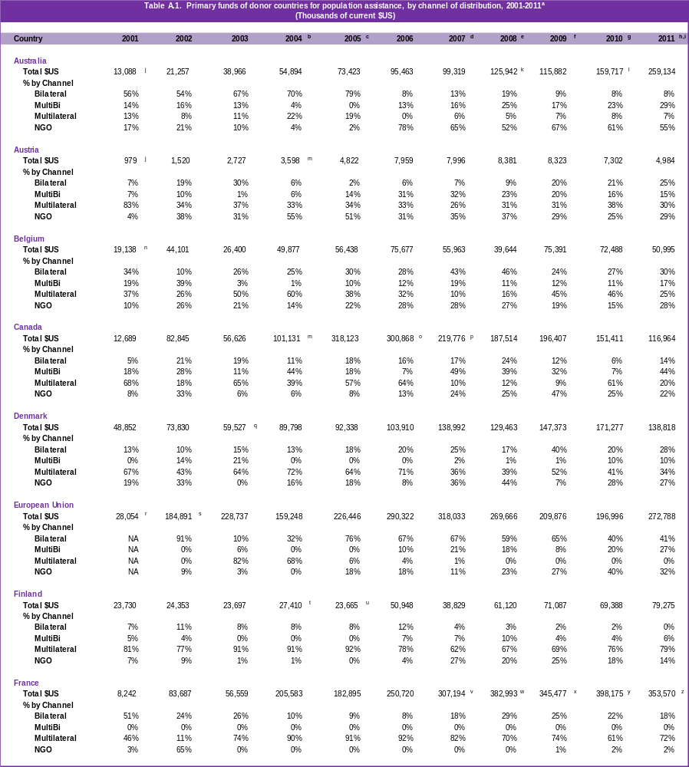

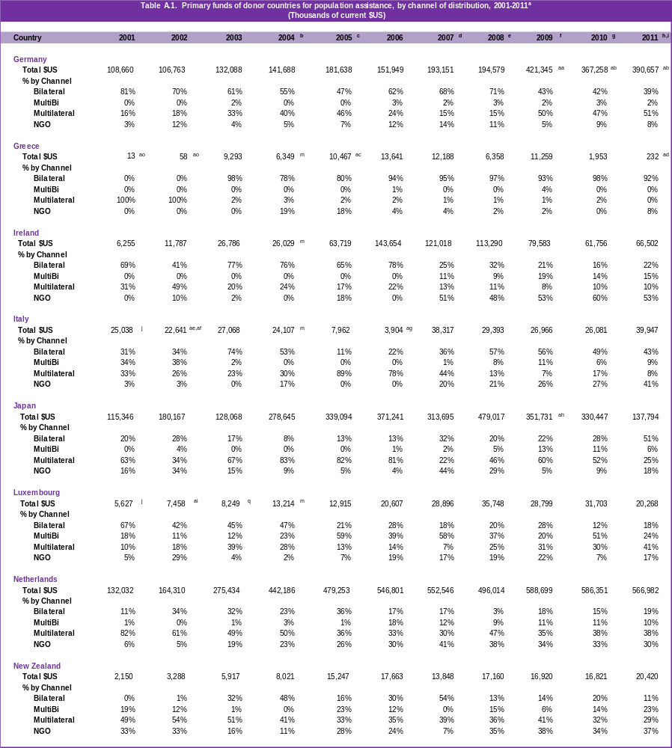

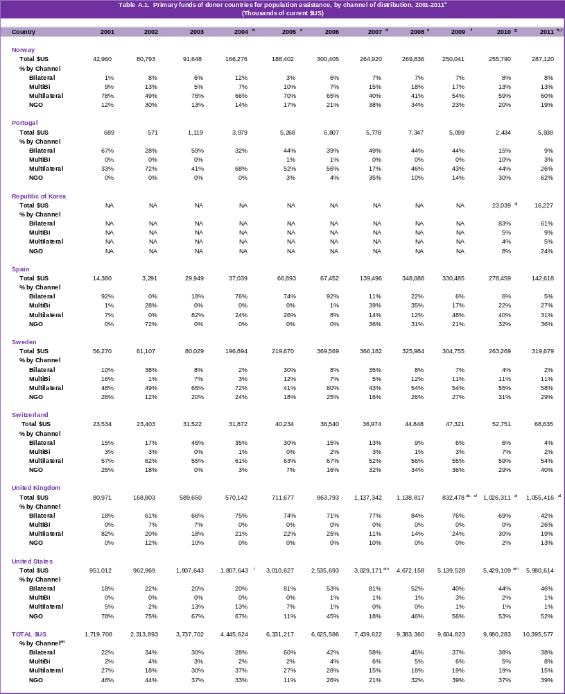
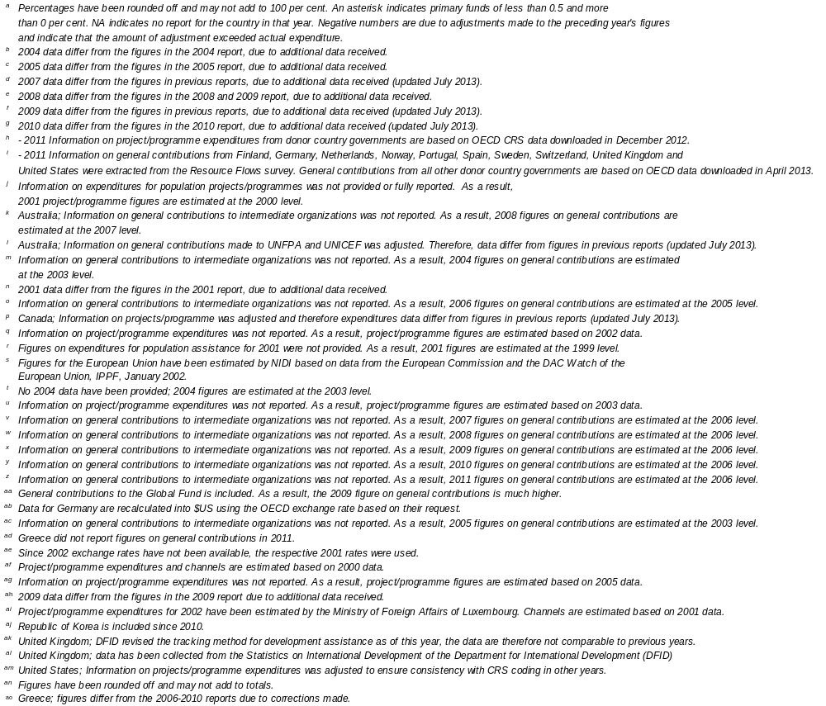

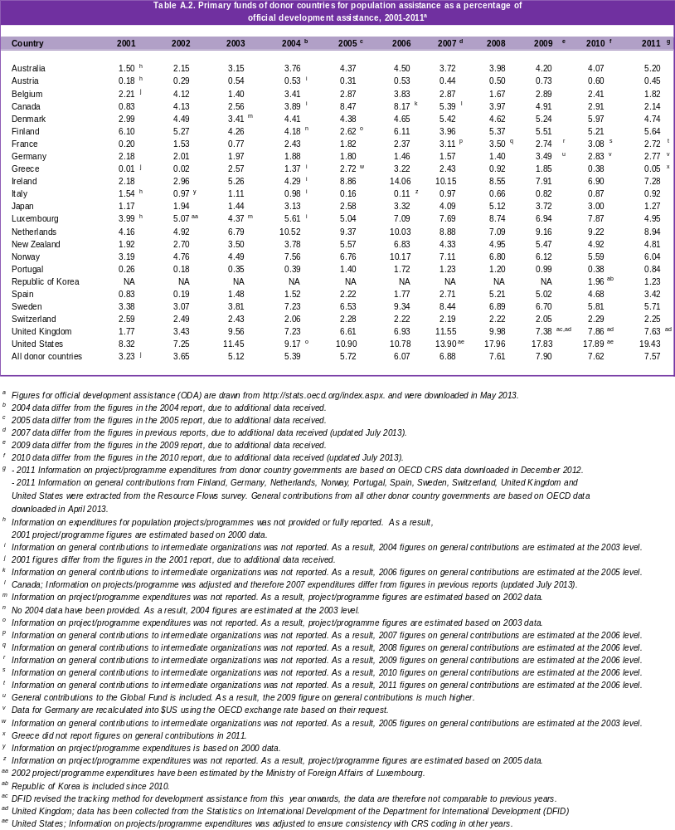
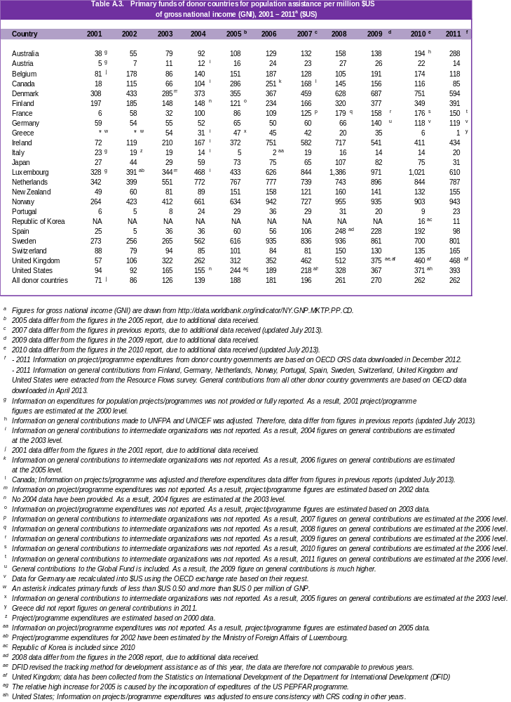

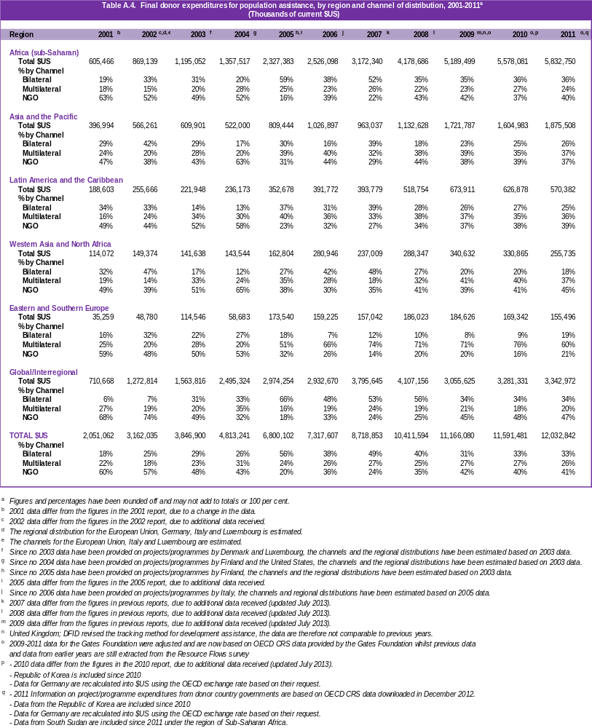

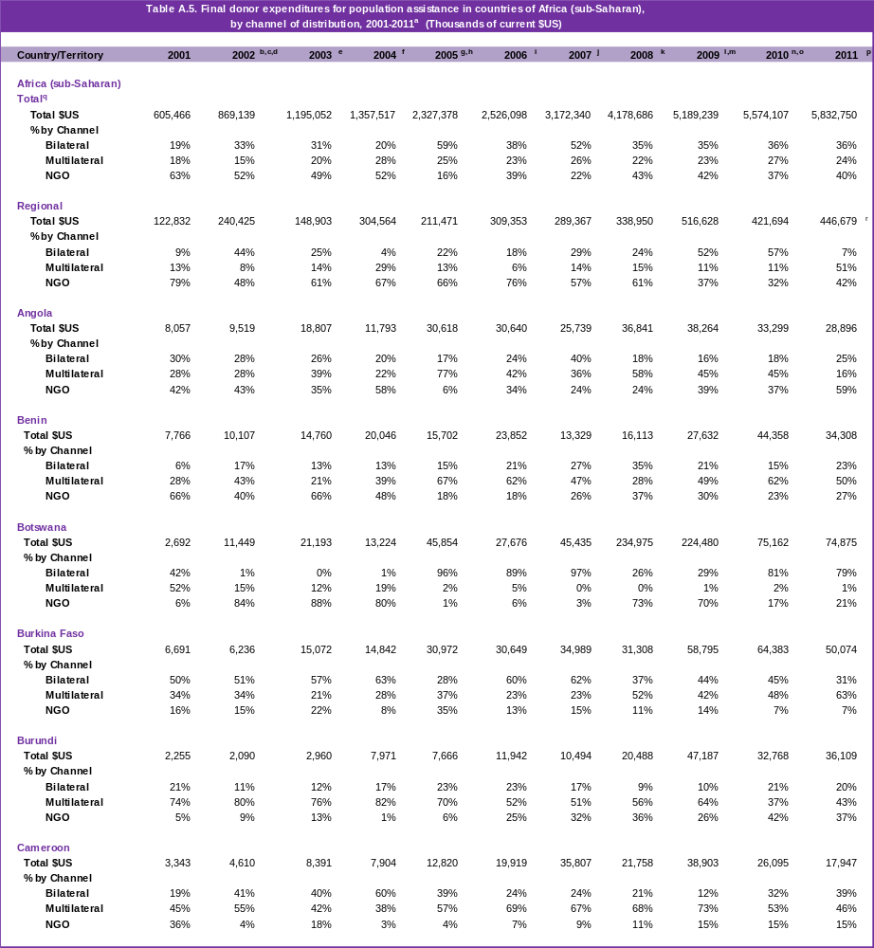

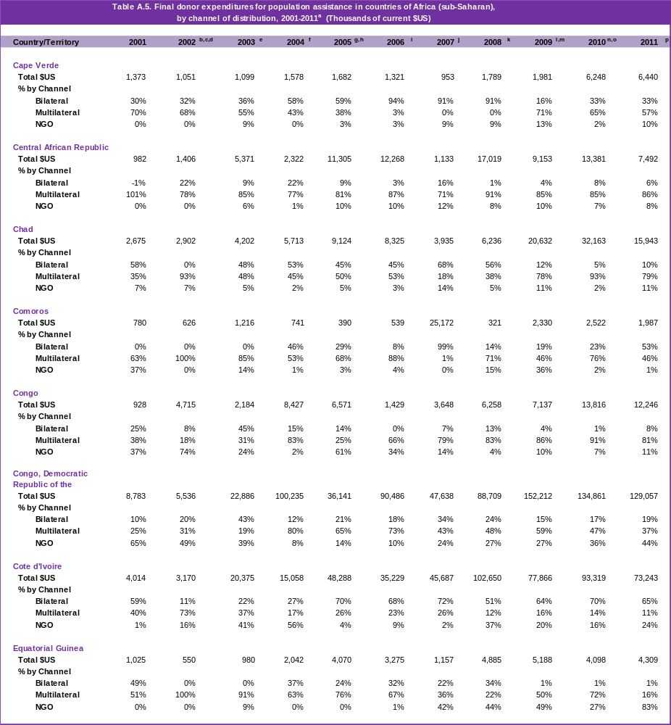

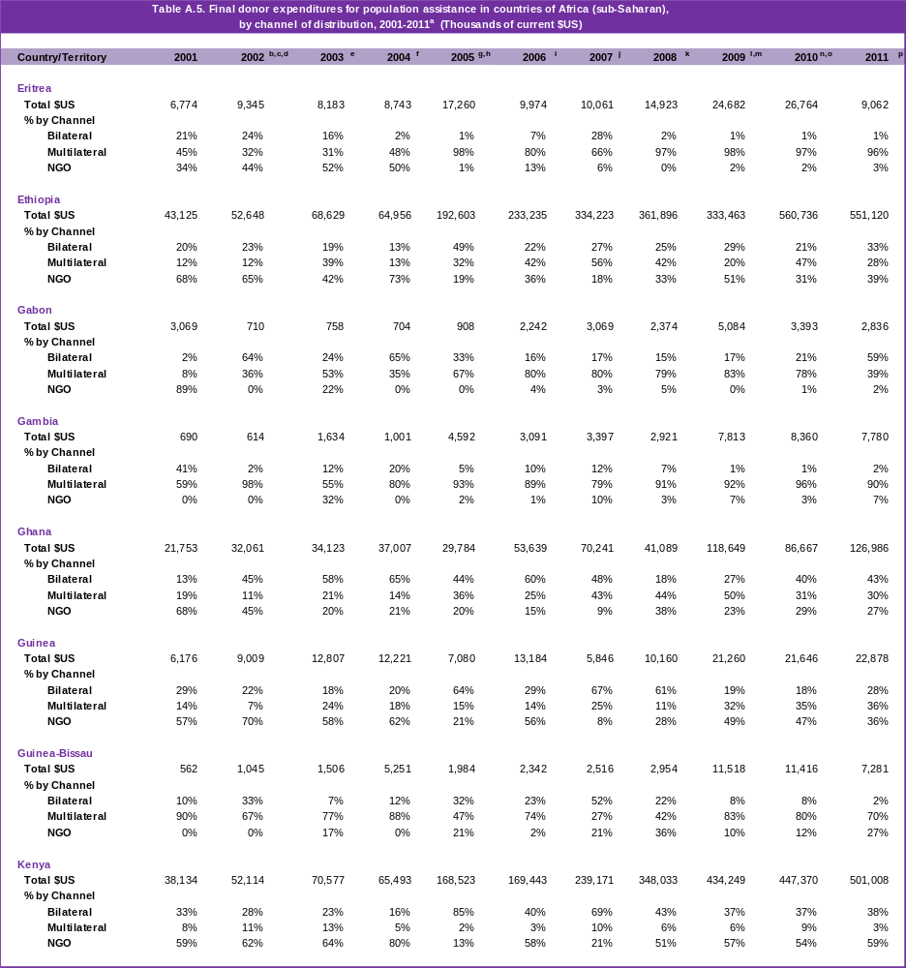
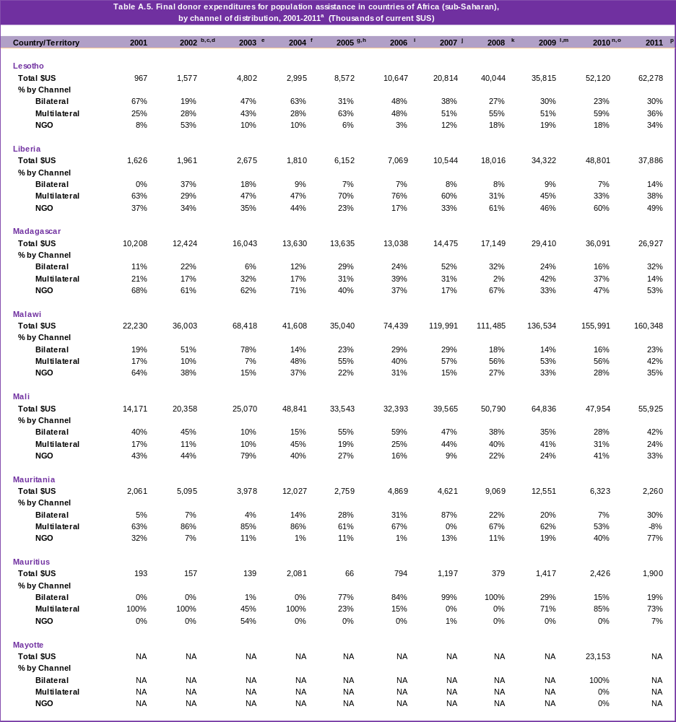

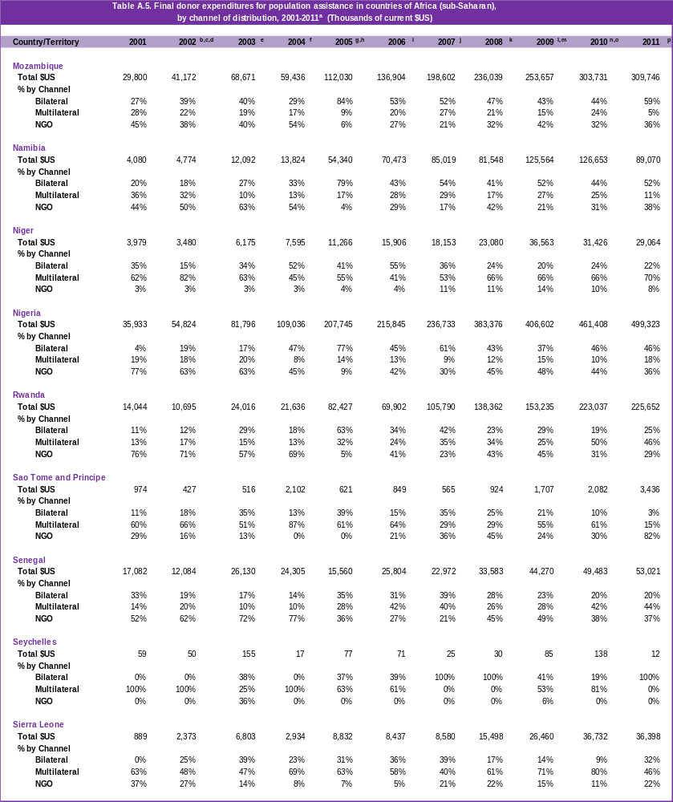

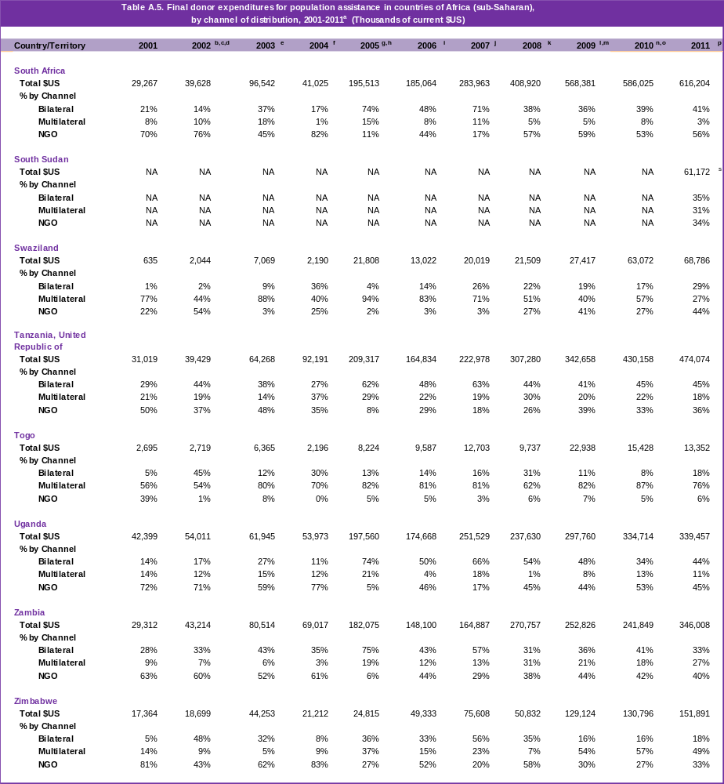

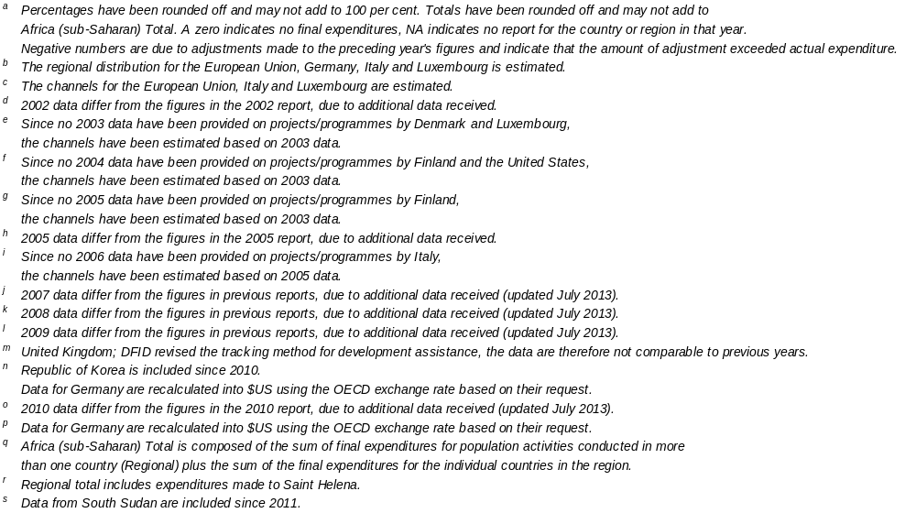
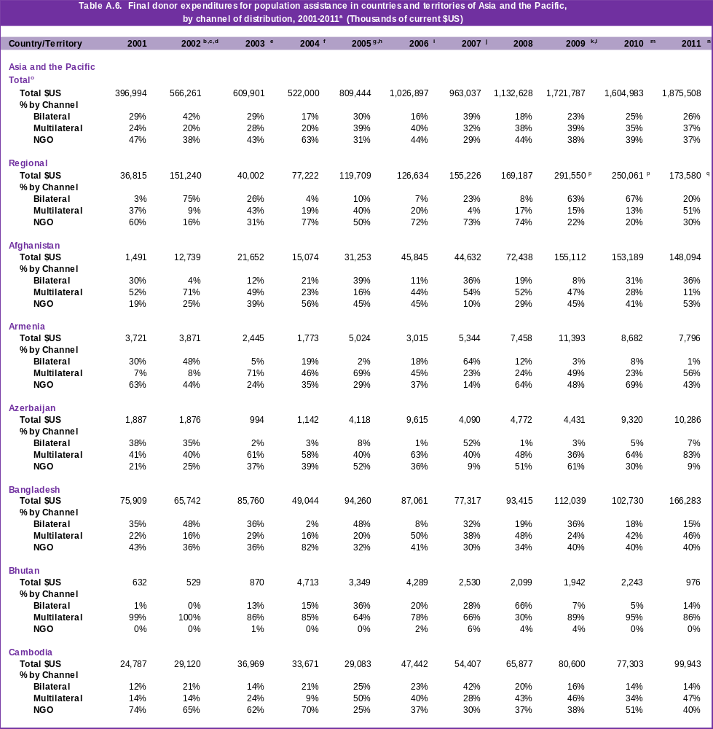

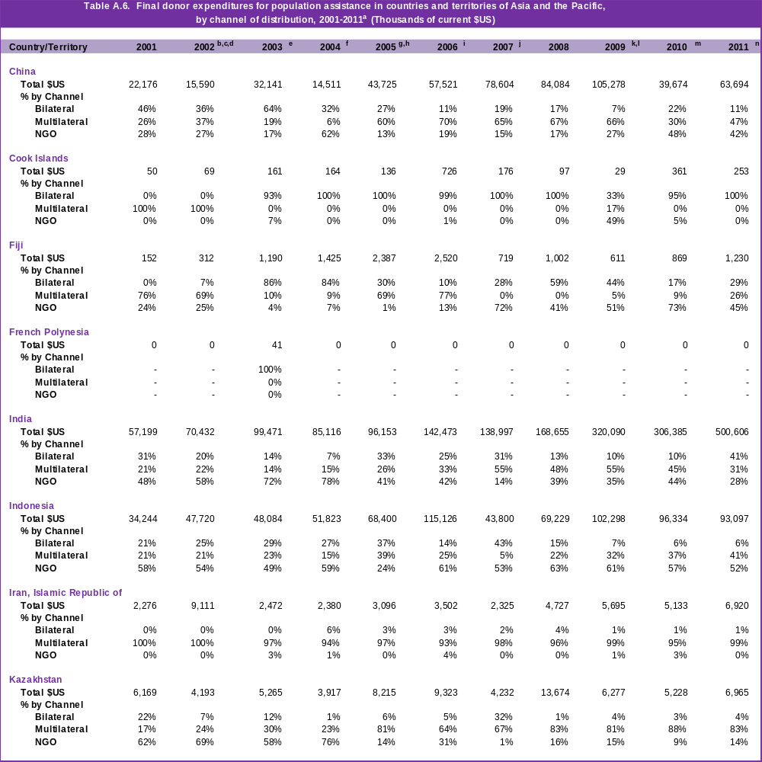

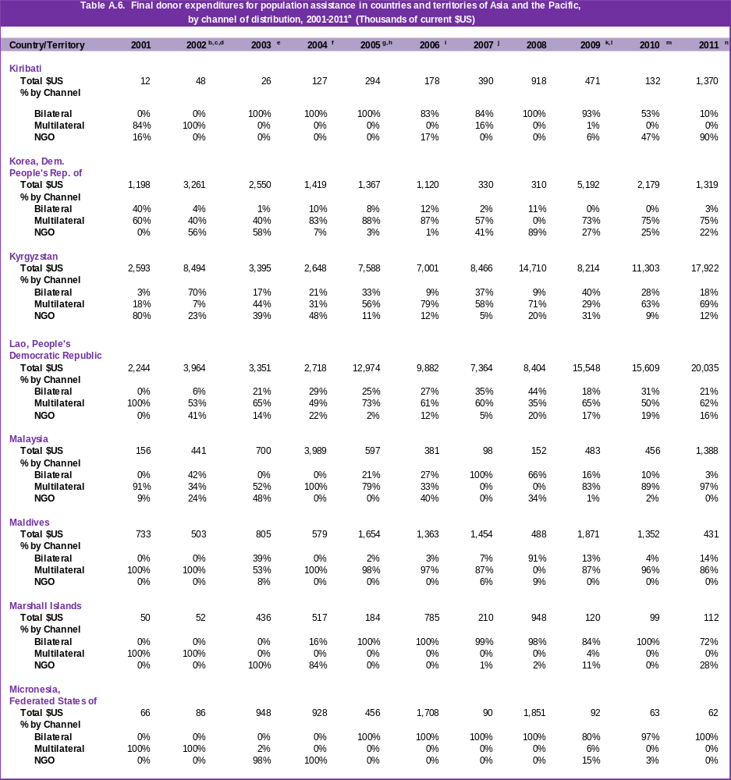

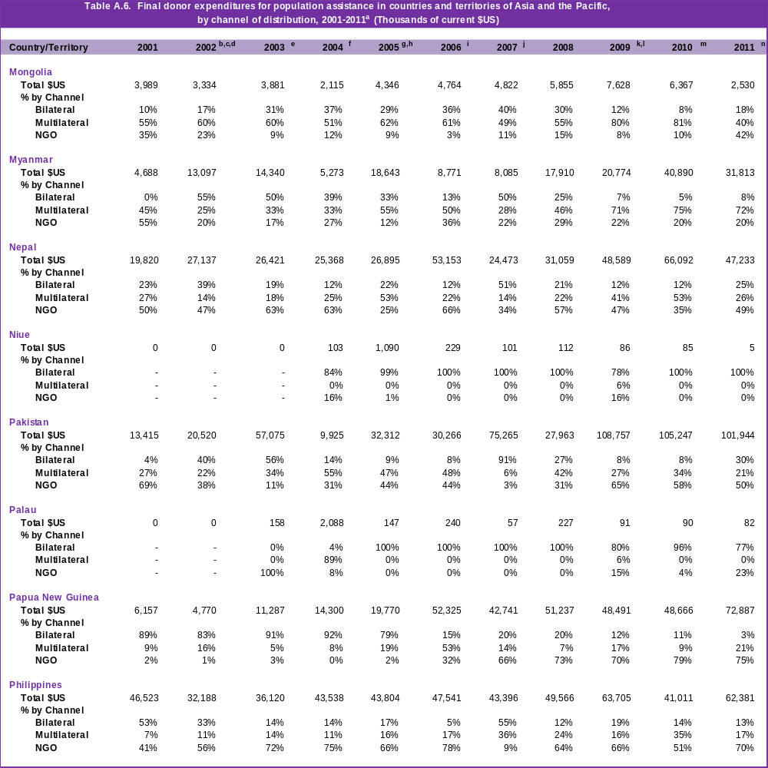

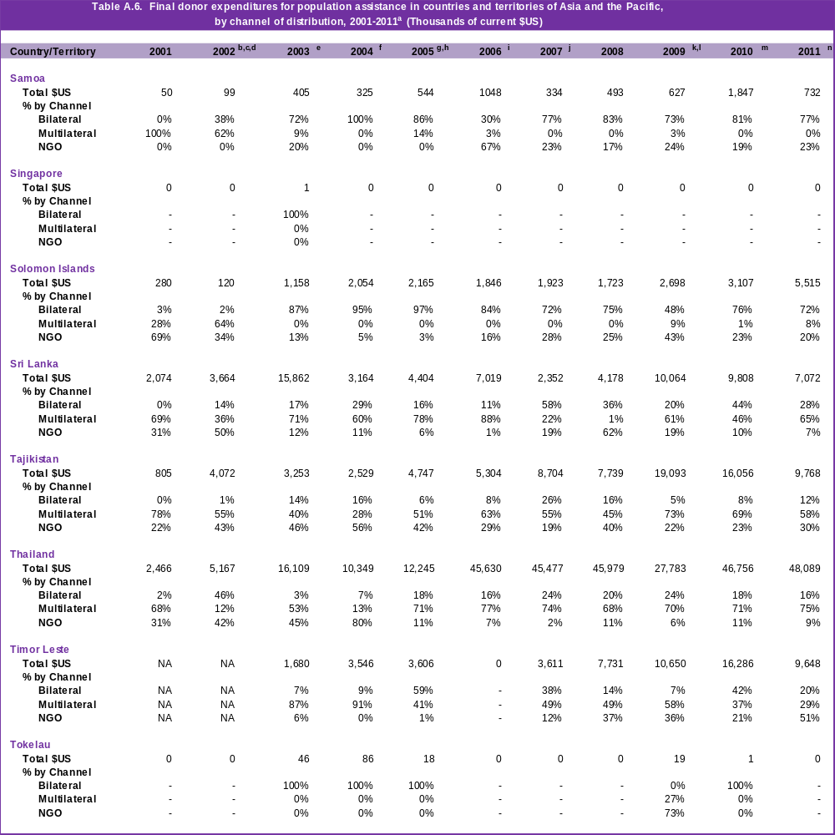

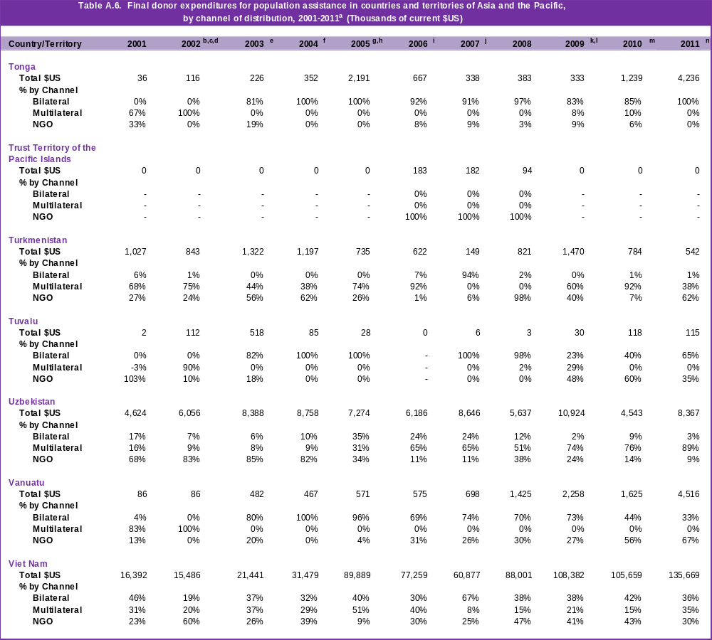

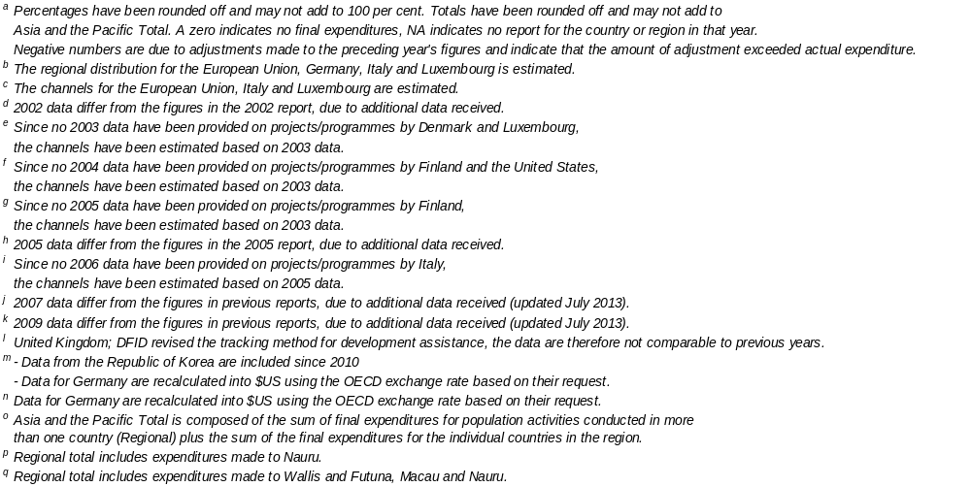

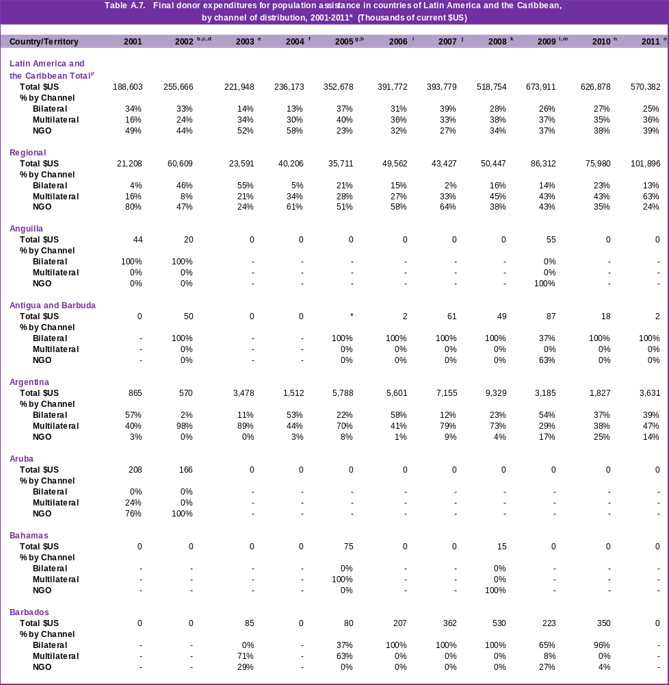

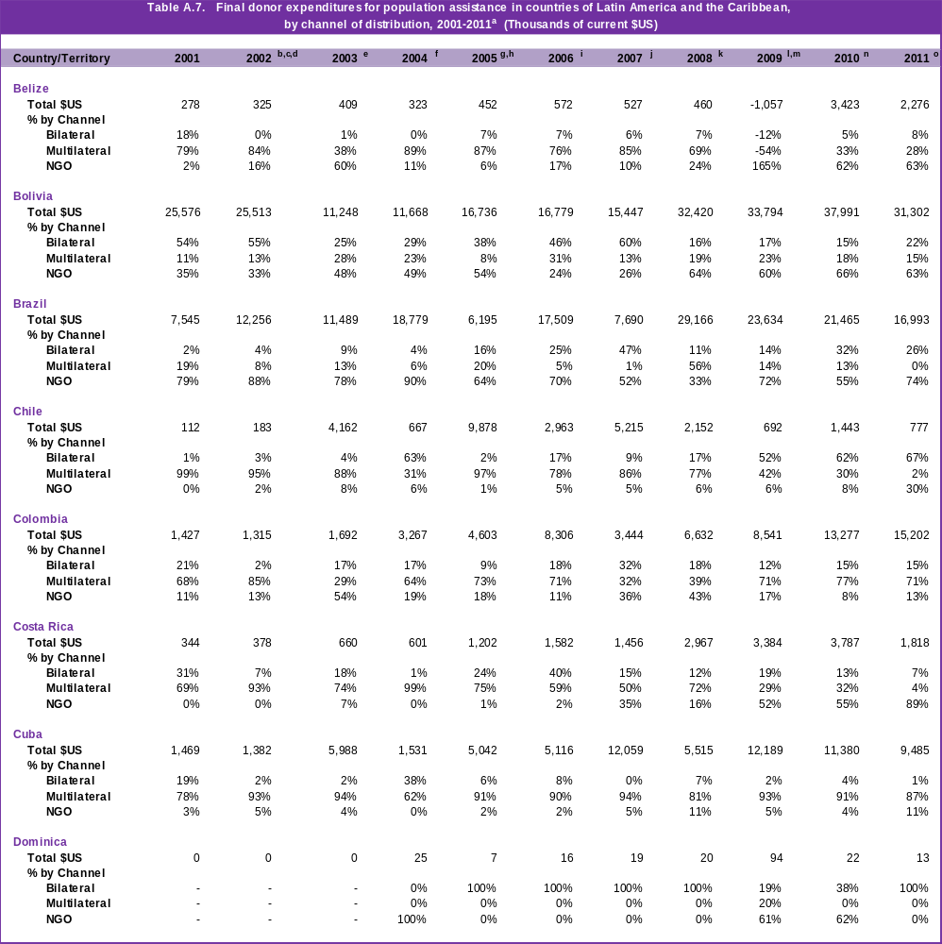

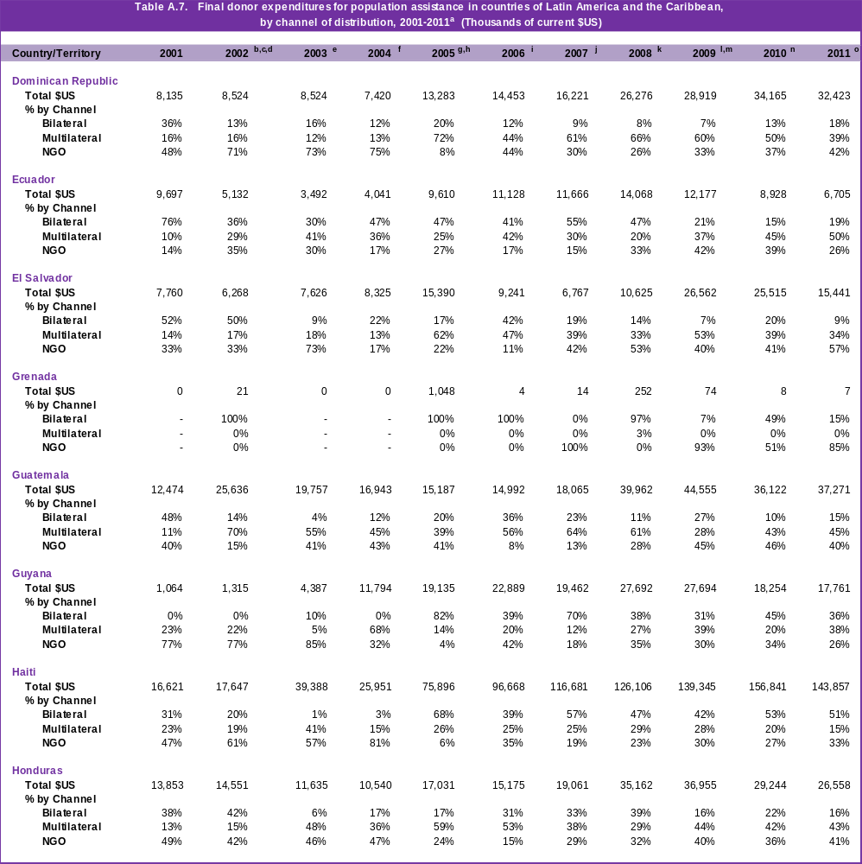

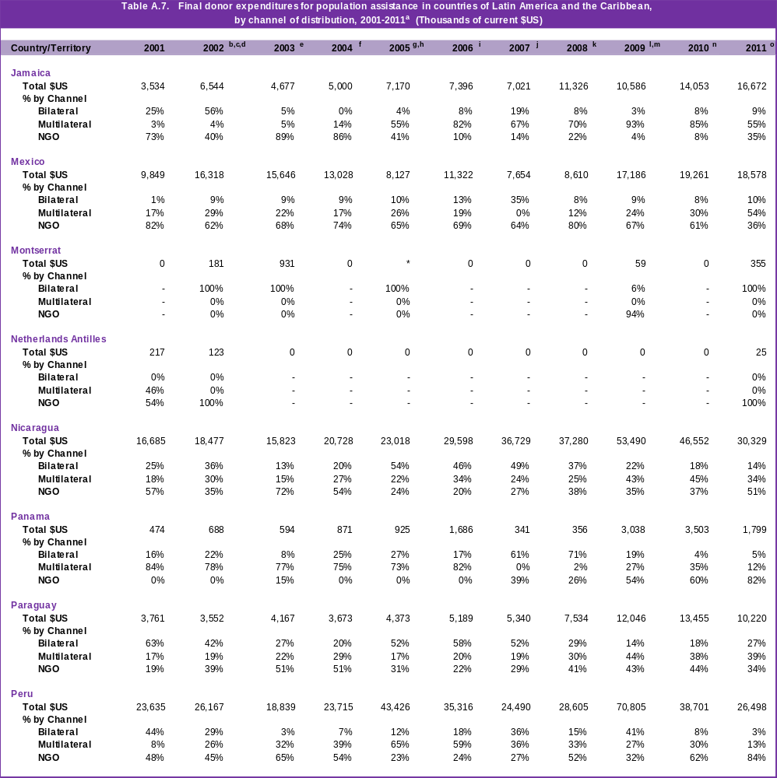

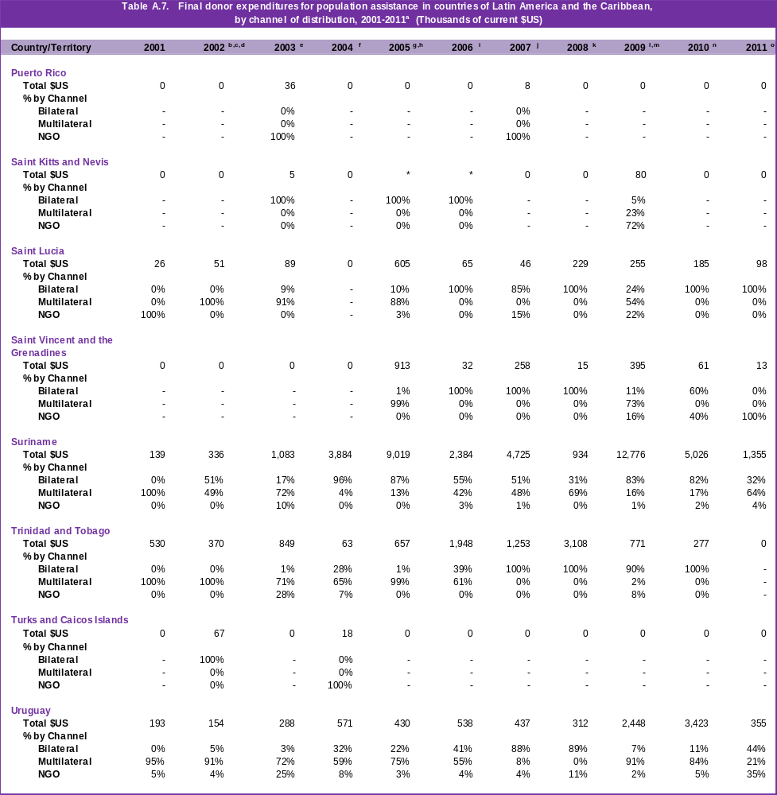

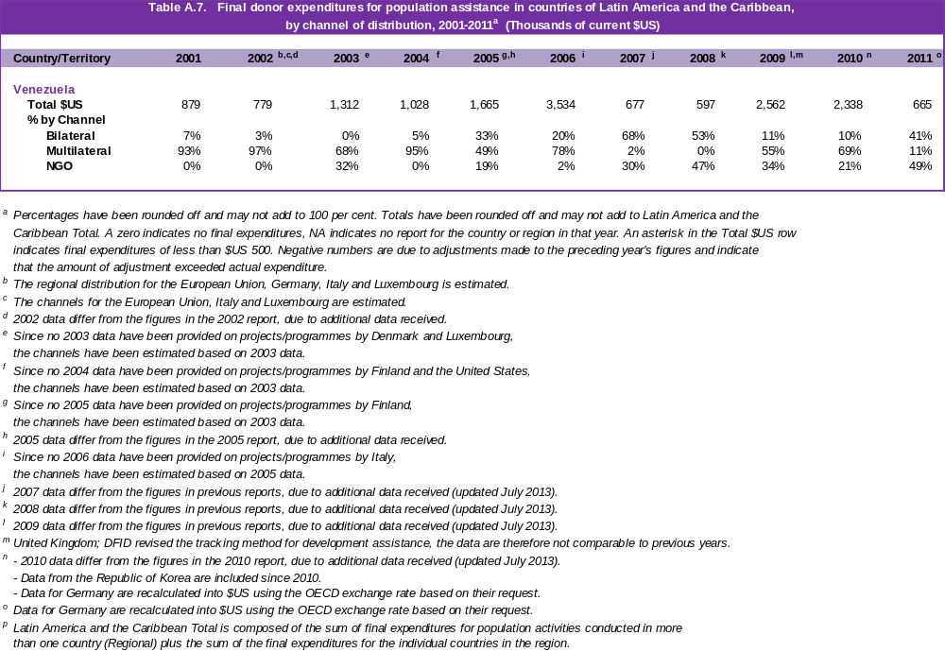

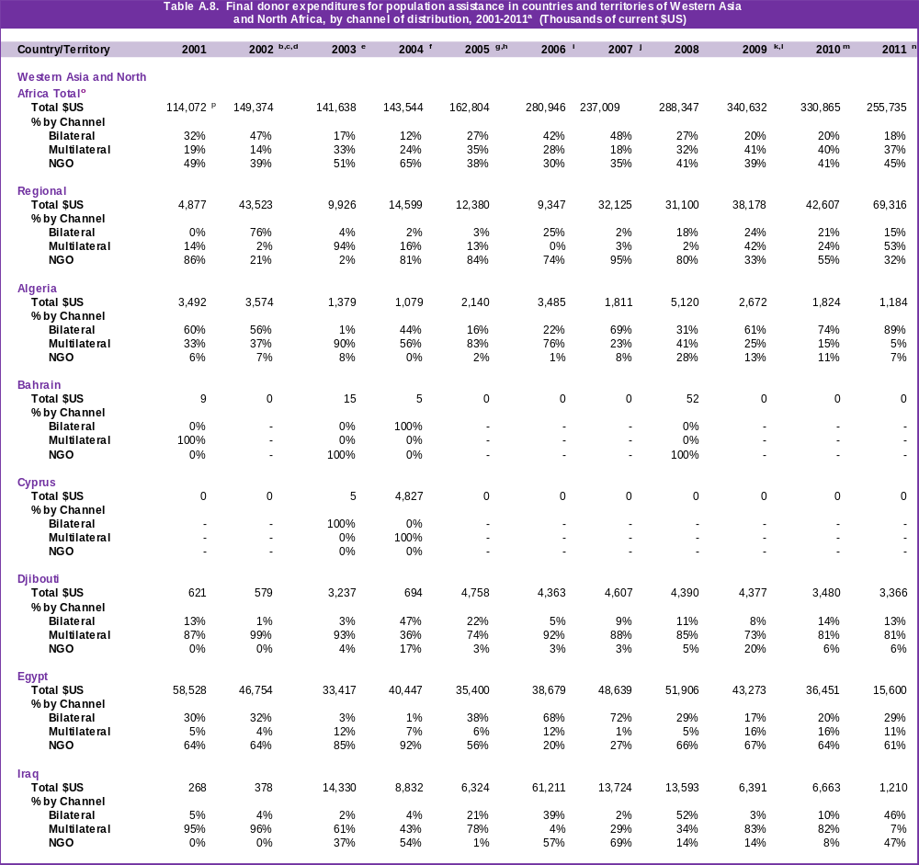

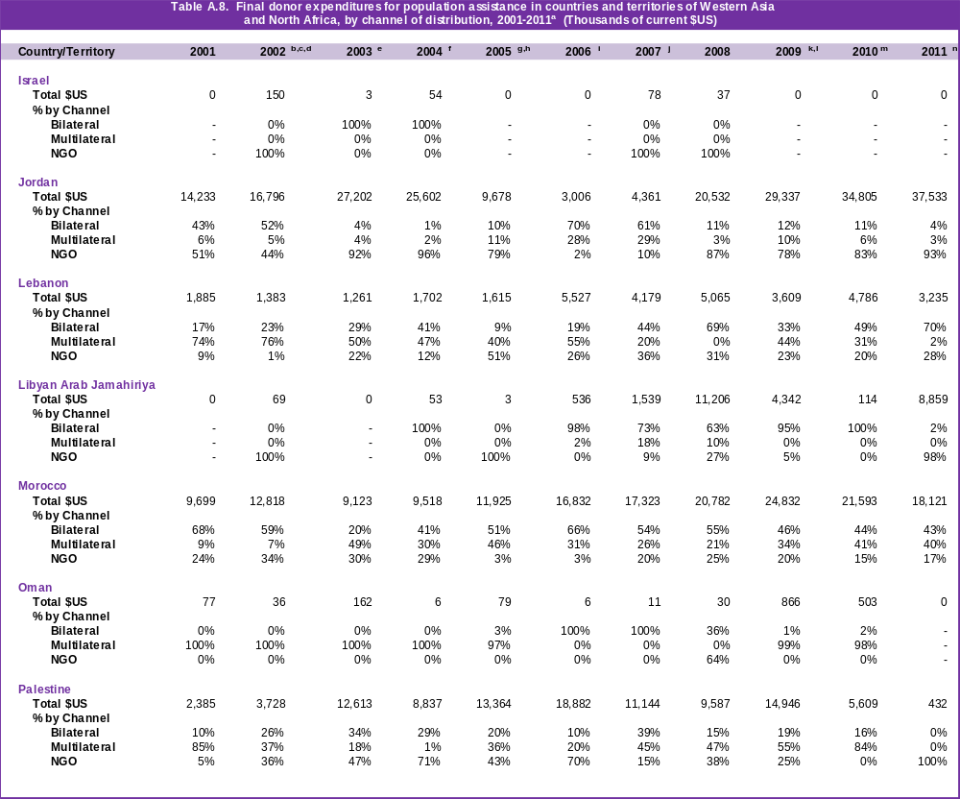

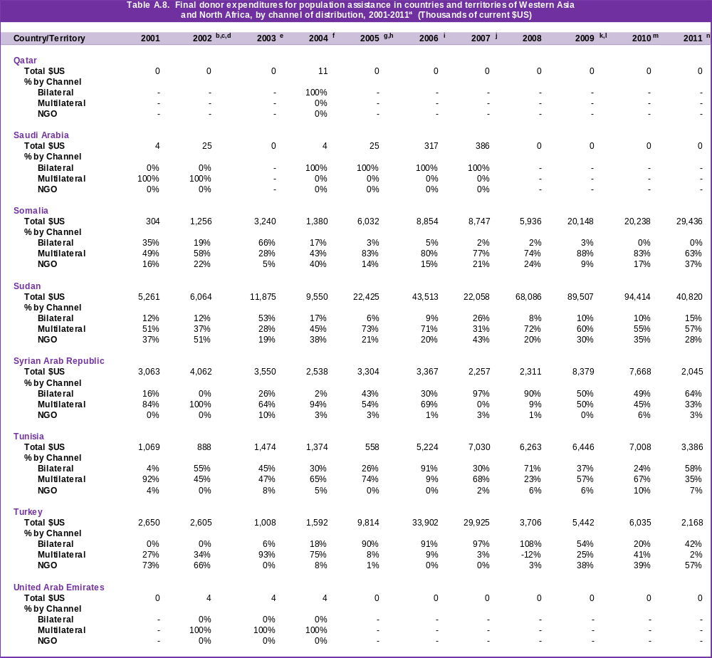

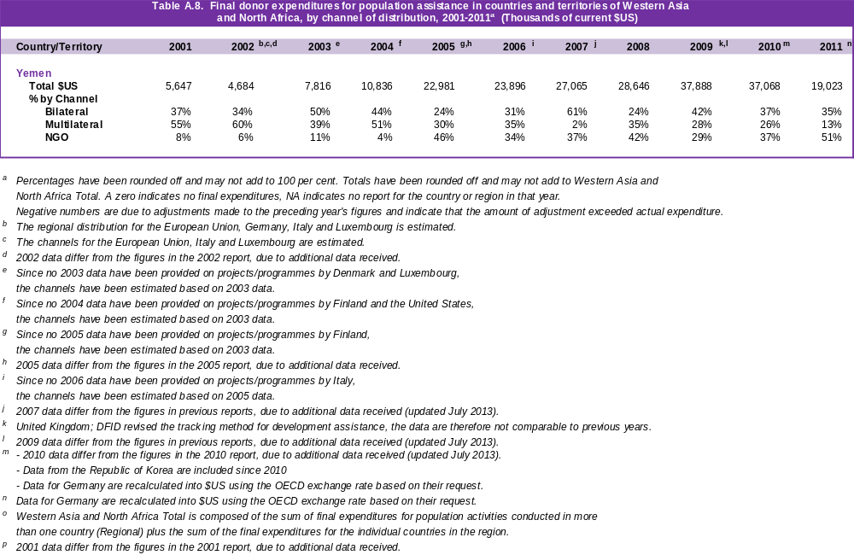

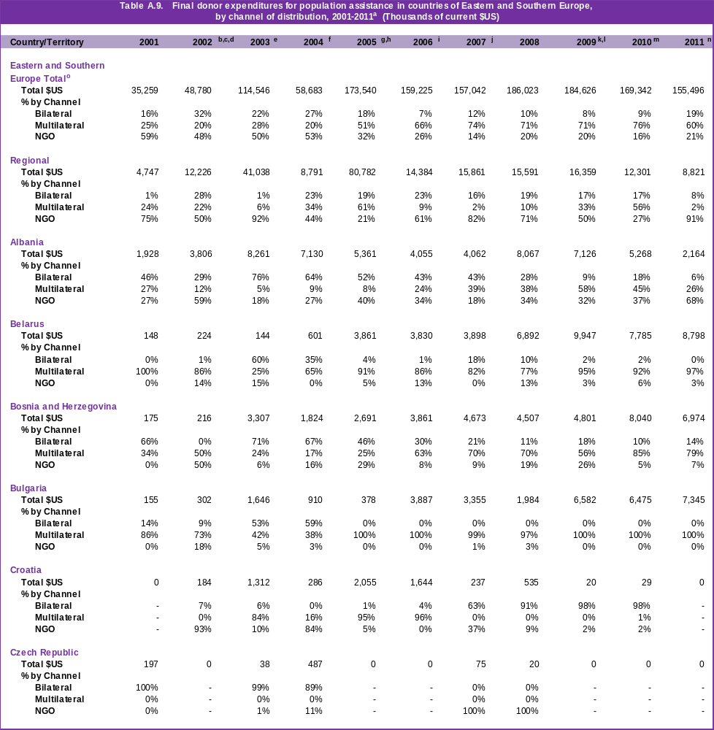

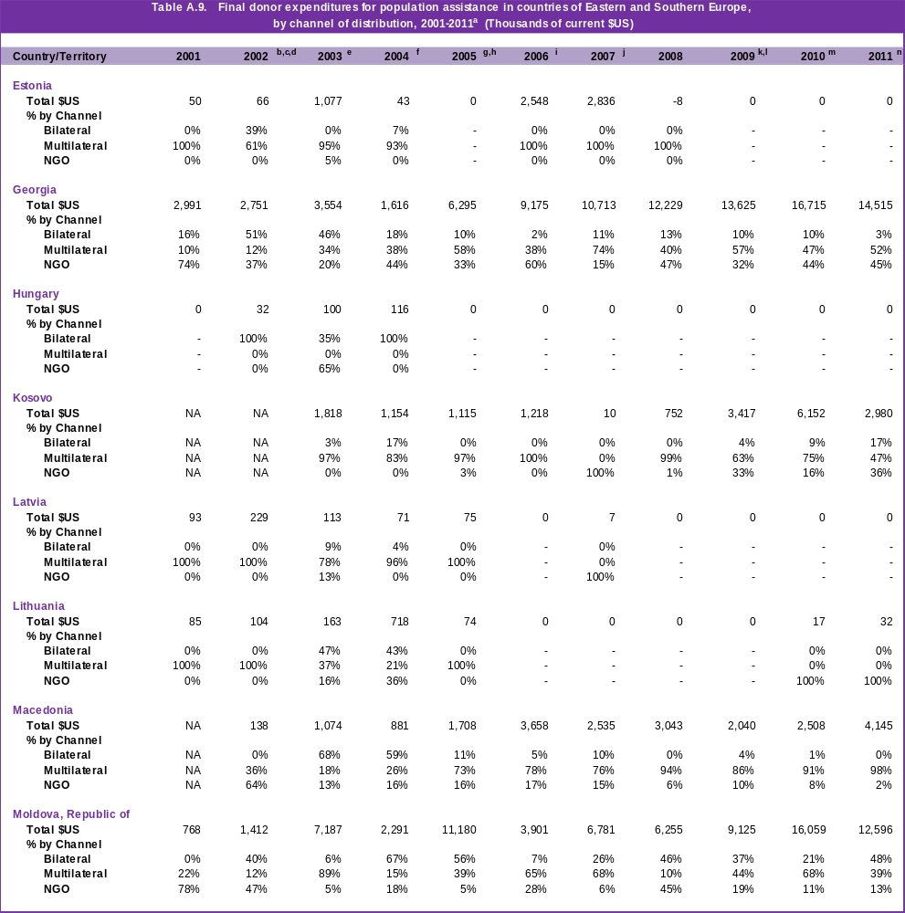

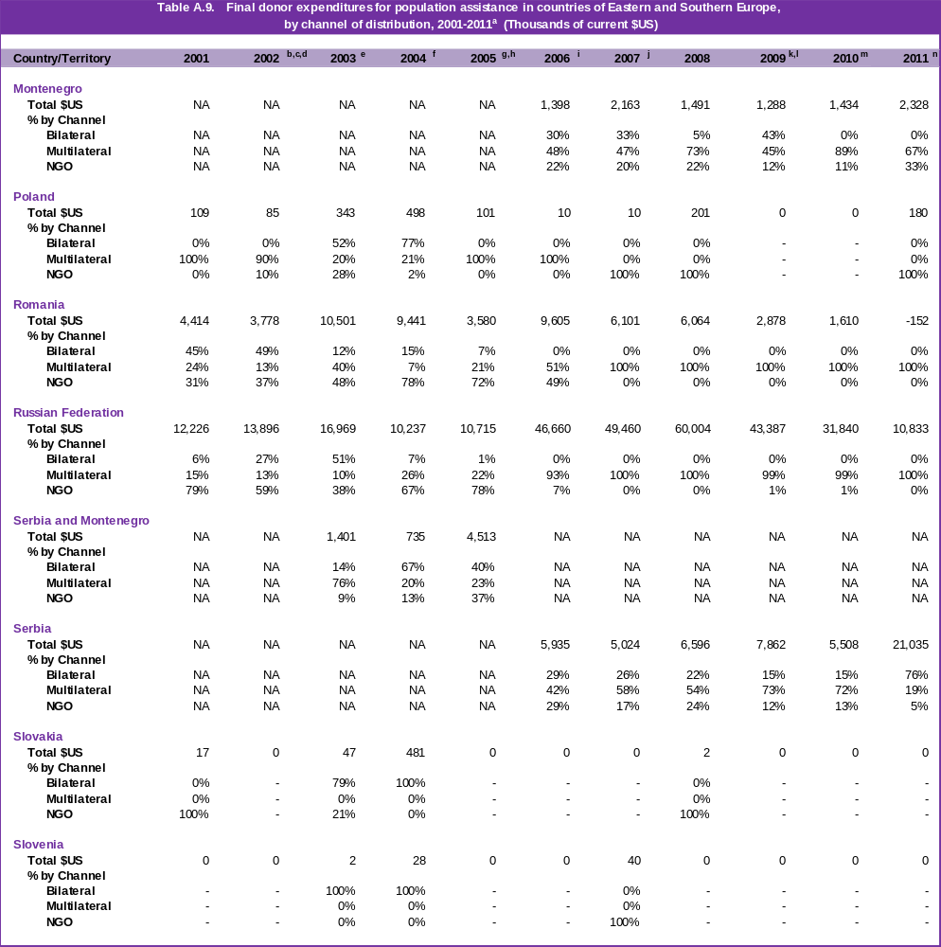

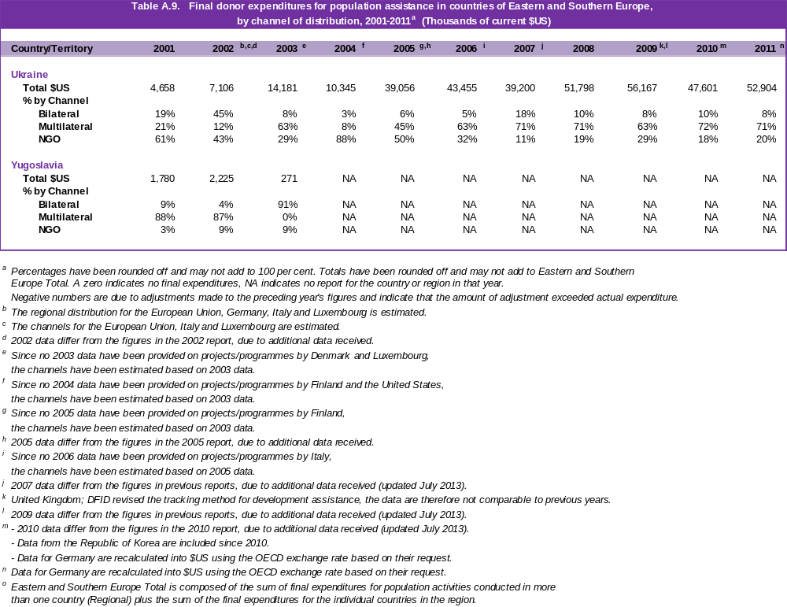
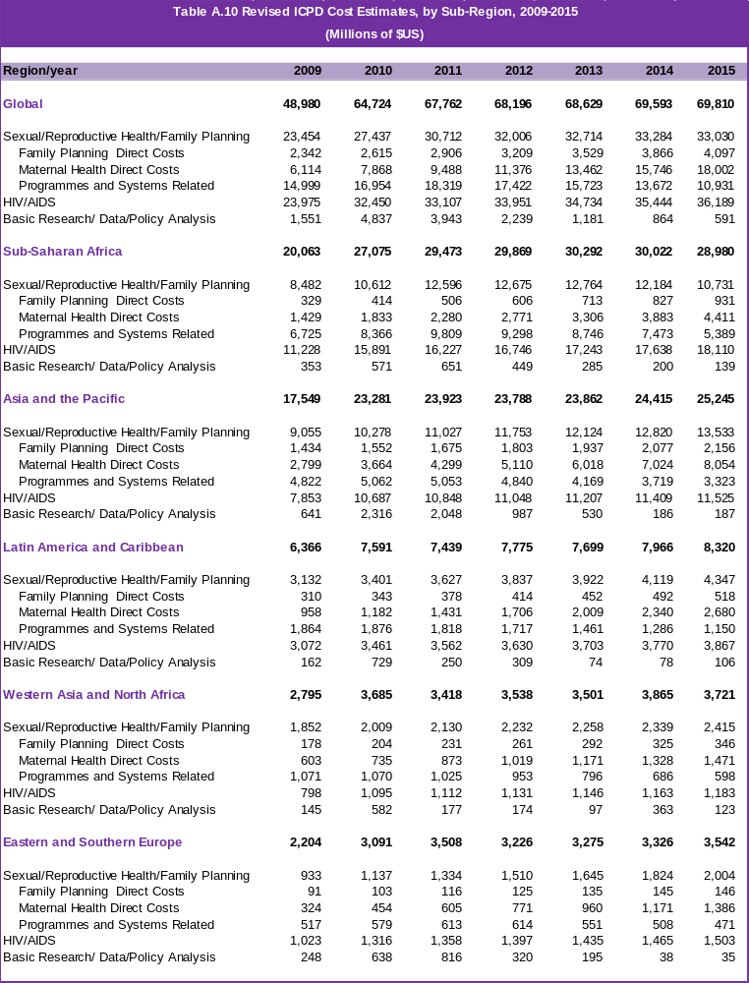
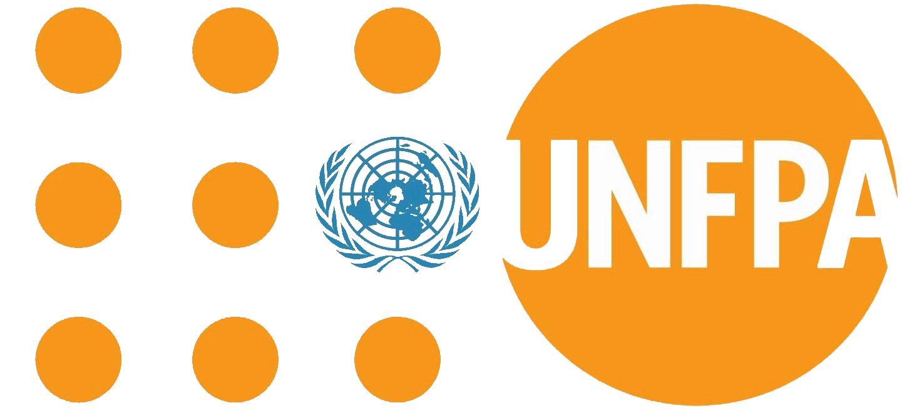
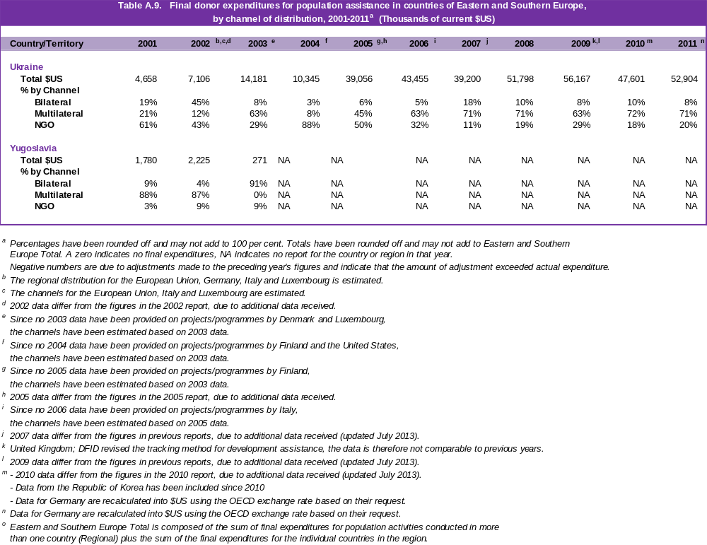
United Nations Population Fund
605 Third Avenue
New York, NY 10158
www.unfpa.org

ISBN XXX-X-XXXXX-XXX-X
E/2013

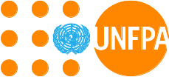

United Nations Population Fund
605 Third Avenue
New York, NY 10158
www.unfpa.org

ISBN 978-0-89714-021-8
E/2013

ISBN XXX-X-XXXXX-XXX- ISBN XXX-X-XXXXX-XXX-
United Nations Population Fund
605 Third Avenue
New York, NY 10158
www.unfpa.org

ISBN XXX-X-XXXXX-XXX-X
E/2013

United Nations Population Fund
605 Third Avenue
New York, NY 10158
www.unfpa.org

ISBN XXX-X-XXXXX-XXX-X
E/2013

m

All references to developing countries in this report also include countries with economies in transition.
All subsequent references to dollars are to US dollars.
See Report of the Secretary-General on the Flow of Financial Resources for the Implementation of the Programme of Action of the International Conference on Population and Development presented to the 42nd session of the Commission on Population and Development in March 2009. The target for 2011 is almost $68 billion (See Special Theme Box 7). http://daccessdds.un.org/doc/UNDOC/GEN/N09/215/67/PDF/N0921567.pdf?OpenElement
The questionnaires are available on the resource flows web site (http://www.resourceflows.org).
See Erik Beekink Projections of Funds for Population and AIDS Activities, 2011 -2013, The Hague, 2013.
See Erik Beekink, Projections of Funds for Population and AIDS Activities, 2011-2013. The Hague, 2013. Available on the Resource Flows web site (www.resourceflows.org).

