Values of Biodiversity in Indonesia
(1993)
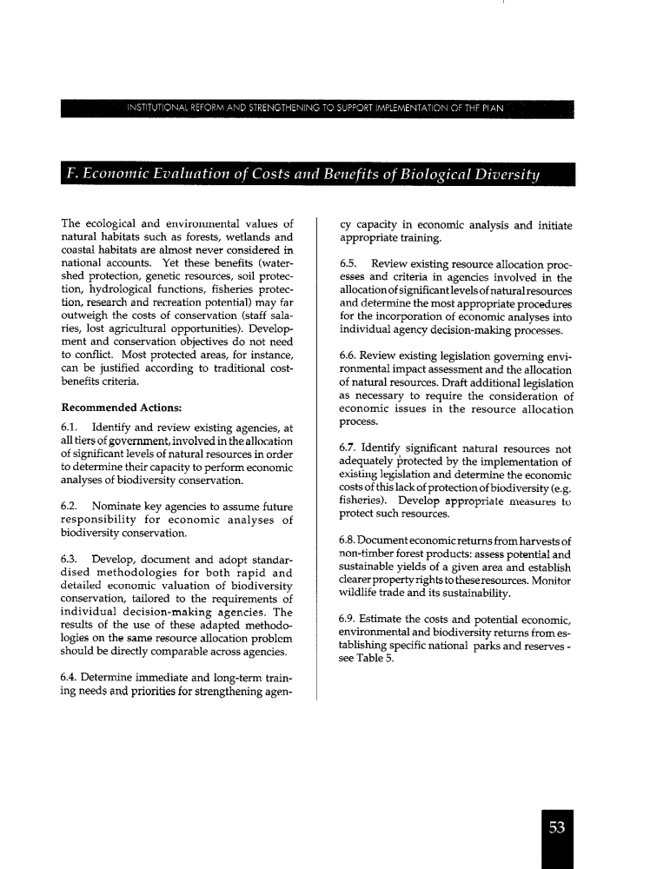
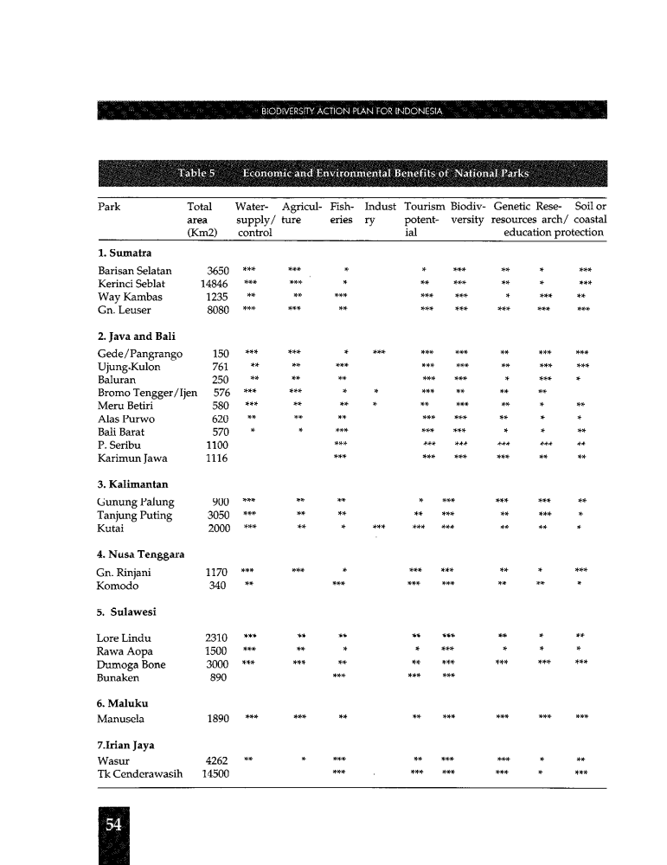

(2003)
THE SIGNIFICANCE AND VALUE OF BIODIVERSITY
This section discusses some of the significance and value of biodiversity that have been partly adapted from economic assessment of biological resources by the Natural Resources Management Program (NRM/EPIQ)4 . Economic valuation deals more with the economic aspect of biological resources, while the values presented here represent the entire value of biodiversity. There is thus a need to distinguish biological resources and biodiversity. Biological resources are often interpreted as assets to produce products and services only, while biodiversity refers to all aspects of life support system, which includes the social, economic and environment dimensions, knowledge system, ethics and the relationship between these various aspects. These values have been acknowledged and known, but they are often ignored because not all these values can always be assigned a monetary value. For example, the meranti timber cut from the forest and then sold to a sawmill has a clear value in dollar. But the meranti tree, which is allowed to grow in watershed areas to prevent erosion and protect soil, clearly has a great significance, but assigning a monetary value to this would be difficult.

Therefore economic valuation of biological resources is needed to assign economic value to all their benefits. Yet not all benefits can be valued economically. Even so, economic valuation is still important as one of the tools to make decisions on biodiversity management options. Biodiversity valuation methods are presented in Box 2.1. The entire significance of biodiversity is described below, while the value of conservation areas is provided in Box 2.2.

Existence value
In this case, biodiversity is valued due to it existence in a given area (Ehrenfeld 1991). This value is not associated with the potential of a certain organism, but is linked to its right to live as a part of nature. Existence value is sometimes known as intrinsic value, which is associated with ethics, that is a value based on ethics or religion. All religions of the world teach humans to protect God’s creations. By adhering to the existence value, some people feel they get a benefit, in the form of an opportunity to practice their religion.

Existence value is also linked to aesthetic value for humans. For example, many people, whether nature lovers or tourists, are willing to spend money to visit national parks in order to see animals in their natural habitat, although they get no economic benefit from such an activity. A more concrete example is the fact that tourists are willing to pay a lot of money to enjoy coral reefs in their natural form at the Bunaken National Park (NP), whose recreation value indeed amounts to Rp. 9,8 billion per year (NRM/EPIQ nd). Similarly, cave lovers or speleologists are willing to pay a lot of money and to take risks just to enjoy the beauty of the caves in Indonesia.

Although the existence value of biodiversity is hard to quantify in monetary terms, the benefit in increasing the psychological wellbeing of humans is quite clear. This is the reason why some people, particularly in developed countries, are willing to mobilize funds for nature and biodiversity conservation mainly to be able to enjoy their existence value.

Ecological value
Biodiversity provides ecological or environmental services for humans. For instance, forests maintain the hydrological balance thus preventing floods and droughts. Forests also maintain soil fertility by supplying nutrients through the leaf litter, prevent erosion and regulate the micro climate. Coral reef and seagrass provide nursery grounds for various fish and shrimp species.

Karst and cave ecosystems provide a place for water storage that is used by the organisms in the surrounding areas and protection for seed dispersing and pollinating bats that are useful for plant reproduction.

The ecological value can be harnessed if biodiversity is considered as one entity, where the components are inter-dependent. For example, the diverse ecosystems provide a place for the food chain to function and a space for species to survive and breed. A well functioning ecosystem can supply and produce environmental services beneficial for the species living in it; these services are, among others, protection of water and soil quality, regulation of local climate. Environmental services are undervalued because it is difficult to quantify. Yet, this value is substantially high, as presented in Box 2.2.

Species diversity makes it possible to create food chain among plants and animals; this guarantees continuity of food supply for each species. Various species also develop mutually beneficial relationship within the food chain. For instance, insects that take nectar from flowers help in the pollination process of plants, or bats that eat durian actually help the dispersal of durian seed.

Genetic diversity is needed by each species to maintain their breeding capability, develop resistance to diseases and adapt to environmental changes. Species need a supply of diverse genes in order to survive in the ever changing environment.

Heritage value
This value is associated with the wish to conserve biodiversity for future generations. For instance, the Kasepuhan community in Halimun Mountain, West Java, stores seeds from each rice variety to be planted in the next season, and to conserve their rice varieties. Their purpose is to reserve this valuable resource for the next generations. Among communities in Mentawai (an island off the West Coast of Sumatra) only certain people are allowed to hunt monkeys and turtles to get protein. The number of animals killed is also limited and the meat is equally shared among community members. The intention is to prevent wasteful use of and depletion of resources, to make them available for the next generation.

This value is often linked to the sociocultural and option values. Certain species or area is deliberately conserved and bequeathed from generation to generation in order to maintain the cultural and spiritual identity of certain ethnic groups or so that the next generations maybe able to fulfil their needs.

Option value
This is the value of biodiversity in providing benefits for communities in the future (Primack et al. 1998). Biodiversity has uses and values, which may not yet be known or cannot be utilized by humans at present. With the change in demands and consumption pattern as well as technological advances, this value will be important in the future. The potential of wild plants as medicinal sources is an example of the option value. Many pharmaceutical companies and government health agencies are intensively trying to discover new medicinal materials from biodiversity in its natural habitat in order to treat diseases such as AIDS and cancer. It should be noted that the 20 most often prescribed drugs in the USA, with an average annual value of US$ 6 billion contain chemicals found in nature (Primack et al. 1998).

Similarly, germplasm collections in the various research centers may not seem to have direct value at present, while the cost of maintenance is quite high. But, in the future, cultivated and wild plant germplasm collections will become very valuable for agricultural plant breeding.

The economic value of most of the world’s species may be unknown yet at present, or knowledge on their utilization is limited. If one species with a high option value becomes extinct, even before it can be identified, the loss for human welfare can perhaps be high. If biodiversity were to be considered as a manual for improving the welfare of human beings, then the loss of one species would be like tearing a page of that manual (Primack et al. 1998).

When we need information to solve one of our problems, which may be contained in that torn page, only then can we become aware that we have lost that information forever. The option value is similar to savings that will enable humans to develop choices in order to adapt when faced with physical environmental and social changes.

Consumptive value
This value is derived from direct benefits from biodiversity, such as for food, housing or clothing. Communities in Indonesia consume no less than 100 food plant species (those producing grains and tubers). No less than 100 bean or nut species, 450 fruit species and 250 vegetable and mushroom species are used in their daily diet. Some 940 plant species are used in traditional medicine (KMNLH 1997).
Wild plant species from the forest, known with its aphrodisiac properties such as Euriycoma longifolia, Ficus deltoidea and the yellow root Arcangelisia flava, and cultivated species such as ginger (Zingiber officinale), turmeric (Curcuma domestica), galangal (Kaempferia galanga), java tea (Orthosiphon aristatus) and cardamom (Amomum cardamomum) are also used in traditional medicine by local communities. Some species, such as rosy periwinkle, have in fact been used in modern medicine products. More than 100 timber species, 56 bamboo species and 150 rattan species have also been used to build houses and make household utensils by communities (KMNLH 1997).

Productive value
This is the market value derived from trade in biodiversity at the local, national and international markets. For instance, the global market value of drugs derived from genetic resources is estimated to be US$ 75,000-150,000 million per year. The annual total value of sectors associated with the seeds market all over the world is US$ 45 billion, while the total output from the world’s agro- ecosystem is equivalent to US$ 1.3 trillion per year (WEHAB Working Group 2002). In fact, about 40% of the world’s economy depend on biological processes and products, in other words biodiversity (Crucible Group 2000; UNEP 2002).

Indonesia’s economy has also largely been dependent on the productive value of biodiversity. During the 1970s and 1980s, forest products were important source of non-oil exports and revenue (Resosudarmo 2000). In 1998 seaweed export generated US$ 45 million (Suhartono 2000) and fish product exports generated US$ 2 billion in 2000 (Dirjen P3K- DKP 2001). Biodiversity-based industries are also important for domestic economy. For example the value of domestic sale of processed jamu (herbal medicine) was Rp. 200-400 billion in 1999, with an annual increase of 10% (Putterman 1999). Domestic sales of non-timber forest products such as terpentine, cayuput oil, copal and silk contributed to about Rp. 41 billion to the national economy (Departemen Kehutanan 2000).

The productive value of genetic resources (including human genes) will be increasingly important in the future, particularly in terms of creating new crop varieties, micro-organisms for industrial processes and gene therapy on livestock and humans. With advances in modern biotechnology and bioinformatics, the 21st century is often called the biotech century. The profitable business during this century is the life sciences industry, that is pharmaceutical, health, food, agriculture and cosmetics. All these industries rely on biodiversity as raw materials and biotechnology and bioknowledge, which will continue to develop in the future.

Life sciences industry will lead to increased commercialization of biodiversity. Thus the emphasis would be on the productive value of biodiversity, by sidelining all its other values. There are concerns that this imbalance will lead to degradation of biodiversity, particularly those considered devoid of economic/productive value.

The above description shows that biodiversity has local and global values. The perception and knowledge on the two values differ. Generally local biodiversity value is not well documented, and therefore is not well represented in the biodiversity policy debate and formulation at the global level (Vermeulen and Koziell 2002). The difference between local and global biodiversity value is given in Table 2.2.

HERITAGE FOR FUTURE GENERATIONS
The significance and value of biodiversity for human life and national development, as described above, is not just for this generation, but also for future generations. But from the range of benefits, very often only the productive value is emphasized, ignoring other values.

The monolithic ways of production (only one mode or one type of utilization, for example timber), and monoculture cultivation system have reduced the entire set of values of biodiversity.

Such a monolithic way in considering the values of biodiversity has led to degradation of natural habitat, species extinction, erosion of cultural diversity, and weakening of knowledge system at the local, national and global levels. In this process, only a few people benefit, but a large part of the community, whose livelihoods depend on biological resources, experience impoverishment.

Biodiversity as a development asset is in a critical condition, as will be discussed in Chapters 3 and 4. Unless there is a shift in the paradigm, production and utilization pattern, as well as mechanisms for sharing of benefits, it is difficult to predict if this asset will still available for future generations.

Depletion of assets will hamper the sustainability of development activities. Future generation will not have sufficient biological resources, for which they have right of, to meet their needs. Therefore, sustainable biodiversity management is required, not only in Indonesia, but also at the global level, to ensure the welfare of the present and future generations.

The first step towards this is to identify the biological richness and detect the rate of degradation as well as factors causing its degradation. These will be discussed in Chapter 3.

Box 2.1 BIODIVERSITY ECONOMIC VALUATION METHODS
Natural resources valuation will enhance the understanding about the value and services provided by natural resources and biodiversity. Valuation can help decision-makers to make alternative development policy choices that will most benefit their region. Valuation would also be useful in identifying and comparing the investment made, opportunity costs, and the benefits produced. A better understanding of who bears the cost and who enjoys the benefit is important in formulating and implementing effective policies for protecting and utilizing natural resources efficiently (NRM/EPIQ).

There are five valuation approaches (IIED 2001 in Vermeulen and Koziell 2002):
a. Market price approaches, including estimation of profits from consumption and subsistent production;
b. Surrogate market approaches, including travel cost model, the price of enjoyment and substitution approach;
c. Production function approaches, that emphasize on the biophysical relationship between the functions of forests and market activities;
d. Stated preference approaches, particularly contingency valuation methods together with their variations;
e. Cost based approaches, including compensation cost and cost for maintaining it.
The above methods can provide a relative value estimation, which can compare resources in different locations. This method also assigns monetary value to those values, which cannot be accommodated by the market by making direct comparisons between various products and services.

Box 2.2 CONSERVATION AREAS: ASSET OR LIABILITY?

Conservation areas are often treated as liabilities because their environmental services cannot be assessed fully, or are underestimated. Such a notion can be eliminated by several techniques and approaches that can provide a comprehensive value for all the significance and functions of biodiversity.

Valuation has been conducted in some conservation areas and areas with high biodiversity in Indonesia, such as Gunung Leuser National Park, Togean Islands, Taka Bonerate NP, Gede-Pangrango NP and Bunaken NP. Results of studies show that the total economic value of these areas is higher than the productive value and other forms of utilization. For example, the monetary value of tourism activities and environmental services (water regulation for agriculture and household use and sedimentation control) derived from the protection of the Gede-Pangrango NP amounts to Rp. 40,80 billion per year (for net present value - NPV or a 10% discount rate) and very much higher than the management costs and the monetary value from timber felling in the area which amounts to only Rp. 27,96 billion. The annual value derived from protecting Bunaken NP is estimated to be 9,6 billion, and Bukit Baka Raya NP is Rp.10 billion. The economic benefits of protecting water in Ruteng is US$ 35 per household per year and the economic benefit of improving the quality of the water in Ciliwung river is estimated to be Rp. 30 million per year (NRM/EPIQ).

Likewise, protecting forest in Gede, Halimun, Pangrango and Salak mountains in West Java will guarantee drinking water supply for the communities and for various economic activities such as agriculture and processing industries in the Jakarta-Bogor-Tangerang-Bekasi area, Sukabumi and Banten.
Source: extracted from training on economic valuation of natural resources by NRM/EPIQ.

Table 2.2. Differences between global and local value of biodiversity
Global | Local
Non-direct and non-use values are the priorities | Direct use value is as important, if not more important, than non-use and indirect use values
Emphasis on conservation, with or without sustainable use | Emphasis on sustainable use
Usually no specific user groups | Specific user groups
Endemic and rare species given high value | Endemic species has same value as  other species
Focus on genotype (genetic information) | Focus on phenotype (visible traits)
Wild and cultivated biodiversity are treated differently | Same treatment for wild and cultivated biodiversity
Source: Vermuelen and Koziell 2002.

Further economic benefit analysis on forest ecosystem and others.

(2009)

1.4.1. Economic Implications
An estimated number of 40 million Indonesians living in rural areas depend their subsistence needs to the biodiversity around them. Studies that have been conducted in Riau Islands in 1997 (in SoER Indonesia 2007) indicated that economic value of fishery-related ecosystem is about U.S. $ 3858.91 per hectare per year (Kompas, 21 October 2003 in NSPAM Wetland 2004).

On the other hand, forest biodiversity also provides a variety of both "goods" and "services", from the results of timber and non-timber that generate significant income to the State (Table 1.15), to play an important role in the mitigation of climate change as carbon storage. At the same time, forest provides source of life and employment for millions of people, thus forest biological diversity plays an important role in economic, social and cultural life in many local communities.

Another important economic potential of the ecosystems is the value of environmental services. Kurniawan et al. (2008) conducted economic valuation as part of the environmental services (water as a resource, biodiversity, unique natural landscape, nature tourism, archaeological sites and cultural area) in-Maros Karst Regions Pangkep (KKMP) each year using the approach for direct calculation of the direct use value, indirect use value and non-use value. His study indicated the direct value of IDR 1,199,918,615,100, indirect use value of IDR 808,117,741,600, and non-use value of IDR 64,464,730,000. Therefore, total annual economic value of some environmental services in KKMP about IDR 2,072,501,086,700.

Damage to forest ecosystems due to various human activities, such as fire, deforestation and land degradation, destruction of Karst ecosystem by mining activities, and damage to aquatic ecosystems due to the pollution of coastal and river areas and mangrove and coastal areas conversion into fishponds, port and settlement will reduce productivity level of ecosystems that affect local and national income generated from forest and sea products. It could also reduce the economic value of environmental services derived from Karts ecosystems.

Indonesia (1993). Biodiversity Action Plan for Indonesia, Ministry of National Development Planning /National Development Planning Agency, Jakarta, 1993, 75 pp.
Indonesia (2003). Indonesian Biodiversity Strategy and Action Plan NATIONAL DOCUMENT, The National Development Planning Agency (BAPPENAS), 2003, 140 pp.
Indonesia (2009). Fourth National Report - the Convention on Biological Biodiversity, Ministry for Environment, 2009, 127 pp.

